
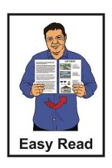


Join He Ara Tangata
Consumer Reference Group

Published: November 2025

About this Easy Read


This Easy Read is from Te Aho o Te Kahu – Cancer Control Agency.


Te Aho o Te Kahu – Cancer Control Agency is the part of the Government in charge of making Aotearoa New Zealand better at looking after people with cancer.

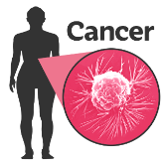
Cancer is an illness that makes people very sick.

It happens when cells do not stop growing when they should.
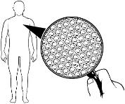

Cells are the tiny building blocks
that make up all living things.

When you see the words
we / our / us in this Easy Read they mean Te Aho o te Kahu – Cancer Control Agency.


We are looking for 4 new people to join our consumer reference group.

Our consumer reference group is
a group of people who

- know what it is like to have cancer in Aotearoa New Zealand
or
- have supported people with cancer.


They support us to improve cancer care for everyone in Aotearoa New Zealand.

Who can join He Ara Tangata?


The name of the consumer
reference group is He Ara Tangata.

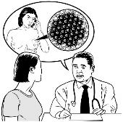
You can join He Ara Tangata if you:
have cancer
had cancer in the past

have supported someone else who had cancer like a:
- whānau / family member
- friend.



You do not need to be a health professional like a:
doctor
nurse.



You do not need to know a lot about how we look after people with cancer in Aotearoa New Zealand.

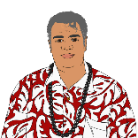
We very much want applications from:
Māori
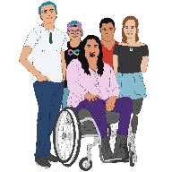
Pacific peoples
tāngata whaikaha / disabled people
rainbow people.


The application is how you tell us you would like to join He Ara Tangata.


Rainbow people means people who are:
lesbian
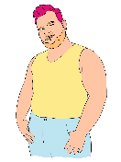
gay
bisexual
transgender

takatāpui
queer
intersex

asexual
other people who fit in similar groups.

What does He Ara Tangata do?


He Ara Tangata has up to 12 members.
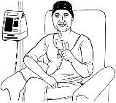

They know what it is like to have cancer in Aotearoa New Zealand.


They use this knowledge to:

tell us what they think about our work
work with us to make Aotearoa New Zealand better at looking after people with cancer.


He Ara Tangata meets every 3 months.


Meetings can be:
online
in person.


There is at least 1 in person meeting every year.

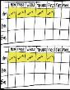
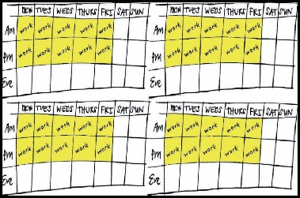
The meetings can last:
half a day
a whole day.


We will pay you to:

read information to get ready for meetings
come to meetings.


We will pay for you to travel to
in person meetings.


You can read more about what He Ara Tangata does on this website:

https://tinyurl.com/vw5ma5t3


This website is not in Easy Read.

How to apply


Fill in the online application form if you want to be part of He Ara Tangata:

https://forms.office.com/r/RMCRXnWdMk

This form is not in Easy Read.


Send us an email if you:
cannot fill in the online application form

would like to apply another way like by sending us a video
have any questions.


You can email us at:

lee.benjamin@teaho.govt.nz


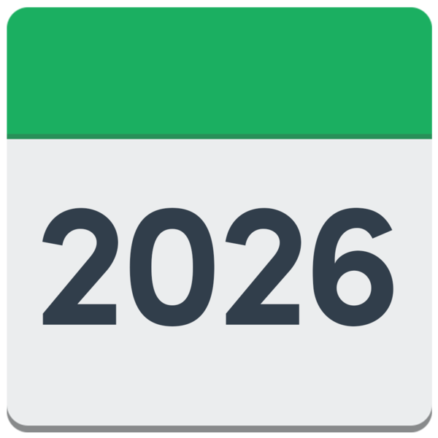
We need to get your application by
5 pm on Friday 30 January 2026.


We will look at all the applications.

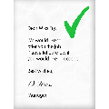
We will let you know if we would like you to join He Ara Tangata by Monday 16 February 2026.


There might be other ways to be part of our work in future if we do not ask you to join He Ara Tangata this time.


This information has been written by Te Aho o Te Kahu – Cancer Control Agency.


It has been translated into Easy Read by the Make it Easy Kia Māmā Mai service of People First New Zealand Ngā Tāngata Tuatahi.

The ideas in this document are not the ideas of People First New Zealand Ngā Tāngata Tuatahi.

All images used in this Easy Read document are subject to copyright rules and cannot be used without permission.


Make it Easy uses images from:


- Photosymbols

- Change Images


- Huriana Kopeke-Te Aho

- SGC Image Works

- T Wood


- Studio Rebeko

- Inga Kramer.

