
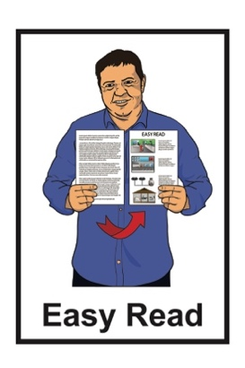

Disabled People and Cancer in Aotearoa New Zealand
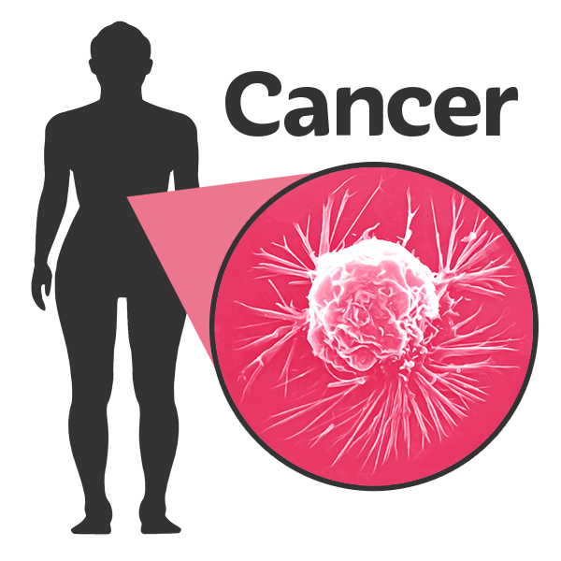

Published: March 2026

Before you start

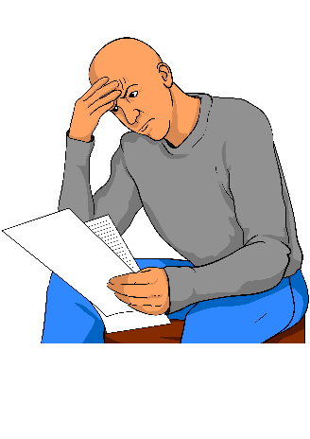
This is a long document.

It can be hard for some people to read a document this long.

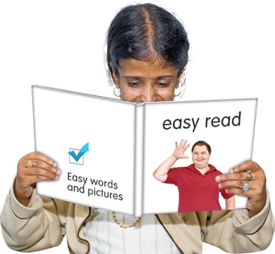
Some things you can do to make it easier are:
read it a few pages at a time
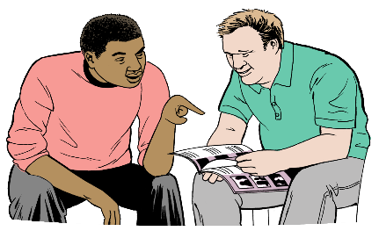
set aside some quiet time to look at it
have someone read it with you to support you to understand it.

Some of the information in this document may make people:
upset
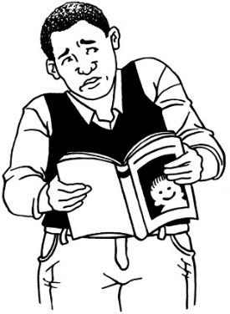
worried.


This information is not meant to scare anyone.


This information does not mean the things in this document will happen to:
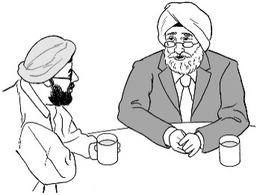
you
people you know.

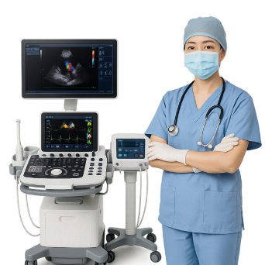
This document talks about things like:
medical care
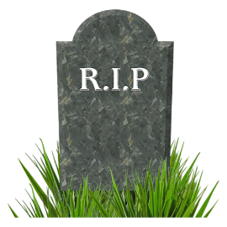
death
abuse.

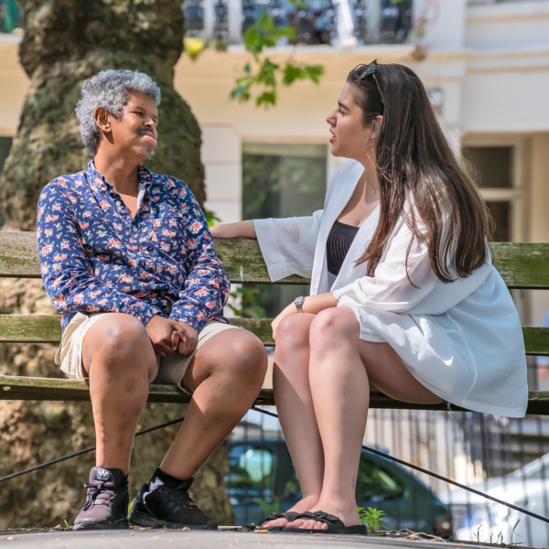
If you are worried you can talk to your:
whānau / family
friends.

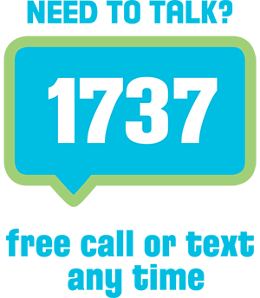
You can also contact Need to Talk:
call 1737
text 1737.


It does not cost any money to call / text 1737.

What you will find in this Easy Read

Page number:

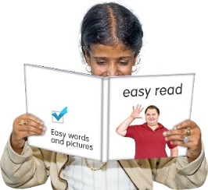
About this document 7


What are the disability and
cancer reports? 10
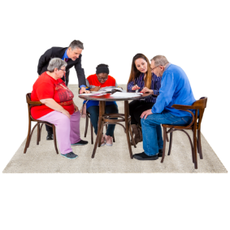
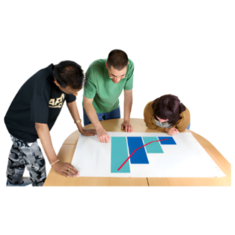
Disabled people and this project 15

How we identified
disabled people 17


Key findings 19

Disabled people with cancer 21
Page number:

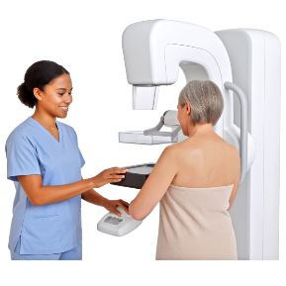
Getting checked for cancer 27

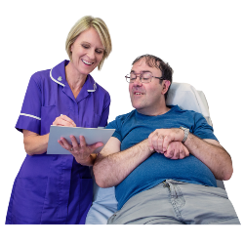
Cancer care for disabled people 30

Healthcare workers and
disability 31
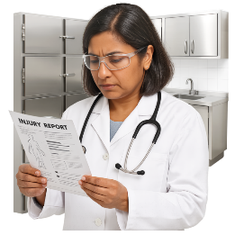

Testing disabled people for
cancer 32

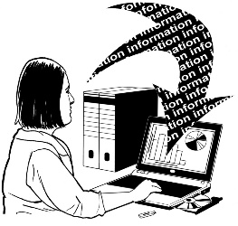
Using data to make cancer care
better 34

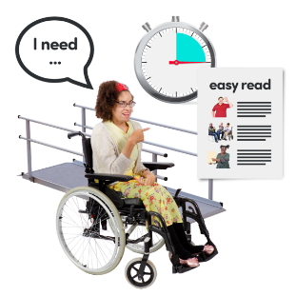
Better cancer services for
disabled people 37

Page number:

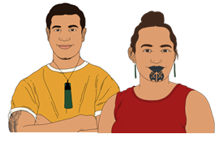
How cancer affects tāngata
whaikaha Māori / disabled Māori 38

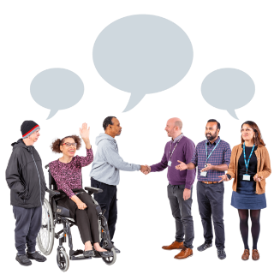
How the health system can
use these reports 40

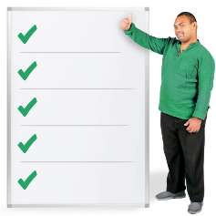
Better cancer services for
disabled people 42

What is happening next? 46

About this document

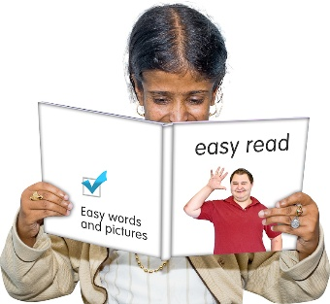
This Easy Read is a summary of Frequently Asked Questions about 2 reports about cancer and disabled people.

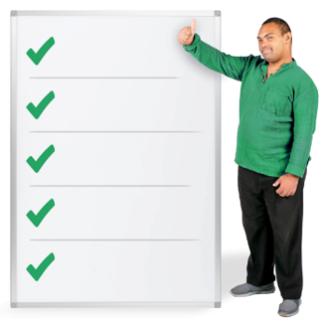
A summary tells you the main ideas from a longer document.

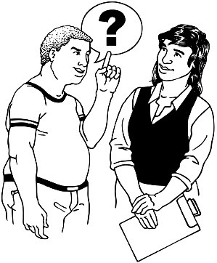
Here Frequently Asked Questions are questions that get asked a lot about the reports.

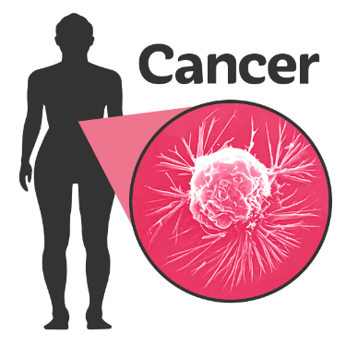
Cancer is a disease that:
happens when tiny parts of your body called cells grow in the wrong way
can make people very sick
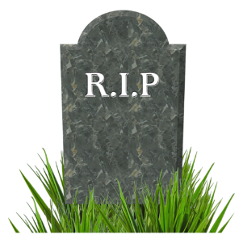
can kill people
can be hard to get rid of.

The reports were done by Te Aho o Te Kahu Cancer Control Agency.

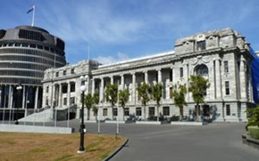
Te Aho o Te Kahu Cancer Control Agency is the part of the
Government that works to make cancer care better for people.

In this document Te Aho o Te Kahu Cancer Control Agency will be called the Agency.

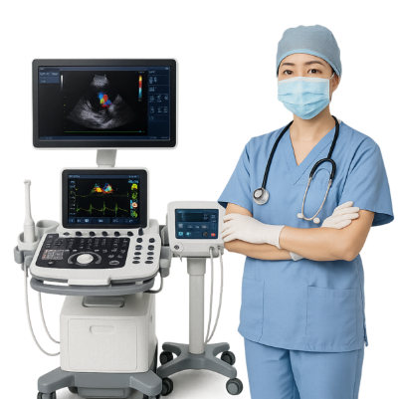
In this document we / us / our
means the Agency.

In this document cancer care means:
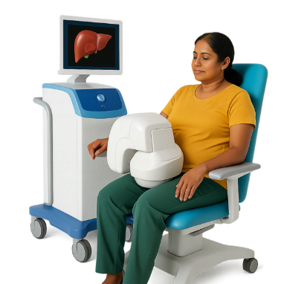
support for when / after people have cancer
cancer treatments which are things to try and stop the cancer


You can read the full reports at:

https://bit.ly/teaho-DACR
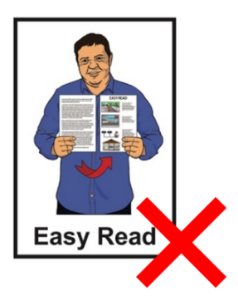
The full reports are not in Easy Read.

What are the disability and cancer reports?

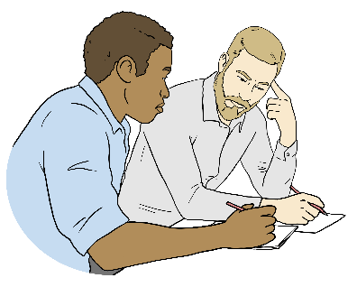
In 2021 the Agency saw that there was not enough research on how cancer affects disabled people in Aotearoa New Zealand.
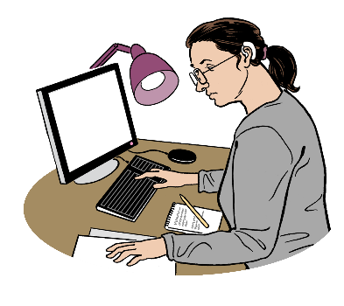

Research means finding out a lot of information about something.


The Agency has released 2 reports on how cancer affects disabled people in Aotearoa New Zealand.

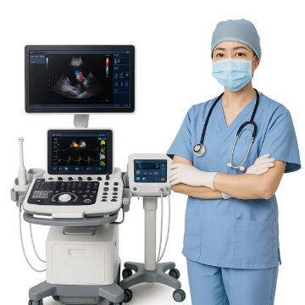
The reports show what makes it hard for disabled people to:
find out they have cancer quickly
get good cancer care.
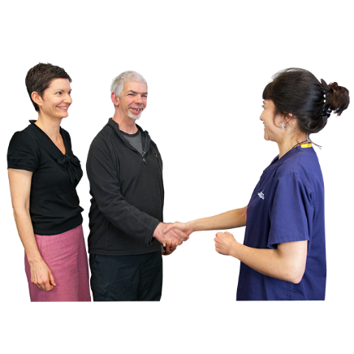
What is in these reports can be used to work out how to make it easier for disabled people with cancer to get the support they need.

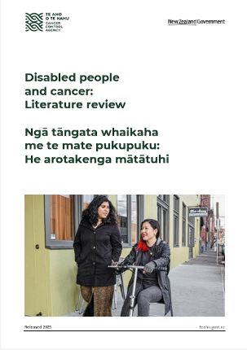
The reports are:
Disabled people and cancer: Literature review / Ngā tāngata whaikaha me te mate pukupuku: He arotakenga mātātuhi
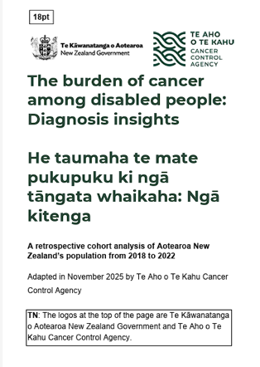
The burden of cancer among disabled people: Diagnosis insights / He taumaha te mate pukupuku ki ngā tāngata whaikaha: Ngā kitenga.

Disabled people and cancer: Literature review

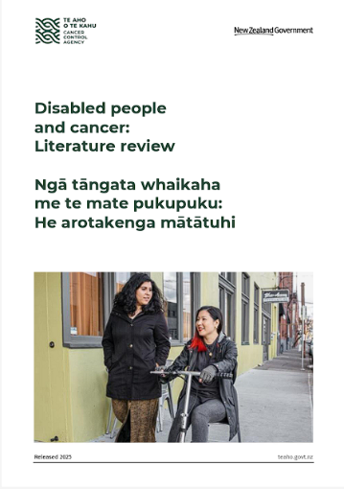
The Disabled people and cancer: Literature review will support everyone working in health care to learn more about the barriers faced by disabled people when:
getting diagnosed with cancer
being treated for cancer.

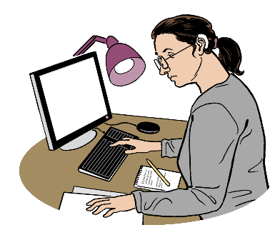
A literature review means reading research from a lot of different
places to see what we know.

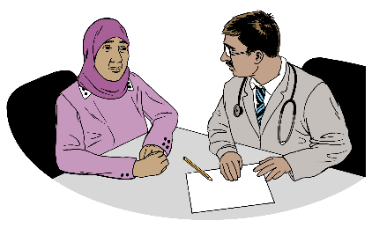
Here being diagnosed means a doctor tells you that you have a disease like cancer.

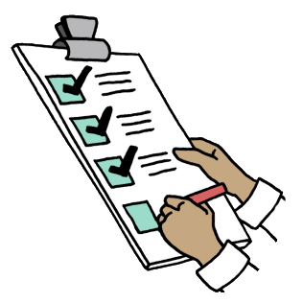
The literature review also explains:
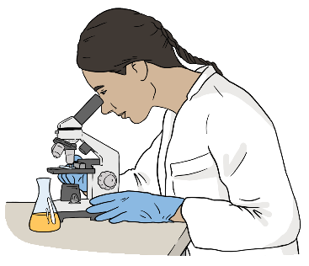
ways to make it easier for disabled people to get the cancer care they need
what research still needs to be done.

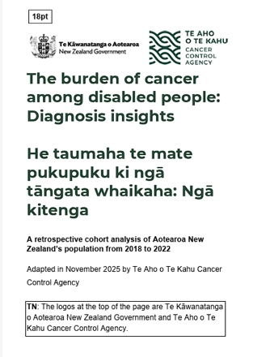
The burden of cancer among disabled people: Diagnosis insights

This report looks at how many disabled adults are diagnosed with cancer out of all the adults in Aotearoa New Zealand.
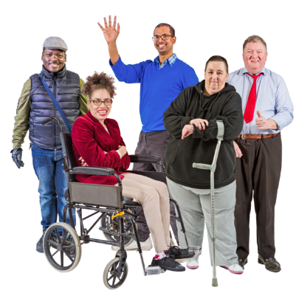

The report says that disabled people get diagnosed with cancer more often than the total population

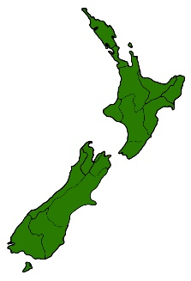
In this document total population means all the adults in New Zealand.

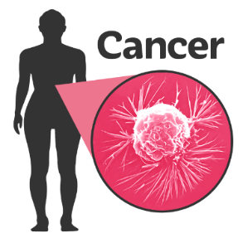
The report says that most of the time being disabled does not cause people to get cancer.

Disabled people and this project

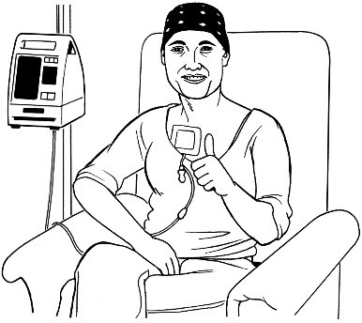
The Agency made sure that disabled people with experience of cancer were part of the project team.

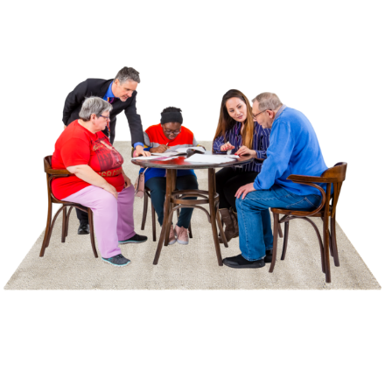
3 Lived Experience Advisor roles were made for people with lived experience of:
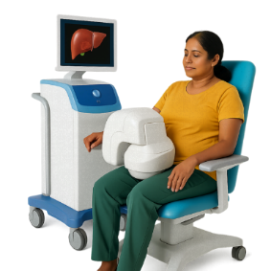
disability
and
cancer.

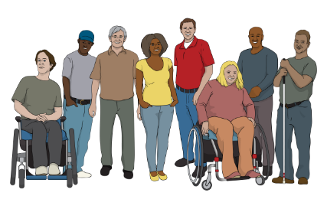
The Lived Experience Advisors represented different kinds of people who live in Aotearoa New Zealand.

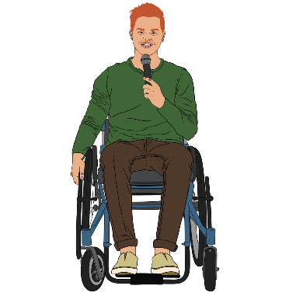
To represent a group of people means to speak up for everyone in that group.

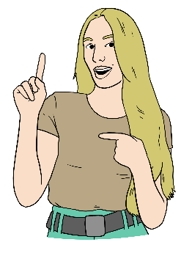
A member of He Ara Tangata also supported the project team.


He Ara Tangata is a group that
gives advice to the Agency about how to make things better for people experiencing cancer.

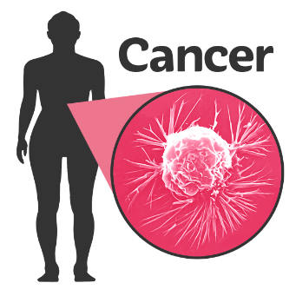
This member:
is not disabled
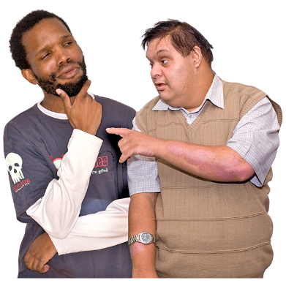
has experience with cancer
has experience in supporting disabled people.

How we identified disabled people

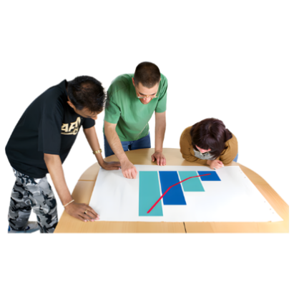
We used 2 data sources to identify disabled people in Aotearoa New Zealand.

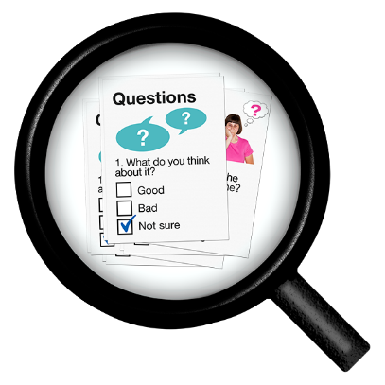
Data sources are sets of information about things like how many people have disabilities in New Zealand.

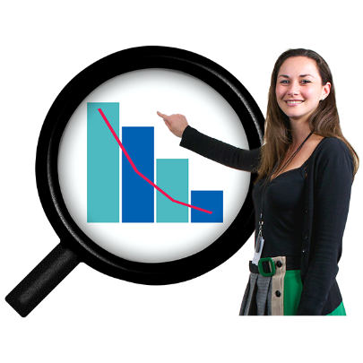
Here to identify someone means using data sources to work out things like how many disabled people there are in New Zealand.


Because of how some data sources are done not all disabled people are part of the data sources.

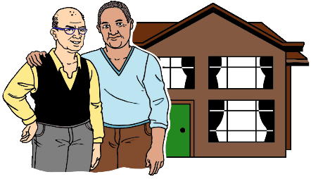
The data sources we used were:
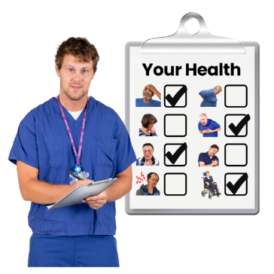
household surveys like the Census
health records data like needs assessment information.


These data sources are anonymous.

Here anonymous means that
no one can tell who the data is about.

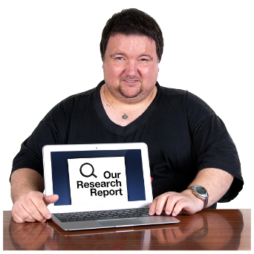

We used this information to find out more about the things we needed to report on.

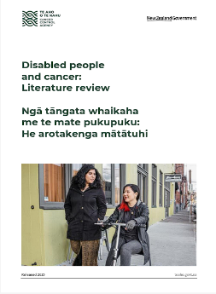
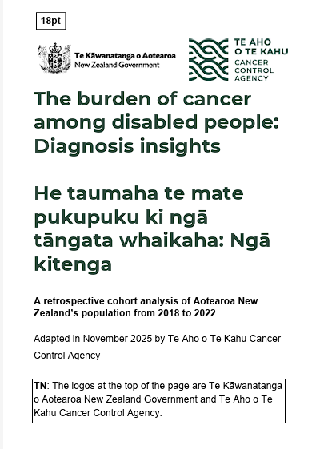
You can find out more about how we did this in the full reports.

Key findings


Key findings are the most important things found out when doing research.

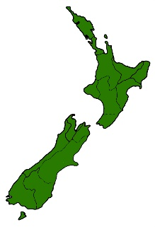
The experiences of disabled people with cancer have not been researched much in:
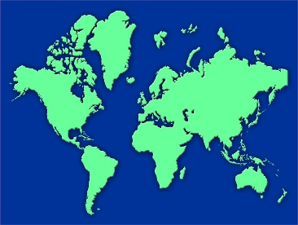
New Zealand
other countries.

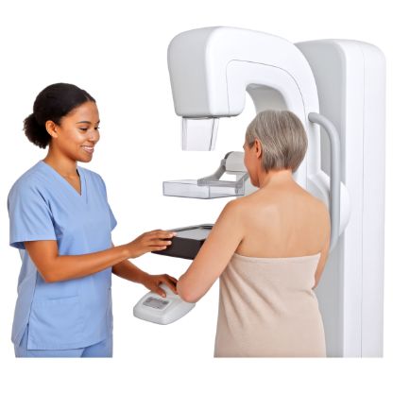
Most research only looks at cancer screening.

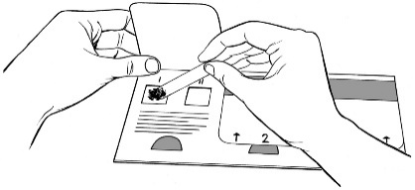
Cancer screening means different tests to check if you have:
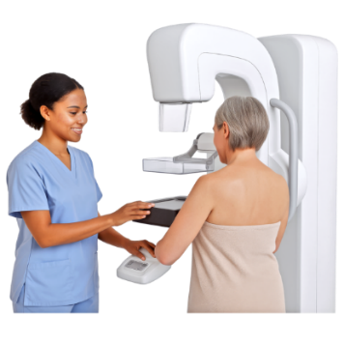
bowel cancer
cervical cancer
breast cancer.

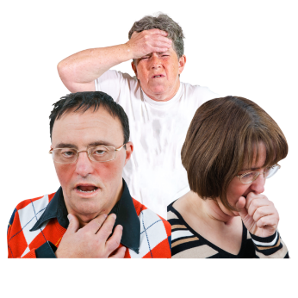
Screening is different to testing because screening can be done
even if you do not have any symptoms of cancer.

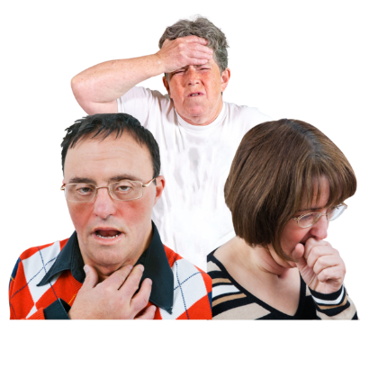
Symptoms are things that show you might be sick like:
pain
a fever / feeling very hot.

Not everyone needs screening tests.

People only get offered screening if they:
are the right age for screening
have the body part that needs screening.

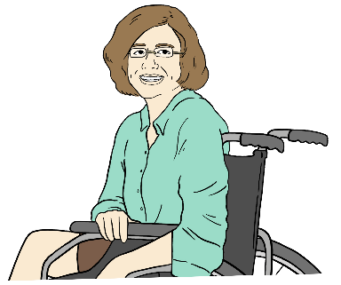
The world does not know much about things to do with disabled people with cancer like:
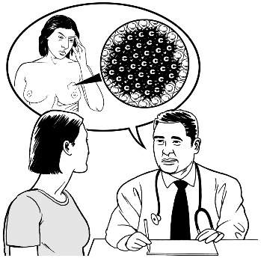
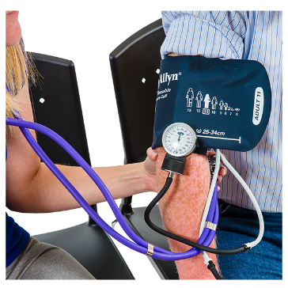
what kind of treatment they have
how people find out they have cancer
what kind of care they get


The world does not know much about what kind of support disabled people with cancer get when:
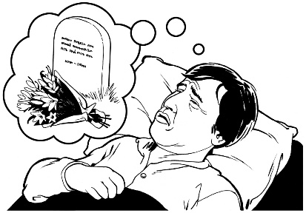
their cancer cannot be cured
they are dying.

Using data to make cancer care better

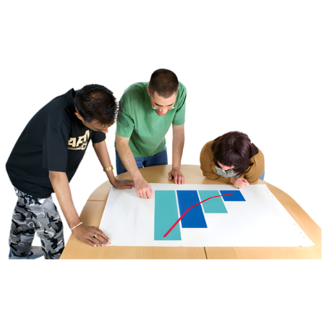
Here data means information collected about disabled people so we can find out more about how to make cancer care better.

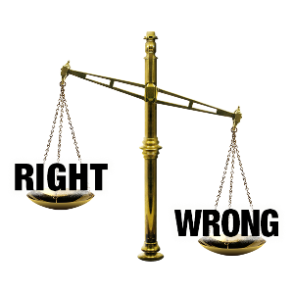
Collecting good data about disabled people is important to:
find out if something is not fair
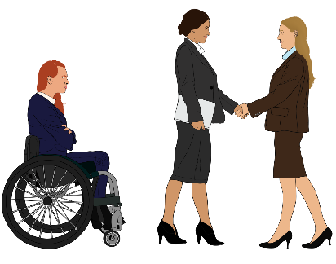
make health services better
stop disabled people being forgotten about
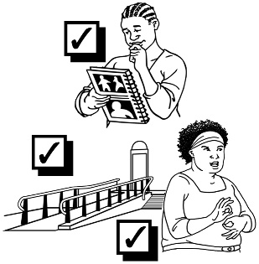
meet the needs of disabled people.

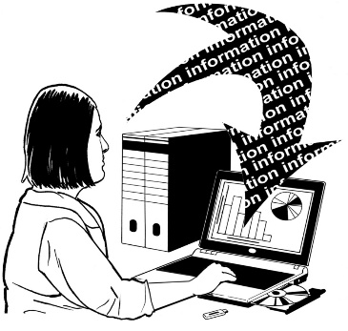
Aotearoa New Zealand does not always collect information about disability the same way.

This makes it hard to know:
who is disabled
what disabled people need.


Other countries also find these things hard because the world does not just have 1 way of:
deciding what a disability is
identifying disabled people.
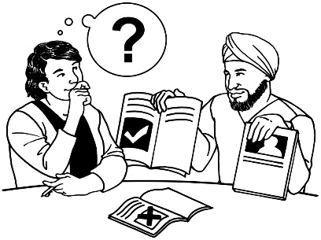

This makes it hard to look at how disability works around the world.

To make things better for disabled people it is important everyone:
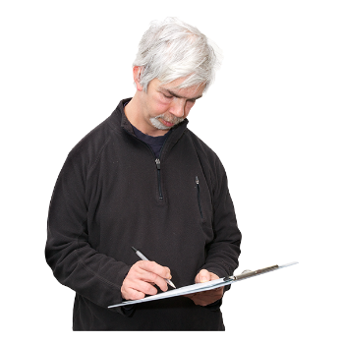
collects data the same way
has the same way of identifying disabled people.

Disabled people with cancer

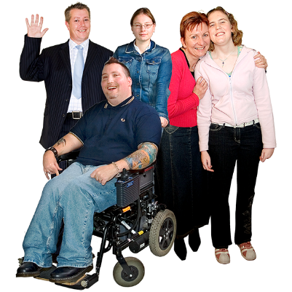
Disabled people in are more likely to be diagnosed with cancer than the total population in Aotearoa New Zealand.

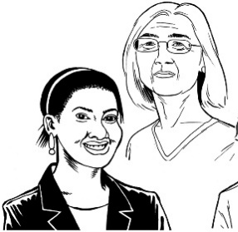
The group that experiences this the most is people from 45 to 65 years old.

Tāngata whaikaha Māori / disabled Māori are told they have cancer more often than other groups of disabled New Zealanders.

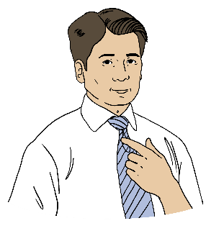
Other groups of disabled people who get diagnosed with cancer more are:
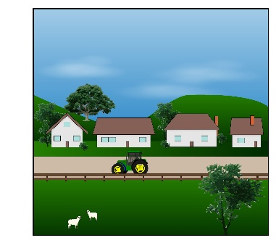
males / men
people living rurally like on a farm
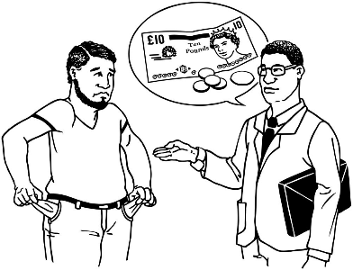
people who live in areas where most people do not have the things they need to live good lives.

We looked at 4 different cancers in both:
disabled people
the total population.

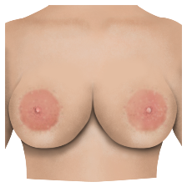
These cancers were:
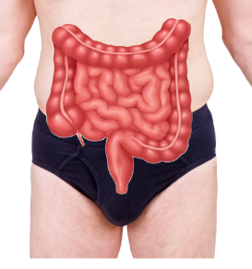
breast cancer
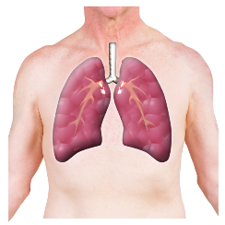
bowel cancer
lung cancer
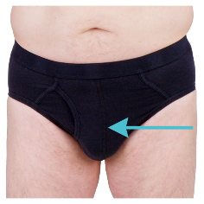
prostate cancer.

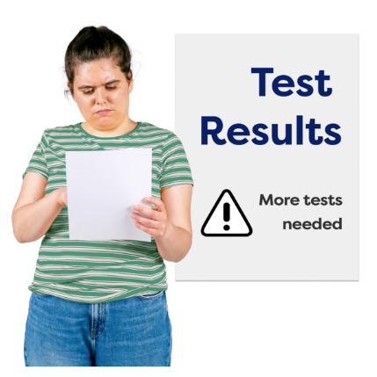
Disabled people are more likely than the total population to be diagnosed with:
breast cancer
bowel cancer
lung cancer.

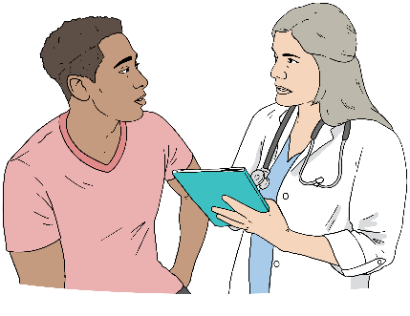
Disabled people are less likely than the total population to be diagnosed with prostate cancer.

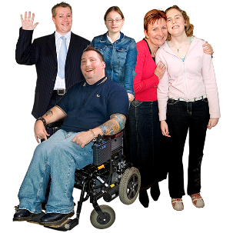
Because disabled people are more likely to be diagnosed with cancer than the total population in New Zealand we think that:

some of the cancers could have been prevented / stopped from happening
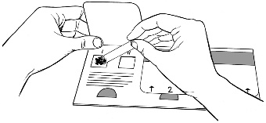
how we check for cancer early is very important.

Some disabled people have health conditions that can make them more likely to get cancer.
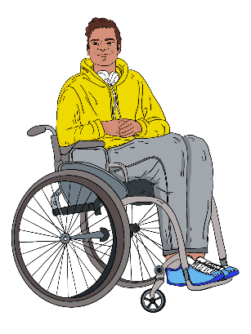

Most of the time being disabled does not mean you are more likely to get cancer.

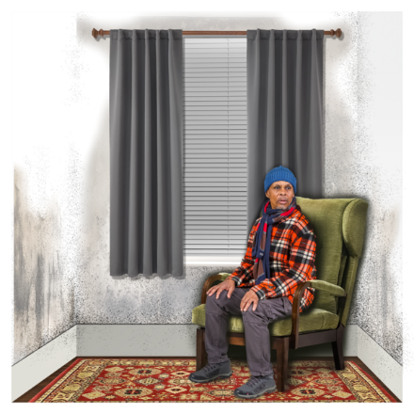
Disabled people getting cancer more often is likely because of things that make it easier for someone to get cancer.


These are things a lot of disabled people experience like:
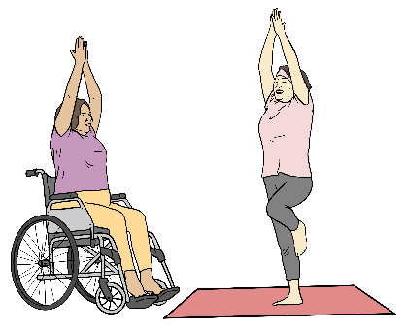
not being able to buy healthy food
living somewhere that makes them sick
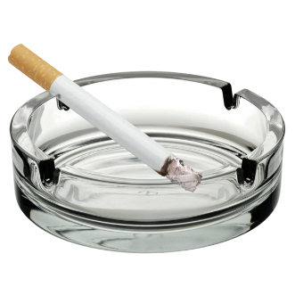
not being able to exercise enough
breathing in cigarette smoke.

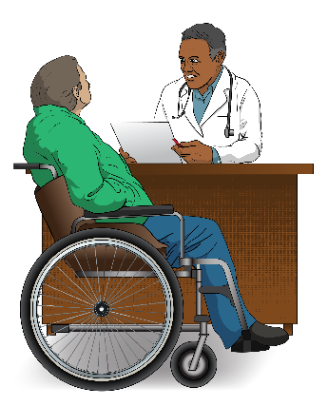
Disabled people can also sometimes find it hard to get to the doctor.

These things can make it harder to:

stay healthy
find out if you have cancer sooner.

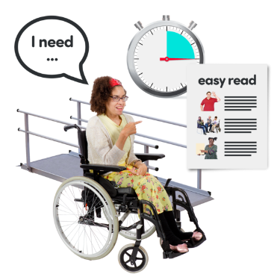
What we have found out shows that it is important cancer care / services work for disabled people.

Getting checked for cancer

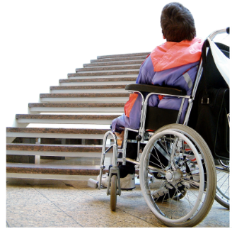
Disabled people can have a hard time getting checked for cancer because of things like:
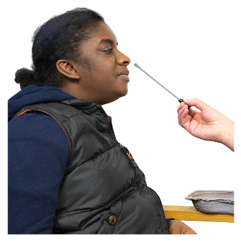
medical centres not being accessible
tests being painful for some people
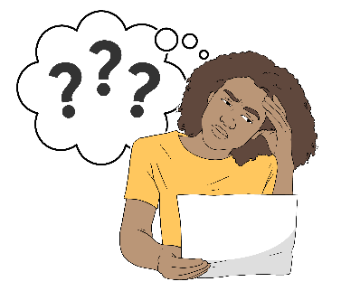
information about the tests being confusing

healthcare workers not knowing enough about disability
not being able to pay for the tests
trauma they may have had in the past.

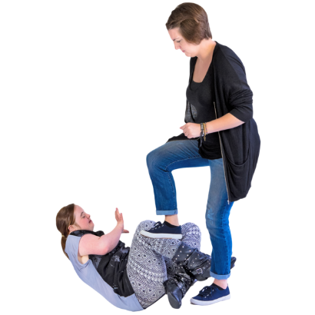
Trauma means feelings that last after something bad happens to you like:
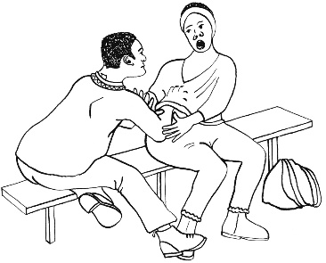
physical abuse / someone
hurting your body often
sexual assault / someone making you do sexual things you do not want to do
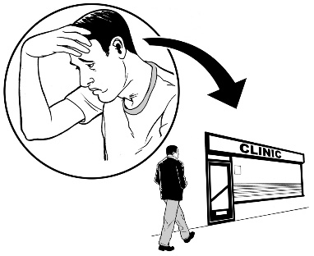
medical trauma like getting hurt because a test was not done the right way.

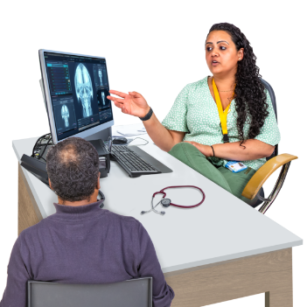
People like doctors sometimes think the symptoms of cancer they are seeing are caused by a disability.

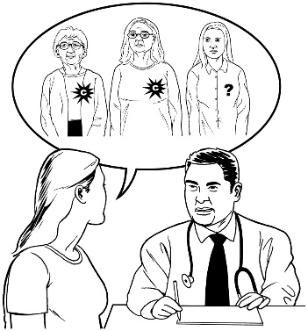
If a doctor thinks a symptom is because of a disability then:
the doctor might miss that the disabled person has cancer
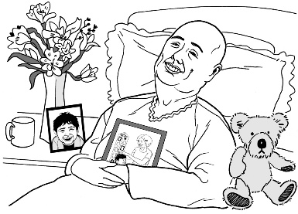
the disabled person might be treated for cancer later than
non-disabled people.


This can mean that disabled people get worse health outcomes.

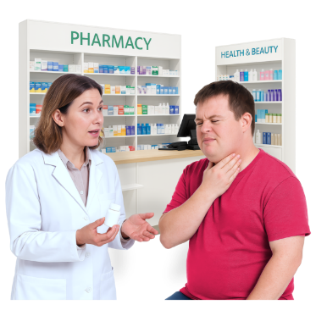
Health outcomes are the things that happen because of how well someone has had their health cared for.

Cancer care for disabled people

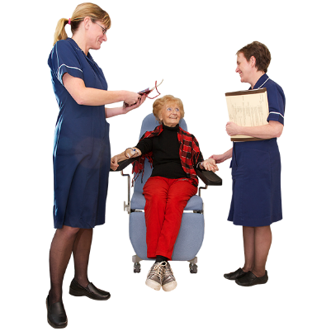
Disabled people do not always get the same cancer care as non-disabled people.

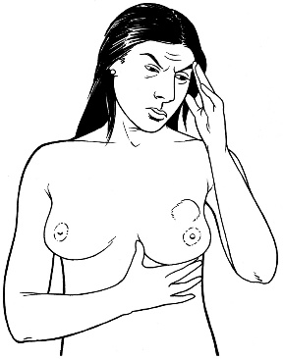
An example of this is that women with learning disability who have breast cancer are more likely to:
have their whole breast removed
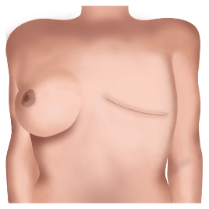
not just have the piece of their breast with the cancer removed.

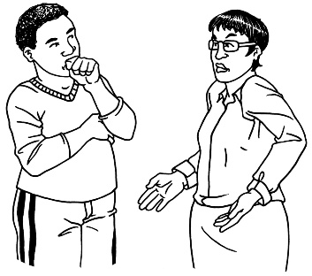
Disabled people with some kinds of cancer get less treatment than
non-disabled people.

Healthcare workers and disability

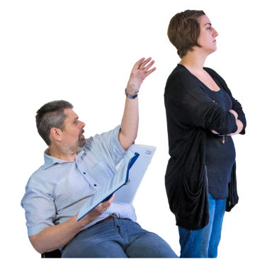
Problems accessing cancer care can happen when healthcare workers:
think badly about disabled people
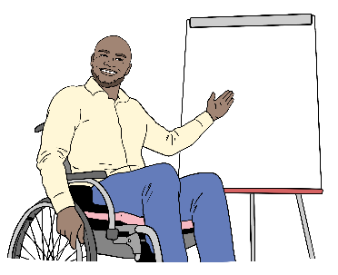
do not show that they understand
have not had enough training.

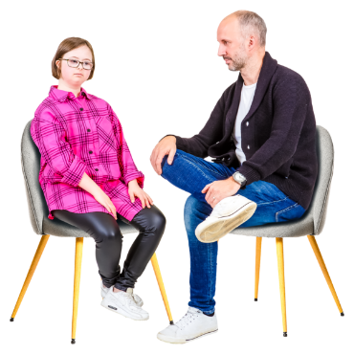
This could look like healthcare workers not:
speaking in a way the disabled person needs
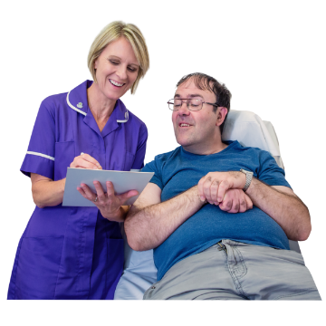
making things easy
offering the right support.

Testing disabled people for cancer


Around the world disabled people are less likely to be screened for cancer than non-disabled people.

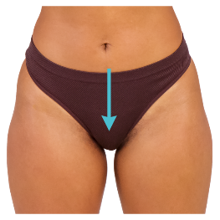
This can happen with:
cervical cancer
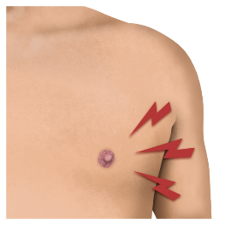
breast cancer.

This means cancer may not be found early.
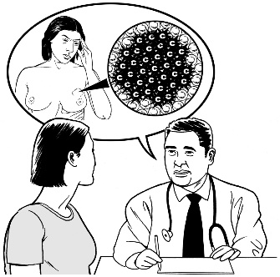

Cancer not being found early can make it harder to treat.

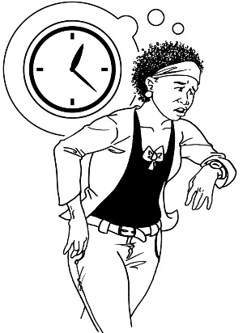
Some reasons disabled people might find it harder to get cancer care are:
appointment times they cannot get to
not enough support to use health services like the doctor
information that is confusing
health staff who have not had enough training about disability.


All services to do with cancer need to be accessible to disabled people like:
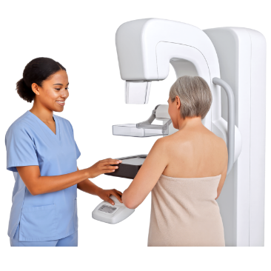
programmes to stop smoking
screening programmes that check for cancer
cancer care services.

Better cancer services for disabled people

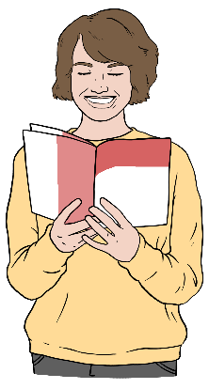
Things that can be done to make cancer services better for disabled people are things like:
making sure all health information is easy to understand
giving health professionals good training about disability
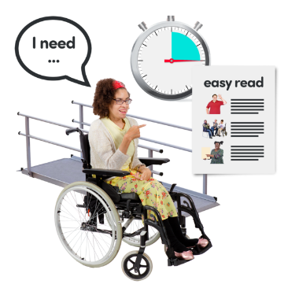
making sure health care is accessible
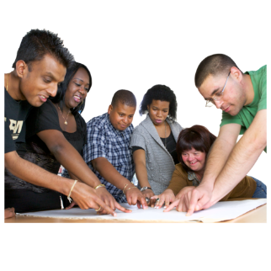
offering support for appointments
designing services with disabled people.

How cancer affects tāngata whaikaha Māori / Māori disabled people

Tāngata whaikaha Māori / Māori disabled people are more likely to:
be diagnosed with cancer
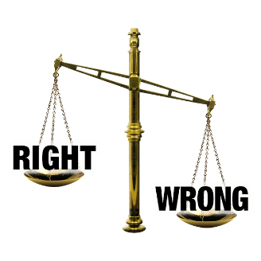
have a harder time accessing cancer care because of:
- things not being fair
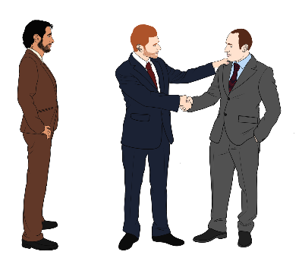
- discrimination which means people being treated badly because of who they are
- the effects of colonisation.

Colonisation is when a group of people from 1 country called colonisers:
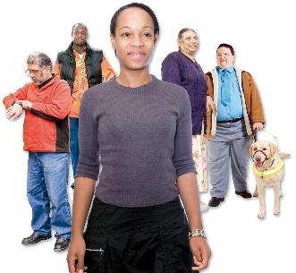
set up home in another country
take over the country from the people who already live there.
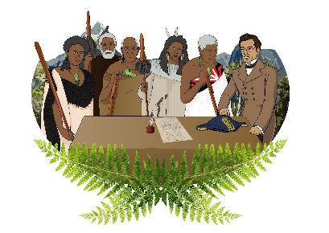

New Zealand was colonised by the British.

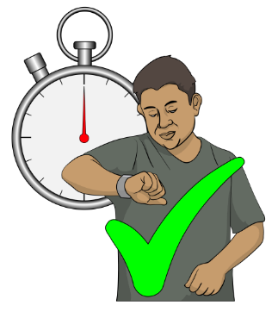
How tāngata whaikaha Māori are treated in cancer care needs to be fixed as soon as possible.

How the health system can

use these reports

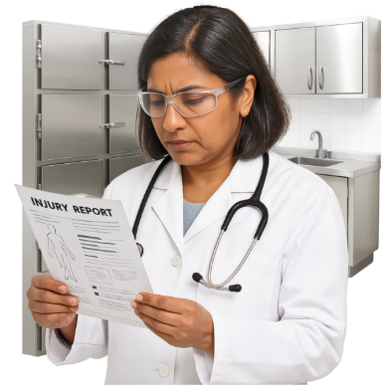
The reports done by the Agency can be used by people who work in the health system like:
health professionals like doctors
people who run cancer services
government agencies.

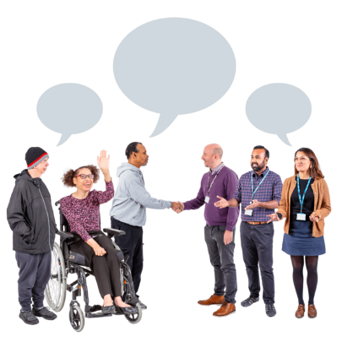
These reports can support people to:
talk about cancer services
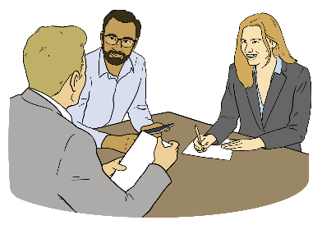
check cancer services are working well
work on other things that affect the health of disabled people.
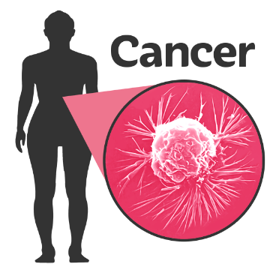
The reports also tell us:
how cancer affects disabled people
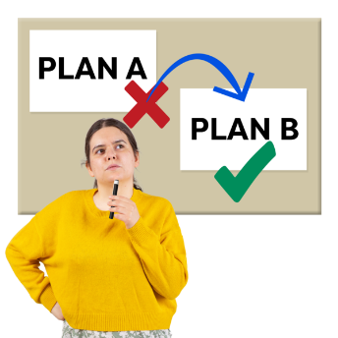
facts that can be used to make better plans for:
- stopping cancer

- finding cancer early
- making cancer services better.

Better cancer services for disabled people

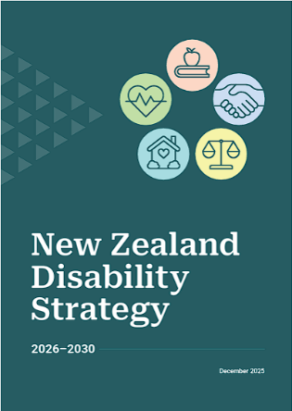
A new version of the New Zealand Disability Strategy for 2026 to 2030 has been written this year.

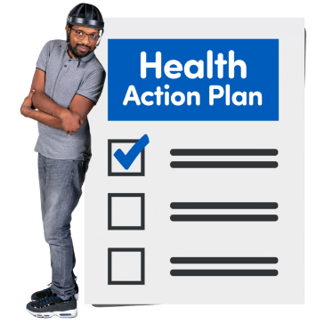
It has plans for health that will say how the Government will make health care better for disabled people.

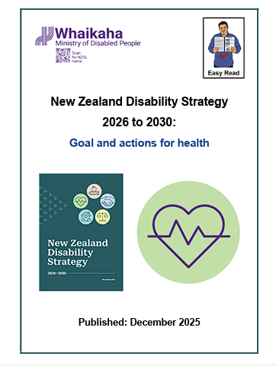
You can find an Easy Read of the New Zealand Disability Strategy 2026 to 2030: Goals and actions for health at:

https://bit.ly/4tvcQIm

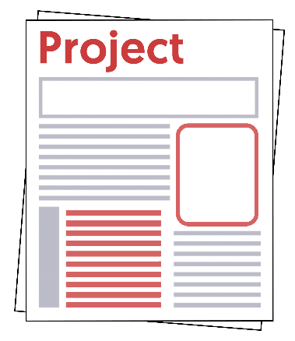
Health New Zealand Te Whatu Ora is working on a project called the Patient Profile and National Health Index.


The Patient Profile and National Health Index will let disabled people tell health services what support they need when they get care.

The Patient Profile and National Health Index is also called the PPNHI.

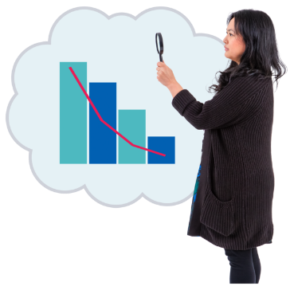
Work is being done to make sure disabled people can be found in the data the New Zealand health system collects.

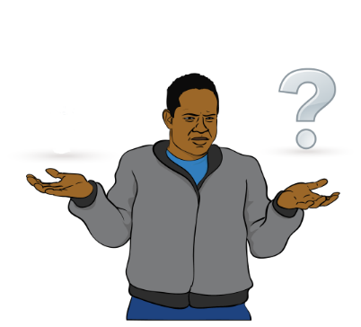
The way the data is collected now does not find out if someone has a disability.

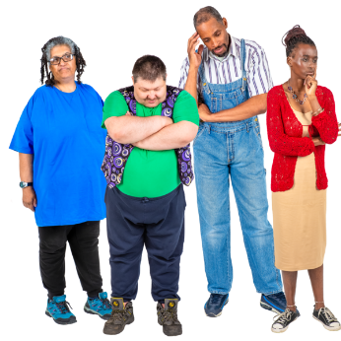
This makes it hard to:
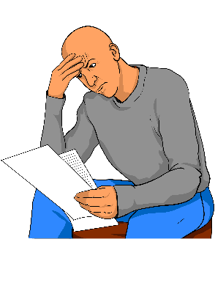
understand the problems disabled people face
fix health problems that affect disabled people.

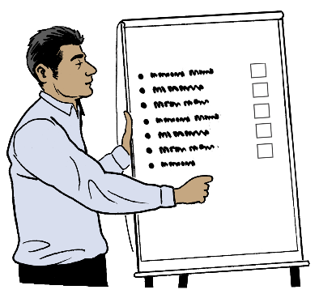
Health NZ also has a big plan to give better care to disabled people by doing things like:
teaching staff about disability

changing how things work
making services easier to use.

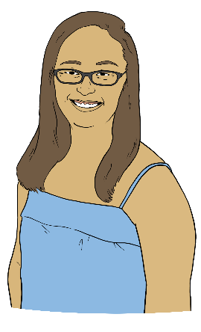
The Ministry of Health is working on ways to support better health for people with learning disability.

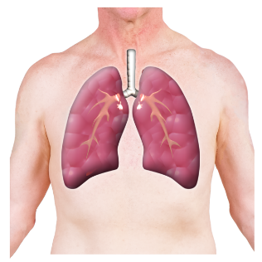
A new screening programme for lung cancer is being planned.

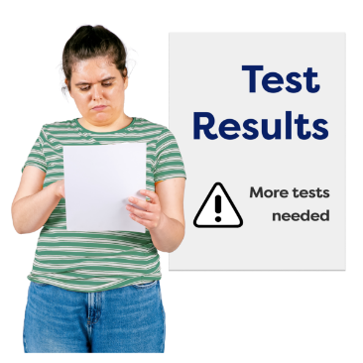
If it happens then this programme will:
find lung cancer sooner
treat lung cancer sooner
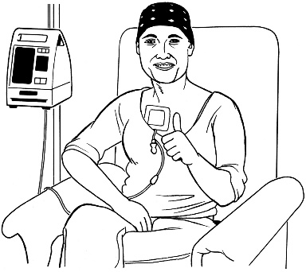
manage lung cancer better
make it easier for people to deal with lung cancer.

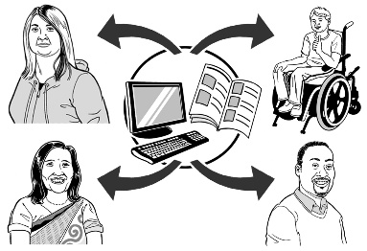
Sharing the reports will give everyone the information they need to make the health system better.

What is happening next?

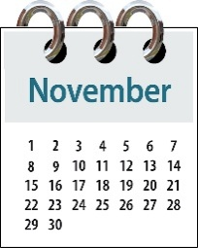
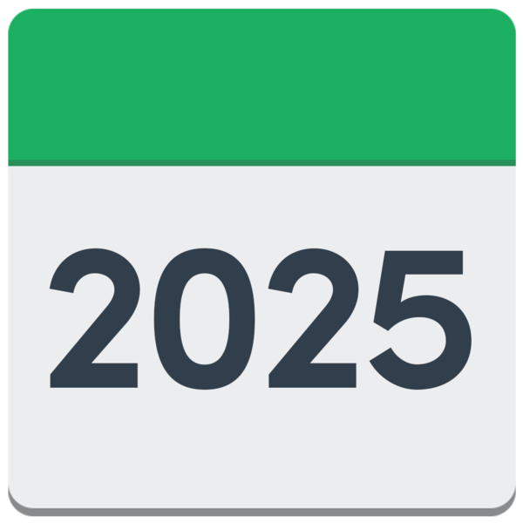
We put the reports on our website in November 2025.

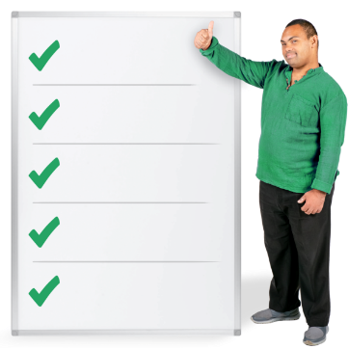
We have also been sharing with other groups:
the key points of the reports
the next steps.

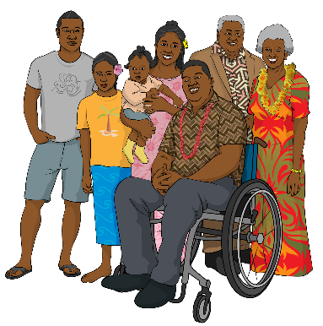
The Agency will keep trying to better understand the health needs of:
disabled people
their whānau / families.

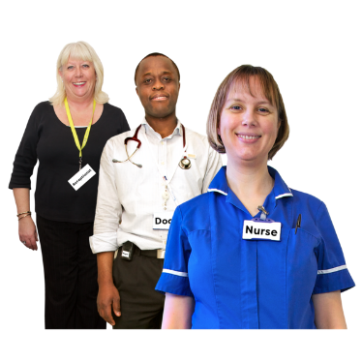
We will try to understand better by working with:
health organisations
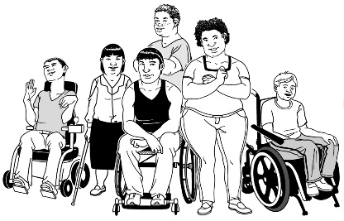
the disability community.

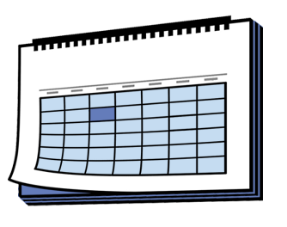
We need to learn more about:
how long disabled people live after finding out they have cancer
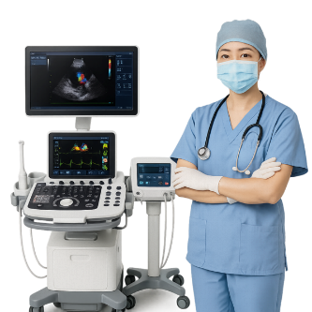
when disabled people have their cancer found
what treatment disabled people get for cancer.

This information has been written by Te Aho o Te Kahu Cancer Control Agency.

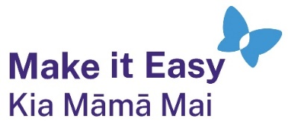
It has been translated into Easy Read by the Make it Easy Kia Māmā Mai service of People First New Zealand Ngā Tāngata Tuatahi.
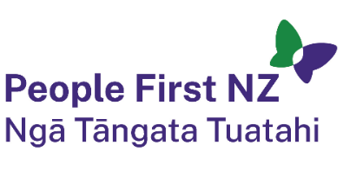
The ideas in this document are not the ideas of People First New Zealand Ngā Tāngata Tuatahi.

All images used in this Easy Read document are subject to copyright rules and cannot be used without permission.


Make it Easy uses images from:

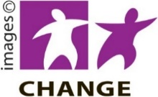
- Photosymbols

- Change Images


- Huriana Kopeke-Te Aho

- SGC Image Works

- T Wood


- Studio Rebeko

- Inga Kramer.

