


Supplementary Document
to The Cervical Cancer Elimination Plan 2026–
2040

Citation: Cancer Control Agency. 2026. Supplementary Document to The Cervical Cancer Elimination Plan 2026–2040 . Wellington: Cancer Control Agency
Published in September 2026 by the Ministry of Health and the Cancer Control Agency
PO Box 5013, Wellington 6140, New Zealand
ISBN 978-1-0670993-5-0
TP 0050
This document is available at teaho.govt.nz
 | This work is licensed under the Creative Commons Attribution 4.0 International licence. In essence, you are free to: share ie, copy and redistribute the material in any medium or format; adapt ie, remix, transform and build upon the material. You must give appropriate credit, provide a link to the licence and indicate if changes were made.

Contents
Executive Summary: New Zealand’s vision, current state and targets 5
Introduction 6
The burden of cervical cancer in New Zealand 6
Purpose of the Plan 10
How we developed the Plan 10
Understanding the basics 13
Strategic priorities and actions for elimination of cervical cancer 15
Pillar 1: Improve HPV vaccination rates 15
Pillar 2: Improve HPV screening coverage and follow-up of positive screening results 23
Pillar 3: Improve treatment of cervical pre-cancer and cancer 32
Pillar 4: Enablers 39
Next steps 42
Implementation 42
Accountability 42
References 43
Endnotes 45

List of Figures
Figure 1: Cervical cancer incidence per year, by ethnicity, New Zealand, 2003-2023 | 7
Figure 2: Cervical cancer mortality per year, by ethnicity, New Zealand, 2003-2023 | 7
Figure 3: Cervical cancer incidence per year, by deprivation quantile, New Zealand, 2003-2023 | 8
Figure 4: Cervical cancer mortality per year, by deprivation quantile, New Zealand, 2001-2023 | 8
Figure 5: Proportion of 15-year-olds with at least one dose of HPV vaccine or fully immunised against, by ethnicity, New Zealand, 2023-2026 | 16
Figure 6: Proportion of 15-year-olds with at least one dose of HPV vaccine or fully immunised against HPV, by deprivation quintile, New Zealand, 2023-2026 | 16
Figure 7: Proportion of eligible female population with at least one dose of HPV vaccine or fully immunised, by age groups, New Zealand, 2023-2026 | 17
Figure 8: Proportion of eligible male population with at least one dose of HPV vaccine or fully immunised, by age groups, New Zealand, 2023-2026 | 17
Figure 9: Percentage up-to-date with cervical screening, by ethnicity, New Zealand, 2012-2026 | 24
Figure 10: Percentage up-to-date with cervical screening, by deprivation, New Zealand, 2012-2026 | 24
Figure 11: Percentage up-to-date with cervical screening, by age group, New Zealand, 2012–2026 | 25
Figure 12: Proportion of participants requiring a colposcopy within 30 working days following a positive screening result, receive the procedure within 30 working days, January to March 2026, by ethnicity | 26
Figure 13: Proportion of participants requiring a colposcopy within 30 working days following a positive screening result, receive the procedure within 30 working days, January to March 2026, by deprivation quintile. | 27
Figure 14: Proportion of participants with high-grade cervical precancerous lesions following screening are treated within 40 working days, January to March 2026, by ethnicity. | 32
Figure 15: Proportion of participants with high-grade cervical precancerous lesions following screening are treated within 40 working days, January to March 2026, by deprivation quintile. | 32
Figure 16: Faster Cancer Treatment 31-day achievement rate, by ethnicity, July 2020 – June 2026 | 34
Figure 17: Faster Cancer Treatment 31-day achievement rate, by deprivation, July 2020 – June 2026 | 34
Figure 18: Faster Cancer Treatment 31-day achievement rate, by treatment type, July 2020 – June 2026 | 35

Executive Summary: New Zealand’s vision, current state and targets
New Zealand will eliminate cervical cancer – that is, achieve an annual incidence of less than four cases per 100,000 women – for all population groups by 2040. The elimination timing is informed by the cancer forecasting modelling developed by the Cancer Control Agency, which assesses how different scenarios of key interventions are expected to influence cervical cancer incidence over time.
The vision and targets will only be considered achieved when they are met and sustained across all population groups with targeted approaches that prioritise those with the greatest unmet health need.
New Zealand targets at a glance
  received at least one dose of the  HPV vaccine by age 15  by 2035 |  | 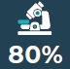  up to date with cervical  screening  by 2030 |  | receive timely colposcopy  within 30 working days  by 2030 | 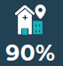  of people with high-grade cervical pre-  cancerous lesions treated within 40 working days  by 2030 |  | of people with cervical cancer receive  cancer management within 31 days  by 2030
 | World Health Organization Global Strategy 2030 targets |  | New Zealand current state |  |  | New Zealand’s elimination targets
  1: Vaccination | - 90% of girls fully vaccinated with the HPV vaccine by the age of 15 |  | January to March 2026  - 68.7% eligible people received at least one dose of HPV vaccine by age 15  - 60% of eligible people fully vaccinated by age 15 |  |  | By 2035  - 90% of eligible people receive at least one dose of the HPV vaccine by age 15 (interim targets of 75% by 2028, 80% by 2030)  Additional indicator  - 90% of eligible people are fully vaccinated with the HPV vaccine by age 15.
  2: Screening | - 70% of women screened using a high-performance test by the age of 35, and again by the age of 45 |  | June 2026  - 77% of eligible people are up to date with cervical screening  January to March 2026  - 66.5% of participants requiring a colposcopy within 30 working days of referral following a positive screening result, receive the procedure within 30 working days of referral |  |  | By 2030  - 80% of eligible people are up to date with cervical screening  - 80% of participants requiring a colposcopy within 30 working days of referral following a positive screening result, receive the procedure within 30 working days of referral
  3: Treatment | - 90% of women with pre-cancer treated  - 90% of women with invasive cancer managed |  | January to March 2026  - 76.7% of participants with high-grade cervical pre-cancerous lesions following screening are treated within 40 working days of their decision to treat  July 2025 to June 2026  - 88.6% of people with cervical cancer received cancer management within 31 days of the decision to treat |  |  | By 2030  - 90% of participants with high-grade cervical pre-cancerous lesions following screening are treated within 40 working days of their decision to treat2  - 90% of people with cervical cancer receive cancer management within 31 days of the decision to treat (interim target of 88% by 2026/27)

Introduction
This supplementary document offers a comprehensive overview of the burden of cervical cancer in New Zealand. It outlines the development of the New Zealand Cervical Cancer Elimination Plan 2026 - 2040 (the Plan) and provides fundamental information regarding cervical cancer and its association with human papillomavirus (HPV) infection. Additionally, the supplementary document presents data on:
- the current state of HPV vaccination
- cervical screening and follow-up
- treatment for both cervical pre-cancer and cancer in New Zealand.
Detail on the actions to achieve and maintain elimination are also included.

The burden of cervical cancer in New Zealand
Cervical cancer is the 12th most common cancer among women in New Zealand and the fourth most common cancer among women aged between 15 and 44 years. Based on the most recent five-year data, on average 179 people were diagnosed with cervical cancer each year with approximately 52 deaths. On average, Māori are diagnosed at a younger age than people who identify as European/other, with a median age at diagnosis of 44 years compared with 46 years.
Fortunately, cervical cancer is one of the most preventable types of cancer. Through vaccination, early detection through screening, and timely treatment, we have the opportunity to effectively eliminate cervical cancer and its impact on New Zealanders.
Since New Zealand established the National Cervical Screening Programme in 1990, overall cervical cancer incidence and mortality rates have reduced. Due to relatively small annual case numbers, year-to-year rates can fluctuate considerably. To better show underlying trends over time, we have used three-year rolling averages to depict both incidence and mortality rates (see figure 1 to 4).
In the most recent three-year period for which we have data (2021–2023), the average cervical cancer incidence was 6.1 per 100,000 women overall but 8.0 for Māori and 10.2 for Pacific peoples. All population groups are above the cervical cancer elimination threshold of fewer than 4 cases per 100,000 women per year (for international comparability, we report all rates standardised to the WHO 2001 population standard).
Māori, Pacific peoples and people living in the most deprived areas continue to experience notably higher cervical cancer incidence and mortality than people who identify as European/other and those living in less deprived areas.
Detailed incidence and mortality data are available through the State of Cancer dashboard.
HPV primary screening is more sensitive than cytology-based test and screening coverage has been improving as outlined in Pillar 2: Improve HPV screening coverage and follow up. As a result, reported cervical cancer incidence may appear to rise, particularly for screen-detected cancers. This would likely reflect improved detection of existing cancers that may otherwise have been diagnosed later, rather than a true increase in the underlying occurrence of disease.
Figure 1: Cervical cancer incidence per year, by ethnicity, New Zealand, 2003-2023
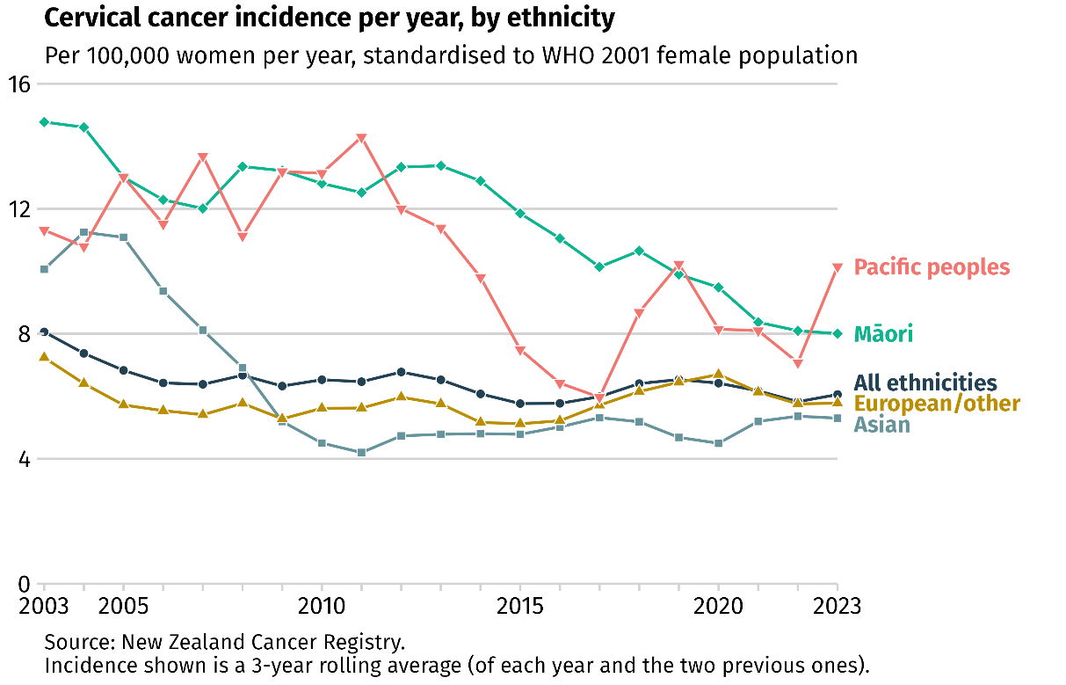

Figure 2: Cervical cancer mortality per year, by ethnicity, New Zealand, 2003-2023
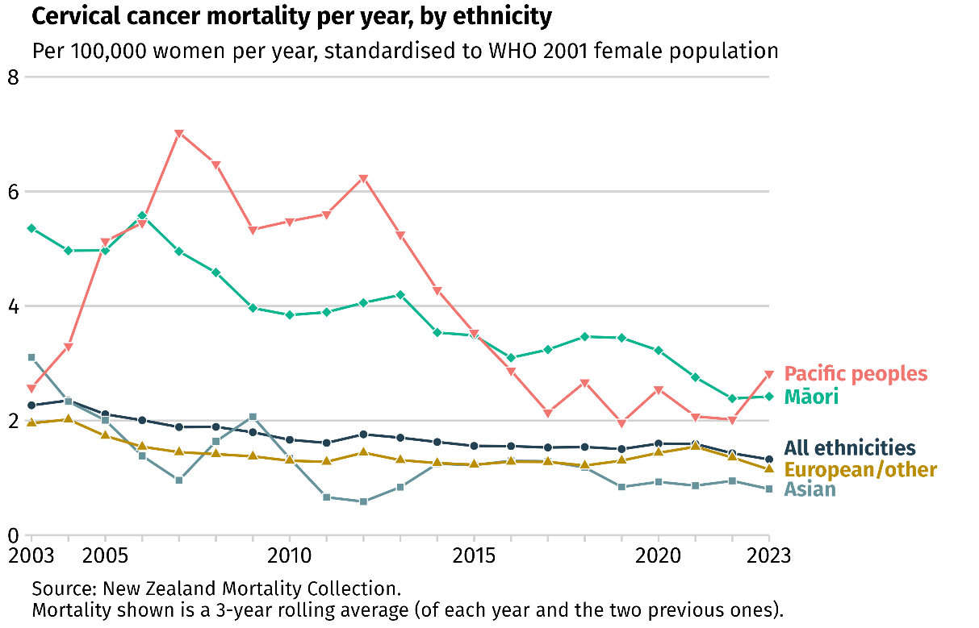

Figure 3: Cervical cancer incidence per year, by deprivation quantile, New Zealand, 2003-2023
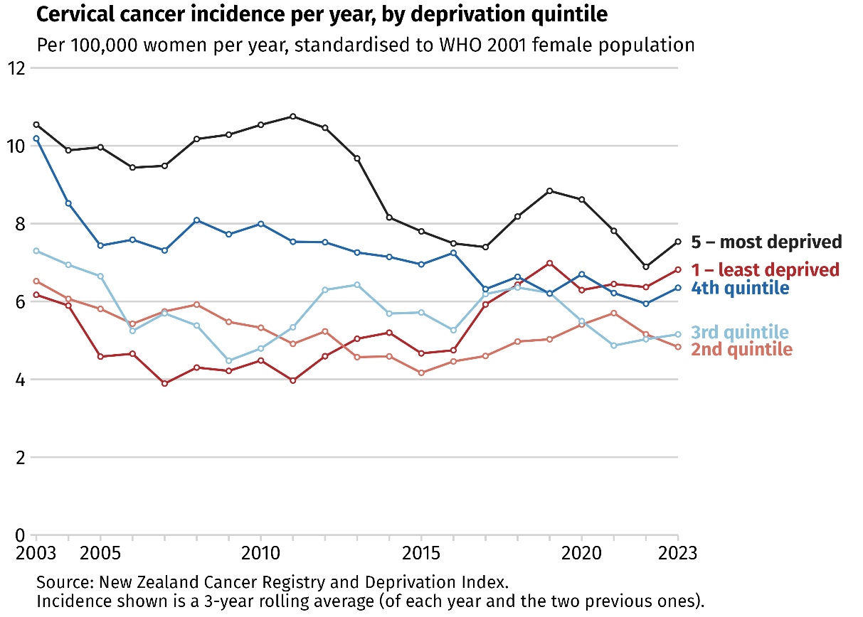

Figure 4: Cervical cancer mortality per year, by deprivation quantile, New Zealand, 2001-2023
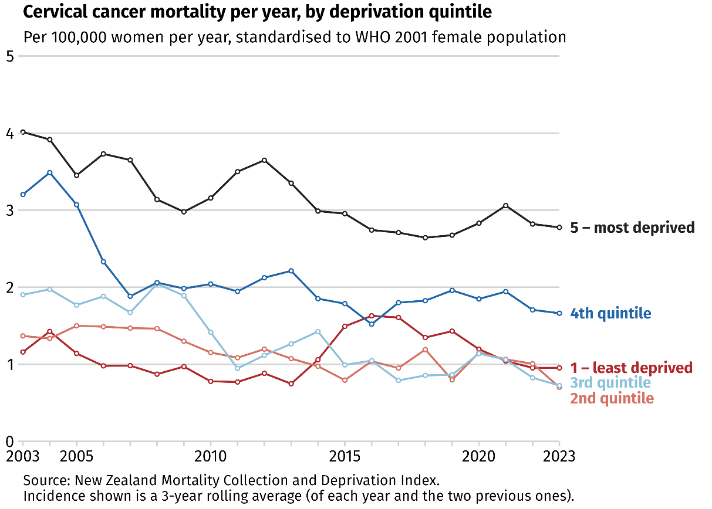

Purpose of the Plan
In 2020, the World Health Organization (WHO) launched the “Global strategy to accelerate the elimination of cervical cancer as a public health problem” (Global Strategy) and 194 countries, including New Zealand, committed to eliminating cervical cancer.
Many countries comparable to New Zealand have developed national plans and targets informed by the Global Strategy, including Australia, Ireland and Canada.
The Plan demonstrates New Zealand’s commitment to eliminating cervical cancer.
The delivery of HPV vaccination, cervical screening and treatment of cervical cancer are already well established in New Zealand. Progress to-date reflects contributions of many individuals, communities, advocacy groups, non-government organisations (NGOs), health providers and government agencies. But while rates of cervical cancer have decreased significantly over recent decades we are not where we need to be on the pathway to achieve elimination.
More work is therefore needed to achieve and maintain elimination for all New Zealanders. Further, for New Zealand, reaching and sustaining elimination means reducing incidence to less than 4 cases per 100,000 women for all population groups, including those with disproportionately higher incidence and mortality such as Māori and Pacific peoples.
The Plan supports the priorities outlined in the “Government Policy Statement on Health 2024-2027” by highlighting the actions needed to improve equitable and timely access to HPV vaccination, cervical screening and treatment services for all who need them. It also drives continuous quality improvement to ensure health services remain safe, efficient and responsive to all.
The Plan delivers on the commitment in the “New Zealand Cancer Action Plan 2026-2029”, to develop a New Zealand cervical cancer elimination plan. This includes establishing a New Zealand specific modelling approach to inform and support this work.

How we developed the Plan
The Ministry of Health and the Cancer Control Agency worked in partnership to develop the Plan. In parallel, the Cancer Control Agency has been developing a modelling framework, incorporating scenario forecasting tailored to the New Zealand context, to support the Plan’s objectives.
The Plan was informed through collaboration with academics, cancer specialists and researchers, consumer representative groups, NGOs, clinical and service delivery experts, as well as health analytics and epidemiology experts. Their collective expertise and perspectives spanning policy, equity, cultural considerations, whānau voice, clinical practice, operational delivery, and scenario modelling, were instrumental in shaping a comprehensive and inclusive plan.

Ensuring a needs-based approach
A needs-based approach not only improves health equity but can also guide investment and prioritisation decisions where they will have the greatest impact. Addressing unmet health need requires targeted actions and resources to ensure everyone has the opportunity to reach their highest possible standard of health.
The Plan recognises that there is clear evidence from New Zealand data that certain population groups including Māori, Pacific peoples and people living in areas of high deprivation have higher cervical cancer incidence and/or mortality rates. These groups also experience inequities in access to cervical cancer prevention, screening, follow up and treatment services. International data suggests that other population groups including people with multicultural backgrounds, people living in rural areas, disabled people including those with mental health conditions and people from LGBTQI+ (lesbian, gay, bisexual, transgender, queer, intersex, and other sexual orientations and gender identities) communities may face multiple forms of disadvantage and are likely to experience inequitable access to cervical cancer related services compared to the general population. However, there is limited robust population-level data for these groups in New Zealand, which makes it challenging to measure their unique needs.
The Health and Disability Commission has acknowledged that a gap in New Zealand health data makes widespread inequities for disabled people invisible. Recent findings from the “Disabled People’s | Tāngata Whaikaha Experiences of Health Services” indicated that disabled people continue to experience significant barriers in accessing health services, including challenges relating to accessible communication, reasonable accommodations, informed consent and care coordination. While these findings are not specific to cervical cancer or its related services, they highlight important considerations when designing and delivering services to ensure they are accessible and responsive to the needs of disabled people.
It is important to recognise that people may have multiple and interconnected dimensions of identity (including ethnicity, age, gender, disability, sexual orientation and socioeconomic status). This is often referred to as “intersectionality”. Overlapping disadvantage can contribute to inequitable outcomes across cervical cancer prevention, screening and early detection and treatment. For example, tāngata whaikaha Māori (disabled Māori) may be particularly affected by compounding barriers where disability intersects with other factors.
Achieving the targets set out in this elimination plan will require a targeted approach that focuses on populations experiencing the greatest unmet health need. This plan includes actions designed to improve outcomes across all population groups while prioritising those furthest from the targets.

Te Tiriti o Waitangi | Treaty of Waitangi
The health sector is committed to honouring the special relationship between Māori and the Crown under the Treaty of Waitangi. The Healthy Futures (Pae Ora) Act 2022 sets out the Crown’s commitment to the Treaty of Waitangi with specific provisions for Māori health. In particular, the Act requires the Minister of Health to establish the Hauora Māori Advisory Committee to advise both the Minister of Health and the Health New Zealand Board with regard to Māori health aspirations and system performance for Māori. It also recognises the role of Iwi-Māori Partnership Boards in representing local perspectives of Māori communities on health outcomes, based on their needs and aspirations.
In developing its advice to the Minister of Health on Māori health priorities, the Hauora Māori Advisory Committee has identified cervical screening and HPV vaccination as measures for improving Māori health outcomes. Recommendations from the Hauora Māori Advisory Committee monitoring reports on these areas have been used to inform the plan.
The Plan has also been informed by the recommendations of the Parliamentary Review Committee on the National Cervical Screening Programme, which highlighted opportunities to strengthen the cervical screening pathway.

What is out of scope of the Plan
While the Plan provides a comprehensive approach to drive cervical cancer elimination, certain areas are not included within its scope:
- Detailed steps for implementation such as operational or service delivery guidelines. This will be the role of relevant operational agencies such as Health New Zealand to ensure practicality, adaptability, and responsiveness.
- Funding allocation: the Plan highlights the areas and actions most likely to contribute to the elimination of cervical cancer. Decisions about how these actions may be funded and resourced will be determined through annual budgeting processes, which provide flexibility to address changing priorities and emerging needs.
- Other women’s health initiatives not directly related to cervical cancer: noting that activities aimed at eliminating cervical cancer may impact other areas of women’s health, including sexual health and other gynaecological initiatives.
- Other HPV-related cancers: noting that high-risk HPV infections are associated with other types of cancer and improving HPV vaccination will bring additional benefits in supporting prevention of those cancers.

Understanding the basics

What is cervical cancer?
Cervical cancer is an abnormal growth of cells that starts in the lining of the cervix. The cervix is the opening to the vagina from the uterus.
The strongest risk factor for developing cervical cancer is having a persistent HPV infection. Other risk factors that can increase the likelihood of developing cervical cancer are smoking, age (cervical cancer incidence peaks in people aged between 40 and 49 years), and having a weakened immune system (immunosuppression).

HPV infection and vaccination
HPV is a common group of viruses that spread through direct skin-to-skin contact, most often during sexual activity.
HPV is the main cause of several cancers. These include:
- virtually all cervical cancers
- 90% of anal cancers
- 75% of vaginal cancers
- 70% of oropharyngeal (the part of the throat just behind the mouth) cancers
- 69% of vulval (the external genital areas of a female) cancers
- 63% of penile cancers.
There are many different types of HPV. Some types can cause cancer, while others cause conditions such as genital warts. Two high-risk types (HPV16 and 18) cause about 70% of cervical cancers. The HPV vaccine used in New Zealand protects against these two types, as well as several other cancer-causing types and the types that cause most genital warts. The vaccine is highly effective at preventing cancer with an excellent safety profile.
Most HPV infections clear on their own and do not cause health problems. However, sometimes when a high-risk HPV infection persists in the cervix, it can cause abnormal cell changes. Over time, these changes can become precancerous and can develop into cervical cancer if not detected and managed early.

Cervical screening and associated tests
Cervical screening is a test that checks for HPV infection or any cell changes in the cervix. After the HPV primary test, the sample is tested for the DNA of high-risk HPV types.
If a cervical screening test shows a positive HPV result or abnormal cell changes, a person may need a further cytology test (microscopic examination of the cells) and/or a colposcopy (a procedure to look at the cervix more closely). A cytology sample is examined by specially trained cytology professionals. They assess the cervical cells for any abnormal changes and determine whether further colposcopy is required. During the colposcopy, the clinician may take a small tissue sample to be examined by anatomical pathologists to diagnose and grade cervical abnormalities. The results inform clinical management, including follow-up and treatment decisions. Most treatments can be delivered in a colposcopy clinic.

Symptomatic cervical cancer
Some symptoms may appear when precancerous changes develop into cervical cancer. The signs and symptoms include:
- bleeding or spotting between periods
- bleeding or spotting after sex
- bleeding or spotting after periods have stopped (after menopause)
- unusual and persistent discharge from the vagina
- persistent pain in the pelvis
- pain during sex.
People have the best chance of good outcomes when cancer is found and treated early. However, in New Zealand, 13.9% of people with cervical cancer were diagnosed after an emergency or acute (unplanned) hospital admission. Being diagnosed in this way usually indicates the cancer has been developing for some time and has become symptomatic. Further, 85% of people diagnosed with cervical cancer have either never participated in cervical screening or are under-screened.

Strategic priorities and actions for elimination of cervical cancer
The Plan sets out 39 actions for New Zealand to achieve and sustain cervical cancer elimination. This Supplementary Document presents important facts and progress under each of the four pillars. The actions reflect a combination of established initiatives, planned activities, and newly identified actions to accelerate progress towards elimination.
Whānau voices were also drawn from the Cancer Control Agency’s report – “The voices of whānau Māori affected by cancer” alongside other studies. While not all quotes and insights relate specifically to cervical cancer, they provide important perspectives into the broader experience of whānau Māori and other people affected by cancer and/or their encounters with the health system.

Pillar 1: Improve HPV vaccination rates

Key facts
- Persistent high-risk HPV infections are responsible for almost all cases of cervical cancer.
- HPV infection can be effectively prevented by the HPV vaccine.
- The HPV vaccine works best when administered at a younger age, prior to HPV infection (i.e. children aged nine years and over). Children and young people develop a stronger immune response to the vaccine, providing effective and long-lasting protection against HPV infection and HPV-related cancers.
- Emerging international evidence is starting to show the strong cancer prevention impact of the HPV vaccine. Recent data from Scotland shows no reported cases of cervical cancer in those who have been fully vaccinated since their vaccination programme began in 2008. Australia has also reported, for the first time since 1982, no cases of cervical cancer in women under the age of 25 in 2021. In England, among the cohort with vaccination coverage of around 88–90% at age 12–13 years, there were no cervical cancer deaths.
- A single dose of the HPV vaccine provides protection against HPV infection and HPV-related cancers that is comparable to the two-dose schedule administered to children and young people aged nine to 14 years, with effectiveness estimated at around 97-98%
- From term 3 2026, the School Based Immunisation Programme will focus on delivering the first dose of HPV vaccine to eligible students, usually in Year 7 and 8.
- The HPV vaccine is available at a range of pharmacies, medical centres, Hauora Māori providers and Pacific Health providers free of charge for:
  - those who choose to receive a second dose or are clinically recommended to complete the three-dose schedule.
  - people aged between nine and 26 who have not yet received the vaccine.

Current state

HPV vaccination
The WHO vaccination target only includes girls. According to data from the Aotearoa Immunisation Register 69.7% of females that turned 15 years old between January and March 2026, had received their first dose of the HPV vaccine, and 61.5% were fully vaccinated. This is well below the WHO goal of 90% of girls fully vaccinated by age 15.
New Zealand’s 90% vaccination target is broader than the WHO target as it measures coverage for all eligible people by age 15. Between January and March 2026, 68.5% of young people had received their first dose, and 60.3% were fully vaccinated by age 15. Vaccination coverage by age 15 is slightly lower among people recorded as male than those recorded as female. Regional variation was evident with Te Waipounamu and Central displayed higher coverage (75.1% and 72.2% for first dose respectively) than Northern and Te Manawa Taki (66.6% and 64% respectively).
When coverage is assessed for eligible people that have turned 25, uptake is substantially lower. 43.2% have received their first dose and 32.1% were fully vaccinated between January and March 2026. When results were separated by gender, uptake is much higher among females than males: 65.1% of females had received a first dose and 54.2% were fully immunised, compared with 21.4% and 10.3% of males, respectively. This is largely because vaccine eligibility was expanded from girls only to include everyone aged between nine and 26 in 2017. This significantly increased the total number of eligible people.
Young adults, Māori, Pacific peoples and people living in areas of high deprivation have lower vaccination rates.
Figure 5: Proportion of 15-year-olds with at least one dose of HPV vaccine or fully immunised against, by ethnicity, New Zealand, 2023-2026

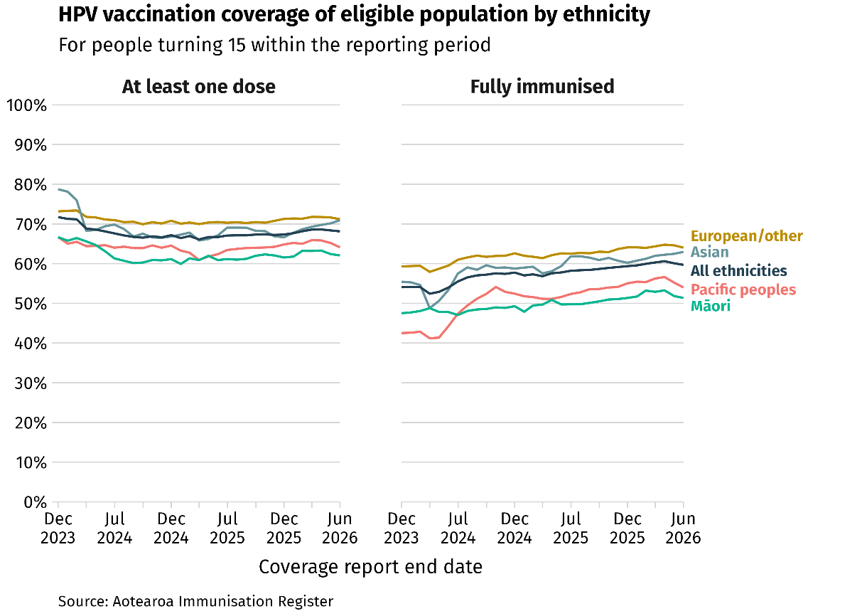

Figure 6: Proportion of 15-year-olds with at least one dose of HPV vaccine or fully immunised against HPV, by deprivation quintile, New Zealand, 2023-2026

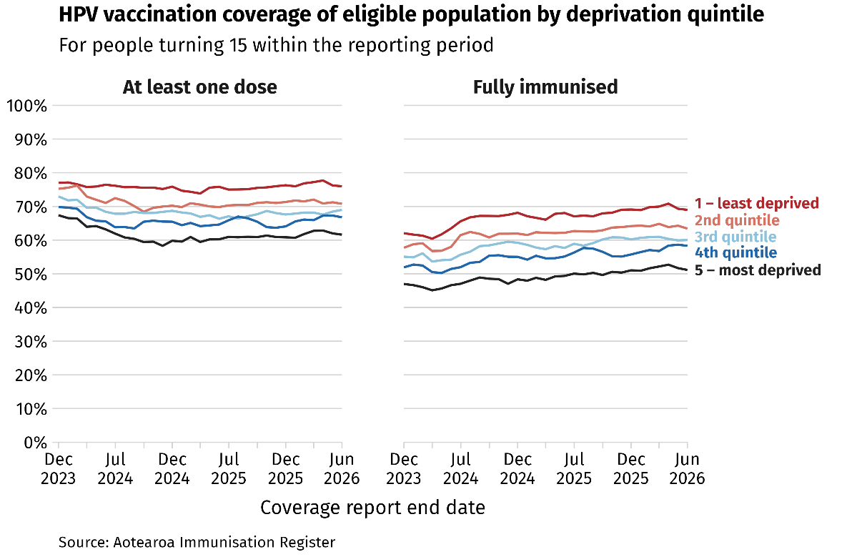

Figure 7: Proportion of eligible female population with at least one dose of HPV vaccine or fully immunised, by age groups, New Zealand, 2023-2026

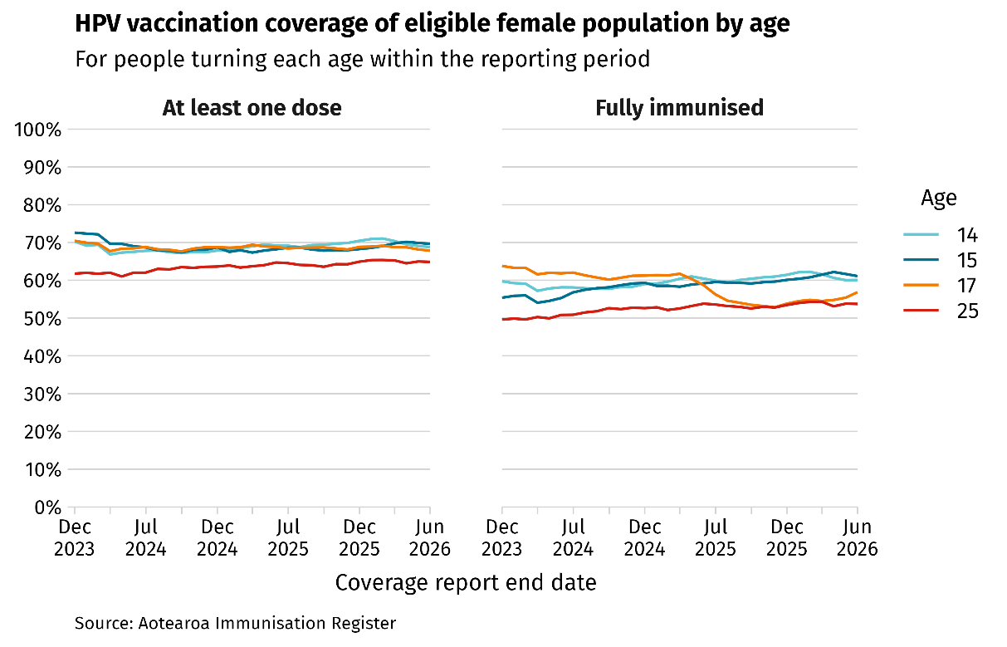

Figure 8: Proportion of eligible male population with at least one dose of HPV vaccine or fully immunised, by age groups, New Zealand, 2023-2026

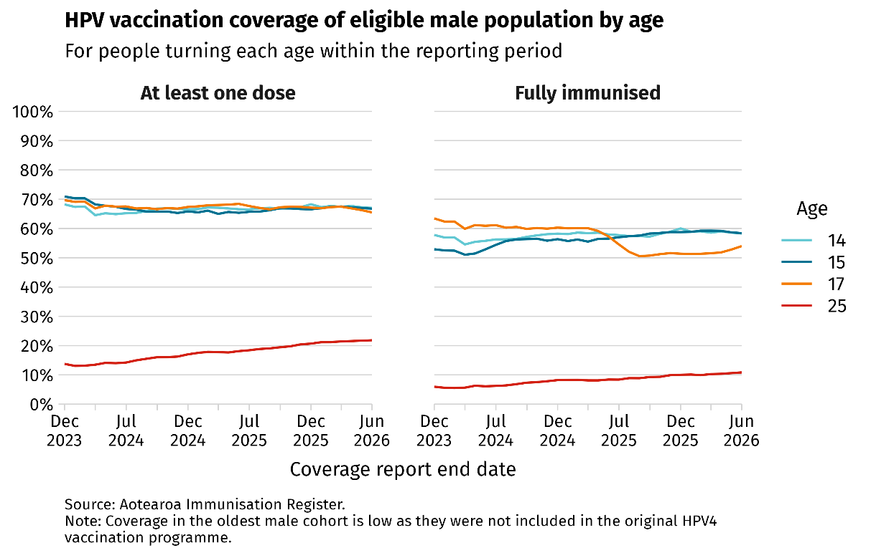

The School Based Immunisation Programme is the primary delivery model for scheduled HPV immunisation for children aged 11 and 12 years, with differences in delivery approaches across regions.
Although HPV vaccines are highly safe and effective, misinformation can reduce confidence among parents and caregivers. Community-based and co-designed information and resources can help address hesitancy and support informed decisions.
Countries with higher HPV vaccination rates offer more than one way to get vaccinated, including school visits and community options, which makes it easier to catch up if someone misses the first opportunity. In 2024, New Zealand enabled pharmacies to order funded HPV vaccine, significantly expanding access.

HPV vaccination in the Realm of New Zealand (Niue, Tokelau and the Cook Islands)
Niue and Tokelau established their HPV vaccination programmes in 2019. vaccinating both girls and boys with uptake rates of 98% and 90% respectively. The Cook Islands introduced the HPV vaccination programme in 2010, focusing exclusively on girls with a 90% uptake rate.

Consideration of a one-dose HPV schedule
New Zealand funds Gardasil 9 – a type of HPV vaccine that protects against 9 types of HPV infection.
In 2022, the WHO updated its recommendations for the HPV vaccine, supporting the use of a single-dose schedule. The WHO Strategic Advisory Group of Experts (SAGE) on Immunization stated a single‑dose schedule is considered to provide solid and comparable protection against cervical cancer to a two‑dose regimen. Some countries, including Australia, have shifted to one-dose HPV vaccination schedule. This is enabled by differences in legislation and processes from that used in New Zealand to determine immunisation programme schedules. A one-dose schedule is expected to reduce programme costs and to allow greater focus on increasing first-dose coverage.
The approved HPV vaccination course in New Zealand is still a two or three dose schedule. Most children aged nine-14 are considered fully immunised once they have received two doses. When the first dose is given at age 15 or older, a total of three doses is required. Some population groups with a compromised immune system (such as those living with human immunodeficiency virus (HIV) and transplant recipients), also require three doses.
This multi-dose schedule is specified in the datasheet approved by Medsafe. Amendments to the datasheet can only occur if the manufacturer submits an application supported by sufficient evidence.
To date this has not occurred and as a result, under the Medicines Act, a single-dose schedule of HPV vaccine would be considered off-label use and would require an individual prescription for every person vaccinated. This makes it impractical for a large-scale vaccination programme, such as the School Based Immunisation Programme.
A Medical Products Bill, in development to replace the Medicines Act, will enable regulations to allow off-label use of vaccines, subject to appropriate safeguards. This may allow a shift to a single-dose HPV vaccination programme in New Zealand in the future.
As the School Based Immunisation Programme shifts its focus towards prioritising the first dose, this approach can direct resources towards improving first-dose uptake, supporting further improvements in the HPV vaccination target.

Whānau voice
The Cancer Control Agency’s report: “The voices of whānau Māori affected by cancer” highlighted a need for improved cancer prevention, with an opportunity to work more closely with Māori communities and providers.
“It’s better to prevent!”
“[What works?] - Whānau, iwi on the ground doing the mahi… giving people that are on the ground the resources to do this work.”
Māori working in the wider cancer sector also specifically highlighted the importance of HPV vaccination among rangatahi (young people) as a significant prevention strategy and the need to address vaccine hesitancy. Key enablers were:
- whānau and iwi leadership at a community level
- improved information on the benefits of vaccination
- improved integration of screening and vaccination campaigns
- a greater focus on the benefits of HPV vaccination for boys.
The qualitative study “Pasifika women’s knowledge and perceptions of cervical-cancer screening and the implementation of self-testing in Aotearoa New Zealand” includes a reflection on the HPV vaccination programme experienced at school.
“…prevent some things and that they told us what HPV was but, at that age, you don’t really understand”

The way forward
The National Public Health Service within Health New Zealand will lead the actions in this section with a focus on under-vaccinated groups including Māori, Pacific peoples, people living in areas of high deprivation and young adults. This will include a multi-pronged approach encompassing vaccine promotion, School Based Immunisation Programme delivery and opportunistic catch-up.
The elimination target for vaccination is for one dose of the HPV vaccine, reflecting emerging evidence of comparable protection to multi-dose regimens.

Increase the awareness of the HPV vaccine as a safe and effective vaccine to prevent cancers
1 | Improve targeted public messaging and resources on the HPV vaccine’s safety and benefits in preventing multiple HPV-related cancers, complemented by vaccination campaigns. This will be informed by successful international approaches and tested with communities to ensure relevance and resonance. This includes partnering with communities and organisations to amplify the key messages and improve reach among those with low HPV vaccination coverage: Māori, Pacific peoples, people living in areas of high deprivation, young adults and disabled people, through tailored approaches such as taking a whānau centred model. Campaigns will be coordinated with Health New Zealand and Pharmac to ensure sufficient capacity and vaccine supply to meet the increase in demand. The campaign and public messaging will be regularly monitored and evaluated to ensure they are effective, inclusive and resonate across all population groups.

Increase HPV vaccination uptake through the School Based Immunisation Programme
2 | Update and co-design resources for the School Based Immunisation Programme to ensure they are fit-for-purpose, adaptable, culturally appropriate and accessible. This includes a particular focus on population groups with high unmet health need, including Māori, Pacific peoples, people living in areas of high deprivation and disabled people.
3 | Collaborate with local communities including Hauora Māori, Pacific providers and the education sectors (kura, specialist schools and alternative education sites), to co-develop and implement innovative education and programme delivery methods to improve HPV vaccine uptake among eligible students.
4 | Collaborate with the Ministry of Education to increase participation of schools in the School Based Immunisation Programme. This also includes kura, specialist schools and alternative education sites.

Promote opportunistic HPV vaccination outside of schools
5 | Increase participation from a broader and more diverse range of providers by offering onboarding support and expanding delivery through providers that already have established connections with people experiencing high unmet health need. This includes providers working with Māori, Pacific peoples, communities living in areas of high deprivation and disabled people.
6 | Partner with communities and organisations, including Iwi-Māori Partnership boards, Māori health providers, relevant tāngata whaikaha Māori networks, iwi and non-government organisations, to co-design and deliver tailored approaches that promote HPV vaccine catch-up, increase awareness of where people can access the vaccine outside of schools (e.g. Hauora Māori providers, Pacific providers, Sexual Wellbeing Aotearoa, pharmacies and primary care). This could include whānau-centred approaches.
7 | Continue to explore ways to systematically identify and recall people aged between 14 and 26, who have no recorded dose of the HPV vaccine. This is complemented by supporting vaccination providers to deliver targeted vaccine catch-up opportunities. Particular focus should be given to Māori, Pacific peoples, people living in areas of high deprivation, disabled people and those approaching 27 years of age where they are nearing the upper age limit for funded HPV vaccination eligibility. For instance, offer the HPV vaccine to people attending their first cervical screening at age 25 if they aren't already vaccinated.

Pillar 2: Improve HPV screening coverage and follow-up of positive screening results

Key facts
- Cervical cancer develops from precancerous lesions that were not identified and treated in time.
- Cervical screening through HPV testing can detect high-risk HPV infections and is highly effective in correctly identifying approximately 90–95% of women with high-grade cervical precancerous lesions in a single screening round.
- The National Cervical Screening Programme (NCSP) is for women or anyone with a cervix, aged between 25 and 69. Some people aged between 70 and 74 who are unscreened or under-screened may need extra HPV testing before they exit the programme.
- The NCSP switched from cytology-based testing to primary HPV testing in September 2023 and now provides people the option of self-testing. For most people the recommended screening interval is every five years. Those who are immunocompromised or have positive results may need more frequent testing.
- The NCSP is coordinated and centrally managed by Health New Zealand and delivered primarily through primary care providers.
- Free primary screening is currently available to participants who:
are Māori or Pacific
hold a community services card
are 30 years or over and have never had a cervical screening test
are 30 years or over and have not had regular screening (have not had a cervical screen in the past 5 years).
- HPV vaccination provides long-term protection against future infections, while cervical screening identifies existing HPV infections and precancerous changes, making it critical for achieving more immediate reductions in cervical cancer incidence and mortality.
- Undertaking primary HPV testing is only the first step in the cervical screening pathway. The benefits of screening are only realised when positive results are followed up and managed appropriately and in a timely manner.
- Screening Support Services are delivered across National Public Health Service, Hauora Māori Services and Pacific Health. They help people who experience barriers to access to breast and cervical screening, assessment and treatment services. However, there are areas with no Screening Support Service providers.

Current state

HPV screening
The uptake of cervical screening has increased since the roll-out of HPV primary testing in September 2023 and the option of self-testing was introduced. The introduction of HPV primary testing builds on many years of research, community engagement and advocacy, as well as the efforts of Health New Zealand to implement the evidence-based improvements within the NCSP.
Among eligible individuals aged 30–34 and 40–44 in June 2026, 71.5% and 78.5% have had an up-to-date cervical screening test, surpassing the WHO target of 70% screened once by age 35 and again by age 45.
As a high-income country, New Zealand offers cervical screening at regular intervals instead of just twice in a lifetime. For all eligible people, overall up to date primary screening coverage has increased to 77.3% (June 2026) from 67% (August 2023 – prior to the rollout of HPV primary testing). While this increase is very encouraging, it remains below the national screening target of 80% set by the NCSP. While there was regional variation the differences were relatively modest. Te Waipounamu showed the highest coverage among all four regions in June 2026 at 78.9%, followed by Northern (77.5%), Central (77.1%) and Te Manawa Taki (75%).
From September 2023 to June 2026, 81.6% of participants opted for HPV self-testing with the remainder having a cervical sample collected by a trained sample-taker. Among those previously unscreened or under-screened, 89.7% and 87.4% chose the self-testing option respectively.
Young adults between 25 and 29 years of age have the lowest screening uptake (61.1%) among all age groups. Māori and Asian population groups show the lowest participation in screening compared to other ethnicities at 70.2% and 66.3%, respectively. Pacific peoples saw the greatest improvement in screening participation, reaching 80.1% in June 2026, achieved the 80% target, compared with 58% three years ago. Screening rates also drop from 87.9% in the least deprived areas, to 67.5% in the most deprived areas.
While cervical screening is free for certain groups (including Māori, Pacific peoples, community service card holders, and those who have never been screened or are under-screened), a variety of service-related, cultural and informational barriers still hinder participation. For instance, perceptions and knowledge about cervical screening, challenges related to personal privacy and confidentiality, indirect costs, negative experiences and mistrust of the health system can all limit uptakes.
Figure 9: Percentage up-to-date with cervical screening, by ethnicity, New Zealand, 2012-2026
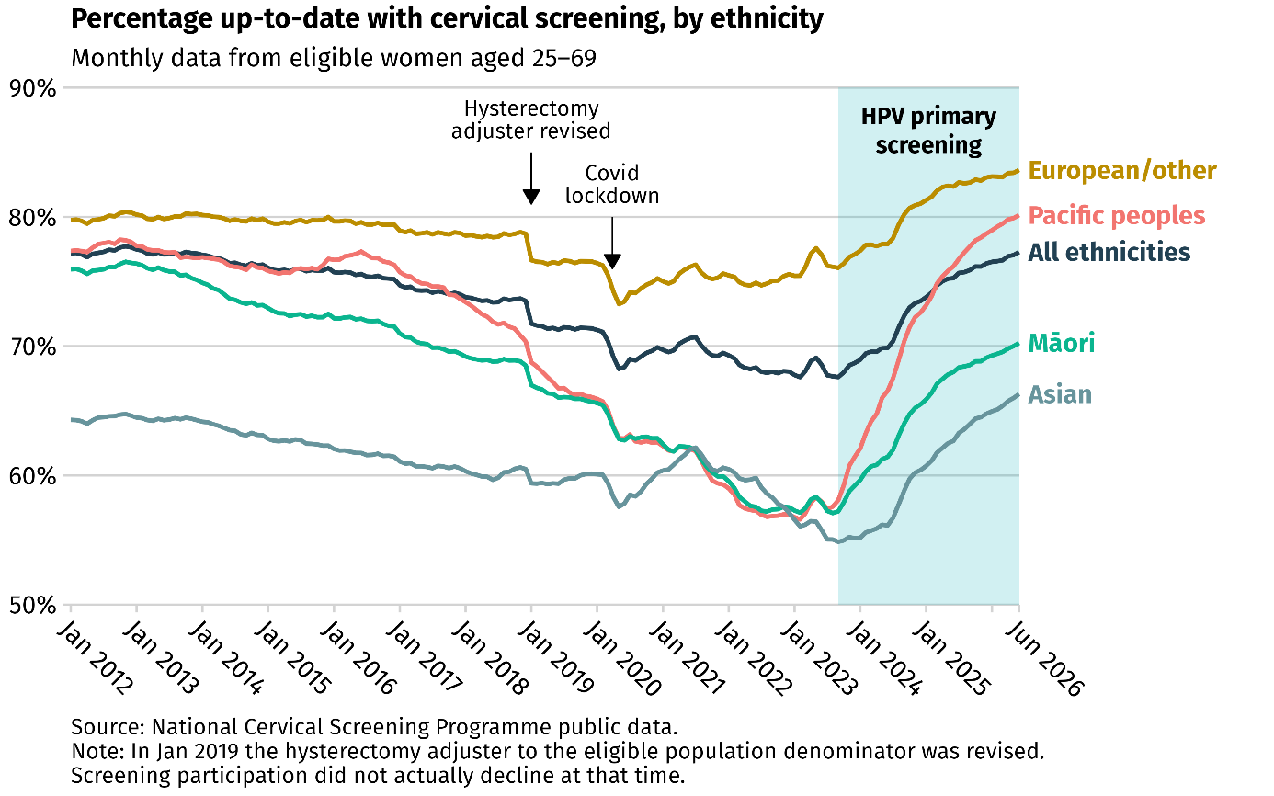
Figure 10: Percentage up-to-date with cervical screening, by deprivation, New Zealand, 2012-2026
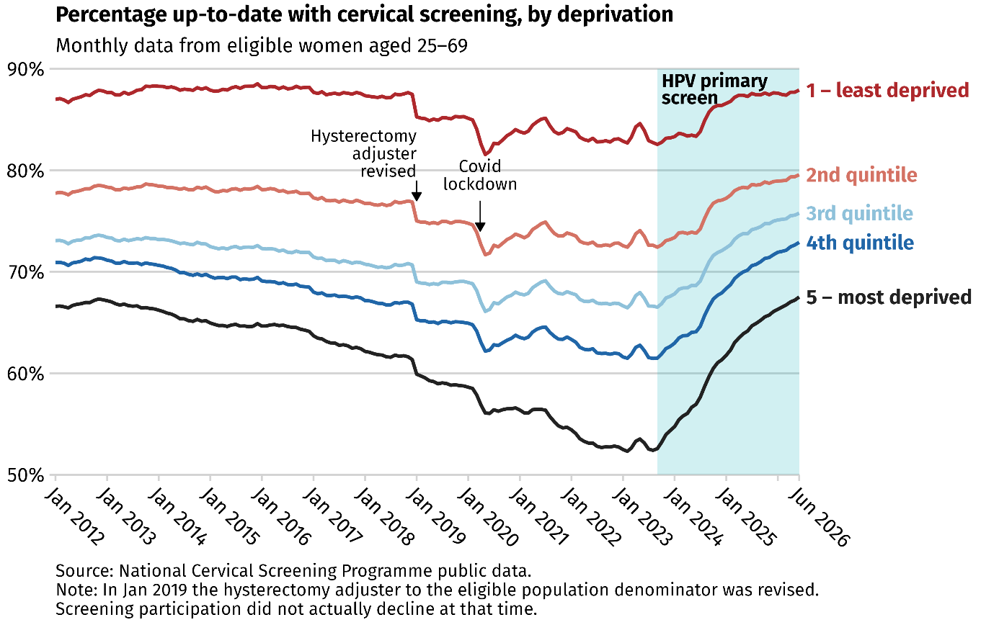
Figure 11: Percentage up-to-date with cervical screening, by age group, New Zealand, 2012–2026
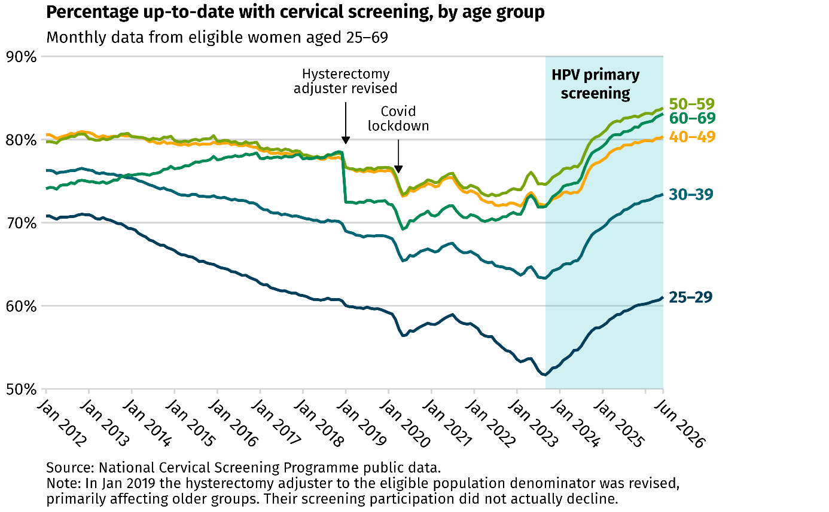
Although population-level data are limited, published studies indicate that people from LGBTQI+ communities such as lesbian and bisexual women, non-binary people and transgender men with a cervix are less likely to participate in cervical screening. This highlights the need for improved understanding of the relationship between sexuality and gender minority status and cervical cancer risk as well as ensuring the screening services are inclusive, accessible and responsive to the needs of people from LGBTQI+ communities.

HPV screening in the Realm of New Zealand (Niue, Tokelau and the Cook Islands)

Niue, Tokelau and the Cook Islands are transitioning to population-based cervical screening including enabling local laboratories to perform HPV primary testing and self-testing approaches. This is supported by New Zealand’s Ministry of Health, through the Polynesian Health Corridors programme, as well as regional partners such as the Pacific Community and the University of Auckland, with ongoing work to develop cervical screening guidelines in collaboration with Health New Zealand.

Follow up of positive screening results
The NCSP generates most of the referrals to colposcopy services. The introduction of primary HPV testing, which is more sensitive than the previous cytology-based test, has led to an expected increase in referrals for colposcopy. While this increase in screening participation is positive, it has resulted in higher demand on colposcopy services and increased wait times. The volumes are expected to plateau as people move into the regular five-year HPV screening cycles (the previous cytology-based test had a three-year cycle).
Health New Zealand currently employs eight practising nurse colposcopists and is training seven additional registered nurses for colposcopy. This additional workforce is expected to improve service capacity and support more timely access to colposcopy. Between January to March 2026, about 66.5% of participants requiring a colposcopy within 30 working days following a positive screening result, received the procedure within 30 working days of referral, below the target of 80%.
Māori and Pacific peoples are less likely to access timely colposcopy: 57.7% of Māori participants and 56.6% of Pacific participants received colposcopy within 30 working days, compared with 69.7% of participants who identified as European/other.
Timely colposcopy is lower among people residing in the most deprived areas with 55.4% receiving the colposcopy within 30 days, compared with 68.6% among those living in the least deprived areas.
Figure 12: Proportion of participants requiring a colposcopy within 30 working days following a positive screening result, receive the procedure within 30 working days, January to March 2026, by ethnicity
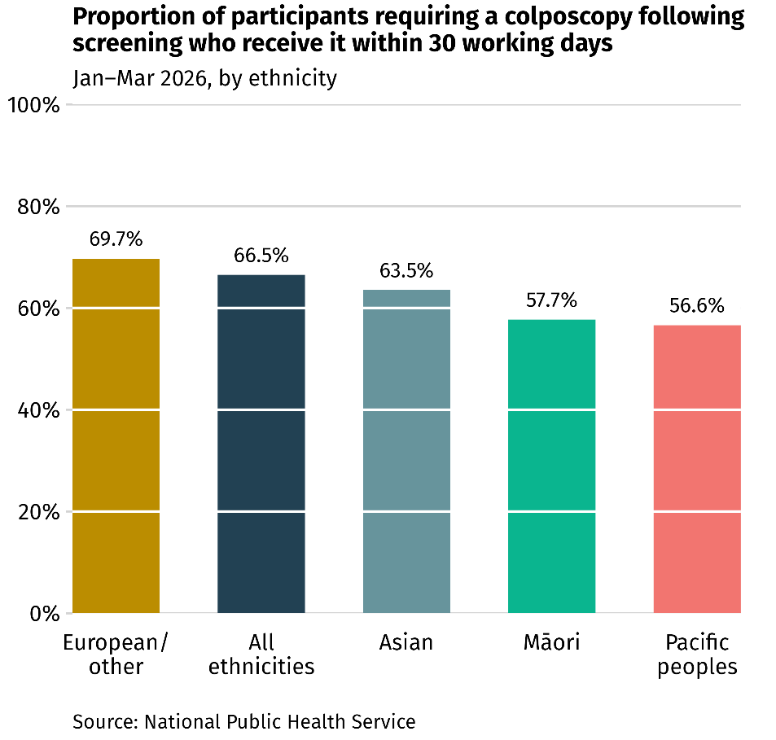
Figure 13: Proportion of participants requiring a colposcopy within 30 working days following a positive screening result, receive the procedure within 30 working days, January to March 2026, by deprivation quintile.
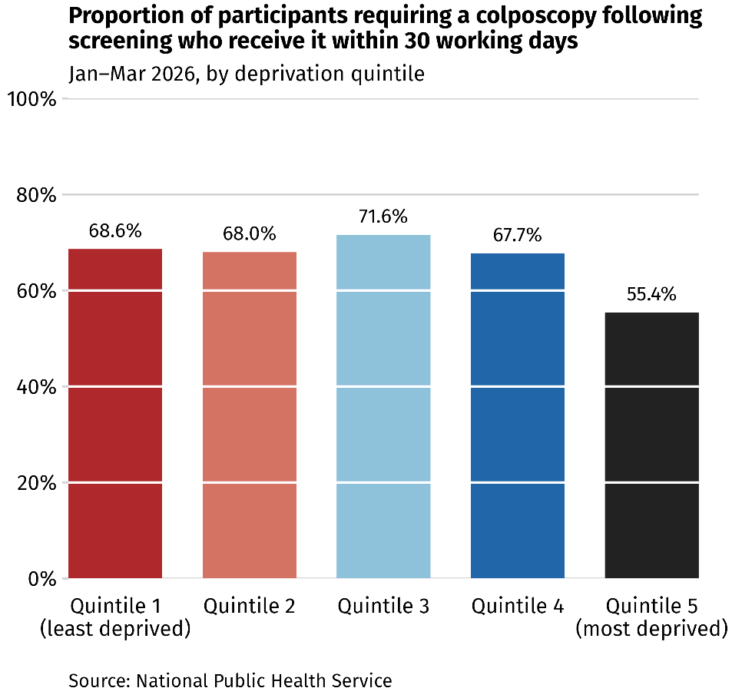

Pathology services
Increasing primary screening coverage to 80% would result in a higher volume of primary tests. This will consequently drive higher demand for downstream services, including cytology, colposcopy and anatomical pathology. Cervical cytology review remains a largely manual process which is labour intensive and time consuming. Increased colposcopy activity will also generate more tissue specimens requiring histological assessment by anatomical pathologists to diagnose and grade precancerous cervical lesions and invasive cervical cancers. In addition, there are three national laboratory hubs processing cervical screening specimens but with limited integrated business continuity and interoperability across the hubs.
To support the anticipated growth in demand, pathology service capacity and capability will need to be monitored and considered as part of future implementation planning. This may include consideration of service coordination, workforce planning, digital enablement, infrastructure and other operational requirements through appropriate Health New Zealand pathology and implementation planning processes.

Whānau voice
The Cancer Control Agency’s report – “The voices of whānau Māori affected by cancer” captured the importance of screening, appreciation for screening programmes, and a preference for patient-centred, holistic screening services that provide effective support and education, are well designed and integrated with other services.
“We need to continue to emphasise things like screening… These initiatives could have a huge impact on our people”
“When they discovered my cancer, I was devastated, but I was also grateful. That is what screening is for, to find the cancer before it spreads.”
“Education and screening at marae would be good.”
It also highlighted barriers to screening as indirect costs, a lack of trust in screening services, the lack of kaupapa Māori screening services, few Māori staff within the services, limited health literacy and a perception that screening is not a priority.
HPV self-testing was also viewed as a convenient, less invasive and mana-enhancing process.
A recent study on “Clinician and patient experiences with opportunistic offer of HPV self-testing in Aotearoa New Zealand primary care clinics: interview and survey findings” and the qualitative study “Pasifika women’s knowledge and perceptions of cervical-cancer screening and the implementation of self-testing in Aotearoa New Zealand” both found views on HPV self-testing were largely positive.
“It was easy, quick and private” [Pacific participant]
“Didn’t hesitate when the nurse told me about this self-test because I get to do it myself whereas before I don’t go to my cervical appointments” [Pacific participant]
“Didn’t feel very confident, I hope I did it correctly as next is due in 5 years” [Asian participant]

The way forward
The NCSP will lead actions to further improve primary screening uptake through HPV testing, sustaining the current upward trend in participation, and focus on population groups who are under-screened including Māori, Asian, young adults, people living in areas of high deprivation and people from LGBTQI+ communities. People who are never screened or under-screened face the highest risk of developing cervical cancer. Although Pacific peoples have seen significant improvement, continued effort is needed to maintain momentum.
A strong emphasis will also be placed on timely follow up after positive results, recognising that screening is only effective when identified issues are followed up and managed promptly.

Increase the HPV primary screening uptake with a focus on population groups with the low coverage.
8 | Build on and strengthen Screening Support Services to co-design a range of innovative community-based service delivery models aimed at improving screening rates for never screened and under-screened groups including Māori, Pacific peoples, young adults, people living in areas of high deprivation, disabled people and people from LGBTQI+ communities, at the times that work for them. This could include a more integrated approach across cervical and breast screening programmes where appropriate, integration of telehealth and Screening Support Services and partnering with Hauora Māori providers, Pacific providers, and health providers experienced in delivering inclusive care for LGBTQI+ communities.
9 | Identify areas of high unmet health need and explore the establishment of additional Screening Support Services providers where services are not currently available.
10 | Explore options for providing free cervical screening to everyone eligible for the NCSP, so the programme aligns with other publicly funded cancer screening programmes.
11 | Investigate low cervical screening rates within the NCSP among Asian populations, including analysis of cancer incidence and mortality by specific Asian ethnicities, to identify potential disparities. Ensure findings are used to inform service design, communication approaches, and targeted support where required, developed in partnership with affected communities. Approaches should be culturally safe, community-informed, and responsive to diverse needs, recognising the heterogeneity of Asian populations and the different experiences, barriers, and needs of specific Asian ethnic groups.
12 | Explore and implement alternative approaches to improve cervical screening participation among communities and population groups with low screening coverage. Potential approaches may include expanding outreach screening sites, such as marae-based services, to serve remote communities and individuals not registered with primary health providers, and direct mailing of HPV self-test kits to eligible participants. Alternative approaches should be informed by local research, preferences of participants and communities, and consultation with appropriately trained healthcare providers. The design and delivery of such approaches could include partnership with communities and organisations such as Iwi-Māori Partnership boards, Māori health providers, relevant tāngata whaikaha Māori networks, iwi and non-government organisations, to ensure they are responsive to needs, preferences and aspirations of the communities and population groups with lower screening coverage, recognising the role of whānau in supporting participation and access.

Strengthen and improve follow-up for participants with positive screening results.
13 | Strengthen recall and follow‑up processes for people overdue for repeat HPV tests, cytology tests, and colposcopy appointments by improving people-focused scheduling, removing barriers to attendance, and prioritising those with the longest delay. This could include integration of telehealth and Screening Support Services.
14 | Maintain routine review and validation of the colposcopy waiting list to confirm ongoing clinical need, ensure individuals still require the procedure and are prioritised within the appropriate timeframe.
15 | Train more nurse colposcopists through well-defined training and capability development pathways, aligned with planned service roles following completion.
16 | Scope and undertake service modelling and evidence-based analysis to inform future services planning and workforce requirements. For example, colposcopy modelling to project future demand and capacity.
17 | Assess the feasibility, and set up, of community-based and mobile clinics for colposcopy service delivery. This should take into account the needs of population groups that face greater barriers to access including Māori, Pacific peoples and people living in areas of high deprivation, as well as communities in areas where access to service is limited.
18 | Nationally implement the revised “Clinical Practice Guidelines for Cervical Screening” to enhance the triage process for people with positive screening results.

Improve cervical screening service effectiveness and delivery.
19 | Develop a prospective cervical cancer audit to provide timely insights into who is developing invasive cervical cancer and the factors contributing to the diagnosis. The audit should include cervical cancer diagnosis following a normal screening result, and support understanding of where the screening programme needs to adapt. Findings should be used to inform continuous quality improvements across the screening pathway, with a focus on people with higher cervical cancer incidence such as Māori and Pacific peoples.
20 | Strengthen the usability, functionality, and data quality of the cervical screening programme register, ensuring it can flexibility adjust to new evidence and approaches such as updated clinical guidelines and risk-based screening.

Review the Health Act 1956 provisions relating to the NCSP.
21 | As part of the broader review of the Health Act 1956, the Ministry of Health will review Part 4A to ensure the provisions remain fit-for-purpose and continue to meet the needs of the programme. This review will take the history of the programme into account and include engagement with the National Kaitiaki Group and other key stakeholders.

Pillar 3: Improve treatment of cervical pre-cancer and cancer

Key facts
- Clinicians can effectively prevent cervical cancer by identifying precancerous lesion(s) on the cervix through screening and treating these by removing pre-cancerous cells.
- Cervical screening is designed to detect HPV infection and identify precancerous changes, rather than to diagnose cancer itself. When cervical cancer is diagnosed through symptoms, it highlights the importance of symptoms awareness and timely assessment when early signs and symptoms occur.
- If cervical cancer is found early and is still limited to the cervix, five-year survival is around 91%. However, if the cancer has spread to distant parts of the body, five-year survival drops to around 19%.
- Treatment for invasive cervical cancer may involve more extensive surgery, removal of lymph nodes, and the use of chemotherapy or chemoradiation therapy.
- Gynaecological oncology services provide specialist care for individuals diagnosed with gynaecological cancers, including invasive cervical cancer.
- It is essential to provide people diagnosed with cervical cancer access to high-quality care to ensure optimal outcomes for all, regardless of population group or where people live.

Current state

Treatment of cervical pre-cancer
Treatment for cervical pre-cancer can often be provided safely and effectively in a colposcopy clinic under local anaesthesia. General anaesthesia may be indicated in some cases but can depend on factors such as theatre availability and competing demand for procedures that require general anaesthetic and theatre time. Services should support people to receive treatment in a way that is accessible, comfortable and acceptable to them.
Between January and March 2026, 76.7% of participants with high-grade cervical pre-cancerous lesions following screening were treated within 40 working days of their decision to treat. This exceeds the current NCSP target of 70%. As part of the Plan, this target will increase to 90%.
All ethnic groups exceeded the 70% target, although rates varied: Asian participants had the highest rate at 81.1%, followed by Pacific participants at 77.4%, Māori participants at 76.1%, and European/other participants at 75.6%.
The rates varied across deprivation quintiles, with no clear linear relationship between deprivation quintile and the pre-cancer treatment rate. The highest rate was observed in the 4th quintile at 80.6%, while the lowest was the noted in the 2nd quintile at 67.6%.
With the target increasing to 90%, further improvements will be required to ensure more people receive timely treatment across all population groups, with targeted efforts to achieve equitable gains.
Figure 14: Proportion of participants with high-grade cervical precancerous lesions following screening are treated within 40 working days, January to March 2026, by ethnicity.

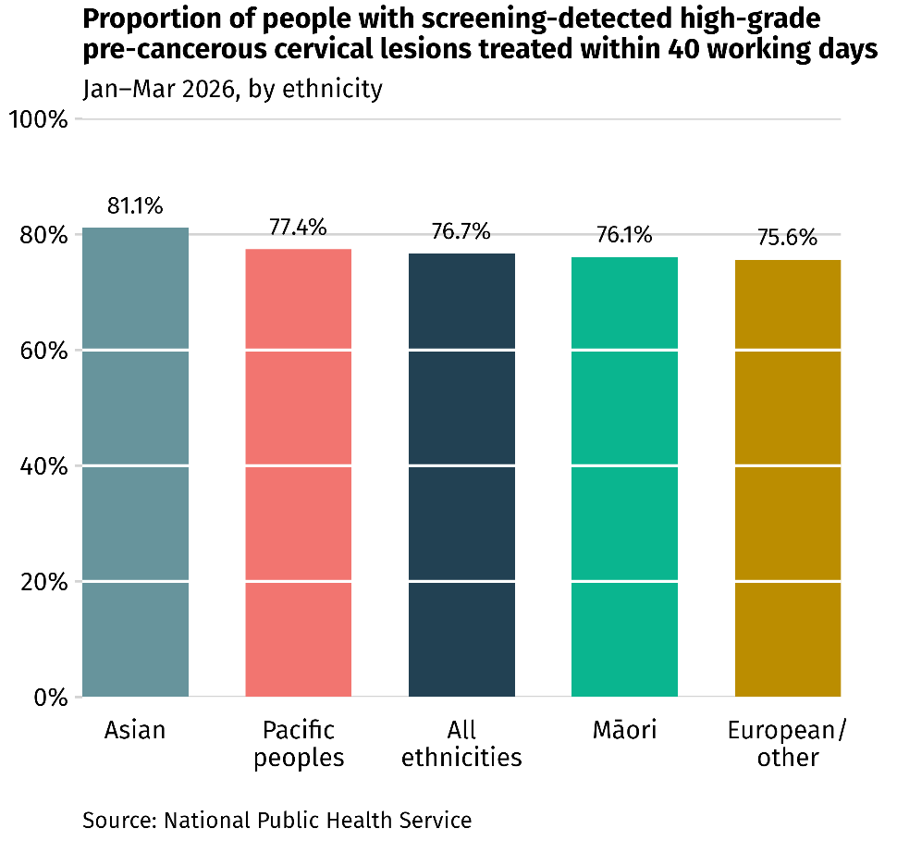

Figure 15: Proportion of participants with high-grade cervical precancerous lesions following screening are treated within 40 working days, January to March 2026, by deprivation quintile.

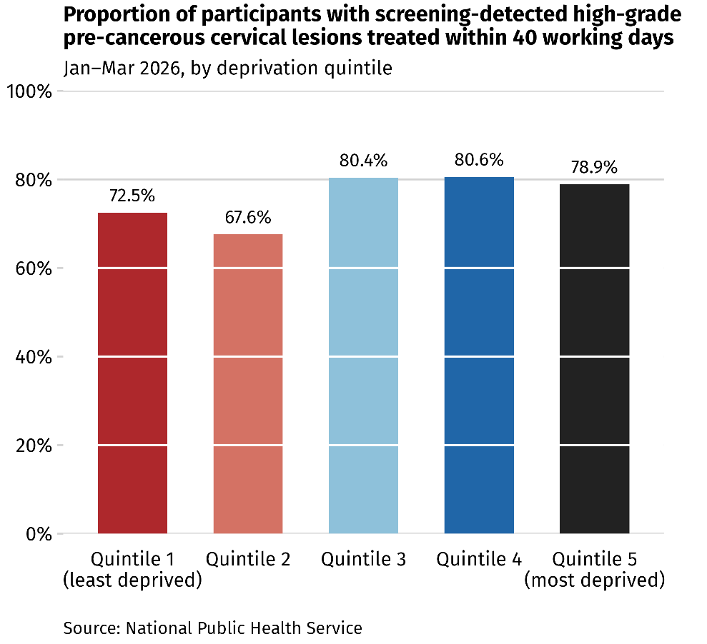

Treatment of cervical cancer
Gynaecological oncology services are under significant strain due to a shortage of qualified gynaecological oncologists and a growing demand for care.
Health New Zealand’s “Health Workforce Plan” identifies addressing shortage in critical workforces including specialists as a priority. The gynaecological oncology workforce is a small and highly specialised subspecialty globally, making recruitment and retention an ongoing challenge. Differences in workforce conditions and the clinical practice environment, compared with other similar countries, can affect New Zealand’s ability to attract and retain these specialists.
This pressure is increasing, particularly as the number of other gynaecological cancers, such as endometrial cancer, continues to increase. These challenges are reflected in the Faster Cancer Treatment (FCT) targets.
Cervical cancer cases included in the FCT 62-day indicator are relatively few. Between July 2020 and June 2026, 63.8% of cases (111 of 174) met the FCT 62-day indicator. Achievement rates remain inequitable across some population groups, including Asian, Pacific peoples, Māori, and those living in the most deprived areas. However, the small number of cases overall means that the disaggregated achievement rate is sensitive to minor changes in case numbers.
In July 2024, the FCT 31-day target was revised from 85% to 90%. Health New Zealand implemented incremental benchmarks to support attainment of the 90% target by 2030. For the 2025/26 period, the FCT 31-day achievement rate for cervical cancer was 88.3%, achieved the interim target of 87% for this period. Although there was regional variation, Northern, Te Manawataki and Central all achieved the interim target at 89.2%, 94.7% and 90.6% respectively, In contrast, Te Waipounamu’s achievement rate was only 77.8%. The target has increased to 88% for 2026/27.
Over the period of July 2020 to June 2026, the overall proportion of people with cervical cancer who received their first treatment within 31 days of the decision to treat was 88.4%. Pacific peoples experienced the lowest rate at 81.8%, while the rate recorded for Māori was 89.3%. The rates varied across deprivation quintiles, with no clear linear relationship between deprivation quintile and the 31-day rate. The highest rate was observed in the 4th quintile at 91.4%, while the lowest was the noted in the 3rd quintile at 85%.
When surgery is the initial treatment for cervical cancer, the 31-day achievement rate is noticeably lower than for other primary treatments like chemotherapy or radiation therapy. This may reflect the fact that surgery is the most common initial treatment for cervical cancer and is subject to additional capacity constraints, including operating theatre availability, access to general anaesthesia and other surgical workforce capacity.
However, performance against FCT targets should be interpreted with caution, as they do not always account for clinical complexity. Some delays are intentional and clinically appropriate, reflecting good clinical practice rather than expediting treatment at all costs. For example, in cervical cancer management, treatment sometimes is intentionally postponed for at least six weeks following a cone biopsy to allow sufficient time for healing.
Figure 16 Faster Cancer Treatment 31-day achievement rate, by ethnicity, July 2020 – June 2026

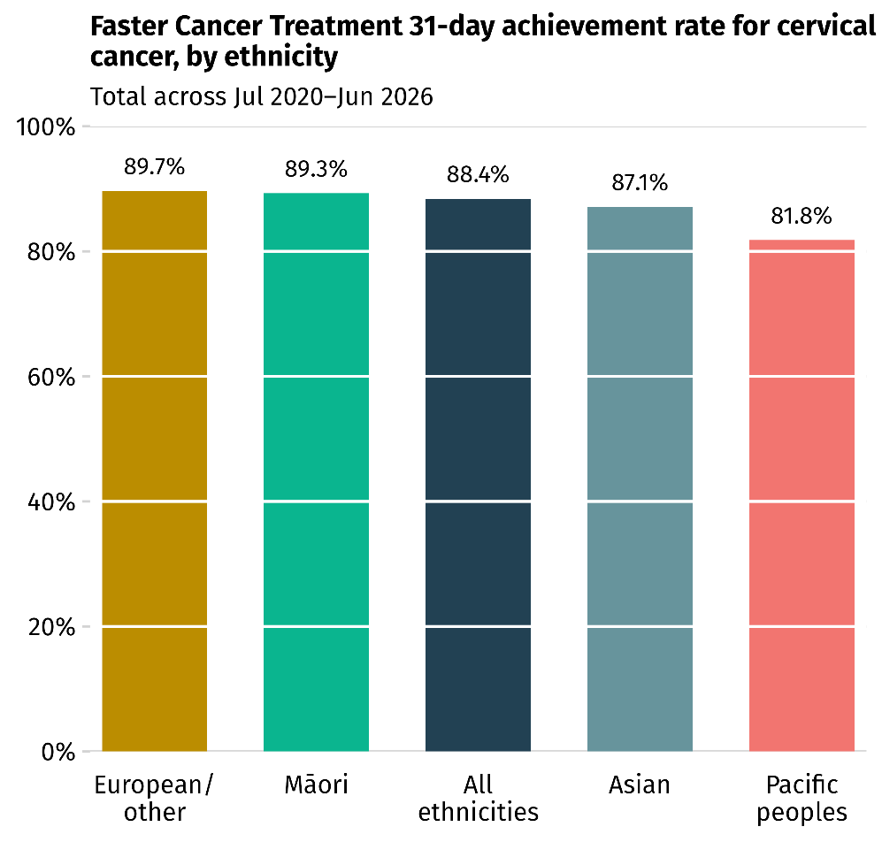

Figure 17: Faster Cancer Treatment 31-day achievement rate, by deprivation, July 2020 – June 2026

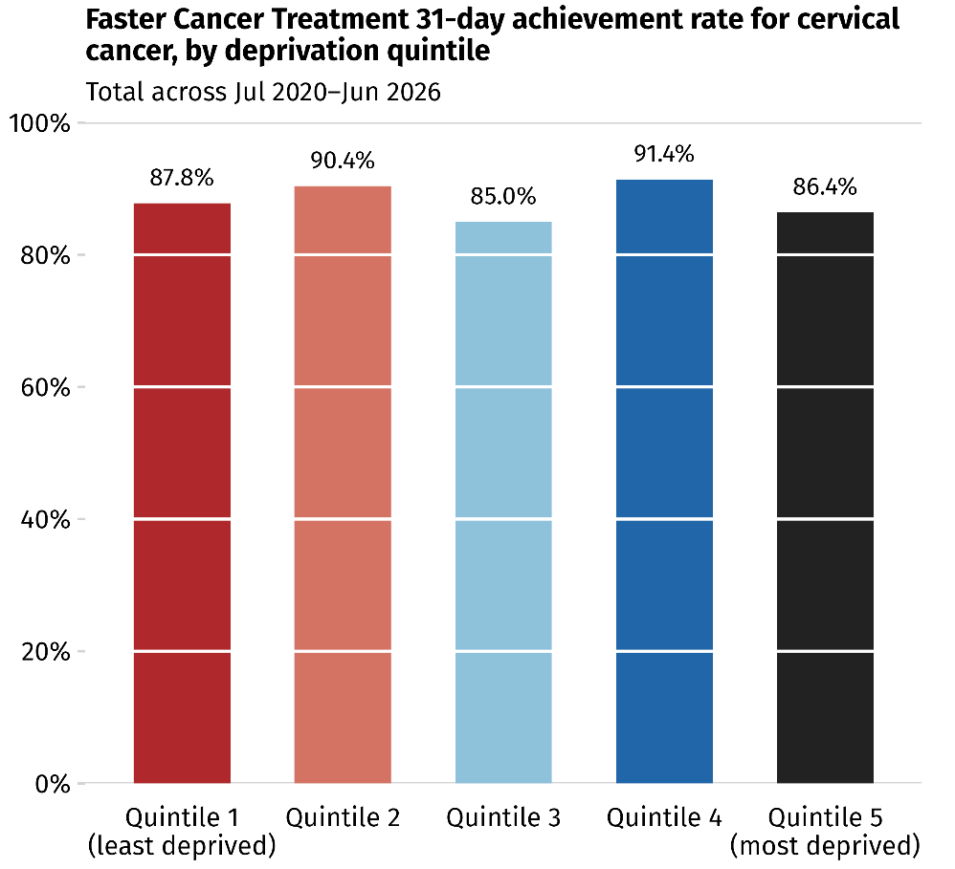

Figure 18: Faster Cancer Treatment 31-day achievement rate, by treatment type, July 2020 – June 2026

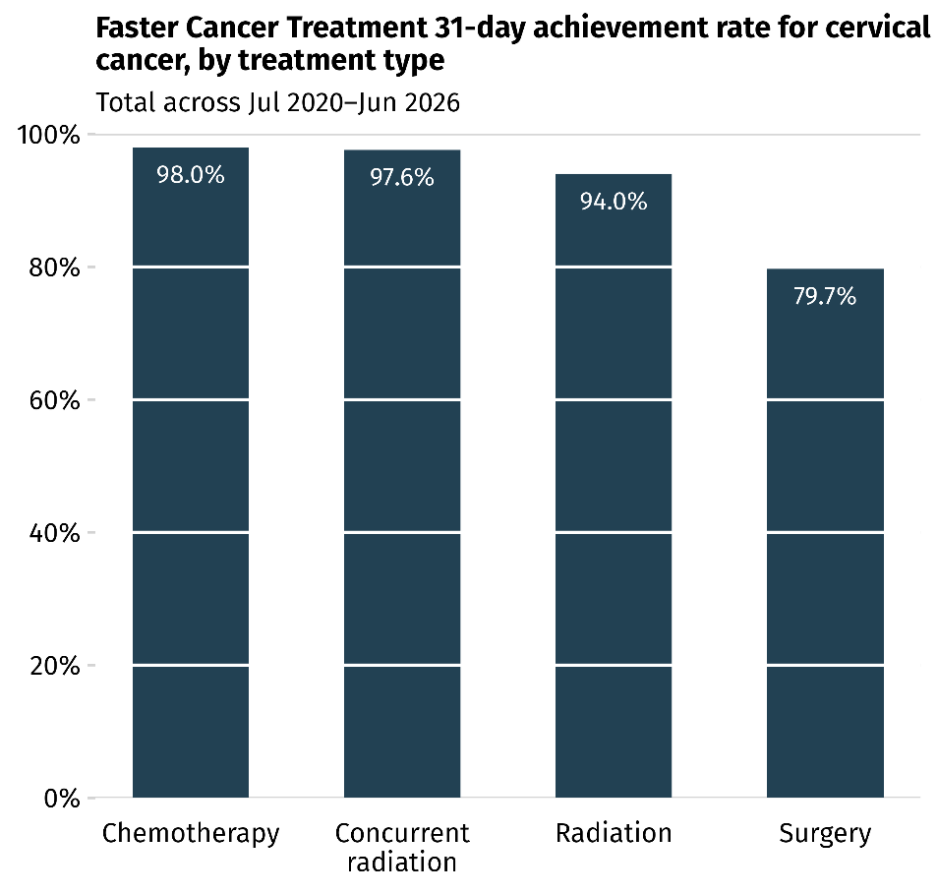

A 2011 report (“Report to the Ministry of Health on a proposed national service improvement plan for gynaecological cancer services”) highlighted issues and challenges and proposed a national service improvement plan. Since the report was completed, some improvements have been observed with the shift to centralising care for complex cases, alongside the closure of very small centres that did not meet minimum case volume thresholds for service provision. However, ongoing challenges necessitate consideration of alternative workforce configuration and service delivery models. For instance, Wellington hospital no longer has a permanent gynaecological oncologist based there due to workforce shortages and inability to recruit. As a result, permanent and well-established gynaecological oncology speciality services are primarily provided through Auckland City hospital and Christchurch hospital. In the Central Region, gynaecological oncology services operate through a cross-regional model, whereby Christchurch based gynaecological oncologists provide specialist expertise alongside locally delivered services including care coordination, nursing, general gynaecology, theatre and other components of care.

Cancer care continuum
The actions below in this pillar currently focuses on gynaecological oncology services and workforce. But cervical cancer care extends beyond the specialist treatment and encompasses the wider care pathway, including diagnostics, multidisciplinary care, recovery, survivorship, palliative care and end-of-life care. Many of the broader system considerations needed to support optimal cancer care. These aspects are addressed through the “Cancer Action Plan 2026-2029”, which outlines the current state and future actions to support people across all stages of the cancer experience.

Whānau voice
The Cancer Control Agency’s report – “The voices of whānau Māori affected by cancer” captured insights about treatment across cancer types. This included support for travel if required, care closer to home if it is as safe and effective as care in a hospital setting, treatment delivered by Māori health professionals, and the importance of whakawhanaungatanga (the process of establishing relationships).
“You can’t think when you’re first diagnosed”
“You have no idea where you sit in the queue for treatment”
Participants said that they want all treatment options explained to them, to support informed decision-making. This includes privately funded options, and clinicians should not assume that whānau cannot afford treatment options.
The qualitative study on “Pacific peoples’ experiences of cancer and its treatment in Aotearoa New Zealand” highlighted lived experiences including the challenge in accessing care.
“Having to go into Auckland every day is a stress on the families they are trying to get there”

The way forward
The NSCP will continue efforts to further improve timely treatment for participants identified with high-grade pre-cancerous lesions.
Health New Zealand will place a focus on gynaecological oncology services, supported by updated service data to inform resourcing and planning, and to support workforce expansion and sustainability. Broader considerations relating to the cancer care continuum are addressed through the “Cancer Action Plan 2026-2029”.
Increase timely treatment for cervical precancer in line with the new target.
22 | Ensure colposcopy services are culturally responsive and whānau-centred to support equitable access to assessment and treatment. Promote accessible, flexible and trauma-informed models of care including community-based services, flexible hours, disability access and greater choice in managing pain and anxiety
23 | Improve resourcing within obstetrics and gynaecology services to enable sustained involvement in managing people with positive screening results and ensure colposcopy services can be sustainably delivered alongside other gynaecology service demands. This includes robust service planning, workforce succession planning, maintenance of specialist expertise, appropriate delegation such as expanding the use of nurse colposcopists, and quality assurance activities.

Strengthen and evolve the model of centralised specialist care and local service delivery.
24 | Develop and implement a gynaecological oncology clinical service plan, building on the recommendations of the 2011 Report. This plan will guide future service configuration, workforce development, and implementation priorities over the next ten years, informed by epidemiology, service activity, demand and workforce supply projections, as well as to address the interdependency of the gynaecological oncology services and pathology services. Operational cost estimates will be developed as part of the planning process based on forecast treatment volumes, with capital investment requirements addressed separately within this approach.
25 | Support the models of centralised specialist care with local delivery with appropriate access measures aligned with the National Travel Assistance improvement programme. This includes travel and accommodation for patients and their support people, improved awareness of available assistance, equitable eligibility and access arrangement, responsive travel coordination and logistics, so that distance and other practical barriers does not delay timely treatment, particularly for people with high unmet health need such as Māori, Pacific peoples, people living in areas of high deprivation and disabled people.

Expand and retain the gynaecological oncology workforce.
26 | Strengthen the sustainability of the gynaecological oncology workforce through a coordinated approach to workforce planning, including training capacity, retention, succession planning, accreditation of training centres, and targeted international recruitment, informed by current and future service needs. Workforce development should also seek to support training, recruitment and leadership pathways that encourage greater representation of the communities it services.
27 | Enhance protected time for teaching, research, and leadership activities, and establish clear career pathways for trainees upon completion of their training, aligned with national workforce planning and best practice across specialties.
28 | Assess factors affecting the competitiveness and sustainability of gynaecological oncology roles in New Zealand, including workforce conditions and service settings, relative to comparable countries, and develop a plan to improve the attractiveness of these specialist roles.

Improve timely treatment for cervical cancer
29 | Strengthen coordination, access and support across the cervical cancer treatment pathway to improve treatment timeliness particularly for population groups experiencing the most delays. This includes ensuring people and their whānau receive timely, accessible and audience-appropriate information about treatment, supported by clear communication, culturally responsive support and navigation throughout the pathway.

Pillar 4: Enablers
There are several enablers that will support progress towards elimination of cervical cancer under the three pillars of vaccination, screening and treatment.

Data gaps
There are gaps in health data for some population groups, including disabled people, former refugees, and people from LGBTQI+ communities, who are not adequately or consistently identified within the datasets. The absence of robust identifiers limits our ability to understand health needs and experiences from these population groups, assess how they are affected by policy and system changes and monitor their health outcomes. Strengthening the collection and linkage of relevant data would support more evidence-based decision-making and improve the ability to monitor progress towards equitable health outcomes.
Initiatives are underway that aim to improve the availability and quality of data for these population groups. For example, Health New Zealand and the Ministry of Health are exploring approaches to strengthen disability data collection and improve the quality, completeness and usability of disability data to ensure it is fit for purpose. Furthermore, opportunities to improve the visibility of former refugee populations within health data are being explored.

Modelling
The Cancer Control Agency is leading modelling work to forecast cervical cancer incidence. The modelling takes account of demographic changes, the impact of HPV vaccinated cohorts ageing into the higher-risk age groups and the transition to primary HPV screening. It can be used to test a range of scenarios and estimate future cervical cancer incidence, including when the elimination threshold (fewer than four cases per 100,000 women) may be achieved.
Given the complexity of the modelling, the elimination year presented in the Plan should be considered a preliminary estimate based on a set of scenarios and assumptions. These include assumptions regarding future vaccination coverage and effectiveness, cervical screening participation and programme performance, follow-up and retention within screening, population change and the continuation of historically observed incidence trends. The modelling will continue to be refined and validated as new evidence, data and programme information become available.
Beyond informing the development of the Plan, the modelling will serve as an ongoing tool to monitor progress towards elimination and assess whether current trajectories remain on track.
The development of the modelling and its ongoing use to monitor progress towards elimination will continue to be undertaken in accordance with Māori data sovereignty and data governance principles. This includes engagement with and seeking approval from the National Kaitiaki Group to support the appropriate use, analysis and reporting of Māori data.

Post-elimination era
As New Zealand makes progress towards cervical cancer elimination, it will become an increasingly uncommon disease. The ESMO (European Society for Medical Oncology) Sarcoma and Rare Cancers Congress 2024 highlighted the considerable diagnostic delays and misdiagnosis experienced by people with rare cancers. In the post-elimination era, health systems must be equipped to maintain cervical cancer related disease awareness and sustain clinical expertise for diagnosis and treatment to reduce the risk of further entrenching inequities for those who do receive a diagnosis of cervical cancer.

Whānau voice
The Cancer Control Agency’s report, “The voices of whānau Māori affected by cancer” captured insights that participants want to see more research and innovation with whānau at the centre as well as more acknowledgement of existing innovative community-led initiatives.
“[We need research that] elevates lived experience as evidence”
“Non-Māori workforce generally lacks cultural competency and safety...”
The importance of culturally safe care was also highlighted, with a need for greater training and accountability for non-Māori staff. New Zealand is home to diverse communities, yet persistent inequities remain across population groups. Building health services which are culturally safe, inclusive and trusted by the communities they serve is critical to strengthening trust and delivering care that is responsive, professional, and accessible for all.

The way forward

Improve data integration and visualisation and monitor and evaluate cervical cancer elimination across all priorities.
30 | Continue to support the progressive digitisation and linkage of gynaecological malignancy data collection across pathology and clinical diagnosis, treatment and outcomes to enable automated data collection and analysis. This will support the identification of delays, variations, and opportunities for improvement.
31 | The Cancer Control Agency and the Ministry of Health to produce annual reporting on progress towards elimination, highlight achievements, identify challenges and areas for improvement and actions to support ongoing progress. Reports will be publicly available to provide transparency and keep people, communities and organisations informed of the delivery of the Plan and progress towards elimination.
32 | The Cancer Control Agency to continue validating and finalising the forecasting model and use the modelling to monitor the performance across vaccination, screening and follow up, and treatment to evaluate its impact on timelines towards cervical cancer elimination.

Monitor, assess and undertake research and evidence to inform improvements in cervical cancer prevention, early detection and treatment.
33 | Continue monitoring HPV genotypes to track vaccine impact, monitor potential shifts in genotype distribution across New Zealand population groups and ensure clinical services remain fit for purpose.
34 | Explore and assess emerging evidence on safe and effective cervical screening technologies and approaches, such as point-of-care HPV testing, to inform future screening practice that meets the needs of people and communities.
35 | Monitor emerging evidence and generate New Zealand specific evidence to inform future evolution of cervical screening. This includes consideration of alternative screening approaches based on risk profiles.
36 | Implement a hybrid consent model for the School Based Immunisation Programme, providing digital consent option as a primary method, while retaining paper-based alternatives, to improve return rates, efficiency and reduce the administrative burden for schools and public health nurses.
37 | Conduct surveys and other research and engagement activities to gather feedback from people who consented to HPV vaccination and those who declined to inform continuous improvement and lift rates in low-coverage communities, such as Māori and Pacific peoples.
38 | Prepare for successful post‑elimination phase by monitoring and learning from early‑eliminating countries. Lessons learned should be assessed and adapted in the context of New Zealand health system, population needs and equity challenges, to inform future service planning. This includes how best to preserve clinical skills and expertise in managing cervical precancer and cancer as it becomes increasingly rare. This could include partnering with communities and organisations and drawing on their insights, expertise and understanding of the communities they serve.

Continue to enhance health services to be culturally safe, inclusive and trusted by the communities they serve.
39 | Enhance training to strengthen workforce capability in delivering culturally safe, inclusive, accessible and trauma-informed services respond to people from diverse cultural, linguistic backgrounds, disabled people, people from LGBTQI+ communities and those who have experienced sexual violence or abuse.

Next steps

Implementation
The Plan sets the strategic direction, objectives and targets for cervical cancer elimination, while detailed implementation decisions will be considered through Health New Zealand’s planning and delivery process.
Health New Zealand will identify which actions can be delivered within existing baselines, which may require consideration for additional investment through future Budget processes, and which require longer-term system change. This will include determining the appropriate order of actions, recognising interdependencies, and identifying where actions can be progressed concurrently. Consideration of implementation matters such as feasibility, service configuration, workforce requirements, infrastructure, digital enablement and resourcing will form part of these planning processes. Some actions will require ongoing monitoring, evaluation and iterative refinement rather than one-off implementation, to ensure they remain effective and responsive over time.
Successful implementation will require sustained, long-term planning and commitment at a national system level, rather than short-term or fragmented interventions. To achieve cervical cancer elimination for all New Zealanders, Health New Zealand will need to maintain strong partnerships and form targeted, sustained collaboration with communities, schools, primary health care providers, Hauora Māori health providers, tāngata whaikaha Māori networks, Pacific providers and health providers experienced in delivering inclusive care for LGBTQI+ communities. This includes working alongside population groups with high unmet health need to co-design and tailor actions, ensuring they are culturally appropriate, accessible, and effective in reducing inequities.

Accountability
Robust monitoring and regular reporting will be required to track progress against targets and elimination vision. The Hauora Māori Advisory Committee currently oversee HPV vaccine and screening uptake from a Māori health and equity perspective. Following the development of the Plan, Health New Zealand will be responsible for implementation and service delivery, while the Cancer Control Agency and the Ministry of Health will provide system stewardship.
The Cancer Control Agency and the Ministry of Health will jointly monitor progress against the Plan and assess performance against agreed measures and outcomes through annual public reporting. The reporting will be disaggregated by population groups to identify inequities and support timely action. When progress is not on track, or performance declines, the Cancer Control Agency and the Ministry of Health will work with Health New Zealand and engage with communities, service providers and other partners to identify barriers to progress and determine appropriate actions to address underlying issues and restore progress toward the intended outcomes.

References
Bartholomew K, Maxwell A, Yang L, et al. 2026. Clinician and patient experiences with opportunistic offer of HPV self-testing in Aotearoa New Zealand primary care clinics: interview and survey findings. BMC primary care, 27(1), 147. DOI: https://doi.org/10.1186/s12875-026-03247-z
Brewer N, Foliaki S, Gray M, et al. 2022. Pasifika women's knowledge and perceptions of cervical-cancer screening and the implementation of self-testing in Aotearoa New Zealand: A qualitative study. The Lancet Regional Health–Western Pacific, 28. DOI: https://doi.org/10.1016/j.lanwpc.2022.100551
Carroll R, Tan K, Ker, A, et al. 2023. Uptake, experiences and barriers to cervical screening for trans and non‐binary people in Aotearoa New Zealand. Australian and New Zealand Journal of Obstetrics and Gynaecology, 63(3), 448-453. DOI: https://doi.org/10.1111/ajo.13674
Hauora Māori Advisory Committee. 2026. Population priority monitoring reports. Ministry of Health. URL: https://www.health.govt.nz/about-us/new-zealands-health-system/health-system-roles-and-organisations/health-committees-and-boards/hauora-maori-advisory-committee/population-priority-monitoring-reports
Health & Disability Commissioner - Te Toihau Hauora, Hauātanga. 2026. Disabled people’s | Tāngata whaikaha experiences of health services: Report on complaints to HDC. Wellington: Health & Disability Commissioner - Te Toihau Hauora, Hauātanga. URL: Disabled People’s | Tāngata Whaikaha Experiences of Health Services: report on complaints to HDC
Ministry of Health. 2025. Report of the parliamentary review committee regarding the national cervical screening programme. Wellington: Ministry of Health (due to publish September 2026).
Health New Zealand – Te Whatu Ora. 2024. New Zealand Health Workforce Plan. Wellington: Health New Zealand – Te Whatu Ora. URL: new-zealand-health-workforce-plan-2024.pdf
Hefford M & Ehrenberg N. 2011. It takes a team: Report to the Ministry of Health on a proposed national service improvement plan for gynaecological cancer services. Sapere Research Group. URL: 40427_it_takes_a_team-_national_plan_for_gynaecological_cancer_services_22_july_2011_0.pdf
Kreimer AR, Porras C, Liu D, et al. 2025. Noninferiority of one HPV vaccine dose to two doses. New England Journal of Medicine, 393(24), 2421-2433. DOI: https://doi.org/10.1056/NEJMoa2506765
Ministry of Health. 2024. Government Policy Statement on Health 2024 – 2027. Wellington: Ministry of Health. URL: www.health.govt.nz/publications/government-policy-statement on-health-2024-2027.
New Zealand Legislation. 2026. Healthy Futures (Pae Ora) Amendment Act. Wellington: Parliamentary Counsel Office. URL: www.legislation.govt.nz/act/public/2022/0030/latest/LMS575405.html.
Palmer TJ, Kavanagh K, Cuschieri K, et al. 2024. Invasive cervical cancer incidence following bivalent human papillomavirus vaccination: a population-based observational study of age at immunization, dose, and deprivation. JNCI: Journal of the National Cancer Institute, 116(6), 857-865. DOI: https://doi.org/10.1093/jnci/djad263Perelini OM, Nosa VH, Wilson MK, et al. 2025. Pacific Peoples' Experiences of Cancer and Its Treatment in Aotearoa New Zealand Through Talanoa: A Qualitative Study of Samoan and Tongan Participants. JCO Global Oncology, 11, e2400133. DOI: https://doi.org/10.1200/GO.24.00133
Te Aho o Te Kahu – Cancer Control Agency. 2023. Rongohia Te Reo, Whatua He Oranga: The voices of whānau Māori affected by cancer. Wellington: Te Aho o Te Kahu – Cancer Control Agency.
Te Aho o Te Kahu – Cancer Control Agency. 2024. Quality Improvement Monitoring Report – Route to diagnosis: People diagnosed with cancer within 30 days of an emergency or acute (unplanned) hospital admission. Wellington: Te Aho o Te Kahu – Cancer Control Agency. URL: https://teaho.govt.nz/index.php/reports-and-numbers/reports/route-diagnosis people-diagnosed-cancer-within-30-days-emergency-or-acute-unplanned-hospital admission.
Te Aho o Te Kahu – Cancer Control Agency. 2026. New Zealand Cancer Action Plan 2026-2029. Wellington: Te Aho o Te Kahu – Cancer Control Agency.
Te Aho o Te Kahu – Cancer Control Agency. 2025. State of Cancer dashboard. Wellington: Te Aho o Te Kahu – Cancer Control Agency. URL: https://minhealthnz.shinyapps.io/state_of_cancer/.
Sasieni P & Falcaro M. 2026. Cervical cancer mortality trends following HPV vaccination in England, 2001–24: An analysis of population-based mortality data. The Lancet, 408(10550), 162–168. DOI: https://doi.org/10.1016/S0140-6736(26)00918-9
Smith M, Brotherton J, Machalek D, et al. 2025. 2025 cervical cancer elimination progress report: Australia's progress towards the elimination of cervical cancer as a public health problem. NHMRC Centre of Research Excellence in Cervical Cancer Control.
Snellman J, Pankakoski M, Heinävaara S, et al. 2025. Increased cervical cancer incidence in the target age of screening – variation by mode of detection. International Journal of Cancer, 159(2), 359-367. DOI: https://doi.org/10.1002/ijc.70371
World Health Organization. 2020. Global strategy to accelerate the elimination of cervical cancer as a public health problem. World Health Organization.
World Health Organization. 2022. One-dose human papillomavirus (HPV) vaccine offers solid protection against cervical cancer. World Health Organization. URL: https://www.who.int/news/item/11-04-2022-one-dose-human-papillomavirus-%28hpv%29-vaccine-offers-solid-protection-against-cervical-cancer

Endnotes

New study validates previous conclusions supporting a single-dose HPV vaccination schedule
The apparent drop in cervical screening coverage in 2018-2019 was not caused by a sudden decline in participation. Instead, it reflects a change in how the eligible population was estimated. A revised hysterectomy adjuster was implemented, meaning more people were considered eligible for screening. This increased the denominator which resulted in lower coverage. The drop was more obvious in the 60-69 age group where hysterectomy prevalence is higher, and estimates are more sensitive.
Part 4A of the Health Act provides legislative framework for the NCSP. However, the provisions were developed in the context of a cytology-based screening programme, not the current HPV primary screening practice.
The statutory guardian of information relating to wāhine Māori held on the NCSP register
HPV genotypes are specific genetic types of HPV; different genotypes may carry different risks. For example, HPV 16 and 18 are two genotypes that cause around 70% of cervical cancers worldwide at the moment.
The additional indicator continues to align with the current multi-dose schedule, which remains in place due to legislative requirements, but subject to change pending the new Medical Products Bill. More details are outlined in Pillar One.
This indicator replaces the “3-year coverage” calculation to make it relevant following the change to HPV primary screening from the previous cytology-based programme. The calculation of coverage considers when the participant's most recent test was in relation to the implementation of HPV primary screening to account for the change to the screening interval. This allows coverage to continue to be monitored during the transition period. For example, a participant whose most recent test was prior to the 12th of September 2023 would be considered up-to-date for a period of three years following that test. A participant whose most recent test was after the 12th of September 2023 would be considered up-to-date for a period of five years following that test.
The target is subject to change following ongoing review of clinical guidance and standards, including emerging evidence that may inform different timeframes or thresholds.
Precancerous lesions in the treatment target refers to histological confirmation of high-grade squamous intraepithelial lesion
We recognise that a person’s gender may differ from their sex recorded at birth and what is indicated on their legal documents. Throughout this report, the sex and gender terminology used aligns with internationally defined targets and nationally collected data. As a result, we refer to boys and girls or female and male when referring to the HPV vaccination coverage and targets, and the term women when reporting cervical cancer incidence and mortality. This reflects the way these targets and data are defined, collected and reported in datasets.
From September 2023 to September 2026, most participants will be transitioning from a previous cytology screen to HPV primary screening. During this time, ‘under-screened’ is defined as 5 years (3 years if immune deficient) from their previous normal cytology screen. For subsequent screening rounds (after person has had their first round of HPV primary screening), under-screened is defined as 7 years from previous normal HPV screen (5 years if immune-deficient).
New Zealand introduced FCT indicators in July 2012, which aim to help coordinate timely access to appointments and tests for people with a high suspicion of cancer, leading to timely diagnoses, access to treatment and better outcomes. The 62-day indicator measures the proportion of patients with a high suspicion of cancer who receive their first treatment within 62 days of referral, with a target of 90%. This indicator applies only to patients entering secondary care via a high-suspicion cancer referral, primarily from primary care. The 31-day FCT target is that 90% of patients should receive cancer management within 31 days from decision to treat.

