The burden of cancer among disabled people: Diagnosis insights
He taumaha te mate pukupuku ki ngā tāngata whaikaha: Ngā kitenga
A retrospective cohort analysis of Aotearoa New Zealand’s population from 2018 to 2022


Citation: Te Aho o Te Kahu – Cancer Control Agency. 2025. The burden of cancer among disabled people: Diagnosis insights. He taumaha te mate pukupuku ki ngā tāngata whaikaha: Ngā kitenga. Wellington: Te Aho o Te Kahu – Cancer Control Agency.
Published in November 2025 by Te Aho o Te Kahu – Cancer Control Agency
PO Box 5013, Wellington 6140, Aotearoa New Zealand
ISBN 978-1-0670993-0-5
TP0045

This document is available at teaho.govt.nz
 | This work is licensed under the Creative Commons Attribution 4.0 International licence. In essence, you are free to: share ie, copy and redistribute the material in any medium or format; adapt ie, remix, transform and build upon the material. You must give appropriate credit, provide a link to the licence and indicate if changes were made.

Disclaimers
Ngā whakakape

Integrated Data Infrastructure
These results are not official statistics. They have been created for research purposes from the Integrated Data Infrastructure (IDI), which is carefully managed by Stats NZ. For more information about the IDI, visit stats.govt.nz/integrated-data.

The opinions, findings, recommendations and conclusions expressed in this report based on this data are those of the author(s), not Stats NZ or any other agency whose data has been used.

Where the IDI has been used as the data source, this is noted under each table and graph. Access to the anonymised data used in this study was provided by Stats NZ under the security and confidentiality provisions of the Data and Statistics Act 2022 and the Privacy Act 2020. The Act allows public sector agencies to request data on behalf of the Government Statistician for inclusion in the Integrated Data Infrastructure (IDI) and to use it for approved statistical and research purposes. Only individuals authorised under the Data and Statistics Act 2022 are permitted to access data about a particular person, household, business, or organisation. All results in this report have been confidentialised to protect these groups from identification and to ensure their information remains secure.

Careful consideration has been given to privacy, security and confidentiality issues associated with using administrative and survey data in the IDI. Further detail can be found in the privacy impact assessment for the IDI.

Washington Group Short Set
The Washington Group Short Set (WGSS) is a tool commonly used for identifying disabled people, aiming to capture people with functional limitations such as vision, hearing, and mobility. The focus of the WGSS is to identify individuals who are at greater risk than the general population of experiencing restricted social participation because of difficulties undertaking basic activities. There are limitations with this tool, with concerns about its accuracy to validate real impairment/disability experience because of its reliance on a limited range of questions on functional limitations that omits questions on mental health and some other impairments (Goddard and Hall 2025). For more information on the limitations of the WGSS, refer to Appendix 1.

Karakia
Aho nuku Aho rangi  Hei mataaho tuanuku  Hei mataaho tuarangi  Hei aho rā rikiriki  Hei aho o te wao  Kia hoki ki te pū  Kia hoki ki te rito  Kia hoki ki te whānau  Whakaemi, whakamana,  Whakaora i te tangata  Turuturu whakamaua kia tina  Tina!  Haumi-e. Hui-e. Tāiki e! | Binding weave of Ranginui – Sky Father and Papatūānuku – Earth Mother  Connecting all the earth with the far reaches of the heavens  Weaving together the intensity of the sun and the sacredness of the forests  Drawing us back to the foundations – those who have gone before, to the children who are our future, to the family  Gather together, with empowerment, revival and healing to the person/people.  Stand strong and steadfast, hold firm, together, affirm!

In this report we use karakia to acknowledge the content represents lives affected by mate pukupuku (cancer). The karakia above establishes our connection through this work to those past lives, their whānau and a more positive outlook for the future.

Contents
Ngā ihirangi
Disclaimers Ngā whakakape iii
Integrated Data Infrastructure iii
Washington Group Short Set iii
Karakia v
Executive summary He whakarāpopototanga ix
Results xii
Next steps xiv
Introduction He kupu whakataki 1
The health of disabled people 1
The modifiable risk factors for developing cancer 3
Improving visibility of disabled people in health data 4
Summary of methods Ngā tukanga 6
Understanding the results in this report 8
Results Ngā hua 11
All cancer 11
Cancer type 15
Conclusions and next steps He whakakapi, me te ahu whakamua 29
Waiata 32
Appendix 1: Methods Āpitihanga tuatahi 33
Disability indicator 33
Follow-up start and end dates 35
Key exclusions 36
Cancer diagnosis rate 36
Stratification 37
Standardisation 37
Sensitivity analysis 39
Confidentiality and suppression 43
Individual-level data items 43
Appendix 2: Data Tables Āpitihanga tuarua 46
Lung cancer incidence 46
Bowel cancer incidence 48
Breast cancer incidence 49
Prostate cancer incidence 50
References Ngā tohutoro 51

List of tables
Table 1: Age-standardised rate of cancer Incidence among disabled people and the total population per 100,000 person-years, 2018–2022 12
Table 2: Age-standardised rate of cancer incidence among disabled people and the total population per 100,000 person-years, by cancer type, 2018–2022 15
Table 3: Standard population used in this analysis, showing the distribution of person-years by age group. This reflects the age distribution of the disabled cohort. 38
Table 4: Crude and age-standardised cancer incidence rates per 100,000 person-years for all cancers combined among disabled people (survey, health records and combined data) 39
Table 5: Individual-level data items used for analysis 44
Table 6: Age-standardised incidence of lung cancer among disabled people and the total population per 100,000 person-years, 2018–2022 46
Table 7: Age-standardised incidence of bowel cancer among disabled people and the total population per 100,000 person-years, 2018–2022 48
Table 8: Age-standardised incidence of breast cancer among disabled people and the total population per 100,000 person-years, 2018–2022 49
Table 9: Age-standardised incidence of prostate cancer among disabled people and the total population per 100,000 person-years, 2018–2022 50

List of figures
Figure 1: Age-standardised cancer incidence rate among disabled people and the total population per 100,000 person-years, by demographic, 2018–2022 xiii
Figure 2: Outcomes of the New Zealand Cancer Action Plan 2019–2029 5
Figure 3: Age-standardised rate of cancer incidence among disabled people and the total population per 100,000 person-years, by demographic, 2018–2022 13
Figure 4: Age-specific rate of cancer incidence among disabled people and the total population, per 100,000 person-years, 2018–2022 14
Figure 5: Age-standardised rate of cancer incidence among disabled people and the total population, by cancer type, 2018–2022 (age standardised to the disabled population) 16
Figure 6: Age-standardised rate of lung cancer incidence among disabled people and the total population per 100,000 person-years, by demographic, 2018–2022 17
Figure 7: Age-specific rates of lung cancer incidence among disabled people and the total population, per 100,000 person-years, 2018–2022 18
Figure 8: Age-standardised incidence of bowel cancer among disabled people and the total population per 100,000 person-years, by demographic, 2018–2022 20
Figure 9: Age-specific incidence of bowel cancer among disabled people and the total population, per 100,000 person-years, 2018–2022 21
Figure 10: Age-standardised incidence of breast cancer among disabled people and the total population per 100,000 person-years, by demographic, 2018–2022 23
Figure 11: Age-specific incidence of breast cancer among disabled people and the total population, per 100,000 person-years, 2018–2022 24
Figure 12: Age-standardised incidence of prostate cancer among disabled people and the total population per 100,000 person-years, by demographic, 2018–2022 26
Figure 13: Age-specific incidence of prostate cancer among disabled people and the total population, per 100,000 person-years, 2018–2022 27
Figure 14: Overdiagnosis outcomes (National Cancer Institute 2021) 28
Figure 15: Age distribution of cancer cases and person-years among disabled people and the total population, 2018–2022 38
Figure 16: Age-standardised cancer incidence rates among disabled people, by data source, 2018–2022 40

Figure 17: Age-specific cancer incidence among disabled people and the total
population, per 100,000 person-years, by data source, 40
2018—2022

Executive summary
He whakarāpopototanga
This report provides new data and insights on disabled people with cancer in Aotearoa New Zealand. Close to one in five New Zealanders (17%) were identified as disabled in the 2023 Household Disability Survey. After adjusting for age, this proportion is higher among Māori and Pacific peoples, at 24% and 21% respectively, and lower among Asian people, with 13% identified as disabled. Despite disabled people making up a significant proportion of the population, there is little information available on cancer among disabled New Zealanders.

International evidence shows that health services, including cancer services, often fall short in meeting the specific accessibility and inclusion needs of disabled people. This is driven by a wide range of factors like communication barriers, inaccessible facilities and inadequate support services, and it leads to poorer access, care and outcomes.

In Aotearoa New Zealand disabled people consistently report unmet health needs. In the 2019/20 New Zealand Health Survey, data showed that 47% of disabled people had an unmet need for primary health care. Similar patterns are seen in the more recent 2023/24 New Zealand Health Survey, where specific reasons for unmet need for primary health care were outlined with stark results. Across all measures, disabled people faced unmet need in accessing primary care when compared with non-disabled people. Areas where disabled people were particularly impacted included:
- not having a support person or interpreter to accompany them to appointments (disabled people were more than seven times as likely as non-disabled people to not access a GP due to this limitation)
- owing money to the clinic (disabled people were more than five-and-a-half times as likely as non-disabled people to owe money to a clinic)
- inability to fill prescriptions due to cost (disabled people were more than three-and-a-half times as likely as non-disabled people to be unable to afford prescriptions).

These do not reflect total unmet need, and many of the other indicators exploring unmet need for accessing primary care did not show the same substantial level of disadvantage for disabled people. The 2023 Household Disability Survey, which considered unmet need across broader areas such as healthcare, education, and work accessibility, found 62% of disabled people (506,000) had at least one unmet need.

The nature of disabilities are diverse. Functional limitations can involve a range of areas – such as mobility, vision, hearing or learning – and many other aspects of how people interact with each other and their environment. In general, disability can be considered as something that happens when people with impairments face barriers in society. Societal barriers can be wide ranging, from physical barriers such as inaccessible buildings and transport, attitudinal barriers including negative stereotypes, discrimination and ableism, institutional barriers such as fragmented services and short-term policy focus, and systemic barriers such as the ongoing impacts of colonisation, power imbalances and poverty.

Improving the visibility of key population groups such as disabled people and gaining a deeper understanding of inequities, experience and outcomes for these groups is important in achieving the goals of the New Zealand Cancer Action Plan – Te Mahere mō te Mate Pukupuku o Aotearoa 2019–2029 and improving the quality of cancer care for all New Zealanders.

The effort to quantify the burden of cancer in disabled people for this report faced many challenges and as such, there are some important caveats and nuances that readers should be aware of. The focus of this work is on disabled people who are diagnosed with cancer, rather than people who became disabled because of cancer or cancer treatment. Further detail regarding key exclusions is available in Appendix 1: Methods.

Disability status is not consistently recorded in official datasets, making it challenging to identify disabled people. To address this, in this report a proxy indicator of disability was used, based on people’s reported functional limitations from the 2018 Census and 2016 Household Labour Force Survey. Where people didn’t answer these questions, additional health records (Socrates and interRAI) were used to help identify disability. These sources mainly capture those with higher support needs, either through self-reported limitations or through service use. This approach may miss people with less significant disabilities. Further information is available in the Summary of Methods.

We performed a retrospective cohort analysis of Aotearoa New Zealand’s population from 2018 to 2022. We compared cancer diagnosis rates for those identified as having a disability with the cancer incidence of the total population. We looked at overall cancer diagnosis and the diagnosis rates for the four most common cancer types in Aotearoa New Zealand: lung, breast, bowel and prostate cancer.

Throughout this report we have explored rates of cancer diagnosis overall, but also by specific age bands. Age is strongly linked to cancer risk, and disability also becomes more common as people age. By looking at cancer diagnosis rates across different age bands, and in particular among adults under 75 years, where both cancer and disability are less likely to be age-related, we can better understand the impact of cancer on disabled people compared to the total population. While this is an important aspect of this report, we recognise that cancer services across the continuum need to serve all disabled people well, regardless of age.

There are likely components of underestimation and overestimation contributing to these results. Due to the nature of the datasets used for these analyses, it is not possible to accurately define a non-disabled population. For this reason, total population, which also included the disabled population, is used as a comparison group. We also recognise that the prevalence of disability is likely underreported among Māori and Pacific peoples, due to factors such as limitations of ethnicity data and differences in cultural beliefs about disability. Therefore, the true extent of inequities—especially for tāngata whaikaha Māori—may be greater than reported.

Conversely, there are also likely to be components of overestimation of results through the impact of people with disabilities linked with their cancer diagnosis being included in the analysis. This is particularly relevant for the Socrates and interRAI datasets which are linked to residential care, home support services and needs assessment. There is a greater likelihood that disability and cancer could be linked in these datasets. For example, an undiagnosed cancer may produce symptoms causing disability which then prompts a needs assessment. In this instance, the person would be included in the disabled group whereas their disability was a result of their undiagnosed cancer.

Limitations of this work have also meant that people with intellectual and developmental disabilities have not been included in this analysis. When the approach was confirmed for this report, there was no way of identifying intellectually disabled people across administrative datasets in the Integrated Data Infrastructure (IDI). That code has now been included in the IDI so future work will be able to identify this subgroup within the data.

Where possible, sensitivity analyses have explored the contribution of these potential sources of bias. However, this analysis does not fully identify how these sources of underestimation or overestimation have contributed to the results, so these estimates should be interpreted with caution.

This means that for these reasons and others related to working with data where disability status is recorded (as discussed elsewhere), the results shown in this report are not directly comparable to those in other reports published by the Agency.

Results

Overall
Cancer diagnosis was more common among disabled people than among the total New Zealand population. After adjusting for age differences, disabled people were 22% more likely to be diagnosed with cancer than the total population (rate ratio (RR) 1.22; 95% confidence interval (CI) 1.20–1.24). The highest difference was seen in the 45–65 years age group, where disabled people were 34% more likely to be diagnosed with cancer than the total population of the same age.

Tāngata whaikaha Māori (disabled Māori) had the highest rate of cancer diagnosis within the disabled population. Disabled males, disabled people living rurally, and disabled people living in areas of high deprivation were other subgroups within the disabled population that had particularly high rate of cancer diagnosis (Figure 1).

Figure 1: Age-standardised cancer incidence rate among disabled people and the total population per 100,000 person-years, by demographic, 2018–2022
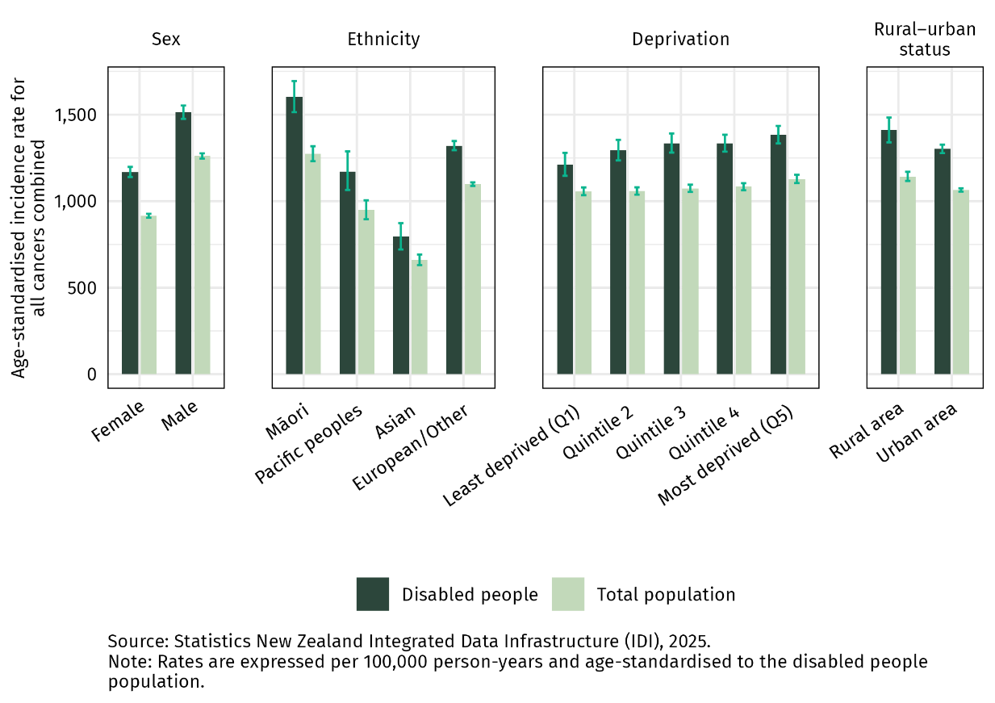

Lung cancer
The biggest differences for disabled people compared with the total population were seen in lung cancer. Overall, disabled people were found to have a 71% higher rate of lung cancer diagnosis compared with the total population (RR 1.71; 95% CI 1.62–1.80). Among disabled people, tāngata whaikaha Māori experienced the highest incidence of lung cancer. This increased risk of lung cancer mirrors increased smoking rates among disabled people, who are 1.76 times as likely as non-disabled adults to be daily smokers.

The analysis also shows that disabled people living in areas of highest deprivation were more than twice as likely as disabled people living in the least deprived areas to be diagnosed with lung cancer. This highlights how cumulative layers of disadvantage – often described as intersectionality – can amplify health risks for disabled people.

Bowel cancer
Disabled people were found to have a 12% higher rate of bowel cancer diagnosis compared with the total population (RR 1.12; 95% CI 1.06–1.18). Disabled people living rurally were 20% more likely to be diagnosed with bowel cancer than the total rural population.

Breast cancer
Disabled people had an 11% higher rate of breast cancer diagnosis compared with the total population across all age groups (RR 1.11; 95% CI 1.05–1.18). Disabled people over the age of 75 were 24% more likely to be diagnosed with breast cancer than people of the same age in the total population.

Prostate cancer
Prostate cancer demonstrates a notably different pattern to the other cancers included in this review. Disabled people were less likely to be diagnosed with prostate cancer than the total population (RR 0.88; 95% CI 0.83–0.93).

This lower rate of prostate cancer diagnosis is seen among other population groups that have an overall higher rate of cancer diagnosis, such as Māori and people living in areas of higher deprivation. This is likely related to differences in the likelihood of accessing PSA testing in primary care.

Next steps
This report shows that cancer is more commonly diagnosed among disabled New Zealanders compared with the total population. Specific differences vary by cancer type, with disabled people experiencing particularly high rates of lung cancer diagnosis. It is likely the causes of this increased risk are multifactorial, and most likely explained by higher exposure to cancer risk factors due to barriers accessing the social determinants of health. The disabling impacts of cancer, which can occur prior to diagnosis, are also likely to play a role.

These findings highlight the importance of cancer services being designed to meet the needs of disabled people. International and local evidence also shows that disabled people who access health services and specialist cancer services regularly encounter barriers related to communication, access and equipment.

To be inclusive of disabled people, it is essential that cancer prevention interventions, cancer screening, cancer detection, cancer treatment services and cancer survivorship support are informed by the lived experience of disabled people with cancer.

The shortage of quality data on disabled people in health has serious consequences for disabled New Zealanders, including hidden unmet health needs and inequities. One of the main challenges in generating or locating evidence about the experiences and outcomes of disabled people within the health system is the inconsistent recording of disability status across administrative datasets. This issue extends beyond health data alone. The health sector has an opportunity to lead on this issue by collaborating with disabled people and experts within the disability sector to improve how disability status is recorded and interpreted to ensure the system better meets their needs. Work to address this issue in health administrative data has begun and is being led by Health New Zealand – Te Whatu Ora.

Further quantitative and qualitative research will be required to address the many gaps that exist in the evidence that is available in Aotearoa New Zealand on cancer-related health outcomes for disabled people. For example, research that investigates survival insights and understanding stage at diagnosis would also provide important detail on where barriers exist and how cancer impacts the disabled population.
Te Aho o Te Kahu – Cancer Control Agency (the Agency) will continue to work with health entities and the disability sector to build a shared understanding of disparities and identify changes to improve cancer care and outcomes for disabled people - and tāngata whaikaha Māori in particular - across our system of cancer care.

Other publications from the Disability and Cancer Project:
- Disabled people and cancer: Literature review
This report summarises local and international literature relating to disabled people with cancer. It aims to help the wider health sector better understand the factors that impact disabled people when accessing and navigating the cancer care system. It also highlights ways to mitigate barriers for disabled people so that evidence-based approaches can be incorporated into policy and practice.
- Lived experience disability and cancer interviews
The Disability and Cancer Project team included three disabled people with lived experience of cancer. The experiences represented through our Lived Experience Advisors included wāhine Māori, migrant/refugee, under 25, over 65, rainbow, and a range of cancers. While our Lived Experience Advisors’ perspectives were diverse, we also recognise that each disabled person’s experience is unique.

Introduction
He kupu whakataki
Te Aho o Te Kahu – Cancer Control Agency (the Agency) has identified a lack of research on cancer for disabled New Zealanders (Te Aho o Te Kahu – Cancer Control Agency 2021). The 2023 Stats NZ Household Disability Survey recently reported that 17% of New Zealanders are disabled, and a 24% proportion of Māori (Stats NZ 2023). Disabled people are also a key population group identified within the New Zealand health strategies.

The health of disabled people
International evidence consistently shows that disabled people have poorer health and wellbeing outcomes and die earlier than non-disabled people (Te Aho o Te Kahu – Cancer Control Agency 2025; World Health Organization 2011). Despite experiencing a higher prevalence of chronic health conditions, health services – including cancer services – often fall short in meeting specific accessibility and inclusion needs of disabled people. This leads to poorer access, care and outcomes and is driven by a wide range of factors like communication barriers, inaccessible facilities and inadequate support services (Iezonni 2022; Te Aho o Te Kahu – Cancer Control Agency 2025).

In Aotearoa New Zealand, disabled people use health services at least twice as often as the non-disabled population (Health and Disability System Review 2020), yet self-rated health status is lower when compared with non-disabled people (Minister of Health 2023). Health and disability surveys consistently show that disabled people in Aotearoa New Zealand report unmet health needs:
- The 2019/20 New Zealand Health Survey found that 47% of disabled people had an unmet need for primary health care (Ministry of Health 2020).
- The 2023 New Zealand Household Disability Survey found that 62% of disabled people (506,000) had at least one unmet health need (Stats NZ 2023).

When looking specifically at cancer outcomes for disabled people, there is limited information available. However, there is some indication that the prevalence of some types of cancer is higher in disabled people compared with non-disabled people (Hughes et al 2022; Iezzoni 2022). In Aotearoa New Zealand, a 2023 IHC report found that those with intellectual disability had a slightly higher estimated prevalence of total cancer compared with those without intellectual disability (rate ratio (RR) 1.07; Beltran-Castillon and McLeod 2023). For this measurement, prevalence was estimated by identifying age-standardised rates of cancer care and treatment over two years to June 2018. These differences are likely to be at least in part explained by higher exposure to modifiable risk factors for cancer.

In some cases, however, these differences remain after specific risk factors have been controlled for. For example, Iezzoni and colleagues (2020) analysed national health survey data in the United States, focusing on the association between two categories of disability – movement difficulties and complex activity limitations – and four cancer types: bowel cancer, non-Hodgkin lymphoma, prostate cancer and ovarian cancer. The study found that in general, disabled people had higher rates of all four cancer types and were older than non-disabled people when they were diagnosed. In some instances, an increased risk remained after adjusting for key cancer risk factors. The authors noted that there was no clear explanation for the finding, and that it highlighted the importance of vigilance in diagnosis and screening for disabled people. Similarly, an increased risk of some types of leukaemia has been observed for people with Down syndrome.

Similar patterns of inequity by ethnicity also persist among disabled people. A 2019 Māori Health Disability Statistical Report found tāngata whaikaha Māori were almost one-and-a-half times as likely as disabled non-Māori to be diagnosed with cancer. When considering breast cancer specifically, this relationship was even more marked. Here, tāngata whaikaha Māori women were more than twice as likely as disabled non-Māori women to be diagnosed with breast cancer (Ministry of Health 2019b). This is an example of the impact that cumulative layers of disadvantage, often referred to as intersectionality, can have on specific population groups.

The modifiable risk factors for developing cancer
Cancer is a complex disease, and it is not currently possible to predict with certainty who will develop cancer. However, there are several modifiable risk factors associated with an increased likelihood of developing cancer. These include smoking, higher body weight, low levels of physical activity, alcohol use, chronic infections, and inadequate nutrition (Te Aho o Te Kahu – Cancer Control Agency 2022).

There are many broader factors that impact people’s exposure to cancer risk factors; social, political and economic factors shape the environments in which people live and the likelihood that they will be exposed to cancer-causing risk factors.

Disabled people experience barriers to accessing the social determinants of health, including higher rates of poverty than the non-disabled population, and they experience significant barriers and discrimination to accessing education, employment, health care and other services (Minister of Health 2023). These differences are associated with higher exposure to cancer-causing risk factors, including smoking rates, increased body weight and physical inactivity for disabled people compared with non-disabled people (Beltran-Castillon and McLeod 2023; Iezzoni 2022; Minister of Health 2023; World Health Organization 2011).

In addition, the legacy of colonisation in Aotearoa has profoundly shaped the social, economic and environmental conditions in which Māori live, work and play—conditions that directly influence exposure to modifiable cancer risk factors such as tobacco use. Colonisation has contributed to systemic inequities, including higher rates of deprivation and marginalisation, which are strongly linked to increased smoking prevalence (Gurram et al 2024). Despite recent declines in smoking rates, Māori remain significantly more likely to smoke daily than non-Māori, with wāhine Māori facing particularly high rates (Ministry of Health 2024). Given that disabled people are 1.76 times as likely as non-disabled adults to be daily smokers, this has significant implications for tāngata whaikaha Māori.

Improving visibility of disabled people in health data
Accurate, appropriate and consistent collection of data is important to identify and address the needs of disabled people. Conversely, if this is done poorly it can render disabled people ‘invisible’ and contribute to ongoing marginalisation and discrimination. Data can help shape the design of policies and services to ensure disabled people are not disadvantaged in their ability to participate in society on an equal basis with non-disabled people.

Disability status is not consistently collected within many official datasets in Aotearoa New Zealand. Improving the collection and sharing of disability data was identified as a high priority by the Health and Disability System Review (Health and Disability System Review 2020). The importance of disability data is also emphasised in the United Nations Convention on the Rights of Persons with Disabilities. This includes the use of data to monitor activities, identify and address barriers, and ensure data is disseminated in an accessible way (Office for Disability Issues – Te Tarī Mō Ngā Take Hauātanga 2016; United Nations 2006).

The extent of inequities—especially for tāngata whaikaha Māori— are likely underreported. Addressing these limitations will require improved, culturally appropriate data collection, consistent recording of disability status, and further research into cancer outcomes and care pathways for tāngata whaikaha Māori.

Data on tāngata whaikaha Māori supports the health system to deliver on obligations under Te Tiriti o Waitangi, specifically the active protection of tāngata whaikaha Māori health outcomes and efforts to achieve Māori health equity in cancer care and more broadly.

Timely availability of health outcomes and wellbeing information on tāngata whaikaha Māori contributes to a key priority (Priority 7) in Whakamaua: Māori Health Action Plan 2020–2025 (Ministry of Health 2020). In conjunction with other actions, this report adds to the Māori health and disability evidence base that contributes to improved Māori health and wellbeing.

Improving the visibility of key population groups and what we know about the inequities, experience and outcomes for these groups is important in achieving the four outcomes under the New Zealand Cancer Action Plan 2019–2029, which are shown in Figure 2 below (Ministry of Health 2019a).

Figure 2: Outcomes of the New Zealand Cancer Action Plan 2019–2029
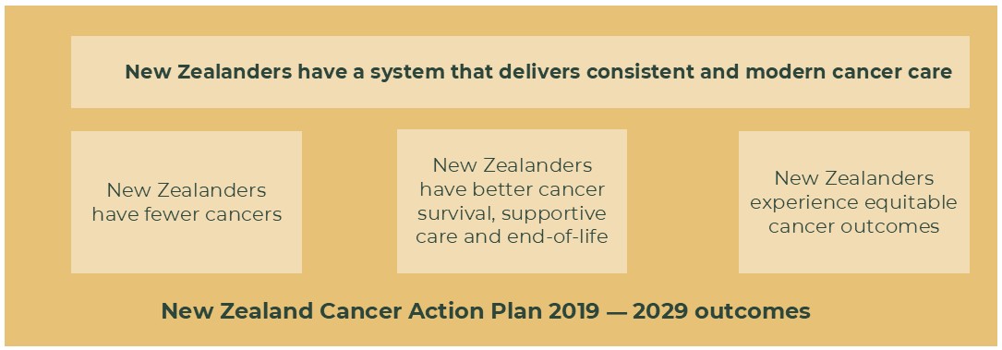

This report aims to provide new insights on disabled people with cancer in Aotearoa New Zealand. It is the Agency’s response to a key gap in the data available; a gap that has also been identified in Disabled People and Cancer: Literature Review Ngā Tāngata Whaikaha me te mate pukupuku: he arotakenga mātātuhi (Te Aho o Te Kahu – Cancer Control Agency 2025).

Summary of methods
Ngā tukanga
Please see Appendix 1 for the complete methods.

This study is a retrospective cohort analysis of Aotearoa New Zealand’s population from 2018 to 2022. It compares cancer diagnosis for people identified as having a disability with the total population (which includes both disabled and non-disabled people). Due to the nature of the datasets used for these analyses, it is not possible to accurately define a non-disabled population. For this reason, total population is used as a comparison group. However, this means any differences between disabled and non-disabled people may be greater than those shown in this study. Other potential causes of underestimation or overestimation of results are discussed in Appendix 1.

Throughout this report we have explored rates of cancer diagnosis overall, but also by specific age bands. Age is strongly linked to cancer risk, and disability also becomes more common as people age. By looking at cancer diagnosis rates across different age bands, and in particular among adults under 75 years, where both cancer and disability are less likely to be age-related, we can better understand the impact of cancer on disabled people compared to the total population. While this is an important aspect of this report, we recognise that cancer services across the continuum need to serve all disabled people well, regardless of age.

The inconsistent collection of disability status is an issue that impacts the quality of data available both internationally and in Aotearoa New Zealand. This creates challenges when conducting analyses such as these. In this project, we used a proxy indicator of disability developed by the Social Wellbeing Agency (2022). The indicator measures the functional limitations people experience in day-to-day life from questions asked in the 2018 Census (of the entire population) and the 2016 Household Labour Force Survey (of samples of the adult population). Because some people did not take part, or did not answer the disability-related questions, we used other health records to help fill in the gaps. The datasets used for this – Socrates and interRAI – identified the same functional limitations asked about in the 2018 Census and the 2016 Household Labour Force Survey. It is important to note that this definition mainly identifies those with greater support needs – either due to self-reported high functional limitations or more significant disability identified through services.

The cohort was derived from the usual resident population in accordance with our selection criteria. It comprised 4,204,524 individuals over 15 years of age who were usually living in New Zealand at some point between 2018 and 2022. Among those, 306,705 people were identified as disabled, based on the Social Wellbeing Agency definition. Approximately 58% of this group were identified using survey data, and approximately 42% using health records. Disability prevalence is likely underreported among Māori and Pacific peoples due to limitations in ethnicity data and cultural differences in the understanding and reporting of disability. This undercounting may lead to an underestimation of disparities and health needs for these groups.

Overall, 85,692 disabled and non-disabled people were diagnosed with cancer from 2018 to 2022. Of this group of 85,692 people, 12,354 people identified as disabled prior to their cancer diagnosis. This means approximately 1 in 7 cancer registrations occurred in disabled people (as identified in this analysis).

There are some limitations to this proxy indicator. As noted by the Social Wellbeing Agency, this indicator does not incorporate information relating to the barriers that exist in a person’s environment that limit participation, and therefore only reflects a portion of disabled people’s experience. The categories created by the indicator may not be the same as how some disabled people would choose to describe themselves (Social Wellbeing Agency 2022). Categories are also grounded in a Eurocentric, individualised model that may not fully align with Māori or other cultural perspectives on disability, which are more collective and whānau-centred. Notwithstanding these limitations, this indicator provides a step towards our aim to develop an understanding of the experience of disabled people with cancer.

It is also important to consider the different demographics of the populations captured by the two data sources (survey-based data and health records). The Socrates and interRAI datasets are linked to residential care, home support services and needs assessment. These datasets tend to have a higher proportion of older adults when compared with the census and Household Labour Force Survey data. Figure 15 demonstrates the different age structures of the two data sources (survey-based data and health records), and Figure 17 illustrates age-specific cancer incidence among disabled people across these data sources, and the total population.

A proportion of health needs assessments used to identify functional limitations (disability status) in the Socrates and interRAI datasets may have been triggered by declining function or increasing fragility due to an undiagnosed cancer. This means that the higher rate of overall cancer diagnosis found among disabled people may in part be due to some disability being caused by cancer. This is called selection bias – where the identification of the exposure (disability) is related to the outcome (cancer). The potential impact of this bias was explored with the application of a washout period. Among those identified as disabled who were later diagnosed with cancer, most had a gap of more than two months between the two events, suggesting that the majority of disability identifications preceded the cancer diagnosis by a meaningful period. This is discussed in further detail in the sensitivity analysis in Appendix 1. While this does not change the need for cancer services to be inclusive of the needs of this group, it is important to consider when drawing conclusions about disabled people’s risk of developing cancer.

We applied a dynamic population approach, which is considered appropriate when long-term data from the start of exposure is unavailable (Vandenbroucke and Pearce 2015). This method allowed us to estimate cancer diagnosis rates and rate ratios while reflecting real-world patterns and minimising potential biases.

Understanding the results in this report
In this analysis we have used age-standardised rates per person-years and rate ratios to compare cancer diagnosis rates in the disabled population and the total population.

Age standardisation: The likelihood of being disabled increases with age, meaning a population of disabled people may have a higher proportion of older people compared with the general population. Since cancer risk also increases with age, comparing cancer rates between disabled and non-disabled groups without adjusting for age could be misleading. Age-standardisation is an important method for comparing outcomes across different groups. In Aotearoa New Zealand, different populations vary in terms of the ages of people in each group. For example, some ethnicities, genders and regions may comprise more young people or more older people than others. As age is an important determinant of cancer incidence and outcomes, a population with a younger age distribution may seem to have similar or better outcomes than a population with an older population – but this may be only because of differences in age distribution between the two groups. Standardising age structures between groups allows for more accurate comparisons, enabling a clearer examination of disparities. Age-standardised proportions are calculated by the direct standardisation method, which multiplies the non-age-standardised proportions by a standard population.

Person-years: Person-years is a statistical measure that combines the number of people in a study with the amount of time each person spends in the study. For example, if one person is followed for one year, that counts as one person-year. If ten people are each followed for six months, that’s five person-years (since 10 × half a year = 5 years).

If we simply counted cancer cases among disabled people and compared them to the total population, we might miss differences in how long people were part of the study. Some people may have been diagnosed soon after the study began, while others may have been part of the study for many years before being diagnosed with cancer.

Measuring person-years rather than just the number of people in a study allows for a fairer comparison between disabled people and the total population. It means any differences in rates of cancer diagnosis between the two groups are not due to how long people were part of the study, accounting for the dynamic nature of disability status over time. This is a different approach to methods generally used and cancer incidence rates usually reported by the Agency, and so the results presented here are not directly comparable with other reports we have published.

Rate ratio (RR): This measures how much more (or less) likely a new diagnosis of cancer is in one group compared with another. The risk of cancer diagnosis in each of the groups is compared using a ratio to find out if one group is at higher risk than the other. A rate ratio of exactly 1 would mean both groups are at the same risk of a new cancer diagnosis. If the rate ratio is greater than 1, it would mean disabled people have a higher risk of a new cancer diagnosis than non-disabled people, while if the rate ratio is less than 1, it would mean disabled people have a lower risk of a new cancer diagnosis.

Confidence interval (CI): Confidence intervals are used to indicate the precision of an estimate such as a rate ratio. They show how much the estimate could vary if a different set of data had been used. Confidence intervals are usually calculated with a specific probability, most commonly 95%. This means that there is a 95% chance that the true value lies within the range of the two values of the confidence interval. A narrow range means the estimate is more precise, while a wide range means it is less precise.

Results
Ngā hua

All cancer
Our analysis found that disabled people were more likely to be diagnosed with cancer than the total population across all demographic groups. Table 1 on page 12 summarises the overall rate of cancer diagnosis for disabled people and the total population. Between 2018 and 2022 the overall age-standardised rate of cancer diagnosis for disabled people was 1,312 per 100,000 person-years compared with 1,073 per 100,000 person-years for the total population. This means that overall, disabled people had a 22% higher rate of cancer diagnosis than the total population (RR 1.22; 95% CI 1.20–1.24).

Tāngata whaikaha Māori had the highest rate of cancer diagnosis (1,602 per 100,000 person-years). Among other demographic subgroups, particularly high rates of cancer diagnosis were also seen among disabled males (1,513 per 100,000 person-years), disabled people living rurally (1,410 per 100,000 person-years) and disabled people living in areas of high deprivation (1,384 per 100,000).

These findings are shown in Figure 3 on page 13.

Table 1: Age-standardised rate of cancer Incidence among disabled people and the total population per 100,000 person-years, 2018–2022
 | Disabled people (rate per 100,000 person-years) | Total population  (rate per 100,000 person-years) | Rate ratio  (95% CI)
Overall cancer diagnosis rate | 1,312 | 1,073 | 1.22 (1.20–1.24)
Sex
Female | 1,168 | 916 | 1.28 (1.25–1.31)
Male | 1,514 | 1,261 | 1.20 (1.17–1.23)
Ethnicity
Māori | 1,602 | 1,274 | 1.26 (1.20–1.33)
Pacific peoples | 1,171 | 949 | 1.23 (1.12–1.35)
Asian | 794 | 660 | 1.20 (1.09–1.32)
European/Other | 1,321 | 1,098 | 1.20 (1.17–1.23)
Area of deprivation
Quintile 1 (least deprived) | 1,211 | 1,057 | 1.15 (1.09–1.22)
Quintile 2 | 1,294 | 1,059 | 1.22 (1.16–1.28)
Quintile 3 | 1,335 | 1,074 | 1.24 (1.19–1.30)
Quintile 4 | 1,334 | 1,083 | 1.23 (1.18–1.28)
Quintile 5 (most deprived) | 1,384 | 1,128 | 1.23 (1.18–1.28)
Rurality
Rural | 1,410 | 1,143 | 1.23 (1.17–1.30)
Urban | 1,302 | 1,065 | 1.22 (1.20–1.25)
Age group
15–44 years | 118 | 97 | 1.22 (1.07–1.39)
45–64 years | 904 | 675 | 1.34 (1.28–1.40)
65–74 years | 1,793 | 1,493 | 1.20 (1.16–1.25)
≥75 years | 2,134 | 1,778 | 1.20 (1.17–1.23)
Source: Stats NZ Integrated Data Infrastructure (IDI), 2025.
Note: Rates (apart from age group rates) are expressed per 100,000 person-years and age-standardised to the disabled people population.

Figure 3: Age-standardised rate of cancer incidence among disabled people and the total population per 100,000 person-years, by demographic, 2018–2022

Differences in rates of cancer diagnosis between disabled people and the total population were seen across all age groups. However, the largest difference was seen in the 45–64 years age group, where disabled people were 34% more likely to be diagnosed with cancer than the total population (Figure 4).

Figure 4: Age-specific rate of cancer incidence among disabled people and the total population, per 100,000 person-years, 2018–2022

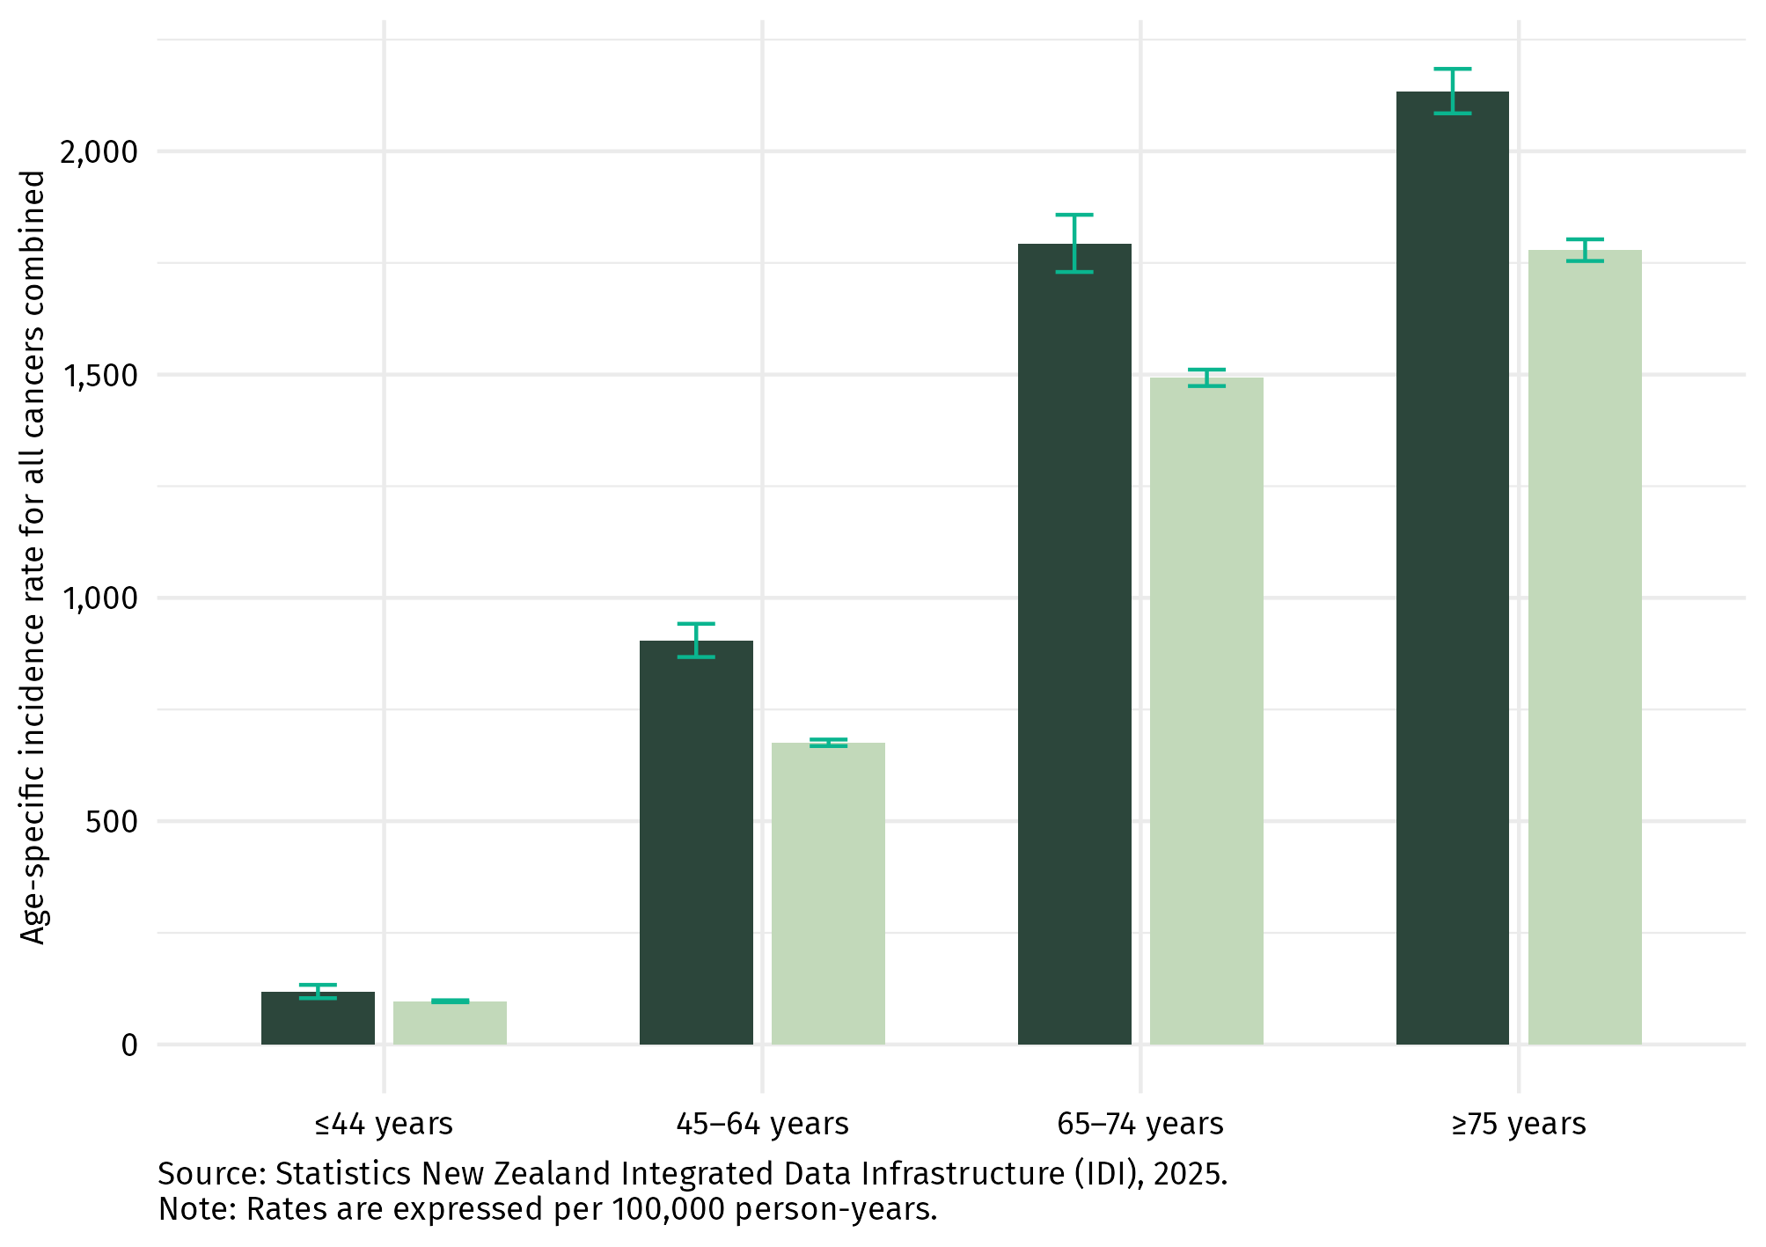


Discussion
This analysis found that overall cancer diagnosis was more common among disabled people, across all demographic groups, when compared with the total population. A similar pattern was seen in the distribution of cancer for the disabled population as is seen in the general population, with cancer diagnosis being more common with increasing age and more common among certain demographic groups, including Māori and those living in areas of high deprivation. Overall, approximately 1 in 7 cancers occurred in disabled people.

In the majority of cases, it is unlikely that cancer is caused by the same factors that contributed to disability. The barriers disabled people - tāngata whaikaha Māori in particular - face in accessing the social determinants of health can increase their risk of exposure to key cancer risk factors. Disabled people are exposed to higher levels of several cancer-causing risk factors than non-disabled people, including smoking, increased body weight and physical inactivity (Beltran-Castillon and McLeod 2023; Iezzoni 2022; Minister of Health 2023; World Health Organization 2011). Additionally, it may be that a functional disability and cancer have a common cause. For example, someone might experience limited mobility because of a respiratory disease due to smoking, and then subsequently develop lung cancer due to this same exposure.

Cancer type
Rates of diagnosis of cancer among disabled people were also examined for the four most common cancer types diagnosed in Aotearoa New Zealand: bowel, lung, prostate and breast cancer (Table 2 and Figure 5). Among these, disabled people were more likely to be diagnosed with lung, breast and bowel cancer than the total population. This was different to the pattern seen for prostate cancer, where disabled people were less likely to be diagnosed with prostate cancer than the total population. These trends are discussed further below.

Table 2: Age-standardised rate of cancer incidence among disabled people and the total population per 100,000 person-years, by cancer type, 2018–2022
 | Disabled people  (rate per 100,000  person-years) | Total population  (rate per 100,000  person-years) | Rate ratio  (95% CI)
Bowel cancer | 166 | 149 | 1.12 (1.06–1.18)
Breast cancer | 133 | 120 | 1.11 (1.05–1.18)
Lung cancer | 176 | 103 | 1.71 (1.62–1.80)
Prostate cancer | 149 | 170 | 0.88 (0.83–0.93)
Source: Stats NZ Integrated Data Infrastructure (IDI), 2025.
Note: Rates are expressed per 100,000 person-years and age-standardised to the disabled people population.

Figure 5: Age-standardised rate of cancer incidence among disabled people and the total population, by cancer type, 2018–2022 (age standardised to the disabled population)

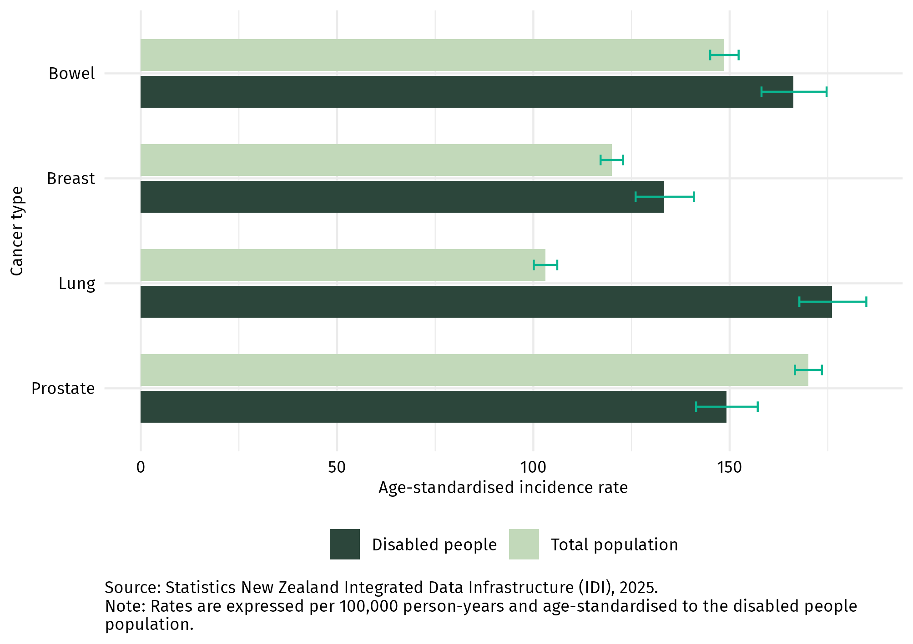

Lung cancer
Of the four cancers analysed, the largest difference in rates of diagnosis for disabled people was seen in lung cancer. Disabled people had a 71% higher rate of lung cancer diagnosis compared with the total population (RR 1.71; 95% CI 1.62–1.80).

When analysed using a single additional demographic (eg. Ethnicity, sex, deprivation level or rural/urban location), tāngata whaikaha Māori had the highest rate of lung cancer diagnosis with an incidence of 328 per 100,000 person-years (Figure 6).
Lung cancer risk is strongly associated with socio-economic status, with much higher rates of lung cancer for those living in the most deprived areas compared with those living in the least deprived areas. Disabled people living in areas of highest deprivation (quintile 5) are more than twice as likely as disabled people living in the least deprived areas to be diagnosed with lung cancer (quintile 1). Figure 6 below shows that this pattern is also seen for the total population, but with higher rates of lung cancer diagnosis for disabled people across all quintiles.

Figure 6: Age-standardised rate of lung cancer incidence among disabled people and the total population per 100,000 person-years, by demographic, 2018–2022

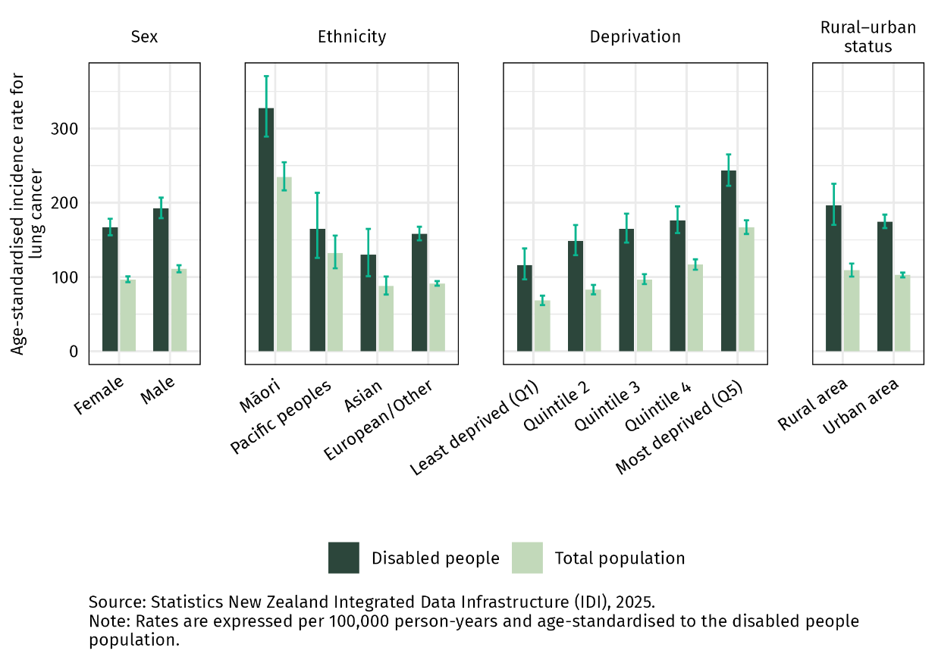

Higher rates of lung cancer among disabled people were seen across all age groups (Figure 7), but the difference was most marked for people aged 45-64 years. In this age group, disabled people were more than twice as likely as the total population to be diagnosed with lung cancer. See Appendix 2 for detailed data tables.

Figure 7: Age-specific rates of lung cancer incidence among disabled people and the total population, per 100,000 person-years, 2018–2022

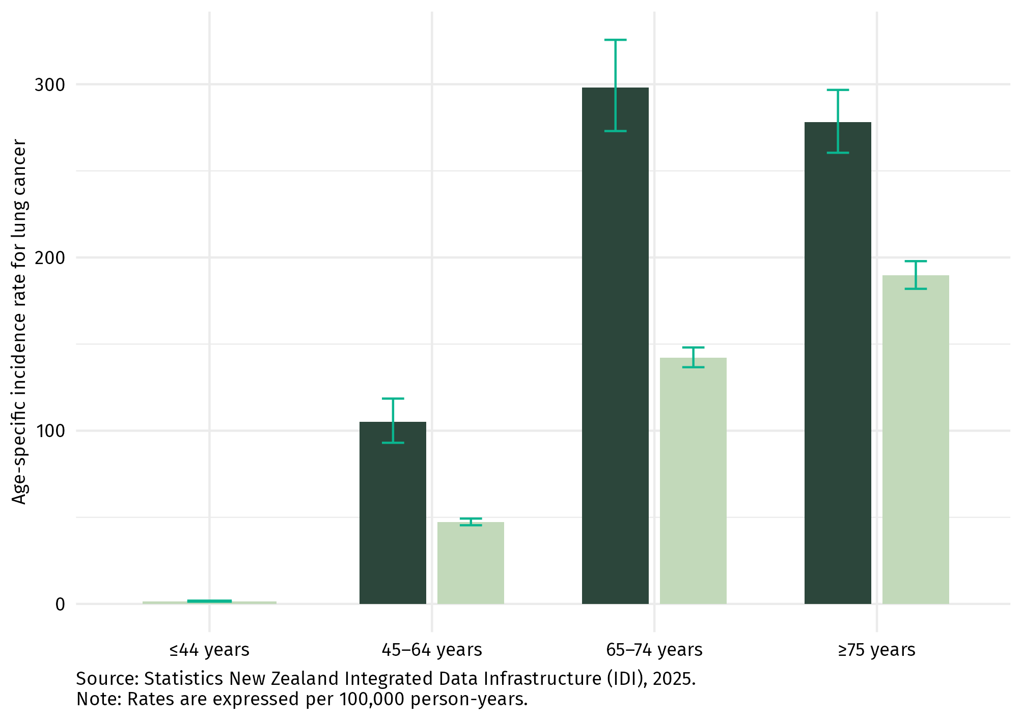

Discussion
Smoking is a particularly important consideration when interpreting these findings. Smoking is the single largest cause of lung cancer, accounting for approximately 85% of all lung cancers globally (World Health Organization 2023).

Disabled people are more likely to be exposed to this key risk factor, being 1.76 times as likely as non-disabled adults to be daily smokers (Ministry of Health 2024). Increased exposure to this risk factor places disabled people at higher risk of developing lung cancer. More research is needed to understand how other factors might also be contributing to the inequities in rates of lung cancer diagnoses between disabled people and the total population. Further analysis of the route to diagnosis would also be helpful.

Despite recent declines in smoking rates, Māori remain significantly more likely to smoke daily than non-Māori, with wāhine Māori facing particularly high rates (Ministry of Health 2024). Smoking is also heavily associated with socioeconomic deprivation, with those living in areas of highest deprivation six times more likely to be daily smokers than those living in the least deprived areas (Ministry of Health 2024). Māori are overrepresented in these areas of high deprivation (Stats NZ 2025).

Tāngata whaikaha Māori therefore experience the compounded effects of colonisation, disability, ableism, and deprivation, which is reflected in these rates of lung cancer diagnosis. This variation underscores how broader socio-political determinants — rooted in colonial structures — continue to shape cancer outcomes and reinforce inequities in health for tāngata whaikaha Māori. It is essential that actions aimed at empowering people to make positive decisions about their health, such as smoking cessation support, serve disabled communities well.

Bowel cancer
Although not as marked as with lung cancer, differences are also seen in rates of bowel cancer diagnosis (Figure 8, Figure 9). Disabled people have a 12% higher rate of bowel cancer diagnosis compared with the total population (RR 1.12; 95% CI 1.06–1.18). Disabled people living rurally also have particularly high rates of bowel cancer (193 per 100,000 person-years) and are 20% more likely to be diagnosed with bowel cancer than the total rural population. See Appendix 2 for detailed data tables.
Figure 8: Age-standardised incidence of bowel cancer among disabled people and the total population per 100,000 person-years, by demographic, 2018–2022
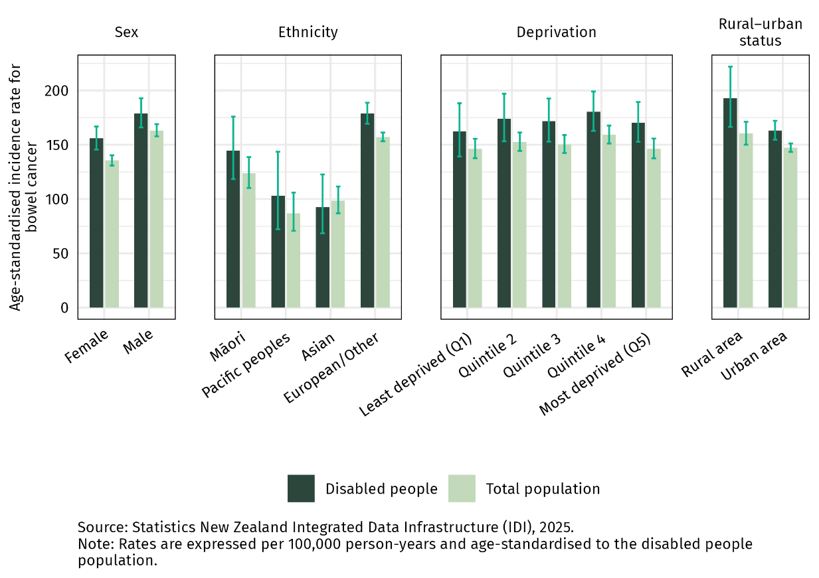

Rates of bowel cancer diagnosis increase with age, with this pattern seen across both disabled people and the total population. Across the different age brackets analysed, disabled people over the age of 75 have the highest rate of diagnosis of bowel cancer (314 per 100,000 person-years).

Figure 9: Age-specific incidence of bowel cancer among disabled people and the total population, per 100,000 person-years, 2018–2022

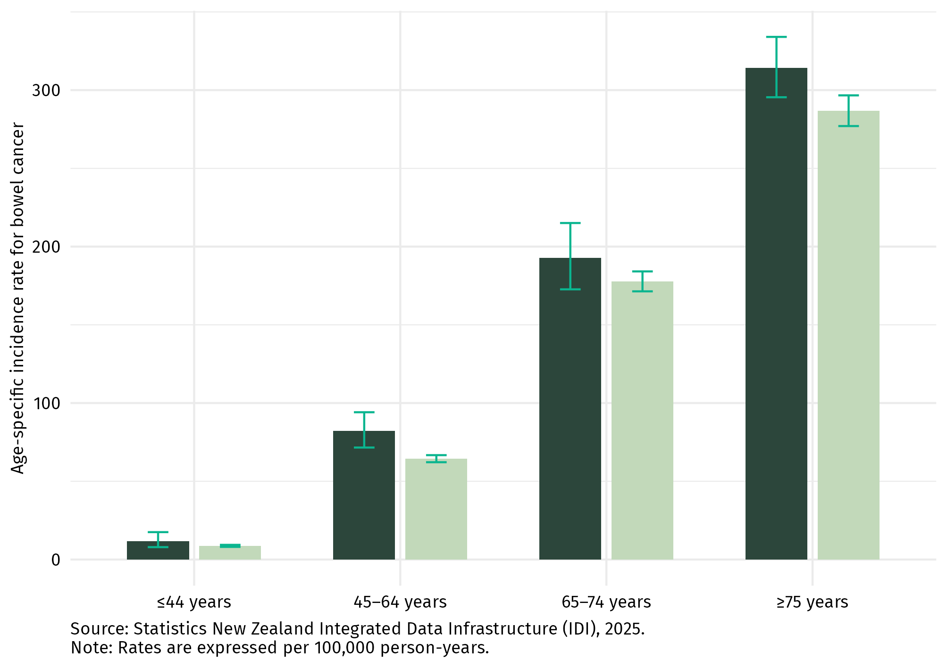

Discussion
Several modifiable risk factors increase a person’s risk of developing bowel cancer, including increased body weight, alcohol and smoking. Disabled people are more likely than non-disabled people to be exposed to a number of these risk factors. Disabled adults are 1.35 times as likely as non-disabled adults to have excess body weight. Disabled people are also 1.76 times as likely to be daily smokers (Ministry of Health 2024).

Screening is one pathway for diagnosing bowel cancer. Bowel cancer screening is now available for free for people aged 60 to 74 years in New Zealand through the National Bowel Screening Programme (NBSP). The rollout of the NBSP began in 2017 and was completed in 2022, meaning implementation of the programme was underway during the time period of data used in this analysis (2018–2022). As a result, these findings will not capture the full effect of the NBSP.

There is international research that indicates disabled people may be less likely than non-disabled people to receive bowel cancer screening (Floud et al 2017; Liao et al 2021; Ouellette-Kuntz et al 2015; Te Aho o Te Kahu – Cancer Control Agency 2025). However, the analysis in this report does not explain what the impact of access to screening services might be for disabled people.

Further work on the pathway to diagnosis for disabled people with bowel cancer would provide additional information on whether the NBSP is effectively reaching disabled people. Similarly, additional analysis on the stage of cancer at diagnosis would provide useful information on where there are missed opportunities to effectively target interventions to minimise the burden of bowel cancer among disabled people.

Breast cancer
Disabled people have an 11% higher rate of diagnosis of breast cancer compared with the total population (RR 1.11; 95% CI 1.05–1.18). There are differences in the rate of breast cancer diagnosis by ethnicity (Figure 10), with tāngata whaikaha Māori having the highest rates of breast cancer diagnosis (199 per 100,000 person-years). See Appendix 2 for detailed data tables.

Figure 10: Age-standardised incidence of breast cancer among disabled people and the total population per 100,000 person-years, by demographic, 2018–2022
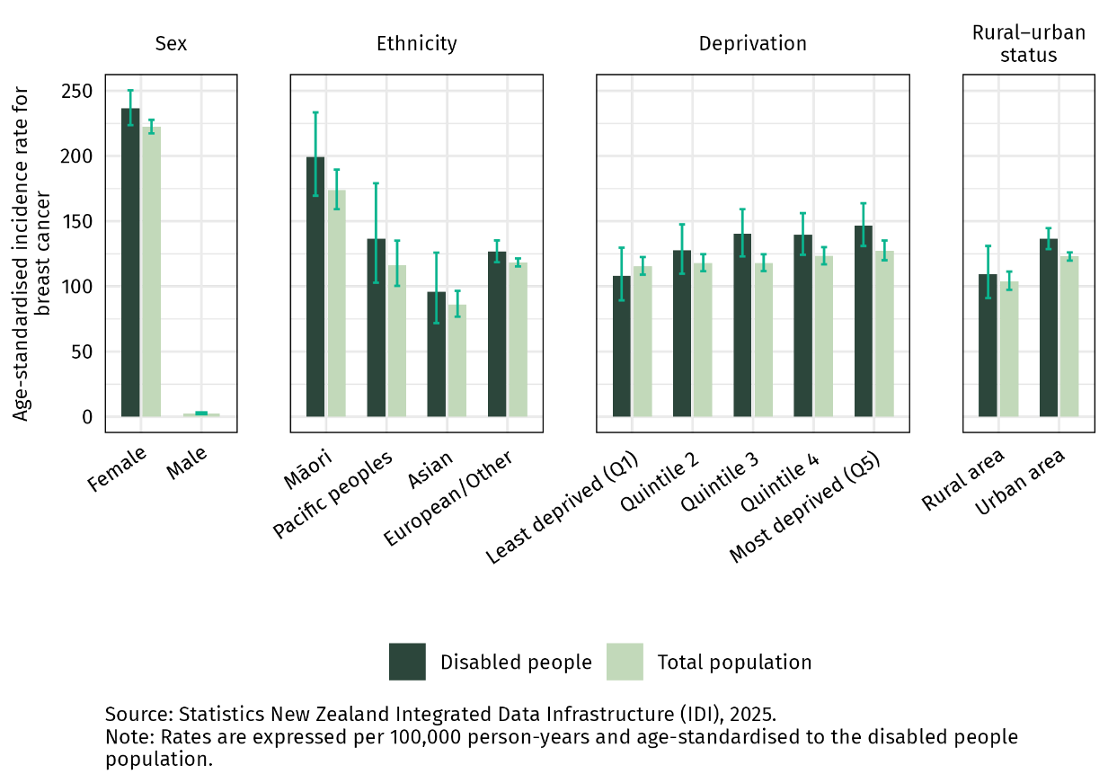

Of note, there is minimal difference in the rate of diagnosis of breast cancer between disabled people and the total population for those aged under 75 years (Figure 11). This suggests that a major driver of the difference in rates of breast cancer diagnosis between disabled people and the total population is due to differences in those over the age of 75, where disabled people are more likely to be diagnosed with breast cancer than the total population.

Figure 11: Age-specific incidence of breast cancer among disabled people and the total population, per 100,000 person-years, 2018–2022

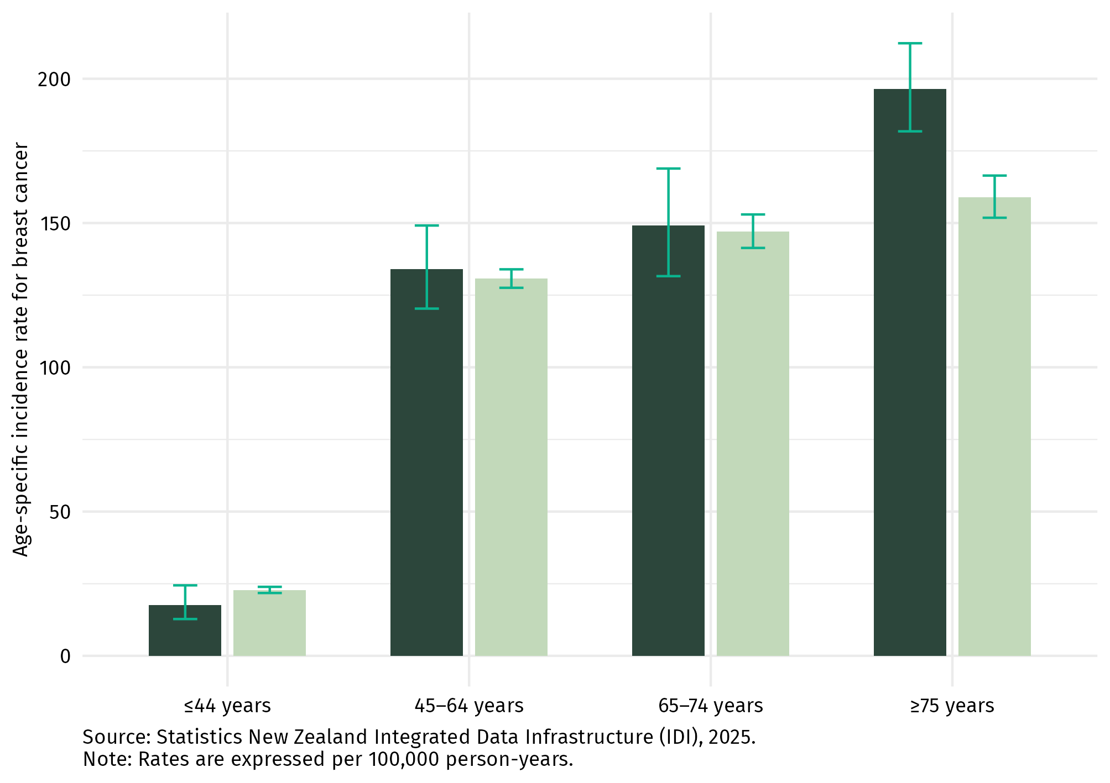

Discussion
Risk factors for breast cancer include family history (and related genetic pre-disposition), alcohol consumption, excess body weight after menopause, physical inactivity and hormonal/reproductive history. Disabled adults have higher rates of hazardous drinking (RR 1.45; 95% CI 1.19–1.78) and obesity (RR 1.35; 95% CI 1.21–1.49) than non-disabled adults, and they are less likely to be physically active (RR 0.69; 95% CI 0.60–0.79), all of which increase the risk of developing breast cancer (Ministry of Health 2024).

In New Zealand, 2-yearly breast screening is available for people aged 45–69. While there are similar rates of breast cancer seen between disabled people and the total population within the screening age group, this does not necessarily mean that screening programmes are meeting the needs of the disabled population. Based on international literature it is likely that disabled people experience barriers to accessing screening services (Kilic et al 2019; Mele et al 2005; Peters and Cotton 2014; Yankaskas et al 2010). While this could be a factor in the results found in this report, we cannot tell from this analysis what the impact might be.

Given the higher exposure to cancer risk factors experienced by disabled people, it is possible that the similar rates of breast cancer among disabled people and the general population could indicate underdiagnosis of breast cancer in the disabled people of screening age. Further analysis of the route to diagnosis and participation in screening programmes would help ensure these programmes were meeting the needs of disabled people.

Prostate cancer
Findings for prostate cancer differed to those seen for other cancer types that were analysed. Overall, disabled people were less likely to be diagnosed with prostate cancer than the total population. Figure 12 and 13 show that this is largely consistent across different demographics. See Appendix 2 for detailed data tables.
Figure 12: Age-standardised incidence of prostate cancer among disabled people and the total population per 100,000 person-years, by demographic, 2018–2022
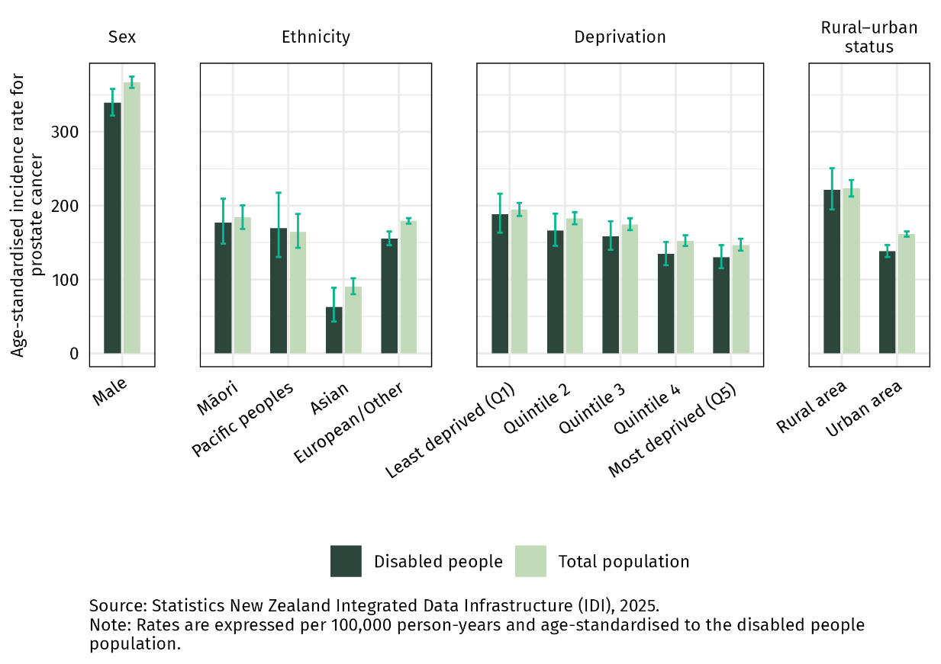
Figure 13: Age-specific incidence of prostate cancer among disabled people and the total population, per 100,000 person-years, 2018–2022
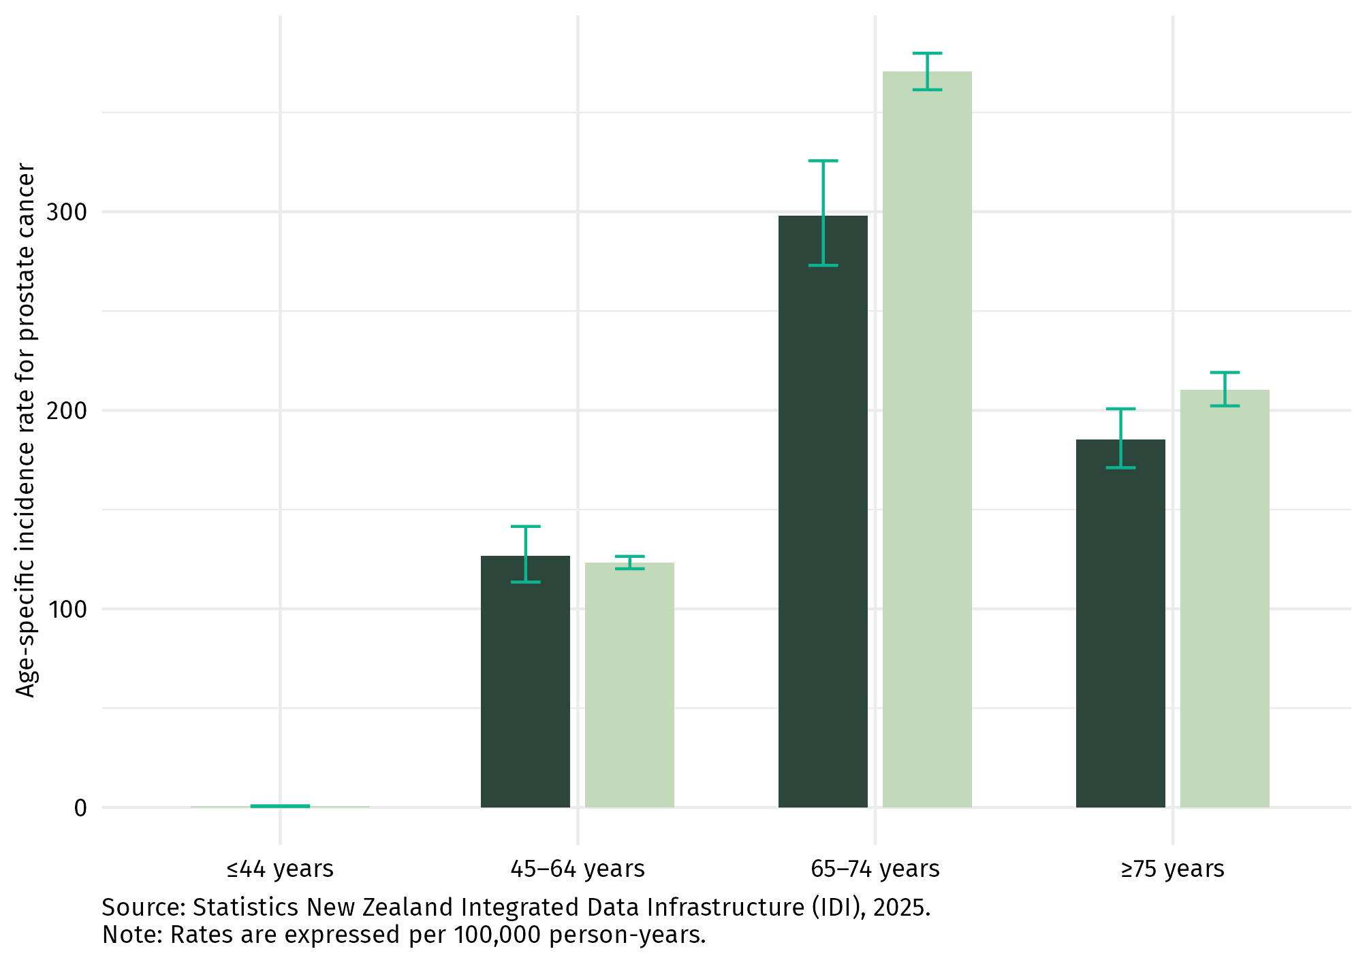

Discussion
Age and family history are the biggest risk factors for prostate cancer. The observed difference between disabled people and the total population is most likely being driven by underdiagnosis of prostate cancer among disabled people, overdiagnosis in the total population, or a combination of both.

Disabled people are not the only population group where unexpectedly low rates of prostate cancer diagnosis are observed. Other population groups who usually experience high rates of cancer diagnosis – including Māori, Pacific peoples and those living in areas of highest deprivation – all have lower rates of prostate cancer than the European/other population and those living in areas of lowest deprivation (Te Aho o Te Kahu – Cancer Control Agency 2021; Te Whatu Ora 2024). However, despite these groups having lower rates of prostate cancer diagnosis, they have higher mortality rates from prostate cancer (Te Whatu Ora 2024). As with disabled people, these differences in rates of diagnosis and mortality rates could indicate a combination of overdiagnosis and underdiagnosis, alongside barriers along the treatment pathway.

Underdiagnosis of prostate cancer among disabled people could also be due to barriers to accessing health services more broadly, or diagnostic overshadowing. Diagnostic overshadowing occurs when a disabled person presents with symptoms of a health condition (in this case prostate cancer) and the symptoms are incorrectly attributed to their disability, leading to delayed or missed diagnoses.

Overdiagnosis of prostate cancer in the total population may also be a factor affecting these results. Overdiagnosis is the diagnosis of cancer in people who would have lived their entire life without ever experiencing harm or developing symptoms from their cancer (Figure 14).

Overdiagnosis is a well noted phenomenon for prostate cancer. Due to the slow-growing nature of many prostate cancers, there is a risk of overdiagnosis, especially when opportunistic PSA (prostate-specific antigen) testing occurs. Opportunistic PSA testing (i.e., testing outside of a national screening programme) is more prevalent in higher income men of European/Other ethnicity, a group for which overdiagnosis is more common. While overdiagnosis is difficult to quantify, it is estimated that this could occur in 21% to 50% of screen-detected prostate cancers (Fenton et al 2018).

Figure 14: Overdiagnosis outcomes (National Cancer Institute 2021)
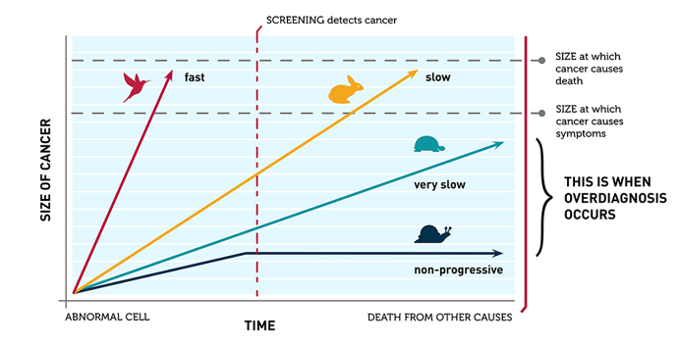

Conclusions and next steps
He whakakapi, me te ahu whakamua
Some of the patterns seen in the distribution of cancer for disabled people are similar to those seen in the general population. Cancer diagnosis among disabled people is more common with increasing age, and is more common among certain population groups including Māori and those living in areas of high deprivation. But this analysis also found higher overall rates of cancer diagnosis for disabled people across all demographic groups analysed – that is, disabled people had higher overall rates of cancer diagnosis than the total population across both sexes, every ethnicity, all deprivation levels and both locations (ie. rural and urban status).
When looking at different cancer types, this analysis found particularly high rates of lung cancer diagnosis among disabled people compared with the total population. Higher rates of diagnosis of bowel and breast cancer were also found. Of the four cancers analysed, prostate cancer was the only cancer where lower rates of diagnosis were seen among disabled adults compared with the total population.
In the majority of cases, it is unlikely that cancer is caused by the same factors that contributed to disability. An important consideration is the increased risk disabled people face due to increased exposure to key cancer risk factors. Some health conditions that are disabling can also increase cancer risk. Further work is required to understand the relationship between disability and cancer risk, with a focus on supporting initiatives to both reduce the burden of preventable cancer among disabled people and provide cancer services that meet the needs of disabled people.
There are a number of limitations to the analysis in this report. The Social Wellbeing Agency definition of disability does not fully reflect the true prevalence of disability in Aotearoa New Zealand. It may include people with temporary disabilities (short-term impairment) and is more likely to identify those with sensory or mobility impairments than those with social, behavioural, learning or cognitive disabilities (Social Wellbeing Agency 2022). In addition, it does not reflect the way some disabled people would choose to be categorised.
Due to the method of identifying disabilities in this analysis, selection bias may be present with the inclusion of disabilities that are caused by undiagnosed cancers. Further details on how this potential bias was explored are provided in a sensitivity analysis in Appendix 1, which includes an assessment of the time between disability identification and cancer diagnosis. Among those identified as disabled who were later diagnosed with cancer, most had a gap of more than three months between the two events, suggesting that the majority of disability identifications preceded the cancer diagnosis by a meaningful period.
Since the indicator we used relies on multiple data sources (combining survey and administrative data), some disabled people may be misclassified as non-disabled. For this reason, we compared those identified as disabled with the total population rather than ‘non-disabled’. This means any differences between disabled and non-disabled people may be greater than those shown in this study. This is also discussed further in the sensitivity analysis in Appendix 1.

The definition of disability used in this analysis will not fully capture the unique experiences and worldviews of some tāngata whaikaha Māori and other non-European disability communities. For example, the Washington Group Short Set (WGSS) is based on the International Classification of Functioning, Disability and Health (ICF) classification of disability, which is grounded in an individualist, Eurocentric worldview. This definition may not fully align with Māori concepts of disability, which emphasise the collective experience of disability within ancestral, whānau and community contexts (Hickey and Wilson 2017).
In addition, the analysis in this report does not include data for people with intellectual or developmental disabilities. When the approach was confirmed for this report, there was no way of identifying intellectually disabled people across administrative datasets in the Integrated Data Infrastructure (IDI). That code has now been included in the IDI so future work will be able to identify this subgroup within the data. The scope of this analysis also excludes children or those who were disabled following their cancer diagnosis.
Despite these limitations, the findings in this report contribute valuable information to help understand the burden of cancer among the disabled population.
The Agency strongly supports the improvement of disability data collection, both within the cancer sector and more broadly. Health New Zealand is progressing the Patient Profile National Health Index (PPNHI) project, which aims to address the inability to identify disabled people in datasets associated with the National Health Index (NHI). The project will also aims to provide a mechanism for disabled people to communicate their access requirements at point of care.

There are many opportunities for further research to improve our understanding of the diagnosis of cancer for disabled people – for example, the stage of cancer at diagnosis for disabled people or the routes to diagnosis (such as a comparison between diagnoses made via screening or emergency department presentations).

Our findings indicate that cancer diagnosis is more common among disabled people. Strengthening screening protocols and thoroughly evaluating new symptoms are crucial to ensuring timely diagnosis and improved health outcomes for this population group. More generally, it is critical that the whole cancer care pathway (prevention activities, screening, diagnostic, treatment, care after treatment and palliative care) is designed to meet the needs of disabled people and that cancer care providers have the necessary knowledge and tools to provide that individualised care. The Agency believes these insights are a valuable tool that can inform this work.

Waiata
Mā wai te kahu āhuru e kanoi,  Mōku, mō te iwi, mō te motu e?  Me moanarua te hae,  Me whakamahu te kino  ka ngau i te aho ki te manawa.  Ka hihiri, ka rarapa i te pō,  ki te whai ao,  Ka ao mārama.  He ranga wairua nō Hine, nō Rongo,  Tēnei āhuru mōwai e.  Mā wai te kahu āhuru e kanoi?  Me hoki … ki te whānau e. | Who shall weave this protective cloak,  For me, for the people, for the nation?  To repair the tear,  To heal the wound  That bites upon the thread to the heart, mind, spirit.  (I/We) sought for it in te pō [realm of hidden potential]  In te whai ao [realm of dawning potential]  And it is clear [te ao mārama – realm of realised potential]  Inspired by Hine and Rongo [female divinity and healing]  This haven of protection  Who shall weave this protective cloak?  [The answer is] centred within family.

In closing this report with waiata we acknowledge the heavy burden of cancer within the population. We also acknowledge the potential for these insights to improve outcomes for disabled people who have cancer in Aotearoa New Zealand.

Appendix 1: Methods
Āpitihanga tuatahi
This study is a retrospective cohort analysis of Aotearoa New Zealand’s population from 2018 to 2022. It compares cancer incidence for those identified as disabled with those across the total population.

We applied a dynamic population approach, which is considered appropriate when long-term data from the start of exposure is unavailable (Vandenbroucke and Pearce 2015). This method allowed us to estimate cancer incidence and rate ratios while reflecting real-world patterns and minimising potential biases.

Our approach was informed by methods used in comparable studies, which have assessed cancer incidence using time at risk (person-years) and applied standardised rate ratios to measure the likelihood of developing cancer for different population groups, including for people with diabetes or intellectual disability (Gurney et al 2022; Ward et al 2024).

Disability indicator
Disability data collection is imperfect, and there is not an ideal way to classify people into categories. However, to better understand the experience of disabled people with cancer, we have worked with disability data experts and used up-to-date guidance to identify a preferred option of an indicator of disability.

We used the proxy indicator of disability developed by the Social Wellbeing Agency. The indicator uses Stats NZ’s Integrated Data Infrastructure (IDI). The IDI is a secure database that brings together data collected by different government agencies for research use. This indicator is based on questions asked about functional limitations people experience in day-to-day life. As noted by the Social Wellbeing Agency, this indicator does not incorporate information relating to the barriers that exist in a person’s environment that limit participation, and therefore only reflects a portion of disabled people’s experience. It may not be the same as how some disabled people would choose to describe themselves (Social Wellbeing Agency 2022).
The Social Wellbeing Agency definition is thought to provide a credible alternative when disability survey data is not available (Social Wellbeing Agency 2022).

We used four data sources to identify functional impairments.
      - The New Zealand Census of Population and Dwellings is the official count of all people and homes in Aotearoa. It takes place every five years. This analysis uses the 2018 Census, which was held on 6 March 2018.
      - The Household Labour Force Survey samples the adult population and gives insight into employment and functional status across the working-age population. This analysis uses results from the 2016 Household Labour Force Survey.
      - The interRAI database contains information about everyone living in aged residential care and everyone receiving publicly funded home support services in Aotearoa.
      - Socrates (National Needs Assessment and Service Coordination Information) is a database used by Ministry-funded NASC (Needs Assessment and Service Coordination) agencies to record information about people who are eligible for disability support services.

The Washington Group Short Set (WGSS) is used in the census and the Household Labour Force Survey. The WGSS is a brief questionnaire designed to identify individuals with disabilities based on functional limitations within existing Stats NZ censuses and surveys. These focus on six functional limitations that frequently occur in diverse contexts that are associated with social exclusion (Washington Group on Disability Statistics 2020).

The WGSS questions are as follows:
      - Do you have difficulty seeing, even if wearing glasses?
      - Do you have difficulty hearing, even if using a hearing aid?
      - Do you have difficulty walking or climbing steps?
      - Do you have difficulty remembering or concentrating?
      - Do you have difficulty (with self-care such as) washing all over or dressing?
      - Using your usual (customary) language, do you have difficulty communicating, for example understanding or being understood?

For this study, the answers to each question were categorised into three options: no limitation, low functional limitation and high functional limitation. We have followed the practice outlined by the Social Wellbeing Agency and identified someone as ‘disabled’ if they have high functional limitation in at least one activity, and ‘non-disabled’ otherwise.

The interRAI and Socrates data sources do not use the exact questions as in the WGSS, but comparable questions in these datasets have been categorised in a similar way as that described above.

As the indicator we used relies on multiple sources (combining survey and administrative data), some disabled people may be misclassified as non-disabled. For this reason, we compare those identified as disabled with the total population rather than ‘non-disabled’ – however, this means any differences between disabled and non-disabled people may be greater than those shown in this study. Additionally, it is recognised that the prevalence of disability is likely underreported among Māori and Pacific peoples due to factors such as limitations of ethnicity data and differences in cultural beliefs about disability. This would also lead to an underestimation of results.

In contrast, there are also likely to be components of overestimation of results through the impact of people with disabilities linked with their cancer diagnosis being included in the analysis. This could be due to an undiagnosed cancer that is causing disability, or people experiencing a disabling health condition that is linked to a cancer diagnosis.

Follow-up start and end dates
The study period was 30 June 2018 to 30 June 2022. For all people usually resident in Aotearoa New Zealand at 30 June 2018, that became the start of their follow-up period. If someone became a usual resident of Aotearoa New Zealand at a date after the beginning of the study, their follow-up start date was individualised to that point.

For people identified as disabled, follow-up started from the date their disability status was confirmed or from 30 June 2018, whichever came later.

Follow-up ended at the earliest of the following: their cancer diagnosis date (if any), date of death, the date they left the country, or the end of the study period (30 June 2022).

Key exclusions
This study excluded:
- Individuals whose disability was confirmed after their cancer diagnosis
This is a consideration for future research, but our current focus is on understanding the end-to-end experience of disabled people (ie, those who were disabled before their cancer diagnosis).
- Individuals under 15 years of age
This is in part due to limitations of using the Washington Group Short Set (WGSS) for determining limitations in functioning for children. For this foundation piece we have chosen to focus on adults with cancer. We acknowledge the importance of adding to the knowledge base for disabled children experiencing cancer, and this may be an area of focus in the future.
- Individuals who became usual residents of Aotearoa New Zealand after their cancer diagnosis.

Cancer diagnosis rate
First, we calculated person-years by adding up the time each person was followed between their start and end dates. This sum of person-years for each comparison group served as the denominator to calculate incidence rates, while the number of cancer cases between 2018 and 2022 served as the numerator. This helped to measure how often new cancer cases occurred in a cohort of those usually resident in Aotearoa New Zealand between 2018 and 2022. This approach accounts for varying follow-up times, the end points of which may differ due to:
- developing cancer
- death
- leaving the country.
It is important to note that individuals contribute person-years to both the disability group and the total population.
Since we are following individuals rather than cancer registrations, we stop counting person-years for a person once they are diagnosed with their first primary cancer during the follow-up period.

Stratification
Our results were stratified by selected variables (listed in detail below), including sex, age group, ethnicity, deprivation, rurality and cancer type.
The New Zealand Index of Deprivation (NZDep) is an area-based measure of socioeconomic deprivation in New Zealand (Atkinson et al 2019). It measures the level of deprivation for people in each small area, based on nine census variables. In this report, NZDep is displayed in quintiles. Each NZDep quintile contains about 20% of small areas (SA1s) in New Zealand.
Rural–urban status at time of diagnosis was determined using Stats NZ’s urban rural indicator (IUR) There are alternative classification systems that can be used to identify rural status, including the Geographical Classification of Health (GCH), which is being used increasingly in health research (Whitehead et al 2022). These systems define rurality differently and so it is not possible to directly compare results.

Standardisation
Age-standardised incidence rates were calculated using direct standardisation.
Figure 15 gives an overview of the age distribution of the disabled cohort compared with the total population, showing a higher proportion of older people in the disabled group. To account for this, the person-years distribution for disabled people was used as the standard population and is presented in
Table 3.

Figure 15: Age distribution of cancer cases and person-years among disabled people and the total population, 2018–2022

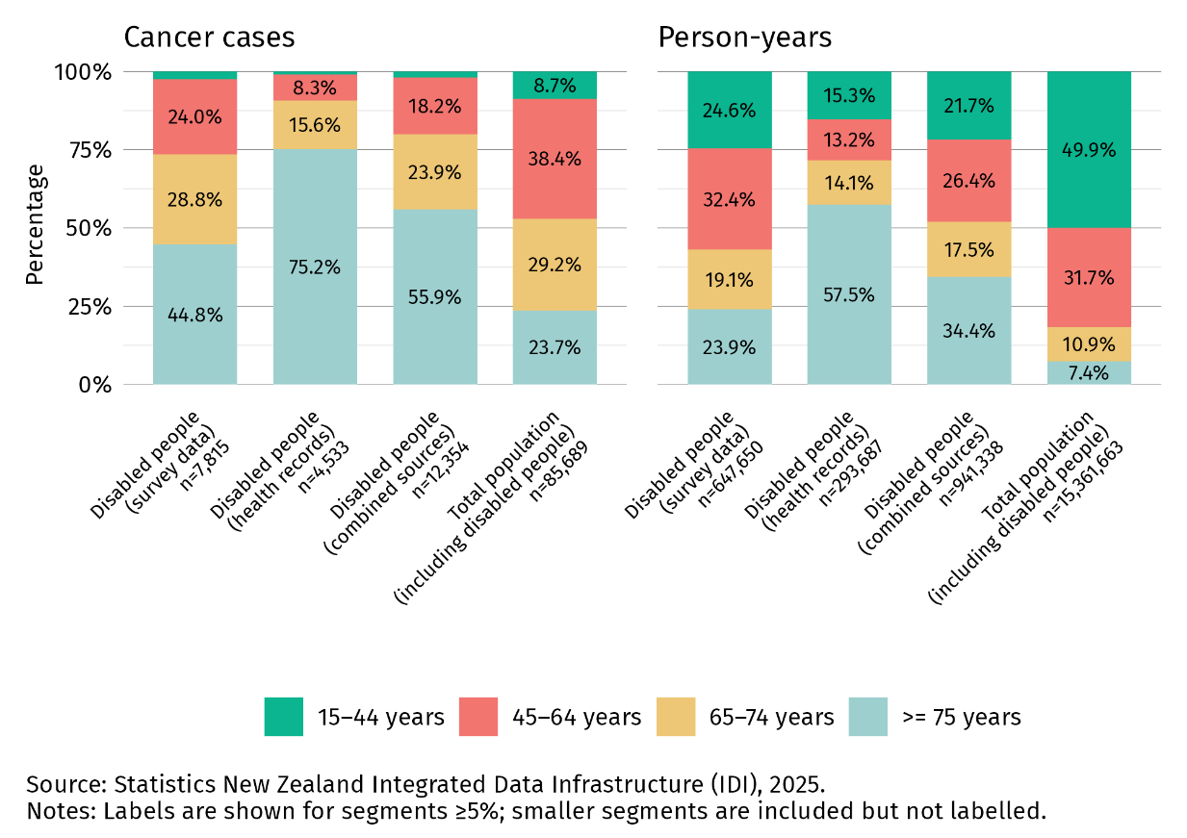

Table 3: Standard population used in this analysis, showing the distribution of person-years by age group. This reflects the age distribution of the disabled cohort.
Age group (years) | Distribution (%)
15–44 | 21.67
45–64 | 26.41
65–74 | 17.53
≥75 | 34.39

Wide age groups were used to account for small numbers and avoid multiple empty cells when conducting age adjustments for subpopulation groups, particularly for the disabled population (Gurney et al 2020). This approach ensured more stable estimates while maintaining the integrity of comparisons across groups.

Relative standard error was calculated to assess the stability of the age-standardised rates. If a relative standard error was greater than 30%, the results were deemed to be ‘unstable’ (Washington State Department of Health 2012).

Sensitivity analysis
A comprehensive sensitivity analysis was conducted to assess the robustness of findings and ensure that differences in estimated cancer incidence between disabled and total populations were not unduly influenced by data source selection, methodological assumptions, or population overlap.

This analysis examined how estimated rates of cancer diagnosis vary depending on whether survey data alone, administrative data alone, or a combination of both are used. Both crude and age-standardised incidence rates were calculated for key demographic groups such as sex, ethnicity, socioeconomic deprivation, and rurality, and then compared across data sources.

While differences in age structure and data coverage influenced results —particularly for Asian peoples — the combined approach produced a more balanced and stable representation. Notably, lung cancer incidence was higher using administrative data, whereas prostate cancer incidence appeared higher using survey data.

Crude and age-standardised incidence rates for all cancers combined, stratified by sex, ethnicity, socioeconomic deprivation, and rurality, are presented in Table 4. Figure 16 shows age-standardised incidence rates by cancer type and data source.

Table 4: Crude and age-standardised cancer incidence rates per 100,000 person-years for all cancers combined among disabled people (survey, health records and combined data)
 |  | Survey data |  |  | Health records |  |  | Combined sources
 | Crude rate |  | Age-standardised rate | Crude rate |  | Age-standardised rate | Crude rate |  | Age-standardised rate
Cases eligible | 1,206.7 |  | 1,357.9 | 1,543.5 |  | 1,273.0 | 1,311.8 |  | 1,312.5
Sex
Female | 1,083.4 |  | 1,192.6 | 1,501.7 |  | 1,162.8 | 1,226.1 |  | 1,168.5
Male | 1,339.5 |  | 1,552.8 | 1,609.3 |  | 1,466.3 | 1,414.3 |  | 1,513.9
Ethnicity
Māori | 1,023.6 |  | 1,657.9 | 1,377.1 |  | 1,566.5 | 1,106.1 |  | 1,602.2
Pacific peoples | 888.5 |  | 1,236.5 | 1,036.0 |  | 1,078.9 | 922.7 |  | 1,171.5
Asian | 623.4 |  | 805.7 | 886.2 |  | 864.2 | 677.1 |  | 794.1
European/Other | 1,352.9 |  | 1,375.0 | 1,634.2 |  | 1,261.1 | 1,450.3 |  | 1,320.9
Area of deprivation
Quintile 1  (least deprived) | 1,155.7 |  | 1,265.5 | 1,406.8 |  | 1,197.1 | 1,223.9 |  | 1,211.3
Quintile 2 | 1,230.1 |  | 1,340.2 | 1,559.8 |  | 1,243.7 | 1,328.5 |  | 1,293.7
Quintile 3 | 1,261.0 |  | 1,378.4 | 1,576.3 |  | 1,218.6 | 1,358.3 |  | 1,334.8
Quintile 4 | 1,228.0 |  | 1,379.0 | 1,599.1 |  | 1,328.1 | 1,344.8 |  | 1,334.2
Quintile 5  (most deprived) | 1,159.7 |  | 1,415.1 | 1,476.8 |  | 1,353.3 | 1,249.4 |  | 1,383.6
Rurality
Rural | 1,258.4 |  | 1,443.7 | 1,506.5 |  | 1,313.6 | 1,309.7 |  | 1,410.0
Urban | 1,199.0 |  | 1,345.8 | 1,546.6 |  | 1,270.7 | 1,312.9 |  | 1,301.8
Source: Stats NZ Integrated Data Infrastructure (IDI), 2025.
Note: Rates are expressed per 100,000 person-years and age-standardised to the disabled people population.

Figure 16: Age-standardised cancer incidence rates among disabled people, by data source, 2018–2022

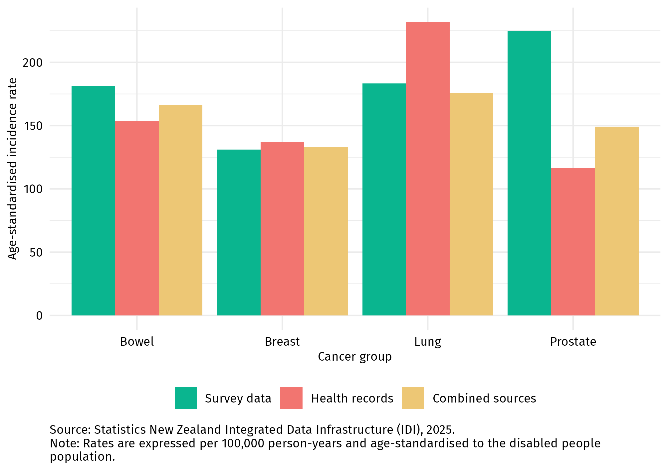

Figure 17: Age-specific cancer incidence among disabled people and the total population, per 100,000 person-years, by data source, 2018–2022
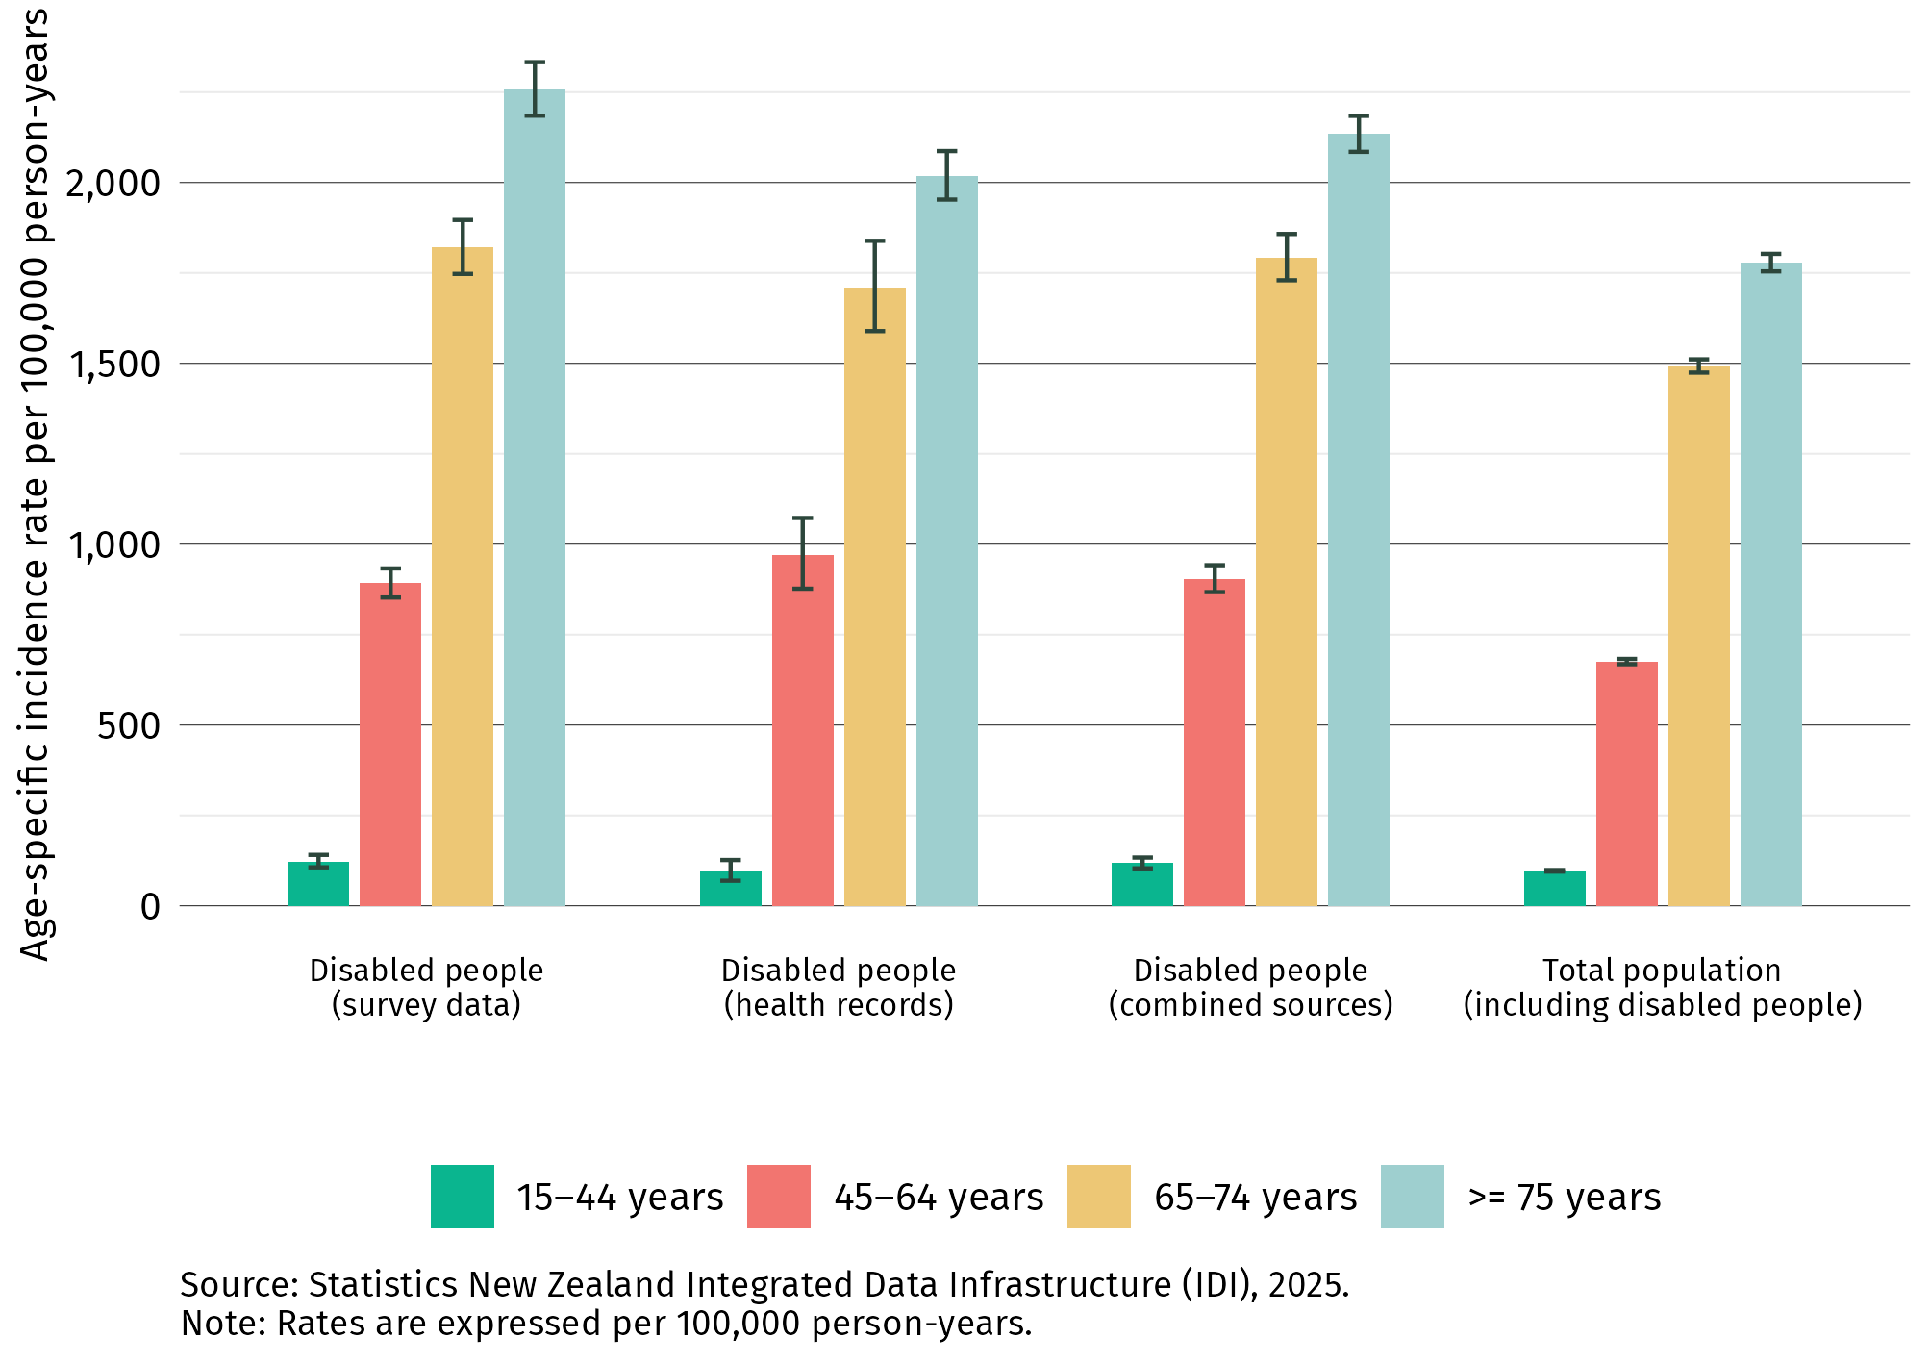

To assess the potential influence of reverse causation, several washout periods (or lag times) were applied following disability confirmation and before cancer diagnosis, to minimise potential reverse causation (for example, disability status being assessed due to undiagnosed cancer). Crude case counts were modelled using a Poisson GLM with a log link, expressed as:

“numerator_value ~ window_days * value + offset(log(denominator_value))”

The analysis showed that rates of diagnosis remained higher among the disability group compared to the total population, with this difference decreasing as the washout period increased. When a 30-day washout period was applied there was minimal change to the increased risk of cancer diagnosis experienced by disabled people. Figure 18:18 illustrates the effect of lag time on cancer incidence rate ratios.

Figure 18:18 Effect of Lag Time on Cancer Incidence Rate Ratios for all cancers combined
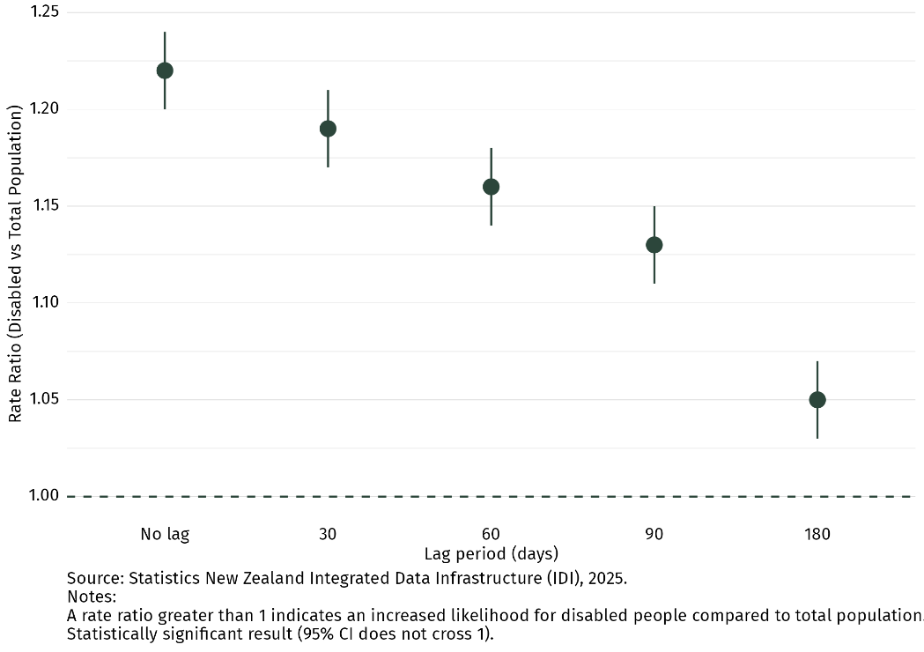

Finally, overlapping population bias was evaluated by quantifying the extent to which person-time in the total population (used as the reference group) included contributions from disabled individuals. Comparison of relative risks using the true non-disabled population versus the total population indicated minimal overlap bias overall. Slightly greater bias was observed for lung and prostate cancers, and moderate effects were seen for Māori and Pacific peoples, but for most other groups, the influence of overlap on incidence estimates was negligible.

Confidentiality and suppression
Counts less than 6 have been suppressed, and rounding to the nearest multiple of 3 (RR3) has been applied in accordance with Stats NZ guidelines to protect confidentiality (Stats NZ 2020).

Individual-level data items
Table 5 outlines the individual-level data items used for analysis, including the variable reporting in the analysis.

Table 5: Individual-level data items used for analysis
 | Variable | Description
1 | ID | Unique identifier for each individual.
2 | Usual Residence Date | The date the individual became a usual resident of Aotearoa New Zealand.
3 | Sex | Sex of each individual (either ‘Male’ or ‘Female’).
4 | Age Group | The individual’s age group at the start of that individual’s follow-up period.
5 | Ethnicity | The individual’s ethnic group (‘Māori’, ‘Pacific Peoples’, ‘Asian’ or ‘European/other’).
6 | Deprivation | Deprivation quintile in which the individual lived at the start of their follow-up period (NZDep2018).
7 | Urban–Rural Status | The area in which the individual lived at the start of the follow-up period according to the Stats NZ’s Urban Rural Indicator (IUR) of 2023.
8 | Disability Status | Binary indicator of whether an individual had a disability at any time during the follow-up period (‘Yes’ or ‘No’ according to Social Wellbeing Agency definition).
9 | Date of Disability Confirmation | The earliest date on which disability status was confirmed following the start of the follow-up period.  NB: We are primarily interested in what the disability status was at the start of the follow-up period for each individual.
10 | Disability Status Record Source | The record source that was used to indicate disability status.
11 | Cancer Status | Binary indicator of whether an individual was diagnosed with cancer during the follow-up period (‘Yes’ or ‘No’).  NB: We used the first primary cancer registered for each individual during the follow-up period.
12 | Cancer Type | Four common cancer types: breast, bowel, lung and prostate. Other cancers were categorised as ‘Other’.
13 | Cancer Diagnosis Date | The date of first primary cancer diagnosis within the follow-up period (if applicable).
14 | Left the Country | Binary indicator of whether an individual left the country (no longer a usual resident) during the follow-up period (‘Yes’ or ‘No’).
15 | Left the Country Date | The date of leaving the country (30 June of the year in which an individual was no longer considered a usual resident) for those alive (if applicable).
16 | Follow-up Start Date | The latest of ‘30 June 2018’ or ‘date of becoming a usual resident’.
17 | Follow-up End Date | The earliest of ‘30 June 2022’, ‘Cancer Diagnosis Date’, ‘Date of Death’ or ‘Left the Country Date’.
18 | Person-Years (Overall) | Person-years for each individual (number of days at risk (from Follow-up Start Date to Follow-up End Date) / 365.25).
19 | Person-Years (With Disability) | Person-years for each individual (number of days at risk (from Date of Disability Confirmation) / 365.25).  NB: For those who had their disability status confirmed prior to the follow-up period start date, person-years were counted for those individuals from 30 June 2018.

Appendix 2: Data Tables
Āpitihanga tuarua

Lung cancer incidence
Table 6: Age-standardised incidence of lung cancer among disabled people and the total population per 100,000 person-years, 2018–2022
 | Disabled people  (rate per 100,000 person-years) | Total population  (rate per 100,000 person-years) | Rate ratio  (95% CI)
Overall lung cancer incidence | 176 | 103 | 1.71 (1.62–1.80)
Sex
Female | 167 | 97 | 1.72 (1.60–1.85)
Male | 193 | 111 | 1.74 (1.61–1.88)
Ethnicity
Māori | 328 | 235 | 1.39 (1.24–1.56)
Pacific peoples | 165 | 132 | 1.25 (0.96–1.62)
Asian | 130 | 88 | 1.48 (1.15–1.90)
European/Other | 158 | 91 | 1.73 (1.62–1.84)
Area of deprivation
Quintile 1 (least deprived) | 116 | 68 | 1.70 (1.41–2.05)
Quintile 2 | 149 | 83 | 1.79 (1.55–2.07)
Quintile 3 | 165 | 97 | 1.70 (1.49–1.93)
Quintile 4 | 176 | 117 | 1.51 (1.35–1.69)
Quintile 5 (most deprived) | 243 | 167 | 1.46 (1.33–1.60)
Rurality
Rural | 196 | 109 | 1.80 (1.56–2.08)
Urban | 175 | 103 | 1.70 (1.60–1.80)
Age group
45–64 years | 105 | 47 | 2.22 (1.95–2.52)
65–74 years | 298 | 142 | 2.10 (1.91–2.31)
≥75 years | 278 | 190 | 1.47 (1.36–1.59)
Source: Stats NZ Integrated Data Infrastructure (IDI), 2025.
Notes: Rates (apart from age group rates) are expressed per 100,000 person-years and age-standardised to the disabled people population.
There were no cases available for individuals between the ages of 15 and 44.

Bowel cancer incidence
Table 7: Age-standardised incidence of bowel cancer among disabled people and the total population per 100,000 person-years, 2018–2022
 | Disabled people  (rate per 100,000 person-years) | Total population  (rate per 100,000 person-years) | Rate ratio  (95% CI)
Overall bowel cancer incidence | 166 | 149 | 1.12 (1.06–1.18)
Sex
Female | 156 | 136 | 1.15 (1.07–1.24)
Male | 179 | 163 | 1.10 (1.02–1.19)
Ethnicity
Māori | 145 | 124 | 1.17 (0.97–1.41)
Pacific | 103 | 87 | 1.19 (0.85–1.67)
Asian | 93 | 99 | 0.94 (0.71–1.25)
European/Other | 179 | 157 | 1.14 (1.08–1.21)
Area of deprivation
Quintile 1 (least deprived) | 162 | 146 | 1.11 (0.95–1.30)
Quintile 2 | 174 | 153 | 1.14 (1.00–1.30)
Quintile 3 | 172 | 150 | 1.14 (1.01–1.26)
Quintile 4 | 180 | 159 | 1.13 (1.01–1.26)
Quintile 5 (most deprived) | 170 | 146 | 1.16 (1.03–1.30)
Rurality
Rural | 193 | 160 | 1.20 (1.04–1.39)
Urban | 163 | 147 | 1.11 (1.05–1.18)
Age group
15–44 years | 12 | 9 | 1.35 (0.90–2.03)
45–64 years | 82 | 64 | 1.27 (1.10–1.46)
65–74 years | 193 | 178 | 1.08 (0.96–1.21)
≥75 years | 314 | 287 | 1.10 (1.03–1.18)
Source: Stats NZ Integrated Data Infrastructure (IDI), 2025.
Note: Rates (apart from age group rates) are expressed per 100,000 person-years and age-standardised to the disabled people population.

Breast cancer incidence
Table 8: Age-standardised incidence of breast cancer among disabled people and the total population per 100,000 person-years, 2018–2022
 | Disabled people  (rate per 100,000 person-years) | Total population  (rate per 100,000 person-years) | Rate ratio  (95% CI)
Overall breast cancer incidence | 133 | 120 | 1.11 (1.05–1.18)
Sex
Female | 237 | 223 | 1.06 (1.00–1.12)
Ethnicity
Māori | 199 | 174 | 1.15 (1.00–1.32)
Pacific | 137 | 116 | 1.17 (0.91–1.51)
Asian | 96 | 86 | 1.12 (0.85–1.47)
European/Other | 127 | 118 | 1.07 (1.00–1.15)
Area of deprivation
Quintile 1 (least deprived) | 108 | 116 | 0.93 (0.77–1.12)
Quintile 2 | 128 | 118 | 1.08 (0.93–1.26)
Quintile 3 | 140 | 118 | 1.19 (1.04–1.36)
Quintile 4 | 139 | 123 | 1.13 (1.00–1.27)
Quintile 5 (most deprived) | 147 | 127 | 1.15 (1.03–1.29)
Rurality
Rural | 110 | 104 | 1.05 (0.88–1.25)
Urban | 136 | 123 | 1.11 (1.05–1.18)
Age group
15–44 years | 18 | 23 | 0.77 (0.55–1.07)
45–64 years | 134 | 131 | 1.02 (0.91–1.14)
65–74 years | 149 | 147 | 1.01 (0.89–1.15)
≥75 years | 196 | 159 | 1.24 (1.13–1.36)
Source: Stats NZ Integrated Data Infrastructure (IDI), 2025.
Note: Rates (apart from age group rates) are expressed per 100,000 person-years and age-standardised to the disabled people population.

Prostate cancer incidence
Table 9: Age-standardised incidence of prostate cancer among disabled people and the total population per 100,000 person-years, 2018–2022
 | Disabled people  (rate per 100,000 person-years) | Total population  (rate per 100,000 person-years) | Rate ratio  (95% CI)
Overall prostate cancer incidence | 149 | 170 | 0.88 (0.83–0.93)
Sex
Male | 340 | 367 | 0.93 (0.88–0.98)
Ethnicity
Māori | 177 | 184 | 0.96 (0.82–1.12)
Pacific | 169 | 164 | 1.03 (0.80–1.32)
Asian | 63 | 90 | 0.70 (0.49–0.99)
European/Other | 156 | 179 | 0.87 (0.82–0.92)
Area of deprivation
Quintile 1 (least deprived) | 188 | 195 | 0.97 (0.84–1.12)
Quintile 2 | 166 | 183 | 0.91 (0.80–1.04)
Quintile 3 | 159 | 175 | 0.91 (0.80–1.03)
Quintile 4 | 134 | 153 | 0.88 (0.78–0.99)
Quintile 5 (most deprived) | 130 | 147 | 0.89 (0.79–1.01)
Rurality
Rural | 221 | 223 | 0.99 (0.87–1.12)
Urban | 138 | 162 | 0.86 (0.81–0.91)
Age group
45–64 years | 127 | 123 | 1.03 (0.92–1.15)
65–74 years | 298 | 371 | 0.80 (0.73–0.88)
≥75 years | 185 | 210 | 0.88 (0.80–0.96)
Source: Stats NZ Integrated Data Infrastructure (IDI), 2025.
Notes: Rates (apart from age group rates) are expressed per 100,000 person-years and age-standardised to the disabled people population.
There were no cases available for individuals between the ages of 15 and 44.

References
Ngā tohutoro
Atkinson E, Salmond C, Crampton P. 2019. NZDep2018 Index of Deprivation – Final Research Report. Wellington: Department of Public Health, University of Otago. URL: https://www.otago.ac.nz/__data/assets/pdf_file/0020/326711/nzdep2018-index-of-deprivation-research-report-final-dec-2020-823833.pdf
Beltran-Castillon L, McLeod K. 2023. From Data to Dignity: Health and wellbeing indicators for New Zealanders with intellectual disability – Mai i te raraunga ki te rangatiratanga o te noho: Ngā tūtohu hauora, toiora hoki mō te hunga whai kaha o Aotearoa. IHC. https://www.ihc.org.nz/publications/from-data-to-dignity-health-and-wellbeing-indicators-for-new-zealanders-with-intellectual-disability-easy-read
Fenton JJ, Weyrich MS, Durbin S, et al. 2018. Prostate-specific antigen-based screening for prostate cancer: Evidence report and systematic review for the US Preventive Services Task Force. Journal of the American Medical Association 319(18): 1914–31. https://doi.org/10.1001/jama.2018.3712
Floud S, Barnes I, Verfürden M, et al. 2017. Disability and participation in breast and bowel cancer screening in England: a large prospective study. British Journal of Cancer 117(11): 1711–14. https://doi.org/10.1038/bjc.2017.331
Goddard KS, Hall JP. 2025. Limitations of the Washington Group Short Set in capturing moderate and severe mobility disabilities. Health Affairs Scholar 3(2): qxaf015. https://doi.org/10.1093/haschl/qxaf015
Gurney J, Stanley J, Sarfati D. 2020. The inequity of morbidity: Disparities in the prevalence of morbidity between ethnic groups in New Zealand. Journal of Comorbidity 10: 2235042X20971168. https://doi.org/10.1177/2235042x20971168
Gurney J, Stanley J, Teng A, et al. 2022. Cancer and diabetes co-occurrence: A national study with 44 million person-years of follow-up. PLOS ONE 17(11): e0276913. https://doi.org/10.1371/journal.pone.0276913
Gurram, N., Carroll, F., et al. 2024. Understanding ethnic inequities associated with tobacco use in Aotearoa New Zealand: A quantitative analysis. Health Promotion International, 39(3). https://doi.org/10.1093/heapro/daae045
Health and Disability System Review. 2020. Health and Disability System Review – Final report – Pūrongo whakamutunga. Wellington: Health and Disability System Review. https://www.systemreview.health.govt.nz/final-report
Hickey H, Wilson D. 2017. Whānau hauā: Reframing disability from an Indigenous perspective. MAI Journal 6(1): 82–94. https://www.journal.mai.ac.nz/content/wh%C4%81nau-hau%C4%81-reframing-disability-indigenous-perspective
Hughes RB, Robinson-Whelen S, Knudson C. 2022. Cancer disparities experienced by people with disabilities. International Journal of Environmental Research and Public Health 19(15): 9187. https://doi.org/10.3390/ijerph19159187
Iezzoni LI. 2022. Cancer detection, diagnosis, and treatment for adults with disabilities. The Lancet Oncology 23(4): e164–73. https://doi.org/10.1016/s1470-2045(22)00018-3
Iezzoni LI, Rao SR, Agaronnik ND, et al. 2020. Cross-sectional analysis of the associations between four common cancers and disability. Journal of the National Comprehensive Cancer Network 18(8): 1031–44. https://doi.org/10.6004/jnccn.2020.7551
Kilic A, Tastan S, Guvenc G, et al. 2019. Breast and cervical cancer screening for women with physical disabilities: A qualitative study of experiences and barriers. Journal of Advanced Nursing 75(9): 1976–86. https://doi.org/10.1111/jan.14048
Liao CM, Huang WH, Kung PT, et al. 2021. Comparison of colorectal cancer screening between people with and without disability: A nationwide matched cohort study. BMC Public Health 21: 1034. https://doi.org/10.1186/s12889-021-11105-z
Mele N, Archer J, Pusch BD. 2005. Access to breast cancer screening services for women with disabilities. Journal of Obstetric, Gynecologic, and Neonatal Nursing 34: 453–464.
Minister of Health. 2023. Provisional Health of Disabled People Strategy. Wellington: Ministry of Health. https://www.health.govt.nz/publications/health-of-disabled-people-strategy
Ministry of Health. 2019a. Te Mahere mō te Mate Pukupuku o Aotearoa 2019–2029 New Zealand Cancer Action Plan 2019–2029. Revised January 2020. Wellington: Ministry of Health. https://www.health.govt.nz/publications/new-zealand-cancer-action-plan-2019-2029
Ministry of Health. 2019b. Māori Health Disability Statistical Report. Wellington: Ministry of Health. https://www.waitangitribunal.govt.nz/en/inquiries/kaupapa-inquiries/health-services-and-outcomes
Ministry of Health. 2020. Whakamaua: Māori Health Action Plan 2020–2025. Wellington: Ministry of Health.
Ministry of Health. 2024. Annual Data Explorer 2023/24: New Zealand Health Survey [Data File]. https://minhealthnz.shinyapps.io/nz-health-survey-2023-24-annual-data-explorer/_w_1309071e/#!/home
National Cancer Institute. 2021. Overdiagnosis outcomes. https://visualsonline.cancer.gov/details.cfm?imageid=12720 (accessed 30 October 2025).
Office for Disability Issues – Te Tarī Mō Ngā Take Hauātanga. 2016. New Zealand Disability Strategy 2016–2026. https://www.disabilitysupport.govt.nz/disabled-people/resources-for-people-new-to-the-disability-community/new-zealand-disability-strategy-2016-2026
Ouellette-Kuntz H, Coo H, Cobigo V, et al. 2015. Uptake of colorectal cancer screening among Ontarians with intellectual and developmental disabilities. PLOS ONE 10(2): e0118023. https://doi.org/10.1371/journal.pone.0118023
Peters K, Cotton A. 2014. Barriers to breast cancer screening in Australia: Experiences of women with physical disabilities. Journal of Clinical Nursing 24(3–4): 563–72. https://doi.org/10.1111/jocn.12696
Social Wellbeing Agency. 2022. Developing an Indicator Relating to Disability. https://sia.govt.nz/assets/Te-Atatu-Developing-an-indicator-of-disability.pdf
Stats NZ. 2020. Microdata Output Guide (5th edition, version 2). Wellington: Stats NZ. https://www.stats.govt.nz/assets/Methods/Microdata-Output-Guide-2020-v5-Sept22update.pdf
Stats NZ. 2023. Household Disability Survey 2023 – findings, definitions, and design summary. Wellington: Stats NZ. https://www.stats.govt.nz/reports/household-disability-survey-2023-findings-definitions-and-design-summary/

Stats NZ. 2025. Aotearoa Data Explorer Place and Ethnic Group Summaries. Stats NZ. https://tools.summaries.stats.govt.nz/ethnic-group/maori#new-zealand-index-of-socioeconomic-deprivation (Accessed 10 November 25).
Te Aho o Te Kahu – Cancer Control Agency. 2021. He Pūrongo Mate Pukupuku o Aotearoa 2020 – The State of Cancer in New Zealand 2020. Wellington: Te Aho o Te Kahu – Cancer Control Agency. https://teaho.govt.nz/index.php/reports-and-numbers/reports/state-cancer-new-zealand-2020
Te Aho o Te Kahu – Cancer Control Agency. 2022. Pūrongo Ārai Mate Pukupuku – Cancer Prevention Report. Wellington: Te Aho o Te Kahu – Cancer Control Agency. https://teaho.govt.nz/index.php/reports-and-numbers/reports/cancer-prevention-report
Te Aho o Te Kahu – Cancer Control Agency. 2025. Disabled People and Cancer: Literature Review - Ngā Tāngata Whaikaha me te mate pukupuku: he arotakenga mātātuhi. Wellington: Te Aho o Te Kahu – Cancer Control Agency. https://teaho.govt.nz/application/files/7617/6410/6750/Disabled_people_and_cancer_Literature_Review_Te_Aho_o_Te_Kahu_Cancer_Control_Agency_27_November_2025.pdf

Te Whatu Ora. 2024. Cancer web tool. https://www.tewhatuora.govt.nz/for-health-professionals/data-and-statistics/cancer/data-web-tool (accessed 12 December 2024).
United Nations. 2006. Convention on the Rights of Persons with Disabilities. https://www.ohchr.org/en/instruments-mechanisms/instruments/convention-rights-persons-disabilities
Vandenbroucke J, Pearce N. 2015. Point: Incident exposures, prevalent exposures, and causal inference: Does limiting studies to persons who are followed from first exposure onward damage epidemiology? American Journal of Epidemiology 182(10): 826–833. https://doi.org/10.1093/aje/kwv225
Ward LM, Cooper S-A, Sosenko F, et al. 2024. Population-based cancer incidence and mortality rates and ratios among adults with intellectual disabilities in Scotland: a retrospective cohort study with record linkage. BMJ Open 14(8): e084421. https://doi.org/10.1136/bmjopen-2024-084421
Washington Group on Disability Statistics. 2020. The Washington Group Short Set on Functioning (WG-SS). https://www.washingtongroup-disability.com/question-sets/wg-short-set-on-functioning-wg-ss/
Washington State Department of Health. 2012. Guidelines for Using Confidence Intervals for Public Health Assessment. https://doh.wa.gov/sites/default/files/legacy/Documents/1500/ConfIntGuide.pdf
Whitehead J, Davie G, de Graaf B, et al. 2022. Defining rural in Aotearoa New Zealand: a novel geographic classification for health purposes. N Z Med J, 2022. 135(1559): p. 24-40. https://nzmj.org.nz/media/pages/journal/vol-135-no-1559/defining-rural-in-aotearoa-new-zealand-a-novel-geographic-classification-for-health-purposes/b85eea4c89-1696472104/defining-rural-in-aotearoa-new-zealand-a-novel-geographic-classification-for-health-purposes-open-access.pdf
World Health Organization. 2011. World Report on Disability. Geneva: World Health Organization. https://www.who.int/publications/i/item/9789241564182
World Health Organization. 2023. Lung cancer. https://www.who.int/news-room/fact-sheets/detail/lung-cancer (accessed 14 August 2025).
Yankaskas BC, Dickens P, Bowling JM, et al. 2010. Barriers to adherence to screening mammography among women with disabilities. American Journal of Public Health 100(5): 947–53. https://doi.org/10.2105/AJPH.2008.150318

Available at stats.govt.nz/privacy-impact-assessments/privacy-impact-assessment-for-the-integrated-data-infrastructure.
We note these proportions are lower compared with the previous survey, likely due in part to methodological changes that mean these results reflect only people who reported a high level of difficulty with functional tasks. In total, 51% of the population reported at least some difficulty with functional tasks. Source: customised data from the 2023 Household Disability Survey, provided by Stats NZ in May 2025.
Available at Disabled people and cancer: Literature review
Available at teaho.govt.nz/index.php/our-work/disability-and-cancer-project
We note these proportions are lower compared to the previous survey, likely due in part to the impact of methodological changes.
The age of eligibility for the NBSP will reduce to 58 years in a staged approach from late 2025.
Hazardous drinking is measured using the 10-question Alcohol Use Disorders Identification Test (AUDIT) developed by the World Health Organization. The AUDIT is a 10-item questionnaire that covers alcohol consumption, dependence and adverse consequences. Hazardous drinkers are those who obtain an AUDIT score of 8 or more, representing an established pattern of drinking that carries a high risk of future damage to physical or mental health.
The age of eligibility for BreastScreen Aotearoa is being extended to include women aged 70–74.
For more information on the disability indicator work of the Social Wellbeing Agency (which became the Social Investment Agency in 2024), visit sia.govt.nz/publications/Te-Atatu-Developing-an-indicator-of-disability.

