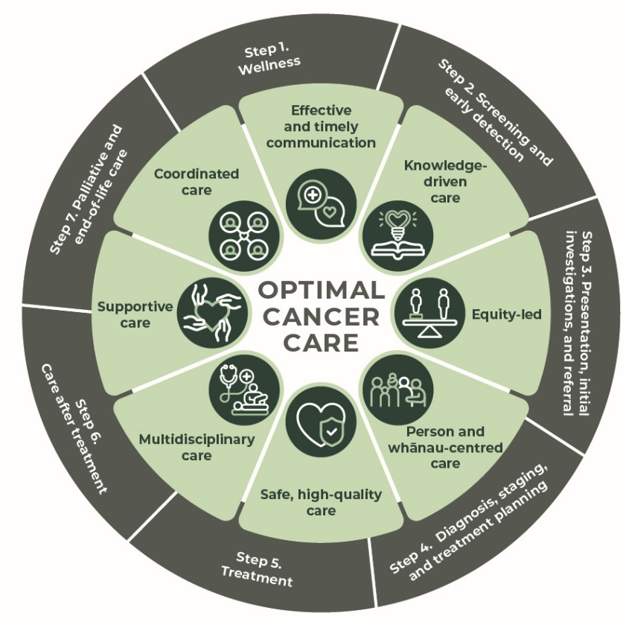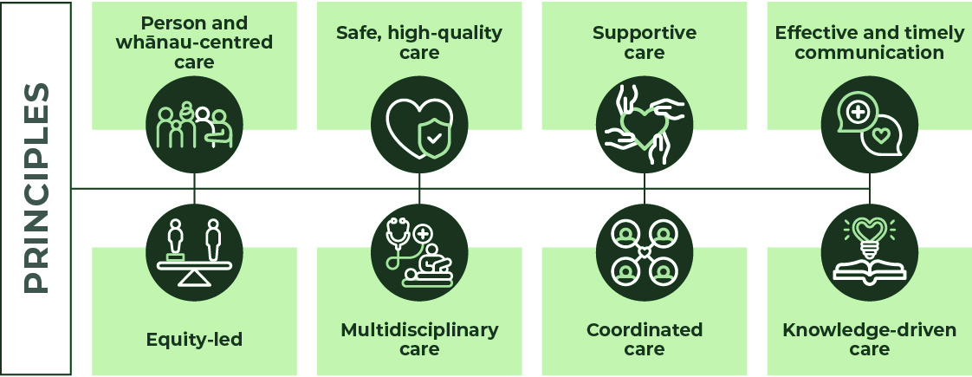
Optimal cancer care pathway for people with bowel cancer September 2024 (updated 12/9/25)

Quick reference guide (Edition One, version 2). 

Step 1: Wellness – cancer prevention efforts should be part of all cancer control pathways. This step recommends actions the person/whānau can take to improve their wellbeing and reduce the overall risk of cancer.

The Optimal Cancer Care Pathways (OCCP) describe the standard of care that people and whānau across Aotearoa, New Zealand can expect from the public health system. They follow eight principles: person and whānau-centred care; equity-led; safe, high-quality care; multidisciplinary care; supportive care; coordinated care; effective and timely communication; and knowledge-driven care. The OCCP guides health providers in ensuring the person and their whānau receive optimal, supportive care at each stage of their cancer diagnosis and treatment.

Checklist:
- Carry out a health and wellbeing assessment including discussions around screening services and ways to reduce cancer risk.
- Assess the individual’s risk of developing cancer, including a family history of bowel or other cancer.
- Provide screening recommendations if eligible.
- Encourage eligible people to participate in national screening programmes.
- Discuss recent weight changes and monitor weight.
- Discuss and record alcohol intake. Offer support for reducing alcohol consumption if appropriate.
- Record person’s smoking status and offer stop smoking advice/support if appropriate.
- Record physical activity.
- Consider referral to a dietitian, physiotherapist, or exercise programme.
- Give the person education on being sun smart.
- Ask person if they have an existing advance care plan, advance directive, or enduring power of attorney, and discuss as required.
Evidence-based research shows that general cancer and wellbeing risks can be reduced by:
- eating a nutritious diet
- maintaining a healthy weight
- taking regular, moderate to vigorous-intensity activity
- avoiding or limiting alcohol intake
- being sun smart
- identifying pre-disposing infections such as, Hepatitis C
- keeping up to date with immunisations or vaccines such as, Human Papilloma Virus (HPV)
- avoiding smoking including marijuana and exposure to second-hand smoke
- current smokers (or those who have recently quit) should be offered best practice tobacco dependence treatment and an opt-out referral to an intervention service such as Quitline
- avoiding vaping
- participating in screening services such as breast, cervical, bowel cancer screening
- preventing occupational exposure to asbestos, silica, radon heavy metal, diesel exhaust and polycyclic aromatic hydrocarbons.

Early detection
The person/whanau should report any bowel symptoms to their health care provider.
Bowel cancer non-modifiable risks include:
- being over 50 years old
- having a close family member diagnosed with bowel cancer before 55 years old
- having two or more close family members of the same side of your family who have had bowel cancer
- having a known genetic bowel cancer syndrome in your family (such as familial adenomatous polyposis (FAP), Lynch Syndrome or other rare conditions
- if you have previously had polyps (adenomas) in the bowel and close family members who have had polyps in the bowel
- having inflammatory bowel diseases such as ulcerative colitis or Crohn’s disease.

Screening programmes increase the chance of identifying cancer early and improve the person’s treatment outcome.
General Practitioners (GP)/clinicians check if the person and their whānau have any relevant screening due and arrange support to attend.
Assessing family history and appropriate referral for surveillance recommendations can significantly impact prevention or early detection for the person/whānau with a familial colorectal cancer risk.
There are three national screening programmes for breast, bowel, and human papillomavirus testing (HPV) for cervical cancer.
National Bowel Screening is free and offered every two years to people aged 60 to 74 years who are eligible for publicly funded health care.
Free bowel screening is available to Māori and Pacific people from the age of 50 to 74. This is not yet nationally available.
Refer to the bowel cancer optimal cancer care pathway for more information about the screening and early detection.

Step 2: Screening and early detection - recommends options for screening and early detection for the person/whānau with bowel cancer.

Checklist:
- Assess and discuss the individual’s risk of developing cancer.
- Support the person and their whānau to follow surveillance guidance if they’re at an increased risk of familial cancer.
- Provide screening recommendations if eligible.
- For people/whānau with a family history of bowel cancer, assess risk category and provide appropriate recommendations. For further information:
Te Whatu Ora – Health New Zealand. 2023. Update on Surveillance Recommendations for Individuals with a Family/Whānau History of Colorectal Cancer. Wellington: Te Whatu Ora – Health New Zealand
- If assessed as high risk, refer the person/whānau either to the New Zealand Familial GI Cancer Service (NZFGCS) or to a genetic service for an accurate risk assessment.
For further information visit: Genetic Health Service New Zealand – genetichealthservice.org.nz
New Zealand Familial Gastrointestinal Cancer Service - nzfgcs.co.nz

- For guidance on the surveillance of the person with previous bowel polyps, refer:
Te Whatu Ora – Health New Zealand. 2024. Update on polyp surveillance guidelines.
- Discuss recent weight changes and monitor weight.
- Encourage participation in National Screening Programmes to eligible people.
If signs and symptoms of cancer are present refer to ‘Step 3: Presentation, initial investigation and referral’.

Communication
- Ensure the person and their whānau understands:
- the importance of participation in bowel screening if eligible
- the importance of reporting symptoms early
- awareness of family history: Time to Screen: Do you have a family history of bowel cancer?
- the national bowel screening programme and how it works
- when they should receive their results
- what to do if they don’t receive their results
- where appropriate, referral for the person/whanau either to the New Zealand Familial GI Cancer Service (NZFGCS) or to a genetic service for an accurate risk assessment.
- Providing appropriate information and referral to relevant specialty or support services as required
- what’s involved if they need to be transferred to a specialist service.

Screening timeframes
- If participating in the national screening programme for bowel cancer, the person will be notified of the screening test kit result within 3 weeks.
- The person will be contacted by the primary care provider within 10 working days of a positive FIT and an appointment arranged to explain the positive FIT and referral process.
- The person will be referred for national bowel screening colonoscopy within 10 working days of a positive FIT.

Useful Websites:
Update on Surveillance Recommendations for Individuals with a Family/Whānau History of Colorectal Cancer
Update on polyp surveillance guidelines genetichealthservice.org.nz
New Zealand Familial Gastrointestinal Cancer Service

The types of investigations undertaken will depend on many factors, including access to diagnostic tests, the availability of medical specialists and including preferences.
The types of investigations undertaken will depend on many factors, including access to diagnostic tests, the availability of medical specialists and including preferences.
A person may present via primary care, an emergency presentation or incidental finding with a high suspicion of bowel cancer.
Māori and Pacific peoples often present at an earlier age than the general population, so awareness and consideration of this needs to factor into assessment and review of signs and symptoms.
There is a small but significant increase in the incidence of bowel cancer in younger persons, and clinicians should not discount suggestive symptoms in young persons especially if the symptoms are persistent.
Signs and symptoms of bowel cancer to investigate include:
- rectal bleeding
- unexplained iron deficiency anemia
- change in bowel habit (loose stools or constipation), especially a recent one that does not have another explanation such as an infection or opioid use
- undiagnosed abdominal pain or tenderness
- unexplained rectal or abdominal mass.
Bowel cancer assessment includes:
- checking if eligible or participating in the National Bowel Screening Programme
- relevant medical history, including previous adenomas, bowel cancer, inflammatory bowel disease
- relevant medications and allergies: NSAIDs, anticoagulants, antiplatelets and immunosuppressants
- comorbidities
- relevant physical examination: ECOG, frailty assessment, weight, abdominal examination, digital rectal examination
- relevant investigations (laboratory, radiology): full blood count, iron studies and ferritin, liver function tests, creatinine, and electrolytes
- familial history including: family history of bowel cancer and other cancers including unknown primary cancers
- relevant social history.

Referral
A clinical suspicion or laboratory/ imaging findings suggestive of cancer require further investigation and a referral to hospital specialist services.
If the person presents with one of the following red flags, the referral should be triaged as a high suspicion of cancer:
- known or suspected bowel cancer (on imaging, or palpable or visible on rectal examination).
- unexplained rectal bleeding (benign anal causes treated or excluded) WITH iron deficiency anaemia (haemoglobin and ferritin below the local reference range).
- altered bowel habit (looser and/or more frequent) > 6 weeks duration PLUS unexplained rectal bleeding (benign anal causes treated or excluded) AND aged ≥ 50 years.
Step 3: Presentation, initial investigations, and referral outlines how to initiate the appropriate investigations and referrals to specialist/s in a timely manner for the person with bowel cancer.

Checklist:
- Complete all cancer assessments.
- Record signs and symptoms.
- Inform the person and their whānau of preliminary results.
- Discuss referral options of cancer care are discussed with the person and their whānau, including cost implications if private provider requested.
- Complete and record supportive care needs assessment, refer to allied health services as required.
- Inform the person and their whānau of cultural services and relevant support groups available.
- Initiate referrals and arrange further investigation.

Timeframes
- If there is a high suspicion of bowel cancer, submit referral immediately to hospital specialist services.
- If symptoms suggest bowel cancer, the person and their whānau are referred to colonoscopy or CTC within 2 weeks for urgent investigation or within 6 weeks for a routine investigation.
- High suspicion of cancer referral is triaged within 1-2 working days and referrer is notified.
- Confirm that the person referred urgently with a high suspicion of cancer will attend their first specialist assessment (FSA) clinic within two weeks.

Communication:
Explain to person and their whānau that they are being referred to a hospital specialist service and why, including:
- how long this may take
- who to contact if their symptoms change
- what to do if they do not receive their specialist appointment within the specified time.

Familial cancer risk
Referral to NZFGCS or a genetic health service if features of the cancer suggest a genetic predisposition:
- early age onset
- histology (if available)
- multiple primary cancers.
Between 1 and 5 per cent of colorectal cancers are specifically inherited (familial adenomatous polyposis and Lynch) and up to 10-15 per cent may have some inherited component
Hereditary syndromes
All newly diagnosed cases of colorectal cancer should be tested for:
- mismatch repair deficiency, preferably on initial biopsy
- BRAF and methylation testing for tumours showing MLH1 loss
- Where there is metastatic disease, RAF status and MMR.
- If family history assessment or features of the cancer suggest a genetic predisposition, refer the person to either the New Zealand Familial GI Cancer Service (NZFGCS) or to a genetic service for an accurate risk assessment.
- For further information visit:
- Genetic Health Service New Zealand – genetichealthservice.org.nz
- New Zealand Familial Gastrointestinal Cancer Service - nzfgcs.co.nz.
Te Whatu Ora – Health New Zealand. 2023. Update on Surveillance Recommendations for Individuals with a Family/Whānau History of Colorectal Cancer. Wellington: Te Whatu Ora – Health New Zealand
Treatment planning
Optimal cancer care requires a multidisciplinary approach to ensure treatment plans are tailored to an individual’s needs in collaboration with the whānau and health care team.
Diagnosis for bowel cancer may include:
- Endoscopy: sigmoidoscopy, colonoscopy for complete colonic assessment and diagnostic purposes
- Radiology: virtual colonoscopy (CT colonography), CT colonography is considered as an alternative for people with comorbidities affecting their suitability for colonoscopy
- Pathology: biopsies
- Laboratory: routine blood tests including ferritin and carcinoembryonic antigen.
Staging for bowel cancer is by:
- CT scan of the chest, abdomen, and pelvis
- MRI of the pelvis for rectal cancer to determine radiologic staging to define the extent of tumour spread and to determine neoadjuvant therapy use.
Performance status
Assess performance status using the Eastern
Cooperative Oncology Group (ECOG) Performance Status Scale to inform prehabilitation and treatment recommendations.
Prehabilitation
Initiate prehabilitation as early as possible after diagnosis to optimise the person’s wellbeing prior to treatment.
Districts that provide bowel cancer surgery should have a programme such as Enhanced Recovery after Surgery, implemented and follow ERAS protocols. This may include the use of specialist nurses to provide pre- and post-surgical support and education.

Checklist:
- Endoscopy services should assess the persons family history in relationship to bowel cancer with appropriate on-referral to the New Zealand Familial Gastrointestinal Cancer Service or Genetic Health Service when required.
- Confirm diagnosis.
- Referral to a cancer care coordinator.
- Record performance status and comorbidities.
- Discuss the person’s diagnosis at a multidisciplinary meeting (MDM) and inform
- the person and their whānau of the treatment decision.
- Consider enrolment in clinical trial.
- Consider fertility consequences with treatment and refer to fertility specialist as required.
- All people with a high suspicion of cancer have a person to coordinate their care.
- Assess supportive care needs and refer to allied health services as required.
- Ensure primary and secondary prehabilitation to optimize overall well-being is initiated.
- Referral to bowel specific support services as required.
- Begin Enhanced Recovery After surgery (ERAS) protocol if for surgery.
- Give the person and their whānau information on Cancer Society, Canteen, cancer NGOs and/or relevant cultural services and support groups available.
Step 4: Diagnosis, staging, and treatment planning outlines the process for confirming the diagnosis and stage of cancer and the planning of subsequent treatment.

Timeframe
- Staging investigations should be completed within 2 weeks.
- If required, an MDM should occur within two weeks of the suspected or confirmed diagnosis.
- The person referred with high suspicion of cancer and triaged by a clinician will receive their first treatment within 62-days from date of referral.

Communication:
The lead clinician and team are responsible for:
- discussing a timeframe for diagnosis and treatment options with person and their whānau
- explaining the role of the role of the MDM team in treatment planning and ongoing care
- encouraging discussion about the diagnosis, prognosis, advance care planning and palliative care while clarifying wishes, needs, beliefs, and expectations of the person and their whānau and their ability to comprehend the communication
- providing appropriate information and referral to support services as required
- communication with the GP of the person and their whānau about the diagnosis, treatment plan and recommendations from the MDM.

Establish the intent of treatment:
- curative
- non-curative
- symptom palliation
- palliative care.
Treatment options
Surgery – may be used to stage the cancer and as a form of therapy. Surgery is recommended for many people with bowel cancer.
Systemic therapy – people who may benefit from systemic therapy includes those:
- at high risk of recurrence and who may benefit from adjuvant therapy after surgery with locally advanced/ clinically high-risk features of rectal cancer, treated with neoadjuvant therapy
- with non-resectable, locally advanced or metastatic disease.

Radiation therapy – the person who may benefit from radiation therapy includes those with:
- Locally advanced/clinically high-risk rectal cancer
- symptomatic, non-resectable locally advanced rectal cancer who may benefit from radiation therapy with or without concurrent chemotherapy given with palliative (non-curative) intent
- colon cancer where the tumour has penetrated a fixed structure
- definitive treatment (+/- “Watch and Wait”) for people who are unfit for surgery or who wish to avoid surgery.
Palliative care – Early referral to palliative care can improve quality of life and in some cases survival. Referral is based on need, not prognosis.
Step 5: Treatment describes publicly funded optimal treatment for bowel cancer by suitably trained and experienced clinicians and team members, in an appropriate environment.

Checklist:
- Health providers/professional, treating specialist has relevant qualifications, experience, and expertise.
- Discuss the intent of treatment and the risks and benefits discussed with the person and their whānau.
- Discuss and provide the agreed treatment plan with the person, their whānau and GP.
- Assess supportive care needs and refer to allied health services as required.
- Give the person and their whānau information on cancer non-governmental organisations (NGOs,) cultural services and support groups available.
- Consider early referral to palliative care if appropriate.
- Discuss advanced care planning with the person and their whānau.

Timeframes
- The person with a confirmed diagnosis of bowel cancer receives their first treatment within 31-days of the decision to treat.
- The person referred urgently with a high suspicion of bowel cancer receives their first cancer treatment within 62-days.
- Time to surgery, if required after neoadjuvant radiation therapy, depends on the regimen.
- The person with non-metastatic bowel cancer is presented in the bowel cancer MDM within three weeks after surgery for consideration of adjuvant therapy.
- If radiation or chemotherapy is a first treatment, treatment should occur within 31-days of the decision to treat.
- Adjuvant chemotherapy should begin within four weeks after surgery, where recovery allows.

Communication:
The lead clinician and team are responsible for discussing these areas with the person and their whānau:
- treatment options including the intent of treatment, risks, and benefits
- advance care planning
- finding appropriate support for exercise programmes to improve treatment outcomes if required.

Provide a summary of the treatment and follow-up care plan to the person, their whānau and their GP outlining:
- diagnosis, including tests performed and results
- any referral to the NZFGGCS or genetic health service for treatment and include types and dates of tests/treatment
- current toxicities (severity, management and expected outcomes)
- interventions and treatment plans from other health providers/professionals
- potential long-term and latent effects of treatment and care of these
- supportive care services provided
- a follow-up schedule, including tests required and timing
- contact information for key health care providers/ professionals who can offer support for lifestyle modification
- a process for rapid re-entry to medical services for suspected recurrence
- ongoing assessments of the effects of treatment such as:
  - changes to bowel function
  - formation of a stoma
  - fatigue
  - nutrition
  - sexual function
  - bladder function
  - peripheral neuropathy.

Checklist:
- Provide a survivorship plan that includes a summary of the treatment and follow-up care plan to the person, whānau and their GP.
- Assess supportive care needs and refer to allied health services as required.
- Give the person and their whānau information on the Cancer Society, Cancer NGOs and/or relevant cultural services and support groups available.

Step 6: Care after treatment - the person and their whānau access appropriate follow up and surveillance and are supported to achieve their optimal health after cancer treatment.

Communication
A key way to support the person and their whānau is by coordinating ongoing, clear communications between all health providers/professionals involved in their providing their cancer care.
Palliative and end-of-life care may be provided through:
- hospital palliative care
- home and community-based care
- community nursing, including access to appropriate equipment.
Early identification, correct assessment and treatment of pain and other symptoms prevent and relieves suffering.

Communication
The lead clinician (or delegated representative) is responsible for:
- explaining the treatment summary and follow up care plan to the person and their whānau
- informing the person and their whānau about secondary prevention and healthy living
- discussing the follow-up care plan with the person and their whānau
- communicating the follow-up care plan with the GP
- providing guidance for rapid re-entry to specialist services.

Step 7: Palliative and end-of-life care provides the person facing life-limiting conditions and their whānau with holistic support and coordinated services based on their specific needs.

Checklist:
- Refer to specialist palliative care services as required.
- Refer to supportive care services as required.
- Make sure the person and their whānau are aware of the prognosis and what to expect when someone has a life limiting disease and/or is dying.
- Activation of advance care plan, directive, or enduring power of attorney.

