PANCREATIC CANCER QUALITY IMPROVEMENT MONITORING REPORT

May 2023

Acknowledgements
This report publishes quality performance indicator (QPI) data from the New Zealand Cancer Registry and Te Whatu Ora national data collections for patients diagnosed with pancreatic cancer in Aotearoa New Zealand from 1 January 2015 to 31 December 2019.

The report is being released by Te Aho o Te Kahu, Cancer Control Agency (Te Aho o Te Kahu), in collaboration with the National Pancreatic Cancer Working Group (NPCWG).

The development group acknowledges that each data point reflects an individual or cluster of patients and that each diagnosis of pancreatic cancer will have significantly affected the patient and their whānau/family. The group acknowledge all of those involved.

Authors
This report was prepared by Te Aho o Te Kahu and published as part of our quality improvement programme.
Citation: Te Aho o Te Kahu. 2023. Pancreatic Cancer Quality Improvement Monitoring Report. Wellington: Te Aho o Te Kahu.
Published in May 2023 by Te Aho o Te Kahu, the Cancer Control Agency
PO Box 5013, Wellington 6140, New Zealand
TP0009


This document is available at teaho.govt.nz
 | This work is licensed under the Creative Commons Attribution 4.0 International licence. In essence, you are free to: share ie, copy and redistribute the material in any medium or format; adapt ie, remix, transform and build upon the material. You must give appropriate credit, provide a link to the licence and indicate if changes were made.

Contents
1 Executive summary vi
1.1 Introduction vi
1.2 Equity vi
1.3 Summary of quality performance indicator results and recommendations vii
1.4 General recommendations xiii
2 Glossary xv
3 Introduction 1
3.1 Pancreatic cancer in Aotearoa 1
3.2 The quality performance indicator programme 2
3.3 Quality performance indicator development process for pancreatic cancer 2
3.4 How to use this report 3
3.5 Te Tiriti o Waitangi 5
3.6 Equity 5
3.7 Data limitations and data improvement projects 6
3.8 Cancer service planning programme 8
3.9 Pancreatic cancer cohort 9
4 Quality performance indicators 11
4.1 Route to diagnosis 11
4.2 Pancreatic resection 15
4.3 Biliary drainage/stenting 22
4.4 Tissue diagnosis 27
4.5 Medical oncology review 31
4.6 Radiation therapy 35
4.7 Days alive and out of hospital 39
4.8 Post-operative mortality 43
4.9 Overall survival 45
5 General recommendations 50
Appendices 52
Appendix A: Methods 52
Appendix B: District Health Board result tables 56
Appendix C: References 67
Appendix D: Working group members 70

List of Figures
Figure 1: Proportion of people with pancreatic cancer diagnosed within 30 days following an emergency/acute admission to hospital, by district health board of residence 13
Figure 2: People who had a pancreatic resection (2015–2020) by district health board of service, for all indications, pancreatic cancer overall including neuroendocrine tumours and pancreatic cancer excluding neuroendocrine tumours 16
Figure 3: Proportion of people diagnosed with pancreatic cancer (2015–2019) who had pancreatic resection, by district health board of residence 18
Figure 4 Proportion of people diagnosed with pancreatic cancer (2015–2019) who had pancreatic resection, by district health board of service 19
Figure 5: People diagnosed with pancreatic cancer (2015–2019) who underwent pancreatic resection outside of their DHB of residence, showing their DHB of residence and DHB of service, representing tertiary referal flow (not all DHBs are represented, see Table 4). 20
Figure 6: Proportion of people diagnosed with pancreatic cancer (2015–2019) who had a biliary drainage or stenting procedure, by district health board of residence 24
Figure 7 Proportion of people diagnosed with pancreatic cancer (2015–2019) who had a biliary drainage or stenting procedure, by district health board of service 25
Figure 8: Proportion of people diagnosed with pancreatic cancer who had tissue diagnosis, by district health board of residence 29
Figure 9: Proportion of people diagnosed with pancreatic cancer who were reviewed by a medical oncologist, by district health board of residence 33
Figure 10: Proportion of people diagnosed with pancreatic cancer who had radiation therapy, by district health board of residence 37
Figure 11: Median number of days alive and out of hospital at 30 days following pancreatic resection for those diagnosed between 2015 and 2019 by district health board of residence and district health board of service 41
Figure 12: Proportion of people diagnosed with pancreatic cancer alive one year after diagnosis, by district health board of residence 48

List of Tables
Table 1: Demographic characteristics of the pancreatic cancer cohort for those diagnosed 2015–2019 9
Table 2: Proportion of people with pancreatic cancer diagnosed within 30 days following an emergency/acute admission to hospital, by year of diagnosis (2015–2019), sex, age group, ethnicity, deprivation and disease extent 12
Table 3: Proportion of people diagnosed with pancreatic cancer who had pancreatic resection, by year of diagnosis (2015–2019), sex, age group, ethnicity, deprivation and disease extent 16
Table 4: Overview of referral patterns for people diagnosed with pancreatic cancer (2015–2019) who underwent pancreatic cancer resection, by DHB (inferred by comparison of DHB of residence and DHB of service) 20
Table 5: Proportion of people diagnosed with pancreatic cancer who had a biliary drainage or stenting procedure, by year of diagnosis (2015–2019), sex, age group, ethnicity, deprivation and disease extent 23
Table 6: Proportion of people diagnosed with pancreatic cancer who had tissue diagnosis, by year of diagnosis (2015–2019), sex, age group, ethnicity, deprivation and disease extent 28
Table 7: Proportion of people diagnosed with pancreatic cancer who were reviewed by a medical oncologist, by year of diagnosis (2015–2019), sex, age group, ethnicity, deprivation and disease extent 32
Table 8: Proportion of people diagnosed with pancreatic cancer who had radiation therapy, by year of diagnosis (2015–2019), sex, age group, ethnicity, deprivation and disease extent 36
Table 9: Median number of days alive and out of hospital at 30 days following pancreatic resection for pancreatic cancer for those diagnosed between 2015 and 2019 40
Table 10: Proportion of people diagnosed with pancreatic cancer alive 1 and 2 years after diagnosis, by year of diagnosis (2015–2019), sex, age group, ethnicity, deprivation and disease extent 46
Table 11: Proportion of people diagnosed with pancreatic cancer (2015–2019) admitted to hospital via emergency department within 30 days of diagnosis, by district health board of residence 56
Table 12: Proportion of people diagnosed with pancreatic cancer (2015–2019) who had pancreatic resection, by district health board of residence and of service 57
Table 13: Proportion of people diagnosed with pancreatic cancer (2015–2019) who had a biliary drainage or stenting procedure, by district health board of residence and service 58
Table 14: Proportion of people diagnosed with pancreatic cancer (2015–2019) who had tissue diagnosis, by district health board of residence 59
Table 15: Proportion of people diagnosed with pancreatic cancer (2015–2019) who were reviewed by a medical oncologist, by district health board of residence 60
Table 16: Proportion of people diagnosed with pancreatic cancer (2015–2019) who had radiation therapy, by district health board of residence 61
Table 17: Median number of days alive and out of hospital at 90 days following pancreatic resection for those diagnosed between 2015 and 2019, by district health board of residence 62
Table 18: Median number of days alive and out of hospital at 30 and 90 days following pancreatic resection for those diagnosed between 2015 and 2019, by district health board of residence 64
Table 19: Proportion of people diagnosed with pancreatic cancer (2015–2019) alive 1 and 2 years after diagnosis, by district health board of residence 65

Executive summary

Introduction
The quality performance indicator (QPI) programme aims to provide information to support the improvement of cancer services and achievement of better outcomes for people diagnosed with cancer across Aotearoa New Zealand.

The programme develops, calculates and reports on QPIs using national data collections. Each indicator for each cancer type is reported by district health board (DHB) (now referred to as districts), enabling comparison between cancer care providers.

The intention is to highlight variation in treatment and outcomes between districts or hospitals and to identify where further investigation might be needed to support quality improvement actions.

We intend the recommendations in this report to be a guide to the actions districts or hospitals could take to improve their performance. Districts and hospitals should develop and implement local quality improvement plans with actions appropriate to their local context and priorities.

In this report, the QPIs are calculated using crude (unadjusted) data. It is therefore important to interpret these data with caution. Because the Māori population structure is younger than the New Zealand European population structure, and because age is strongly related to some outcomes (such as survival), ethnicity-stratified data should not be used to make comparisons between ethnic groups, particularly for survival data.

At the time of publishing this report, DHBs had been disestablished (as part of the 1 July 2022 health and disability sector reforms); however, this report uses the term ‘DHB’ in data tables, graphs and some commentary, as DHBs were in existence during the period the report covers (1 January 2015 to 31 December 2019).

The most common cancer arising from the pancreas is pancreatic ductal adenocarcinoma, accounting for around 90% of cases. In Aotearoa, over 630 patients are diagnosed with pancreatic cancer each year, and the incidence of pancreatic cancer has increased for both Māori and non-Māori. This cancer has a very low 5-year survival rate, and Māori are more likely to die from it compared with non-Māori, indicating inequities in diagnosis and treatment that warrant further investigation and quality improvement action.

Equity
In Aotearoa, people have health differences that are not only avoidable but unfair and unjust. In prioritising equity, we recognise that different people with different levels of advantage require different approaches and resources to experience equitable health outcomes. Internationally, QPIs are a recognised tool for identifying opportunities for quality improvement and addressing inequity.

Summary of quality performance indicator results and recommendations
The cohort we used for the analysis comprised 2,556 people diagnosed with a new primary diagnosis of pancreatic cancer from 1 January 2015 to 31 December 2019.

This report includes all cases of pancreatic cancer, with the exclusion of pancreatic neuroendocrine tumours (PNETs), which account for about 5% of cancers arising from the pancreas. PNETs have different biology, treatments and outcomes compared with pancreatic ductal adenocarcinoma, and are therefore best grouped with other neuroendocrine tumours (NETs) for the purposes of quality improvement. This report terms the remaining cases in our cohort ‘pancreatic cancer’, noting that the majority will be pancreatic ductal adenocarcinoma.

Results can also be viewed in the cancer care explorer web tool at this website.

Inequities for Māori
We have stratified all QPI data, except for the ‘Post-operative mortality’ QPI, by ethnicity. For the majority of QPIs, results suggest inequity for Māori, although we note that small numbers mean it is challenging to know if there is a true difference.

Māori and Pacific peoples were more likely to have their pancreatic cancer diagnosed following an acute hospital admission. Māori with pancreatic cancer had lower rates of pancreatic resection than people of European/other and Asian ethnicities. These inequities may be explained by more advanced disease at diagnosis, reduced access to primary care and diagnostics and greater comorbidity.

Rates of biliary drainage/stenting appeared higher for Māori and Asian patients compared with European/other and Pacific peoples. These inequities may be explained by more advanced disease at diagnosis, reduced access to primary care and diagnostics and greater comorbidity.

Route to diagnosis
This indicator reports on the proportion of people diagnosed with pancreatic cancer within 30 days of an emergency/acute admission to hospital via the emergency department (ED). The intention behind this indicator is that diagnosis following an unplanned admission to hospital should be rare.

A considerable proportion (68.7%) of people with pancreatic cancer had an emergency/acute admission to hospital in the 30 days prior to their cancer diagnosis. This reflects recent research that found Aotearoa had higher rates for this measure compared to other high-income countries, and is therefore an area for focused attention and improvement (McPhail, 2022). Māori and Pacific people and those living in higher-deprivation areas were more likely to be diagnosed within 30 days of an emergency/acute admission.
Recommendations
Hospital or district quality improvement
Ensure adequate primary care access to imaging (such as ultrasonography).
Examine district- or hospital-level data to determine reasons for admission.
Health system quality improvement
Develop nationally consistent high suspicion of cancer referral pathways.
Promote awareness of the importance of early diagnosis in primary care.
Encourage research into early diagnosis of pancreatic cancer.

Pancreatic resection
This indicator reports on the proportion of people with pancreatic cancer who have a pancreatic resection. In addition to recording the number of people who undergo surgery, this QPI indicates the number of people who will be candidates for chemotherapy, recognising the increasingly preferred approach of using chemotherapy prior to surgery (neoadjuvant treatment).

Between 2015 and 2019, only 7.2% of people with pancreatic cancer had a pancreatic resection. In conjunction with the low proportion of medical oncology review (23.9%, refer to the medical oncology review QPI), this indicates that there are considerable opportunities for improving the management of pancreatic cancer patients in Aotearoa.

Pancreatic resections were performed in 13 DHBs, and there was a wide range of volumes across DHBs. This is relevant considering there is a relationship between volume of surgery and outcomes.
Recommendations
Hospital or district quality improvement
Review district- or hospital-level data to determine if there are inequities to comorbidity, access or more advanced disease at presentation.
Ensure all eligible patients have the opportunity to seek specialist advice from a medical oncologist.
Health system quality improvement
Consider reporting data over a longer interval and/or larger geographic area.
Continue investigation of optimal cancer service delivery across the country through the cancer service planning programme, which includes surgical services (see section 2.8).

Biliary drainage/stenting
This indicator reports on the proportion of pancreatic cancer patients who had a biliary drainage procedure. All people with pancreatic cancer should have biliary drainage for obstructive jaundice when indicated and the intent of this indicator is to explore if this is the case. Indications include delay to pancreatic resection, symptom management and pre-neoadjuvant chemotherapy.

The overall proportion of people with pancreatic cancer who had had biliary drainage was 34.8%. The proportions for people of Asian ethnicity and Māori was higher (41.4% and 37.2% respectively). There was less variation than we expected across DHBs. The explanations for existing variation may include differences in case mix, access to the procedure and the proportion of patients receiving neoadjuvant chemotherapy.
Recommendations
Hospital or district quality improvement
Collect data on indication for biliary drainage and stenting. This will give information on whether biliary drainage is being performed as a bridge to pancreatic resection (which may reflect delays to surgery), due to neoadjuvant chemotherapy or to palliate symptoms in a patient not being considered for pancreatic resection.
Health system quality improvement
Standardise indications for pre-operative biliary stenting/drainage.

Tissue diagnosis
This indicator reports on the proportion of people with pancreatic cancer who had a tissue diagnosis recorded. Although not always feasible, it is optimal to undertake a tissue diagnosis before surgery or chemotherapy. The intent of this indicator is to explore whether this is occurring and if there is any variation in practice.

The overall proportion of people with pancreatic cancer who had a tissue diagnosis was 56.4%. There were lower proportions of tissue diagnoses in those with distant Surveillance, Epidemiology and End Results (SEER) stage and those in older age groups, who were less likely to have proceeded to surgery or chemotherapy.

The lower proportions among Māori and those living in more deprived areas are likely to be due to a combination of reasons that may include higher comorbidity and reduced access to diagnostic services. Differential access to diagnostics such as endoscopic ultrasound or CT guided biopsy may explain the geographical variation, noting that four of the five DHBs below the lower 95% confidence limit are in the South Island.

Recommendations
Hospital or district quality improvement
Consider all patients for tissue diagnosis. This consideration may consist of a formal discussion between the clinician and the person diagnosed with pancreatic cancer, and should include those who may not want to undergo treatment.

Medical oncology review
This indicator reports on the proportion of people with pancreatic cancer who were reviewed by a medical oncologist. People diagnosed with pancreatic cancer should be given the opportunity to consult with a medical oncologist regarding systemic anti-cancer therapy (eg, chemotherapy) for malignancy and the intent of this QPI is to confirm if this is occurring or not.

It is well accepted that the majority of people with pancreatic cancer will benefit from a review by a medical oncologist and consideration of systemic therapy; however, between 2015 and 2019 this occurred in only 23.9% of pancreatic cancer patients in Aotearoa.

The percentage of people with regionalised cancer reviewed by a medical oncologist was 56%; this is still low.

It is notable that less than half (43.8%) of those aged between 18 and 49 years were seen by a medical oncologist.

People living in the most deprived areas were less likely to see a medical oncologist than those living in the least deprived areas (these proportions were 20.5% for quintile 5 and 30% for quintile 1).
Recommendations
Hospital or district quality improvement
Offer every pancreatic cancer patient a discussion with a medical oncologist as early as possible.
For people with pancreatic cancer diagnosed at a localised or regionalised SEER summary stage, districts may choose to examine their local data and consider using a quality improvement approach to prioritise these patients for medical oncology review, as these patients will experience the most potential absolute benefit from multi-modality care.
Agree on definitions of ‘high suspicion’ of pancreatic cancer and referral guidelines nationally to ensure equitable care. Pancreatic adenocarcinoma is metastatic at diagnosis for the majority of patients, and any delay to pathways can mean a person misses the opportunity to gain survival benefit from systemic therapy, as their performance status can decline quickly.

Adopt multidisciplinary ‘one-stop’ clinics for entry from primary to secondary care for patients with a ‘high suspicion’ of pancreatic cancer. A multidisciplinary approach can also support centres where there is limited medical oncology capacity.

Radiation therapy
This indicator reports on the proportion of people with pancreatic cancer who have received radiation therapy. People with pancreatic cancer should be given the opportunity to discuss their radiation treatment options and to have radiation treatment where this is appropriate.

Overall, the low proportion (4.9%) of people with pancreatic cancer receiving radiation therapy is in keeping with international data. The younger age group (those aged 18–49 years) were more likely to receive radiation therapy than older age groups, but the numbers are small.

Some DHBs had a very low proportion of people receiving radiation therapy, warranting further investigation at the DHB level, although, again, we note that numbers are small.

The explanation for the results may include factors such as reduced access to radiation therapy between DHBs and better access to coeliac plexus block as an alternative to radiation therapy for faster-acting pain relief.
Recommendations
Hospital or district quality improvement
Include a radiation oncologist as part of the multidisciplinary team for the management of pancreatic cancer patients.
Offer every pancreatic cancer patient a discussion with a radiation oncologist.
Health system quality improvement
In future calculations of this QPI, include reporting by the type of radiation therapy received (eg, stereotactic, brachytherapy or external beam).

Days alive and out of hospital
This indicator reports on the median number of days people spend alive and out of hospital 30 days after pancreatic resection for pancreatic cancer. People with pancreatic cancer receiving optimal care will have a lower complication rate and a shorter hospital stay, which will be reflected in more days alive and out of hospital.

Between 2015 and 2019, people with pancreatic cancer who had a pancreatic resection were alive and out of hospital for a median of 20 days in the 30 days following surgery.

Recommendations
Hospital or district quality improvement
Consider further investigation if the rate for a particular hospital is outside the norm or 95% confidence interval.

Post-operative mortality
This indicator reports on the proportion of people with pancreatic cancer who died within 30 and 90 days of pancreatic resection. We can use treatment-related mortality as a marker of the quality and safety of cancer treatment.

The overall 30-day mortality following pancreatic resection for people with pancreatic cancer was 3.8% for those diagnosed between 2015 and 2019. The 90-day mortality was 5.4%. This is above the internationally accepted rate of <5%, indicating an opportunity for improvement.
Recommendations
Hospital or district quality improvement
Continue to collect and report on ‘failure to rescue’ data to inform discussions at hospital mortality and morbidity meetings.
At district level, investigate mortality after pancreatic resection to determine if there are systemic issues.

Overall survival
This indicator reports on the proportion of people with pancreatic cancer who survived 1 and 2 years after their diagnosis. Overall survival rates are an indication of the quality of clinical management and outcome measures, and the rates in Aotearoa should be equivalent to those in other high-income countries. While overall survival rates in Aotearoa are comparable to some international studies (Burmeister et al 2015; Rawla et al 2019), rates of pancreatic cancer survival in Aotearoa have been slower to improve than in some other high-income countries (Arnold et al 2019).

The results for this QPI reflect the insidious and aggressive nature of pancreatic cancer. The overall survival of people with pancreatic cancer was 21.8% at 1 year and 9.7% at 2 years. Although small numbers make comparison difficult, survival at 1 and 2 years was higher for Asian people and lowest for Māori and people in the European/other group.

Please note, these survival statistics are calculated using crude (unadjusted) data. Ethnicity-stratified data should be interpreted with caution and should not be used to make comparisons between ethnic groups, particularly for this QPI relating to survival.

Recommendations
Hospital or district quality improvement
Continue to undertake age-standardised district-, hospital- and national level reporting of the overall survival QPI to monitor pancreatic cancer diagnosis and treatment rates in Aotearoa compared with other similar countries.

General recommendations
The general recommendations that follow apply to both hospitals/districts and health entities at the national level. We intend these recommendations to be read in conjunction with the recommendations that sit under each QPI.

Early diagnosis
- Develop clear, standardised and nationally consistent (where appropriate) referral pathways for people with suspected pancreatic cancer.
- Develop tools to help community-based health care practitioners, including general practitioners (GPs), to recognise patients at high risk of pancreatic cancer to minimise delayed diagnosis.

Multidisciplinary care
- Adopt a multidisciplinary care model for the management of people with pancreatic cancer that includes the following:
- discussion of the majority of cases at the multidisciplinary meeting (including repeat discussions at different stages through the treatment journey)
- use of a dedicated pancreatic cancer clinic to coordinate efficient engagement of specialists and health care system resources. The clinic should be multidisciplinary, using a patient-centred model of care to improve efficiency and patient experience
- access to a dedicated specialist nurse to streamline system navigation and provide immediate and accessible support and advice.

Palliative care
- View palliative care as an essential part of treating people with pancreatic cancer; that is, active involvement of palliative care nurses and specialists should not be limited to end-of-life care, but should occur throughout the pancreatic cancer patient’s journey for the management of symptoms and, particularly, pain.

Data improvements
- Continue to build a comprehensive collection of national, hospital- and patient-level pancreatic cancer data to inform aspects of care across the cancer care pathway, including more detailed identification of inequities and quality improvement opportunities.

Workforce
- Continue to prioritise oncology workforce capacity. Te Whatu Ora has convened a Workforce Taskforce to agree the key priority interventions for immediate workforce expansions where service failure is at risk if the workforce is not supported in the short term. This taskforce will work with employee organisations, relevant union partners, tertiary training institutions and professional regulators to accelerate the need for a trained workforce in priority service areas while national strategic workforce initiatives are being implemented.

Glossary
Term | Description
Adenocarcinoma | Cancer that begins in cells that line certain internal organs and that have gland-like (secretory) properties.
Adjuvant treatment | Cancer treatment given after the main treatment to lower the risk that the cancer will return.
Advanced disease | Cancer that has spread from where it started or come back some time after treatment (recurrence). Pancreatic cancer can be quite advanced when it is first diagnosed.
Biliary drainage (and stenting) | A procedure to insert a tube into a bile duct, usually performed to treat a blockage in the biliary system that can cause complications (such as jaundice). A stent can also be placed across the blockage to keep the bile duct open.
Biopsy | Removal of tissue to be looked at under a microscope to help in the diagnosis of a disease.
Brachytherapy | A type of radiation therapy in which a radiation source is inserted inside or near the tumor.
Carcinoma | The medical term for cancer.
Coeliac plexus block | A procedure to treat upper abdominal pain by injection around the coeliac plexus (a group of nerves in the upper abdomen near the pancreas).
Chemotherapy | Treatment aimed at destroying cancer cells using anti-cancer drugs, which are also called cytotoxic drugs.
Clinical trial | A type of research study that tests how well new medical approaches or medicines work, including new methods of screening, prevention, diagnosis or treatment of a disease.
Computerised tomography (CT) | An X-ray imaging technique, which allows detailed investigation of the internal organ of the body.
CT guided biopsy | Using CT for image guidance, a biopsy needle is directed towards a lesion and a tissue sample obtained for pathologic evaluation.
Curative intent treatment | Treatment given with the aim of curing the cancer.
District health board (DHB) | An organisation previously responsible for ensuring publicly funded health and disability services are provided to people living in a geographical area.  District health board of residence was an organisation responsible for providing or funding the provision of health and disability services to people living in its geographical area.  District health board of service was the organisation that delivered health and disability services or treatment. This could have been on behalf of a DHB of residence.
Eastern Cooperative Oncology Group (ECOG) scale | A scale developed by ECOG to assess how a patient’s disease is progressing, assess how the disease affects the daily living abilities of the patient and determine appropriate treatment and prognosis.
Endoscopic ultrasound | A diagnostic test that examines the inside of the digestive tract and nearby organs using a camera alongside high-frequency sound waves (ultrasound)
External beam radiation therapy | The most common method of delivering radiation to treat cancer using a machine called a linear accelerator.
Histological/histopathological | To do with the structure, composition and function of tissues under the microscope, and their abnormalities.
Index of Deprivation (NZDep) | An area-based measure of socioeconomic deprivation in Aotearoa that measures the level of deprivation for people in each small area. It is based on nine Census variables. In this report, NZDep is displayed in quintiles. Each NZDep decile contains about 20% of small areas in Aotearoa.
Interventional radiology | Delivery of precise, targeted treatment for complex diseases and conditions using minimally invasive image-guided techniques.
Intractable pruritus | Itchy skin that is difficult to manage/treat.
Jaundice | A condition in which the skin, whites of the eyes and mucous membranes turn yellow because of a high level of bilirubin, a yellow-orange bile pigment.
Malignant | Cancerous. Malignant cells can invade and destroy nearby tissue and spread to other parts of the body.
Morbidity | The extent of ill health a particular condition causes.
Mortality rate | The death rate, which reflects the number of deaths per unit of population in any specific region, age group, disease or other classification, usually expressed as deaths per 1000, 10,000 or 100,000.
Multidisciplinary | A treatment-planning approach or team that includes several doctors and other health care professionals who are experts in different specialties (disciplines).
Neoadjuvant treatment | Additional treatment given before the main treatment to improve the chance of success, for example, chemotherapy given to shrink a tumour prior to surgery.
Neuroendocrine tumours (NETs) | Cancers that develop in neuroendocrine cells.
Nihilism (therapeutic) | Perception of lack of value of treatment.
Palliative care | Care given to improve the quality of life of patients who have a serious or life-threatening disease.
Palliative treatment | Treatment given to alleviate symptoms due to the underlying cancer but that is not expected to cure it.
Pancreatic ductal adenocarcinoma (PDAC) | The most common pancreatic cancer.
Pancreatic neuroendocrine tumour (PNET) | Tumor that develops in the neuroendocrine cells in the pancreas.
Percutaneous transhepatic approach | Procedural approach through the skin and liver (such as for biliary drainage and stenting).
Performance status | A measure of how well a patient is able to perform ordinary tasks and carry out daily activities, by various scales, including those of the World Health Organization (WHO) and ECOG. For example, a WHO score of 0 = asymptomatic and 4 = bedridden; an ECOG score of 0 = fully active and 5 = dead.
Prognosis | An assessment of the expected future course and outcome of treatment.
Radiotherapy | Treatment using high energy X-rays to destroy cancer cells.
Resectable | Able to be removed by surgery.
SNOMED CT medical terminology | A comprehensive system of clinical terminology that comprises over 350,000 concepts and 1,200,000 terms in health and social care. It combines human-readable descriptions and coded concepts in a poly-hierarchical structure that captures meaning through relationships.
Stage | A way of describing the size of a cancer and how far it has grown. Staging is important because it helps decide which treatments are required.
Stenting | Insertion of a plastic or wire mesh tube into a blocked duct or hollow organ to keep it open and restore the flow of bile, blood or other fluids.
Stereotactic radiation therapy | A type of external radiation therapy that is able to very precisely target a tumour using special equipment.
Stratification | The separation of data into smaller, more defined groups based on a predetermined set of criteria.
Surgical resection | Surgery to remove tissue or part or all of an organ.
Surveillance, epidemiology and end results (SEER) summary staging | A system that describes the stage of development reached by a tumour at diagnosis. It involves classifying a cancer case into a broad category (in-situ, localised, regional extension and distant metastases), representing the extent of involvement of the tumour as determined using all diagnostic and therapeutic evidence available at the end of the first course of therapy or within four months of the date of diagnosis, whichever is earlier. For further information on the definitions of SEER staging, refer to the Ministry of Health website.
Tissue | A group or layer of cells that work together to perform a specific function.
Tumour | An abnormal mass of tissue that results when cells divide more than they should or do not die when they should. Tumours may be benign (not cancer), or malignant (cancer).
Ultrasonography/ultrasound | A commonly used imaging test using high-frequency sound waves (ultrasound) to capture images in the body.

Introduction

Pancreatic cancer in Aotearoa
Types of cancer included in this report
This report includes all cases of pancreatic cancer, with the exclusion of pancreatic neuroendocrine tumours (NETs).
The most common cancer arising from the pancreas is pancreatic ductal adenocarcinoma, accounting for around 90% of cases. We have used the term ‘pancreatic cancer’ for the purposes of this report; we note that rarer pancreatic cancers will make up a small portion of the cohort.
Neuroendocrine tumours account for about 5% of cancers arising from the pancreas. This group of tumours has different biology, treatments, and outcomes compared to adenocarcinomas and are therefore best grouped with other neuroendocrine tumours for the purposes of quality improvement.

Internationally, the incidence of pancreatic cancer is increasing, and 5-year survival rates for pancreatic cancer have shown little improvement compared to rates for other common solid cancers (Kamisawa et al 2016; McGuigan et al 2018; Pourshams et al 2019; Sung et al 2021).

In Aotearoa, over 630 patients are diagnosed with pancreatic cancer each year, and the incidence of pancreatic cancer has increased for both Māori and non-Māori (Te Aho o Te Kahu 2021).

Pancreatic cancer has a very low 5-year survival rate, 12%, and Māori are more likely to die from this cancer compared with non-Māori (Gurney et al 2020). Additionally, in Aotearoa, improvement in outcomes from pancreatic cancer over time appears to lag behind other high-income countries (Arnold et al 2019).

As with many cancers, the risk of pancreatic cancer increases with some modifiable risk factors, such as tobacco and alcohol use, type 2 diabetes and excess body weight (Te Aho o Te Kahu 2022). Physical activity can reduce risk. More information on the prevention of cancer can be found on Te Aho o Te Kahu’s website. Other risk factors for include certain genetic mutations (such as BRCA2) and chronic pancreatitis (Kamisawa et al 2016; Klein 2019).

Acknowledging the risk factors identified, this report provides important insight into areas for potential quality improvement activity aimed at addressing poor pancreatic cancer survival rates. It provides intelligence about variation in pancreatic cancer detection and treatment approaches in Aotearoa.

The quality performance indicator programme
In December 2019, Te Aho o Te Kahu, the Cancer Control Agency, was created to provide national leadership for and oversight of cancer control in Aotearoa. More information about Te Aho o Te Kahu can be found at its website.

As part of delivering on its mandate, Te Aho o Te Kahu has continued the Ministry of Health’s cancer quality performance indicator (QPI) programme.

The QPI programme aims to provide information to support the improvement of cancer services and better outcomes for people diagnosed with cancer across Aotearoa.

The programme develops, calculates and reports on QPIs using national data collections. Each indicator for each cancer type is reported by district health board (DHB), enabling comparison between cancer care providers. The intention is to highlight variation in treatment and outcomes and to identify where we require further investigation to support quality improvement actions.

At the time of publishing this report, DHBs had been disestablished (as part of the 1 July 2022 health and disability sector reforms); however, this report uses the term ‘DHB’ in data tables, graphs and some commentary, as DHBs were in existence during the period the report covers (1 January 2015 to 31 December 2019). The report also refers to ‘districts’ (the term replacing DHBs) and hospitals.

The QPI programme intends to provide information on the full cancer pathway from referral through diagnostics and treatment to survivorship and palliation. However, due to current data limitations in national collections, most of the pancreatic cancer QPIs contained in this report are focused on treatment. This will change as new data becomes available – and we note that the programme also aims to highlight where data collection or reporting improvements could be made.

Quality performance indicator development process for pancreatic cancer
Te Aho o Te Kahu continued the Ministry of Health’s work with the national pancreatic cancer working group (the working group), membership of which can be found at Appendix D, to develop the pancreatic cancer-specific QPIs contained in this report. We publicly consulted on the drafts of these in October 2021.

We added an additional QPI (‘Route to diagnosis’) after consultation, because other working groups that have developed cancer-specific QPIs (such as those for bowel, lung and prostate cancer) had included this measure, and the working group has determined it to be a reliable proxy measure of equity of access to diagnosis.

Pancreatic Cancer Quality Performance Indicators: Descriptions, 2023 (Te Aho o Te Kahu 2023) outlines the full list of 19 QPIs and the selection and development process.

We were able to calculate nine of the 19 QPIs using existing data from national collections. This report provides the results of these calculations (Appendix B provides more information on the data sources). The remaining 10 QPIs are ‘aspirational’; we will measure and report on them in the future when cancer data improvement projects make this possible.

To calculate the nine pancreatic cancer QPIs, we extracted data from the New Zealand Cancer Registry (NZCR) and other national data collections for people diagnosed with a new primary diagnosis of pancreatic cancer from 1 January 2015 to 31 December 2019. We chose this timeframe because it contains the most complete data.

The QPIs are generally calculated and reported by DHB. The report presents the variation in diagnosis and treatment indicators between hospitals, using funnel plots to compare results.

Prior to public release, Te Aho o Te Kahu provided this report to districts, and provided the data used to do the calculations on request, to enable audits of the results against local data and changes to the report where applicable.

How to use this report
The QPI programme is aimed at clinicians and health professionals involved in cancer care, as well as those responsible for the delivery of cancer services and management within districts and hospitals.

The results of the QPI calculations provide a baseline for discussion and can be used to inform further investigation and quality improvement activity at local, regional and national levels.
The intention is for clinicians and management involved in the diagnosis and treatment of pancreatic cancer to review the report and identify where their district or hospital might be outside the norm compared with other services for a specific indicator.

Where a district or hospital identifies that its performance is outside the norm compared to other districts or hospitals, or is outside the 95% confidence intervals on the funnel plots, clinicians and hospital managers should investigate whether this variation is unwarranted and identify appropriate quality improvement actions.

Recommendations
We intend that some of the recommendations in this report will be a guide for the actions districts or hospitals could take to improve their performance. Districts and hospitals can use them to develop and implement local quality improvement plans with actions appropriate to their local context and priorities.

Other recommendations relate to work that Te Aho o Te Kahu is responsible for, such as improving the completeness, robustness and timeliness of cancer data for Aotearoa.

These recommendations can help guide national quality improvement programmes for other central government agencies, such as Manatū Hauora, Te Aka Whai Ora and Te Whatu Ora.

We note that some districts and hospitals are already undertaking quality improvement work within cancer services. The recommendations in this report do not preclude additional actions or the districts and hospitals continuing to follow existing effective quality improvement activities.

Te Aho o Te Kahu, including both the national and regional hubs teams, is prepared to work with districts and the new health entities to undertake local, regional and national cancer care quality improvement projects.

Reading this report
We intend that this monitoring report will be read in conjunction with the pancreatic QPI descriptions and pancreatic cancer QPI technical specifications.

The QPI descriptions report gives evidence-based descriptions for each indicator, including the numerator and denominator. This document includes indicators that can be measured and ‘aspirational’ indicators (see section 2.3).

The QPI technical specifications report outlines the method we used for calculating each QPI that is in this report. It provides information on data sources, numerator criteria, denominator criteria, relevant data codes and descriptions and data flow diagrams. Appendix A explains the sources of data for the indicators and the methods of analysis included in this monitoring report.

In this report, the QPIs are calculated using crude (unadjusted) data. It is therefore important to interpret these data with caution. Because the Māori population structure is younger than the New Zealand European population structure, and because age is strongly related to some outcomes (such as survival), ethnicity-stratified data should not be used to make comparisons between ethnic groups, particularly for survival data.

Using funnel plots
Where possible, this report uses funnel plots to make comparisons between DHBs. We plotted the proportions for each DHB against the total number of patients used to estimate the proportion. The average across all DHBs appears as a green line.

While there are no targets assigned to each QPI, districts should consider further investigation if their proportions fall outside of the 95% limits. Depending on the specific QPI, this may be a positive finding, in which case services may choose to share processes and lessons learned with other services. Where it is a negative finding, services may choose to look more closely at local data and consider if quality improvement activity is appropriate, using input from better performing services.

Cancer Care Data Explorer
The Cancer Care Data Explorer is an interactive tool that allows users to explore the quality of care and outcomes for people in Aotearoa diagnosed with cancer. It provides baseline data by cancer group and DHB. The tool is available on the Te Aho o Te Kahu website, and districts can use it to help them understand the results set out in this report.

Privacy
For confidentiality, we have not presented results when there are five or fewer patients in a group. This is to ensure adequate privacy and confidentiality for patients and providers. We have not included values in columns where the numbers can be added across columns even if the value is above five. More information as to this approach can be found on the Stats NZ website (Stats NZ 2019).

Te Tiriti o Waitangi
Te Tiriti o Waitangi (the Treaty of Waitangi) provides an imperative for the Crown to protect and promote the health and wellbeing of Māori, including by responding to and meeting Māori health needs.

The Waitangi Tribunal Health Services and Outcomes Inquiry (Wai 2575), initiated in November 2016, will hear all claims concerning grievances relating to health services and outcomes of national significance for Māori.

Given that Māori have the poorest overall health status in Aotearoa and are significantly disadvantaged in terms of health inequities, it is essential that we ensure the rights, and meet the needs, of Māori people (Ministry of Health 2019b).

From the initial hearings related to primary health care, the Waitangi Tribunal made several recommendations in accordance with the principles of equity, active protection, options and partnership.

Cancer-specific working groups have been developing QPIs to support quality improvement activity that will help to address and deliver improvements for all the people of Aotearoa, but in particular Māori. This includes the presentation of data stratified by ethnicity, which highlights inequities. Addressing these inequities and unwarranted variations will require initiatives that improve access and resolve treatment issues for Māori.

Equity
In Aotearoa, people have health differences that are not only avoidable but unfair and unjust. In prioritising equity, we are recognising that different people with different levels of advantage require different approaches and resources to experience equitable health outcomes (Ministry of Health 2019a).

Internationally, QPIs are a recognised tool for identifying opportunities for quality improvement and addressing inequity. By reporting QPIs by ethnicity, age, sex, deprivation and similar, Te Aho o Te Kahu, other agencies and health care providers will be able to identify specific areas of inequity and develop quality improvement initiatives to address them and monitor progress over time.

Data limitations and data improvement projects
The indicators presented in this report are surrogate measures for quality of care (that is, quality of care can be inferred from them), and there are limitations in the data presented. However, by exposing variations in practice and outcomes we create an opportunity to discuss the causes, and to improve equitable access to services for people with pancreatic cancer. This section outlines several data limitations and gives an overview of Te Aho o Te Kahu data improvement projects that are under way.

The relatively low number of cases of pancreatic cancer in some DHBs meant that we could not analyse some QPIs without risk of individual case identification. Where this was the case, we have reported the data nationally (see, for example, section 3.8).

We have reported on Surveillance, Epidemiology and End Results (SEER) summary staging as recorded in the NZCR; however, because data is incomplete, for a large proportion of cases this is recorded as ‘Unknown’, meaning uncertainty in the true proportions of the other categories.

We classified data in the NZCR by histological type where this was available. Of the cohort included in this report, which excludes pancreatic neuroendocrine tumours (PNETs), the majority of cases are likely to be pancreatic ductal adenocarcinoma; however, only 20% are coded as such where a histological classification is recorded. Around 70% of pancreatic cancers are no more specific in their histology classification than ‘adenocarcinoma, not otherwise specified’. It is also worth noting that the histological diagnosis of pancreatic cancer contains multiple molecular subtypes which are not captured in the dataset. These molecular subtypes are becoming more import for prognostication and treatment decisions, but this report does not capture information on them. The heterogeneity of pancreatic cancer imposes limitations that may impact data analysis in the future.

There is an absence of data from the private sector on treatment of and outcomes from pancreatic cancer. Private hospitals in Aotearoa have recently begun voluntary submission of treatment data, but reporting for the time period of this report was incomplete.

Te Aho o Te Kahu is prioritising the development of solutions to address data gaps issues associated with the 10 ‘aspirational’ QPIs with the CanShare programme, described below.

CanShare – sharing cancer information
CanShare is a national health informatics platform that will allow the timely sharing of complete and accurate cancer data.

Based on the SNOMED CT medical terminology, Fast Healthcare Interoperability Resources and the Aotearoa Health Information Standards Organisation standards, the primary intent of CanShare is to support clinical and patient decision making at the time and point of care.

Outcomes from this work will include advanced analytics capability supporting up-to-date monitoring of cancer care throughout Aotearoa. CanShare has engaged in a number of projects addressing areas of cancer data need, including the following:

The anti-cancer therapy – nationally organised workstreams project
The anti-cancer therapy – nationally organised workstreams (ACT-NOW) project develops a detailed database of information on patients receiving systemic anti-cancer therapy across Aotearoa. ACT-NOW engages with the medical oncology, haematology, pharmacist and nursing communities to identify and reduce variation, enhance equity of access and support resource planning.

ACT-NOW plans to publish all regimens across adult medical oncology and haematology to the Systemic Anti-Cancer Therapy (SACT) Regimen Library by December 2022.

The ACT-NOW data specification, outlining key data items for the national collection to support analyses into equity, clinical quality and resource planning, was finalised in July 2022.

Te Aho o Te Kahu is working closely with Te Whatu Ora Data and Digital to design and build the IT infrastructure to receive, validate, store, link and analyse ACT-NOW data.

More information about ACT-NOW can be found on Te Aho o Te Kahu’s website.

The structured pathology reporting of cancer in Aotearoa – data standards project
Consistent and comprehensive national structured pathology reporting of cancer is a top Te Aho o Te Kahu priority. We have established a project to develop data standards to enable the timely sharing of pathology information for decision-making purposes. The data standards will identify and describe the clinically relevant data elements to aid implementation in requesting and reporting pathology workflows for each cancer. Development and adoption of data standards is fundamental to support the sector to operate successfully in a digital data health environment. Te Aho o Te Kahu will develop data standards for most cancers over the coming years.

More information about the structured pathology data standards programme can be found on Te Aho o Te Kahu’s website.

The radiation oncology collection project
Over 2017–18, the Ministry worked with DHBs and private providers to develop the radiation oncology collection (ROC), a central repository of detailed radiation oncology information. Te Aho o Te Kahu has continued this work.

The purpose of the ROC is to collect and report data to inform linear accelerator capacity planning, support fairer access to radiotherapy and drive more equitable radiation oncology treatment.

The next phase of the project is to analyse ROC data to inform service improvement. The national Radiation Oncology Working Group has identified some variations and is undertaking further investigations.

More information about the ROC project can be found on Te Aho o te Kahu’s website.

The ROC dashboard can be found here.

These projects, along with others, such as work to update the national guidance for multidisciplinary meetings and work aimed at understanding and reducing cancer treatment waiting times, will provide data that we can use to calculate QPIs and support ongoing quality improvement initiatives.

Other agencies, such as such as Manatū Hauora, Te Aka Whai Ora and Te Whatu Ora, also have data quality improvement projects under way that will assist our ability to calculate and report on aspirational QPIs.

Cancer service planning programme
Cancer treatment services in Aotearoa provide high-quality care for most people, most of the time. However, the current service design does not work equally well for everybody. Māori and Pacific peoples experience poorer cancer outcomes than non-Māori, non-Pacific people. The 2022 national health reforms provided an opportunity to improve service design, improve cancer services and address inequities.

Te Aho o Te Kahu has the mandate to provide leadership in cancer control in Aotearoa. As part of our role, we are undertaking a cancer service planning programme of work, aiming to develop the detailed strategic and policy advice, as well as ongoing support for implementation and sustainability, that Te Whatu Ora and Te Aka Whai Ora will need for the delivery and efficacy of cancer treatment services to improve.

Phase one of this programme engaged with a wide range of stakeholders to understand the current challenges in cancer treatment services, define priority areas for action and develop a high-level vision. This led to the report He Mahere Ratonga Mate Pukupuku, Cancer Services Planning: a vision for cancer treatment in the reformed health system. It is available on Te Aho o Te Kahu website.

Phase two started in 2022 and entails multiple streams of work. The first stream is focused on outlining how cancer treatment services should be specified, designed and delivered in Aotearoa in the future. This covers cancer surgery, systemic therapy, stem cell transplant and radiation treatment.

The second stream focuses on the cancer workforce. This will have two parts, the first supporting treatment modality improvements and growing the workforce and the second a mechanism to respond to new opportunities as they arise.

The other streams of work will reflect the broader cancer continuum including developing cancer care pathways and care coordination services for Māori and Pacific peoples.

Taking a whole-of-cancer-service approach provides an opportunity to be innovative about different aspects of care, but in a way that is mindful of the need to strengthen all aspects of the service to enable transformation.

Pancreatic cancer cohort
The cohort used for the analysis in this report comprised 2,556 people with a new primary diagnosis of pancreatic cancer from 1 January 2015 to 31 December 2019, as recorded on the NZCR.

We have included all cases of pancreatic cancer except PNETs. The intent is that the cohort will comprise mostly pancreatic ductal adenocarcinoma, noting that it will also capture rare pancreatic cancers. It is well established that the majority of pancreatic cancer is ductal adenocarcinoma; however, many cases in the dataset do not have a histological classification, and as discussed in section 2.7, those that do most commonly have been given a generic adenocarcinoma label.

Neuroendocrine tumours have been excluded from this analysis because this group of tumours have different biology, treatments, and outcomes and are therefore best grouped with other neuroendocrine tumours for the purposes of quality improvement.

Table 1 outlines the demographic characteristics of the cohort.

Table 1: Demographic characteristics of the pancreatic cancer cohort for those diagnosed 2015–2019
 | People with pancreatic cancer
 | N¹ | %
All cases
Total | 2556 | 100.00
Year of diagnosis
2015 | 494 | 19.33
2016 | 491 | 19.21
2017 | 457 | 17.88
2018 | 518 | 20.27
2019 | 596 | 23.32
Sex
Male | 1329 | 52.00
Female | 1227 | 48.00
Age group
18–49 | 96 | 3.76
50–59 | 325 | 12.72
60–69 | 680 | 26.60
70–79 | 834 | 32.63
80+ | 621 | 24.30
Ethnicity
Māori | 282 | 11.03
Pacific peoples | 94 | 3.68
Asian | 116 | 4.5
European/other | 2022 | 79.1
Unknown | 42 | 1.6
Deprivation quintile (NZDep2018)
Quintile 1 – least deprived | 434 | 16.9
Quintile 2 | 480 | 18.7
Quintile 3 | 564 | 22.1
Quintile 4 | 556 | 21.7
Quintile 5 – most deprived | 522 | 20.4
Rural–urban status
Rural/remote | 485 | 18.9
Urban | 2071 | 81.0
SEER summary staging
Localised | 14 | 0.5
Regionalised | 212 | 8.2
Distant | 1526 | 59.7
Not known | 804 | 31.4
¹ Excludes people registered with pancreatic cancer from death certificates only.
Source: NZCR

Quality performance indicators

Route to diagnosis

Indicator description
Proportion of people diagnosed with pancreatic cancer within 30 days of an emergency/acute admission to hospital.

Context
The intention behind this indicator is that diagnosis following an emergency/acute admission to hospital should be rare, and there should not be significant variation across geographic, socioeconomic and ethnic groupings within Aotearoa.

The insidious onset of pancreatic cancer can contribute to a delay in diagnosis, and people diagnosed with pancreatic cancer following emergency/acute admission to hospital are more likely to have advanced disease (McPhail et al 2022). Where this occurs, it may indicate issues such as inadequate access to primary care

Earlier detection of pancreatic cancer can lead to better outcomes, including better survival and lower risk of complications from treatment. Ideally, the majority of people with pancreatic cancer should be diagnosed through an established elective referral pathway.

Results
As Table 2 shows, 68.7% of people with pancreatic cancer had an emergency/acute admission in the 30 days prior to their cancer diagnosis.

People over the age of 80 (78.1%) , Pacific peoples (76.6%) and Māori (74.8%) were more likely to have an emergency admission prior to their pancreatic cancer diagnosis.

The comparison between DHBs (Figure 1) shows that there were two DHBs outside the upper 95% confidence limit (South Canterbury and Taranaki), meaning a higher proportion of people diagnosed within 30 days of emergency admission to hospital. There were no DHBs below the lower 95% limit. Appendix B presents this data as a table stratified by DHB.
Table 2: Proportion of people with pancreatic cancer diagnosed within 30 days following an emergency/acute admission to hospital, by year of diagnosis (2015–2019), sex, age group, ethnicity, deprivation and disease extent
 |  |  | Emergency hospital admissions
 | People with pancreatic cancer¹ | N | % | 95% confidence intervals
All cases
Total | 2556 | 1757 | 68.7 | 66.9–70.5
Year of diagnosis
2015 | 494 | 330 | 66.8 | 62.5–70.8
2016 | 491 | 327 | 66.6 | 62.3–70.6
2017 | 457 | 321 | 70.2 | 65.9–74.2
2018 | 518 | 370 | 71.4 | 67.4–75.2
2019 | 596 | 409 | 68.6 | 64.8–72.2
Sex
Male | 1329 | 890 | 67.0 | 64.4–69.4
Female | 1227 | 867 | 70.7 | 68.1–73.1
Age group
18–49 | 96 | 61 | 63.5 | 53.6–72.5
50–59 | 325 | 223 | 68.6 | 63.4–73.4
60–69 | 680 | 428 | 62.9 | 59.2–66.5
70–79 | 834 | 560 | 67.1 | 63.9–70.2
80+ | 621 | 485 | 78.1 | 74.7–81.2
Ethnicity
Māori | 282 | 211 | 74.8 | 69.4–79.5
Pacific peoples | 94 | 72 | 76.6 | 67.1–84.0
Asian | 116 | 74 | 63.8 | 54.7–72.0
European/other | 2022 | 1371 | 67.8 | 65.7–69.8
Unknown | 42 | 29 | 69.0 | 54.0–80.9
Deprivation quintiles (NZDep2018)
Quintile 1 – least deprived | 434 | 275 | 63.4 | 58.7–67.8
Quintile 2 | 480 | 327 | 68.1 | 63.8–72.1
Quintile 3 | 564 | 385 | 68.3 | 64.3–72.0
Quintile 4 | 556 | 387 | 69.6 | 65.7–73.3
Quintile 5 – most deprived | 522 | 383 | 73.4 | 69.4–77.0
Rural–urban status
Rural/remote | 485 | 320 | 66.0 | 61.7–70.1
Urban | 2071 | 1437 | 69.4 | 67.4–71.3
SEER summary staging
Localised | 14 | 7 | 50.0 | 26.8–73.2
Regionalised | 212 | 115 | 54.2 | 47.5–60.8
Distant | 1526 | 1082 | 70.9 | 68.6–73.1
Not known | 804 | 553 | 68.8 | 65.5–71.9
¹ Excludes people registered with pancreatic cancer from death certificates only.
Sources: NZCR and National Minimum Dataset (NMDS) (hospital events)

Figure 1: Proportion of people with pancreatic cancer diagnosed within 30 days following an emergency/acute admission to hospital, by district health board of residence
Note: Where a DHB is not represented on a funnel plot, this may be due to either suppression due to low numbers or there being zero cases in that DHB. Please refer to relevant table in Appendix B showing stratification of this QPI by DHB for more information.

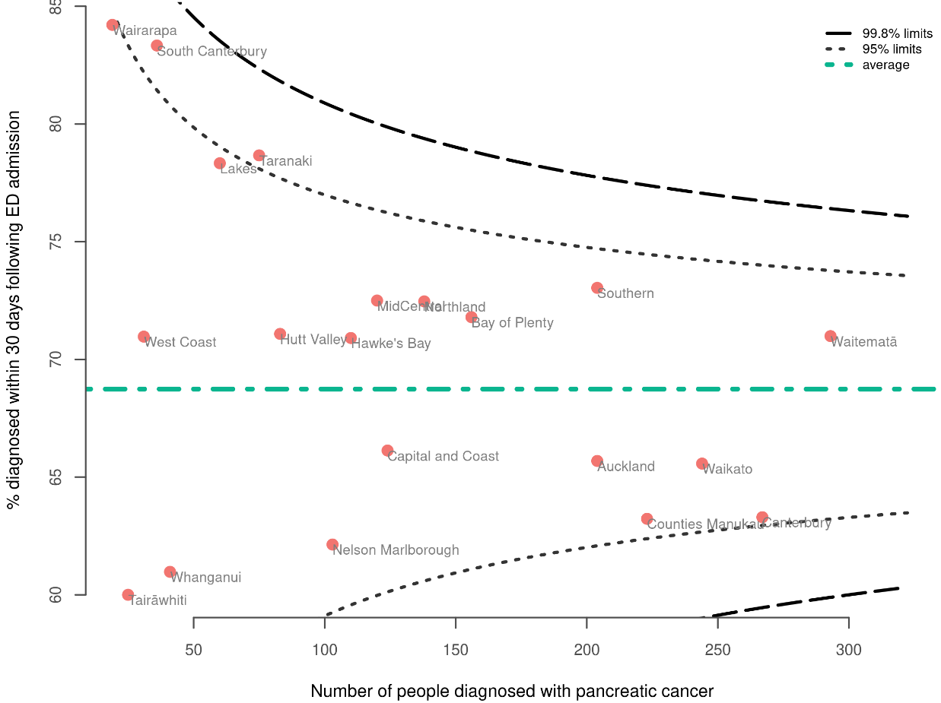

Discussion
A considerable proportion (68.7%) of people with pancreatic cancer had an emergency/acute admission to hospital in the 30 days before their diagnosis. This is higher than the 60% found for Aotearoa in an international study by McPhail et al, which looked at diagnoses over the years 2012–2017 (McPhail et al 2022). The study included PNETs, which are excluded in this report; this is likely to explain the difference in results.

The proportion of people who had an emergency/acute admission to hospital over the 30 days prior to diagnosis was higher for Māori and Pacific peoples compared with European/other. It was also higher for people aged 80 years and over compared with all other age groups. Those living in higher-deprivation areas were more likely to be diagnosed within 30 days of an emergency/acute admission. This may be at least in part related to access to primary care.

We should note that the reasons for an acute or unplanned presentation and admission to hospital are not recorded; for example, an ED visit could be completely unrelated to the subsequent diagnosis of pancreatic cancer. This QPI is still important because of the information it provides on the importance of earlier diagnosis of pancreatic cancer, especially considering the high mortality rate associated with this cancer. It is also useful because it may reflect differences in the way that people access health care across the country. This QPI has exposed variation and the need for quality improvement activity in the context of other cancers, such as bowel, lung and prostate cancer, so it warrants inclusion in this report.

Recommendations
Recommendations
Hospital or district quality improvement
Ensure adequate primary care access to imaging (such as ultrasonography).
Examine district- or hospital-level data to determine reasons for admission.
Health system quality improvement
Develop nationally consistent high suspicion of cancer referral pathways.
Promote awareness of the importance of early diagnosis in primary care.
Encourage research into early diagnosis of pancreatic cancer.

Pancreatic resection

Indicator description
Proportion of people with pancreatic cancer who had a pancreatic resection.

Context
This indicator gives the proportion of people with pancreatic cancer who have had a pancreatic resection, as well as providing information about where the surgery is performed. There is evidence that centres with higher volumes of surgery have better outcomes (Kamisawa et al 2016; Ratnayake et al 2022)

In addition to giving an indication of the proportion of people who have had surgery, this QPI can be considered a proxy for the proportion of people who will be candidates for neoadjuvant and/or adjuvant chemotherapy. Pancreatic resection followed by adjuvant chemotherapy is no longer the preferred approach for many people, and there is a trend towards neoadjuvant chemotherapy followed by pancreatic resection (Versteijne et al 2018). While not universally accepted, this change recognises the systemic nature of pancreatic cancer, the high probability of micro-metastatic disease at presentation, and evidence of the efficacy of neoadjuvant chemotherapy in prolonging survival in people with resectable and borderline resectable pancreatic cancer.

Therefore, a further intent behind this indicator is that all people with resectable and borderline resectable pancreatic cancer should be considered for neoadjuvant chemotherapy and surgical resection. In other words, referral pathways and pre-surgical work-up should include consultation with medical oncology about neoadjuvant chemotherapy.

For additional context, we note that there are indications for pancreatic resection other than pancreatic cancer, including, for example, chronic pancreatitis and mucinous cyst adenoma. Figure 3 shows pancreatic resections due to all causes for pancreatic cancer including and excluding neuroendocrine tumours (NETs) respectively. This highlights the broader context in which pancreatic resection for pancreatic cancer excluding NETs sits, which is the cohort for this report.
Figure 2: People who had a pancreatic resection (2015–2020) by district health board of service, for all indications, pancreatic cancer overall including neuroendocrine tumours and pancreatic cancer excluding neuroendocrine tumours
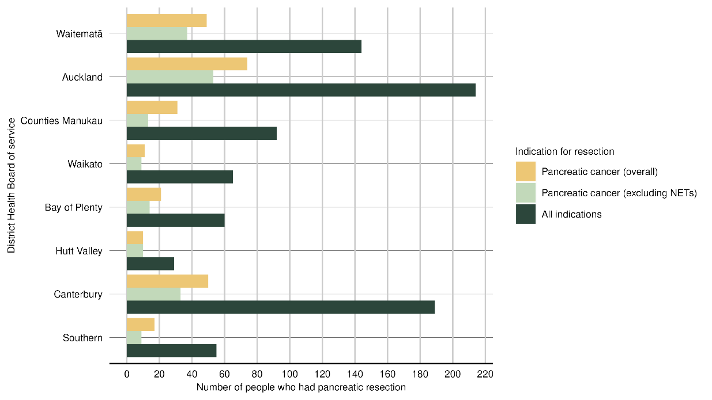

Results
Of people diagnosed with pancreatic cancer between 2015 and 2019, 7.2% had a pancreatic resection (Table 23).

The data shows that younger people with pancreatic cancer were more likely to have a pancreatic resection. People from the European/other group and Asian people had a higher proportion of resection (7.6% and 7.8%, respectively) compared with Māori (5.7%). People living in areas of higher deprivation (quintiles 4 and 5) were less likely to have a pancreatic resection. There was no difference between people who lived in a rural/remote setting (8%) compared with an urban setting (7%). People diagnosed with localised and regionalised pancreatic cancer were more likely (64.3% and 62.7% respectively) to undergo pancreatic resection than those with metastatic disease (1.4%).

Table 3: Proportion of people diagnosed with pancreatic cancer who had pancreatic resection, by year of diagnosis (2015–2019), sex, age group, ethnicity, deprivation and disease extent
 |  |  | Had pancreatic resection
 | People with pancreatic cancer¹ | N | % | 95% confidence intervals
All cases
Total | 2556 | 184 | 7.2 | 6.3–8.3
Year of diagnosis
2015 | 494 | 40 | 8.1 | 6.0–10.8
2016 | 491 | 44 | 9.0 | 6.7–11.8
2017 | 457 | 37 | 8.1 | 5.9–11.0
2018 | 518 | 28 | 5.4 | 3.8–7.7
2019 | 596 | 35 | 5.9 | 4.3–8.1
Sex
Male | 1329 | 108 | 8.1 | 6.8–9.7
Female | 1227 | 76 | 6.2 | 5.0–7.7
Age group
18–49 | 96 | 13 | 13.5 | 8.1–21.8
50–59 | 325 | 34 | 10.5 | 7.6–14.3
60–69 | 680 | 69 | 10.1 | 8.1–12.6
70–79 | 834 | 61 | 7.3 | 5.7–9.3
80+ | 621 | 7 | 1.1 | 0.5–2.3
Ethnicity
Māori | 282 | 16 | 5.7 | 3.5–9.0
Pacific peoples | 94 | * | * | 1.7–10.4
Asian | 116 | 9 | 7.8 | 4.1–14.1
European/other | 2022 | 153 | 7.6 | 6.5–8.8
Unknown | 42 | * | * | 1.3–15.8
Deprivation quintile (NZDep2018)
Quintile 1 – least deprived | 434 | 47 | 10.8 | 8.2–14.1
Quintile 2 | 480 | 36 | 7.5 | 5.5–10.2
Quintile 3 | 564 | 35 | 6.2 | 4.5–8.5
Quintile 4 | 556 | 41 | 7.4 | 5.5–9.9
Quintile 5 – most deprived | 522 | 25 | 4.8 | 3.3–7.0
Rural–urban status
Rural/remote | 485 | 39 | 8.0 | 5.9–10.8
Urban | 2071 | 145 | 7.0 | 6.0–8.2
SEER Summary staging
Localised | 14 | 9 | 64.3 | 38.8–83.7
Regionalised | 212 | 133 | 62.7 | 56.1–69.0
Distant | 1526 | 21 | 1.4 | 0.9–2.1
Not known | 804 | 21 | 2.6 | 1.7–4.0
¹ Excludes people registered with pancreatic cancer from death certificates only.
* Suppressed due to low number of cases.
Sources: NZCR and NMDS (hospital events)
Figure 3 and Figure 4 are funnel plots showing DHB resection rates by DHB of residence and DHB of service respectively. Pancreatic resection was performed in 13 centres. Auckland had the highest proportion of those with pancreatic cancer undergoing resection and Waikato the lowest.

Figure 3: Proportion of people diagnosed with pancreatic cancer (2015–2019) who had pancreatic resection, by district health board of residence
Note: Where a DHB is not represented on a funnel plot this may be due to either suppression due to low numbers or there being zero cases in that DHB. Please refer to relevant table in Appendix B showing stratification of this QPI by DHB for more information.

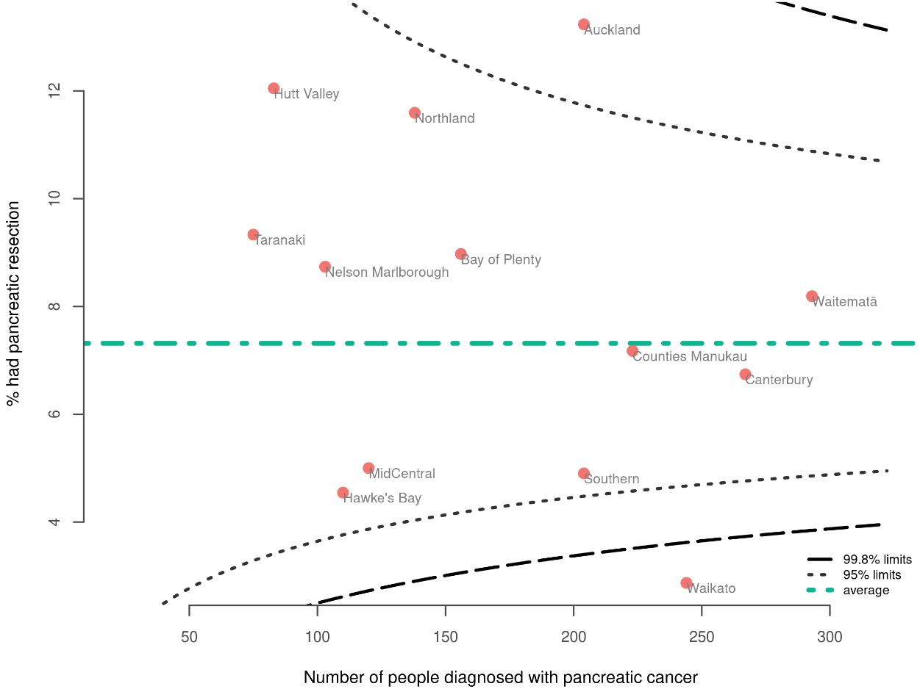

Figure 4 Proportion of people diagnosed with pancreatic cancer (2015–2019) who had pancreatic resection, by district health board of service
Note: Where a DHB is not represented on a funnel plot this may be due to either suppression due to low numbers or there being zero cases in that DHB. Please refer to relevant table in Appendix B showing stratification of this QPI by DHB for more information.
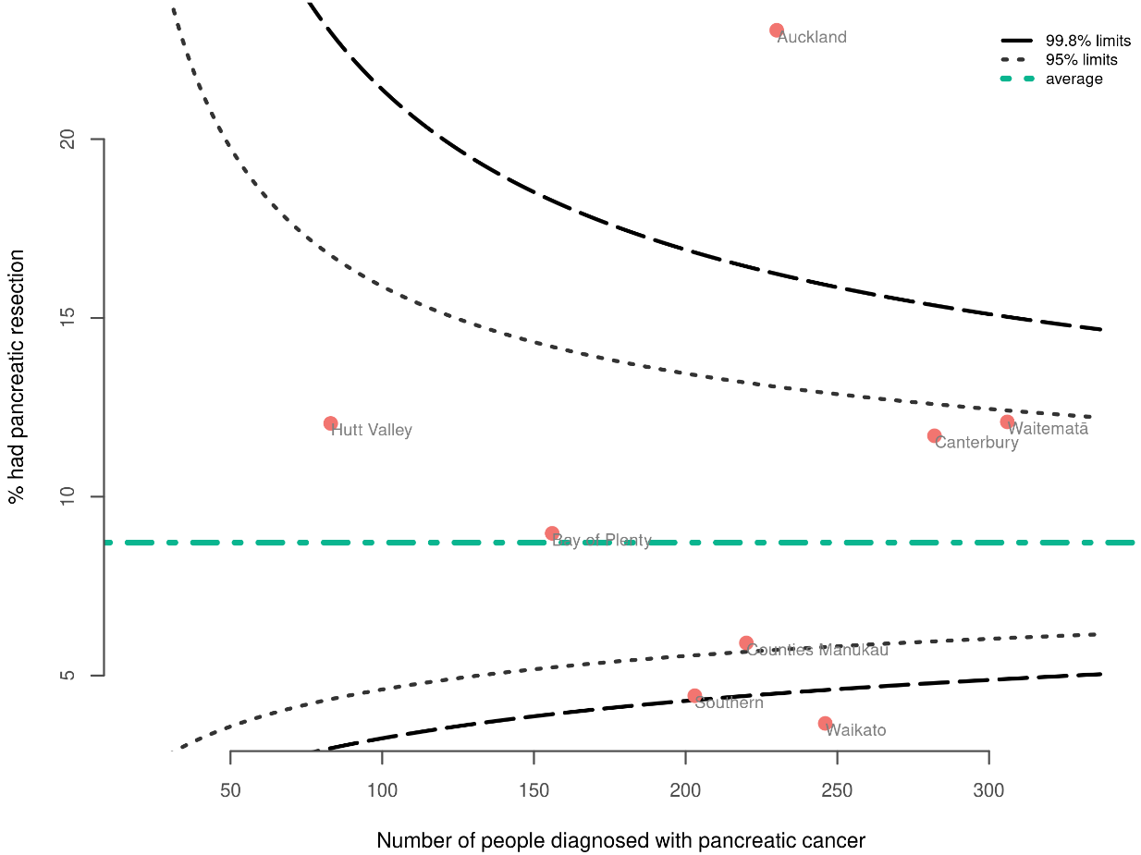

Table 13 in Appendix B compares DHB of service with DHB of residence. Around 30% of those who had pancreatic resections had them performed outside their DHB of residence (this is equivalent to the tertiary referral rate).

Figure 5 is a representation of this group of people, showing their DHB of residence and where they underwent pancreatic resection. Table 4 also gives information on DHBs and patterns of surgical services. Due to low numbers, we are unable to show specific numbers; however, Figure 5 gives an indication as to referral patterns in Aotearoa. Four centres receive referrals from other centres: Auckland, Canterbury, Waikato and Waitematā.

Table 4: Overview of referral patterns for people diagnosed with pancreatic cancer (2015–2019) who underwent pancreatic cancer resection, by DHB (inferred by comparison of DHB of residence and DHB of service)
Resections performed and referrals received | Resections performed, no referrals made, no referrals received | Resections performed, some referrals made, no referrals received | No resections performed, all referred | No resections or referrals of cases living in area of residence
Auckland  Canterbury  Waikato  Waitematā | Bay of Plenty  Hutt Valley  Wairarapa | Capital and Coast  Counties Manukau  MidCentral  Nelson Marlborough  South Canterbury  Southern | Hawke’s Bay  Lakes  Northland  Tairāwhiti  Taranaki  West Coast | Whanganui

Figure 5: People diagnosed with pancreatic cancer (2015–2019) who underwent pancreatic resection outside of their DHB of residence, showing their DHB of residence and DHB of service, representing tertiary referal flow (not all DHBs are represented, see Table 4).
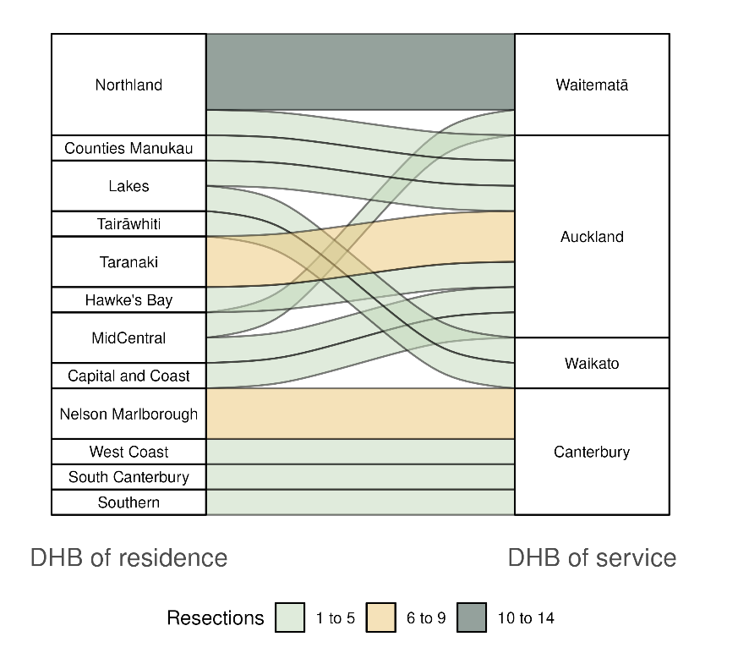

Discussion
Overall, a small proportion of people with pancreatic cancer (7.2%) had a pancreatic resection. Other jurisdictions report similarly low proportions. Queensland, for example, reported in 2022 that 9% of people with pancreatic, biliary tract and duodenal cancers underwent pancreatic resection (Queensland Government 2022).

As numbers of pancreatic resections were small, results comparing groups should be interpreted with caution. However, we note some potential differences. People 80 years and over were less likely to have a pancreatic resection, as were those living in greater social deprivation: this may reflect comorbidity and frailty in those populations. Whether people were living in a rural or remote area did not appear to influence pancreatic resection proportion. Pancreatic resection was performed in only 64.3% of people with localised disease; similar findings are reported overseas (Bilimoria et al 2007).

Because the number of resections was low and widely dispersed across Aotearoa, it is not possible to draw definitive conclusions from individual DHBs; in the future, the data on pancreatic resections may need to be reported regionally and possibly over a longer interval. Pancreatic resections were performed in 13 DHBs (see Table 4), and there was a wide range of volumes across DHBs. Four DHBs received referrals from other centres. This is relevant considering the relationship with outcomes after pancreatic cancer surgery (Kamisawa et al 2016; Ratnayake et al 2022). Te Aho o Te Kahu is undertaking a cancer service planning project to assist other health agencies to determine optimal cancer service delivery across the country, including for surgical services. For further information on this programme, see section 2.8.

As section 3.5 reports, the overall proportion of people with pancreatic cancer who were reviewed by a medical oncologist was only 23.9% (Table 7). Taken together, the QPIs relating to surgery and chemotherapy indicate that there are considerable opportunities for improving the treatment of pancreatic cancer patients in Aotearoa.

Recommendations
Recommendations
Hospital or district quality improvement
Review district- or hospital-level data to determine if there are inequities to comorbidity, access or more advanced disease at presentation.
Ensure all eligible patients have the opportunity to seek specialist advice from a medical oncologist.
Health system quality improvement
Consider reporting data over a longer interval and/or larger geographic area.
Continue investigation of optimal cancer service delivery across the country through the cancer service planning programme, which includes surgical services (see section 2.8).

Biliary drainage/stenting

Indicator description
Proportion of pancreatic cancer patients who had a biliary drainage procedure.

Context
The intention behind this indicator is that all people with pancreatic cancer should have biliary drainage for obstructive jaundice when indicated.

Biliary drainage can be performed prior to pancreatic resection. While not all people require this procedure before surgery, in some instances it may be performed due to an anticipated prolonged delay before pancreatic resection. There may therefore be a link between the number of biliary drainage procedures and the prevalence of delay before definitive surgery. Although national level data is not available to differentiate by indication, the overall proportion of biliary drainage procedures and variations by DHB may provide insights.

Other indications include symptom management, including in the setting of palliative care (such as intractable pruritus), and pre-treatment stenting prior to neoadjuvant chemotherapy.

Biliary drainage and stenting are usually achieved by endoscopy, but may require a percutaneous transhepatic approach by interventional radiology.

Results
The overall proportion of people who had had biliary drainage was 34.8% (Table 5). There was no variation associated with sex, age or deprivation quintile. The proportion was slightly higher for people in rural/remote settings, at 36.9%, compared with 34.3% for urban people.

Māori and Asian people had a higher proportion of biliary drainage/stenting procedures (at 37.2% and 41.4% respectively) compared with Pacific peoples (33%) and those in the European/other group (34.3%).

The comparison between DHBs of residence (Figure 6) showed that five DHBs were outside the 95% confidence limits: Northland and Southland had higher proportions while Auckland, Nelson Marlborough and Canterbury had lower proportions. The comparison between DHB of service (Figure 7) showed two DHBs above the 95% confidence limit and 2 below; these were different DHBs to the aforementioned comparison.

Table 13 in Appendix B shows biliary drainage procedures by DHB of residence and service. The majority of DHBs performed these procedures. Of those who had biliary drainage, 16% had it performed outside their DHB of residence (this is equivalent to the tertiary referral rate).

Table 5: Proportion of people diagnosed with pancreatic cancer who had a biliary drainage or stenting procedure, by year of diagnosis (2015–2019), sex, age group, ethnicity, deprivation and disease extent
 |  |  | Had biliary drainage/stenting procedure
 | People with pancreatic cancer¹ | N | % | 95% confidence intervals
All cases
Total | 2556 | 890 | 34.8 | 33.0–36.7
Year of diagnosis
2015 | 494 | 174 | 35.2 | 31.1–39.5
2016 | 491 | 159 | 32.4 | 28.4–36.6
2017 | 457 | 158 | 34.6 | 30.4–39.0
2018 | 518 | 184 | 35.5 | 31.5–39.7
2019 | 596 | 215 | 36.1 | 32.3–40.0
Sex
Male | 1329 | 466 | 35.1 | 32.5–37.7
Female | 1227 | 424 | 34.6 | 31.9–37.3
Age group
18–49 | 96 | 34 | 35.4 | 26.6–45.4
50–59 | 325 | 113 | 34.8 | 29.8–40.1
60–69 | 680 | 254 | 37.4 | 33.8–41.1
70–79 | 834 | 276 | 33.1 | 30.0–36.4
80+ | 621 | 213 | 34.3 | 30.7–38.1
Ethnicity
Māori | 282 | 105 | 37.2 | 31.8–43.0
Pacific peoples | 94 | 31 | 33.0 | 24.3–43.0
Asian | 116 | 48 | 41.4 | 32.8–50.5
European/other | 2022 | 694 | 34.3 | 32.3–36.4
Unknown | 42 | 12 | 28.6 | 17.2–43.6
Deprivation quintile (NZDep2018)
Quintile 1 – least deprived | 434 | 149 | 34.3 | 30.0–38.9
Quintile 2 | 480 | 155 | 32.3 | 28.3–36.6
Quintile 3 | 564 | 210 | 37.2 | 33.3–41.3
Quintile 4 | 556 | 197 | 35.4 | 31.6–39.5
Quintile 5 – most deprived | 522 | 179 | 34.3 | 30.3–38.5
Rural–urban status
Rural/remote | 485 | 179 | 36.9 | 32.7–41.3
Urban | 2071 | 711 | 34.3 | 32.3–36.4
SEER summary staging
Localised | 14 | * | * | 7.6–47.6
Regionalised | 212 | * | * | 34.2–47.3
Distant | 1526 | 413 | 27.1 | 24.9–29.3
Not known | 804 | 388 | 48.3 | 44.8–51.7
¹ Excludes people registered with pancreatic cancer from death certificates only.
* Suppressed due to low number of cases.
Sources: NZCR and NMDS (hospital events)

Figure 6: Proportion of people diagnosed with pancreatic cancer (2015–2019) who had a biliary drainage or stenting procedure, by district health board of residence
Note: Where a DHB is not represented on a funnel plot this may be due to either suppression due to low numbers or there being zero cases in that DHB. Please refer to relevant table in Appendix B showing stratification of this QPI by DHB for more information.

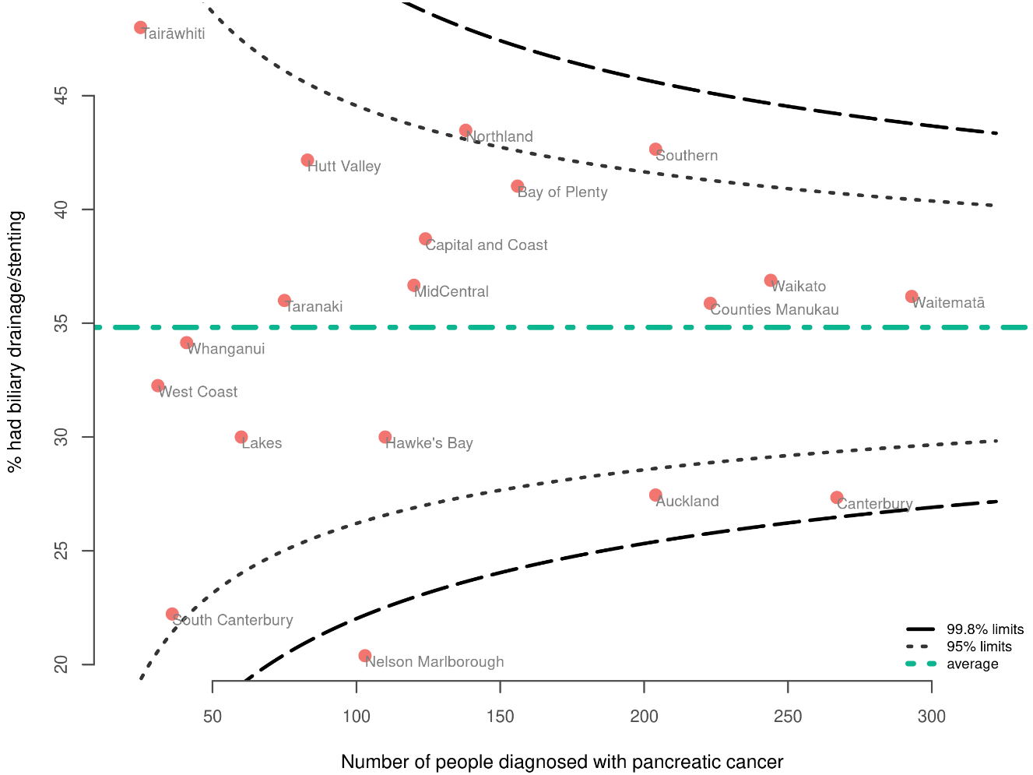

Figure 7 Proportion of people diagnosed with pancreatic cancer (2015–2019) who had a biliary drainage or stenting procedure, by district health board of service
Note: Where a DHB is not represented on a funnel plot this may be due to either suppression due to low numbers or there being zero cases in that DHB. Please refer to relevant table in Appendix B showing stratification of this QPI by DHB for more information.
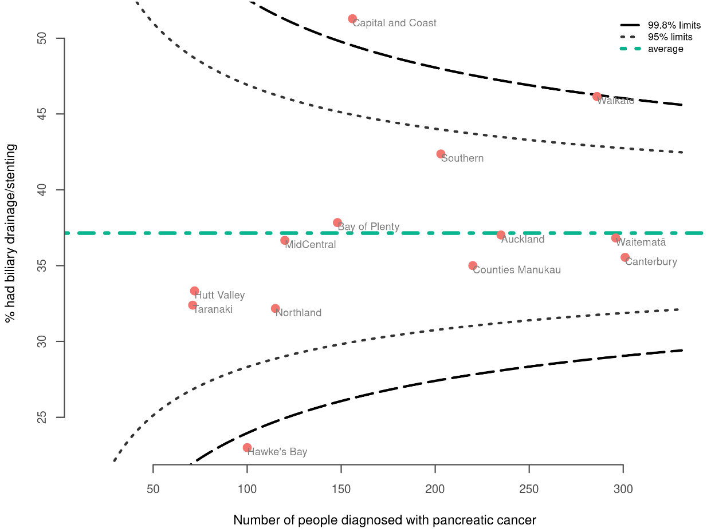

Discussion
Overall, 34.8% of people with pancreatic cancer had a biliary drainage or stenting procedure, and it was more common in people of Māori and Asian ethnicity.

There was less variation than we expected in the proportion of biliary drainage across DHBs. The explanations for existing variation may include differences in case mix, access to the procedure and the proportion of patients receiving neoadjuvant chemotherapy. There may also be a relationship with the proportion of people receiving pancreatic resection; therefore, this QPI can be considered in conjunction with QPI 3.2, ‘Pancreatic resection’.

Where the disease is localised, a person is more likely to undergo surgery without biliary drainage or stenting. Due to the low numbers involved in this indicator, caution is required in interpreting the data. A person with regionalised disease is more likely to require neoadjuvant treatment and more likely to undergo stenting to manage jaundice while awaiting surgery. The ‘not known’ extent-of-disease group is large, meaning there are notable limitations to the interpretation of this stratified data.

Recommendations
Recommendations
Hospital or district quality improvement
Collect data on indication for biliary drainage and stenting. This will give information on whether biliary drainage is being performed as a bridge to pancreatic resection (which may reflect delays to surgery), due to neoadjuvant chemotherapy or to palliate symptoms in a patient not being considered for pancreatic resection.
Health system quality improvement
Standardise indications for pre-operative biliary stenting/drainage.

Tissue diagnosis

Indicator description
Proportion of people with pancreatic cancer who had a recorded tissue diagnosis at the time of registration.

Context
Tissue diagnosis is the histologic or cytologic confirmation of cancer type, as performed by a pathologist. It is important for guiding some treatment decisions. A tissue diagnosis identifies the tumour type, enables molecular analysis to ascertain the suitability of targeted therapies and can contribute to estimating prognosis.

A tissue diagnosis is indicated for all people with suspected pancreatic cancer and who are fit for treatment. The intent of this indicator is to explore whether this is occurring and if there is any variation in practice.

We note that biopsies carry a risk of complication, and not every patient will benefit from tissue diagnosis. There are a number of situations in which a tissue diagnosis is not possible and reasons why a tissue diagnosis is not indicated; for example, if a person is too frail for treatment or nearing the end of their life.

Results
The overall proportion of people with pancreatic cancer who had a tissue diagnosis was 56.4% (Table 6).

A tissue diagnosis was less common in older people compared to the younger age groups (the proportion for those aged 80+ years was 22% compared with people aged 18-49 years at 86.5%) and also more common for females compared with males (proportions were 53.1% and 59.4% respectively). Māori (56.4%) and people in the European/other (55.5%) group were less likely to have a tissue diagnosis than Pacific peoples (62.8%) and people of Asian ethnicity (71.6%).

People living in the most deprived areas were less likely to have a tissue diagnosis than those in least deprived areas (proportions for quintiles 5 and 1 respectively were 51.9% and 64.3%). People living in rural/remote settings were more likely to have a tissue diagnosis compared to those living in an urban setting (proportions were 62.9% and 54.9% respectively).

As we expected, people diagnosed with localised and regionalised pancreatic cancer were more likely to have a tissue diagnosis (proportions were 92.9% and 93.9% respectively) than those with distant pancreatic cancer (55.0%).

The comparison between DHBs (Figure 8) shows four DHBs (Auckland, Counties Manukau, Waitematā and Capital Coast) above the 95% confidence limit with a tissue diagnosis proportion above 65%. There were five DHBs (Canterbury, Bay of Plenty, Southern, Nelson-Marlborough and South Canterbury) below the 95% confidence limit with a tissue diagnosis proportion below 50%. Table 14 in Appendix B presents stratification by DHB.

Table 6: Proportion of people diagnosed with pancreatic cancer who had tissue diagnosis, by year of diagnosis (2015–2019), sex, age group, ethnicity, deprivation and disease extent
 |  |  | Had tissue diagnosis
 | People with pancreatic cancer¹ | N | % | 95% confidence intervals
All cases
Total | 2556 | 1441 | 56.4 | 54.4–58.3
Year of diagnosis
2015 | 494 | 264 | 53.4 | 49.0–57.8
2016 | 491 | 278 | 56.6 | 52.2–60.9
2017 | 457 | 271 | 59.3 | 54.7–63.7
2018 | 518 | 285 | 55.0 | 50.7–59.3
2019 | 596 | 343 | 57.6 | 53.5–61.5
Sex
Male | 1329 | 790 | 59.4 | 56.8–62.1
Female | 1227 | 651 | 53.1 | 50.3–55.8
Age group
18–49 | 96 | 83 | 86.5 | 78.2–91.9
50–59 | 325 | 251 | 77.2 | 72.4–81.5
60–69 | 680 | 499 | 73.4 | 69.9–76.6
70–79 | 834 | 470 | 56.4 | 53.0–59.7
80+ | 621 | 138 | 22.2 | 19.1–25.7
Ethnicity
Māori | 282 | 159 | 56.4 | 50.5–62.0
Pacific peoples | 94 | 59 | 62.8 | 52.7–71.9
Asian | 116 | 83 | 71.6 | 62.8–79.0
European/other | 2022 | 1122 | 55.5 | 53.3–57.6
Unknown | 42 | 18 | 42.9 | 29.1–57.8
Deprivation quintile (NZDep2018)
Quintile 1 – least deprived | 434 | 279 | 64.3 | 59.7–68.7
Quintile 2 | 480 | 286 | 59.6 | 55.1–63.9
Quintile 3 | 564 | 305 | 54.1 | 50.0–58.1
Quintile 4 | 556 | 300 | 54.0 | 49.8–58.1
Quintile 5 – most deprived | 522 | 271 | 51.9 | 47.6–56.2
Rural–urban status
Rural/remote | 485 | 305 | 62.9 | 58.5–67.1
Urban | 2071 | 1136 | 54.9 | 52.7–57.0
SEER summary staging
Localised | 14 | 13 | 92.9 | 68.5–98.7
Regionalised | 212 | 199 | 93.9 | 89.8–96.4
Distant | 1526 | 840 | 55.0 | 52.5–57.5
Not known | 804 | 389 | 48.4 | 44.9–51.8
¹ Excludes people registered with pancreatic cancer from death certificates only.
Sources: NZCR

Figure 8: Proportion of people diagnosed with pancreatic cancer who had tissue diagnosis, by district health board of residence

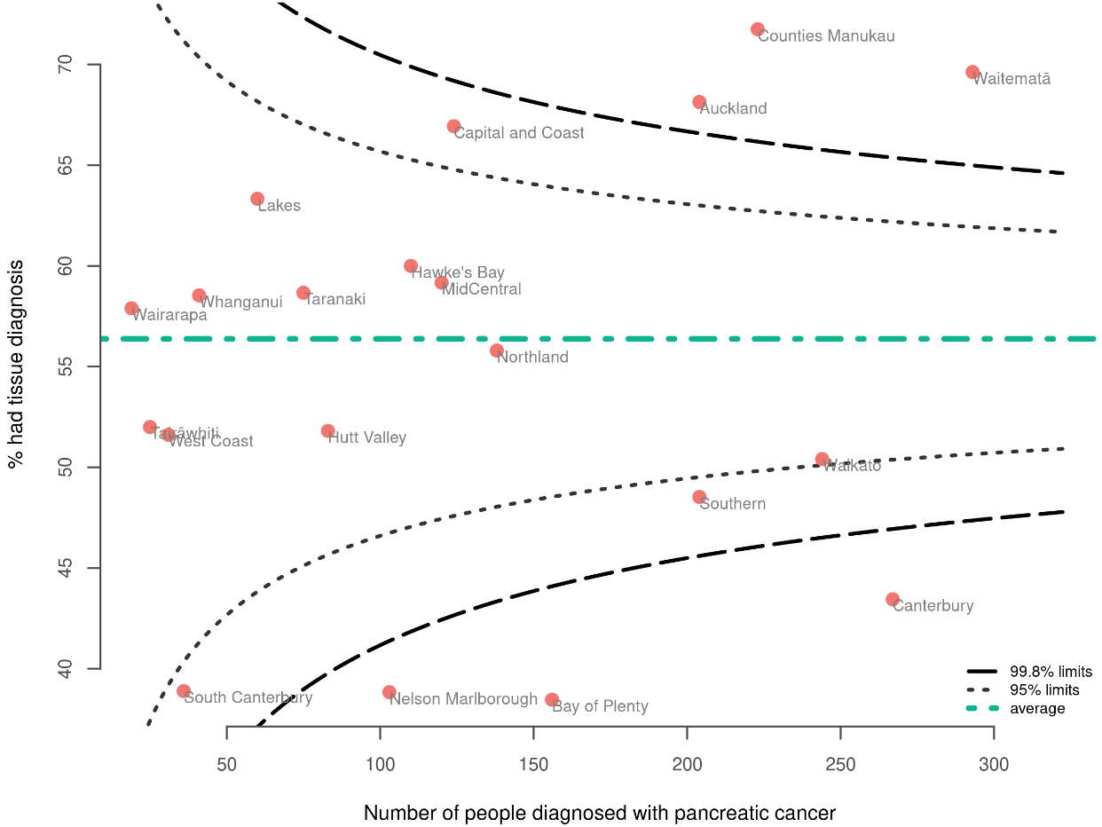

Discussion
People who require a tissue diagnosis include those for whom there is diagnostic uncertainty (such as whether a mass is cancer or not) and those for whom chemotherapy is offered before surgical resection. Groups with a lower proportion of tissue diagnosis may have had higher proportions of comorbidity or frailty, meaning they were not candidates for surgical and medical oncology treatment. This may account for the lower proportion of tissue diagnoses performed for older age groups and people with a distant extent of disease.

The lower proportion of tissue diagnosis among Māori and for those living in more deprived areas is likely to be attributable to a combination of reasons that may include higher comorbidity and reduced access to diagnostic services. Varying rates of access to diagnostics such as endoscopic ultrasound or CT guided biopsy may also explain geographical variation, noting that four of the five DHBs below the lower 95% confidence limit are in the South Island.

Recommendations
Recommendations
Hospital or district quality improvement
Consider all patients for tissue diagnosis. This consideration may consist of a formal discussion between the clinician and the person diagnosed with pancreatic cancer and should include those who may not want to undergo treatment.

Medical oncology review

Indicator description
Proportion of people with pancreatic cancer who were reviewed by a medical oncologist.

Context
People diagnosed with pancreatic cancer should be given the opportunity to consult with a medical oncologist regarding systemic therapy for malignancy. The intention behind this indicator is to identify how often this occurs.

Most pancreatic cancer patients present with locally advanced or metastatic disease, which means that surgical management is not appropriate, and medical management should be the mainstay of treatment. Patients with all stages of pancreatic cancer benefit from chemotherapy, but their performance status, and therefore fitness for chemotherapy, falls rapidly over time. Therefore, timely access will lead to better outcomes. Importantly, people with all stages of pancreatic cancer benefit from medical oncology review, even where there are no plans for systemic therapy; for example, to manage endocrine or exocrine complications.

Research has demonstrated improved survival in those who meet with a medical oncologist (Mavros et al 2019). The magnitude of benefit is greater in earlier stages via neo-adjuvant and adjuvant systemic therapy. However, there is also a correlation between meeting with a medical oncologist and survival improvement for those with advanced disease (Mavros et al 2019; Santucci et al 2022).

Results
The overall proportion of people with pancreatic cancer who were reviewed by a medical oncologist was 23.9% (Table 7).

The proportion of people reviewed by a medical oncologist varied by age; the proportion was lowest in those over 80 years of age (4.8%) and highest in the 18–49-year age group (43.8%).

Māori and those in the European/other group were less likely to be reviewed by a medical oncologist (21.3% and 23.6% respectively) than Pacific (27.7%) and Asian (32.8%) people.

People living in the most deprived areas were less likely to be reviewed by a medical oncologist than those living in the least deprived areas (20.5% for quintile 5 and 30% for quintile 1).

People living in rural/remote settings were more likely to be reviewed by a medical oncologist than those living in an urban setting (proportions were 26% and 23.4% respectively).

Comparison between DHBs (Figure 9) shows two DHBs (Auckland and Counties Manukau) above the 95% confidence limit and three DHBs (MidCentral, Bay of Plenty and Southern) below the 95% confidence limit. Table 15 in Appendix B presents stratification by DHB.

Table 7: Proportion of people diagnosed with pancreatic cancer who were reviewed by a medical oncologist, by year of diagnosis (2015–2019), sex, age group, ethnicity, deprivation and disease extent
 |  |  | Reviewed by a medical oncologist
 | People with pancreatic cancer¹ | N | % | 95% confidence intervals
All cases
Total | 2556 | 611 | 23.9 | 22.3–25.6
Year of diagnosis
2015 | 494 | 84 | 17.0 | 13.9–20.6
2016 | 491 | 127 | 25.9 | 22.2–29.9
2017 | 457 | 120 | 26.3 | 22.4–30.5
2018 | 518 | 133 | 25.7 | 22.1–29.6
2019 | 596 | 147 | 24.7 | 21.4–28.3
Sex
Male | 1329 | 327 | 24.6 | 22.4–27.0
Female | 1227 | 284 | 23.1 | 20.9–25.6
Age group
18–49 | 96 | 42 | 43.8 | 34.3–53.7
50–59 | 325 | 116 | 35.7 | 30.7–41.0
60–69 | 680 | 230 | 33.8 | 30.4–37.5
70–79 | 834 | 193 | 23.1 | 20.4–26.1
80+ | 621 | 30 | 4.8 | 3.4–6.8
Ethnicity
Māori | 282 | 60 | 21.3 | 16.9–26.4
Pacific peoples | 94 | 26 | 27.7 | 19.6–37.4
Asian | 116 | 38 | 32.8 | 24.9–41.7
European/other | 2022 | 477 | 23.6 | 21.8–25.5
Unknown | 42 | 10 | 23.8 | 13.5–38.5
Deprivation quintile (NZDep2018)
Quintile 1 – least deprived | 434 | 130 | 30.0 | 25.8–34.4
Quintile 2 | 480 | 111 | 23.1 | 19.6–27.1
Quintile 3 | 564 | 135 | 23.9 | 20.6–27.6
Quintile 4 | 556 | 128 | 23.0 | 19.7–26.7
Quintile 5 – most deprived | 522 | 107 | 20.5 | 17.3–24.2
Rural–urban status
Rural/remote | 485 | 126 | 26.0 | 22.3–30.1
Urban | 2071 | 485 | 23.4 | 21.6–25.3
SEER summary staging
Localised | 14 | * | * | 16.3–61.2
Regionalised | 212 | * | * | 48.9–62.2
Distant | 1526 | 331 | 21.7 | 19.7–23.8
Not known | 804 | 157 | 19.5 | 16.9–22.4
¹ Excludes people registered with pancreatic cancer from death certificates only.
* Suppressed due to low number of cases.
Sources: NZCR and National Non-Admitted Patient Collection (NNPAC)

Figure 9: Proportion of people diagnosed with pancreatic cancer who were reviewed by a medical oncologist, by district health board of residence
Note: Where a DHB is not represented on a funnel plot this may be due to either suppression due to low numbers or there being zero cases in that DHB. Please refer to relevant table in Appendix B showing stratification of this QPI by DHB for more information.
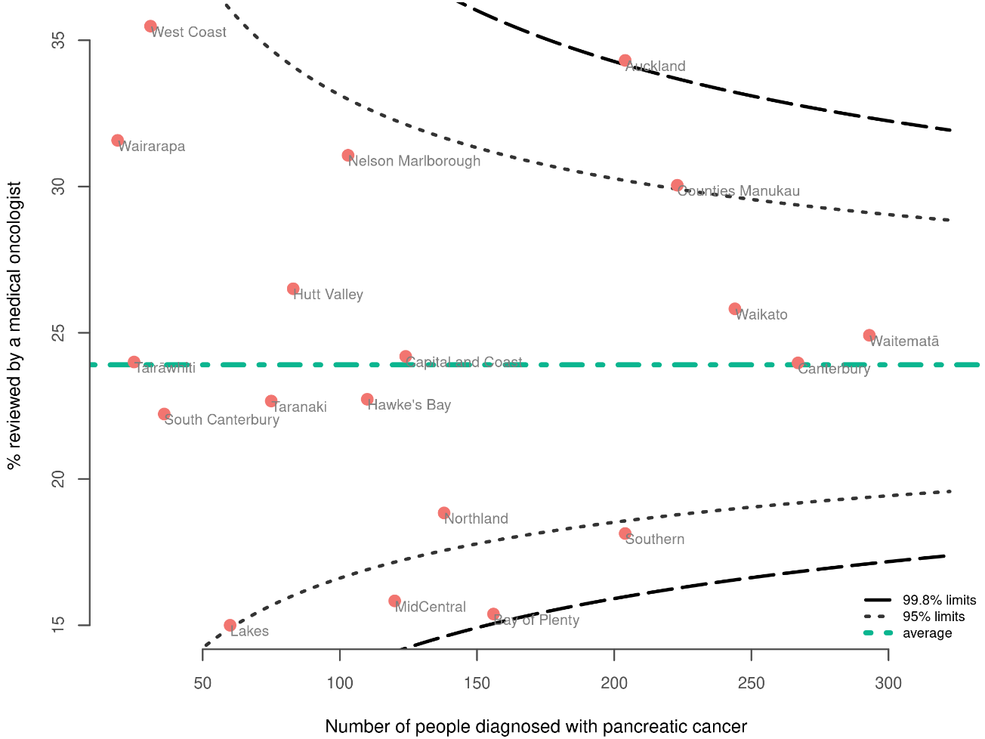

Discussion
It is well accepted that the majority of people with pancreatic cancer will benefit from a review by a medical oncologist and consideration of systemic therapy, but this occurred in only 23.9% of cases. Studies internationally vary in their reports of the proportion of people reviewed by medical oncologists. Researchers found a similarly low 31% in Nova Scotia (Hurton et al 2017). Other Canadian figures show a higher proportion of people who received medical oncology review, even excluding those with localised disease. In Ontario, 64.9% of people with advanced pancreatic cancer had a medical oncology review (Mavros et al 2019) and in Alberta, the figure was 54% (Abdel-Rahman et al 2018).

It is notable that less than half (43.8%) of those aged between 18 and 48 years were seen by a medical oncologist. Although people living in remote/rural settings were more likely to be reviewed by a medical oncologist (26% compared with 23.4%), those living in the most deprived settings were less likely to be reviewed by a medical oncologist than those living in the least deprived settings (20.5% for quintile 5 compared with 30% for quintile 1).

There is evidence internationally that nihilism regarding treatment of pancreatic cancer is reducing (O'Reilly et al 2020). However, it is possible that this plays a part in the lower proportion of people receiving medical oncology review in Aotearoa.

Recommendations
Recommendations
Hospital or district quality improvement
Offer every pancreatic cancer patient a discussion with a medical oncologist as early as possible.
For people with pancreatic cancer diagnosed at a localised or regionalised SEER summary stage, districts may choose to examine their local data and consider using a quality improvement approach to prioritise these patients for medical oncology review, as these patients will experience the most potential absolute benefit from multi-modality care.
Agree on definitions of ‘high suspicion’ of pancreatic cancer and referral guidelines nationally to ensure equitable care. Pancreatic adenocarcinoma is metastatic at diagnosis for the majority of patients, and any delay to pathways can mean a person misses the opportunity to gain survival benefit from systemic therapy, as their performance status can decline quickly.
Adopt multidisciplinary ‘one-stop’ clinics for entry from primary to secondary care for patients with a ‘high suspicion’ of pancreatic cancer. A multidisciplinary approach can also support centres where there is limited medical oncology capacity.

Radiation therapy

Indicator description
Proportion of people with pancreatic cancer who received radiation therapy.

Context
People with pancreatic cancer should be given the opportunity to discuss their radiation treatment options and to have radiation treatment where this is appropriate. The intention behind this indicator is to measure whether this is occurring, giving providers the opportunity to further investigate if necessary.

Radiation therapy is an alternative means of local control and palliation for non-resectable pancreatic cancer. It can act as a reasonable alternative to chemotherapy for patients having shorter courses of palliative therapy. Tissue diagnosis is not always a prerequisite for radiation therapy in the palliative setting, with treatment being delivered on a radiological diagnosis.

In patients with borderline resectable disease who are being offered neoadjuvant chemotherapy, the addition of radiation therapy can improve disease-free survival, negative resection margin rates (Versteijne et al 2020) and local control (Hammel et al 2016).

The shift to include radiation therapy more in the management of pancreatic cancer is being realised in the adjuvant, neoadjuvant and definitive settings, as outlined in international guidelines (eviQ Cancer Treatments Online 2021; Palta et al 2019).

Results
The overall proportion of people with pancreatic cancer who had radiation therapy was 4.9% (Table 8).

Numbers of people receiving radiation therapy were small, making it difficult to comment on differences between groups; results should be interpreted with caution. Māori and people in the European/other group may have been less likely to receive radiation therapy (proportions were 7.8% and 4% respectively) than Asian (10.3%) people. The proportion of people receiving radiation therapy appeared lower for older age groups: proportions were 16.7% for 18–49-year-olds and 1.1% for those 80 years and over.

The comparison between DHBs (Figure 10) was compromised by the small number of patients; definitive conclusions are difficult to draw. Table 16 in Appendix B presents stratification by DHB.

Table 8: Proportion of people diagnosed with pancreatic cancer who had radiation therapy, by year of diagnosis (2015–2019), sex, age group, ethnicity, deprivation and disease extent
 |  |  | Had radiation therapy
 | People with pancreatic cancer¹ | N | % | 95% confidence intervals
All cases
Total | 2556 | 125 | 4.9 | 4.1–5.8
Year of diagnosis
2015 | 494 | 25 | 5.1 | 3.5–7.4
2016 | 491 | 17 | 3.5 | 2.2–5.5
2017 | 457 | 19 | 4.2 | 2.7–6.4
2018 | 518 | 27 | 5.2 | 3.6–7.5
2019 | 596 | 37 | 6.2 | 4.5–8.4
Sex
Male | 1329 | 68 | 5.1 | 4.1–6.4
Female | 1227 | 57 | 4.6 | 3.6–6.0
Age group
18–49 | 96 | 16 | 16.7 | 10.5–25.4
50–59 | 325 | 28 | 8.6 | 6.0–12.2
60–69 | 680 | 45 | 6.6 | 5.0–8.7
70–79 | 834 | 29 | 3.5 | 2.4–4.9
80+ | 621 | 7 | 1.1 | 0.5–2.3
Ethnicity
Māori | 282 | 22 | 7.8 | 5.2–11.5
Pacific peoples | 94 | * | * | 2.3–11.9
Asian | 116 | 12 | 10.3 | 6.0–17.2
European/other | 2022 | 84 | 4.2 | 3.4–5.1
Unknown | 42 | * | * | 1.3–15.8
Deprivation quintile (NZDep2018)
Quintile 1 – least deprived | 434 | 17 | 3.9 | 2.5–6.2
Quintile 2 | 480 | 30 | 6.2 | 4.4–8.8
Quintile 3 | 564 | 27 | 4.8 | 3.3–6.9
Quintile 4 | 556 | 19 | 3.4 | 2.2–5.3
Quintile 5 – most deprived | 522 | 32 | 6.1 | 4.4–8.5
Rural–urban status
Rural/remote | 485 | 19 | 3.9 | 2.5–6.0
Urban | 2071 | 106 | 5.1 | 4.2–6.2
SEER summary staging
Localised | 14 | * | * | 1.3–31.5
Regionalised | 212 | * | * | 4.0–10.8
Distant | 1526 | 58 | 3.8 | 3.0–4.9
Not known | 804 | 52 | 6.5 | 5.0–8.4
¹ Excludes people registered with pancreatic cancer from death certificates only.
* Suppressed due to low number of cases.
Sources: NZCR and ROC

Figure 10: Proportion of people diagnosed with pancreatic cancer who had radiation therapy, by district health board of residence
Note: Where a DHB is not represented on a funnel plot this may be due to either suppression due to low numbers or there being zero cases in that DHB. Please refer to relevant table in Appendix B showing stratification of this QPI by DHB for more information.
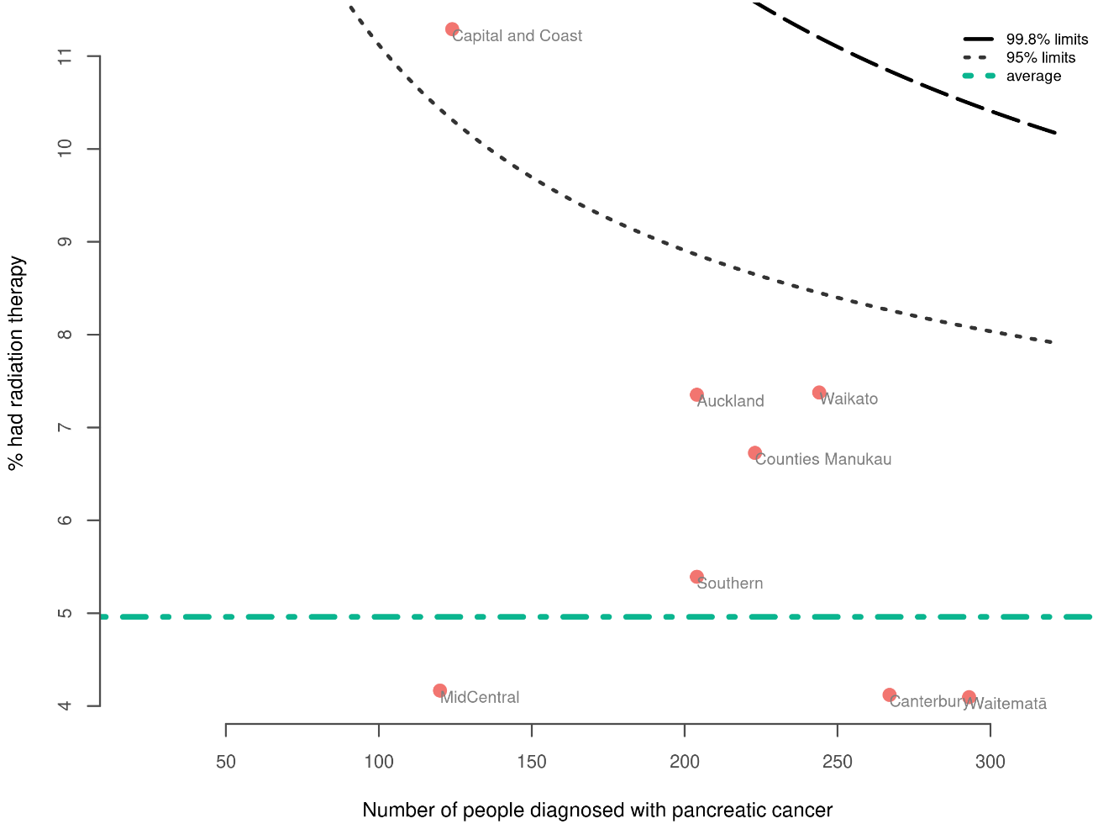

Discussion
Overall, the low proportion (4.9%) of people with pancreatic cancer receiving radiation therapy is in keeping with international data (Cancer Research UK 2017).

The younger age group (those aged 18–49 years) were more likely to receive radiation therapy than older age groups (but note that the numbers are small). This might be because an active palliative intervention with radiotherapy is more likely to be offered to a patient with good baseline performance status and larger physiological reserve to withstand the side effects.

Some DHB regions had a very low proportion of people receiving radiation therapy, warranting further investigation at the DHB level. The explanation may involve factors such as reduced access to radiation therapy between DHBs or better access to coeliac plexus block as an alternative to radiation therapy for faster-acting pain relief.

Recommendations
Recommendations
Hospital or district quality improvement
Include a radiation oncologist as part of the multidisciplinary team for the management of pancreatic cancer patients.
Offer every pancreatic cancer patient a discussion with a radiation oncologist.
Health system quality improvement
In future calculations of this QPI, include reporting by the type of radiation therapy received (eg, stereotactic, brachytherapy or external beam).

Days alive and out of hospital

Indicator description
The median number of days people spend alive and out of hospital 30 days after pancreatic resection for pancreatic cancer.

Context
People with pancreatic cancer receiving optimal care will have a lower complication rate and a shorter hospital stay, which will be reflected in a more days alive and out of hospital. ‘Out of hospital’ means the patient has been discharged and not readmitted to any hospital over the 30 days from the date of resection.

This indicator is designed as a person-centred measure (Jerath et al 2019). The intention is to focus on information at the level of the individual. A comparison is also made between DHBs, noting that small numbers in each DHB make interpretation difficult. Any inequities in relation to complication rates and outcomes can be measured by this indicator.

This section reports on days alive and out of hospital in the 30 days after pancreatic resection. Appendix B provides information on days alive and out of hospital in a 90-day period.

Results
People diagnosed with pancreatic cancer between 2015 and 2019 who had had a pancreatic resection were alive and out of hospital for a median of 20 days in the 30 days after surgery (Table 9). The median number of days was similar for females (21 days) and males (20 days) and across different age groups.

Noting small numbers, Pacific peoples had the lowest median days alive and out of hospital at 30 days (13 days) compared with Māori (20 days), people in the European/other group (20 days) and Asian people (21 days). People living in the most deprived areas had the lowest median number of days alive and out of hospital for the 30 days following a pancreatic resection compared with those living in the least deprived areas (the median number of days for people in quintile 5 was 18.5 days, compared with 21.5 for people in quintile 1).

There was no difference in the median number of days alive and out of hospital for people living in rural/remote settings (20 days) and urban settings (20 days). There was also no difference in median number days alive and out of hospital between patients with localised and distant disease (21 days). Table 18 in Appendix B presents stratification by DHB.

Table 9: Median number of days alive and out of hospital at 30 days following pancreatic resection for pancreatic cancer for those diagnosed between 2015 and 2019
 |  |  |  | Days alive and out of hospital at 30 days following pancreatic resection
 | Had pancreatic resection | Discharged routinely1 |  |  | Median | Minimum | Maximum
All cases
Total | 184 | 167 |  |  | 20.0 | 0 | 27
Year of diagnosis
2015 | 40 | 35 |  |  | 17.0 | 0 | 25
2016 | 44 | 39 |  |  | 20.0 | 2 | 26
2017 | 37 | 35 |  |  | 20.0 | 0 | 27
2018 | 28 | 26 |  |  | 20.0 | 0 | 26
2019 | 35 | 32 |  |  | 21.0 | 0 | 24
Sex
Male | 108 | 96 |  |  | 20.0 | 0 | 27
Female | 76 | 71 |  |  | 21.0 | 0 | 26
Age group
18–49 | 13 | 12 |  |  | 20.5 | 0 | 24
50–59 | 34 | 32 |  |  | 20.0 | 0 | 25
60–69 | 69 | 68 |  |  | 20.0 | 0 | 26
70–79 | 61 | 50 |  |  | 20.0 | 0 | 27
80+ | 7 | 5 |  |  | 21.0 | 5 | 22
Ethnicity
Māori | 16 | 14 |  |  | 20.0 | 0 | 25
Pacific peoples | * | * |  |  | 13.0 | 6 | 25
Asian | 9 | 9 |  |  | 21.0 | 7 | 24
European/other | 153 | 138 |  |  | 20.0 | 0 | 27
Unknown | * | * |  |  | 21.0 | 21 | 21
Deprivation quintile (NZDep2018)
Quintile 1 – least deprived | 47 | 40 |  |  | 22.0 | 0 | 27
Quintile 2 | 36 | 34 |  |  | 20.0 | 0 | 23
Quintile 3 | 35 | 32 |  |  | 19.5 | 0 | 25
Quintile 4 | 41 | 39 |  |  | 21.0 | 0 | 26
Quintile 5 – most deprived | 25 | 22 |  |  | 18.5 | 0 | 25
Rural–urban status
Rural/remote | 39 | 34 |  |  | 20.0 | 0 | 27
Urban | 145 | 133 |  |  | 20.0 | 0 | 26
SEER summary staging
Localised | 9 | 7 |  |  | 21.0 | 5 | 24
Regionalised | 133 | 123 |  |  | 20.0 | 0 | 26
Distant | 21 | 19 |  |  | 21.0 | 11 | 27
Not known | 21 | 18 |  |  | 20.0 | 0 | 23
1 Excludes in-hospital deaths and those who were discharged to another facility.
* Suppressed due to low number of cases.
0 means that a patient has never been discharged from the hospital
Sources: NZCR and NMDS (hospital events)

Figure 11 presents this indicator across DHBs. This information should be interpreted with caution due to low numbers, and we note that not all DHBs are represented due to small number suppression. For DHB of service, the median number of days alive and out of hospital for Waikato and Canterbury sat above the national median.

Figure 11: Median number of days alive and out of hospital at 30 days following pancreatic resection for those diagnosed between 2015 and 2019 by district health board of residence and district health board of service
Note: Where a DHB is not represented, this may be due to either suppression due to low numbers or there being zero cases in that DHB.
Please refer to relevant table in Appendix B showing stratification of this QPI by DHB for more information.
00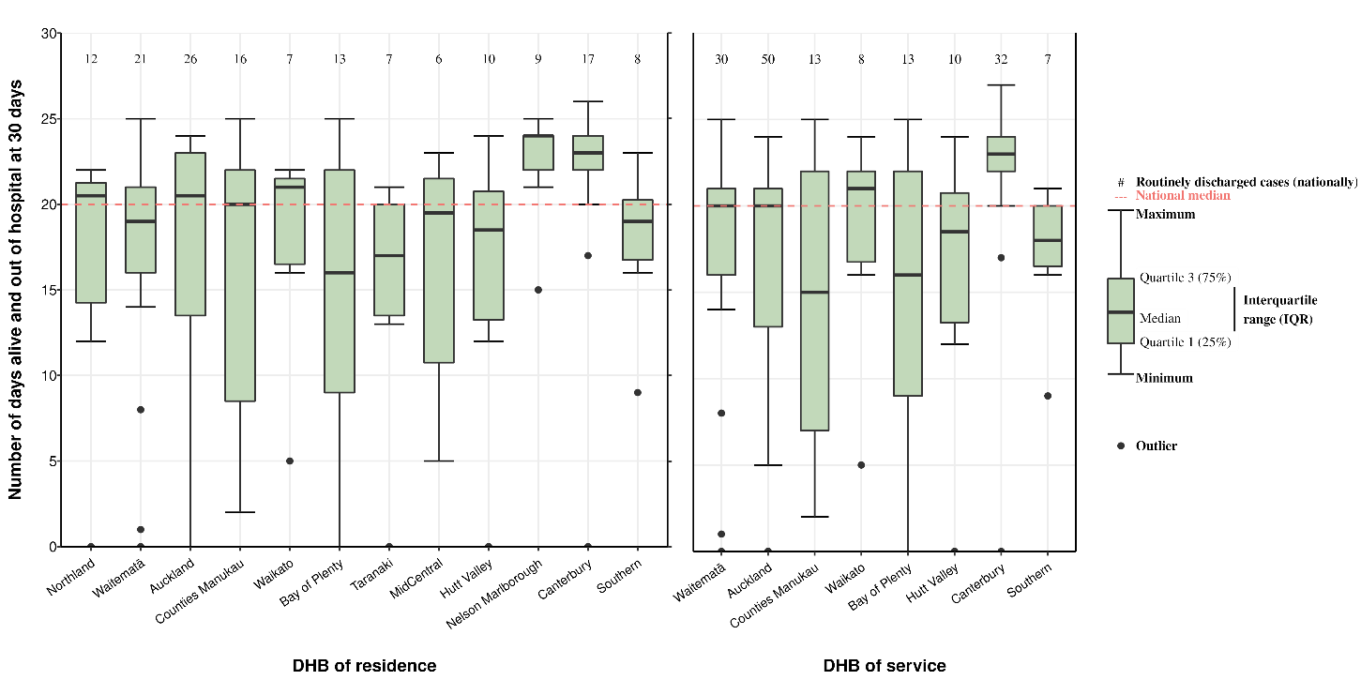

Discussion
Low numbers of pancreatic resections mean that caution is required in interpreting the data for this indicator. It would be beneficial to review future data on a regional basis and over a longer time period.

We note that the data applies to different types of hospital operations; this may contribute to differences. In other words, this metric might be skewed by case mix, including the complexity of the cancer or the person’s general health. Patients at centres undertaking complex resections (for instance, pancreatic resections that are provided to more comorbid patients and include venous resection, multi-visceral resection and/or arterial reconstruction) may be at higher risk of complications, leading to a lower median number of days alive and out of hospital. At this stage it is not possible to risk-adjust for case mix.

The median number of days alive and out of hospital at 30 days was lower for Pacific people (13 days) compared with Māori (20 days), those in the European/other group (20 days) and Asian (21 days). If this is a true difference, the reasons for this are not identified, but could include risk profile, delays in presentation, differences in referral pathways and institutional differences in practice. Similar or other factors might explain the lower median number of days alive and out of hospital at 30 days for those living in the most deprived areas (the number for people living in quintile 5 was 18.5 days) compared with least deprived areas (the number for people living in quintile 1 was 22 days). It is notable that there was no difference in this indicator according to whether people lived in rural/remote or urban settings.

Recommendations
Recommendations
Hospital or district quality improvement
Consider further investigation if the rate for a particular hospital is outside the norm or 95% confidence interval.

Post-operative mortality

Indicator description
Proportion of people with pancreatic cancer who died within 30 and 90 days of pancreatic resection.

Context
The mortality rate at 30 and 90 days after pancreatic resection should be equivalent to the rate in other comparable countries, and there should not be significant variation across geographic, socioeconomic or ethnic groupings.

Post-operative mortality is a marker of the quality and safety of cancer treatment provided by the multidisciplinary team. Death within 30 or 90 days of pancreatic resection may mean the treatment was inappropriate, the patient's fitness to receive surgery was not adequately assessed or the post-surgical monitoring was suboptimal. It may also be due to disease progression.

The results of this indicator will assist exploration of these factors.

We plan for future QPI reports to include a more comprehensive indicator that looks at mortality after all treatment with curative intent, including adjuvant and neoadjuvant chemotherapy.

Results
Given the low mortality rate and the low number of pancreatic resections, it is not possible to conduct subgroup analyses based on year, sex, age, ethnicity, deprivation, rurality or extent of disease.

The overall 30-day mortality rate following pancreatic resection for people diagnosed with pancreatic cancer between 2015 and 2019 was 3.8%. The 90-day mortality rate was 5.4%.

Discussion
International comparisons indicate that mortality rates of less than 5% are typical for population-based studies (McPhee et al 2007; Queensland Government 2022; Swanson et al 2014). Mortality rates of 2% or less are reported from international centres of excellence (Lidsky et al 2017; O'Mahoney et al 2016; Swanson et al 2014), indicating that there is room for improvement in Aotearoa. This might come through better case selection, restricting pancreatic resections to higher volume centres, improving ‘failure to rescue’ rates, and more timely and effective chemotherapy, for example.

Recommendations
Recommendations
Hospital or district quality improvement
Continue to collect and report on ‘failure to rescue’ data to inform discussions at hospital mortality and morbidity meetings.
At district level, investigate mortality after pancreatic resection to determine if there are systemic issues.

Overall survival

Indicator description
Proportion of people with pancreatic cancer who survived at 1, 2 and 5 years from diagnosis.

Context
Survival rates from pancreatic cancer in Aotearoa should at least be equivalent to those in other comparable countries. There should not be significant variation across geographic, socioeconomic and ethnic groupings.

Overall survival rates are an indication of the quality of clinical management and outcome measures. These rates reflect many factors, including early detection, the general health and wellbeing of the population, access to health care and genetic and environmental variables.

For most cancers, survival at 5 years after diagnosis is generally accepted as an indicator of cure. As pancreatic cancer has a poor prognosis, 1-year and 2-year survival time is more informative about the overall quality and effectiveness of care (O'Brien et al 2010); therefore, only 1- and 2-year survival rates are reported here.

Please note, these survival statistics are calculated using crude (unadjusted) data. Ethnicity-stratified data should be interpreted with caution and should not be used to make comparisons between ethnic groups, particularly for this QPI relating to survival.

Results
The overall survival of people with pancreatic cancer from 2015 to 2019 was 21.8% at 1 year and 9.7% at 2 years (Table 10).

The survival rate at 1 and 2 years was marginally higher for males (23.6% and 10.3% respectively) than it was females (19.8% and 9.1% respectively).

There was a substantial reduction in survival with age. For 1-year survival the rate ranged from 36.5% (for the 18–49 age group) to 10.1% (for the 80+ age group). For 2-year survival it ranged from 17.6% to 2.6%.

Māori (20.6%) and those in the European/other group (21.6%) people had lower 1-year survival rates compared with Pacific (25%) and Asian (28.4%) people. The 2-year survival figures for Māori (9.2%) and people in the European/other group (9.4%) were lower than the equivalent figure for Asian people (16.1%).

Those people living in the most deprived areas had lower 1-year and 2-year survival rates than those in least deprived areas. For 1-year survival the rate was 18% for quintile 5 and 28.6% for quintile 1. For 2-year survival it was 7.5% and 14.9% respectively.

People living in rural/remote settings had a marginally higher 1-year survival rate than those living in an urban setting (those rates were 23.1% and 21.5% respectively). There was no difference for the 2-year survival rate.

People diagnosed with localised and regionalised pancreatic cancer had higher 1-year survival rates (78.6% and 67.9% respectively) than those with distant disease (9.7%).

The comparison between DHBs (Figure 10) for one-year survival rates shows one DHB (Auckland) above the 99.8% confidence limit, one DHB on the upper 95% confidence limit (Waitematā) and no DHBs below the 95% confidence limit.

The 2- and 5-year survival figures were too small to analyse by DHB; therefore funnel plots are not presented.

Table 19 in Appendix B presents stratification by DHB.

Table 10: Proportion of people diagnosed with pancreatic cancer alive 1 and 2 years after diagnosis, by year of diagnosis (2015–2019), sex, age group, ethnicity, deprivation and disease extent
 | 1-year overall survival |  |  |  | 2-year overall survival
 | Cases^{1,2} | N | % | 95% confidence intervals | Cases^{1,3} | N | % | 95% confidence intervals
All cases
Total | 2556 | 557 | 21.8 | 20.2–23.4 | 1960 | 191 | 9.7 | 8.5–11.1
Year of diagnosis
2015 | 494 | 117 | 23.7 | 20.1–27.6 | 494 | 54 | 10.9 | 8.5–14.0
2016 | 491 | 113 | 23.0 | 19.5–26.9 | 491 | 46 | 9.4 | 7.1–12.3
2017 | 457 | 94 | 20.6 | 17.1–24.5 | 457 | 42 | 9.2 | 6.9–12.2
2018 | 518 | 105 | 20.3 | 17.0–23.9 | 518 | 49 | 9.5 | 7.2–12.3
2019 | 596 | 128 | 21.5 | 18.4–25.0 | - | - | - | -
Sex
Male | 1329 | 314 | 23.6 | 21.4–26.0 | 1009 | 104 | 10.3 | 8.6–12.3
Female | 1227 | 243 | 19.8 | 17.7–22.1 | 951 | 87 | 9.1 | 7.5–11.1
Age group
18–49 | 96 | 35 | 36.5 | 27.5–46.4 | 74 | 13 | 17.6 | 10.6–27.8
50–59 | 325 | 109 | 33.5 | 28.6–38.8 | 248 | 42 | 16.9 | 12.8–22.1
60–69 | 680 | 193 | 28.4 | 25.1–31.9 | 529 | 63 | 11.9 | 9.4–14.9
70–79 | 834 | 157 | 18.8 | 16.3–21.6 | 642 | 61 | 9.5 | 7.5–12.0
80+ | 621 | 63 | 10.1 | 8.0–12.8 | 467 | 12 | 2.6 | 1.5–4.4
Ethnicity
Māori | 282 | 58 | 20.6 | 16.3–25.7 | 206 | 19 | 9.2 | 6.0–14.0
Pacific peoples | 94 | 24 | 25.5 | 17.8–35.2 | 74 | * | * | 7.5–23.1
Asian | 116 | 33 | 28.4 | 21.0–37.2 | 87 | 14 | 16.1 | 9.8–25.2
European/other | 2022 | 436 | 21.6 | 19.8–23.4 | 1556 | 146 | 9.4 | 8.0–10.9
Unknown | 42 | 6 | 14.3 | 6.7–27.8 | 37 | * | * | 1.5–17.7
Deprivation quintile (NZDep2018)
Quintile 1 – least deprived | 434 | 124 | 28.6 | 24.5–33.0 | 335 | 50 | 14.9 | 11.5–19.1
Quintile 2 | 480 | 104 | 21.7 | 18.2–25.6 | 365 | 38 | 10.4 | 7.7–14.0
Quintile 3 | 564 | 114 | 20.2 | 17.1–23.7 | 412 | 38 | 9.2 | 6.8–12.4
Quintile 4 | 556 | 121 | 21.8 | 18.5–25.4 | 432 | 34 | 7.9 | 5.7–10.8
Quintile 5 – most deprived | 522 | 94 | 18.0 | 14.9–21.5 | 416 | 31 | 7.5 | 5.3–10.4
Rural–urban status
Rural/remote | 485 | 112 | 23.1 | 19.6–27.0 | 370 | 35 | 9.5 | 6.9–12.9
Urban | 2071 | 445 | 21.5 | 19.8–23.3 | 1590 | 156 | 9.8 | 8.4–11.4
SEER summary staging
Localised | 14 | 11 | 78.6 | 52.4–92.4 | 12 | * | * | 32.0–80.7
Regionalised | 212 | 144 | 67.9 | 61.4–73.8 | 167 | * | * | 35.8–50.7
Distant | 1526 | 148 | 9.7 | 8.3–11.3 | 1184 | 46 | 3.9 | 2.9–5.1
Not known | 804 | 254 | 31.6 | 28.5–34.9 | 597 | 66 | 11.1 | 8.8–13.8
¹ Excludes people registered with pancreatic cancer from death certificates only.
² Cases include those diagnosed with pancreatic cancer between 2015 and 2019.
³ Cases include those diagnosed with pancreatic cancer between 2015 and 2018.
* Suppressed due to low number of cases.
Sources: NZCR and National Health Index (NHI)

Figure 12: Proportion of people diagnosed with pancreatic cancer alive one year after diagnosis, by district health board of residence
Note: Where a DHB is not represented on a funnel plot this may be due to either suppression due to low numbers or there being zero cases in that DHB. Please refer to relevant table in Appendix B showing stratification of this QPI by DHB for more information.

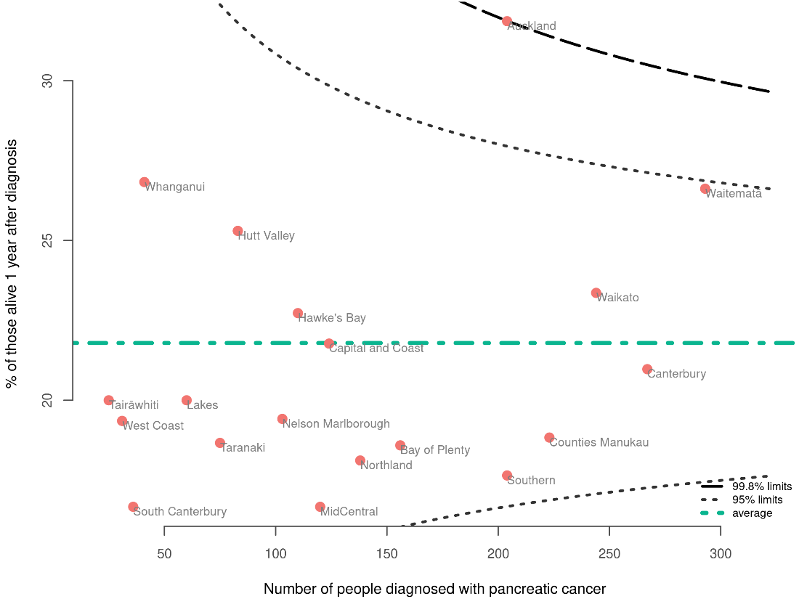

Discussion
This QPI reflects the insidious and aggressive nature of pancreatic cancer. The overall survival rates for pancreatic cancer are poor compared to most common cancers (Arnold et al 2019). Overall survival rates in Aotearoa are comparable to some international studies (Burmeister et al 2015; Rawla et al 2019). However, rates of pancreatic cancer survival in Aotearoa have been slower to improve than in some other high-income countries (Arnold et al 2019). There are many factors that contribute to the poor overall survival rates for this cancer; some are highlighted by the QPIs presented in this report.

The better survival figures for Auckland and Waitematā may in part reflect a bias related to differences in case mix. Contributing factors may include younger age, lower comorbidity and better access to primary care and early diagnosis. However, due to small numbers in some DHBs it is difficult to know if variations in these areas are due to chance.

Recommendations
Recommendations
Hospital or district quality improvement
Continue to undertake age-standardised district-, hospital- and national level reporting of the overall survival QPI to monitor pancreatic cancer diagnosis and treatment rates in Aotearoa compared with other similar countries.

General recommendations
The general recommendations that follow apply to both hospitals/districts and health entities at the national level. We intend these recommendations to be read in conjunction with the recommendations that sit under each QPI.

Early diagnosis
- Develop clear, standardised and nationally consistent (where appropriate) referral pathways for people with suspected pancreatic cancer.
- Develop tools to help community-based health care practitioners, including GPs, to recognise patients at high risk of pancreatic cancer to minimise delayed diagnosis.

Multidisciplinary care
- Adopt a multidisciplinary care model for the management of people with pancreatic cancer that includes the following:
- discussion of the majority of cases are discussed at the multidisciplinary meeting (including repeat discussions at different stages through the treatment journey)
- use of a dedicated pancreatic cancer clinic to coordinate efficient engagement of specialists and health care system resources. The clinic should be multidisciplinary, using a patient-centred model of care to improve efficiency and patient experience
- access to a dedicated specialist nurse to streamline system navigation and provide immediate and accessible support and advice.

Palliative care
- View palliative care as an essential part of treating people with pancreatic cancer; that is, active involvement of palliative care nurses and specialists should not be limited to end-of-life care, but should occur throughout the pancreatic cancer patient’s journey for the management of symptoms and, particularly, pain).

Data improvements
- Continue to build a comprehensive collection of national, hospital- and patient-level pancreatic cancer data, to inform aspects of care across the cancer care pathway, including more detailed identification of inequities and quality improvement opportunities.

Workforce
- Continue to prioritise oncology workforce capacity. Te Whatu Ora has convened a Workforce Task force to agree the key priority interventions for immediate workforce expansions where service failure is at risk if the workforce is not supported in the short term. This Taskforce will work with employee organisations, relevant union partners, tertiary training institutions and professional regulators to accelerate the need for a trained workforce in priority service areas while national strategic workforce initiatives are being implemented.

Appendices
- Methods
We intend that the methods outlined in this section will be read in conjunction with the pancreatic QPI technical specifications report (Te Aho o Te Kahu 2023 in press). That report outlines methods for calculating each QPI, including information on data sources, numerator criteria, denominator criteria, relevant data codes and descriptions and data flow diagrams.
- Data sources
All patient data for this report came from administrative datasets held within the Ministry of Health’s national data collections. These include the following.

New Zealand Cancer Registry
The New Zealand Cancer Registry (NZCR) is a population-based registry. It is the most comprehensive source of information on people who have been diagnosed with cancer in Aotearoa. It is primarily based on pathology reporting but includes information from other sources, including death certificates, radiation oncology treatment and reviews of the diagnosis coding for people admitted to public hospitals. For more information about the registration process, see the Ministry of Health’s website.

National Health Index
The National Health Index (NHI) is a registration system that includes information to identify health care users, such as name, address (including domicile code), date of birth, sex and ethnicity. We used the NHI to obtain date of death for people with pancreatic cancer in Aotearoa.

National Minimum Dataset
The National Minimum Dataset (NMDS) is a national collection of public and private hospital discharge information, including coded clinical data for inpatients and day patients. Linking NZCR data to NMDS data gave us a view of the procedures each patient underwent as treatments in public hospitals leading up to and following their pancreatic cancer diagnosis.

Radiation Oncology Collection
The Radiation Oncology Collection (ROC) is a national collection of data about the delivery of private and public courses of radiation therapy. Cancer care providers have submitted data electronically in an agreed format since 2018, although most providers have supplied historic data back to 2012.

Data collected for each course of radiation therapy delivered includes treatment centre, diagnosis code (according to the International Statistical Classification of Diseases and Related Health Problems, Tenth Revision, Australian Modification, 8th edition), treatment site.

We only extracted publicly funded radiation therapy treatments from this collection for linking with the NZCR data.

National Non-Admitted Patients Collection
The National Non-Admitted Patients Collection (NNPAC) information includes event-based purchase units that relate to medical and surgical outpatient events and emergency department (ED) events. This includes information on the type of service provided and the health specialty involved.

The NNPAC allows the Ministry of Health and districts to monitor outpatient activity and ensure that districts are appropriately remunerated for the services they provide.

The NNPAC provides national consistent data on non-admitted patient (outpatient and ED) activity.
- Definitions derived from National Collections
People diagnosed following an ED presentation were defined as people who had an acute or emergency admission (from NMDS) in the 30 days before their date of diagnosis.

People with surgical resection for pancreatic cancer was derived from the procedures coded on inpatient admitted events (from NMDS) where the procedure was one of 4 procedures identified as curative surgery for pancreatic cancer.

People who were reviewed by a medical oncologist was derived from NNPAC first specialist appointments for medical oncology using purchase unit codes.

Days alive and out of hospital was derived from inpatient admitted events (from NMDS) where length of stay at hospital following pancreatic resection and during readmission (if it occurred) were subtracted from a defined measure timeframe (30 days and 90 days from the date of pancreatic resection).
- Data processing
We considered a patient to be diagnosed with primary pancreatic cancer when that patient was registered on the NZCR for the first time with a diagnosis of pancreatic cancer. We excluded pancreatic neuroendocrine tumours.

We linked data from the Ministry of Health’s national collections to the cancer registrations at the patient level using NHI numbers to obtain information on patient care and follow-up.

We extracted data from the NZCR for people diagnosed with pancreatic cancer from 1 January 2015 to 31 December 2019. The report includes only publicly funded treatments.
- Statistical analysis
Most results discussed in this report are descriptive. We have reported the results of categorical data as percentages. We typically grouped results by DHB of residence (ie, where the patient resided at the time of diagnosis). For the pancreatic resection QPI, biliary drainage/stenting QPI and days alive and out of hospital QPI, we also present results by DHB of service.

For confidentiality, we have not presented results when there were fewer than or equal to five patients in a group. This is to ensure adequate privacy and confidentiality for patients and providers. We have not included values in columns where the numbers can be added across columns even if the value is above five. More information on this approach can be found on the Stats NZ website (Stats NZ 2019).

Funnel plots
Where appropriate, this report uses funnel plots to make comparisons between DHBs. We plotted the proportion for each DHB against the total number of patients used to estimate the proportion to give a better appreciation of how the number of patients differ in each DHB. The average across all DHBs appears as a green line.

There are two control limit lines on each plot. The funnel limits are statistically calculated based on the average proportion and the number of patients included in the estimate and therefore create a ‘funnel’ shape. The inner line is the 95% limit, where 5 out of every 100 might be expected to lie on the basis of expected random variation. The outer line is the 99.8% limit, where 2 out of every 1000 might be expected to lie. Where a DHB’s results lie outside these limits, this could represent expected variation, but may also represent unwarranted variation requiring further investigation.

Note that proportion estimates have greater uncertainty when estimated from fewer patients.

Stratification
Stratifying variables include age group, sex, ethnic group, extent of disease at diagnosis (SEER summary staging), NZDep 2018 quintile (linked to cancer registrations using health domicile codes) and urban/rural status. Data is stratified and presented in data tables in Appendix B.

SEER summary staging is a system that describes the stage of development reached by the tumour at diagnosis using the Surveillance, Epidemiology, and End Results (SEER) summary staging. The system classifies a cancer case into a broad category (in-situ, localised, regional extension and distant metastases), representing the extent of involvement of the tumour as determined using all diagnostic and therapeutic evidence available at the end of the first course of therapy or within four months of the date of diagnosis, whichever is earlier.

Index of Deprivation (NZDep) is an area-based measure of socioeconomic deprivation in Aotearoa (Atkinson et al 2015). It measures the level of deprivation for people in each small area. It is based on nine Census variables. In this report, NZDep is displayed in quintiles. Each NZDep decile contains about 20% of small areas in Aotearoa.

Urban/rural status at time of diagnosis was determined using health domicile codes for people with pancreatic cancer based on Stats NZ’s Statistical Standard for Geographic Areas 2018, which classifies Aotearoa into areas that share common urban or rural characteristics and is used to disseminate a broad range of Stats NZ’s social, demographic and economic statistics.

Other variables (such as risk group, performance status, TNM (tumour, node, metastasis) group stage and comorbidity) are not available in national collections but should be available in local records. We did not make any standardisation adjustments to the data due to missing stage data and other risks such as comorbidity. We encourage providers to interpret their results in the context of the case mix for their region.

- District Health Board result tables
Table 11: Proportion of people diagnosed with pancreatic cancer (2015–2019) admitted to hospital via emergency department within 30 days of diagnosis, by district health board of residence
 |  |  | Emergency hospital admissions
 | People with pancreatic cancer¹ | N | % | 95% confidence intervals
DHB of residence
Northland | 138 | 100 | 72.5 | 64.5–79.2
Waitematā | 293 | 208 | 71.0 | 65.5–75.9
Auckland | 204 | 134 | 65.7 | 58.9–71.9
Counties Manukau | 223 | 141 | 63.2 | 56.7–69.3
Waikato | 244 | 160 | 65.6 | 59.4–71.3
Lakes | 60 | 47 | 78.3 | 66.4–86.9
Bay of Plenty | 156 | 112 | 71.8 | 64.3–78.3
Tairāwhiti | 25 | 15 | 60.0 | 40.7–76.6
Taranaki | 75 | 59 | 78.7 | 68.1–86.4
Hawke's Bay | 110 | 78 | 70.9 | 61.8–78.6
Whanganui | 41 | 25 | 61.0 | 45.7–74.3
MidCentral | 120 | 87 | 72.5 | 63.9–79.7
Capital and Coast | 124 | 82 | 66.1 | 57.4–73.9
Hutt Valley | 83 | 59 | 71.1 | 60.6–79.7
Wairarapa | 19 | 16 | 84.2 | 62.4–94.5
Nelson Marlborough | 103 | 64 | 62.1 | 52.5–70.9
West Coast | 31 | 22 | 71.0 | 53.4–83.9
Canterbury | 267 | 169 | 63.3 | 57.4–68.9
South Canterbury | 36 | 30 | 83.3 | 68.1–92.1
Southern | 204 | 149 | 73.0 | 66.6–78.7
¹ Excludes people registered with pancreatic cancer from death certificates only.
Sources: NZCR and NMDS (hospital events)

Table 12: Proportion of people diagnosed with pancreatic cancer (2015–2019) who had pancreatic resection, by district health board of residence and of service
 |  |  | DHB of residence |  |  | DHB of service
 | Cancer cases¹ | Resected (N) | Resected (%) | 95% confidence intervals | Cancer cases¹ | Resected (N) | Resected (%) | 95% confidence intervals
Northland | 138 | 16 | 11.6 | 7.3–18.0 | 122 | - | - | -
Waitematā | 293 | 24 | 8.2 | 5.6–11.9 | 306 | 37 | 12.1 | 8.9–16.2
Auckland | 204 | 27 | 13.2 | 9.3–18.6 | 230 | 53 | 23.0 | 18.1–28.9
Counties Manukau | 223 | 16 | 7.2 | 4.5–11.3 | 220 | 13 | 5.9 | 3.5–9.8
Waikato | 244 | 7 | 2.9 | 1.4–5.8 | 246 | 9 | 3.7 | 1.9–6.8
Lakes | 60 | * | * | 1.7–13.7 | 57 | - | - | -
Bay of Plenty | 156 | 14 | 9.0 | 5.4–14.5 | 156 | 14 | 9.0 | 5.4–14.5
Tairāwhiti | 25 | * | * | 0.7–19.5 | 24 | - | - | -
Taranaki | 75 | 7 | 9.3 | 4.6–18.0 | 68 | - | - | -
Hawke's Bay | 110 | * | * | 2.0–10.2 | 105 | - | - | -
Whanganui | 41 | - | - | - | 41 | - | - | -
MidCentral | 120 | 6 | 5.0 | 2.3–10.5 | 116 | * | * | 0.5–6.1
Capital and Coast | 124 | * | * | 0.8–6.9 | 122 | * | * | 0.1–4.5
Hutt Valley | 83 | 10 | 12.0 | 6.7–20.8 | 83 | 10 | 12.0 | 6.7–20.8
Wairarapa | 19 | * | * | 0.9–24.6 | 19 | * | * | 0.9–24.6
Nelson Marlborough | 103 | 9 | 8.7 | 4.7–15.8 | 95 | * | * | 0.2–5.7
West Coast | 31 | * | * | 3.3–24.9 | 28 | - | - | -
Canterbury | 267 | 18 | 6.7 | 4.3–10.4 | 282 | 33 | 11.7 | 8.5–16.0
South Canterbury | 36 | * | * | 4.4–25.3 | 33 | * | * | 0.5–15.3
Southern | 204 | 10 | 4.9 | 2.7–8.8 | 203 | 9 | 4.4 | 2.3–8.2
¹ Excludes people registered with pancreatic cancer from death certificates only. * Suppressed due to low number of cases.
Sources: NZCR and NMDS
Table 13: Proportion of people diagnosed with pancreatic cancer (2015–2019) who had a biliary drainage or stenting procedure, by district health board of residence and service
 |  |  | DHB of residence |  |  | DHB of service
 | Cancer cases1 | Procedure (N) | Procedure (%) | 95% confidence intervals | Cancer cases1 | Procedure (N) | Procedure (%) | 95% confidence intervals
Northland | 138 | 60 | 43.5 | 35.5–51.8 | 115 | 37 | 32.2 | 24.3–41.2
Waitematā | 293 | 106 | 36.2 | 30.9–41.8 | 296 | 109 | 36.8 | 31.5–42.5
Auckland | 204 | 56 | 27.5 | 21.8–33.9 | 235 | 87 | 37.0 | 31.1–43.4
Counties Manukau | 223 | 80 | 35.9 | 29.9–42.4 | 220 | 77 | 35.0 | 29.0–41.5
Waikato | 244 | 90 | 36.9 | 31.1–43.1 | 286 | 132 | 46.2 | 40.5–51.9
Lakes | 60 | 18 | 30.0 | 19.9–42.5 | 42 | - | - | -
Bay of Plenty | 156 | 64 | 41.0 | 33.6–48.9 | 148 | 56 | 37.8 | 30.4–45.9
Tairāwhiti | 25 | 12 | 48.0 | 30.0–66.5 | 14 | * | * | 1.3–31.5
Taranaki | 75 | 27 | 36.0 | 26.1–47.3 | 71 | 23 | 32.4 | 22.7–43.9
Hawke's Bay | 110 | 33 | 30.0 | 22.2–39.1 | 100 | 23 | 23.0 | 15.8–32.2
Whanganui | 41 | 14 | 34.1 | 21.6–49.5 | 29 | * | * | 1.9–22.0
MidCentral | 120 | 44 | 36.7 | 28.6–45.6 | 120 | 44 | 36.7 | 28.6–45.6
Capital and Coast | 124 | 48 | 38.7 | 30.6–47.5 | 156 | 80 | 51.3 | 43.5–59.0
Hutt Valley | 83 | 35 | 42.2 | 32.1–52.9 | 72 | 24 | 33.3 | 23.5–44.8
Wairarapa | 19 | * | * | 8.5–43.3 | 15 | - | - | -
Nelson Marlborough | 103 | 21 | 20.4 | 13.7–29.2 | 82 | - | - | -
West Coast | 31 | 10 | 32.3 | 18.6–49.9 | 21 | - | - | -
Canterbury | 267 | 73 | 27.3 | 22.3–33.0 | 301 | 107 | 35.5 | 30.4–41.1
South Canterbury | 36 | * | * | 11.7–38.1 | 30 | * | * | 1.8–21.3
Southern | 204 | 87 | 42.6 | 36.1–49.5 | 203 | 86 | 42.4 | 35.8–49.2
¹ Excludes people registered with pancreatic cancer from death certificates only. * Suppressed due to low number of cases.
Sources: NZCR and NMDS

Table 14: Proportion of people diagnosed with pancreatic cancer (2015–2019) who had tissue diagnosis, by district health board of residence
 |  |  | Had tissue diagnosis
 | People with pancreatic cancer¹ | N | % | 95% confidence intervals
Northland | 138 | 77 | 55.8 | 47.5–63.8
Waitematā | 293 | 204 | 69.6 | 64.1–74.6
Auckland | 204 | 139 | 68.1 | 61.5–74.1
Counties Manukau | 223 | 160 | 71.7 | 65.5–77.3
Waikato | 244 | 123 | 50.4 | 44.2–56.6
Lakes | 60 | 38 | 63.3 | 50.7–74.4
Bay of Plenty | 156 | 60 | 38.5 | 31.2–46.3
Tairāwhiti | 25 | 13 | 52.0 | 33.5–70.0
Taranaki | 75 | 44 | 58.7 | 47.4–69.1
Hawke's Bay | 110 | 66 | 60.0 | 50.7–68.7
Whanganui | 41 | 24 | 58.5 | 43.4–72.2
MidCentral | 120 | 71 | 59.2 | 50.2–67.5
Capital and Coast | 124 | 83 | 66.9 | 58.3–74.6
Hutt Valley | 83 | 43 | 51.8 | 41.2–62.2
Wairarapa | 19 | 11 | 57.9 | 36.3–76.9
Nelson Marlborough | 103 | 40 | 38.8 | 30.0–48.5
West Coast | 31 | 16 | 51.6 | 34.8–68.0
Canterbury | 267 | 116 | 43.4 | 37.6–49.4
South Canterbury | 36 | 14 | 38.9 | 24.8–55.1
Southern | 204 | 99 | 48.5 | 41.8–55.4
¹ Excludes people registered with pancreatic cancer from death certificates only.
Source: NZCR

Table 15: Proportion of people diagnosed with pancreatic cancer (2015–2019) who were reviewed by a medical oncologist, by district health board of residence
 |  |  | Reviewed by a medical oncologist
 | People with pancreatic cancer¹ | N | % | 95% confidence intervals
Northland | 138 | 26 | 18.8 | 13.2–26.2
Waitematā | 293 | 73 | 24.9 | 20.3–30.2
Auckland | 204 | 70 | 34.3 | 28.1–41.1
Counties Manukau | 223 | 67 | 30.0 | 24.4–36.4
Waikato | 244 | 63 | 25.8 | 20.7–31.7
Lakes | 60 | 9 | 15.0 | 8.1–26.1
Bay of Plenty | 156 | 24 | 15.4 | 10.6–21.9
Tairāwhiti | 25 | * | * | 11.5–43.4
Taranaki | 75 | 17 | 22.7 | 14.7–33.3
Hawke's Bay | 110 | 25 | 22.7 | 15.9–31.4
Whanganui | 41 | * | * | 1.3–16.1
MidCentral | 120 | 19 | 15.8 | 10.4–23.4
Capital and Coast | 124 | 30 | 24.2 | 17.5–32.4
Hutt Valley | 83 | 22 | 26.5 | 18.2–36.9
Wairarapa | 19 | 6 | 31.6 | 15.4–54.0
Nelson Marlborough | 103 | 32 | 31.1 | 22.9–40.5
West Coast | 31 | 11 | 35.5 | 21.1–53.1
Canterbury | 267 | 64 | 24.0 | 19.2–29.4
South Canterbury | 36 | 8 | 22.2 | 11.7–38.1
Southern | 204 | 37 | 18.1 | 13.5–24.0
¹ Excludes people registered with pancreatic cancer from death certificates only.
* Suppressed due to low number of cases.
Sources: NZCR and NNPAC

Table 16: Proportion of people diagnosed with pancreatic cancer (2015–2019) who had radiation therapy, by district health board of residence
 |  |  | Had radiation therapy
 | People with pancreatic cancer¹ | N | % | 95% confidence intervals
Northland | 138 | * | * | 1.1–7.2
Waitematā | 293 | 12 | 4.1 | 2.4–7.0
Auckland | 204 | 15 | 7.4 | 4.5–11.8
Counties Manukau | 223 | 15 | 6.7 | 4.1–10.8
Waikato | 244 | 18 | 7.4 | 4.7–11.4
Lakes | 60 | * | * | 2.6–15.9
Bay of Plenty | 156 | * | * | 0.1–3.5
Tairāwhiti | 25 | * | * | 4.2–30.0
Taranaki | 75 | * | * | 0.2–7.2
Hawke's Bay | 110 | * | * | 0.5–6.4
Whanganui | 41 | * | * | 2.5–19.4
MidCentral | 120 | * | * | 1.8–9.4
Capital and Coast | 124 | 14 | 11.3 | 6.8–18.1
Hutt Valley | 83 | * | * | 1.2–10.1
Wairarapa | 19 | * | * | 0.9–24.6
Nelson Marlborough | 103 | * | * | 0.2–5.3
West Coast | 31 | * | * | 0.6–16.2
Canterbury | 267 | 11 | 4.1 | 2.3–7.2
South Canterbury | 36 | - | - | -
Southern | 204 | 11 | 5.4 | 3.0 - 9.4
¹ Excludes people registered with pancreatic cancer from death certificates only.
* Suppressed due to low number of cases.
Sources: NZCR and ROC

Table 17: Median number of days alive and out of hospital at 90 days following pancreatic resection for those diagnosed between 2015 and 2019, by district health board of residence
 |  |  |  | Days alive and out of hospital at 90 days following pancreatic resection
 | Had pancreatic resection | Discharged routinely¹ |  | Median | Minimum | Maximum
All cases
Total | 184 | 167 |  | 78.0 | 27 | 87
Year of diagnosis
2015 | 40 | 35 |  | 76.0 | 27 | 85
2016 | 44 | 39 |  | 78.0 | 48 | 85
2017 | 37 | 35 |  | 80.0 | 47 | 87
2018 | 28 | 26 |  | 78.5 | 43 | 86
2019 | 35 | 32 |  | 80.0 | 28 | 84
Sex
Male | 108 | 96 |  | 76.0 | 27 | 87
Female | 76 | 71 |  | 80.0 | 28 | 86
Age group
18–49 | 13 | * |  | 80.0 | 43 | 84
50–59 | 34 | 32 |  | 79.5 | 47 | 85
60–69 | 69 | 68 |  | 77.0 | 27 | 86
70–79 | 61 | 50 |  | 79.5 | 29 | 87
80+ | 7 | * |  | 81.0 | 59 | 82
Ethnicity
Māori | 16 | 14 |  | 73.5 | 47 | 85
Pacific peoples | * | * |  | 73.0 | 66 | 76
Asian | 9 | 9 |  | 79.0 | 67 | 84
European/other | 153 | 138 |  | 79.0 | 27 | 87
Unknown | * | * |  | 81.0 | 81 | 81
Deprivation quintile (NZDep2018)
Quintile 1 – least deprived | 47 | 40 |  | 81.0 | 29 | 87
Quintile 2 | 36 | 34 |  | 79.5 | 43 | 83
Quintile 3 | 35 | 32 |  | 76.0 | 27 | 85
Quintile 4 | 41 | 39 |  | 79.0 | 28 | 85
Quintile 5 – most deprived | 25 | 22 |  | 74.5 | 48 | 85
Rural–urban status
Rural/remote | 39 | 34 |  | 78.0 | 27 | 87
Urban | 145 | 133 |  | 78.0 | 28 | 86
SEER summary staging
Localised | 9 | 7 |  | 81.0 | 65 | 84
Regionalised | 133 | 123 |  | 78.0 | 29 | 86
Distant | 21 | 19 |  | 80.0 | 62 | 87
Not known | 21 | 18 |  | 80.0 | 27 | 83
¹ Excludes in-hospital deaths and those who were discharged to another facility.
* Suppressed due to low number of cases.
Sources: NZCR and NMDS (hospital events)

Table 18: Median number of days alive and out of hospital at 30 and 90 days following pancreatic resection for those diagnosed between 2015 and 2019, by district health board of residence
 |  |  | Days alive and out of hospital at 30 days following pancreatic resection |  |  | Days alive and out of hospital at 90 days following pancreatic resection
 | Had pancreatic resection | Discharged routinely¹ | Median | Minimum | Maximum | Median | Minimum | Maximum
Northland | 16 | 12 | 15.0 | 0 | 22 | 73.5 | 27 | 82
Waitematā | 24 | 21 | 19.0 | 0 | 25 | 79.0 | 37 | 85
Auckland | 27 | 26 | 20.0 | 0 | 24 | 79.0 | 29 | 84
Counties Manukau | 16 | 16 | 19.5 | 2 | 23 | 78.0 | 62 | 83
Waikato | 7 | 7 | 17.0 | 5 | 22 | 75.0 | 65 | 81
Lakes | * | * | 18.0 | 15 | 24 | 78.0 | 75 | 84
Bay of Plenty | 14 | 13 | 16.0 | 0 | 25 | 76.0 | 47 | 85
Taranaki | 7 | 7 | 17.0 | 0 | 21 | 74.0 | 47 | 81
Hawke's Bay | * | * | 19.0 | 0 | 20 | 79.0 | 43 | 80
MidCentral | 6 | 6 | 19.5 | 5 | 23 | 79.5 | 61 | 83
Capital and Coast | * | * | 19.0 | 13 | 20 | 73.0 | 70 | 80
Hutt Valley | 10 | 10 | 17.5 | 0 | 24 | 75.5 | 51 | 84
Nelson Marlborough | 9 | 9 | 22.0 | 7 | 25 | 82.0 | 59 | 85
West Coast | * | * | 23.0 | 23 | 24 | 83.0 | 78 | 84
Canterbury | 18 | 17 | 23.0 | 0 | 26 | 82.0 | 28 | 86
South Canterbury | * | * | 23.0 | 21 | 27 | 83.0 | 81 | 87
Southern | 10 | 8 | 19.0 | 9 | 23 | 79.0 | 69 | 83
¹ Excludes in-hospital deaths and those who were discharged to another facility. * Suppressed due to low number of cases.
Sources: NZCR and NMDS (hospital events)
Table 19: Proportion of people diagnosed with pancreatic cancer (2015–2019) alive 1 and 2 years after diagnosis, by district health board of residence
 | 1-year overall survival |  |  |  | 2-year overall survival
 | Included cases^{1,2} | N | % | 95% confidence intervals | Included cases^{1,3} | N | % | 95% confidence intervals
Northland | 138 | 25 | 18.1 | 12.6–25.4 | 109 | 10 | 9.2 | 5.1–16.1
Waitematā | 293 | 78 | 26.6 | 21.9–32.0 | 231 | 25 | 10.8 | 7.4–15.5
Auckland | 204 | 65 | 31.9 | 25.9–38.5 | 159 | 31 | 19.5 | 14.1–26.3
Counties Manukau | 223 | 42 | 18.8 | 14.2–24.5 | 172 | 16 | 9.3 | 5.8–14.6
Waikato | 244 | 57 | 23.4 | 18.5–29.1 | 187 | 20 | 10.7 | 7.0–15.9
Lakes | 60 | 12 | 20.0 | 11.8–31.8 | 44 | * | * | 5.0–24.0
Bay of Plenty | 156 | 29 | 18.6 | 13.3–25.4 | 118 | 8 | 6.8 | 3.5–12.8
Tairāwhiti | 25 | * | * | 8.9–39.1 | 18 | * | * | 1.0–25.8
Taranaki | 75 | 14 | 18.7 | 11.5–28.9 | 62 | * | * | 2.5–15.4
Hawke's Bay | 110 | 25 | 22.7 | 15.9–31.4 | 83 | 6 | 7.2 | 3.4–14.9
Whanganui | 41 | 11 | 26.8 | 15.7–41.9 | 33 | * | * | 3.1–23.6
MidCentral | 120 | 20 | 16.7 | 11.1–24.3 | 90 | * | * | 2.4–12.4
Capital and Coast | 124 | 27 | 21.8 | 15.4–29.8 | 85 | 9 | 10.6 | 5.7–18.9
Hutt Valley | 83 | 21 | 25.3 | 17.2–35.6 | 64 | 6 | 9.4 | 4.4–19.0
Wairarapa | 19 | * | * | 2.9–31.4 | 15 | - | - | -
Nelson Marlborough | 103 | 20 | 19.4 | 12.9–28.1 | 80 | 6 | 7.5 | 3.5–15.4
West Coast | 31 | 6 | 19.4 | 9.2–36.3 | 23 | * | * | 0.8–21.0
Canterbury | 267 | 56 | 21.0 | 16.5–26.3 | 204 | 20 | 9.8 | 6.4–14.7
South Canterbury | 36 | 6 | 16.7 | 7.9–31.9 | 29 | * | * | 3.6–26.4
Southern | 204 | 36 | 17.6 | 13.0–23.5 | 154 | 12 | 7.8 | 4.5–13.1
¹ Excludes people registered with pancreatic cancer from death certificates only.
² Cases include those diagnosed with pancreatic cancer between 2015 and 2019.
³ Cases include those diagnosed with pancreatic cancer between 2015 and 2018.
* Suppressed due to low number of cases.
Sources: NZCR and NHI

- References
Abdel-Rahman O, Xu Y, Tang PA, et al. 2018. A real-world, population-based study of patterns of referral, treatment, and outcomes for advanced pancreatic cancer. Cancer Medicine 7(12): 6385–92. DOI: 10.1002/cam4.1841 (accessed 19 January 2023).
Arnold M, Rutherford MJ, Bardot A, et al. 2019. Progress in cancer survival, mortality, and incidence in seven high-income countries 1995–2014 (ICBP SURVMARK-2): a population-based study. The Lancet Oncology 20(11): 1493–1505. DOI: 10.1016/s1470-2045(19)30456-5 (accessed 17 January 2023).
Atkinson J, Salmond C, Crampton P. 2015. NZDep2013 Index of Deprivation. URL: https://www.otago.ac.nz/wellington/otago069936.pdf (accessed 26 January 2023).
Bilimoria KY, Bentrem DJ, Ko CY, et al. 2007. National failure to operate on early stage pancreatic cancer. Annals of Surgery 246(2): 173-180. DOI: 10.1097/SLA.0b013e3180691579 (accessed 19 January 2023).
Burmeister EA, O'Connell DL, Beesley VL, et al. 2015. Describing patterns of care in pancreatic cancer: a population-based study. Pancreas 44(8): 1259–65.
Cancer Research UK. 2017. Pancreatic cancer statistics. URL: https://www.cancerresearchuk.org/health-professional/cancer-statistics/statistics-by-cancer-type/pancreatic-cancer (accessed 19 January 2023).
eviQ Cancer Treatments Online. 2021. Pancreas definitive/neoadjuvant EBRT chemoradiation. URL: https://www.eviq.org.au/radiation-oncology/upper-gastrointestinal/3581-pancreas-definitive-neoadjuvant-ebrt-chemorad (accessed 19 January 2023).
Gurney J, Stanley J, McLeod M, et al. 2020. Disparities in Cancer-Specific Survival Between Maori and Non-Maori New Zealanders, 2007–2016. JCO Global Oncology 6: 766–74. DOI: 10.1200/GO.20.00028 (accessed 17 January 2023).
Hammel P, Huguet F, van Laethem JL, et al. 2016. Effect of Chemoradiotherapy vs Chemotherapy on Survival in Patients With Locally Advanced Pancreatic Cancer Controlled After 4 Months of Gemcitabine With or Without Erlotinib: The LAP07 Randomized Clinical Trial. JAMA 315(17): 1844–53. DOI: 10.1001/jama.2016.4324 (accessed 19 January 2023).
Hurton S, Urquhart R, Kendell C, et al. 2017. Variations in Medical Oncology Utilization for Pancreatic Cancer Patients in Nova Scotia. Journal of the Pancreas 18(1), 62–8.
Jerath A, Austin PC, Wijeysundera DN. 2019. Days Alive and Out of Hospital: Validation of a Patient-centered Outcome for Perioperative Medicine. Anesthesiology 131(1): 84–93. DOI: 10.1097/ALN.0000000000002701 (accessed 17 January 2023).
Kamisawa T, Wood LD, Itoi T, et al. 2016. Pancreatic cancer. The Lancet 388(10039): 73–85. DOI: 10.1016/s0140-6736(16)00141-0 (accessed 17 January 2023).
Klein AP. 2019. Pancreatic cancer: a growing burden. The Lancet Gastroenterology & Hepatology 4(12): 895–6. DOI: 10.1016/s2468-1253(19)30323-1 (accessed 17 January 2023).
Lidsky ME, Sun Z, Nussbaum DP, et al. 2017. Going the extra mile: improved survival for pancreatic cancer patients traveling to high-volume centers. Annals of Surgery 266(2): 333–338.
Mavros MN, Coburn NG, Davis LE, et al. 2019. Low rates of specialized cancer consultation and cancer-directed therapy for noncurable pancreatic adenocarcinoma: a population-based analysis. CMAJ 191(21): E574–E580. DOI: 10.1503/cmaj.190211 (accessed 19 January 2023).
McGuigan A, Kelly P, Turkington RC, et al. 2018. Pancreatic cancer: A review of clinical diagnosis, epidemiology, treatment and outcomes. World Journal of Gastroenterology 24(43): 4846–4861. DOI: 10.3748/wjg.v24.i43.4846 (accessed 17 January 2023).
McPhail S, Swann R, Johnson SA, et al. 2022. Risk factors and prognostic implications of diagnosis of cancer within 30 days after an emergency hospital admission (emergency presentation): an International Cancer Benchmarking Partnership (ICBP) population-based study. The Lancet Oncology 23(5): 587–600. DOI: 10.1016/s1470-2045(22)00127-9 (accessed 17 January 2023).
McPhee JT, Hill JS, Whalen GF, et al. 2007. Perioperative Mortality for Pancreatectomy: A National Perspective. Annals of Surgery 246(2): 246–53. DOI: 10.1097/01.sla.0000259993.17350.3a (accessed 19 January 2023).
Ministry of Health. 2019a. Achieving Equity in Health Outcomes: Summary of a discovery process. URL: https://www.health.govt.nz/publication/achieving-equity-health-outcomes-summary-discovery-process (accessed 17 January 2023).
Ministry of Health. 2019b. Wai 2575 Māori Health Trends Report. URL: https://www.health.govt.nz/publication/wai-2575-maori-health-trends-report (accessed 17 January 2023).
O'Brien I, Britton E, Sarfati D, et al. 2010. The voice of experience: results from cancer control New Zealand's first national cancer care survey. New Zealand Medical Journal (Online) 123(1325).
O'Mahoney PR, Yeo HL, Sedrakyan A, et al. 2016. Centralization of pancreatoduodenectomy a decade later: impact of the volume–outcome relationship. Surgery 159(6): 1528–38.
O'Reilly EM, Cockrum P, Surinach A, et al. 2020. Reducing nihilism in metastatic pancreatic ductal adenocarcinoma: Treatment, sequencing, and effects on survival outcomes. Cancer Medicine 9(22): 8480–90. DOI: 10.1002/cam4.3477 (accessed 19 January 2023).
Palta M, Godfrey D, Goodman KA, et al. 2019. Radiation Therapy for Pancreatic Cancer: Executive Summary of an ASTRO Clinical Practice Guideline. Practical Radiation Oncology 9(5): 322–32. DOI: https://doi.org/10.1016/j.prro.2019.06.016(accessed 19 January 2023).
Pourshams A, Sepanlou SG, Ikuta KS,et al. 2019. The global, regional, and national burden of pancreatic cancer and its attributable risk factors in 195 countries and territories, 1990–2017: a systematic analysis for the Global Burden of Disease Study 2017. The Lancet Gastroenterology & Hepatology 4(12): 934–47. DOI: 10.1016/s2468-1253(19)30347-4 (accessed 17 January 2023).
Queensland Government. 2022. Queensland Cancer Quality Index: Indicators of safe, quality cancer care. Cancer care in public and private hospitals 2005-2019. URL: https://cancerallianceqld.health.qld.gov.au/queensland-cancer-quality-index/ (accessed 19 January 2023).
Ratnayake B, Pendharkar SA, Connor S, et al. 2022. Patient volume and clinical outcome after pancreatic cancer resection: A contemporary systematic review and meta-analysis. Surgery 172(1): 273–83. DOI: 10.1016/j.surg.2021.11.029 (accessed 17 January 2023).
Rawla P, Sunkara T, Gaduputi V. 2019. Epidemiology of Pancreatic Cancer: Global Trends, Etiology and Risk Factors. World Journal of Oncology 10(1): 10–27. DOI: 10.14740/wjon1166 (accessed 20 January 2023).
Santucci J, Tacey M, Thomson B, et al. 2022. Impact of first-line FOLFIRINOX versus Gemcitabine/Nab-Paclitaxel chemotherapy on survival in advanced pancreatic cancer: Evidence from the prospective international multicentre PURPLE pancreatic cancer registry. European Journal of Cancer 174: 102–112. DOI: https://doi.org/10.1016/j.ejca.2022.06.042 (accessed 19 January 2023).
Stats NZ. 2019. Applying confidentiality rules to 2018 Census data and summary of changes since 2013. URL: https://www.stats.govt.nz/methods/applying-confidentiality-rules-to-2018-census-data-and-summary-of-changes-since-2013 (accessed 17 January 2023).
Sung H, Ferlay J, Siegel RL, et al. 2021. Global Cancer Statistics 2020: GLOBOCAN Estimates of Incidence and Mortality Worldwide for 36 Cancers in 185 Countries. CA: a cancer journal for clinicians 71(3): 209–49. DOI: 10.3322/caac.21660 (accessed 17 January 2023).
Swanson RS, Pezzi CM, Mallin K, et al. 2014. The 90-Day Mortality After Pancreatectomy for Cancer Is Double the 30-Day Mortality: More than 20,000 Resections From the National Cancer Data Base. Annals of Surgical Oncology 21(13): 4059–67. DOI: 10.1245/s10434-014-4036-4 (accessed 19 January 2023).
Te Aho o Te Kahu. 2021. He Pūrongo Mate Pukupuku o Aotearoa 2020: The State of Cancer in New Zealand 2020. URL: https://teaho.govt.nz/publications/cancer-state (accessed 17 January 2023).
Te Aho o Te Kahu. 2022. Pūrongo Ārai Mate Pukupuku: Cancer Prevention Report. URL: https://teaho.govt.nz/publications/prevention-report (accessed 17 January 2023).
Versteijne E, Suker M, Groothuis K, et al. 2020. Preoperative Chemoradiotherapy Versus Immediate Surgery for Resectable and Borderline Resectable Pancreatic Cancer: Results of the Dutch Randomized Phase III PREOPANC Trial. Journal of Clinical Oncology 38(16): 1763–73. DOI: 10.1200/JCO.19.02274 (accessed 19 January 2023).
Versteijne E, Vogel JA, Besselink MG, et al. 2018. Meta-analysis comparing upfront surgery with neoadjuvant treatment in patients with resectable or borderline resectable pancreatic cancer. British Journal of Surgery 105(8): 946–58. DOI: 10.1002/bjs.10870 (accessed 17 January 2023).

- Working group members
In 2022, the National Pancreatic Cancer Working Group members were as follows.

Chair
Professor John Windsor, surgeon, Te Whatu Ora Te Toka Tumai Auckland and University of Auckland

Members
toAssociate Professor Adam Bartlett, surgeon, Te Whatu Ora Te Toka Tumai Auckland
Associate Professor Andrew MacCormick, surgeon, Te Whatu Ora, Counties Manukau
Dr Andrew Miller, pathologist, Canterbury Health Laboratories
Dr Andrew Wilson, anaesthetist, Te Whatu Ora Te Toka Tumai Auckland
Dr Anna Wojtacha, medical oncologist, Te Whatu Ora, Nelson Marlborough
Dr Chris McKee, radiologist, Te Whatu Ora Waitematā
Dr Colleen Van Der Vyver, palliative medicine specialist, Te Whatu Ora Te Pae Hauora o Ruahine o Tararua MidCentral
Dr Daniel Cookson, interventional radiologist, Te Whatu Ora Counties Manukau
Dr David Orr, hepato/gastroenterologist, Te Whatu Ora Te Toka Tumai Auckland
Dr Dean Harris, Medical oncologist, Te Whatu Ora Waitaha Canterbury
Dr Dorothy Lombe, radiation oncologist, Te Whatu Ora Te Pae Hauora o Ruahine o Tararua MidCentral
Dr Emma McMenamin, palliative medicine SMO, Te Whatu Ora Capital and Coast and Hutt Valley
Dr Frank Weilert, gastroenterologist, Te Whatu Ora Waitaha Canterbury
Dr Gabriel Lau, radiologist, Pacific Radiology
Grant Middleton, consumer
Helen Brown, dietitian, Nurse Maude Canterbury
Dr Janet Hayward, general practitioner, Nelson-Marlborough
Dr Jeremy Rossaak, surgeon, Te Whatu Ora, Hauora a Toi Bay of Plenty
Professor Jonathan Koea, surgeon, Te Whatu Ora Waitematā
Dr Kate Clarke, medical oncologist, Te Whatu Ora, Capital and Coast and Hutt Valley
Dr Matthew Drake, anatomical pathologist, Te Whatu Ora Waitaha Canterbury
Dr Michael Rodgers, surgeon, Te Whatu Ora Waitematā
Nadine Peake, cancer nurse coordinator, Te Whatu Ora Waitaha Canterbury
Dr Paul Restall, histopathologist, Te Whatu Ora Te Toka Tumai Auckland
Petro Nel, clinical nurse specialist
Dr Sam Wall, anaesthetist, Te Whatu Ora Te Toka Tumai Auckland
Dr Saxon Connor, surgeon, Te Whatu Ora Waitaha Canterbury
Dr Sayali Pendharkar-Orpe, lead science advisor, Ministry of Health
Dr Simon Bann, surgeon, Te Whatu Ora Capital and Coast and Hutt Valley

As currently in place at Auckland, Waitematā and Christchurch.
An interoperability standard for electronic exchange of health care information.
The SACT Regimen library is a component of the ACT-NOW programme to manage the regimen development, maintenance and publication process. This serves as a source of truth for nationally developed regimen definitions and is designed to support more equitable, standardised and evidence driven treatment across Aotearoa.
In this report, an emergency admission is defined as a hospital admission that is acute or unplanned and does not include people who attend the ED for review and are then discharged. An emergency admission may occur by a number of routes, including via the ED and an outpatient clinic.
This QPI can be considered in conjunction with QPI 3.5.
‘Failure to rescue’ rates indicate the number of deaths in hospital that could have been prevented.
As currently in place at Auckland, Waitematā and Christchurch.

