CANCER SERVICE QUALITY INDICATORS

Quality Improvement Monitoring Report – SUMMARY
Route to diagnosis:
People diagnosed with cancer within 30-days of an emergency or acute (unplanned) hospital admission
March 2024

A high rate of cancer patients diagnosed after an emergency admission suggests we need to get better at earlier diagnosis in the community
A key goal of the National Cancer Action Plan 2019–2029 (Ministry of Health 2019) is to improve cancer survival rates across Aotearoa New Zealand. Achieving this goal requires people to be diagnosed and treated as early as possible. However, compared to other countries, people in Aotearoa New Zealand experience a high rate of being first diagnosed with cancer after an emergency or acute (unplanned) hospital admission, which is likely to be after the cancer has been progressing for some time.

People who are diagnosed with cancer after an emergency admission to a hospital will experience poorer survival or health outcomes compared to those who are diagnosed through more appropriate pathways (ie, primary care and community-based diagnostic services). Patients being diagnosed through hospital emergency admissions often present with severe symptoms indicating advanced stage of disease and resulting in poorer outcomes. These patients have poorer quality of life, a worse experience, and are less likely to be offered curative treatment (McPhail et al 2022; Pham et al 2019; Zhou et al 2017).
The definition of a ‘cancer diagnosis following emergency or acute (unplanned) hospital admission’ is a cancer diagnosis that occurs within 30 days of an emergency or acute admission (ie, unplanned admission) to hospital, regardless of whether the reason for the visit is related to the cancer that is subsequently diagnosed. For this summary and the associated full report, we refer to this as an ‘emergency admission.’

There are rare instances when a cancer diagnosis 30 days after admission is a complete coincidence and not related to the reason for the admission. However, this limitation does not diminish the importance of this measure overall. The high rates of cancer diagnosis following emergency admission in Aotearoa New Zealand compared to other countries and the variation between geographical regions and inequities between population groups combine to tell us that we need to do better.
Due to the nature of how some cancers develop, a diagnosis following an emergency admission is not always an indication of a failure in the health system. This can be due to the type of cancer and symptoms, individual patient factors, or a combination of these – you can read more about this in the next section, which describes some causal factors.

This is a summary of the Quality Improvement Monitoring Report – Route to diagnosis: People diagnosed with cancer within 30 days of an emergency or acute (unplanned) hospital admission. You can read the full report on our website: www.teaho.govt.nz/publications

Many factors may contribute to a high rate of cancer diagnosis after an emergency admission
There are a range of factors that lead to a person receiving a cancer diagnosis following an emergency admission to a hospital. Several essential factors that impact the diagnosis of cancer, such as workforce and technology capacity (ie, shortages), affect the entire health system and are not unique to cancer services. Understanding these precursors or causal factors is an important part of determining where to act to identify cancer earlier and improve survival rates and treatment experiences for patients. Figure 1 lists some of the causal factors identified through research.

Figure 1: Factors that contribute to a cancer diagnosis following an emergency admission
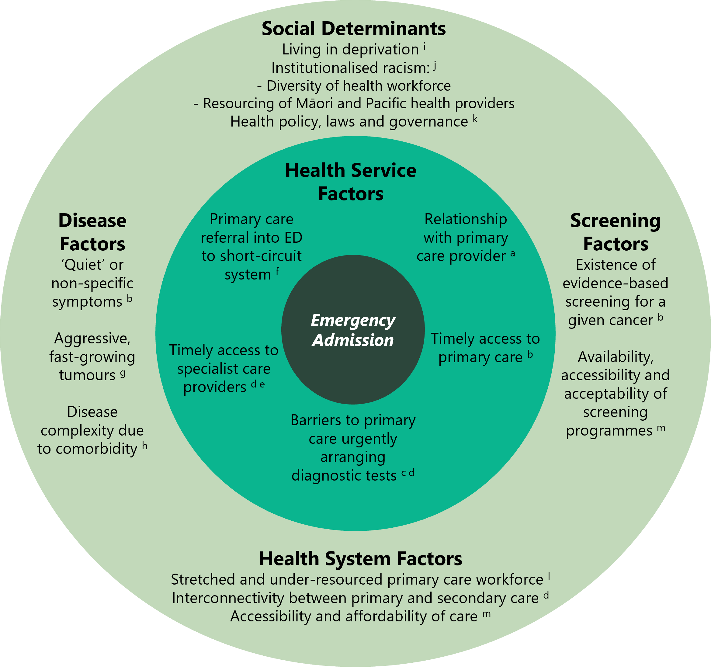
ª Cassim et al 2019; ^{b} McPhail et al 2022; ^{c} Htun et al 2017; ^{d} Nekhlyudov and Latosinsky 2010;
^{e} Murchie et al 2017; ^{f} Beatty et al 2009; ^{g} Lyratzopoulos et al 2014; ^{h} Majano et al 2022; ^{i} Abel et al 2015;
^{j} Waitangi Tribunal 2019; ^{k} Liberman 2019; ^{l} Grimmond et al 2021; ^{m} Meheus et al 2019

Why does it matter?
A fully optimised and well supported primary care, community diagnostics and specialist referral system (supported by effective screening programmes) should lead to more cancer patients being diagnosed earlier, which in turn should lead to improved outcomes. A lack thereof will result in a disproportionate percentage of patients being diagnosed through hospital emergency admissions, often when presenting with severe symptoms indicating advanced stage of disease and resulting in poorer outcome, as seen in Figure 2 below.

These patients also have poorer quality of life, a worse experience, and are less likely to be offered curative treatment compared to those who do not have an emergency admission (McPhail et al 2022; Pham et al 2019; Zhou et al 2017).

The other important consideration is the extent to which vulnerable or under-served populations (such as Māori, Pacific peoples, and/or people living in rural and remote communities) are more likely to be diagnosed after emergency admission. Data on this will be used to inform discussions with Health New Zealand | Te Whatu Ora, community and primary health care providers (eg, GPs, pharmacists) and other key agencies on ways to improve cancer detection and diagnosis processes and reduce cancer diagnoses via emergency admission across Aotearoa New Zealand.

Figure 2: Proportion of deaths within 12 months of cancer diagnosis in Aotearoa New Zealand, by diagnosis following emergency admission and no emergency admission, 2012–2017
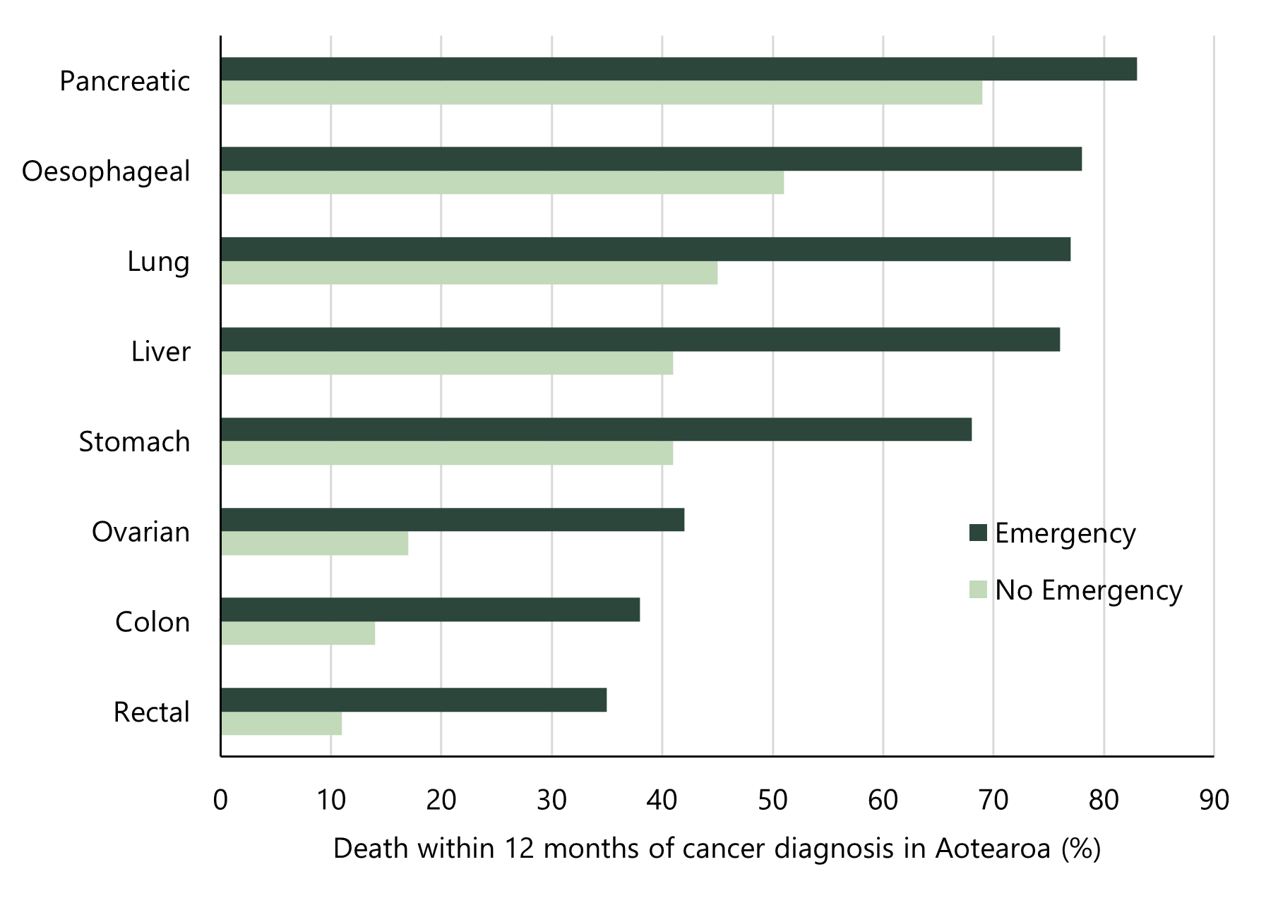
Note: Graph created using data from McPhail et al 2022.

Aotearoa New Zealand compares poorly to peer countries
In 2022, an International Cancer Benchmarking Partnership (ICBP) study analysed cancer registrations and linked hospital admissions data from 14 jurisdictions in six countries: Australia, Canada, Denmark, Aotearoa New Zealand, Norway, and the United Kingdom. This focused on eight cancers: oesophageal, stomach, colon, rectal, liver, pancreatic, lung and ovarian. The findings were published in The Lancet Oncology in 2022 (McPhail et al 2022).

The ICBP report identified that Aotearoa New Zealand had the highest rates of emergency presentation prior to diagnosis for all of these cancers except liver cancer, for which we had the third highest rate (Figure 3).

Being included in the ICBP study present both an opportunity and a challenge. The opportunity is to identify the best practices in the highest performing countries that can be adapted and implemented in Aotearoa New Zealand. The challenge is to change the system in Aotearoa New Zealand to address this poor performance.

Figure 3: International Cancer Benchmarking Programme cancer diagnosis following emergency admission: Aotearoa compared with 13 other international jurisdictions for eight cancer types. The green bars indicate Aotearoa proportions; the grey bars indicate the other jurisdictions.
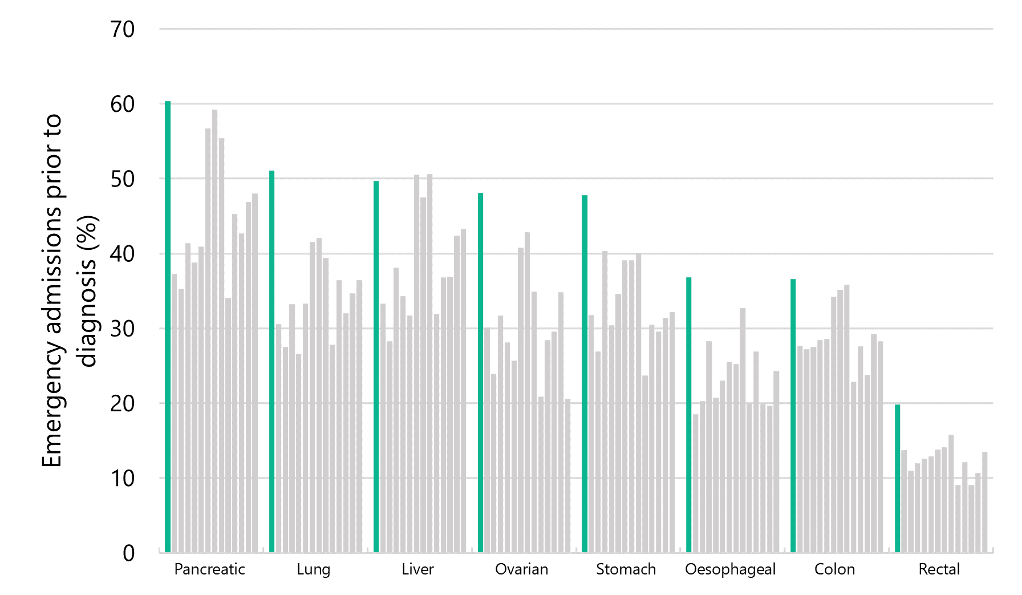

Brain, pancreatic and lung cancers are among the cancers with the highest rate of diagnosis after an emergency admission
The likelihood of emergency admission varies between cancer types. This is because each cancer has different characteristics or symptoms.

As shown in Figure 4, proportions are highest for cancers that are more likely to have sudden onset of severe symptoms requiring urgent treatment, such as some brain and central nervous system cancers, and cancers that can be initially ‘quiet’ or have non-specific symptoms that can then require urgent review, such as pancreatic cancer. However, many other cancer types (like lung, stomach, and bladder) can present with symptoms and/or indications that could (should) be detected and managed in the primary care/community setting.

Figure 4: Proportion of emergency admissions by cancer type in Aotearoa, 2017–2021
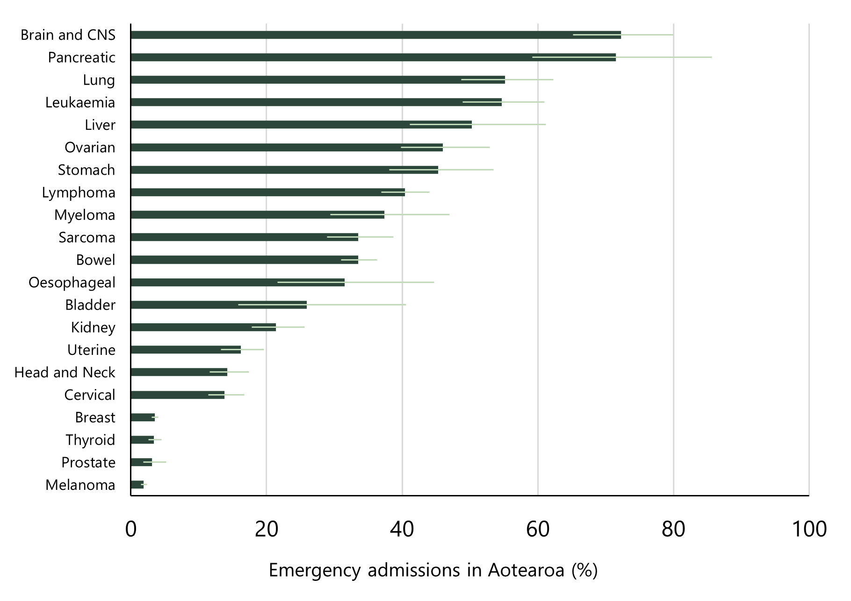
Note: The light green line indicates the 95% confidence interval. CNS = central nervous system.

Māori are more likely to be diagnosed after an emergency admission
Figure 5 compares the total rate of cancer diagnosis following emergency admission between Māori and non-Māori/non-Pacific/non-Asian people (ie, European/other ethnicity) and shows the results by district (where people live).

It shows that, across Aotearoa New Zealand, Māori are more likely to be diagnosed following an emergency admission than people of European/other ethnicity. For example, the figure shows that in Auckland, Māori are twice as likely to be diagnosed following an emergency admission compared to people of European/other ethnicity. These results are not surprising given Māori are less likely than people of European/other ethnicity to have reliable access to primary care services and other supports that decrease the likelihood of late stage, emergency admission based diagnoses.

Figure 5: Māori compared to European/other ethnicity emergency admission for all cancers combined, by district of residence
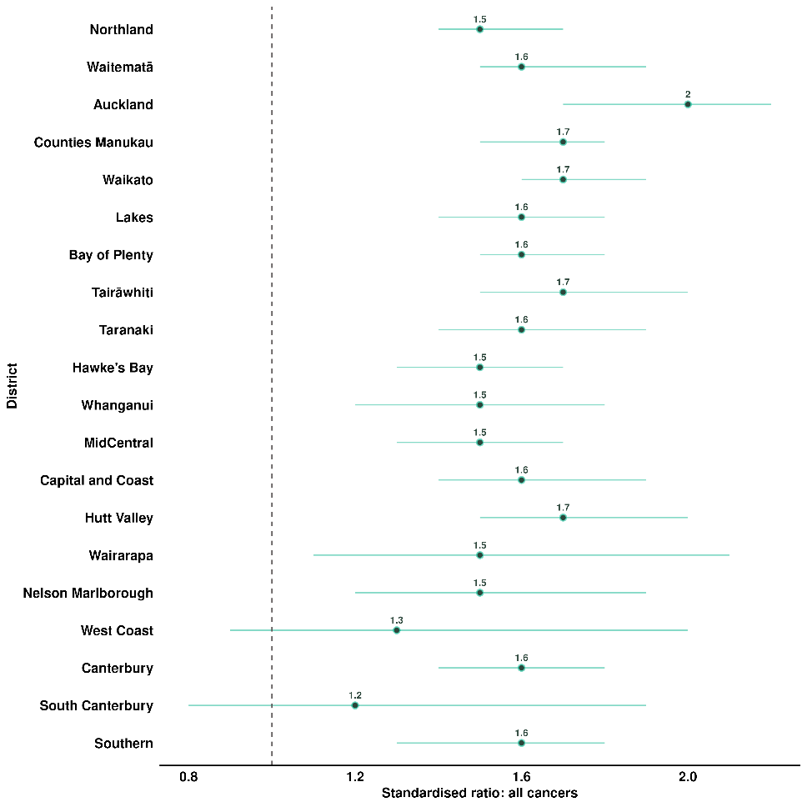
Note: Points represent the standardised ratio, and lines represent the 95% confidence interval. For the West Coast and South Canterbury districts, the error bars are wider than others and cross 1. One reason for this is due to smaller Māori populations and therefore smaller case numbers for Māori in those areas. While less statistically certain, there is likely to be an inequitable ratio for Māori in these areas.

Cancer-specific results
The full report provides information regarding cancer diagnosis following emergency admission for 22 cancer types. In the next two sections we have provided example information for bowel and lung cancers. There are many factors that contribute towards the differences between these two cancer types, including smoking status, access to screening and access to primary care; however, for bowel and lung cancer we have provided brief narrative as to contributing factors and solutions.

Note to readers about the confidence intervals shown in this report
Confidence intervals are most used when working with sample data to estimate how likely it is that the result is true of the whole population. Therefore, confidence intervals are often used to decide if a difference between two groups being looked at is likely to be a true difference (if the confidence intervals overlap, there may not be a true difference). This report uses whole population data (ie, it is not a sample), so confidence intervals should be interpreted differently. They are presented in this report to give an impression of what variation there may be over time (rather than the likelihood the result is true). Therefore, overlapping confidence intervals do not indicate the absence of a difference between compared groups.

Spotlight on bowel cancer
Of the 15,139 people diagnosed with bowel cancer between 2017 and 2021, 30% were diagnosed within 30 days of an emergency admission. Proportions were highest among Māori (47%) and Pacific peoples (52.7%) compared to people of European/other ethnicity (30.6%). Proportions were also higher among those in younger (18–49 years) and older (80+ years) age groups. Emergency admissions were higher as deprivation increased (Figure 6).

Figure 6: Proportion of people diagnosed with bowel cancer in the 30 days following emergency admission, by sex, ethnicity, NZDep2018 quintile, rural–urban status (all age-standardised), and age (non-standardised) for the years 2017–2021
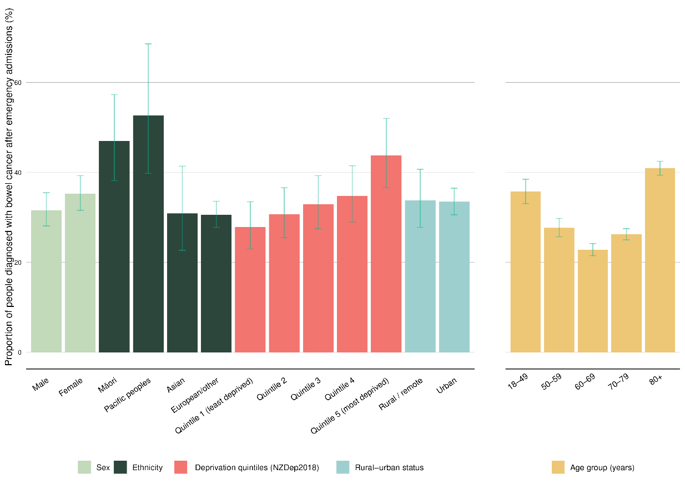

Figure 7 shows that the proportion of emergency admissions have some variability by district. Tairāwhiti results are difficult to accurately interpret due to low case numbers.
Figure 7: Funnel plot showing proportion of people diagnosed with bowel cancer in the 30 days following emergency admission, by district of residence, for the years 2017–2021 (un-standardised)
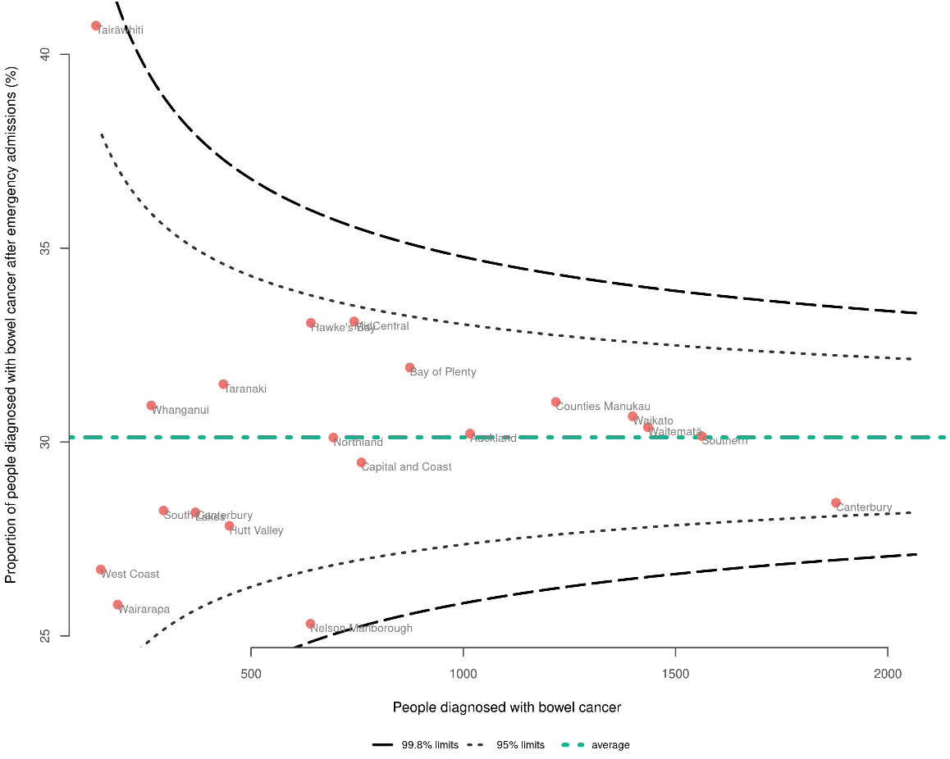

The national bowel cancer screening programme, which was rolled out relatively recently, should, over time, lead to an overall reduction in the proportion of emergency admissions among those of screening age.

The national bowel screening programme is currently making changes (eg, a lower starting age from 60 to 50 years for Māori and Pacific peoples) aimed at ensuring equitable access/reducing inequities for different population groups.

Interventions aimed at improving access to primary care (such as further resourcing of primary care delivered by Māori health providers) should lead to an overall reduction in the proportion of emergency admissions, but this will vary between groups depending on who is targeted by these interventions.

Spotlight on lung cancer
Of the 11,141 people diagnosed with lung cancer between 2017 and 2021, half were diagnosed within 30 days of an emergency admission. Like bowel cancer, proportions were highest among Māori (54.1%) and Pacific peoples (65.4%) compared with Asian (48.1%) and European/other (49.6%), as well as among younger people (aged 18–49) and older people (aged 80+) (Figure 8).

Figure 8: Proportion of people diagnosed with lung cancer in the 30 days following emergency admission, by sex, ethnicity, NZDep2018 quintile, rural–urban status (all age-standardised), and age (non-standardised) for the years 2017–2021
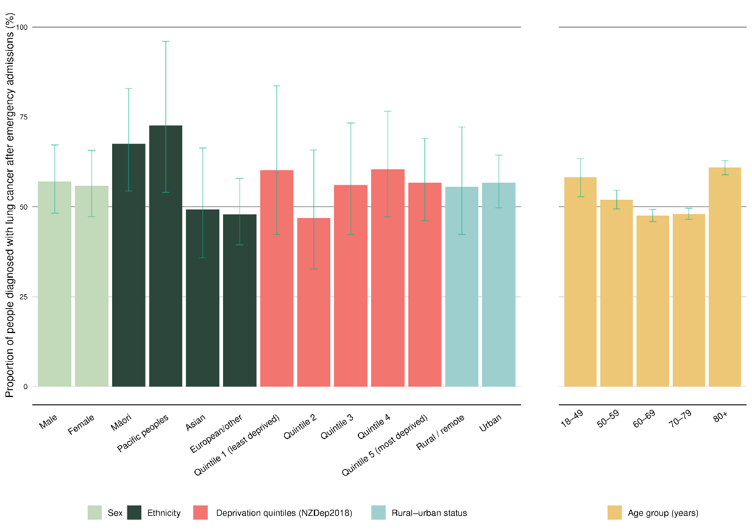

Figure 9 (on the next page) shows that there is broad variability in the proportion of emergency admissions between districts in New Zealand, including between large centres.

Figure 9: Funnel plot showing proportion of people diagnosed with lung cancer in the 30 days following emergency admission, by district of residence, for the years 2017–2021 (un-standardised)
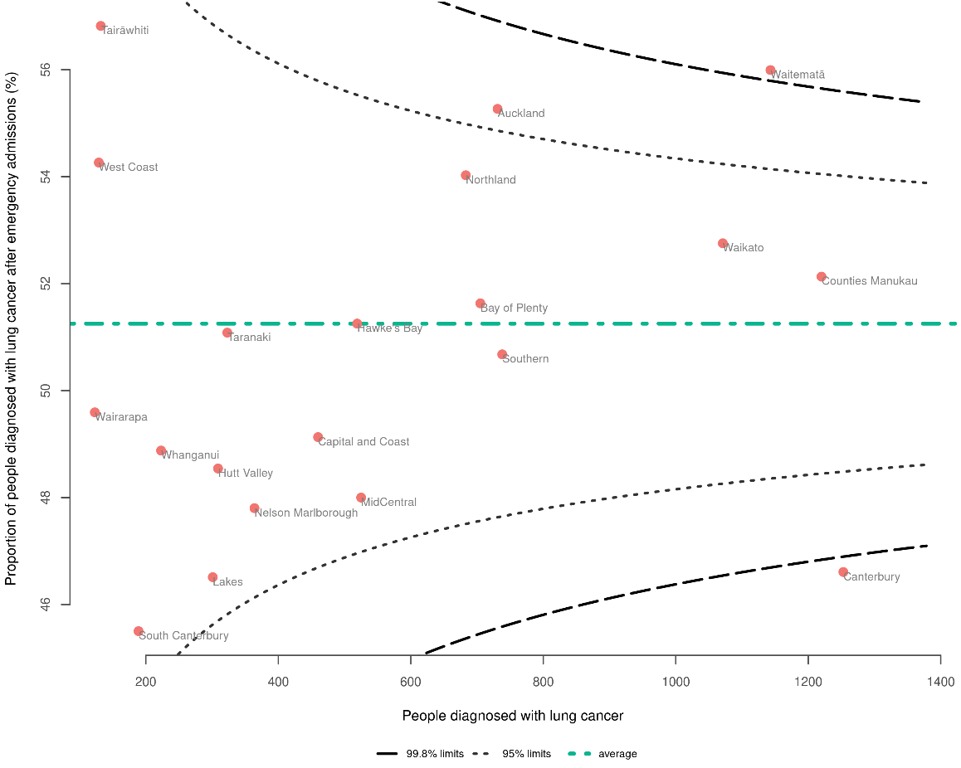

A national lung cancer screening programme is being scoped by Health New Zealand | Te Whatu Ora. If appropriately implemented, it should reduce the proportion of emergency admissions prior to diagnosis among those within the target population (which is yet to be determined).

Interventions aimed at improving access to primary care (such as further resourcing of primary care delivered by Māori health providers) should lead to an overall reduction in the proportion of emergency admissions, but this will vary between groups depending on who is targeted by these interventions.

What are some of the potential solutions?
When someone develops cancer, it is important for them to be diagnosed as early as possible, through an established referral pathway, starting in primary and community care. They should also be supported by a health service that is culturally safe and trusted by the person and their whānau.

Several factors that impact the diagnosis of cancer, such as workforce shortages and institutional racism, also affect the entire health system. These issues are well known and are being addressed at the national, regional, and local level.

Within the path to cancer diagnosis, there are key opportunities and initiatives to develop and build on, some already underway and some requiring further investigation. Figure 10 outlines example actions along the path to diagnosis. It highlights, alongside the causal factors outlined in Figure 1, the complexity of health system and other factors leading to a high proportion of emergency admissions.

Te Aho o Te Kahu will work with Health New Zealand | Te Whatu Ora, primary and community care organisations (eg, GPs, pharmacists) and other key agencies to use the findings in the report to improve cancer detection and diagnosis services and outcomes for cancer patients and their whānau.

Figure 10: The path to diagnosis showing possible areas of focus to improve early cancer detection and diagnosis, with examples of opportunities
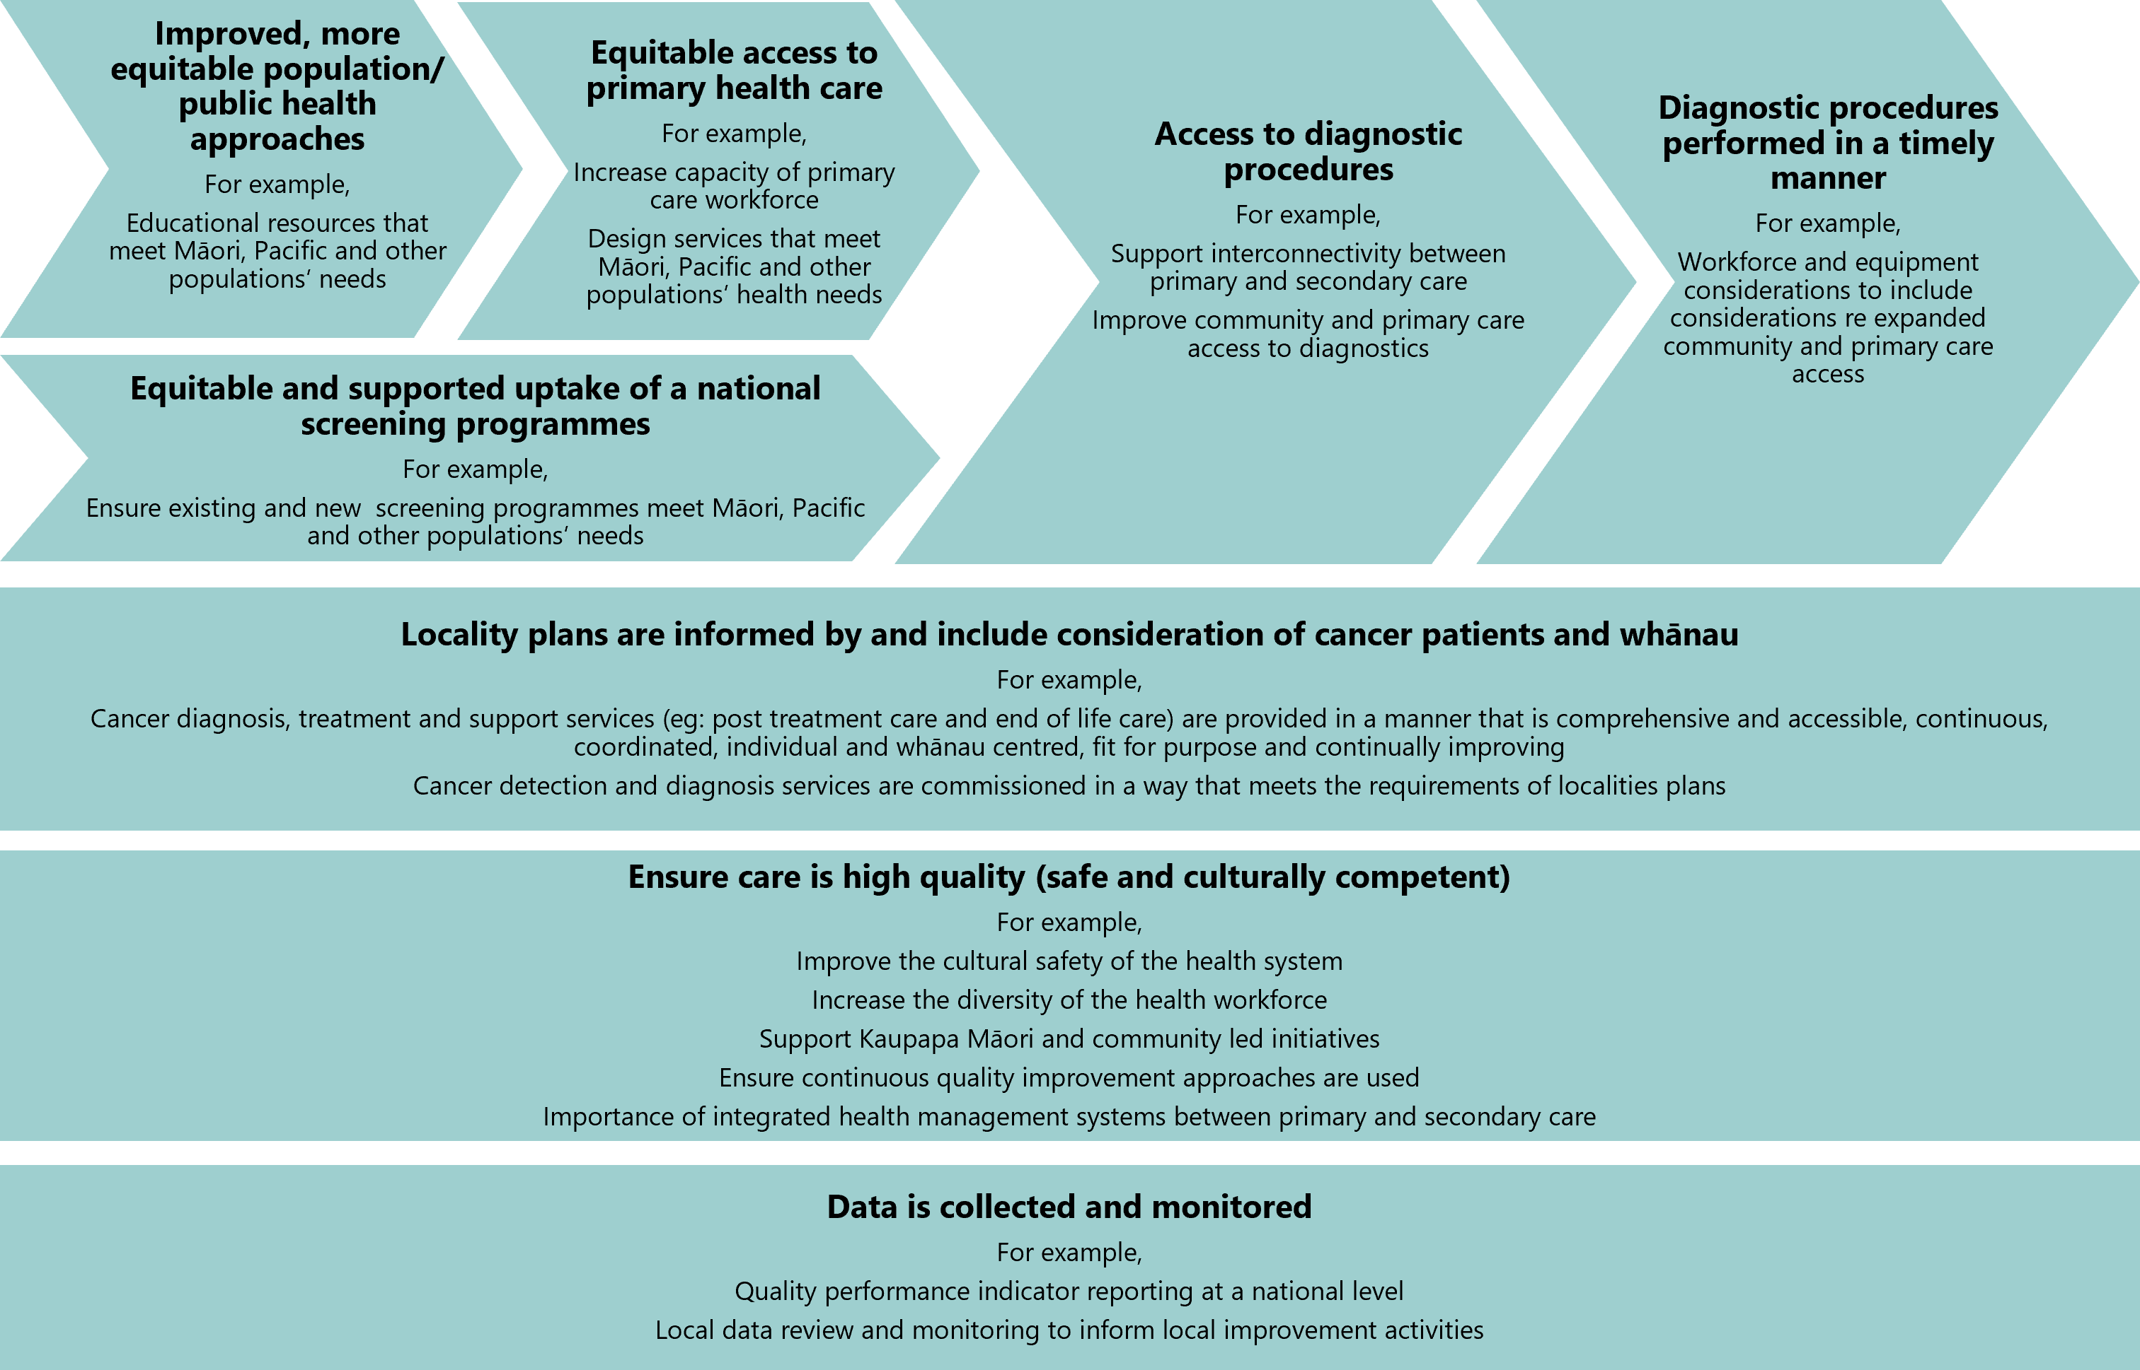

References
Abel GA, Shelton J, Johnson S, et al. 2015. Cancer-specific variation in emergency presentation by sex, age, and deprivation across 27 common and rarer cancers. British Journal of Cancer 112(1): S129–36. URL: doi.org/10.1038/bjc.2015.52
Beatty S, Stevens W, Stevens G, et al. 2009. Lung cancer patients in New Zealand initially present to secondary care through the emergency department rather than by referral to a respiratory specialist. The New Zealand Medical Journal (Online) 122(1294): 33–41. URL: pubmed.ncbi.nlm.nih.gov/19465945
Cassim S, Chepulis L, Keenan R, et al. 2019. Patient and carer perceived barriers to early presentation and diagnosis of lung cancer: A systematic review. BMC Cancer 19(1): 25.
Grimmond D, Martin G, Tu D. 2021. 2021 GP Future Workforce Requirements Report. Allen + Clarke.
Htun HW, Elwood JM, Ioannides SJ, et al. 2017. Investigations and referral for suspected cancer in primary care in New Zealand – A survey linked to the International Cancer Benchmarking Partnership. European Journal of Cancer Care 26(3): e12634.
Liberman, J. 2019. Chapter 12. The role of law in reducing global cancer inequalities. In: S Vaccarella, J Lortet-Tieulent, R Saracci, et al. (eds), Reducing Social Inequalities in Cancer: Evidence and priorities for research. Lyon: IARC Scientific Publications: 276–87.
Lyratzopoulos G, Saunders CL, Abel GA. 2014. Are emergency diagnoses of cancer avoidable? A proposed taxonomy to motivate study design and support service improvement. Future Oncology 10(8): 1329–33.
Majano SB, Lyratzopoulos G, Rachet B, et al. 2022. Do presenting symptoms, use of pre-diagnostic endoscopy and risk of emergency cancer diagnosis vary by comorbidity burden and type in patients with colorectal cancer? British Journal of Cancer 126(4): 652–63.
McPhail S, Swann R, Johnson SA, et al. 2022. Risk factors and prognostic implications of diagnosis of cancer within 30 days after an emergency hospital admission (emergency presentation): An International Cancer Benchmarking Partnership (ICBP) population-based study. The Lancet Oncology 23(5): 587–600. URL: doi.org/10.1016/s1470-2045(22)00127-9
Meheus F, Atun R, Ilbawi A. 2019. Chapter 10. The role of health systems in addressing inequalities in access to cancer control. In: S Vaccarella, J Lortet-Tieulent, R Saracci, et al. (eds), Reducing Social Inequalities in Cancer: Evidence and priorities for research. Lyon: IARC Scientific Publications: 228–49.
Murchie P, Smith SM, Yule MS, et al. 2017. Does emergency presentation of cancer represent poor performance in primary care? Insights from a novel analysis of linked primary and secondary care data. British Journal of Cancer 116(9): 1148–58.
Nekhlyudov L and Latosinsky S. 2010. The interface of primary and oncology specialty care: From symptoms to diagnosis. Journal of the National Cancer Institute Monographs 2010(40): 11–17.
Pham TM, Gomez-Cano M, Salika T, et al. 2019. Diagnostic route is associated with care satisfaction independently of tumour stage: Evidence from linked English Cancer Patient Experience Survey and cancer registration data. Cancer Epidemiology 61: 70–78. URL: doi.org/10.1016/j.canep.2019.04.011
Waitangi Tribunal. 2019. Hauora: Report on Stage One of the Health Services and Outcomes Kaupapa Inquiry – WAI 2575. Lower Hutt: Waitangi Tribunal.
Zhou Y, Abel GA, Hamilton W, et al. 2017. Diagnosis of cancer as an emergency: A critical review of current evidence. Nature Reviews Clinical Oncology 14(1): 45–56. URL: doi.org/10.1038/nrclinonc.2016.155

www.nsu.govt.nz/health-professionals/national-bowel-screening-programme/lower-starting-age-m%C4%81ori-and-pacific-peoples

