LUNG CANCER QUALITY Improvement monitoring report Update 2025

Using 2019–2022 data

2025

Citation: Te Aho o Te Kahu – Cancer Control Agency. 2025. Lung Cancer Quality Improvement Monitoring Report Update. Wellington: Te Aho o Te Kahu – Cancer Control Agency.
Published in July 2025 by Te Aho o Te Kahu – Cancer Control Agency.
PO Box 5013, Wellington 6140, New Zealand
ISBN 978-1-7385872-5-4
TP0019

This document is available at teaho.govt.nz
 | This work is licensed under the Creative Commons Attribution 4.0 International licence. In essence, you are free to: share ie, copy and redistribute the material in any medium or format; adapt ie, remix, transform and build upon the material. You must give appropriate credit, provide a link to the licence and indicate if changes were made.

Acknowledgements
This report publishes quality performance indicator (QPI) results from the New
Zealand Cancer Registry and other Health New Zealand – Te Whatu Ora (Health NZ) national data collections for patients diagnosed with lung cancer in New Zealand from 1 January 2019 to 31 December 2022.

The report is being released by Te Aho o Te Kahu – Cancer Control Agency (the Agency), in collaboration with the National Lung Cancer Working Group (the working group). It builds on the work previously done by the Ministry of Health, the working group and the Agency to identify and report on QPIs for those diagnosed with lung cancer in New Zealand from 2015 to 2018 (with the first lung cancer QPI reports published by the Agency in 2021).

We acknowledge that each data point that appears in or has contributed to this report represents a person or cluster of people who have been diagnosed with lung cancer. We extend our support to those people and their whānau, whose lives will have been significantly affected by lung cancer. We are committed to sharing this data with the wider health sector to improve the early diagnosis and timely treatment of lung cancer for all people in New Zealand.

Note regarding use of the term
‘district health board’
At the time of publishing this report, district health boards (DHBs) have been disestablished (as part of the 1 July 2022 health and disability sector reforms). This report uses the term ‘DHB’ in data tables, graphs and some commentary, as they were in existence during the period the report covers (1 January 2019 to 31 December 2022). The report also refers to ‘districts’ (the term that has replaced ‘DHBs’) and hospitals.

Contents
1 Overview 3
About Te Aho o Te Kahu | Cancer Control Agency 3
About the quality performance indicator programme 3
About lung cancer 4
About this report 4
Accompanying reports 5
Disruptive events 6
Summary of findings for period two 7
Next steps 14
2 Lung cancer cohort 15
3 Quality performance indicators – period two results in detail 17
QPI 1: Route to diagnosis 17
QPI 6: Surgical resection 20
QPI 10: Overall survival at one year from diagnosis 23
QPI 11: Cancer treatment at the end of life 26
APPENDIX A: Glossary and abbreviations 29
APPENDIX B: National lung cancer working group members 30
APPENDIX C: Methods 32
APPENDIX D: Supplementary tables 38
APPENDIX E: References 47

List of Figures
Figure 1: Absolute change for all lung cancer quality performance indicators between period one (2015–2018) and period two (2019–2022) (non-age-standardised) 11
Figure 2: Rate ratios (Māori compared with nMnPnA) for all lung cancer quality performance indicators, 2019–2022 (age-standardised) 13
Figure 3: Proportion of people with lung cancer who were diagnosed following an emergency presentation, by sex, ethnicity, NZDep2018 quintile, rural–urban status, SEER summary stage (age-standardised) and age group (age-specific), 2019–2022 18
Figure 4: Proportion of people diagnosed with lung cancer following an emergency presentation, by district health board of residence, 2019–2022 (non-age-standardised) 18
Figure 5: Proportion of people with non-small cell lung cancer who received a curative surgical resection, by sex, ethnicity, NZDep2018 quintile, rural–urban status, SEER Summary Stage (age-standardised) and age group (age-specific), 2019–2022 21
Figure 6: Proportion of people with non-small cell lung cancer who received curative surgical resection, by district health board of residence, 2019–2022 (non-age-standardised) 21
Figure 7: Proportion of people with lung cancer who were alive one year after diagnosis, by sex, ethnicity, NZDep2018 quintile, rural–urban status, SEER Summary Stage (age-standardised) and age group (age-specific), 2019–2022 24
Figure 8: Proportion of people with lung cancer who were alive one year after diagnosis, by district health board of residence, 2019–2022 (non-age-standardised) 24
Figure 9: Proportion of people with lung cancer who received SACT within 30 days prior to death, by sex, ethnicity, NZDep2018 quintile, rural–urban status, SEER summary stage (age-standardised) and age (age-specific), 2019–2022 27
Figure 10: Proportion of people with lung cancer who received SACT within 30 days prior to death, by district health board of residence, 2019–2022 (non-age-standardised) 27
Figure 11: Lung cancer quality performance indicator case eligibility flow diagram: inclusion, exclusion criteria and subtype distribution with key clinical indicators, 2019–2022 33

List of Tables
Table 1: Demographic characteristics of people diagnosed with lung cancer in New Zealand, 2019–2022 15
Table 2: Māori diagnosed with lung cancer in New Zealand, 2015–2022 35
Table 3: Proportion of people diagnosed with lung cancer following emergency presentation, by year of diagnosis, sex, age group, ethnicity, deprivation quintile (NZDep2018), rural–urban status and SEER Summary Staging, 2019-2022 38
Table 4: Proportion of people diagnosed with lung cancer following emergency presentation, by district health board of residence, 2019–2022 40
Table 5: Proportion of people diagnosed with non-small cell lung cancer who received a curative resection, by year of diagnosis, sex, age group, ethnicity, deprivation quintile (NZDep2018), rural–urban status and SEER Summary Staging, 2019–2022 41
Table 6: Proportion of people diagnosed with non-small cell lung cancer who received a curative resection, by district health board of residence, 2019–2022 42
Table 7: Proportion of people with lung cancer who were alive one year after diagnosis, by year of diagnosis, sex, age group, ethnicity, deprivation quintile (NZDep2018), rural–urban status and SEER Summary Staging, 2019–2022 43
Table 8: Proportion of people with lung cancer who were alive one year after diagnosis, by district health board of residence, 2019–2022 44
Table 9: Proportion of people with lung cancer who received systemic anti-cancer therapy within 30 days prior to death, by year of diagnosis, sex, age group, ethnicity, deprivation quintile (NZDep2018), rural–urban status and SEER Summary Staging, 2019–2022 45
Table 10: Proportion of people with lung cancer who received systemic anti-cancer therapy within 30 days of death, by district health board of residence, 2019–2022 46

Overview

About Te Aho o Te Kahu | Cancer Control Agency
Te Aho o Te Kahu – Cancer Control Agency (the Agency) is a standalone departmental government agency. Its chief executive reports directly to the Minister of Health. The Agency was created in December 2019 in recognition of increasing cancer incidence, increasing complexities of treatment and the impact cancer has on the lives of New Zealanders.

The Agency’s purpose and functions were defined in a 2020 Cabinet paper, which states:
The Agency will develop initiatives to monitor and improve cancer system performance and practice improvements. Robust monitoring and evaluation will support stronger governance and drive the actions forward.
As part of this, the Agency’s cancer quality performance indicator (QPI) programme provides information to support the improvement of cancer detection, diagnosis, treatment and post-treatment services, to deliver better health outcomes for all people across New Zealand.

About the quality performance indicator programme
This lung cancer QPI report is part of the Agency’s QPI programme. The QPI programme develops, calculates and reports on QPIs using national data collections, registries and other data sources. Wherever the data allows, each QPI is reported by demographic variables (eg, ethnicity, rural-urban, age, sex and deprivation) and by geography (ie, by district health board (DHB), now referred to as districts), enabling comparison between groups and between cancer care providers. The QPI programme reports highlight unwarranted variation in cancer diagnosis, treatment and outcomes, and identify where quality improvement action(s) could or should be prioritised.

To date, we have reported on cancer-specific QPIs for bowel (first in 2019, then an update in 2022), lung (first in 2021 and now via this update), prostate, pancreatic and breast cancers, which are available on our website here. Also, in March 2024, we published a QPI report that analysed cases of people diagnosed with cancer within 30 days of an emergency or acute (unplanned) hospital admission for 22 cancer types. The report is available on our website here.

About lung cancer
Lung cancer is one of the leading causes of cancer death worldwide. In New Zealand, it is among the most common and deadliest cancers. Lung cancer begins when abnormal cells grow in an uncontrolled way in one or both lungs. There are two main types: non-small cell lung cancer (NSCLC), the most common, and small cell lung cancer (SCLC), which is faster-growing and more aggressive.

Because lung cancer often develops without obvious symptoms, it is often found at an advanced stage, making it difficult to cure (Gurney et al 2024). Between 2017-2021, more than half (51.3%) of lung cancer cases were diagnosed following an emergency hospital admission, which is indicative of late-stage detection (Te Aho o Te Kahu 2024). Māori were disproportionality affected with 54.1% being diagnosed this way, reflecting the significant inequities in access to timely diagnosis and care (Te Aho o Te Kahu 2024). While overall incidence of lung cancer has declined over time, significant disparities remain in survival and outcomes for some population groups.

Measuring the quality of lung cancer care, via reports such as this one, is essential as it helps identify where the health system is performing well and where improvements may be needed. High-quality data will allow health services to design effective and targeted interventions and allocate resources more equitably to improve survival and quality of care for people with lung cancer.

About this report
The first lung cancer quality improvement report (the 2021 report) was published in 2021, alongside corresponding reports providing the indicator descriptions and technical specifications. The 2021 report provided data for eight out of 11 QPIs (three potential indicators were unable to be calculated due to data limitations). The data came from the New Zealand Cancer Registry (NZCR) and other Health New Zealand – Te Whatu Ora (Health NZ) national collections for the 8,577 patients that were diagnosed with lung cancer in New Zealand between 1 January 2015 and 31 December 2018 (period one).
Readers should note population level stage at diagnosis based on the tumour, node, metastasis (TNM) system and patient performance status (a determinant of qualification for treatment) are not currently available in Health NZ’s national data collections. We advise readers to take this into account when interpreting the results.
For this 2025 update, we used data from the NZCR and other Health NZ national collections to recalculate the same eight lung cancer QPIs reported on in 2021. The recalculation (this report and the associated dashboard) includes information about detection, diagnosis, treatment and outcomes for the 9,567 people with a new primary diagnosis of lung cancer in New Zealand between 1 January 2019 and 31 December 2022 (period two).

The results of all eight lung cancer QPIs are in the updated lung cancer QPI dashboard, which can be found here.

This report focuses on and presents the results for four of the eight lung cancer QPIs only. They are:
- QPI 1: Route to diagnosis
- QPI 6: Surgical resection
- QPI 10: Overall survival at one year from diagnosis
- QPI 11: Cancer treatment at the end of life.

While all eight QPIs are important for understanding the quality of lung cancer care in New Zealand, we chose to only detail these four in this report because they show either noticeable change over time or, in the case of the QPI regarding lung cancer treatment at the end of life, results that warrant prioritised attention or improvement. The other four indicators showed results that were relatively unchanged from period one and, therefore, while they have been updated in the online dashboard, to improve the readability of this report, those results are not included.

Detail about the differences between period one (1 January 2015 and 31 December 2018) and period two (1 January 2019 and 31 December 2022), at a national level for each indicator, are detailed later in this document, in the section entitled ‘Change over time’.

This report also provides age-standardised data comparing results by and exposing variation between demographic groupings (ie, by age, sex, deprivation, rural–urban status and ethnicity) and by extent of disease at diagnosis using the SEER Summary Staging classifications (localised, regionalised and distant), for period two only. Information about geographical variation (ie, by district) is also provided, although district-level comparisons are not age-standardised; instead, funnel plots are used to show how districts perform relative to each other and against the national average. This information is provided to inform quality improvement prioritisation and activity.

Looking at the results for different population groups helps us understand how those people experience lung cancer care in New Zealand. While the national data shows overall positive changes in key indicators, the breakdown by different demographic groups shows that not everyone is benefiting equally.

A summary of change over time, change from an equity perspective and the findings against each QPI follows. More detail about the four QPIs, including bar charts, which show the differences between demographic groupings and by SEER Summary Staging, and funnel plots that show geographical variation, can be found in section two of this report.

Accompanying reports
This monitoring report is best read in conjunction with the lung cancer QPI descriptions and lung cancer QPI technical specifications, which can be found on our website here.

The lung cancer QPI descriptions report provides the rationale, evidence and other information for each of the 11 potential indicators (which are made up of measurable and aspirational indicators), including the four reported on in this report and the additional four that have been updated in the dashboard.

The lung cancer QPI technical specifications report outlines the method we used for calculating each of the eight QPIs that are currently able to be calculated. It provides information on data sources, numerator criteria, denominator criteria, relevant data codes, descriptions and data-flow diagrams. Appendix C of this document supplements the technical specifications, providing further detail on sources of data and statistical methods.

Disruptive events
New Zealand and the health sector experienced considerable challenges during the time covered by this report (1 January 2019 to 31 December 2022).

COVID-19
The COVID-19 pandemic may have affected some of the results and variations we have identified and should be considered when interpreting the results in this report. National and regional alert level changes occurred many times between 2020 and 2022 (Department of the Prime Minister and Cabinet 2023). These changes may have impacted cancer detection and diagnosis in particular (in general cancer treatment that was already underway, continued regardless of the alert levels). Throughout the COVID-19 pandemic, the Agency produced reports that collated evidence on the impact the pandemic had on cancer diagnosis and treatment to support policy development and response planning (Te Aho o Te Kahu 2021b). Those reports may provide useful context for results presented here.

Whakaari/White Island
On 9 December 2019, Whakaari/White Island erupted. Caring for the survivors had a significant impact on nearby district health boards (DHBs) and hospitals, especially Whakatāne Hospital and Bay of Plenty DHB, which handled the immediate triage of survivors.

After the immediate triage of survivors, there was a coordinated response across many DHBs to provide treatment. Specifically, the National Burn Centre at Middlemore Hospital and all the regional burns units (Waikato, Hutt Valley and Christchurch) took on patients over and above their normal workload. As a result, many elective surgical lists were cancelled to fulfil this demand for acute operating theatre time and theatre staff (Hayes et al 2022). It is possible that other elective diagnostic and treatment decisions were delayed or cancelled due to the eruption.

Waikato District Health Board cyber-attack
On 25 May 2021, Waikato DHB experienced a cyber-attack that affected all phone lines and hospital computer systems. As a result, surgeries were postponed, and seriously ill patients were transferred to other hospitals. In addition, people in the Waikato district who were undergoing radiation therapy had their treatment moved to other capable sites across New Zealand. It took several months to restore compromised systems and address the backlog of surgeries, treatments, and appointments (Waikato District Health Board 2022).

Summary of findings for period two

Summary of QPI 1: Route to diagnosis
For details including definitions, inclusion criteria and more detailed commentary, see QPI 1: Route to detection.
This measure investigates the proportion of people who received their lung cancer diagnosis following an emergency presentation. Being diagnosed this way is often associated with having more advanced cancer, which leads to poorer survival or health outcomes compared with those who are diagnosed through more appropriate pathways, such as primary care and community-based diagnostic services (McPhail et al 2022, Te Aho o Te Kahu 2024).

In period two (1 January 2019 to 31 December 2022):
- A high proportion (44.8%) of people were diagnosed with lung cancer following an emergency presentation. Once adjusted for age, Pacific peoples (58.2%) and Māori (47.2%) were more likely to be diagnosed with lung cancer following an emergency presentation compared to people of European/other and Asian ethnicities (41.2% and 42.9%, respectively).
- People living in areas of higher deprivation (49.1% in quintile 5) were more likely to be diagnosed following an emergency presentation compared with those experiencing lower deprivation (38.1% in quintile 1).
- Most people (64.8%) diagnosed with advanced lung cancer (distant, based on SEER Summary Staging) were more likely to be diagnosed following an emergency presentation. This proportion is much higher compared to those diagnosed with localised lung cancer (6.1%) and regionalised lung cancer (25.4%).

Summary of QPI 6: Surgical resection for non-small cell lung cancer
For details including definitions, inclusion criteria and more detailed commentary, see QPI 6: Surgical resection.

This measure is important because complete surgical resection is considered the gold standard of treatment for early-stage lung cancer and offers the best chance of cure (Te Aho o Te Kahu 2021a).

In period two (1 January 2019 to 31 December 2022):
- Once adjusted for age, Māori with non-small cell lung cancer (NSCLC) were least likely to receive a curative surgical resection (16.8%) compared to Pacific peoples (19.2%), those of European/other (20.0%) and Asian (24.4%) ethnicities.
- Those living in the most deprived areas (quintile 5) were less likely to receive curative surgical resection than those living in the least deprived areas (quintile 1) (19.4% and 21.3%, respectively).
- Those living in rural areas were less likely to receive a curative surgical resection (17.6%) compared with those living in urban areas (20.2%).
- Most people (86.8%) diagnosed with localised lung cancer received curative surgical resection. This proportion was lower among those with regionalised lung cancer (44.9%) and much lower for people with advanced lung cancer (distant, based on SEER Summary Staging) at just 1.7%.

Summary of QPI 10: Overall survival at one year from diagnosis
For details including definitions, inclusion criteria and more detailed commentary, see QPI 10: Overall survival at one year from diagnosis.

This measure is important because overall survival is an important outcome measure in lung cancer management. Due to the poor prognosis of lung cancer, overall survival at one year from diagnosis can be used as an indicator of effectiveness of the care pathway, including diagnosis and treatment.

In period two (1 January 2019 to 31 December 2022):
- 46.7% of people diagnosed with lung cancer survived one year after diagnosis. Once adjusted for age, Māori had the lowest overall survival rate of all ethnic groups, at 41.8%, followed by Pacific peoples (47.5%), European/other (51.4%) and Asian ethnicities (70.7%).
- Overall survival at one year was lowest for people who experienced the highest levels of deprivation. The proportion of people who survived one year after lung cancer diagnosis in the most deprived quintile (quintile 5) of the population was 44.1%, compared with 61.3% in the least deprived quintile (quintile 1).
- People with lung cancer living in rural areas had poorer overall survival rates at one year than those living in urban areas (45.6% and 51.4%, respectively).
- Most people (96.1%) diagnosed with localised lung cancer were still alive one year after diagnosis. This proportion dropped to 69.1% for those with regionalised lung cancer and 22.7% for people with advanced lung cancer (distant, based on SEER Summary Staging).

Summary of QPI 11: Cancer treatment at the end of life
For details including definitions, inclusion criteria and more detailed commentary, see QPI 11: Cancer treatment at the end of life.

Ensuring cancer patients at the end of life do not receive aggressive treatment, like systemic anti-cancer therapy (SACT), that does little to improve outcomes is an important measure of the quality (or otherwise) of the patient care. Most experts agree the focus should be on pain management and ensuring the best possible quality of life.

In period two (1 January 2019 to 31 December 2022):
- 7.2% of people with lung cancer in New Zealand received systemic anti-cancer therapy (SACT) within 30 days before death. Although our finding is lower compared to rates of SACT received within 30 days of death in some international jurisdictions, there is room for improvement, especially when rates are broken down by demographic subsets.
- When considering variation by districts, the proportion of people with lung cancer who received SACT within 30 days before death ranged from 3.5% in Hutt Valley and Nelson Marlborough DHBs to 14.0% in Lakes DHB.
- Once adjusted for age, people of Asian ethnicity were the most likely to receive SACT within 30 days before death (10.8%), compared with European/other (7.0%), Pacific peoples (7.4%) and Māori (7.5%).
- Furthermore, 8.7% of people living in rural areas received SACT within 30 days before death, compared with 6.6% of those living in urban areas.

Change over time for the four QPIs
Figure 1 shows the absolute change (non-age-standardised) lung cancer indicator results between period one (1 January 2015 and 31 December 2018) and period two (1 January 2019 to 31 December 2022) for all eight of the lung cancer QPIs (only four of which are reported in detail in this report).

Figure 1 shows that there has been a small improvement in the lung cancer QPI results over time. However, as previously noted, improvements have not been experienced by all population and geographic groupings equally or to the same degree, meaning that inequities persist. The information below provides a summary and more detailed information and comparisons between groups can be found in section three of this report.

QPI 1: Route to diagnosis
- Between periods, the proportion of people who received their lung cancer diagnosis following an emergency presentation has remained at a similar level (45.0% in period one to 44.8% in period two).
- Comparison of demographic groups shows that inequities remained the same between periods. For example, Pacific peoples and Māori remained most likely to be diagnosed with lung cancer following an emergency presentation compared to people of European/other and Asian ethnicities. Given the known relationship between route to diagnosis and the stage or severity of disease, this is an important equity issue.
QPI 6: Surgical resection for non-small cell lung cancer
- As previously stated, complete surgical resection is considered the gold standard of treatment for early-stage lung cancer and offers the best chance of cure; therefore, it is good to see that between periods, the proportion of people who received a surgical resection for non-small cell lung cancer (NSCLC) has increased slightly (16.7% in period one to 18.9% in period two). This is a positive finding given the service disruptions at the time (COVID-19 pandemic, Waikato cyber-attack, Whakaari-White Island eruption) and the associated strain on front-line health services.
- Māori and Pacific peoples with NSCLC saw improvements over time in receiving curative surgery. However, they are still less likely to receive this treatment compared to people of European/other and Asian ethnicities, which is an important equity issue.
QPI 10: Overall survival at one year from diagnosis
- Between periods, there was a 4.9% absolute increase in one-year survival (41.8% in period one to 46.7% in period two), a positive change.
- However, when looking at different ethnic groups, only people of European/other ethnicity with lung cancer showed a meaningful improvement. No similar improvement was seen for other ethnic groups, which is a concern.
QPI 11: Cancer treatment at the end of life
- Between periods, the absolute proportion of those with lung cancer who received SACT within 30 days prior to death remained relatively static (5.9% in period one to 5.6% in period two), which as a concern as it is reasonable to expect an improvement from period one to period two as this coincides with increased awareness of the importance of not overtreating at end of life.

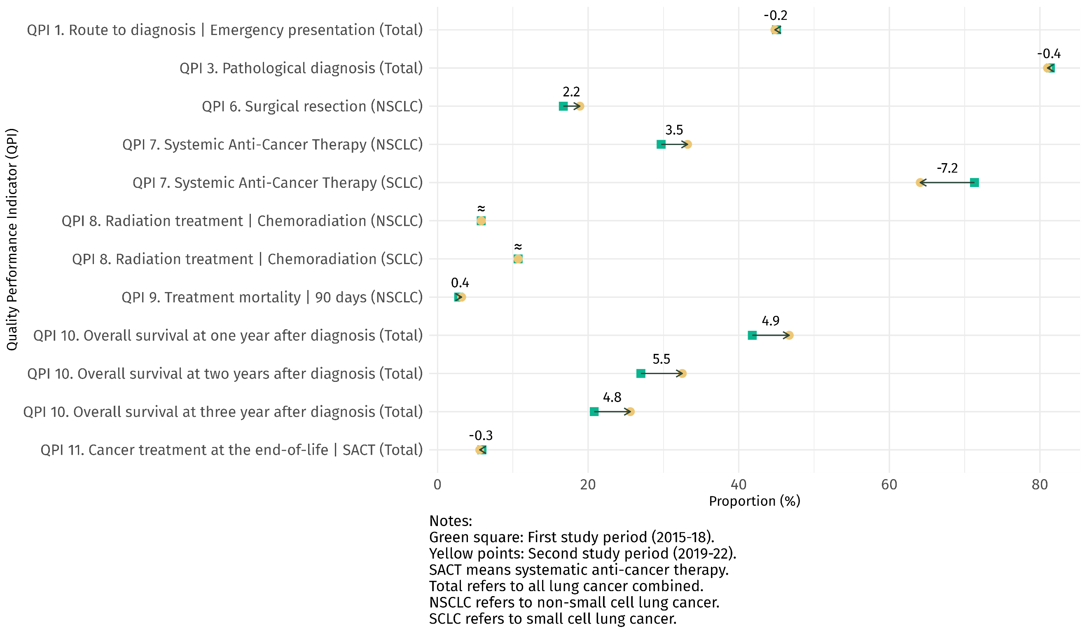
Figure 1: Absolute change for all lung cancer quality performance indicators between period one (2015–2018) and period two (2019–2022) (non-age-standardised)

Equity
In this report, we apply an equity ‘lens’, which means we recognise that different people from different parts of society (eg, rural vs urban, low deprivation vs high, male vs female, different ethnicities and so on) require different approaches and resources to experience equitable health outcomes. The definition of those who experience inequity is wide. It incorporates many different socioeconomic groupings and possible dimensions of equity, for example, those associated with ethnic differences and those associated with deprivation (Ministry of Health 2023).

A first step in reducing disparities and variation in treatment and outcome (and other equity-focused measures) is to produce information that highlights unwarranted differences so they can be tackled, and the system improved in a way that reduces the likelihood of the inequities continuing. We shed light on inequities in our information by age-standardising data and using standardised ratios. See Appendix C for more information on these two processes.

Figure 2 shows age-standardised rate ratios comparing Māori with non-Māori, non-Pacific, non-Asian (nMnPnA) ethnicity. A rate ratio greater than 1 indicates a higher likelihood of an outcome for Māori. A rate ratio less than 1 indicates a lower likelihood for Māori. Green indicates when the ratio reflects a better outcome based on the indicator description, while red indicates when the ratio reflects a less favourable outcome. We also show confidence intervals. In this context confidence intervals relate to the number of people within the group and give an impression of the precision of the result (see Appendix C for more information). However, if the confidence interval does not include 1.0, it suggests a significant difference between the groups being compared.

The data shows that Māori experience inequities for three QPIs; we believe these results mean that prioritised improvement activity is warranted. Details are provided in figure 2, but in summary, the three indicators and the findings are:

- QPI 1: Route to diagnosis
Māori were 15% more likely than those of nMnPnA ethnicity to be diagnosed with lung cancer after an emergency presentation (age-standardised rate ratio 1.15, 95% confidence interval (CI) 1.07-1.24).
- QPI 6: Surgical resection for NSCLC
Māori were 16% less likely than those of nMnPnA ethnicity to receive curative surgical resection for NSCLC (age-standardised rate ratio 0.84, 95% CI 0.72-0.97).
- QPI 10: Overall survival at one year from diagnosis
Māori had the lowest overall survival rates compared with those of nMnPnA ethnicity. Māori were 19% less likely to be alive after one year (age-standardised rate ratio 0.81, 95% CI 0.75-0.87), 30% less likely to be alive after two years (age-standardised rate ratio 0.70, 95% CI 0.63-0.78) and 41% less likely to be alive after three years from a lung cancer diagnosis (age-standardised rate ratio 0.59, 95% CI 0.50-0.69).

Figure 2: Rate ratios (Māori compared with nMnPnA) for all lung cancer quality performance indicators, 2019–2022 (age-standardised)

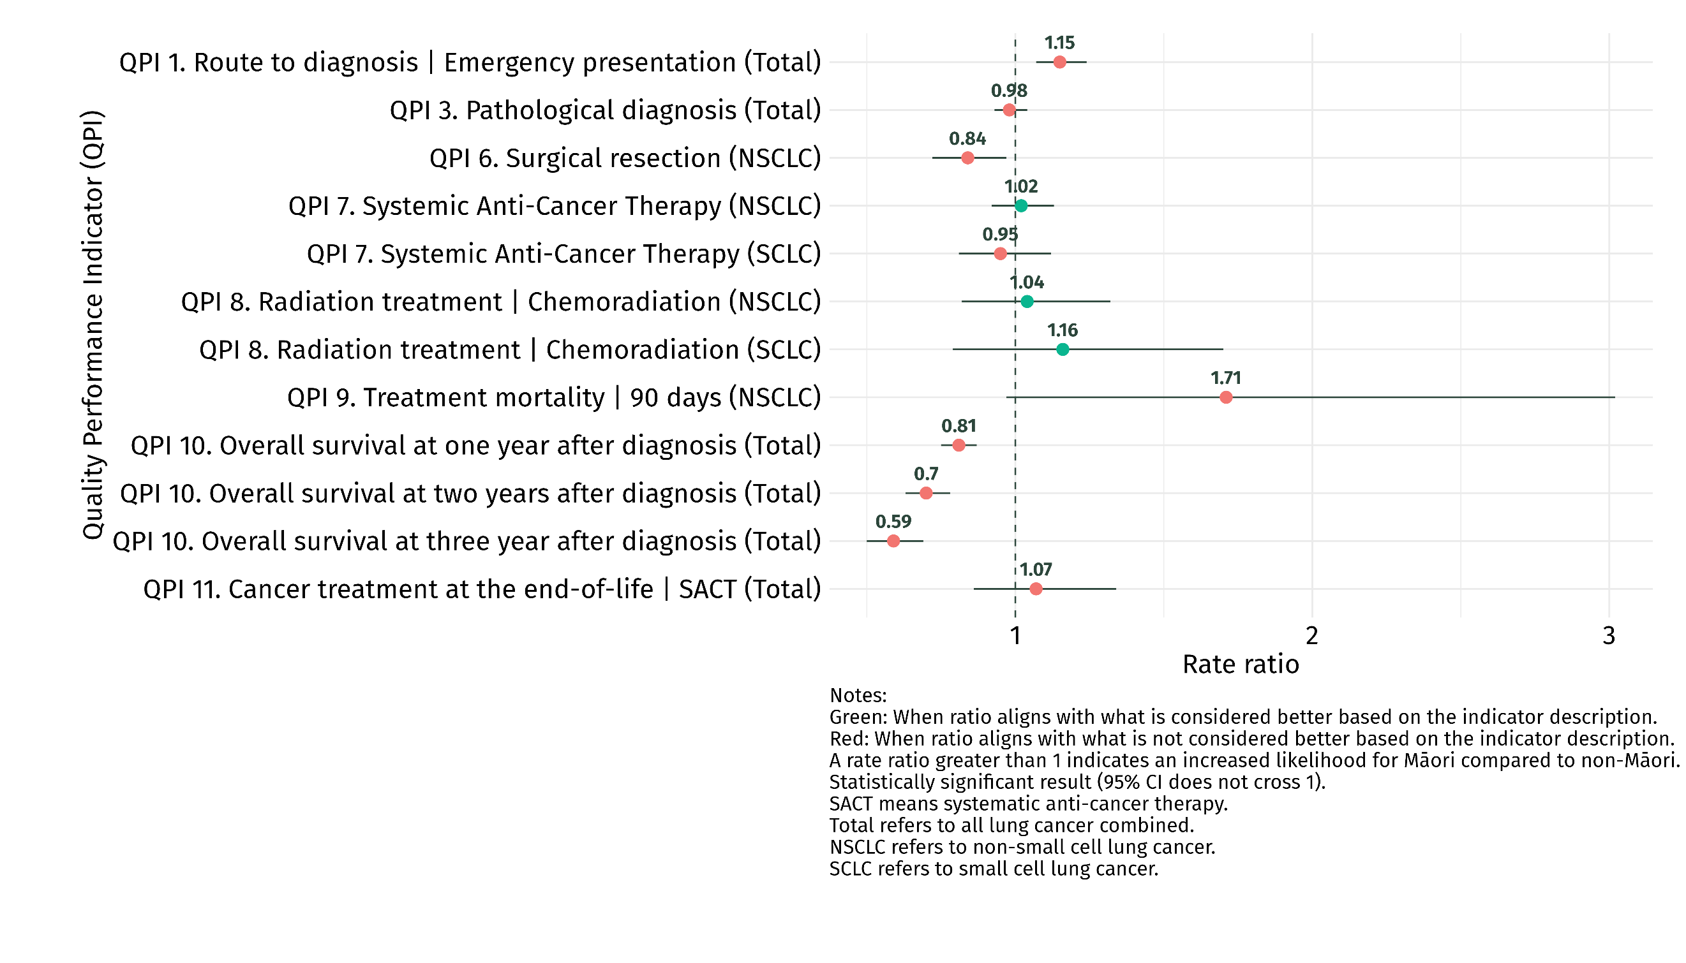

Next steps
The remainder of this report provides a breakdown of the specifics for the 9,567 people who received a new primary diagnosis of lung cancer between 1 January 2019 and 31 December 2022 (section two) and the results of each QPI by sex, age group, ethnicity, deprivation quintile (NZDep2018), rurality, extent of disease at diagnosis (SEER Summary Staging) and DHB of domicile (section three).

We recommend that the next steps, following publication, should be further investigation at a district and/or regional level, to better understand variation, particularly where districts are outliers in this analysis.

Further investigations and subsequent improvement activities present opportunities to reduce inequities, improve health services and care pathways, validate and improve local data collections, and encourage districts to share what they learn with each other.

Lung cancer cohort
The cohort used for the analysis in this report comprises 9,567 people who received a new primary diagnosis of lung cancer between 1 January 2019 and 31 December 2022, as recorded in the New Zealand Cancer Registry (NZCR).

Table 1 outlines the demographic characteristics of the cohort.
Table 1: Demographic characteristics of people diagnosed with lung cancer in New Zealand, 2019–2022
 | People with lung cancer*
 | n | %
Cases eligible
Total | 9,567 | 100.0
Diagnosis subtypes
Small cell | 1,065 | 11.1
Non-small cell | 6,565 | 68.6
Other/unspecified | 1,937 | 20.3
Year of diagnosis
2019 | 2,282 | 23.9
2020 | 2,451 | 25.6
2021 | 2,460 | 25.7
2022 | 2,374 | 24.8
Sex
Male | 4,633 | 48.4
Female | 4,932 | 51.6
Age group (years)
18-49 | 294 | 3.1
50-59 | 1,201 | 12.6
60-69 | 2,788 | 29.1
70-79 | 3,654 | 38.2
80+ | 1,630 | 17.0
Ethnicity
Māori | 2,012 | 21.1
Pacific peoples | 485 | 5.1
Asian | 579 | 6.1
European/other | 6,467 | 67.8

Deprivation quintile (NZDep2018)
1 (least deprived) | 1,175 |  | 12.7
2 | 1,481 |  | 16.1
3 | 1,792 |  | 19.4
4 | 2,115 |  | 22.9
5 (most deprived) | 2,657 |  | 28.8
Rural–urban status
Rural | 2,493 |  | 26.1
Urban | 7,074 |  | 73.9
SEER Summary Staging
Localised | 837 |  | 12.4
Regionalised | 1,499 |  | 22.2
Distant | 4,409 |  | 65.4
* Excludes people registered with cancer from death certificates only
Source: New Zealand Cancer Registry

Quality performance indicators – period two results in detail

QPI 1: Route to diagnosis

Indicator description
This indicator measures the proportion of people with lung cancer who were diagnosed within 14 days after an acute admission to hospital or a visit to an emergency department (ED) (emergency presentation).

Context
People presenting with lung cancer via an emergency department are more likely to have advanced, incurable disease than those diagnosed through a clinic and, in addition, initial presentation to an ED is a strong negative predictor of survival (Beatty et al 2009). The ED is not the ideal environment for routine cancer work-up for patients, whānau and staff, because EDs have reduced out-of-hours access to specialist imaging, knowledge and support and the patient journey is therefore likely to be less smooth.

Results
In period two, a high proportion (44.8%) of people were diagnosed with lung cancer following an emergency presentation.

Once adjusted for age, Pacific peoples (58.2%) and Māori (47.2%) were more likely to be diagnosed following an emergency presentation than people of European/other and Asian ethnicities (41.2% and 42.9%, respectively).

People living in areas of higher deprivation (49.1% in quintile 5) were more likely to be diagnosed following an emergency presentation compared with those in areas of lower deprivation (38.1% in quintile 1).

Most people (64.8%) diagnosed with advanced lung cancer (distant, based on SEER Summary Staging) were more likely to be diagnosed following an emergency presentation. This proportion is much higher compared to those diagnosed with localised lung cancer (6.1%) and regionalised lung cancer (25.4%).

Figure 3: Proportion of people with lung cancer who were diagnosed following an emergency presentation, by sex, ethnicity, NZDep2018 quintile, rural–urban status, SEER summary stage (age-standardised) and age group (age-specific), 2019–2022
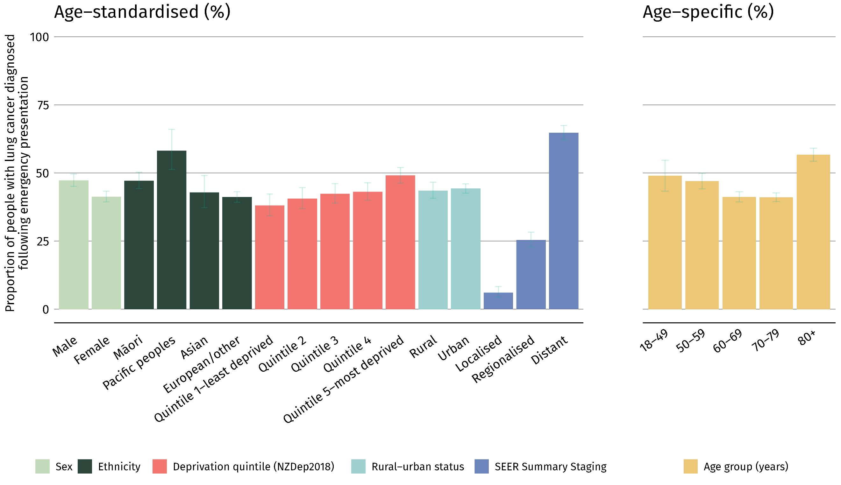

As Figure 4 below, the proportion of people diagnosed with lung cancer following an emergency presentation varied widely between DHBs. Waitematā DHB was above the upper 99.8% limit, where 51.8% of people were diagnosed with lung cancer following an emergency presentation. In comparison, Canterbury DHB was below the lower 99.8% limit, where 34.9% of people were diagnosed with lung cancer following an emergency presentation.

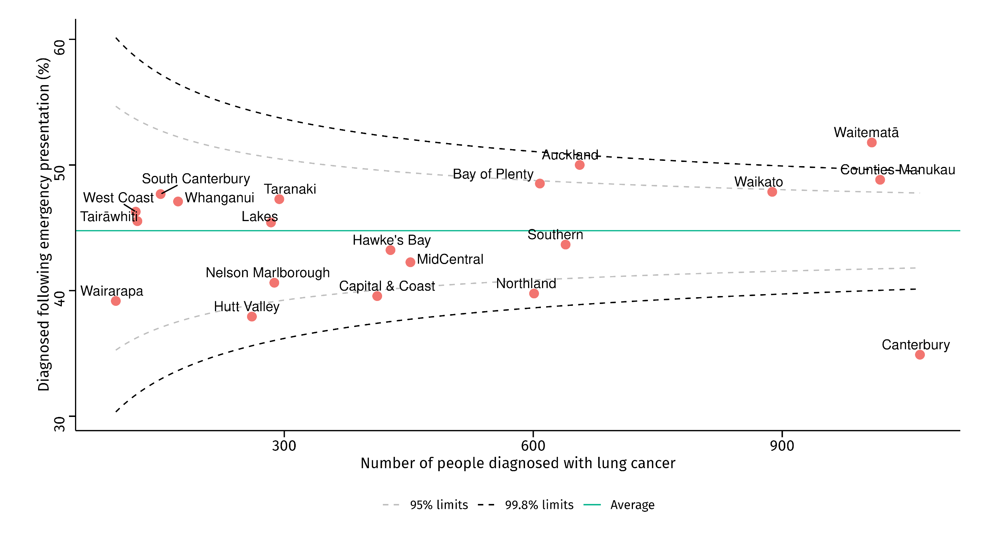
Figure 4: Proportion of people diagnosed with lung cancer following an emergency presentation, by district health board of residence, 2019–2022 (non-age-standardised)

Discussion
Between periods, there was no overall change in the proportion of people diagnosed with lung cancer within 14 days of an emergency presentation. A recent study by the International Cancer Benchmarking Partnership reported that of 14 jurisdictions in six countries (Australia, Canada, Denmark, New Zealand, Norway and the United Kingdom), New Zealand had the worst rates of lung cancer diagnoses 30 days following acute admission to hospital (Lawrenson et al 2024; McPhail et al 2022; Te Aho o Te Kahu 2024).

Recent evidence shows that those who have an emergency presentation within 30 days prior to a lung cancer diagnosis are more than twice as likely to die within 12 months (Gurney et al 2023). This is because people presenting through an ED typically have more advanced-stage lung cancer than those presenting to their general practitioner (Lawrenson et al 2024).

This is consistent with our findings and reinforces that many cancers diagnosed via an emergency presentation could have been identified earlier. In New Zealand, this is due to multifactorial barriers such as decreased health literacy (meaning patients are less like to recognise early symptoms) and systemic barriers to accessing appropriate and timely diagnostic services in primary care (Htun et al 2017; Lawrenson et al 2024). These barriers disproportionately affect Māori, Pacific peoples and those living in high-deprivation areas (Cassim et al 2021; Gurney et al 2023; Te Aho o Te Kahu 2024).

To reduce the overall volume of lung cancer diagnosed via an emergency presentation in New Zealand, lung cancer diagnoses must shift to primary care and targeted lung screening settings (Gimpel et al 2022; Gurney et al 2023; Lawrenson et al 2020; Te Aho o Te Kahu 2021c; Te Aho o Te Kahu 2024). Actions to achieve this shift where it is needed most could include removing cost barriers to primary care and resourcing Māori and Pacific-led primary care services adequately (Gurney et al 2023; Lawrenson et al 2024).

QPI 6: Surgical resection

Indicator description
This indicator measures the proportion of people with non-small cell lung cancer (NSCLC) receiving surgical resection with curative intent.

Context
Complete surgical resection is the gold standard of treatment for early-stage lung cancer and offers the best chance of cure. Surgical resection is recommended for patients with clinical stage I and II NSCLC (Howington et al 2013).

Surgery should also be considered in selected regionally advanced lung cancers (stage IIIA). This is most appropriately agreed in a multi-disciplinary meeting setting, with the goal of maximising a patient’s survival chances, as well as their quality of life.

Results
In period two, 18.9% of people with NSCLC had curative surgical resection. However, once adjusted for age, Māori with NSCLC were least likely to receive a curative surgical resection (16.8%) compared with those of Asian (24.4%) and European/other (20.0%) ethnicities.

Those living in the most deprived areas (quintile 5) were less likely to receive curative surgical resection than those living in the least deprived areas (quintile 1) (19.4% and 21.3%, respectively).

Those living in rural areas were less likely to receive a curative surgical resection (17.6%) compared with those living in urban areas (20.2%).

Most people (86.8%) diagnosed with localised lung cancer received curative surgical resection. This proportion was lower among those with regionalised lung cancer (44.9%) and much lower for people with advanced lung cancer (distant, based on SEER Summary Staging) at just 1.7%.

Figure 5: Proportion of people with non-small cell lung cancer who received a curative surgical resection, by sex, ethnicity, NZDep2018 quintile, rural–urban status, SEER Summary Stage (age-standardised) and age group (age-specific), 2019–2022
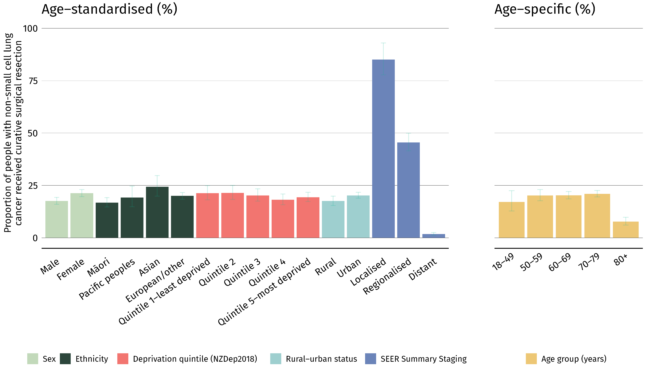

As shown in Figure 6, no DHBs fell outside of the upper or lower limits of the funnel plot for the 2019–2022 period. Resection rates ranged between 11.4% (Whanganui) and 25.3% (Northland).

Figure 6: Proportion of people with non-small cell lung cancer who received curative surgical resection, by district health board of residence, 2019–2022 (non-age-standardised)
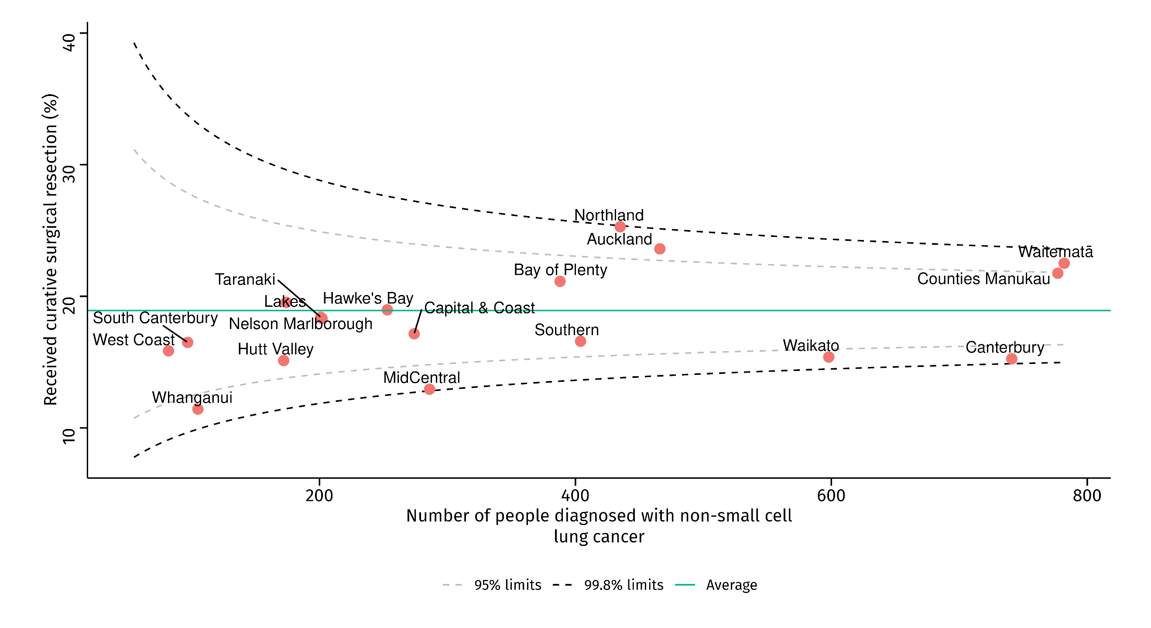

Discussion
Our finding that Māori were least likely to receive surgical resection with curative intent for NSCLC aligns with existing research.

A 2024 New Zealand study showed that, for Māori with lung cancer, the odds of accessing curative surgery were 28% lower than European/other ethnicity with lung cancer (Gurney et al 2024). These differences were only partially accounted for when adjusted for age, comorbidity and tumour type.

Since period one, rates of curative surgical resection for NSCLC have been increasing. This change has been observed across ethnicities, however, Māori and Pacific peoples are still less likely to receive curative surgical resection compared with other ethnic groups. Improving rates of curative surgical resection for NSCLC requires an understanding of the broad, complex and interrelated factors that affect those with NSCLC. Those factors most relevant to this report include barriers to routes to diagnosis, accessing treatment and timely access to health facilities.

The demographic variation warrants further investigation, particularly as meaningful change in the proportion of those with lung cancer who receive curative treatment is most dependent on increasing the proportion of people diagnosed in the early stages of disease (Lawrenson et al 2020).

QPI 10: Overall survival at one year from diagnosis

Indicator description
This indicator measures overall (all-cause) survival for people with lung cancer at one year from diagnosis.

Context
Good survival is the overall aim of our process and outcome measures in lung cancer management. Survival is the product of all interventions, from screening and early detection through to treatment. Survival rates also incorporate factors such as the general health and wellbeing of the population, access to health care, and genetic and environmental variables.

For most cancers, survival five years after diagnosis is generally accepted as an indicator of cure. However, as lung cancer has an overall poor prognosis, one-year survival can be used as an indicator of effectiveness of care (Vrijens et al 2016).

Results
Between 2019 and 2022, 46.7% of people diagnosed with lung cancer survived one year after diagnosis. After adjusting for age, Māori had the lowest overall survival of all ethnic groups, with 41.8% alive after one year from diagnosis. This was followed by Pacific peoples (47.5%), European/other (51.4%) and Asian (70.7%) ethnicities.

Overall survival at one year was lowest for people who experienced the highest levels of deprivation. The proportion of people who survived one year after lung cancer diagnosis in the most deprived quintile (quintile 5) of the population was 44.1%, compared with 61.3% in the least deprived quintile (quintile 1).
People with lung cancer living in rural areas had poorer overall survival rates at one year than those living in urban areas (45.6% and 51.4%, respectively).
Most people (96.1%) diagnosed with localised lung cancer were still alive one year after diagnosis. This proportion dropped to 69.1% for those with regionalised lung cancer and 22.7% for people with advanced lung cancer (distant, based on SEER Summary Staging).

Figure 7: Proportion of people with lung cancer who were alive one year after diagnosis, by sex, ethnicity, NZDep2018 quintile, rural–urban status, SEER Summary Stage (age-standardised) and age group (age-specific), 2019–2022

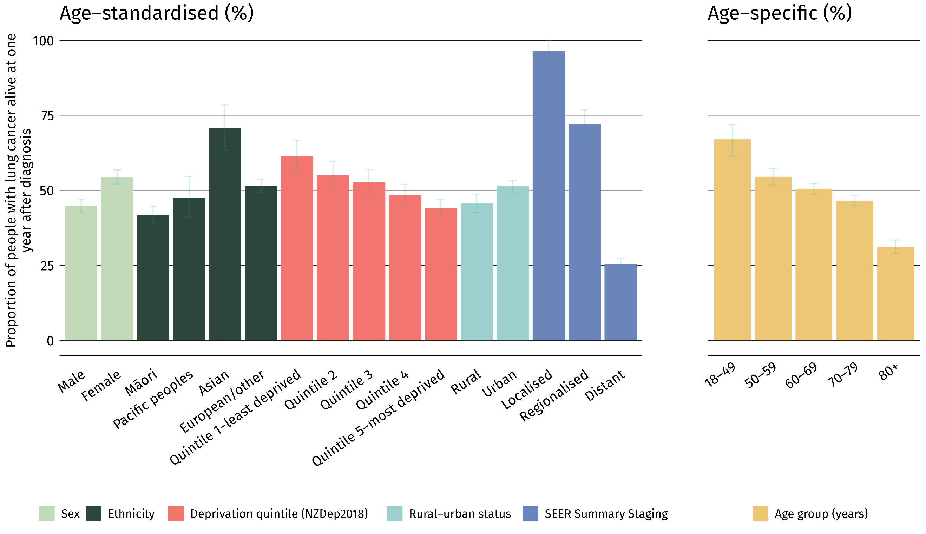

One-year survival rates by DHB in period two ranged between 30.9% in Tairāwhiti and 54.6% in Auckland DHB. Tairāwhiti was below the lower 99.8% limit of the funnel plot, however it is important to consider the potential influence of small numbers on this result. Alongside Auckland DHB, one year survival in both Waitematā (52.9%) and Counties Manukau (52.2%) DHBs were above the upper 99.8% limit of the funnel plot.

Figure 8: Proportion of people with lung cancer who were alive one year after diagnosis, by district health board of residence, 2019–2022 (non-age-standardised)
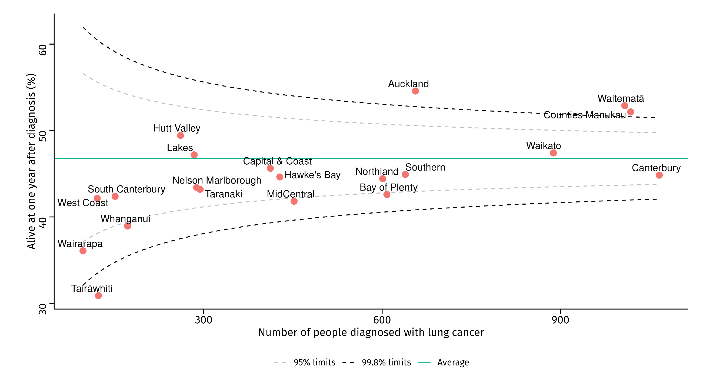

Discussion
We found that, overall, the proportion of people alive one-year after a lung cancer diagnosis has increased in New Zealand. International evidence has found overall cancer survival rates have been improving in high-income countries (Arnold et al 2019). However, these improvements are not equally distributed, and results vary according to ethnicity, socioeconomic status and place of residence.

There were notable demographic variations in the one-year lung cancer survival rates, highlighting how inequities intersect. We found that Māori and Pacific peoples had the lowest one-year survival rates, as did those living in areas of high deprivation and living rurally.

The results for this indicator highlight inequities that persist in cancer mortality. While overall cancer survival rates are improving for Māori and non-Māori, there is a substantial gap in survival rates, where Māori continue to experience poorer survival rates, especially for lung cancer. A combination of patient factors (co-morbidity, deprivation, tumour biology) and health system factors (access to early detection, availability of quality treatment, and affordability and acceptability of quality treatment) are the main factors that contribute towards disparities in overall cancer survival between Māori and non-Māori (Te Aho o Te Kahu 2021c). These results warrant further investigation, especially given the concerns regarding the inequities in one-year survival rates for Māori and Pacific peoples with lung cancer.

QPI 11: Cancer treatment at the end of life

Indicator description
This indicator measures the proportion of people with lung cancer who died (from any cause) and received systemic anti-cancer therapy (SACT) within 30 days prior to death.

Context
During cancer treatment, quality of life should be a priority and SACT should only be offered when there is a reasonable chance it will provide a meaningful benefit. In a hospital setting where the culture is often focused on cure, continuing invasive procedures, investigations and treatments may compromise the patient’s quality of life and comfort. Although SACT is a meaningful tool for managing lung cancer, patients should be able to withstand the side effects and survive long enough to experience the benefits (Gibson et al 2019). Therefore, patients receiving SACT within 30 days prior to death are unlikely to benefit from it (Gibson et al 2019).

End-of-life chemotherapy and aggressive end-of-life care can have negative effects, including higher rates of ED visits, hospitalisation including admissions to intensive care, and lower levels of engagement with hospice services (Bylicki et al 2021).

This indicator aims to assess treatment of people with lung cancer at the end of life and how decisions are made about SACT and its potential benefits.

Results
Between 2019 and 2022, 5.6% of people with lung cancer received SACT within 30 days prior to death.

Once adjusted for age, people of Asian ethnicity were the most likely to receive SACT within 30 days prior to death at 10.8%. Furthermore, 8.7% of people living in rural areas received SACT within 30 days prior death compared with 6.6% of those living in urban areas.

When considering specific age groups, it was uncommon for people over 80 years of age to receive SACT within 30 days prior to death (0.9%), compared with 5.1% of people aged between 70-79.

Figure 9: Proportion of people with lung cancer who received SACT within 30 days prior to death, by sex, ethnicity, NZDep2018 quintile, rural–urban status, SEER summary stage (age-standardised) and age (age-specific), 2019–2022

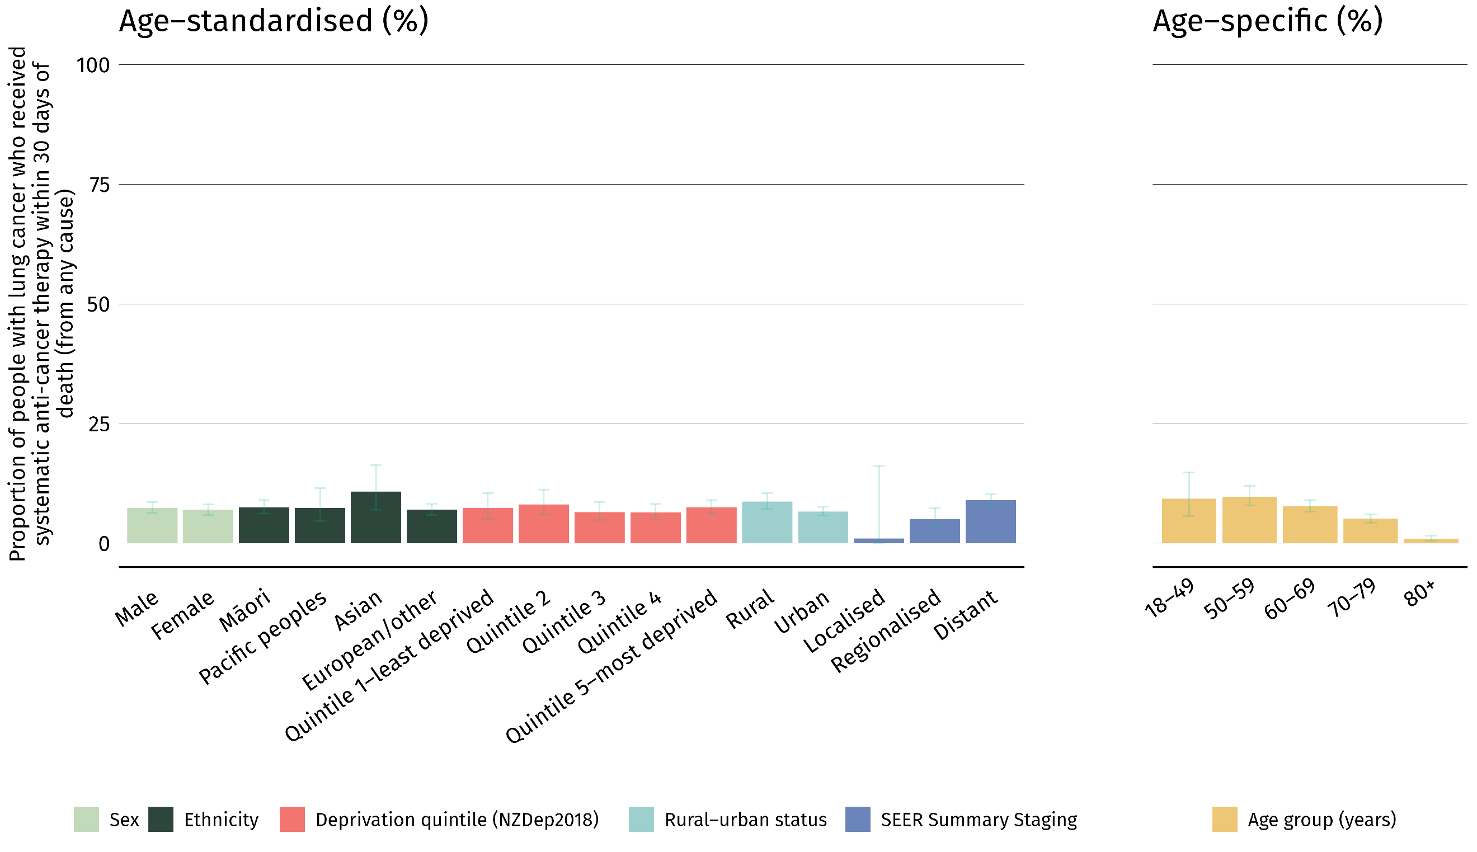

The proportion of people with lung cancer who received SACT within 30 days of death ranged between DHBs, from 3.5% in Hutt Valley and Nelson Marlborough to 14.0% in Lakes DHB. Lakes DHB was above the upper 99.8% limit of the funnel plot.

Figure 10: Proportion of people with lung cancer who received SACT within 30 days prior to death, by district health board of residence, 2019–2022 (non-age-standardised)
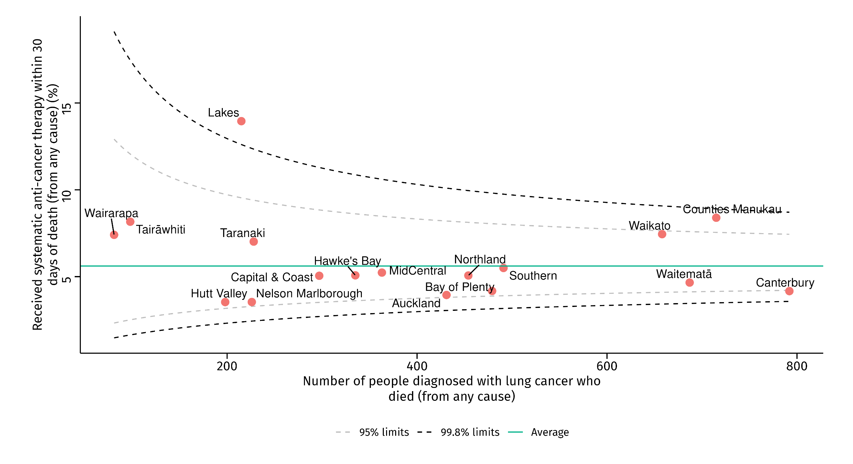

Discussion
Receiving SACT at the end of life is associated with lower quality of life for patients with late-stage lung cancer and higher use of health resources (Le et al 2024; Beaudet et al 2022; Geyer et al 2023; Zhu et al 2018). This is partly because aggressive cancer treatment at the end of a patient’s life can increase their chances of being admitted to ED, hospitals and intensive care units (Garg et al 2024; Singh et al 2024).

Our results show that 5.6% of those with lung cancer received SACT in the last 30 days of life. This is comparable, or lower, than international rates for lung cancer SACT at the end of life (Bekelman et al 2016; Garg et al 2024; Mattsson et al 2021; Rochigneux et al 2017; Skov Benthien et al 2018). However, these results show that there has been little change over time in the proportion of people with lung cancer that received SACT in the last 30 days of life in New Zealand since period one (5.9% in period one).

Differences also remain after adjusting for age, ethnicity, rurality, age, sex and deprivation. Inequities continue to persist, which suggests that complex decisions around end-of-life care are influenced by factors beyond the level of the individual patient. Investigating these factors could help to address inequities.

APPENDIX A: Glossary and abbreviations
Term | Description
Chemoradiation | A treatment that combines chemotherapy with radiotherapy.
Non-small cell lung cancer (NSCLC) | A group of lung cancers that is named for the kinds of cells found in the cancer and how the cells look under a microscope. The three main types of non-small cell lung cancer are squamous cell carcinoma, large cell carcinoma and adenocarcinoma. Non-small cell lung cancer is the most common kind of lung cancer.
SEER Summary Staging | A system that describes the stage of development reached by the tumour at diagnosis using the Surveillance, Epidemiology and End Results (SEER) Summary Staging. The system classifies a cancer case into a broad category (in-situ, localised, regional extension and distant metastases), representing the extent of involvement of the tumour as determined using all diagnostic and therapeutic evidence available at the end of the first course of therapy or within four months of the date of diagnosis, whichever is earlier (Health New Zealand | Te Whatu Ora 2024).
Small cell lung cancer (SCLC) | An aggressive (fast-growing) cancer that forms in tissues of the lung and can spread to other parts of the body. The cancer cells look small and oval-shaped when looked at under a microscope.
Systemic anti-cancer therapy (SACT) | A collective term to describe the growing number of differing therapies used in malignancy to achieve palliation. Improving symptoms, quality of life (QOL) and where possible quantity of life are the goals of these treatments.
Tumour, node, metastasis (TNM) staging system | A system to describe the amount and spread of cancer in a patient’s body, using TNM. T describes the size of the tumour and any spread of cancer into nearby tissue; N describes spread of cancer to nearby lymph nodes; and M describes metastasis (spread of cancer to other parts of the body). When available, TNM scores are used in conjunction with other information, such as blood test results, histologic (cell) test results and risk factors, to define the stage groups for most cancers. All people who meet the criteria of a stage group are then expected to have similar prognosis and outcome.

APPENDIX B: National lung cancer working group members
In 2024–2025, the National Lung Cancer Working Group was chaired by James Entwisle, clinical leader, Radiology Department, Wellington Hospital, and comprised:
- Brendan Luey, consultant medical oncologist, Health New Zealand | Te Whatu Ora – Capital, Coast and Hutt Valley and Bowen Icon Cancer Centre
- Chris Harrington, consultant radiation oncologist, Health New Zealand | Te Whatu Ora Canterbury
- Claire Hardie, radiation oncologist, Health New Zealand | Te Whatu Ora MidCentral, and joint chair, central region lung group
- Dianne Keip, cancer care coordinator, Health New Zealand | Te Whatu Ora Hawke’s Bay
- Felicity Meikle, cardiothoracic specialist, Health New Zealand | Te Whatu Ora Waikato
- George Laking, medical oncologist, Health New Zealand | Te Whatu Ora – Auckland; chair of the Māori Health Committee of the Royal Australasian College of Physicians; and board member of Hei Āhuru Mōwai Māori Cancer Leadership Aotearoa
- Greg Frazer, respiratory and general physician, Health New Zealand | Te Whatu Ora Canterbury, and clinical senior lecturer, University of Otago
- Jeremy Hyde, pathologist, Awanui Labs, Nelson
- Jonathan Adler, consultant palliative care, Health New Zealand | Te Whatu Ora Capital, Coast and Hutt Valley
- Joseph Stafford, consumer and Māori representative
- Mark Taylor, clinical director of primary and integrated care, Health New Zealand | Te Whatu Ora Waikato, and specialist general practitioner
- Paul Conaglen, cardiothoracic specialist, Health New Zealand | Te Whatu Ora Waikato, and chair, Te Manawa Taki lung group
- Paul Dawkins, respiratory physician, Health New Zealand | Te Whatu Ora Counties Manukau
- Rob McNeill, chair of the Northern Region Lung Cancer Working Group and senior lecturer, Faculty of Medical and Health Sciences, University of Auckland
- Ross Lawrenson, Professor of Population Health and director of medicine, University of Waikato
- Sean Galvin, cardiothoracic surgeon and joint chair, central region lung group.

A special thank you to the sub-working group, to which the National Lung Cancer Working Group delegated, for working closely with Te Aho o Te Kahu to complete this lung cancer quality performance indicator update project. The sub-working group comprised:
- Chris Harrington
- James Entwisle
- Paul Dawkins
- Ross Lawrenson.

APPENDIX C: Methods
These methods, together with the lung cancer quality performance indicator (QPI) technical specifications and the lung cancer QPI descriptions documents, outline methods for calculating each QPI, including information on data sources, numerator criteria, denominator criteria, relevant data codes and descriptions, and data flow diagrams.

We used existing routinely available national administrative data sources to work through individual patients’ cancer journeys for all people diagnosed with lung cancer between 1 January 2019 and 31 December 2022. We examined the sequence of events that took patients to their diagnosis, treatment and outcome.

Each QPI has its own inclusion and exclusion criteria. Figure 11 shows a flow diagram of which cases were included or excluded. For more detail, see the lung cancer QPI technical specifications document.

Figure 11: Lung cancer quality performance indicator case eligibility flow diagram: inclusion, exclusion criteria and subtype distribution with key clinical indicators, 2019–2022
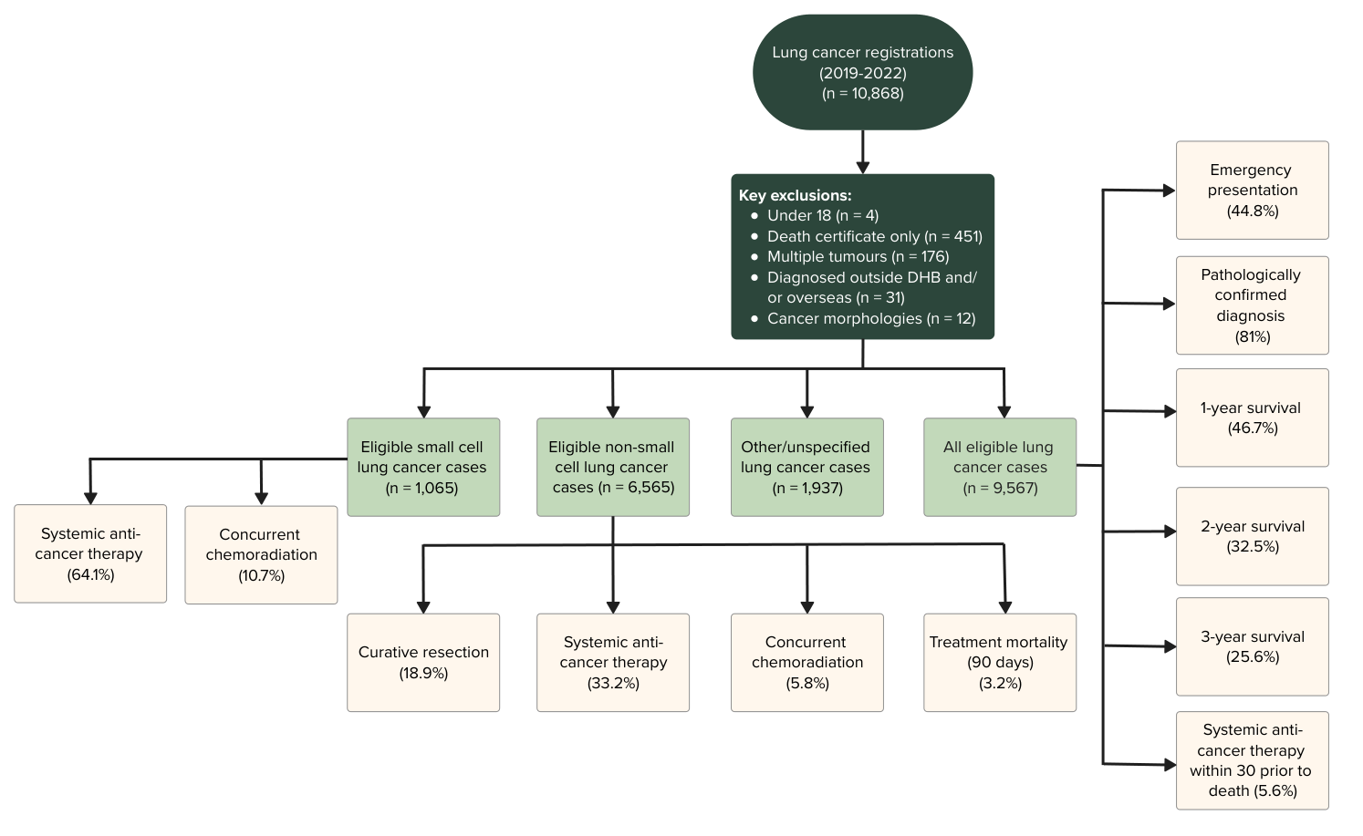

Statistical analysis
Most results discussed in this report are descriptive. We report the results of categorical data as percentages. For district-level reporting, we typically group results by district health board (DHB) of domicile (ie, where the patient lived at the time of diagnosis).

Suppression rules
For confidentiality, we have not presented results when there are five or fewer patients in a group. This is to ensure adequate privacy and confidentiality for patients and providers.

We have not included values in columns where the numbers can be added across columns even if the value is above five.

We have also suppressed additional results if the results where there are five or fewer patients in a group can be calculated. This is referred to as secondary suppression. More information about this is on the Stats NZ website (Stats NZ 2021).

Stratification
Stratifying variables include age group, sex, ethnic group, extent of disease at diagnosis (SEER Summary Staging), NZDep2018 quintile (linked to cancer registrations using health domicile codes) and urban–rural status. Data is stratified and presented in data tables in Appendix D.

SEER Summary Staging is a system that describes the stage of development reached by the tumour at diagnosis using the Surveillance, Epidemiology and End Results (SEER) Summary Staging. The system classifies a cancer case into a broad category (in-situ, localised, regional extension and distant metastases), representing the extent of involvement of the tumour as determined using all diagnostic and therapeutic evidence available at the end of the first course of therapy or within four months of the date of diagnosis, whichever is earlier (Health New Zealand | Te Whatu Ora 2024).

Index of Deprivation (NZDep) is an area-based measure of socioeconomic deprivation in New Zealand (Atkinson et al 2019). It measures the level of deprivation for people in each small area, based on nine Census variables. In this report, NZDep is displayed in quintiles. Each NZDep decile contains about 20% of small areas in New Zealand.

Rural–urban status at time of diagnosis was determined using the Geographic Classification for Health (GCH). The GCH is a rural–urban geographic classification designed specifically for New Zealand. It allows health researchers and policymakers to monitor variations in health outcomes accurately across different areas. For more information, visit the GCH website.

Age standardisation
Age standardisation is an important method for comparing outcomes across different ethnic groups.

In New Zealand, different populations vary in terms of the ages of people in each group. For example, some ethnicities, genders and districts may have more young people or older people compared with others.

Age is an important determinant of cancer incidence and outcomes. A population with a younger age distribution may seem to have similar or better outcomes than those with an older population – but this may be only because of differences between the groups in their age distribution. By standardising age structures between groups, comparisons become more accurate, and disparities can be examined more clearly.

Age-standardised proportions are calculated by the direct standardisation method, which multiplies the non-age-standardised proportions by a standard population. The standard population used in this report is a cohort of all Māori aged 18 years and over diagnosed with lung cancer between 2015 and 2022. All were included in the analysis.

Table 2: Māori diagnosed with lung cancer in New Zealand, 2015–2022
Age group (years) | Population distribution (%)
18–49 | 4.46
50–54 | 8.24
55–59 | 15.27
60–64 | 18.94
65–69 | 19.50
70–74 | 18.34
75+ | 15.24
Total | 100.00
Note: Those under the age of 18 years are excluded from the analysis.
Source: New Zealand Cancer Registry 2024.

Confidence intervals, relative standard error and significance testing
A confidence interval represents a range of values that express the uncertainty around an estimate, such as an age-standardised proportion. It shows how much the estimate could vary if a different set of data had been used. Confidence intervals are usually calculated with a specific probability, most commonly 95%. This means there is a 95% chance that the true value lies within the given range.

When comparing results between two time periods or two groups, confidence intervals can give a rough idea of whether a difference is likely to be real or just due to chance. If the confidence intervals do not overlap, we can say there is a statistically significant difference. If they do overlap, that does not necessarily mean there is no difference — we would need to run further statistical testing to be sure (VanEenwyk 2012). Unless stated, this has not been applied to the data in this report.

Confidence intervals also give an impression of the precision of the results (ie, whether the numbers are large or small). Wide confidence intervals indicate there is a smaller number of people within the group. Proportions with wide confidence intervals are more likely to fluctuate over time. Conversely, narrow confidence intervals indicate there is a larger number of people within that group so we can be more certain that the results reflected are a true representation of what is occurring nationally, and that there is less likely to be variation over time.

In this report, we calculate confidence intervals for age-standardised proportions at the 95% level, following the method outlined by Fay and Feuer (1997). For non-age-standardised proportions by DHB, we use Wilson’s formula, which approximates the exact method (Rothman 2012), also at the 95% level.

Relative standard error (RSE) was also calculated to assess the stability of the age-standardised proportions. If an RSE is greater than 30%, the results are deemed to be ‘unstable’ and have been annotated in the tables in Appendix D of this report (VanEenwyk 2012).

Funnel plots
Where appropriate, this report uses funnel plots to make comparisons between DHBs. We plot the proportion for each DHB against the total number of patients used to estimate the proportion, which also shows how patient volumes can differ across the country. The average across all DHBs appears as a green line.

There are two control limit lines on each plot. These limits are statistically calculated based on the average proportion and the number of patients included in the estimate and therefore create a ‘funnel’ shape.

The inner line is the 95% limit, where five out of every 100 might be expected to lie based on expected random variations. The outer line is the 99.8% limit, where two out of every 1,000 might be expected to lie. Where a DHB’s results lie outside these limits, this could represent expected variation, but may also represent unwarranted variation requiring further investigation.

Note that proportion estimates have greater uncertainty when estimated from fewer patients.

Assessing change over time
A trend analysis using Poisson regression was performed in R to estimate average change per year (rate ratios) (Atkinson et al 2008). Where relevant (ie, where the results were found to be statistically significant), analysis is provided in the commentary. The model used robust standard errors to control for mild violation of the distribution assumption that the variance equals the mean (Cameron and Trivedi 2009). We also calculated 95% confidence intervals for all estimates.

To assess changes in real-world practice, we calculated the percentage of absolute change in the non-age-standardised overall results between the two periods for each indicator. This approach reflects the actual differences observed over time without adjusting for demographic shifts. However, since differences in age distribution can influence trends, we used rate ratios to compare age-standardised results between the two periods. This allows for a fairer comparison by accounting for variations in population age structures.

APPENDIX D: Supplementary tables
Table 3: Proportion of people diagnosed with lung cancer following emergency presentation, by year of diagnosis, sex, age group, ethnicity, deprivation quintile (NZDep2018), rural–urban status and SEER Summary Staging, 2019-2022
 |  |  | Age-standardised proportion
 | People with  lung cancer* | Diagnosed following emergency presentation (%) | % | 95% confidence intervals
Cases eligible
Total | 9,567 | 44.8 | 44.1 | 42.6–45.6
Year of diagnosis
2019 | 2,282 | 41.8 | 40.9 | 38.1–44.0
2020 | 2,451 | 45.0 | 44.6 | 41.7–47.6
2021 | 2,460 | 45.8 | 44.8 | 41.8–47.9
2022 | 2,374 | 46.3 | 45.8 | 42.8–49.1
Sex
Male | 4,633 | 47.3 | 47.3 | 45.1–49.6
Female | 4,932 | 42.4 | 41.3 | 39.4–43.3
Age group (years)
18-49 | 294 | 49.0 | - | -
50-59 | 1,201 | 47.0 | - | -
60-69 | 2,788 | 41.2 | - | -
70-79 | 3,654 | 41.1 | - | -
80+ | 1,630 | 56.7 | - | -
Ethnicity
Māori | 2,012 | 47.1 | 47.2 | 44.3–50.3
Pacific peoples | 485 | 59.2 | 58.2 | 51.3–66.0
Asian | 579 | 43.7 | 42.9 | 37.3–49.1
European/other | 6,467 | 43.0 | 41.2 | 39.3–43.1
Deprivation quintile (NZDep2018)
Quintile 1 (least deprived) | 1,175 | 39.3 | 38.1 | 34.3–42.3
Quintile 2 | 1,481 | 42.2 | 40.6 | 36.9–44.6
Quintile 3 | 1,792 | 44.4 | 42.4 | 38.9–46.1
Quintile 4 | 2,115 | 44.1 | 43.1 | 40.0–46.4
Quintile 5 (most deprived) | 2,657 | 48.7 | 49.1 | 46.3–52.0
Rural–urban status
Rural | 2,493 | 43.6 | 43.5 | 40.7–46.6
Urban | 7,074 | 45.2 | 44.3 | 42.6–46.0
SEER Summary Staging
Localised | 837 | 6.2 | 6.1 | 4.5–8.3
Regionalised | 1,499 | 26.7 | 25.4 | 22.8–28.3
Distant | 4,409 | 65.3 | 64.8 | 62.2–67.4
* Excludes people registered with cancer from death certificates only.
Sources: New Zealand Cancer Registry, National Minimum Dataset (hospital events) and National Non-Admitted Patient Collection.

Table 4: Proportion of people diagnosed with lung cancer following emergency presentation, by district health board of residence, 2019–2022

 |  | Diagnosed following emergency presentation
District health board  of residence | People with lung cancer* | % | 95% confidence intervals
Northland | 601 | 39.8 | 35.9–43.7
Waitematā | 1,008 | 51.8 | 48.7–54.9
Auckland | 656 | 50.0 | 46.2–53.8
Counties Manukau | 1,018 | 48.8 | 45.8–51.9
Waikato | 888 | 47.9 | 44.6–51.1
Lakes | 284 | 45.4 | 39.7–51.2
Bay of Plenty | 608 | 48.5 | 44.6–52.5
Tairāwhiti | 123 | 45.5 | 37.0–54.3
Taranaki | 294 | 47.3 | 41.6–53.0
Hawke's Bay | 428 | 43.2 | 38.6–48.0
Whanganui | 172 | 47.1 | 39.8–54.5
MidCentral | 452 | 42.3 | 37.8–46.9
Capital & Coast | 412 | 39.6 | 35.0–44.4
Hutt Valley | 261 | 37.9 | 32.3–44.0
Wairarapa | 97 | 39.2 | 30.1–49.1
Nelson Marlborough | 288 | 40.6 | 35.1–46.4
West Coast | 121 | 46.3 | 37.6–55.1
Canterbury | 1,066 | 34.9 | 32.1–37.8
South Canterbury | 151 | 47.7 | 39.9–55.6
Southern | 639 | 43.7 | 39.9–47.5

* Excludes people registered with cancer from death certificates only.
Sources: New Zealand Cancer Registry, National Minimum Dataset (hospital events) and National Non-Admitted Patient Collection.
Table 5: Proportion of people diagnosed with non-small cell lung cancer who received a curative resection, by year of diagnosis, sex, age group, ethnicity, deprivation quintile (NZDep2018), rural–urban status and SEER Summary Staging, 2019–2022
 |  |  | Age-standardised proportion
 | People with non-small cell lung cancer* | Received curative resection (%) | % | 95% confidence intervals
Cases eligible
Total | 6,565 | 18.9 | 19.5 | 18.4–20.8
Year of diagnosis
2019 | 1,548 | 19.3 | 20.4 | 18.0–23.1
2020 | 1,688 | 17.4 | 17.6 | 15.5–20.0
2021 | 1,658 | 18.6 | 19.2 | 17.0–21.8
2022 | 1,671 | 20.5 | 20.9 | 18.6–23.5
Sex
Male | 3,209 | 17.4 | 17.6 | 16.0–19.3
Female | 3,355 | 20.4 | 21.3 | 19.6–23.0
Age group (years)
18-49 | 228 | 17.1 | - | -
50-59 | 884 | 20.2 | - | -
60-69 | 2,041 | 20.3 | - | -
70-79 | 2,597 | 21 | - | -
80+ | 815 | 7.7 | - | -
Ethnicity
Māori | 1,306 | 16.8 | 16.8 | 14.7–19.2
Pacific peoples | 374 | 18.4 | 19.2 | 14.8–24.7
Asian | 491 | 23.4 | 24.4 | 19.9–29.7
European/other | 4,378 | 19.1 | 20.0 | 18.4–21.6
Deprivation quintile (NZDep2018)
Quintile 1 (least deprived) | 894 | 21.3 | 21.3 | 18.1–24.9
Quintile 2 | 1,042 | 20.2 | 21.4 | 18.3–25.0
Quintile 3 | 1,219 | 19.6 | 20.2 | 17.5–23.4
Quintile 4 | 1,428 | 17.6 | 18.2 | 15.8–20.9
Quintile 5 (most deprived) | 1,744 | 18.8 | 19.4 | 17.3–21.7
Rural–urban status
Rural | 1,673 | 17.8 | 17.6 | 15.4–19.9
Urban | 4,892 | 19.3 | 20.2 | 18.9–21.7
SEER Summary Staging
Localised | 676 | 86.8 | 85.1 | 77.8–93.0
Regionalised | 1,184 | 44.9 | 45.5 | 41.5–49.9
Distant | 2,899 | 1.7 | 1.8 | 1.3–2.5
* Excludes people registered with cancer from death certificates only.
Sources: New Zealand Cancer Registry and National Minimum Dataset (hospital events).
Table 6: Proportion of people diagnosed with non-small cell lung cancer who received a curative resection, by district health board of residence, 2019–2022
 |  | Received curative resection
 | People with non-small  cell lung cancer* |  | % | 95% confidence intervals
District health board
of residence
Northland | 435 |  | 25.3 | 21.4–29.6
Waitematā | 782 |  | 22.5 | 19.7–25.6
Auckland | 466 |  | 23.6 | 20.0–27.7
Counties Manukau | 777 |  | 21.8 | 19.0–24.8
Waikato | 598 |  | 15.4 | 12.7–18.5
Lakes | 174 |  | 19.5 | 14.3–26.1
Bay of Plenty | 388 |  | 21.1 | 17.4–25.5
Tairāwhiti | s |  | s | s
Taranaki | 201 |  | 18.4 | 13.7–24.3
Hawke's Bay | 253 |  | 19.0 | 14.6–24.3
Whanganui | 105 |  | 11.4 | 6.7–18.9
MidCentral | 286 |  | 12.9 | 9.5–17.3
Capital & Coast | 274 |  | 17.2 | 13.2–22.1
Hutt Valley | 172 |  | 15.1 | 10.5–21.2
Wairarapa | s |  | s | s
Nelson Marlborough | 202 |  | 18.3 | 13.6–24.2
West Coast | 82 |  | 15.9 | 9.5–25.3
Canterbury | 741 |  | 15.2 | 12.8–18.0
South Canterbury | 97 |  | 16.5 | 10.4–25.1
Southern | 404 |  | 16.6 | 13.3–20.5
* Excludes people registered with cancer from death certificates only.
s – Proportions for counts under 6 have been suppressed and are denoted as 's' to protect confidentiality. Secondary suppression has been applied to prevent any potential disclosure of suppressed values through calculation.
Sources: New Zealand Cancer Registry and National Minimum Dataset (hospital events).
 |  |  | Age-standardised proportion
 | People with  lung cancer* | Alive at one year  after diagnosis (%) | % | 95% confidence intervals
Cases eligible
Total | 9,567 | 46.7 | 49.9 | 48.3–51.5
Year of diagnosis
2019 | 2,282 | 47.2 | 50.1 | 46.9–53.5
2020 | 2,451 | 47.2 | 49.4 | 46.3–52.6
2021 | 2,460 | 46 | 49.6 | 46.4–52.9
2022 | 2,374 | 46.6 | 50.6 | 47.4–54.0
Sex
Male | 4,633 | 42.2 | 44.8 | 42.6–47.1
Female | 4,932 | 51 | 54.4 | 52.1–56.8
Age group (years)
18-49 | 294 | 67 | - | -
50-59 | 1,201 | 54.6 | - | -
60-69 | 2,788 | 50.5 | - | -
70-79 | 3,654 | 46.6 | - | -
80+ | 1,630 | 31.2 | - | -
Ethnicity
Māori | 2,012 | 41.6 | 41.8 | 39.0–44.7
Pacific peoples | 485 | 46.6 | 47.5 | 41.1–54.7
Asian | 579 | 69.4 | 70.7 | 63.4–78.6
European/other | 6,467 | 46.4 | 51.4 | 49.2–53.7
Deprivation quintile (NZDep2018)
Quintile 1 (least deprived) | 1,175 | 56 | 61.3 | 56.2–66.7
Quintile 2 | 1,481 | 50.1 | 55.0 | 50.5–59.7
Quintile 3 | 1,792 | 48.1 | 52.7 | 48.7–56.9
Quintile 4 | 2,115 | 45.6 | 48.5 | 45.1–52.0
Quintile 5 (most deprived) | 2,657 | 42.6 | 44.1 | 41.4–46.9
Rural–urban status
Rural | 2,493 | 43.6 | 45.6 | 42.7–48.8
Urban | 7,074 | 47.9 | 51.4 | 49.5–53.3
SEER Summary Staging
Localised | 837 | 96.1 | 96.4 | 89.4–100.0
Regionalised | 1,499 | 69.1 | 72.1 | 67.5–76.9
Distant | 4,409 | 22.7 | 25.5 | 23.9–27.2
Table 7: Proportion of people with lung cancer who were alive one year after diagnosis, by year of diagnosis, sex, age group, ethnicity, deprivation quintile (NZDep2018), rural–urban status and SEER Summary Staging, 2019–2022

* Excludes people registered with cancer from death certificates only.
Sources: New Zealand Cancer Registry and Mortality Collection.

Table 8: Proportion of people with lung cancer who were alive one year after diagnosis, by district health board of residence, 2019–2022
 |  |  | Alive one year after diagnosis
 |  | People with lung cancer* |  | % | 95% confidence intervals
District health board
of residence
Northland |  | 601 |  | 44.4 | 40.5–48.4
Waitematā |  | 1,008 |  | 52.9 | 49.8–55.9
Auckland |  | 656 |  | 54.6 | 50.7–58.3
Counties Manukau |  | 1,018 |  | 52.2 | 49.1–55.2
Waikato |  | 888 |  | 47.4 | 44.1–50.7
Lakes |  | 284 |  | 47.2 | 41.5–53.0
Bay of Plenty |  | 608 |  | 42.6 | 38.7–46.6
Tairāwhiti |  | 123 |  | 30.9 | 23.4–39.5
Taranaki |  | 294 |  | 43.2 | 37.7–48.9
Hawke's Bay |  | 428 |  | 44.6 | 40.0–49.4
Whanganui |  | 172 |  | 39.0 | 32.0–46.4
MidCentral |  | 452 |  | 41.8 | 37.4–46.4
Capital & Coast |  | 412 |  | 45.6 | 40.9–50.5
Hutt Valley |  | 261 |  | 49.4 | 43.4–55.5
Wairarapa |  | 97 |  | 36.1 | 27.2–46.0
Nelson Marlborough |  | 288 |  | 43.4 | 37.8–49.2
West Coast |  | 121 |  | 42.1 | 33.7–51.1
Canterbury |  | 1,066 |  | 44.8 | 41.9–47.8
South Canterbury |  | 151 |  | 42.4 | 34.8–50.4
Southern |  | 639 |  | 44.9 | 41.1–48.8
* Excludes people registered with cancer from death certificates only.
Sources: New Zealand Cancer Registry and Mortality Collection.
Table 9: Proportion of people with lung cancer who received systemic anti-cancer therapy within 30 days prior to death, by year of diagnosis, sex, age group, ethnicity, deprivation quintile (NZDep2018), rural–urban status and SEER Summary Staging, 2019–2022
 |  |  | Age-standardised proportion
 | People with  lung cancer* | Received SACT within 30 days prior to death (%) | % | 95% confidence intervals
Cases eligible
Total | 7,109 | 5.6 | 7.2 | 6.4–8.0
Year of diagnosis
2019 | 1,840 | 5.2 | 7.1 | 5.7–8.9
2020 | 1,918 | 5 | 6.0 | 4.8–7.5
2021 | 1,801 | 6.4 | 8.2 | 6.6–10.0
2022 | 1,550 | 5.9 | 7.5 | 5.9–9.5
Sex
Male | 3,636 | 5.7 | 7.4 | 6.3–8.6
Female | 3,471 | 5.5 | 7.0 | 5.9–8.1
Age group (years)
18-49 | 161 | 9.3 | - | -
50-59 | 812 | 9.7 | - | -
60-69 | 1,964 | 7.7 | - | -
70-79 | 2,744 | 5.1 | - | -
80+ | 1,428 | 0.9 | - | -
Ethnicity
Māori | 1,621 | 7.3 | 7.5 | 6.2–9.0
Pacific peoples | 354 | 7.1 | 7.4 | 4.6–11.5
Asian | 314 | 8.9 | 10.8 | 7.0–16.3
European/other | 4,797 | 4.7 | 7.0 | 5.9–8.2
Deprivation quintile (NZDep2018)
Quintile 1 (least deprived) | 762 | 5.1 | 7.4 | 5.1–10.5
Quintile 2 | 1,025 | 6.1 | 8.1 | 6.0–11.2
Quintile 3 | 1,334 | 4.5 | 6.5 | 4.8–8.6
Quintile 4 | 1,615 | 5.1 | 6.4 | 5.0–8.2
Quintile 5 (most deprived) | 2,077 | 6.5 | 7.5 | 6.2–9.0
Rural–urban status
Rural | 1,905 | 7.2 | 8.7 | 7.2–10.5
Urban | 5,204 | 5 | 6.6 | 5.8–7.6
SEER Summary Staging
Localised | s | s | s | s
Regionalised | 868 | 4.3 | 5.0 | 3.3–7.3
Distant | 4,040 | 7.4 | 9.0 | 8.0–10.2
* Excludes people registered with cancer from death certificates only.
s – Proportions for counts under 6 have been suppressed and are denoted as 's' to protect confidentiality. Secondary suppression has been applied to prevent any potential disclosure of suppressed values through calculation.
SACT = systemic anti-cancer therapy
Sources: New Zealand Cancer Registry, Pharmaceutical Collection and Mortality Collection.

Table 10: Proportion of people with lung cancer who received systemic anti-cancer therapy within 30 days of death, by district health board of residence, 2019–2022
 |  | Received SACT within 30 days of death
 | People with lung cancer who died (from any cause)* | % | 95% confidence intervals
District health board
of residence
Northland | 454 | 5.1 | 3.4–7.5
Waitematā | 687 | 4.7 | 3.3–6.5
Auckland | 431 | 3.9 | 2.5–6.2
Counties Manukau | 715 | 8.4 | 6.6–10.7
Waikato | 658 | 7.5 | 5.7–9.7
Lakes | 215 | 14.0 | 10.0–19.2
Bay of Plenty | 479 | 4.2 | 2.7–6.4
Tairāwhiti | 98 | 8.2 | 4.2–15.3
Taranaki | 228 | 7.0 | 4.4–11.1
Hawke's Bay | 335 | 5.1 | 3.2–8.0
Whanganui | s | s | s
MidCentral | 363 | 5.2 | 3.4–8.0
Capital & Coast | 297 | 5.1 | 3.1–8.2
Hutt Valley | 198 | 3.5 | 1.7–7.1
Wairarapa | 81 | 7.4 | 3.4–15.2
Nelson Marlborough | 226 | 3.5 | 1.8–6.8
West Coast | s | s | s
Canterbury | 792 | 4.2 | 3.0–5.8
South Canterbury | s | s | s
Southern | 491 | 5.5 | 3.8–7.9
* Excludes people registered with cancer from death certificates only.
s – Proportions for counts under 6 have been suppressed and are denoted as 's' to protect confidentiality. Secondary suppression has been applied to prevent any potential disclosure of suppressed values through calculation.
SACT = systemic anti-cancer therapy
Sources: New Zealand Cancer Registry, Pharmaceutical Collection and Mortality Collection.

APPENDIX E: References
Arnold M, Rutherford, MJ, Bardot A, et al. 2019. Progress in cancer survival, mortality, and incidence in seven high-income countries 1995–2014 (ICBP SURVMARK-2): a population-based study. The Lancet Oncology 20(11): 1493–505.
Atkinson E, Salmond C, Crampton P. 2019. NZDep2018 Index of Deprivation, Final Research Project. URL: https://www.otago.ac.nz/__data/assets/pdf_file/0020/326711/nzdep2018-index-of-deprivation-research-report-final-dec-2020-823833.pdf (accessed 30 April 2025).
Beatty S, Stevens W, Stevens G, et al. 2009. Lung cancer patients in New Zealand initially present to secondary care through the emergency department rather than by referral to a respiratory specialist. The New Zealand Medical Journal (Online) 122(1294).
Beaudet MÉ, Lacasse Y, Labbé C. 2022. Palliative Systemic Therapy Given near the End of Life for Metastatic Non-Small Cell Lung Cancer. Current Oncology 29(3): 1316–25. DOI: 10.3390/curroncol29030112.
Bekelman JE, Halpern SD, Blankart CR, et al. 2016. Comparison of site of death, health care utilization, and hospital expenditures for patients dying With cancer in 7 developed countries. JAMA - Journal of the American Medical Association 315(3): 272–83. DOI: 10.1001/jama.2015.18603.
Bylicki O, Riviere F, Tournier C, et al. 2021. Factors Assosicated with Aggressiveness of End-of Life Care for Lung Cancer Patients and Associated Costs of Care. Clinical Lung Cancer 22(3). URL: https://doi.org/10.1016/j.cllc.2020.05.017.
Cameron A, Trivedi P. 2009. Microeconometrics Using Stata. College Station, TX: Stata Press.
Cassim S, Kidd J, Rolleston A, et al. 2021. Hā Ora: Barriers and enablers to early diagnosis of lung cancer in primary healthcare for Māori communities. Eur J Cancer Care (Engl) 30(2): e13380. DOI: 10.1111/ecc.13380.
Department of the Prime Minister and Cabinet. 2023. Timeline of significant COVID-19 events. URL: www.dpmc.govt.nz/sites/default/files/2023-10/pr-timeline-significant-events-activities.pdf (accessed 15 January 2025).
Garg V, Ruiz Buenrostro A, Heuniken K, et al. 2024. Novel Systemic Anticancer Therapy and Healthcare Utilization at the End of Life: A Retrospective Cohort Study. Cancer Medicine 13(23). DOI: 10.1002/cam4.70450.
Geyer T, Le NS, Groissenberger I, et al. 2023. Systemic Anticancer Treatment Near the End of Life: a Narrative Literature Review. Current Treatment Options in Oncology 24(10): 1328–50. DOI: 10.1007/s11864-023-01115-x.
Gibson A, Li H, D’Silva A, et al. 2019. Factors associated with early mortality in non-small cell lung cancer patients following systematic anti-cancer therapy: a 10 year population-based study. Lung Cancer 134: 141–6. URL: https://doi.org/10.1016/j.lungcan.2019.06.003.
Gimpel D, Pan A, Manikavasagar V, et al. 2022. Early diagnosis of surgically curable lung cancer is commonly serendipitous. NZ Med J 135(1556): 44–52.
Gurney J, Davies A, Stanley J, et al. 2023. Emergency presentation prior to lung cancer diagnosis: A national-level examination of disparities and survival outcomes. Lung Cancer 179: 107174.
Gurney J, Davies A, Stanley J, et al. 2024. Access to and timeliness of lung cancer surgery, radiation therapy, and systemic therapy in New Zealand: a universal health care context. JCO Global Oncology 10: e2300258. URL: https://ascopubs.org/doi/10.1200/GO.23.00258#abstract.
Hayes T, Coleman B, Locke M. 2022. Volcanic disruption: the impact of Whakaari White Island on the provision of elective surgical care in Counties Manukau. ANZ Journal of Surgery 92(1–2): 167–71.
Health New Zealand | Te Whatu Ora. 2024. What information we collect. URL: www.tewhatuora.govt.nz/for-health-professionals/clinical-guidance/diseases-and-conditions/cancer/new-zealand-cancer-registry-nzcr/new-zealand-cancer-registry-what-we-collect (accessed 25 March 2025).
Howington JA, Blum MG, Chang AC, et al. 2013. Treatment of stage I and II non-small cell lung cancer: diagnosis and management of lung cancer: American College of Chest Physicians evidence-based clinical practice guidelines. Chest 143(5): e278S–e313S.
Htun HW, Elwood JM, Ioannides SJ, et al. 2017. Investigations and referral for suspected cancer in primary care in New Zealand-A survey linked to the International Cancer Benchmarking Partnership. Eur J Cancer Care (Engl) 26(3). DOI: 10.1111/ecc.12634.
Lawrenson R, Lao C, Brown L, et al. 2020. Management of patients with early stage lung cancer - why do some patients not receive treatment with curative intent? BMC Cancer 20(1): 109. DOI: 10.1186/s12885-020-6580-6.
Lawrenson R, Lao C, Nguyen H, et al. 2024. Characteristics and outcomes of lung cancer patients presenting through the emergency department: a Waikato District Health Board study. NZ Med J 137(1603): 14–24. DOI: 10.26635/6965.6481.
Le NS, Zeybek A, Hackner K, et al. 2024. Systemic anticancer therapy near the end of life: an analysis of factors influencing treatment in advanced tumor disease. ESMO Open 9(9): 103683. DOI: 10.1016/j.esmoop.2024.103683.
Mattsson TO, Pottegård A, Jørgensen TL, et al. 2021. End-of-life anticancer treatment–a nationwide registry-based study of trends in the use of chemo-, endocrine, immune-, and targeted therapies. Acta Oncologica 60(8): 961–7. DOI:10.1080/0284186X.2021.1890332.
McPhail S, Swann R, Johnson SA, et al. 2022. Risk factors and prognostic implications of diagnosis of cancer within 30 days after an emergency hospital admission (emergency presentation): an International Cancer Benchmarking Partnership (ICBP) population-based study. The Lancet Oncology 23(5): 587–600.
Rochigneux P, Raoul JL, Beaussant Y, et al. 2017. Use of chemotherapy near the end of life: What factors matter? Annals of Oncology 28(4): 809–17. DOI: 10.1093/annonc/mdw654.
Rothman KJ. 2012. Epidemiology: an introduction. Oxford: Oxford University Press.
Singh J, Grov EK, Turzer M, et al. 2024. Hospitalizations and re-hospitalizations at the end-of-life among cancer patients; a retrospective register data study. BMC Palliative Care 23(1). DOI: 10.1186/s12904-024-01370-1.
Skov Benthien K, Adsersen M, Petersen MA, et al. 2018. Is specialized palliative cancer care associated with use of antineoplastic treatment at the end of life? A population-based cohort study. Palliative Medicine 32(9): 1509–17. doi:10.1177/0269216318786393
Stats NZ. 2021. Information about the standard for gender, sex, and variations of sex characteristics. URL: www.stats.govt.nz/methods/information-about-the-standard-for-gender-sex-and-variations-of-sex-characteristics.
Te Aho o Te Kahu. 2021b. Cancer Care and COVID-19. URL: https://teaho.govt.nz/index.php/our-work/covid-19/cancer-care-and-covid-19 (accessed 14 January 2025).
Te Aho o Te Kahu. 2021a. Lung Cancer Quality Improvement Monitoring Report 2021. URL: https://teaho.govt.nz/index.php/download_file/view/fc5a7f82-d181-436a-a8aa-9d55e79db033/55 (accessed 5 March 2025).
Te Aho o Te Kahu. 2021c. He Pūrongo Mate Pukupuku o Aotearoa 2020, The State of Cancer in New Zealand 2020. URL: https://teaho.govt.nz/index.php/reports-and-numbers/reports/state-cancer-new-zealand-2020 (accessed 5 March 2025).
Te Aho o Te Kahu. 2024. Route to diagnosis: People diagnosed with cancer within 30-days of an emergency or acute (unplanned) hospital admission. URL: https://teaho.govt.nz/application/files/4817/4053/7383/RTD_Report_People_diagnosed_with_cancer_after_emergency_or_unplanned_hospital_admission_March_2024_002.pdf (accessed 5 March 2025).
VanEenwyk J. 2012. Guidelines for using and developing rates for public health assessment. Washington State Department of Health. URL: https://doh.wa.gov/sites/default/files/legacy/Documents/1500/ConfIntGuide.pdf (accessed 5 March 2025).
Vrijens F, Verleye L, De Gendt C, et al. 2016. Quality indicators for the management of lung cancer – Supplement. Health Services Research (HSR). KCE Reports 266S. D/2016/10.273/40. Brussels: Belgian Health Care Knowledge Centre.
Waikato District Health Board. 2022. Waikato District Health Board (WDHB) Incident Response Analysis. URL: www.tewhatuora.govt.nz/assets/Publications/Proactive-releases/WDHB-Final-Report-2.0-redacted.pdf (accessed 8 January 2025).
Zhu Y, Tang K, Zhao F, et al. 2018. End-of-life chemotherapy is associated with poor survival and aggressive care in patients with small cell lung cancer. Journal of Cancer Research and Clinical Oncology 144(8): 1591–9. DOI: 10.1007/s00432-018-2673-x.

In this report, we look only at one-year survival after diagnosis of all lung cancer. Other breakdowns are in the online dashboard.
In this report, we look only at one-year survival after diagnosis of all lung cancer. Other breakdowns are in the online dashboard.
It is important to note that not all SACT provided at the end of life is ‘inappropriate’. Some SACT is administered with palliative intent. This discussion is mainly focused on chemotherapy and other aggressive SACT administered with curative intent in the final 30 days of life.

