Lung Cancer Quality Performance Indicator Specifications
LCQI09 Treatment Mortality
2021

Citation: Te Aho o Te Kahu. 2021. Lung Cancer Quality Performance Indicator Specifications: LCQI09 Treatment Mortality. Wellington: Te Aho o Te Kahu.
Published in March 2021 by the Te Aho o Te Kahu
PO Box 5013, Wellington 6140, New Zealand
ISBN 978-1-99-002991-2 (online)
HP 7605

This document is available at teaho.govt.nz
 | This work is licensed under the Creative Commons Attribution 4.0 International licence. In essence, you are free to: share ie, copy and redistribute the material in any medium or format; adapt ie, remix, transform and build upon the material. You must give appropriate credit, provide a link to the licence and indicate if changes were made.

Contents
Introduction 1
Sources of data for indicator 1
LCQI09 Treatment mortality 2
Measure items 2
Case eligibility criteria (denominator) 4
Numerator criteria 6
Curative resection ACHI procedure codes 6
Chemotherapy drug codes and names 7

Introduction
This information is provided to make it easier for analysts to replicate our calculations. For each measure we have provided supporting information, a table and a flow diagram.

This document provides specifications for the following measure.

Measure | Measure abbreviation | Measure  type
Proportion of people with lung cancer who died within 30 days of treatment with curative intent (surgery, systemic anti-cancer therapy, chemoradiation, radiotherapy), by type (NSCLC/SCLC). | death_30 | Quality improvement
Proportion of people with lung cancer who died within 30 days of treatment with curative intent (surgery, systemic anti-cancer therapy, chemoradiation, radiotherapy), by type (NSCLC/SCLC). | death_90 | Quality improvement

Sources of data for indicator
- New Zealand Cancer Registry (NZCR) – a population-based register of all primary malignant diseases diagnosed in New Zealand, excluding squamous and basal cell skin cancers
- National Minimum Dataset (NMDS) – a collection of public and private hospital discharge information, including coded clinical data for inpatients and day patients
- National Non-Admitted Patients Collection (NNPAC) – includes event-based purchase units that relate to medical and surgical outpatient events and emergency department events
- Pharmaceutical Collection (PHARMS) – a data warehouse that supports the management of pharmaceutical subsidies, and contains claim and payment information from pharmacists for subsidised dispensings
- Radiation Oncology Collection (ROC) – a collection of radiation oncology treatment data, including both public and private providers.
- Mortality Collection (MORT) – classifies the underlying cause of death for all deaths registered in New Zealand

More information on these data sources can be found on the Ministry of Health’s website: www.health.govt.nz.

LCQI09 Treatment mortality
Proportion of people with lung cancer who died within 30 or 90 days of treatment with curative intent (surgery, systemic anti-cancer therapy, radiation therapy), by type (NSCLC/SCLC).

Measure type: quality improvement

Measure items
Dataset | Data item | Description
NZCR | NHI | Patient identifier
NZCR | Cancer event ID | Cancer registration identifier
NZCR | Date of initial diagnosis | Date person first diagnosed with lung cancer
NZCR | Diagnosis year | Calendar year of first diagnosis
NZCR | Site | Primary organ of origin of the cancer (ICD-10-AM 8th Edition code)
NZCR | Morphology code | 4-digit code (ICD-O-3) for microscopic or cellular anatomy of the cancer
NZCR | Basis | Basis of diagnosis
NZCR | DHB of domicile | DHB code for domicile of patient at diagnosis
NZCR | DHB | DHB name based on domicile of patient at diagnosis
NZCR | Age at diagnosis | Age of patient at diagnosis in years
NZCR | Prioritised ethnicity | Ethnic group derived from patient’s ethnicity
NZCR | Sex | Sex of patient
NZCR | Deprivation quintile | NZDep2013 index of social deprivation quintile based on patient’s domicile
NZCR | Date of death | Date patient died
NZCR | TNM_T | Stage at diagnosis – tumour
NZCR | TNM_N | Stage at diagnosis – node
NZCR | TNM_M | Stage at diagnosis – metastases
NZCR | Behaviour code | Neoplastic behaviour of the cancer
NZCR | Multiple tumour flags | Person diagnosed with more than one tumour
NZCR | Registration status code | Status of registration processing
NMDS | Surgical procedure code | ICD10 procedure code
NMDS | Surgical procedure | Description of surgical procedure
NMDS | Date of curative surgery | Date of procedure considered as curative treatment of the primary site
NMDS | DHB of service | DHB of service for patient
ROC | Start date | Date of treatment start
ROC | End date | Date of treatment end
ROC | Treatment occurrence | Treatment occurrence
ROC | Intent of treatment | Intent of treatment indicator
ROC | Fractionation | Planned fractions
ROC | Dose | Dosage used
ROC | Facility | Facility of service
PHARMS | Date of dispensing | Date of dispensing of chemotherapy drugs
PHARMS | Chemical ID | Identifier for drug
PHARMS | Chemical name | Name of chemotherapy drug

Case eligibility criteria (denominator)
Diagram reference | Assessment | Item | Codes
1 | First or only diagnosis of malignant neoplasm | Primary site | First diagnosis of lung cancer (trachea C33 or bronchus C34)
2 | Exclude manually censored case | Exclusion | Registration codes not R_C (registered complete) or R_R (registered)  No incident cancer (exclude people with multiple tumour flags = yes)  People diagnosed following death certificate only (basis = 0)  People domiciled outside of New Zealand (DHB_code = 999)  Cancer morphologies of melanoma, sarcoma and other unusual morphologies (codes 8333, 8720, 8772, 8800, 8801, 8803, 8805, 8815, 8890, 9040, 9041, 9133)
3 | Diagnosis date | Date of initial diagnosis | 2015–18
4 | Male or female | Sex | M or F
5 | Adult patient 18 years and older at diagnosis | Age at diagnosis | 18 years and older
6 | Invasive tumours | Behaviour code | 3
7 | Radical treatment | Treatment | 7.1 Surgery as treatment  a. Include ACHI (8th edition) procedure codes:  3844000, 3844001, 3843800, 9016900, 3843801, 3844100, 3844101, 3843802  AND  b. surgery date between -30 and 183 days from diagnosis date  7.2 SABR as treatment  From ROC dataset, include patients with:  a. treatment_occurrence = “First Treatment”  b. clinical_code_icd10_am8 like (“C33%”, “C34%”)  c. Treatment intent = 1 (curative)  d. Dose between 48 GY and 60 GY  e. Fractionation between 3# and 8#  f. Treatment start date between -30 and 275 days from diagnosis date  7.3 Concurrent chemoradiation  From ROC dataset, include patients with:  a. treatment_occurrence = “First Treatment”  b. clinical_code_icd10_am8 like (“C33%”, “C34%”)  c. Treatment start date between -30 and 275 days from diagnosis date  AND  From PHARMS dataset, include patients with:  d. Drugs with chemical ID 3826, 3825, 2433, 3847, 3811, 3815, 3834, 3842, 3816, 4088, 3966, 3916, 1369, 3813, 2319, 2320  AND  e. PHARMS date of dispensing between ROC start date and ROC end date

Numerator criteria
Diagram reference | Assessment | Item | Codes
8 | Number of people with lung cancer who died within 30 days of treatment with radical intent (surgery, SABR, concurrent chemoradiation) | death_30 | Patient died within 30 days of treatment. If more than 1 treatment, date of first treatment is used.
 | Number of people with lung cancer who died within 90 days of treatment with curative intent (surgery, SABR, concurrent chemoradiation) | death_90 | Patient died within 90 days of treatment. If more than 1 treatment, date of first treatment is used.

Curative resection ACHI procedure codes
Clinical code | Clinical code description | Block description
3844000 | Wedge resection of lung | Partial resection of lung
3844001 | Radical wedge resection of lung | Partial resection of lung
3843800 | Segmental resection of lung | Partial resection of lung
9016900 | Endoscopic wedge resection of lung | Partial resection of lung
3843801 | Lobectomy of lung | Lobectomy of lung
3844100 | Radical lobectomy | Lobectomy of lung
3844101 | Radical pneumonectomy | Pneumonectomy
3843802 | Pneumonectomy | Pneumonectomy

Chemotherapy drug codes and names
Chemical ID | Chemical name
3826 | Cisplatin
3825 | Carboplatin
2433 | Etoposide
3847 | Etoposide phosphate
3811 | Irinotecan hydrochloride
3815 | Paclitaxel
3834 | Docetaxel
3842 | Gemcitabine hydrochloride
3816 | Vinorelbine
4088 | Pemetrexed
3966 | Gefitinib
3916 | Erlotinib hydrochloride
1369 | Cyclophosphamide
3813 | Doxorubicin
2319 | Vinblastine sulphate
2320 | Vincristine sulphate

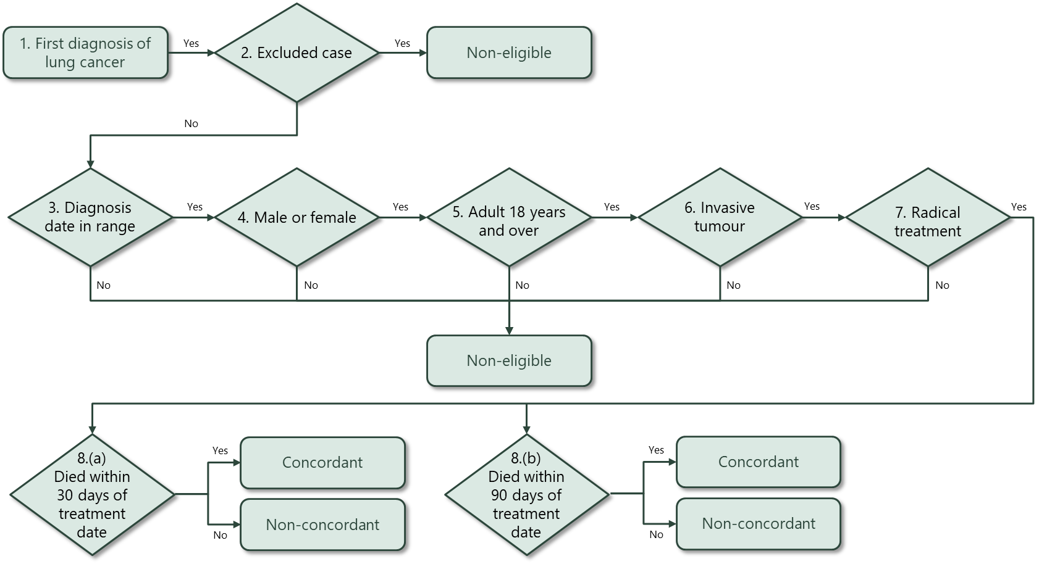

Hospital events in NMDS are coded using the International Statistical Classification of Diseases and Related Health Problems, Tenth Revision, Australian Modification (ICD-10-AM) for diagnoses and the Australian Classification of Health Interventions (ACHI) for procedures. Both ICD-10-AM and ACHI are from the Independent Hospital Pricing Authority, Australia.

