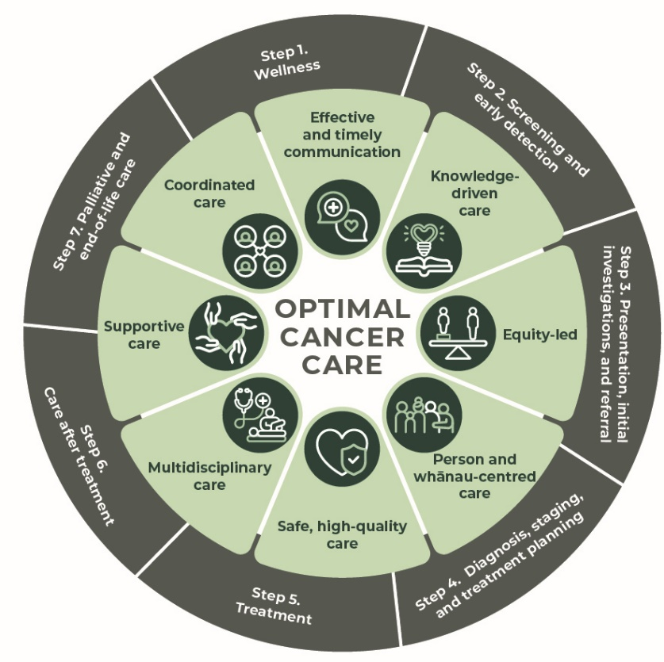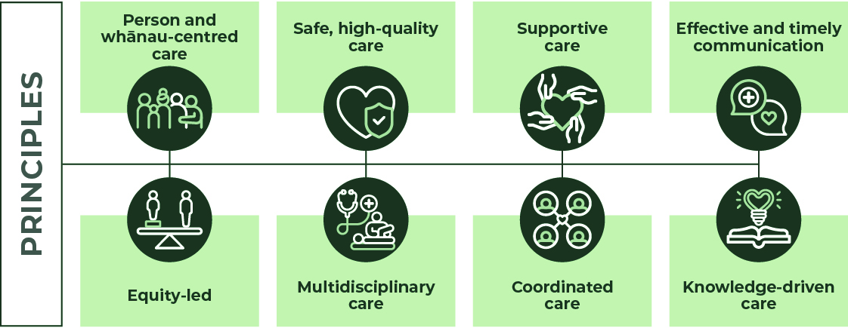
Optimal cancer care pathway for people with ovarian cancer February 2025 (updated 12/9/25)

Quick reference guide (Edition One, version 2). 

Step 1: Wellness – cancer prevention efforts should be part of all cancer control pathways. This step recommends actions the person/whānau can take to improve their wellbeing and reduce the overall risk of cancer.
The Optimal Cancer Care Pathways (OCCP) describe the standard of care that people and whānau across Aotearoa, New Zealand can expect from the public health system. They follow eight principles: person and whānau-centred care; equity-led; safe, high-quality care; multidisciplinary care; supportive care; coordinated care; effective and timely communication; and knowledge-driven care. The OCCP guides health providers in ensuring the person and their whānau receive optimal, supportive care at each stage of their cancer diagnosis and treatment.

Checklist:
- Carry out a health and wellbeing assessment including discussions around screening services and ways to reduce cancer risk.
- Assess the individual’s risk of developing cancer.
- Encourage eligible people to participate in national screening programmes.
- Discuss recent weight changes and monitor weight.
- Discuss and record alcohol intake. Offer support for reducing alcohol consumption if appropriate.
- Record person’s smoking status and offer stop smoking advice/support if appropriate.
- Record physical activity.
- Consider referral to a dietitian, physiotherapist, or exercise programme.
- Give the person education on being sun smart.
- Ask person if they have an existing advance care plan, advance directive, or enduring power of attorney, and discuss as required.
Evidence-based research shows that general cancer and wellbeing risks can be reduced by:
- eating a nutritious diet
- maintaining a healthy weight
- taking regular, moderate to vigorous-intensity activity
- avoiding or limiting alcohol intake
- being sun smart
- identifying pre-disposing infections such as, Hepatitis C
- keeping up to date with immunisations or vaccines such as, Human Papilloma Virus (HPV)
- avoiding smoking including marijuana and exposure to second-hand smoke)
- current smokers (or those who have recently quit) should be offered best practice tobacco dependence treatment and an opt-out referral to an intervention service such as Quitline
- avoiding vaping
- participating in screening services such as breast, cervical, bowel cancer screening
- preventing occupational exposure to asbestos, silica, radon heavy metal, diesel exhaust and polycyclic aromatic hydrocarbons.

Assess family history of cancer as part of a routine wellness check.
There is no national screening programme for ovarian cancer.
Refer to the ovarian cancer optimal cancer care pathway for more information about early detection.
Early detection
Health care providers/professionals support the person/whānau to identify and minimise personal ovarian​ cancer risks.
Some factors that may reduce the risk of developing ovarian cancer are:
- using an oral contraceptive pill
- giving birth and breastfeeding
- previous surgical procedures such as tubal ligation, salpingectomy, and risk-reducing salpingo-oophorectomy for women who have a known ovarian cancer predisposition gene.
Risk factors that may increase the risk of ovarian cancer include:
- having a genetic mutation such as BRCA or Lynch syndrome. For women at potentially high risk of ovarian cancer, GP referral to a familial cancer service is recommended for risk assessment, possible genetic testing and management planning (which may include risk-reducing surgery).
Refer to the optimal care pathway for women with ovarian cancer for other risk factors.
- endometriosis

Step 2: Prevention and early detection - recommends options for prevention and early diagnosis for the person/whānau with suspected ovarian cancer.

- Assess and discuss the individual’s risk of developing cancer.
- Support the person and their whānau to follow surveillance guidance if they’re at an increased risk of familial cancer.
- Refer to clinical genetic services where appropriate.
- Discuss recent weight changes and monitor weight.
- If signs and symptoms of cancer are present refer to ‘Step 3: Presentation, initial investigation and referral’ below.

Communication
Ensure the person and their whānau understands:
- when they should receive their results
- how to follow up if they don’t receive their results
- what’s involved if they need to be transferred to a specialist service.

Step 3: Presentation, initial investigations, and referral outlines how to initiate the appropriate investigations and referrals to specialist/s in a timely manner for the person with ovarian cancer.

The types of investigations undertaken will depend on many factors, including access to diagnostic tests, the availability of medical specialists and including preferences.
A person and their whānau may present via primary care, an emergency presentation or incidental finding with a high suspicion of ovarian cancer.
Signs and symptoms of ovarian cancer to investigate may include:
- persistent abdominal distension or bloating
- increased abdominal girth
- pressure in the abdomen.
- early satiety or loss of appetite
- feeling full after only a small amount of food
- pelvic or abdominal pain without a known cause
- indigestion
- increased urinary urgency or frequency
- change in bowel habits, irritable bowel symptoms, especially if new onset and aged older than 50 years
- unexplained weight loss or fatigue
- postmenopausal bleeding
Ovarian cancer assessment includes the relevant:
- medical history, including relevant medications and menopausal status
- physical examination findings (may include internal gynaecology examination)
- investigations including imaging and tumour markers
- Risk of Malignancy RMI score
- familial cancer history
- social history

Referral
A clinical suspicion or laboratory/ imaging findings suggestive of cancer require further investigation and a referral to hospital specialist services.
If the person presents with one of the following red flags, the referral should be triaged as a high suspicion of cancer:
- Biopsy-proven or cytology positive gynaecological malignant or premalignant disease, or gestational trophoblastic disease.
- Significant symptoms including abnormal vaginal bleeding, discharge, or pelvic pain, and abnormal clinical findings suspicious of gynaecological malignancy including lymphadenopathy, vaginal nodularity, or pelvic induration.
- Rapidly growing pelvic mass or genital lump.
- Patients with a palpable or incidentally found pelvic mass (including any large complex ovarian mass larger than 8 cm) unless investigations (ultrasound and tumour markers) suggest benign disease.
- Patients with a documented genetic risk who have a suspicious pelvic abnormality or symptoms.
Checklist:
- Inform the person and their whānau of preliminary results.
- Discuss referral options of cancer care are discussed with the person and their whānau, including cost implications if private provider requested.
- Complete and record supportive care needs assessment, refer to allied health services as required.
- Inform the person and their whānau of cultural services and relevant support groups available.
- Initiate referrals and arrange further investigation.

Timeframes
- Women with clinical suspicion of an ovarian cancer or any of the red flags from above are offered an appointment for a pelvic ultrasound that falls within two weeks of the date of receipt of that referral.
- If there is a high suspicion of ovarian cancer, submit referral immediately to hospital specialist services.
- High suspicion of cancer referral is triaged within 1-2 working days and referrer is notified.
- Confirm that the person referred urgently with a high suspicion of cancer will attend their first specialist assessment (FSA) clinic within two weeks.

Communication:
Explain to person and their whānau that they are being referred to a hospital specialist service and why, including:
- how long this may take
- who to contact if their symptoms change
- what to do if they do not receive their specialist appointment within the specified time.

Step 4: Diagnosis, staging, and treatment planning outlines the process for confirming the diagnosis and stage of cancer and the planning of subsequent treatment.

Diagnosis for ovarian cancer may include:
- Radiology: pelvic ultrasound, CT scan, or MRI abdomen/pelvis for younger persons
- Pathology: Biopsy, fluid aspiration for cytology
- Laboratory: routine blood tests, CA125, Ca19-9, CEA and in younger people, HCG, AFP LDH
- Risk of Malignancy RMI score
- any other investigation (e.g. an endoscopy might be indicated by symptoms or clinical findings suggestive of other primary cancer).
Staging for ovarian cancer is by:
- Pathological staging occurs after surgery
- Where surgical staging is not possible, staging can be based on clinical findings and investigations
Performance status
- ECOG, geriatric assessment for persons over age 70
Multidisciplinary meeting
- The person with ovarian cancer is discussed and/or registered at a gynaecology oncology MDM
Clinical genetics referral
Referral to clinical genetic services for ovarian cancer is considered if features of the cancer suggest a genetic predisposition, such as:
- histology and genetic testing
- early age at onset
- multiple primary cancers
- family history of similar or related cancers
Treatment planning
Optimal cancer care requires a multidisciplinary approach to ensure treatment plans are tailored to an individual’s needs in collaboration with the whānau and health care team.

Checklist:
- Confirm diagnosis.
- Referral to a cancer care coordinator.
- Record performance status and comorbidities.
- Discuss the person’s diagnosis at a multidisciplinary meeting (MDM) and inform the person and their whānau of the treatment decision.
- Consider enrolment in clinical trial.
- Assess supportive care needs and refer to allied health services as required.
- Ensure primary and secondary prehabilitation to optimize overall well-being is initiated.
- Begin Enhanced Recovery After surgery (ERAS) protocol if for surgery.
- Give the person and their whānau information on Cancer Society, cancer NGOs and/or relevant cultural services and support groups available.
Timeframe
- Diagnostic investigations should be completed within two weeks of the initial specialist assessment.
- Radiological investigations required for treatment planning should be completed within two weeks of the date of receipt of that referral.
- The MDM discussion takes place within 14 days of referral (provided referral criteria are met).

Communication:
The lead clinician and team are responsible for:
- discussing a timeframe for diagnosis and treatment options with person and their whānau
- explaining the role of the role of the MDM team in treatment planning and ongoing care
- encouraging discussion about the diagnosis, prognosis, advance care planning and palliative care while clarifying wishes, needs, beliefs, and expectations of the person and their whānau and their ability to comprehend the communication
- communication with the GP of the person and their whānau about the diagnosis, treatment plan and recommendations from the MDM.

Step 5: Treatment describes publicly funded optimal treatment for ovarian cancer by trained and experienced clinicians and team members, in an appropriate environment.

Establish the intent of treatment:
- curative
- non-curative
- symptom palliation
- palliative care.
Treatment options
Surgery – may be used to stage the cancer and as a form of therapy. The type of surgery offered will depend on several factors such as the type, grade and stage of the disease, the person’s age, performance status and desire or not to retain fertility.
Systemic chemotherapy – Chemotherapy may be required before or after surgery. The appropriateness and type of chemotherapy or drug therapy will be determined by the multidisciplinary team.
Radiation therapy –
Some women with ovarian cancer may benefit from radiation therapy for symptomatic relief and palliation of metastatic or recurrent disease.
Targeted therapies
Some women may instead be offered hormone therapy or targeted therapy or given this treatment after chemotherapy as a ‘maintenance’ treatment.
Palliative care – Early referral to palliative care can improve quality of life and in some cases survival. Referral is based on need, not prognosis.
Checklist:
- Health providers/professional, treating specialist has relevant qualifications, experience, and expertise.
- Discuss the intent of treatment and the risks and benefits discussed with the person and their whānau.
- Discuss and provide the agreed treatment plan with the person, their whānau and GP.
- Assess supportive care needs and refer to allied health services as required.
- Give the person and their whānau information on cancer non-governmental organisations (NGOs,) cultural services and support groups available.
- Consider early referral to palliative care if appropriate.
- Discuss advanced care planning with the person and their whānau.

Timeframes
- The person with a confirmed diagnosis of ovarian cancer receives their first treatment within 31 days of the decision to treat.
- The person referred urgently with a high suspicion of ovarian cancer receives their first cancer treatment within 62 days.
- Time to surgery, if required after neoadjuvant radiation therapy, depends on regime.
- The person with non-metastatic ovarian cancer is presented in the gynaecology MDM within 3 weeks of surgery for consideration of adjuvant therapy.
- Adjuvant radiation therapy or systemic therapy should start within 4 weeks of the decision to treat.

Communication:
The lead clinician and team are responsible for discussing these areas with the person and their whānau:
- treatment options including the intent of treatment, risks, and benefits
- advance care planning
- options for healthy lifestyle support to improve treatment outcomes such as exercise and nutrition.

Step 6: Care after treatment - the person and their whānau access appropriate follow up and surveillance and are supported to achieve their optimal health after cancer treatment.

Checklist:
- Provide a survivorship plan that includes a summary of the treatment and follow-up care plan to the person, whānau and their GP.
- Consider early referral to palliative care, especially for symptomatic persons
- Assess supportive care needs and refer to allied health services as required.
- For people with ovarian cancer, assessment for referral to the following rehabilitation or recovery services should be undertaken such as:
  - a nurse specialist, physiotherapist, or urologist for incontinence/stoma issues
  - a counsellor ideally specializing in cancer matters and/or psychosexual function
  - a lymphoedema physiotherapy assessment for lymphoedema
- Give the person and their whānau information on Cancer Society and/or relevant cultural services and support groups available.
Provide a summary of the treatment and follow-up care plan to the person, their whānau and their GP outlining:
- diagnosis, including tests performed and results
- current toxicities (severity, management and expected outcomes)
- interventions and treatment plans from other health providers/professionals
- potential long-term and latent effects of treatment and care of these
- supportive care services provided
- a follow-up schedule, including tests required and timing
- contact information for key health care providers/ professionals who can offer support for lifestyle modification
- a process for rapid re-entry to medical services for suspected recurrence
- ongoing assessments of the effects of treatment such as:
  - fatigue
  - nutrition
  - sexual function
  - bladder function
  - lymphodema
  - peripheral neuropathy.

Step 7: Palliative and end-of-life care provides the person facing life-limiting conditions and their whānau with holistic support and coordinated services based on their specific needs.

Communication
The lead clinician (or delegated representative) is responsible for:
- explaining the treatment summary and follow up care plan to the person and their whānau
- informing the person and their whānau about secondary prevention and healthy living
- discussing the follow-up care plan with the person and their whānau
- communicating the follow-up care plan with the GP
- providing guidance for rapid re-entry to specialist services.

Communication
A key way to support the person and their whānau is by coordinating ongoing, clear communications between all health providers/professionals involved in their providing their cancer care.
Checklist:
- Refer to specialist palliative care services as required.
- Refer to supportive care services as required.
- Make sure the person and their whānau are aware of the prognosis and what to expect when someone has a life limiting disease and/or is dying.
- Activation of advance care plan, directive, or enduring power of attorney.
Palliative and end-of-life care may be provided through:
- hospital palliative care
- home and community-based care
- community nursing, including access to appropriate equipment.
Early identification, correct assessment and treatment of pain and other symptoms prevent and relieves suffering.

Communication
A key way to support the person and their whānau is by coordinating ongoing, clear communications between all health providers/professionals involved in their providing their cancer care.
Palliative and end-of-life care may be provided through:
- hospital palliative care
- home and community-based care
- community nursing, including access to appropriate equipment.
Early identification, correct assessment and treatment of pain and other symptoms prevent and relieves suffering.

Step 7: Palliative and end-of-life care provides the person facing life-limiting conditions and their whānau with holistic support and coordinated services based on their specific needs.

Checklist:
- Refer to specialist palliative care services as required.
- Refer to supportive care services as required.
- Make sure the person and their whānau are aware of the prognosis and what to expect when someone has a life limiting disease and/or is dying.
- Activation of advance care plan, directive, or enduring power of attorney.

