Annual Report
for the year ended 30 June 2024
Presented to the House of Representatives pursuant to section 44 of the Public Finance Act 1989
Citation: Ministry of Health. 2024. Annual Report for the Year Ended 30 June 2024. Wellington: Ministry of Health.
Published in October 2024 by the Ministry of Health
PO Box 5013, Wellington 6140, New Zealand
ISBN 978-1-991075-97-0 (print)
ISBN 978-1-991075-98-7 (online)
HP 8878
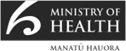
This document is available at health.govt.nz
 | This work is licensed under the Creative Commons Attribution 4.0 International licence. In essence, you are free to: share ie, copy and redistribute the material in any medium or format; adapt ie, remix, transform and build upon the material. You must give appropriate credit, provide a link to the licence and indicate if changes were made.

Te Aho o Te Kahu – Cancer Control Agency Annual Report 2023/24

Chief Executive foreword
Tēnā koe

Reflecting on my first year as Tumu Whakarae (Chief Executive) for Te Aho o Te Kahu, I am proud of the collective efforts of our kaimahi (staff), and the many people working tirelessly across the cancer system – and of the positive impact of those efforts. At the same time, I acknowledge there is more work ahead to achieve our vision of fewer cancers, better survival, and equity for all.

Actions to improve the experience and outcomes for people and whānau living with cancer are being developed and put into place, in the face of growing demand and rapidly evolving treatment options.

We have a growing population who are living longer, often with multiple conditions. With more people surviving their first diagnosis of cancer, this requires the health system to provide them with more complex or long-term support and monitoring.

Cancer treatment options are evolving rapidly, including new medicines to precision medicines and artificial intelligence. The costs for treatments are also often increasingly expensive.

These factors, combined with global shortages of cancer and healthcare workers, and fiscal constraints, means we are focusing on helping the sector prepare for new treatments, balanced with continuing to deliver quality cancer care services in ways we FCTknow will deliver the most effective outcomes for people, while increasing prevention and early detection efforts.

Over the past year, Te Aho o Te Kahu continued to lead and/or support key work to enable the system to respond to these challenges. This was in close collaboration with our Advisory Groups (clinicians, consumers, and system leaders), Health New Zealand – Te Whatu Ora, the Ministry of Health – Manatū Hauora, Hei Āhuru Mōwai, health system stakeholders, and whānau. These are some highlights from that mahi:
- Updated the National PET-CT indication list and criteria, which received approximately $3M of government funding to provide equitable access to these scans across the motu (country).
- Expansion of radiation treatment capacity informed by our modelling and resource forecasting work – including progress on new treatment facilities in Whangārei, Taranaki, and Hawke’s Bay.
- Advised government on the $604 million cancer medicines funding policy announcement and finalising a blood cancer medicines gaps analysis report.
- Developed a cancer workforce implementation plan to attract and retain the current workforce; support international recruitment for specialists; and develop training and career pathways for Māori and Pacific peoples in health.
- Designed four Optimal Cancer Care Pathways that will guide the planning, coordination, and delivery of best practice cancer prevention and care services across New Zealand for different types of cancer.
- Finalise a comprehensive Stem Cell Transplant Model of Care to guide future work to deliver optional transplant and cellular therapy.

At the heart of our efforts are the thousands of people and whānau living with, or who have lost loved ones to cancer. These lived experiences continue to drive our work to continually improve access to cancer services and put people at the heart of how they are delivered.

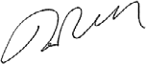
Ngā manaakitanga,
Rami Rahal
Tumu Whakarae, Chief Executive
Te Aho o Te Kahu, Cancer Control Agency

He mihi nā te Tumu Whakarae
Tēnā koe

I a au e tiro whakamuri ana ki taku tau tuatahi hei Tumu Whakarae o Te Aho o Te Kahu, e tū whakahīhī ana au i ngā mahi a ō mātou kaimahi katoa rātou ko te kāhui nui tonu huri noa i te pūnaha mate pukupuku i ā rātou whakapaunga kaha – waihoki ko ngā hua o aua mahi. Heoi, e mōhio ana au arā atu anō ngā mahi e tutuki ai tō mātou wawata kia iti ake ngā momo mate pukupuku, kia nui ake te whakarauoratanga mai i tēnei māuiui me te whakaūnga o te mana taurite mā te katoa.

Kei te whakawhanakehia, kei te whakatinanahia hoki ngā tūmahi hei whakapai ake i ngā wheako me ngā hua ki ngā tāngata me ngā whānau e pāngia ana e te mate pukupuku, ahakoa e piki haere tonu ana ngā hiahia me ngā ara rongoā hei whai mā te tūroro.

Kei te piki ake te nui o te taupori me te roa o te oranga, he tini hoki ngā mate o te nuinga. Nō te pikinga ake o ngā tāngata e whakarauorahia ana i te kitenga tuatahi o te mate pukupuku, me kaha hoki te pūnaha hauora ki te tautoko i ō rātou hiahia matatini, me ū hoki rānei ngā mahi tautoko, me aroturuki hoki.

Kei te tere whanake mai ngā momo rongoā mō te mate pukupuku, pērā i ngā rongoā o ngā pae hauora hou me te hangarau atamai. Kei te piki ake hoki te utu o ngā rongoā.

I runga i ēnei āhuatanga, waihoki te iti o te puna kaimahi me ngā here ki te taha pūtea, ko te aronga matua, he āwhina i te rāngai hauora ki te takatū mō ngā rongoā hou i a mātou e whakarato tonu ana i ngā mahi atawhai ki te hunga e pāngia ana e te mate pukupuku, e tino whaihua ai te tangata, e piki ake ai hoki ngā mahi kaupare mate pukupuku me te kitenga tōmua o tēnei mate.

I te roanga o tērā tau, kei te kōkiri/kei te tautoko tonu a Te Aho o Te Kahu i ngā mahi mātāmua kia āhei te pūnaha ki te whakaea i ērā take. He mahinga ngātahi hoki tēnei ki te taha o ā mātou Rōpū Whāiti (ko ngā kaimahi haumanu, ko ngā kiritaki, ko ngā kaiārahi hauora) rātou ko Te Whatu Ora, ko Te Manatū Hauora, ko Hei Āhuru Mōwai, ko ngā kaihāpai o te pūnaha hauora, ko ngā whānau. Anei ētahi o ngā mahi whakahirahira mai i aua mahi:
- UKua whakahoungia te rārangi tūtohu me ngā paearu a te National PET-CT. I whakawhiwhia tērā kaupapa ki te $3m i te kāwanatanga kia taurite te whakawhiwhinga ki ēnei momo karapa huri noa i te motu.
- Ko te whakawhānuitanga o te haumanu iraruke i runga anō i ā mātou tauira me ngā matapae e pā ana ki ngā rauemi – pērā i te ahunga whakamua o ngā whare rongoā hou ki Whangārei, ki Taranaki me Te Matau-a-Māui.
- Kua tāpae kōrero ki te kāwanatanga mō te whakapuakitanga o te kaupapa here e pā ana ki te pūtea mō ngā rongoā mate pukupuku, e $600M te nui.
- Kua whakawhanakehia mai tētahi mahere mō te whakatinanatanga o te kāhui kaimahi mō te mate pukupuku, hei whakapoapoa, hei whakaū hoki i ngā kaimahi o nāianei; hei tautoko i te mahi rapu mātanga ki rāwāhi, hei whakawhanake hoki i ngā mahi whakangungu me ngā ara mahi i te ao hauora mā te Māori me ngā iwi o Te Moananui-a-Kiwa.
- Kua whakahoahoatia kia whā ngā Optimal Cancer Care Pathways, hei ārahi i te whakamaheretanga, i ngā whakaritenga me te whakaratonga o ngā mahi e āta kaupare atu ana i te mate pukupuku, e atawhai tika ana i te tangata e pāngia ana e ngā momo mate pukupuku rerekē, huri noa i te motu. Kua whakaoti tētahi kaupapa nui e pā ana ki te Stem Cell Transplant Model hei ārahi i ngā mahi e haere mai ana, hei whakapuare mai i te kūwaha ki te huaranga me te whakatō pūtautau, hei kōwhiringa anō mā te tūroro.

Kei te pūtake o ā mātou mahi, ko te takitini rātou ko ō rātou whānau e pāngia ana, e tangi ana hoki rānei i te iwi nui kua riro i te mate pukupuku. Kei te āia ā mātou mahi e ēnei wheako tūturu, kia pai ake ngā toronga atu ki ngā ratonga o te mate pukupuku, ā, kia noho te tangata ki te pūtake o te whakaratonga o aua mahi.

Ngā manaakitanga,
Rami Rahal
Tumu Whakarae, Chief Executive
Te Aho o Te Kahu, Cancer Control Agency

Tā mātou aronga – An agency focused on cancer
Te Aho o Te Kahu Cancer Control Agency’s vision for Aotearoa New Zealand is that all people will experience fewer cancers, better survival rates, and equitable cancer outcomes. Our strategic direction and work are guided by our values. We are equity-led, knowledge-driven, outcomes-focused and person and whānau-centred.

We are a departmental agency that reports directly to the Minister of Health and is hosted by Ministry of Health - Manatū Hauora. We were set up in 2020 to:
- unite work across cancer control to deliver better health outcomes for all people across New Zealand
- report on the health sectors’ progress towards the goals and outcomes in the New Zealand Cancer Action Plan 2019–2029 – Te Mahere mō te Mate Pukupuku o Aotearoa 2019–2029 (the Cancer Action Plan).

The Cancer Action Plan outlines a range of actions the health sector will deliver to achieve the following four outcomes:
- New Zealanders have a system that delivers consistent and modern cancer care.
Lifting our country’s performance in cancer care requires coordinated national leadership, a skilled and sustainable workforce and the information at the right time to inform decisions.
- New Zealanders experience equitable cancer outcomes.
Everyone diagnosed with cancer will receive the best treatment and care, regardless of who they are or where they live.
- New Zealanders have fewer cancers.
Investing in policies and programmes to help prevent cancer will have the most significant impact on reducing cancer in New Zealand and will ensure the delivery of equitable health outcomes for all people.
- New Zealanders have better cancer survival, supportive care, and end-of-life care.
People and whānau receive quality cancer care at the right times in ways that suit them. This care includes early detection, diagnosis, and treatment, as well as living well with cancer or end-of-life care.

Cancer continues to be the leading cause of death across the country.
Each year, 9,000 people in New Zealand die of cancer, and another 27,000 are diagnosed with some form of this disease. We predict the number of people diagnosed with cancer in our country will double by 2050.

Many people or communities continue to experience inequities in cancer outcomes.
- Māori people are 20% more likely to be diagnosed with cancer and twice as likely to die from it compared with the rest of our population.
- Pacific peoples experience worse cancer survival rates and treatment outcomes than other people in New Zealand.
- Thyroid cancer rates are higher for Asian people than other ethnicities.
- Disabled people often experience increased health risks and face a range of barriers to health care, including transport, communication issues, and access to appropriate services.
- People living in poorer areas are more likely to be diagnosed with cancer.

Our cancer survival rates are not keeping up with survival rates in similar countries. This can, in part, be attributed to the following factors:
- An aging and growing population. (We are treating more people who are often living with multiple health conditions, or have advanced cancer, both require more complex, coordinated care and support.)
- More support and monitoring (People who survive cancer often need more complex/long-term support and monitoring.)
- Stretched cancer and clinical workforces.
- Increasing costs to provide current and new medicines/treatments.
- Rapidly changing technologies, treatments, and medicines, which may require additional qualified staff and spaces to deliver.
- Inequitable access to cancer services and screening, as well as socio-economic inequities.
- Changes across the key health organisations following the health reforms.

We support and unite the wider health system by:
- providing and coordinating advice to the government on the design and function of cancer services and addressing service issues or opportunities
- maintaining strong partnerships with key health organisations that work across cancer prevention, care, and treatment
- bringing together sector stakeholders to progress and achieve shared objectives
- leading or coordinating national initiatives to improve cancer outcomes
- collating and sharing cancer data to inform decisions and improve service delivery
- supporting cancer services when a service is, or is likely to be, disrupted or is not meeting demand or expectations.

Key partner agencies consult us on activities they lead within the cancer system and we often work together to produce joint advice. For more information, see Ngā hoamahi – Our partners.

In the year from 1 July 2023 to 30 June 2024 we reset our agency’s structure and how we work to lead and unite the cancer control work within the reformed health system. The cancer sector is making steady progress towards achieving the goals of the Cancer Action Plan. Having an agency that is solely focused on cancer within the health sector remains critical to reduce cancer incidence, improve survival rates and provide equitable, quality cancer care to those who need it. International studies confirm that countries with a dedicated cancer control agency deliver better cancer outcomes, compared with those where cancer control is one function of a wider health organisation.

Ngā hoamahi – Our partners
We partner with a range of government and non-governmental organisations and advisory groups on improving cancer outcomes for all people. Our partners provide invaluable advice, insights and connections that inform our work, advice and understanding of the wider health and disability system.

Figure 1 shows the work we are involved in and where we collaborate with key stakeholders across all aspects across the cancer continuum.

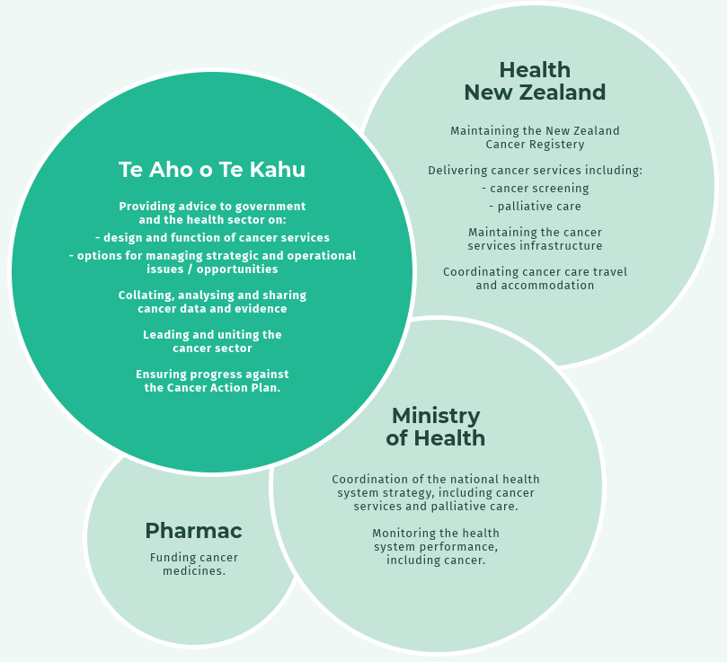
Figure 1: The relationship of agencies involved in specific areas of cancer control

We also work closely with Te Tāhū Hauora Health Quality & Safety Commission New Zealand on the quality improvement and safety of cancer services.

We collaborate with Hei Āhuru Mōwai Cancer Leadership Aotearoa (Hei Āhuru Mōwai) on agreed strategic work and projects focused on improving Māori cancer outcomes. We also support their leadership and rangatiratanga through operational and project funding.

Hei Āhuru Mōwai members sit on other key advisory and working groups, providing strategic input to our work programme direction, targeted advice towards achieving equitable cancer outcomes for Māori, access to Māori cancer expertise and support for developing Māori capability across our organisation.

We are indebted to Hei Āhuru Mōwai for gifting our agency a precious taonga - our te reo Māori name. Te Aho o Te Kahu means ‘the central thread of the cloak’. The aho or thread binds the many whenu (strands) into one kahu (cloak) to protect people and whānau affected by cancer. This name reflects our role in the cancer system rather than being a translation of ‘cancer control agency’, which is why we use both terms in our branding.

We thank outgoing Tumuaki Chief Executive of Hei Āhuru Mōwai Cindy Dargaville
(Ngāti Maniapoto, Waikato, Te Rarawa) for the strong relationship we had developed over the past year.

He Ara Tangata our Consumer Reference Group provides advice and solutions from a lived- experience perspective. Members are embedded in projects across our work programme to ensure consumers’ voices are reflected in our mahi. To support our commitment to Te Tiriti of Waitangi (Te Tiriti), He Ara Tangata is led by Māori chair with 50% Māori membership.

The National Clinical Assembly provides clinical advice to support our long-term strategic direction for reducing cancer incidence and improving the cancer care system. Clinicians representing a broad range of cancer-related medical, nursing, and allied health specialities are members of the assembly.

The National Child Cancer Network New Zealand and Adolescent and Young Adult Cancer Network Aotearoa are contracted organisations who care for children and young people with cancer. We collaborate on their work programmes, discuss progress and issues, and provide support on delivery.

Working and other advisory groups. We engage regularly with three primary clinical working groups - Medical Oncology, Radiation Oncology and Haematology. Their expertise informs our agency’s work and maintains our connections with regions and districts. We also meet with more than 200 health professionals via a range of time-limited advisory groups, on specific subjects as needed.

We also engage with a wide array of other government entities, sector groups, programmes, and projects as part of being ‘Te Aho’ across the cancer system, including:
- whānau with lived experience of cancer
- iwi and Māori organisations and service providers
- Pacific organisations and service providers
- government organisations including: Whaikaha – Ministry of Disabled People; Ministry for Ethnic Communities – Te Tari Mātāwaka; Health and Disability Commissioner – Te Toihau Hauora, Hauātanga; and Health Research Council
- clinicians (in the Clinical Assembly and specialised clinical working groups)
- research/academic institutions: University of Otago (including the Surgical Cancer Research Group), University of Auckland (Waipapa Taumata Rau) and The University of Queensland, Australia
- international organisations including Cancer Australia, CPAC (Canadian Partnership Against Cancer) and we have and will continue to participate in the International Cancer Benchmarking Partnership, spearheaded by Cancer Research UK
- Cancer Non-Governmental Organisations (CANGO)
- peak and professional bodies, including Royal Australasian College of Surgeons and Cancer Nurses College

Anei mātou – Who we are
In July 2023, we welcomed our new Tumuaki (Chief Executive) Rami Rahal to the agency. Rami moved from Canada bringing with him over 30 years of health system leadership experience and dedication to improving outcomes for people affected by cancer, particularly indigenous communities.

In his first few months Rami focused on meeting our kaimahi, key partners, advisory groups and the regional cancer services and people they care for, to understand the broader cancer system, and the challenges and opportunities ahead.

In October 2023 the Executive Leadership embarked on a process with kaimahi and key stakeholders to develop a new ‘knowledge to action’ approach to our work, supported by revisions to the organisational structure, and revised work programme. This was an opportune time to clarify and confirm our role and activities, within the newly reformed health system, and as we near the midpoint in delivering the National Cancer Action Plan 2019-2029.

Our aims for the new strategy and structure and ways of working, alongside our advisory groups) were to set us up to:
- deliver on our strategic priorities
- maintain a strong focus on equity and person/whānau centred care
- use a whole-of-organisation approach to convert data and insights into actions that can improve/innovate the cancer system (Knowledge to Action strategy)
- better support strategic system leadership and engagement with partners
- create more opportunities for career progression
- enhance corporate governance and organisational effectiveness, and workplace culture.

The three strands of the knowledge to action approach are:
- Data and analytics — collaborating on data collections, standards and tools needed to deliver up-to-date, shareable knowledge to inform system and patient decisions.
- System Performance and Innovation — knowledge ‘snapshots’, reports and research that highlight best practice, risks, or opportunities across the cancer system.
- Knowledge Translation and Implementation — collaborating with health sector and consumers on guidance, tools, and initiatives to improve the cancer system and outcomes for all people.

To support the knowledge to action approach we refined our structure and operating model. This involved:
- Setting up an Executive, Strategic, and Operational governance model to streamline decision making and planning
- Creating a team of three Chief Advisor roles to provide stakeholder management and policy advice on surgical, clinical and Māori health. We retitled two existing roles and established one new position which is yet to filled.
- Established a Director, Equity and Whānau Centred-care position on the Executive Leadership Team, by merging the vacant Manager, People-centred-care role with Manager Equity role.
- Established a Group Manager Programmes role and realigned the three administrator roles to focus on programme delivery.
- Reprioritised the agency’s work programme using a matrix model, with regional and national kaimahi leading and collaborating on work to use capabilities more effectively.

We have four regional teams who work across Northern, Te Manawa Taki, Central, and Te Wai Pounamu. They collaborate with clinical and operational cancer teams across the motu. Our national team is based in the Ministry of Health’s office in Wellington.
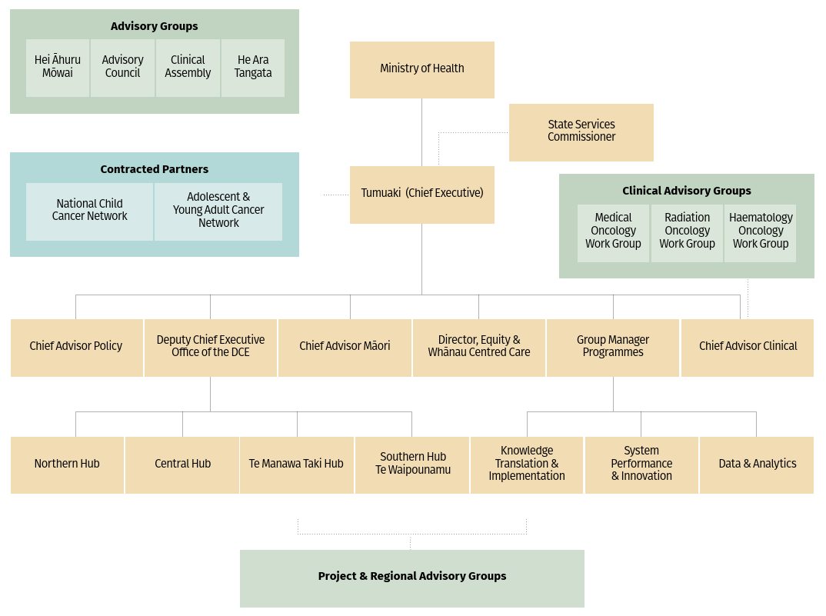

Pūmau ki Te Tiriti – Our commitment to Te Tiriti o Waitangi
Like the Ministry of Health, we uphold and contribute to the Crown’s obligations under
Te Tiriti o Waitangi (Te Tiriti) as a departmental agency of the public service (as provided by section 14 of the Public Service Act 2020).

We are also guided by the health sector principles as outlined in the Pae Ora (Healthy Futures) Act 2022 which recognise the Crown’s intention to give effect to the principles of Te Tiriti, and improving the health sector for Māori and hauora Māori outcomes.

Te kanorautanga me te whaiwāhitanga – Diversity and inclusion
We actively work to create diverse and inclusive workspaces for kaimahi and guests. This contributes to overall staff retention and engagement, and better supports our role to lead or support the design and delivery of equitable cancer services.

As part of Te Kawa Mataaho - the Public Service Commission’s Diversity and Inclusion Executive Champions Network, we are working towards five priorities under their Papa Pounamu diversity programme. These are: cultural competence, addressing bias, inclusive leadership, building relationships and employee-led networks.

Our Whāinga Amorangi cultural plan and E Tipu E Tipu Māori Language Plan (see Ngā whakatutukinga – What we have achieved and Tō mātou whakahaere – Our performance sections) outlines a range of learning actions and goals that support these public sector goals.

Our kaimahi work with the Ministry of Health to create, deliver, and take part in awareness, learning, and celebration events under the Ministry’s culture and inclusion strategy, Whiria te Tangata. We also promote resources and events that kaimahi can use/attend that celebrate different cultures, languages, and aspects of diversity in New Zealand’s communities. Some examples include Pink Shirt Day, Diwali, Sign Language Week, and Mental Health Awareness Week.

Kaimahi are also encouraged to join employee-led networks (available via the Ministry and the wider public service) to build connections and share knowledge.

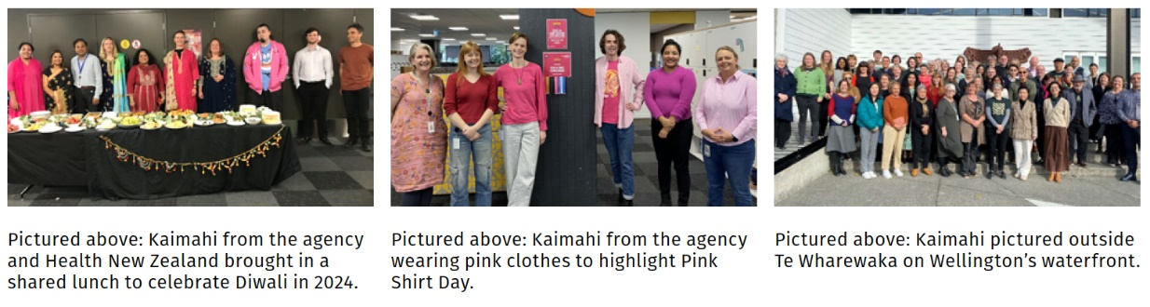

Ō mātou kaimahi – Our people
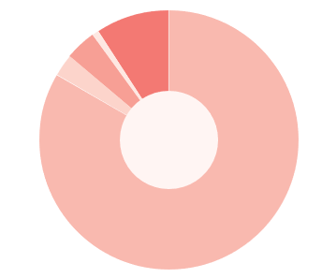
As at 30 June 2024, our agency employed 61 people (57.8%) as full-time equivalents (FTEs). This included two people on parental leave. In addition, there were a total of 2.5 FTE contract roles.

We employed 55.8 of the 57.8 FTEs on permanent contracts, with two FTE on fixed term and a 0.60 FTE on secondment.

At this time, we were recruiting six FTE roles.
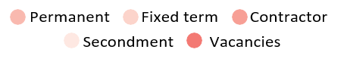
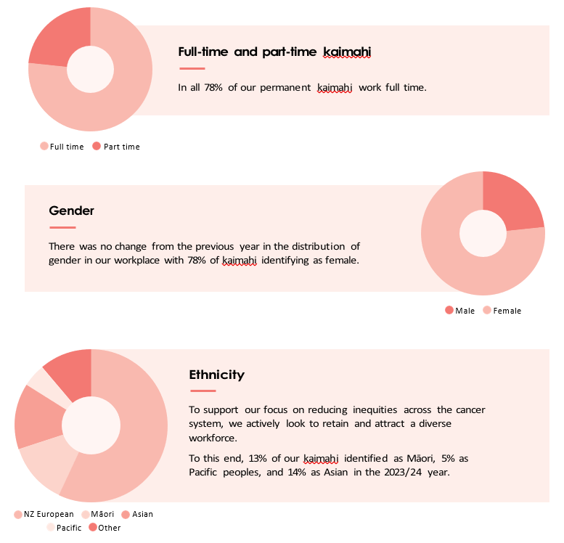

Ō mātou takune – Our intentions for 2023/24
Our strategic direction and work programme aligns with, or contributes to, the goals and outcomes described in the following health and public sector strategies and strategic documents:
- The New Zealand Cancer Control Strategy 2023
- New Zealand Cancer Action Plan 2019–2029.
- The six Pae Ora Strategies:
- New Zealand Health Strategy
- Pae Tū: Hauora Māori Strategy
- Te Mana Ola: The Pacific Health Strategy
- Health of Disabled People Strategy
- Rural Health Strategy.
- Women’s Health Strategy
- Government Policy Statement on Health 2024–2027.
- 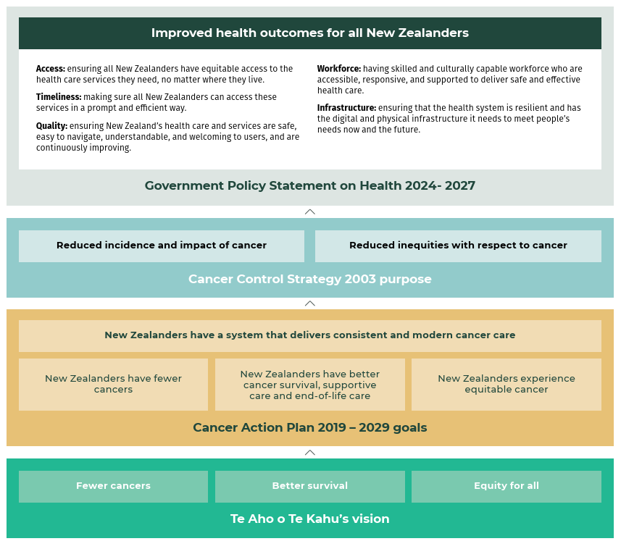

Our work programme

Outcome 1:
New Zealanders have a system that delivers consistent and modern cancer care
Our priorities | Our work
Supporting a system that delivers consistent and modern care | - Building a high-performing agency  - Committing to capability building  - Providing good systems and processes  - Actively supporting the health sector  - Developing and updating cancer service quality performance indicators
Transforming the future of cancer service delivery | Building on the Cancer Services Planning Programme including:  - Optimal Cancer Care Pathways  - Models of Care for Systemic, Cellular and Radiation therapies  - Multidisciplinary meetings guidelines  - CAR-T Cell Therapy Model of Care  - Delivering the first monitoring report  For more information, see Ngā whakatutukinga – What we have achieved.
Providing better quality, more connected data | Developing CanShare system including:  - Anti-Cancer Therapies — Nationally Organised Workstreams (ACT-NOW) Programme  - Structured Pathology Reporting of Cancer Data Standards Project  - National Radiation Oncology Collection (ROC)  - Collaboration across data and digital health

Outcome 2:
New Zealanders have fewer cancers
Our priorities | Our work
Achieving fewer cancers through a focus on prevention | - Cancer research  - Primary health care project  - Advice for primary care

Outcome 3:
New Zealanders have better cancer survival
Our priorities | Our work
Improving cancer survival | - Quality performance indicator programme (QPI)  - Released a QPI monitoring report: Route to Cancer Diagnosis Report: People diagnosed with cancer within 30 days of an emergency or unplanned hospital admission  - Analysis and report on blood cancer medicines availability  - Supporting cancer medicines implementation  - Supporting clinical trials

Outcome 4:
New Zealanders experience equitable cancer outcomes
Our priorities | Our work
Improving equity of cancer outcomes | - Feeding back through Māori community hui (meetings)  - Embedding equity-led thinking  - Finalising the Pacific peoples’ cancer research project  - Disability and cancer project completed  - Supporting cancer care navigation services  - Supporting equity-led work across the health sector including the National Travel Assistance scheme  - Ensuring the cancer service quality performance indicators report from an equity perspective.

Ngā whakatutukinga – What we have achieved

He pūnaha manaaki – Supporting a system that delivers consistent and modern care
Over the 2023/24 year, we supported the outgoing and incoming Ministers and Associate Ministers of Health by providing responsive, high-quality, timely advice across a range of cancer topics through regular meetings, briefing papers, and weekly updates. We maintain strong relationships with the Ministers’ offices to continue our role as the trusted cancer advisor to government.

We have continued to strengthen our regional and national relationships with Health
New Zealand over the past year to provide cancer advice and support in resolving challenges and taking opportunities to improve cancer care for all New Zealanders. Some highlights include progressing key deliverables in the Cancer Services Planning Programme, and providing advice and support to implement the new medicines (including cancer) that are being made available through the Government’s $604 million budget boost to Pharmac’s Combined Pharmaceutical Budget (CPB).

We have continued to engage He Ara Tangata Consumer Advisory Group on our and the wider health sectors’ activities so the voices of people and whānau are strengthened throughout the design and delivery cancer care across the motu (country).

We also focused on the relationships with many service providers nationwide who play a key role in supporting people and whānau to ensure that our approaches are relevant, meet each region’s needs and implementable.

National Clinical Network Cancer
We worked with Health New Zealand to start to establish a joint National Clinical Network Cancer. The joint Network Cancer is one of several that Health New Zealand has been working to set up set up since October 2023 to help drive unified healthcare standards, reduce variations, and enhance equitable access to health services nationwide.

In June 2024 we signed the agreed Terms of Reference and shared governance for the Network. We supported Health New Zealand with an Expression of Interest (EOI) process to appoint the Network’s Co-leads. They will work with the Network’s oversight group (senior leaders from both organisations) to lead the network, including the delivery of the Health New Zealand cancer work programme and the EOI process to appoint the members.

Through the EOI process it is expected that there will be approximately 20 members appointed. They will include Māori and Pacific peoples, interprofessional and primary care leadership and membership to ensure the networks take a system-wide view. Each region will also be represented.

We expect to confirm the Co-leads and open the EOI for members in October 2024, and hold the network’s inaugural meeting by early 2025.

We are also engaged with other clinical networks managed by Health NZ that are cancer related, such as radiology, to support improvements across the health system.

Transforming the future of cancer service delivery
We have made strong progress in delivering the Cancer Services Planning Programme. This involves several workstreams that will change the way cancer treatment is delivered. We will support Health New Zealand to deliver equitable access to high-quality care by producing evidence-based guidance to commissioning entities on how treatment and support services should be organised to achieve optimal, equitable cancer outcomes.

This programme started by working with clinical and cancer specialists and consumers to identify the current issues in adult cancer treatment services in Aotearoa New Zealand.

We are continuing to work with these groups on the design and implementation of the recommendations.

Between July 2023 and June 2024 we achieved a number of key deliverables that will support the system to provide more equitable, person and whānau centred centre consistently across the motu, which you can read in more detail in the next section.

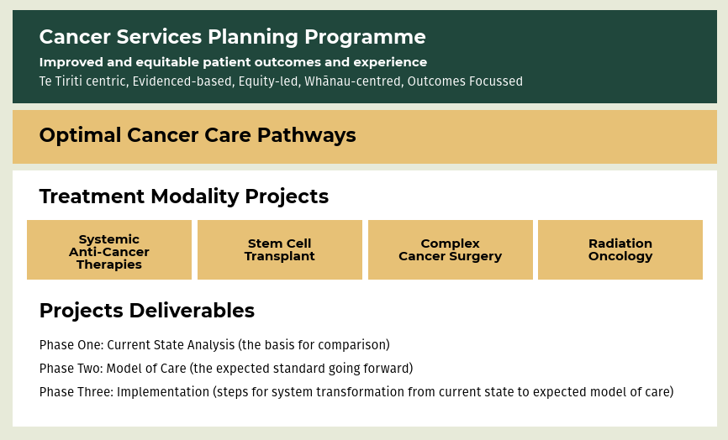

Cancer Services Planning programme involves the following areas:

1. Transplant and Cellular Therapy
Cellular therapies play a growing role in treating cancer.

Each year in Aotearoa New Zealand, around 370 people receive a stem cell transplant. These therapies can provide people with improved health outcomes, and
for a significant number, a long-term cure. The Stem Cell Transplant Project was set up to develop a model of care for this complex critical treatment pathway.

Creating the comprehensive end-to-end pathway for providing optimal transplant and cellular therapy involved 18 months of extensive clinical engagement across the motu, and the agency’s advisory groups.

Edition One of the Model of Care for Transplant and Cellular Therapy Services in Aotearoa, New Zealand was released on 1 December 2023. Feedback from the sector is showing the pathway is informing both large planning decisions, and how to improve these services day-to-day. It was used to inform the development of a significant national business case to expand these services.

We are supporting Health New Zealand on work to identify variations between current practices and the Model of Care and develop an action plan to respond to any gaps, which they are leading. They have also recently commissioned a Clinical Service Plan to implement the identified priorities for improvement.

2. Stem cell transplant
Stem cell transplant services are fragmented, inequitable, and do not meet the growing needs across the motu. In June 2023 we finalised a sustainable future service model for stem cell transplant. We are continuing to use the model to inform planning with clinical trials and Health New Zealand and to help resolve capacity issues.

3. Surgical services
Over 2023 and 2024 the agency developed three capability frameworks for three types of complex cancer surgery in Aotearoa New Zealand. They were Hepato-Pancreatico-Biliary (HBP) surgery, Oesophagogastric (throat) surgery and Head and Neck surgery. The Framework describes a set of capabilities a hospital needs to ensure safe, high quality and equitable cancer outcomes for people requiring complex cancer surgeries. We are currently working with Health New Zealand to develop an implementation approach with clinical leads.

4. Radiation oncology
The radiation oncology component of the Cancer Services Planning Programme involves the development of a model of care which describes how radiation oncology services will optimally be structured and delivered to achieve equitable, accessible treatment for all people. The first draft of the model of care has been developed in
partnership with the radiation oncology sector and was presented to the radiation oncology working group in May 2024. The model of care describes radiation oncology as a single system of care, operating under a standardised national service model that is sustainable for the future. It also focuses on increasing the workforce and the linear accelerator stock in public hospitals.

5. Workforce
The cancer workforce continues to struggle to meet existing demand. This demand is expected to grow by 40% by 2040. Health New Zealand, the agency and the Ministry continue to work together on planning for future workforce needs, such
as targeted approaches to address specific role shortages such as radiation oncologists.

In 2023 Te Aho o Te Kahu with sector partners, in response to capacity issues that radiation therapists (RTs) were facing, developed ‘National Guidance for Advanced Practice in Radiation Therapy’. The document aims to support services to utilise the skills or RTs working to top of scope. There is a significant exit rate for RTs with limited career options and fewer RTs are entering the training programme.

We created a specific cancer workforce plan which has contributed to the development of the Health New Zealand’s strategic plan. We are continuing to work with Health New Zealand to ensure cancer workforce capacity and capability will align with future demand for, and improvements to, cancer treatment across Aotearoa New Zealand.

6. Optimal Cancer Care Pathways
It is important to focus on ways to identify and remove unwarranted variations in how people receive cancer services and care. This is because these variations can contribute to people experiencing worse cancer or health outcomes.

Working with clinicians and advisory groups the agency developed optimal cancer care pathways for the most common tumours. These pathways clearly describe what to expect, and who is involved at every stage in delivering quality cancer care to people and whānau, regardless of who they are or where they live.

The pathways are based on the Australian Optimal Care Pathway approach and are a tool for system leaders and service providers to identify unwarranted variations and inequity to drive continuous quality improvement.

In June 2024 we finalised the first editions for bowel, breast, lung, and pancreatic cancers which will be piloted by Health New Zealand. There are another fourteen pathways in the final stages of development.

7. Standards for high-quality cancer Multidisciplinary Meetings (MDMs)
Multidisciplinary Meetings (MDMs) are an important part of providing quality and equitable cancer care. MDMs are where health professionals review and discuss all the clinical, psychosocial, and cultural information about a patient, and recommend personalised treatment and care options based on the person’s needs and best practice cancer treatment pathways.

Effective meetings can improve the quality of cancer care people receive and, often their health outcomes. MDMs can help:
- improve treatment planning as health professionals considers the full range of therapeutic options available
- reduce health inequities experienced by Māori, Pacific peoples, people living rurally and other priority patients using a person-centred framework
- improved communication between care providers as clear lines of responsibility are developed between members of the MDM
- improved service coordination
- greater continuity of care and less duplication of services
- more patients being offered the opportunity to take part in relevant clinical trials
- enabling clinicians to share and discuss latest evidence and/or approaches to increase skills and knowledge.

We worked across the sector with subject matter experts and an advisory group to reset the direction of MDMs in New Zealand and provide detailed best practice requirements for MDM governance, resourcing, processes and data. This resulted in the agency releasing the Standards for high-quality cancer Multidisciplinary Meetings (MDMs) in Aotearoa New Zealand in March 2024.

8. Cancer care coordination
Cancer care coordination and support services currently exist across Aotearoa but are not consistently available, supported, or prioritised. Cancer care coordination plays a
significant role in reducing the trauma of cancer diagnosis and increases the likelihood that whānau will complete their cancer treatment and increase their survival rates, particularly for Māori and Pacific peoples who often experience worse cancer outcomes.

We are working across the health sector to develop a Cancer Care Navigation Guide to provide clear requirements when establishing a community-based Cancer Care Navigation Service (CCNS). This will enable the commissioning of effective and consistent cancer co-ordination services throughout the country, with the initial focus on reducing the disparities for Māori and Pacific cancer patients.

Providing better quality, more connected data

CanShare national health informatics platform
Providing clinicians, people and whānau with up-to-date information to inform their decisions at the point of care is a crucial in helping improve cancer outcomes. The CanShare programme is a series of workstreams that aims to bring together separate treatment and cancer data collections, supported by new national data standards and analytics under one national platform. This will enable clinicians and health organisations to:
- Access accurate and up-to-date data to plan and monitor a person’s cancer care and treatment.
- Monitor cancer treatment across the motu (country) to quickly identify and address potential service disruptions, or inconsistencies in care.

We have continued to work closely with Health New Zealand who are responsible for the cloud database that will host CanShare. We are leading several CanShare data workstreams, some of which are outlined below.

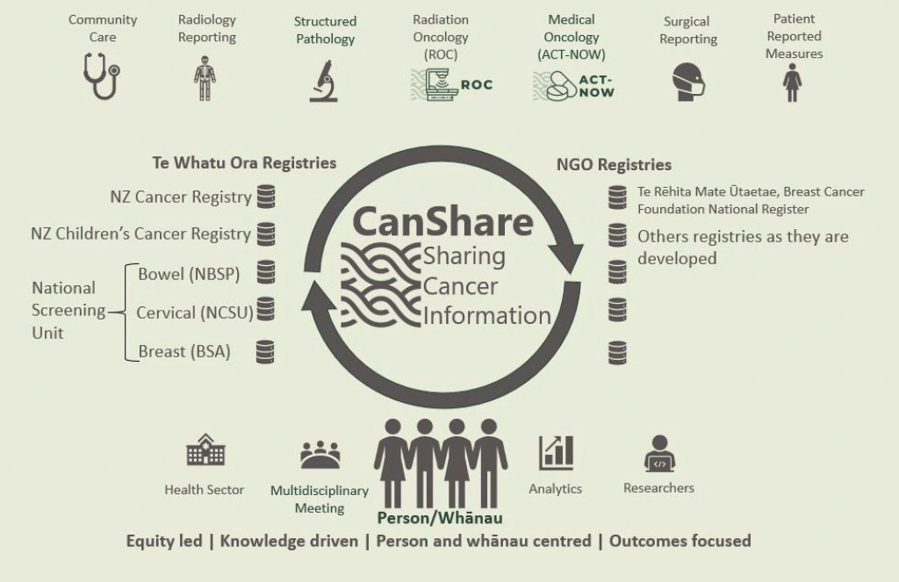

Anti-Cancer Therapies — Nationally Organised Workstreams (ACT-NOW)
The ACT-NOW programme is building a national systemic anti-cancer therapy (SACT) data collection and analytics. Using consistent ways to collect treatment regime data will allow the health sector to:
- monitor and compare how different regimens and/or services are performing
- identify any variations and where quality improvement interventions may be needed
- potentially add in early warning systems to flag areas of concern before they occur.

This will help the cancer system ensuring all people receive consistent cancer care, no matter where they live, or who they may be.

We are continuing to work with key partners agreeing on SACT definitions for the different treatment regimes.

Structured pathology
This project involves the wider sector to develop HISO (Health Information Standards Organisation) endorsed pathology data standards, to enable data to be shared and compared.

We have released 17 HISO standards over the past two years. We are working with the sector to finalise 40 data standards across the gastrointestinal, genitourinary, gynaecological, and soft tissue and bone cancer groups. The learnings from this work are helping us develop industry leading tools to support pathology providers and vendors implement these with clinicians.

National Radiation Oncology Collection (ROC)
This central repository of detailed radiation oncology information informs an understanding of radiation oncology service delivery and linear accelerator capacity, utilisation, and planning. This supports actions to improve access to radiotherapy and drive more cost-effective treatment. The ROC has been used as the key data source to underpin national planning for increased treatment capacity and workforce.

Faster cancer treatment health target and indicator
Faster Cancer Treatment (FCT) indicators measure peoples’ access to cancer services at national and regional levels. Health New Zealand collects standardised information on the time for patients who have been referred urgently with a high suspicion of cancer to see a specialist (62-day indicator) and the time to receive treatment once a ‘decision to treat’ is made (31-day target). Te Aho o Te Kahu has been supporting process improvements with the teams who collect this data. This has improved the quality and consistency of data collected across the country.

FCT is currently one measure of cancer care performance that helps identify areas for systematic improvement. The 31-day target measures the proportion of people that receive their first treatment within 31 days of a decision to treat.

In March 2024 the government announced five new health targets including one for cancer treatment that incorporates the 31-day measure.

While it is retrospective and there is a lead time of several weeks between activity and reporting, FCT can be reported regionally and by ethnicity which aligns with the direction Health New Zealand is taking to develop a more regionalised focus on improving health services.

In addition the Faster cancer treatment 62-day wait time indicators require districts to collect standardised information on patients who have been referred urgently with a high suspicion of cancer.

Over 2023/24 the agency supported Health New Zealand to streamline historical faster cancer treatment guidance documents by amalgamating them into a single document to support services reporting faster cancer treatment wait time indicators. This work also included clarification of the business rules to support nationally consistent reporting by services. In addition, an escalation plan and FCT coordinator/tracker orientation pack were developed, and support provided to the Health New Zealand community health pathways team with standardising consistent FCT information for Aotearoa. We are currently supporting the quality improvement of these indicators — for example, through our work to improve consistency of business rules, quality data management and reporting. We transferred ownership of this work to Health New Zealand in 2024.

Health Information Standards Organisation (HISO) standards
We continued to work with Health New Zealand on the selection, development and adoption of data and digital standards for the health sector. Nationally agreed and HISO-endorsed data standards support the vision for a fully interoperable digital health system by enabling cancer data to be shared more easily between systems information for decision-making, quality improvement and research. Standards enable different data systems to ‘talk to each other’.

As previously mentioned, the Structured Pathology reporting programme has made progress working on up to 40 HISO (Health Information Standards Organisation) standards to describe histopathology reports; The ACTNOW programme is close to completing its entire library of systemic anticancer therapy regimens, which will allow an understanding of how patients are being treated throughout the motu. The Snowflake data analytics database is now operational and will drive improved cancer data analytics, monitoring, reporting, and research. Work is also ongoing to allow Te Rēhita Mate Ūtaetae (the Breast Cancer Foundation National Register) to be supported by the CanShare platform.

Behind these outcomes are advances in our development of SNOMED CT (the national health terminology) to describe cancer data; and FHIR, the interoperability standard supporting the near real-time sharing of these data.

Development of a monitoring framework
The New Zealand Cancer Action Plan 2019–2029 sets four outcomes and multiple related actions across the cancer control pathway. This year, we have continued to report against this monitoring framework so we can transparently assess our progress towards achieving the aspirations of the Cancer Action Plan.

We will report on 11 broad indicators to give a ‘snapshot’ of the current state of cancer control in Aotearoa New Zealand. Each year, we will calculate the indicators and present the results in a monitoring report to show progress in the cancer control system. The monitoring report will also present activities being undertaken to achieve the outcomes and actions of the Cancer Action Plan. A summary of the monitoring report is available in the section ‘Tō mātou whakahaere – Our performance’.

Leadership and collaboration across data and digital health
We continued working with Health New Zealand and the Ministry of Health to highlight the needs of cancer patients and whānau within data and digital system changes.

In 2023/24 kaimahi sat on key digital governance and advisory groups, including the Hira Programme Governance Group, the Digital Enablement Oversight Group, the Digital Health Equity Reference Group, the National Data Platform Steering Committee and Tātai Pae Ora. We also chair the Cancer Working Group within the New Zealand Telehealth Forum.

Kia whakaiti iho te mate pukupuku – Achieving fewer cancers through a focus on prevention

Cancer screening

Cervical Screening Elimination Strategy
The agency is supporting the Public Health Agency and Health New Zealand on progressing the implementation of the cervical cancer elimination strategy. This work involves improvement planning across three pillars and their corresponding World Health Organization targets which are:
- vaccination: 90% of girls fully vaccinated with the HPV vaccine by the age of 15 (in Aotearoa New Zealand this target is applied to both boys and girls).
- screening: 70% of women screened using a high-performance test by the age of 35, and again by the age of 45.
- treatment: 90% of women with pre-cancer treated and 90% of women with invasive cancer managed.

Human Papilloma Virus (HPV)
HPV testing was introduced in September 2023, and since then significant progress has been made to increase the volumes of those who fit the testing criteria. As at April 2024 coverage was 70.9%, a 2-percentage point improvement from March 2024, and improvement in uptake across all ethnicities. The investment in the targeted approach to those communities with high need has been beneficial. HPV testing will be a significant contributor to eliminating cervical cancer in Aotearoa New Zealand.

Investigating a lung screening programme
Lung cancer is one of most diagnosed cancers across Aotearoa New Zealand, and is the second most common cancer diagnosed in Māori people. In 2024 we were invited to join a new Health New Zealand project to investigate the policies, pathways, costs and capacity needed to set up and implement an equitable national lung cancer screening programme. We are supporting this through advice, resources and data to identify potential pathways.

Cancer research

Cancer Research UK (CRUK) / International Cancer Benchmarking Partnership (ICBP) New Zealand Visit
The agency’s established relationships with international research partners like Cancer Research UK (CRUK) provides important insights that can inform the design and delivery of New Zealand’s cancer services.

ICBP (run by CRUK) is an international multidisciplinary collaborative partnership that facilitates research to measure variations in cancer survival, incidence, and mortality between countries, and the factors that cause these differences. This is useful data countries can use to improve cancer services and policies, with the aim of increasing survival and enhancing the patient experience.
New Zealand is a partner in this research work, contributing some financial support, national data, and our expertise. We recently completed and published ‘Routes to Diagnosis Report’ which utilised the ICBP methodology. This has ensured consistency and comparability across partner countries.

In April 2024 we hosted the CRUK/ICBP team in Wellington for three days as part of their planned visits with partner countries. During this visit the CRUK/ICBP team introduced the third phase of their research ‘cancer survival benchmark’. The visit provided an opportunity to strengthen our international collaboration with a specific focus on early detection. On that topic, the CRUK team shared very useful insights on the initiatives under way in the UK (and elsewhere in Europe) aimed at supporting primary care and community diagnostic pathways to early detection.

By strengthening our relationships with the teams at CRUK and ICBP team we will be able to continue to use their insights to inform our work in improving cancer outcomes. We have been invited to participate in phase 3 of the ICBP work, which will on Workforce. Details of this phase are currently being confirmed.

Kia runga noa ake te mataora – Improving cancer survival

Blood cancer medicines availability analysis
Every year in Aotearoa New Zealand, around 2,800 people are diagnosed with a blood cancer. There are no known prevention or screening interventions for any blood cancers.

It is generally established that Aotearoa New Zealand has access to fewer cancer medicines than countries we like to compare ourselves to including Australia, the United Kingdom and Canada. To determine the extent to which there was a difference between public funding of medicines in Australia and public funding of medicines in Aotearoa New Zealand, we published Understanding the Gap: an analysis of the availability of cancer medicines in Aotearoa in 2022. This report identified 20 medicines that were funded for the treatment of cancer in Australia, but not in Aotearoa New Zealand, which also met a minimum threshold of clinical benefit based on a tool developed by the European Society for Medical Oncology (ESMO).

At the time of the 2022 report, there was no tool available to measure the magnitude of the clinical benefit for blood cancer medicines gaps, so the report only described the clinical benefit for solid tumour medicine gaps. In 2023, the European Society for Medical Oncology (ESMO) released a new version of the ESMO-MCBS tool called the ESMO-MCBS:H (H for haematological or blood cancers) that can be used to assess the clinical value of blood cancer medicines. This version of the tool meant we were able to determine the magnitude of clinical benefit for blood cancer medicines and complete the picture of medicine availability differences between Australia and Aotearoa.

We carried out this analysis in the first half of 2024 to develop a draft report by early June 2024. This report is now in the final stages of review, editing and layout and we expect it to be ready to publish in October 2024.

Increasing access to new cancer medicine
In June 2024 the Government announced an unprecedented $604 million funding boost to Pharmac’s Combined Pharmaceutical Budget (CPB) over four years to increase cancer medicine availability. For the first time an additional $38 million was allocated for delivery of the new medicines in the first year. Additional implementation budget may be released in future years if required.

The Increasing Access to Medicines Programme is a collaboration between Health New Zealand and Te Aho o Te Kahu, with support from the Ministry of Health and Pharmac. Our aim is to ensure that the newly funded cancer treatments, and the cancer care that people are currently receiving in the public health system, are successfully delivered in a well-functioning, equitable and responsive cancer service. We are also embedding future focused models of care that are more sustainable, resilient and responsive to local needs and that provide care closer to home.

At the time of the funding announcement, Pharmac estimated that the additional $604 million of funding would cover approximately:
- 26 cancer medicines for several cancers, including thyroid, bowel, breast, bladder, lung, head and neck, prostate, liver, ovarian, kidney and four different blood cancers.
- 28 other medicines for a wide range of conditions including infections, respiratory conditions, osteoporosis, sexual health, dermatology, inflammatory conditions, and mental health.

Quality improvement programme
The agency’s quality performance indicator (QPI) programme provides information to support the monitoring and improvement of cancer services to ensure actions aimed at achieving better outcomes for people and whānau with cancer are prioritised.

While most people receive quality cancer care most of the time, there are others who do not. People and communities experience different inequities at every stage along the cancer continuum. From a person’s exposure to cancer causing risk factors such as unhealthy diets, excess weight, smoking or alcohol, the speed of diagnosis, ability to access high quality cancer treatment, timely referral to specialist care, or the level of palliative care or bereavement support provided for whānau after death. These cumulative inequities contribute to poorer health outcomes.

The QPI team work with the wider sector on reports and monitoring (using data from national collections, such as the New Zealand Cancer Registry (NZCR)) that can identify unwarranted variation (between providers and / or between population groups) and issues with cancer detection, diagnosis, treatment, and outcomes, to inform quality improvement activities.

In March 2024 the agency released the Route to cancer diagnosis report: People diagnosed with cancer within 30-days of an emergency or unplanned hospital admission. Cancer that is diagnosed this way is often later stage, has fewer treatment options and patients have poorer outcomes. This report also showed that:
- New Zealanders experiences a high rate of being diagnosed with cancer after an emergency or unplanned admission - 23.9% across 22 different types of cancer, with some being much lower (for example, breast cancer) and others, (for example lung cancer and pancreatic cancer) being much higher.
- Māori are more likely to be diagnosed following an emergency admission than people of other ethnicities in almost all districts.
- certain districts consistently perform better than others (ie have lower rates of diagnosis following and ED or unplanned admission), which may point to stronger connections between primary and secondary care services and/or more effective primary care/community diagnostics models that could be scaled and used in other parts of the country.

We are continuing to share the report findings with Health New Zealand, community and primary health care providers and other key agencies, to identify areas where we can improve cancer detection and diagnosis processes, and to help identify peoples’ cancer diagnosis earlier across Aotearoa New Zealand.

With the introduction of the national health reforms and new health organisations that are responsible for commissioning and delivering health services, we are relooking at our cancer service quality improvement approach. As part of this work, we are developing a quality improvement framework for Te Aho o Te Kahu, to guide the quality improvement work that will result from the QPI programme and other projects such as CanShare.

Supporting the national clinical trials network
Clinical trials are a key tool for achieving better cancer outcomes for those people with cancer who are eligible to take part. The low availability of, or inequitable access to cancer clinical trials in Aotearoa New Zealand continues to be of concern to patients and whānau, and the health sector. The Ministry of Health is working with Health New Zealand on the design of equitable clinical trials for all conditions, including cancer, based on the recommendations in the Enhancing Aotearoa New Zealand Clinical Trials report.

Over the 2023/24 year, we continued to provide support and highlight the needs of cancer patients to the Ministry and Health New Zealand. We also presented at the clinical trials workshop hosted by Cancer Trials New Zealand, and the New Zealand Society for Oncology meeting in September 2023.

Te whakapai mana taurite o ngā hua mate pukupuku – Improving equity of cancer outcomes

Hearing the voices of whānau Māori
Over 2023/24 we completed our visits with mana whenua, and local health organisations to share the results of the 13-community hui we hosted across the motu in 2022. Through the hui we listened to more than 2,500 whānau Māori, including patients, whānau and Māori working in cancer care or the wider health and social sectors.

This resulted in the release of three reports in March 2023:
- Rongohia Te Reo, Whatua He Oranga: The voices of whānau Māori affected by cancer shares the experiences and aspirations of thousands of whānau Māori affected by cancer.
- Te Tikanga — Engaging with whānau Māori affected by cancer:
a kaupapa Māori approach outlines the kaupapa Māori principles used to design and deliver the hui series.
- He Urupare: Responding to the experiences of whānau Māori affected by cancer describes some of the work Te Aho o Te Kahu and other health agencies are doing that responds to, or aligns with, whānau insights.

We are continuing to use and share these documents to inform the agency’s work programme and key cancer services planning documents such as Models of Care and Optimal Cancer Care Pathways.

Embedding equity-led thinking
We have strengthened our focus on equity, with capability development a key area of work.

We have also incorporated equity frameworks into key business processes and project planning methodology. Our internal community of practice, Te Kāhui Mana Taurite, supports equity analysis across the entire Cancer Services Planning programme. This rōpū (group) identified and analysed equity issues across each area of the programme. The voices of patients and whānau were integrated into this analysis, as was national and international literature. Te Kāhui Mana Taurite will be broadened in 2023/24 to cover all our agency’s work programme.

We have also been supporting the equity work of other agencies and organisations. Our Equity team has shared insights with other health and community colleagues, both formally and informally, through guest speaker presentations, various governance and advisory roles, and publication of research papers.

Pacific cancer patients and whānau
We partnered with Moana Connect to carry out research within the Pacific community to help identify areas to improve the coordination and delivery of cancer care for Pacific peoples and their kaaiga (family).

We are in the final stages of reviewing the research for release in late 2024/early 2025. We plan to share with kaimahi, key health organisations and providers and consider ways the health system can adapt to address the gaps, challenges and barriers some Pacific peoples experience, and improve the supports they may need.

Experiences of disabled people with cancer
In 2022/23 we developed the disability and cancer project to build health sector understanding on the incidence, experience of cancer, and cancer outcomes for disabled New Zealanders. There is little evidence in this area, but He Pūrongo Mate Pukupuku o Aotearoa 2020, the State of Cancer Report 2020, showed that disabled people can often experience poorer health outcomes.

In early 2023/24 we appointed three fixed-term lived-experience advisors (disability and cancer) to support this work. We are grateful for the insights, advice, and connections they shared with the agency. They were generous in sharing their experiences, and the barriers they faced in being diagnosed and treated for cancer, which are available in a range of accessible formats on our website.

The advisors’ insights, a literature review of disabled peoples experience in cancer care, combined with research and data matching we are conducting with the New Zealand Cancer Registry, will provide a clear picture of where we need to influence the equitable delivery of cancer services to disabled people and their whānau in Aotearoa.

We are preparing the literature review and data reporting to publish in a range of accessible formats later in 2024. We are also developing an approach for how we embed the insights gained into cancer service design and delivery across the sector, including capabilities development across the agency.

World Indigenous Cancer Conference 2024
Between 18 - 20 March 2024, the Victorian Comprehensive Cancer Centre Alliance (VCCC) in partnership with the International Agency for Research on Cancer hosted the third World Indigenous Cancer Conference 2024 (WICC) in Naarm (Melbourne) Australia.

The conference involved researchers, cancer survivors and carers, health professionals, cancer care services and providers, policy makers and Indigenous communities and organisations from around the world. The aim was to highlight and share examples of global leadership in Indigenous cancer care, strategies, governance, advocacy, and empowerment. This included kaimahi involved in cancer research or whānau centred care, along with our partners at Hei Āhuru Mōwai.

Our Chief Executive and Director Equity and Whānau Centred Care were on the panel of speakers who opened the event. They shared:
- the range of inequities Māori people can face at each stage of the cancer continuum
- what we learned from listening to the experiences of more than 2,500 Māori people with cancer, whānau, and Māori working in cancer care or the wider health and social sectors (refer to Hui insights reports)
- how we are embedding the hui insights and equity in our work, the Cancer Action Plan, and the broader health sector, to help reduce these inequities.

Sasha joined Hei Āhuru Mōwai Māori Cancer Leadership Tumuaki, Chief Executive, Cindy Dargaville to share our organisations experiences in the opportunities and work needed to embed partnership into cancer control in Aotearoa New Zealand.

Two of the agency’s Kaikōkiri Kaupapa Mana Taurite (Project Manager Equity) also ran a workshop on how we designed the hui to engage with whānau Māori affected by cancer using a kaupapa Māori approach involving whānau (family), hapū (kinship group) and iwi (larger extended groups or tribe).

International research on indigenous and tribal peoples and cancer
In 2024, the agency was invited to contribute to a book, called Indigenous and Tribal Peoples and Cancer. This was the first-time research on Indigenous and Tribal peoples’ experiences with cancer and cancer control had been brought together.

We collaborated with Cancer Australia and the Canadian Partnership Against Cancer (CPAC) on a chapter focused on cancer control and care.

The book will be published in October 2024 and we will provide links to it on our website.

Sector performance
Under the Cancer Action Plan, we developed a framework to monitor progress towards the plan’s four outcomes and supporting actions. A broad range of indicators were chosen for each Cancer Action Plan outcomes based on relevance and measurability; the accurateness and availability of data; and the impact on inequities. We also
considered indicators used in global cancer control plans and whether they could be practically applied to Aotearoa New Zealand’s context.

Monitoring will become an annual process enabling us to track progress and activities
across the cancer care system. This will show the effectiveness of the work underway in each area and identify areas for further investigation or action.

Below, we list each of the four outcomes specified in the Cancer Action Plan, followed by one relevant indicator and graphs and commentary presenting data relevant to that indicator. The results of this monitoring are not solely the responsibility of Te Aho o Te Kahu, and the indicators are long term measures, so we expect some will shift slowly.

Outcome 1:
New Zealanders have a system that delivers consistent and modern cancer care
Indicator:
Ethnic distribution of the current cancer workforce and Aotearoa New Zealand’s total population for 2023 (based on the 2018)

The health system strives to attract and maintain a workforce that represents the communities it serves. Research shows that ethnically diverse health workforces can help reduce health inequalities in multicultural societies like Aotearoa New Zealand.

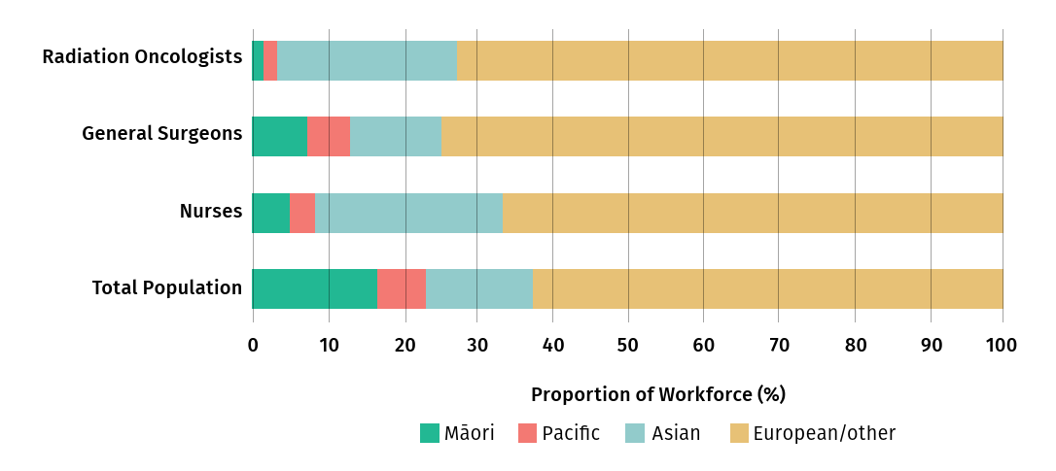
Figure 2: shows the ethnic distribution of radiation oncologists, general surgeons, and nurses in 2023, alongside the ethnic distribution of our country’s population.

Outcome 2:
New Zealanders experience equitable cancer outcomes
Indicator:
Routes to diagnosis — Proportion of cancers that were diagnosed in 2022 following an emergency presentation within 14 days before the date of diagnosis.

Early diagnosis improves cancer outcomes by providing care at the earliest possible stage. Ideally the diagnosis would be through a primary or community health care service (such as a General Practitioner or a screening programme) and treatment would be provided by a trusted, culturally responsive secondary health service.

In 2022, Māori (30%) and Pacific peoples (36%) were more likely to be diagnosed with cancer following an emergency presentation, than Asian (26%) and European/Other (22%) for all cancers. This is one example of how the agency’s monitoring work highlights inequities in cancer, so we can work with the sector on reducing them.

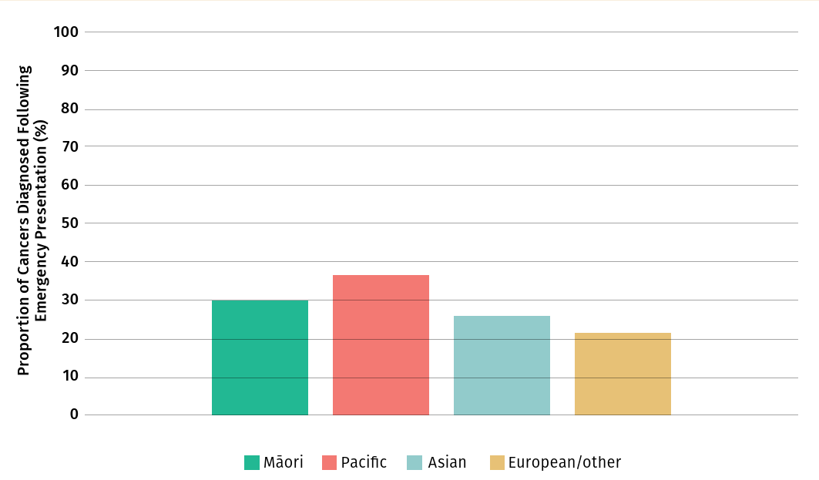
Figure 3: Proportion of cancers diagnosed following emergency presentation by ethnicity, 2023

Outcome 3:
New Zealanders have fewer cancers
Indicator:
Tobacco — Proportion of New Zealanders who were daily smokers

The rate of daily smoking appears to be reducing for most ethnic groups over time. Pacific peoples saw the biggest reduction from 18.2% in 2021/2022 to 6.4% in 2022/2023.
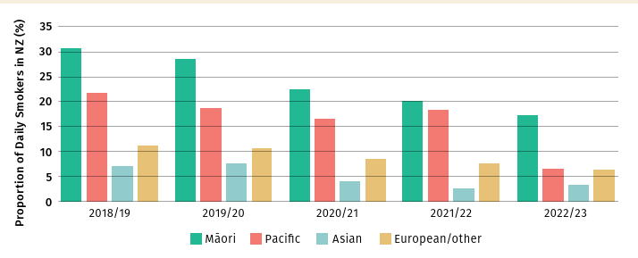
Figure 4: Proportion of daily smokers in New Zealand, by ethnicity, 2018/19–2022/23

Outcome 4:
New Zealanders have better cancer survival, supportive care, and end-of-life care
Indicator:
Surgery — Proportion of New Zealanders with cancer who received surgical treatment in 2022/23
Surgery is one way to increase a person’s survival rate following a cancer diagnosis. The rate of surgical resection for lung and pancreatic cancers was around 5–25% in the 2022/23 year. The rates of lung and pancreatic cancers increased for Māori and Pacific peoples compared with the previous year. Note: this is the latest data available.
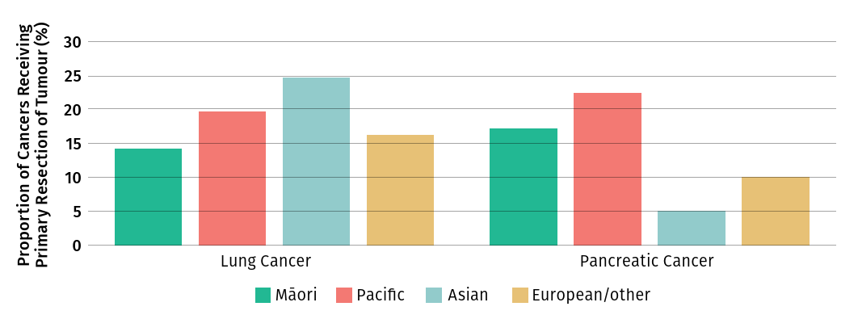
Figure 5: Proportion of New Zealanders who received surgical treatment for lung or pancreatic cancer, by ethnicity, 2022/23

Tō mātou whakahaere – Our performance
Performance measure | 2021/22 | 2022/23 | 2023/24 | Notes
Kaimahi satisfaction | NA | 84% | 72% | Kōrero Mai survey undertaken in October 2023.
Sick/domestic leave taken | 4.7 days | 8.2 days | 6.7 days | We actively encourage kaimahi take sick leave to support both public health efforts and staff wellbeing.
Kaimahi turnover | 13% | 16% | 21% | Our flat organisational structure can hamper career growth opportunities.
Percentage Māori kaimahi | 11% | 11% | 13% | Focus on recruiting Māori kaimahi and capability development.
Percentage Pacific kaimahi | 6% | 5% | 5% | Focus on recruiting Pacific kaimahi and capability development.
Percentage non-European kaimahi | 40% | 34% | 40%
Diversity and inclusion |  |  |  | Statements from 2021 Public Service Census.  The 2023 Census was deferred to and is proposed to run in March 2025.
I believe my agency supports and actively promotes an inclusive workplace. | 93% |  | 80% | Kōrero Mai survey undertaken in October 2023.  Average across the public service was 78%.
The people in my workgroup behave in an accepting manner to people from diverse backgrounds / The person I report to creates an inclusive team environment, showing care for success and wellbeing. | 91% |  | 83% | Kōrero Mai survey undertaken in October 2023.  Average across the public service was 81%.
I feel accepted as a valued member of the team./ I feel welcome and included at the agency. | 86% |  | 83% | Kōrero Mai survey undertaken in October 2023.  Average across the public service was 79%.
I am satisfied with my work–life balance. / I am able to maintain a balance between my personal and working life. | 59% |  | 81% | Kōrero Mai survey undertaken in October 2023.  Average across the public service was 52%.
Te reo Māori |  |  |  | Statements from 2021 Public Service Census.  The 2023 Census was deferred to and is proposed to run in March 2025.
I use at least some te reo Māori words and phrases. | 84% | 89.7% | 89% | Average across the public service was 58%.
I hear leaders regularly using te reo words and phrases. | 93%
Staff are supported to improve our te reo Māori. | 84% |  | 83% | Average across the public service was 59%.
How many staff have never studied te reo Māori? | 6  people | 12  people |  | This statement is no longer in Te Arawhiti’s Māori Crown Capability Framework. We have included the results to the question below in the Whāinga Amorangi kaimahi capability survey – ‘Percentage of kaimahi who can pronounce te reo Māori words correctly.’
Māori–Crown relations |  |  |  | From Whāinga Amorangi kaimahi capability survey
I am comfortable supporting tikanga Māori in my agency. | 87% | 97.9% | 97%
I am encouraged and supported to engage with Māori. | 91% |  | 96% | This statement is no longer in Te Arawhiti’s Māori Crown Capability Framework. We have included the results to the question below in the Whāinga Amorangi kaimahi capability survey – ‘Percentage of kaimahi who believe that Te Aho o Te Kahu engages effectively with Māori’
I feel confident in my ability to identify aspects of my agency’s work that may disadvantage Māori. | 89% | 95% | 93%
I understand how my agency’s Te Tiriti responsibilities apply to its work. | 89% | 89.7% | 88%
Te Aho o Te Kahu enables me to apply Māori–Crown relations skills to my work | 49% | 34% | 84% | This statement is no longer in Te Arawhiti’s Māori Crown Capability Framework. We have included the results to the question below in the Whāinga Amorangi kaimahi capability survey - ‘Percentage of kaimahi able to describe how Te Tiriti applies to their work.’
Official Information Act (OIA) timeliness | 100% | 100% | 100% | From Ministry of Health data

Building a high performing agency and capabilities
We are focused on attracting and retaining a diverse, capable workforce who is passionate about reducing the impact of cancer on our communities. Our kaimahi bring together a broad range of skills including:
- leadership, critical thinking
- clinical and pharmaceutical experience and expertise
- people and whānau centred care
- Māori and Pacific cultural expertise
- cancer sector knowledge and understanding
- analytics and data insights
- systems thinking, working with complex systems, and behavioural science
- system improvement and innovation
- strong networks and relationships.

These capabilities are strengthened through our effective relationships across the sector, and collaboration on shared work, or areas of mutual interest.

To increase capacity where needed to deliver our reprioritised work programme, or support new areas of work, we support kaimahi in learning, through job-shadowing, courses, or certifications. These include:
- machinery of government expertise, such as responding to OIAs etc.
- te ao Māori, te reo Māori and Te Tiriti o Waitangi
- SNOMED CT certifications
- data visualisation courses
- disability awareness
- unconscious bias e-learning as part of induction process
- health and safety.

Systems and processes
We are continuing to update and introduce new systems and processes, with support from the Ministry of Health.

We are in the final stages of implementing a ‘promotion round’ for kaimahi. This is a structured assessment and selection process to help both managers and kaimahi understand kaimahi are ready to move ahead in their career pathway.

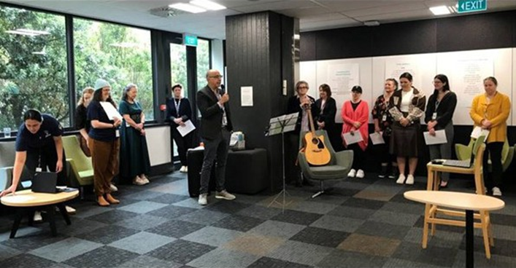
Photograph: Rama Rahal opening Te Wiki o Te Reo Māori 2023 with kaimahi from the Ministry of Health and Te Aho o Te Kahu

Whāinga Amorangi – Māori Crown Relations capabilities
We have been ambitious in adopting all six domains of the individual capability component of the Māori Crown relations capability framework developed by Te Arawhiti – the Office for Māori Crown Relations (Te Arawhiti). This approach aligns to our vision, values, and strategic documents including:
- Pae Tū Hauora Māori Health Strategy
- Whakamaua: Māori Health Action Plan 2020–2025
- Pae Ora (Healthy Futures) Act 2022
- The Cancer Action Plan.
Kaimahi can access the Ministry of Health’s online learning courses on Te Rito, Te Reo and Tikanga, Ngutuawa - Te Tiriti tools to build their cultural capabilities and help our agency meet the expectations of the Public Service Act 2020. They can also attend workshops or training, such as The Wall Walk® and Te Arawhiti Crown engagement with Māori.

It is difficult to separate out the investment to implement our plan for developing cultural capabilities, as we are hosted by the Ministry of Health. Both organisations can leverage off the capability opportunities the Ministry offers, as well as those our agency runs.

The progress kaimahi have made across under the six individual capability six domains of the Māori Crown relations capability framework developed by Te Arawhiti is outlined below.

Te reo Māori
Goal:
Te reo Māori is regularly spoken, understood, and valued in Te Aho o Te Kahu.
Our annual Whāinga Amorangi survey found that 49% of kaimahi have experienced a noho marae.

What we achieved in 2023/24
- Percentage of kaimahi who:
- had a te reo Māori development goals in their Personal Development Plan: 43%
- completed a te reo Māori language courses: 89%
- attended:
- a noho marae stay in 23/24: 8%
- Appointed a Pou Herenga role (0.2 FTE) to provide cultural knowledge, advice, and support across the agency
- Established a Chief Advisor Māori role which is being recruited.
- Held learning events during Matariki, Mahuru Māori including a focus during Te Wiki o te reo Māori
- Publications include bilingual forewords and summaries, or are fully translated when they are specific to a Māori audience
- Incorporated bilingual signposting on our website.
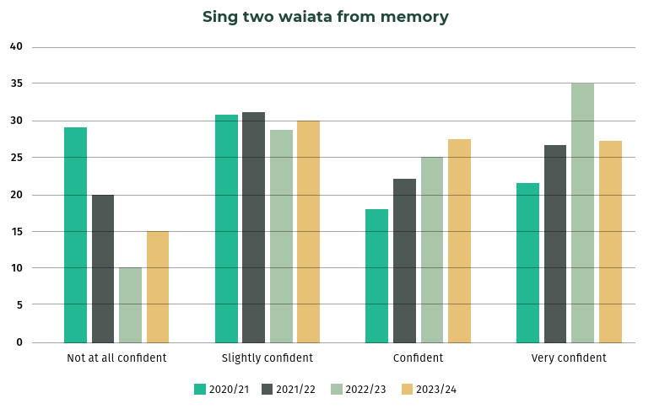
Figure 6: Percentage of kaimahi who can sing at least two agency waiata from memory

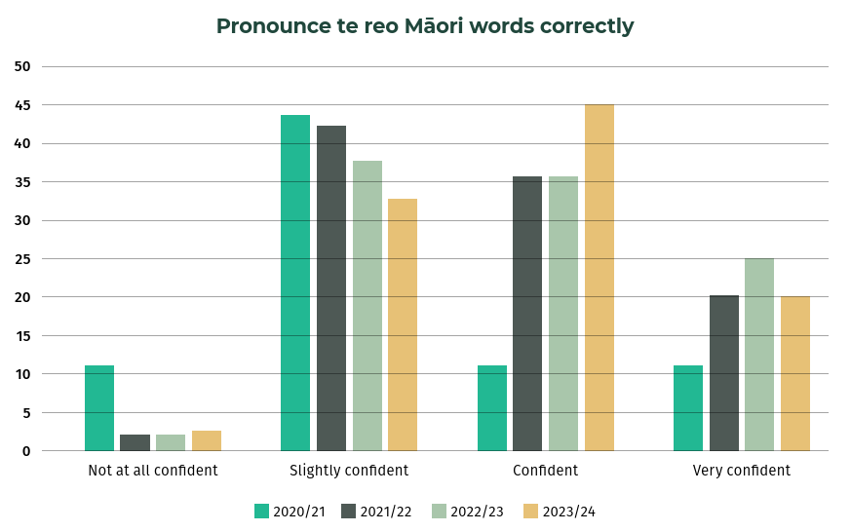
Figure 7: Percentage of kaimahi who can pronounce te reo Māori words correctly
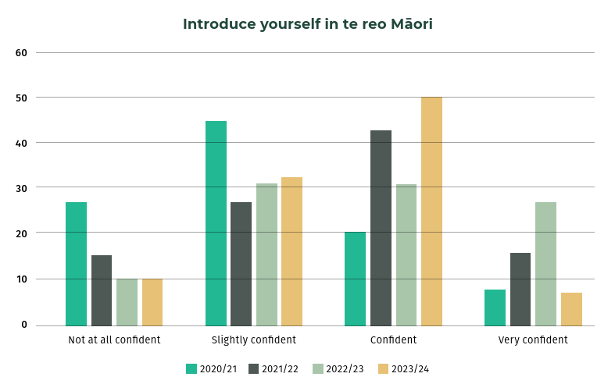
Figure 8: Percentage of kaimahi who feel comfortable introducing themselves in te reo Māori

Tikanga / Kawa
Goal:
Te Aho o Te Kahu creates and adopts a culture where tikanga is welcomed and practiced.

What we achieved in 2023/24:
- 88% of kaimahi correctly identified our Pou Herenga, and 75% knew how that role supports our work
- Regular Tikanga Tuesdays sessions were run by our Pou Herenga for the agency and Ministry of Health.

Understanding racial equity and institutional racism

Goal:
Te Aho o Te Kahu identifies and addresses institutional racism

What we achieved in 2023/24:
More kaimahi felt confident / very confident in identifying practices and processes in our work that may inadvertently disadvantage Māori than in the previous year.

Worldview knowledge
Goal:
Te ao Māori informs the development of agency work.

What we achieved in 2023/24:
- More kaimahi felt confident explaining kaupapa Māori concepts compared with previous years.
- Most kaimahi believe understanding te ao Māori is relevant to their own, and the broader agency’s work
- Keynote speaker at the World Indigenous Cancer Conference 2024 in Melbourne, Australia.
- We purchased, or were gifted, books to support kaimahi education
- The agency hosted a lunchtime screening of the documentary Whetū Marama during Matariki
- Our Pou Herenga delivered a 3 Kete workshop to develop an agency culture that enhances mana.
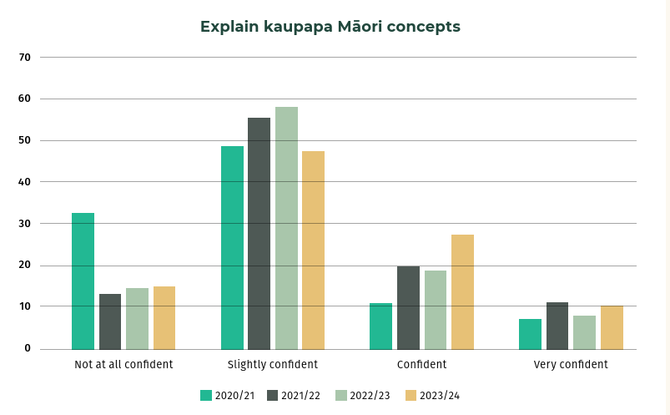
Figure 9: Percentage of kaimahi who can explain kaupapa Māori concepts

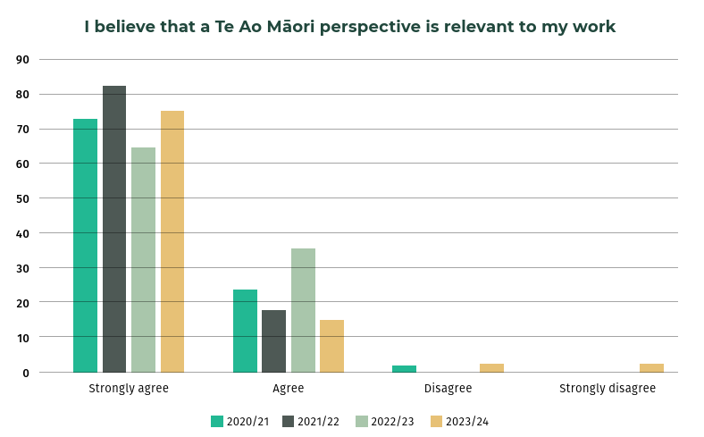
Figure 10: Percentage of kaimahi who believe te ao Māori perspectives are relevant to their work

Engagement with Māori
Goal:
Te Aho o Te Kahu has the knowledge, skills, and processes to engage with Māori. Māori voices are heard, and their feedback influences the direction of our work.

What we achieved in 2023/24:
- Six kaimahi attended the Te Arawhiti Engaging with Māori training
- A kaimahi Māori rōpū was set up which meets monthly
- The disability and cancer project involved tāngata Whaikaha Māori lived experience.
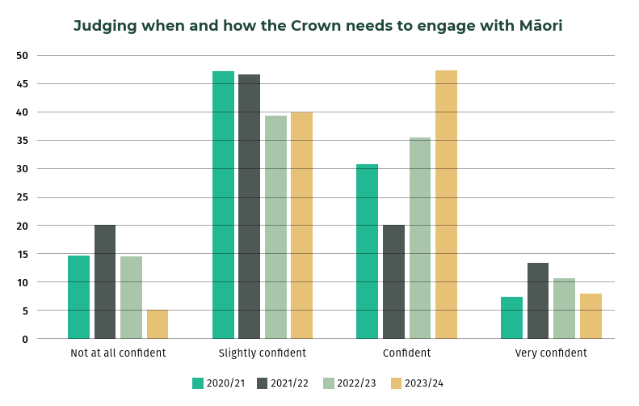
Figure 11: Percentage of kaimahi who feel confident in judging when and how the Crown needs to engage with Māori

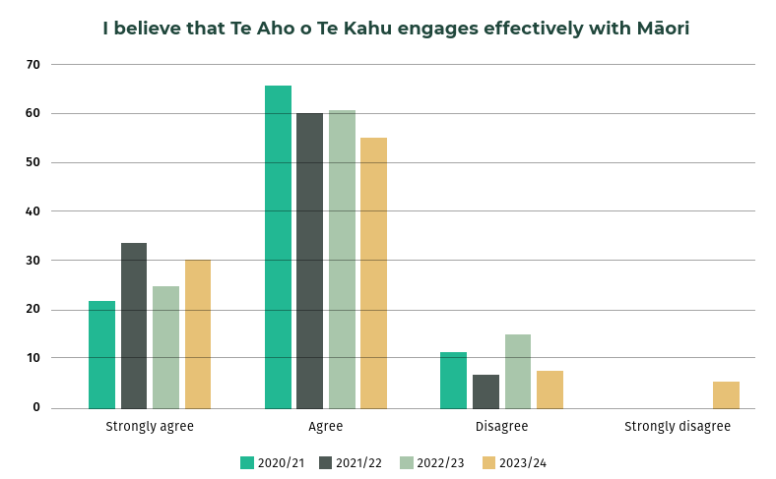
Figure 12: Percentage of kaimahi who believe that Te Aho o Te Kahu engages effectively with Māori

Aoteroa New Zealand history and Te Tiriti o Waitangi / Treaty of Waitangi
Goal:
Te Aho o Te Kahu kaimahi understand differences between Te Tiriti o Waitangi and The Treaty of Waitangi and have space to discuss questions.

What we achieved in 2023/24:
- 14% of kaimahi have a minimum of one goal in their Personal Development Plan
- During Te Wiki o Te Reo Māori, the agency screened the documentary drama ‘Te Tiriti o Waitangi – What really happened’ for Manatū Hauora and agency kaimahi
- 4 kaimahi attended Wall Walk® on Te Tiriti

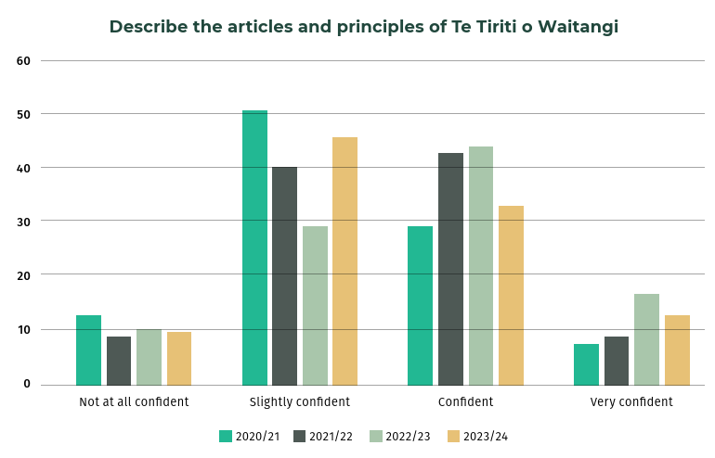
Figure 13: Percentage of kaimahi able to describe the articles and principles of Te Tiriti

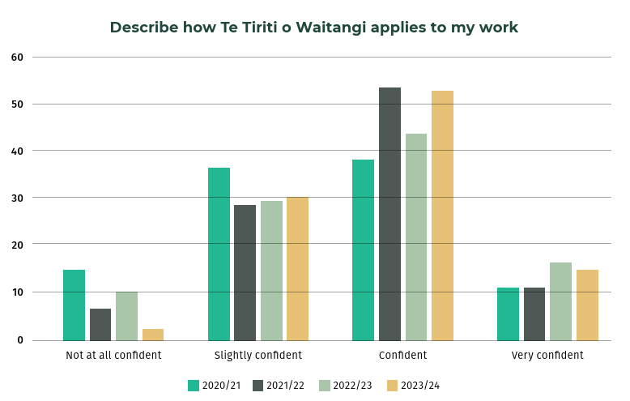
Figure 14: Percentage of kaimahi able to describe how Te Tiriti applies to their work

E Tipu E Tipu – Māori Language Plan
We identified the following five capability goals in our Māori language plan, E Tipu E Tipu.
- Status: Raising the profile and value of the Māori language across the agency.
- Critical awareness: Raising awareness of the need to revitalise te reo Māori.
- Acquisition: Growing the number of kaimahi learning te reo Māori, through formal or informal learning.
- Use: Normalising and increasing kaimahi and stakeholders use of te reo Māori.
- Corpus: Increasing the availability and/or development of relevant terms and words to widen language use specific to Te Aho o Te Kahu.

Some examples of these goals being applied across our agency include:
- our induction information describing our ingoa, values and commitment to te ao Māori
- our communication plans detailing appropriate inclusion of te reo Māori
- providing opportunities for kaimahi to learn te reo Māori, te ao Māori or Te Tiriti via courses or free online resources.
- key meetings (for example, kaimahi hui) include karakia and/or waiata
- te reo Māori goals are included in each personal development plans
- encouraging good pronunciation of key reo Māori kupu (words) relating to our work
- bilingual signs, job titles, email greetings and signoffs.

Haepapa Tauākī – Statement of responsibility
I am responsible for the accuracy of any end-of-year performance information prepared by Te Aho o Te Kahu, and for whether that information is included in the annual report.

In my opinion, this annual report fairly reflects the operations, progress, and organisational health and capability of Te Aho o Te Kahu over the year 1 July 2023 to 30 June 2024.

Ngā manaakitanga,

Rami Rahal
Tumu Whakarae, Chief Executive
Te Aho o Te Kahu, Cancer Control Agency
30 September 2024

Minister of Health. 2003. The New Zealand Cancer Control Strategy. Wellington: Ministry of Health and the New Zealand Cancer Control Trust. URL: http://www.health.govt.nz/system/files/2011-11/cancercontrolstrategy.pdf (accessed 8 September 2024).
Ministry of Health. 2019. New Zealand Cancer Action Plan 2019–2029 – Te Mahere mō te Mate Pukupuku o Aotearoa 2019–2029. Revised January 2020 Wellington: Ministry of Health. URL: http://www.health.govt.nz/publications/new-zealand-cancer-action-plan-2019-2029 (accessed 8 September 2024).
Minister of Health. 2024. Government Policy Statement on Health 2024–2027. Wellington: Ministry of Health. URL: http://www.health.govt.nz/publications/government-policy-statement-on-health-2024-2027(accessed 9 September 2024).
Te Aho o Te Kahu. 2024. Quality Improvement Monitoring Report – Route to diagnosis: People diagnosed with cancer within 30 days of an emergency or acute (unplanned) hospital admission. Wellington: Te Aho o Te Kahu – Cancer Control Agency.
Minister of Health. 2023. Pae Tū: Hauora Māori Strategy. Wellington: Ministry of Health. URL: http://www.health.govt.nz/system/files/2023-07/hp8748-pae-tu-hauora-maori-strategy.pdf (accessed 9 September 2024).
Ministry of Health. 2020. Whakamaua: Māori Health Action Plan 2020–2025. Wellington: Ministry of Health. URL: http://www.health.govt.nz/publications/whakamaua-maori-health-action-plan-2020-2025 (accessed 9 September 2024).

