- CANCER SERVICE QUALITY INDICATORS
Quality Improvement Monitoring Report
Route to diagnosis:
People diagnosed with cancer within 30-days of an emergency or acute (unplanned) hospital admission
March 2024

Acknowledgements
This report publishes quality performance indicator (QPI) data from the New Zealand Cancer Registry (NZCR) and other Health New Zealand | Te Whatu Ora national data collections for patients diagnosed with cancer in Aotearoa New Zealand from 1 January 2017 to 31 December 2021.

The development group acknowledges that each data point reflects an individual or cluster of patients and that each diagnosis of cancer will have significantly affected the patient and their whānau.

For noting
At the time of publishing this report, district health boards had been disestablished as part of the 1 July 2022 health and disability sector reforms. For this report, even though the data is from a period when district health boards were in existence (1 January 2017 to 31 December 2021), we use the new term ‘district(s)’ to refer to district health boards throughout the report.

Authors
The report is being released by Te Aho o Te Kahu | Cancer Control Agency as part of its cancer quality performance indicator programme.

Citation: Te Aho o Te Kahu. 2024. Quality Improvement Monitoring Report – Route to diagnosis: People diagnosed with cancer within 30 days of an emergency or acute (unplanned) hospital admission. Wellington: Te Aho o Te Kahu.
Published in March 2024 by Te Aho o Te Kahu | Cancer Control Agency
PO Box 5013, Wellington 6140, New Zealand

ISBN 978-1-9911905-8-1 (online)
TP0012

This document is available at teaho.govt.nz
 | This work is licensed under the Creative Commons Attribution 4.0 International licence. In essence, you are free to: share ie, copy and redistribute the material in any medium or format; adapt ie, remix, transform and build upon the material. You must give appropriate credit, provide a link to the licence, and indicate if changes were made.

CONTENTS
Executive summary xi
1 Introduction 1
1.1 About Te Aho o Te Kahu 1
1.2 The cancer quality performance indicator programme 2
1.3 Context 2
1.4 Patient voice 3
1.5 Next steps for Te Aho o Te Kahu 3
2 Why does this matter? 5
2.1 New Zealand compares poorly to peer countries 5
2.2 Brain, pancreatic and lung cancers are among the cancers with the highest rate of emergency diagnosis 6
2.3 Impact on experiences and outcomes 7
3 Māori are more likely to be diagnosed after an emergency admission 10
4 Many factors may contribute to high emergency department diagnosis rates 14
4.1 What are some of the causal factors? 14
4.2 What are some of the potential solutions? 16
5 How to use the remainder of this report 18
6 Results by cancer type 20
6.1 Bladder cancer 20
6.2 Bowel cancer 22
6.3 Brain and central nervous system cancers 24
6.4 Breast cancer 26
6.5 Cervical cancer 28
6.6 Head and neck cancer 29
6.7 Kidney cancer 31
6.8 Leukaemia 33
6.9 Liver cancer 35
6.10 Lung cancer 37
6.11 Lymphoma 39
6.12 Melanoma 41
6.13 Myeloma 43
6.14 Neuroendocrine tumours (NETs) 45
6.15 Oesophageal cancer 47
6.16 Ovarian cancer 49
6.17 Pancreatic cancer 51
6.18 Prostate cancer 53
6.19 Sarcoma 55
6.20 Stomach cancer 57
6.21 Thyroid cancer 59
6.22 Uterine cancer 60
References 62
Appendix A: Methods 64
Appendix B: Technical specifications 67
Appendix C: Comparisons with other similar reports 72
Appendix D: Supplementary tables by cancer type 76

List of tables
Table 1: Age-standardised proportions (%) of people diagnosed within 30 days of an emergency admission by cancer types, by ethnic group 12
Table 2: Referenced definitions of emergency admission and route to diagnosis 72
Table 3: Percentage of people diagnosed with cancer following emergency admission, by sex, ethnic group and social deprivation, 2015/16 to 2018 73
Table 4: People diagnosed with bladder cancer following emergency admission, by year of diagnosis, sex, age group, ethnicity, deprivation quintile (NZDep2018) and rural–urban status 76
Table 5: People diagnosed with bladder cancer following emergency admission, by district of residence 78
Table 6: People diagnosed with bowel cancer following emergency admission, by year of diagnosis, sex, age group, ethnicity, deprivation quintile (NZDep2018) and rural–urban status 79
Table 7: People diagnosed with bowel cancer following emergency admission, by district of residence 81
Table 8: People diagnosed with brain and central nervous system cancer following emergency admission, by year of diagnosis, sex, age group, ethnicity, deprivation quintile (NZDep2018) and rural–urban status 82
Table 9: People diagnosed with brain and central nervous system cancer following emergency admission, by district of residence 84
Table 10: People diagnosed with breast cancer following emergency admission, by year of diagnosis, sex, age group, ethnicity, deprivation quintile (NZDep2018) and rural–urban status 85
Table 11: People diagnosed with breast cancer following emergency admission, by district of residence 87
Table 12: People diagnosed with cervical cancer following emergency admission, by year of diagnosis, sex, age group, ethnicity, deprivation quintile (NZDep2018) and rural–urban status 88
Table 13: People diagnosed with cervical cancer following emergency admission, by district of residence 90
Table 14: People diagnosed with head and neck cancer following emergency admission, by year of diagnosis, sex, age group, ethnicity, deprivation quintile (NZDep2018) and rural–urban status 91
Table 15: People diagnosed with head and neck cancer following emergency admission, by district of residence 93
Table 16: People diagnosed with kidney cancer following emergency admission, by year of diagnosis, sex, age group, ethnicity, deprivation quintile (NZDep2018) and rural–urban status 94
Table 17: People diagnosed with kidney cancer following emergency admission, by district of residence 96
Table 18: People diagnosed with leukaemia following emergency admission, by year of diagnosis, sex, age group, ethnicity, deprivation quintile (NZDep2018) and rural–urban status 97
Table 19: People diagnosed with leukaemia cancer following emergency admission, by district of residence 99
Table 20: People diagnosed with liver cancer following emergency admission, by year of diagnosis, sex, age group, ethnicity, deprivation quintile (NZDep2018) and rural–urban status 100
Table 21: People diagnosed with liver cancer following emergency hospital admission, by district of residence 102
Table 22: People diagnosed with lung cancer following emergency admission, by year of diagnosis, sex, age group, ethnicity, deprivation quintile (NZDep2018) and rural–urban status 103
Table 23: People diagnosed with lung cancer following emergency admission, by district of residence 105
Table 24: People diagnosed with lymphoma following emergency admission, by year of diagnosis, sex, age group, ethnicity, deprivation quintile (NZDep2018) and rural–urban status 106
Table 25: People diagnosed with lymphoma following emergency admission, by district of residence 108
Table 26: People diagnosed with melanoma following emergency admission, by year of diagnosis, sex, age group, ethnicity, deprivation quintile (NZDep2018) and rural–urban status 109
Table 27: People diagnosed with melanoma following emergency admission, by district of residence 111
Table 28: People diagnosed with myeloma following emergency admission, by year of diagnosis, sex, age group, ethnicity, deprivation quintile (NZDep2018) and rural–urban status 112
Table 29: People diagnosed with myeloma following emergency hospital admission, by district of residence 114
Table 30: People diagnosed with NETs following emergency admission, by year of diagnosis, sex, age group, ethnicity, deprivation quintile (NZDep2018) and rural–urban status 115
Table 31: People diagnosed with NETs following emergency admission, by district of residence 117
Table 32: People diagnosed with poorly differentiated NETs following emergency admission, by year of diagnosis, sex, age group, ethnicity, deprivation quintile (NZDep2018) and rural–urban status 118
Table 33: People diagnosed with poorly differentiated NETs following emergency admission, by district of residence 120
Table 34: People diagnosed with moderately differentiated NETs following emergency admission, by year of diagnosis, sex, age group, ethnicity, deprivation quintile (NZDep2018) and rural–urban status 121
Table 35: People diagnosed with moderately differentiated NETs following emergency admission, by district of residence 123
Table 36: People diagnosed with well differentiated NETs following emergency admission, by year of diagnosis, sex, age group, ethnicity, deprivation quintile (NZDep2018) and rural–urban status 124
Table 37: People diagnosed with well differentiated NETs following emergency admission, by district of residence 126
Table 38: People diagnosed with oesophageal cancer following emergency admission, by year of diagnosis, sex, age group, ethnicity, deprivation quintile (NZDep2018) and rural–urban status 127
Table 39: People diagnosed with oesophageal cancer following emergency admission, by district of residence 129
Table 40: People diagnosed with ovarian cancer following emergency admission, by year of diagnosis, sex, age group, ethnicity, deprivation quintile (NZDep2018) and rural–urban status 130
Table 41: People diagnosed with ovarian cancer following emergency admission, by district of residence 132
Table 42: People diagnosed with pancreatic cancer following emergency admission, by year of diagnosis, sex, age group, ethnicity, deprivation quintile (NZDep2018) and rural–urban status 133
Table 43: People diagnosed with pancreatic cancer following emergency admission, by district of residence 135
Table 44: People diagnosed with prostate cancer following emergency admission, by year of diagnosis, sex, age group, ethnicity, deprivation quintile (NZDep2018) and rural–urban status 136
Table 45: People diagnosed with prostate cancer following emergency admission, by district of residence 138
Table 46: People diagnosed with sarcoma following emergency admission, by year of diagnosis, sex, age group, ethnicity, deprivation quintile (NZDep2018) and rural–urban status 139
Table 47: People diagnosed with sarcoma following emergency admission, by district of residence 141
Table 48: People diagnosed with stomach cancer following emergency admission, by year of diagnosis, sex, age group, ethnicity, deprivation quintile (NZDep2018) and rural–urban status 142
Table 49: People diagnosed with stomach cancer following emergency admission, by district of residence 144
Table 50: People diagnosed with thyroid cancer following emergency admission, by year of diagnosis, sex, age group, ethnicity, deprivation quintile (NZDep2018) and rural–urban status 145
Table 51: People diagnosed with thyroid cancer following emergency admission, by district of residence 147
Table 52: People diagnosed with uterine cancer following emergency admission, by year of diagnosis, sex, age group, ethnicity, deprivation quintile (NZDep2018) and rural–urban status 148
Table 53: People diagnosed with uterine cancer following emergency admission, by district of residence 150

List of figures
Figure 1: International Cancer Benchmarking Programme cancer diagnosis following emergency admission: Aotearoa compared with 13 other international jurisdictions for eight cancer types 6
Figure 2: Proportion of emergency admissions by cancer type in Aotearoa, 2017–2021 7
Figure 3: Proportion of deaths within 12 months of cancer diagnosis in Aotearoa, by diagnosis following emergency admission and no emergency admission, 2012–2017 8
Figure 4: Māori compared to European/other ethnicity emergency admission for all cancers combined, by district of residence. Points represent the standardised ratio, and lines represent the 95% confidence interval. 11
Figure 5: Factors that contribute to a cancer diagnosis following an emergency admission 15
Figure 6: The path to diagnosis showing possible areas of focus to improve early cancer detection and diagnosis, with examples of opportunities 17
Figure 7: Proportion of people diagnosed with bladder cancer in the 30 days following emergency admission, by sex, ethnicity, NZDep2018 quintile, rural–urban status (all age-standardised), and age (non-standardised) for the years 2017–2021 20
Figure 8: Funnel plot showing proportion of people diagnosed with bladder cancer in the 30 days following emergency admission, by district of residence, for the years 2017–2021 (un-standardised) 21
Figure 9: Proportion of people diagnosed with bowel cancer in the 30 days following emergency admission, by sex, ethnicity, NZDep2018 quintile, rural–urban status (all age-standardised), and age (non-standardised) for the years 2017–2021 22
Figure 10: Funnel plot showing proportion of people diagnosed with bowel cancer in the 30 days following emergency admission, by district of residence, for the years 2017–2021 (un-standardised) 23
Figure 11: Proportion of people diagnosed with brain and central nervous system (CNS) cancer in the 30 days following emergency admission, by sex, ethnicity, NZDep2018 quintile, rural–urban status (all age-standardised), and age (non-standardised) for the years 2017–2021 24
Figure 12: Funnel plot showing proportion of people diagnosed with brain and central nervous system cancer in the 30 days following emergency admission, by district of residence, for the years 2017–2021 (un-standardised) 25
Figure 13: Proportion of people diagnosed with breast cancer in the 30 days following emergency admission, by sex, ethnicity, NZDep2018 quintile, rural–urban status (all age-standardised), and age (non-standardised) for the years 2017–2021 26
Figure 14: Funnel plot showing proportion of people diagnosed with breast cancer in the 30 days following emergency admission, by district of residence, for the years 2017–2021 (un-standardised) 27
Figure 15: Proportion of people diagnosed with cervical cancer in the 30 days following emergency admission, by sex, ethnicity, NZDep2018 quintile, rural–urban status (all age-standardised), and age (non-standardised) for the years 2017–2021 28
Figure 16: Proportion of people diagnosed with head and neck cancer in the 30 days following emergency admission, by sex, ethnicity, NZDep2018 quintile, rural–urban status (all age-standardised), and age (non-standardised) for the years 2017–2021 29
Figure 17: Funnel plot showing proportion of people diagnosed with head and neck cancer in the 30 days following emergency admission, by district of residence, for the years 2017–2021 (un-standardised) 30
Figure 18: Proportion of people diagnosed with kidney cancer in the 30 days following emergency admission, by sex, ethnicity, NZDep2018 quintile, rural–urban status (all age-standardised), and age (non-standardised) for the years 2017–2021 31
Figure 19: Funnel plot showing proportion of people diagnosed with kidney cancer in the 30 days following emergency admission, by district of residence, for the years 2017–2021 (un-standardised) 32
Figure 20: Proportion of people diagnosed with leukaemia in the 30 days following emergency admission, by sex, ethnicity, NZDep2018 quintile, rural–urban status (all age-standardised), and age (non-standardised) for the years 2017–2021 33
Figure 21: Funnel plot showing proportion of people diagnosed with leukaemia in the 30 days following emergency admission, by district of residence, for the years 2017–2021 (un-standardised) 34
Figure 22: Proportion of people diagnosed with liver cancer in the 30 days following emergency admission, by sex, ethnicity, NZDep2018 quintile, rural–urban status (all age-standardised), and age (non-standardised) for the years 2017–2021 35
Figure 23: Funnel plot showing proportion of people diagnosed with liver cancer in the 30 days following emergency admission, by district of residence, for the years 2017–2021 (un-standardised) 36
Figure 24: Proportion of people diagnosed with lung cancer in the 30 days following emergency admission, by sex, ethnicity, NZDep2018 quintile, rural–urban status (all age-standardised), and age (non-standardised) for the years 2017–2021 37
Figure 25: Funnel plot showing proportion of people diagnosed with lung cancer in the 30 days following emergency admission, by district of residence, for the years 2017–2021 (un-standardised) 38
Figure 26: Proportion of people diagnosed with lymphoma in the 30 days following emergency admission, by sex, ethnicity, NZDep2018 quintile, rural–urban status (all age-standardised), and age (non-standardised) for the years 2017–2021 39
Figure 27: Funnel plot showing proportion of people diagnosed with lymphoma in the 30 days following emergency admission, by district of residence, for the years 2017–2021 (un-standardised) 40
Figure 28: Proportion of people diagnosed with melanoma in the 30 days following emergency admission, by sex, ethnicity, NZDep2018 quintile, rural–urban status (all age-standardised), and age (non-standardised) for the years 2017–2021 41
Figure 29: Funnel plot showing proportion of people diagnosed with melanoma in the 30 days following emergency admission, by district of residence, for the years 2017–2021 (un-standardised) 42
Figure 30: Proportion of people diagnosed with myeloma in the 30 days following emergency admission, by sex, ethnicity, NZDep2018 quintile, rural–urban status (all age-standardised), and age (non-standardised) for the years 2017–2021 43
Figure 31: Funnel plot showing proportion of people diagnosed with myeloma in the 30 days following emergency admission, by district of residence, for the years 2017–2021 (un-standardised) 44
Figure 32: Proportion of people diagnosed with NETs in the 30 days following emergency admission, by sex, ethnicity, NZDep2018 quintile, rural–urban status (all age-standardised), and age (non-standardised) for the years 2017–2021 45
Figure 33: Funnel plot showing proportion of people diagnosed with NETs in the 30 days following emergency admission, by district of residence, for the years 2017–2021 (un-standardised) 46
Figure 34: Proportion of people diagnosed with oesophageal cancer in the 30 days following emergency admission, by sex, ethnicity, NZDep2018 quintile, rural–urban status (all age-standardised), and age (non-standardised) for the years 2017–2021 47
Figure 35: Funnel plot showing proportion of people diagnosed with oesophageal cancer in the 30 days following emergency admission, by district of residence, for the years 2017–2021 (un-standardised) 48
Figure 36: Proportion of people diagnosed with ovarian cancer in the 30 days following emergency admission, by sex, ethnicity, NZDep2018 quintile, rural–urban status (all age-standardised), and age (non-standardised) for the years 2017–2021 49
Figure 37: Funnel plot showing proportion of people diagnosed with ovarian cancer in the 30 days following emergency admission, by district of residence, for the years 2017–2021 (un-standardised) 50
Figure 38: Proportion of people diagnosed with pancreatic cancer in the 30 days following emergency admission, by sex, ethnicity, NZDep2018 quintile, rural–urban status (all age-standardised), and age (non-standardised) for the years 2017–2021 51
Figure 39: Funnel plot showing proportion of people diagnosed with pancreatic cancer in the 30 days following emergency admission, by district of residence, for the years 2017–2021 (un-standardised) 52
Figure 40: Proportion of people diagnosed with prostate cancer in the 30 days following emergency admission, by sex, ethnicity, NZDep2018 quintile, rural–urban status (all age-standardised), and age (non-standardised) for the years 2017–2021 53
Figure 41: Funnel plot showing proportion of people diagnosed with prostate cancer in the 30 days following emergency admission, by district of residence, for the years 2017–2021 (un-standardised) 54
Figure 42: Proportion of people diagnosed with sarcoma in the 30 days following emergency admission, by sex, ethnicity, NZDep2018 quintile, rural–urban status (all age-standardised), and age (non-standardised) for the years 2017–2021 55
Figure 43: Funnel plot showing proportion of people diagnosed with sarcoma in the 30 days following emergency admission, by district of residence, for the years 2017–2021 (un-standardised) 56
Figure 44: Proportion of people diagnosed with stomach cancer in the 30 days following emergency admission, by sex, ethnicity, NZDep2018 quintile, rural–urban status (all age-standardised), and age (non-standardised) for the years 2017–2021 57
Figure 45: Funnel plot showing proportion of people diagnosed with stomach cancer in the 30 days following emergency admission, by district of residence, for the years 2017–2021 (un-standardised) 58
Figure 46: Proportion of people diagnosed with thyroid cancer in the 30 days following emergency admission, by sex, ethnicity, NZDep2018 quintile, rural–urban status (all age-standardised), and age (non-standardised) for the years 2017–2021 59
Figure 47: Proportion of people diagnosed with uterine cancer in the 30 days following emergency admission, by sex, ethnicity, NZDep2018 quintile, rural–urban status (all age-standardised), and age (non-standardised) for the years 2017–2021 60
Figure 48: Funnel plot showing proportion of people diagnosed with uterine cancer in the 30 days following emergency admission, by district of residence, for the years 2017–2021 (un-standardised) 61

Executive summary

A high rate of cancer patients diagnosed in emergency departments suggests we need to get better at earlier diagnosis in the community
A key goal of the National Cancer Action Plan 2019–2029 (Ministry of Health 2019) is to improve cancer survival rates across Aotearoa New Zealand. Achieving this goal requires people to be diagnosed and treated as early as possible. However, compared to other countries, people in Aotearoa New Zealand experience a high rate of being first diagnosed with cancer after an emergency or acute (unplanned) hospital admission, which is likely to be after the cancer has been progressing for some time.

People who are diagnosed with cancer after an emergency admission to a hospital will experience poorer survival or health outcomes compared to those who are diagnosed through more appropriate pathways (ie, primary care and community-based diagnostic services). Patients being diagnosed through hospital emergency admissions often present with severe symptoms indicating advanced stage of disease and resulting in poorer outcomes. These outcomes include poorer survival, poorer quality of life and worse patient experience, and these patients are less likely to be offered curative treatment (McPhail et al 2022; Pham et al 2019; Zhou et al 2017).
The definition of a ‘cancer diagnosis following emergency or acute (unplanned) hospital admission’ is a cancer diagnosis that occurs within 30 days of an emergency or acute admission (ie, unplanned admission) to hospital, regardless of whether the reason for the visit is related to the cancer that is subsequently diagnosed. For this summary and the associated full report, we refer to this as an ‘emergency admission’.

The data used to calculate this indicator is robust and, importantly, the method is consistent with that used by the International Cancer Benchmarking Partnership (ICBP) study published in The Lancet Oncology in 2022 (McPhail et al 2022). The ICBP analysed cancer registration and linked hospital admissions data from 14 jurisdictions in six countries (Australia, Canada, Denmark, Aotearoa New Zealand, Norway and the United Kingdom) for eight cancers (oesophageal, stomach, colon, rectal, liver, pancreatic, lung and ovarian). The ICBP report identified that Aotearoa New Zealand had the highest rates of emergency presentation prior to diagnosis for all of these cancers except liver cancer, for which we had the third highest rate.

Aotearoa New Zealand’s results in this study, in addition to our understanding of poorer outcomes and inequity related to this indicator, gives additional weight to the importance of measuring and reporting on this indicator at a more granular level, including by district and ethnicity, to inform next steps in improving our performance against this measure relative to comparable countries.

We recognise that, because of the nature of some cancers, an emergency or unplanned admission is not always an indication of a failure in the system. We are also aware that there are rare instances when a cancer diagnosis 30 days after admission is a complete coincidence and not related to the reason for the admission. However, this limitation does not diminish the importance of this measure overall. The high rates of cancer diagnosis following emergency admission in Aotearoa New Zealand compared to other countries and the variation between geographical regions and inequities between population groups combine to tell us that we need to do better.

Key findings
The likelihood of diagnosis following emergency admission varies according to cancer type. As can be expected, rates are highest for cancers that typically have sudden onset of severe symptoms requiring urgent treatment (such as some brain and central nervous system cancers), and cancers that are initially ‘quiet’ or have non-specific symptoms (such as pancreatic and ovarian cancers) that can then require urgent review.

The main part of the report provides results by 22 cancer types, including by demographic criteria and between districts. There was variation in the findings for each cancer type, with some having broad variation between districts and others less so.

A key trend was found for Māori compared with people of European/other ethnicity. We found that Māori were more likely to be diagnosed following an emergency admission than people of European/other ethnicity in almost all districts.

References
McPhail S, Swann R, Johnson SA, et al. 2022. Risk factors and prognostic implications of diagnosis of cancer within 30 days after an emergency hospital admission (emergency presentation): An International Cancer Benchmarking Partnership (ICBP) population-based study. The Lancet Oncology 23(5): 587–600. URL: doi.org/10.1016/s1470-2045(22)00127-9
Ministry of Health. 2019. New Zealand Cancer Action Plan 2019–2029 – Te Mahere mō te Mate Pukupuku o Aotearoa 2019–2029. Revised January 2020. Wellington: Ministry of Health.
Pham TM, Gomez-Cano M, Salika T, et al. 2019. Diagnostic route is associated with care satisfaction independently of tumour stage: Evidence from linked English Cancer Patient Experience Survey and cancer registration data. Cancer Epidemiology 61: 70–78. URL: doi.org/10.1016/j.canep.2019.04.011
Zhou Y, Abel GA, Hamilton W, et al. 2017. Diagnosis of cancer as an emergency: A critical review of current evidence. Nature Reviews Clinical Oncology 14(1): 45–56. URL: doi.org/10.1038/nrclinonc.2016.155

Introduction

About Te Aho o Te Kahu
Te Aho o Te Kahu | the Cancer Control Agency (‘the agency) is a standalone departmental government agency.It was created in December 2019 in recognition of increasing cancer incidence, increasing complexities of treatment, and the impact cancer has on the lives of New Zealanders.

Evidence shows persistent inequity and unwarranted variation throughout the cancer care journey in Aotearoa New Zealand. Also, the number of people diagnosed with cancer is expected to double in the next two decades, New Zealanders have poorer cancer survival rates than Australians, and Māori and Pacific peoples have worse cancer survival rates than other New Zealanders (Te Aho o Te Kahu 2021a).

The agency’s purpose and functions were defined in a 2020 Cabinet paper, which states:

The agency will develop initiatives to monitor and improve cancer system performance and practice improvements. Robust monitoring and evaluation will support stronger governance and drive the actions forward.
The agency’s focus is on leading and uniting efforts to deliver better cancer outcomes for Aotearoa New Zealand. In this it is guided by the goals and outcomes in the National Cancer Action Plan 2019–2029 (Ministry of Health 2019).

Te Aho o Te Kahu has the following vision:
Kia whakaiti iho te mate pukupuku | Kia runga noa ake te mataora | Kia taurite ngā huanga
Fewer cancers | Better survival | Equity for all
And the following values:
He Mana Taurite | Mana Tāngata | Whai Māramatanga | Kia Angitū
Equity-led | Whānau-centred | Knowledge-driven | Outcomes-focused

In the years since its creation, Te Aho o Te Kahu has learned about where gains can be made to improve cancer diagnosis, treatment and outcomes and has refined its role and functions. The cancer quality performance indicator (QPI) programme has been an important part of this.

The cancer quality performance indicator programme
The cancer QPI programme uses national data from the New Zealand Cancer Registry (NZCR) and other Health New Zealand | Te Whatu Ora collections and registries, such as Te Rēhita Mate Ūtaetae | the Breast Cancer Foundation National Register, to develop reports and provide information to support activities aimed at the improvement of cancer services and the achievement of equitable outcomes for people diagnosed with cancer.

To date, Te Aho o Te Kahu has reported on cancer-specific QPIs for bowel, lung, prostate and pancreas cancers and is currently working to calculate and report on QPIs for breast cancer. These reports and information about the cancer QPI programme are available on the agency’s website at teaho.govt.nz/reports/qpi.

This report forms a key part of ensuring that information regarding the current state of cancer care in Aotearoa New Zealand is available and able to be used to support quality improvement (QI) prioritisation discussions at national, regional and local levels. It provides data for one indicator for 22 different cancer types.

Context
With the advent of the 1 July 2022 health and disability sector reforms, the patient safety and health care QI landscape has changed. There are now new agencies with the mandate to work alongside existing agencies to ensure that cancer patients and whānau are receiving diagnosis, treatment and outcomes that are high-quality, timely, equitable and safe.

The agencies with significant roles to play in this space include (but are not limited to):
- Te Aho o Te Kahu | the Cancer Control Agency
- Health New Zealand | Te Whatu Ora
- Māori Health Authority | Te Akai Whai Ora. As the Authority was disestablished on 27 February. 2024 we will engage with the teams who will be transferred to Health New Zealand and the Ministry of Health by the end of March 2024.
- Ministry of Health | Manatū Hauora
- Health Quality & Safety Commission | Te Tāhū Hauora.

Te Aho o Te Kahu intends that the reports from the cancer QPI programme be used by those involved in the care of cancer patients – especially cancer clinicians, cancer service management, those responsible for commissioning health care services, and those responsible for the quality and safety of those services – to identify their district or region’s results, consider how they compare with other districts or regions and, where this comparison is less than favourable, take improvement action.
It is also intended that the organisations listed above make use of the cancer QPI programme reports to inform their national, regional and local cancer service QI priorities.

Patient voice
An important rationale for this indicator is patient experience. People’s stories play a central role in QI by providing actionable information about patient experiences in the health system (Grob et al 2019; Tsianakas et al 2012).

In 2021, the agency met with more than 2,500 whānau affected by cancer across the motu to hear their stories. Their stories are captured in the hui report Rongohia Te Reo, Whatua He Oranga: The voices of whānau Māori affected by cancer (Te Aho o Te Kahu 2023a). This makes for compelling reading and provides insight into some of the barriers faced by whānau accessing health care and throughout their cancer experience.

Although we do not know if any of these whānau were diagnosed following an emergency admission, they do provide vivid examples of the lived reality for whānau that may contribute to delayed diagnosis in the current health system. When those involved in health care QI are asking how they can make improvements to the system, the whānau voice provides concrete information about improvements that would be meaningful for patients and whānau.

Next steps for Te Aho o Te Kahu
Releasing this report in draft is ‘step 1’ in a series of steps the agency intends to take to ensure that the information is acted on to reduce inequities and improve cancer care and patient outcomes.

The steps are:
Step 1 | Share this report with key stakeholders at all levels of the cancer control system and ask for information about planned next steps based on the information contained in the report – ie, what local, regional or national QI activity will be undertaken as a result of the information in this report (plus other local data and contextual information)?
Step 2 | Work with key stakeholders at all levels of the cancer control system to better understand the results, implications and next steps – ie, undertake additional drill down at a local level to understand local issues and potential solutions.
Step 3 | Work with key stakeholders at all levels of the cancer control system to support the identification, prioritisation and resourcing of associated QI activity so that local, regional and national plans are understood, and duplication of effort or resource is avoided.
Step 4 | Undertake QI activity, share and learn from successes and failures – undertake continuous QI (CQI) over coming years.
We will work with Health New Zealand | Te Whatu Ora, primary and community care organisations (eg, GPs, pharmacists) and other key agencies to use the findings in the report to improve cancer detection and diagnosis services and outcomes for cancer patients and their whānau.

Why does this matter?
There are a number of factors that make this indicator relevant and important – most notably, Aotearoa New Zealand’s performance compared with other countries and clear evidence of poorer experience and outcomes for those who have emergency admissions.

A fully optimised and well supported primary care, community diagnostics and specialist referral system (supported by effective screening programmes) should lead to more cancer patients being diagnosed earlier, which in turn should lead to improved outcomes. A lack thereof will result in a disproportionate percentage of patients being diagnosed through hospital emergency admissions, often when presenting with severe symptoms indicating advanced stage of disease, and resulting in poorer outcome, as seen in Figure 3 below.

The other important consideration is the extent to which vulnerable or under-served populations (such as Māori, Pacific peoples, and/or people living in rural and remote communities) are more likely to be diagnosed after emergency admission. Data on this will be used to inform discussions with Health New Zealand, community and primary health care providers (eg, GPs, pharmacists) and other key agencies on ways to improve cancer detection and diagnosis processes and reduce cancer diagnoses via emergency admission across the country.

New Zealand compares poorly to peer countries
In 2022, an International Cancer Benchmarking Partnership (ICBP) study analysed cancer registrations and linked hospital admissions data from 14 jurisdictions in six countries: Australia, Canada, Denmark, Aotearoa New Zealand, Norway and the United Kingdom. This focused on eight cancers: oesophageal, stomach, colon, rectal, liver, pancreatic, lung and ovarian. The findings were published in The Lancet Oncology in 2022 (McPhail et al 2022).

The ICBP report identified that Aotearoa New Zealand had the highest rates of emergency presentation prior to diagnosis for all of these cancers except liver cancer, for which we had the third highest rate (Figure 1).

Being included in the ICBP study presents both an opportunity and a challenge. The opportunity is to identify the best practices in the highest performing countries that can be adapted and implemented in New Zealand. The challenge is to change the system in Aotearoa to address this poor performance.
Figure 1: International Cancer Benchmarking Programme cancer diagnosis following emergency admission: Aotearoa compared with 13 other international jurisdictions for eight cancer types
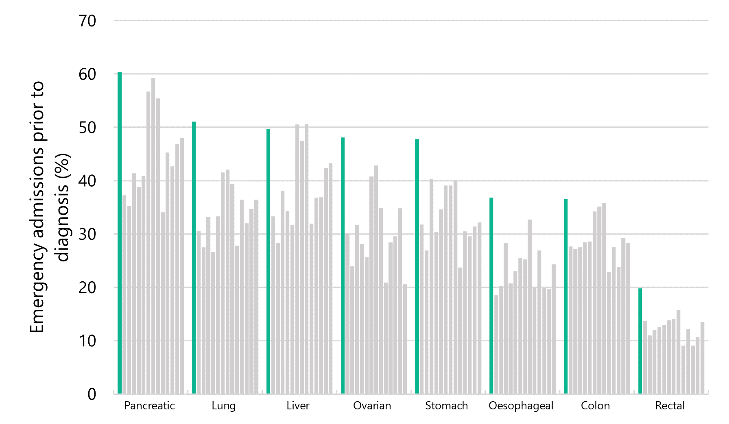
Note: The green bars indicate Aotearoa proportions; the grey bars indicate the other jurisdictions.

Aotearoa New Zealand’s results in this study, in addition to our understanding of poorer outcomes and inequity related to this indicator, give additional weight to the importance of measuring this indicator at a more granular level – for example, by district and ethnicity – to inform next steps in improving our performance against this measure relative to comparable countries.

Brain, pancreatic and lung cancers are among the cancers with the highest rate of emergency diagnosis
The likelihood of emergency admission varies between cancer types. This finding is expected because each cancer has different symptoms or characteristics.

As shown in Figure 2 below, proportions are highest for cancers that are more likely to have sudden onset of severe symptoms requiring urgent treatment, such as some brain and central nervous system cancers, and cancers that can be initially ‘quiet’ or have non-specific symptoms that can then require urgent review, such as pancreatic cancer. However, many other cancer types (like lung, stomach and bladder) can present with symptoms and/or indications that could (should) be detected and managed in the primary care/community setting.
Figure 2: Proportion of emergency admissions by cancer type in Aotearoa, 2017–2021
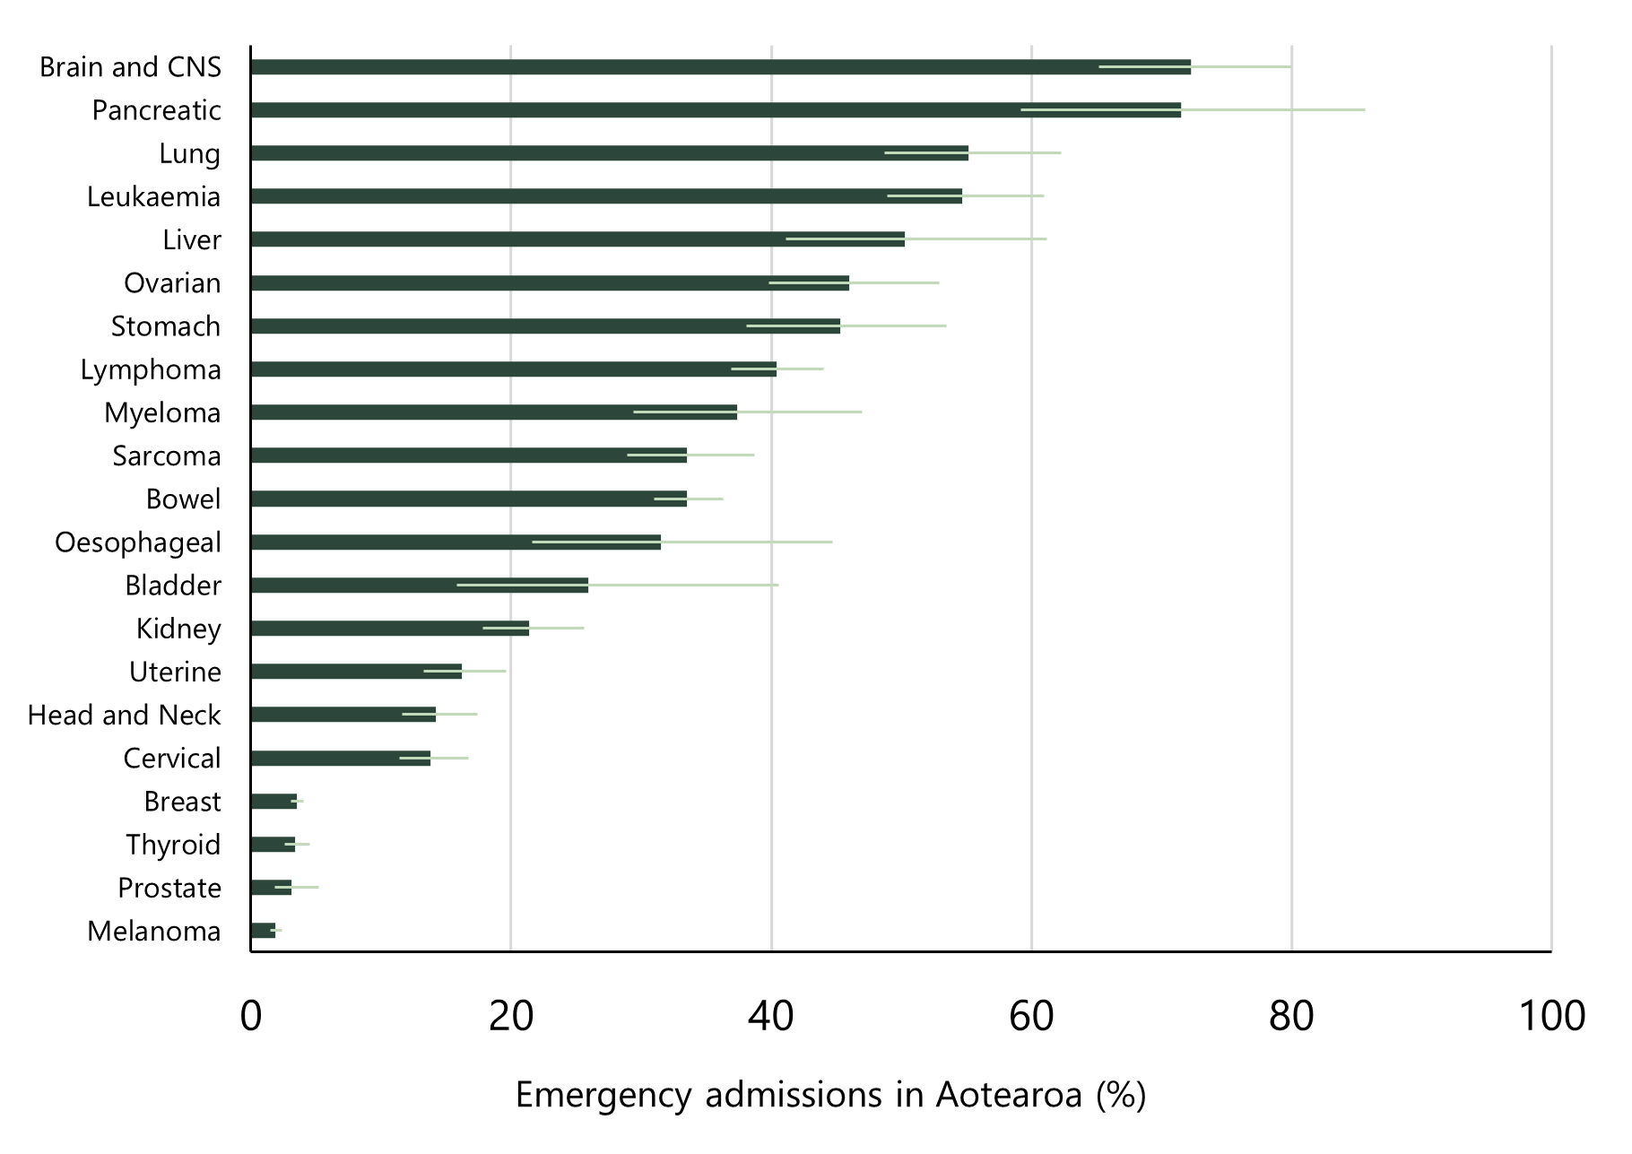
Note: The light green line indicates the 95% confidence interval. CNS = central nervous system.

Impact on experiences and outcomes
Cancer patients diagnosed after an emergency admission to hospital have poorer survival and other outcomes compared to patients with non-emergency diagnoses (Pham et al 2019; Zhou et al 2017), as shown in Figure 3.
Figure 3: Proportion of deaths within 12 months of cancer diagnosis in Aotearoa, by diagnosis following emergency admission and no emergency admission, 2012–2017
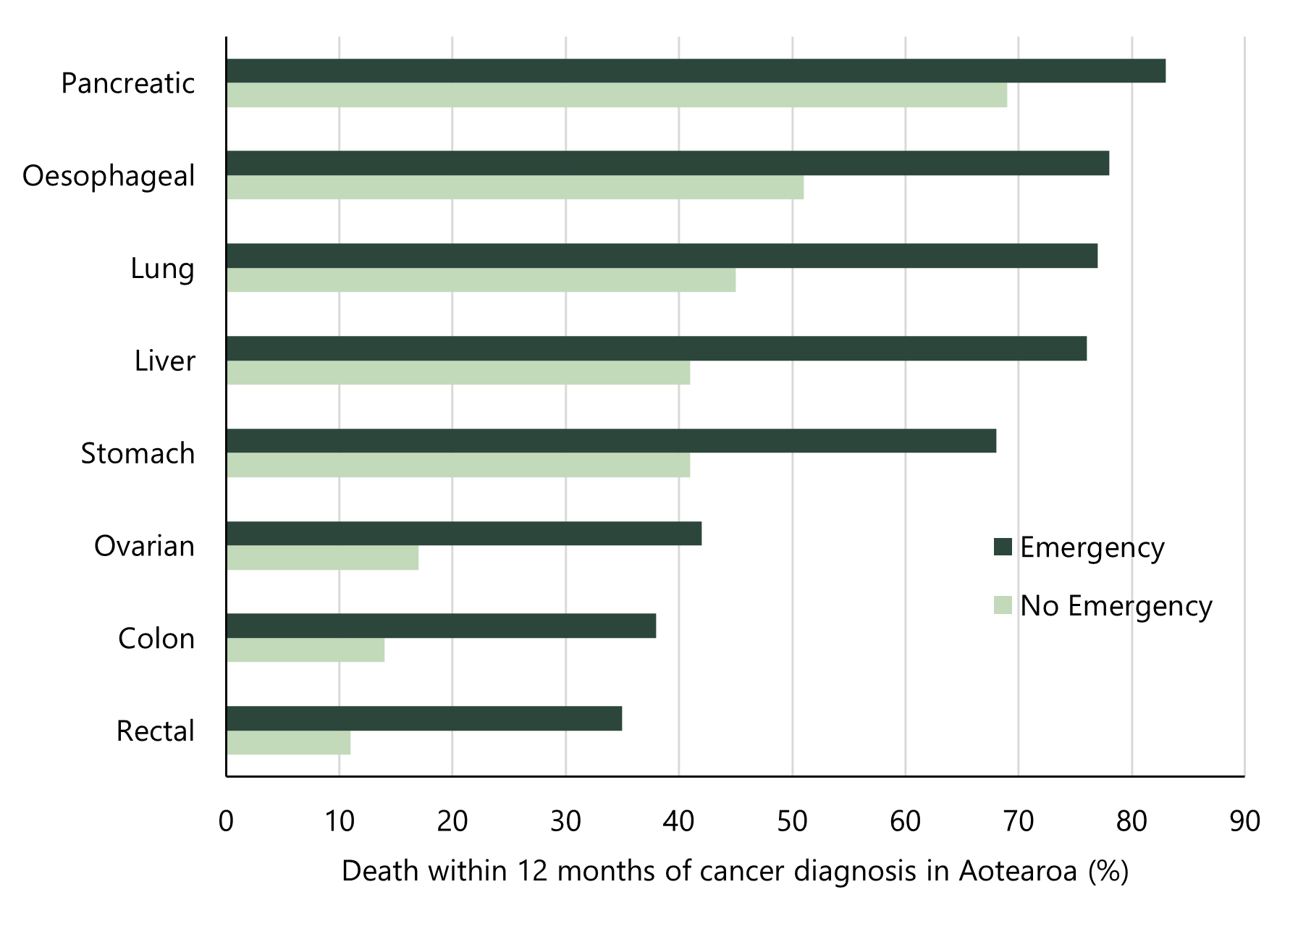
Note: Graph created using data from McPhail et al 2022.

Other outcomes include worse quality of life, worse patient experiences and less-frequent use of treatments with curative intent (Zhou et al 2017). For example, patients diagnosed following an emergency admission are also less likely to receive any anti-cancer treatment, regardless of age, gender, ethnicity, social deprivation, comorbidity, tumour type and tumour stage (Beatty et al 2009). Zhou et al (2017) found that patients with any of the 15 different types of cancers included in the study that were diagnosed through emergency admission had a lower one-year survival compared with those who were diagnosed electively. For example, for colorectal cancer the one-year survival rates for patients diagnosed via an emergency versus elective route were 50% and 82%, respectively. Similarly, for patients with lung cancer the one-year survival rates were 12% and 40%, respectively (Zhou et al 2017).

There are several reasons why people with cancer may be diagnosed soon after an emergency admission. In some cases, emergency admissions may be unavoidable and represent an appropriate treatment pathway. For example, an individual may have minimal symptoms and therefore had no prior contact with the health system (Abel et al 2015), or may have had a relatively sudden onset of symptoms requiring urgent treatment, such as for some central nervous system cancers. Alternatively, in some individuals, symptoms preceded the emergency admission, but clinicians or patients may not have recognised their significance right away (McPhail et al 2022). We can see examples of this in the hui report Rongohia Te Reo, Whatua He Oranga from Thomas and Karen, two patients whose symptoms were not picked up for different reasons. Thomas states:

Now I tell people, ‘If you notice any changes in your body which you are concerned about, go and get checked’. The earlier people are diagnosed the better chance we have of surviving (Te Aho o Te Kahu 2023a).

Karen describes navigating the health system as ‘harder than our ancestors navigating the Pacific’ and two years passing before it was admitted that her diagnosis had been missed.

I kept asking questions but kept being told there was nothing to worry about – that is despite getting sicker and sicker. I was losing weight and turning yellow before they admitted something was wrong (Te Aho o Te Kahu 2023a).

Te Aho o Te Kahu has already examined the proportion of diagnosis after emergency admission for four cancer types: bowel, lung, prostate and pancreatic. For bowel, lung and prostate cancer, the proportion of diagnosis following an emergency presentation (not an emergency admission to hospital) was 26%, 45% and 6%, respectively (Te Aho o Te Kahu 2021 a, b, c). More recently, for pancreatic cancer, where a more specific definition was used (diagnosis with pancreatic cancer within 30 days of an emergency admission to hospital), the proportion was 69% (Te Aho o Te Kahu 2023b).

In our recent lung cancer QPI report, we identified that for lung cancer, New Zealand had high emergency admission rates compared with other countries (36% in Canada, 34% in England and 35% for non-small cell lung cancer in Australia; Te Aho o Te Kahu 2021a).

Māori are more likely to be diagnosed after an emergency admission
Te Tiriti o Waitangi provides an imperative for the Crown to protect and promote the health and wellbeing of Māori, including by responding to and meeting Māori health needs.

In Aotearoa New Zealand, Māori and Pacific peoples have health differences that are not only avoidable but unfair and unjust. We note that a first step in addressing our challenges as a country is to produce information in a way that highlights inequities. Our equity-focused reporting aims to recognise that different people with different levels of advantage require different approaches and resources to experience equitable health outcomes. As noted earlier in the report, people diagnosed in an emergency setting are more likely to have poorer experiences and outcomes compared to patients with non-emergency diagnoses. The information in this report will support targeted work to recognise and improve cancer detection and diagnosis for those who need it most.

Figure 4 compares the total rate of cancer diagnosis following emergency admission between Māori and non-Māori/non-Pacific/non-Asian people (ie, European/other ethnicity), and shows the results by district (where people live).

It shows that, in all districts, Māori are more likely to be diagnosed following an emergency admission compared to people of European/other ethnicity. For example, the figure shows that in Auckland, Māori are twice as likely to be diagnosed following an emergency admission compared to people of European/other ethnicity. These results are not surprising given Māori are less likely than people of European/other ethnicity to have reliable access to primary care services and other supports that decrease the likelihood of late stage, emergency admission based diagnoses.

The standardised ratios for all cancers combined by district (Figure 4) indicates the difference in proportion of diagnoses following emergency admission for Māori compared to people of European/other ethnicity (not including Pacific peoples or Asian people).

For the West Coast and South Canterbury districts, the error bars are wider than others and cross 1. One reason for this is smaller case numbers for Māori in those areas, and while less statistically certain there is likely to be an inequitable ratio for Māori in these areas.

Figure 4: Māori compared to European/other ethnicity emergency admission for all cancers combined, by district of residence. Points represent the standardised ratio, and lines represent the 95% confidence interval.
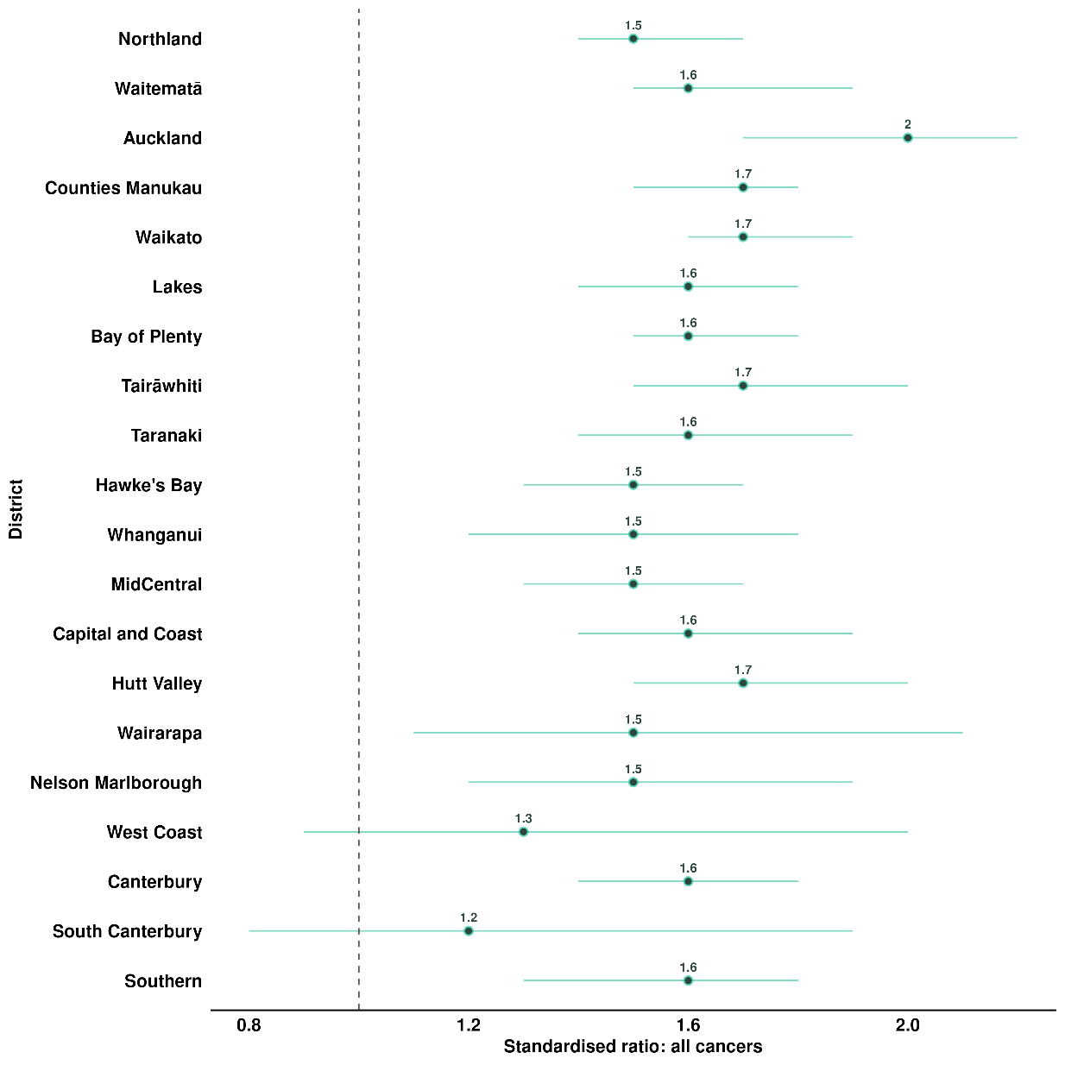

Table 1 presents age-standardised proportions of people diagnosed following an emergency admission by ethnicity. For the majority of cancer types included in this report, as found above, there was a higher proportion of Māori diagnosed following an emergency admission compared to the total population. Similarly, higher proportions were found for Pacific peoples across cancer types (noting that for some cancer types there were small case numbers for Pacific peoples, so the data should be interpreted with caution). More detailed information about case numbers can be found in Appendix D.

Looking more closely at the four most commonly diagnosed cancers among Māori (Te Aho o Te Kahu 2021a):
- For Māori diagnosed with lung cancer, 67.5% were diagnosed following an emergency admission, compared with 47.9% of people of European/other ethnicity.
- For Māori diagnosed with bowel cancer, 47% were diagnosed following an emergency admission, compared with 30.6% of people of European/other ethnicity.
- For Māori diagnosed with breast cancer, 4.2% were diagnosed following an emergency admission, compared with 2.8% of people of European/other ethnicity.
- For Māori diagnosed with prostate cancer, 8.3% were diagnosed following an admission, compared with 2.1% of people of European/other ethnicity.

Looking more closely at the four most commonly diagnosed cancers among Pacific peoples (Te Aho o Te Kahu 2021a):
- For Pacific peoples diagnosed with lung cancer, 72.6% were diagnosed following an emergency admission, compared with 46% of people of European/other ethnicity.
- For Pacific peoples diagnosed with uterine cancer, 27.4% were diagnosed following an emergency admission, compared with 6.7% of people of European/other ethnicity.
- For Pacific peoples diagnosed with breast cancer, 7.3% were diagnosed following an emergency admission, compared with 2.8% of people of European/other ethnicity.
- For Pacific peoples diagnosed with prostate cancer, 24.5% were diagnosed following an emergency admission, compared with 2.1% of people of European/other ethnicity.
Table 1: Age-standardised proportions (%) of people diagnosed within 30 days of an emergency admission by cancer types, by ethnic group
 |  | Ethnic group
 | Total |  | Māori | Pacific peoples | Asian | European/  other
Cancer type
All cancers | 20.7%  (20.1–21.2) |  | 31.1%  (29.3–32.9) | 33.4%  (30.9–36.1) | 20.9%  (19.3–22.7) | 16.8%  (16.2–17.5)
Bladder cancer | 25.9%  (15.8–40.7) |  | 39.8%  (15.3–87.3) | 26%  (6.3–75.8) | 1.3%  (0.5–96.3) | 24.6%  (12–45.6)
Bowel cancer | 33.5%  (30.9–36.2) |  | 47%  (38.2–57.3) | 52.7%  (39.8–68.6) | 30.9%  (22.7–41.4) | 30.6%  (27.8–33.6)
Brain and central nervous system cancer | 72.3%  (65.2–80) |  | 82.5%  (60.3–110.7) | 66%  (38.3–108.1) | 84.2%  (61–114) | 69.5%  (61.5–78.3)
Breast cancer | 3.5%  (3.1–4) |  | 4.2%  (3–5.6) | 7.3%  (5.1–10.2) | 4.1%  (2.8–5.8) | 2.8%  (2.3–3.4)
Cervical cancer | 13.9%  (11.4–16.8) |  | 21.9%  (15.1–30.7) | 30.7%  (17.4–50.5) | 10%  (4.9–18.6) | 10.3%  (7.6–13.6)
Head and neck cancer | 14.2%  (11.6–17.4) |  | 26.1%  (17.4–37.7) | 22%  (12–37.6) | 10%  (4.9–18.6) | 11.4%  (8.4–15.1)
Kidney cancer | 21.4%  (17.8–25.6) |  | 32.2%  (22.4–45.2) | 20%  (9.8–38.3) | 16.6%  (8.6–29.6) | 19.4%  (15–24.7)
Leukaemia | 54.7%  (48.9–61) |  | 63.1%  (49.8–78.9) | 71.2%  (53.7–92.8) | 64.6%  (48–85.4) | 47.6%  (40.3–55.8)
Liver cancer | 50.3%  (41.1–61.2) |  | 58.8%  (40.8–82.5) | 70.6%  (46.1–104.1) | 40.9%  (22–70.4) | 37.8%  (25.6–54.4)
Lung cancer | 56.5%  (50.2–63.3) |  | 67.5%  (54.4–82.9) | 72.6%  (54–96) | 49.3%  (35.8–66.4) | 47.9%  (39.4–57.9)
Lymphoma | 40.4%  (36.9–44) |  | 52.2%  (42.4–63.6) | 49.8%  (34.7–69.9) | 45.8%  (36.6–56.7) | 35.7%  (31.7–40)
Melanoma | 1.9%  (1.5–2.4) |  | 1.7%  (0.9–5.8) | 16.1%  (0.5–87) | 7.7%  (0.8–32.9) | 1.8%  (1.4–2.4)
Myeloma | 37.4%  (29.4–47) |  | 51.6%  (33.7–76.2) | 37.2%  (16.8–73.4) | 52.1%  (21.3–108.8) | 29.1%  (20.1–41.2)
Neuroendocrine tumours (NETs) | 54.3%  (47.9–61.4) |  | 63.1%  (50.1–78.7) | 58.2%  (37.8–86.3) | 31.8%  (16.3–56.9) | 52.9%  (44.6–62.5)
NETs (poorly differentiated) | 51.7%  (31.2–81.5) |  | 61.5%  (11.7–195) | 91.7%  (5.6–443.2) | 39.3%  (5.2–156.4) | 50%  (26.6–87.1)
NETs (moderately differentiated) | 46.7%  (33.1–64.3) |  | 60.8%  (30.6–109.1) | 32.7%  (4.6–113.7) | 0.9%  (0–100.7) | 46.5%  (29.7–69.8)
NETs (well differentiated) | 58.9%  (50.2–68.8) |  | 65.5%  (49.4–85.5) | 62.5%  (36.6–100.5) | 35.4%  (15–72.5) | 59.1%  (47.3–73.2)
NETs (other) | 44.2%  (30.4–62.4) |  | 58.1%  (29.2–104.9) | 51.5%  (11.8–152.2) | 37.2%  (3.9–156.8) | 38.3%  (22.3–62.1)
Oesophageal cancer | 31.5%  (21.6–44.8) |  | 32.3%  (11.4–75.9) | 30%  (4.6–116.5) | 32.1%  (9.7–81.4) | 30.2%  (18.2–47.7)
Ovarian cancer | 46%  (39.8–52.9) |  | 67%  (48.9–89.9) | 53.9%  (35.2–79.5) | 39%  (26.9–55.4) | 40.9%  (33.2–50.1)
Pancreatic cancer | 71.5%  (59.2–85.7) |  | 75.4%  (51.1–108.1) | 86.5%  (48.2–145.1) | 69%  (34.7–125.7) | 67.4%  (51.8–86.8)
Prostate cancer | 3.1%  (1.8–5.2) |  | 8.3%  (1.7–25.7) | 24.5%  (4–82) | 0.9%  (0.6–32.3) | 2.1%  (1–4.1)
Sarcoma | 33.5%  (28.9–38.7) |  | 45.4%  (34.9–58.3) | 30.5%  (20–45.2) | 29.4%  (18.5–44.8) | 30.3%  (24.1–37.8)
Stomach cancer | 45.3%  (38.1–53.5) |  | 49.5%  (37.1–65) | 63.3%  (43.7–89.4) | 47.8%  (30–73) | 34.2%  (24.2–47.3)
Thyroid cancer | 3.4%  (2.6–4.5) |  | 5.3%  (2.8–9.5) | 9%  (4.6–16.4) | 2%  (0.9–4.1) | 2.7%  (1.8–4.3)
Uterine cancer | 16.2%  (13.3–19.6) |  | 18%  (11.3–27.4) | 27.4%  (21.4–34.7) | 8.8%  (4–17.5) | 6.7%  (3.7–11.4)
Figures between parentheses represent the 95 percent confidence intervals.
Sources: New Zealand Cancer Registry (NZCR) and National Minimum Dataset (NMDS; hospital events)
Note: Age standardised to the 2001 Census Māori population. Figures in parentheses represent 95% confidence intervals.

Many factors may contribute to high emergency department diagnosis rates

What are some of the causal factors?
When someone develops cancer, it is important for them to be diagnosed as early as possible, through an established referral pathway, starting in primary and community care. They should also be supported by a health service that is culturally safe and trusted by the person and their whānau.

Understanding precursors or causal factors is an important part of determining where to act to improve (reduce) our rates of cancer diagnosis following emergency admission. There are a range of factors that lead to a person receiving a cancer diagnosis following an emergency admission to a hospital. Understanding these precursors or causal factors is an important part of determining where to act to identify cancer earlier and improve survival rates and treatment experiences for patients. Figure 5 lists some of the causal factors identified through research.

Figure 5: Factors that contribute to a cancer diagnosis following an emergency admission
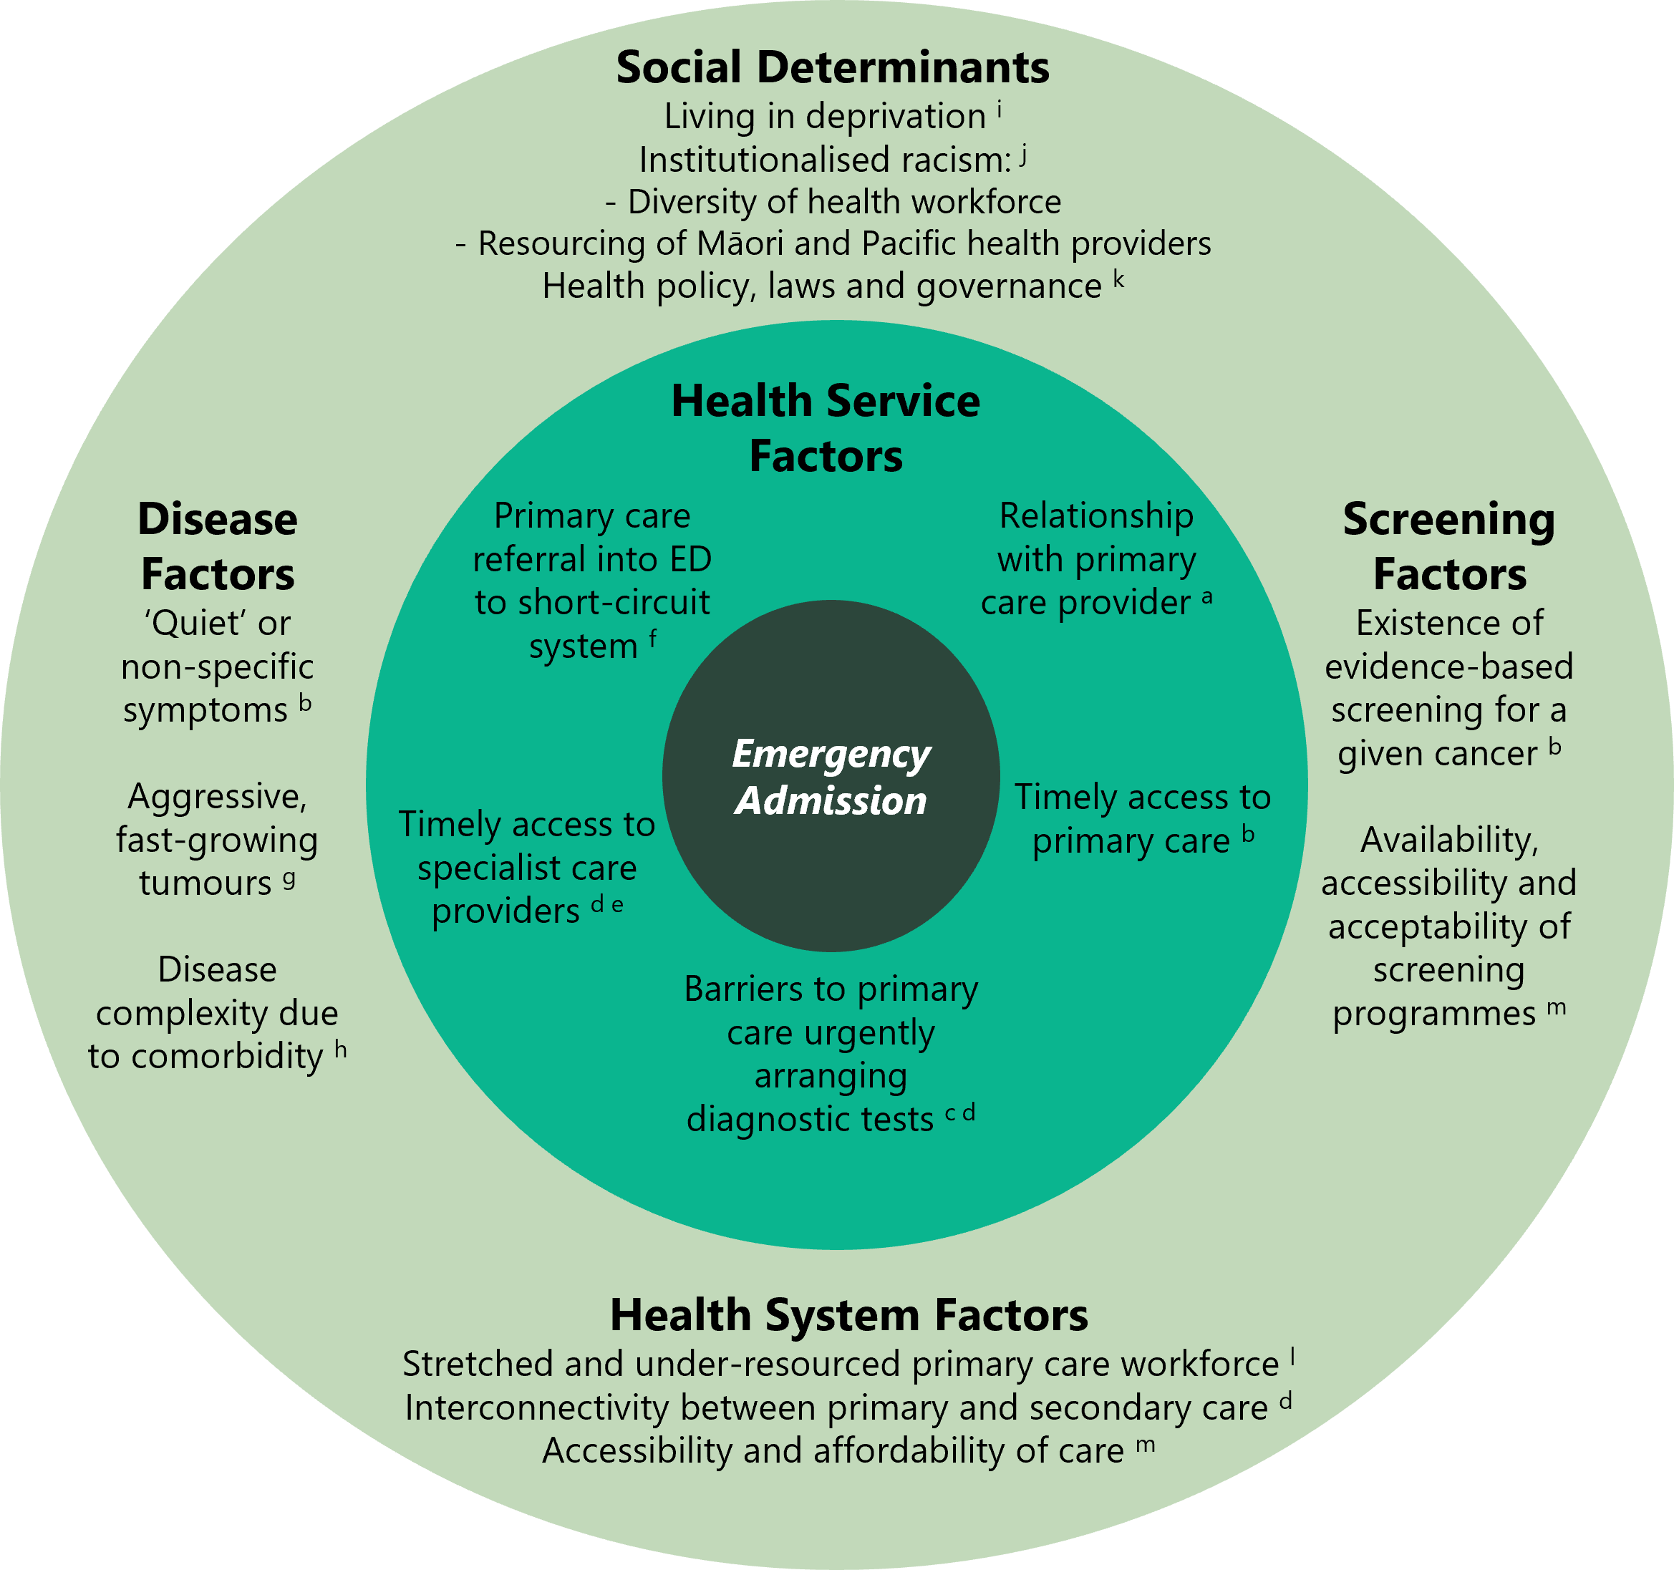
Notes:
a) (Cassim et al 2019)
b) (McPhail et al 2022)
c) (Htun et al 2017)
d) (Nekhlyudov and Latosinsky 2010)
e) (Murchie et al 2017)
f) (Beatty et al 2009)
g) (Lyratzopoulos et al 2014)
h) (Majano et al 2022)
i) (Abel et al 2015)
j) (Waitangi Tribunal 2019)
k) (Liberman J 2019)
l) (Grimmond et al 2021)
m) (Meheus et al 2019).

With this initial understanding of the causal factors that contribute to a higher proportion of emergency presentations, we can further explore the opportunities for the health sector to improve cancer early detection and diagnosis.

What are some of the potential solutions?
When someone develops cancer, it is important for them to be diagnosed as early as possible, through an established referral pathway, starting in primary and community care. They should also be supported by a health service that is culturally safe and trusted by the person and their whānau.

Several factors that impact the diagnosis of cancer, such as workforce shortages and institutional racism, also affect the entire health system. These issues are well known and are being addressed at the national, regional and local level.

Within the path to cancer diagnosis, there are key opportunities and initiatives to develop and build on, some already underway and some requiring further investigation. Figure 6 outlines example actions along the path to diagnosis. It highlights, alongside the causal factors outlined in Figure 5, the complexity of health system and other factors leading to a high proportion of emergency admissions.

Te Aho o Te Kahu carried out this analysis to understand how different locations and population groups, such as age groups and ethnicities, are affected by diagnosis after emergency admission. The results will be used to inform discussions with Health New Zealand | Te Whatu Ora, community and primary health care providers (eg, GPs, pharmacists) and other key agencies, on ways to improve cancer detection and diagnosis processes and reduce cancer diagnoses via emergency admission across Aotearoa New Zealand.

Figure 6: The path to diagnosis showing possible areas of focus to improve early cancer detection and diagnosis, with examples of opportunities
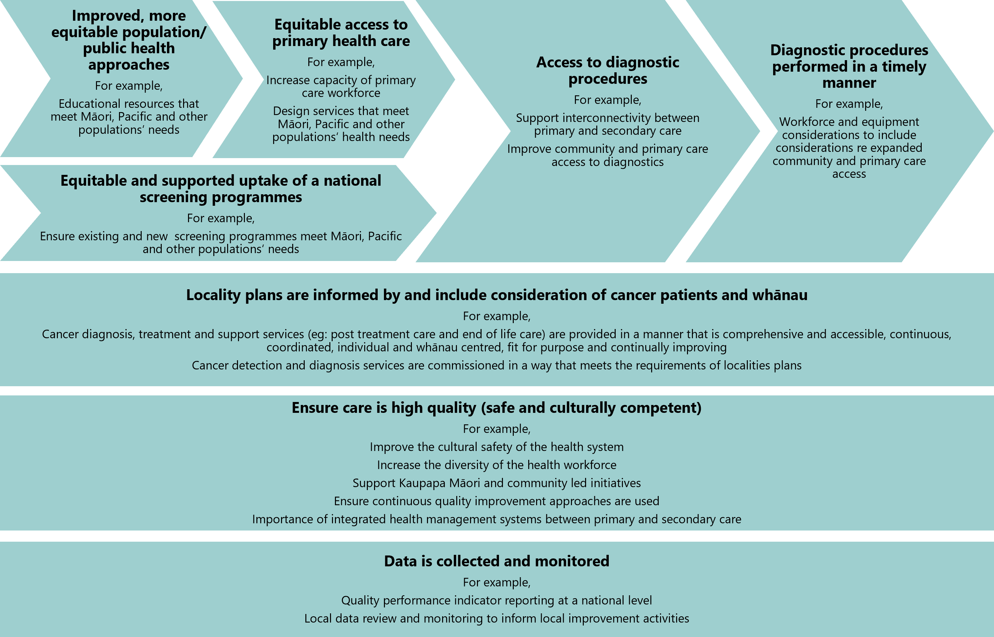

How to use the remainder of this report
The next section describes reports on the ‘Route to diagnosis’ indicator by cancer type. The intention of the results are to highlight differences between districts at a specific cancer type for this indicator. For each of the 22 cancer types reported, the results are presented in two sections:
- Bar charts that show the age-standardised data stratified by ethnicity, deprivation, sex and rurality
- Funnel plots that demonstrate differences between districts.

Funnel plots are used to show variation between districts and visually depict when a district falls outside of the 95% limits. We plotted the proportions for each district along with the total number of patients used to estimate the proportion. The average across all districts appears as a green line; this is not an evidence-based best practice target or a benchmark – it is the national average.

Where the funnel plots show that a district’s performance varies in an unfavourable way compared to others, clinicians, health care managers, commissioners and those focused on health care QI should investigate whether this variation is unwarranted and identify appropriate QI actions based on their local context and priorities. Alongside each funnel plot, data by demographic characteristic (eg, ethnicity) is provided to further identify differences between groups that may need attention.

Note to readers about the confidence intervals shown in this report
Confidence intervals are most used when working with sample data to estimate how likely it is that the result is true of the whole population. Therefore, confidence intervals are often used to decide if a difference between two groups being looked at is likely to be a true difference (if the confidence intervals overlap, there may not be a true difference). This report uses whole population data (ie, it is not a sample), so confidence intervals should be interpreted differently. They are presented in this report to give an impression of what variation there may be over time (rather than the likelihood the result is true). Therefore, overlapping confidence intervals do not indicate the absence of a difference between compared groups.

The methods used in this report involved analysing patient data obtained from administrative data sets maintained by Health New Zealand, which included the New Zealand Cancer Registry (NZCR) and the National Minimum Dataset (NMDS).
Statistical analysis was primarily descriptive, with results presented as percentages and grouped by age, sex, ethnicity, extent of disease at diagnosis, socioeconomic deprivation, rural–urban status, and districts.

Age standardisation was used to compare ethnicity, sex, deprivation quintiles and rural–urban status. Moreover, standardised ratios were calculated to identify equity gaps between Māori and other ethnic groups in district areas.

At the time of publishing this report, district health boards have been disestablished (as part of the 1 July 2022 health and disability sector reforms). For consistency, this report uses the term ‘district’ throughout, including in data tables, graphs and some commentary, even though the data used is from a time when district health boards were in existence (1 January 2017 to 31 December 2021).

For confidentiality, we have not presented results when there are fewer than six patients in a group. This is to ensure adequate privacy and confidentiality for patients and providers. We have not included values in columns where the numbers can be added across columns to a number lower than six even if the value is above five. More information as to this approach can be found on the Stats NZ website (Stats NZ 2019).

For more detailed information on the methods, please refer to Appendix A.

The technical specifications are provided at Appendix B.

Appendix C provides information about differences between this report and other similar reports/indicators/analysis.

Appendix D provides the data behind the bar charts and funnel plots in two tables for each cancer type:
- people diagnosed with specific cancer following emergency admission, by year of diagnosis, sex, age group, ethnicity, deprivation quintile (according to the New Zealand Deprivation Index 2018 (NZDep2018)) and rural–urban status
- people diagnosed with specific cancer following emergency admission, by district of residence.

Presenting the same or similar data in multiple formats enables reviewers coming from different perspectives to glean information from the data that is most relevant, depending on their interest or viewpoint.

Results by cancer type

Bladder cancer
There were 2,210 people diagnosed with bladder cancer between 2017 and 2021, with 26.6% diagnosed in the 30 days following an emergency admission. The proportion was higher for women than for men (37.5% compared to 21.3%, respectively), and for Māori (39.8%) compared with people of European/other ethnicity (24.6%) (Figure 7).

Figure 7: Proportion of people diagnosed with bladder cancer in the 30 days following emergency admission, by sex, ethnicity, NZDep2018 quintile, rural–urban status (all age-standardised), and age (non-standardised) for the years 2017–2021
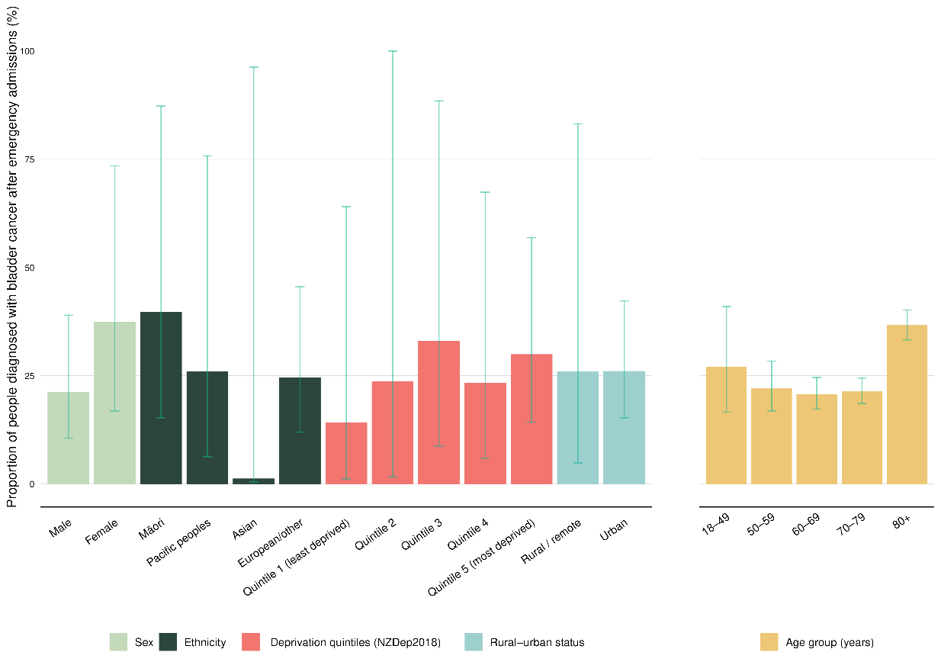
Note: See Appendix D for more detailed information. Confidence intervals are presented to indicate potential variation over time. Overlapping confidence intervals do not indicate an absence of differences between compared groups.

There was a broad range of proportions across districts, ranging from 20.6% diagnosed in the 30 days following an emergency admission in Taranaki to 37.5% in MidCentral. There were no districts outside the 99.8% limits, with MidCentral alone sitting above the 95% upper limit (Figure 8).
Figure 8: Funnel plot showing proportion of people diagnosed with bladder cancer in the 30 days following emergency admission, by district of residence, for the years 2017–2021 (un-standardised)
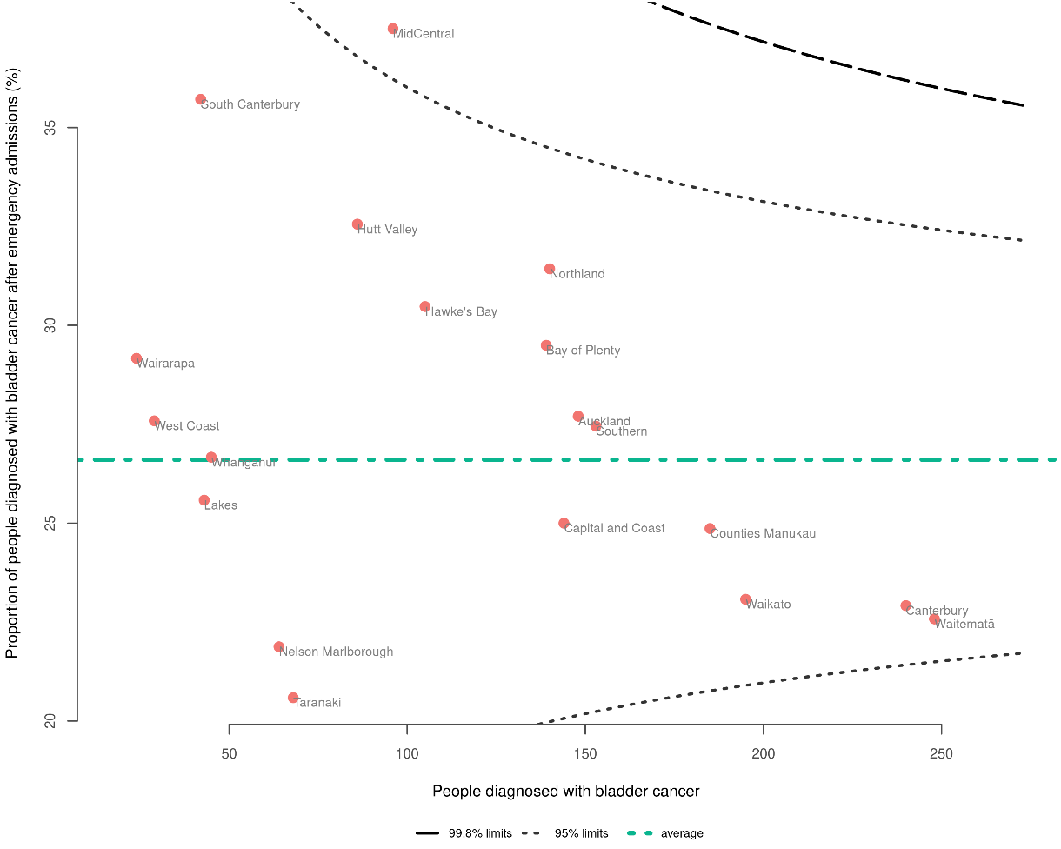
Note: See Appendix D for more detailed information.

Bowel cancer
There were 15,139 people diagnosed with bowel cancer between 2017 and 2021. Overall, 30.1% of those people were diagnosed in the 30 days following an emergency admission.

Pacific peoples and Māori were more commonly diagnosed following an emergency admission compared with other ethnicities. There was a proportion of 52.7% for Pacific peoples and 47% for Māori compared with 30.6% for people of European/other ethnicity. There was a higher number of men than women with bowel cancer; however, there was an indication that more females presented following an emergency admission (35.3%) compared to males (31.6%) (Figure 9).

Figure 9: Proportion of people diagnosed with bowel cancer in the 30 days following emergency admission, by sex, ethnicity, NZDep2018 quintile, rural–urban status (all age-standardised), and age (non-standardised) for the years 2017–2021
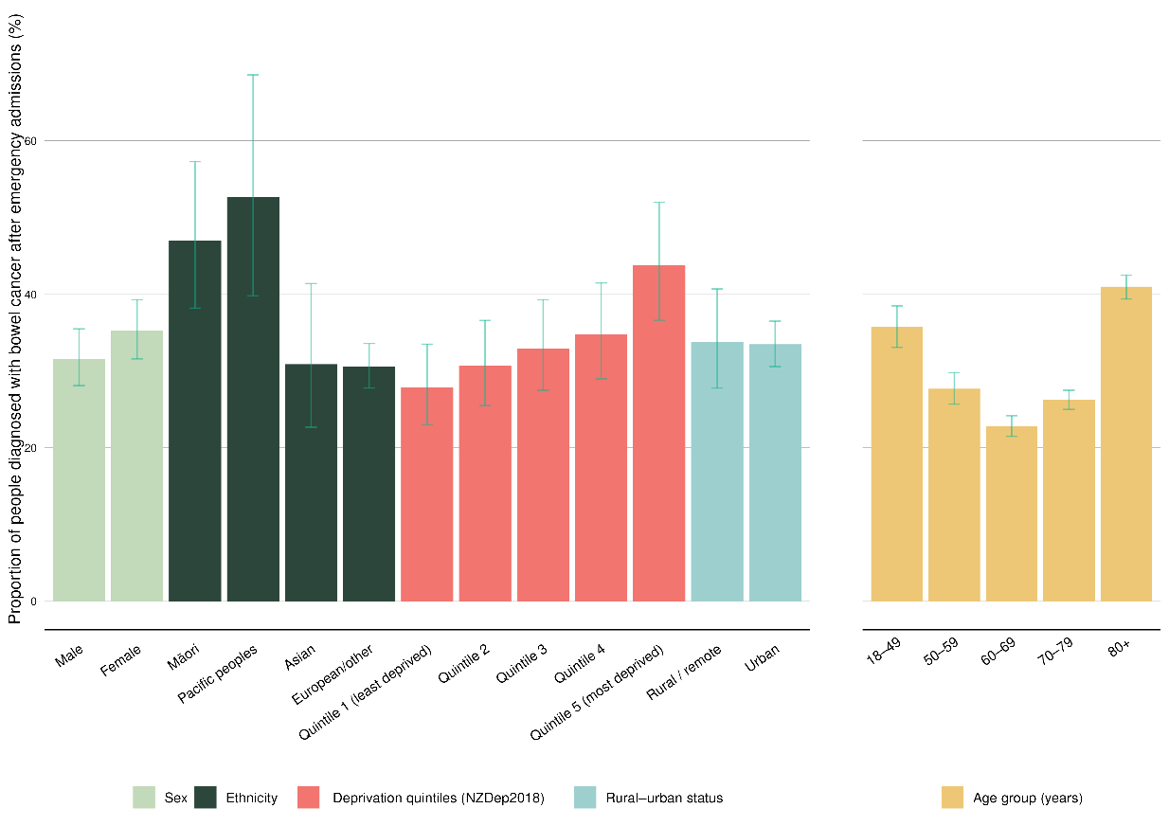
Note: See Appendix D for more detailed information. Confidence intervals are presented to indicate potential variation over time. Overlapping confidence intervals do not indicate an absence of differences between compared groups.

Tairāwhiti was above the upper 95% limit line with a proportion of 40.7%; however, numbers of people diagnosed in this district were smaller than in many districts. Nelson Marlborough sat below the lower 95% limit, having a smaller proportion than other districts, with 25.3% people being diagnosed in the 30 days after an emergency admission (Figure 10).

As part of the cancer QPI programme, we published the Bowel Cancer Quality Improvement Monitoring Report Update 2022 (Te Aho o Te Kahu 2022), which provides quality performance indicators specific to bowel cancer, including route to diagnosis. Note that the time period of data included and the definition of ‘emergency admission’ (see Table 2 in Appendix C) differ between reports, therefore variation in data will be seen.

Figure 10: Funnel plot showing proportion of people diagnosed with bowel cancer in the 30 days following emergency admission, by district of residence, for the years 2017–2021 (un-standardised)
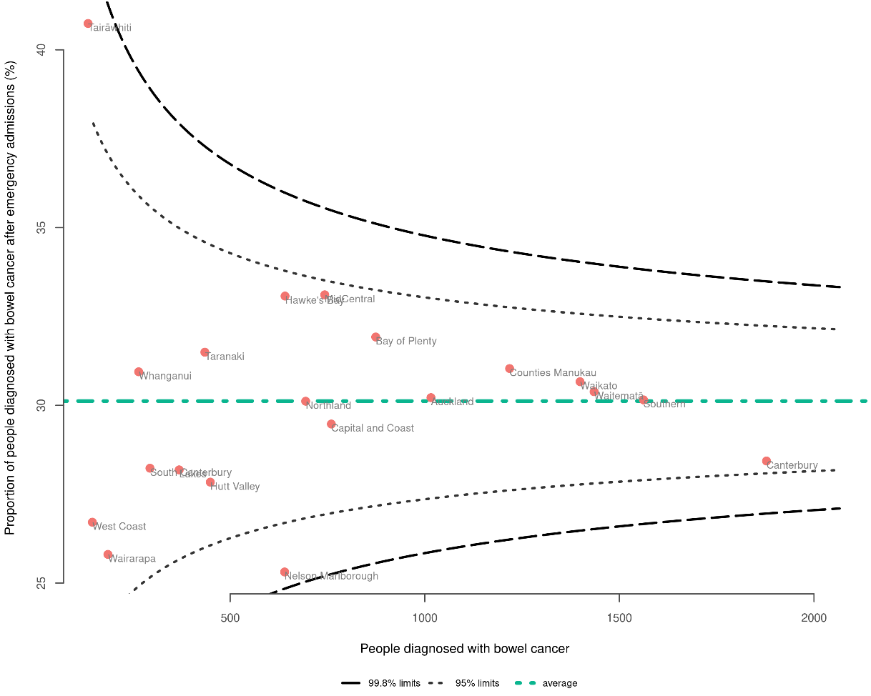
Note: See Appendix D for more detailed information.

Brain and central nervous system cancers
There were 1,571 people diagnosed with brain and central nervous system (CNS) cancer between 2017 and 2021. Overall, 81.5% of those people were diagnosed in the 30 days following an emergency admission. This high proportion likely reflects the acute nature of presentation of this cancer type and the urgency often required for investigation and treatment, which may require an acute admission to hospital. There was minimal variation between ethnicities, deprivation quintiles, sex, rurality and age with the exception of people aged 18–49, who had a slightly lower proportion of 68.5% (Figure 11).

Figure 11: Proportion of people diagnosed with brain and central nervous system (CNS) cancer in the 30 days following emergency admission, by sex, ethnicity, NZDep2018 quintile, rural–urban status (all age-standardised), and age (non-standardised) for the years 2017–2021
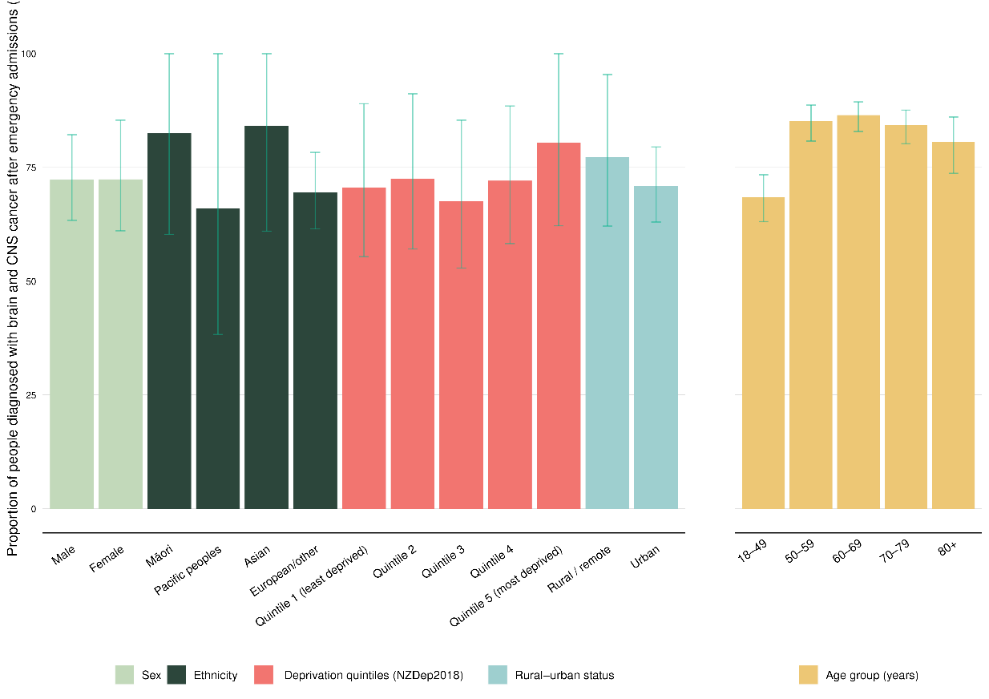
Note: See Appendix D for more detailed information. Confidence intervals are presented to indicate potential variation over time. Overlapping confidence intervals do not indicate an absence of differences between compared groups.

Canterbury had the lowest proportion of diagnoses in the 30 days after an emergency admission at 66.8%. The overall average was high, with two districts above the upper 95% limit line – Hawke’s Bay at 92.1% and Waitematā at 88.1% (Figure 12).
Figure 12: Funnel plot showing proportion of people diagnosed with brain and central nervous system cancer in the 30 days following emergency admission, by district of residence, for the years 2017–2021 (un-standardised)
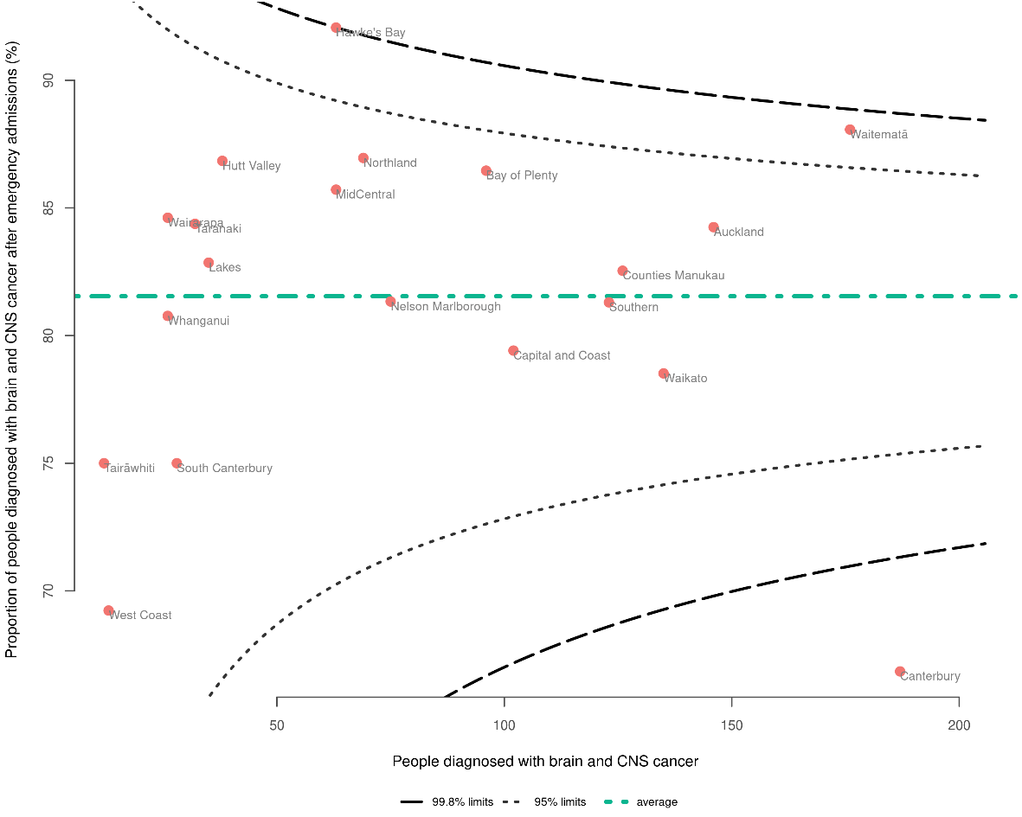
Note: See Appendix D for more detailed information.

Breast cancer
There were 17,301 people diagnosed with breast cancer between 2017 and 2021. Overall, 4.4% of those people were diagnosed in the 30 days following an emergency admission. Pacific peoples in particular were more commonly diagnosed following an emergency admission (7.3%) compared with Māori (4.2%), Asian people (4.1%) and people of European/other ethnicity (2.8%). People aged 80+ were more likely to be diagnosed after an emergency admission (11.2%) compared with younger people. People living in areas of higher deprivation also had a higher proportion compared to people in the least deprived areas (Figure 13).

Figure 13: Proportion of people diagnosed with breast cancer in the 30 days following emergency admission, by sex, ethnicity, NZDep2018 quintile, rural–urban status (all age-standardised), and age (non-standardised) for the years 2017–2021
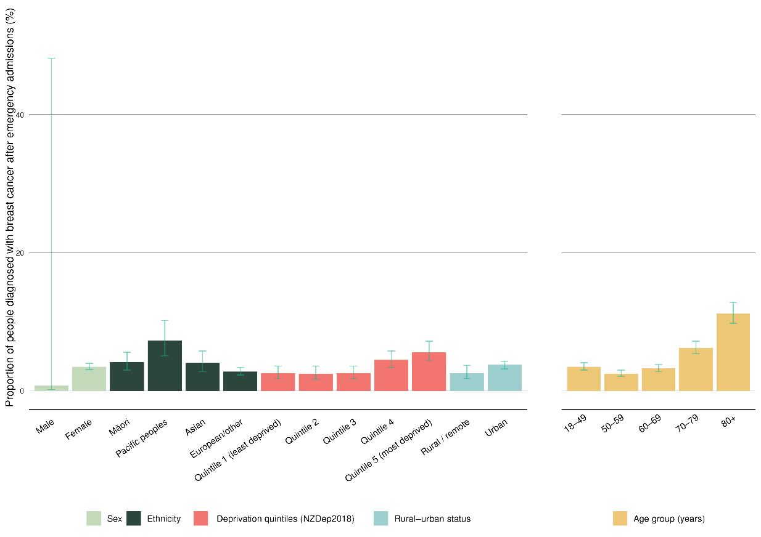
Note: See Appendix D for more detailed information. Confidence intervals are presented to indicate potential variation over time. Overlapping confidence intervals do not indicate an absence of differences between compared groups.

Two districts were below the lower 95% limit – Bay of Plenty (3.1%) and Canterbury (3.1%) – with no districts above the upper 95% limit and all districts sitting within a 2.9% to 5.7% proportion range (Figure 14).

Figure 14: Funnel plot showing proportion of people diagnosed with breast cancer in the 30 days following emergency admission, by district of residence, for the years 2017–2021 (un-standardised)
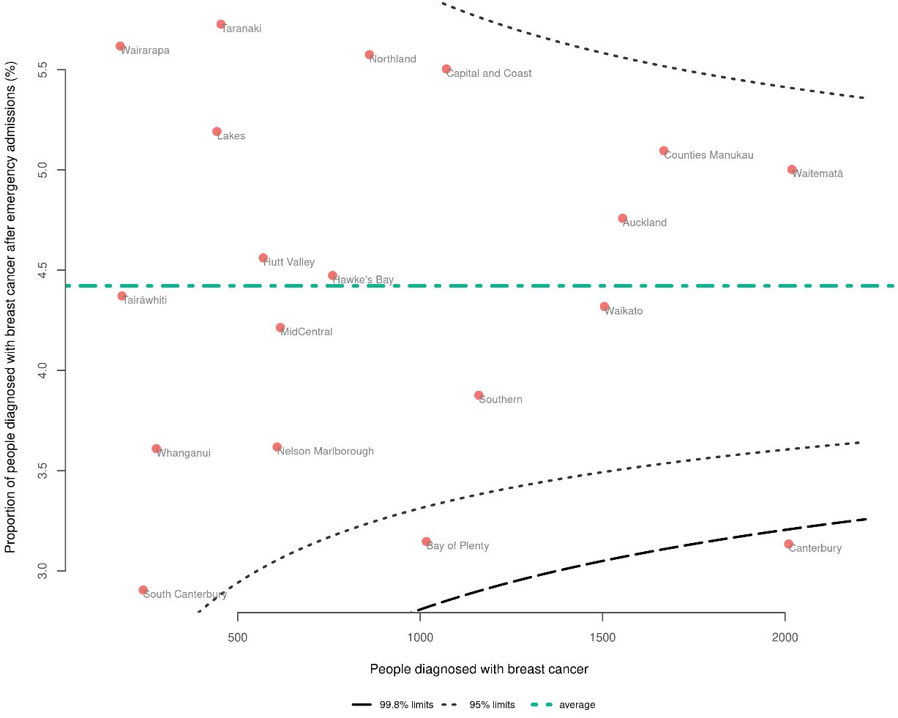
Note: See Appendix D for more detailed information.

Cervical cancer
There were 863 people diagnosed with cervical cancer between 2017 and 2021. Overall, 15.5% of those people were diagnosed in the 30 days following an emergency admission. Women aged 80+ were more likely to be diagnosed following an emergency admission; however, the small numbers mean this information should be interpreted with caution (see Appendix D, which includes information about actual numbers/volumes, as opposed to the proportions illustrated in Figure 15 below). Pacific women and wāhine Māori had higher proportions (30.7% and 21.9%, respectively) than Asian women and women of European/other ethnicity (10.0% and 10.3%, respectively) (Figure 15).

Figure 15: Proportion of people diagnosed with cervical cancer in the 30 days following emergency admission, by sex, ethnicity, NZDep2018 quintile, rural–urban status (all age-standardised), and age (non-standardised) for the years 2017–2021
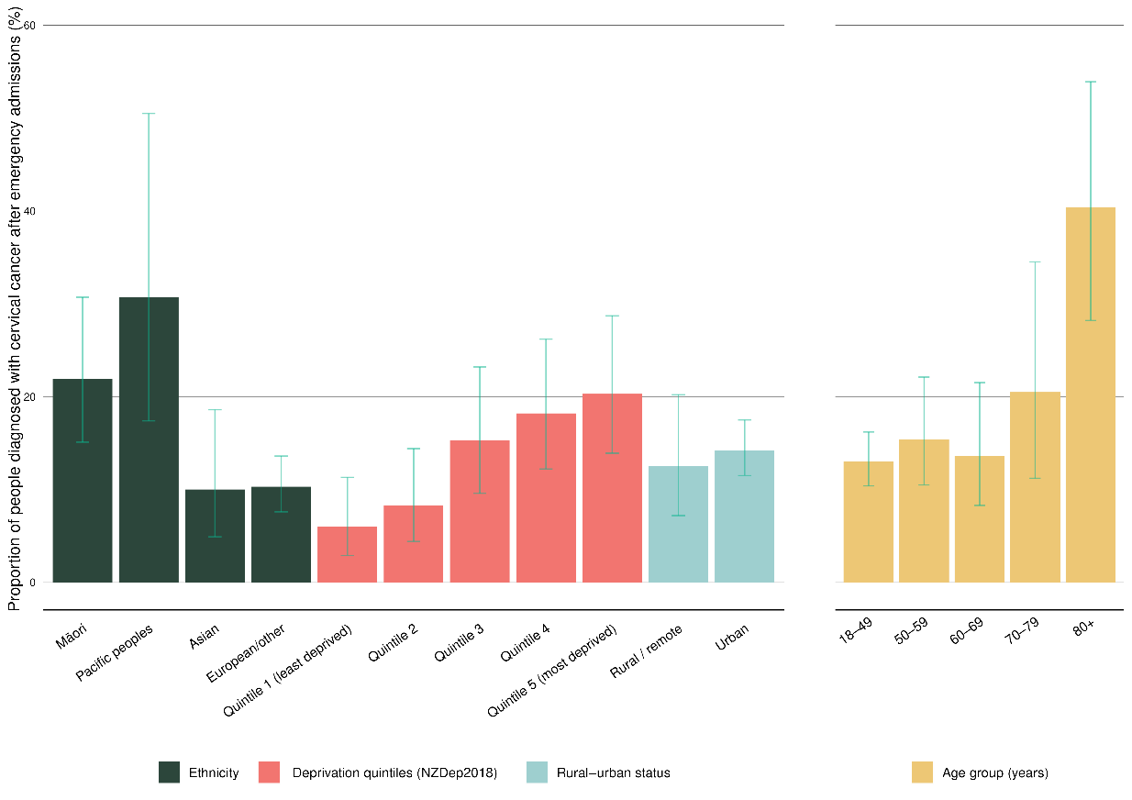
Note: See Appendix D for more detailed information. Confidence intervals are presented to indicate potential variation over time. Overlapping confidence intervals do not indicate an absence of differences between compared groups.

Due to small case numbers in many districts, a funnel plot is not presented for cervical cancer; however, additional information can be found in Appendix D.

Head and neck cancer
There were 3,361 people diagnosed with head and neck cancer between 2017 and 2021. Overall, 12.5% of those people were diagnosed in the 30 days following an emergency admission. Although the numbers are small, Māori and Pacific peoples were more commonly diagnosed following an emergency admission (26.1% and 22.0%, respectively) compared to people of European/other ethnicity (11.4%) (Figure 16).

Figure 16: Proportion of people diagnosed with head and neck cancer in the 30 days following emergency admission, by sex, ethnicity, NZDep2018 quintile, rural–urban status (all age-standardised), and age (non-standardised) for the years 2017–2021
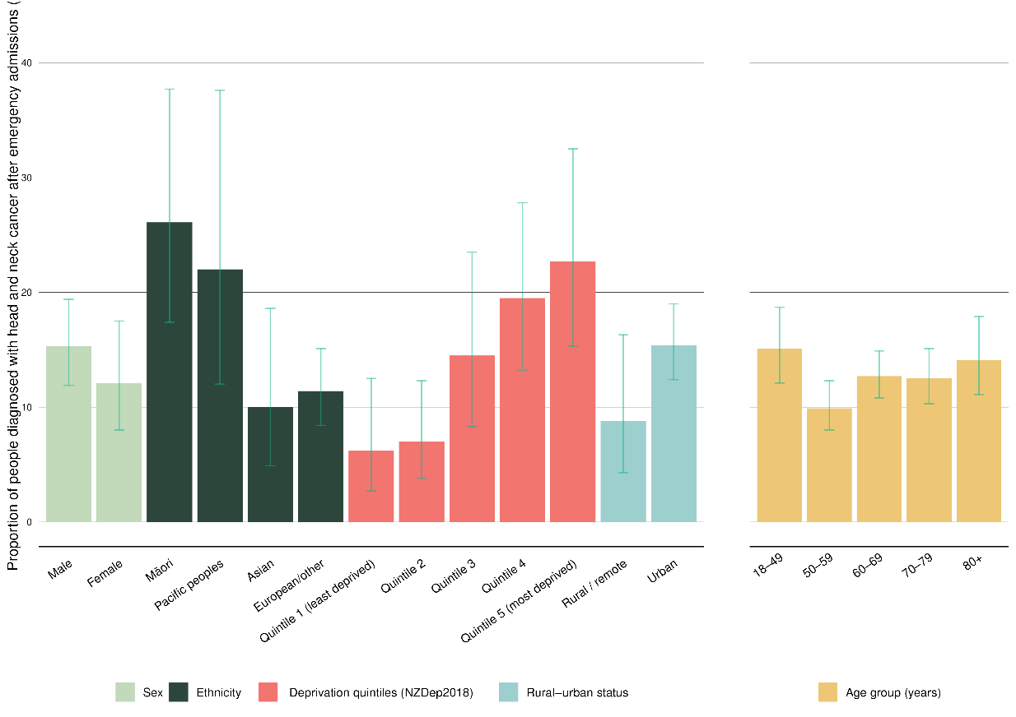
Note: See Appendix D for more detailed information. Confidence intervals are presented to indicate potential variation over time. Overlapping confidence intervals do not indicate an absence of differences between compared groups.

There was a generally narrow spread between districts – from 8.0% to 16.6% – with Tairāwhiti an outlier above the upper 95% limit. However, numbers in this district were small, so this data should be interpreted with caution (Figure 17).
Figure 17: Funnel plot showing proportion of people diagnosed with head and neck cancer in the 30 days following emergency admission, by district of residence, for the years 2017–2021 (un-standardised)
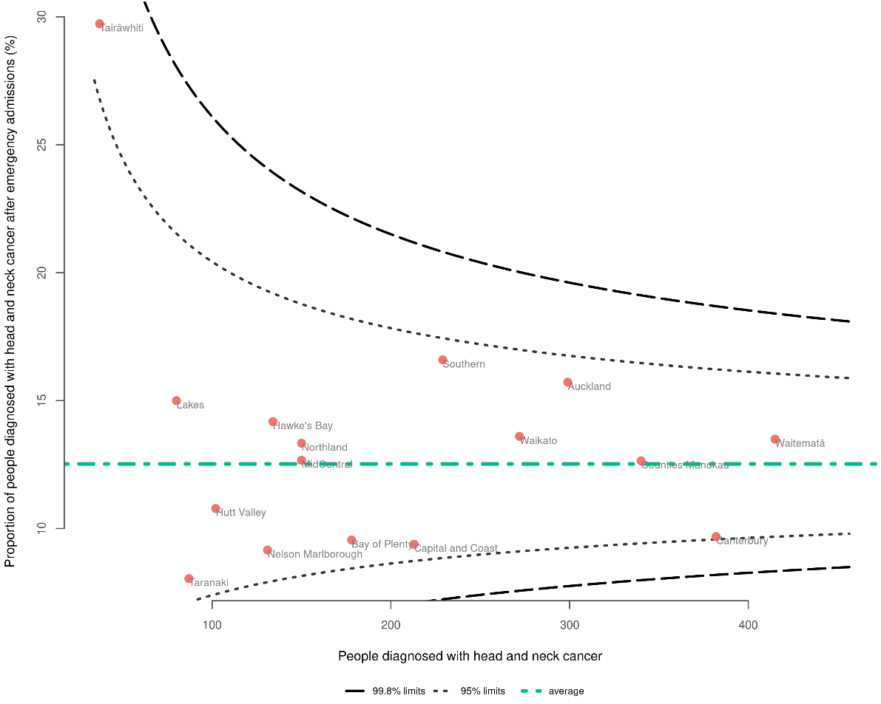
Note: See Appendix D for more detailed information.

Kidney cancer
There were 2,944 people diagnosed with kidney cancer between 2017 and 2021. Overall, 25.7% of those people were diagnosed in the 30 days following an emergency admission. Māori had higher proportions (32.2%) compared to people of European/other ethnicity (19.4%) and Asian people (16.6%) (Figure 18).

Figure 18: Proportion of people diagnosed with kidney cancer in the 30 days following emergency admission, by sex, ethnicity, NZDep2018 quintile, rural–urban status (all age-standardised), and age (non-standardised) for the years 2017–2021
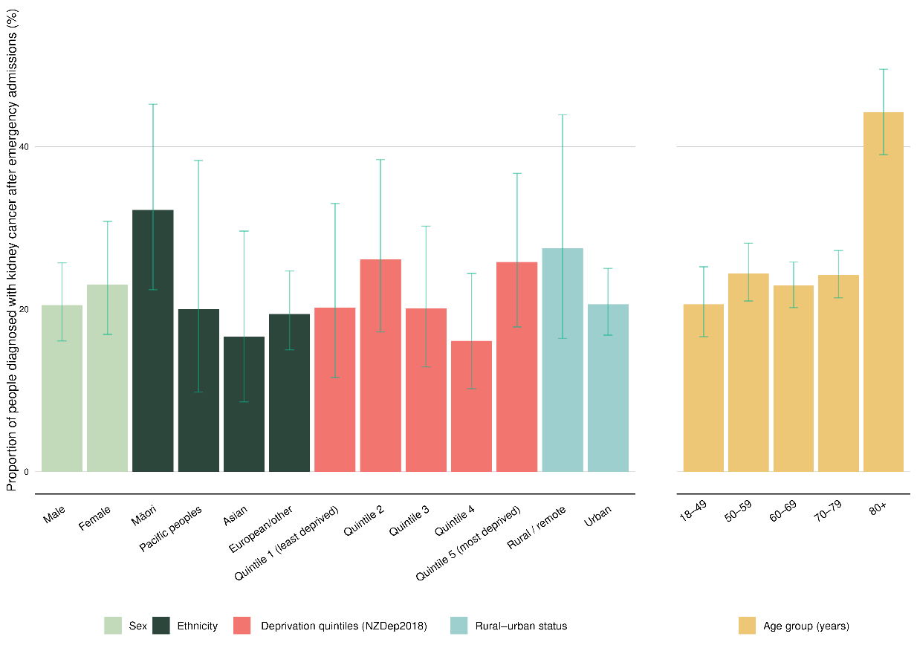
Note: See Appendix D for more detailed information. Confidence intervals are presented to indicate potential variation over time. Overlapping confidence intervals do not indicate an absence of differences between compared groups.

Nelson Marlborough, MidCentral and Canterbury had proportions below the lower 95% limits, and Lakes was above the upper 95% limits. However, the small numbers in some districts mean this data should be interpreted with caution (Figure 19).
Figure 19: Funnel plot showing proportion of people diagnosed with kidney cancer in the 30 days following emergency admission, by district of residence, for the years 2017–2021 (un-standardised)
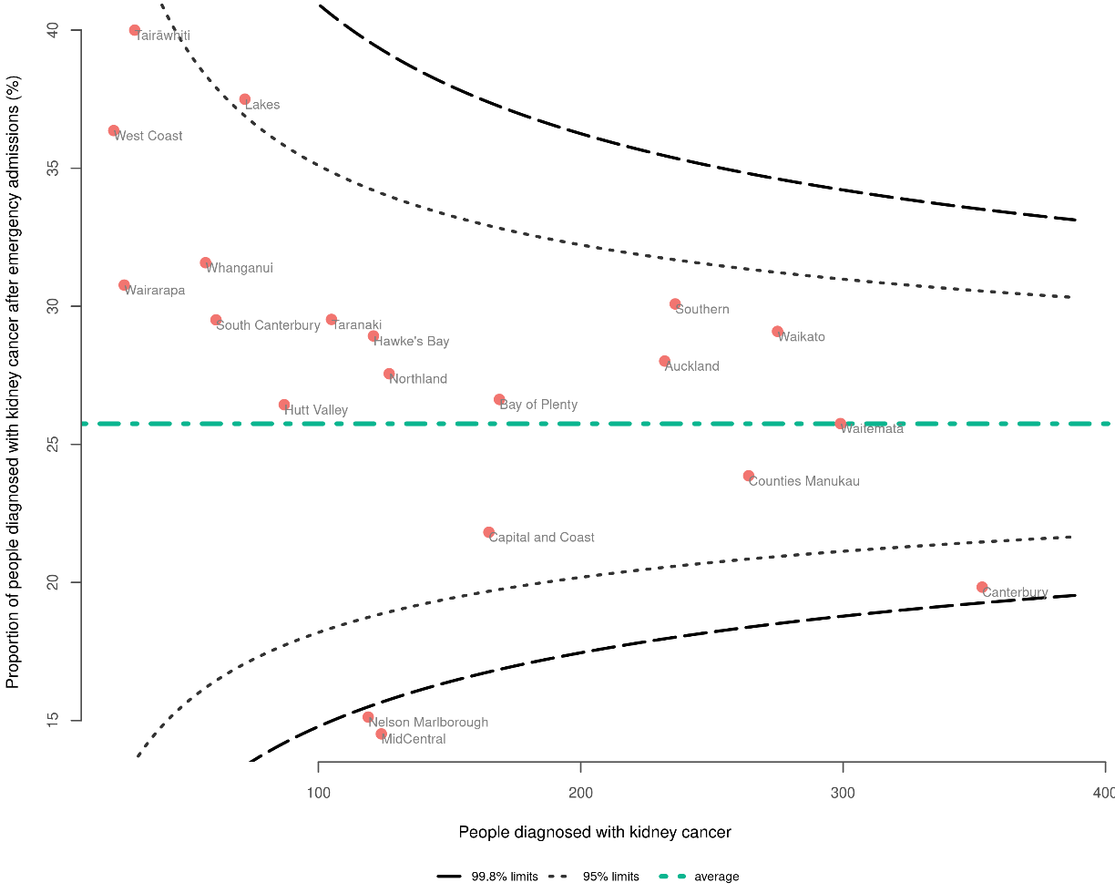
Note: See Appendix D for more detailed information.

Leukaemia
There were 3,385 people diagnosed with leukaemia between 2017 and 2021. Overall, 39.5% of those people were diagnosed in the 30 days following an emergency admission. Pacific peoples had the highest proportion (71.2%), followed by Asian people (64.6%), Māori (63.1%) and people of European/other ethnicity (47.6%). People aged 18–49 were the most likely to be diagnosed following an emergency admission (60.9%) (Figure 20).

Figure 20: Proportion of people diagnosed with leukaemia in the 30 days following emergency admission, by sex, ethnicity, NZDep2018 quintile, rural–urban status (all age-standardised), and age (non-standardised) for the years 2017–2021
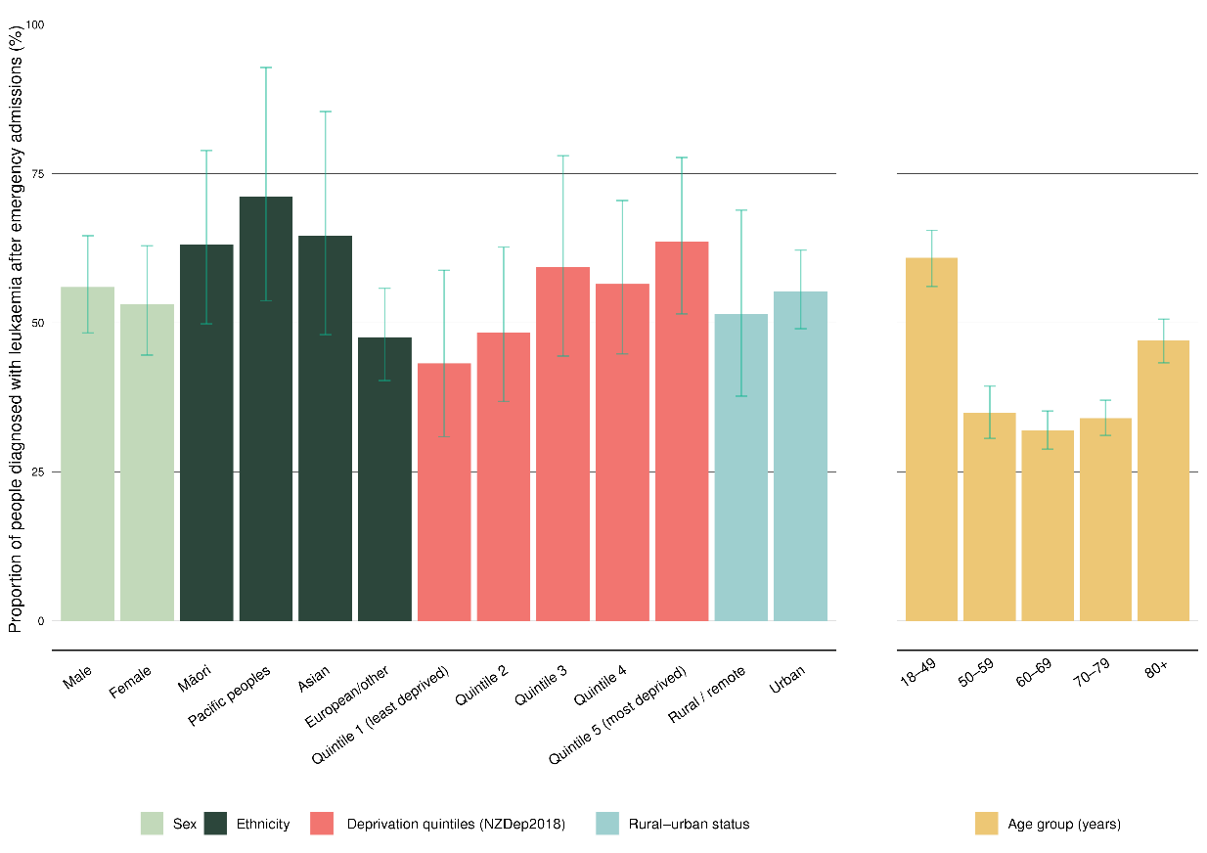
Note: See Appendix D for more detailed information. Confidence intervals are presented to indicate potential variation over time. Overlapping confidence intervals do not indicate an absence of differences between compared groups.

Counties Manukau, Taranaki and Waitematā had proportions above the upper 95% limit, while Nelson Marlborough and Canterbury sat below the lower 95% limit. However, the small numbers in some districts (including Taranaki and Nelson Marlborough) mean this data should be interpreted with caution (Figure 21).
Figure 21: Funnel plot showing proportion of people diagnosed with leukaemia in the 30 days following emergency admission, by district of residence, for the years 2017–2021 (un-standardised)
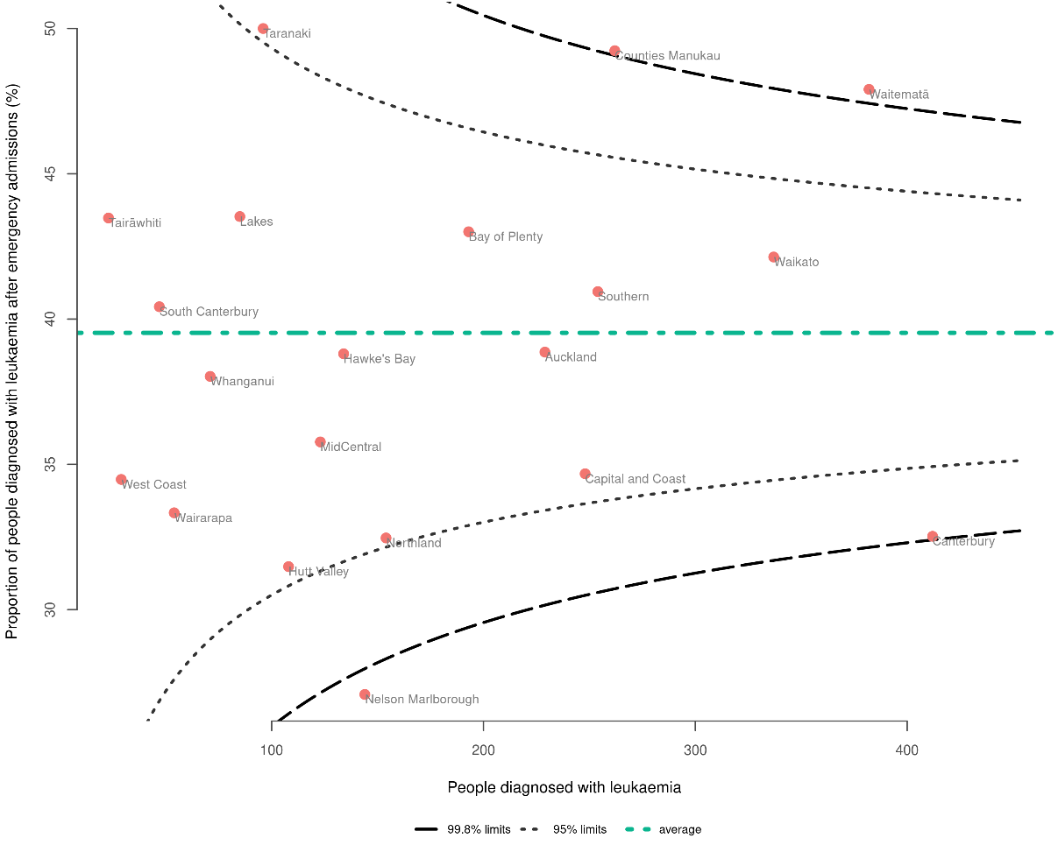
Note: See Appendix D for more detailed information.

Liver cancer
There were 1,824 people diagnosed with liver cancer between 2017 and 2021. Overall, 49.8% of those people were diagnosed in the 30 days following an emergency admission. Pacific peoples had a notably higher proportion than other ethnicities (Figure 22). Pacific peoples had a proportion of 70.6%, compared with 58.8% for Māori, 40.9% for Asian and 37.8% for people of European/other ethnicity. People aged 80+ were more likely to be diagnosed following an emergency admission (75.3%) compared to other age groups (Figure 22).

Figure 22: Proportion of people diagnosed with liver cancer in the 30 days following emergency admission, by sex, ethnicity, NZDep2018 quintile, rural–urban status (all age-standardised), and age (non-standardised) for the years 2017–2021
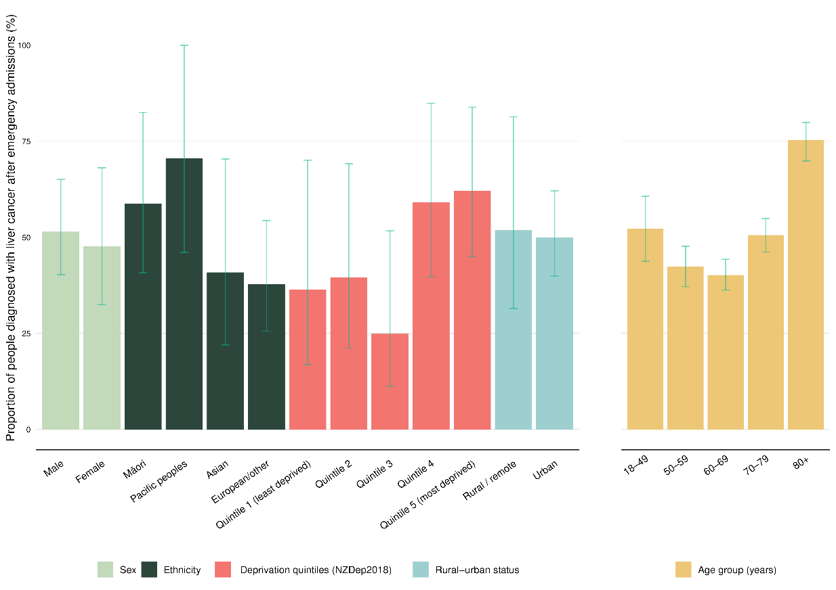
Note: See Appendix D for more detailed information. Confidence intervals are presented to indicate potential variation over time. Overlapping confidence intervals do not indicate an absence of differences between compared groups.

No districts sat outside the 95% limits of the funnel plot (Figure 23).
Figure 23: Funnel plot showing proportion of people diagnosed with liver cancer in the 30 days following emergency admission, by district of residence, for the years 2017–2021 (un-standardised)
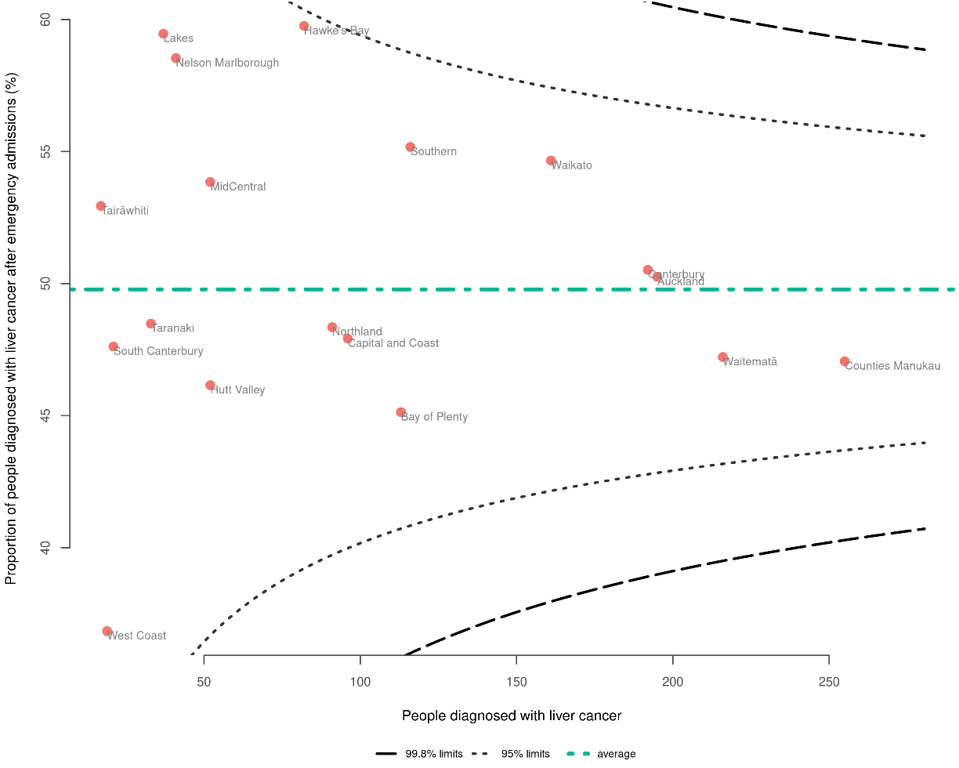
Note: See Appendix D for more detailed information.

Lung cancer
There were 11,141 people diagnosed with lung cancer between 2017 and 2021. Overall, 51.3% of those people were diagnosed in the 30 days following an emergency admission. Pacific peoples had the highest proportion (65.4%), followed by Māori (54.1%), people of European/other ethnicity (49.6%) and Asian people (48.1%). People aged 80+ (60.9%) and those aged 18–49 (58.2%) were more commonly diagnosed after an emergency admission compared to other age groups (47.6%–52.0%) (Figure 24).

Figure 24: Proportion of people diagnosed with lung cancer in the 30 days following emergency admission, by sex, ethnicity, NZDep2018 quintile, rural–urban status (all age-standardised), and age (non-standardised) for the years 2017–2021
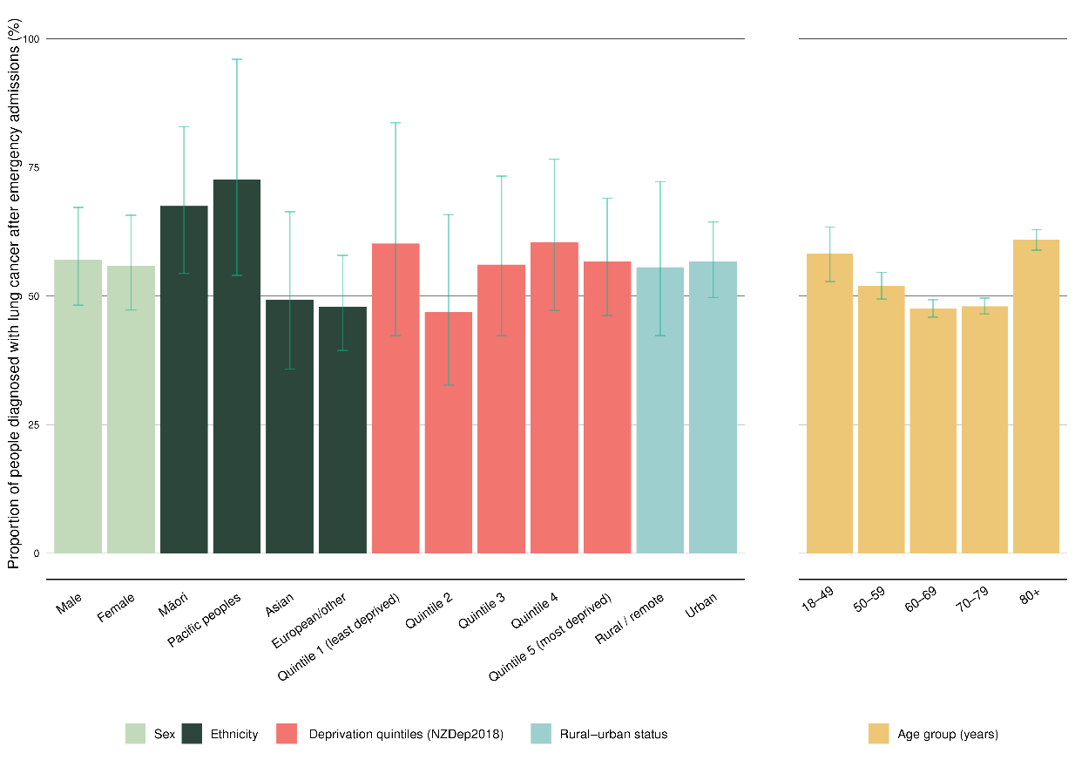
Note: See Appendix D for more detailed information. Confidence intervals are presented to indicate potential variation over time. Overlapping confidence intervals do not indicate an absence of differences between compared groups.

Canterbury sat below the lower 95% limit with a proportion of 46.6%, while two districts were above the upper 95% limit: Auckland (55.3%) and Waitematā (56.0%) (Figure 25).
Figure 25: Funnel plot showing proportion of people diagnosed with lung cancer in the 30 days following emergency admission, by district of residence, for the years 2017–2021 (un-standardised)
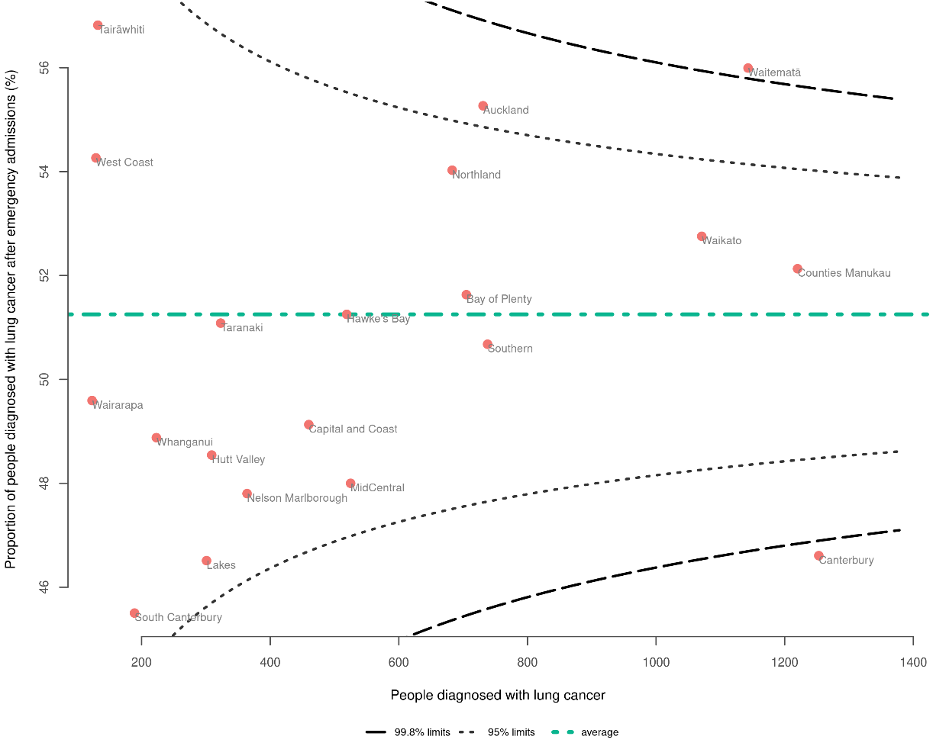
Note: See Appendix D for more detailed information.

As part of the cancer QPI programme, we published the Lung Cancer Quality Improvement Monitoring Report 2021 (Te Aho o Te Kahu 2021b), which provides quality performance indicators specific to lung cancer, including route to diagnosis. Note that the time period of data included and the definition of ‘emergency admission’ (see Table 2 in Appendix C) differ between reports, therefore variation in data will be seen.

Lymphoma
There were 5,362 people diagnosed with lymphoma between 2017 and 2021. Overall, 38.8% of those people were diagnosed in the 30 days following an emergency admission. Māori and Pacific peoples were more commonly diagnosed following an emergency admission than people of European/other ethnicity. The proportions were 47.7% for Māori, 55.6% for Pacific peoples, 44.0% for Asian people, and 36.5% for people of European/other ethnicity (Figure 26).

Figure 26: Proportion of people diagnosed with lymphoma in the 30 days following emergency admission, by sex, ethnicity, NZDep2018 quintile, rural–urban status (all age-standardised), and age (non-standardised) for the years 2017–2021
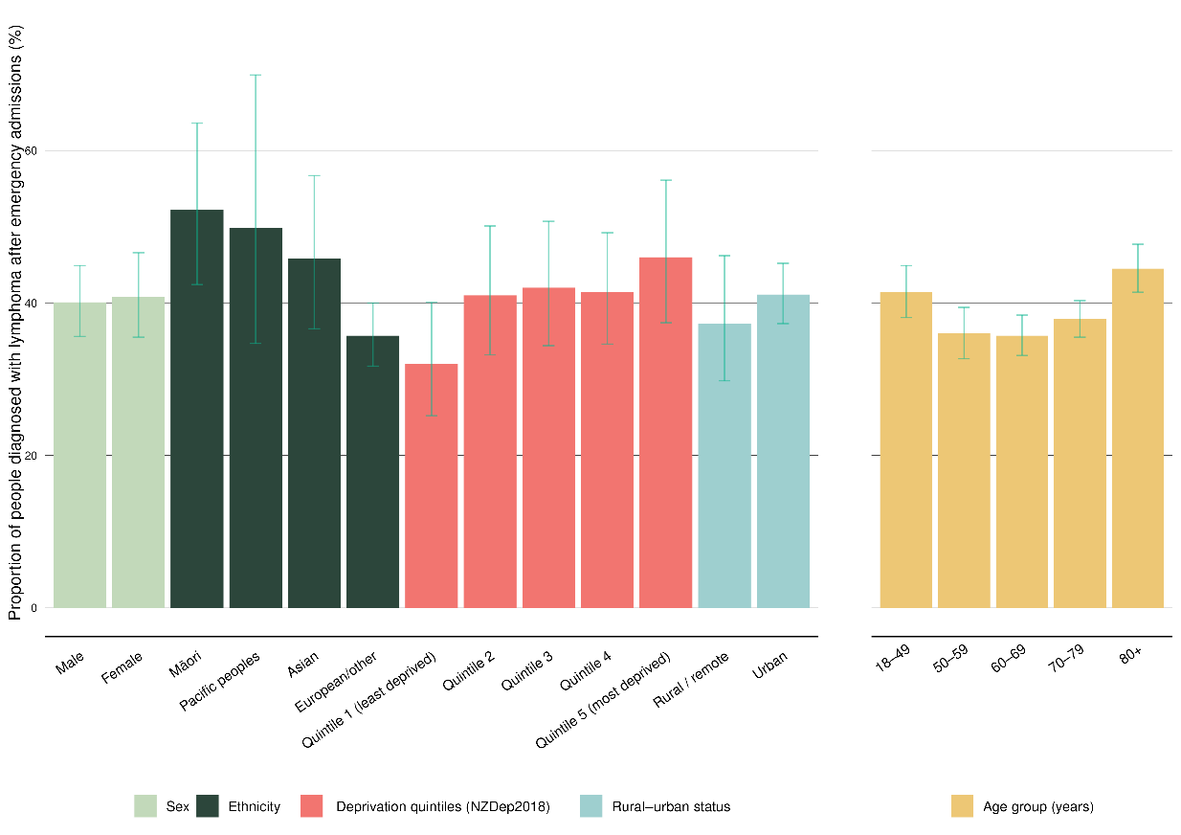
Note: See Appendix D for more detailed information. Confidence intervals are presented to indicate potential variation over time. Overlapping confidence intervals do not indicate an absence of differences between compared groups.

Counties Manukau sat above the upper 95% limit at 46.1%, while Canterbury was below the lower 95% limit with a proportion of 33.1% (Figure 27).
Figure 27: Funnel plot showing proportion of people diagnosed with lymphoma in the 30 days following emergency admission, by district of residence, for the years 2017–2021 (un-standardised)
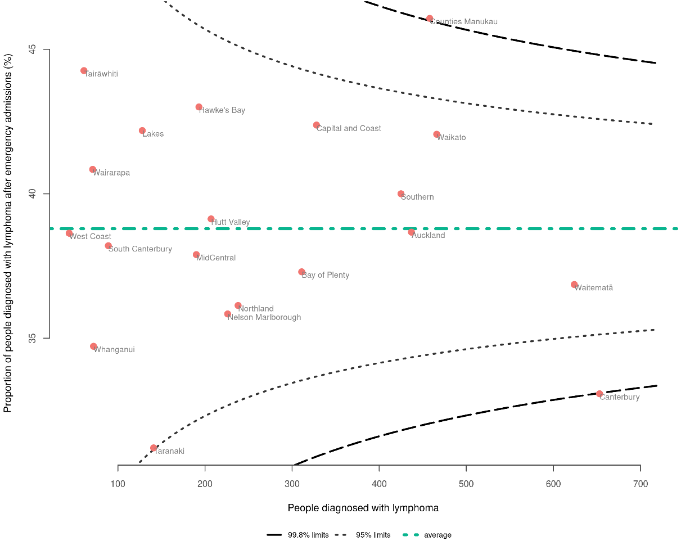
Note: See Appendix D for more detailed information.

Melanoma
There were 13,461 people diagnosed with melanoma between 2017 and 2021. Overall, 3.3% of those people were diagnosed in the 30 days following an emergency admission. People aged 80+ had a higher proportion (6.4%) compared to younger age groups (1.7%–3.6%) (Figure 28).

People living in the most deprived areas had a higher proportion (4.5%) than those in the least deprived areas (1.3%). Small numbers of people of Pacific, Māori and Asian ethnicity who were diagnosed with melanoma make it challenging to compare between ethnicities (see Appendix D for case numbers).

Figure 28: Proportion of people diagnosed with melanoma in the 30 days following emergency admission, by sex, ethnicity, NZDep2018 quintile, rural–urban status (all age-standardised), and age (non-standardised) for the years 2017–2021
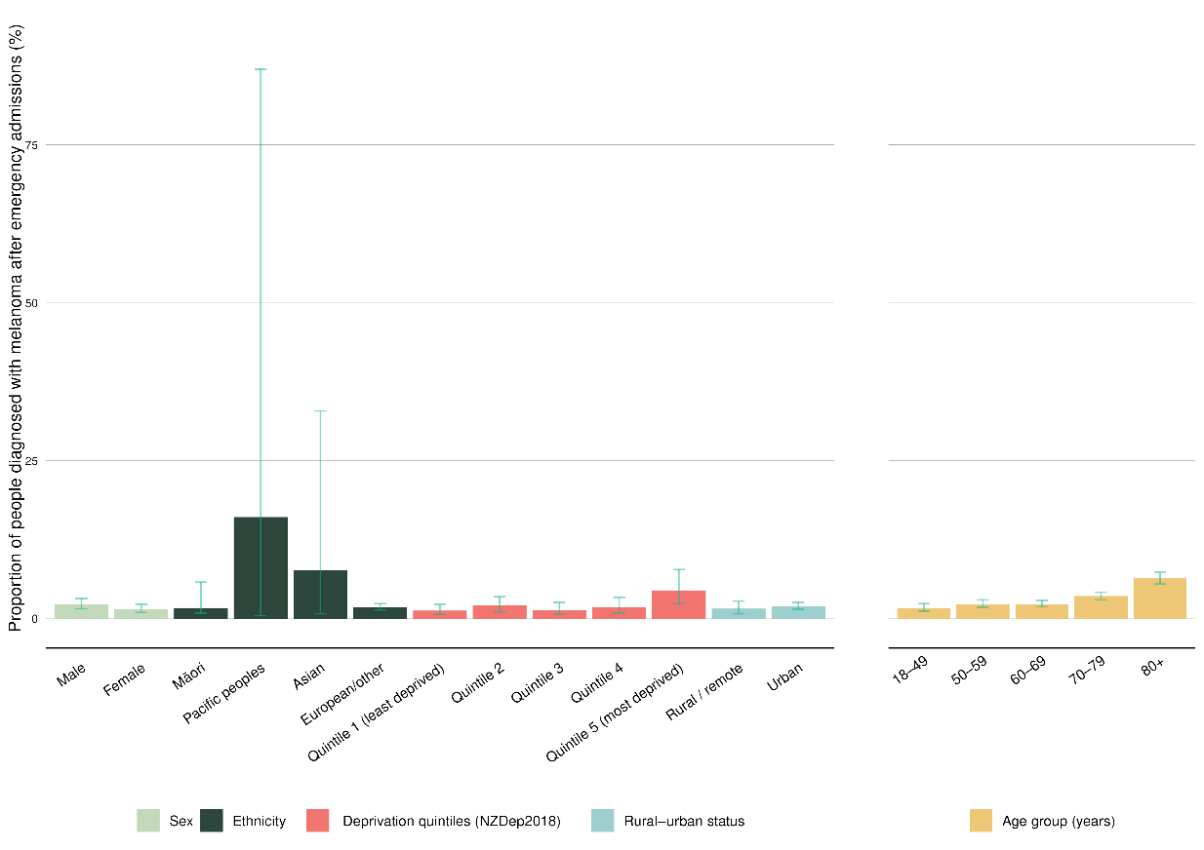
Note: See Appendix D for more detailed information. Confidence intervals are presented to indicate potential variation over time. Overlapping confidence intervals do not indicate an absence of differences between compared groups.

District comparison using a funnel plot did not reveal any notable outliers (Figure 29).
Figure 29: Funnel plot showing proportion of people diagnosed with melanoma in the 30 days following emergency admission, by district of residence, for the years 2017–2021 (un-standardised)
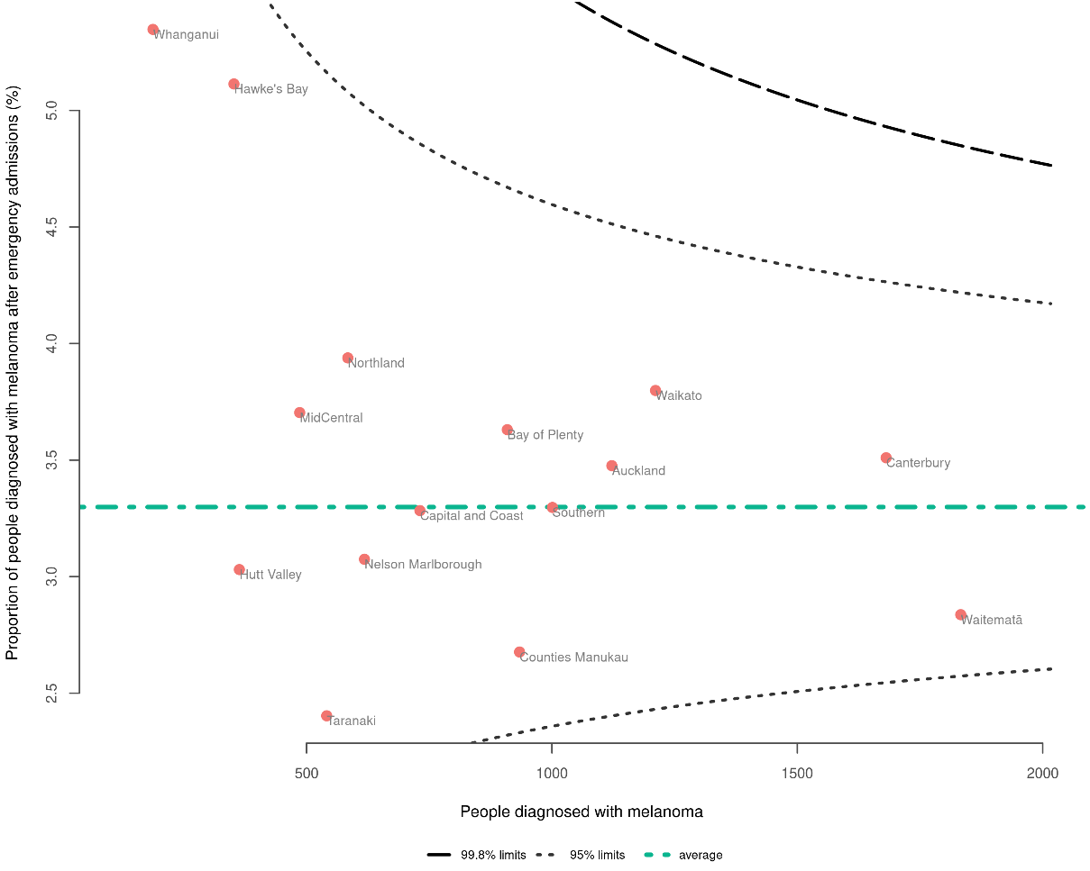
Note: See Appendix D for more detailed information.

Myeloma
There were 2,094 people diagnosed with myeloma between 2017 and 2021. Overall, 40.9% of those people were diagnosed in the 30 days following an emergency admission. People aged 80+ most commonly were diagnosed following an emergency admission (52.3%) (Figure 30).

Māori and Asian people were most likely to be diagnosed following an emergency admission (51.6% and 52.1%, respectively), followed by Pacific peoples (37.2%) and people of European/other ethnicity (29.1%). However, the small numbers, particularly for Pacific peoples and Asian people, mean this data should be interpreted with caution (see Appendix D for case numbers).

Figure 30: Proportion of people diagnosed with myeloma in the 30 days following emergency admission, by sex, ethnicity, NZDep2018 quintile, rural–urban status (all age-standardised), and age (non-standardised) for the years 2017–2021
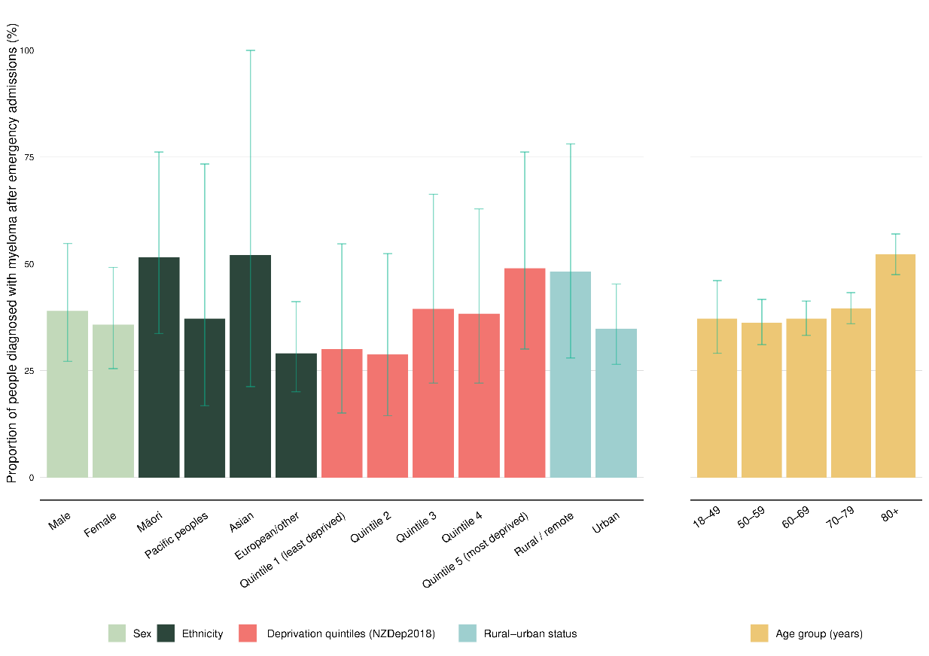
Note: See Appendix D for more detailed information. Confidence intervals are presented to indicate potential variation over time. Overlapping confidence intervals do not indicate an absence of differences between compared groups.

District comparison by funnel plot shows Canterbury below the lower 95% limit with a proportion of 29.9%. Tairāwhiti was an outlier; however, there were small numbers in this district. Counties Manukau was above the upper 95% limit with a proportion of 50.0% (Figure 31).
Figure 31: Funnel plot showing proportion of people diagnosed with myeloma in the 30 days following emergency admission, by district of residence, for the years 2017–2021 (un-standardised)
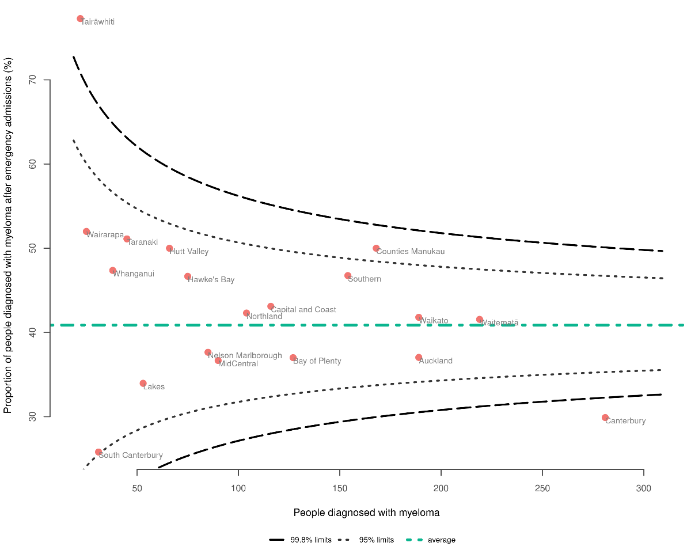
Note: See Appendix D for more detailed information.

Neuroendocrine tumours (NETs)
There were 1,419 people diagnosed with neuroendocrine tumours (NETs) between 2017 and 2021. Overall, 44.3% of those people were diagnosed in the 30 days following an emergency admission.

Asian people were less likely to be diagnosed following an emergency admission (32.4%) compared with Māori (55.3%), Pacific peoples (51.2%) and people of European/other ethnicity (41.9%). People aged 15–49 and people aged 80+ were more likely to be diagnosed following an emergency admission (58.7% and 57.3%, respectively) compared to the other age groups (50–59 years, 42.5%; 60–69 years, 34.7%; 70–79 years, 38.3%) (Figure 32).

Figure 32: Proportion of people diagnosed with NETs in the 30 days following emergency admission, by sex, ethnicity, NZDep2018 quintile, rural–urban status (all age-standardised), and age (non-standardised) for the years 2017–2021
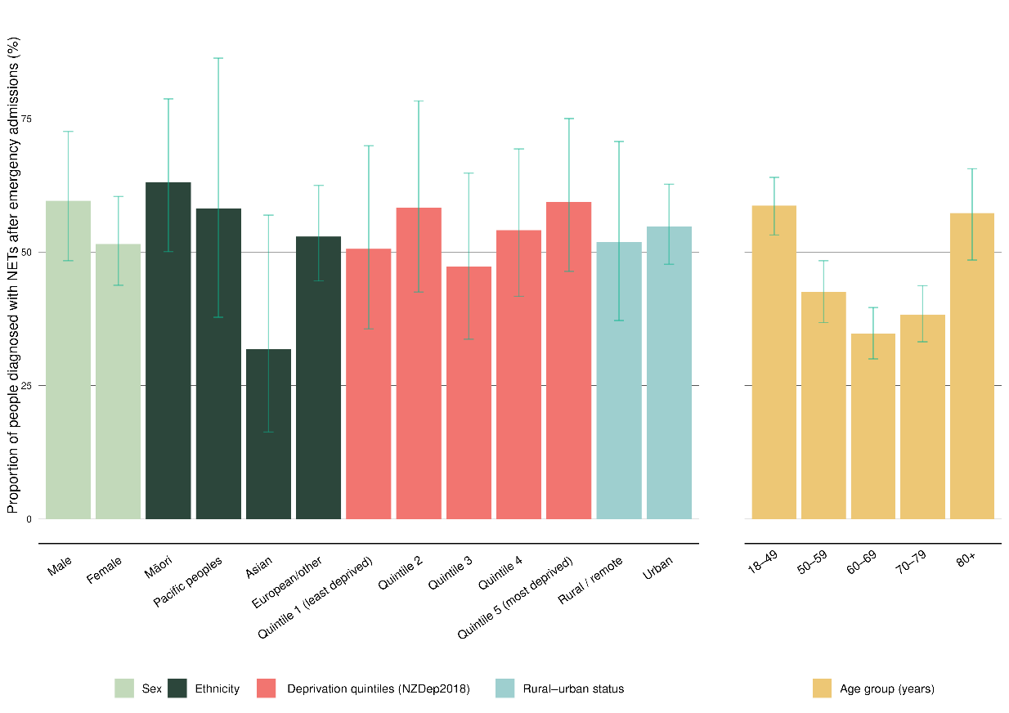
Note: See Appendix D for more detailed information. Confidence intervals are presented to indicate potential variation over time. Overlapping confidence intervals do not indicate an absence of differences between compared groups.

The funnel plot for NETs shows no outliers (Figure 33).
Figure 33: Funnel plot showing proportion of people diagnosed with NETs in the 30 days following emergency admission, by district of residence, for the years 2017–2021 (un-standardised)
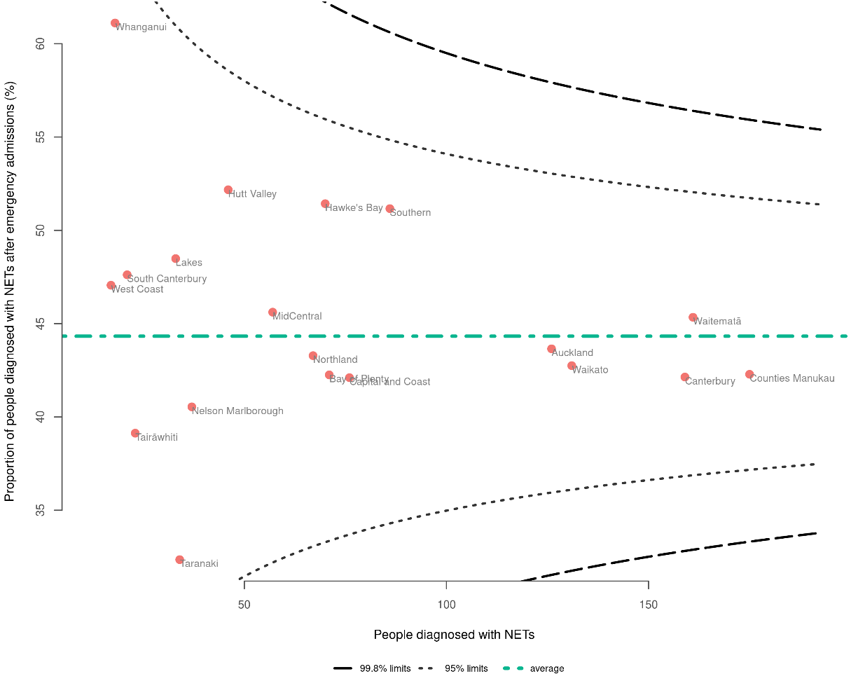
Note: See Appendix D for more detailed information.

Considering the variety of presentations and prognoses of NETs, we have analysed the results for NETs according to the category given in the NZCR. More detail is available in Appendix A.

Oesophageal cancer
There were 1,553 people diagnosed with oesophageal cancer between 2017 and 2021. Overall, 34.0% of those people were diagnosed in the 30 days following an emergency admission. People aged 80+ were more likely to be diagnosed following an emergency admission (43.1%) than those aged 60–69 (28.2%) (Figure 34).

There are no clear differences between ethnicities, which is likely due to smaller numbers of people not of European/other ethnicity (see Appendix D for case numbers).

Figure 34: Proportion of people diagnosed with oesophageal cancer in the 30 days following emergency admission, by sex, ethnicity, NZDep2018 quintile, rural–urban status (all age-standardised), and age (non-standardised) for the years 2017–2021
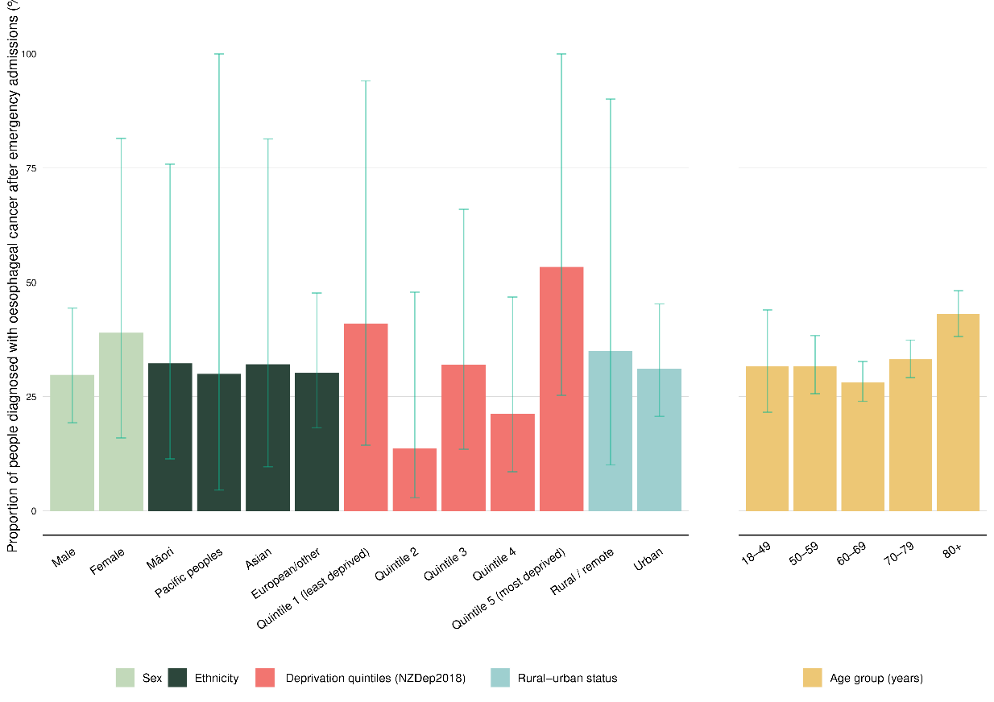
Note: See Appendix D for more detailed information. Confidence intervals are presented to indicate potential variation over time. Overlapping confidence intervals do not indicate an absence of differences between compared groups.

The numbers of people with oesophageal cancer are small, so outliers plotted closest to the y-axis should be interpreted with caution (such as Tairāwhiti). Waikato was below the lower 95% limit with a proportion of 25.5% (Figure 35).
Figure 35: Funnel plot showing proportion of people diagnosed with oesophageal cancer in the 30 days following emergency admission, by district of residence, for the years 2017–2021 (un-standardised)
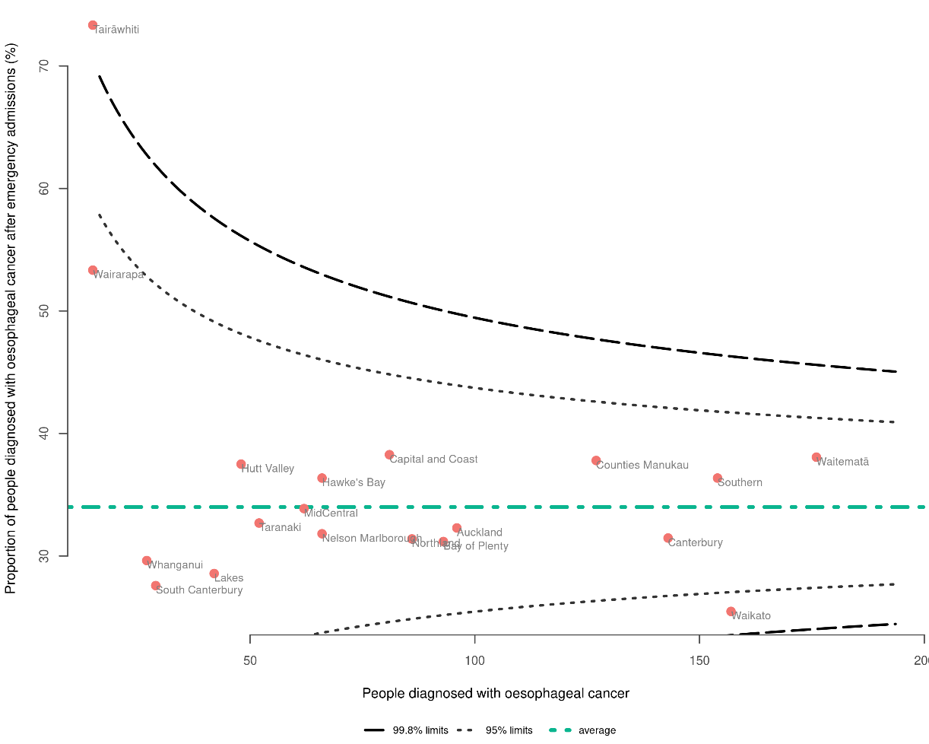
Note: See Appendix D for more detailed information.

Ovarian cancer
There were 1,531 people diagnosed with ovarian cancer between 2017 and 2021. Overall, 46.9% of those people were diagnosed in the 30 days following an emergency admission.

When comparing by ethnicity, Māori had the highest proportion (67.0%), followed by Pacific peoples (53.9%), people of European/other ethnicity (40.9%), and Asian people (39.0%).

People aged 80+ had a higher proportion (57.1%) compared to those aged 60–69 (40.6%), and those living in more deprived areas had a higher proportion (52.8%) compared to those in the least deprived areas (29.7%) (Figure 36).

Figure 36: Proportion of people diagnosed with ovarian cancer in the 30 days following emergency admission, by sex, ethnicity, NZDep2018 quintile, rural–urban status (all age-standardised), and age (non-standardised) for the years 2017–2021
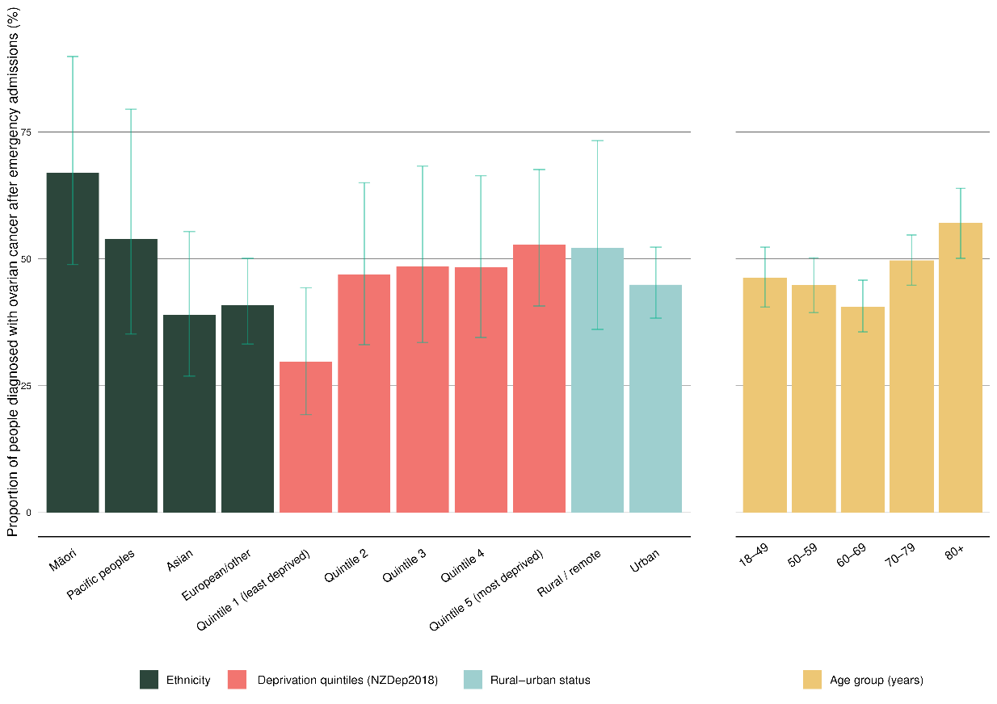
Note: See Appendix D for more detailed information. Confidence intervals are presented to indicate potential variation over time. Overlapping confidence intervals do not indicate an absence of differences between compared groups.

When comparing districts, there appeared to be a broad range of proportions across Aotearoa. Taranaki sat above the upper 95% limit with a proportion of 62.1%, and Canterbury sat on the lower 95% limit with a proportion of 39.7% (Figure 37).
Figure 37: Funnel plot showing proportion of people diagnosed with ovarian cancer in the 30 days following emergency admission, by district of residence, for the years 2017–2021 (un-standardised)
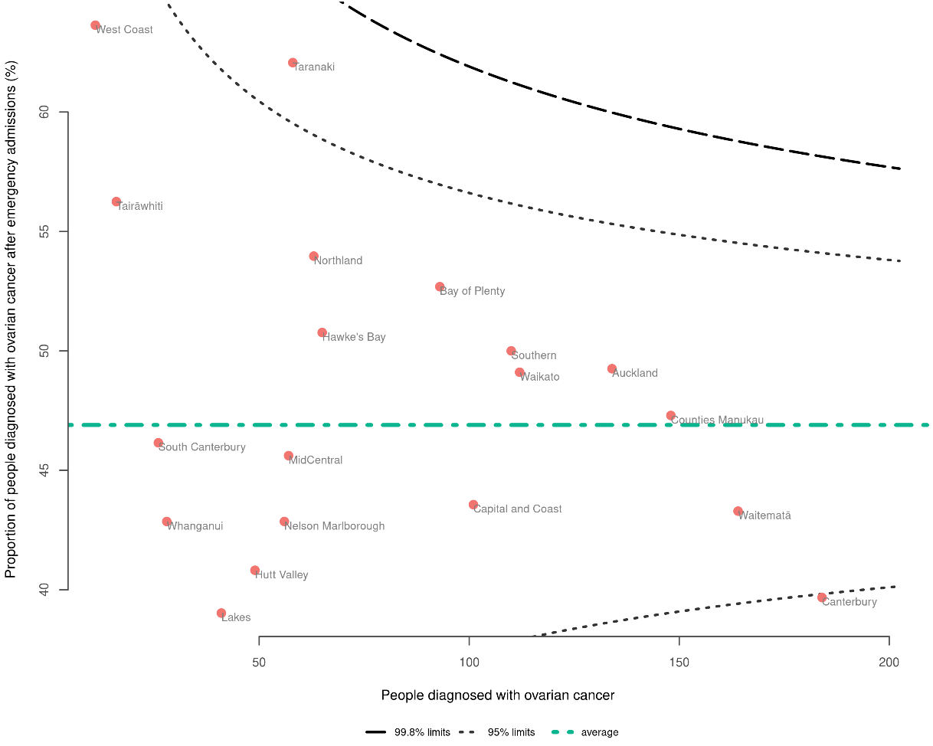
Note: See Appendix D for more detailed information.

Pancreatic cancer
There were 2,804 people diagnosed with pancreatic cancer between 2017 and 2021. Overall, 69.5% of those people were diagnosed in the 30 days following an emergency admission. While this overall proportion is high, Māori and Pacific peoples had higher proportions (75.4% and 86.5%, respectively) compared to Asian people (69.0%) and people of European/other ethnicity (67.4%). People aged 80+ had a higher proportion (79.2%) compared to those aged 50–79 (Figure 38).

Figure 38: Proportion of people diagnosed with pancreatic cancer in the 30 days following emergency admission, by sex, ethnicity, NZDep2018 quintile, rural–urban status (all age-standardised), and age (non-standardised) for the years 2017–2021
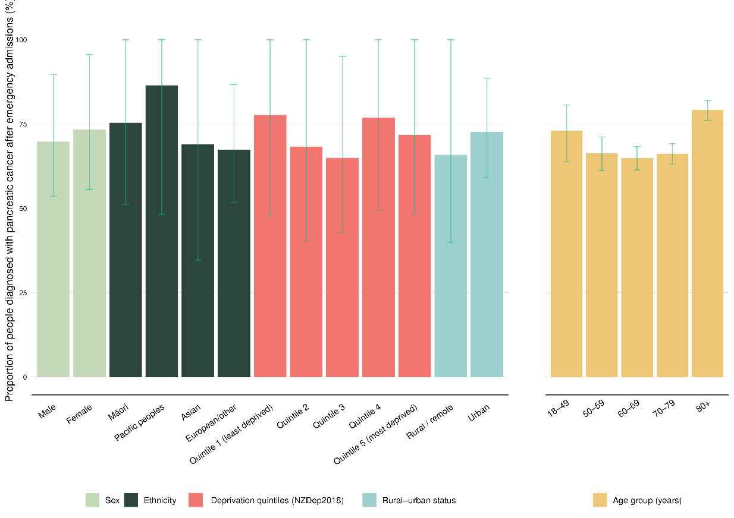
Note: See Appendix D for more detailed information. Confidence intervals are presented to indicate potential variation over time. Overlapping confidence intervals do not indicate an absence of differences between compared groups.

Waitematā sat above the upper 95% limit with a proportion of 75.1%. Nelson Marlborough and Canterbury were below the lower 95% limit with proportions of 58.9% and 62.6%, respectively (Figure 39).
Figure 39: Funnel plot showing proportion of people diagnosed with pancreatic cancer in the 30 days following emergency admission, by district of residence, for the years 2017–2021 (un-standardised)
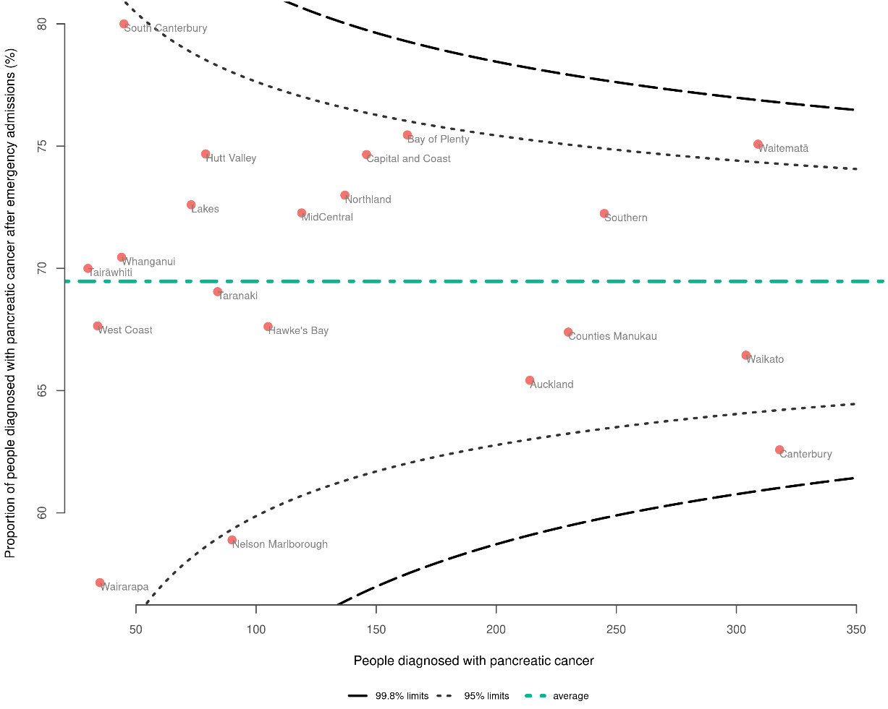
Note: See Appendix D for more detailed information.

As part of the cancer QPI programme, we published the Pancreatic Cancer Quality Improvement Monitoring Report 2023 (Te Aho o Te Kahu 2023b), which provides quality performance indicators specific to pancreatic cancer, including route to diagnosis. Note that while the definition of ‘emergency presentation’ is the same in both reports, the time period differs, therefore there will be differences between the results reported.

Prostate cancer
There were 20,241 people diagnosed with prostate cancer between 2017 and 2021. Overall, 6.1% of those people were diagnosed in the 30 days following an emergency admission. People aged 80+ were notably more likely to be diagnosed following an emergency admission, with a proportion of 30.5%. Māori and Pacific peoples were more commonly diagnosed following an emergency admission (8.3% and 24.5%, respectively) compared to people of European/other ethnicity (2.1%) (Figure 40).

Figure 40: Proportion of people diagnosed with prostate cancer in the 30 days following emergency admission, by sex, ethnicity, NZDep2018 quintile, rural–urban status (all age-standardised), and age (non-standardised) for the years 2017–2021
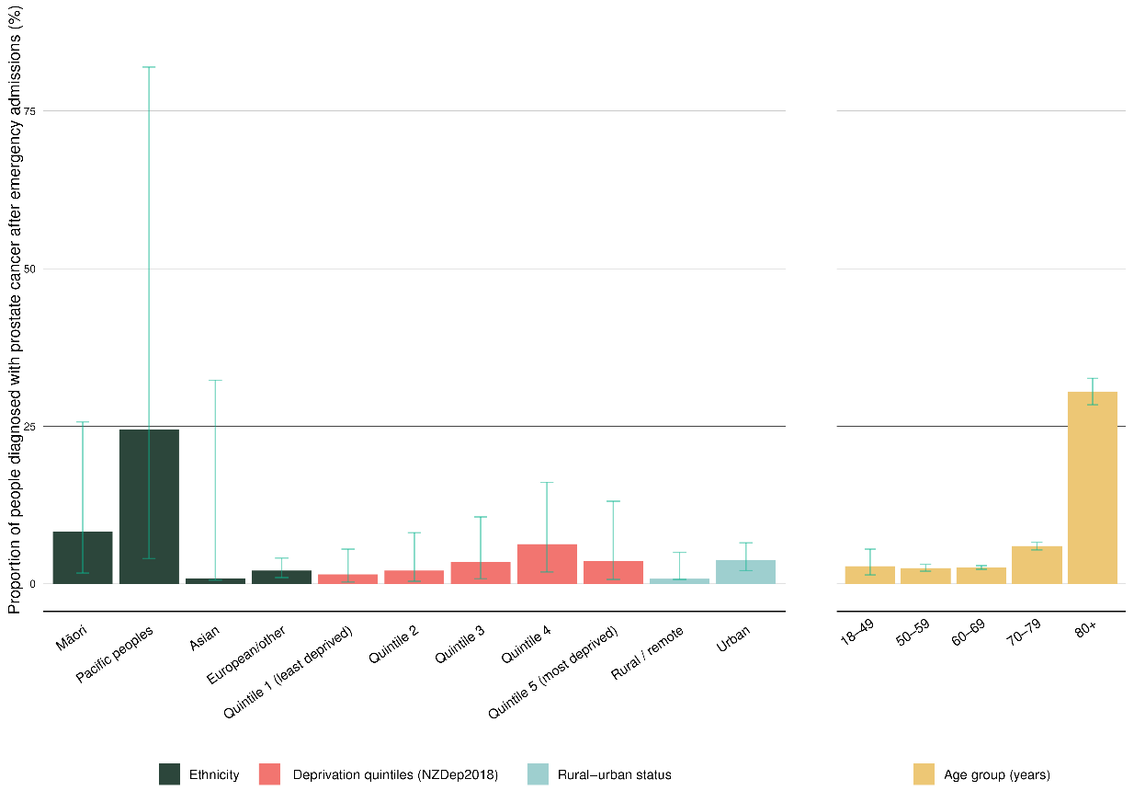
Note: See Appendix D for more detailed information. Confidence intervals are presented to indicate potential variation over time. Overlapping confidence intervals do not indicate an absence of differences between compared groups.

There were three districts above the upper 95% limit: Bay of Plenty (9.2%), Hawke’s Bay (8.2%), and Auckland (7.6%). There were four districts below the lower 95% limit: Waitematā (5.1%), South Canterbury (3.6%), Southern (4.7%) and Canterbury (4.5%) (Figure 41).
Figure 41: Funnel plot showing proportion of people diagnosed with prostate cancer in the 30 days following emergency admission, by district of residence, for the years 2017–2021 (un-standardised)
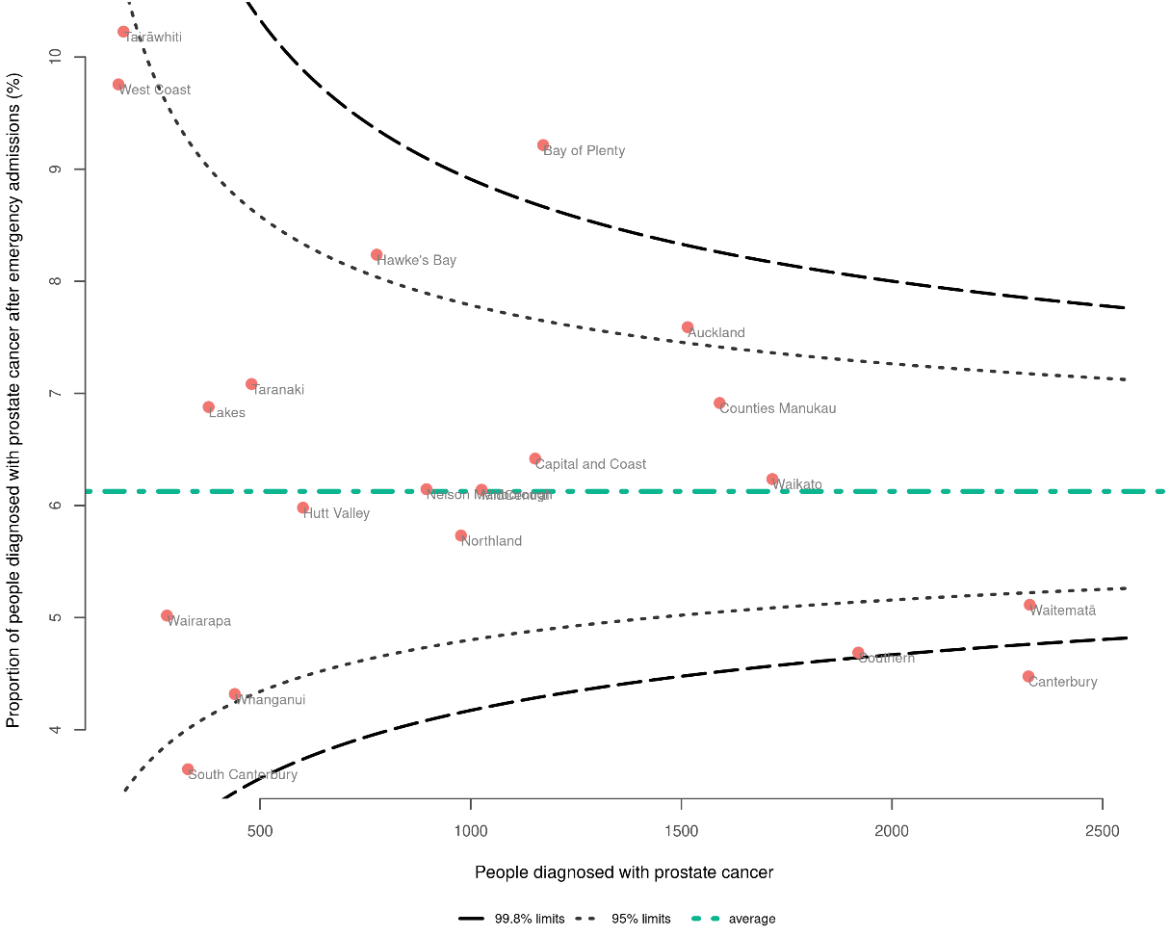
Note: See Appendix D for more detailed information.

As part of the cancer QPI programme, we published the Prostate Cancer Monitoring Report Update 2021 (Te Aho o Te Kahu 2021c), which provides quality performance indicators specific to prostate cancer, including route to diagnosis. Note that the time period of data included and the definition of ‘emergency admission’ (see Table 2 in Appendix C) differ between reports, therefore variation in data will be seen.

Sarcoma
There were 1,398 people diagnosed with sarcoma between 2017 and 2021. Overall, 32.1% of those people were diagnosed in the 30 days following an emergency admission.

Māori were more commonly diagnosed following an emergency admission (45.4%) compared to people of European/other ethnicity (30.3%). People living in the most deprived quintile were more likely to be diagnosed following an emergency admission (40.8%) compared to those in the least deprived areas (25.0%) (Figure 42).

Figure 42: Proportion of people diagnosed with sarcoma in the 30 days following emergency admission, by sex, ethnicity, NZDep2018 quintile, rural–urban status (all age-standardised), and age (non-standardised) for the years 2017–2021
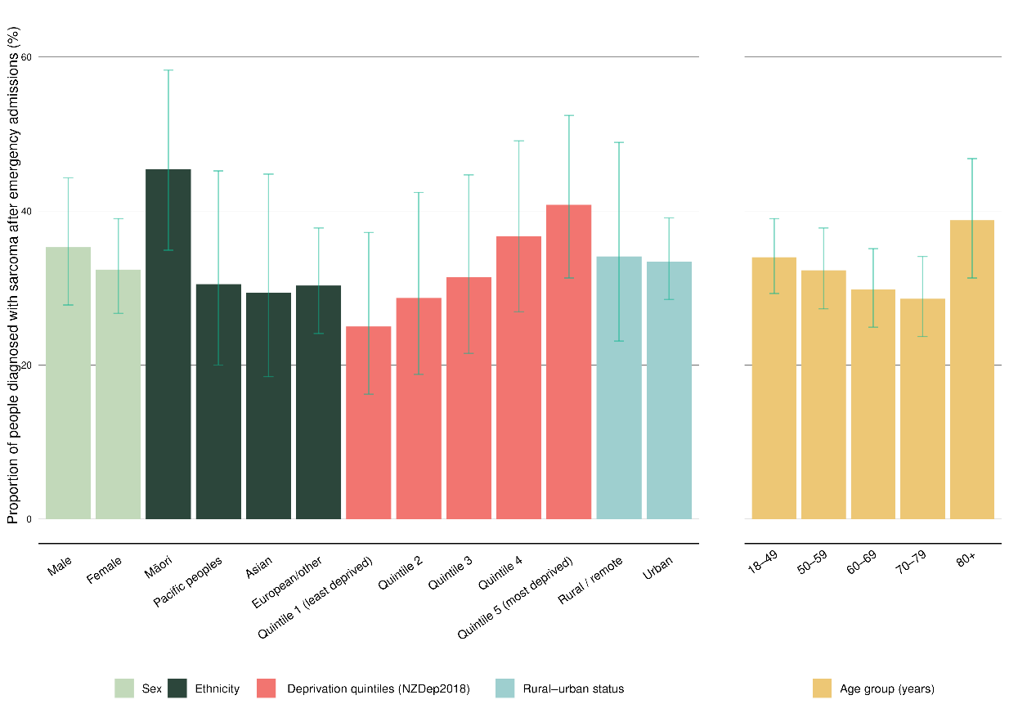
Note: See Appendix D for more detailed information. Confidence intervals are presented to indicate potential variation over time. Overlapping confidence intervals do not indicate an absence of differences between compared groups.

Not all districts are represented on the funnel plot due to small numbers. Tairāwhiti was an outlier; however, small numbers mean interpretation requires caution. Canterbury was below the lower 95% limit with a proportion of 21.2% (Figure 43).
Figure 43: Funnel plot showing proportion of people diagnosed with sarcoma in the 30 days following emergency admission, by district of residence, for the years 2017–2021 (un-standardised)
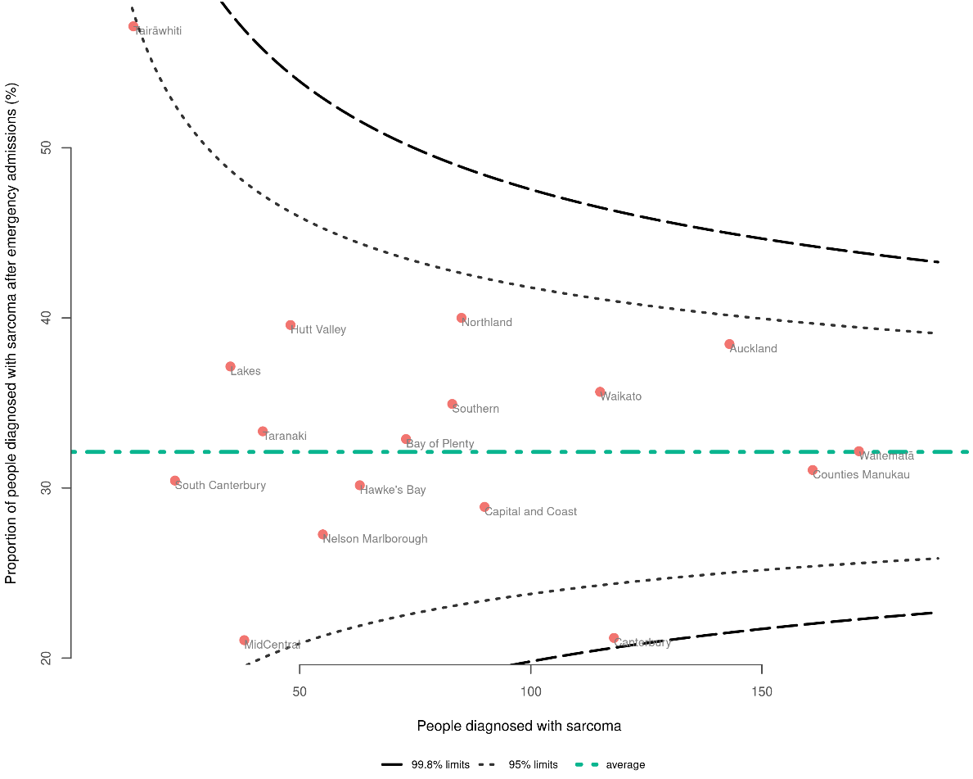
Note: See Appendix D for more detailed information.

Stomach cancer
There were 1,858 people diagnosed with stomach cancer between 2017 and 2021. Overall, 45.7% of those people were diagnosed in the 30 days following an emergency admission. Māori and Pacific people had higher proportions (49.5% and 63.3%, respectively) compared with people of European/other ethnicity (34.2%). Those living in more deprived areas had a higher proportion compared to those in the least deprived areas (Figure 44).

Figure 44: Proportion of people diagnosed with stomach cancer in the 30 days following emergency admission, by sex, ethnicity, NZDep2018 quintile, rural–urban status (all age-standardised), and age (non-standardised) for the years 2017–2021
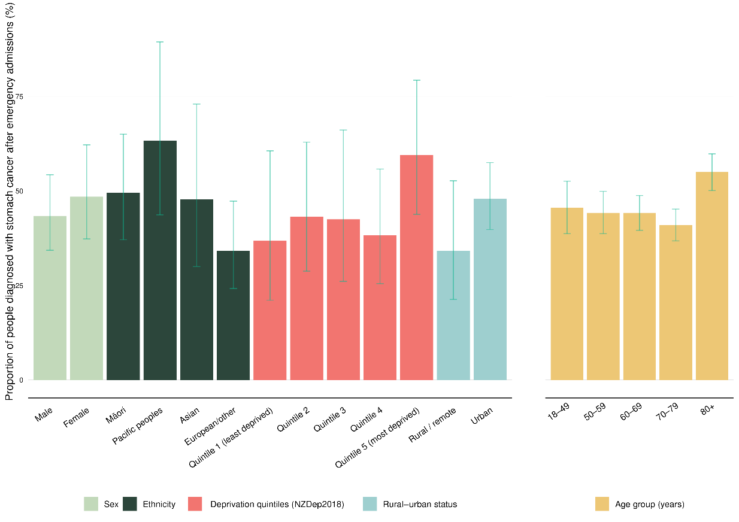
Note: See Appendix D for more detailed information. Confidence intervals are presented to indicate potential variation over time. Overlapping confidence intervals do not indicate an absence of differences between compared groups.

Counties Manukau was an outlier compared to other districts, with a proportion of 54.4%. One district, Taranaki, was below the lower 95% limit with a proportion of 32.1% (Figure 45).
Figure 45: Funnel plot showing proportion of people diagnosed with stomach cancer in the 30 days following emergency admission, by district of residence, for the years 2017–2021 (un-standardised)
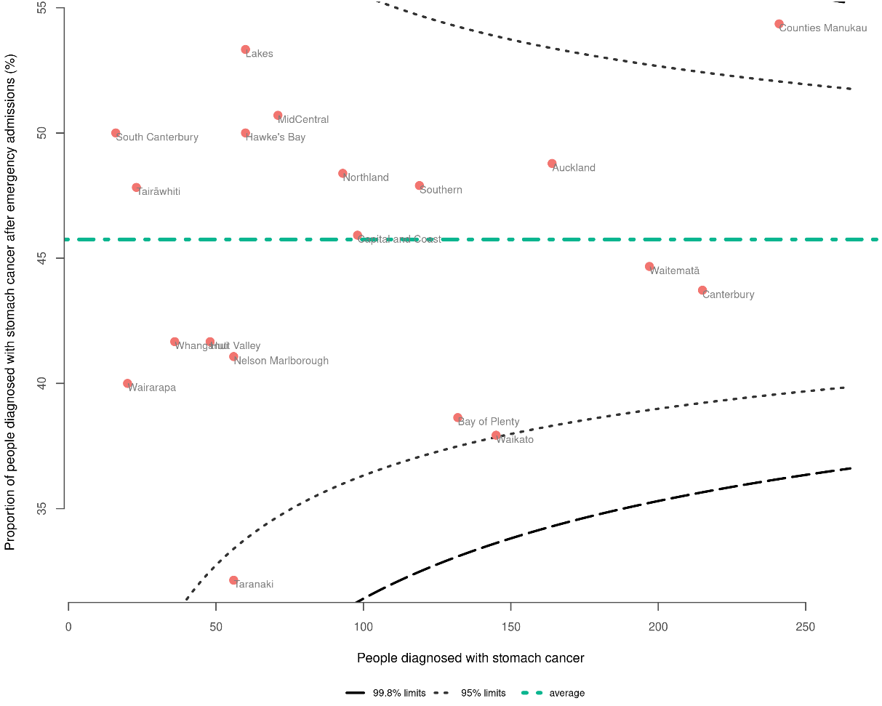
Note: See Appendix D for more detailed information.

Thyroid cancer
There were 1,720 people diagnosed with thyroid cancer between 2017 and 2021. Overall, 6.3% of those people were diagnosed in the 30 days following an emergency admission. Pacific peoples had the highest proportion (9.0%) compared with people of European/other ethnicity (2.7%) (although small case numbers for Pacific peoples means this should be interpreted with caution). Older people had higher proportions compared with people in younger age groups (80+ years at 19.1%, 18–49 years at 1.9%) (Figure 46).

Figure 46: Proportion of people diagnosed with thyroid cancer in the 30 days following emergency admission, by sex, ethnicity, NZDep2018 quintile, rural–urban status (all age-standardised), and age (non-standardised) for the years 2017–2021
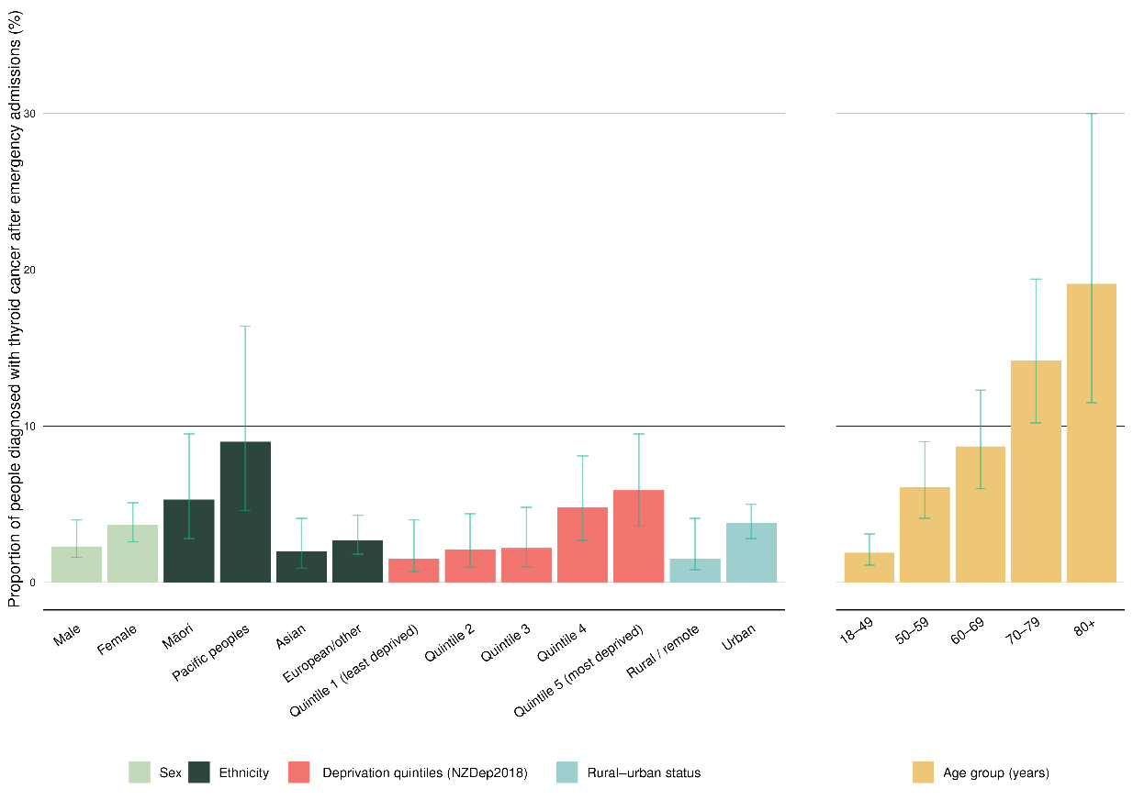
Note: See Appendix D for more detailed information. Confidence intervals are presented to indicate potential variation over time. Overlapping confidence intervals do not indicate an absence of differences between compared groups.

Due to small case numbers in many districts, a funnel plot is not included for thyroid cancer; however, more information can be found in Appendix D.

Uterine cancer
There were 3,124 people diagnosed with uterine cancer between 2017 and 2021. Overall, 11.9% of those people were diagnosed in the 30 days following an emergency admission.

Pacific peoples were most likely to be diagnosed following an emergency admission. The proportion for Pacific peoples was 27.4%, compared with Māori at 18%, Asian people at 8.8% and people of European/other ethnicity at 6.7%. People aged 80+ and people aged 18–49 were more commonly diagnosed following an emergency admission (25.6%) than other age groups. Urban dwellers and those living in more deprived areas had a higher proportion compared to those in the least deprived areas (Figure 47).

Figure 47: Proportion of people diagnosed with uterine cancer in the 30 days following emergency admission, by sex, ethnicity, NZDep2018 quintile, rural–urban status (all age-standardised), and age (non-standardised) for the years 2017–2021
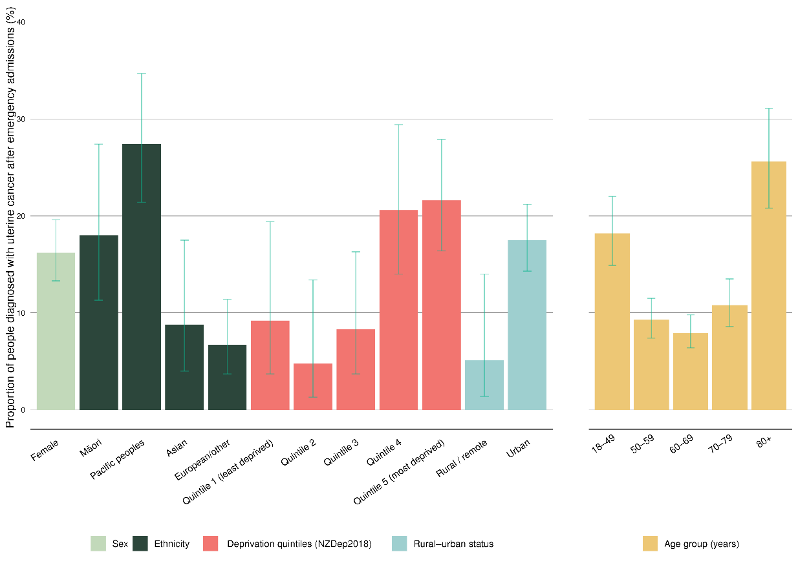
Note: See Appendix D for more detailed information. Confidence intervals are presented to indicate potential variation over time. Overlapping confidence intervals do not indicate an absence of differences between compared groups.

Counties Manukau was an outlier, sitting above the upper 95% limit with a proportion of 19.7%. Three districts were below the lower 95% limit: Capital & Coast (7.9%), Southern (8.0%) and Canterbury (8.0%) (Figure 48).
Figure 48: Funnel plot showing proportion of people diagnosed with uterine cancer in the 30 days following emergency admission, by district of residence, for the years 2017–2021 (un-standardised)
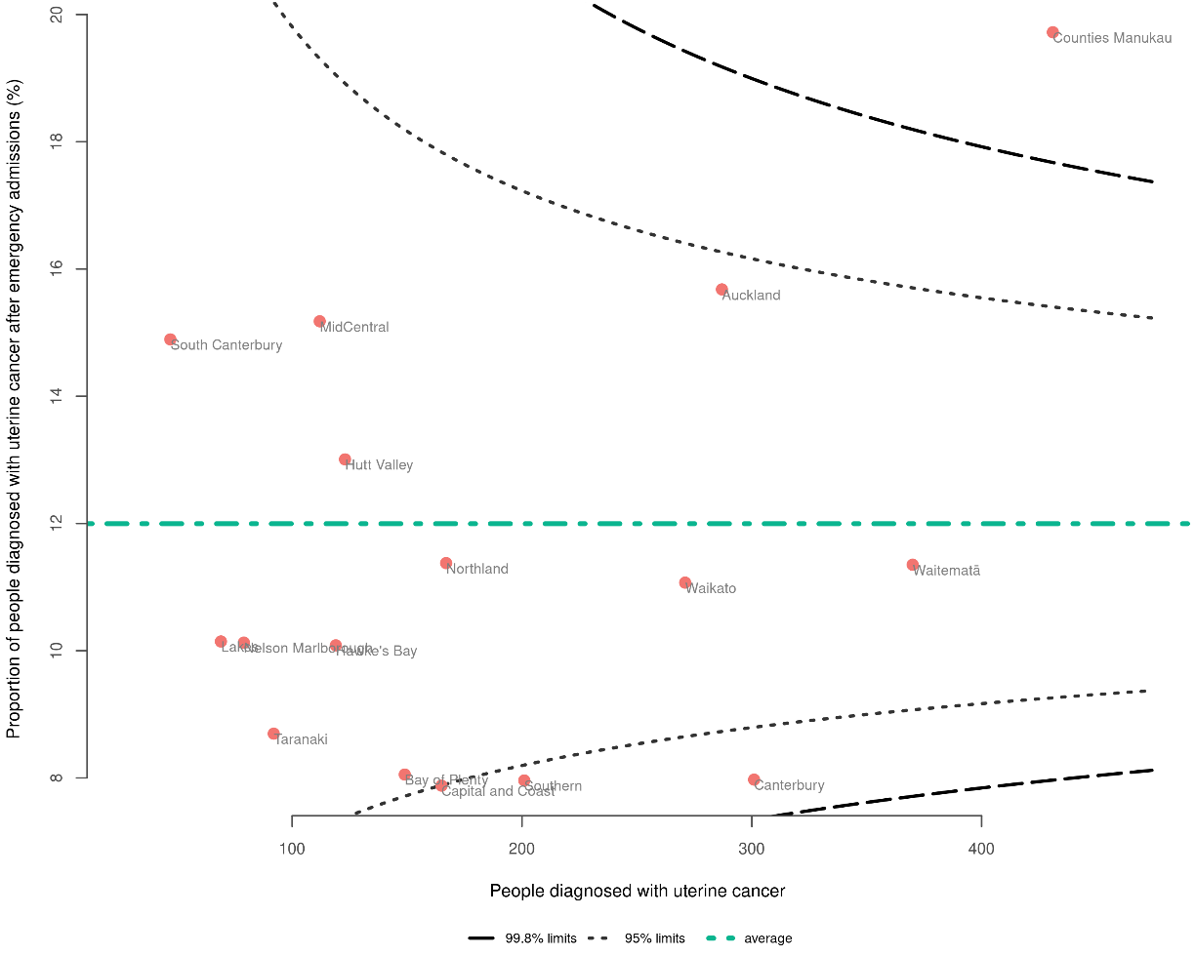
Note: See Appendix D for more detailed information.

References
Abel GA, Shelton J, Johnson S, et al. 2015. Cancer-specific variation in emergency presentation by sex, age, and deprivation across 27 common and rarer cancers. British Journal of Cancer 112(1): S129–36. URL: doi.org/10.1038/bjc.2015.52
Atkinson J, Salmond C, Crampton P. 2019. NZDep2018 Index of Deprivation, Interim Research Report, December 2019. Wellington: University of Otago.
Beatty S, Stevens W, Stevens G, et al. 2009. Lung cancer patients in New Zealand initially present to secondary care through the emergency department rather than by referral to a respiratory specialist. The New Zealand Medical Journal (Online) 122(1294): 33–41. URL: pubmed.ncbi.nlm.nih.gov/19465945
Cassim S, Chepulis L, Keenan R, et al. 2019. Patient and carer perceived barriers to early presentation and diagnosis of lung cancer: A systematic review. BMC Cancer 19(1): 25.
Grimmond D, Martin G, Tu D. 2021. 2021 GP Future Workforce Requirements Report. Allen + Clarke.
Grob R, Schlesinger M, Barre LR, et al. 2019. What words convey: the potential for patient narratives to inform quality improvement. The Milbank Quarterly 97(1): 176–227.
Htun HW, Elwood JM, Ioannides SJ, et al. 2017. Investigations and referral for suspected cancer in primary care in New Zealand – A survey linked to the International Cancer Benchmarking Partnership. European Journal of Cancer Care 26(3): e12634.
Liberman, J. 2019. Chapter 12. The role of law in reducing global cancer inequalities. In: S Vaccarella, J Lortet-Tieulent, R Saracci, et al. (eds), Reducing Social Inequalities in Cancer: Evidence and priorities for research. Lyon: IARC Scientific Publications: 276–87.
Lyratzopoulos G, Saunders CL, Abel GA. 2014. Are emergency diagnoses of cancer avoidable? A proposed taxonomy to motivate study design and support service improvement. Future Oncology 10(8): 1329–33.
Majano SB, Lyratzopoulos G, Rachet B, et al. 2022. Do presenting symptoms, use of pre-diagnostic endoscopy and risk of emergency cancer diagnosis vary by comorbidity burden and type in patients with colorectal cancer? British Journal of Cancer 126(4): 652–63.
McPhail S, Swann R, Johnson SA, et al. 2022. Risk factors and prognostic implications of diagnosis of cancer within 30 days after an emergency hospital admission (emergency presentation): An International Cancer Benchmarking Partnership (ICBP) population-based study. The Lancet Oncology 23(5): 587–600. URL: doi.org/10.1016/s1470-2045(22)00127-9
Ministry of Health. 2019. New Zealand Cancer Action Plan 2019–2029 – Te Mahere mō te Mate Pukupuku o Aotearoa 2019–2029. Revised January 2020. Wellington: Ministry of Health.
Meheus F, Atun R, Ilbawi A. 2019. Chapter 10. The role of health systems in addressing inequalities in access to cancer control. In: S Vaccarella, J Lortet-Tieulent, R Saracci, et al. (eds), Reducing Social Inequalities in Cancer: Evidence and priorities for research. Lyon: IARC Scientific Publications: 228–49.
Murchie P, Smith SM, Yule MS, et al. 2017. Does emergency presentation of cancer represent poor performance in primary care? Insights from a novel analysis of linked primary and secondary care data. British Journal of Cancer 116(9): 1148–58.
National Cancer Registration and Analysis Service. 2021. Official Statistics: Emergency Presentations. URL: www.ncin.org.uk/cancer_type_and_topic_specific_work/topic_specific_work/cancer_outcome_metrics (accessed 2 March 2021).
Nekhlyudov L and Latosinsky S. 2010. The interface of primary and oncology specialty care: From symptoms to diagnosis. Journal of the National Cancer Institute Monographs 2010(40): 11–17.
Pham TM, Gomez-Cano M, Salika T, et al. 2019. Diagnostic route is associated with care satisfaction independently of tumour stage: Evidence from linked English Cancer Patient Experience Survey and cancer registration data. Cancer Epidemiology 61: 70–78. URL: doi.org/10.1016/j.canep.2019.04.011
Stats NZ. 2019. Applying confidentiality rules to 2018 Census data and summary of changes since 2013. URL: www.stats.govt.nz/methods/applying-confidentiality-rules-to-2018-census-data-and-summary-of-changes-since-2013 (accessed 30 November 2023).
Te Aho o Te Kahu. 2021a. He Pūrongo Mate Pukupuku o Aotearoa 2020 – The State of Cancer in New Zealand 2020. Wellington: Te Aho o Te Kahu.
Te Aho o Te Kahu. 2021b. Lung Cancer Quality Improvement Monitoring Report 2021. Wellington: Te Aho o Te Kahu.
Te Aho o Te Kahu. 2021c. Prostate Cancer Quality Improvement Monitoring Report 2021. Wellington: Te Aho o Te Kahu.
Te Aho o Te Kahu. 2022. Bowel Cancer Quality Improvement Monitoring Report Update 2022. Wellington: Te Aho o Te Kahu.
Te Aho o Te Kahu. 2023a. Rongohia Te Reo, Whatua He Oranga: The voices of whānau Māori affected by cancer. Wellington: Te Aho o Te Kahu
Te Aho o Te Kahu. 2023b. Pancreatic Cancer Quality Improvement Monitoring Report 2023. Wellington: Te Aho o Te Kahu.
Tsianakas V, Maben J, Wiseman T, et al. 2012. Using patients’ experiences to identify priorities for quality improvement in breast cancer care: Patient narratives, surveys or both? BMC Health Services Research 12: 1–11.
Waitangi Tribunal. 2019. Hauora: Report on Stage One of the Health Services and Outcomes Kaupapa Inquiry – WAI 2575. Lower Hutt: Waitangi Tribunal.
White BE, Rous B, Chandrakumaran K, et al. 2022. Incidence and survival of neuroendocrine neoplasia in England 1995–2018: A retrospective, population-based study. The Lancet Regional Health–Europe 23.
Wright CM, Halkett G, Carey Smith R, et al. 2020. Sarcoma epidemiology and cancer-related hospitalisation in Western Australia from 1982 to 2016: A descriptive study using linked administrative data. BMC Cancer 20(1): 625.
Zhou Y, Abel GA, Hamilton W, et al. 2017. Diagnosis of cancer as an emergency: A critical review of current evidence. Nature Reviews Clinical Oncology 14(1): 45–56. URL: doi.org/10.1038/nrclinonc.2016.155
- Methods
To fully understand the methods used, this section should be read alongside the technical specifications provided in Appendix B. The technical specifications include details on data sources (more detail than what is provided below), criteria for numerator and denominator, data codes, descriptions and a data flow diagram.

Data sources
All patient data for this report was obtained from administrative data sets (national collections) maintained by Health New Zealand. These data sets include:
- New Zealand Cancer Registry (NZCR): The NZCR is a comprehensive registry that provides information on cancer diagnoses in Aotearoa. It collects data from pathology reports, death certificates, radiation oncology treatment, and diagnosis coding for people admitted to public hospitals.
- National Minimum Dataset (NMDS): The NMDS is a national collection of hospital discharge information, including clinical data for inpatients and day patients. Linking NZCR data to NMDS data allowed us to examine hospital admissions prior to cancer diagnosis.

Data processing
We identified patients as being diagnosed with primary cancer when they were registered on the NZCR for the first time with a diagnosis of specific cancers. We extracted data from the NZCR for individuals diagnosed with cancer between 1 January 2017 and 31 December 2021. Data linkage between the NMDS and the NZCR was done at the patient level using National Health Index (NHI) numbers to gather information on patient care and follow-up.

Statistical analysis
Most results discussed in this report are descriptive. We have reported the results of categorical data as percentages. We typically grouped results by district of residence (ie, where the patient resided at the time of diagnosis).

For confidentiality, we have not presented results when there were fewer than six patients in a group. This is to ensure adequate privacy and confidentiality for patients and providers. We have not included values in columns where the numbers can be added across columns to fewer than six even if the value is above five. More information on this approach can be found on the Stats NZ website (Stats NZ 2019).

Funnel plots
Where appropriate, this report uses funnel plots to make comparisons between districts. We plotted the proportion for each district along with the total number of patients used to estimate this proportion to demonstrate how the number of patients differ by district. The average across all districts appears as a green line.

There are two ‘control limit’ lines on each plot. The funnel limits are statistically calculated based on the average proportion and the number of patients included in the estimate, and therefore create a ‘funnel’ shape. The inner line is the 95% limit, where 5 out of every 100 might be expected to be positioned on the basis of expected random variation. The outer line is the 99.8% limit, where 2 out of every 1000 might be expected to be positioned. Where a district’s results lie outside these limits, this could represent expected variation, but may also represent unwarranted variation requiring further investigation.

Note that the estimated proportions have greater uncertainty when estimated from fewer patients.

Stratification
Stratifying variables include age, sex, ethnicity, New Zealand Deprivation Index 2018 (NZDep2018) quintile (linked to cancer registrations using domicile codes) and rural–urban status. Data is stratified and presented in data tables in Appendix C.

The New Zealand Deprivation Index (NZDep) is an area-based measure of socioeconomic deprivation in Aotearoa (Atkinson et al 2019). It measures the level of deprivation for people in each small area. It is based on nine census variables. In this report, NZDep is displayed in quintiles.

Rural–urban status at time of diagnosis was determined using health domicile codes for people with cancer based on Stats NZ’s Statistical Standard for Geographic Areas 2018, which classifies New Zealand into areas that share common rural or urban characteristics and is used to disseminate a broad range of Stats NZ’s social, demographic and economic statistics.

Other variables (such as risk group, performance status, TNM (tumour, node, metastasis) group stage and comorbidity) were not available for inclusion in this broad report. We did not make any standardisation adjustments (aside from where we have age standardised) due to lack of data in the data sets used such as complete stage at diagnosis and comorbidity. We encourage providers to interpret their results in the context of the case mix for their region.

Confidence intervals
Confidence intervals are most commonly used when working with sample data to estimate how likely it is that the result is true of the whole population. Therefore, confidence intervals are often used to decide if a difference between two groups being looked at is likely to be a true difference (if the confidence intervals overlap, there may not be a true difference). This report uses whole population data (ie, it is not a sample), so confidence intervals should be interpreted differently. They are presented in this report to give an impression of what variation there may be over time (rather than the likelihood the result is true). Therefore, overlapping confidence intervals do not indicate the absence of a difference between compared groups.

Standardisation
In New Zealand, different groups of people have different age distributions. This means that the populations can vary in terms of the ages of people in each group. For example, some ethnicities, genders and regions may have more young people or older people compared to others. Age is also an important determinant of cancer outcomes, so a population with a younger age distribution may seem to have similar or better outcomes than those with an older population – but this may be only because of differences between the groups in their age distribution.

To make fairer comparisons between groups, we use age standardisation. This method helps us remove the influence of these age differences when comparing different groups. We calculate an overall standardised rate for each group at a national level, using a standard population as a reference point. In this case, the Māori population from the 2001 Census is used as the standard.

It is important to note that age-standardised rates are those rates that groups would have if they had the same age structure as the standard population. Sometimes there were only a few cases when analysing data at the regional or district level. In these cases, we used a method called indirect standardisation to calculate standardised ratios. This helped us compare the Māori population with the European/other population group within the same region or district. These ratios are used to determine whether a particular population is more, less or equally likely to achieve a certain outcome compared to a standard or reference group.

Standardised ratios cannot be used to compare results between different regions or over time. Their main purpose is to make comparisons within the same region or district and understand how different populations within that area may differ in terms of achieving specific outcomes.

Classification of NETs and sarcoma
NETs occurring between 2017 and 2021 across all sites were grouped and reported as a separate cancer type. An exception was made to exclude large cell neuroendocrine and small cell carcinomas of the lung from the NETs analysis due to their high incidence in this organ, which could potentially bias the results (White et al 2022). Additionally, services for small cell carcinomas, particularly, are typically overseen by respiratory physicians, given their strong association with smoking, resulting in distinct characteristics and treatment pathways. Please refer to Appendix B for a comprehensive list of morphology codes falling under the NETs category.

For sarcoma cases within the same timeframe, we followed the classification provided by the Information Network on Rare Cancers (RARECARENet), aligning with previously published research on sarcomas using registry data specific to Western Australia (Wright et al 2020). You can find a comprehensive list of morphology codes in Appendix B.

- Technical specifications

Description
Measurability | Measurable
Indicator title | Route to diagnosis
Indicator description | Proportion of people diagnosed with <<type>> cancer within 30 days of an emergency admission.
Specifications | Numerator | Number of people with <<type>> cancer who were admitted to hospital via emergency admission within 30 days of cancer diagnosis.
Specifications | Denominator | Number of people diagnosed with <<type>> cancer.
Specifications | Exclusions | Number of people diagnosed with <<type>> cancer at death.  People registered with cancer from death certificates only.
Data sources | National Non-Admitted Patients Collection, New Zealand Cancer Registry, National Minimum Dataset
Data items
Date range | 2017–2021 data
Justification or notes | - No assumptions about clinical state of the emergency of admitted patients nor the coded reason (diagnosis) relating to the emergency hospital admission episode.  - ‘Emergency admission’ was defined as diagnosis of cancer within 30 days after an emergency hospital admission (not just presentation to an emergency department).  - 30-day cut off – histologically verified diagnosis and aligns with other health care measures (eg, 30-day post-operative mortality or 30-day hospital readmission).  - There is a chance that the emergency admission preceding diagnosis is unrelated to the cancer.

Data source, items and description
Data set | Data item | Description
NZCR | NHI | Patient identifier
NZCR | Cancer event ID | Cancer registration identifier
NZCR | Date of initial diagnosis | Date person first diagnosed with <<type>> cancer
NZCR | Diagnosis year | Calendar year of first diagnosis
NZCR | Site | Primary organ of origin of the cancer (ICD-10-AM 8th edition code)
NZCR | Morphology code | 4-digit code for microscopic or cellular anatomy of the cancer (ICD-O-3)
NZCR | Basis | Basis of diagnosis
NZCR | Extent of disease | A code describing the stage of development reached by the tumour at diagnosis
NZCR | District of domicile | District code for domicile of patient at diagnosis
NZCR | District | District name based on domicile of patient at diagnosis
NZCR | Age at diagnosis | Age of patient at diagnosis in years
NZCR | Prioritised ethnicity | Ethnic group derived from patient’s ethnicity
NZCR | Sex | Sex of patient
NZCR | Deprivation quintile | NZDep2018 index of social deprivation quintile based on patient’s domicile
NZCR | Behaviour code | Neoplastic behaviour of the cancer
NZCR | Multiple tumour flags | Person diagnosed with more than one tumour
NZCR | Registration status code | Status of registration processing
NMDS | District name | District of service for patient
NMDS | Admission type | Type of inpatient admission
NMDS | Event start date | Date of admission
NMDS | Event end date | Date of discharge

Case eligibility criteria (denominator)
Diagram reference | Assessment | Item | Codes
1 | First or only diagnosis of malignant neoplasm | Primary site | First diagnosis of:  - bladder cancer (C67)  - bowel cancer (colorectal cancer) (C18–C20, excl. C18.1 and morphology codes 8240, 8249, 8246, 8070, 8720, 8013, 8041, 8244, 8936)  - brain and central nervous system cancers (C71–C72)  - breast cancer (C50)  - cervical cancer (C53)  - head and neck cancer (C00–C14, C30–C32)  - kidney cancer (C64)  - leukaemia (C91–C95)  - liver cancer (C22)  - lung cancer (C33–C34, excl. morphology codes 8333, 8720, 8772, 8800, 8801, 8803, 8805, 8815, 8890, 9040, 9041, 9133)  - lymphoma (C81–C86)  - melanoma of the skin (C43)  - myeloma (C90)  - oesophageal cancer (C15)  - ovarian cancer (C48.1–2 and C56–C570)  - pancreatic cancer (C25, excl. C25.4 and incl. morphology codes 8000, 8010, 8020, 8021, 8022, 8140, 8141, 8211, 8230, 8500, 8521, 8050, 8260, 8441, 8450, 8453, 8470, 8471, 8472, 8473, 8480, 8481, 8503, 8560, 8576, 8510, 8490, 8035)  - prostate cancer (C61, excl. morphology codes 8041, 8045, 8246, 8890, 8980)  - stomach cancer (C16)  - thyroid cancer (C73)  - uterine cancer (C54–C55)  - neuroendocrine tumours (NETs), incl. any cancer site with morphology codes 8013 (excl. lung [C34 and C78]), 8041–8045 (excl. lung), 8150–8158, 8240–8247, 8249, 9091 and 8510, 8512, 8513 (for thyroid only)  - sarcoma (soft tissue sarcoma), including:  - all cancers sites except C40.0–C41.9 (includes unknown primary sites) with morphology codes 8710–8711, 8800–8935, 8959, 8963–8964, 8990–8991, 9020, 9040–9044, 9120–9133, 9150, 9170, 9180, 9231, 9240, 9251, 9260, 9364–9365, 9540, 9560–9571, 9580–9581  - all cancer sites except C40.0–C41.9, C7–C8, C60, C44, C63.2 with morphology code 8940  - all cancer sites except C40.0–C41.9, C56, C62, C71, C72 with morphology code 9473  - bone sarcoma (C40.0–C41.9), incl. morphology codes 8800–8801, 8803–8806, 8810, 8811–8812, 8815, 8830, 8840, 8850–8855, 8890–8891, 8894–8896, 8900–8902, 8910, 8912, 8920, 9040–9044, 9120–9133, 9150, 9170, 9180–9250, 9260–9261, 9310, 9364, 9370–9372, 9540–9581  - gastrointestinal stromal tumour, incl. any cancer site with morphology code 8936  - Kaposi’s sarcoma, incl. any cancer site with following morphology code 9140.
2 | Exclude manually censored case | Exclusion | - Appendix (C18.1), islets of Langerhans (C25.4), non-melanoma skin cancer (C44)  - Registration codes not R_C (registered complete) or R_R (registered)  - No incident cancer (exclude people with multiple tumour flags = yes)  - People diagnosed following death certificate only (basis = 0)  - People domiciled outside of New Zealand (district_code = 999)
3 | Diagnosis date | Date of initial diagnosis | 2017–2021
4 | Male or female | Sex | M or F
5 | Adult patient 18 years and older at diagnosis | Age at diagnosis | 18 years and older
6 | Invasive tumours | Behaviour code | 3 (specifying the behaviour of the tumour, in terms of its malignancy and metastasis)

Numerator
Diagram reference | Assessment | Item | Codes
7 | Number of people diagnosed with cancer within 30 days of an emergency hospital admission. | ed_diag | - Inpatient (NMDS)  - Admission type = ‘Acute’  - Includes admissions within 30 days prior to diagnosis date.

Calculation process/flow chart
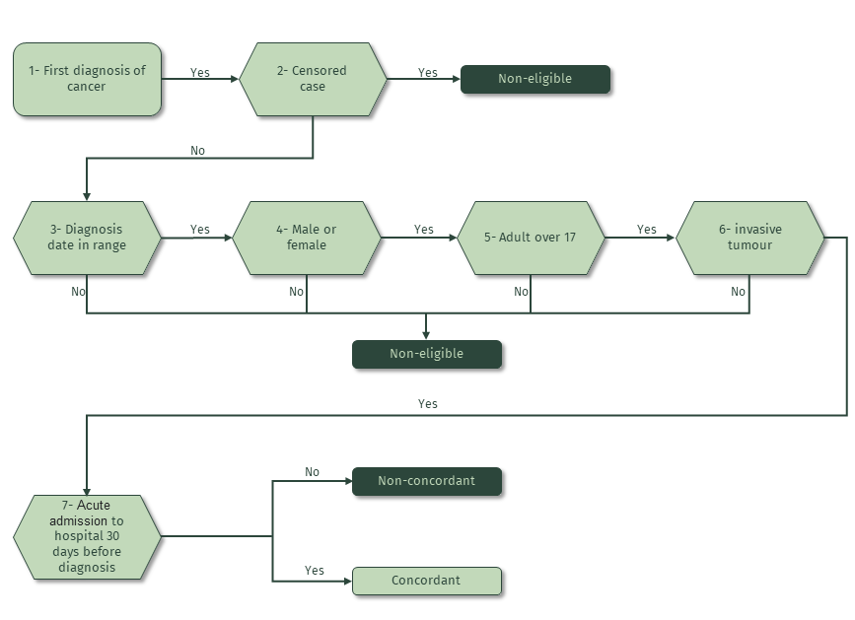
- Comparisons with other similar reports

Definitions
We note that in previous research and quality improvement reporting, a range of methods have been used to define ‘emergency admission prior to diagnosis’. These variations include:
- the terminology used (eg, route to diagnosis vs emergency presentation vs emergency hospital or acute admission)
- the timeframe post-presentation to a cancer diagnosis (eg, 30 days)
- the scope of the definition (eg, ‘emergency presentation’ vs ‘emergency presentation leading to admission to hospital’ vs ‘emergency admission to hospital via emergency or acute services’).

In Table 2 we have extracted the definitions from three articles (McPhail et al 2022; Pham et al 2019; Zhou et al 2017) as well as from our existing cancer QPI programme to help interpret the evidence effectively. The definition used in the current report is consistent with the ICBP study published in The Lancet Oncology in 2022 (McPhail et al 2022).

Table 2: Referenced definitions of emergency admission and route to diagnosis
Citation | Definition
McPhail et al (2022) | ‘Emergency presentation’ was defined as the diagnosis of cancer within 30 days after an emergency hospital admission.
Pham et al (2019) | ‘Emergency hospital admission’ was defined as cancer diagnosis soon after any emergency hospital admission, attendance at the accident and emergency department, emergency general practice referral or emergency between hospital transfer.
Zhou et al (2017) | ‘Emergency presentation’ was defined as patients who present to emergency health care services and/or received emergency treatment shortly before their diagnosis.
Pancreatic cancer –  Te Aho o Te Kahu (2023b) | ‘Route to diagnosis’ was defined as ‘diagnosis with pancreatic cancer within 30 days of an emergency or acute admission to hospital’. An acute or unplanned hospital admission does not include people who attended the emergency department for review and then were discharged. An emergency admission may occur by a number of routes such as via the emergency department or outpatient clinic.
Bowel cancer –  Te Aho o Te Kahu (2022) | ‘Route to diagnosis’ was defined as the ’proportion of people with bowel cancer who are diagnosed following a referral to a clinic, screening or presentation to an emergency department (with or without surgery)’.
Lung cancer –  Te Aho o Te Kahu (2021b) | ‘Route to diagnosis’ was defined as the ‘proportion of people with lung cancer who are diagnosed following a referral to a clinic or presentation to an emergency department’.
Prostate cancer –  Te Aho o Te Kahu (2021c) | ‘Route to diagnosis’ was defined as the ‘proportion of men with prostate cancer who are diagnosed following a presentation to an emergency department’.

Regardless of method used, there is a general trend of poorer outcomes for people who have their cancer diagnosis associated with an emergency admission compared with primary care or screening settings. Considering the variation in methods and definitions, there should be caution when comparing results between previous findings and those shown in this report.

Inequities found in our cancer-specific quality performance indicator reports
Previous cancer QPI programme reports for bowel, lung, prostate and pancreatic cancers have identified inequities relating to cancer diagnosis following an emergency admission. Table 3 gives an overview of the results from our previous cancer-specific QPI reports.

Table 3: Percentage of people diagnosed with cancer following emergency admission, by sex, ethnic group and social deprivation, 2015/16 to 2018
 | Lung cancer (%) | Prostate cancer (%) | Bowel cancer (%) | Pancreatic cancer (%)
Ethnicity
Māori | 48.9 | 8.4 | 36.7 | 74.8
Pacific peoples | 57.4 | 10.7 | 44.4 | 76.6
Asian | 41.5 | 8.0 | 27.3 | 63.8
European/other | 43.2 | 5.8 | 25.0 | 67.8
Unknown | – | 1.4 | 9.4 | 69.0
Sex
Female | 44.5 | – | 28.0 | 67.0
Male | 45.6 | 100 | 24.7 | 70.7
Deprivation quintile (NZDep2018)
Quintile 1 – least deprived | 39.0 | 3.9 | 22.3 | 63.4
Quintile 2 | 42.0 | 5.3 | 23.7 | 68.1
Quintile 3 | 44.8 | 6.2 | 25.0 | 68.3
Quintile 4 | 46.4 | 7.2 | 26.3 | 69.6
Quintile 5 – most deprived | 48.1 | 8.7 | 34.4 | 73.4

Almost half of all lung cancers were diagnosed via an emergency presentation (not admission), but this is not evenly spread throughout the population or country (see Table 3). We identified:
- geographical inequities ranging from 30.8% to 62.7% between districts
- ethnicity inequities, with higher rates for Māori (48.9%) and Pacific peoples (57.4%) compared with people of European/other ethnicity (43.2%)
- deprivation inequities with rates increasing as social deprivation increased (NZDep2018quintile 1 at 39% and quintile 5 at 48.1%) (Te Aho o Te Kahu 2021a).

For bowel cancer, 26.3% of all cases are diagnosed after an emergency presentation, and this is not evenly spread throughout the population or country. We identified:
- age inequities for people aged younger than 50 years (32.7%) or over 75 years (30.5%)
- ethnicity inequities for Pacific peoples (44.4%) and Māori (36.7%)
- deprivation inequities for those living in areas of high social deprivation (NZDep2018 quintile 1 at 22.3% and quintile 5 at 34.4%) (Te Aho o Te Kahu 2021a).

For prostate cancer, the rate of diagnosis following emergency presentation in Aotearoa was 6.1%, slightly lower than the rate for prostate cancer in the United Kingdom of 7% (National Cancer Registration and Analysis Service 2021). We identified:
- age inequities, with patients aged 75 years and over more likely to be diagnosed following emergency presentation (not admission) (17.2%) compared with those in younger age groups (5.3% or less)
- ethnicity inequities, with Māori, Pacific peoples and Asian people more likely to be diagnosed following emergency presentation (not admission) (8.4%, 10.7% and 8.0%, respectively) than people of European/other ethnicity (5.8%)
- deprivation inequities, with patients living in areas of high social deprivation more likely to be diagnosed following emergency presentation (not admission) (8.7%) than those living in areas of low social deprivation (3.9%) (Te Aho o Te Kahu 2021c).

A considerable proportion (68.7%) of people with pancreatic cancer had an emergency admission in the 30 days before their diagnosis. Also, the proportion of people who had an emergency admission prior to diagnosis was higher for Māori and Pacific peoples (74.8% and 76.6%, respectively) compared with people of European/other ethnicity (67.8%). Those living in the most deprived areas were also more likely to be diagnosed within 30 days of an emergency admission (Te Aho o Te Kahu 2023b).

These inequities present in very real ways for whānau as they try to access health services. This is highlighted in the hui report Rongohia Te Reo, Whatua He Oranga, where whānau Māori describe ‘racism’ being ‘rife’ among the ‘gatekeepers’ of the system.
‘I am not welcomed in my language, then you mispronounce my name. It just goes on and on ... it all determines my level of trust.’ (Te Aho o Te Kahu 2023a)
- Supplementary tables by cancer type

Bladder cancer
Table 4: People diagnosed with bladder cancer following emergency admission, by year of diagnosis, sex, age group, ethnicity, deprivation quintile (NZDep2018) and rural–urban status
 | People with cancer¹ | % emergency admission² | Age-standardised proportion
 | People with cancer¹ | % emergency admission² | % | Confidence interval (95%)
All cases
Total | 2,210 | 26.6 | 25.9 | 15.8–40.7
Year of diagnosis
2017 | 394 | 26.1 | 25.1 | 5.8–74.8
2018 | 435 | 27.1 | 38.5 | 10.5–101.7
2019 | 460 | 23.9 | 28.5 | 11.3–60.5
2020 | 460 | 27.0 | 12.0 | 1.8–46.5
2021 | 461 | 28.9 | 27.3 | 5.7–84.3
Sex
Male | 1,629 | 24.1 | 21.3 | 10.6–39.0
Female | 580 | 33.6 | 37.5 | 16.9–73.5
Age group
18–49 | 48 | 27.1 | – | –
50–59 | 199 | 22.1 | – | –
60–69 | 469 | 20.7 | – | –
70–79 | 748 | 21.4 | – | –
80+ | 746 | 36.7 | – | –
Ethnicity
Māori | 153 | 39.2 | 39.8 | 15.3–87.3
Pacific peoples | 55 | 32.7 | 26.0 | 6.3–75.8
Asian | 72 | 15.3 | 1.3 | 0.5–96.3
European/other | 1,915 | 25.8 | 24.6 | 12.0–45.6
Deprivation quintiles (NZDep2018)
Quintile 1 – least deprived | 398 | 20.1 | 14.2 | 1.2–64.1
Quintile 2 | 450 | 26.0 | 23.7 | 1.7–111.3
Quintile 3 | 516 | 26.4 | 33.1 | 8.8–88.5
Quintile 4 | 446 | 28.7 | 23.4 | 5.9–67.4
Quintile 5 – most deprived | 400 | 31.8 | 30.0 | 14.3–56.9
Rural–urban status
Rural/remote | 456 | 21.7 | 26.0 | 4.9–83.2
Urban | 1,754 | 27.9 | 26.1 | 15.3–42.3
¹ Excludes people registered with cancer from death certificates only.
² Non-age-standardised data.
Sources: NZCR and NMDS (hospital events)
Note: Confidence intervals are presented to indicate potential variation over time. Overlapping confidence intervals do not indicate an absence of differences between compared groups.

Table 5: People diagnosed with bladder cancer following emergency admission, by district of residence
 | People with  cancer¹ | % emergency  admission^{1,2} | Ratio (Māori to European/other)^{2,3}
District of residence
National | 2,210 | 26.6 (24.8–28.5) | 1.8 (1.4–2.3)
Northland | 140 | 31.4 (24.3–39.5) | 1.6 (0.8–3.4)
Waitematā | 248 | 22.6 (17.8–28.2) | 5.8 (2.9–11.6)
Auckland | 148 | 27.7 (21.1–35.4) | 1.8 (0.4–7)
Counties Manukau | 185 | 24.9 (19.2–31.6) | 1.4 (0.5–3.7)
Waikato | 195 | 23.1 (17.7–29.5) | 2.2 (1.1–4.5)
Lakes | 43 | 25.6 (14.9–40.2) | 1.9 (0.6–5.7)
Bay of Plenty | 139 | 29.5 (22.5–37.5) | 1.8 (0.9–3.9)
Tairāwhiti | 16 | (14.2–55.6)* | 8 (2–32)
Taranaki | 68 | 20.6 (12.7–31.6) | †
Hawke’s Bay | 105 | 30.5 (22.5–39.8) | 1.2 (0.4–3.6)
Whanganui | 45 | 26.7 (16–41) | 0.9 (0.1–6.5)
MidCentral | 96 | 37.5 (28.5–47.5) | †
Capital & Coast | 144 | 25 (18.6–32.7) | 5.2 (1.7–16.3)
Hutt Valley | 86 | 32.6 (23.6–43) | 1.4 (0.5–4.4)
Wairarapa | 24 | 29.2 (14.9–49.2) | †
Nelson Marlborough | 64 | 21.9 (13.5–33.4) | †
West Coast | 29 | 27.6 (14.7–45.7) | †
Canterbury | 240 | 22.9 (18.1–28.6) | 4.2 (1.8–10.1)
South Canterbury | 42 | 35.7 (23–50.8) | 3.3 (0.8–13.2)
Southern | 153 | 27.5 (21–35) | 0.7 (0.2–2.9)
* Indicates that there were either fewer than six or no reported cases of that particular cancer in the district during the study period.
† Indicates that ratio unable to be reported due to small numbers in at least one group.
¹ Excludes people registered with cancer from death certificates only.
² Confidence intervals are presented to indicate potential variation over time. Overlapping confidence intervals do not indicate an absence of differences between compared groups.
³ Standardised ratios were used here to compare the likelihood that Māori will be diagnosed with cancer following an emergency admission compared to people of European/other ethnicity.
Sources: NZCR and NMDS (hospital events)

Bowel cancer
Table 6: People diagnosed with bowel cancer following emergency admission, by year of diagnosis, sex, age group, ethnicity, deprivation quintile (NZDep2018) and rural–urban status
 | People with cancer¹ | % emergency admission² | Age-standardised proportion
 | People with cancer¹ | % emergency admission² | % | Confidence interval (95%)
All cases
Total | 15,139 | 30.1 | 33.5 | 30.9–36.2
Year of diagnosis
2017 | 2,801 | 30.0 | 33.6 | 27.8–40.4
2018 | 2,991 | 31.7 | 37.0 | 31.1–43.9
2019 | 3,065 | 30.5 | 32.9 | 27.2–39.5
2020 | 3,156 | 30.0 | 31.3 | 26.2–37.2
2021 | 3,126 | 28.5 | 32.9 | 27.4–39.2
Sex
Male | 8,176 | 28.6 | 31.6 | 28.1–35.5
Female | 6,955 | 31.9 | 35.3 | 31.6–39.3
Age group
18–49 | 1,221 | 35.8 | – | –
50–59 | 1,834 | 27.7 | – | –
60–69 | 3,541 | 22.8 | – | –
70–79 | 4,713 | 26.3 | – | –
80+ | 3,830 | 41.0 | – | –
Ethnicity
Māori | 1,004 | 38.7 | 47.0 | 38.2–57.3
Pacific peoples | 373 | 48.5 | 52.7 | 39.8–68.6
Asian | 757 | 25.8 | 30.9 | 22.7–41.4
European/other | 12,906 | 29.1 | 30.6 | 27.8–33.6
Deprivation quintiles (NZDep2018)
Quintile 1 – least deprived | 2,854 | 25.9 | 27.9 | 23.0–33.5
Quintile 2 | 3,098 | 28.5 | 30.7 | 25.5–36.6
Quintile 3 | 3,355 | 28.8 | 32.9 | 27.5–39.3
Quintile 4 | 3,198 | 31.5 | 34.8 | 29.0–41.5
Quintile 5 – most deprived | 2,630 | 36.7 | 43.8 | 36.6–52.0
Rural–urban status
Rural/remote | 3,121 | 27.3 | 33.8 | 27.8–40.7
Urban | 12,018 | 30.9 | 33.5 | 30.6–36.5
¹ Excludes people registered with cancer from death certificates only.
² Non-age-standardised data.
Sources: NZCR and NMDS (hospital events)
Note: Confidence intervals are presented to indicate potential variation over time. Overlapping confidence intervals do not indicate an absence of differences between compared groups.

Table 7: People diagnosed with bowel cancer following emergency admission, by district of residence
 | People with cancer¹ | % emergency  admission^{1,2} | Ratio (Māori to European/other)^{2,3}
District of residence
National | 15,139 | 30.1 (29.4–30.9) | 1.5 (1.3–1.6)
Northland | 694 | 30.1 (26.8–33.6) | 1.5 (1.1–2.1)
Waitematā | 1,435 | 30.4 (28.1–32.8) | 1.5 (1–2.3)
Auckland | 1,016 | 30.2 (27.5–33.1) | 1.6 (1–2.7)
Counties Manukau | 1,218 | 31 (28.5–33.7) | 1.6 (1.1–2.1)
Waikato | 1,399 | 30.7 (28.3–33.1) | 1.5 (1.1–1.9)
Lakes | 369 | 28.2 (23.8–33) | 1.9 (1.3–2.8)
Bay of Plenty | 874 | 31.9 (28.9–35.1) | 1.3 (0.9–1.9)
Tairāwhiti | 135 | 40.7 (32.8–49.2) | 1.8 (1.1–2.9)
Taranaki | 435 | 31.5 (27.3–36) | 1 (0.5–2)
Hawke’s Bay | 641 | 33.1 (29.5–36.8) | 1.7 (1.1–2.4)
Whanganui | 265 | 30.9 (25.7–36.7) | 1.3 (0.7–2.4)
MidCentral | 743 | 33.1 (29.8–36.6) | 1.5 (1–2.3)
Capital and Coast | 760 | 29.5 (26.3–32.8) | 1.3 (0.8–2.2)
Hutt Valley | 449 | 27.8 (23.9–32.2) | 1.4 (0.8–2.6)
Wairarapa | 186 | 25.8 (20.1–32.5) | 0.6 (0.1–4.4)
Nelson Marlborough | 640 | 25.3 (22.1–28.8) | 1.4 (0.7–2.9)
West Coast | 146 | 26.7 (20.2–34.4) | 2 (0.8–4.8)
Canterbury | 1,878 | 28.4 (26.4–30.5) | 1.1 (0.7–1.8)
South Canterbury | 294 | 28.2 (23.4–33.6) | 0.5 (0.1–3.5)
Southern | 1,562 | 30.2 (27.9–32.5) | 1.1 (0.7–1.9)
* Indicates that there were either less than six or no reported cases of that particular cancer in the district during the study period.
† Indicates that ratio unable to be reported due to small numbers in at least one group.
¹ Excludes people registered with cancer from death certificates only.
² Confidence intervals are presented to indicate potential variation over time. Overlapping confidence intervals do not indicate an absence of differences between compared groups.
³ Standardised ratios were used here to compare the likelihood that Māori will be diagnosed with cancer following an emergency admission compared to people of European/other ethnicity.
Sources: NZCR and NMDS (hospital events)

Brain and central nervous system cancer
Table 8: People diagnosed with brain and central nervous system cancer following emergency admission, by year of diagnosis, sex, age group, ethnicity, deprivation quintile (NZDep2018) and rural–urban status
 | People with cancer¹ | % emergency admission² | Age-standardised proportion
 | People with cancer¹ | % emergency admission² | % | Confidence interval (95%)
All cases
Total | 1,571 | 81.5 | 72.3 | 65.2–80.0
Year of diagnosis
2017 | 300 | 77.3 | 64.6 | 51.7–80.1
2018 | 314 | 79.6 | 80.7 | 62.6–102.7
2019 | 290 | 84.5 | 73.8 | 57.6–93.6
2020 | 319 | 80.6 | 72.2 | 56.3–91.6
2021 | 348 | 85.3 | 73.6 | 59.0–91.0
Sex
Male | 913 | 81.3 | 72.3 | 63.4–82.2
Female | 656 | 82.0 | 72.4 | 61.1–85.4
Age group
18–49 | 314 | 68.5 | – | –
50–59 | 311 | 85.2 | – | –
60–69 | 422 | 86.5 | – | –
70–79 | 369 | 84.3 | – | –
80+ | 155 | 80.6 | – | –
Ethnicity
Māori | 108 | 83.3 | 82.5 | 60.3–110.7
Pacific peoples | 46 | 80.4 | 66.0 | 38.3–108.1
Asian | 80 | 82.5 | 84.2 | 61.0–114.0
European/other | 1,328 | 81.4 | 69.5 | 61.5–78.3
Deprivation quintiles (NZDep2018)
Quintile 1 – least deprived | 342 | 82.7 | 70.6 | 55.4–89.0
Quintile 2 | 350 | 80.3 | 72.5 | 57.1–91.2
Quintile 3 | 330 | 79.1 | 67.6 | 52.9–85.4
Quintile 4 | 328 | 81.1 | 72.1 | 58.3–88.5
Quintile 5 – most deprived | 220 | 85.9 | 80.4 | 62.2–102.7
Rural–urban status
Rural/remote | 367 | 82.0 | 77.3 | 62.1–95.4
Urban | 1,204 | 81.4 | 70.9 | 63.0–79.5
¹ Excludes people registered with cancer from death certificates only.
² Non-age-standardised data.
Sources: NZCR and NMDS (hospital events)
Note: Confidence intervals are presented to indicate potential variation over time. Overlapping confidence intervals do not indicate an absence of differences between compared groups.

Table 9: People diagnosed with brain and central nervous system cancer following emergency admission, by district of residence
 | People with cancer¹ | % emergency  admission^{1,2} | Ratio (Māori to European/other)^{2,3}
District of residence
National | 1,571 | 81.5 (79.5–83.4) | 1 (0.9–1.3)
Northland | 69 | 87 (77–93) | 1.1 (0.6–2.1)
Waitematā | 176 | 88.1 (82.4–92.1) | 0.9 (0.4–1.8)
Auckland | 146 | 84.2 (77.5–89.3) | 1.1 (0.4–2.6)
Counties Manukau | 126 | 82.5 (75–88.2) | 1.3 (0.6–2.7)
Waikato | 135 | 78.5 (70.9–84.6) | 0.9 (0.5–1.7)
Lakes | 35 | 82.9 (67.3–91.9) | 0.4 (0.1–2.8)
Bay of Plenty | 96 | 86.5 (78.2–91.9) | 1.2 (0.6–2.4)
Tairāwhiti | 12 | 75 (46.8–91.1) | 1.5 (0.6–4)
Taranaki | 32 | 84.4 (68.2–93.1) | 0.6 (0.1–2.3)
Hawke’s Bay | 63 | 92.1 (82.7–96.6) | 1.1 (0.6–2.2)
Whanganui | 26 | 80.8 (62.1–91.5) | 1.6 (0.4–6.3)
MidCentral | 63 | 85.7 (75–92.3) | 1.2 (0.6–2.5)
Capital and Coast | 102 | 79.4 (70.6–86.1) | 1.4 (0.5–3.6)
Hutt Valley | 38 | 86.8 (72.7–94.2) | †
Wairarapa | 26 | 84.6 (66.5–93.8) | †
Nelson Marlborough | 75 | 81.3 (71.1–88.5) | †
West Coast | 13 | 69.2 (42.4–87.3) | †
Canterbury | 187 | 66.8 (59.8–73.2) | 0.9 (0.4–2.2)
South Canterbury | 28 | 75 (56.6–87.3) | 0.6 (0.1–4.1)
Southern | 123 | 81.3 (73.5–87.2) | 1.1 (0.5–2.6)
* Indicates that there were either less than six or no reported cases of that particular cancer in the district during the study period.
† Indicates that ratio unable to be reported due to small numbers in at least one group.
¹ Excludes people registered with cancer from death certificates only.
² Confidence intervals are presented to indicate potential variation over time. Overlapping confidence intervals do not indicate an absence of differences between compared groups.
³ Standardised ratios were used here to compare the likelihood that Māori will be diagnosed with cancer following an emergency admission compared to people of European/other ethnicity.
Sources: NZCR and NMDS (hospital events)

Breast cancer
Table 10: People diagnosed with breast cancer following emergency admission, by year of diagnosis, sex, age group, ethnicity, deprivation quintile (NZDep2018) and rural–urban status
 | People with cancer¹ | % emergency admission² | Age-standardised proportion
 | People with cancer¹ | % emergency admission² | % | Confidence interval (95%)
All cases
Total | 17,301 | 4.4 | 3.5 | 3.1–4.0
Year of diagnosis
2017 | 3,290 | 4.2 | 3.9 | 2.9–5.3
2018 | 3,544 | 4.0 | 3.3 | 2.4–4.5
2019 | 3,449 | 5.0 | 4.3 | 3.2–5.6
2020 | 3,445 | 4.3 | 2.4 | 1.7–3.4
2021 | 3,573 | 4.6 | 3.7 | 2.7–4.9
Sex
Male | 139 | 5.8 | 0.8 | 0.2–48.2
Female | 17,151 | 4.4 | 3.5 | 3.1–4.0
Age group
18–49 | 3,931 | 3.5 | – | –
50–59 | 4,236 | 2.5 | – | –
60–69 | 4,593 | 3.3 | – | –
70–79 | 2,775 | 6.2 | – | –
80+ | 1,766 | 11.2 | – | –
Ethnicity
Māori | 2,398 | 4.7 | 4.2 | 3.0–5.6
Pacific peoples | 933 | 7.4 | 7.3 | 5.1–10.2
Asian | 1,386 | 4.0 | 4.1 | 2.8–5.8
European/other | 12,504 | 4.2 | 2.8 | 2.3–3.4
Deprivation quintiles (NZDep2018)
Quintile 1 – least deprived | 3,482 | 3.4 | 2.6 | 1.8–3.6
Quintile 2 | 3,565 | 3.7 | 2.5 | 1.7–3.6
Quintile 3 | 3,446 | 4.2 | 2.6 | 1.8–3.6
Quintile 4 | 3,563 | 4.9 | 4.5 | 3.4–5.8
Quintile 5 – most deprived | 3,239 | 6.1 | 5.6 | 4.4–7.2
Rural–urban status
Rural/remote | 3,354 | 3.4 | 2.6 | 1.8–3.7
Urban | 13,947 | 4.7 | 3.8 | 3.2–4.3
¹ Excludes people registered with cancer from death certificates only.
² Non-age-standardised data.
Sources: NZCR and NMDS (hospital events)
Note: Confidence intervals are presented to indicate potential variation over time. Overlapping confidence intervals do not indicate an absence of differences between compared groups.

Table 11: People diagnosed with breast cancer following emergency admission, by district of residence
 | People with  cancer¹ | % emergency admission^{1,2} | Ratio (Māori to European/other)^{2,3}
District of residence
National | 17,301 | 4.4 (4.1–4.7) | 1.4 (1.2–1.7)
Northland | 861 | 5.6 (4.2–7.3) | 1.1 (0.7–1.9)
Waitematā | 2,019 | 5 (4.1–6) | 1.5 (0.8–3)
Auckland | 1,555 | 4.8 (3.8–5.9) | 1.3 (0.5–3.4)
Counties Manukau | 1,668 | 5.1 (4.1–6.3) | 1.1 (0.6–2)
Waikato | 1,505 | 4.3 (3.4–5.5) | 1.9 (1.2–3)
Lakes | 443 | 5.2 (3.5–7.7) | 1.7 (0.9–3)
Bay of Plenty | 1,017 | 3.1 (2.2–4.4) | 0.8 (0.3–1.9)
Tairāwhiti | 183 | 4.4 (2.2–8.4) | 0.7 (0.3–1.9)
Taranaki | 454 | 5.7 (3.9–8.3) | 0.9 (0.3–2.8)
Hawke’s Bay | 760 | 4.5 (3.2–6.2) | 1.7 (0.9–3.2)
Whanganui | 277 | 3.6 (2–6.5) | 2 (0.7–5.3)
MidCentral | 617 | 4.2 (2.9–6.1) | 0.7 (0.2–2.7)
Capital and Coast | 1,072 | 5.5 (4.3–7) | 0.2 (0–1.6)
Hutt Valley | 570 | 4.6 (3.1–6.6) | 1.9 (0.8–4.5)
Wairarapa | 178 | 5.6 (3.1–10) | †
Nelson Marlborough | 608 | 3.6 (2.4–5.4) | 2.7 (1–7.3)
West Coast | 102 | (0.2–5.3)* | †
Canterbury | 2,010 | 3.1 (2.5–4) | 2 (0.9–4.5)
South Canterbury | 241 | 2.9 (1.4–5.9) | †
Southern | 1,161 | 3.9 (2.9–5.1) | 1.8 (0.7–4.8)
* Indicates that there were either less than six or no reported cases of that particular cancer in the district during the study period.
† Indicates that ratio unable to be reported due to small numbers in at least one group.
¹ Excludes people registered with cancer from death certificates only.
² Confidence intervals are presented to indicate potential variation over time. Overlapping confidence intervals do not indicate an absence of differences between compared groups.
³ Standardised ratios were used here to compare the likelihood that Māori will be diagnosed with cancer following an emergency admission compared to people of European/other ethnicity.
Sources: NZCR and NMDS (hospital events)

Cervical cancer
Table 12: People diagnosed with cervical cancer following emergency admission, by year of diagnosis, sex, age group, ethnicity, deprivation quintile (NZDep2018) and rural–urban status
 | People with cancer¹ | % emergency admission² | Age-standardised proportion
 | People with cancer¹ | % emergency admission² | % | Confidence interval (95%)
All cases
Total | 863 | 15.5 | 13.9 | 11.4–16.8
Year of diagnosis
2017 | 165 | 17.0 | 14.0 | 8.8–21.5
2018 | 181 | 15.5 | 14.6 | 9.3–21.8
2019 | 182 | 9.3 | 8.5 | 4.8–14.2
2020 | 166 | 18.7 | 17.9 | 11.6–26.6
2021 | 169 | 17.8 | 15.0 | 9.4–22.8
Age group
18–49 | 515 | 13.0 | – | –
50–59 | 149 | 15.4 | – | –
60–69 | 103 | 13.6 | – | –
70–79 | 44 | 20.5 | – | –
80+ | 52 | 40.4 | – | –
Ethnicity
Māori | 157 | 23.6 | 21.9 | 15.1–30.7
Pacific peoples | 63 | 28.6 | 30.7 | 17.4–50.5
Asian | 111 | 11.7 | 10.0 | 4.9–18.6
European/other | 532 | 12.4 | 10.3 | 7.6–13.6
Deprivation quintiles (NZDep2018)
Quintile 1 – least deprived | 155 | 7.7 | 6.0 | 2.9–11.3
Quintile 2 | 159 | 10.7 | 8.3 | 4.4–14.4
Quintile 3 | 163 | 17.8 | 15.3 | 9.6–23.2
Quintile 4 | 186 | 17.7 | 18.2 | 12.2–26.2
Quintile 5 – most deprived | 200 | 21.5 | 20.3 | 13.9–28.7
Rural–urban status
Rural/remote | 156 | 11.5 | 12.5 | 7.2–20.2
Urban | 707 | 16.4 | 14.2 | 11.5–17.5
¹ Excludes people registered with cancer from death certificates only.
² Non-age-standardised data.
Sources: NZCR and NMDS (hospital events)
Note: Confidence intervals are presented to indicate potential variation over time. Overlapping confidence intervals do not indicate an absence of differences between compared groups.

Table 13: People diagnosed with cervical cancer following emergency admission, by district of residence
 | People with  cancer¹ | % emergency admission^{1,2} | Ratio (Māori to European/other)^{2,3}
District of residence
National | 863 | 15.5 (13.3–18.1) | 2.1 (1.5–2.9)
Northland | 48 | 18.8 (10.2–31.9) | 2.2 (0.9–5.3)
Waitematā | 92 | 14.1 (8.4–22.7) | 2.6 (0.6–10.4)
Auckland | 97 | 16.5 (10.4–25.1) | 2.7 (0.7–10.9)
Counties Manukau | 99 | 21.2 (14.3–30.3) | 2.4 (1.1–5.4)
Waikato | 66 | 21.2 (13.1–32.5) | 2.3 (1.1–4.9)
Lakes | 24 | (0.7–20.2)* | †
Bay of Plenty | 42 | (1.3–15.8)* | †
Tairāwhiti | 6 | * | †
Taranaki | 27 | (5.9–32.5)* | 1.3 (0.2–9.2)
Hawke’s Bay | 38 | 15.8 (7.4–30.4) | †
Whanganui | 12 | (1.5–35.4)* | †
MidCentral | 21 | (5–34.6)* | 0.9 (0.1–6.5)
Capital and Coast | 75 | 14.7 (8.4–24.4) | 3.8 (1–15.3)
Hutt Valley | 19 | (5.5–37.6)* | 3.3 (0.5–23.7)
Wairarapa | 9 | * | †
Nelson Marlborough | 26 | (2.1–24.1)* | †
West Coast | * | (11.8–76.9)* | †
Canterbury | 97 | 17.5 (11.2–26.3) | 3.2 (1.2–8.5)
South Canterbury | 13 | (4.3–42.2)* | †
Southern | 47 | 14.9 (7.4–27.7) | 1 (0.1–7.4)
* Indicates that there were either less than six or no reported cases of that particular cancer in the district during the study period.
¹ Excludes people registered with cancer from death certificates only.
† Indicates that ratio unable to be reported due to small numbers in at least one group.
² Confidence intervals are presented to indicate potential variation over time. Overlapping confidence intervals do not indicate an absence of differences between compared groups.
³ Standardised ratios were used here to compare the likelihood that Māori will be diagnosed with cancer following an emergency admission compared to people of European/other ethnicity.
Sources: NZCR and NMDS (hospital events)

Head and neck cancer
Table 14: People diagnosed with head and neck cancer following emergency admission, by year of diagnosis, sex, age group, ethnicity, deprivation quintile (NZDep2018) and rural–urban status
 | People with cancer¹ | % emergency admission² | Age-standardised proportion
 | People with cancer¹ | % emergency admission² | % | Confidence interval (95%)
All cases
Total | 3,361 | 12.5 | 14.2 | 11.6–17.4
Year of diagnosis
2017 | 648 | 12.2 | 14.2 | 8.5–22.4
2018 | 681 | 12.2 | 11.4 | 6.7–18.4
2019 | 652 | 11.0 | 14.7 | 8.7–23.5
2020 | 656 | 11.7 | 18.1 | 11.5–27.2
2021 | 724 | 15.2 | 12.9 | 8.0–20.0
Sex
Male | 2,360 | 13.9 | 15.3 | 11.9–19.4
Female | 1,001 | 9.4 | 12.1 | 8.0–17.5
Age group
18–49 | 450 | 15.1 | – | –
50–59 | 764 | 9.9 | – | –
60–69 | 1,025 | 12.7 | – | –
70–79 | 712 | 12.5 | – | –
80+ | 410 | 14.1 | – | –
Ethnicity
Māori | 406 | 21.9 | 26.1 | 17.4–37.7
Pacific peoples | 156 | 21.2 | 22.0 | 12.0–37.6
Asian | 215 | 11.6 | 10.0 | 4.9–18.6
European/other | 2,572 | 10.6 | 11.4 | 8.4–15.1
Deprivation quintiles (NZDep2018)
Quintile 1 – least deprived | 646 | 9.3 | 6.2 | 2.7–12.5
Quintile 2 | 668 | 10.0 | 7.0 | 3.8–12.3
Quintile 3 | 654 | 12.4 | 14.5 | 8.3–23.5
Quintile 4 | 708 | 13.4 | 19.5 | 13.2–27.8
Quintile 5 – most deprived | 682 | 17.3 | 22.7 | 15.3–32.5
Rural–urban status
Rural/remote | 662 | 8.8 | 8.8 | 4.3–16.3
Urban | 2,699 | 13.4 | 15.4 | 12.4–19.0
¹ Excludes people registered with cancer from death certificates only.
² Non-age-standardised data.
Sources: NZCR and NMDS (hospital events)
Note: Confidence intervals are presented to indicate potential variation over time. Overlapping confidence intervals do not indicate an absence of differences between compared groups.

Table 15: People diagnosed with head and neck cancer following emergency admission, by district of residence
 | People with  cancer¹ | % emergency admission^{1,2} | Ratio (Māori to European/other)^{2,3}
District of residence
National | 3,361 | 12.5 (11.4–13.7) | 2.2 (1.8–2.7)
Northland | 150 | 13.3 (8.8–19.7) | 1.7 (0.9–3.4)
Waitematā | 415 | 13.5 (10.5–17.1) | 2.8 (1.5–5)
Auckland | 299 | 15.7 (12–20.3) | 1.4 (0.5–3.7)
Counties Manukau | 340 | 12.6 (9.5–16.6) | 1.6 (0.8–3.1)
Waikato | 272 | 13.6 (10–18.2) | 3.2 (1.6–6.1)
Lakes | 80 | 15 (8.8–24.4) | 1.5 (0.6–3.9)
Bay of Plenty | 178 | 9.6 (6–14.8) | 6 (3–12.1)
Tairāwhiti | 37 | 29.7 (17.5–45.8) | 4.5 (2–10.1)
Taranaki | 87 | 8 (4–15.7) | 4.2 (1.3–12.9)
Hawke’s Bay | 134 | 14.2 (9.3–21.1) | 1.3 (0.5–3.4)
Whanganui | 57 | 10.5 (4.9–21.1) | 3.3 (1.1–10.2)
MidCentral | 150 | 12.7 (8.3–18.9) | 0.6 (0.1–4.3)
Capital and Coast | 213 | 9.4 (6.2–14.1) | 2.6 (1–6.8)
Hutt Valley | 102 | 10.8 (6.1–18.3) | 15.2 (6.8–33.8)
Wairarapa | 32 | (1.7–20.1)* | †
Nelson Marlborough | 131 | 9.2 (5.3–15.3) | †
West Coast | 31 | (3.3–24.9)* | †
Canterbury | 382 | 9.7 (7.1–13.1) | 3.2 (1.4–7.2)
South Canterbury | 42 | (3.8–22.1)* | †
Southern | 229 | 16.6 (12.3–22) | 2 (0.6–6.1)
* Indicates that there were either less than six or no reported cases of that particular cancer in the district during the study period.
† Indicates that ratio unable to be reported due to small numbers in at least one group.
¹ Excludes people registered with cancer from death certificates only.
² Confidence intervals are presented to indicate potential variation over time. Overlapping confidence intervals do not indicate an absence of differences between compared groups.
³ Standardised ratios were used here to compare the likelihood that Māori will be diagnosed with cancer following an emergency admission compared to people of European/other ethnicity.
Sources: NZCR and NMDS (hospital events)

Kidney cancer
Table 16: People diagnosed with kidney cancer following emergency admission, by year of diagnosis, sex, age group, ethnicity, deprivation quintile (NZDep2018) and rural–urban status
 | People with cancer¹ | % emergency admission² | Age-standardised proportion
 | People with cancer¹ | % emergency admission² | % | Confidence interval (95%)
All cases
Total | 2,944 | 25.7 | 21.4 | 17.8–25.6
Year of diagnosis
2017 | 546 | 22.5 | 16.2 | 9.4–26.5
2018 | 565 | 27.3 | 30.7 | 20.8–43.9
2019 | 546 | 24.2 | 21.2 | 13.3–32.6
2020 | 630 | 25.6 | 17.8 | 11.8–26.2
2021 | 657 | 28.6 | 21.5 | 14.2–31.8
Sex
Male | 1,984 | 25.9 | 20.5 | 16.1–25.7
Female | 957 | 25.6 | 23.0 | 16.9–30.8
Age group
18–49 | 340 | 20.6 | – | –
50–59 | 558 | 24.4 | – | –
60–69 | 878 | 22.9 | – | –
70–79 | 826 | 24.2 | – | –
80+ | 342 | 44.2 | – | –
Ethnicity
Māori | 373 | 30.6 | 32.2 | 22.4–45.2
Pacific peoples | 98 | 30.6 | 20.0 | 9.8–38.3
Asian | 156 | 19.9 | 16.6 | 8.6–29.6
European/other | 2,303 | 25.3 | 19.4 | 15.0–24.7
Deprivation quintiles (NZDep2018)
Quintile 1 – least deprived | 521 | 19.4 | 20.2 | 11.6–33.0
Quintile 2 | 597 | 26.3 | 26.1 | 17.2–38.4
Quintile 3 | 663 | 25.8 | 20.1 | 12.9–30.2
Quintile 4 | 599 | 25.0 | 16.1 | 10.2–24.4
Quintile 5 – most deprived | 561 | 31.7 | 25.8 | 17.8–36.7
Rural–urban status
Rural/remote | 630 | 24.4 | 27.5 | 16.4–43.9
Urban | 2,314 | 26.1 | 20.6 | 16.8–25.0
¹ Excludes people registered with cancer from death certificates only.
² Non-age-standardised data.
Sources: NZCR and NMDS (hospital events)
Note: Confidence intervals are presented to indicate potential variation over time. Overlapping confidence intervals do not indicate an absence of differences between compared groups.

Table 17: People diagnosed with kidney cancer following emergency admission, by district of residence
 | People with  cancer¹ | % emergency admission^{1,2} | Ratio (Māori to European/other)^{2,3}
District of residence
National | 2,944 | 25.7 (24.2–27.4) | 1.4 (1.1–1.6)
Northland | 127 | 27.6 (20.5–35.9) | 1.2 (0.6–2.3)
Waitematā | 299 | 25.8 (21.1–31) | 1.2 (0.6–2.6)
Auckland | 232 | 28 (22.6–34.1) | 1.7 (0.8–3.8)
Counties Manukau | 264 | 23.9 (19.1–29.4) | 1.8 (1.1–2.9)
Waikato | 275 | 29.1 (24–34.7) | 1.3 (0.8–2.1)
Lakes | 72 | 37.5 (27.2–49) | 1.9 (1.1–3.3)
Bay of Plenty | 169 | 26.6 (20.5–33.8) | 1.1 (0.6–2.2)
Tairāwhiti | 30 | (24.6–57.7)* | 1.8 (0.7–4.9)
Taranaki | 105 | 29.5 (21.6–38.8) | 1 (0.4–2.3)
Hawke’s Bay | 121 | 28.9 (21.6–37.6) | 1.4 (0.8–2.6)
Whanganui | 57 | 31.6 (21–44.5) | 0.7 (0.1–4.9)
MidCentral | 124 | 14.5 (9.4–21.8) | 1.6 (0.5–5)
Capital and Coast | 165 | 21.8 (16.2–28.7) | 1.1 (0.4–3.4)
Hutt Valley | 87 | 26.4 (18.3–36.6) | 0.7 (0.2–2.9)
Wairarapa | 26 | (16.5–50)* | †
Nelson Marlborough | 119 | 15.1 (9.8–22.6) | 0.6 (0.1–4.1)
West Coast | 22 | (19.7–57)* | †
Canterbury | 353 | 19.8 (16–24.3) | 1.3 (0.5–3.6)
South Canterbury | 61 | 29.5 (19.6–41.9) | †
Southern | 236 | 30.1 (24.6–36.2) | 1.6 (0.7–3.5)
* Indicates that there were either less than six or no reported cases of that particular cancer in the district during the study period.
† Indicates that ratio unable to be reported due to small numbers in at least one group.
¹ Excludes people registered with cancer from death certificates only.
² Confidence intervals are presented to indicate potential variation over time. Overlapping confidence intervals do not indicate an absence of differences between compared groups.
³ Standardised ratios were used here to compare the likelihood that Māori will be diagnosed with cancer following an emergency admission compared to people of European/other ethnicity.
Sources: NZCR and NMDS (hospital events)

Leukaemia
Table 18: People diagnosed with leukaemia following emergency admission, by year of diagnosis, sex, age group, ethnicity, deprivation quintile (NZDep2018) and rural–urban status
 | People with cancer¹ | % emergency admission² | Age-standardised proportion
 | People with cancer¹ | % emergency admission² | % | Confidence interval (95%)
All cases
Total | 3,385 | 39.5 | 54.7 | 48.9–61.0
Year of diagnosis
2017 | 661 | 39.2 | 58.0 | 44.6–74.2
2018 | 697 | 36.3 | 47.4 | 35.9–61.5
2019 | 691 | 37.8 | 46.9 | 36.1–60.0
2020 | 666 | 40.5 | 63.1 | 49.9–78.7
2021 | 670 | 44.0 | 59.6 | 45.6–76.7
Sex
Male | 2,111 | 38.3 | 56.0 | 48.3–64.6
Female | 1,272 | 41.6 | 53.1 | 44.6–62.9
Age group
18–49 | 404 | 60.9 | – | –
50–59 | 456 | 34.9 | – | –
60–69 | 815 | 31.9 | – | –
70–79 | 1,003 | 34.0 | – | –
80+ | 707 | 47.0 | – | –
Ethnicity
Māori | 361 | 51.0 | 63.1 | 49.8–78.9
Pacific peoples | 136 | 66.9 | 71.2 | 53.7–92.8
Asian | 148 | 54.7 | 64.6 | 48.0–85.4
European/other | 2,718 | 35.9 | 47.6 | 40.3–55.8
Deprivation quintiles (NZDep2018)
Quintile 1 – least deprived | 645 | 31.6 | 43.2 | 30.9–58.8
Quintile 2 | 707 | 36.9 | 48.4 | 36.8–62.7
Quintile 3 | 723 | 39.1 | 59.4 | 44.4–78.0
Quintile 4 | 730 | 42.6 | 56.5 | 44.8–70.5
Quintile 5 – most deprived | 579 | 48.0 | 63.6 | 51.5–77.7
Rural–urban status
Rural/remote | 687 | 37.8 | 51.5 | 37.7–68.9
Urban | 2,698 | 40.0 | 55.3 | 49.0–62.2
¹ Excludes people registered with cancer from death certificates only.
² Non-age-standardised data.
Sources: NZCR and NMDS (hospital events)
Note: Confidence intervals are presented to indicate potential variation over time. Overlapping confidence intervals do not indicate an absence of differences between compared groups.

Table 19: People diagnosed with leukaemia cancer following emergency admission, by district of residence
 | People with  cancer¹ | % emergency admission^{1,2} | Ratio (Māori to European/other)^{2,3}
District of residence
National | 3,385 | 39.5 (37.9–41.2) | 1.4 (1.2–1.6)
Northland | 154 | 32.5 (25.6–40.2) | 0.8 (0.4–1.6)
Waitematā | 382 | 47.9 (42.9–52.9) | 0.8 (0.4–1.9)
Auckland | 229 | 38.9 (32.8–45.3) | 2.2 (1–4.8)
Counties Manukau | 262 | 49.2 (43.2–55.3) | 1.1 (0.7–1.8)
Waikato | 337 | 42.1 (37–47.5) | 1.2 (0.8–1.8)
Lakes | 85 | 43.5 (33.5–54.1) | 1.6 (0.9–2.7)
Bay of Plenty | 193 | 43 (36.2–50.1) | 1.3 (0.9–2)
Tairāwhiti | 23 | 43.5 (25.6–63.2) | 1.7 (0.7–3.7)
Taranaki | 96 | 50 (40.2–59.8) | 1.3 (0.6–2.8)
Hawke’s Bay | 134 | 38.8 (31–47.3) | 1.5 (0.9–2.6)
Whanganui | 71 | 38 (27.6–49.7) | 1.6 (0.8–3.1)
MidCentral | 123 | 35.8 (27.9–44.6) | 2.3 (1.2–4.4)
Capital and Coast | 248 | 34.7 (29–40.8) | 1.7 (1–3.1)
Hutt Valley | 108 | 31.5 (23.5–40.7) | 2 (0.9–4.4)
Wairarapa | 54 | 33.3 (22.2–46.6) | 2 (0.8–5.4)
Nelson Marlborough | 144 | 27.1 (20.5–34.9) | 0.9 (0.2–3.7)
West Coast | 29 | 34.5 (19.9–52.7) | 0.6 (0.2–2.4)
Canterbury | 412 | 32.5 (28.2–37.2) | 1 (0.5–2)
South Canterbury | 47 | 40.4 (27.6–54.7) | †
Southern | 254 | 40.9 (35.1–47.1) | 1.3 (0.6–2.8)
* Indicates that there were either less than six or no reported cases of that particular cancer in the district during the study period.
† Indicates that ratio unable to be reported due to small numbers in at least one group.
¹ Excludes people registered with cancer from death certificates only.
² Confidence intervals are presented to indicate potential variation over time. Overlapping confidence intervals do not indicate an absence of differences between compared groups.
³ Standardised ratios were used here to compare the likelihood that Māori will be diagnosed with cancer following an emergency admission compared to people of European/other ethnicity.
Sources: NZCR and NMDS (hospital events)

Liver cancer
Table 20: People diagnosed with liver cancer following emergency admission, by year of diagnosis, sex, age group, ethnicity, deprivation quintile (NZDep2018) and rural–urban status
 | People with cancer¹ | % emergency admission² | Age-standardised proportion
 | People with cancer¹ | % emergency admission² | % | Confidence interval (95%)
All cases
Total | 1,824 | 49.8 | 50.3 | 41.1–61.2
Year of diagnosis
2017 | 336 | 50.3 | 31.4 | 17.7–52.9
2018 | 338 | 50.6 | 57.4 | 37.3–85.2
2019 | 364 | 51.1 | 57.7 | 37.4–85.8
2020 | 407 | 47.7 | 52.9 | 32.6–82.0
2021 | 379 | 49.6 | 51.4 | 30.2–82.6
Sex
Male | 1,236 | 48.1 | 51.5 | 40.3–65.1
Female | 588 | 53.2 | 47.7 | 32.5–68.1
Age group
18–49 | 130 | 52.3 | – | –
50–59 | 335 | 42.4 | – | –
60–69 | 574 | 40.2 | – | –
70–79 | 502 | 50.6 | – | –
80+ | 283 | 75.3 | – | –
Ethnicity
Māori | 382 | 47.1 | 58.8 | 40.8–82.5
Pacific peoples | 155 | 63.2 | 70.6 | 46.1–104.1
Asian | 189 | 40.7 | 40.9 | 22.0–70.4
European/other | 1,083 | 50.2 | 37.8 | 25.6–54.4
Deprivation quintiles (NZDep2018)
Quintile 1 – least deprived | 245 | 45.7 | 36.4 | 16.9–70.1
Quintile 2 | 322 | 47.5 | 39.6 | 21.2–69.2
Quintile 3 | 348 | 51.7 | 24.9 | 11.2–51.7
Quintile 4 | 424 | 51.2 | 59.1 | 39.8–84.9
Quintile 5 – most deprived | 484 | 50.6 | 62.1 | 45.0–83.9
Rural–urban status
Rural/remote | 314 | 50.6 | 51.9 | 31.5–81.4
Urban | 1,510 | 49.6 | 50.0 | 39.9–62.1
¹ Excludes people registered with cancer from death certificates only.
² Non-age-standardised data.
Sources: NZCR and NMDS (hospital events)
Note: Confidence intervals are presented to indicate potential variation over time. Overlapping confidence intervals do not indicate an absence of differences between compared groups.

Table 21: People diagnosed with liver cancer following emergency hospital admission, by district of residence
 | People  with cancer¹ | % emergency admission^{1,2} | Ratio (Māori to European/other)^{2,3}
District of residence
National | 1,824 | 49.8 (47.5–52.1) | 1.1 (1–1.3)
Northland | 91 | 48.4 (38.4–58.5) | 1.4 (0.8–2.5)
Waitematā | 216 | 47.2 (40.7–53.9) | 0.9 (0.5–1.7)
Auckland | 195 | 50.3 (43.3–57.2) | 1.1 (0.6–2)
Counties Manukau | 255 | 47.1 (41–53.2) | 1.2 (0.8–1.9)
Waikato | 161 | 54.7 (46.9–62.2) | 1.2 (0.8–1.8)
Lakes | 37 | 59.5 (43.5–73.7) | 2.6 (1.6–4.4)
Bay of Plenty | 113 | 45.1 (36.3–54.3) | 1.1 (0.7–1.8)
Tairāwhiti | 17 | 52.9 (31–73.8) | 5 (1.9–13.3)
Taranaki | 33 | 48.5 (32.5–64.8) | 0.5 (0.1–3.8)
Hawke’s Bay | 82 | 59.8 (48.9–69.7) | 1.2 (0.8–1.8)
Whanganui | 16 | (6.6–43)* | †
MidCentral | 52 | 53.8 (40.5–66.7) | 0.4 (0.1–1.6)
Capital and Coast | 96 | 47.9 (38.2–57.8) | 0.8 (0.3–2.2)
Hutt Valley | 52 | 46.2 (33.3–59.5) | 1.4 (0.7–2.7)
Wairarapa | 19 | 31.6 (15.4–54) | 1.1 (0.3–4.4)
Nelson Marlborough | 41 | 58.5 (43.4–72.2) | 0.8 (0.2–3.3)
West Coast | 19 | 36.8 (19.1–59) | †
Canterbury | 192 | 50.5 (43.5–57.5) | 1.2 (0.7–1.9)
South Canterbury | 21 | 47.6 (28.3–67.6) | †
Southern | 116 | 55.2 (46.1–63.9) | 0.8 (0.4–1.7)
* Indicates that there were either less than six or no reported cases of that particular cancer in the district during the study period.
† Indicates that ratio unable to be reported due to small numbers in at least one group.
¹ Excludes people registered with cancer from death certificates only.
² Confidence intervals are presented to indicate potential variation over time. Overlapping confidence intervals do not indicate an absence of differences between compared groups.
³ Standardised ratios were used here to compare the likelihood that Māori will be diagnosed with cancer following an emergency admission compared to people of European/other ethnicity.
Sources: NZCR and NMDS (hospital events)

Lung cancer
Table 22: People diagnosed with lung cancer following emergency admission, by year of diagnosis, sex, age group, ethnicity, deprivation quintile (NZDep2018) and rural–urban status
 | People with cancer¹ | % emergency admission² | Age-standardised proportion
 | People with cancer¹ | % emergency admission² | % | Confidence interval (95%)
All cases
Total | 11,141 | 51.3 | 56.5 | 50.2–63.3
Year of diagnosis
2017 | 2,094 | 52.2 | 53.7 | 40.7–69.8
2018 | 2,240 | 51.7 | 56.8 | 44.3–72.1
2019 | 2,194 | 48.2 | 56.8 | 42.5–74.6
2020 | 2,344 | 51.4 | 55.6 | 41.5–73.3
2021 | 2,269 | 52.7 | 59.2 | 45.8–75.6
Sex
Male | 5,568 | 52.8 | 57.1 | 48.2–67.2
Female | 5,570 | 49.7 | 55.9 | 47.3–65.7
Age group
18–49 | 330 | 58.2 | – | –
50–59 | 1,419 | 52.0 | – | –
60–69 | 3,215 | 47.6 | – | –
70–79 | 3,979 | 48.0 | – | –
80+ | 2,198 | 60.9 | – | –
Ethnicity
Māori | 2,291 | 54.1 | 67.5 | 54.4–82.9
Pacific peoples | 555 | 65.4 | 72.6 | 54.0–96.0
Asian | 628 | 48.1 | 49.3 | 35.8–66.4
European/other | 7,602 | 49.6 | 47.9 | 39.4–57.9
Deprivation quintiles (NZDep2018)
Quintile 1 – least deprived | 1,396 | 46.4 | 60.2 | 42.3–83.7
Quintile 2 | 1,760 | 48.8 | 46.9 | 32.7–65.8
Quintile 3 | 2,296 | 50.7 | 56.1 | 42.3–73.3
Quintile 4 | 2,632 | 51.8 | 60.5 | 47.2–76.6
Quintile 5 – most deprived | 3,049 | 54.8 | 56.7 | 46.2–69.0
Rural–urban status
Rural/remote | 2,083 | 50.5 | 55.6 | 42.3–72.2
Urban | 9,058 | 51.4 | 56.7 | 49.7–64.4
¹ Excludes people registered with cancer from death certificates only.
² Non-age-standardised data.
Sources: NZCR and NMDS (hospital events)
Note: Confidence intervals are presented to indicate potential variation over time. Overlapping confidence intervals do not indicate an absence of differences between compared groups.

Table 23: People diagnosed with lung cancer following emergency admission, by district of residence
 | People with  cancer¹ | % emergency admission^{1,2} | Ratio (Māori to European/other)^{2,3}
District of residence
National | 11,141 | 51.3 (50.3–52.2) | 1.1 (1.1–1.2)
Northland | 683 | 54 (50.3–57.7) | 1 (0.8–1.2)
Waitematā | 1,143 | 56 (53.1–58.8) | 1.1 (0.8–1.4)
Auckland | 731 | 55.3 (51.6–58.8) | 1.3 (1–1.7)
Counties Manukau | 1,220 | 52.1 (49.3–54.9) | 1.1 (1–1.3)
Waikato | 1,071 | 52.8 (49.8–55.7) | 1.2 (1–1.4)
Lakes | 301 | 46.5 (41–52.2) | 0.9 (0.7–1.2)
Bay of Plenty | 705 | 51.6 (47.9–55.3) | 1.1 (0.9–1.3)
Tairāwhiti | 132 | 56.8 (48.3–65) | 1.6 (1.2–2.1)
Taranaki | 323 | 51.1 (45.7–56.5) | 1.1 (0.8–1.6)
Hawke’s Bay | 519 | 51.3 (47–55.5) | 1.1 (0.8–1.3)
Whanganui | 223 | 48.9 (42.4–55.4) | 1.4 (1–2)
MidCentral | 525 | 48 (43.8–52.3) | 1 (0.7–1.4)
Capital and Coast | 460 | 49.1 (44.6–53.7) | 1.3 (1–1.8)
Hutt Valley | 309 | 48.5 (43–54.1) | 1.3 (1–1.8)
Wairarapa | 123 | 49.6 (40.9–58.3) | 1.4 (0.8–2.2)
Nelson Marlborough | 364 | 47.8 (42.7–52.9) | 0.9 (0.6–1.5)
West Coast | 129 | 54.3 (45.7–62.6) | 0.8 (0.4–1.7)
Canterbury | 1,253 | 46.6 (43.9–49.4) | 0.9 (0.7–1.2)
South Canterbury | 189 | 45.5 (38.6–52.6) | 1.3 (0.6–3)
Southern | 738 | 50.7 (47.1–54.3) | 1.3 (0.9–1.7)
* Indicates that there were either less than six or no reported cases of that particular cancer in the district during the study period.
† Indicates that ratio unable to be reported due to small numbers in at least one group.
¹ Excludes people registered with cancer from death certificates only.
² Confidence intervals are presented to indicate potential variation over time. Overlapping confidence intervals do not indicate an absence of differences between compared groups.
³ Standardised ratios were used here to compare the likelihood that Māori will be diagnosed with cancer following an emergency admission compared to people of European/other ethnicity.
Sources: NZCR and NMDS (hospital events)

Lymphoma
Table 24: People diagnosed with lymphoma following emergency admission, by year of diagnosis, sex, age group, ethnicity, deprivation quintile (NZDep2018) and rural–urban status
 | People with cancer¹ | % emergency admission² | Age-standardised proportion
 | People with cancer¹ | % emergency admission² | % | Confidence interval (95%)
All cases
Total | 5,362 | 38.8 | 40.4 | 36.9–44.0
Year of diagnosis
2017 | 967 | 35.9 | 40.4 | 32.6–49.6
2018 | 1,068 | 36.4 | 35.3 | 28.5–43.2
2019 | 1,042 | 38.3 | 40.7 | 33.3–49.3
2020 | 1,129 | 40.8 | 40.6 | 33.0–49.5
2021 | 1,156 | 41.9 | 44.7 | 37.0–53.6
Sex
Male | 3,075 | 38.7 | 40.1 | 35.6–44.9
Female | 2,283 | 38.9 | 40.8 | 35.5–46.6
Age group
18–49 | 806 | 41.4 | – | –
50–59 | 773 | 36.0 | – | –
60–69 | 1,291 | 35.7 | – | –
70–79 | 1,546 | 37.9 | – | –
80+ | 946 | 44.5 | – | –
Ethnicity
Māori | 516 | 47.7 | 52.2 | 42.4–63.6
Pacific peoples | 187 | 55.6 | 49.8 | 34.7–69.9
Asian | 357 | 44.0 | 45.8 | 36.6–56.7
European/other | 4,289 | 36.5 | 35.7 | 31.7–40.0
Deprivation quintile (NZDep2018)
Quintile 1 – least deprived | 1,100 | 33.5 | 32.0 | 25.2–40.1
Quintile 2 | 1,041 | 37.0 | 41.0 | 33.2–50.1
Quintile 3 | 1,167 | 38.8 | 42.0 | 34.4–50.7
Quintile 4 | 1,154 | 40.5 | 41.4 | 34.6–49.2
Quintile 5 – most deprived | 899 | 45.1 | 46.0 | 37.4–56.1
Rural–urban status
Rural/remote | 1,099 | 35.5 | 37.3 | 29.8–46.2
Urban | 4,263 | 39.6 | 41.1 | 37.3–45.2
¹ Excludes people registered with cancer from death certificates only.
² Non-age-standardised data.
Sources: NZCR and NMDS (hospital events)
Note: Confidence intervals are presented to indicate potential variation over time. Overlapping confidence intervals do not indicate an absence of differences between compared groups.

Table 25: People diagnosed with lymphoma following emergency admission, by district of residence
 | People with  cancer¹ | % emergency admission^{1,2} | Ratio (Māori to European/other)^{2,3}
District of residence
National | 5,362 | 38.8 (37.5–40.1) | 1.3 (1.2–1.5)
Northland | 238 | 36.1 (30.3–42.4) | 1.3 (0.9–2.1)
Waitematā | 624 | 36.9 (33.2–40.7) | 1.6 (1–2.5)
Auckland | 437 | 38.7 (34.2–43.3) | 1.6 (1–2.6)
Counties Manukau | 458 | 46.1 (41.6–50.6) | 1.2 (0.8–1.9)
Waikato | 466 | 42.1 (37.7–46.6) | 0.9 (0.6–1.4)
Lakes | 128 | 42.2 (34–50.8) | 0.9 (0.5–1.5)
Bay of Plenty | 311 | 37.3 (32.1–42.8) | 1 (0.6–1.6)
Tairāwhiti | 61 | 44.3 (32.5–56.7) | 0.9 (0.5–1.7)
Taranaki | 141 | 31.2 (24.1–39.3) | 3.2 (1.9–5.4)
Hawke’s Bay | 193 | 43 (36.2–50.1) | 1.1 (0.6–1.9)
Whanganui | 72 | 34.7 (24.8–46.2) | 1.6 (0.7–3.6)
MidCentral | 190 | 37.9 (31.3–45) | 1.8 (1.1–2.9)
Capital and Coast | 328 | 42.4 (37.1–47.8) | 1.7 (1–2.8)
Hutt Valley | 207 | 39.1 (32.7–45.9) | 1.7 (1–2.9)
Wairarapa | 71 | 40.8 (30.2–52.5) | 1.1 (0.4–3.5)
Nelson Marlborough | 226 | 35.8 (29.9–42.3) | 1.6 (0.7–3.3)
West Coast | 44 | 38.6 (25.7–53.4) | †
Canterbury | 653 | 33.1 (29.6–36.8) | 1.6 (1–2.5)
South Canterbury | 89 | 38.2 (28.8–48.6) | †
Southern | 425 | 40 (35.5–44.7) | 0.9 (0.5–1.8)
* Indicates that there were either less than six or no reported cases of that particular cancer in the district during the study period.
† Indicates that ratio unable to be reported due to small numbers in at least one group.
¹ Excludes people registered with cancer from death certificates only.
² Confidence intervals are presented to indicate potential variation over time. Overlapping confidence intervals do not indicate an absence of differences between compared groups.
³ Standardised ratios were used here to compare the likelihood that Māori will be diagnosed with cancer following an emergency admission compared to people of European/other ethnicity.
Sources: NZCR and NMDS (hospital events)

Melanoma
Table 26: People diagnosed with melanoma following emergency admission, by year of diagnosis, sex, age group, ethnicity, deprivation quintile (NZDep2018) and rural–urban status
 | People with cancer¹ | % emergency admission² | Age-standardised proportion
 | People with cancer¹ | % emergency admission² | % | Confidence interval (95%)
All cases
Total | 13,461 | 3.3 | 1.9 | 1.5–2.4
Year of diagnosis
2017 | 2,548 | 4.0 | 1.5 | 0.8–2.8
2018 | 2,726 | 2.9 | 0.9 | 0.4–1.9
2019 | 2,721 | 3.2 | 2.2 | 1.2–3.7
2020 | 2,620 | 3.0 | 2.2 | 1.1–3.9
2021 | 2,846 | 3.5 | 2.7 | 1.6–4.3
Sex
Male | 7,443 | 4.0 | 2.3 | 1.6–3.2
Female | 6,012 | 2.4 | 1.5 | 1.0–2.3
Age group
18–49 | 1,841 | 1.7 | – | –
50–59 | 2,298 | 2.3 | – | –
60–69 | 3,363 | 2.3 | – | –
70–79 | 3,527 | 3.6 | – | –
80+ | 2,432 | 6.4 | – | –
Ethnicity
Māori | 267 | 5.6 | 1.7 | 0.9–5.8
Pacific peoples | 30 | 6.7 | 16.1 | 0.5–87.0
Asian | 37 | 8.1 | 7.7 | 0.8–32.9
European/other | 13,067 | 3.2 | 1.8 | 1.4–2.4
Deprivation quintiles (NZDep2018)
Quintile 1 – least deprived | 3,412 | 2.3 | 1.3 | 0.7–2.3
Quintile 2 | 3,017 | 2.8 | 2.1 | 1.1–3.5
Quintile 3 | 3,116 | 3.2 | 1.4 | 0.7–2.6
Quintile 4 | 2,484 | 3.6 | 1.8 | 0.9–3.4
Quintile 5 – most deprived | 1,426 | 6.2 | 4.5 | 2.4–7.8
Rural–urban status
Rural/remote | 3,053 | 2.6 | 1.6 | 0.8–2.8
Urban | 10,408 | 3.5 | 2.0 | 1.5–2.6
¹ Excludes people registered with cancer from death certificates only.
² Non-age-standardised data.
Sources: NZCR and NMDS (hospital events)
Note: Confidence intervals are presented to indicate potential variation over time. Overlapping confidence intervals do not indicate an absence of differences between compared groups.

Table 27: People diagnosed with melanoma following emergency admission, by district of residence
 | People with  cancer¹ | % emergency admission^{1,2} | Ratio (Māori to European/other)^{2,3}
District of residence
National | 13,461 | 3.3 (3–3.6) | 2.6 (1.6–4.3)
Northland | 584 | 3.9 (2.6–5.8) | 4.2 (1–16.6)
Waitematā | 1,833 | 2.8 (2.2–3.7) | †
Auckland | 1,122 | 3.5 (2.6–4.7) | †
Counties Manukau | 934 | 2.7 (1.8–3.9) | 7.2 (1.8–28.8)
Waikato | 1,211 | 3.8 (2.9–5) | 4 (1–16.2)
Lakes | 291 | 2.1 (0.9–4.4) | †
Bay of Plenty | 909 | 3.6 (2.6–5.1) | 3.4 (0.8–13.5)
Tairāwhiti | 129 | 3.9 (1.7–8.8) | 11.3 (1.6–80.5)
Taranaki | 541 | 2.4 (1.4–4.1) | †
Hawke’s Bay | 352 | 5.1 (3.3–7.9) | 7.6 (1.1–53.6)
Whanganui | 187 | 5.3 (2.9–9.6) | †
MidCentral | 486 | 3.7 (2.4–5.8) | †
Capital and Coast | 731 | 3.3 (2.2–4.8) | 2.2 (0.3–15.5)
Hutt Valley | 363 | 3 (1.7–5.3) | †
Wairarapa | 181 | 0.6 (0.1–3.1) | †
Nelson Marlborough | 618 | 3.1 (2–4.8) | †
West Coast | 103 | 2.9 (1–8.2) | 19.5 (2.7–138.4)
Canterbury | 1,681 | 3.5 (2.7–4.5) | †
South Canterbury | 204 | 2.9 (1.4–6.3) | 6.6 (0.9–46.5)
Southern | 1,001 | 3.3 (2.4–4.6) | 4.3 (1.1–17.1)
* Indicates that there were either less than six or no reported cases of that particular cancer in the district during the study period.
† Indicates that ratio unable to be reported due to small numbers in at least one group.
¹ Excludes people registered with cancer from death certificates only.
² Confidence intervals are presented to indicate potential variation over time. Overlapping confidence intervals do not indicate an absence of differences between compared groups.
³ Standardised ratios were used here to compare the likelihood that Māori will be diagnosed with cancer following an emergency admission compared to people of European/other ethnicity.
Sources: NZCR and NMDS (hospital events)

Myeloma
Table 28: People diagnosed with myeloma following emergency admission, by year of diagnosis, sex, age group, ethnicity, deprivation quintile (NZDep2018) and rural–urban status
 | People with cancer¹ | % emergency admission² | Age-standardised proportion
 | People with cancer¹ | % emergency admission² | % | Confidence interval (95%)
All cases
Total | 2,094 | 40.9 | 37.4 | 29.4–47.0
Year of diagnosis
2017 | 402 | 39.6 | 36.1 | 18.0–65.9
2018 | 407 | 40.8 | 27.1 | 13.3–51.0
2019 | 424 | 38.7 | 37.0 | 21.6–60.0
2020 | 417 | 44.4 | 33.7 | 19.6–55.5
2021 | 444 | 41.0 | 51.6 | 31.3–80.8
Sex
Male | 1,243 | 41.6 | 39.0 | 27.2–54.8
Female | 850 | 39.9 | 35.8 | 25.5–49.2
Age group
18–49 | 121 | 37.2 | – | –
50–59 | 309 | 36.2 | – | –
60–69 | 551 | 37.2 | – | –
70–79 | 692 | 39.6 | – | –
80+ | 421 | 52.3 | – | –
Ethnicity
Māori | 230 | 44.3 | 51.6 | 33.7–76.2
Pacific peoples | 113 | 45.1 | 37.2 | 16.8–73.4
Asian | 102 | 42.2 | 52.1 | 21.3–108.8
European/other | 1,640 | 40.0 | 29.1 | 20.1–41.2
Deprivation quintiles (NZDep2018)
Quintile 1 – least deprived | 425 | 36.2 | 30.1 | 15.1–54.7
Quintile 2 | 422 | 34.1 | 28.8 | 14.5–52.4
Quintile 3 | 455 | 42.2 | 39.5 | 22.1–66.3
Quintile 4 | 406 | 47.8 | 38.3 | 22.1–62.9
Quintile 5 – most deprived | 385 | 44.4 | 49.0 | 30.1–76.2
Rural–urban status
Rural/remote | 436 | 38.3 | 48.2 | 28.0–78.1
Urban | 1,658 | 41.6 | 34.8 | 26.5–45.3
¹ Excludes people registered with cancer from death certificates only.
² Non-age-standardised data.
Sources: NZCR and NMDS (hospital events)
Note: Confidence intervals are presented to indicate potential variation over time. Overlapping confidence intervals do not indicate an absence of differences between compared groups.

Table 29: People diagnosed with myeloma following emergency hospital admission, by district of residence
 | People with  cancer¹ | % emergency admission^{1,2} | Ratio (Māori to European/other)^{2,3}
District of residence
National | 2,094 | 40.9 (38.8–43) | 1.2 (1–1.5)
Northland | 104 | 42.3 (33.3–51.9) | 1 (0.6–1.9)
Waitematā | 219 | 41.6 (35.2–48.2) | 0.6 (0.1–2.3)
Auckland | 189 | 37 (30.5–44.1) | 1.9 (0.9–4.3)
Counties Manukau | 168 | 50 (42.5–57.5) | 1.2 (0.7–2.1)
Waikato | 189 | 41.8 (35–48.9) | 1 (0.6–1.6)
Lakes | 53 | 34 (22.7–47.4) | 2.4 (1.1–5)
Bay of Plenty | 127 | 37 (29.1–45.7) | 0.9 (0.4–2)
Tairāwhiti | 22 | 77.3 (56.6–89.9) | †
Taranaki | 45 | 51.1 (37–65) | 1.5 (0.5–4.7)
Hawke’s Bay | 75 | 46.7 (35.8–57.8) | 1.2 (0.5–2.6)
Whanganui | 38 | 47.4 (32.5–62.7) | 0.6 (0.2–2.4)
MidCentral | 90 | 36.7 (27.4–47) | 0.6 (0.1–4.2)
Capital & Coast | 116 | 43.1 (34.5–52.2) | 0.8 (0.3–2.2)
Hutt Valley | 66 | 50 (38.3–61.7) | 1.1 (0.6–2.3)
Wairarapa | 25 | 52 (33.5–70) | †
Nelson Marlborough | 85 | 37.6 (28.1–48.3) | 2.3 (0.6–9)
West Coast | 17 | (13.3–53.1)* | †
Canterbury | 281 | 29.9 (24.8–35.5) | 1.2 (0.4–3.1)
South Canterbury | 31 | 25.8 (13.7–43.2) | †
Southern | 154 | 46.8 (39–54.6) | 1.6 (0.7–3.3)
* Indicates that there were either less than six or no reported cases of that particular cancer in the district during the study period.
† Indicates that ratio unable to be reported due to small numbers in at least one group.
¹ Excludes people registered with cancer from death certificates only.
² Confidence intervals are presented to indicate potential variation over time. Overlapping confidence intervals do not indicate an absence of differences between compared groups.
³ Standardised ratios were used here to compare the likelihood that Māori will be diagnosed with cancer following an emergency admission compared to people of European/other ethnicity.
Sources: NZCR and NMDS (hospital events)

Neuroendocrine tumours (NETs)
Table 30: People diagnosed with NETs following emergency admission, by year of diagnosis, sex, age group, ethnicity, deprivation quintile (NZDep2018) and rural–urban status
 | People with cancer¹ | % emergency admission² | Age-standardised proportion
 | People with cancer¹ | % emergency admission² | % | Confidence interval (95%)
All cases
Total | 1,419 | 44.3 | 54.3 | 47.9–614
Differentiation
Poorly | 226 | 51.8 | 51.7 | 31.2–81.5
Moderately | 212 | 38.2 | 46.7 | 33.1–64.3
Well | 700 | 44.9 | 58.9 | 50.2–68.8
Year of diagnosis
2017 | 257 | 47.9 | 61.5 | 46.5–80.1
2018 | 249 | 47.8 | 56.9 | 42.2–75.2
2019 | 260 | 43.8 | 56.9 | 42.0–75.5
2020 | 355 | 41.7 | 49.2 | 37.3–64.0
2021 | 298 | 41.9 | 49.0 | 35.8–65.7
Sex
Male | 629 | 46.7 | 59.6 | 48.4–72.6
Female | 789 | 42.5 | 51.5 | 43.8–60.4
Age group
18–49 | 315 | 58.7 | – | –
50–59 | 273 | 42.5 | – | –
60–69 | 378 | 34.7 | – | –
70–79 | 329 | 38.3 | – | –
80+ | 124 | 57.3 | – | –
Ethnicity
Māori | 244 | 55.3 | 63.1 | 50.1–78.7
Pacific peoples | 84 | 51.2 | 58.2 | 37.8–86.3
Asian | 68 | 32.4 | 31.8 | 16.3–56.9
European/other | 1,017 | 41.9 | 52.9 | 44.6–62.5
Deprivation quintiles (NZDep2018)
Quintile 1 – least deprived | 246 | 38.2 | 50.6 | 35.6–69.9
Quintile 2 | 278 | 45.3 | 58.3 | 42.5–78.3
Quintile 3 | 294 | 43.2 | 47.3 | 33.7–64.8
Quintile 4 | 302 | 42.7 | 54.1 | 41.7–69.3
Quintile 5 – most deprived | 299 | 51.2 | 59.4 | 46.4–75.0
Rural–urban status
Rural/remote | 277 | 44.8 | 51.9 | 37.2–70.7
Urban | 1,142 | 44.2 | 54.8 | 47.7–62.7
¹ Excludes people registered with cancer from death certificates only.
² Non-age-standardised data.
Sources: NZCR and NMDS (hospital events)
Note: Confidence intervals are presented to indicate potential variation over time. Overlapping confidence intervals do not indicate an absence of differences between compared groups.

Table 31: People diagnosed with NETs following emergency admission, by district of residence
 | People with  cancer¹ | % emergency admission^{1,2} | Ratio (Māori to European/other)^{2,3}
District of residence
National | 1,419 | 44.3 (41.8–46.9) | 1.3 (1.1–1.5)
Northland | 67 | 43.3 (32.1–55.2) | 2.3 (1.4–3.8)
Waitematā | 161 | 45.3 (37.8–53.1) | 1 (0.5–2.3)
Auckland | 126 | 43.7 (35.3–52.4) | 0.9 (0.4–2.1)
Counties Manukau | 175 | 42.3 (35.2–49.7) | 1.3 (0.8–2.1)
Waikato | 131 | 42.7 (34.6–51.3) | 1.5 (1–2.4)
Lakes | 33 | 48.5 (32.5–64.8) | †
Bay of Plenty | 71 | 42.3 (31.5–53.8) | 1.6 (0.9–2.9)
Tairāwhiti | 23 | 39.1 (22.2–59.2) | 0.4 (0.2–1.2)
Taranaki | 34 | 32.4 (19.1–49.2) | 4.3 (1.9–9.5)
Hawke’s Bay | 70 | 51.4 (40–62.8) | 1.4 (0.7–2.7)
Whanganui | 18 | 61.1 (38.6–79.7) | 0.9 (0.3–2.7)
MidCentral | 57 | 45.6 (33.4–58.4) | 0.9 (0.4–1.9)
Capital and Coast | 76 | 42.1 (31.6–53.3) | 1.7 (0.6–5.3)
Hutt Valley | 46 | 52.2 (38.1–65.9) | 0.6 (0.2–2.4)
Wairarapa | 11 | 27.3 (9.7–56.6) | †
Nelson Marlborough | 37 | 40.5 (26.3–56.5) | 1.3 (0.2–9.5)
West Coast | 17 | 47.1 (26.2–69) | †
Canterbury | 159 | 42.1 (34.7–49.9) | 1.4 (0.7–2.6)
South Canterbury | 21 | 47.6 (28.3–67.6) | †
Southern | 86 | 51.2 (40.8–61.4) | 1.7 (0.8–3.6)
* Indicates that there were either less than six or no reported cases of that particular cancer in the district during the study period.
† Indicates that ratio unable to be reported due to small numbers in at least one group.
¹ Excludes people registered with cancer from death certificates only.
² Confidence intervals are presented to indicate potential variation over time. Overlapping confidence intervals do not indicate an absence of differences between compared groups.
³ Standardised ratios were used here to compare the likelihood that Māori will be diagnosed with cancer following an emergency admission compared to people of European/other ethnicity.
Sources: NZCR and NMDS (hospital events)

NETs (poorly differentiated)
Table 32: People diagnosed with poorly differentiated NETs following emergency admission, by year of diagnosis, sex, age group, ethnicity, deprivation quintile (NZDep2018) and rural–urban status
 | People with cancer¹ | % emergency admission² | Age-standardised proportion
 | People with cancer¹ | % emergency admission² | % | Confidence interval (95%)
All cases
Total | 226 | 51.8 | 51.7 | 31.2–81.5
Year of diagnosis
2017 | 35 | 45.7 | 48.6 | 10.2–148.7
2018 | 39 | 56.4 | 13.2 | 7.9–104.3
2019 | 40 | 50.0 | 60.0 | 19.0–148.3
2020 | 65 | 50.8 | 62.4 | 22.3–142.0
2021 | 47 | 55.3 | 56.9 | 16.9–145.2
Sex
Male | 122 | 51.6 | 48.2 | 10.2–147.8
Female | 104 | 51.9 | 53.6 | 31.1–87.6
Age group
18–49 | 23 | 52.2 | – | –
50–59 | 50 | 52.0 | – | –
60–69 | 57 | 50.9 | – | –
70–79 | 75 | 50.7 | – | –
80+ | 21 | 57.1 | – | –
Ethnicity
Māori | 35 | 51.4 | 61.5 | 11.7–195.0
Pacific peoples | 15 | 66.7 | 91.7 | 5.6–443.2
Asian | 13 | 46.2 | 39.3 | 5.2–156.4
European/other | 162 | 50.6 | 50.0 | 26.6–87.1
Deprivation quintiles (NZDep2018)
Quintile 1 – least deprived | 29 | 51.7 | 65.6 | 26.0–139.1
Quintile 2 | 48 | 47.9 | 11.3 | 6.6–102.9
Quintile 3 | 48 | 54.2 | 55.7 | 20.7–124.2
Quintile 4 | 50 | 48.0 | 50.1 | 4.4–224.7
Quintile 5 – most deprived | 51 | 56.9 | 49.9 | 11.3–149.5
Rural–urban status
Rural/remote | 47 | 61.7 | 70.9 | 20.9–181.2
Urban | 179 | 49.2 | 47.5 | 26.5–80.1
¹ Excludes people registered with cancer from death certificates only.
² Non-age-standardised data.
Sources: NZCR and NMDS (hospital events)
Note: Confidence intervals are presented to indicate potential variation over time. Overlapping confidence intervals do not indicate an absence of differences between compared groups.

Table 33: People diagnosed with poorly differentiated NETs following emergency admission, by district of residence
 | People with  cancer¹ | % emergency admission^{1,2} | Ratio (Māori to European/other)^{2,3}
District of residence
National | 226 | 51.8 (45.3–58.2) | 1 (0.6–1.6)
Northland | 12 | 50 (25.4–74.6) | 3.4 (1.3–9.1)
Waitematā | 15 | 53.3 (30.1–75.2) | †
Auckland | 18 | 44.4 (24.6–66.3) | †
Counties Manukau | 33 | 48.5 (32.5–64.8) | 0.5 (0.1–2.2)
Waikato | 27 | 66.7 (47.8–81.4) | 2.1 (0.8–5.6)
Lakes | * | (23.1–88.2)* | †
Bay of Plenty | 17 | 41.2 (21.6–64) | 0.7 (0.2–2.7)
Tairāwhiti | * | (4.6–69.9)* | †
Taranaki | 7 | (2.6–51.3)* | †
Hawke’s Bay | 13 | 69.2 (42.4–87.3) | †
Whanganui | * | (43.9–100)* | †
MidCentral | 7 | (8.2–64.1)* | †
Capital & Coast | 9 | (12.1–64.6)* | †
Hutt Valley | 6 | (18.8–81.2)* | †
Nelson Marlborough | 10 | (23.7–76.3)* | †
Canterbury | 23 | 60.9 (40.8–77.8) | †
South Canterbury | * | (3.6–62.4)* | †
Southern | 12 | 75 (46.8–91.1) | †
* Indicates that there were either less than six or no reported cases of that particular cancer in the district during the study period.
† Indicates that ratio unable to be reported due to small numbers in at least one group.
¹ Excludes people registered with cancer from death certificates only.
² Confidence intervals are presented to indicate potential variation over time. Overlapping confidence intervals do not indicate an absence of differences between compared groups.
³ Standardised ratios were used here to compare the likelihood that Māori will be diagnosed with cancer following an emergency admission compared to people of European/other ethnicity.
Sources: NZCR and NMDS (hospital events)

NETs (moderately differentiated)
Table 34: People diagnosed with moderately differentiated NETs following emergency admission, by year of diagnosis, sex, age group, ethnicity, deprivation quintile (NZDep2018) and rural–urban status
 | People with cancer¹ | % emergency admission² | Age-standardised proportion
 | People with cancer¹ | % emergency admission² | % | Confidence interval (95%)
All cases
Total | 212 | 38.2 | 46.7 | 33.1–64.3
Year of diagnosis
2017 | 33 | 27.3 | 42.9 | 13.5–103.2
2018 | 32 | 46.9 | 65.4 | 32.6–117.8
2019 | 37 | 51.4 | 49.7 | 21.2–101.3
2020 | 65 | 33.8 | 35.1 | 15.7–69.1
2021 | 45 | 35.6 | 43.6 | 16.4–96.9
Sex
Male | 92 | 35.9 | 37.4 | 18.4–69.1
Female | 119 | 40.3 | 52.4 | 34.7–76.5
Age group
18–49 | 55 | 50.9 | – | –
50–59 | 39 | 25.6 | – | –
60–69 | 53 | 34.0 | – | –
70–79 | 51 | 37.3 | – | –
80+ | 14 | 42.9 | – | –
Ethnicity
Māori | 35 | 45.7 | 60.8 | 30.6–109.1
Pacific peoples | 10 | 30.0 | 32.7 | 4.6–113.7
Asian | 9 | 11.1 | 0.9 | 0.0–100.7
European/other | 157 | 38.2 | 46.5 | 29.7–69.8
Deprivation quintiles (NZDep2018)
Quintile 1 – least deprived | 43 | 34.9 | 39.5 | 14.8–86.3
Quintile 2 | 39 | 35.9 | 53.1 | 18.7–121.6
Quintile 3 | 58 | 46.6 | 54.9 | 24.0–109.2
Quintile 4 | 39 | 33.3 | 38.4 | 16.3–77.4
Quintile 5 – most deprived | 33 | 36.4 | 48.9 | 22.6–93.4
Rural–urban status
Rural/remote | 30 | 36.7 | 59.7 | 21.3–133.4
Urban | 182 | 38.5 | 45.0 | 30.9–63.6
¹ Excludes people registered with cancer from death certificates only.
² Non-age-standardised data.
Sources: NZCR and NMDS (hospital events)
Note: Confidence intervals are presented to indicate potential variation over time. Overlapping confidence intervals do not indicate an absence of differences between compared groups.

Table 35: People diagnosed with moderately differentiated NETs following emergency admission, by district of residence
 | People with  cancer¹ | % emergency admission^{1,2} | Ratio (Māori to European/other)^{2,3}
District of residence
National | 212 | 38.2 (31.9–44.9) | 1.3 (0.8–2.1)
Northland | * | (3.6–62.4)* | †
Waitematā | 20 | 30 (14.5–51.9) | †
Auckland | 25 | 36 (20.2–55.5) | †
Counties Manukau | 25 | 40 (23.4–59.3) | 1.2 (0.4–3.9)
Waikato | 12 | (19.3–68)* | 0.9 (0.2–3.4)
Lakes | * | * | †
Bay of Plenty | 8 | (7.1–59.1)* | †
Tairāwhiti | * | (6.1–79.2)* | †
Taranaki | * | * | †
Hawke’s Bay | 7 | (15.8–75)* | †
Whanganui | * | (9.5–90.5)* | †
MidCentral | 6 | (9.7–70)* | 1 (0.1–7.1)
Capital and Coast | 17 | 41.2 (21.6–64) | †
Hutt Valley | 7 | (35.9–91.8)* | 0.5 (0.1–3.5)
Wairarapa | * | (9.5–90.5)* | †
Nelson Marlborough | * | (4.6–69.9)* | †
West Coast | * | (11.8–76.9)* | †
Canterbury | 26 | 42.3 (25.5–61.1) | †
South Canterbury | 7 | (25–84.2)* | †
Southern | 26 | 38.5 (22.4–57.5) | †
* Indicates that there were either less than six or no reported cases of that particular cancer in the district during the study period.
† Indicates that ratio unable to be reported due to small numbers in at least one group.
¹ Excludes people registered with cancer from death certificates only.
² Confidence intervals are presented to indicate potential variation over time. Overlapping confidence intervals do not indicate an absence of differences between compared groups.
³ Standardised ratios were used here to compare the likelihood that Māori will be diagnosed with cancer following an emergency admission compared to people of European/other ethnicity.
Sources: NZCR and NMDS (hospital events)

NETs (well differentiated)
Table 36: People diagnosed with well differentiated NETs following emergency admission, by year of diagnosis, sex, age group, ethnicity, deprivation quintile (NZDep2018) and rural–urban status
 | People with cancer¹ | % emergency admission² | Age-standardised proportion
 | People with cancer¹ | % emergency admission² | % | Confidence interval (95%)
All cases
Total | 700 | 44.9 | 58.9 | 50.2–68.8
Year of diagnosis
2017 | 132 | 53.8 | 66.6 | 47.6–91.0
2018 | 130 | 42.3 | 60.2 | 40.5–86.6
2019 | 127 | 42.5 | 61.1 | 41.3–87.4
2020 | 161 | 42.2 | 54.9 | 37.8–77.4
2021 | 150 | 44.0 | 52.2 | 35.3–74.7
Sex
Male | 303 | 45.9 | 65.3 | 50.5–83.1
Female | 397 | 44.1 | 55.2 | 44.7–67.4
Age group
18–49 | 189 | 65.1 | – | –
50–59 | 139 | 43.9 | – | –
60–69 | 181 | 29.8 | – | –
70–79 | 143 | 32.9 | – | –
80+ | 48 | 60.4 | – | –
Ethnicity
Māori | 124 | 60.5 | 65.5 | 49.4–85.5
Pacific peoples | 47 | 51.1 | 62.5 | 36.6–100.5
Asian | 39 | 30.8 | 35.4 | 15.0–72.5
European/other | 487 | 41.5 | 59.1 | 47.3–73.2
Deprivation quintiles (NZDep2018)
Quintile 1 – least deprived | 125 | 36.0 | 51.6 | 31.3–80.6
Quintile 2 | 135 | 49.6 | 65.0 | 43.8–93.3
Quintile 3 | 134 | 41.0 | 44.5 | 26.4–70.9
Quintile 4 | 148 | 44.6 | 60.2 | 43.7–80.9
Quintile 5 – most deprived | 158 | 51.3 | 65.5 | 48.8–86.2
Rural–urban status
Rural/remote | 137 | 46.0 | 54.2 | 34.4–81.8
Urban | 563 | 44.6 | 59.6 | 50.1–70.5
¹ Excludes people registered with cancer from death certificates only.
² Non-age-standardised data.
Sources: NZCR and NMDS (hospital events)
Note: Confidence intervals are presented to indicate potential variation over time. Overlapping confidence intervals do not indicate an absence of differences between compared groups.

Table 37: People diagnosed with well differentiated NETs following emergency admission, by district of residence
 | People with  cancer¹ | % emergency admission^{1,2} | Ratio (Māori to European/other)^{2,3}
District of residence
National | 700 | 44.9 (41.2–48.6) | 1.3 (1–1.6)
Northland | 28 | 39.3 (23.6–57.6) | 1 (0.4–2.7)
Waitematā | 106 | 49.1 (39.7–58.4) | 1.4 (0.6–3.2)
Auckland | 58 | 41.4 (29.6–54.2) | 1.1 (0.5–2.7)
Counties Manukau | 95 | 47.4 (37.6–57.3) | 1.3 (0.7–2.4)
Waikato | 62 | 32.3 (22–44.6) | 2 (1–3.8)
Lakes | 21 | 52.4 (32.4–71.7) | †
Bay of Plenty | 34 | 41.2 (26.4–57.8) | 1.4 (0.6–3.4)
Tairāwhiti | 11 | 54.5 (28–78.7) | 1.5 (0.5–4.7)
Taranaki | 22 | 40.9 (23.3–61.3) | 2.3 (0.9–6.1)
Hawke’s Bay | 38 | 47.4 (32.5–62.7) | 1.3 (0.6–2.7)
Whanganui | 7 | (25–84.2)* | †
MidCentral | 27 | 48.1 (30.7–66) | 1 (0.4–2.8)
Capital and Coast | 33 | 51.5 (35.2–67.5) | 3 (0.7–11.9)
Hutt Valley | 22 | 45.5 (26.9–65.3) | 1.2 (0.2–8.5)
Wairarapa | * | (11.8–76.9)* | †
Nelson Marlborough | 14 | (11.7–54.6)* | †
West Coast | 8 | (13.7–69.4)* | †
Canterbury | 78 | 41 (30.8–52.1) | 1.1 (0.4–2.8)
South Canterbury | * | (15–85)* | †
Southern | 27 | 63 (44.2–78.5) | 1.2 (0.4–3.8)
* Indicates that there were either less than six or no reported cases of that particular cancer in the district during the study period.
† Indicates that ratio unable to be reported due to small numbers in at least one group.
¹ Excludes people registered with cancer from death certificates only.
² Confidence intervals are presented to indicate potential variation over time. Overlapping confidence intervals do not indicate an absence of differences between compared groups.
³ Standardised ratios were used here to compare the likelihood that Māori will be diagnosed with cancer following an emergency admission compared to people of European/other ethnicity.
Sources: NZCR and NMDS (hospital events)

Oesophageal cancer
Table 38: People diagnosed with oesophageal cancer following emergency admission, by year of diagnosis, sex, age group, ethnicity, deprivation quintile (NZDep2018) and rural–urban status
 | People with cancer¹ | % emergency admission² | Age-standardised proportion
 | People with cancer¹ | % emergency admission² | % | Confidence interval (95%)
All cases
Total | 1,553 | 34.0 | 31.5 | 21.6–44.8
Year of diagnosis
2017 | 285 | 36.1 | 25.2 | 9.1–58.7
2018 | 274 | 32.1 | 40.3 | 13.8–93.5
2019 | 325 | 32.9 | 29.2 | 9.1–73.2
2020 | 359 | 33.4 | 29.1 | 14.1–54.7
2021 | 310 | 35.5 | 39.6 | 15.2–87.1
Sex
Male | 1,100 | 33.5 | 29.8 | 19.3–44.4
Female | 453 | 35.1 | 39.0 | 16.0–81.5
Age group
18–49 | 63 | 31.7 | – | –
50–59 | 205 | 31.7 | – | –
60–69 | 408 | 28.2 | – | –
70–79 | 506 | 33.2 | – | –
80+ | 371 | 43.1 | – | –
Ethnicity
Māori | 149 | 38.9 | 32.3 | 11.4–75.9
Pacific peoples | 34 | 50.0 | 30.0 | 4.6–116.5
Asian | 54 | 38.9 | 32.1 | 9.7–81.4
European/other | 1,297 | 32.6 | 30.2 | 18.2–47.7
Deprivation quintiles (NZDep2018)
Quintile 1 – least deprived | 257 | 28.0 | 41.0 | 14.4–94.1
Quintile 2 | 294 | 32.0 | 13.7 | 2.9–47.9
Quintile 3 | 348 | 31.6 | 32.0 | 13.5–66.0
Quintile 4 | 343 | 36.7 | 21.3 | 8.6–46.8
Quintile 5 – most deprived | 310 | 40.6 | 53.4 | 25.3–100.9
Rural–urban status
Rural/remote | 299 | 30.8 | 35.0 | 10.1–90.1
Urban | 1,254 | 34.8 | 31.1 | 20.7–45.3
¹ Excludes people registered with cancer from death certificates only.
² Non-age-standardised data.
Sources: NZCR and NMDS (hospital events)
Note: Confidence intervals are presented to indicate potential variation over time. Overlapping confidence intervals do not indicate an absence of differences between compared groups.

Table 39: People diagnosed with oesophageal cancer following emergency admission, by district of residence
 | People with  cancer¹ | % emergency admission^{1,2} | Ratio (Māori to European/other)^{2,3}
District of residence
National | 1,553 | 34 (31.7–36.4) | 1.3 (1–1.7)
Northland | 86 | 31.4 (22.6–41.8) | †
Waitematā | 176 | 38.1 (31.2–45.4) | 1.2 (0.4–3.1)
Auckland | 96 | 32.3 (23.8–42.2) | 1.7 (0.7–4.6)
Counties Manukau | 127 | 37.8 (29.8–46.5) | 1.7 (0.7–4.2)
Waikato | 157 | 25.5 (19.3–32.8) | 1.1 (0.5–2.4)
Lakes | 42 | 28.6 (17.2–43.6) | 0.6 (0.1–3.9)
Bay of Plenty | 93 | 31.2 (22.7–41.2) | 1.8 (0.8–3.9)
Tairāwhiti | 15 | 73.3 (48–89.1) | †
Taranaki | 52 | 32.7 (21.5–46.2) | 0.3 (0.1–1.3)
Hawke’s Bay | 66 | 36.4 (25.8–48.4) | 1.2 (0.5–3.3)
Whanganui | 27 | 29.6 (15.9–48.5) | 3.3 (0.5–23.7)
MidCentral | 62 | 33.9 (23.3–46.3) | 1.4 (0.4–4.3)
Capital & Coast | 81 | 38.3 (28.4–49.2) | 0.7 (0.1–4.9)
Hutt Valley | 48 | 37.5 (25.2–51.6) | 2.5 (1–6)
Wairarapa | 15 | 53.3 (30.1–75.2) | †
Nelson Marlborough | 66 | 31.8 (21.8–43.8) | †
West Coast | 18 | 33.3 (16.3–56.3) | †
Canterbury | 143 | 31.5 (24.4–39.5) | †
South Canterbury | 29 | 27.6 (14.7–45.7) | 1.4 (0.2–9.8)
Southern | 154 | 36.4 (29.2–44.2) | 1.1 (0.3–3.3)
* Indicates that there were either less than six or no reported cases of that particular cancer in the district during the study period.
† Indicates that ratio unable to be reported due to small numbers in at least one group.
¹ Excludes people registered with cancer from death certificates only.
² Confidence intervals are presented to indicate potential variation over time. Overlapping confidence intervals do not indicate an absence of differences between compared groups.
³ Standardised ratios were used here to compare the likelihood that Māori will be diagnosed with cancer following an emergency admission compared to people of European/other ethnicity.
Sources: NZCR and NMDS (hospital events)

Ovarian cancer
Table 40: People diagnosed with ovarian cancer following emergency admission, by year of diagnosis, sex, age group, ethnicity, deprivation quintile (NZDep2018) and rural–urban status
 | People with cancer¹ | % emergency admission² | Age-standardised proportion
 | People with cancer¹ | % emergency admission² | % | Confidence interval (95%)
All cases
Total | 1,531 | 46.9 | 46.0 | 39.8–52.9
Year of diagnosis
2017 | 299 | 48.5 | 46.4 | 32.3–65.0
2018 | 307 | 45.9 | 42.1 | 29.7–58.3
2019 | 297 | 45.5 | 41.2 | 29.0–57.4
2020 | 321 | 47.0 | 45.1 | 32.9–60.7
2021 | 307 | 47.6 | 55.0 | 40.4–73.6
Age group
18–49 | 272 | 46.3 | – | –
50–59 | 324 | 44.8 | – | –
60–69 | 357 | 40.6 | – | –
70–79 | 382 | 49.7 | – | –
80+ | 196 | 57.1 | – | –
Ethnicity
Māori | 176 | 58.5 | 67.0 | 48.9–89.9
Pacific peoples | 90 | 53.3 | 53.9 | 35.2–79.5
Asian | 145 | 44.8 | 39.0 | 26.9–55.4
European/other | 1,113 | 44.7 | 40.9 | 33.2–50.1
Deprivation quintiles (NZDep2018)
Quintile 1 – least deprived | 277 | 37.5 | 29.7 | 19.3–44.3
Quintile 2 | 320 | 45.9 | 46.9 | 33.1–65.0
Quintile 3 | 303 | 47.5 | 48.5 | 33.5–68.3
Quintile 4 | 319 | 48.9 | 48.4 | 34.5–66.4
Quintile 5 – most deprived | 311 | 53.4 | 52.8 | 40.7–67.6
Rural–urban status
Rural/remote | 271 | 48.0 | 52.2 | 36.1–73.3
Urban | 1,260 | 46.7 | 44.9 | 38.3–52.3
¹ Excludes people registered with cancer from death certificates only.
² Non-age-standardised data.
Sources: NZCR and NMDS (hospital events)
Note: Confidence intervals are presented to indicate potential variation over time. Overlapping confidence intervals do not indicate an absence of differences between compared groups.

Table 41: People diagnosed with ovarian cancer following emergency admission, by district of residence
 | People with  cancer¹ | % emergency admission^{1,2} | Ratio (Māori to European/other)^{2,3}
District of residence
National | 1,531 | 46.9 (44.4–49.4) | 1.4 (1.1–1.7)
Northland | 63 | 54 (41.8–65.7) | 0.8 (0.4–1.6)
Waitematā | 164 | 43.3 (35.9–50.9) | 1 (0.4–2.5)
Auckland | 134 | 49.3 (40.9–57.6) | 0.6 (0.1–2.3)
Counties Manukau | 148 | 47.3 (39.4–55.3) | 1.3 (0.8–2.3)
Waikato | 112 | 49.1 (40–58.2) | 1.7 (1–3.1)
Lakes | 41 | 39 (25.7–54.3) | 3.1 (1.5–6.1)
Bay of Plenty | 93 | 52.7 (42.6–62.5) | 1.6 (0.9–2.8)
Tairāwhiti | 16 | 56.2 (33.2–76.9) | †
Taranaki | 58 | 62.1 (49.2–73.4) | 0.6 (0.3–1.6)
Hawke’s Bay | 65 | 50.8 (38.9–62.5) | 1.3 (0.6–3)
Whanganui | 28 | 42.9 (26.5–60.9) | †
MidCentral | 57 | 45.6 (33.4–58.4) | 1.2 (0.5–3)
Capital and Coast | 101 | 43.6 (34.3–53.3) | 1.8 (0.8–4)
Hutt Valley | 49 | 40.8 (28.2–54.8) | 1.5 (0.7–3.4)
Wairarapa | 15 | 40 (19.8–64.3) | †
Nelson Marlborough | 56 | 42.9 (30.8–55.9) | †
West Coast | 11 | 63.6 (35.4–84.8) | †
Canterbury | 184 | 39.7 (32.9–46.9) | 1.6 (0.6–4.3)
South Canterbury | 26 | 46.2 (28.8–64.5) | †
Southern | 110 | 50 (40.8–59.2) | 1 (0.4–2.4)
* Indicates that there were either less than six or no reported cases of that particular cancer in the district during the study period.
† Indicates that ratio unable to be reported due to small numbers in at least one group.
¹ Excludes people registered with cancer from death certificates only.
² Confidence intervals are presented to indicate potential variation over time. Overlapping confidence intervals do not indicate an absence of differences between compared groups.
³ Standardised ratios were used here to compare the likelihood that Māori will be diagnosed with cancer following an emergency admission compared to people of European/other ethnicity.
Sources: NZCR and NMDS (hospital events)

Pancreatic cancer
Table 42: People diagnosed with pancreatic cancer following emergency admission, by year of diagnosis, sex, age group, ethnicity, deprivation quintile (NZDep2018) and rural–urban status
 | People with cancer¹ | % emergency admission² | Age-standardised proportion
 | People with cancer¹ | % emergency admission² | % | Confidence interval (95%)
All cases
Total | 2,804 | 69.5 | 71.5 | 59.2–85.7
Year of diagnosis
2017 | 457 | 70.2 | 72.8 | 46.3–110.1
2018 | 518 | 71.4 | 65.5 | 40.9–100.8
2019 | 599 | 68.3 | 54.3 | 33.7–84.3
2020 | 650 | 69.4 | 81.1 | 53.2–119.3
2021 | 580 | 68.4 | 84.3 | 55.6–123.4
Sex
Male | 1,448 | 67.8 | 69.8 | 53.6–89.7
Female | 1,356 | 71.2 | 73.4 | 55.6–95.6
Age group
18–49 | 104 | 73.1 | – | –
50–59 | 342 | 66.4 | – | –
60–69 | 724 | 64.9 | – | –
70–79 | 918 | 66.2 | – | –
80+ | 716 | 79.2 | – | –
Ethnicity
Māori | 339 | 74.9 | 75.4 | 51.1–108.1
Pacific peoples | 92 | 80.4 | 86.5 | 48.2–145.1
Asian | 160 | 65.6 | 69.0 | 34.7–125.7
European/other | 2,186 | 68.6 | 67.4 | 51.8–86.8
Deprivation quintiles (NZDep2018)
Quintile 1 – least deprived | 512 | 65.8 | 77.7 | 47.8–120.5
Quintile 2 | 515 | 70.1 | 68.3 | 40.4–109.7
Quintile 3 | 623 | 68.1 | 65.0 | 43.0–95.1
Quintile 4 | 588 | 68.0 | 76.9 | 49.5–115.2
Quintile 5 – most deprived | 566 | 75.3 | 71.8 | 48.3–103.8
Rural–urban status
Rural/remote | 560 | 66.2 | 65.9 | 39.9–104.0
Urban | 2,244 | 70.3 | 72.7 | 59.2–88.6
¹ Excludes people registered with cancer from death certificates only.
² Non-age-standardised data.
Sources: NZCR and NMDS (hospital events)
Note: Confidence intervals are presented to indicate potential variation over time. Overlapping confidence intervals do not indicate an absence of differences between compared groups.

Table 43: People diagnosed with pancreatic cancer following emergency admission, by district of residence
 | People with  cancer¹ | % emergency admission^{1,2} | Ratio (Māori to European/other)^{2,3}
District of residence
National | 2,804 | 69.5 (67.7–71.1) | 1.1 (1–1.3)
Northland | 137 | 73 (65–79.7) | 1.4 (1–1.9)
Waitematā | 309 | 75.1 (70–79.6) | 1 (0.7–1.6)
Auckland | 214 | 65.4 (58.8–71.5) | 1.2 (0.7–2.1)
Counties Manukau | 230 | 67.4 (61.1–73.1) | 1 (0.6–1.7)
Waikato | 304 | 66.4 (61–71.5) | 1.2 (0.9–1.7)
Lakes | 73 | 72.6 (61.4–81.5) | 1.4 (0.9–2.2)
Bay of Plenty | 163 | 75.5 (68.3–81.4) | 0.9 (0.6–1.4)
Tairāwhiti | 30 | 70 (52.1–83.3) | 0.9 (0.4–2)
Taranaki | 84 | 69 (58.5–77.9) | 1.3 (0.6–2.8)
Hawke’s Bay | 105 | 67.6 (58.2–75.8) | 0.7 (0.4–1.3)
Whanganui | 44 | 70.5 (55.8–81.8) | 1.3 (0.6–2.7)
MidCentral | 119 | 72.3 (63.6–79.5) | 1 (0.5–1.9)
Capital and Coast | 146 | 74.7 (67–81) | 1.1 (0.6–1.9)
Hutt Valley | 79 | 74.7 (64.1–83) | 1.4 (0.7–2.6)
Wairarapa | 35 | 57.1 (40.9–72) | 1.3 (0.3–5.3)
Nelson Marlborough | 90 | 58.9 (48.6–68.5) | 1.9 (0.8–4.6)
West Coast | 34 | 67.6 (50.8–80.9) | †
Canterbury | 318 | 62.6 (57.1–67.7) | 1.1 (0.6–2.1)
South Canterbury | 45 | 80 (66.2–89.1) | †
Southern | 245 | 72.2 (66.3–77.5) | 1.1 (0.6–1.8)
* Indicates that there were either less than six or no reported cases of that particular cancer in the district during the study period.
† Indicates that ratio unable to be reported due to small numbers in at least one group.
¹ Excludes people registered with cancer from death certificates only.
² Confidence intervals are presented to indicate potential variation over time. Overlapping confidence intervals do not indicate an absence of differences between compared groups.
³ Standardised ratios were used here to compare the likelihood that Māori will be diagnosed with cancer following an emergency admission compared to people of European/other ethnicity.
Sources: NZCR and NMDS (hospital events)

Prostate cancer
Table 44: People diagnosed with prostate cancer following emergency admission, by year of diagnosis, sex, age group, ethnicity, deprivation quintile (NZDep2018) and rural–urban status
 | People with cancer¹ | % emergency admission² | Age-standardised proportion
 | People with cancer¹ | % emergency admission² | % | Confidence interval (95%)
All cases
Total | 20,241 | 6.1 | 3.1 | 1.8–5.2
Year of diagnosis
2017 | 3,798 | 6.7 | 2.5 | 0.5–8.9
2018 | 4,111 | 5.9 | 4.6 | 1.4–11.6
2019 | 4,148 | 5.7 | 3.5 | 0.8–10.3
2020 | 3,943 | 6.1 | 2.4 | 0.4–9.0
2021 | 4,241 | 6.3 | 2.3 | 0.5–8.4
Age group
18–49 | 282 | 2.8 | – | –
50–59 | 3,079 | 2.5 | – | –
60–69 | 9,215 | 2.6 | – | –
70–79 | 5,789 | 6.0 | – | –
80+ | 1,876 | 30.5 | – | –
Ethnicity
Māori | 1,623 | 8.6 | 8.3 | 1.7–25.7
Pacific peoples | 647 | 12.5 | 24.5 | 4.0–82.0
Asian | 709 | 5.4 | 0.9 | 0.6–32.3
European/other | 17,096 | 5.7 | 2.1 | 1.0–4.1
Deprivation quintiles (NZDep2018)
Quintile 1 – least deprived | 4,753 | 4.3 | 1.5 | 0.3–5.5
Quintile 2 | 4,354 | 5.1 | 2.1 | 0.4–8.1
Quintile 3 | 4,280 | 5.7 | 3.5 | 0.8–10.6
Quintile 4 | 3,837 | 8.0 | 6.3 | 1.9–16.1
Quintile 5 – most deprived | 3,011 | 8.6 | 3.6 | 0.7–13.1
Rural–urban status
Rural/remote | 5,067 | 5.0 | 0.8 | 0.7–5.0
Urban | 15,174 | 6.5 | 3.8 | 2.1–6.5
¹ Excludes people registered with cancer from death certificates only.
² Non-age-standardised data.
Sources: NZCR and NMDS (hospital events)
Note: Confidence intervals are presented to indicate potential variation over time. Overlapping confidence intervals do not indicate an absence of differences between compared groups.

Table 45: People diagnosed with prostate cancer following emergency admission, by district of residence
 | People with  cancer¹ | % emergency admission^{1,2} | Ratio (Māori to European/other)^{2,3}
District of residence
National | 20,241 | 6.1 (5.8–6.5) | 1.9 (1.6–2.2)
Northland | 977 | 5.7 (4.4–7.4) | 2.2 (1.3–3.5)
Waitematā | 2,327 | 5.1 (4.3–6.1) | 1.2 (0.5–3)
Auckland | 1,515 | 7.6 (6.4–9) | 2.1 (1–4.3)
Counties Manukau | 1,591 | 6.9 (5.8–8.3) | 1.7 (0.9–3.2)
Waikato | 1,716 | 6.2 (5.2–7.5) | 1.6 (1–2.8)
Lakes | 378 | 6.9 (4.7–9.9) | 3 (1.5–6)
Bay of Plenty | 1,172 | 9.2 (7.7–11) | 1.7 (1.1–2.7)
Tairāwhiti | 176 | 10.2 (6.6–15.6) | 0.7 (0.3–1.9)
Taranaki | 480 | 7.1 (5.1–9.7) | 2.1 (0.9–4.7)
Hawke’s Bay | 777 | 8.2 (6.5–10.4) | 1.4 (0.7–2.9)
Whanganui | 440 | 4.3 (2.8–6.6) | 3.2 (1.4–7.1)
MidCentral | 1,026 | 6.1 (4.8–7.8) | 2.2 (1.2–4.3)
Capital and Coast | 1,153 | 6.4 (5.1–8) | 1.7 (0.8–3.5)
Hutt Valley | 602 | 6 (4.4–8.2) | 1.3 (0.5–3.4)
Wairarapa | 279 | 5 (3–8.2) | 3.1 (1–9.6)
Nelson Marlborough | 895 | 6.1 (4.8–7.9) | 1.7 (0.4–6.9)
West Coast | 164 | 9.8 (6.1–15.3) | †
Canterbury | 2,324 | 4.5 (3.7–5.4) | 1.8 (0.8–4.3)
South Canterbury | 329 | 3.6 (2.1–6.3) | †
Southern | 1,920 | 4.7 (3.8–5.7) | 1.8 (0.8–3.9)
* Indicates that there were either less than six or no reported cases of that particular cancer in the district during the study period.
† Indicates that ratio unable to be reported due to small numbers in at least one group.
¹ Excludes people registered with cancer from death certificates only.
² Confidence intervals are presented to indicate potential variation over time. Overlapping confidence intervals do not indicate an absence of differences between compared groups.
³ Standardised ratios were used here to compare the likelihood that Māori will be diagnosed with cancer following an emergency admission compared to people of European/other ethnicity.
Sources: NZCR and NMDS (hospital events)

Sarcoma
Table 46: People diagnosed with sarcoma following emergency admission, by year of diagnosis, sex, age group, ethnicity, deprivation quintile (NZDep2018) and rural–urban status
 | People with cancer¹ | % emergency admission² | Age-standardised proportion
 | People with cancer¹ | % emergency admission² | % | Confidence interval (95%)
All cases
Total | 1,398 | 32.1 | 33.5 | 28.9–38.7
Year of diagnosis
2017 | 207 | 26.6 | 29.6 | 19.1–44.2
2018 | 257 | 29.6 | 30.8 | 21.6–42.9
2019 | 248 | 35.9 | 38.5 | 27.5–52.5
2020 | 330 | 35.5 | 35.1 | 25.7–47.1
2021 | 356 | 31.5 | 32.8 | 23.8–44.2
Sex
Male | 676 | 32.7 | 35.3 | 27.8–44.3
Female | 722 | 31.6 | 32.4 | 26.7–39.0
Age group
18–49 | 362 | 34.0 | – | –
50–59 | 297 | 32.3 | – | –
60–69 | 309 | 29.8 | – | –
70–79 | 283 | 28.6 | – | –
80+ | 147 | 38.8 | – | –
Ethnicity
Māori | 242 | 43.4 | 45.4 | 34.9–58.3
Pacific peoples | 137 | 34.3 | 30.5 | 20.0–45.2
Asian | 114 | 28.9 | 29.4 | 18.5–44.8
European/other | 895 | 29.3 | 30.3 | 24.1–37.8
Deprivation quintiles (NZDep2018)
Quintile 1 – least deprived | 261 | 28.0 | 25.0 | 16.2–37.2
Quintile 2 | 272 | 27.2 | 28.7 | 18.8–42.4
Quintile 3 | 273 | 30.8 | 31.4 | 21.5–44.7
Quintile 4 | 280 | 35.0 | 36.7 | 26.9–49.1
Quintile 5 – most deprived | 312 | 38.5 | 40.8 | 31.3–52.4
Rural–urban status
Rural/remote | 259 | 30.9 | 34.1 | 23.1–48.9
Urban | 1,139 | 32.4 | 33.4 | 28.5–39.1
¹ Excludes people registered with cancer from death certificates only.
² Non-age-standardised data.
Sources: NZCR and NMDS (hospital events)
Note: Confidence intervals are presented to indicate potential variation over time. Overlapping confidence intervals do not indicate an absence of differences between compared groups.

Table 47: People diagnosed with sarcoma following emergency admission, by district of residence
 | People with  cancer¹ | % emergency admission^{1,2} | Ratio (Māori to European/other)^{2,3}
District of residence
National | 1,398 | 32.1 (29.7–34.6) | 1.5 (1.2–1.8)
Northland | 85 | 40 (30.2–50.6) | 1.2 (0.8–2)
Waitematā | 171 | 32.2 (25.6–39.5) | 1.6 (0.9–3.1)
Auckland | 143 | 38.5 (30.9–46.6) | 2 (1.1–3.7)
Counties Manukau | 161 | 31.1 (24.4–38.6) | 1.2 (0.7–2.1)
Waikato | 115 | 35.7 (27.5–44.7) | 1.5 (0.8–2.8)
Lakes | 35 | 37.1 (23.2–53.7) | 2.3 (0.9–6)
Bay of Plenty | 73 | 32.9 (23.2–44.3) | 1.7 (1–3.1)
Tairāwhiti | 14 | 57.1 (32.6–78.6) | †
Taranaki | 42 | 33.3 (21–48.4) | 0.6 (0.1–4.5)
Hawke’s Bay | 63 | 30.2 (20.2–42.4) | 1.2 (0.5–2.9)
Whanganui | 23 | (7–37.1)* | 1.2 (0.2–8.9)
MidCentral | 38 | 21.1 (11.1–36.3) | †
Capital and Coast | 90 | 28.9 (20.5–39) | 1.2 (0.5–3.3)
Hutt Valley | 48 | 39.6 (27–53.7) | 1.9 (0.9–3.9)
Wairarapa | 11 | (5.1–47.7)* | †
Nelson Marlborough | 55 | 27.3 (17.3–40.2) | 7.1 (2.7–18.9)
West Coast | 7 | (2.6–51.3)* | †
Canterbury | 118 | 21.2 (14.8–29.4) | 0.7 (0.2–2.9)
South Canterbury | 23 | 30.4 (15.6–50.9) | †
Southern | 83 | 34.9 (25.6–45.7) | 1.1 (0.2–7.9)
* Indicates that there were either less than six or no reported cases of that particular cancer in the district during the study period.
† Indicates that ratio unable to be reported due to small numbers in at least one group.
¹ Excludes people registered with cancer from death certificates only.
² Confidence intervals are presented to indicate potential variation over time. Overlapping confidence intervals do not indicate an absence of differences between compared groups.
³ Standardised ratios were used here to compare the likelihood that Māori will be diagnosed with cancer following an emergency admission compared to people of European/other ethnicity.
Sources: NZCR and NMDS (hospital events)

Stomach cancer
Table 48: People diagnosed with stomach cancer following emergency admission, by year of diagnosis, sex, age group, ethnicity, deprivation quintile (NZDep2018) and rural–urban status
 | People with cancer¹ | % emergency admission² | Age-standardised proportion
 | People with cancer¹ | % emergency admission² | % | Confidence interval (95%)
All cases
Total | 1,858 | 45.7 | 45.3 | 38.1–53.5
Year of diagnosis
2017 | 375 | 46.9 | 43.3 | 26.9–66.9
2018 | 368 | 46.7 | 47.1 | 31.9–67.6
2019 | 344 | 41.6 | 42.8 | 28.9–61.5
2020 | 364 | 46.2 | 46.0 | 31.2–66.1
2021 | 407 | 46.9 | 47.0 | 31.5–68.1
Sex
Male | 1,263 | 43.6 | 43.4 | 34.3–54.3
Female | 595 | 50.3 | 48.5 | 37.3–62.2
Age group
18–49 | 193 | 45.6 | – | –
50–59 | 294 | 44.2 | – | –
60–69 | 453 | 44.2 | – | –
70–79 | 520 | 41.0 | – | –
80+ | 398 | 55.0 | – | –
Ethnicity
Māori | 319 | 54.5 | 49.5 | 37.1–65.0
Pacific peoples | 165 | 65.5 | 63.3 | 43.7–89.4
Asian | 176 | 44.3 | 47.8 | 30.0–73.0
European/other | 1,186 | 41.0 | 34.2 | 24.2–47.3
Deprivation quintiles (NZDep2018)
Quintile 1 – least deprived | 304 | 35.5 | 36.8 | 21.1–60.6
Quintile 2 | 349 | 42.7 | 43.2 | 28.8–62.9
Quintile 3 | 372 | 43.0 | 42.5 | 26.1–66.1
Quintile 4 | 380 | 46.3 | 38.3 | 25.5–55.8
Quintile 5 – most deprived | 452 | 56.9 | 59.5 | 43.8–79.3
Rural–urban status
Rural/remote | 356 | 40.7 | 34.2 | 21.3–52.7
Urban | 1,502 | 46.9 | 47.9 | 39.8–57.5
¹ Excludes people registered with cancer from death certificates only.
² Non-age-standardised data.
Sources: NZCR and NMDS (hospital events)
Note: Confidence intervals are presented to indicate potential variation over time. Overlapping confidence intervals do not indicate an absence of differences between compared groups.

Table 49: People diagnosed with stomach cancer following emergency admission, by district of residence
 | People with  cancer¹ | % emergency admission^{1,2} | Ratio (Māori to European/other)^{2,3}
District of residence
National | 1,858 | 45.7 (43.5–48) | 1.4 (1.2–1.6)
Northland | 93 | 48.4 (38.5–58.4) | 1.4 (0.9–2.1)
Waitematā | 197 | 44.7 (37.9–51.6) | 1.6 (0.9–2.8)
Auckland | 164 | 48.8 (41.2–56.4) | 1.7 (0.9–3.1)
Counties Manukau | 241 | 54.4 (48–60.5) | 1.5 (1–2.2)
Waikato | 145 | 37.9 (30.4–46) | 1.7 (1–2.9)
Lakes | 60 | 53.3 (40.9–65.4) | 1.3 (0.8–2.1)
Bay of Plenty | 132 | 38.6 (30.8–47.2) | 1.7 (1.1–2.7)
Tairāwhiti | 23 | 47.8 (29.2–67) | 1.2 (0.5–2.7)
Taranaki | 56 | 32.1 (21.4–45.2) | 1.4 (0.5–3.7)
Hawke’s Bay | 60 | 50 (37.7–62.3) | 1 (0.5–2.3)
Whanganui | 36 | 41.7 (27.1–57.8) | 1.8 (0.7–4.9)
MidCentral | 71 | 50.7 (39.3–62) | 0.9 (0.5–1.8)
Capital and Coast | 98 | 45.9 (36.4–55.8) | 1.1 (0.5–2.2)
Hutt Valley | 48 | 41.7 (28.8–55.7) | 1 (0.4–2.7)
Wairarapa | 20 | 40 (21.9–61.3) | †
Nelson Marlborough | 56 | 41.1 (29.2–54.1) | 1.6 (0.4–6.6)
West Coast | 8 | (13.7–69.4)* | †
Canterbury | 215 | 43.7 (37.3–50.4) | 1.8 (1–3)
South Canterbury | 16 | 50 (28–72) | †
Southern | 119 | 47.9 (39.1–56.8) | 1.3 (0.4–4)
* Indicates that there were either less than six or no reported cases of that particular cancer in the district during the study period.
† Indicates that ratio unable to be reported due to small numbers in at least one group.
¹ Excludes people registered with cancer from death certificates only.
² Confidence intervals are presented to indicate potential variation over time. Overlapping confidence intervals do not indicate an absence of differences between compared groups.
³ Standardised ratios were used here to compare the likelihood that Māori will be diagnosed with cancer following an emergency admission compared to people of European/other ethnicity.
Sources: NZCR and NMDS (hospital events)

Thyroid cancer
Table 50: People diagnosed with thyroid cancer following emergency admission, by year of diagnosis, sex, age group, ethnicity, deprivation quintile (NZDep2018) and rural–urban status
 | People with cancer¹ | % emergency admission² | Age-standardised proportion
 | People with cancer¹ | % emergency admission² | % | Confidence interval (95%)
All cases
Total | 1,720 | 6.3 | 3.4 | 2.6–4.5
Year of diagnosis
2017 | 322 | 6.5 | 3.1 | 1.6–6.0
2018 | 300 | 6.7 | 3.2 | 1.5–6.4
2019 | 354 | 7.3 | 4.5 | 2.5–7.7
2020 | 369 | 4.9 | 2.7 | 1.2–5.4
2021 | 375 | 6.1 | 3.6 | 1.9–6.5
Sex
Male | 527 | 7.2 | 2.3 | 1.6–4.0
Female | 1,192 | 5.8 | 3.7 | 2.6–5.1
Age group
18–49 | 746 | 1.9 | – | –
50–59 | 375 | 6.1 | – | –
60–69 | 312 | 8.7 | – | –
70–79 | 219 | 14.2 | – | –
80+ | 68 | 19.1 | – | –
Ethnicity
Māori | 272 | 7.4 | 5.3 | 2.8–9.5
Pacific peoples | 141 | 13.5 | 9.0 | 4.6–16.4
Asian | 349 | 2.9 | 2.0 | 0.9–4.1
European/other | 951 | 6.2 | 2.7 | 1.8–4.3
Deprivation quintiles (NZDep2018)
Quintile 1 – least deprived | 303 | 4.0 | 1.5 | 0.7–4.0
Quintile 2 | 362 | 4.7 | 2.1 | 1.0–4.4
Quintile 3 | 330 | 5.2 | 2.2 | 1.0–4.8
Quintile 4 | 365 | 7.1 | 4.8 | 2.7–8.1
Quintile 5 – most deprived | 357 | 10.1 | 5.9 | 3.6–9.5
Rural–urban status
Rural/remote | 280 | 4.6 | 1.5 | 0.8–4.1
Urban | 1,440 | 6.6 | 3.8 | 2.8–5.0
¹ Excludes people registered with cancer from death certificates only.
² Non-age-standardised data.
Sources: NZCR and NMDS (hospital events)
Note: Confidence intervals are presented to indicate potential variation over time. Overlapping confidence intervals do not indicate an absence of differences between compared groups.

Table 51: People diagnosed with thyroid cancer following emergency admission, by district of residence
 | People with  cancer¹ | % emergency admission^{1,2} | Ratio (Māori to European/other)^{2,3}
District of residence
National | 1,720 | 6.3 (5.2–7.5) | 1.6 (1–2.5)
Northland | 70 | (3.1–15.7)* | 1.2 (0.3–4.9)
Waitematā | 267 | 5.6 (3.4–9.1) | 1.2 (0.3–5)
Auckland | 240 | 5.8 (3.5–9.6) | 3.9 (1.3–12.2)
Counties Manukau | 239 | 7.5 (4.8–11.6) | 3.2 (1.2–8.4)
Waikato | 135 | 4.4 (2.1–9.4) | 1.9 (0.5–7.6)
Lakes | 53 | (1–12.8)* | †
Bay of Plenty | 91 | 7.7 (3.8–15) | †
Tairāwhiti | 8 | (2.2–47.1)* | †
Taranaki | 23 | (0.8–21)* | †
Hawke’s Bay | 57 | 12.3 (6.1–23.2) | 13.5 (4.4–41.9)
Whanganui | 25 | (8.9–39.1)* | †
MidCentral | 64 | (2.5–15)* | 2.2 (0.3–15.4)
Capital and Coast | 115 | (1.4–8.6)* | 17.3 (4.3–69.3)
Hutt Valley | 32 | (3.2–24.2)* | †
Wairarapa | 15 | (1.2–29.8)* | †
Nelson Marlborough | 28 | (7.9–35.6)* | †
West Coast | * | (6.1–79.2)* | †
Canterbury | 157 | (1.4–7.2)* | †
South Canterbury | 12 | * | †
Southern | 86 | (1.8–11.4)* | †
* Indicates that there were either less than six or no reported cases of that particular cancer in the district during the study period.
¹ Excludes people registered with cancer from death certificates only.
² Confidence intervals are presented to indicate potential variation over time. Overlapping confidence intervals do not indicate an absence of differences between compared groups.
³ Standardised ratios were used here to compare the likelihood that Māori will be diagnosed with cancer following an emergency admission compared to people of European/other ethnicity.
Sources: NZCR and NMDS (hospital events)

Uterine cancer
Table 52: People diagnosed with uterine cancer following emergency admission, by year of diagnosis, sex, age group, ethnicity, deprivation quintile (NZDep2018) and rural–urban status
 | People with cancer¹ | % emergency admission² | Age-standardised proportion
 | People with cancer¹ | % emergency admission² | % | Confidence interval (95%)
All cases
Total | 3,124 | 11.9 | 16.2 | 13.3–19.6
Year of diagnosis
2017 | 535 | 10.3 | 12.4 | 6.3–22.3
2018 | 603 | 11.8 | 18.2 | 11.4–27.6
2019 | 651 | 12.9 | 16.3 | 10.5–24.1
2020 | 687 | 12.5 | 16.6 | 10.7–24.6
2021 | 648 | 11.7 | 16.5 | 10.6–24.7
Sex
Female | 3,123 | 11.9 | 16.2 | 13.3–19.6
Age group
18–49 | 451 | 18.2 | – | –
50–59 | 775 | 9.3 | – | –
60–69 | 984 | 7.9 | – | –
70–79 | 637 | 10.8 | – | –
80+ | 277 | 25.6 | – | –
Ethnicity
Māori | 490 | 12.4 | 18.0 | 11.3–27.4
Pacific peoples | 514 | 24.3 | 27.4 | 21.4–34.7
Asian | 252 | 9.9 | 8.8 | 4.0–17.5
European/other | 1,856 | 8.6 | 6.7 | 3.7–11.4
Deprivation quintiles (NZDep2018)
Quintile 1 – least deprived | 479 | 7.9 | 9.2 | 3.7–19.4
Quintile 2 | 530 | 7.9 | 4.8 | 1.3–13.4
Quintile 3 | 592 | 10.1 | 8.3 | 3.7–16.3
Quintile 4 | 646 | 14.6 | 20.6 | 14.0–29.4
Quintile 5 – most deprived | 876 | 15.8 | 21.6 | 16.4–27.9
Rural–urban status
Rural/remote | 539 | 7.1 | 5.1 | 1.4–14.0
Urban | 2,585 | 12.9 | 17.5 | 14.3–21.2
¹ Excludes people registered with cancer from death certificates only.
² Non-age-standardised data.
Sources: NZCR and NMDS (hospital events)
Note: Confidence intervals are presented to indicate potential variation over time. Overlapping confidence intervals do not indicate an absence of differences between compared groups.

Table 53: People diagnosed with uterine cancer following emergency admission, by district of residence
 | People with  cancer¹ | % emergency admission^{1,2} | Ratio (Māori to European/other)^{2,3}
District of residence
National | 3,124 | 11.9 (10.8–13.1) | 1.8 (1.4–2.3)
Northland | 167 | 11.4 (7.4–17.1) | 0.6 (0.3–1.5)
Waitematā | 370 | 11.4 (8.5–15) | 1.2 (0.3–5)
Auckland | 287 | 15.7 (11.9–20.3) | 3.2 (1.4–7.2)
Counties Manukau | 431 | 19.7 (16.2–23.7) | 2.7 (1.4–5)
Waikato | 271 | 11.1 (7.9–15.4) | 1.1 (0.6–2.2)
Lakes | 69 | 10.1 (5–19.5) | 1.6 (0.5–5)
Bay of Plenty | 149 | 8.1 (4.7–13.5) | 8.5 (3.8–18.9)
Tairāwhiti | 34 | (4.7–26.6)* | †
Taranaki | 92 | 8.7 (4.5–16.2) | 4.6 (1.7–12.2)
Hawke’s Bay | 119 | 10.1 (5.9–16.8) | 1.5 (0.2–10.7)
Whanganui | 58 | (3.7–18.6)* | 6.7 (1.7–26.7)
MidCentral | 112 | 15.2 (9.7–23) | 0.8 (0.1–5.8)
Capital and Coast | 165 | 7.9 (4.7–13) | 8 (2.6–24.7)
Hutt Valley | 123 | 13 (8.2–20.1) | 0.9 (0.3–2.8)
Wairarapa | 26 | (2.1–24.1)* | †
Nelson Marlborough | 79 | 10.1 (5.2–18.7) | 4.3 (0.6–30.7)
West Coast | 23 | * | †
Canterbury | 301 | 8 (5.4–11.6) | 0.8 (0.1–6)
South Canterbury | 47 | 14.9 (7.4–27.7) | 1.9 (0.3–13.4)
Southern | 201 | 8 (5–12.5) | 2.4 (0.6–9.7)
* Indicates that there were either less than six or no reported cases of that particular cancer in the district during the study period.
† Indicates that ratio unable to be reported due to small numbers in at least one group.
¹ Excludes people registered with cancer from death certificates only.
² Confidence intervals are presented to indicate potential variation over time. Overlapping confidence intervals do not indicate an absence of differences between compared groups.
³ Standardised ratios were used here to compare the likelihood that Māori will be diagnosed with cancer following an emergency admission compared to people of European/other ethnicity.
Sources: NZCR and NMDS (hospital events)

The full document and other information about the ICBP can be found here: www.cancerresearchuk.org/health-professional/data-and-statistics/international-cancer-benchmarking-partnership-icbp.
Funnel plots are not presented for cervical and thyroid cancers because the numbers of people diagnosed following an emergency admission were small.
Data for 2015 was unavailable in the previous QPI report for prostate cancer.

