

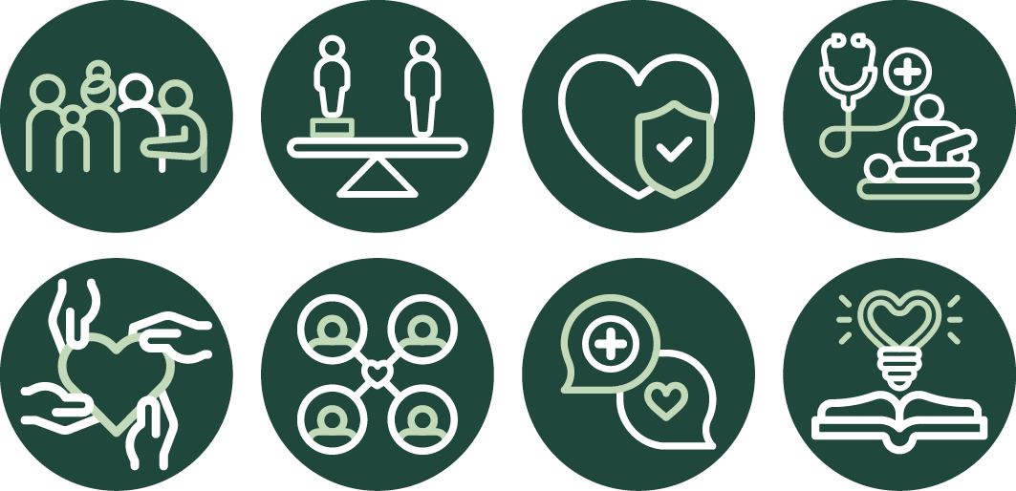

Optimal Cancer Care Pathway (OCCP)
January 2025 | OCCP Principles


Citation: Te Aho o Te Kahu. 2025. Optimal cancer care pathway principles. Wellington: Te Aho o Te Kahu.
Published in 2025 by Te Aho o Te Kahu | Cancer Control Agency, PO Box 5013, Wellington 6140, New Zealand
ISSN 3021-3053 (online)
TP0024



This document is available at teaho.govt.nz

This work is licensed under the Creative Commons Attribution 4.0 International licence. In essence, you are free to: share i.e., copy and redistribute the material in any medium or format; adapt i.e., remix, transform and build upon the material. You must give appropriate credit, provide a link to the licence and indicate if changes were made.
Whakataukī

Have a sense of the message in the winds…

Anei he taonga nō te mātanga nō Ahitereiria
Koutou maa I takoto te koha ki a mātou

Here is a treasure from the skilled and able specialist in Australia
Greetings for this treasure you have gifted us here in Aotearoa to explore and use

E ki ana te tangi o tatou manu
Ko te manu e kai ana ki te miro, nōnā te ngahere
Ko te manu e kai ana ki te mātauranga nōnā te Ao

It has been reiterated that when our manu cries, we sit up and listen
The bird that feeds upon local berries, local knowledge will prosper
The bird that feeds upon wisdom, our world knowledge will flourish.

It is an exciting time to feed off the wisdom of other cultures
Matua Tau Huirama

We would like to acknowledge The Voices of Whānau Māori Affected by Cancer (2023); He Ara Tangata – Te Aho o Te Kahu Consumer Group; the project team; clinicians; and national and special interest working groups that contributed to the development of the Optimal Cancer Care Pathways.
Special acknowledgement is extended to the Cancer Council Australia, who generously shared their Optimal Care Pathways framework and provided permission for it to be adapted to support people and whānau across Aotearoa New Zealand experiencing cancer.

Contents

Principles of the optimal cancer care pathway 6
Principle 1: Person and whānau-centred care 7
Principle 2: Equity-led 11
Principle 3: Safe, high-quality care 13
Principle 4: Multidisciplinary care 15
Principle 5: Supportive care 16
Principle 6: Coordinated care 18
Principle 7: Effective and timely communication 20
Principle 8: Knowledge-driven care 22
References 25

Optimal cancer care pathways
Optimal cancer care pathways (OCCPs) are critical tools for guiding the national delivery of consistent, safe, high-quality, evidence-based cancer care for people and whānau across Aotearoa New Zealand. Research shows OCCPs improve the outcomes and experiences of people and their whānau affected by cancer to guide the design and delivery of cancer care services that are systematic, equitable, connected, and timely (Cancer Council Australia, nd).
OCCPs are a framework for achieving health equity in cancer control using a person and whānau centred approach to provide people with equitable, high-quality care, regardless of where they live or receive cancer treatment. OCCPs help to:
- identify gaps in existing cancer services
- address barriers and unwarranted variations in accessing high-quality care
- identify opportunities for system improvements
- continually improve the way services are planned and coordinated.
As shown in Figure 1, the OCCPs map seven key steps in providing cancer care based on evidence-based practice, underpinned by eight principles to deliver the optimal level of care. While the seven steps appear linear, in practice, the care a person receives may not be. The steps provided will be tailored to their specific situation and needs, for example the type of cancer they have, when and how the cancer is diagnosed and managed, the person’s decisions, and how they respond to treatment.
OCCPs are designed to be used alongside clinical guidelines. The OCCPs do not constitute medical advice or replace clinical judgement or guidance.
Figure 1: Optimal Cancer Care model
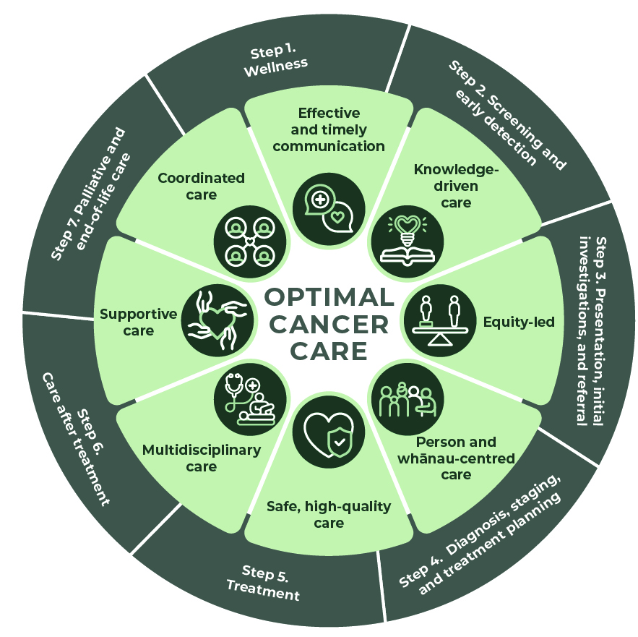

Principles of the optimal cancer care pathway
The principles underpinning OCCPs are essential to achieving the best cancer care, experience, and outcomes of the person and their whānau. OCCPs put the person and their whānau at the centre of care planning throughout their treatment/care and prompt the health care system to coordinate high-quality care. The person and their whānau are informed and involved in decisions throughout their cancer experience, according to their preferences, needs and values.

Figure 2: Principles of optimal cancer care
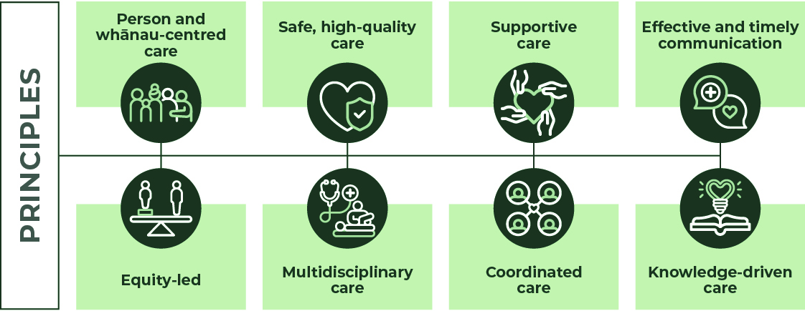



Principle 1: Person and whānau-centred care | 
Person and whānau centred care places the individual and their whānau at the heart of the system and respects and responds to their preferences, needs, and values.
Evidence shows that when the person and their whānau are involved in decision making, their wellbeing, satisfaction and health outcomes improve, and resources are allocated more efficiently (Ministry of Health 2023a).
Person and whānau centred care includes:
- enabling the person and their whānau to make informed choices according to their preferences, needs and values
- clarifying their expectations of care
- respecting and incorporating their cultural and religious beliefs into all interactions
- addressing their specific needs, including physical, social, learning disabilities and mental health
- providing care as close to the person and their whānau as appropriate, which may include outreach clinics, telehealth, or home visits
- giving them access to appropriate cancer information, including investigations, diagnosis, referral, and treatment opportunities; expected timelines; and related expenses
- talking to them about their cancer, treatment, care after treatment, survivorship, and palliative care as appropriate
- encouraging them to consider advance care planning and advance directives
- supporting them to document what is important to them and what their wishes are for future health care and quality of life.

Cultural safety
Cultural safety includes a critical consciousness where health care professionals and health care organisations engage in ongoing self-reflection and self-awareness and hold themselves accountable for providing culturally safe care, as defined by the person and their whānau and their communities. This may include communities based on ethnicity; age or generation; gender; sexual orientation; socioeconomic status; religious or spiritual belief; and disability (Medical Council of New Zealand 2019; Reid and Robson 2000).
Cultural safety enables the person and their whānau to express and comment on practices, be involved in decision-making about their own care, and contribute to the achievement of positive health outcomes and experiences. For Māori, the importance of mātauranga Māori and rongoā is recognised, particularly as a mechanism to improving Māori health and wellbeing.
There are increasing numbers of Māori health providers/professionals that offer rongoā services as alternative or complementary care options, and within cancer care itself (Medical Council of New Zealand 2019).
Power imbalances embedded in our current health system can affect people using the system and lead to experiences of disempowerment in their cancer journey. This can be prevented through the awareness and practice of cultural safety programmes.
Adolescent and young adults
The Service Provision for Adolescent and Young Adult Cancer Patients in New Zealand including Standards of Care will be used alongside the OCCPs to define best practice for adolescent and young adult (AYA) cancer patients (AYA Cancer Network Aotearoa 2016). The goal of the standards is to achieve excellence in AYA cancer care and address outcome disparities for certain ethnic, disease-specific and age-related populations for and among AYA cancer patients in New Zealand. Standard 4.2 advises shortening the 62-day Ministry of Health FCT indicator to 42 days for AYA cancer patients as timely access to treatment improves cancer outcomes (AYA Cancer Network Aotearoa. 2016).
Access to care
To improve access to care, it is important to:
- find the best way to engage with the person and their whānau that will enhance their access to care, such as email, text, postal address, engagement with support services
- understand the social context that may make it difficult for them to get access on specific days or times
- establish if they have a regular primary health care provider – if not, then support them to find one that is suitable and enrol
- identify any comorbid conditions – including physical disabilities, learning disabilities and mental health issues to be addressed – that may impact the ability to access cancer care
- offer care as close to the person’s home as appropriate, which may include outreach clinics, telehealth, or home visits
- explain why a particular service is not available closer to home, and look at options for supporting people to attend, such as transport and accommodation, via the Cancer Society or hospice and/or non-governmental organisations (NGOs).
Shared care
Shared care involves multiple providers/professionals and/or services who collaboratively manage the person and their whānau health and wellbeing. This can include differing medical, nursing, and allied health practitioners and whānau navigators. Shared care between hospital, specialist services and primary care can be delivered in two or more settings by two or more professionals.
For many population groups, this may also include health and social providers that offer alternative or complementary care options that align with cultural health and wellbeing practices. Quality and streamlined communications between shared care practitioners and the person and their whānau is key to successful shared care.
Shared decision making is the collaboration between the person and their whānau and health care providers/professionals to make care decisions based on the available medical evidence in accordance with the preferences of the person and their whānau (Czuba et al 2023). This will occur at each step of the pathway.
Informed choice and consent
People and their whānau who are enabled to make informed decisions have greater confidence to manage their cancer experience and make choices according to their preferences, needs and values to achieve better health outcomes.
Health providers/professionals are responsible for enabling informed choices. This includes obtaining consent for all procedures from either the person or their substitute decision maker if they are not deemed competent. The Code of Health and Disability Services Consumers’ Rights describes the right to be fully informed (Right 6) and the right to make an informed choice and give consent (Right 7) (Health and Disability Commissioner 1996).
Health providers/professionals will give the person and their whānau:
- individualised and timely information and guidance about their treatment options and care along the pathway
- information about the cancer, screening services, details of care, timelines, investigations, diagnosis, referral options, clinical trials, care after treatment, and palliative and end-of-life care
- information on the advantages and disadvantages of each treatment option, the associated side effects, and how it affects daily life and ability to carry out usual activities
- information related to travel and living away from home, including available support services such as National Travel Assistance (NTA), NGO community-based accommodation and potential direct and indirect costs that they may incur. This includes making them aware that while public hospital health care is free to those eligible in Aotearoa, there are related costs such as:
  - over-the-counter medications
  - travel costs
  - parking fees at public and private hospitals
  - private specialist with the option of ongoing treatment in a public hospital
  - private hospital services and diagnostic tools, such as x-rays, scans
  - indirect costs such as taking time off work
- information on other relevant support services for the person and their whānau, such as NGO services, kaupapa Māori care coordination, and rongoā.
Advance care planning
The health care team will support discussions on advance care planning with the person and their whānau at different steps throughout the pathway to ensure that their needs and wishes are central to the care they receive. Advance care planning is the process of thinking about, talking about, and planning for future health and end-of-life care. It can help the person and their whānau and the health care team to understand what health care they would or would not want.
This is especially helpful when individuals can no longer speak for themselves due to treatment side effects or other complicating health factors (Te Tahū Hauora 2022).

Advance Directive
An advance directive is similar to an advance care plan in terms of expressing the wishes of a person and their whānau. It is a signed statement that sets out, in advance, the
treatment wanted or not wanted if the person becomes unwell in the future. An advance directive is an effective way to provide more control over the treatment and care a person receives if they experience an episode of mental or other illness that leaves them unable to decide or communicate preferences at that time (Health and Disability Commissioner, nd). The Code of Health and Disability Services Consumers’ Rights gives any person who is legally competent to make a health care choice the right to make an advance directive. Communication with the person and their whānau to inform them of the ability to complete and identify their wishes in advance is discussed and once completed, shared with all care providers.
Enduring Power of Attorney
An enduring power of attorney (EPA) is a legal document that identifies a person to make decisions on behalf of an individual when they can no longer make these decisions. An EPA for personal care and welfare is often documented in advance, naming the person who can make decisions. It will only come into effect when a clinician determines that the individual no longer has the mental capacity to decide (Health and Disability Commissioner, nd; Public Trust, nd). The provider is responsible for ensuring any barriers to care do not influence the person or representative, for or against treatment.

Principle 2: Equity-led | 
Equity-led care recognises that not all people have the same level of advantage, so different groups require different approaches and resources to receive equal health outcomes (Te Kawanatanga o Aotearoa 2023).
There are often inequities at every step along the cancer continuum, including an individual’s exposure to risk factors, their likelihood of developing cancer, access to screening, timeliness to assessment and diagnosis, and their ability to access appropriate cancer treatment and ongoing care (Dew et al 2015; Gurney et al 2020; Hill et al 2010; Seneviratne et al 2015; Signal et al 2015; Walker et al 2008).
Using an equity-led focus provides an opportunity to identify and address the reasons for inequity and/or unwarranted variation so everyone can enjoy improved health outcomes. Research clearly shows that inequities affect different population groups in a range of different ways.
- Māori are approximately 20% more likely to develop cancer than non-Māori and twice as likely to die from cancer (Robson et al 2010; Te Aho o Te Kahu 2021a).
- Pacific peoples experience higher incidence and mortality for a range of cancers compared with non-Pacific people, with notably higher rates for uterine cancer.
- Asian people experience lower incidence of cancer overall, although they have higher incidence of thyroid cancer.
- People living in deprived and rural remote areas are more likely to be exposed to a range of cancer-causing risk factors, are more likely to develop cancer overall, have less choice and access to health care, and are more likely to have poorer survival rates.
- People living with mental illness experience poorer survival rates for some types of cancer.
- There is limited information on cancer outcomes for people with disabilities, those with diverse sexual or gender identities, and those living in rural areas, but it is likely the barriers these communities experience also contribute to cancer inequities.
Equity-led care includes providing a welcoming, culturally appropriate, and responsive health care system by:
- embedding cultural safety
- increasing the diversity of the workforce
- prioritising access to investigations, diagnosis and treatment for Māori and other population groups experiencing disparity

- removing or mitigating barriers to care, including:
- implicit bias and racism
- difficulty accessing care
- geography
- transport and accommodation
- financial and time pressures

- prioritising access to cancer care by:
- clinical need
- ethnicity
- disability
- geography
- route of entry – for example, reducing the number of people who are diagnosed via an emergency department

- innovation and service redesign initiatives to cancer care, including:
- co-designing services with priority population groups using lived experience
- building health literacy knowledge
- promoting prevention strategies, screening and health programmes co-designed with and for priority groups
- using equity-based reporting
- utilising holistic need assessment tools adapted specifically to suit the needs of Māori and other priority populations
- ensuring kaupapa Māori cancer care coordination services are accessible to Māori no matter the treatment setting. These services work in partnership with the treating team to support Māori before, during and after treatment.

Principle 3: Safe, high-quality care | 

Health care providers/professionals are responsible for providing safe, high-quality care.
The person will be referred to an individual practitioner or service with appropriate expertise. Health providers/professionals will have the required and appropriate training, credentials, and experience to deliver safe, high-quality care. This includes that health providers/professionals:
- undertake regular quality reviews of their performance, contribute to regular audits of their care, and are actively involved in continuing professional development
- are certified against Ngā Paerewa Health and Disability Services Standard NZS 8134:2021 (Standards New Zealand 2021)
- monitor and evaluate care and outcomes to enable the delivery of safe, high-quality care and where required drive service improvement where unwarranted variation has been identified
- have the necessary resources (equipment and staff), clinical guidelines, policies, and procedures in place to provide safe, quality cancer care
- have clear governance systems in place to monitor, identify and respond to safety and quality issues.

To ensure safe and high-quality cancer care, health services and providers will ensure:
- OCCPs are used as a framework to evaluate and monitor practice over time. Services will routinely collect relevant minimum datasets to support benchmarking, quality, and safety of care, and drive continuous service improvement
- Te Tahū Hauora (Health Quality and Safety Commission) work with clinicians, providers, and consumers to improve health and disability support services
- physical systemic anti-cancer therapy infusion spaces will meet the Australasian Health Facility Guidelines and Supplementary Aotearoa New Zealand Design Guidance. healthfacilityguidelines.com.au
- all providers will use The Royal Australian and New Zealand College of Radiologists (RANZCR) Radiation Oncology Practice Standards (Part A and Part B) in the establishment and delivery of radiation oncology treatment services. All providers will utilise the Royal College of Radiologists (RCR) guidelines - endorsed for use in New Zealand – to standardise prescriptions and review unwarranted variation where necessary
- all providers will continue to uphold the Radiation Safety Act 2016 and the Radiation Safety Regulations 2016, administered by the Ministry of Health’s Office of Radiation Safety (ORS) on behalf of the New Zealand Government. The purpose of the legislation is to establish a framework to protect the health and safety of people and protect the environment from the harmful effects of ionising radiation while allowing for its safe and beneficial use
- quality committees ensure health care is informed by evidence. Health providers/professionals have a responsibility to evaluate and monitor their practice and services
- the person and their whānau should be offered the safest options for care, which may include using telehealth
- national cancer service models of care are implemented and embedded in cancer care planning and delivery.

Patient-reported experience and outcome measures
Patient-reported experience measures (PREMs) and patient-reported outcome measures (PROMs) should be incorporated into routine cancer care.
PREMs are used to obtain the experience and observations of the person and their whānau on aspects of health care services they have received. Patient experience data is collected for specific services and then relayed to service providers/professionals to instigate improvements in health care services. This information helps an organisation to understand and improve the safety and quality of care.
PROMs measure aspects of a person’s health status such as symptoms and quality of life and are collected directly from the person either online or by using paper-based clinical notes, forms, or surveys. Collecting PROMs and then instigating an appropriate clinical response has been shown to prolong survival, reduce health system use and improve the person’s quality of life.
Choosing wisely
Kia āta kōwhiri – the Choosing Wisely campaign – seeks to reduce harm from unnecessary and low-value tests and treatment. Clinical leaders are required to monitor for any new recommendations pertaining to the cancer pathway and actively investigate how these will be embedded into clinical practice (Te Tahū Hauora 2023).
Providers will ensure governance mechanisms are in place to support any national decisions relating to changes in clinical practice/technology to enable these to be implemented consistently and in a timely manner.

Principle 4: Multidisciplinary care | 
Multidisciplinary care is an integrated team approach that involves all relevant health professionals discussing all available options and making joint recommendations about treatment (including palliative care) and supportive care plans, which consider the preferences of the person and their whānau.
Multidisciplinary care improves outcomes of the person and their whānau. Multidisciplinary care includes:
- a team approach, including primary care, that involves core disciplines that are integrated to provide cancer care with input from other specialties as required – this may also include key NGO staff who are actively supporting the person and their whānau
- communication among team members regarding assessments, treatment planning, treatment, supportive care and follow-up and surveillance plans
- access to publicly funded treatment regardless of geographical remoteness or size of institution
- care delivery in agreement with nationally agreed OCCPs, models of care and clinical guidelines
- involving the person and their whānau in all decision making.

Multidisciplinary care occurs across the OCCP and more formally within cancer multi-disciplinary meetings (MDMs).
Multidisciplinary meetings (MDM)
The cancer MDM is a forum for collaboration between health professionals with expertise in the diagnosis and management of cancer. At these meetings, participants collectively review all clinical, psychosocial, and cultural information pertinent to each person’s care and recommend personalised treatment and care options.
The person may be referred for an MDM discussion at the initial treatment planning stage or at specific times during and after their treatment if multiple treatments are planned.
How MDMs are managed is guided by the following standards:
- Standards for High-Quality Multidisciplinary Meetings (MDMs) in Aotearoa New Zealand (Te Aho o Te Kahu 2024)
- HISO 10038.4:2021 Cancer Multidisciplinary Meeting Data Standard (Te Aho o Te Kahu 2021b).

Principle 5: Supportive care | 
Supportive care is a vital part of any cancer treatment programme, including palliative care. Supportive care deals with issues that emerge for the person and their whānau from the effects of the cancer diagnosis, its treatment and after care. It is made up of all the services, information, and resources the person and their whānau may need to meet their physical, psychological, social, spiritual and information needs from the time of diagnosis.
Supportive care involves routinely and systematically assessing and working with the person and their whānau to understand and identify their needs across the following five domains.
- Taha tinana (physical) includes a wide range of physical symptoms that may be acute, short lived or ongoing, requiring continuing interventions or rehabilitation (including equipment and aids).
- Taha hinengaro (psychological) includes a range of issues relating to the mental and emotional health and wellbeing of the person and their whānau and personal relationships.
- Taha whānau (social) includes a range of social and practical issues that will affect the person and their whānau, such as emotional support, maintaining social networks, managing work, financial concerns, accommodation, and travel.
- Taha wairua (spiritual) includes beliefs, values, and a sense of meaning and purpose, identity and, for some people, religion (Ministry of Health | Manatū Hauora 2017a).
- Information includes access to understandable, relevant information about the medical, practical, and emotional aspects of cancer and its treatment, including recovery, survivorship support services and the health system overall (Fitch 2008).
Supportive care is a core component of evidence-based clinical care, and its benefits are well established. All people with cancer and their whānau will be formally supported and have access to information as defined above. The wishes and needs of the person and their whānau will determine the level of support provided.
Supportive care is a standard and routine aspect of cancer care. The treatment team will make the person and their whānau aware of this.
Supportive care should begin from the time of diagnosis and continue throughout the cancer pathway.
Cancer and palliative NGOs play a significant role in providing supportive care services for the person and their whānau, including information, transport, accommodation, support groups and, at times, direct care of the person and their whānau. The person and their whānau will be made aware of these services and early access facilitated.
For health providers/professionals, supportive care involves:
- screening and assessing the person and their whānau for their supportive care needs, including being aware of and delivering culturally appropriate care
  - All members of the multidisciplinary team have a role in enabling the person and their whānau to access supportive care along the cancer care pathway.

  - Assessment should be undertaken at each step of the pathway and at times of transition – for example, initial presentation or diagnosis, at the beginning of treatment or a new phase of treatment, and a change in/or development of new symptoms.
  - Diverse cultures may have different needs and/or prioritise these differently. Appropriate cultural needs assessments are undertaken.
  - Health providers/professionals should use a validated screening tool when undertaking an assessment.
- enabling referral pathways to supportive care providers/professionals – referrals may be for:
  - kaupapa Māori and Whānau Ora services to access mātauranga Māori and to implement traditional practices
  - cancer services offered by NGOs, such as community hauora providers and allied health providers
  - palliative care services, such as primary care, hospices, aged residential care, and specialist hospital care
  - specialist hospital services, such as psychologists and social workers.
- providing the person and their whānau with information on the range of multidisciplinary support services, groups and therapies designed to assist them to live well with cancer and its treatment and optimise recovery.

Survivorship
Living with, through and beyond cancer
Te noho ora me te matepukupuku, eke panuku noa
Survivorship is an integral part of cancer care from the point of diagnosis with specific assessments, programmes and services focused on living with, through and beyond cancer. Maximising healthy living means reducing the likelihood of getting cancer, diagnosing cancer early, and accessing high-quality treatment and appropriate after-care services. The OCCP specifically references survivorship in Step 6: Care after Treatment; however, functions supporting survivorship are included in all steps.
Survivorship support includes the following:
- providing support whether on a curative or non-curative pathway, or wherever the person and their whānau are in that pathway
- ensuring psychological, social, spiritual, medical, supportive care and cultural and rehabilitative needs are regularly assessed and addressed
- integrated and coordinated services to ensure people affected by cancer receive continuity of care
- health and supportive care providers working with the person and their whānau affected by cancer to have their survivorship needs identified and met
- survivorship support programmes, services and resources are person and whānau centred, culturally appropriate, co-designed with people affected by cancer, routinely evaluated, and designed and delivered in different ways to support equity in access and outcomes. The programmes will be inclusive of self-management strategies and information.
For more information, see the Cancer Survivorship in New Zealand – Consensus Statement on the Cancer Society NZ website cancer-survivorship-consensus-statement (Central Cancer Network, Cancer Society NZ and Cancer Nurses College 2018).

Principle 6: Coordinated care | 
Care coordination is the responsibility of all health care staff, both clinical and non-clinical, who work with the person and their whānau. All people with cancer receive coordinated care across multiple services and/or providers.
Care coordination is a comprehensive approach to achieving continuity of care for the person and their whānau. Seamless care coordination is essential for the person and their whānau to optimally navigate the complexity of the health system and promotes service efficiency. Care coordination ensures access and care is delivered in a systematic, connected, and timely way that meets the needs and preferences of the person and their whānau.
Coordinated care includes:
- having proactive and timely communications with the person and their whānau, identifying their needs and preferences
- making referrals to appropriate services, including NGOs, to help the person and their whānau navigate through the cancer pathway
- using equity-based criteria to identify people who would benefit most from direct support from care coordinators
- coordinating appointments to minimise disruptions, to value the time of the person and their whānau, and/or to recognise specific needs, such as living rurally or relying on public transport
- coordinating clinical requirements to support advance care planning/directives, timely diagnosis, treatment, and survivorship care
- making appropriate tests and results available, and providing timely access to MDMs so that treatment decisions can be made
- making medical records available to all members of the treating team and at scheduled appointments
- providing access to clinical trials
- arranging translation or interpreter services if the person and their whānau are from a non-English-speaking background or have difficulty communicating due to a physical disability
- providing clear referral pathways, handover procedures and communication between care providers/professionals, including shared care arrangements
- providing referrals and access to supportive care and practical supports, such as transport, accommodation, advance care planning and financial support
- giving people in rural and remote areas access to telehealth for managing the vulnerable person and their whānau
- ensuring that providers who outsource cancer care services have a responsibility for ensuring timely, coordinated care.

In Aotearoa New Zealand cancer care coordination has been shown to improve access and timeliness to diagnostic and treatment services and improve the experience of the person and their whānau throughout the cancer journey.
Care coordination brings together different health providers/professionals, teams, and health services. It also encompasses advance care planning, MDMs, multidisciplinary assessment clinics, supportive care screening and assessment, referral practices, data collection, clinical guidelines, common protocols, information for the person and their whānau, and individual clinical treatment.
Primary care coordinates access to specialist services. Community HealthPathways enable a consistent and standardised approach for diagnostic work up and e-referral. Care coordination may be facilitated through electronic health record management such as Manage My Health, My Indici and hospital platforms such as Clinical Workstation.
Formal care coordination through appointed navigators, cancer care coordinators and specialist cancer nurses play an important role in managing and supporting the person and their whānau.
Cancer care coordinators may come from various professional backgrounds, including regulated and non-regulated professions. The role of clerical administration is an essential care coordination function to support the person and their whānau to access health providers/professionals.
National Travel Assistance
Assessing and addressing transportation needs of people and their whānau who need to attend cancer diagnostics and treatment appointments is a key to ensuring they receive timely care and to address inequities.
The National Travel Assistance (NTA) scheme helps people financially who are referred by their specialist to see another specialist and need to travel long distances or travel frequently. The specialists must be part of a government-funded health and disability service.
NTA support may also extend to accommodation and support-person costs, including payment towards the cost of a motel room, or an allowance when staying with friends and family (accommodation is not usually approved for travel less than 100 km one way). NTA is administered by Health New Zealand | Te Whatu Ora. Additional information, including eligibility criteria, can be found on the Te What Ora website at tewhatuora.govt.nz/our-health-system/hospitals-and-specialist-services/national-travel-assistance.
In addition, there are often district and regional hospital-based transport services such as shuttles to support the person and their whānau. Many NGOs provide support for the person and their whānau requiring travel for cancer treatment, including volunteer drivers and shuttle services. Early referral is recommended.

Principle 7: Effective and timely communication


Everyone employed in the health care system is responsible for ensuring effective and timely communication that meets the needs of the person and their whānau.
Open and clear communication is a key principle of care for the person and their whānau. This includes communication between primary care services, community services, specialist health professionals, and the person and their whānau. General practitioners (GPs) should be involved in care from the point of a high suspicion of cancer and diagnosis, and the person should be encouraged to maintain a relationship with their GP through all stages of their cancer care.
Communication should be regular and timely. Attendance of a family member or carer at clinical appointments is beneficial for many people, as they can provide informational and emotional support. GPs and clinicians should encourage and support the involvement of family/whānau members and carers by providing an inclusive and supportive consultation environment.
Every person with cancer will have different communication needs, including cultural and language differences. When anyone involved in treatment communicates with the person and their whānau, health care professionals will be truthful and transparent but aware of cultural and psychological sensitivities.
This includes:
- using professionally trained interpreters as required – for example, when communicating with people from culturally diverse backgrounds whose primary spoken language is not English or for people with a hearing impairment
- using culturally safe and appropriate forms of communication
- encouraging and facilitating cultural and advocacy support, such as the Nationwide Health and Disability Advocacy Service | Ngā Kaitautoko advocacy.org.nz
- communicating with the person and their whānau as partners in care – empower the person and their whānau to be active in treatment discussions and be intentional about breaking down the power differential that exists
- using plain language and avoiding complex medical terms/jargon
- communicating at a level relevant to the person’s health literacy and that of their whānau and carers
- using tools, diagrams, and accessible formats as appropriate, including those for people with specific needs, such as those with cognitive difficulties and disabilities
- providing information on cancer, diagnostic tests, treatment types and follow-up requirements
- sharing clinical information documents for example discharge summary; treatment plan; chemotherapy regimen information; clinic letters; survivorship plan
- providing information on community-based supportive care services and resources
- identifying the person and their whānau substitute treatment decision-maker when required to ensure they are involved in relevant discussions
- assessing they have understood information by asking them and their whānau to say in their own words what has been conveyed
- providing adequate time to explain complex, sensitive information to the person and their whānau and to answer any questions that may arise
- seeking consent before conveying information between health care providers/professionals, teams, or with whānau
- ensuring the person and their whānau do not have to convey information between areas of care – it is the provider’s and health care system’s responsibility to transfer information between areas of care
- being respectful if a person and their whānau ask for a second opinion from another health professional
- ensuring the person and their whānau know who to contact if they have any questions or concerns
- ensuring the person and their whānau are enrolled with primary care and aware of how to access electronic information, where appropriate
- providing information in accordance with the Health Information Privacy Code 2020 online at privacy.org.nz/privacy-act-2020/codes-of-practice/hipc2020/ (Office of the Privacy Commissioner. 2020).
Health care providers will also consider offering the person and their whānau a cancer information booklet or a question prompt list before a consultation (see Appendix 3). Question prompt lists are effective in improving communication and the psychological and cognitive outcomes of people with cancer. Summaries of key consultations improve the person’s recall of information and satisfaction. Written care plans, treatment summaries, survivorship care plans and advance care directives are effective records and communication tools.
Telehealth is becoming an increasingly acceptable alternative to face-to-face consultations. When using telehealth, the team must consider what is best for the person and their whānau, including their preferences. A face-to-face consultation should be the first option, if it is safe, when delivering critical diagnosis information, a change in therapy or prescribing intensive treatment. If this is not an option, a video/phone consultation should be considered, and the person should be encouraged to have a support person with them (Health New Zealand | Te Whatu Ora 2023b).
Breaking bad news
For the person with cancer and their whānau, bad news can occur many times along the care pathway, including at diagnosis, treatment, and survivorship (Morton 1996). The quality of how this news is delivered can affect the wellbeing of the person and their whānau, including their:
- psychosocial adjustment
- coping ability
- health outcomes
- satisfaction with care
- level of uncertainty.
Cultural awareness and individual differences should guide how difficult news is shared with the person. Understanding any barriers to communication, avoiding jargon, active listening and ensuring a support person is present are critical factors in breaking bad news (Cassim et al 2021).
Serious Illness Conversation Guide Aotearoa (HQSC) resource is available to support health professionals/providers. Aotearoa-Serious-Illness-Conversation-Guide-Oct-2019.pdf
Principle 8: Knowledge-driven care | 

Research, clinical trials, and measurement tools play an important role in establishing the efficacy and safety of diagnostic, prognostic and therapeutic interventions as well as establishing the role of psychological, supportive care and palliative care interventions.
Optimal cancer care is evidence based and expertise driven. The OCCP is a knowledge tool developed for the person and their whānau and those working within health care. The OCCP provides a framework to ensure there is monitoring of care, outcomes, and evidence-based practice, including appropriate and timely implementation. It also includes the promotion of emerging therapies and supporting research and clinical trials.
Research and clinical trials
Research and clinical trials are fundamental to the ongoing evolution and improvement in evidence-based practice and outcomes for the person and their whānau.
Clinical trials and emerging therapies may lead to improved cancer outcomes, testing new treatments and approaches, and offering the person and their whānau access to potentially more effective therapies than otherwise available to them.
Clinical trials may be a valuable option for people with rare, difficult-to-treat conditions for which there may be limited evidence about how the condition is best treated or managed. People who participate in these clinical trials may have improved outcomes.
Clinicians and multidisciplinary teams should be aware of the clinical trials that are suitable for the person and their whānau, paying particular attention to ensuring equity of access to trials.
Clinicians will refer appropriate people to other treating centres to participate in research or clinical trials at any stage of the care pathway and enable the person and their whānau to discuss the pros and cons of participating in such trials.
Any member of the multidisciplinary team can discuss cross-referral between clinical trial centres. Eligibility to participate in a clinical trial should be discussed with the person.
Health services implement policies and procedures that facilitate equitable access to clinical trials for all people, including culturally diverse people and those who live in rural or remote communities.
Education and training
Research and clinical trials provide an opportunity to educate health professionals who are in training. Cancer centres may be affiliated with teaching hospitals, universities, or research groups to promote higher education or to develop the academic workforce, leading to more sustainable practice. Specialists are encouraged to take up and retain active membership to professional societies and organisations that can assist with professional development.
Monitoring and measuring
Monitoring and measuring provide a basis for health services and providers to assess cancer care efficacy and outcomes.
Health providers, services and professionals have a responsibility to evaluate and monitor practice outcomes to support benchmarking, quality and safety of care, and service improvement. Services should routinely collect system/service-level or tumour-specific minimum datasets and/or measures, including equity-based monitoring where possible.
Each step in the pathway provides opportunities to identify key measures, including access, interventions and outcomes that can be monitored to identify areas of concern, including inequities and unwarranted variation, and the impact of actions taken to address these.
These measures can include:
- patient-reported experience and outcome measures (PREMs and PROMs)
- Ngā Paerewa Health and Disability Services Standard www.standards.govt.nz/shop/nzs-81342021 (NZS 8134:2021, Standards New Zealand 2021), which provides the foundation for describing best practice and contributes to continuous improvement in the quality of health and disability services – it identifies the rights of people, ensuring service providers know their responsibilities for safe outcomes
- a stocktake of educational information to ensure the person and their whānau are receiving consistent and appropriate information regarding the cancer, treatment, and supportive care services available
- Te Aho o Te Kahu national cancer quality performance indicators to improve the quality of cancer services to enable the delivery of better outcomes for the person and their whānau undergoing cancer care.
Monitoring and service improvement can be undertaken at local, regional, and national levels. This will require effective clinical and system governance to oversee, identify and respond to issues.
Faster Cancer Treatment
Faster Cancer Treatment (FCT) aims to help coordinate timely access to appointments and tests for all people eligible for publicly funded treatment in Aotearoa New Zealand with cancer or with a high suspicion of cancer (Health New Zealand | Te Whatu Ora 2023a). This leads to timely access to diagnosis, treatment, and better outcomes for people with cancer. FCT includes the 31-day Health Target and 62-day indicator which you can read in detail on Health NZ Data dictionary website.
The FCT Health Target/indicator support:
- optimal timely access to cancer care for people and their whānau
- early identification of potential delays to care, enabling proactive action to avoid delays
- a tracking system to remove the guesswork as to what point people are at on the pathway
- a continuous quality improvement approach by finding solutions to system problems and showing trends
- quality data leading to better decision-making and a data source for audit and research.

31-day Health Target
- The maximum length of time a patient should wait from the decision-to-treat date to receiving their first treatment (or other management) for cancer is 31 days.
- The 31-day Health Target is reported as 90% of patients receiving their cancer treatment (or other management) within 31 days from the decision to treat.
- All records submitted for the 62-day indicator, should by definition, also contain data that enables the 31-day Health Target to be calculated.
- Following the MDM, consultation with the person and their whānau to agree on treatment, should be completed as soon as possible to meet the 31-day Health Target.
62-day indicator
- 62 days is the maximum length of time a patient should wait for their first treatment when referred:
- with a high suspicion of cancer (without a confirmed pathological diagnosis of cancer at referral)
- where the triaging clinician believes the patient needs to be seen within two weeks to receive their first treatment (or other management) for cancer.
- The 62-day indicator is reported as 90% of patients receiving their cancer treatment (or other management) within 62 days from date of referral to first treatment.
- If the MDM does not occur by day 28, the person is unlikely to meet the 62-day pathway.
- The estimated cohort of patients on the 62-day pathway who meet the criteria for measurement should be approximately 25% of all cancers registered on the New Zealand Cancer Registry.
The reporting of delay codes for people who do not achieve the 62-day FCT indicators is mandated nationally (Health New Zealand | Te Whatu Ora 2023a).
Clinical guidelines and/or service models of care
Community HealthPathways supports primary care as a main source of assessment, management, and referral information. This includes high suspicion of cancer definitions that are suggestive of cancer.
Districts/regions will comply with national service models of care and implement initiatives where there is unwarranted variation that identifies a need to improve.
Tumour-specific clinical guidelines underpin the OCCP. These need to be relevant and up to date.

References
AYA Cancer Network Aotearoa. 2016. Service Provision for Adolescent and Young Adult Cancer Patients in New Zealand including Standards of Care 2016. URL: ayacancernetwork.org.nz/standards-of-care-2 (accessed 22 February 2024).
Cancer Council Australia. (nd). Optimal Care Pathways. URL: www.cancer.org.au/health-professionals/optimal-cancer-care-pathways (accessed 22 February 2024).
Cassim, S., Kidd. J., Keenan, K., Middleton, K., Rolleston, A., Hokowhitu, B., Firth, M., Wong, J., Lawrenson, R. 2021. Indigenous perspectives on breaking bad news: ethical considerations for health care providers URL: pubmed.ncbi.nlm.nih.gov/33419938 / (accessed 08/02/24).
Central Cancer Network, Cancer Society, Cancer Nurses College. 2018. Cancer Survivorship in New Zealand – Consensus Statement. URL: www.cancer.org.nz/assets/Uploads/Survivorship-Consensus-Statement.pdf (accessed 2 February 2024).
Community Health Pathways. 2024. NZ NGO Sites Portal. URL: HealthPathways NZ NGO Sites Portal (communityhealthpathways.org)
Czuba KJ, Owens R, Brown PA, et al. 2023. Patients’ and clinicians’ views on shared decision making in cancer care: a qualitative study of Aotearoa New Zealand patients’ and clinicians’ perspectives. New Zealand Medical Journal 136(1581): 10–27.
Dew K, Signal L, Davies C, et al. 2015. Dissonant roles: The experience of Māori in cancer care. Social Science Medicine 138: 144–51. URL: doi.org/10.1016/j.socscimed.2015.06.008 (accessed 22 February 2024).
Fitch, M. 2008. Supportive care framework. Canadian Oncology Nursing Journal 18(1): 6–24. URL: doi.org/10.5737/1181912x181614 (accessed 22 February 2024).
Gurney JK, Robson B, Koea J, et al. 2020. The most commonly diagnosed and most common causes of cancer death for Māori New Zealanders. The New Zealand Medical Journal (Online) 133(1521): 77–6.
Health New Zealand | Te Whatu Ora. 2023a. Faster Cancer Treatment Indicators, Business Rules and Data Definitions. Wellington:.URL: http://view.officeapps.live.com/op/view.aspx?src=https%3A%2F%2Fwww.tewhatuora.govt.nz%2Fassets%2FOur-health-system%2FData-and-statistics%2FNZ-health-stats%2FData-references%2FData-dictionaries%2FFCT-Indicators-Data-Definitions-and-Business-Rules-v6.4-September-2023.docx&wdOrigin=BROWSELINK
Health New Zealand | Te Whatu Ora. 2023b. National Telehealth Service. URL: www.tewhatuora.govt.nz/our-health-system/digital-health/national-telehealth-service (accessed 22 February 2024).
Health and Disability Commissioner | Te Toihau Hauora Hauātanga. (nd). Advance Directives & Enduring Powers of Attorney. URL: www.hdc.org.nz/your-rights/about-the-code/advance-directives-enduring-powers-of-attorney (accessed 22 February 2024).
Health and Disability Commissioner. 1996. Code of Health and Disability Services Consumers’ Rights. URL: www.hdc.org.nz/your-rights/about-the-code/code-of-health-and-disability-services-consumers-rights (accessed 22 February 2024).
Health Quality and Safety Commission. 2022. Serious Illness Conversation Guide, Aotearoa. www.hqsc.govt.nz/assets/Our-work/Advance-care-planning/ACP-info-for-clinicians/Publications-resources/Aotearoa-Serious-Illness-Conversation-Guide-Oct-2019.pdf (accessed 28 March 2024)
Hill S, Sarfati D, Blakely T, et al. 2010. Survival disparities in Indigenous and non-Indigenous New Zealanders with colon cancer: the role of patient comorbidity, treatment, and health service factors. Journal of Epidemiology & Community Health 64(2): 117–23.
Hospice New Zealand. 2019a. A Guide For Carers. Wellington: New Zealand. URL: https://www.hospice.org.nz/wp-content/uploads/2019/03/A-Guide_for_Carers_WEB.pdf (accessed 21 March 2024).
Hospice New Zealand. 2019b. Mauri mate: A Māori Palliative Care Framework for Hospices.URL: www.hospice.org.nz/mauri-mate/ (accessed 13/12/23).
Hospice New Zealand. 2019c. Palliative Care Handbook. URL: www.hospice.org.nz/resources/palliative-care-handbook (accessed 22 February 2024).
Hospice New Zealand. 2019d. Ngā Paerewa Pairuri Tāngata | Standards for Palliative Care. URL: www.hospice.org.nz/wp-content/uploads/2019/04/HNZ-Standards-2019-full-copy-interactiveFINAL-.pdf (accessed 20 February 2024).
Medical Council of New Zealand. 2019. Statement on Cultural Safety. URL: www.mcnz.org.nz/assets/standards/b71d139dca/Statement-on-cultural-safety.pdf (accessed 22 February 2024).
Ministry of Health | Manatū Hauora. 2023a. New Zealand Health Strategy 2023. URL: www.health.govt.nz/system/files/documents/publications/new-zealand-health-strategy-oct23.pdf (accessed 22 February 2024).
Ministry of Health | Manatū Hauora. 2023b. Faster Cancer Treatment and shorter stays in emergency department.URL:www.health.govt.nz/new-zealand-health-system/accountability-and-funding/planning-and-performance-data/faster-cancer-treatment-and-shorter-stays-emergency-department(accessed 02/08/23).
Ministry of Health | Manatū Hauora. 2019. New Zealand Cancer Action Plan 2019–2029 – Te Mahere mō te Mate Pukupuku o Aotearoa 2019–2029. Revised January 2020. Wellington: Ministry of Health. URL: www.health.govt.nz/publication/new-zealand-cancer-action-plan-2019-2029 (accessed 22 February 2024).
Ministry of Health | Manatū Hauora. 2017a. Māori health models – Te Whare Tapa Wha. URL: www.health.govt.nz/our-work/populations/maori-health/maori-health-models/maori-health-models-te-whare-tapa-wha (accessed 22 February 2024).
Morton R. 1996. Breaking bad news to patients with cancer. Prof Nurse. 1996 Jul;11(10):669-71. PMID: 8718375. URL: pubmed.ncbi.nlm.nih.gov/8718375/ (accessed 02 February 2024).
Office of the Privacy Commissioner | Te Mana Mātapono Matatapu. Health Information Privacy Code 2020. URL: www.privacy.org.nz/privacy-act-2020/codes-of-practice/hipc2020/ (accessed 22 February 2024)
Public Trust. (nd). Enduring Power of Attorney. URL: www.publictrust.co.nz/products-and-services/enduring-power-of-attorney/personal-care-epa (accessed 22 February 2024).
Reid P, Robson B. 2000. Understanding health inequities. In: Hauora: Māori Standards of Health IV. A study of the years 2000–2005. Wellington: Te Rōpō Rangahau Hauora a Eru Pōmare.
Robson B, Cormack D, Purdie, G. 2010. Unequal impact II: Māori and non-Māori cancer statistics by deprivation and rural-urban status 2002–2006. Wellington: Te Rōpō Rangahau Hauora a Eru Pōmare.
Seneviratne S, Campbell I, Scott N, et al. 2015. Treatment delay for Māori women with breast cancer in New Zealand. Ethnicity & Health 20(2): 178–93.
Signal V, Sarfati D, Cunningham R, et al. 2015. Indigenous inequities in the presentation and management of stomach cancer in New Zealand: A country with universal health care coverage. Gastric Cancer 18(3): 571–9. URL: doi.org/10.1007/s10120-014-0410-y (accessed 22 February 2024).
Standards New Zealand. 2021. NZS 8134:2021 Ngā Paerewa Health and Disability Services Standard. URL: www.standards.govt.nz/shop/nzs-81342021 (accessed 22 February 2024).
Te Aho o Te Kahu | Cancer Control Agency. 2024. Standards for high-quality Multidisciplinary Meetings (MDMs) in Aotearoa New Zealand. URL: https://mohgovtnz.sharepoint.com/:w:/r/sites/TeAhooTeKahu/Shared%20Documents/General/MDM%20Guidance%20Review%202023/Draft%20document/Final%20MDM%20Stds%20Mar2024.docx?d=wa4bf5f72ab47470d88131f1f5a9ade61&csf=1&web=1&e=ZtDE5F (accessed 23 March 2024).
Te Aho o Te Kahu | Cancer Control Agency. 2024. HISO 10038.4:2021 Cancer Multidisciplinary Meeting Data Standard. URL: www.canshare.co.nz/dataStandards.html (accessed 23 March 2024). This is an unendorsed draft at this time and is for reference only.
Te Aho o Te Kahu | Cancer Control Agency. 2021a. He Pūrongo Mate Pukupuku o Aotearoa 2020 | The State of Cancer in New Zealand 2020. Wellington: Te Aho o Te Kahu | Cancer Control Agency.
Te Aho o Te Kahu | Cancer Control Agency. 2021b. HISO 1038.4:2021 Cancer Multidisciplinary Meeting Data Standard. URL: www. teaho.govt.nz/static/reports/HISO-0038-4-2021.pdf (accessed 9 August 2023) Wellington: Te Aho o Te Kahu | Cancer Control Agency.
Te Kawanatanga o Aotearoa | New Zealand Government. 2023. New Zealand Health Strategy. URL: www.health.govt.nz/system/files/documents/publications/new-zealand-health-strategy-oct23.pdf (accessed 22 February 2024).
Te Tahū Hauora | Health Quality & Safety Commission New Zealand. 2023. Kia āta kōwhiri – Choosing Wisely. URL: www.hqsc.govt.nz/resources/choosing-wisely (accessed 22 February 2024).
Te Tahū Hauora | Health Quality & Safety Commission New Zealand. 2022. Te whakamahere tiaki i mua i te wā taumaha | Advance care planning. URL: www.hqsc.govt.nz/our-work/advance-care-planning (accessed 22 February 2024).
Walker T, Signal L, Russell M, et al. 2008. The road we travel: Māori experience of cancer. New Zealand Medical Journal 121(1279): 27–35. www.ncbi.nlm.nih.gov/pubmed/18709045 (accessed 22 February 2024).

Optimal Cancer Care Pathway Supplementary Information

