COVID-19 and cancer services

Report 2

Working report on the impact of COVID-19 on cancer services for the period ending May 2020

June 2020

Contents

Contents 2
Summary of findings 3
Introduction 5
Cancer Registrations 6
Gastrointestinal endoscopy 12
Bronchoscopy 13
Combined curative cancer surgery 15
Colorectal cancer surgery 16
Lung cancer surgery 18
Prostate cancer surgery 19
Medical oncology 21
Radiation oncology 23
Haematology 26
Appendix 1: NZCR data 29
Appendix 2: NZCR registrations by DHB 30
Appendix 3: Surgical procedure codes 32

Summary of findings
Overview of impact of COVID-19 on cancer diagnosis and treatment
This report shows an increase in new registrations and diagnostic procedures in May compared to April 2020. The overall number of diagnostic procedures and new cancer registrations in 2020 remains lower than 2019. Cancer treatment services continued during the COVID-19 pandemic. The disruptions to diagnostic services seen in April 2020 are now showing up in medical oncology, radiation oncology and haematology services, with fewer attendances in May, as expected.

Background and data
- This is the second report looking at the impact of COVID-19 and the lockdown on cancer services. The first report presented data to April 2020, this report looks at the period until the end of May 2020.
- The purpose of this analysis was to rapidly measure the impact of COVID-19 and the lockdown on cancer services to assist with recovery planning.
- The report focuses on the aspects of the cancer care pathway for which we have readily available data and does not capture all aspects of the care.
- Comparisons between 2020 and 2019 do not consider any projected increase in diagnoses over time.
- The focus of the report was to understand the impact of COVID-19 on existing service delivery and does not address pre-existing unmet need.

Cancer diagnosis

Registrations
- Overall for the year to date (up until end of May 2020), there have been 954 fewer cancer registrations compared to the same time period in 2019, a 7% decrease.
- There were 525 fewer cancer registrations in May 2020 compared to May 2019. This is an 18% decrease in cancer registrations.
- The decrease in cancer registrations was similar across ethnic groups. Over the year to date there was a 5% decrease in registrations for Māori and 8% decrease for Pacific, compared to a 9% decrease for European/other. There was an increase in registrations for people in the Asian ethnic group.
- The decrease in registrations over the lockdown period was relatively consistent across tumour groups; however, the overall impact on registrations for the year to date was most marked for haematology/lymphoid, melanoma and non-melanoma skin cancer, prostate and breast cancers.
- The decrease in cancer registrations over the lockdown period is seen relatively consistently across all DHBs. However, the impact of the lockdown on cumulative registrations for the year to date varied by DHB.

Diagnostics
- There were fewer gastrointestinal endoscopies performed in May 2020 compare to May 2019; however, the decrease seen in May 2020 (20%) is considerably smaller than the decrease seen in April 2020 (77%).
- For the year to date there are 18% fewer gastrointestinal endoscopies performed in 2020 compared to 2019. Māori had a smaller cumulative reduction (12%) compared to non-Māori/non-Pacific (20%).
- There were 34% fewer bronchoscopies performed in May 2020 compared to May 2019. Overall there were 29% fewer bronchoscopies performed in the first five months of 2020 compared to the first five months of 2019.
- Māori were disproportionately impacted by the overall year to date decrease in bronchoscopies (38% decrease for Māori, compared to 29% decrease for non-Māori/non-Pacific). This appears to have started prior to the lockdown, with fewer bronchoscopies from February 2020.

Cancer Treatment

Surgery
- Overall, the impact of COVID-19 on cancer surgery volumes has been minimal, with 5% fewer surgeries performed in 2020 compared to 2019. There has been a 6% increase in surgery for Māori in 2020 compared to 2019.
- As noted in the previous report, the decrease in surgery seen over the lockdown period appeared to be largely driven by the decrease in diagnostic services.
- There has been an overall 35% increase in curative colorectal cancer surgery for Māori for the year to date compared to the same time period in 2019.
- Despite an increase in curative lung cancer surgery in May 2020 compared to May 2019, there remains an overall 9% decrease in curative lung cancer surgeries in 2020 compared to 2019.
- The decrease in lung cancer surgery follows the pattern seen for bronchoscopies, with the decrease starting prior to lockdown. It is unclear what is driving this, but it could be due to a change in the investigation and management of lung cancer earlier in 2020 in anticipation of COVID-19. This could include an increase in radiotherapy for lung cancer to minimise invasive respiratory procedures and protect ICU capacity. The decrease in lung cancer surgery is most noticeable for Māori, with fewer curative surgeries performed since the beginning of 2020 (noting that the numbers are relatively small).
- There has been an increase in prostate cancer surgeries performed in May 2020 compared to May 2019. For the year to date there has been a 10% increase in prostate cancer surgeries compared to 2019.

Chemotherapy and radiotherapy
- Overall, for the year to date the number of medical oncology FSAs and attendances for medical oncology IV chemotherapy is comparable to 2019.
- There has been a 10% decrease in attendances for radiation therapy for the year to date compared to 2019. This is similar for Māori (11%) and non-Māori/non-Pacific (10%).
- There has been a decrease in medical oncology, radiation oncology and haematology FSAs and treatment in the month of May 2020 compared to May 2019. This likely reflects the flow on effect of the disruption to diagnostic services and cancer surgery seen in April 2020.

Introduction

Purpose of this report
This report is a follow up to the report released by Te Aho o Te Kahu on 28 May 2020, which outlined the impact of COVID-19 and the lockdown on cancer services in New Zealand. The first report presented data until the end April 2020, this report looks at data through to the end of May 2020.
The report focuses on the aspects of the cancer care pathway for which we have readily available data and does not capture all aspects of the care. Critical aspects of cancer care, including access to primary care, radiology and palliative care are not measured in this report.

Data and analysis
The data in this report comes from Ministry of Health national data collections. Each section of the report includes information on where the data is from and any limitations with the data. Numbers in this report may not match the previous report exactly, due to late coding/submission of data.
It is important to note that the purpose of the analysis is to rapidly measure the impact of COVID-19 and the recovery on cancer services and does not consider pre-existing unmet need. The report also makes direct comparisons between 2020 and 2019 and does not consider any projected increase in diagnoses over time.

Key dates
Key dates in relation to COVID-19 that may be of use when reviewing the report include:
- 23 March: alert level 3 and hospital alert level framework released
- 26 March: alert level 4
- 28 April: alert level 3
- 14 May: alert level 2
- 9 June: alert level 1

Cancer Registrations

Notes on data
- The data come from laboratory reports to the New Zealand Cancer Register (NZCR). This means that cancers diagnosed without haematology or pathology (e.g. radiology alone) will not be counted in this analysis.
- There are now more registrations in April than estimated in the April report. This is due to referrals to NZCR from Community Anatomic Pathology Service (CAPS) laboratory reports now being available and included and a correction to a date filter.
- ‘Date’ is date of diagnosis on the NZCR – usually the date the specimen was taken from the person and sent to the laboratory. Analyses include all new provisional and registered cancer events based on pathology and haematology reports. Data were extracted from NZCR on 29 June 2020.
- Further information on this data is included in Appendix 1.

Results
Table 1 and Figure 1 show the decrease in cancer registrations in 2020 compared to 2019 by month, and the cumulative impact this has had on cancer registrations for the year to date (up until the end of May 2020). There is a reduction in registrations in May 2020 compared to May 2019; however, this is considerably smaller than the reduction seen in April.
Table 1: Absolute number and percentage change in cancer registrations in 2020 compared to 2019 by month, and cumulative year to date
 | March 2020 |  | April 2020 |  | May 2020 |  | Year to date
 | Number | % | Number | % | Number | % | Number | %
Māori | 15 | 6.0 | -71 | -28.9 | -32 | -12.4 | -54 | -4.5
Pacific | -6 | -5.7 | -21 | -24.1 | -38 | -31.4 | -40 | -8.3
Asian | 23 | 17.2 | -34 | -28.3 | -21 | -13.7 | 38 | 6.2
European/Other | -84 | -3.7 | -826 | -40.2 | -435 | -18.5 | -916 | -8.7
Total Population | -41 | -1.5 | -949 | -37.7 | -525 | -18.1 | -954 | -7.4
Note: a small number of reports have ‘unspecified’ ethnicity, meaning the sum of all ethnic groups may not equal the total population.
Figure 1: Total number of cancer registrations by month and year (left), cumulative number of cancer registrations by month and year (right)
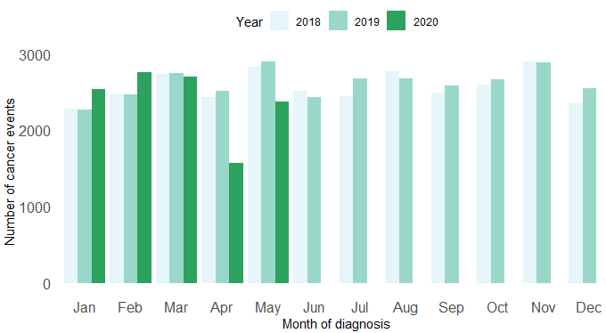 | 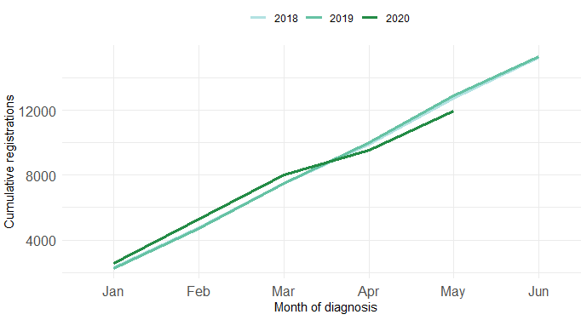
Figure 2: Number of cancer registrations by month and year, by ethnicity
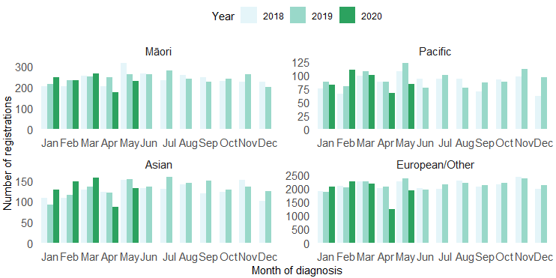
Figure 3: Cumulative number of cancer registrations by year, by ethnicity
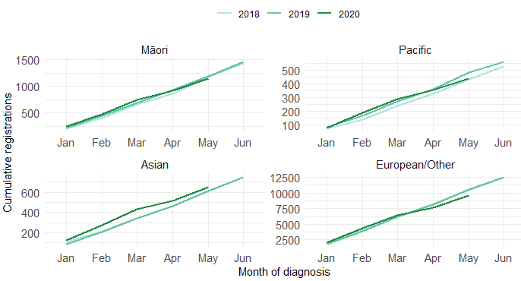
There was a decrease in cancer registrations across all major cancer groups in May 2020 compared to May 2019, with the exception of prostate and urinary system cancers; however, this had a variable impact on the overall difference in registrations for the year to date. Table 2 shows the change in cancer registrations in 2020 compared to 2019 by cancer group, for cancers with over 1000 registrations per year. This is presented as number of registrations by month (Figure 4) and cumulative number of registrations by year (Error! Reference source not found.).
Table 2: Changes in cancer registration in 2020 compared to 2019 by month and for the year to date, absolute difference in number of cases and percentage change, by cancer group.
 | March 2020 |  | April 2020 |  | May 2020 |  | Year to date
Cancer Group | Number | % | Number | % | Number | % | Number | %
Breast | 40 | 11.6 | -194 | -53.7 | -131 | -32.7 | -211 | -12.4
Cervix | 45 | 29.2 | -84 | -46.9 | -48 | -25.1 | 54 | 6.9
Colorectal | -13 | -4.4 | -95 | -36.3 | -17 | -5.7 | -30 | -2.3
Gynaecology | 11 | 11.2 | -7 | -8.8 | -21 | -18.9 | -2 | -0.4
Haematology and lymphoid | 13 | 6.7 | -83 | -40.9 | -75 | -32.1 | -147 | -14.5
Melanoma and non-melanoma skin | -23 | -3.3 | -308 | -53.1 | -288 | -41.7 | -454 | -14.4
Other digestive system | -13 | -9.4 | -37 | -27.4 | -9 | -6.0 | -24 | -3.7
Prostate | -116 | -31.1 | -147 | -50.7 | 28 | 8.1 | -213 | -13.5
Respiratory and thorax | -21 | -12.4 | -16 | -11.0 | -14 | -9.4 | -47 | -6.2
Urinary system | -15 | -10.7 | 3 | 2.7 | 4 | 3.3 | -2 | -0.3
Figure 4: Number of cancer registrations by month and year, by ethnicity
Figure 5: Number of cancer registrations by month and year, by cancer group
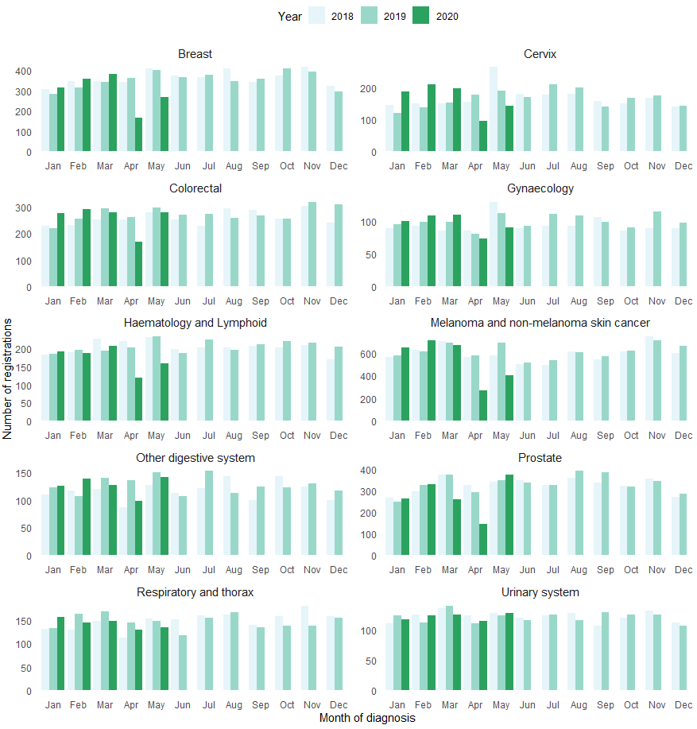

Figure 6: Cumulative number of cancer registrations by year, by cancer group
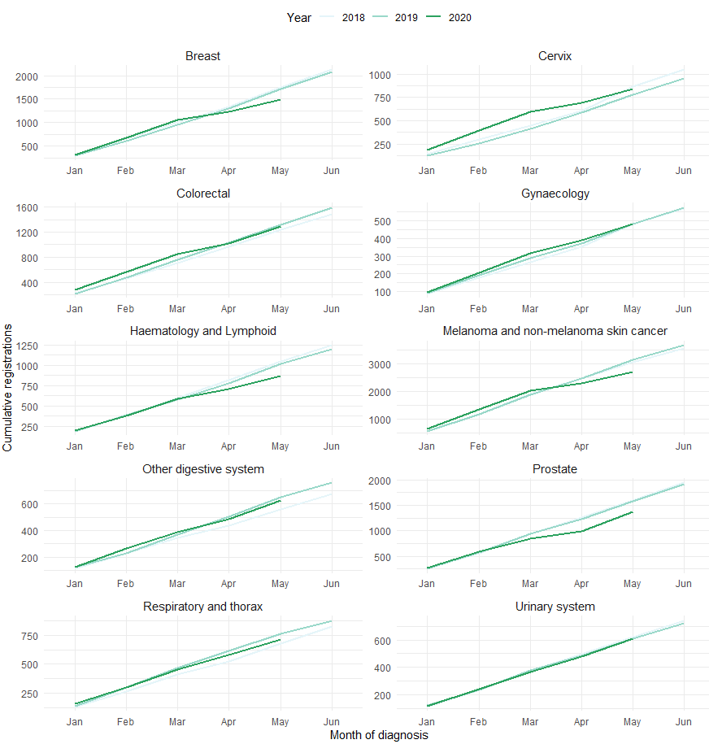
The decrease in cancer registrations in April and May is seen relatively consistently across all DHBs. However, the impact of the lockdown on overall registrations for the year to date varies by DHB.
Table 3 shows the changes in cancer registration in 2020 compared to 2019 for the year to date (up until end of May 2020) by DHB. This is presented as absolute difference in number of cases, as well as the percentage difference. Appendix 2 includes graphs showing monthly and cumulative cancer registrations by DHB.

Table 3: Changes in cancer registration in 2020 compared to 2019 by month and for the year to date, absolute difference in number of cases and percentage change, by DHB of domicile (See Appendix 2 for graphs)
 | March 2020 |  | April 2020 |  | May 2020 |  | Year to date
DHB | Number | % | Number | % | Number | % | Number | %
Northland | -23 | -18.1 | -18 | -17.1 | -14 | -10.9 | -12 | -2.1
Waitemata | 31 | 9.7 | -126 | -38.8 | -110 | -27.8 | -161 | -9.8
Auckland | 14 | 5.6 | -70 | -36.1 | -56 | -20.5 | -107 | -9.2
Counties Manukau | 8 | 3.2 | -77 | -35.8 | -32 | -12.6 | -46 | -4.0
Waikato | -3 | -1.2 | -90 | -40.4 | -38 | -15.8 | -141 | -12.0
Bay of Plenty | -22 | -12.2 | -35 | -24.0 | -40 | -24.7 | -50 | -6.5
Tairawhiti | -5 | -17.2 | -22 | -61.1 | -12 | -38.7 | -33 | -22.8
Lakes | 14 | 25.5 | -29 | -46.0 | -15 | -20.5 | -18 | -5.8
Taranaki | 31 | 54.4 | -31 | -38.8 | -45 | -40.2 | 5 | 1.4
Hawke's Bay | -28 | -24.6 | -35 | -38.9 | -10 | -9.7 | -58 | -11.9
Whanganui | 11 | 22.4 | -18 | -37.5 | -8 | -15.7 | -6 | -2.4
MidCentral | 23 | 21.3 | -35 | -35.0 | 2 | 1.9 | 42 | 8.6
Capital & Coast | -7 | -4.7 | -65 | -44.5 | -13 | -8.4 | -54 | -7.9
Hutt Valley | -6 | -7.3 | -16 | -25.0 | -23 | -27.1 | -10 | -2.7
Wairarapa | -5 | -14.3 | -5 | -20.8 | 4 | 16.7 | 2 | 1.5
Nelson Marlborough | -21 | -16.0 | -42 | -39.6 | -32 | -29.1 | -49 | -9.5
West Coast | 2 | 16.7 | -7 | -31.8 | -14 | -43.8 | -26 | -23.9
Canterbury | -9 | -3.1 | -85 | -31.2 | -30 | -10 | -44 | -3.2
South Canterbury | 6 | 20.0 | -14 | -35.9 | -5 | -14.7 | -10 | -5.7
Southern | -54 | -25.4 | -133 | -60.7 | -38 | -16.6 | -197 | -19.1

Key points
- Overall for the year to date (up until end of May 2020), there have been 954 fewer cancer registrations compared to the same time period in 2019, a 7% decrease.
- There were 525 fewer cancer registrations in May 2020 compared to May 2019. This is a 18% decrease in cancer registrations. This is a smaller decrease than seen in April 2020 compared to April 2019 (a 38% decrease), indicating a return towards normal service provision.
- The decrease in cancer registrations was similar across all ethnic groups. Over the year to date there was a 5% decrease in registrations for Māori and 8% decrease for Pacific, compared to a 9% decrease for European/other. There was an increase in registrations for people in the Asian ethnic group.
- The decrease in registrations over April and May was relatively consistent across tumour groups; however, the overall impact on registrations for the year to date was most marked for haematology/lymphoid, melanoma and non-melanoma skin cancer, prostate and breast cancers.
- The decrease in cancer registrations is seen relatively consistently across all DHBs. However, the impact of the lockdown on cumulative registrations for the year to date varied by DHB.

Gastrointestinal endoscopy

Notes on data
- Gastrointestinal endoscopy data were extracted from National Non-admitted Patient Collection (outpatient) and National Minimum Dataset (inpatient) on 29 June 2020.
- Includes colonoscopies and gastroscopies for all indications (i.e. not just cancer).
- Technical information: Gastroscopies (Purchase Unit Code - MS02005), Colonoscopies (Purchase Unit Code - MS02007), Combined Gastroscopies + Colonoscopies (Purchase Unit Code - MS02014).

Results
Table 4: Absolute number and percentage change in colonoscopy and gastroscopy in 2020 compared to 2019 by month, and cumulative year to date
 | March 2020 |  | April 2020 |  | May 2020 |  | Year to date
 | Number | % | Number | % | Number | % | Number | %
Māori | -17 | -3% | -354 | -68% | -87 | -14% | -339 | -12%
Non-Māori/Non-Pacific | -769 | -13% | -4324 | -78% | -1424 | -22% | -5649 | -20%
Total Population | -716 | -11% | -4802 | -77% | -1503 | -20% | -5940 | -18%

Figure 7: Number of gastrointestinal endoscopy procedures by month and year, for the total population (left) and for Māori (right)

Figure 8: Cumulative number of gastrointestinal endoscopy procedures by year, for the total population (left) and for Māori (right)

Key points
- Gastrointestinal endoscopy services have increased substantially in May 2020 compared to April 2020; however, there remains a significant deficit between the number of endoscopies performed in 2020 compared to 2019.
- Overall, for the year to date there has been 18% fewer gastrointestinal endoscopies performed in 2020 compared to 2019, with Māori having a smaller cumulative reduction (12%) compared to non-Māori/non-Pacific (20%)
- The decrease in gastrointestinal endoscopies seen in May 2020 (20%) is considerably smaller than the decrease in April 2020 (77%) compared to the same months in 2019.

Bronchoscopy

Notes on data
- Bronchoscopy data were extracted from National Non-admitted Patient Collection (outpatient) and National Minimum Dataset (inpatient) on the 29th June 2020.
- Includes bronchoscopies for any indication (i.e. not just cancer).
- Technical information: Bronchoscopies (Purchase Unit Code - MS02003).

Results
Table 5: Absolute number and percentage change in bronchoscopies in 2020 compared to 2019 by month, and cumulative year to date
 | March 2020 |  | April 2020 |  | May 2020 |  | Year to date
 | Number | % | Number | % | Number | % | Number | %
Māori | -11 | -32% | -25 | -83% | -19 | -43% | -71 | -38%
Non-Māori/Non-Pacific | -6 | -3% | -145 | -74% | -81 | -35% | -275 | -29%
Total Population | -16 | -7% | -176 | -74% | -95 | -34% | -345 | -29%
Figure 9: Number of bronchoscopies by month and year, for the total population (left) and for Māori (right)

Figure 10: Cumulative number of bronchoscopies procedures by year, for the total population (left) and for Māori (right)

Key points
- Bronchoscopy services have increased in May 2020 compared to April 2020; however, there remains a significant deficit between the number of bronchoscopies performed in 2020 compared to 2019.
- Overall there were 29% fewer bronchoscopies performed in the first five months of 2020 compared to the first five months of 2019.
- Māori were disproportionately impacted by the cumulative decrease in bronchoscopies (38% decrease for Māori compared to 29% decrease for non-Māori/non-Pacific). This appears to have started prior to the lockdown, with fewer bronchoscopies from February 2020.

Combined curative cancer surgery

Notes on data
- This report includes data on curative surgery for colorectal, lung and prostate cancer. These cancers were chosen because a pre-validated list of surgical procedure codes for these cancers already existed within Te Aho o Te Kahu, agreed on as part of the quality performance indicator work programme. These three cancers are therefore used as case studies for cancer surgery more generally. The procedure codes are included in Appendix 3.
- The data was extracted from the National Minimum Dataset on 29 June 2020.

Results
Table 6: Absolute number and percentage change in curative surgery (colorectal, lung and prostate) in 2020 compared to 2019 by month, and cumulative year to date
 | March 2020 |  | April 2020 |  | May 2020 |  | Year to date
 | Number | % | Number | % | Number | % | Number | %
Māori | 6 | 16% | -6 | -15% | 0 | 0% | 9 | 6%
Non-Māori/Non-Pacific | -19 | -6% | -87 | -27% | 2 | 1% | -80 | -6%
Total Population | -18 | -5% | -103 | -27% | -6 | -2% | -82 | -5%

Figure 11: Number of curative cancer surgeries (prostate, colorectal, lung) by month and year, for the total population (left) and for Māori (right)

Figure 12: Cumulative number of curative cancer surgeries (colorectal, lung, prostate) by year, for the total population (left) and for Māori (right)

Key points
- Overall, the impact of COVID-19 on cancer surgery volumes has been minimal, with 5% fewer surgeries performed in 2020 compared to 2019. There has been a 6% increase in surgery for Māori in 2020 compared to 2019.
- As noted in the previous report, the decrease in surgery seen over the lockdown period appeared to be largely driven by the decrease in diagnostic services.

Colorectal cancer surgery

Notes on data
- A list of the surgical procedure codes used for analysis are included in Appendix 3.
- The data was extracted from the National Minimum Dataset on 29 June 2020.

Results
Table 7: Absolute number and percentage change in curative colorectal cancer surgery in 2020 compared to 2019 by month, and cumulative year to date
 | March 2020 |  | April 2020 |  | May 2020 |  | Year to date
 | Number | % | Number | % | Number | % | Number | %
Māori | 15 | 94% | -1 | -4% | 4 | 27% | 28 | 35%
Non-Māori/Non-Pacific | -23 | -11% | -77 | -34% | -34 | -19% | -105 | -11%
Total Population | -8 | -3% | -87 | -33% | -34 | -17% | -84 | -8%

Figure 13: Number of curative colorectal cancer surgeries by month and year, for the total population (left) and for Māori (right)

Figure 14: Cumulative number of curative colorectal cancer surgeries by year, for the total population (left) and for Māori (right)

Key points
- There was a decrease in colorectal surgery in April and May 2020 compared to 2019. This has led to an overall 8% decrease in colorectal surgery for the year to date. This is likely to be largely driven by the decline in diagnostic colonoscopies performed during lockdown.
- Overall, there has been a 35% increase in curative colorectal cancer surgery for Māori for the year to date compared to the same time period in 2019

Lung cancer surgery

Notes on data
- A list of the surgical procedure codes used for analysis are included in Appendix 3.
- The data were extracted from the National Minimum Dataset on 29 June 2020.
- The number of lung cancer surgeries performed each month is relatively small, so caution is needed when comparing data by month.

Results
Table 8: Absolute number and percentage change in curative lung cancer surgery in 2020 compared to 2019 by month, and cumulative year to date.
 | March 2020 |  | April 2020 |  | May 2020 |  | Year to date
 | Number | % | Number | % | Number | % | Number | %
Total Population | -18 | -24% | -7 | -11% | 12 | 21% | -27 | -9%
*Due to the small number of surguries performed each month calculations have only been included for the total population rather than by ethnicity
Figure 15: Number of curative lung cancer surgeries by month and year, total population (left) and for Māori (right)

*Due to the small number of surgeries performed each month it is not possible to draw conclusions from small changes between months.
Figure 16: Cumulative number of curative lung cancer surgeries by year, for the total population (left) and for Māori (right)

Key points
- There was an increase in curative lung cancer surgery in May 2020 compared to May 2019.
- Overall, for the year to date there has been a 9% decrease in curative lung cancer surgeries compared to 2019. There has been a large decrease in curative lung cancer surgery for Māori in 2020 compared to 2019.
- The decrease in lung cancer surgery follows the pattern seen for bronchoscopies, with the decrease starting prior to lockdown. It is unclear what is driving this, but it could be due to a change in the investigation and management of lung cancer earlier in 2020 in anticipation of COVID-19. This could include an increase in radiotherapy for lung cancer to minimise invasive respiratory procedures and protect ICU capacity. Te Aho o Te Kahu is looking into this further.
- The early decrease in lung cancer surgery is most noticeable for Māori, with fewer curative surgeries performed since the beginning of 2020, noting that the numbers are relatively small.

Prostate cancer surgery

Notes on data
- A list of the surgical procedure codes used for analysis are included in Appendix 3.
- The data was extracted from the National Minimum Dataset on 29 June 2020.
- The number of prostate cancer surgeries performed each month is relatively small, so caution is needed when comparing data by month.

Results
Table 9: Absolute number and percentage change in curative prostate cancer surgery in 2020 compared to 2019 by month, and cumulative year to date
 | March 2020 |  | April 2020 |  | May 2020 |  | Year to date
 | Number | % | Number | % | Number | % | Number | %
Total Population | 8 | 13% | -9 | -16% | 16 | 27% | 29 | 10%
*Due to the small number of surguries performed each month calculations have only been included for the total population
Figure 17: Number of curative prostate cancer surgeries by month and year, total population (left) and for Māori (right)

*Due to the small number of surguries performed each month it is not possible to draw conclusions from small changes between month.
Figure 18: Cumulative number of curative prostate cancer surgeries by year, for the total population (left) and for Māori (right)

Key points
- For the year to date there has been a 10% increase in prostate cancer surgeries compared to 2019. There was an increase in prostate cancer surgeries performed in May 2020 compared to May 2019.

Medical oncology

Notes on data
- Extracted from National Non-admitted patient collection (Outpatient collection) on 29 June 2020.
- First specialist assessment (FSA) reflects counts of first attendance for specialist medical oncology assessment.
- IV chemotherapy reflects appointments for outpatient and inpatient IV chemotherapy for non-haematological indications.
- Technical information: medical oncology FSA (PUC M50020), and IV chemotherapy (PUC MS02009)

Results
Table 10: Absolute number and percentage change in medical oncology first specialist assessments in 2020 compared to 2019 by month, and cumulative year to date
 | March 2020 |  | April 2020 |  | May 2020 |  | Year to date
 | Number | % | Number | % | Number | % | Number | %
Māori | 27 | 28% | -17 | -17% | -4 | -3% | -23 | -4%
Non-Māori/Non-Pacific | 46 | 8% | 73 | 13% | -73 | -10% | 16 | 1%
Total Population | 95 | 13% | 68 | 10% | -84 | -9% | 39 | 1%
Figure 19: Number of medical oncology first specialist assessments by month and year, for the total population (left) and for Māori (right)

Figure 20: Cumulative number of medical oncology first specialist assessments by year, for the total population (left) and for Māori (right)

Table 11: Absolute number and percentage change in IV chemotherapy attendances in 2020 compared to 2019 by month, and cumulative year to date
 | March 2020 |  | April 2020 |  | May 2020 |  | Year to date
 | Number | % | Number | % | Number | % | Number | %
Māori | 91 | 12% | 116 | 17% | 22 | 3% | 488 | 13%
Non-Māori/Non-Pacific | 223 | 5% | -347 | -7% | -750 | -14% | -448 | -2%
Total Population | 334 | 6% | -228 | -4% | -761 | -11% | 0 | 0%
Figure 21: Number of attendances for IV chemotherapy by month and year, for the total population (left) and for Māori (right)

Figure 22: Cumulative number of attendances for IV chemotherapy by year, for the total population (left) and for Māori (right)

Key points
- Overall for the year to date the number of medical oncology FSAs in 2020 is comparable to 2019.
- There has been a 9% decrease in medical oncology FSAs in May 2020 compared to May 2019. This is to be expected, given the decrease in diagnostic services and cancer surgery seen in April 2020 leading to a delayed decrease in medical oncology FSAs in May.
- Overall, there is no difference in IV chemotherapy for the total population to end May 2020 compared with 2019, and there has been a 13% increase in IV chemotherapy for Māori in that period.
- There was an 11% decrease in attendances for IV chemotherapy in May 2020 compared to May 2019, likely reflecting the delayed impact on medical oncology following the disruptions to services in April 2020.

Radiation oncology

Notes on data
- Extracted from National Non-admitted patient collection on 29 June 2020.
- First specialist assessment (FSA) reflects counts of first attendance for radiation oncology specialist assessment.
- Megavoltage attendance reflects appointments for planning/simulation and for treatment with radiation therapy on a linear accelerator.
- Technical information: radiation oncology FSA (PUC M50022), megavoltage attendances (Purchase Unit Code M50025)

Results
Table 12: Absolute number and percentage change in radiation oncology first specialist assessments in 2020 compared to 2019 by month, and cumulative year to date
 | March 2020 |  | April 2020 |  | May 2020 |  | Year to date
 | Number | % | Number | % | Number | % | Number | %
Māori | 24 | 24% | 10 | 8% | 3 | 2% | 32 | 6%
Non-Māori/Non-Pacific | 50 | 6% | 5 | 1% | -156 | -17% | -67 | -2%
Total Population | 68 | 7% | 27 | 3% | -169 | -15% | -42 | -1%
Figure 23: Number of radiation oncology first specialist assessments by month and year, total population (left) and for Māori (right)

Figure 24: Cumulative number of radiation oncology first specialist assessments by month and year, total population (left) and for Māori (right)

Table 13: Absolute number and percentage change in radiation therapy attendances in 2020 compared to 2019 by month, and cumulative year to date
 | March 2020 |  | April 2020 |  | May 2020 |  | Year to date
 | Number | % | Number | % | Number | % | Number | %
Māori | -63 | -4% | -370 | -23% | -391 | -21% | -874 | -11%
Non-Māori/Non-Pacific | -1 | 0% | -1837 | -18% | -3167 | -26% | -5656 | -10%
Total Population | 46 | 0% | -2175 | -18% | -3730 | -25% | -6282 | -10%
Figure 25: Number of attendances for radiation therapy by month and year, total population (left) and for Māori (right)

Figure 26: Cumulative number of attendances for radiation therapy by month and year, total population (left) and for Māori (right)

Key points
- Overall for the year to date the number of radiation oncology FSAs in 2020 is comparable to 2019.
- There was a 15% decrease in radiation oncology FSAs in May 2020 compared to May 2019. This likely reflects the delayed impact of the disruption to diagnostic services and surgery seen in April 2020.
- For the year to date there has been a 10% decrease in attendances for radiation therapy. This is similar for Māori (11%) and non-Māori/non-Pacific (10%). There was a 25% reduction in attendances for radiotherapy in May 2020 compared to May 2019.

Haematology

Notes on data
- Extracted from National Non-admitted Patient Collection (outpatient) and National Minimum Dataset (inpatient) 29 June 2020.
- First specialist assessment (FSA) reflects counts of first attendance for specialist haematology assessment for any indication (i.e. not just cancer).
- IV chemotherapy reflects appointments for IV chemotherapy for haematological malignancies.
- Technical information: Haematology FSA (Purchase Unite Code - M30002), IV haem/chemo (Purchase Unit Code - M30020).

Results
Table 14: Absolute number and percentage change in haematology FSAs in 2020 compared to 2019 by month, and cumulative year to date
 | March 2020 |  | April 2020 |  | May 2020 |  | Year to date
 | Number | % | Number | % | Number | % | Number | %
Māori | -3 | -4% | 0 | 0% | -14 | -21% | 8 | 3%
Non-Māori/Non-Pacific | -20 | -4% | -69 | -17% | -236 | -42% | -340 | -15%
Total Population | -25 | -4% | -65 | -14% | -260 | -39% | -351 | -13%
Figure 27: Number of haematology first specialist assessments by month and year, total population (left) and for Māori (right)

Figure 28: Cumulative number of haematology first specialist assessments by month and year, total population (left) and for Māori (right)

Table 15: Absolute number and percentage change in IV chemotherapy attendances for haematological malignancies in 2020 compared to 2019 by month, and cumulative year to date
 | March 2020 |  | April 2020 |  | May 2020 |  | Year to date
 | Number | % | Number | % | Number | % | Number | %
Māori | 40 | 21% | 30 | 17% | -54 | -23% | 37 | 4%
Non-Māori/Non-Pacific | 284 | 19% | -111 | -7% | -185 | -11% | 288 | 4%
Total Population | 337 | 19% | -50 | -3% | -205 | -10% | 373 | 4%
Figure 29: Number attendances for IV chemotherapy for haematological malignancies by month and year, total population (left) and for Māori (right)

Figure 30: Cumulative number of attendances for IV chemotherapy for haematological malignancies by month and year, total population (left) and for Māori (right)

Key points
- There was a decrease in haematology first specialist appointments during May 2020 compared to May 2019. One contributor to this is likely to be a decrease in FSAs for non-malignant, non-urgent indications, deferred as part of the hospital response framework. For the year to date there has been a 13% decrease in haematology FSAs.
- The decrease in FSAs also aligns with the decrease in haematological cancer registrations (see Figure 5 and Figure 6). This may reflect a decrease in access to primary care and blood tests during the lock down, which has not been measured in this report.
- For the year to date there has been a 4% increase in IV chemotherapy for haematology compared to the same time period in 2019. As noted with the medical oncology and radiation oncology attendances, there has been a decrease in attendance for IV chemotherapy for haematological malignancies in May 2020 compared to May 2019. This likely reflects the delayed impact of the disruption to diagnostic services seen in April 2020.

Appendix 1: NZCR data

The New Zealand Cancer Registry as a source of data for new cancer diagnoses
Cancer registration is a process where data is collated from multiple sources about people diagnosed with cancer and rules are applied to determine the type of cancer they have. This information is recorded in the New Zealand Cancer Registry. Each tumour is classified using an international World Health Organisation standard so that cancer incidence can be compared between countries. The tumour is staged based on all the information available within 4 months of diagnosis. This process may take up to six months or more depending on the number of missing reports that need to be followed up with laboratories.
For each registration there may be multiple pathology reports as there may be multiple procedures performed on the tumour. This means there will be more than one registration for people diagnosed with more than one type of tumour.
Cancer registrations come from pathology laboratories, haematology laboratories, mortality records and reviewing hospital discharge records. Laboratory reports provide the best source of near real time data to monitor new diagnoses of cancer in New Zealand.

Pathology reports as a data source for providing near real time monitoring cancer diagnoses
Pathology reports (documents) are received by the NZCR as electronic messages. An administrator triages these documents each day and if the document appears to meet the requirements for registration the document is “administered”. The document may relate to an existing registration or may contain information for a new cancer event. Documents that do not meet the cancer reporting requirements will be marked as “deleted”, “rejected” or “agreed not for registration”.
The administrator creates a new provisional cancer event if the pathology report identifies a new cancer diagnosis for this person. This new cancer event is assigned to a cancer group and this provisional event is then queued for further assessment by a clinical coder. If the required information has been provided the coder creates a new registration. If some information is not yet available, then the registration is held open until further information arrives to complete the registration or determine that the tumour does not meet the registration criteria.

Appendix 2: NZCR registrations by DHB

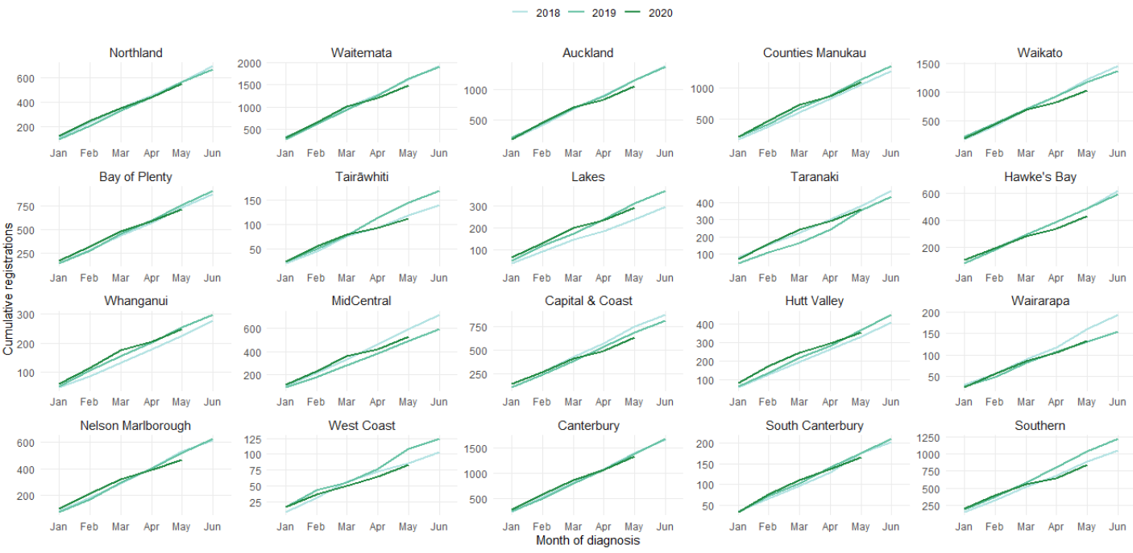

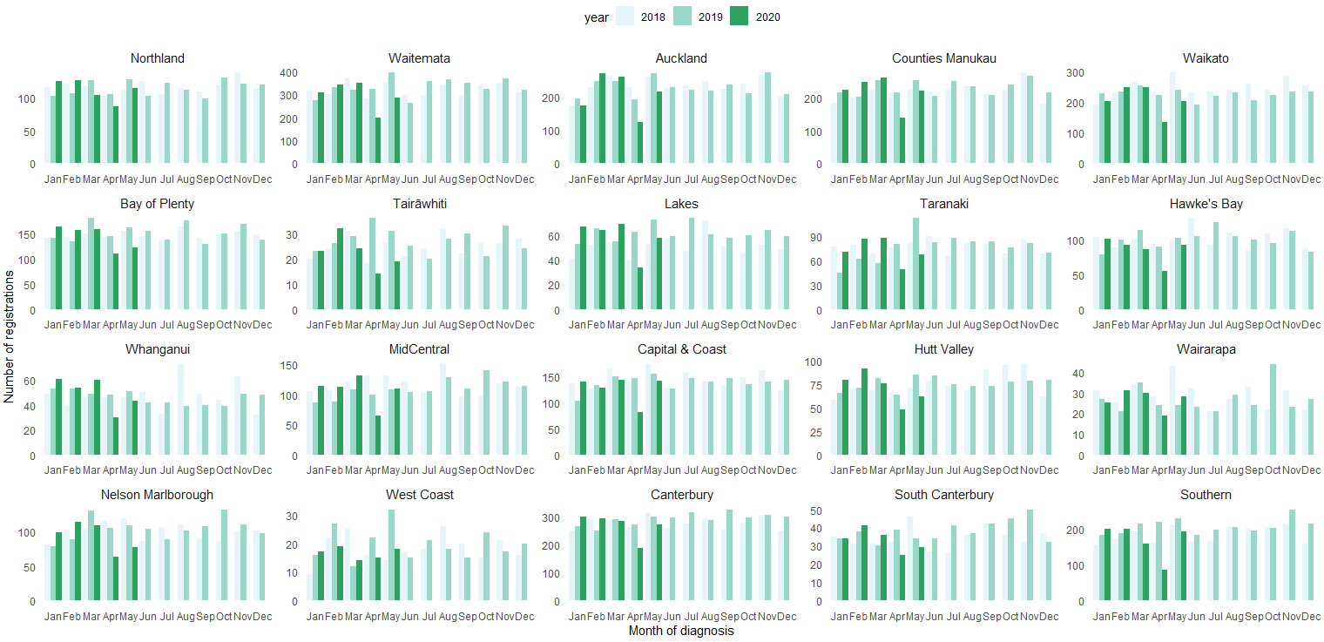

Appendix 3: Surgical procedure codes
Below is a list of the surgical procedure codes that were used for analysis on curative cancer surgery.
COLORECTAL CANCER SURGERY
Clinical code | Block short description | Clinical code description
3200000 | Colectomy | Limited excision of large intestine with formation of stoma
3200001 | Colectomy | Right hemicolectomy with formation of stoma
3200300 | Colectomy | Limited excision of large intestine with anastomosis
3200301 | Colectomy | Right hemicolectomy with anastomosis
3200400 | Colectomy | Subtotal colectomy with formation of stoma
3200401 | Colectomy | Extended right hemicolectomy with formation of stoma
3200500 | Colectomy | Subtotal colectomy with anastomosis
3200501 | Colectomy | Extended right hemicolectomy with anastomosis
3200600 | Colectomy | Left hemicolectomy with anastomosis
3200601 | Colectomy | Left hemicolectomy with formation of stoma
3200900 | Colectomy | Total colectomy with ileostomy
3201200 | Colectomy | Total colectomy with ileorectal anastomosis
3201500 | Total proctocolectomy | Total proctocolectomy with ileostomy
3202400 | Anterior resection of rectum | High anterior resection of rectum
3202500 | Anterior resection of rectum | Low anterior resection of rectum
3202600 | Anterior resection of rectum | Ultra low anterior resection of rectum
3202800 | Anterior resection of rectum | Ultra low anterior resection of rectum with hand sutured coloanal anastomosis
3203000 | Rectosigmoidectomy or proctectomy | Rectosigmoidectomy with formation of stoma
3203900 | Rectosigmoidectomy or proctectomy | Abdominoperineal proctectomy
3205100 | Total proctocolectomy | Total proctocolectomy with ileo-anal anastomosis
3205101 | Total proctocolectomy | Total proctocolectomy with ileo-anal anastomosis and formation of temporary ileostomy
3206000 | Rectosigmoidectomy or proctectomy | Restorative proctectomy
3209900 | Excision of lesion or tissue of rectum or anus | Per anal submucosal excision of lesion or tissue of rectum
3211200 | Rectosigmoidectomy or proctectomy | Perineal rectosigmoidectomy
9220800 | Anterior resection of rectum | Anterior resection of rectum, level unspecified

LUNG CANCER SURGERY
Clinical code | Clinical code description | Block Description
3844000 | Wedge resection of lung | Partial resection of lung
3844001 | Radical wedge resection of lung | Partial resection of lung
3843800 | Segmental resection of lung | Partial resection of lung
9016900 | Endoscopic wedge resection of lung | Partial resection of lung
3843801 | Lobectomy of lung | Lobectomy of lung
3844100 | Radical lobectomy | Lobectomy of lung
3844101 | Radical pneumonectomy | Pneumonectomy
3843802 | Pneumonectomy | Pneumonectomy

PROSTATE CANCER SURGERY
Clinical code | Block short description | Clinical code description
3720004 | Open prostatectomy | Retropubic prostatectomy
3720900 | Open prostatectomy | Radical prostatectomy
3720901 | Other closed prostatectomy | Laparoscopic radical prostatectomy
3721000 | Open prostatectomy | Radical prostatectomy with bladder neck reconstruction
3721001 | Other closed prostatectomy | Laparoscopic radical prostatectomy with bladder neck reconstruction
3721100 | Open prostatectomy | Radical prostatectomy with bladder neck reconstruction and pelvic lymphadenectomy
3721101 | Other closed prostatectomy | Laparoscopic radical prostatectomy with bladder neck reconstruction and pelvic lymphadenectomy
3720900 | Open prostatectomy | Radical prostatectomy
3720901 | Closed prostatectomy | Laparoscopic radical prostatectomy
3721000 | Open prostatectomy | Radical prostatectomy with bladder neck reconstruction
3721001 | Closed prostatectomy | Laparoscopic radical prostatectomy with bladder neck reconstruction
3721100 | Open prostatectomy | Radical prostatectomy with bladder neck reconstruction and pelvic lymphadenectomy

