COVID-19 and cancer services

Report four

Working report on the impact of COVID-19 on cancer services for the period ending July 2020

August 2020

Contents

Contents 2
Summary of findings 3
Introduction 5
Cancer Registrations 6
Faster cancer treatment 11
Gastrointestinal endoscopy 13
Bronchoscopy 14
Combined curative cancer surgery 16
Colorectal cancer surgery 18
Lung cancer surgery 19
Prostate cancer surgery 21
Medical oncology 22
Radiation oncology 25
Haematology 27
Appendix 1: NZCR data information 30
Appendix 2: NZCR registrations by DHB 31
Appendix 3: Diagnosis and treatment data by DHB 33
Appendix 4: Surgical procedure codes 44

Summary of findings
Overview of impact of COVID-19 on cancer diagnosis and treatment
There continues to be an increase in new cancer registrations and diagnostic procedures in July 2020. This report shows that we are catching up on the dip in cancer registrations seen over the lockdown period. The overall number of diagnostic procedures and new cancer registrations in 2020 remains somewhat lower than 2019 but the gap continues to close. Cancer treatment services – surgery, medical oncology, radiation oncology and haematology – continued during the COVID-19 lockdown and continue to be delivered at pre-COVID volumes in the months since.

Background and data
- This is the fourth report looking at the impact of COVID-19 on cancer services. This report looks at the period until the end of July 2020.
- The purpose of this analysis was to rapidly measure the impact of COVID-19 on cancer services to assist with recovery planning.
- The report focuses on the aspects of the cancer care pathway for which we have readily available data and does not capture all aspects of the care.
- Comparisons between 2020 and 2019 do not consider any projected increase in diagnoses over time.
- The focus of the report was to understand the impact of COVID-19 on existing service delivery and does not address pre-existing unmet need.

Equity
- Māori have seen a similar decrease in overall cancer registrations in 2020 as non-Māori/non-Pacific, both 3%.
- In the first seven months of 2020 there has been a smaller decrease in gastrointestinal endoscopy for Māori (3% decrease) than for non-Māori/non-Pacific (8%) compared to the same time period in 2019. There has been an increase in curative colorectal cancer surgery for Māori (53 more surgeries, 47% increase) compared to a 9% decrease for non-Māori/non-Pacific.
- Overall, the impact of COVID-19 on the number of attendances for medical oncology and radiation oncology appears to be similar for Māori as for non-Māori/non-Pacific.
- Lung cancer remains the area where inequities from COVID-19 are evident. Māori have been disproportionately impacted by the cumulative decrease in bronchoscopies (29% decrease for Māori compared to 19% decrease for non-Māori/non-Pacific).
- Despite the 20% decrease in bronchoscopies, there has been a 4% decrease in new diagnoses of respiratory and thorax cancer. However, there is a 19% decrease in new diagnoses of lung cancer for Māori in the first 7 months of 2020 compared to the same time period in 2019 (41 fewer cancers). This has also resulted in fewer curative lung cancer surgeries performed in 2020.

Cancer diagnosis

Registrations
- Overall for the year to date (up until end of July 2020), there have been 448 fewer cancer registrations compared to the same time period in 2019, a 2.5% decrease. This is a smaller deficit than was seen at the end of June (689 fewer cancer than 2019, 4.5% decrease).
- There were 266 more cancers registered in July 2020 compared to July 2019, a 10% increase.
- The decrease in cancer registrations is similar for Māori (3.3%) and European/Other (3.1%). There are now a similar number of registrations for Pacific People as was seen in 2019 and there remains an increase in registrations for people in the Asian ethnic group (as seen in previous months).
- The overall impact of COVID-19 on registrations for the year to date has been most marked for prostate, haematology/lymphoid, melanoma and non-melanoma skin cancer and breast cancers (all have seen a 6-10% decrease for the year to date).

Diagnostics
- COVID-19 has had minimal impact on the number of people referred to secondary care with a high suspicion of cancer. A similar proportion of people are meeting the 62-day target time frame* as pre-COVID. (*Patients referred with a high suspicion of cancer should receive their first treatment within 62 days of receipt of referral).
- Gastrointestinal endoscopy: services remained at pre-COVID levels in July. Overall, for the year to date there have been 7% fewer gastrointestinal endoscopies performed in 2020 compared to 2019. This is smaller a gap than was seen at the end of June 2020, when there were 11% fewer gastrointestinal endoscopies performed compared to the first six months of 2019.
  - Despite the 7% year to date decrease in colonoscopies, there has been a 1% increase in registrations of colorectal cancer. This indicates that triage systems are operating well within DHBs, with those at highest risk being prioritised to receive their colonoscopies.
- Bronchoscopy: overall there were 20% fewer bronchoscopies performed in the first seven months of 2020 compared to the first seven months of 2019.

Cancer Treatment

Surgery
- The impact of COVID-19 on cancer surgery volumes has been minimal, with 2% fewer curative surgeries performed for selected cancers in the first seven months of 2020 compared to the first seven months of 2019. There has been an 21% increase in surgery for Māori in 2020 compared to 2019.
- For the year to date there has been a 6% decrease in curative lung cancer surgery compared to 2019.

Chemotherapy and radiotherapy
- Medical oncology: for the year to date the number of medical oncology first specialist assessments (FSAs) and number of attendances for IV chemotherapy in 2020 is comparable to 2019.
  - There has been a 15% increase in attendances for IV chemotherapy for Māori during the first seven months of 2020 compared to the same time period in 2019.
- Radiation oncology: for the year to date the number of radiation oncology FSAs in 2020 is comparable to 2019.
  - There has been a 7% decrease in attendances for radiation therapy. This is similar for Māori (7%) and non-Māori/non-Pacific (7%). This may be the result of national hypofractionation guidance.
- Haematology: for the year to date there has been an 8% decrease in haematology FSAs compared to the same time period in 2019 (nothing that this includes non-malignant haematology referrals).
  - There has been a 5% increase in IV chemotherapy for haematology compared to the same time period in 2019.

Introduction

Purpose of this report
This is the fourth report released by Te Aho o Te Kahu outlining the impact of COVID-19 on cancer services in New Zealand. This report looks at data through to the end of July 2020.
The report focuses on the aspects of the cancer care pathway for which we have readily available data and does not capture all aspects of the care. Critical aspects of cancer care, including access to primary care, radiology and palliative care are not measured in this report.

Data and analysis
The data in this report comes from Ministry of Health national data collections. Each section of the report includes information on where the data is from and any limitations with the data. Numbers in this report may not match the previous report exactly, due to late coding/submission of data. Te Aho o Te Kahu are actively working with DHBs to improve the accuracy and completeness of national collections data within the context of cancer.
It is important to note that the purpose of the analysis is to rapidly measure the impact of COVID-19 and the recovery on cancer services and does not consider pre-existing unmet need. The report also makes direct comparisons between 2020 and 2019 and does not consider any projected increase in diagnoses over time.

Key dates
Key dates to 31 July 2020 in relation to COVID-19 that may be of use when reviewing the report include:
- 23 March: alert level 3 and hospital alert level framework released
- 26 March: alert level 4
- 28 April: alert level 3
- 14 May: alert level 2
- 9 June: alert level 1
The impact of the shift to Alert Level 3 for Auckland and Level 2 for the rest of New Zealand in August will be shown in the next report, for the period ending August 2020. This report will be released in late September 2020.

Cancer Registrations

Notes on data
- The data come from laboratory reports to the New Zealand Cancer Register (NZCR). This means that cancers diagnosed without haematology or pathology (e.g. radiology alone) will not be counted in this analysis.
- Data included in this report is provisional, and exact numbers will change as data is finalised.
- ‘Date’ is date of diagnosis on the NZCR – usually the date the specimen was taken from the person and sent to the laboratory. Analyses include all new provisional and registered cancer events based on pathology and haematology reports. Data were extracted from NZCR on 21 August 2020.
- Further information on this data is included in Appendix 1.

Results
Table 1 shows the change in provisional cancer registrations in 2020 compared to 2019 by month, and the cumulative impact this has had on cancer registrations for the year to date (up until the end of July 2020).
Table 1: Absolute number and percentage change in cancer registrations in 2020 compared to 2019 by month, and cumulative year to date
 | May 2020 |  | June 2020 |  | July 2020 |  | Year to date
 | Number | % | Number | % | Number | % | Number | %
Māori | -34 | -13.1 | -24 | -9.2 | 17 | 6.1 | -57 | -3.3
Pacific | -38 | -31.4 | 21 | 26.9 | 19 | 19.2 | 4 | 0.6
Asian | -23 | -15 | 16 | 12 | -3 | -1.9 | 44 | 4.8
European/Other | -415 | -17.7 | 231 | 11.8 | 216 | 10.2 | -458 | -3.1
Total Population | -511 | -17.6 | 240 | 9.8 | 266 | 10 | -448 | -2.5
Note: a small number of reports have ‘unspecified’ ethnicity, meaning the sum of all ethnic groups may not equal the total population.
Figure 1: Total number of cancer registrations by month and year (left), cumulative number of cancer registrations by month and year (right)
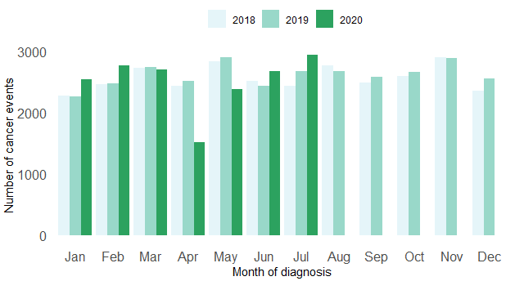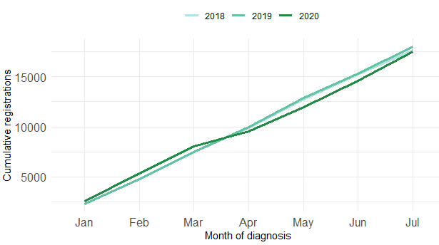
Figure 2: Number of cancer registrations by month and year, by ethnicity
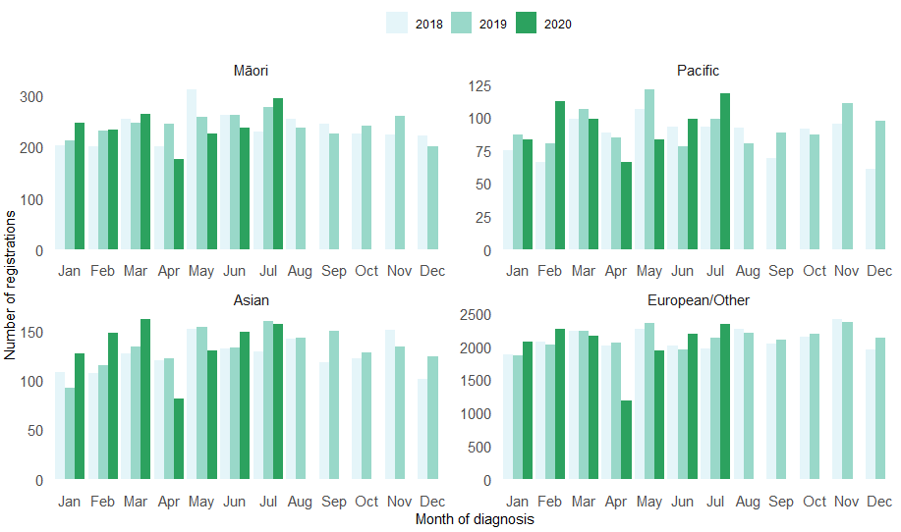
Figure 3: Cumulative number of cancer registrations by year, by ethnicity 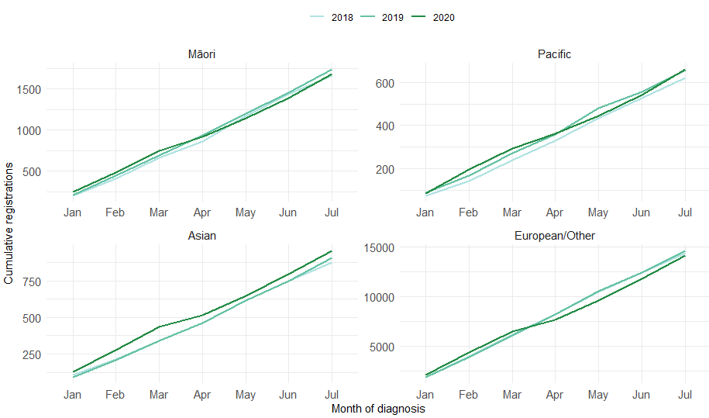
Table 2: Changes in cancer registration for 10 most common cancers in 2020 compared to 2019 by month and for the year to date, absolute difference in number of cases and percentage change, by cancer group.
 | May 2020 |  | June 2020 |  | July 2020 |  | Year to date*
Cancer Group | Number | % | Number | % | Number | % | Number | %
Breast | -138 | -34.4 | -16 | -4.4 | 33 | 8.7 | -211 | -8.6
Cervix | -44 | -23 | 18 | 10.6 | 0 | 0 | 76 | 6.5
Colorectal | -13 | -4.4 | -3 | -1.1 | 36 | 13.3 | 17 | 0.9
Gynaecology | -18 | -16.1 | 24 | 26.1 | -1 | -0.9 | 31 | 4.5
Haematology and lymphoid | -70 | -29.9 | 11 | 5.9 | 14 | 6.2 | -109 | -7.6
Melanoma and non-melanoma skin | -278 | -40.4 | 49 | 9.5 | 108 | 20 | -277 | -6.6
Other digestive system | -16 | -10.7 | 34 | 31.8 | -26 | -17 | -13 | -1.4
Prostate | 35 | 10.1 | -22 | -6.5 | 6 | 1.9 | -227 | -10.1
Respiratory and thorax | -14 | -9.4 | 4 | 3.4 | -9 | -5.8 | -40 | -3.9
Urinary system | 7 | 5.7 | 14 | 12.1 | 33 | 26.4 | 51 | 6
*Note: this analysis uses provision data for the 2020 registrations, some cancers may initially be classified as ‘non-specified’, and subsequently be re-classified into one of the cancer groups as more information is available.
Figure 4: Number of cancer registrations by month and year, by cancer group
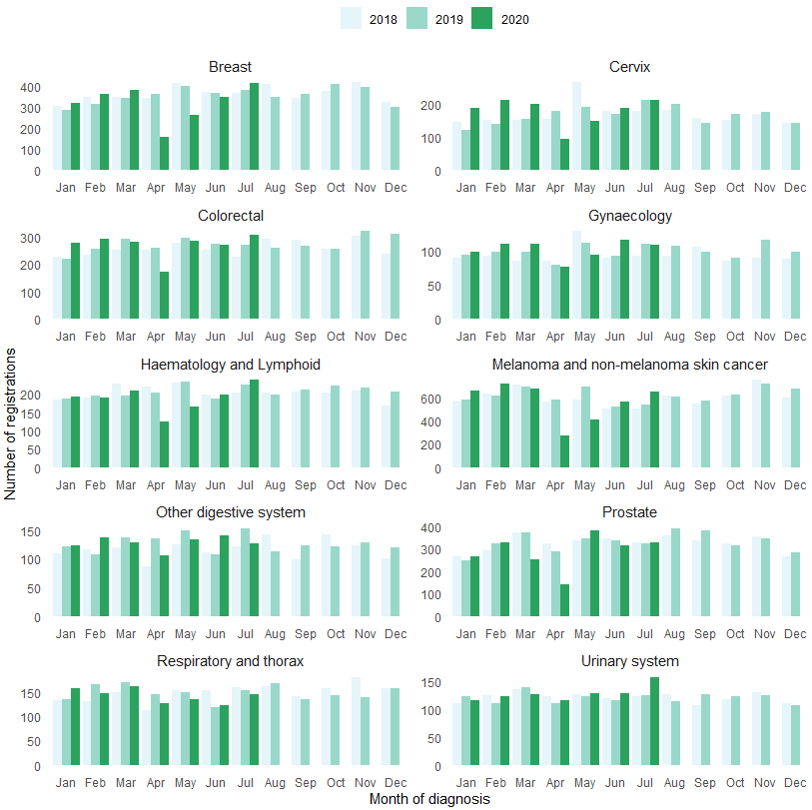
Figure 5: Cumulative number of cancer registrations by year, by cancer group
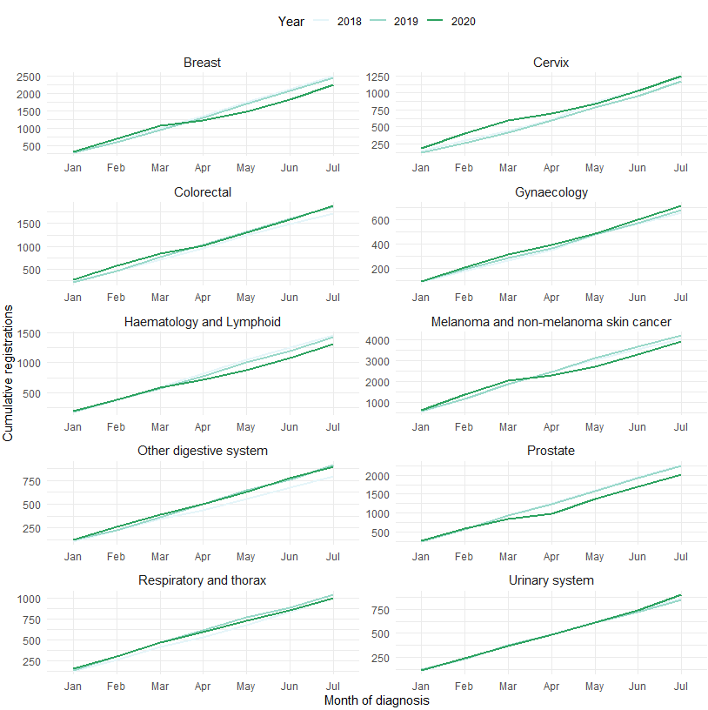

Table 3: Changes in cancer registration in 2020 compared to 2019 by month and for the year to date, absolute difference in number of cases and percentage change, by DHB of domicile (See Appendix 2 for graphs)
 | May 2020 |  | June 2020 |  | July 2020 |  | Year to date
DHB | Number | % | Number | % | Number | % | Number | %
Northland | -16 | -12.4 | 6 | 5.9 | 13 | 10.6 | -7 | -1
Waitemata | -101 | -25.7 | 107 | 40.8 | 15 | 4.2 | -50 | -2.6
Auckland | -57 | -20.9 | 42 | 18.2 | 29 | 13.1 | -71 | -5.1
Counties Manukau | -36 | -14.2 | 38 | 18.4 | -6 | -2.4 | -9 | -0.7
Waikato | -35 | -14.6 | 29 | 15.2 | 45 | 20.6 | -105 | -7.7
Bay of Plenty | -41 | -25.3 | -16 | -10.3 | 32 | 23.2 | -65 | -7.1
Tairawhiti | -12 | -38.7 | 9 | 36 | 17 | 85 | -25 | -14.7
Lakes | -16 | -21.9 | 0 | 0 | 5 | 6.8 | -20 | -5.4
Taranaki | -46 | -41.1 | -7 | -8.5 | -17 | -19.3 | 1 | 0.2
Hawke's Bay | -7 | -6.9 | -12 | -11.2 | -15 | -12 | -62 | -10.5
Whanganui | -8 | -15.7 | 6 | 14.3 | 21 | 50 | 1 | 0.3
MidCentral | 3 | 2.8 | 4 | 3.8 | 5 | 4.7 | 52 | 8.7
Capital & Coast | -10 | -6.5 | -3 | -2.3 | 7 | 4.8 | -54 | -6.6
Hutt Valley | -19 | -22.4 | -8 | -9.5 | 7 | 9.3 | -15 | -3.3
Wairarapa | 4 | 16.7 | 8 | 34.8 | 15 | 71.4 | 9 | 5.8
Nelson Marlborough | -27 | -24.5 | 2 | 1.9 | 30 | 33.7 | -42 | -6.8
West Coast | -15 | -46.9 | 11 | 73.3 | 1 | 4.8 | -17 | -13.7
Canterbury | -32 | -10.7 | -29 | -9.8 | 25 | 8 | -73 | -4.4
South Canterbury | -6 | -17.6 | 7 | 20.6 | -1 | -2.4 | -4 | -1.9
Southern | -38 | -16.6 | 44 | 24 | 43 | 22.1 | -154 | -12.7

Key points
- Overall for the year to date (up until end of July 2020), there have been 448 fewer cancer registrations compared to the same time period in 2019, a 2.5% decrease. This is a smaller deficit than was seen at the end of June (689 fewer cancer than 2019, 4.5% decrease).
- There were 266 more cancers registered in July 2020 compared to July 2019, a 10% increase.
- The decrease in cancer registrations is similar for Māori (3.3%) and European/Other (3.1%). There are now a similar number of registrations for Pacific People as was seen in 2019 and there remains an increase in registrations for people in the Asian ethnic group (as seen in previous months).
- The overall impact of COVID-19 on registrations for the year to date has been most marked for prostate, haematology/lymphoid, melanoma and non-melanoma skin cancer and breast cancers – all have seen a 6-10% decrease for the year to date.

Faster cancer treatment

Notes on data
- The data were extracted from the Faster Cancer Treatment database on 20 August 2020. Data is reported quarterly.
- These data aim to capture a broader part of the diagnostic and referral pathway; however, they only include a subset of people being investigated for cancer.
- Data relate to the 62-day pathway and includes patients with a high-suspicion of cancer and a need to be seen within two weeks. These patients should receive their first treatment within 62-day of receipt of referral.
- Analysis includes all referrals onto the 62-day pathway.

Results
Table 4: Absolute number and percentage change in number of referrals for patients with a high-suspicion of cancer, in 2020 compared to 2019 by month, and cumulative year to date
 | March 2020 |  | April 2020 |  | May 2020 |  | June 2020 |  | Year to date
 | Number | % | Number | % | Number | % | Number | % | Number | %
Māori | 20 | 44% | 8 | 15% | -10 | -18% | -1 | -2% | -2 | -1%
Non-Māori/Non-Pacific | 65 | 16% | 28 | 8% | -26 | -7% | -51 | -15% | 94 | 4%
Total Population | 80 | 17% | 43 | 9% | -43 | -10% | -44 | -11% | 99 | 4%
Figure 6: Cumulative number of referrals with a high-suspicion of cancer and a need to be seen within 2-weeks, by year, for the total population (left) and for Māori (right)

Table 5: Proportion of patients with a high-suspicion of cancer and a need to be seen within 2-weeks receiving their first treatment within 62 day of receipt of referral, in 2020 by month, and cumulative year to date
 | Jan | Feb | Mar | Apr | May | Jun | Year to date
Māori | 71% | 79% | 94% | 82% | 79% | 92% | 84%
Non-Māori / Non-Pacific | 83% | 77% | 87% | 91% | 82% | 90% | 85%
Total Population | 81% | 78% | 87% | 90% | 81% | 90% | 85%
Figure 7: Proportion of patients with a high-suspicion of cancer and a need to be seen within 2-weeks receiving their first treatment within 62 day of receipt of referral, in 2020 by month.

Key points
- Overall, COVID-19 has had minimal impact on the number of referrals with a high suspicion of cancer.
- The number of referrals meeting the 62-day target – patients receiving their first treatment within 62 days of receipt of referral – has shown little change over the first six months of 2020.
- This indicates that people who present to their GP with signs/symptoms indicating a high suspicion of cancer are still being referred through to secondary care. There are a similar number being referred as pre-COVID and these people are being seen within a similar time frame as pre-COVID.

Gastrointestinal endoscopy

Notes on data
- Gastrointestinal endoscopy data were extracted from National Non-admitted Patient Collection (outpatient) and National Minimum Dataset (inpatient) on 24 August 2020.
- Includes colonoscopies and gastroscopies for all indications (i.e. not just cancer).
- Technical information: Gastroscopies (Purchase Unit Code - MS02005), Colonoscopies (Purchase Unit Code - MS02007), Combined Gastroscopies + Colonoscopies (Purchase Unit Code - MS02014).

Results
Table 6: Absolute number and percentage change in colonoscopy and gastroscopy in 2020 compared to 2019 by month, and cumulative year to date
 | May 2020 |  | June 2020 |  | July 2020 |  | Year to date
 | Number | % | Number | % | Number | % | Number | %
Māori | -72 | -12% | 152 | 25% | 32 | 5% | -109 | -3%
Pacific Peoples | 12 | 5% | 92 | 41% | 51 | 21% | 203 | 13%
Non-Māori / Non-Pacific | -1187 | -18% | 1355 | 24% | 179 | 3% | -3427 | -8%
Total Population | -1247 | -17% | 1599 | 24% | 262 | 3% | -3333 | -7%

Figure 6: Number of gastrointestinal endoscopy procedures by month and year, for the total population (left) and for Māori (right)

Figure 7: Cumulative number of gastrointestinal endoscopy procedures by year, for the total population (left) and for Māori (right)

Key points
- Gastrointestinal endoscopy services remained at pre-COVID levels in July.
- Overall, for the year to date there have been 7% fewer gastrointestinal endoscopies performed in 2020 compared to 2019. This is smaller a gap than was seen at the end of June 2020, when there were 11% fewer gastrointestinal endoscopies performed compared to the first six months of 2019.
- Māori having a smaller cumulative reduction (3%) compared to non-Māori/non-Pacific (8%). There has been a 13% increase in gastrointestinal endoscopies for Pacific Peoples compared to the same time period in 2019.
- Despite the 7% year to date decrease in colonoscopies, there has been a 1% increase in registrations of colorectal cancer (see Table 2). This indicates that triage systems are operating well within DHBs, with those at highest risk being prioritised to receive their colonoscopies.
- DHBs continue to work to increase the delivery of gastrointestinal endoscopies post lockdown. There is ongoing work nationally to address the demand for colonoscopy services.

Bronchoscopy

Notes on data
- Bronchoscopy data were extracted from National Non-admitted Patient Collection (outpatient) and National Minimum Dataset (inpatient) on the 24 August 2020.
- Includes bronchoscopies for any indication (i.e. not just cancer).
- Technical information: Bronchoscopies (Purchase Unit Code - MS02003).

Results
Table 7: Absolute number and percentage change in bronchoscopies in 2020 compared to 2019 by month, and cumulative year to date
 | May 2020 |  | June 2020 |  | July 2020 |  | Year to date
 | Number | % | Number | % | Number | % | Number | %
Māori | -19 | -43% | 0 | 0% | -3 | -8% | -72 | -29%
Pacific Peoples* | - | - | - | - | - | - | 6 | 10%
Non-Māori / Non-Pacific | -78 | -34% | 33 | 24% | -6 | -4% | -240 | -19%
Total Population | -90 | -32% | 32 | 19% | -6 | -3% | -306 | -20%
*Due to small numbers, monthly figures have not been included for Pacific Peoples
Figure 8: Number of bronchoscopies by month and year, for the total population (left) and for Māori (right)

Figure 9: Cumulative number of bronchoscopies procedures by year, for the total population (left) and for Māori (right)

Key points
- Bronchoscopy services are similar in July 2020 compared to June 2020 and there was a similar number of bronchoscopies performed in July 2020 compared to July 2019.
- However, there remains a deficit between the number of bronchoscopies performed in 2020 compared to 2019. Overall there were 20% fewer bronchoscopies performed in the first seven months of 2020 compared to the first seven months of 2019.
- Māori have been disproportionately impacted by the cumulative decrease in bronchoscopies (29% decrease for Māori compared to 19% decrease for non-Māori/non-Pacific).
- Despite the 20% decrease in bronchoscopies, there has only been a 4% decrease in new diagnoses of respiratory and thorax cancer (see Table 2). However, there is a 19% decrease in new diagnoses of lung cancer for Māori in the first 7 months of 2020 compared to the same time period in 2019 (41 fewer cancers). Note that caution is needed when interpreting the provisional cancer type registrations, as some cancers may initially be classified as ‘non-specified’, and subsequently be re-classified into one of the cancer groups as more information is available.

Combined curative cancer surgery

Notes on data
- This report includes data on curative surgery for colorectal, lung and prostate cancer. These cancers were chosen because a pre-validated list of surgical procedure codes for these cancers already existed within Te Aho o Te Kahu, agreed on as part of the quality performance indicator work programme. These three cancers are therefore used as case studies for cancer surgery more generally. The procedure codes are included in Appendix 4.
- The data was extracted from the National Minimum Dataset on 24 August 2020.

Results
Table 8: Absolute number and percentage change in curative surgery (colorectal, lung and prostate) in 2020 compared to 2019 by month, and cumulative year to date
 | May 2020 |  | June 2020 |  | July 2020 |  | Year to date
 | Number | % | Number | % | Number | % | Number | %
Māori | 1 | 3% | 26 | 100% | 5 | 15% | 46 | 21%
Pacific Peoples* | - | - | - | - | - | - | -20 | -28%
Non-Māori / Non-Pacific | 8 | 3% | -1 | 0% | -2 | -1% | -63 | -3%
Total Population | 1 | 0% | 21 | 6% | -2 | -1% | -37 | -2%
*Due to small numbers, monthly figures have not been included for Pacific Peoples
Figure 10: Number of curative cancer surgeries (prostate, colorectal, lung) by month and year, for the total population (left) and for Māori (right)

Figure 11: Cumulative number of curative cancer surgeries (colorectal, lung, prostate) by year, for the total population (left) and for Māori (right)

Key points
- Overall, the impact of COVID-19 on cancer surgery volumes has been minimal, with 2% fewer surgeries performed in the first seven months of 2020 compared to the first seven months of 2019. There has been an 21% increase in surgery for Māori in 2020 compared to 2019.
- There has been a 28% decrease in surgeries for Pacific Peoples, noting that this represents small numbers (20 fewer surgeries over seven months).

Colorectal cancer surgery

Notes on data
- A list of the surgical procedure codes used for analysis are included in Appendix 4.
- The data was extracted from the National Minimum Dataset on 24 August 2020.

Results
Table 9: Absolute number and percentage change in curative colorectal cancer surgery in 2020 compared to 2019 by month, and cumulative year to date
 | May 2020 |  | June 2020 |  | July 2020 |  | Year to date
 | Number | % | Number | % | Number | % | Number | %
Māori | 6 | 40% | 13 | 100% | 10 | 56% | 53 | 47%
Pacific Peoples* | - | - | - | - | - | - | -17 | -39%
Non-Māori / Non-Pacific | -30 | -16% | -9 | -5% | -12 | -7% | -118 | -9%
Total Population | -28 | -14% | 0 | 0% | -8 | -4% | -82 | -6%
*Due to small numbers, monthly figures have not been included for Pacific Peoples
Figure 12: Number of curative colorectal cancer surgeries by month and year, for the total population (left) and for Māori (right)

Figure 13: Cumulative number of curative colorectal cancer surgeries by year, for the total population (left) and for Māori (right)

Key points
- Colorectal cancer surgery continues to operate at pre-COVID volumes.
- Overall there has been a 6% decrease in colorectal surgery for the year to date compared to the first seven months of 2020. This is likely to be largely driven by the decline in diagnostic colonoscopies performed during lockdown.
- Overall, there has been a 47% increase in curative colorectal cancer surgery for Māori for the year to date compared to the same time period in 2019.

Lung cancer surgery

Notes on data
- A list of the surgical procedure codes used for analysis are included in Appendix 4.
- The data were extracted from the National Minimum Dataset on 24 August 2020.
- The number of lung cancer surgeries performed each month is relatively small, so caution is needed when comparing data by month.

Results
Table 10: Absolute number and percentage change in curative lung cancer surgery in 2020 compared to 2019 by month, and cumulative year to date.
 | May 2020 |  | June 2020 |  | July 2020 |  | Year to date
 | Number | % | Number | % | Number | % | Number | %
Total Population | 13 | 23% | 7 | 13% | -6 | -12% | -25 | -6%
*Due to the small number of surguries performed each month calculations have only been included for the total population rather than by ethnicity
Figure 14: Number of curative lung cancer surgeries by month and year, total population (left) and for Māori (right)

*Due to the small number of surgeries performed each month it is not possible to draw conclusions from small changes between months.
Figure 15: Cumulative number of curative lung cancer surgeries by year, for the total population (left) and for Māori (right)

Key points
- Overall, for the year to date there has been a 6% decrease in curative lung cancer surgeries compared to 2019.
- The impact on lung cancer surgery is most marked for Māori. This is expected given the decrease in bronchoscopy and lung cancer diagnoses (see discussion page 16).

Prostate cancer surgery

Notes on data
- A list of the surgical procedure codes used for analysis are included in Appendix 4.
- The data was extracted from the National Minimum Dataset on 24 August 2020.
- The volumes for prostate surgery are higher in this report than previously reported due to the inclusion of data from a private provider (that provides public surgery).
- The number of curative prostate cancer surgeries performed each month is relatively small, so caution is needed when comparing data by month.

Results
Table 11: Absolute number and percentage change in curative prostate cancer surgery in 2020 compared to 2019 by month, and cumulative year to date
 | May 2020 |  | June 2020 |  | July 2020 |  | Year to date
 | Number | % | Number | % | Number | % | Number | %
Total Population | 16 | 25% | 14 | 20% | 12 | 21% | 70 | 16%
*Due to the small number of surguries performed each month calculations have only been included for the total population
Figure 16: Number of curative prostate cancer surgeries by month and year, total population (left) and for Māori (right)

*Due to the small number of surguries performed each month it is not possible to draw conclusions from small changes between months.
Figure 17: Cumulative number of curative prostate cancer surgeries by year, for the total population (left) and for Māori (right)

Key points
- For the year to date there has been a 16% increase in prostate cancer surgeries compared to 2019. There was an increase in prostate cancer surgeries performed in July 2020 compared to July 2019.

Medical oncology

Notes on data
- Extracted from National non-admitted patient collection (Outpatient collection) on 24 August 2020.
- First specialist assessment (FSA) reflects counts of first attendance for specialist medical oncology assessment.
- IV chemotherapy reflects appointments for outpatient and inpatient IV chemotherapy for non-haematological indications.
- Technical information: medical oncology FSA (PUC M50020), and IV chemotherapy (PUC MS02009)

Results
Table 12: Absolute number and percentage change in medical oncology first specialist assessments in 2020 compared to 2019 by month, and cumulative year to date
 | May 2020 |  | June 2020 |  | July 2020 |  | Year to date
 | Number | % | Number | % | Number | % | Number | %
Māori | -1 | -1% | 12 | 12% | -17 | -14% | -20 | -3%
Pacific Peoples | -7 | -14% | -6 | -17% | -6 | -14% | 34 | 14%
Non-Māori / Non-Pacific | -60 | -8% | 54 | 9% | -75 | -11% | 47 | 1%
Total Population | -68 | -8% | 60 | 8% | -98 | -12% | 61 | 1%
Figure 18: Number of medical oncology first specialist assessments by month and year, for the total population (left) and for Māori (right)

Figure 19: Cumulative number of medical oncology first specialist assessments by year, for the total population (left) and for Māori (right)

Table 13: Absolute number and percentage change in IV chemotherapy attendances in 2020 compared to 2019 by month, and cumulative year to date
 | May 2020 |  | June 2020 |  | July 2020 |  | Year to date
 | Number | % | Number | % | Number | % | Number | %
Māori | 44 | 6% | 225 | 33% | 56 | 7% | 797 | 15%
Pacific Peoples | -10 | -3% | 57 | 22% | -1 | 0% | 45 | 2%
Non-Māori / Non-Pacific | -581 | -11% | 566 | 12% | -560 | -10% | -121 | 0%
Total Population | -547 | -8% | 848 | 15% | -505 | -8% | 721 | 2%

Figure 20: Number of attendances for IV chemotherapy by month and year, for the total population (left) and for Māori (right)

Figure 21: Cumulative number of attendances for IV chemotherapy by year, for the total population (left) and for Māori (right)

Key points
- Overall, for the year to date the number of medical oncology FSAs and number of attendances for IV chemotherapy in 2020 is comparable to 2019.
- There has been an overall 15% increase in attendances for IV chemotherapy for Māori during the first seven months of 2020 compared to the same time period in 2019.

Radiation oncology

Notes on data
- Extracted from National Non-admitted patient collection on 24 August 2020.
- First specialist assessment (FSA) reflects counts of first attendance for radiation oncology specialist assessment.
- Megavoltage attendance reflects appointments for planning/simulation and for treatment with radiation therapy on a linear accelerator.
- Technical information: radiation oncology FSA (PUC M50022), megavoltage attendances (Purchase Unit Code M50025)

Results
Table 14: Absolute number and percentage change in radiation oncology first specialist assessments in 2020 compared to 2019 by month, and cumulative year to date
 | May 2020 |  | June 2020 |  | July 2020 |  | Year to date
 | Number | % | Number | % | Number | % | Number | %
Māori | 7 | 5% | 23 | 21% | 2 | 2% | 65 | 8%
Pacific Peoples | -15 | -29% | -16 | -36% | -18 | -31% | -37 | -11%
Non-Māori / Non-Pacific | -102 | -11% | 96 | 13% | -217 | -21% | -51 | -1%
Total Population | -110 | -10% | 103 | 11% | -233 | -19% | -23 | 0%
Figure 22: Number of radiation oncology first specialist assessments by month and year, total population (left) and for Māori (right)

Figure 23: Cumulative number of radiation oncology first specialist assessments by month and year, total population (left) and for Māori (right)

Table 15: Absolute number and percentage change in radiation therapy attendances in 2020 compared to 2019 by month, and cumulative year to date
 | May 2020 |  | June 2020 |  | July 2020 |  | Year to date
 | Number | % | Number | % | Number | % | Number | %
Māori | -374 | -20% | 274 | 17% | -256 | -13% | -806 | -7%
Pacific Peoples | -172 | -28% | -3 | -1% | -241 | -34% | 18 | 0%
Non-Māori / Non-Pacific | -3076 | -25% | 554 | 5% | -711 | -6% | -5350 | -7%
Total Population | -3622 | -25% | 825 | 7% | -1208 | -8% | -6138 | -7%
Figure 24: Number of attendances for radiation therapy by month and year, total population (left) and for Māori (right)

Figure 25: Cumulative number of attendances for radiation therapy by month and year, total population (left) and for Māori (right)

Key points
- Overall for the year to date the number of radiation oncology FSAs in 2020 is comparable to 2019.
- For the year to date there has been a 7% decrease in attendances for radiation therapy. This is similar for Māori (7%) and non-Māori/non-Pacific (7%). This may be the result of national hypofractionation guidance. Te Aho o Te Kahu is looking into this further using the Radiation Oncology Collection (ROC database), which allows for more detailed analysis.

Haematology

Notes on data
- Extracted from National Non-admitted Patient Collection (outpatient) and National Minimum Dataset (inpatient) 24 August 2020.
- First specialist assessment (FSA) reflects counts of first attendance for specialist haematology assessment for any indication (i.e. not just cancer).
- IV chemotherapy reflects appointments for IV chemotherapy for haematological malignancies.
- Technical information: Haematology FSA (Purchase Unite Code - M30002), IV haem/chemo (Purchase Unit Code - M30020).

Results
Table 16: Absolute number and percentage change in haematology FSAs in 2020 compared to 2019 by month, and cumulative year to date
 | May 2020 |  | June 2020 |  | July 2020 |  | Year to date
 | Number | % | Number | % | Number | % | Number | %
Māori | -14 | -21% | -32 | -44% | -1 | -2% | -18 | -4%
Pacific Peoples | -10 | -28% | 5 | 16% | 8 | 35% | 2 | 1%
Non-Māori / Non-Pacific | -230 | -41% | 30 | 8% | -67 | -13% | -289 | -9%
Total Population | -254 | -38% | 3 | 1% | -60 | -10% | -305 | -8%
Figure 26: Number of haematology first specialist assessments by month and year, total population (left) and for Māori (right)

Figure 27: Cumulative number of haematology first specialist assessments by month and year, total population (left) and for Māori (right)

Table 17: Absolute number and percentage change in IV chemotherapy attendances for haematological malignancies in 2020 compared to 2019 by month, and cumulative year to date
 | May 2020 |  | June 2020 |  | July 2020 |  | Year to date
 | Number | % | Number | % | Number | % | Number | %
Māori | -54 | -23% | 6 | 4% | -50 | -19% | -10 | -1%
Pacific Peoples | 34 | 47% | 94 | 162% | 65 | 59% | 191 | 32%
Non-Māori / Non-Pacific | -186 | -11% | 381 | 28% | -104 | -5% | 492 | 4%
Total Population | -206 | -10% | 481 | 30% | -89 | -4% | 673 | 5%

Figure 28: Number attendances for IV chemotherapy for haematological malignancies by month and year, total population (left) and for Māori (right)

Figure 29: Cumulative number of attendances for IV chemotherapy for haematological malignancies by month and year, total population (left) and for Māori (right)

Key points
- Overall, for the year to date there has been an 8% decrease in haematology first specialist appointments compared to the same time period in 2019. One contributor to this is likely to be a decrease in FSAs for non-malignant, non-urgent indications, deferred as part of the hospital response framework. These cases may have been effectively managed in primary care and so may never require secondary FSA care in 2020.
- For the year to date there has been a 5% increase in IV chemotherapy for haematology compared to the same time period in 2019.

Appendix 1: NZCR data information

The New Zealand Cancer Registry as a source of data for new cancer diagnoses
Cancer registration is a process where data is collated from multiple sources about people diagnosed with cancer and rules are applied to determine the type of cancer they have. This information is recorded in the New Zealand Cancer Registry. Each tumour is classified using an international World Health Organisation standard so that cancer incidence can be compared between countries. The tumour is staged based on all the information available within 4 months of diagnosis. This process may take up to six months or more depending on the number of missing reports that need to be followed up with laboratories.
For each registration there may be multiple pathology reports as there may be multiple procedures performed on the tumour. This means there will be more than one registration for people diagnosed with more than one type of tumour.
Cancer registrations come from pathology laboratories, haematology laboratories, mortality records and reviewing hospital discharge records. Laboratory reports provide the best source of near real time data to monitor new diagnoses of cancer in New Zealand.

Pathology reports as a data source for providing near real time monitoring cancer diagnoses
Pathology reports (documents) are received by the NZCR as electronic messages. An administrator triages these documents each day and if the document appears to meet the requirements for registration the document is “administered”. The document may relate to an existing registration or may contain information for a new cancer event. Documents that do not meet the cancer reporting requirements will be marked as “deleted”, “rejected” or “agreed not for registration”.
The administrator creates a new provisional cancer event if the pathology report identifies a new cancer diagnosis for this person. This new cancer event is assigned to a cancer group and this provisional event is then queued for further assessment by a clinical coder. If the required information has been provided the coder creates a new registration. If some information is not yet available, then the registration is held open until further information arrives to complete the registration or determine that the tumour does not meet the registration criteria.

Appendix 2: NZCR registrations by DHB
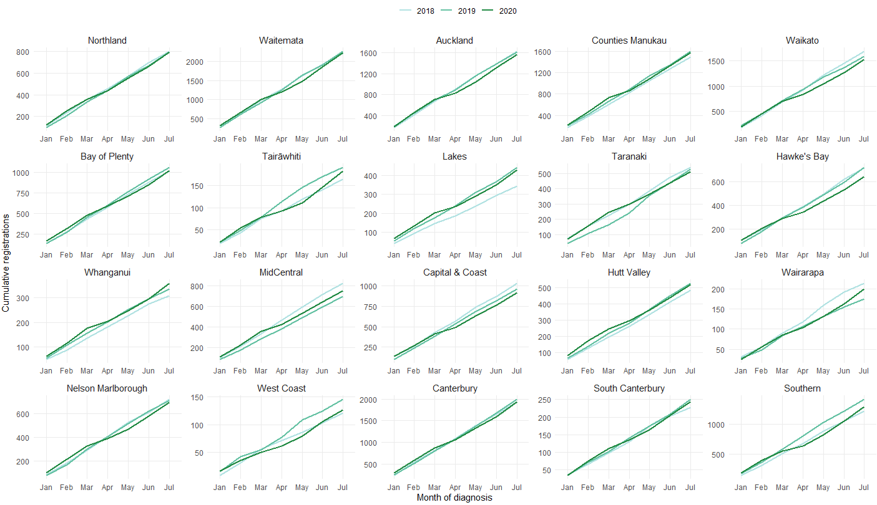

Cancer Registrations by DHB

 | Total |  |  |  |  |  | Māori |  |  |  |  |  | European/Other*
 | Cumulative number for Jan to July |  |  | Difference between 2019 and 2020 |  |  | Cumulative number for Jan to July |  |  | Difference between 2019 and 2020 |  |  | Cumulative number for Jan to July |  |  | Difference between 2019 and 2020
 | 2018 | 2019 | 2020 | Number | % |  | 2018 | 2019 | 2020 | Number | % |  | 2018 | 2019 | 2020 | Number | %
Northland | 695 | 671 | 664 | -7 | -1 |  | 179 | 136 | 157 | 21 | 15.4 |  | 605 | 639 | 624 | -15 | -2.3
Waitemata | 1922 | 1911 | 1861 | -50 | -2.6 |  | 104 | 107 | 125 | 18 | 16.8 |  | 1839 | 1872 | 1764 | -108 | -5.8
Auckland | 1391 | 1389 | 1318 | -71 | -5.1 |  | 64 | 79 | 68 | -11 | -13.9 |  | 1230 | 1158 | 1167 | 9 | 0.8
Counties Manukau | 1269 | 1345 | 1336 | -9 | -0.7 |  | 156 | 179 | 214 | 35 | 19.6 |  | 927 | 954 | 900 | -54 | -5.7
Waikato | 1445 | 1366 | 1261 | -105 | -7.7 |  | 239 | 239 | 202 | -37 | -15.5 |  | 1338 | 1271 | 1232 | -39 | -3.1
Bay of Plenty | 879 | 919 | 854 | -65 | -7.1 |  | 136 | 155 | 139 | -16 | -10.3 |  | 864 | 872 | 859 | -13 | -1.5
Tairāwhiti | 140 | 170 | 145 | -25 | -14.7 |  | 47 | 64 | 74 | 10 | 15.6 |  | 116 | 122 | 104 | -18 | -14.8
Lakes | 296 | 369 | 349 | -20 | -5.4 |  | 88 | 98 | 101 | 3 | 3.1 |  | 236 | 321 | 305 | -16 | -5
Taranaki | 473 | 438 | 439 | 1 | 0.2 |  | 49 | 47 | 46 | -1 | -2.1 |  | 477 | 474 | 456 | -18 | -3.8
Hawke's Bay | 620 | 591 | 529 | -62 | -10.5 |  | 110 | 115 | 93 | -22 | -19.1 |  | 580 | 576 | 522 | -54 | -9.4
Whanganui | 276 | 296 | 297 | 1 | 0.3 |  | 40 | 60 | 43 | -17 | -28.3 |  | 263 | 270 | 309 | 39 | 14.4
MidCentral | 720 | 595 | 647 | 52 | 8.7 |  | 92 | 68 | 73 | 5 | 7.4 |  | 708 | 603 | 647 | 44 | 7.3
Capital & Coast | 870 | 814 | 760 | -54 | -6.6 |  | 67 | 67 | 71 | 4 | 6 |  | 823 | 786 | 731 | -55 | -7
Hutt Valley | 414 | 452 | 437 | -15 | -3.3 |  | 58 | 77 | 46 | -31 | -40.3 |  | 384 | 398 | 427 | 29 | 7.3
Wairarapa | 192 | 154 | 163 | 9 | 5.8 |  | 23 | 10 | 19 | 9 | 90 |  | 186 | 161 | 173 | 12 | 7.5
Nelson Marlborough | 611 | 619 | 577 | -42 | -6.8 |  | 31 | 32 | 24 | -8 | -25 |  | 669 | 661 | 659 | -2 | -0.3
West Coast | 103 | 124 | 107 | -17 | -13.7 |  | 6 | 8 | 9 | 1 |  |  | 115 | 133 | 117 | -16 | -12
Canterbury | 1658 | 1674 | 1601 | -73 | -4.4 |  | 113 | 97 | 105 | 8 | 8.2 |  | 1708 | 1786 | 1700 | -86 | -4.8
South Canterbury | 202 | 209 | 205 | -4 | -1.9 |  | 13 | 13 | 9 | -4 | -30.8 |  | 209 | 235 | 229 | -6 | -2.6
Southern | 1048 | 1213 | 1059 | -154 | -12.7 |  | 49 | 85 | 60 | -25 | -29.4 |  | 1127 | 1294 | 1192 | -102 | -7.9

Appendix 3: Diagnosis and treatment data by DHB
Percentage differences are only presented if the cumulative 2019 total is 10 or greater. In some cases, the grand totals may differ slightly to those presented in the national report. This is due to non-DHB providers being excluded from the analyses within this appendix.

Gastrointestinal endoscopy
 | Total population |  |  |  |  |  | Māori |  |  |  |  |  | Non-Māori / Non-Pacific
 | Cumulative number for Jan to July |  |  | Difference between 2019 and 2020 |  |  | Cumulative number for Jan to July |  |  | Difference between 2019 and 2020 |  |  | Cumulative number for Jan to July |  |  | Difference between 2019 and 2020
 | 2018 | 2019 | 2020 | Number | % |  | 2018 | 2019 | 2020 | Number | % |  | 2018 | 2019 | 2020 | Number | %
Northland | 2118 | 2414 | 1844 | -570 | -24% |  | 351 | 460 | 349 | -111 | -24% |  | 1758 | 1930 | 1480 | -450 | -23%
Waitemata | 4543 | 5266 | 5164 | -102 | -2% |  | 242 | 306 | 276 | -30 | -10% |  | 4138 | 4790 | 4670 | -120 | -3%
Auckland | 3440 | 3743 | 2931 | -812 | -22% |  | 180 | 167 | 170 | 3 | 2% |  | 3033 | 3327 | 2522 | -805 | -24%
Counties Manukau | 4848 | 5222 | 6047 | 825 | 16% |  | 454 | 505 | 608 | 103 | 20% |  | 3807 | 4028 | 4601 | 573 | 14%
Waikato | 2906 | 3749 | 3669 | -80 | -2% |  | 341 | 448 | 443 | -5 | -1% |  | 2518 | 3260 | 3169 | -91 | -3%
Bay of Plenty | 2771 | 2780 | 2734 | -46 | -2% |  | 320 | 363 | 342 | -21 | -6% |  | 2436 | 2408 | 2382 | -26 | -1%
Lakes | 1093 | 1096 | 985 | -111 | -10% |  | 195 | 205 | 198 | -7 | -3% |  | 882 | 876 | 766 | -110 | -13%
Tairāwhiti | 377 | 467 | 388 | -79 | -17% |  | 100 | 134 | 111 | -23 | -17% |  | 275 | 329 | 271 | -58 | -18%
Taranaki | 1141 | 1092 | 1039 | -53 | -5% |  | 116 | 122 | 85 | -37 | -30% |  | 1021 | 965 | 947 | -18 | -2%
Whanganui | 834 | 900 | 714 | -186 | -21% |  | 123 | 117 | 96 | -21 | -18% |  | 708 | 779 | 611 | -168 | -22%
Hawke's Bay | 1406 | 1711 | 1563 | -148 | -9% |  | 157 | 202 | 212 | 10 | 5% |  | 1237 | 1486 | 1325 | -161 | -11%
MidCentral | 1216 | 1249 | 1310 | 61 | 5% |  | 81 | 92 | 116 | 24 | 26% |  | 1123 | 1144 | 1179 | 35 | 3%
Capital & Coast | 1679 | 1696 | 1831 | 135 | 8% |  | 127 | 97 | 146 | 49 | 51% |  | 1488 | 1527 | 1626 | 99 | 6%
Hutt Valley | 1306 | 1728 | 1805 | 77 | 4% |  | 109 | 132 | 188 | 56 | 42% |  | 1147 | 1546 | 1556 | 10 | 1%
Wairarapa | 513 | 617 | 488 | -129 | -21% |  | 44 | 56 | 47 | -9 | -16% |  | 460 | 557 | 437 | -120 | -22%
Nelson Marlborough | 719 | 1483 | 1507 | 24 | 2% |  | 35 | 85 | 81 | -4 | -5% |  | 680 | 1390 | 1413 | 23 | 2%
West Coast | 387 | 356 | 374 | 18 | 5% |  | 30 | 20 | 12 | -8 | -40% |  | 355 | 335 | 360 | 25 | 7%
Canterbury | 3401 | 5418 | 4555 | -863 | -16% |  | 190 | 315 | 257 | -58 | -18% |  | 3162 | 5023 | 4230 | -793 | -16%
South Canterbury | 656 | 702 | 567 | -135 | -19% |  | 30 | 26 | 23 | -3 | -12% |  | 626 | 676 | 543 | -133 | -20%
Southern | 2565 | 2857 | 2472 | -385 | -13% |  | 102 | 151 | 135 | -16 | -11% |  | 2445 | 2686 | 2309 | -377 | -14%
Total | 37919 | 44546 | 41987 | -2559 | -6% |  | 3327 | 4003 | 3895 | -108 | -3% |  | 33299 | 39062 | 36397 | -2665 | -7%

Bronchoscopy

 | Total population |  |  |  |  |  | Māori |  |  |  |  |  | Non-Māori / Non-Pacific
 | Cumulative number for Jan to July |  |  | Difference between 2019 and 2020 |  |  | Cumulative number for Jan to July |  |  | Difference between 2019 and 2020 |  |  | Cumulative number for Jan to July |  |  | Difference between 2019 and 2020
 | 2018 | 2019 | 2020 | Number | % |  | 2018 | 2019 | 2020 | Number | % |  | 2018 | 2019 | 2020 | Number | %
Northland | 53 | 42 | 36 | -6 | -14% |  | 16 | 14 | 10 | -4 | -29% |  | 36 | 28 | 25 | -3 | -11%
Waitemata | 80 | 91 | 82 | -9 | -10% |  | 4 | 5 | 8 | 3 | - |  | 70 | 84 | 70 | -14 | -17%
Auckland | 176 | 226 | 162 | -64 | -28% |  | 19 | 23 | 17 | -6 | -26% |  | 141 | 186 | 129 | -57 | -31%
Counties Manukau | 204 | 208 | 193 | -15 | -7% |  | 41 | 33 | 21 | -12 | -36% |  | 137 | 145 | 142 | -3 | -2%
Waikato | 164 | 161 | 118 | -43 | -27% |  | 34 | 36 | 29 | -7 | -19% |  | 127 | 123 | 86 | -37 | -30%
Bay of Plenty | 83 | 107 | 73 | -34 | -32% |  | 14 | 28 | 19 | -9 | -32% |  | 67 | 77 | 54 | -23 | -30%
Lakes | 45 | 52 | 46 | -6 | -12% |  | 16 | 15 | 19 | 4 | 27% |  | 29 | 36 | 26 | -10 | -28%
Tairāwhiti | 1 | 2 | 16 | 14 | - |  | 1 | 1 | 6 | 5 | - |  | 0 | 1 | 10 | 9 | -
Taranaki | 26 | 30 | 25 | -5 | -17% |  | 4 | 7 | 2 | -5 | - |  | 22 | 23 | 23 | 0 | 0%
Whanganui | 4 | 12 | 8 | -4 | -33% |  | 1 | 6 | 2 | -4 | - |  | 3 | 6 | 6 | 0 | -
Hawke's Bay | 46 | 42 | 23 | -19 | -45% |  | 14 | 10 | 6 | -4 | -40% |  | 32 | 31 | 16 | -15 | -48%
MidCentral | 24 | 20 | 14 | -6 | -30% |  | 3 | 7 | 1 | -6 | - |  | 21 | 13 | 13 | 0 | 0%
Capital & Coast | 53 | 56 | 38 | -18 | -32% |  | 6 | 6 | 6 | 0 | - |  | 43 | 49 | 31 | -18 | -37%
Hutt Valley | 56 | 76 | 50 | -26 | -34% |  | 6 | 18 | 6 | -12 | -67% |  | 47 | 57 | 41 | -16 | -28%
Nelson Marlborough | 43 | 37 | 54 | 17 | 46% |  | 4 | 4 | 5 | 1 | - |  | 39 | 33 | 48 | 15 | 45%
Canterbury | 193 | 249 | 233 | -16 | -6% |  | 14 | 23 | 13 | -10 | -43% |  | 177 | 223 | 212 | -11 | -5%
South Canterbury | 7 | 7 | 11 | 4 | - |  | 0 | 1 | 0 | -1 | - |  | 7 | 6 | 11 | 5 | -
Southern | 136 | 149 | 79 | -70 | -47% |  | 9 | 13 | 8 | -5 | -38% |  | 127 | 133 | 71 | -62 | -47%
Total | 1394 | 1567 | 1261 | -306 | -20% |  | 206 | 250 | 178 | -72 | -29% |  | 1125 | 1254 | 1014 | -240 | -19%

Colorectal cancer surgery

 | Total population |  |  |  |  |  | Māori |  |  |  |  |  | Non-Māori / Non-Pacific
 | Cumulative number for Jan to July |  |  | Difference between 2019 and 2020 |  |  | Cumulative number for Jan to July |  |  | Difference between 2019 and 2020 |  |  | Cumulative number for Jan to July |  |  | Difference between 2019 and 2020
 | 2018 | 2019 | 2020 | Number | % |  | 2018 | 2019 | 2020 | Number | % |  | 2018 | 2019 | 2020 | Number | %
Northland | 42 | 59 | 47 | -12 | -20% |  | 7 | 12 | 14 | 2 | 17% |  | 35 | 47 | 33 | -14 | -30%
Waitemata | 149 | 153 | 125 | -28 | -18% |  | 10 | 11 | 9 | -2 | -18% |  | 136 | 131 | 113 | -18 | -14%
Auckland | 112 | 115 | 113 | -2 | -2% |  | 6 | 6 | 14 | 8 | - |  | 99 | 94 | 95 | 1 | 1%
Counties Manukau | 85 | 73 | 87 | 14 | 19% |  | 6 | 5 | 15 | 10 | - |  | 70 | 64 | 63 | -1 | -2%
Waikato | 127 | 121 | 155 | 34 | 28% |  | 16 | 9 | 24 | 15 | - |  | 108 | 111 | 130 | 19 | 17%
Bay of Plenty | 77 | 82 | 102 | 20 | 24% |  | 12 | 7 | 15 | 8 | - |  | 65 | 74 | 87 | 13 | 18%
Lakes | 41 | 49 | 44 | -5 | -10% |  | 8 | 9 | 8 | -1 | - |  | 32 | 39 | 35 | -4 | -10%
Tairāwhiti | 11 | 16 | 17 | 1 | 6% |  | 4 | 2 | 5 | 3 | - |  | 7 | 14 | 12 | -2 | -14%
Taranaki | 56 | 50 | 42 | -8 | -16% |  | 7 | 3 | 6 | 3 | - |  | 49 | 47 | 36 | -11 | -23%
Whanganui | 30 | 29 | 27 | -2 | -7% |  | 4 | 1 | 2 | 1 | - |  | 26 | 28 | 25 | -3 | -11%
Hawke's Bay | 87 | 84 | 76 | -8 | -10% |  | 14 | 7 | 12 | 5 | - |  | 73 | 76 | 62 | -14 | -18%
MidCentral | 77 | 62 | 69 | 7 | 11% |  | 5 | 4 | 9 | 5 | - |  | 71 | 57 | 60 | 3 | 5%
Hutt Valley | 39 | 39 | 28 | -11 | -28% |  | 1 | 4 | 2 | -2 | - |  | 78 | 77 | 69 | -8 | -10%
Wairarapa | 15 | 10 | 3 | -7 | -70% |  | 2 | 1 | 0 | -1 | - |  | 36 | 35 | 25 | -10 | -29%
Capital & Coast | 88 | 90 | 81 | -9 | -10% |  | 6 | 8 | 10 | 2 | - |  | 54 | 46 | 34 | -12 | -26%
Nelson Marlborough | 54 | 51 | 36 | -15 | -29% |  | 0 | 5 | 2 | -3 | - |  | 164 | 169 | 155 | -14 | -8%
Canterbury | 177 | 182 | 170 | -12 | -7% |  | 10 | 11 | 12 | 1 | 9% |  | 33 | 28 | 20 | -8 | -29%
West Coast | 1 | 4 | 4 | 0 | - |  | - | - | - | - | - |  | 129 | 151 | 122 | -29 | -19%
South Canterbury | 33 | 29 | 22 | -7 | -24% |  | 0 | 1 | 2 | 1 | - |  | 13 | 9 | 3 | -6 | -
Southern | 136 | 159 | 127 | -32 | -20% |  | 6 | 6 | 4 | -2 | - |  | 1 | 4 | 4 | 0 | -
Total | 1437 | 1457 | 1375 | -82 | -6% |  | 124 | 112 | 165 | 53 | 47% |  | 1279 | 1301 | 1183 | -118 | -9%

Lung cancer surgery
 | Total population |  |  |  |  |  | Māori |  |  |  |  |  | Non-Māori / Non-Pacific
 | Cumulative number for Jan to July |  |  | Difference between 2019 and 2020 |  |  | Cumulative number for Jan to July |  |  | Difference between 2019 and 2020 |  |  | Cumulative number for Jan to July |  |  | Difference between 2019 and 2020
 | 2018 | 2019 | 2020 | Number | % |  | 2018 | 2019 | 2020 | Number | % |  | 2018 | 2019 | 2020 | Number | %
Auckland | 156 | 161 | 149 | -12 | -7% |  | 23 | 34 | 21 | -13 | -38% |  | 125 | 115 | 114 | -1 | -1%
Counties Manukau | 1 | 2 | 2 | 0 | - |  | 0 | 0 | 1 | 1 | - |  | 0 | 2 | 1 | -1 | -
Waikato | 64 | 80 | 93 | 13 | 16% |  | 21 | 24 | 22 | -2 | -8% |  | 40 | 56 | 70 | 14 | 25%
Hawke's Bay | 0 | 0 | 1 | 1 | - |  | - | - | - | - | - |  | - | - | - | - | -
Capital & Coast | 69 | 77 | 51 | -26 | -34% |  | 17 | 11 | 6 | -5 | -45% |  | 49 | 61 | 42 | -19 | -31%
Canterbury | 45 | 57 | 64 | 7 | 12% |  | 2 | 3 | 4 | 1 | - |  | 43 | 54 | 60 | 6 | 11%
Southern | 17 | 26 | 18 | -8 | -31% |  | 3 | 0 | 2 | 2 | - |  | 14 | 26 | 16 | -10 | -38%
Total | 352 | 403 | 378 | -25 | -6% |  | 66 | 72 | 56 | -16 | -22% |  | 271 | 314 | 303 | -11 | -4%

Prostate cancer surgery

 | Total population |  |  |  |  |  | Māori |  |  |  |  |  | Non-Māori / Non-Pacific
 | Cumulative number for Jan to July |  |  | Difference between 2019 and 2020 |  |  | Cumulative number for Jan to July |  |  | Difference between 2019 and 2020 |  |  | Cumulative number for Jan to July |  |  | Difference between 2019 and 2020
 | 2018 | 2019 | 2020 | Number | % |  | 2018 | 2019 | 2020 | Number | % |  | 2018 | 2019 | 2020 | Number | %
Northland | 27 | 30 | 18 | -12 | -40% |  | 6 | 3 | 5 | 2 | - |  | 21 | 26 | 13 | -13 | -50%
Waitemata | 43 | 34 | 65 | 31 | 91% |  | 1 | 3 | 1 | -2 | - |  | 41 | 31 | 62 | 31 | 100%
Auckland | 48 | 58 | 76 | 18 | 31% |  | 1 | 5 | 7 | 2 | - |  | 44 | 48 | 67 | 19 | 40%
Counties Manukau | 0 | 1 | 0 | -1 | - |  | - | - | - | - | - |  | 0 | 1 | 0 | -1 | -
Waikato | 40 | 39 | 33 | -6 | -15% |  | 1 | 3 | 2 | -1 | - |  | 39 | 36 | 30 | -6 | -17%
Bay of Plenty | 33 | 33 | 35 | 2 | 6% |  | 4 | 6 | 11 | 5 | - |  | 29 | 27 | 24 | -3 | -11%
Tairāwhiti | 4 | 3 | 6 | 3 | - |  | 1 | 2 | 2 | 0 | - |  | 3 | 1 | 4 | 3 | -
Taranaki | 12 | 12 | 21 | 9 | 75% |  | 1 | 1 | 4 | 3 | - |  | 11 | 11 | 17 | 6 | 55%
Whanganui | 2 | 2 | 3 | 1 | - |  | 0 | 0 | 0 | 0 | - |  | 2 | 2 | 3 | 1 | -
Hawke's Bay | 6 | 11 | 14 | 3 | 27% |  | 0 | 1 | 3 | 2 | - |  | 6 | 10 | 11 | 1 | 10%
MidCentral | 37 | 48 | 48 | 0 | 0% |  | 2 | 7 | 3 | -4 | - |  | 35 | 41 | 45 | 4 | 10%
Capital & Coast | 30 | 39 | 36 | -3 | -8% |  | 1 | 2 | 1 | -1 | - |  | 26 | 34 | 35 | 1 | 3%
Wairarapa | 6 | 6 | 7 | 1 | - |  | 1 | 0 | 1 | 1 | - |  | 5 | 6 | 6 | 0 | -
Nelson Marlborough | 29 | 20 | 24 | 4 | 20% |  | - | - | - | - | - |  | 29 | 19 | 24 | 5 | 26%
West Coast | 4 | 3 | 3 | 0 | - |  | 0 | 0 | 0 | 0 | - |  | 4 | 3 | 3 | 0 | -
Canterbury | 39 | 37 | 46 | 9 | 24% |  | 0 | 2 | 2 | 0 | - |  | 39 | 35 | 43 | 8 | 23%
South Canterbury | 10 | 6 | 11 | 5 | - |  | - | - | - | - | - |  | 10 | 6 | 11 | 5 | -
Southern | 41 | 45 | 51 | 6 | 13% |  | 4 | 2 | 4 | 2 | - |  | 37 | 42 | 47 | 5 | 12%
Total | 411 | 427 | 497 | 70 | 16% |  | 23 | 37 | 46 | 9 | 24% |  | 381 | 379 | 445 | 66 | 17%

Medical oncology first specialist assessments

 | Total population |  |  |  |  |  | Māori |  |  |  |  |  | Non-Māori / Non-Pacific
 | Cumulative number for Jan to July |  |  | Difference between 2019 and 2020 |  |  | Cumulative number for Jan to July |  |  | Difference between 2019 and 2020 |  |  | Cumulative number for Jan to July |  |  | Difference between 2019 and 2020
 | 2018 | 2019 | 2020 | Number | % |  | 2018 | 2019 | 2020 | Number | % |  | 2018 | 2019 | 2020 | Number | %
Northland | 259 | 292 | 230 | -62 | -21% |  | 71 | 74 | 63 | -11 | -15% |  | 188 | 215 | 163 | -52 | -24%
Auckland | 1310 | 1344 | 1479 | 135 | 10% |  | 155 | 144 | 173 | 29 | 20% |  | 993 | 1027 | 1102 | 75 | 7%
Waikato | 492 | 452 | 486 | 34 | 8% |  | 110 | 94 | 105 | 11 | 12% |  | 373 | 345 | 375 | 30 | 9%
Bay of Plenty | 256 | 273 | 307 | 34 | 12% |  | 40 | 61 | 52 | -9 | -15% |  | 214 | 211 | 253 | 42 | 20%
Lakes | 66 | 114 | 111 | -3 | -3% |  | 28 | 38 | 28 | -10 | -26% |  | 37 | 74 | 82 | 8 | 11%
Tairāwhiti | 44 | 85 | 88 | 3 | 4% |  | 22 | 35 | 40 | 5 | 14% |  | 22 | 50 | 48 | -2 | -4%
Taranaki | 135 | 142 | 118 | -24 | -17% |  | 12 | 19 | 14 | -5 | -26% |  | 121 | 123 | 103 | -20 | -16%
MidCentral | 644 | 619 | 633 | 14 | 2% |  | 96 | 104 | 102 | -2 | -2% |  | 532 | 504 | 522 | 18 | 4%
Capital & Coast | 514 | 508 | 512 | 4 | 1% |  | 53 | 68 | 63 | -5 | -7% |  | 428 | 412 | 415 | 3 | 1%
Nelson Marlborough | 251 | 229 | 265 | 36 | 16% |  | 17 | 19 | 12 | -7 | -37% |  | 233 | 209 | 252 | 43 | 21%
West Coast | 18 | 17 | 9 | -8 | -47% |  | 0 | 2 | 0 | -2 | - |  | 18 | 14 | 9 | -5 | -36%
Canterbury | 706 | 785 | 736 | -49 | -6% |  | 44 | 55 | 46 | -9 | -16% |  | 653 | 720 | 676 | -44 | -6%
South Canterbury | 6 | 2 | 35 | 33 | - |  | 0 | 0 | 2 | 2 | - |  | 6 | 2 | 33 | 31 | -
Southern | 343 | 432 | 346 | -86 | -20% |  | 14 | 25 | 18 | -7 | -28% |  | 327 | 404 | 324 | -80 | -20%
Total | 5044 | 5294 | 5355 | 61 | 1% |  | 662 | 738 | 718 | -20 | -3% |  | 4145 | 4310 | 4357 | 47 | 1%

Medical oncology IV chemotherapy

 | Total population |  |  |  |  |  | Māori |  |  |  |  |  | Non-Māori / Non-Pacific
 | Cumulative number for Jan to July |  |  | Difference between 2019 and 2020 |  |  | Cumulative number for Jan to July |  |  | Difference between 2019 and 2020 |  |  | Cumulative number for Jan to July |  |  | Difference between 2019 and 2020
 | 2018 | 2019 | 2020 | Number | % |  | 2018 | 2019 | 2020 | Number | % |  | 2018 | 2019 | 2020 | Number | %
Northland | 1850 | 1650 | 1801 | 151 | 9% |  | 367 | 380 | 565 | 185 | 49% |  | 1462 | 1255 | 1219 | -36 | -3%
Waitemata | 0 | 2 | 0 | -2 | - |  |  |  |  |  |  |  | 0 | 2 | 0 | -2 | -
Auckland | 9845 | 11482 | 12943 | 1461 | 13% |  | 1054 | 987 | 1470 | 483 | 49% |  | 7700 | 9049 | 9983 | 934 | 10%
Waikato | 4073 | 4448 | 3587 | -861 | -19% |  | 622 | 746 | 594 | -152 | -20% |  | 3405 | 3652 | 2933 | -719 | -20%
Bay of Plenty | 3036 | 2810 | 3427 | 617 | 22% |  | 532 | 471 | 700 | 229 | 49% |  | 2461 | 2316 | 2707 | 391 | 17%
Lakes | 1550 | 1821 | 1787 | -34 | -2% |  | 469 | 475 | 535 | 60 | 13% |  | 1028 | 1327 | 1235 | -92 | -7%
Tairāwhiti | 456 | 345 | 330 | -15 | -4% |  | 204 | 154 | 157 | 3 | 2% |  | 251 | 191 | 172 | -19 | -10%
Taranaki | 918 | 1022 | 1032 | 10 | 1% |  | 123 | 59 | 103 | 44 | 75% |  | 785 | 952 | 915 | -37 | -4%
Whanganui | 78 | 52 | 55 | 3 | 6% |  | 16 | 6 | 7 | 1 | - |  | 62 | 46 | 48 | 2 | 4%
Hawke's Bay | 14 | 21 | 54 | 33 | 157% |  | 4 | 3 | 44 | 41 | - |  | 10 | 18 | 10 | -8 | -44%
MidCentral | 3768 | 4639 | 4529 | -110 | -2% |  | 519 | 870 | 734 | -136 | -16% |  | 3166 | 3632 | 3737 | 105 | 3%
Capital & Coast | 3629 | 4108 | 3698 | -410 | -10% |  | 348 | 421 | 441 | 20 | 5% |  | 3120 | 3476 | 3034 | -442 | -13%
Hutt Valley | 69 | 63 | 52 | -11 | -17% |  | 10 | 2 | 2 | 0 | - |  | 59 | 54 | 44 | -10 | -19%
Wairarapa | 15 | 8 | 45 | 37 | - |  | 0 | 2 | 12 | 10 | - |  | 15 | 6 | 31 | 25 | -
Nelson Marlborough | 1783 | 1565 | 1747 | 182 | 12% |  | 148 | 124 | 78 | -46 | -37% |  | 1612 | 1409 | 1651 | 242 | 17%
West Coast | 8 | 30 | 21 | -9 | -30% |  | 0 | 1 | 4 | 3 | - |  | 8 | 29 | 17 | -12 | -41%
Canterbury | 3923 | 3493 | 3629 | 136 | 4% |  | 250 | 234 | 236 | 2 | 1% |  | 3557 | 3184 | 3263 | 79 | 2%
South Canterbury | 612 | 633 | 619 | -14 | -2% |  | 6 | 3 | 12 | 9 | - |  | 606 | 618 | 607 | -11 | -2%
Southern | 3925 | 4313 | 3870 | -443 | -10% |  | 236 | 208 | 249 | 41 | 20% |  | 3667 | 4072 | 3561 | -511 | -13%
Total | 39552 | 42505 | 43226 | 721 | 2% |  | 4908 | 5146 | 5943 | 797 | 15% |  | 32974 | 35288 | 35167 | -121 | 0%

Radiation oncology first specialist assessments

 | Total population |  |  |  |  |  | Māori |  |  |  |  |  | Non-Māori / Non-Pacific
 | Cumulative number for Jan to July |  |  | Difference between 2019 and 2020 |  |  | Cumulative number for Jan to July |  |  | Difference between 2019 and 2020 |  |  | Cumulative number for Jan to July |  |  | Difference between 2019 and 2020
 | 2018 | 2019 | 2020 | Number | % |  | 2018 | 2019 | 2020 | Number | % |  | 2018 | 2019 | 2020 | Number | %
Northland | 200 | 213 | 160 | -53 | -25% |  | 59 | 49 | 59 | 10 | 20% |  | 137 | 161 | 100 | -61 | -38%
Auckland | 1854 | 1846 | 1860 | 14 | 1% |  | 213 | 227 | 207 | -20 | -9% |  | 1420 | 1388 | 1452 | 64 | 5%
Waikato | 772 | 838 | 857 | 19 | 2% |  | 135 | 137 | 188 | 51 | 37% |  | 623 | 682 | 661 | -21 | -3%
Bay of Plenty | 498 | 578 | 531 | -47 | -8% |  | 71 | 77 | 76 | -1 | -1% |  | 422 | 496 | 451 | -45 | -9%
Lakes | 28 | 13 | 10 | -3 | -23% |  | 5 | 3 | 3 | 0 | - |  | 23 | 10 | 7 | -3 | -30%
Tairāwhiti | 49 | 33 | 26 | -7 | -21% |  | 19 | 11 | 13 | 2 | 18% |  | 29 | 22 | 13 | -9 | -41%
MidCentral | 1033 | 937 | 1032 | 95 | 10% |  | 128 | 116 | 141 | 25 | 22% |  | 892 | 810 | 877 | 67 | 8%
Capital & Coast | 820 | 867 | 780 | -87 | -10% |  | 82 | 82 | 80 | -2 | -2% |  | 701 | 749 | 662 | -87 | -12%
Nelson Marlborough | 34 | 133 | 111 | -22 | -17% |  | 2 | 7 | 7 | 0 | - |  | 32 | 125 | 103 | -22 | -18%
West Coast | 3 | 8 | 3 | -5 | - |  | 0 | 1 | 0 | -1 | - |  | 3 | 7 | 3 | -4 | -
Canterbury | 946 | 911 | 1083 | 172 | 19% |  | 48 | 54 | 48 | -6 | -11% |  | 889 | 843 | 1020 | 177 | 21%
Southern | 605 | 646 | 547 | -99 | -15% |  | 33 | 34 | 41 | 7 | 21% |  | 562 | 604 | 497 | -107 | -18%
Total | 6842 | 7023 | 7000 | -23 | 0% |  | 795 | 798 | 863 | 65 | 8% |  | 5733 | 5897 | 5846 | -51 | -1%

Radiation oncology megavoltage fractions

 | Total population |  |  |  |  |  | Māori |  |  |  |  |  | Non-Māori / Non-Pacific
 | Cumulative number for Jan to July |  |  | Difference between 2019 and 2020 |  |  | Cumulative number for Jan to July |  |  | Difference between 2019 and 2020 |  |  | Cumulative number for Jan to July |  |  | Difference between 2019 and 2020
 | 2018 | 2019 | 2020 | Number | % |  | 2018 | 2019 | 2020 | Number | % |  | 2018 | 2019 | 2020 | Number | %
Auckland | 25757 | 26440 | 23857 | -2583 | -10% |  | 3411 | 3658 | 2939 | -719 | -20% |  | 19449 | 20286 | 18318 | -1968 | -10%
Waikato | 12264 | 13594 | 11417 | -2177 | -16% |  | 2314 | 2364 | 2470 | 106 | 4% |  | 9722 | 10951 | 8832 | -2119 | -19%
Bay of Plenty | 11135 | 9085 | 9857 | 772 | 8% |  | 2022 | 1506 | 1548 | 42 | 3% |  | 8938 | 7511 | 8177 | 666 | 9%
MidCentral | 12344 | 14032 | 13114 | -918 | -7% |  | 1763 | 1895 | 1758 | -137 | -7% |  | 10448 | 12057 | 11128 | -929 | -8%
Capital & Coast | 11476 | 12110 | 11305 | -805 | -7% |  | 1264 | 1353 | 1334 | -19 | -1% |  | 9684 | 10173 | 9430 | -743 | -7%
Canterbury | 16554 | 13649 | 14126 | 477 | 3% |  | 1103 | 890 | 833 | -57 | -6% |  | 15103 | 12555 | 13152 | 597 | 5%
Southern | 4411 | 3200 | 2291 | -909 | -28% |  | 343 | 168 | 144 | -24 | -14% |  | 3951 | 2997 | 2140 | -857 | -29%
Total | 93941 | 92110 | 85972 | -6138 | -7% |  | 12220 | 11834 | 11028 | -806 | -7% |  | 77295 | 76530 | 71180 | -5350 | -7%

Haematology first specialist assessment

 | Total population |  |  |  |  |  | Māori |  |  |  |  |  | Non-Māori / Non-Pacific
 | Cumulative number for Jan to July |  |  | Difference between 2019 and 2020 |  |  | Cumulative number for Jan to July |  |  | Difference between 2019 and 2020 |  |  | Cumulative number for Jan to July |  |  | Difference between 2019 and 2020
 | 2018 | 2019 | 2020 | Number | % |  | 2018 | 2019 | 2020 | Number | % |  | 2018 | 2019 | 2020 | Number | %
Northland | 126 | 126 | 139 | 13 | 10% |  | 18 | 28 | 37 | 9 | 32% |  | 107 | 96 | 100 | 4 | 4%
Waitemata | 434 | 370 | 418 | 48 | 13% |  | 22 | 23 | 30 | 7 | 30% |  | 391 | 336 | 368 | 32 | 10%
Auckland | 564 | 561 | 426 | -135 | -24% |  | 41 | 46 | 37 | -9 | -20% |  | 467 | 460 | 338 | -122 | -27%
Counties Manukau | 448 | 426 | 396 | -30 | -7% |  | 44 | 57 | 48 | -9 | -16% |  | 335 | 308 | 287 | -21 | -7%
Waikato | 377 | 446 | 430 | -16 | -4% |  | 61 | 88 | 71 | -17 | -19% |  | 309 | 351 | 352 | 1 | 0%
Bay of Plenty | 232 | 230 | 183 | -47 | -20% |  | 43 | 35 | 27 | -8 | -23% |  | 185 | 190 | 153 | -37 | -19%
Lakes* | 0 | 2 | 0 | -2 | - |  | 0 | 1 | 0 | -1 | - |  | 0 | 1 | 0 | -1 | -
Tairāwhiti | 28 | 21 | 21 | 0 | 0% |  | 10 | 4 | 3 | -1 | - |  | 18 | 16 | 18 | 2 | 13%
Taranaki | 81 | 98 | 97 | -1 | -1% |  | 11 | 6 | 13 | 7 | - |  | 70 | 91 | 84 | -7 | -8%
MidCentral | 428 | 454 | 430 | -24 | -5% |  | 57 | 54 | 54 | 0 | 0% |  | 366 | 395 | 364 | -31 | -8%
Capital & Coast | 475 | 444 | 398 | -46 | -10% |  | 29 | 37 | 43 | 6 | 16% |  | 432 | 387 | 332 | -55 | -14%
Nelson Marlborough | 122 | 91 | 66 | -25 | -27% |  | 1 | 4 | 3 | -1 | - |  | 120 | 86 | 63 | -23 | -27%
West Coast | 9 | 10 | 1 | -9 | -90% |  | 1 | 0 | 0 | 0 | - |  | 8 | 10 | 1 | -9 | -90%
Canterbury | 252 | 314 | 299 | -15 | -5% |  | 13 | 15 | 16 | 1 | 7% |  | 231 | 290 | 280 | -10 | -3%
Southern | 165 | 176 | 160 | -16 | -9% |  | 13 | 10 | 8 | -2 | -20% |  | 149 | 163 | 151 | -12 | -7%
Total | 3741 | 3769 | 3464 | -305 | -8% |  | 364 | 408 | 390 | -18 | -4% |  | 3188 | 3180 | 2891 | -289 | -9%
*Lakes DHB patients receive their haematology FSAs appointments at Waikato DBH. These records are likely to be a coding error.

Haematology IV chemotherapy
 | Total population |  |  |  |  |  | Māori |  |  |  |  |  | Non-Māori / Non-Pacific
 | Cumulative number for Jan to July |  |  | Difference between 2019 and 2020 |  |  | Cumulative number for Jan to July |  |  | Difference between 2019 and 2020 |  |  | Cumulative number for Jan to July |  |  | Difference between 2019 and 2020
 | 2018 | 2019 | 2020 | Number | % |  | 2018 | 2019 | 2020 | Number | % |  | 2018 | 2019 | 2020 | Number | %
Northland | 1093 | 1028 | 826 | -202 | -20% |  | 264 | 217 | 165 | -52 | -24% |  | 829 | 774 | 628 | -146 | -19%
Waitemata | 2346 | 2359 | 2285 | -74 | -3% |  | 49 | 94 | 111 | 17 | 18% |  | 2182 | 2146 | 2022 | -124 | -6%
Auckland | 2015 | 2115 | 1969 | -146 | -7% |  | 120 | 146 | 74 | -72 | -49% |  | 1698 | 1726 | 1695 | -31 | -2%
Counties Manukau* | 1371 | 645 | 1301 | 656 |  |  | 200 | 83 | 119 | 36 |  |  | 847 | 458 | 986 | 528
Waikato | 1104 | 1160 | 1279 | 119 | 10% |  | 157 | 214 | 246 | 32 | 15% |  | 939 | 944 | 1033 | 89 | 9%
Bay of Plenty | 715 | 770 | 604 | -166 | -22% |  | 81 | 51 | 78 | 27 | 53% |  | 634 | 683 | 526 | -157 | -23%
Lakes | 70 | 387 | 379 | -8 | -2% |  | 12 | 113 | 93 | -20 | -18% |  | 58 | 274 | 286 | 12 | 4%
Tairāwhiti | 126 | 68 | 61 | -7 | -10% |  | 13 | 10 | 7 | -3 | -30% |  | 97 | 58 | 54 | -4 | -7%
MidCentral | 1533 | 1643 | 1402 | -241 | -15% |  | 186 | 199 | 119 | -80 | -40% |  | 1324 | 1444 | 1274 | -170 | -12%
Capital & Coast | 1799 | 2018 | 1916 | -102 | -5% |  | 30 | 275 | 243 | -32 | -12% |  | 1684 | 1686 | 1504 | -182 | -11%
Nelson Marlborough | 0 | 0 | 10 | 10 | - |  | 0 | 0 | 0 | 0 | - |  | 0 | 0 | 10 | 10 | -
West Coast | 5 | 10 | 5 | -5 | -50% |  | 0 | 2 | 0 | -2 | - |  | 5 | 8 | 5 | -3 | -
Canterbury* | 1212 | 777 | 1607 | 830 |  |  | 77 | 55 | 175 | 120 |  |  | 1121 | 718 | 1399 | 681
Southern** | 126 | 136 | 145 | 9 | 7% |  | 1 | 2 | 21 | 19 | - |  | 125 | 134 | 123 | -11 | -8%
Total | 13515 | 13116 | 13789 | 673 | 5% |  | 1190 | 1461 | 1451 | -10 | -1% |  | 11543 | 11053 | 11545 | 492 | 4%

*Te Aho o Te Kahu continues to work with Canterbury and Counties DHBs to better understand and improve quality of data in 2019. Number and percentage differences have not been presented as will not accurately reflect the difference between 2019 and 2020 in these DHBs.
** Note the relatively low volumes in Southern DHB are due to variation in coding. This is being followed up.

Appendix 4: Surgical procedure codes
Below is a list of the surgical procedure codes that were used for analysis on curative cancer surgery.
COLORECTAL CANCER SURGERY
Clinical code | Block short description | Clinical code description
3200000 | Colectomy | Limited excision of large intestine with formation of stoma
3200001 | Colectomy | Right hemicolectomy with formation of stoma
3200300 | Colectomy | Limited excision of large intestine with anastomosis
3200301 | Colectomy | Right hemicolectomy with anastomosis
3200400 | Colectomy | Subtotal colectomy with formation of stoma
3200401 | Colectomy | Extended right hemicolectomy with formation of stoma
3200500 | Colectomy | Subtotal colectomy with anastomosis
3200501 | Colectomy | Extended right hemicolectomy with anastomosis
3200600 | Colectomy | Left hemicolectomy with anastomosis
3200601 | Colectomy | Left hemicolectomy with formation of stoma
3200900 | Colectomy | Total colectomy with ileostomy
3201200 | Colectomy | Total colectomy with ileorectal anastomosis
3201500 | Total proctocolectomy | Total proctocolectomy with ileostomy
3202400 | Anterior resection of rectum | High anterior resection of rectum
3202500 | Anterior resection of rectum | Low anterior resection of rectum
3202600 | Anterior resection of rectum | Ultra low anterior resection of rectum
3202800 | Anterior resection of rectum | Ultra low anterior resection of rectum with hand sutured coloanal anastomosis
3203000 | Rectosigmoidectomy or proctectomy | Rectosigmoidectomy with formation of stoma
3203900 | Rectosigmoidectomy or proctectomy | Abdominoperineal proctectomy
3205100 | Total proctocolectomy | Total proctocolectomy with ileo-anal anastomosis
3205101 | Total proctocolectomy | Total proctocolectomy with ileo-anal anastomosis and formation of temporary ileostomy
3206000 | Rectosigmoidectomy or proctectomy | Restorative proctectomy
3209900 | Excision of lesion or tissue of rectum or anus | Per anal submucosal excision of lesion or tissue of rectum
3211200 | Rectosigmoidectomy or proctectomy | Perineal rectosigmoidectomy
9220800 | Anterior resection of rectum | Anterior resection of rectum, level unspecified

LUNG CANCER SURGERY
Clinical code | Clinical code description | Block Description
3844000 | Wedge resection of lung | Partial resection of lung
3844001 | Radical wedge resection of lung | Partial resection of lung
3843800 | Segmental resection of lung | Partial resection of lung
9016900 | Endoscopic wedge resection of lung | Partial resection of lung
3843801 | Lobectomy of lung | Lobectomy of lung
3844100 | Radical lobectomy | Lobectomy of lung
3844101 | Radical pneumonectomy | Pneumonectomy
3843802 | Pneumonectomy | Pneumonectomy

PROSTATE CANCER SURGERY
Clinical code | Block short description | Clinical code description
3720004 | Open prostatectomy | Retropubic prostatectomy
3720900 | Open prostatectomy | Radical prostatectomy
3720901 | Other closed prostatectomy | Laparoscopic radical prostatectomy
3721000 | Open prostatectomy | Radical prostatectomy with bladder neck reconstruction
3721001 | Other closed prostatectomy | Laparoscopic radical prostatectomy with bladder neck reconstruction
3721100 | Open prostatectomy | Radical prostatectomy with bladder neck reconstruction and pelvic lymphadenectomy
3721101 | Other closed prostatectomy | Laparoscopic radical prostatectomy with bladder neck reconstruction and pelvic lymphadenectomy
3720900 | Open prostatectomy | Radical prostatectomy
3720901 | Closed prostatectomy | Laparoscopic radical prostatectomy
3721000 | Open prostatectomy | Radical prostatectomy with bladder neck reconstruction
3721001 | Closed prostatectomy | Laparoscopic radical prostatectomy with bladder neck reconstruction
3721100 | Open prostatectomy | Radical prostatectomy with bladder neck reconstruction and pelvic lymphadenectomy

