COVID-19 and cancer services

Report five

Working report on the impact of COVID-19 on cancer services for the period ending August 2020

October 2020

Contents

Contents 2
Summary of findings 3
Introduction 5
Auckland Regional Snapshot 6
Cancer Registrations 8
Gastrointestinal endoscopy 13
Bronchoscopy 14
Combined curative cancer surgery 16
Colorectal cancer surgery 18
Lung cancer surgery 19
Prostate cancer surgery 21
Medical oncology 22
Radiation oncology 24
Haematology 27
Appendix 1: NZCR data information 30
Appendix 2: NZCR registrations by DHB 31
Appendix 3: Diagnosis and treatment data by DHB 34
Appendix 4: Surgical procedure codes 45

Summary of findings
Overview of impact of COVID-19 on cancer diagnosis and treatment
There continued to be an increase in new cancer registrations in August 2020. We have nearly caught up on the dip in cancer registrations seen over the lockdown period. Cancer treatment services – surgery, medical oncology, radiation oncology and haematology – continued during the COVID-19 lockdown and continue to be delivered at pre-COVID volumes in the months since.

Background and data
- This is the fifth report looking at the impact of COVID-19 on cancer services. This report looks at the period until the end of August 2020.
- The purpose of this analysis was to rapidly measure the impact of COVID-19 on cancer services to assist with recovery planning.
- The report focuses on the aspects of the cancer care pathway for which we have readily available data and does not capture all aspects of the care.
- Comparisons between 2020 and 2019 do not consider any projected increase in diagnoses over time.
- The focus of the report was to understand the impact of COVID-19 on existing service delivery and does not address pre-existing unmet need.

Equity
- There has been a 1.3% decrease in new cancer registrations for Māori in 2020 compared to 2019, similar to the decrease seen for European/other (2.2%).
- Māori have seen a smaller cumulative reduction in gastrointestinal endoscopy (2%) compared to non-Māori/non-Pacific (5%).
- Māori have been disproportionately impacted by the cumulative decrease in bronchoscopies (29% decrease for Māori compared to 16% decrease for non-Māori/non-Pacific).
  - There has been a 16% decrease in new diagnoses of lung cancer for Māori in the first eight months of 2020 compared to the same time period in 2019 (41 fewer cancers).

Auckland Snapshot
- Following new community transmission of COVID-19, Auckland went back to Alert Level 3 lockdown on the 12th of August, with the rest of the country at Alert Level 2.
- Although the move back to Alert Level 3 was extremely challenging for people living in the Auckland region, services were more prepared for the second lockdown.
- As a result, this second lockdown does not yet appear to have impacted the number of new cancer registrations across the three Auckland DHBs.
- There was a decrease in the number of gastrointestinal endoscopy procedures performed during August in Counties Manukau and Auckland DHB.
- Cancer treatment services appear to have been well maintained during the second Auckland lockdown.

Cancer diagnosis

Registrations
- For the year to date – up until end of August 2020 – there have been 312 fewer cancer registrations compared to the same time period in 2019, a 1.5% decrease.
  - This is a smaller deficit than was seen at the end of July 2020 (448 fewer cancers than 2019, a 2.5% decrease).
- The decrease in cancer registrations is 2.2 % European/Other and 1.3% for Māori. There are a similar number of registrations for Pacific People as was seen in 2019 and there remains an increase in registrations for people in the Asian ethnic group (as seen in previous months).
- The overall impact of COVID-19 on registrations for the year to date has been most marked for prostate, haematology/lymphoid and breast cancers – all have seen a 6-10% decrease for the year to date.

Diagnostics
- Gastrointestinal endoscopy: services continued to be delivered at pre-COVID volumes in August. For the year to date there have been 4% fewer gastrointestinal endoscopies performed in 2020 compared to 2019. This is smaller a gap than was seen at the end of July 2020, when there were 7% fewer gastrointestinal endoscopies performed compared to the same time period in 2019.
  - Despite the 4% year to date decrease in colonoscopies, there has been a 2% increase in registrations of colorectal cancer. This indicates that triage systems are operating well within DHBs, with those at highest risk being prioritised to receive their colonoscopies.
- Bronchoscopy: Overall there were 18% fewer bronchoscopies performed in the first eight months of 2020 compared to the first eight months of 2019.

Cancer Treatment

Surgery
- Overall, the impact of COVID-19 on cancer surgery volumes has been minimal, with 1% fewer surgeries performed in the first eight months of 2020 compared to the first eight months of 2019. There has been an 21% increase in surgery for Māori in 2020 compared to 2019.
- Overall, for the year to date there has been a 7% decrease in curative lung cancer surgeries compared to 2019.

Chemotherapy and radiotherapy
- Medical oncology: the number of medical oncology FSAs and attendances for IV chemotherapy in 2020 is comparable to 2019.
- Radiation oncology: the number of radiation oncology FSAs in 2020 is comparable to 2019.
  - For the year to date there has been a 7% decrease in attendances for radiation therapy. This is similar for Māori (5%) and non-Māori/non-Pacific (8%).
- Haematology: there has been a 7% decrease in haematology first specialist appointments compared to the same time period in 2019. One contributor to this is likely to be a decrease in FSAs for non-malignant, non-urgent indications, deferred as part of the hospital response framework.
  - For the year to date there has been a 3% increase in IV chemotherapy for haematology compared to the same time period in 2019.

Introduction

Purpose of this report
This is the fifth report released by Te Aho o Te Kahu outlining the impact of COVID-19 on cancer services in New Zealand. This report looks at data through to the end of August 2020.
The report focuses on the aspects of the cancer care pathway for which we have readily available data and does not capture all aspects of care. Critical aspects of cancer care, including access to primary care, radiology and palliative care are not measured in this report.

Data and analysis
The data in this report comes from Ministry of Health national data collections. Each section of the report includes information on where the data is from and any limitations with the data. Numbers in this report may not match the previous report exactly, due to late coding/submission of data. Te Aho o Te Kahu is actively working with DHBs to improve the accuracy and completeness of national collections data within the context of cancer.
It is important to note that the purpose of the analysis is to rapidly measure the impact of COVID-19 and the recovery on cancer services and does not consider pre-existing unmet need. The report also makes direct comparisons between 2020 and 2019 and does not consider any projected increase in diagnoses over time.

Key dates
Key dates to 31 August 2020 in relation to COVID-19 that may be of use when reviewing the report include:
- 23 March: alert level 3 and hospital alert level framework released
- 26 March: alert level 4
- 28 April: alert level 3
- 14 May: alert level 2
- 9 June: alert level 1
- 12 August: alert level 3 Auckland, alert level 2 the rest of New Zealand
- 30 August: alert level 2.5 Auckland, rest of New Zealand stays at alert level 2

Auckland Regional Snapshot
On the 11th of August 2020, after over 100 days with no community transmission, four cases of COVID-19 were diagnosed in the Auckland region with no link to overseas travel.
On the 12th of August Auckland went back to Alert Level 3 lockdown, with the rest of the country at Level 2. Auckland moved to level 2.5 on the 30th of August.
Although the move back to Level 3 was extremely challenging for people living in the Auckland region, services were more prepared for the second lockdown. This enabled cancer services to maintain business as usual within hospitals, staff had already completed necessary trainings, protocols had been put in place and services had come up with ways of working to minimise the risk of COVID-19.
As a result, this second lockdown does not yet appear to have impacted the number of new cancer registrations across the three Auckland DHBs (see Figure 1).
Figure 1: Total number of cancer registrations in the three Auckland DHBs by month and year (top) and cumulative number of cancer registrations by month and year (bottom)
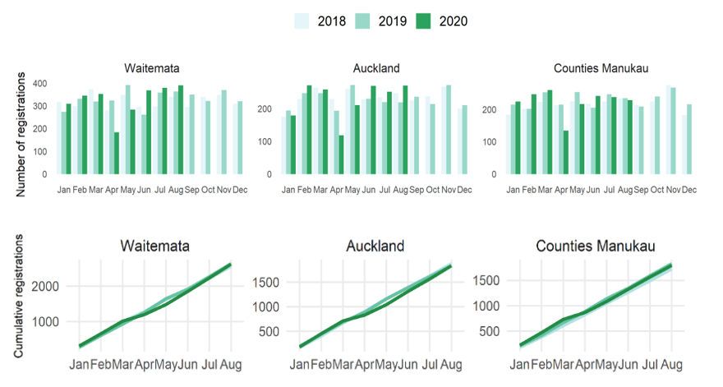
The re-emergence of COVID-19 in the community did, however, cause disruption to people’s lives and to health services. Some services had to operate at decreased capacity due to COVID-19 guidance. Figure 2 shows a decrease in the number of gastrointestinal endoscopy procedures performed during August in Counties Manukau and Auckland DHB (noting that these procedures are completed for several reasons, not just related to cancer).
Patients on the cancer pathway are tracked, with monitoring in place to identify potential delays. When a delay has occurred, people have been rebooked to ensure minimal impact.
Figure 2: Number of gastrointestinal endoscopy procedures in the three Auckland DHBs by month and year
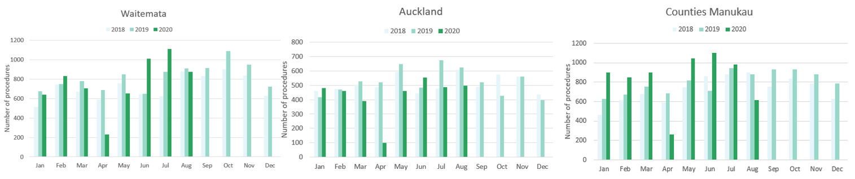
During the initial national lockdown cancer treatment services, including surgery, medical oncology and radiation oncology, were generally well maintained. This was seen again in the Auckland region (see Figure 3) with IV chemotherapy delivery continuing at pre-COVID levels. There was a small decrease in radiation oncology treatments in the Auckland region in August. This is similar to the pattern seen nationally and may in part reflect national hypofractionation guidance (see Radiation Oncology page 24)
During the Auckland lockdown first specialist assessments (FSAs) continued to be delivered face to face. As happened during the first national lockdown there was a move to telehealth for follow up appointments to minimise the need for travel.
Figure 3: Number of attendances for IV chemotherapy by month and year (left) and number of attendances for radiation treatments by month and year (right), for the Auckland region

National Data

Cancer Registrations

Notes on data
- The data come from laboratory reports to the New Zealand Cancer Register (NZCR). This means that cancers diagnosed without haematology or pathology (e.g. radiology alone) will not be counted in this analysis.
- Data included in this report is provisional, and exact numbers will change as data is finalised.
- ‘Date’ is date of diagnosis on the NZCR – usually the date the specimen was taken from the person and sent to the laboratory. Analyses include all new provisional and registered cancer events based on pathology and haematology reports. Data were extracted from NZCR on 21 August 2020.
- Further information on this data is included in Appendix 1.

Results
Table 1 shows the change in provisional cancer registrations in 2020 compared to 2019 by month, and the cumulative impact this has had on cancer registrations for the year to date (up until the end of August 2020).
Table 1: Absolute number and percentage change in cancer registrations in 2020 compared to 2019 by month, and cumulative year to date
 | June 2020 |  | July 2020 |  | August 2020 |  | Year to date
 | Number | % | Number | % | Number | % | Number | %
Māori | 24 | -9.2 | 21 | 7.6 | 28 | 11.7 | -25 | -1.3
Pacific | 25 | 32.5 | 22 | 22.2 | 4 | 5 | 16 | 2.2
Asian | 16 | 11.9 | -2 | -1.3 | 16 | 11.2 | 55 | 5.2
European/Other | 211 | 10.8 | 226 | 10.6 | 118 | 5.4 | -377 | -2.2
Total Population | 224 | 9.2 | 287 | 10.7 | 169 | 6.3 | -312 | -1.5
Note: a small number of reports have ‘unspecified’ ethnicity, meaning the sum of all ethnic groups may not equal the total population.
Figure 4: Total number of cancer registrations by month and year (left), cumulative number of cancer registrations by month and year (right)
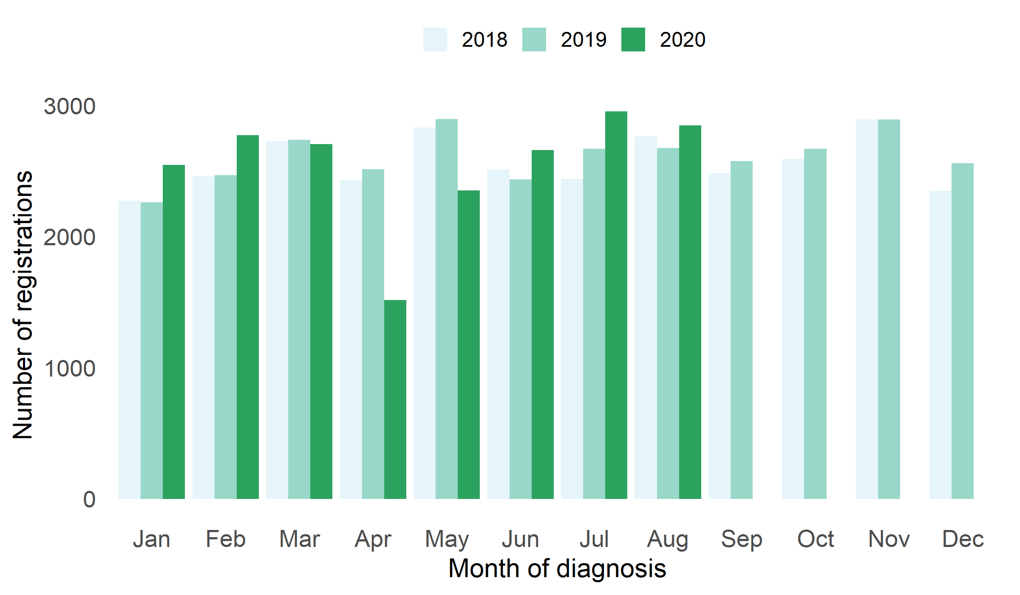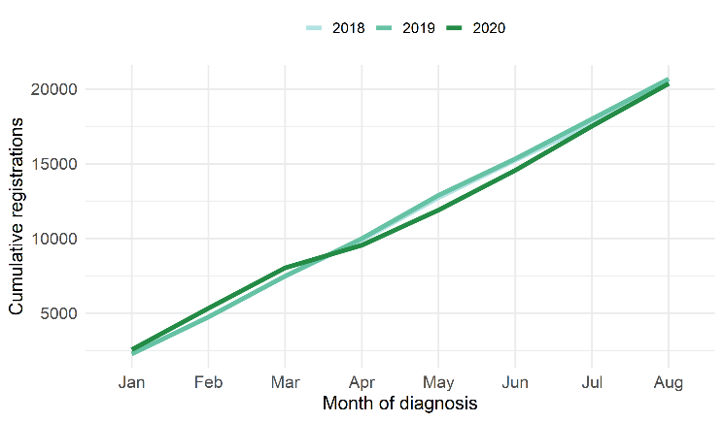
Figure 5: Number of cancer registrations by month and year, by ethnicity
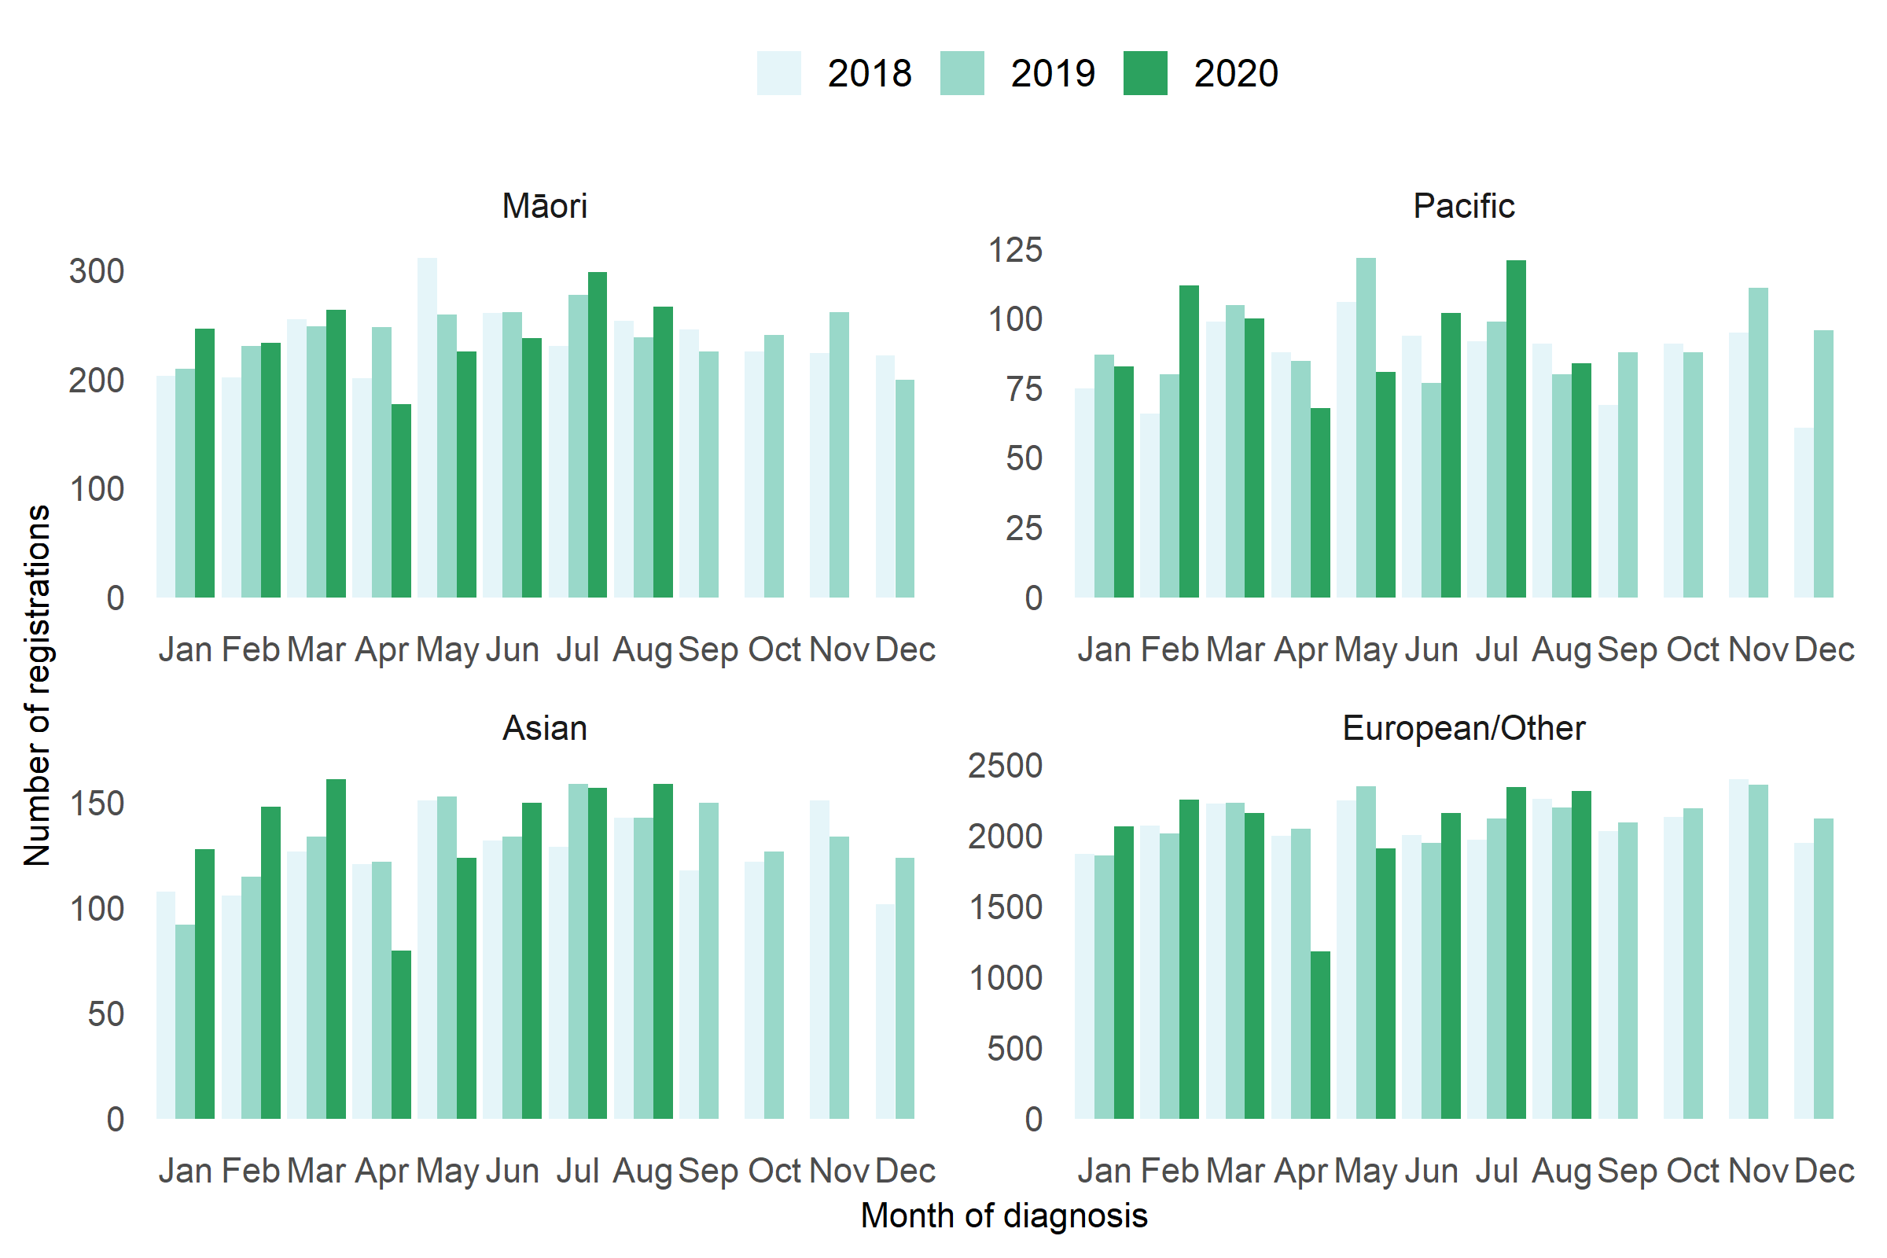
Figure 6: Cumulative number of cancer registrations by year, by ethnicity 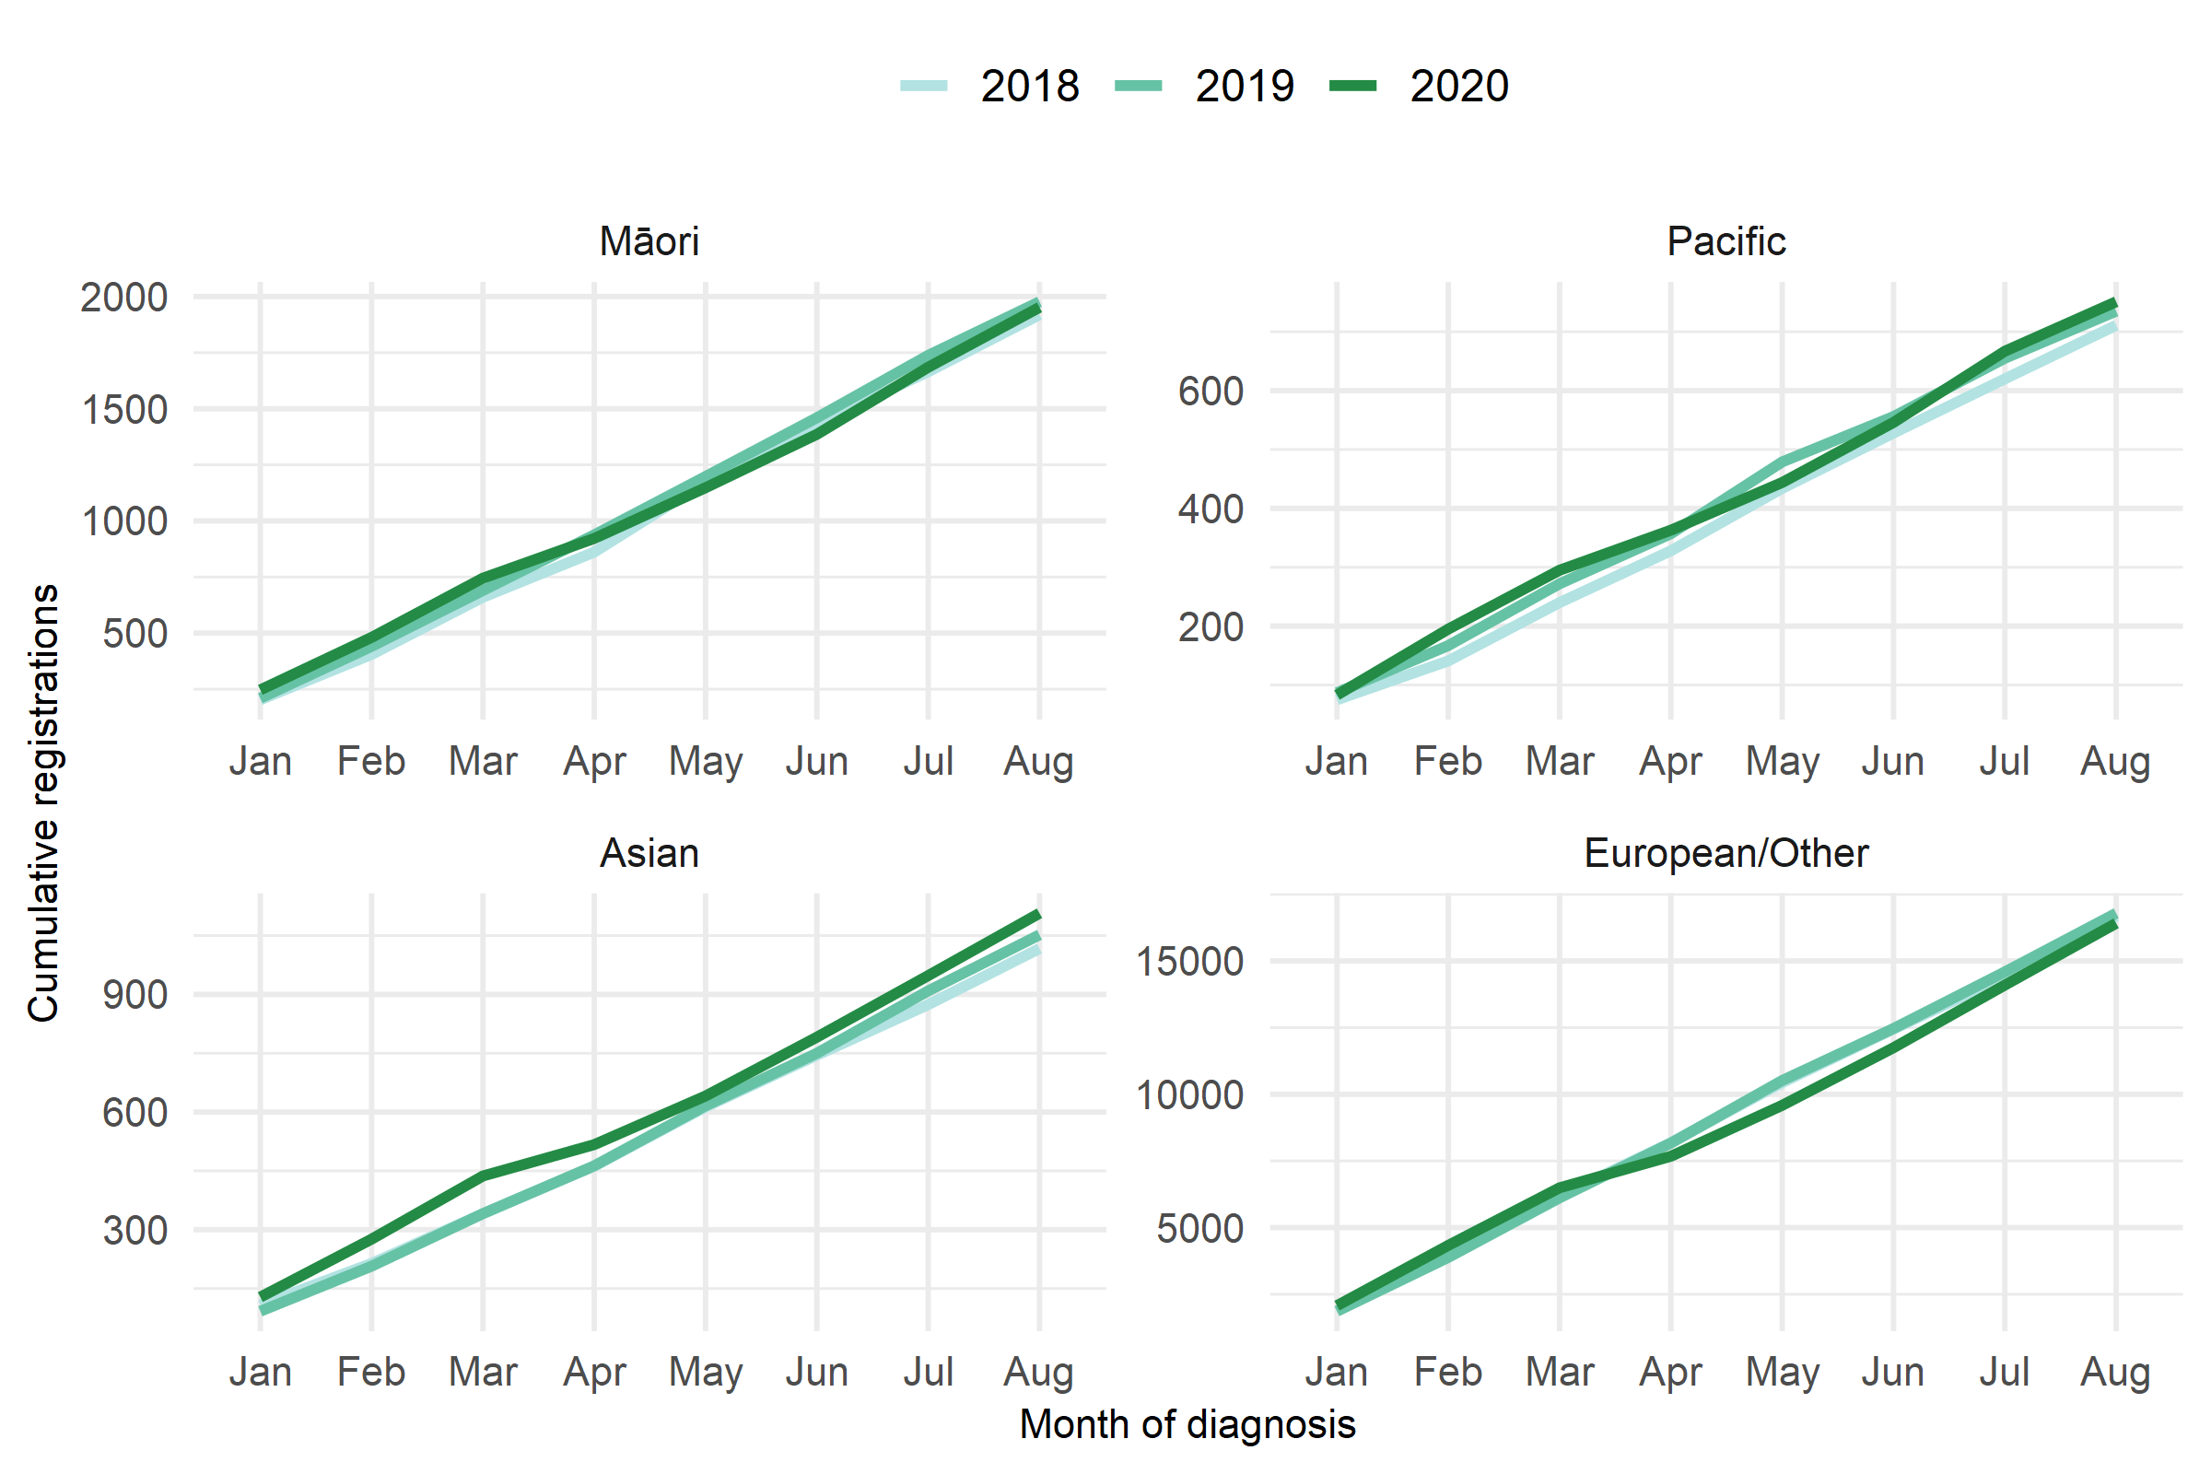
Table 2: Changes in cancer registration for ten most common cancers in 2020 compared to 2019 by month and for the year to date, absolute difference in number of cases and percentage change, by cancer group
 | June 2020 |  | July 2020 |  | August 2020 |  | Year to date*
Cancer Group | Number | % | Number | % | Number | % | Number | %
Breast | -18 | -4.9 | 34 | 9 | 38 | 10.9 | -175 | -6.3
Cervix | 18 | 10.6 | -1 | -0.5 | -6 | -3 | 68 | 5
Colorectal | -2 | -0.7 | 39 | 14.4 | 25 | 9.7 | 47 | 2.2
Gynaecology | 23 | 25 | -2 | -1.8 | -4 | -3.7 | 25 | 3.2
Haematology and lymphoid | 14 | 7.4 | 14 | 6.2 | 2 | 1 | -102 | -6.3
Melanoma and non-melanoma skin | 44 | 8.5 | 115 | 21.3 | 86 | 14.1 | -196 | -4.1
Other digestive system | 42 | 39.3 | -19 | -12.4 | 24 | 21.2 | 35 | 3.4
Prostate | -22 | -6.5 | 10 | 3.1 | -56 | -14.4 | -279 | -10.6
Respiratory and thorax | 4 | 3.4 | -4 | -2.6 | -32 | -19 | -42 | -3.5
Urinary system | 15 | 12.9 | 36 | 29 | 22 | 19.1 | 75 | 7.8
*Note: this analysis uses provision data for the 2020 registrations, some cancers may initially be classified as ‘non-specified’, and subsequently be re-classified into one of the cancer groups as more information is available.
Figure 7: Number of cancer registrations by month and year, by cancer group
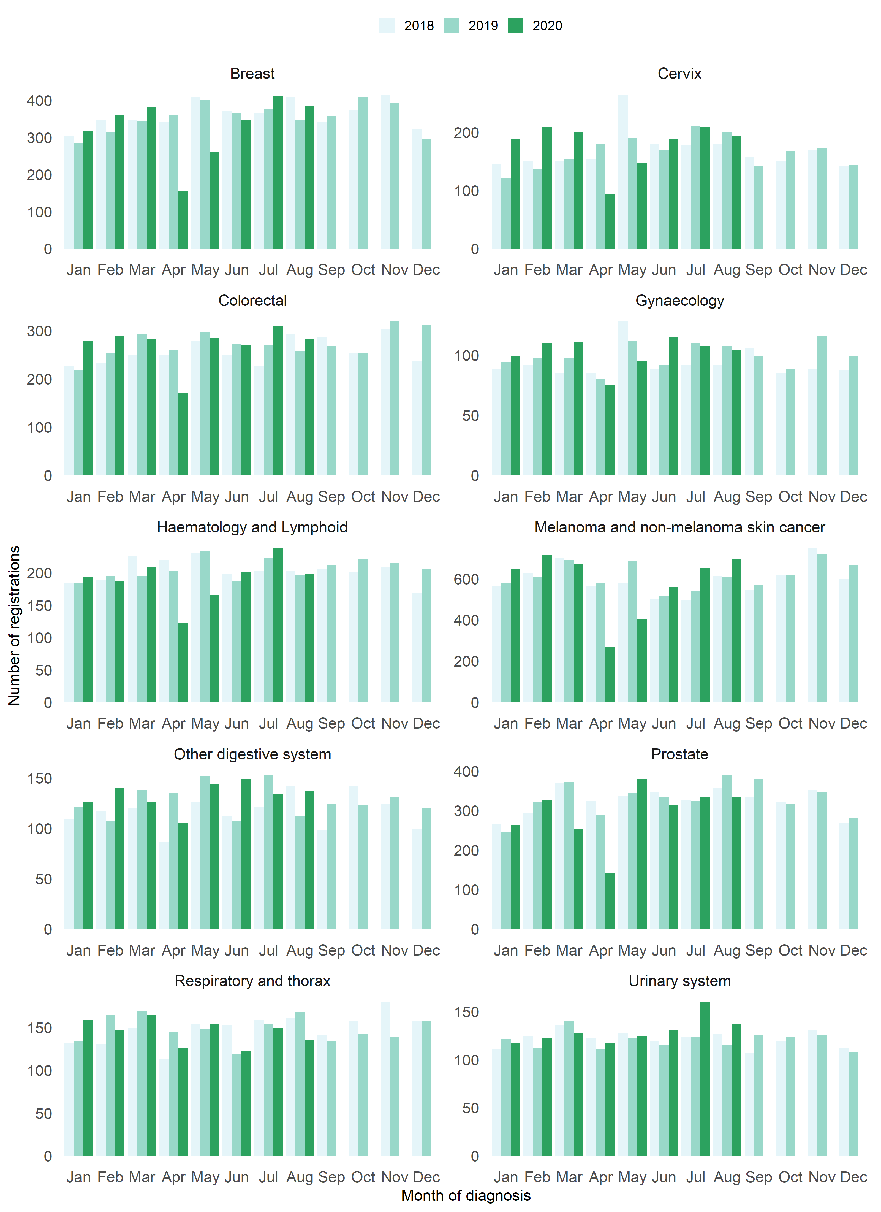
Figure 8: Cumulative number of cancer registrations by year, by cancer group
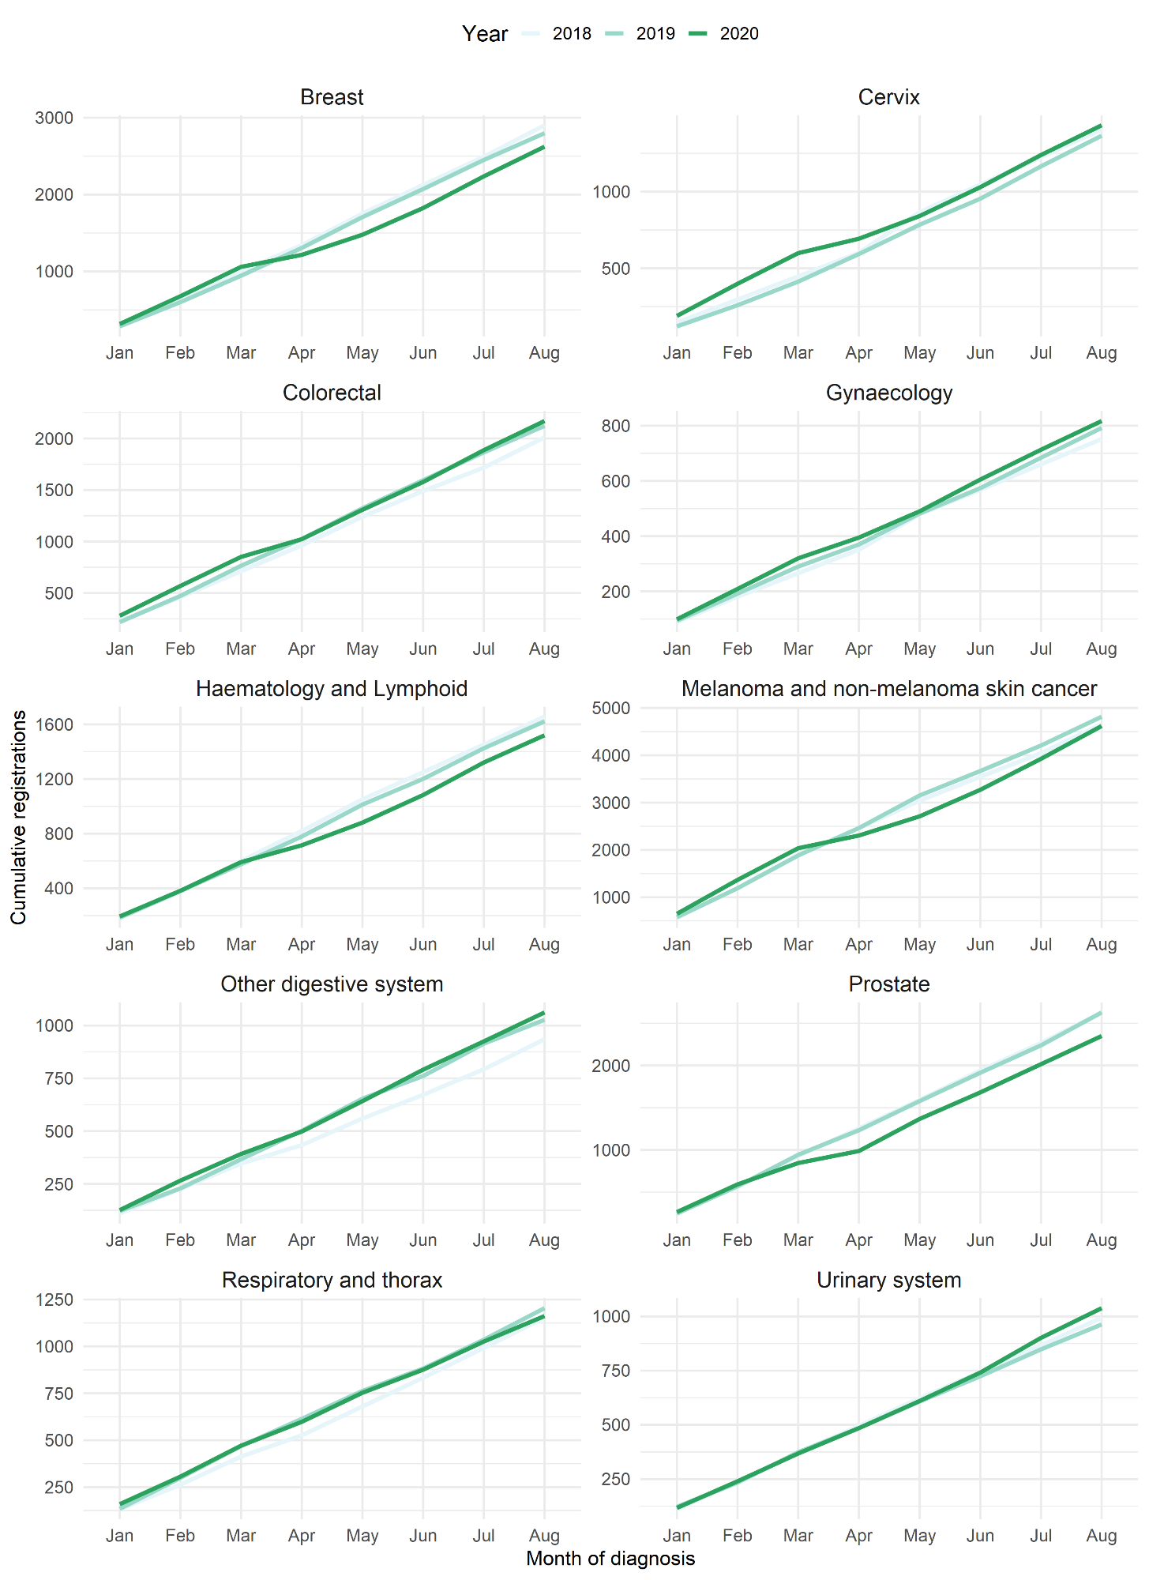

Table 3: Changes in cancer registration in 2020 compared to 2019 by month and for the year to date, absolute difference in number of cases and percentage change, by DHB of domicile (See Appendix 2 for graphs)
 | June 2020 |  | July 2020 |  | August 2020 |  | Year to date
DHB | Number | % | Number | % | Number | % | Number | %
Northland | 4 | 3.9 | 14 | 11.4 | 41 | 36.6 | 43 | 4.7
Waitemata | 107 | 40.8 | 22 | 6.1 | 28 | 7.7 | -9 | -0.3
Auckland | 39 | 16.9 | 31 | 14 | 51 | 23.2 | 4 | 0.2
Counties Manukau | 36 | 17.5 | -8 | -3.2 | -6 | -2.6 | -33 | -1.8
Waikato | 27 | 14.1 | 48 | 22 | -5 | -2.2 | -67 | -3.7
Bay of Plenty | -15 | -9.7 | 34 | 24.6 | -2 | -1.1 | -40 | -3.2
Tairawhiti | 9 | 36 | 18 | 90 | -7 | -25 | -14 | -6.4
Lakes | -1 | -1.7 | 4 | 5.4 | 3 | 5 | -16 | -3.2
Taranaki | -7 | -8.5 | -18 | -20.5 | -15 | -18.1 | -30 | -4.9
Hawke's Bay | -11 | -10.3 | -16 | -12.8 | -10 | -9.5 | -90 | -10.9
Whanganui | 6 | 14.3 | 23 | 54.8 | 13 | 33.3 | 36 | 9.6
MidCentral | 4 | 3.8 | 5 | 4.7 | 1 | 0.8 | 55 | 6.6
Capital & Coast | -1 | -0.8 | 6 | 4.1 | 18 | 12.9 | -31 | -2.8
Hutt Valley | -10 | -11.9 | 7 | 9.3 | 27 | 37 | 17 | 2.8
Wairarapa | 8 | 34.8 | 15 | 71.4 | 11 | 37.9 | 35 | 17.2
Nelson Marlborough | 0 | 0 | 33 | 37.1 | -18 | -17.6 | -28 | -3.5
West Coast | 11 | 73.3 | 0 | 0 | 2 | 11.1 | -17 | -10.4
Canterbury | -34 | -11.4 | 26 | 8.3 | 18 | 6.3 | -44 | -1.9
South Canterbury | 7 | 20.6 | -1 | -2.4 | -2 | -5.4 | -8 | -2.8
Southern | 43 | 23.5 | 49 | 25.1 | 23 | 11.2 | -89 | -5.5

Key points
- For the year to date (up until end of August 2020) there have been 312 fewer cancer registrations compared to the same time period in 2019, a 1.5% decrease. This is a smaller deficit than was seen at the end of July (448 fewer cancers than 2019, a 2.5% decrease).
- The decrease in cancer registrations is similar for Māori (1.3%) and European/Other (2.2%). There are a similar number of registrations for Pacific People as was seen in 2019 and there remains an increase in registrations for people in the Asian ethnic group (as seen in previous months).
- The overall impact of COVID-19 on registrations for the year to date has been most marked for prostate, haematology/lymphoid and breast cancers – all have seen a 6-10% decrease for the year to date.

Gastrointestinal endoscopy

Notes on data
- Gastrointestinal endoscopy data were extracted from National Non-admitted Patient Collection (outpatient) and National Minimum Dataset (inpatient) on 28 September 2020.
- Includes colonoscopies and gastroscopies for all indications (i.e. not just cancer).
- Technical information: Gastroscopies (Purchase Unit Code - MS02005), Colonoscopies (Purchase Unit Code - MS02007), Combined Gastroscopies + Colonoscopies (Purchase Unit Code - MS02014).

Results
Table 4: Absolute number and percentage change in colonoscopy and gastroscopy in 2020 compared to 2019 by month, and cumulative year to date
 | June 2020 |  | July 2020 |  | August 2020 |  | Year to date
 | Number | % | Number | % | Number | % | Number | %
Māori | 158 | 26% | 49 | 7% | 13 | 2% | -81 | -2%
Pacific Peoples | 94 | 43% | 58 | 25% | -19 | -8% | 199 | 11%
Non-Māori / Non-Pacific | 1532 | 28% | 648 | 10% | 8 | 0% | -2381 | -5%
Total Population | 1784 | 29% | 755 | 10% | 2 | 0% | -2263 | -4%
Figure 9: Number of gastrointestinal endoscopy procedures by month and year, for the total population (left) and for Māori (right)

Figure 10: Cumulative number of gastrointestinal endoscopy procedures by year, for the total population (left) and for Māori (right)

Key points
- Gastrointestinal endoscopy services continued to be delivered at pre-COVID volumes in August.
- For the year to date there have been 4% fewer gastrointestinal endoscopies performed in 2020 compared to 2019. This is smaller a gap than was seen at the end of July 2020, when there were 7% fewer gastrointestinal endoscopies performed compared to the same time period in 2019.
- Māori having a smaller cumulative reduction (2%) compared to non-Māori/non-Pacific (5%). There has been a 11% increase in gastrointestinal endoscopies for Pacific Peoples compared to the same time period in 2019.
- Despite the 4% year to date decrease in colonoscopies, there has been a 2% increase in registrations of colorectal cancer (see Table 2). This indicates that triage systems are operating well within DHBs, with those at highest risk being prioritised to receive their colonoscopies.

Bronchoscopy

Notes on data
- Bronchoscopy data were extracted from National Non-admitted Patient Collection (outpatient) and National Minimum Dataset (inpatient) on the 28 September 2020.
- Includes bronchoscopies for any indication (i.e. not just cancer).
- Technical information: Bronchoscopies (Purchase Unit Code - MS02003).

Results
Table 5: Absolute number and percentage change in bronchoscopies in 2020 compared to 2019 by month, and cumulative year to date
 | June 2020 |  | July 2020 |  | August 2020 |  |  | Year to date
 | Number | % | Number | % |  | Number | % | Number | %
Māori | 0 | 0% | -2 | -6% |  | -14 | -31% | -85 | -29%
Pacific Peoples* | - |  | - |  |  | - |  | -3 | -4%
Non-Māori / Non-Pacific | 32 | 23% | 13 | 8% |  | -7 | -4% | -229 | -16%
Total Population | 31 | 18% | 15 | 7% |  | -31 | -14% | -317 | -18%
*Due to small numbers, monthly figures have not been included for Pacific Peoples
Figure 11: Number of bronchoscopies by month and year, for the total population (left) and for Māori (right)

Figure 12: Cumulative number of bronchoscopies procedures by year, for the total population (left) and for Māori (right)

Key points
- There remains a deficit between the number of bronchoscopies performed in 2020 compared to 2019. Overall there were 18% fewer bronchoscopies performed in the first eight months of 2020 compared to the first eight months of 2019.
- Māori have been disproportionately impacted by the cumulative decrease in bronchoscopies (29% decrease for Māori compared to 16% decrease for non-Māori/non-Pacific).
- Despite the 18% decrease in bronchoscopies, there has only been a 3.5% decrease in new diagnoses of respiratory and thorax cancer (see Table 2). However, there is a 16% decrease in new diagnoses of lung cancer for Māori in the first eight months of 2020 compared to the same time period in 2019 (41 fewer cancers). Note that caution is needed when interpreting the provisional cancer type registrations, as some cancers may initially be classified as ‘non-specified’, and subsequently be re-classified into one of the cancer groups as more information is available.

Combined curative cancer surgery

Notes on data
- This report includes data on curative surgery for colorectal, lung and prostate cancer. These cancers were chosen because a pre-validated list of surgical procedure codes for these cancers already existed within Te Aho o Te Kahu, agreed on as part of the quality performance indicator work programme. These three cancers are therefore used as case studies for cancer surgery more generally. The procedure codes are included in Appendix 4.
- The data was extracted from the National Minimum Dataset on 28 September 2020.

Results
Table 6: Absolute number and percentage change in curative surgery (colorectal, lung and prostate) in 2020 compared to 2019 by month, and cumulative year to date
 | June 2020 |  | July 2020 |  | August 2020 |  | Year to date
 | Number | % | Number | % | Number | % | Number | %
Māori | 26 | 100% | 7 | 21% | 3 | 13% | 51 | 21%
Pacific Peoples | -4 | -40% | -5 | -36% | -2 | -14% | -22 | -26%
Non-Māori / Non-Pacific | 1 | 0% | 3 | 1% | 3 | 1% | -52 | -2%
Total Population | 23 | 7% | 5 | 2% | 4 | 1% | -23 | -1%
*Due to small numbers, monthly figures have not been included for Pacific Peoples
Figure 13: Number of curative cancer surgeries (prostate, colorectal, lung) by month and year, for the total population (left) and for Māori (right)

Figure 14: Cumulative number of curative cancer surgeries (colorectal, lung, prostate) by year, for the total population (left) and for Māori (right)

Key points
- Overall, the impact of COVID-19 on cancer surgery volumes has been minimal, with 1% fewer surgeries performed in the first eight months of 2020 compared to the first eight months of 2019. There has been an 21% increase in surgery for Māori in 2020 compared to 2019.
- There has been a 28% decrease in surgeries for Pacific Peoples, noting that this represents small numbers (20 fewer surgeries over eight months).

Colorectal cancer surgery

Notes on data
- A list of the surgical procedure codes used for analysis are included in Appendix 4.
- The data was extracted from the National Minimum Dataset on 28 September 2020.

Results
Table 7: Absolute number and percentage change in curative colorectal cancer surgery in 2020 compared to 2019 by month, and cumulative year to date
 | June 2020 |  | July 2020 |  | August 2020 |  | Year to date
 | Number | % | Number | % | Number | % | Number | %
Māori | 13 | 100% | 12 | 67% | -2 | -17% | 53 | 43%
Pacific Peoples | - |  | - |  | - |  | -19 | -37%
Non-Māori / Non-Pacific | -7 | -4% | -8 | -4% | 12 | 6% | -99 | -7%
Total Population | 2 | 1% | -2 | -1% | 8 | 4% | -65 | -4%
*Due to small numbers, monthly figures have not been included for Pacific Peoples
Figure 15: Number of curative colorectal cancer surgeries by month and year, for the total population (left) and for Māori (right)

Figure 16: Cumulative number of curative colorectal cancer surgeries by year, for the total population (left) and for Māori (right)

Key points
- Colorectal cancer surgery continues to operate at pre-COVID volumes.
- There has been a 1% decrease in colorectal surgery for the year to date compared to the first eight months of 2020.
- Overall, there has been a 21% increase in curative colorectal cancer surgery for Māori for the year to date compared to the same time period in 2019.

Lung cancer surgery

Notes on data
- A list of the surgical procedure codes used for analysis are included in Appendix 4.
- The data were extracted from the National Minimum Dataset on 28 September 2020.
- The number of lung cancer surgeries performed each month is relatively small, so caution is needed when comparing data by month.

Results
Table 8: Absolute number and percentage change in curative lung cancer surgery in 2020 compared to 2019 by month, and cumulative year to date.
 | June 2020 |  | July 2020 |  | August 2020 |  | Year to date
 | Number | % | Number | % | Number | % | Number | %
Total Population | 7 | 13% | -5 | -10% | -8 | -12% | -32 | -7%
*Due to the small number of surguries performed each month calculations have only been included for the total population rather than by ethnicity
Figure 17: Number of curative lung cancer surgeries by month and year, total population (left) and for Māori (right)

*Due to the small number of surgeries performed each month it is not possible to draw conclusions from small changes between months.
Figure 18: Cumulative number of curative lung cancer surgeries by year, for the total population (left) and for Māori (right)

Key points
- Overall, for the year to date there has been a 7% decrease in curative lung cancer surgeries compared to 2019.
- The impact on lung cancer surgery is most marked for Māori. This is expected given the decrease in bronchoscopy and lung cancer diagnoses (see discussion page 16).

Prostate cancer surgery

Notes on data
- A list of the surgical procedure codes used for analysis are included in Appendix 4.
- The data was extracted from the National Minimum Dataset on 28 September 2020.
- The number of curative prostate cancer surgeries performed each month is relatively small, so caution is needed when comparing data by month.

Results
Table 9: Absolute number and percentage change in curative prostate cancer surgery in 2020 compared to 2019 by month, and cumulative year to date
 | June 2020 |  | July 2020 |  | August 2020 |  | Year to date
 | Number | % | Number | % | Number | % | Number | %
Total Population | 14 | 20% | 12 | 21% | 4 | 6% | 74 | 15%
*Due to the small number of surguries performed each month calculations have only been included for the total population
Figure 19: Number of curative prostate cancer surgeries by month and year, total population (left) and for Māori (right)

*Due to the small number of surguries performed each month it is not possible to draw conclusions from small changes between months.
Figure 20: Cumulative number of curative prostate cancer surgeries by year, for the total population (left) and for Māori (right)

Key points
- For the year to date there has been a 15% increase in prostate cancer surgeries compared to 2019.

Medical oncology

Notes on data
- Extracted from National non-admitted patient collection (Outpatient collection) on 28 September 2020.
- First specialist assessment (FSA) reflects counts of first attendance for specialist medical oncology assessment.
- IV chemotherapy reflects appointments for outpatient and inpatient IV chemotherapy for non-haematological indications.
- Technical information: medical oncology FSA (PUC M50020), and IV chemotherapy (PUC MS02009)

Results
Table 10: Absolute number and percentage change in medical oncology first specialist assessments in 2020 compared to 2019 by month, and cumulative year to date
 | June 2020 |  | July 2020 |  | August 2020 |  | Year to date
 | Number | % | Number | % | Number | % | Number | %
Māori | 12 | 12% | -16 | -13% | -21 | -15% | -40 | -5%
Pacific Peoples | -6 | -17% | -6 | -14% | 8 | 20% | 42 | 15%
Non-Māori / Non-Pacific | 54 | 9% | -53 | -8% | -35 | -5% | 34 | 1%
Total Population | 60 | 8% | -75 | -9% | -48 | -6% | 36 | 1%
Figure 21: Number of medical oncology first specialist assessments by month and year, for the total population (left) and for Māori (right)

Figure 22: Cumulative number of medical oncology first specialist assessments by year, for the total population (left) and for Māori (right)

Table 11: Absolute number and percentage change in IV chemotherapy attendances in 2020 compared to 2019 by month, and cumulative year to date
 | June 2020 |  | July 2020 |  | July 2020 |  | Year to date
 | Number | % | Number | % | Number | % | Number | %
Māori | 225 | 33% | 72 | 9% | 17 | 2% | 830 | 14%
Pacific Peoples | 57 | 22% | 5 | 2% | -1 | 0% | 50 | 2%
Non-Māori / Non-Pacific | 577 | 12% | -174 | -3% | -285 | -5% | -8 | 0%
Total Population | 859 | 15% | -97 | -1% | -269 | -4% | 872 | 2%
Figure 23: Number of attendances for IV chemotherapy by month and year, for the total population (left) and for Māori (right)

Figure 24: Cumulative number of attendances for IV chemotherapy by year, for the total population (left) and for Māori (right)

Key points
- Overall, for the year to date the number of medical oncology FSAs and attendances for IV chemotherapy in 2020 is comparable to 2019.

Radiation oncology

Notes on data
- Extracted from National Non-admitted patient collection on 28 September 2020.
- First specialist assessment (FSA) reflects counts of first attendance for radiation oncology specialist assessment.
- Megavoltage attendance reflects appointments for planning/simulation and for treatment with radiation therapy on a linear accelerator.
- Technical information: radiation oncology FSA (PUC M50022), megavoltage attendances (Purchase Unit Code M50025)

Results
Table 12: Absolute number and percentage change in radiation oncology first specialist assessments in 2020 compared to 2019 by month, and cumulative year to date
 | June 2020 |  | July2020 |  | August 2020 |  | Year to date
 | Number | % | Number | % | Number | % | Number | %
Māori | 24 | 22% | 9 | 7% | -32 | -22% | 41 | 4%
Non-Māori / Non-Pacific | 95 | 13% | -193 | -19% | -9 | -1% | -37 | -1%
Pacific Peoples | -16 | -36% | -14 | -24% | -6 | -12% | -39 | -10%
Total Population | 103 | 11% | -198 | -17% | -47 | -4% | -35 | 0%

Figure 25: Number of radiation oncology first specialist assessments by month and year, total population (left) and for Māori (right)

Figure 26: Cumulative number of radiation oncology first specialist assessments by month and year, total population (left) and for Māori (right)

Table 13: Absolute number and percentage change in radiation therapy attendances in 2020 compared to 2019 by month, and cumulative year to date
 | June 2020 |  | July 2020 |  | August 2020 |  | Year to date
 | Number | % | Number | % | Number | % | Number | %
Māori | 274 | 17% | -247 | -12% | 117 | 7% | -680 | -5%
Pacific Peoples | -3 | -1% | -241 | -34% | -27 | -5% | -9 | 0%
Non-Māori / Non-Pacific | 556 | 5% | -620 | -5% | -1519 | -14% | -6776 | -8%
Total Population | 827 | 7% | -1108 | -7% | -1429 | -11% | -7465 | -7%

Figure 27: Number of attendances for radiation therapy by month and year, total population (left) and for Māori (right)

Figure 28: Cumulative number of attendances for radiation therapy by month and year, total population (left) and for Māori (right)

Key points
- Overall for the year to date the number of radiation oncology FSAs in 2020 is comparable to 2019.
- For the year to date there has been a 7% decrease in attendances for radiation therapy. This is similar for Māori (5%) and non-Māori/non-Pacific (8%). This may, in part, be the result of national hypofractionation guidance.

Haematology

Notes on data
- Extracted from National Non-admitted Patient Collection (outpatient) and National Minimum Dataset (inpatient) 28 September 2020.
- First specialist assessment (FSA) reflects counts of first attendance for specialist haematology assessment for any indication (i.e. not just cancer).
- IV chemotherapy reflects appointments for IV chemotherapy for haematological malignancies.
- Technical information: Haematology FSA (Purchase Unite Code - M30002), IV haem/chemo (Purchase Unit Code - M30020).

Results
Table 14: Absolute number and percentage change in haematology FSAs in 2020 compared to 2019 by month, and cumulative year to date
 | June 2020 |  | July 2020 |  | July 2020 |  | Year to date
 | Number | % | Number | % | Number | % | Number | %
Māori | -32 | -44% | -1 | -2% | 9 | 16% | -8 | -2%
Pacific Peoples | 5 | 16% | 8 | 35% | 14 | 64% | 16 | 8%
Non-Māori / Non-Pacific | 30 | 8% | -63 | -12% | -13 | -3% | -297 | -8%
Total Population | 3 | 1% | -56 | -10% | 10 | 2% | -289 | -7%
Figure 29: Number of haematology first specialist assessments by month and year, total population (left) and for Māori (right)

Figure 30: Cumulative number of haematology first specialist assessments by month and year, total population (left) and for Māori (right)

Table 15: Absolute number and percentage change in IV chemotherapy attendances for haematological malignancies in 2020 compared to 2019 by month, and cumulative year to date
 | June 2020 |  | July 2020 |  | August 2020 |  | Year to date
 | Number | % | Number | % | Number | % | Number | %
Māori | 6 | 4% | -49 | -19% | -42 | -17% | -51 | -3%
Pacific Peoples | 94 | 162% | 65 | 59% | 62 | 61% | 253 | 36%
Non-Māori / Non-Pacific | 381 | 28% | -105 | -5% | -196 | -11% | 295 | 2%
Total Population | 481 | 30% | -89 | -4% | -176 | -8% | 497 | 3%
Figure 31: Number attendances for IV chemotherapy for haematological malignancies by month and year, total population (left) and for Māori (right)

Figure 32: Cumulative number of attendances for IV chemotherapy for haematological malignancies by month and year, total population (left) and for Māori (right)

Key points
- Overall, for the year to date there has been a 7% decrease in haematology first specialist appointments compared to the same time period in 2019. One contributor to this is likely to be a decrease in FSAs for non-malignant, non-urgent indications, deferred as part of the hospital response framework. These cases may have been effectively managed in primary care and so may never require secondary FSA care in 2020.
- For the year to date there has been a 3% increase in IV chemotherapy for haematology compared to the same time period in 2019.

Appendix 1: NZCR data information

The New Zealand Cancer Registry as a source of data for new cancer diagnoses
Cancer registration is a process where data is collated from multiple sources about people diagnosed with cancer and rules are applied to determine the type of cancer they have. This information is recorded in the New Zealand Cancer Registry. Each tumour is classified using an international World Health Organisation standard so that cancer incidence can be compared between countries. The tumour is staged based on all the information available within 4 months of diagnosis. This process may take up to six months or more depending on the number of missing reports that need to be followed up with laboratories.
For each registration there may be multiple pathology reports as there may be multiple procedures performed on the tumour. This means there will be more than one registration for people diagnosed with more than one type of tumour.
Cancer registrations come from pathology laboratories, haematology laboratories, mortality records and reviewing hospital discharge records. Laboratory reports provide the best source of near real time data to monitor new diagnoses of cancer in New Zealand.

Pathology reports as a data source for providing near real time monitoring cancer diagnoses
Pathology reports (documents) are received by the NZCR as electronic messages. An administrator triages these documents each day and if the document appears to meet the requirements for registration the document is “administered”. The document may relate to an existing registration or may contain information for a new cancer event. Documents that do not meet the cancer reporting requirements will be marked as “deleted”, “rejected” or “agreed not for registration”.
The administrator creates a new provisional cancer event if the pathology report identifies a new cancer diagnosis for this person. This new cancer event is assigned to a cancer group and this provisional event is then queued for further assessment by a clinical coder. If the required information has been provided the coder creates a new registration. If some information is not yet available, then the registration is held open until further information arrives to complete the registration or determine that the tumour does not meet the registration criteria.

Appendix 2: NZCR registrations by DHB
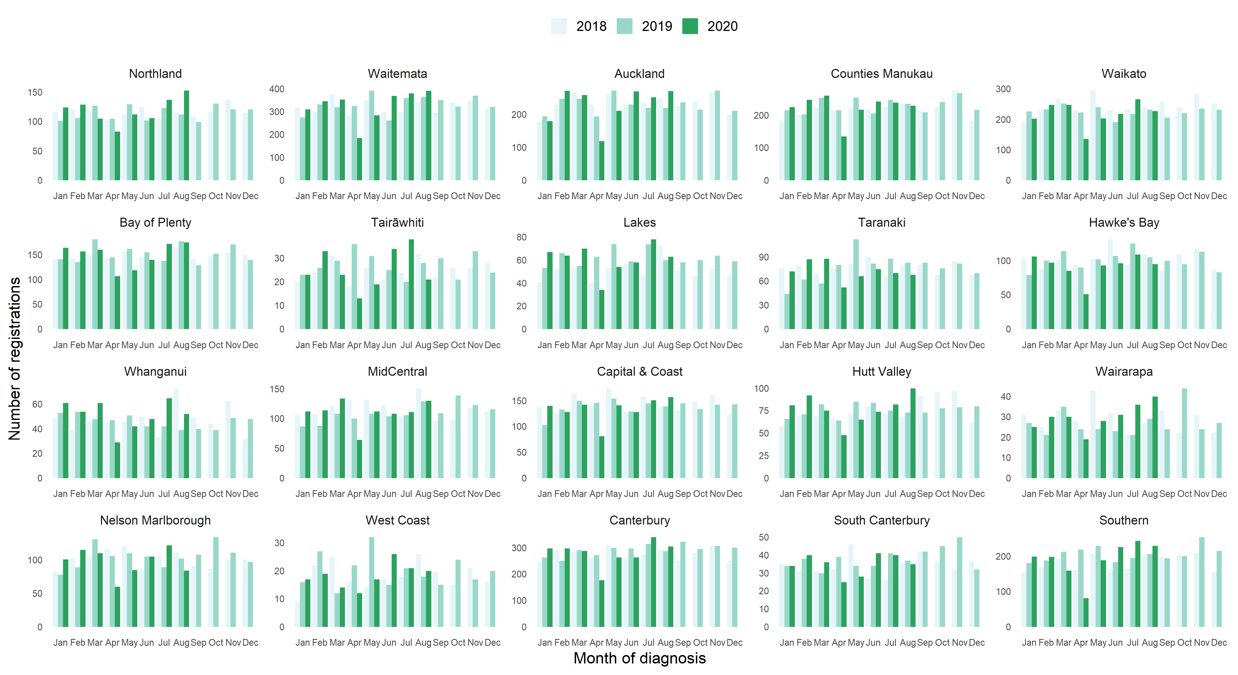
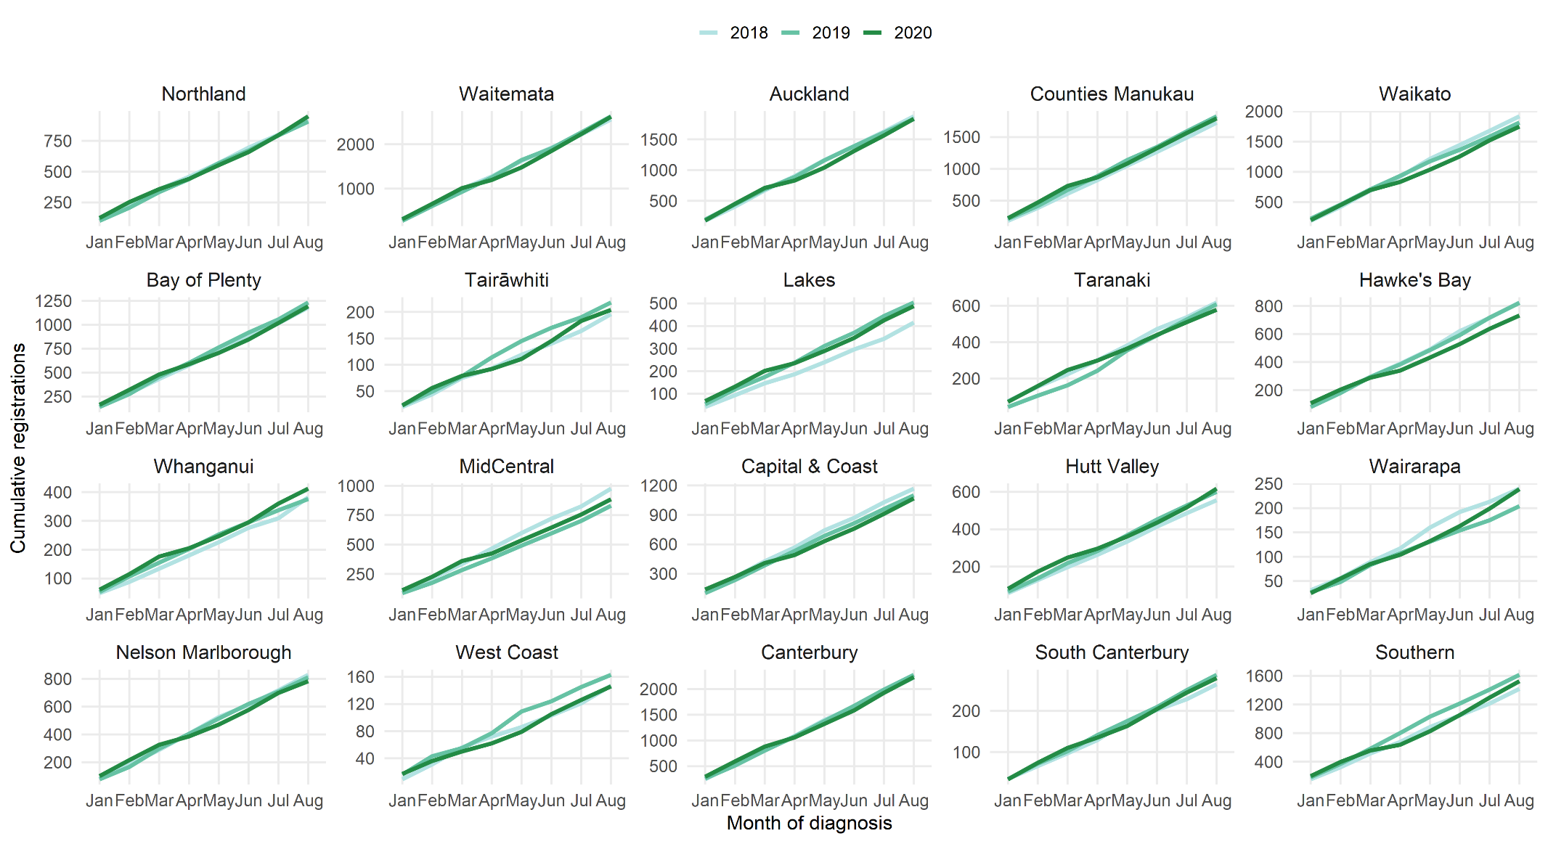

Cancer Registrations by DHB

 | Total Population |  |  |  |  |  | Māori |  |  |  |  |  | European/Other
 | Cumulative number for Jan to Aug |  |  | Difference between 2019 and 2020 |  |  | Cumulative number for Jan to Aug |  |  | Difference between 2019 and 2020 |  |  | Cumulative number for Jan to Aug |  |  | Difference between 2019 and 2020
 | 2018 | 2019 | 2020 | Number | % |  | 2018 | 2019 | 2020 | Number | % |  | 2018 | 2019 | 2020 | Number | %
Northland | 915 | 906 | 949 | 43 | 4.7 |  | 199 | 153 | 188 | 35 | 22.9 |  | 697 | 727 | 745 | 18 | 2.5
Waitemata | 2561 | 2630 | 2621 | -9 | -0.3 |  | 115 | 124 | 139 | 15 | 12.1 |  | 2121 | 2173 | 2080 | -93 | -4.3
Auckland | 1874 | 1830 | 1834 | 4 | 0.2 |  | 79 | 91 | 79 | -12 | -13.2 |  | 1413 | 1317 | 1357 | 40 | 3
Counties Manukau | 1727 | 1827 | 1794 | -33 | -1.8 |  | 177 | 201 | 234 | 33 | 16.4 |  | 1075 | 1103 | 1048 | -55 | -5
Waikato | 1918 | 1815 | 1748 | -67 | -3.7 |  | 272 | 261 | 234 | -27 | -10.3 |  | 1527 | 1466 | 1410 | -56 | -3.8
Bay of Plenty | 1181 | 1234 | 1194 | -40 | -3.2 |  | 163 | 180 | 168 | -12 | -6.7 |  | 1000 | 1020 | 999 | -21 | -2.1
Tairāwhiti | 196 | 218 | 204 | -14 | -6.4 |  | 57 | 74 | 80 | 6 | 8.1 |  | 138 | 140 | 120 | -20 | -14.3
Lakes | 415 | 504 | 488 | -16 | -3.2 |  | 100 | 112 | 121 | 9 | 8 |  | 294 | 365 | 341 | -24 | -6.6
Taranaki | 618 | 608 | 578 | -30 | -4.9 |  | 60 | 55 | 54 | -1 | -1.8 |  | 546 | 548 | 516 | -32 | -5.8
Hawke's Bay | 825 | 822 | 732 | -90 | -10.9 |  | 126 | 137 | 111 | -26 | -19 |  | 673 | 656 | 594 | -62 | -9.5
Whanganui | 382 | 376 | 412 | 36 | 9.6 |  | 49 | 65 | 49 | -16 | -24.6 |  | 325 | 302 | 353 | 51 | 16.9
MidCentral | 975 | 830 | 885 | 55 | 6.6 |  | 105 | 81 | 91 | 10 | 12.3 |  | 839 | 714 | 752 | 38 | 5.3
Capital & Coast | 1167 | 1099 | 1068 | -31 | -2.8 |  | 75 | 83 | 87 | 4 | 4.8 |  | 938 | 897 | 852 | -45 | -5
Hutt Valley | 555 | 600 | 617 | 17 | 2.8 |  | 68 | 85 | 59 | -26 | -30.6 |  | 437 | 454 | 502 | 48 | 10.6
Wairarapa | 240 | 204 | 239 | 35 | 17.2 |  | 24 | 12 | 24 | 12 | 100 |  | 210 | 188 | 208 | 20 | 10.6
Nelson Marlborough | 828 | 810 | 782 | -28 | -3.5 |  | 39 | 33 | 28 | -5 | -15.2 |  | 771 | 760 | 740 | -20 | -2.6
West Coast | 147 | 163 | 146 | -17 | -10.4 |  | 9 | 11 | 8 | -3 | -27.3 |  | 137 | 147 | 137 | -10 | -6.8
Canterbury | 2222 | 2274 | 2230 | -44 | -1.9 |  | 126 | 111 | 113 | 2 | 1.8 |  | 1967 | 2045 | 1974 | -71 | -3.5
South Canterbury | 264 | 287 | 279 | -8 | -2.8 |  | 14 | 15 | 10 | -5 | -33.3 |  | 241 | 270 | 263 | -7 | -2.6
Southern | 1418 | 1614 | 1525 | -89 | -5.5 |  | 62 | 93 | 74 | -19 | -20.4 |  | 1318 | 1487 | 1402 | -85 | -5.7

Appendix 3: Diagnosis and treatment data by DHB
Percentage differences are only presented if the cumulative 2019 total is 10 or greater. In some cases, the grand totals may differ slightly to those presented in the national report. This is due to non-DHB providers being excluded from the analyses within this appendix.

Gastrointestinal endoscopy
 | Total population |  |  |  |  |  | Māori |  |  |  |  |  | Non-Māori / Non-Pacific
 | Cumulative number for Jan to August |  |  | Difference between 2019 and 2020 |  |  | Cumulative number for Jan to July |  |  | Difference between 2019 and 2020 |  |  | Cumulative number for Jan to July |  |  | Difference between 2019 and 2020
 | 2018 | 2019 | 2020 | Number | % |  | 2018 | 2019 | 2020 | Number | % |  | 2018 | 2019 | 2020 | Number | %
Northland | 2514 | 2665 | 2256 | -409 | -15% |  | 419 | 520 | 417 | -103 | -20% |  | 2082 | 1930 | 1480 | -450 | -23%
Waitemata | 5425 | 6178 | 6058 | -120 | -2% |  | 303 | 375 | 334 | -41 | -11% |  | 4933 | 4790 | 4670 | -120 | -3%
Auckland | 4046 | 4367 | 3431 | -936 | -21% |  | 215 | 198 | 201 | 3 | 2% |  | 3558 | 3327 | 2522 | -805 | -24%
Counties Manukau | 5750 | 6102 | 6660 | 558 | 9% |  | 548 | 578 | 667 | 89 | 15% |  | 4513 | 4028 | 4601 | 573 | 14%
Waikato | 3445 | 4368 | 4340 | -28 | -1% |  | 405 | 526 | 500 | -26 | -5% |  | 2985 | 3260 | 3169 | -91 | -3%
Bay of Plenty | 3294 | 3218 | 3280 | 62 | 2% |  | 377 | 417 | 412 | -5 | -1% |  | 2900 | 2408 | 2382 | -26 | -1%
Lakes | 1319 | 1314 | 1169 | -145 | -11% |  | 235 | 242 | 243 | 1 | 0% |  | 1063 | 876 | 766 | -110 | -13%
Tairāwhiti | 444 | 556 | 466 | -90 | -16% |  | 124 | 164 | 136 | -28 | -17% |  | 318 | 329 | 271 | -58 | -18%
Taranaki | 1346 | 1240 | 1042 | -198 | -16% |  | 132 | 137 | 87 | -50 | -36% |  | 1207 | 965 | 947 | -18 | -2%
Whanganui | 974 | 1031 | 843 | -188 | -18% |  | 142 | 135 | 115 | -20 | -15% |  | 829 | 779 | 611 | -168 | -22%
Hawke's Bay | 1663 | 1971 | 1901 | -70 | -4% |  | 190 | 245 | 266 | 21 | 9% |  | 1458 | 1486 | 1325 | -161 | -11%
MidCentral | 1416 | 1465 | 1490 | 25 | 2% |  | 94 | 109 | 133 | 24 | 22% |  | 1308 | 1144 | 1179 | 35 | 3%
Capital & Coast | 1942 | 1905 | 2184 | 279 | 15% |  | 155 | 115 | 172 | 57 | 50% |  | 1713 | 1527 | 1626 | 99 | 6%
Hutt Valley | 1531 | 1980 | 2094 | 114 | 6% |  | 137 | 152 | 219 | 67 | 44% |  | 1332 | 1546 | 1556 | 10 | 1%
Wairarapa | 620 | 717 | 587 | -130 | -18% |  | 50 | 64 | 52 | -12 | -19% |  | 561 | 676 | 543 | -133 | -20%
Nelson Marlborough | 1002 | 1731 | 1766 | 35 | 2% |  | 51 | 96 | 98 | 2 | 2% |  | 947 | 557 | 437 | -120 | -22%
West Coast | 465 | 418 | 444 | 26 | 6% |  | 36 | 26 | 16 | -10 | -38% |  | 427 | 2686 | 2309 | -377 | -14%
Canterbury | 3957 | 6340 | 5505 | -835 | -13% |  | 225 | 365 | 330 | -35 | -10% |  | 3678 | 1390 | 1413 | 23 | 2%
South Canterbury | 795 | 836 | 781 | -55 | -7% |  | 35 | 31 | 35 | 4 | 13% |  | 758 | 335 | 360 | 25 | 7%
Southern | 2997 | 3309 | 3151 | -158 | -5% |  | 120 | 186 | 167 | -19 | -10% |  | 2855 | 5023 | 4230 | -793 | -16%
Total | 44945 | 51711 | 49448 | -2263 | -4% |  | 3993 | 4681 | 4600 | -81 | -2% |  | 39425 | 45298 | 42917 | -2381 | -5%

Bronchoscopy

 | Total population |  |  |  |  |  | Māori |  |  |  |  |  | Non-Māori / Non-Pacific
 | Cumulative number for Jan to August |  |  | Difference between 2019 and 2020 |  |  | Cumulative number for Jan to August |  |  | Difference between 2019 and 2020 |  |  | Cumulative number for Jan to August |  |  | Difference between 2019 and 2020
 | 2018 | 2019 | 2020 | Number | % |  | 2018 | 2019 | 2020 | Number | % |  | 2018 | 2019 | 2020 | Number | %
Northland | 56 | 52 | 43 | -9 | -17% |  | 18 | 16 | 14 | -2 | -13% |  | 37 | 35 | 28 | -7 | -20%
Waitemata | 95 | 99 | 96 | -3 | -3% |  | 7 | 6 | 9 | 3 | - |  | 82 | 91 | 83 | -8 | -9%
Auckland | 208 | 253 | 187 | -66 | -26% |  | 25 | 30 | 19 | -11 | -37% |  | 160 | 203 | 150 | -53 | -26%
Counties Manukau | 228 | 242 | 212 | -30 | -12% |  | 43 | 42 | 27 | -15 | -36% |  | 155 | 162 | 154 | -8 | -5%
Waikato | 189 | 184 | 134 | -50 | -27% |  | 40 | 44 | 32 | -12 | -27% |  | 146 | 138 | 99 | -39 | -28%
Bay of Plenty | 102 | 118 | 90 | -28 | -24% |  | 19 | 32 | 21 | -11 | -34% |  | 81 | 84 | 69 | -15 | -18%
Lakes | 60 | 58 | 49 | -9 | -16% |  | 22 | 18 | 21 | 3 | 17% |  | 38 | 39 | 27 | -12 | -31%
Tairāwhiti | 2 | 2 | 17 | 15 | - |  | 1 | 1 | 6 | 5 | - |  | 1 | 1 | 11 | 10 | -
Taranaki | 29 | 43 | 25 | -18 | -42% |  | 6 | 7 | 2 | -5 | - |  | 23 | 36 | 23 | -13 | -36%
Whanganui | 10 | 12 | 10 | -2 | -17% |  | 4 | 6 | 4 | -2 | - |  | 6 | 6 | 6 | 0 | -
Hawke's Bay | 50 | 45 | 30 | -15 | -33% |  | 14 | 11 | 8 | -3 | -27% |  | 36 | 33 | 21 | -12 | -36%
MidCentral | 28 | 23 | 20 | -3 | -13% |  | 3 | 7 | 1 | -6 | - |  | 25 | 16 | 19 | 3 | 19%
Capital & Coast | 63 | 64 | 48 | -16 | -25% |  | 6 | 9 | 7 | -2 | - |  | 52 | 54 | 39 | -15 | -28%
Hutt Valley | 64 | 89 | 60 | -29 | -33% |  | 8 | 21 | 10 | -11 | -52% |  | 52 | 66 | 46 | -20 | -30%
Nelson Marlborough | 50 | 45 | 57 | 12 | 27% |  | 4 | 5 | 5 | 0 | - |  | 46 | 40 | 51 | 11 | 28%
Canterbury | 219 | 291 | 267 | -24 | -8% |  | 14 | 24 | 16 | -8 | -33% |  | 203 | 263 | 243 | -20 | -8%
South Canterbury | 9 | 9 | 13 | 4 | - |  | 0 | 1 | 0 | -1 | - |  | 9 | 8 | 13 | 5 | -
Southern | 166 | 164 | 118 | -46 | -28% |  | 10 | 15 | 8 | -7 | -47% |  | 156 | 146 | 110 | -36 | -25%
Total | 1628 | 1793 | 1476 | -317 | -18% |  | 244 | 295 | 210 | -85 | -29% |  | 1308 | 1421 | 1192 | -229 | -16%

Colorectal cancer surgery

 | Total population |  |  |  |  |  | Māori |  |  |  |  |  | Non-Māori / Non-Pacific
 | Cumulative number for Jan to August |  |  | Difference between 2019 and 2020 |  |  | Cumulative number for Jan to August |  |  | Difference between 2019 and 2020 |  |  | Cumulative number for Jan to August |  |  | Difference between 2019 and 2020
 | 2018 | 2019 | 2020 | Number | % |  | 2018 | 2019 | 2020 | Number | % |  | 2018 | 2019 | 2020 | Number | %
Northland | 49 | 65 | 56 | -9 | -14% |  | 7 | 13 | 15 | 2 | 15% |  | 42 | 51 | 41 | -10 | -20%
Waitemata | 167 | 176 | 146 | -30 | -17% |  | 10 | 12 | 9 | -3 | -25% |  | 153 | 151 | 134 | -17 | -11%
Auckland | 130 | 133 | 129 | -4 | -3% |  | 7 | 8 | 16 | 8 | - |  | 115 | 110 | 106 | -4 | -4%
Counties Manukau | 93 | 84 | 96 | 12 | 14% |  | 6 | 6 | 15 | 9 | - |  | 75 | 72 | 70 | -2 | -3%
Waikato | 159 | 135 | 180 | 45 | 33% |  | 19 | 10 | 26 | 16 | 160% |  | 136 | 124 | 153 | 29 | 23%
Bay of Plenty | 92 | 96 | 122 | 26 | 27% |  | 13 | 7 | 17 | 10 | - |  | 79 | 88 | 105 | 17 | 19%
Lakes | 48 | 56 | 56 | 0 | 0% |  | 9 | 10 | 8 | -2 | -20% |  | 38 | 44 | 47 | 3 | 7%
Tairāwhiti | 12 | 19 | 17 | -2 | -11% |  | 4 | 2 | 5 | 3 | - |  | 8 | 17 | 12 | -5 | -29%
Taranaki | 67 | 53 | 42 | -11 | -21% |  | 7 | 4 | 6 | 2 | - |  | 60 | 49 | 36 | -13 | -27%
Whanganui | 31 | 32 | 37 | 5 | 16% |  | 4 | 2 | 3 | 1 | - |  | 27 | 30 | 34 | 4 | 13%
Hawke's Bay | 97 | 97 | 100 | 3 | 3% |  | 15 | 7 | 14 | 7 | - |  | 82 | 89 | 83 | -6 | -7%
MidCentral | 89 | 69 | 80 | 11 | 16% |  | 5 | 5 | 10 | 5 | - |  | 83 | 63 | 70 | 7 | 11%
Hutt Valley | 46 | 43 | 30 | -13 | -30% |  | 3 | 4 | 2 | -2 | - |  | 41 | 39 | 27 | -12 | -31%
Wairarapa | 17 | 10 | 3 | -7 | - |  | 2 | 1 | 0 | -1 | - |  | 15 | 9 | 3 | -6 | -
Capital & Coast | 105 | 109 | 92 | -17 | -16% |  | 8 | 8 | 10 | 2 | - |  | 92 | 94 | 80 | -14 | -15%
Nelson Marlborough | 60 | 60 | 41 | -19 | -32% |  | 0 | 6 | 2 | -4 | - |  | 60 | 54 | 39 | -15 | -28%
West Coast | 1 | 4 | 6 | 2 | - |  | - | - | - | - | - |  | 1 | 4 | 6 | 2 | -
Canterbury | 199 | 214 | 193 | -21 | -10% |  | 11 | 11 | 13 | 2 | 18% |  | 185 | 201 | 177 | -24 | -12%
South Canterbury | 37 | 34 | 27 | -7 | -21% |  | 0 | 2 | 2 | 0 | - |  | 37 | 32 | 25 | -7 | -22%
Southern | 156 | 182 | 153 | -29 | -16% |  | 7 | 6 | 4 | -2 | - |  | 148 | 174 | 148 | -26 | -15%
Total | 1655 | 1671 | 1606 | -65 | -4% |  | 137 | 124 | 177 | 53 | 43% |  | 1477 | 1495 | 1396 | -99 | -7%

Lung cancer surgery
 | Total population |  |  |  |  |  | Māori |  |  |  |  |  | Non-Māori / Non-Pacific
 | Cumulative number for Jan to August |  |  | Difference between 2019 and 2020 |  |  | Cumulative number for Jan to August |  |  | Difference between 2019 and 2020 |  |  | Cumulative number for Jan to August |  |  | Difference between 2019 and 2020
 | 2018 | 2019 | 2020 | Number | % |  | 2018 | 2019 | 2020 | Number | % |  | 2018 | 2019 | 2020 | Number | %
Auckland | 183 | 186 | 172 | -14 | -8% |  | 28 | 35 | 27 | -8 | -23% |  | 144 | 135 | 129 | -6 | -4%
Counties Manukau | 1 | 2 | 2 | 0 | - |  | 0 | 0 | 1 | 1 | - |  | 0 | 2 | 1 | -1 | -
Waikato | 79 | 92 | 106 | 14 | 15% |  | 24 | 26 | 26 | 0 | 0% |  | 52 | 66 | 79 | 13 | 20%
Hawke's Bay | 0 | 0 | 1 | 1 | - |  | 0 | 0 | 0 | 0 | - |  | - | - | - | - | -
Capital & Coast | 77 | 96 | 61 | -35 | -36% |  | 18 | 15 | 8 | -7 | -47% |  | 56 | 76 | 50 | -26 | -34%
Canterbury | 52 | 64 | 75 | 11 | 17% |  | 2 | 4 | 4 | 0 | - |  | 50 | 60 | 70 | 10 | 17%
Southern | 24 | 28 | 19 | -9 | -32% |  | 3 | 0 | 2 | 2 | - |  | 21 | 28 | 17 | -11 | -39%
Total | 417 | 468 | 436 | -32 | -7% |  | 75 | 80 | 68 | -12 | -15% |  | 324 | 367 | 346 | -21 | -6%

Prostate cancer surgery

 | Total population |  |  |  |  |  | Māori |  |  |  |  |  | Non-Māori / Non-Pacific
 | Cumulative number for Jan to August |  |  | Difference between 2019 and 2020 |  |  | Cumulative number for Jan to August |  |  | Difference between 2019 and 2020 |  |  | Cumulative number for Jan to August |  |  | Difference between 2019 and 2020
 | 2018 | 2019 | 2020 | Number | % |  | 2018 | 2019 | 2020 | Number | % |  | 2018 | 2019 | 2020 | Number | %
Northland | 35 | 33 | 22 | -11 | -33% |  | 7 | 4 | 5 | 1 | - |  | 28 | 28 | 17 | -11 | -39%
Waitemata | 54 | 41 | 74 | 33 | 80% |  | 2 | 3 | 2 | -1 | - |  | 50 | 38 | 70 | 32 | 84%
Auckland | 55 | 71 | 89 | 18 | 25% |  | 2 | 6 | 8 | 2 | - |  | 50 | 58 | 77 | 19 | 33%
Counties Manukau | 0 | 1 | 0 | -1 | - |  | - | - | - | - | - |  | 0 | 1 | 0 | -1 | -
Waikato | 47 | 40 | 38 | -2 | -5% |  | 1 | 3 | 3 | 0 | - |  | 46 | 37 | 34 | -3 | -8%
Bay of Plenty | 33 | 32 | 28 | -4 | -13% |  | 4 | 6 | 5 | -1 | - |  | 29 | 26 | 23 | -3 | -12%
Lakes | 4 | 7 | 11 | 4 | - |  | 0 | 0 | 6 | 6 | - |  | 4 | 7 | 5 | -2 | -
Tairāwhiti | 4 | 3 | 6 | 3 | - |  | 1 | 2 | 2 | 0 | - |  | 3 | 1 | 4 | 3 | -
Taranaki | 15 | 15 | 21 | 6 | 40% |  | 1 | 2 | 4 | 2 | - |  | 13 | 13 | 17 | 4 | 31%
Whanganui | 3 | 4 | 3 | -1 | - |  | 1 | 0 | 0 | 0 | - |  | 2 | 4 | 3 | -1 | -
Hawke's Bay | 10 | 13 | 16 | 3 | 23% |  | 0 | 1 | 4 | 3 | - |  | 10 | 12 | 12 | 0 | 0%
MidCentral | 48 | 54 | 58 | 4 | 7% |  | 2 | 8 | 3 | -5 | - |  | 46 | 46 | 55 | 9 | 20%
Capital & Coast | 36 | 49 | 44 | -5 | -10% |  | 1 | 2 | 2 | 0 | - |  | 32 | 44 | 41 | -3 | -7%
Nelson Marlborough | 31 | 23 | 27 | 4 | 17% |  | 0 | 2 | 2 | 0 | - |  | 31 | 22 | 27 | 5 | 23%
Wairarapa | 7 | 6 | 7 | 1 | - |  | 1 | 0 | 1 | 1 | - |  | 6 | 6 | 6 | 0 | -
West Coast | 6 | 3 | 4 | 1 | - |  | 1 | 3 | 3 | 0 | - |  | 6 | 3 | 4 | 1 | -
Canterbury | 45 | 39 | 52 | 13 | 33% |  | 0 | 0 | 0 | 0 | - |  | 45 | 37 | 49 | 12 | 32%
South Canterbury | 12 | 7 | 12 | 5 | - |  | - | - | - | - | - |  | 12 | 7 | 12 | 5 | -
Southern | 47 | 56 | 59 | 3 | 5% |  | 4 | 2 | 4 | 2 |  |  | 43 | 53 | 55 | 2 | 4%
Total | 492 | 497 | 571 | 74 | 15% |  | 27 | 41 | 51 | 10 | 24% |  | 456 | 443 | 511 | 68 | 15%

Medical oncology first specialist assessments

 | Total population |  |  |  |  |  | Māori |  |  |  |  |  | Non-Māori / Non-Pacific
 | Cumulative number for Jan to August |  |  | Difference between 2019 and 2020 |  |  | Cumulative number for Jan to August |  |  | Difference between 2019 and 2020 |  |  | Cumulative number for Jan to August |  |  | Difference between 2019 and 2020
 | 2018 | 2019 | 2020 | Number | % |  | 2018 | 2019 | 2020 | Number | % |  | 2018 | 2019 | 2020 | Number | %
Northland | 289 | 335 | 278 | -57 | -17% |  | 80 | 88 | 75 | -13 | -15% |  | 209 | 243 | 199 | -44 | -18%
Auckland | 1547 | 1593 | 1704 | 111 | 7% |  | 181 | 180 | 201 | 21 | 12% |  | 1163 | 1210 | 1261 | 51 | 4%
Waikato | 565 | 530 | 574 | 44 | 8% |  | 121 | 114 | 122 | 8 | 7% |  | 435 | 402 | 445 | 43 | 11%
Bay of Plenty | 315 | 333 | 352 | 19 | 6% |  | 49 | 75 | 63 | -12 | -16% |  | 264 | 255 | 287 | 32 | 13%
Lakes | 79 | 133 | 133 | 0 | 0% |  | 31 | 42 | 37 | -5 | -12% |  | 47 | 87 | 94 | 7 | 8%
Tairāwhiti | 48 | 99 | 97 | -2 | -2% |  | 23 | 43 | 44 | 1 | 2% |  | 25 | 56 | 53 | -3 | -5%
Taranaki | 156 | 166 | 138 | -28 | -17% |  | 14 | 21 | 15 | -6 | -29% |  | 140 | 145 | 122 | -23 | -16%
MidCentral | 739 | 704 | 724 | 20 | 3% |  | 106 | 118 | 116 | -2 | -2% |  | 615 | 574 | 599 | 25 | 4%
Capital & Coast | 590 | 579 | 579 | 0 | 0% |  | 62 | 80 | 75 | -5 | -6% |  | 494 | 468 | 464 | -4 | -1%
Nelson Marlborough | 291 | 266 | 306 | 40 | 15% |  | 19 | 22 | 15 | -7 | -32% |  | 271 | 243 | 289 | 46 | 19%
West Coast | 19 | 19 | 11 | -8 | -42% |  | 0 | 3 | 0 | -3 | - |  | 19 | 15 | 11 | -4 | -27%
Canterbury | 833 | 904 | 837 | -67 | -7% |  | 53 | 65 | 52 | -13 | -20% |  | 770 | 828 | 770 | -58 | -7%
South Canterbury | 6 | 2 | 40 | 38 | - |  | 0 | 0 | 2 | 2 | - |  | 6 | 2 | 38 | 36 | -
Southern | 409 | 502 | 428 | -74 | -15% |  | 19 | 27 | 21 | -6 | -22% |  | 388 | 472 | 402 | -70 | -15%
Total | 5886 | 6165 | 6201 | 36 | 1% |  | 758 | 878 | 838 | -40 | -5% |  | 4846 | 5000 | 5034 | 34 | 1%

Medical oncology IV chemotherapy

 | Total population |  |  |  |  |  | Māori |  |  |  |  |  | Non-Māori / Non-Pacific
 | Cumulative number for Jan to August |  |  | Difference between 2019 and 2020 |  |  | Cumulative number for Jan to August |  |  | Difference between 2019 and 2020 |  |  | Cumulative number for Jan to August |  |  | Difference between 2019 and 2020
 | 2018 | 2019 | 2020 | Number | % |  | 2018 | 2019 | 2020 | Number | % |  | 2018 | 2019 | 2020 | Number | %
Northland | 2125 | 1937 | 2070 | 133 | 7% |  | 445 | 454 | 646 | 192 | 42% |  | 1653 | 1466 | 1405 | -61 | -4%
Auckland | 11470 | 13272 | 14891 | 1619 | 12% |  | 1232 | 1125 | 1701 | 576 | 51% |  | 8996 | 10498 | 11483 | 985 | 9%
Waikato | 4758 | 5137 | 4235 | -902 | -18% |  | 753 | 869 | 684 | -185 | -21% |  | 3950 | 4212 | 3479 | -733 | -17%
Bay of Plenty | 3471 | 3288 | 3887 | 599 | 18% |  | 590 | 552 | 787 | 235 | 43% |  | 2836 | 2709 | 3075 | 366 | 14%
Lakes | 1826 | 2127 | 2041 | -86 | -4% |  | 562 | 556 | 603 | 47 | 8% |  | 1208 | 1547 | 1419 | -128 | -8%
Tairāwhiti | 522 | 396 | 375 | -21 | -5% |  | 226 | 183 | 172 | -11 | -6% |  | 295 | 213 | 202 | -11 | -5%
Taranaki | 1064 | 1196 | 1194 | -2 | 0% |  | 149 | 76 | 117 | 41 | 54% |  | 904 | 1109 | 1062 | -47 | -4%
Whanganui | 91 | 59 | 62 | 3 | 5% |  | 17 | 7 | 8 | 1 | - |  | 74 | 52 | 54 | 2 | 4%
Hawke's Bay | 19 | 27 | 59 | 32 | 119% |  | 8 | 3 | 49 | 46 | - |  | 11 | 24 | 10 | -14 | -58%
MidCentral | 4384 | 5286 | 5219 | -67 | -1% |  | 638 | 971 | 875 | -96 | -10% |  | 3646 | 4164 | 4281 | 117 | 3%
Capital & Coast | 4222 | 4702 | 4179 | -523 | -11% |  | 408 | 500 | 474 | -26 | -5% |  | 3627 | 3969 | 3460 | -509 | -13%
Hutt Valley | 79 | 76 | 71 | -5 | -7% |  | 11 | 2 | 3 | 1 | - |  | 68 | 66 | 62 | -4 | -6%
Wairarapa | 17 | 14 | 50 | 36 | - |  | 0 | 4 | 14 | 10 | - |  | 17 | 10 | 32 | 22 | 220%
Nelson Marlborough | 2059 | 1816 | 1988 | 172 | 9% |  | 161 | 146 | 84 | -62 | -42% |  | 1875 | 1637 | 1885 | 248 | 15%
West Coast | 8 | 31 | 23 | -8 | -26% |  | 0 | 1 | 4 | 3 | - |  | 8 | 30 | 19 | -11 | -37%
Canterbury | 4518 | 4028 | 4157 | 129 | 3% |  | 296 | 263 | 277 | 14 | 5% |  | 4090 | 3677 | 3739 | 62 | 2%
South Canterbury | 701 | 724 | 724 | 0 | 0% |  | 6 | 5 | 17 | 12 | - |  | 695 | 707 | 707 | 0 | 0%
Southern | 4640 | 4893 | 4657 | -236 | -5% |  | 276 | 233 | 265 | 32 | 14% |  | 4339 | 4614 | 4323 | -291 | -6%
Total | 45974 | 49011 | 49883 | 872 | 2% |  | 5778 | 5950 | 6780 | 830 | 14% |  | 38292 | 40706 | 40698 | -8 | 0%

Radiation oncology first specialist assessments

 | Total population |  |  |  |  |  | Māori |  |  |  |  |  | Non-Māori / Non-Pacific
 | Cumulative number for Jan to August |  |  | Difference between 2019 and 2020 |  |  | Cumulative number for Jan to August |  |  | Difference between 2019 and 2020 |  |  | Cumulative number for Jan to August |  |  | Difference between 2019 and 2020
 | 2018 | 2019 | 2020 | Number | % |  | 2018 | 2019 | 2020 | Number | % |  | 2018 | 2019 | 2020 | Number | %
Northland | 238 | 243 | 189 | -54 | -22% |  | 68 | 56 | 66 | 10 | 18% |  | 165 | 184 | 122 | -62 | -34%
Auckland | 2160 | 2129 | 2130 | 1 | 0% |  | 253 | 262 | 248 | -14 | -5% |  | 1651 | 1596 | 1651 | 55 | 3%
Waikato | 875 | 955 | 985 | 30 | 3% |  | 160 | 158 | 213 | 55 | 35% |  | 696 | 778 | 762 | -16 | -2%
Bay of Plenty | 590 | 668 | 604 | -64 | -10% |  | 86 | 97 | 90 | -7 | -7% |  | 499 | 564 | 510 | -54 | -10%
Lakes | 30 | 14 | 10 | -4 | -29% |  | 7 | 3 | 3 | 0 | - |  | 23 | 11 | 7 | -4 | -36%
Tairāwhiti | 58 | 41 | 26 | -15 | -37% |  | 23 | 14 | 13 | -1 | -7% |  | 33 | 27 | 13 | -14 | -52%
MidCentral | 1211 | 1071 | 1180 | 109 | 10% |  | 151 | 141 | 150 | 9 | 6% |  | 1044 | 919 | 1014 | 95 | 10%
Capital & Coast | 922 | 985 | 893 | -92 | -9% |  | 86 | 96 | 89 | -7 | -7% |  | 796 | 848 | 756 | -92 | -11%
Nelson Marlborough | 49 | 149 | 117 | -32 | -21% |  | 4 | 9 | 8 | -1 | - |  | 45 | 139 | 108 | -31 | -22%
West Coast | 4 | 9 | 3 | -6 | - |  | 0 | 1 | 0 | -1 | - |  | 4 | 8 | 3 | -5 | -
Canterbury | 1111 | 1067 | 1250 | 183 | 17% |  | 58 | 68 | 56 | -12 | -18% |  | 1041 | 984 | 1177 | 193 | 20%
Southern | 700 | 738 | 648 | -90 | -12% |  | 36 | 37 | 47 | 10 | 27% |  | 652 | 692 | 591 | -101 | -15%
Total | 7948 | 8069 | 8035 | -34 | 0% |  | 932 | 942 | 983 | 41 | 4% |  | 6649 | 6750 | 6714 | -36 | -1%

Radiation oncology megavoltage fractions

 | Total population |  |  |  |  |  | Māori |  |  |  |  |  | Non-Māori / Non-Pacific
 | Cumulative number for Jan to August |  |  | Difference between 2019 and 2020 |  |  | Cumulative number for Jan to August |  |  | Difference between 2019 and 2020 |  |  | Cumulative number for Jan to August |  |  | Difference between 2019 and 2020
 | 2018 | 2019 | 2020 | Number | % |  | 2018 | 2019 | 2020 | Number | % |  | 2018 | 2019 | 2020 | Number | %
Auckland | 29892 | 30301 | 27103 | -3198 | -11% |  | 4128 | 4112 | 3515 | -597 | -15% |  | 22502 | 23290 | 20741 | -2549 | -11%
Waikato | 13930 | 15452 | 12925 | -2527 | -16% |  | 2676 | 2633 | 2844 | 211 | 8% |  | 10987 | 12538 | 9939 | -2599 | -21%
Bay of Plenty | 12114 | 10386 | 11347 | 961 | 9% |  | 2230 | 1729 | 1906 | 177 | 10% |  | 9709 | 8589 | 9307 | 718 | 8%
MidCentral | 14107 | 16017 | 14995 | -1022 | -6% |  | 2045 | 2204 | 1987 | -217 | -10% |  | 11918 | 13733 | 12726 | -1007 | -7%
Capital & Coast | 13075 | 14058 | 12873 | -1185 | -8% |  | 1514 | 1673 | 1524 | -149 | -9% |  | 10936 | 11692 | 10624 | -1068 | -9%
Canterbury | 19351 | 15573 | 16279 | 706 | 5% |  | 1320 | 1016 | 943 | -73 | -7% |  | 17637 | 14319 | 15185 | 866 | 6%
Southern | 5030 | 3832 | 2627 | -1205 | -31% |  | 356 | 198 | 164 | -34 | -17% |  | 4557 | 3586 | 2446 | -1140 | -32%
Total | 107500 | 105619 | 98154 | -7465 | -7% |  | 14270 | 13565 | 12885 | -680 | -5% |  | 88246 | 87747 | 80971 | -6776 | -8%

Haematology first specialist assessment

 | Total population |  |  |  |  |  | Māori |  |  |  |  |  | Non-Māori / Non-Pacific
 | Cumulative number for Jan to August |  |  | Difference between 2019 and 2020 |  |  | Cumulative number for Jan to August |  |  | Difference between 2019 and 2020 |  |  | Cumulative number for Jan to August |  |  | Difference between 2019 and 2020
 | 2018 | 2019 | 2020 | Number | % |  | 2018 | 2019 | 2020 | Number | % |  | 2018 | 2019 | 2020 | Number | %
Northland | 142 | 150 | 173 | 23 | 15% |  | 19 | 34 | 45 | 11 | 32% |  | 121 | 114 | 125 | 11 | 10%
Waitemata | 493 | 419 | 475 | 56 | 13% |  | 24 | 25 | 31 | 6 | 24% |  | 444 | 381 | 420 | 39 | 10%
Auckland | 656 | 661 | 500 | -161 | -24% |  | 46 | 54 | 43 | -11 | -20% |  | 546 | 545 | 394 | -151 | -28%
Counties Manukau | 526 | 480 | 471 | -9 | -2% |  | 55 | 59 | 59 | 0 | 0% |  | 386 | 354 | 340 | -14 | -4%
Waikato | 450 | 510 | 489 | -21 | -4% |  | 71 | 95 | 82 | -13 | -14% |  | 371 | 408 | 400 | -8 | -2%
Bay of Plenty | 262 | 271 | 210 | -61 | -23% |  | 47 | 40 | 30 | -10 | -25% |  | 211 | 226 | 177 | -49 | -22%
Tairāwhiti | 31 | 22 | 25 | 3 | 14% |  | 12 | 4 | 6 | 2 | - |  | 19 | 17 | 19 | 2 | 12%
Taranaki | 92 | 120 | 110 | -10 | -8% |  | 12 | 7 | 14 | 7 | - |  | 80 | 112 | 96 | -16 | -14%
MidCentral | 503 | 525 | 507 | -18 | -3% |  | 64 | 64 | 63 | -1 | -2% |  | 433 | 455 | 430 | -25 | -5%
Capital & Coast | 558 | 511 | 468 | -43 | -8% |  | 30 | 46 | 50 | 4 | 9% |  | 508 | 442 | 390 | -52 | -12%
Nelson Marlborough | 131 | 104 | 79 | -25 | -24% |  | 1 | 4 | 3 | -1 | - |  | 129 | 99 | 76 | -23 | -23%
Canterbury | 296 | 355 | 344 | -11 | -3% |  | 15 | 18 | 19 | 1 | 6% |  | 272 | 326 | 322 | -4 | -1%
Southern | 192 | 206 | 205 | -1 | 0% |  | 13 | 13 | 11 | -2 | -15% |  | 176 | 189 | 192 | 3 | 2%
West Coast | 11 | 14 | 4 | -10 | -71% |  | 2 | 0 | 0 | 0 | - |  | 9 | 14 | 4 | -10 | -71%
Total | 4343 | 4350 | 4061 | -289 | -7% |  | 411 | 464 | 456 | -8 | -2% |  | 3705 | 3683 | 3386 | -297 | -8%

Haematology IV chemotherapy
 | Total population |  |  |  |  |  | Māori |  |  |  |  |  | Non-Māori / Non-Pacific
 | Cumulative number for Jan to August |  |  | Difference between 2019 and 2020 |  |  | Cumulative number for Jan to August |  |  | Difference between 2019 and 2020 |  |  | Cumulative number for Jan to August |  |  | Difference between 2019 and 2020
 | 2018 | 2019 | 2020 | Number | % |  | 2018 | 2019 | 2020 | Number | % |  | 2018 | 2019 | 2020 | Number | %
Northland | 1244 | 1148 | 932 | -216 | -19% |  | 297 | 247 | 192 | -55 | -22% |  | 947 | 856 | 701 | -155 | -18%
Waitemata | 2718 | 2703 | 2563 | -140 | -5% |  | 53 | 102 | 120 | 18 | 18% |  | 2515 | 2467 | 2273 | -194 | -8%
Auckland | 2355 | 2482 | 2229 | -253 | -10% |  | 153 | 166 | 89 | -77 | -46% |  | 1989 | 2039 | 1905 | -134 | -7%
Counties Manukau* | 1579 | 854 | 1562 | - | - |  | 212 | 104 | 145 | 41 | 39% |  | 999 | 615 | 1173 | 558 | 91%
Waikato | 1307 | 1350 | 1494 | 144 | 11% |  | 181 | 265 | 281 | 16 | 6% |  | 1114 | 1083 | 1213 | 130 | 12%
Bay of Plenty | 863 | 889 | 707 | -182 | -20% |  | 102 | 60 | 93 | 33 | 55% |  | 761 | 789 | 612 | -177 | -22%
Lakes | 118 | 433 | 450 | 17 | 4% |  | 21 | 131 | 114 | -17 | -13% |  | 97 | 302 | 336 | 34 | 11%
Tairāwhiti | 148 | 91 | 72 | -19 | -21% |  | 18 | 10 | 10 | 0 | 0% |  | 114 | 81 | 62 | -19 | -23%
MidCentral | 1800 | 1850 | 1618 | -232 | -13% |  | 214 | 227 | 132 | -95 | -42% |  | 1561 | 1621 | 1471 | -150 | -9%
Capital & Coast | 2062 | 2320 | 2201 | -119 | -5% |  | 41 | 312 | 271 | -41 | -13% |  | 1918 | 1947 | 1716 | -231 | -12%
Nelson Marlborough | 1 | 1 | 10 | 9 | - |  | 0 | 0 | 0 | 0 | - |  | 1 | 1 | 10 | 9 | -
West Coast | 5 | 11 | 6 | -5 | -45% |  | 0 | 2 | 0 | -2 | - |  | 5 | 9 | 6 | -3 | -
Canterbury* | 1410 | 1028 | 1806 | - | - |  | 98 | 82 | 193 | 111 | 135% |  | 1295 | 938 | 1576 | 638 | 68%
Southern** | 144 | 170 | 177 | 7 | 4% |  | 1 | 4 | 21 | 17 | - |  | 143 | 166 | 155 | -11 | -7%
Total | 15754 | 15330 | 15827 | 497 | 3% |  | 1391 | 1712 | 1661 | -51 | -3% |  | 13459 | 12914 | 13209 | 295 | 2%

*Te Aho o Te Kahu continues to work with Canterbury and Counties DHBs to better understand and improve quality of data in 2019. Number and percentage differences have not been presented as will not accurately reflect the difference between 2019 and 2020 in these DHBs.
** Note the relatively low volumes in Southern DHB are due to variation in coding. This is being followed up.

Appendix 4: Surgical procedure codes
Below is a list of the surgical procedure codes that were used for analysis on curative cancer surgery.
COLORECTAL CANCER SURGERY
Clinical code | Block short description | Clinical code description
3200000 | Colectomy | Limited excision of large intestine with formation of stoma
3200001 | Colectomy | Right hemicolectomy with formation of stoma
3200300 | Colectomy | Limited excision of large intestine with anastomosis
3200301 | Colectomy | Right hemicolectomy with anastomosis
3200400 | Colectomy | Subtotal colectomy with formation of stoma
3200401 | Colectomy | Extended right hemicolectomy with formation of stoma
3200500 | Colectomy | Subtotal colectomy with anastomosis
3200501 | Colectomy | Extended right hemicolectomy with anastomosis
3200600 | Colectomy | Left hemicolectomy with anastomosis
3200601 | Colectomy | Left hemicolectomy with formation of stoma
3200900 | Colectomy | Total colectomy with ileostomy
3201200 | Colectomy | Total colectomy with ileorectal anastomosis
3201500 | Total proctocolectomy | Total proctocolectomy with ileostomy
3202400 | Anterior resection of rectum | High anterior resection of rectum
3202500 | Anterior resection of rectum | Low anterior resection of rectum
3202600 | Anterior resection of rectum | Ultra low anterior resection of rectum
3202800 | Anterior resection of rectum | Ultra low anterior resection of rectum with hand sutured coloanal anastomosis
3203000 | Rectosigmoidectomy or proctectomy | Rectosigmoidectomy with formation of stoma
3203900 | Rectosigmoidectomy or proctectomy | Abdominoperineal proctectomy
3205100 | Total proctocolectomy | Total proctocolectomy with ileo-anal anastomosis
3205101 | Total proctocolectomy | Total proctocolectomy with ileo-anal anastomosis and formation of temporary ileostomy
3206000 | Rectosigmoidectomy or proctectomy | Restorative proctectomy
3209900 | Excision of lesion or tissue of rectum or anus | Per anal submucosal excision of lesion or tissue of rectum
3211200 | Rectosigmoidectomy or proctectomy | Perineal rectosigmoidectomy
9220800 | Anterior resection of rectum | Anterior resection of rectum, level unspecified

LUNG CANCER SURGERY
Clinical code | Clinical code description | Block Description
3844000 | Wedge resection of lung | Partial resection of lung
3844001 | Radical wedge resection of lung | Partial resection of lung
3843800 | Segmental resection of lung | Partial resection of lung
9016900 | Endoscopic wedge resection of lung | Partial resection of lung
3843801 | Lobectomy of lung | Lobectomy of lung
3844100 | Radical lobectomy | Lobectomy of lung
3844101 | Radical pneumonectomy | Pneumonectomy
3843802 | Pneumonectomy | Pneumonectomy

PROSTATE CANCER SURGERY
Clinical code | Block short description | Clinical code description
3720004 | Open prostatectomy | Retropubic prostatectomy
3720900 | Open prostatectomy | Radical prostatectomy
3720901 | Other closed prostatectomy | Laparoscopic radical prostatectomy
3721000 | Open prostatectomy | Radical prostatectomy with bladder neck reconstruction
3721001 | Other closed prostatectomy | Laparoscopic radical prostatectomy with bladder neck reconstruction
3721100 | Open prostatectomy | Radical prostatectomy with bladder neck reconstruction and pelvic lymphadenectomy
3721101 | Other closed prostatectomy | Laparoscopic radical prostatectomy with bladder neck reconstruction and pelvic lymphadenectomy
3720900 | Open prostatectomy | Radical prostatectomy
3720901 | Closed prostatectomy | Laparoscopic radical prostatectomy
3721000 | Open prostatectomy | Radical prostatectomy with bladder neck reconstruction
3721001 | Closed prostatectomy | Laparoscopic radical prostatectomy with bladder neck reconstruction
3721100 | Open prostatectomy | Radical prostatectomy with bladder neck reconstruction and pelvic lymphadenectomy

