

# **Update from Prof. Diana Sarfati, Chief Executive of Te Aho o Te Kahu, Cancer Control Agency**

20 Nov 2020

Tēnā koutou katoa,

Over the last couple of months, I have been constantly struck by the dedication of those working in the cancer sector. The determination to make a difference in the lives of those affected by cancer is both humbling and inspiring.

Our name Te Aho o Te Kahu means ‘the central thread of the cloak’ and signifies our role in bringing together all the organisations, service providers and people working across the cancer continuum.

You will be able to see from the following update we are bringing together many threads so our work will improve the lives of those affected by cancer.

## **Website**

I am excited to let you know our website is now live at <https://teaho.govt.nz/>.

Launching our website is the first step in building an important resource for people affected by cancer and gives us a platform for sharing our reports, projects and updates.

Please note this is ‘Phase 1’ of our website development. More content and design features will be coming in due course including:

* Adding additional cancers and support info in the ‘Affected by cancer’ section
* Adding links to various NGOs, service providers and other organisations where appropriate
* Ensuring accessibility
* Reflecting Te Ao Māori

If you do have feedback on any aspect of the website, please provide it to [nicole.willis@teaho.govt.nz](mailto:nicole.willis@teaho.govt.nz).

## **Consumer Reference Group**

The formation of this group completes the set of high-level advisory groups that will support my decision-making as Chief Executive (along with the [Clinical Assembly](https://teaho.govt.nz/about/our-people/leadership) and [Hei Āhuru Mōwai](https://www.heiahurumowai.org.nz/)). This group met for the first time this week. It provided a wonderful opportunity for whakawhānaungatanga and to ‘set the scene’ for our work together.

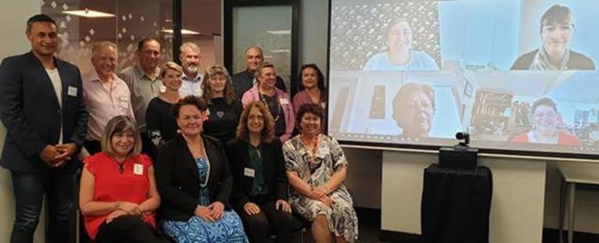

The Consumer Reference Group members are Brian Sheppard, Christine Sapwell, Diana Ayling, Heather Browning, Henare Kani, Jo Stafford, John MacDonald, Leilani Jackson, Libby Burgess, Marj Allan, Mary Bradley, May Seager, Ngāroimata Reid, Sarah Koopu, Theona Ireton and Vivian Hahipene.

More information on Te Aho o Te Kahu advisory groups and introductions from each member of the Consumer Reference Group [can be found here](https://teaho.govt.nz/about/our-people/leadership).

[**COVID and Cancer Services – Fifth Report Released**](https://teaho.govt.nz/reports/cancer-care)

There continues to be an increase in new cancer registrations in August 2020. This report shows we have nearly caught up on the drop in cancer registrations seen over the lockdown period. We are now working to identify impact of COVID on lung cancer specifically - with the hope this can feed into advice on how to address any remaining issues.

New Zealand's COVID cancer response has recently been singled out in [the Lancet Oncology Journal.](https://www.thelancet.com/journals/lanonc/article/PIIS1470-2045(20)30638-0/fulltext?rss=yes) This is a testament to our determined, innovative cancer sector and the bravery and strength of those continuing their battle with cancer during a global pandemic.

## **DHB visits**

I am continuing my visits to DHBs, with a team from Te Aho o Te Kahu visiting Lakes, Waikato and Bay of Plenty DHBs in September, and Hawkes Bay DHB yesterday. I also visited Canterbury and Hawke’s Bay DHBs recently.

These visits allow discussions with chief executives, clinical staff and management teams from each DHB about the role and function of Te Aho o Te Kahu. We were able to hear from them about many of the initiatives underway to improve access to care across their regions and they were able to share their concerns. I thank them for taking the time to connect with us and I look forward to further DHBs visits this year and early next year.

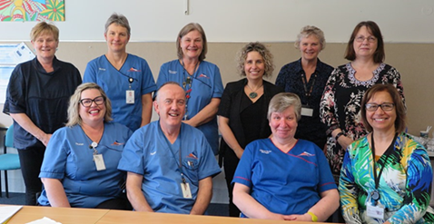

Te Aho o Te Kahu staff with Lakes DHB Cancer Nurses and Psychologist.

## **Lung Cancer Quality Improvement Report**

The draft Lung Cancer Quality Improvement Report has been released to DHBs so they can review and validate the data in the report.  Completing this report is an important step in improving outcomes for people living with Lung Cancer. Once DHB feedback has been incorporated, this report will be published on our website on the [Reports and Publications](https://teaho.govt.nz/reports/publications) page and will inform the Lung Cancer Quality Improvement Plan.

## **Bowel Cancer Quality Improvement Plan**

In October we released the Bowel Cancer Quality Improvement Plan to the sector. This plan sets out actions for quality improvement against the [Bowel Quality Improvement Report](https://teaho.govt.nz/reports/publications) published last year. The plan provides suggested actions for DHBs and looks at where we need to work nationally on further improvements support the sector. My gratitude to the National Bowel Cancer Working Group for the work they have done on this plan. It will be available on our [Reports and Publications](https://teaho.govt.nz/reports/publications) webpage shortly.

## **Kia Ora E Te Iwi**

The Kia Ora e Te Iwi programme has been designed for whānau affected by and coping with cancer. It is an opportunity to learn about cancer, its treatment, services available for support and help with coping skills.

Te Manawa Taki Hub team member, Lydia Rickard, co-facilitated a Kia Ora E Te Iwi Wānanga in Te Araroa and has been involved in a number of Zoom hui with whānau in Taumarunui (Waikato DHB), Taupo (Lakes DHB) and Ruatorea (Hauora Tairāwhiti). There is a strong feedback loop – whānau to DHB and DHB improvements back to whānau. Positive feedback from participants has indicated the Kia Ora E Te Iwi programme is of value to local Whānau Māori.

## **Community Hui**

Our Person and Whānau-centred Care Team has begun planning for a series of Community Hui around the motu in 2021. These are initially being led out of the Central Hub, as a follow-up to the Deep Dive Hui held in the Central region in 2019 and earlier this year.

These hui will provide a platform to come together with Whānau Māori to hear their aspirations for those living with cancer in their communities.

## **Establishment activity continues**

Recruitment continues as we build up our teams, both centrally and in each of our hubs. I am pleased to introduce our recently recruited Clinical Director, Elizabeth Dennett and new Treatment, Quality and Standardisation Manager, Gabrielle Nicholson.

Elizabeth joins us from Otago University where she has been the Associate Professor of Surgery since 2003, and Deputy Head of Department, Surgery and Anaesthesia since 2015. Gabrielle is coming from the Health Quality and Safety Commission where she has held various Senior Programme and Portfolio Management roles since 2012.

I am excited about the expertise, knowledge and skills Elizabeth and Gabrielle will bring to our work programme at Te Aho o Te Kahu. Please see [Our People](https://teaho.govt.nz/about/our-people) page on our website for more information about our team.

In the busy lead-up to Christmas and the New Year please take care of yourselves, your colleagues, your patients and whānau.

Ngā manaakitanga

Di

**Mā te whiritahi, ka whakatutuki ai ngā pūmanawa ā tāngata.** Together weaving the realisation of potential.