COVID-19 and cancer services
A Cancer Control Agency working report on the impact of COVID-19 and the lockdown on cancer services in New Zealand

May 2020

Acknowledgements
With thanks to colleagues in the Ministry of Health, University of Otago, Health Quality and Safety Commission, Hei Āhuru Mōwai, DHBs and clinicians for their input into this report. In particular, the members of the COVID-19 Data Response Advisory Group and the Cancer Agency COVID Agile Response Team.
Members of the Data Response Advisory Group: Alexander Dunn, Angela Pidd, Bridget Robson, Christine Fowler, Christopher Jackson, Diana Sarfati, Elinor Millar, Heidi Watson, James Stanley, Jason Gurney, John Manderson, Michelle Mako, Nikolai Minko, Nina Scott, Richard Hamblin, Ruth Pirie, Scott MacFarlane, Shaun Costello
Members of the Cancer Agency COVID Agile Response Team (CACART): Christopher Jackson, Claire Hardie, Diana Sarfati, Elinor Millar, Mary-Ann Hamilton, Michelle Mako, Mark Winstanley, Myra Ruka, Richard Doocey, Richard North, Robert Weinkove, Suzanne Beuker, Tom Middlemiss

Contents

Contents 3
Summary 4
Introduction 6
Cancer Registrations 7
Gastrointestinal endoscopy 12
Bronchoscopy 13
Combined curative cancer surgery 15
Colorectal cancer surgery 16
Lung cancer surgery 18
Prostate cancer surgery 20
Medical oncology 21
Radiation oncology 24
Haematology 27
Conclusions 30
Appendix 1: NZCR data 31
Appendix 2: NZCR registrations by DHB 32
Appendix 3: Surgical procedure codes 36

Summary
Overview of impact of COVID-19 lockdown on cancer diagnosis and treatment
Cancer treatment services were largely maintained during the COVID-19 lockdown. This was the result of a rapid collective response from the cancer sector across New Zealand, with strong central leadership from the Cancer Control Agency. However, there was a large disruption to diagnostic services, contributing to a significant reduction in new cancer diagnoses. In general, to date, the disruptions to the cancer care pathway have not increased inequities for Māori.

Background and data
- The purpose of this analysis was to rapidly measure the impact of COVID-19 and the lockdown on cancer services.
- Comparisons between 2020 and 2019 do not consider any projected increase in diagnoses over time.
- The focus of the report was to understand the impact of COVID-19 on existing service delivery and does not take into account pre-existing unmet need.
- This is a working report to assist with recovery planning. Further analysis will be completed as more data becomes available.

Cancer diagnosis
- There were 1031 fewer cancer registrations in April 2020 compared to April 2019, a 47% decrease. For the year to date (up until end of April 2020), there were 500 fewer cancer registrations compared to the same time period in 2019.
- The decrease in cancer registrations was similar across ethnic groups. Comparing the first four months of 2020 to the same time period in 2019, there was a 6% decrease in registrations for both Māori and Pacific, and a 7% decrease for European/other.
- The decrease in registrations over the lockdown period is seen across all tumour groups; however, the overall impact on registrations for the year to date was most marked for prostate cancer, haematology/lymphoid and breast cancers.
- The decrease in cancer registrations over the lockdown period is seen relatively consistently across all DHBs. However, the impact of the lockdown on cumulative registrations for the year to date varied by DHB. Southern DHB and Waikato DHB have seen the largest decrease in cancer registrations for the year to date.
- There was a substantial decrease in gastrointestinal endoscopy services over the COVID-19 lockdown. Nationwide there were 79% fewer gastrointestinal endoscopies completed in April 2020 compared to April 2019. Māori were not disproportionately impacted by changes to endoscopy.
- There was a substantial decrease in bronchoscopies performed during the lockdown, with a 75% decrease in the number of bronchoscopies performed in April 2020 compared to April 2019. Māori were disproportionately impacted by the decrease in bronchoscopies over the first four months of the year (35% decrease for Māori compared to 28% decrease for non-Māori/non-Pacific). This appears to have started prior to the lockdown, with fewer bronchoscopies from February 2020.

Cancer Treatment

Surgery
- There was a 33% decrease in curative cancer surgeries (for prostate, lung and colorectal cancers) in April 2020 compared to April 2019. The decrease in surgery was less for Māori than for non-Māori/non-Pacific in the month of April (25% decrease for Māori compared to 33% decrease for non-Māori/non-Pacific).
- The decrease in curative surgery appears to be largely driven by the decrease in diagnostic services.
- There has been a large decrease in curative lung cancer surgery for Māori in 2020 compared to 2019. The decrease in lung cancer surgery follows the pattern seen for bronchoscopies, with the decrease starting prior to lockdown.

Chemotherapy and radiotherapy
- Attendances for intra-venous chemotherapy remained largely stable over the lock down period. There was a small (3%) decrease in attendances in April 2020 compared to April 2019. This likely reflects the implementation of nationally agreed upon guidance, which aimed to preserve day unit capacity and minimise spread of COVID-19. This included consideration of switching from IV therapy to a comparable oral therapy if possible and selection of comparable therapies that require less frequent attendances to hospital.
- There was a decrease in haematology first specialist appointments during April 2020. This aligns with the decrease in haematology cancer registrations and may also reflect a decrease in FSAs for non-malignant, non-urgent indications, deferred as part of the hospital response framework. Despite the decrease in FSAs and diagnoses, attendance for IV chemotherapy for haematological malignancies remained stable during the lockdown.
- Attendance for radiation oncology first specialist assessment remained stable during lockdown. There was an overall reduction in attendances for radiotherapy during April 2020 compared to April 2019. This likely reflects implementation of the nationally agreed upon guidance to hypo-fractionate during the lockdown to minimise the risk of COVID-19 spread and to consider lower contact treatment options, such as hormone therapy for prostate cancer.
- There was a larger decrease in radiation oncology attendances for Māori compared to non-Māori during the lockdown, which is different from the pattern seen for chemotherapy. This may reflect the regional nature of radiotherapy services and greater requirement to travel for treatment. There were disruptions to transport and accommodation options during the lockdown, which may have disproportionately impacted on Māori.

Introduction

Background
New Zealand has, so far, fared comparably well against COVID-19. Early border closures and the pursuance of a COVID-19 elimination strategy prevented our health system from being overrun. This protected people with cancer, enabling hospital services to continue and protecting those who are immunocompromised from the spread of COVID-19.
During the COVID-19 pandemic the Cancer Control Agency worked closely with cancer clinicians across the country, working groups and Hei Āhuru Mōwai to support the ongoing delivery of treatment services. This included identifying and addressing barriers to the provision of services during the lockdown.
However, we don’t fully understand the impact of the national lockdown on the cancer care pathway, including cancer prevention, access to primary care, diagnostics and treatment services. The sudden unplanned disruption in usual care will inevitably lead to a backlog of unmet need. Any disruption will have an impact on cancer patients in general and may have a disproportionate impact on those who already experience greater barriers to accessing care, particularly Māori and Pacific peoples.
Understanding exactly what has happened to cancer care during the lockdown will help with planning for the recovery phase of the pandemic.

Purpose of this report
This report aims to rapidly collate evidence on the magnitude of delays to cancer diagnosis and treatment, and the extent to which this has created or exacerbated inequities. As well as helping with recovery planning, this will provide evidence that will support informed decision-making in relation to the relative benefits and harms of future policy decisions.

Data and analysis
The data in this report comes from Ministry of Health national data collections. Each section of the report includes information on where the data is from and any limitations with the data.
It is important to note that the purpose of the analysis was to rapidly measure the impact of COVID-19 and the lockdown on cancer services and does not take into account pre-existing unmet need. The report also makes direct comparisons between 2020 and 2019 and does not consider any projected increase in diagnoses over time.
This is a working report, developed rapidly to assist with recovery planning. Further analysis will be completed as more data becomes available.

Key dates
This report focuses on the lockdown period. Key dates over this time include:
- 22nd March, alert level 3 and hospital alert level framework released
- 26th March, alert level 4,
- 28th April, alert level 3
- 14th May, alert level 2

Cancer Registrations

Notes on data
- The data come from pathology reports from the New Zealand Cancer Register (NZCR). This means that cancers diagnosed without pathology (e.g. radiology alone) will not be counted in this analysis.
- Due to a temporary issue with referrals through to NZCR, Community Anatomic Pathology Service (CAPS) data has been excluded from all analysis (this accounts for approximately 12% of data). This mostly affects the Auckland DHBs. CAPS are the main provider for private and GP laboratory work.
- ‘Date’ is date of diagnosis on the NZCR – usually the date the specimen was taken from the person and sent to the laboratory. Analyses include all new provisional and registered cancer events based on pathology and haematology reports. Data were extracted on 21 May 2020.
- Further information on this data is included in Appendix 1.

Results
Table 1 and Figure 1 show the decrease in cancer registrations in 2020 compared to 2019 by month, and the cumulative impact this has had on cancer registrations for the year to date (up until the end of April 2020). A similar pattern is seen across all ethnicities (Figure 2 and Figure 3).
Table 1: Absolute number and percentage change in cancer registrations in 2020 compared to 2019 by month, and cumulative year to date
 | March 2020 |  | April 2020 |  | Year to date
 | Number | % | Number | % | Number | %
Māori | 19 | 7.9 | -105 | -43.8 | -55 | -6.0
Pacific | -5 | -5.0 | -30 | -36.6 | -21 | -6.1
Asian | 16 | 13.9 | -40 | -38.8 | 34 | 8.6
European/Other | -45 | -2.3 | -853 | -48.4 | -467 | -6.7
Total Population | -9 | -0.4 | -1031 | -46.9 | -500 | -5.7
Note: a small number of reports have ‘unspecified’ ethnicity, meaning the sum of all ethnic groups may not equal the total population.
Figure 1: Total number of cancer registrations by month and year (left), cumulative number of cancer registrations by year (right)

Figure 2: Number of cancer registrations by month and year, by ethnicity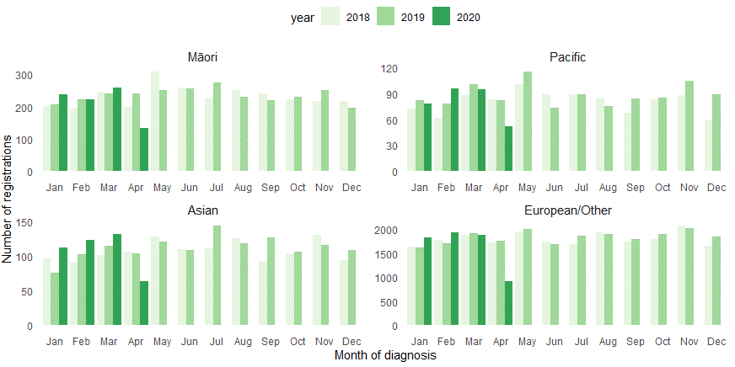
Figure 3: Cumulative number of cancer registrations by year, by ethnicity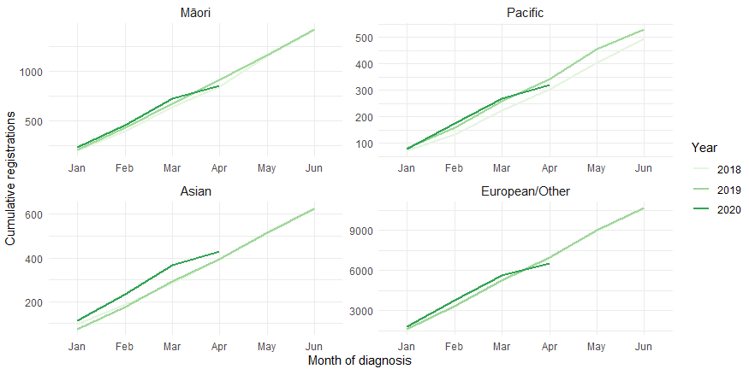

There was a decrease in cancer registrations across all major cancer groups in April 2020; however, this had a variable impact on the overall difference in registrations for the year to date. Table 2 shows the change in cancer registrations in 2020 compared to 2019 by cancer group, for cancers with over 1000 registrations per year. This is presented as number of registrations by month (Figure 4) and cumulative number of registrations by year (Figure 5).

Table 2: Changes in cancer registration in 2020 compared to 2019 by month and for the year to date, absolute difference in number of cases and percentage change, by cancer group.
 | March 2020 |  | April 2020 |  | Year to date
Cancer Group | Number | % | Number | % | Number | %
Prostate | -105 | -32 | -169 | -64.8 | -241 | -21.8
Haematology and Lymphoid | 5 | 2.6 | -100 | -51.0 | -125 | -15.7
Breast | 34 | 10.8 | -210 | -62.3 | -104 | -8.6
Urinary system | -24 | -18.5 | -7 | -7.1 | -40 | -8.8
Melanoma and non-melanoma skin cancer | 8 | 1.6 | -220 | -55.6 | -11 | -0.6
Colorectal | -7 | -2.5 | -110 | -44.5 | -6 | -0.6
Other digestive system | -10 | -7.8 | -50 | -38.8 | -5 | -1.1
Respiratory and thorax | -9 | -5.5 | -29 | -20.1 | -5 | -0.9
Cervix | 15 | 10.3 | -94 | -58.4 | 13 | 2.3
Gynaecology | 18 | 20.2 | -26 | -34.2 | 18 | 5.3
Figure 4: Number of cancer registrations by month and year, by cancer group
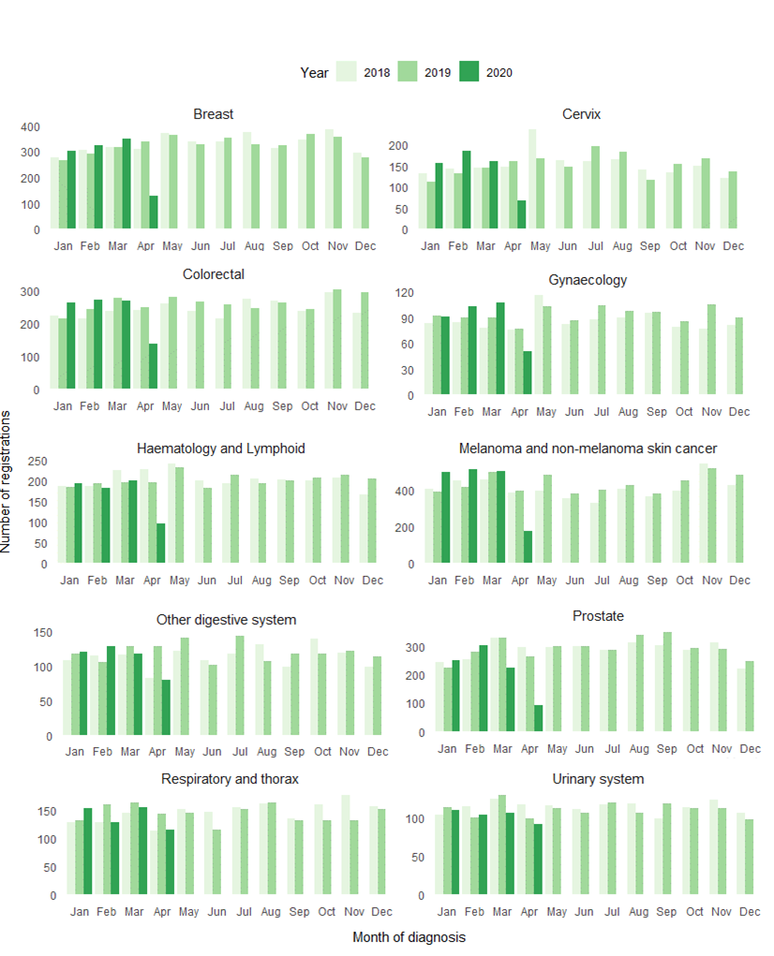
Figure 5: Cumulative number of cancer registrations by year, by cancer group
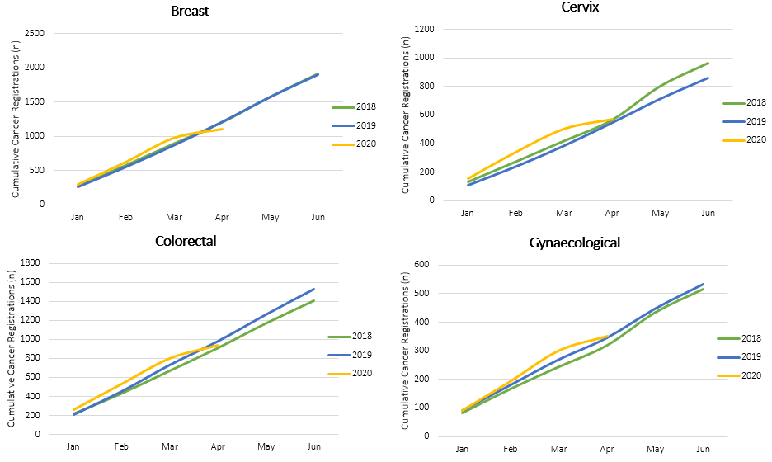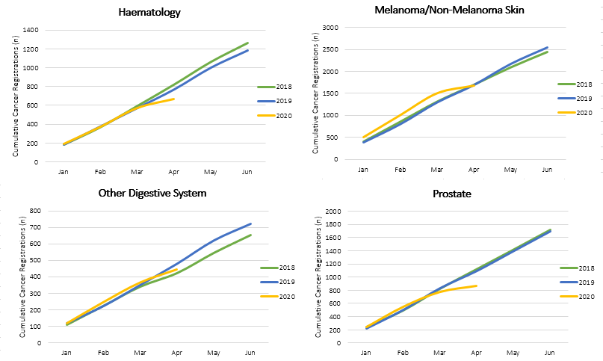
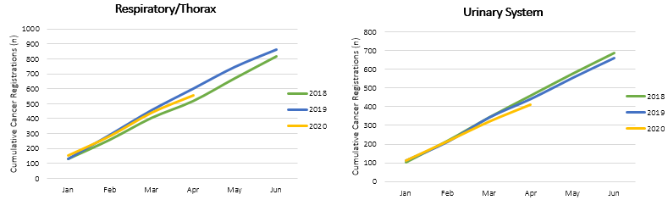
The decrease in cancer registrations over the lockdown period is seen relatively consistently across all DHBs. However, the impact of the lockdown on overall registrations for the year to date varies by DHB. Table 3 shows the changes in cancer registration in 2020 compared to 2019 for the year to date (up until end of April 2020) by DHB. This is presented as absolute difference in number of cases, as well as the percentage difference. Appendix 2 includes graphs showing monthly and cumulative cancer registrations by DHB.
Table 3: Changes in cancer registration in 2020 compared to 2019 by month and for the year to date, absolute difference in number of cases and percentage change, by DHB of domicile (See Appendix 2 for graphs)
 | March 2020 |  | April 2020 |  | Year to date
DHB | Number | % | Number | % | Number | %
Southern | -52 | -24.6 | -153 | -70.2 | -178 | -22%
Waikato | -5 | -2 | -118 | -53.9 | -121 | -13%
Hawkes Bay | -31 | -27.2 | -47 | -53.4 | -62 | -16%
Capital and Coast | -8 | -5.3 | -82 | -56.6 | -56 | -11%
Canterbury | -2 | -0.7 | -120 | -44.3 | -38 | -4%
Bay of Plenty | -24 | -13.3 | -56 | -38.6 | -36 | -6%
Nelson Marlborough | -17 | -13 | -60 | -56.6 | -34 | -8%
Hauora Tairāwhiti | -5 | -17.2 | -24 | -66.7 | -23 | -20%
Northland | -21 | -17.5 | -34 | -34.3 | -18 | -4%
West Coast | 3 | 25 | -10 | -45.5 | -15 | -19%
South Canterbury | 6 | 20 | -20 | -51.3 | -11 | -8%
Lakes | 12 | 21.8 | -35 | -56.5 | -10 | -4%
Auckland | 28 | 21.4 | -21 | -22.1 | -9 | -2%
Wairarapa | -5 | -14.3 | -7 | -29.2 | -5 | -5%
Whanganui | 12 | 24.5 | -23 | -47.9 | -3 | -1%
Counties Manukau | 22 | 11.6 | -66 | -40.2 | 3 | 0%
Hutt Valley | -4 | -4.9 | -26 | -40.6 | 4 | 1%
Waitemata | 27 | 16.1 | -53 | -30.5 | 22 | 3%
MidCentral | 23 | 21.3 | -44 | -44 | 32 | 8%
Taranaki | 32 | 56.1 | -35 | -44.3 | 46 | 19%

Key points
- There were 1031 fewer cancer registrations in April 2020 compared to April 2019. This is a 47% decrease in cancer registrations.
- Overall for the year to date (up until end of April 2020), there have been 500 fewer cancer registrations compared to the same time period in 2019, a 6% decrease.
- The decrease in cancer registrations was similar across ethnic groups. Over the year to date there was a 6% decrease in registrations for both Māori and Pacific, compared to a 7% decrease for European/other. There was an increase in registrations for Asian ethnic group.
- The decrease in registrations over the lockdown period was relatively consistent across tumour groups; however, the overall impact on registrations for the year to date was most marked for prostate cancer, haematology/lymphoid and breast cancers.
- In general, it is likely that any delays to cancer diagnosis due to temporary suspension of screening programmes will not have been detected in the period covered here, although a small amount of the decline in breast cancer registrations may be due to this.
- The decrease in cancer registrations over the lockdown period is seen relatively consistently across all DHBs. However, the impact of the lockdown on cumulative registrations for the year to date varied by DHB. Southern DHB and Waikato DHB have seen the largest decrease in cancer registrations for the year to date.

Gastrointestinal endoscopy

Notes on data
- Gastrointestinal endoscopy data were extracted from National Non-admitted Patient Collection (outpatient) and National Minimum Dataset (inpatient) on 21 May 2020.
- Includes colonoscopies and gastroscopies for all indications (i.e. not just cancer).
- Technical information: Gastroscopies (Purchase Unit Code - MS02005), Colonoscopies (Purchase Unit Code - MS02007), Combined Gastroscopies + Colonoscopies (Purchase Unit Code - MS020014).

Results
There was a significant reduction in gastrointestinal endoscopies during the lock down. Table 4 shows the percentage change in gastrointestinal endoscopy procedures in 2020 compared to 2019. This is presented as difference by each month, as well as overall difference for the year to date (up until the end of April 2020).
Table 4: Percentage change in colonoscopy and gastroscopy in 2020 compared to 2019 by month, and cumulative year to date
 | Jan | Feb | March | April | YTD
Māori | +5% | +16% | -4% | -71% | -13%
Non-Māori/Non-Pacific | +8% | +6% | -15% | -80% | -21%
Total population | +9% | +7% | -13% | -79% | -20%

Figure 6: Number of gastrointestinal endoscopy procedures by month and year, for the total population (left) and for Māori (right)

Figure 7: Cumulative number of gastrointestinal endoscopy procedures by year, for the total population (left) and for Māori (right)

Key points
- There was a substantial decrease in gastrointestinal endoscopy services at the end of March and through April, aligning with the COVID-19 lockdown.
- The decrease in endoscopies is consistent with the decrease in colorectal cancer registrations (see Figure 4 and Figure 5).
- Nationwide there were 79% fewer gastrointestinal endoscopies performed in April 2020 compared to April 2019. Overall, during the first four months of 2020 there has been a 20% decrease in gastrointestinal endoscopies.
- Māori were not disproportionately impacted by changes to endoscopy (a 13% decrease for Māori compared to a 21% decrease for non-Māori/Non-Pacific).

Bronchoscopy

Notes on data
- Bronchoscopy data were extracted from National Non-admitted Patient Collection (outpatient) and National Minimum Dataset (inpatient) on the 21st May 2020.
- Includes bronchoscopies for any indication (i.e. not just cancer).
- Technical information: Bronchoscopies (Purchase Unit Code - MS02003).

Results
There has been a reduction in the number of bronchoscopies performed every month of 2020 compared to 2019 (Table 5). However, this is most significant in April 2020 compared to April 2019 (Figure 8).
Table 5: Percentage change in bronchoscopies in 2020 compared to 2019 by month, and cumulative year to date
 | Jan | Feb | March | April | YTD
Māori | -13% | -22% | -32% | -83% | -35%
Non-Māori/Non-Pacific | -12% | -10% | -3% | -75% | -28%
Total population | -12% | -11% | -7% | -75% | -29%
Figure 8: Number of bronchoscopies by month and year, for the total population (left) and for Māori (right)

Figure 9: Cumulative number of bronchoscopies procedures by year, for the total population (left) and for Māori (right)

Key points
- There was a substantial decrease in bronchoscopies performed during the lockdown, with a 75% decrease in the number of bronchoscopies performed in April 2020 compared to April 2019.
- There were 29% fewer bronchoscopies performed in the first four months of 2020 compared to the first four months of 2019.
- Māori were somewhat disproportionately impacted by the cumulative decrease in bronchoscopies (35% decrease for Māori compared to 28% decrease for non-Māori/non-Pacific). This appears to have started prior to the lockdown, with fewer bronchoscopies from February.
- It is possible that bronchoscopy practice changed earlier than other diagnostic services, due to the anticipation of COVID-19 and caution with aerosolising procedures. It is also possible that this led to an increase in radiological investigation, which would not be captured in these data.

Combined curative cancer surgery

Notes on data
- This report includes data on curative surgery for colorectal, lung and prostate cancer. These cancers were chosen because a pre-validated list of surgical procedure codes for these cancers already existed within the Cancer Control Agency– agreed on as part of the quality performance indicator work programme. These three cancers are therefore used as case studies for cancer surgery more generally. The procedure codes are included in Appendix 3.
- The data was extracted from the National Minimum Dataset on 21 May 2020.

Results
There was a reduction in cancer surgery performed in April 2020 compared to April 2019 (Table 6). This has resulted in a small reductive in the cumulative number of surgeries performed during the first four months of 2020 compared to the same time period in 2019 (Figure 11).
Table 6: Percentage change in curative surgery (colorectal, lung and prostate) in 2020 compared to 2019 by month, and cumulative year to date
 | March | April | YTD
Māori | +16% | -25% | +2%
Non-Māori/Non-Pacific | -8% | -32% | -10%
Total Population | -7% | -33% | -9%

Figure 10: Number of curative cancer surgeries (prostate, colorectal, lung) by month and year, for the total population (left) and for Māori (right)

Figure 11: Cumulative number of curative cancer surgeries (colorectal, lung, prostate) by year, for the total population (left) and for Māori (right)

Key points
- There was a 33% decrease in curative cancer surgeries (prostate, lung and colorectal) in April 2020 compared to April 2019. This contributed to a 9% overall decrease in curative cancer surgeries for 2020 year to date.
- The decrease in surgery was less for Māori than for non-Māori/non-Pacific in the month of April (25% decrease for Māori compared to 32% decrease for non-Māori/non-Pacific). Over the first four months of 2020 there has been a 2% increase in curative cancer surgery for Māori (compared to a 10% decrease for non-Māori/non-Pacific).
- The decrease in curative cancer surgery is less abrupt than the decrease in endoscopies and appears to occur slightly after the lockdown began. This suggests that the decrease in surgery may be driven by a decrease in diagnostic services (this is looked at further in the following section on colorectal surgery)

Colorectal cancer surgery

Notes on data
- A list of the surgical procedure codes used for analysis are included in Appendix 3.
- The data was extracted from the National Minimum Dataset on 21 May 2020.

Results
There was a reduction in the total number of curative colorectal cancer surgeries performed in April 2020 compared to April 2019. The decrease in surgery is smaller for Māori compared to non-Māori (Table 7). Despite the lockdown, there has been a substantial increase in the number of colorectal cancer surgeries for Māori in the first four months of 2020 compared to the same time period in 2019 (Figure 13).
Table 7: Percentage change in curative colorectal cancer surgery in 2020 compared to 2019 by month, and cumulative year to date
 | March | April | YTD
Māori | +94% | -22% | +34%
Non-Māori/Non-Pacific | -14% | -40% | -13%
Total Population | -6% | -40% | -9%

Figure 12: Number of curative colorectal cancer surgeries by month and year, for the total population (left) and for Māori (right)

Figure 13: Cumulative number of curative colorectal cancer surgeries by year, for the total population (left) and for Māori (right)

In general, people with colorectal cancer would expect to receive surgery within a month of colonoscopy. Figure 14 demonstrates the 3-week lag in the decrease in colorectal surgery following the decrease in colonoscopies.
Figure 14: Number of colonoscopies and colorectal surgeries performed in 2020 by week

Key points
- There was a decrease in colorectal surgery during lockdown, this has led to an overall 9% decrease in colorectal surgery for the year to date.
- During April there was a smaller decrease for Māori (-22%) than for non-Māori/non-Pacific (-40%). There has been an overall 34% increase in curative colorectal cancer surgery for Māori for the year to date compared to the same time period in 2019.
- The decrease in colorectal cancer surgeries is likely to be largely driven by the decline in diagnostic colonoscopies performed during lockdown.

Lung cancer surgery

Notes on data
- A list of the surgical procedure codes used for analysis are included in Appendix 3.
- The data were extracted from the National Minimum Dataset on 21 May 2020.
- The number of lung cancer surgeries performed each month is relatively small, so caution is needed when comparing data by month.

Results
Table 8 shows a reduction in the total number of curative lung cancer surgeries performed in 2020 compared to 2019. Due to small numbers, this is only presented for the total population. Figure 16 shows that the reduction in lung cancer surgeries began prior to lockdown, and the cumulative impact of this has been greater for Māori than for the total population.
Table 8: Percentage change in curative lung cancer surgery in 2020 compared to 2019 by month, and cumulative year to date.
 | March | April | YTD
Total Population* | -24% | -15% | -19%
*Due to the small number of surguries performed each month calculations have only been included for the total population rather than by ethnicity
Figure 15: Number of curative lung cancer surgeries by month and year, total population (left) and for Māori (right)

*Due to the small number of surguries performed each month it is not possible to draw conclusions from small changes between months.
Figure 16: Cumulative number of curative lung cancer surgeries by year, for the total population (left) and for Māori (right)

Key points
- There was a decrease in curative lung cancer surgery in April 2020 compared to April 2019. This contributed to a substantial (19%) decrease in curative lung cancer surgeries in the first four months of 2020 compared to 2019.
- There has been a large decrease in curative lung cancer surgery for Māori in 2020 compared to 2019.
- The decrease in lung cancer surgery follows the pattern seen for bronchoscopies, with the decrease starting prior to lockdown. It is unclear what is driving this, but it could be due to a change in the investigation and management of lung cancer earlier in 2020 in anticipation of COVID-19. This could include an increase in radiotherapy for lung cancer to minimise invasive respiratory procedures and protect ICU capacity.
- The early decrease in lung cancer surgery is most noticeable for Māori, with fewer curative surgeries performed since the beginning of 2020 (noting that the numbers are relatively small).

Prostate cancer surgery

Notes on data
- A list of the surgical procedure codes used for analysis are included in Appendix 3.
- The data was extracted from the National Minimum Dataset on 21 May 2020.
- The number of prostate cancer surgeries performed each month is relatively small, so caution is needed when comparing data by month.

Results
There was a decrease in the number of prostate cancer surgeries performed in April 2020 compared to April 2019; however, this has not resulted in an overall reduction in the total number of prostate cancer surgeries performed in 2020 compared to 2019 (Table 9).
Table 9: Percentage change in curative prostate cancer surgery in 2020 compared to 2019 by month, and cumulative year to date
 | March | April | YTD
Total Population* | 13% | -21% | 3%
*Due to the small number of surguries performed each month calculations have only been included for the total population rather than by ethnicity
Figure 17: Number of curative prostate cancer surgeries by month and year, total population (left) and for Māori (right)

*Due to the small number of surguries performed each month it is not possible to draw conclusions from small changes between month.
Figure 18: Cumulative number of curative prostate cancer surgeries by year, for the total population (left) and for Māori (right)

Key points
- There was a drop off in curative prostate cancer surgery during the lockdown. This aligns with a decrease in diagnoses of prostate cancer (see Figure 4 and Figure 5).
- The lockdown has, so far, had minimal impact on the overall number of prostate cancer surgeries performed in 2020 compared to 2019.

Medical oncology

Notes on data
- Extracted from National Non-admitted patient collection (Outpatient collection) on 21 May 2020.
- First specialist assessment (FSA) reflects counts of first attendance for specialist medical oncology assessment.
- IV chemotherapy reflects appointments for outpatient IV chemotherapy for non-haematological indications.
- Technical information: FSA (PUC M50020), outpatient IV chemotherapy (PUC MS02009)

Results
Overall, first specialist appointments for medical oncology remained stable in April 2020 compared to April 2019; however, there was a decrease in FSAs for Māori in April (Table 10).
Table 10: Percentage change in medical oncology first specialist assessments in 2020 compared to 2019 by month, and cumulative year to date
 | Jan | Feb | March | April | YTD
Māori | -6% | -24% | 28% | -19% | -8%
Non-Māori/Non-Pacific | -6% | 0% | 7% | 12% | +1
Total | -4% | -2% | 13% | 9% | +2
Figure 19: Number of medical oncology first specialist assessments by month and year, for the total population (left) and for Māori (right)

Figure 20: Cumulative number of medical oncology first specialist assessments by year, for the total population (left) and for Māori (right)

The was a small decrease in the number of attendances for IV chemotherapy in April 2020 compared to April 2019 for the total population, with an increase seen for Māori (Table 11). Overall, there has been a significant increase in attendances for IV chemotherapy for Māori in the first four months of 2020 compared to the same time period in 2019.
Table 11: Percentage change in IV chemotherapy attendances in 2020 compared to 2019 by month, and cumulative year to date
 | Jan | Feb | March | April | YTD
Māori | 21% | 12% | 11% | 16% | 14%
Non-Māori/Non-Pacific | 7% | 3% | 6% | -6% | 1%
Total | 8% | 4% | 6% | -3% | 2%
Figure 21: Number of attendances for IV chemotherapy by month and year, for the total population (left) and for Māori (right)

Figure 22: Cumulative number of attendances for IV chemotherapy by year, for the total population (left) and for Māori (right)

Key points
- Overall attendance for medical oncology FSAs remained stable during lockdown, despite a decrease in new diagnoses. This may reflect the fact that a large proportion of first line cancer treatment is surgical, and so the decrease in FSAs for medical oncology may occur in the weeks/months to come.
- There was a decrease in FSAs for Māori during the lockdown. This is different from the pattern seen for FSAs for radiation oncology and haematology (see Table 12 and Table 14). This may reflect differences in other parts of the cancer pathway not measured in this report (e.g. radiology), or access to technology for virtual appointments. There was an increase in FSAs for Māori in March, so it is also possible that the fluctuation is related to the relatively small numbers. This will be investigated further and continue to be monitored.
- Attendances for intra-venous chemotherapy remained largely stable over the lock down period. There was a 3% decrease in attendances in April 2020 compared to April 2019. This likely reflects the implementation of nationally agreed upon guidance, which aimed to preserve day unit capacity and minimise spread of COVID-19. This included consideration of switching from IV therapy to oral therapy when there is a broadly comparable health gain and selection of comparable therapies that require less frequent attendances to hospital. This included changes to special authority requirements to reduce pressure on the health system (e.g. change from 3 weekly to 6 weekly pembrolizumab).
- There had been a 14% increase in IV chemotherapy for Māori in the first four months of 2020 compared to 2019.

Radiation oncology

Notes on data
- Extracted from National Non-admitted patient collection on 21 May 2020.
- First specialist assessment (FSA) reflects counts of first attendance for radiation oncology specialist assessment.
- Megavoltage attendance reflects appointments for planning/simulation and for treatment with radiation therapy on a linear accelerator.
- Technical information: radiation oncology FSA (PUC M50022), megavoltage attendances (Purchase Unit Code M50025)

Results
There was minimal change in radiation oncology FSAs in April 2020 compared to April 2019 (Table 12). There has been a consistent number of radiation oncology FSAs over the year for both Māori and for the total population (Figure 24 Figure 24).
Table 12: Percentage change in radiation oncology first specialist assessments in 2020 compared to 2019 by month, and cumulative year to date
 | Jan | Feb | March | April | YTD
Māori | 3% | -7% | 23% | 8% | 6%
Non-Māori/Non-Pacific | 10% | -5% | 6% | 0% | +1%
Total | 7% | -3% | 6% | 2% | 2%
Figure 23: Number of radiation oncology first specialist assessments by month and year, total population (left) and for Māori (right)

Figure 24: Cumulative number of radiation oncology first specialist assessments by month and year, total population (left) and for Māori (right)

There was an overall reduction in radiation therapy attendances (for planning and for treatment) in April 2020 compared to April 2019 (Table 13). This decrease was slightly larger for Māori than for non-Māori (Figure 25 and Figure 26).
Table 13: Percentage change in radiation therapy attendances in 2020 compared to 2019 by month, and cumulative year to date
 | Jan | Feb | March | April | YTD
Māori | -6% | 0% | -5% | -24% | -10%
Non-Māori/Non-Pacific | -3% | -6% | -3 | -19% | -8%
Total | -3% | -4% | -2% | -19% | -7%
Figure 25: Number of attendances for radiation therapy by month and year, total population (left) and for Māori (right)

Figure 26: Cumulative number of attendances for radiation therapy by month and year, total population (left) and for Māori (right)

Key points
- Attendance for radiation oncology first specialist assessment remained stable during lockdown.
- There was an overall reduction in attendances for radiotherapy during April 2020 compared to April 2019. This may reflect implementation of the nationally agreed upon guidance as part of COVID-19 planning to minimise the risk of COVID-10 spread. This included hypo-fractionation where possible and appropriate, and consideration of alternative treatment option, such as hormone therapy for prostate cancer.
- There was a larger decrease in radiation oncology attendances for Māori compared to non-Māori during the lockdown, which is different from the pattern seen for IV chemotherapy. This may reflect the regional nature of radiotherapy services and greater requirement to travel for treatment. There were disruptions to transport and accommodation options during the lockdown, which may have disproportionately impacted on Māori. This may also reflect Māori having more advanced disease at presentation, which would result in shorter courses of radiotherapy.

Haematology

Notes on data
- Extracted from National Non-admitted Patient Collection 21 May 2020.
- First specialist assessment (FSA) reflects counts of first attendance for specialist haematology assessment for any indication (i.e. not just cancer).
- IV chemotherapy reflects appointments for IV chemotherapy for haematological malignancies.
- Technical information: Haematology FSA (Purchase Unite Code - M30002), outpatient IV haem/chemo (Purchase Unit Code - M30020).

Results
There was an overall decrease in haematology first specialist assessments in April 2020 compared to April 2019 (Table 14).
Table 14: Percentage change in haematology FSAs in 2020 compared to 2019 by month, and cumulative year to date
 | Jan | Feb | March | April | YTD
Māori | 45% | 11% | -4% | 0% | +9%
Non-Māori/non-Pacific | 0% | -4% | -4% | -17% | -8%
Total | 3% | -3% | -4% | -14% | -7%
Figure 27: Number of haematology first specialist assessments by month and year, total population (left) and for Māori (right)

Figure 28: Cumulative number of haematology first specialist assessments by month and year, total population (left) and for Māori (right)

There was minimal change in total attendances for IV chemotherapy for haematological malignancies in April 2020 compared to April 2019 (Table 15).
Table 15: Percentage change in IV chemotherapy attendances for haematological malignancies in 2020 compared to 2019 by month, and cumulative year to date
 | Jan | Feb | March | April | YTD
Māori | -7% | 4% | 12% | 26% | 6%
Non-Māori/non-Pacific | 5% | 12% | 19% | -4% | 7%
Total | 3% | 9% | 18% | 1% | 6%
Figure 29: Number attendances for IV chemotherapy for haematological malignancies by month and year, total population (left) and for Māori (right)

Figure 30: Cumulative number of attendances for IV chemotherapy for haematological malignancies by month and year, total population (left) and for Māori (right)

Key points
- There was a decrease in haematology first specialist appointments during April 2020. This may reflect a decrease in FSAs for non-malignant, non-urgent indications, deferred as part of the hospital response framework.
- The decrease in FSAs also aligns with the decrease in haematological cancer registrations (see Figure 4 and Figure 5). This may reflect a decrease in access to primary care and blood tests during the lock down, which has not been measured in this report.
- Despite the decrease in FSAs and diagnoses, attendance for IV chemo for haematological malignancies remained stable during the lockdown.

Conclusions
- Cancer treatment services were largely maintained during the COVID-19 lockdown. This was the result of a strong collective response from the cancer sector across New Zealand, with active central leadership from the Cancer Control Agency.
- There was a substantial reduction in new cancer registrations over the lockdown period. A key contributor to this was a decrease in diagnostic services, demonstrated in this report by the decrease in gastrointestinal endoscopies and bronchoscopies. Other parts of the diagnostic pathway, such as access to primary care and radiology, have not been measured in this report, but are likely to have also contributed to the reduction in new cancer registrations.
- It is likely that any delays to cancer diagnosis due to temporary suspension of screening programmes will not have been detected in the period covered here, although a small amount of the decline in breast cancer registrations may be due to this.
- Overall, the disruptions to the cancer care pathway do not appear to have increased inequities, with Māori being less severely impacted across most measures.
  - One exception is bronchoscopies and lung cancer surgery, where Māori appear to have been disproportionately impacted and where the decline occurred prior to the lockdown.
  - There was also a larger decrease in radiation oncology attendances for Māori compared to non-Māori during the lockdown. This may reflect the regional nature of radiotherapy services and greater requirement to travel for treatment, highlighting the importance of ensuring transport and accommodation continue.
- Clear planning is needed to ensure inequities are not exacerbated during the recovery phase.
- The purpose of this analysis was to measure the impact of the COVID-19 lockdown on existing service delivery. This does not take into account pre-existing unmet need, or any projected increase in diagnoses over time.
- To minimise the ongoing impact of COVID-related health service disruptions the immediate focus should be on diagnostic services. Endoscopy and bronchoscopy services are currently operating. Careful planning is required to ensure these services can address the backlog of patients.
- It takes time for someone to progress through the cancer care pathway, this means it is likely we have not yet seen the full impact of the COVID-19 lockdown. The Cancer Control Agency will continue to monitor services to help with the ongoing planning and delivery of care.

Appendix 1: NZCR data

The New Zealand Cancer Registry as a source of data for new cancer diagnoses
Cancer registration is a process where data is collated from multiple sources about people diagnosed with cancer and rules are applied to determine the type of cancer they have. This information is recorded in the New Zealand Cancer Registry. Each tumour is classified using an international World Health Organisation standard so that cancer incidence can be compared between countries. The tumour is staged based on all the information available within 4 months of diagnosis. This process may take up to six months or more depending on the number of missing reports that need to be followed up with laboratories.
For each registration there may be multiple pathology reports as there may be multiple procedures performed on the tumour. This means there will be more than one registration for people diagnosed with more than one type of tumour.
Cancer registrations come from pathology laboratories, haematology laboratories, mortality records and reviewing hospital discharge records. Laboratory reports provide the best source of near real time data to monitor new diagnoses of cancer in New Zealand.

Pathology reports as a data source for providing near real time monitoring cancer diagnoses
Pathology reports (documents) are received by the NZCR as electronic messages. An administrator triages these documents each day and if the document appears to meet the requirements for registration the document is “administered”. The document may relate to an existing registration or may contain information for a new cancer event. Documents that do not meet the cancer reporting requirements will be marked as “deleted”, “rejected” or “agreed not for registration”.
The administrator creates a new provisional cancer event if the pathology report identifies a new cancer diagnosis for this person. This new cancer event is assigned to a cancer group and this provisional event is then queued for further assessment by a clinical coder. If the required information has been provided the coder creates a new registration. If some information is not yet available, then the registration is held open until further information arrives to complete the registration or determine that the tumour does not meet the registration criteria.

Appendix 2: NZCR registrations by DHB
Note: Due to an issue with referrals through to NZCR, all CAPS (Community Anatomic Pathology Service) data has been excluded (accounts for approximately 12% of data). This means that the number of registrations in the Auckland DHBs appears low.
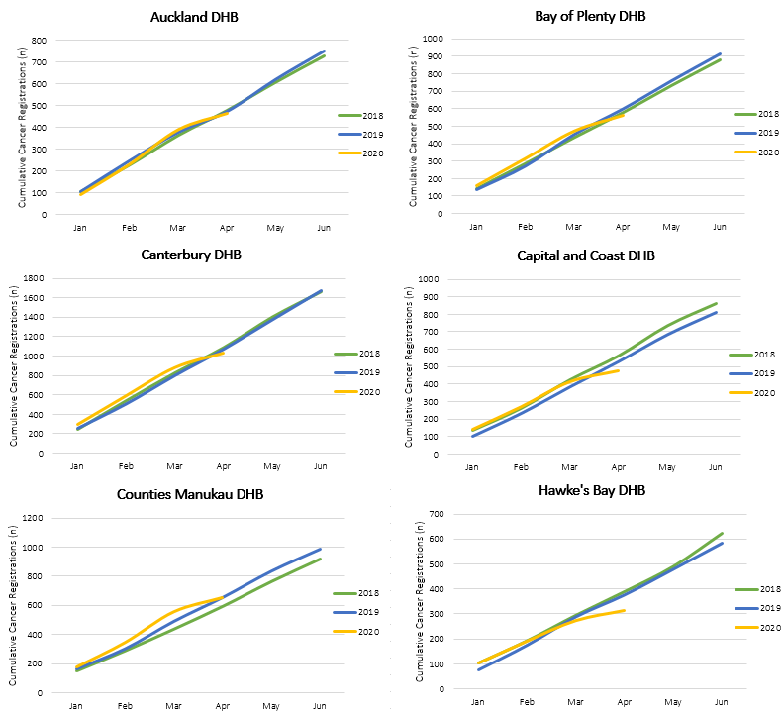
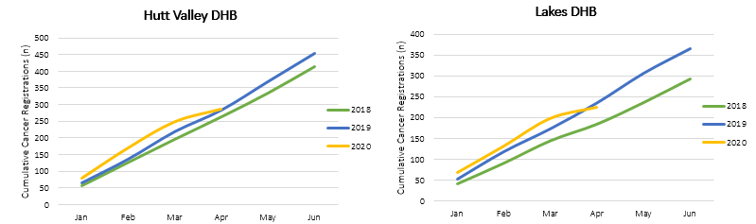
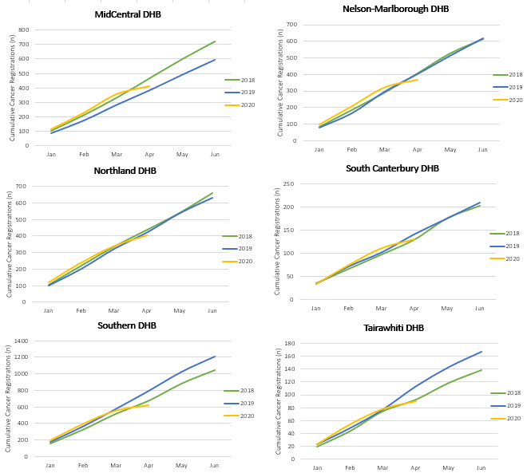
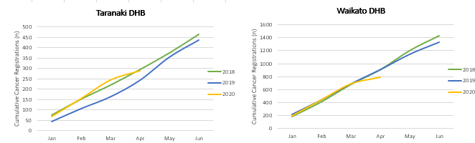
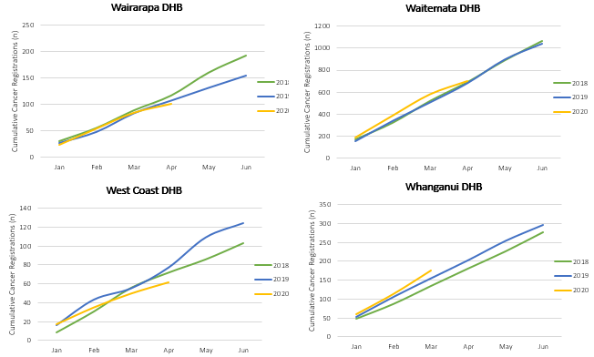

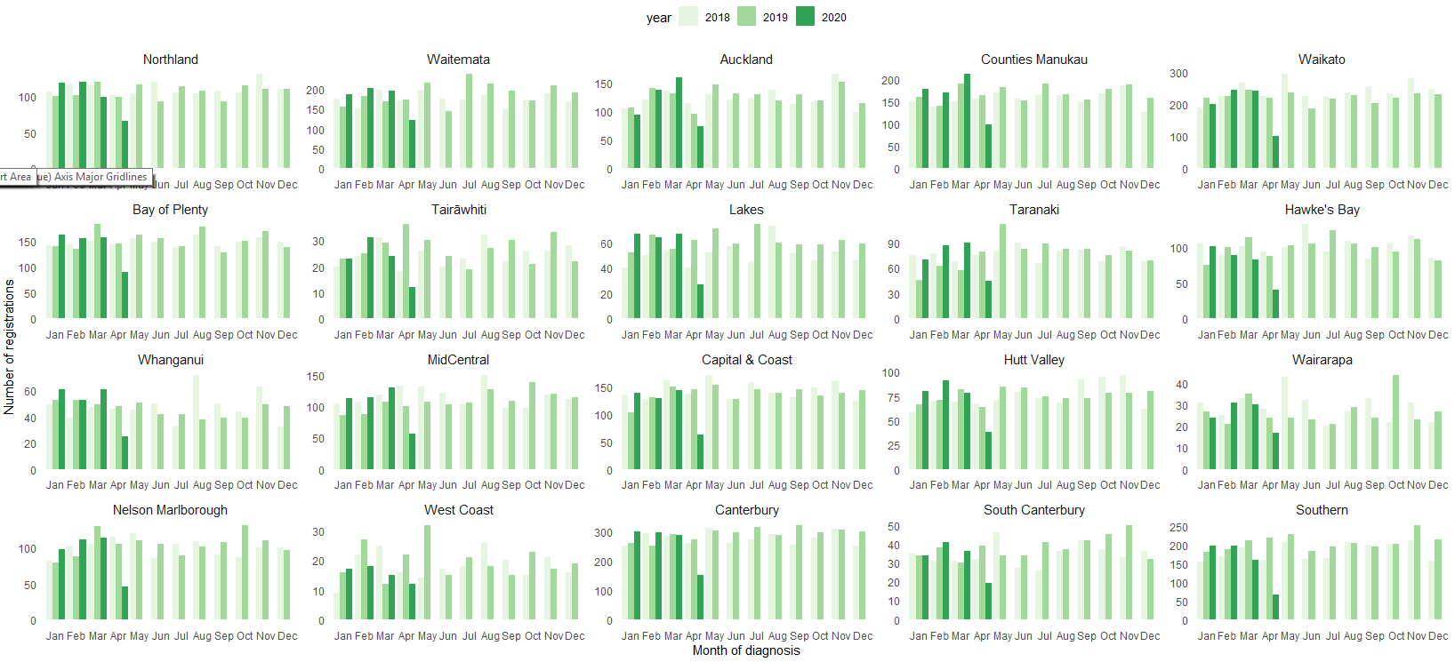

Appendix 3: Surgical procedure codes
Below is a list of the surgical procedure codes that were used for analysis on curative cancer surgery.
COLORECTAL CANCER SURGERY
Clinical code | Block short description | Clinical code description
3200000 | Colectomy | Limited excision of large intestine with formation of stoma
3200001 | Colectomy | Right hemicolectomy with formation of stoma
3200300 | Colectomy | Limited excision of large intestine with anastomosis
3200301 | Colectomy | Right hemicolectomy with anastomosis
3200400 | Colectomy | Subtotal colectomy with formation of stoma
3200401 | Colectomy | Extended right hemicolectomy with formation of stoma
3200500 | Colectomy | Subtotal colectomy with anastomosis
3200501 | Colectomy | Extended right hemicolectomy with anastomosis
3200600 | Colectomy | Left hemicolectomy with anastomosis
3200601 | Colectomy | Left hemicolectomy with formation of stoma
3200900 | Colectomy | Total colectomy with ileostomy
3201200 | Colectomy | Total colectomy with ileorectal anastomosis
3201500 | Total proctocolectomy | Total proctocolectomy with ileostomy
3202400 | Anterior resection of rectum | High anterior resection of rectum
3202500 | Anterior resection of rectum | Low anterior resection of rectum
3202600 | Anterior resection of rectum | Ultra low anterior resection of rectum
3202800 | Anterior resection of rectum | Ultra low anterior resection of rectum with hand sutured coloanal anastomosis
3203000 | Rectosigmoidectomy or proctectomy | Rectosigmoidectomy with formation of stoma
3203900 | Rectosigmoidectomy or proctectomy | Abdominoperineal proctectomy
3205100 | Total proctocolectomy | Total proctocolectomy with ileo-anal anastomosis
3205101 | Total proctocolectomy | Total proctocolectomy with ileo-anal anastomosis and formation of temporary ileostomy
3206000 | Rectosigmoidectomy or proctectomy | Restorative proctectomy
3209900 | Excision of lesion or tissue of rectum or anus | Per anal submucosal excision of lesion or tissue of rectum
3211200 | Rectosigmoidectomy or proctectomy | Perineal rectosigmoidectomy
9220800 | Anterior resection of rectum | Anterior resection of rectum, level unspecified

LUNG CANCER SURGERY
Clinical code | Clinical code description | Block Description
3844000 | Wedge resection of lung | Partial resection of lung
3844001 | Radical wedge resection of lung | Partial resection of lung
3843800 | Segmental resection of lung | Partial resection of lung
9016900 | Endoscopic wedge resection of lung | Partial resection of lung
3843801 | Lobectomy of lung | Lobectomy of lung
3844100 | Radical lobectomy | Lobectomy of lung
3844101 | Radical pneumonectomy | Pneumonectomy
3843802 | Pneumonectomy | Pneumonectomy

PROSTATE CANCER SURGERY
Clinical code | Block short description | Clinical code description
3720004 | Open prostatectomy | Retropubic prostatectomy
3720900 | Open prostatectomy | Radical prostatectomy
3720901 | Other closed prostatectomy | Laparoscopic radical prostatectomy
3721000 | Open prostatectomy | Radical prostatectomy with bladder neck reconstruction
3721001 | Other closed prostatectomy | Laparoscopic radical prostatectomy with bladder neck reconstruction
3721100 | Open prostatectomy | Radical prostatectomy with bladder neck reconstruction and pelvic lymphadenectomy
3721101 | Other closed prostatectomy | Laparoscopic radical prostatectomy with bladder neck reconstruction and pelvic lymphadenectomy
3720900 | Open prostatectomy | Radical prostatectomy
3720901 | Closed prostatectomy | Laparoscopic radical prostatectomy
3721000 | Open prostatectomy | Radical prostatectomy with bladder neck reconstruction
3721001 | Closed prostatectomy | Laparoscopic radical prostatectomy with bladder neck reconstruction
3721100 | Open prostatectomy | Radical prostatectomy with bladder neck reconstruction and pelvic lymphadenectomy

