Lung Cancer Quality Performance Indicator Specifications
LCQI01 Route to Diagnosis
2021

Citation: Te Aho o Te Kahu. 2021. Lung Cancer Quality Performance Indicator Specifications: LCQI01 Route to Diagnosis. Wellington: Te Aho o Te Kahu.
Published in March 2021 by the Te Aho o Te Kahu
PO Box 5013, Wellington 6140, New Zealand
ISBN 978-1-99-002985-1 (online)
HP 7600
This document is available at teaho.govt.nz
This work is licensed under the Creative Commons Attribution 4.0 International licence. In essence, you are free to: share ie, copy and redistribute the material in any medium or format; adapt ie, remix, transform and build upon the material. You must give appropriate credit, provide a link to the licence and indicate if changes were made.

Contents
Introduction 1
Sources of data for indicator 1
LCQI01 Route to diagnosis 2
Measure items 2
Case eligibility criteria (denominator) 3
Numerator criteria 4

Introduction
This information is provided to make it easier for analysts to replicate our calculations. For each measure we have provided supporting information, a table and a flow diagram.

This document provides specifications for the following measure.

Measure | Measure abbreviation | Measure type
Proportion of people with lung cancer who are diagnosed following presentation to an emergency department | emergency | Quality improvement

Sources of data for indicator
- New Zealand Cancer Registry (NZCR) – a population-based register of all primary malignant diseases diagnosed in New Zealand, excluding squamous and basal cell skin cancers
- National Minimum Dataset (NMDS) – a collection of public and private hospital discharge information, including coded clinical data for inpatients and day patients
- National Non-Admitted Patients Collection (NNPAC) – includes event-based purchase units that relate to medical and surgical outpatient events and emergency department events

More information on these data sources can be found on the Ministry of Health’s website: www.health.govt.nz.

LCQI01
Route to diagnosis
Proportion of people with lung cancer who are diagnosed following presentation to an emergency department.

Measure type: quality improvement

Measure items
Dataset | Data item | Description
NZCR | NHI | Patient identifier
NZCR | Cancer event ID | Cancer registration identifier
NZCR | Date of initial diagnosis | Date person first diagnosed with lung cancer
NZCR | Diagnosis year | Calendar year of first diagnosis
NZCR | Site | Primary organ of origin of the cancer (ICD-10-AM 8th Edition code)
NZCR | Morphology code | 4-digit code (ICD-O-3) for microscopic or cellular anatomy of the cancer
NZCR | Basis | Basis of diagnosis
NZCR | DHB of domicile | DHB code for domicile of patient at diagnosis
NZCR | DHB | DHB name based on domicile of patient at diagnosis
NZCR | Age at diagnosis | Age of patient at diagnosis in years
NZCR | Prioritised ethnicity | Ethnic group derived from patient’s ethnicity
NZCR | Sex | Sex of patient
NZCR | Deprivation quintile | NZDep2013 index of social deprivation quintile based on patient’s domicile
NZCR | Date of death | Date patient died
NZCR | TNM_T | Stage at diagnosis – tumour
NZCR | TNM_N | Stage at diagnosis – node
NZCR | TNM_M | Stage at diagnosis – metastases
NZCR | Behaviour code | Neoplastic behaviour of the cancer
NZCR | Multiple tumour flags | Person diagnosed with more than one tumour
NZCR | Registration status code | Status of registration processing
NMDS | Purchase unit code | Type of inpatient admission
NMDS | Event start date | Date of admission
NNPAC | Purchase unit code | Type of outpatient attendance
NNPAC | Date time of service | Date and time of outpatient service
NNPAC | Attendance code | Attendance of outpatient event

Case eligibility criteria (denominator)
Diagram reference | Assessment | Item | Codes
1 | First or only diagnosis of malignant neoplasm | Primary site | First diagnosis of lung cancer (trachea C33 or bronchus C34)
2 | Exclude manually censored case | Exclusion | Registration codes not R_C (registered complete) or R_R (registered)  No incident cancer (exclude people with multiple tumour flags = yes)  People diagnosed following death certificate only (basis = 0)  People domiciled outside of New Zealand (DHB_code = 999)  Cancer morphologies of melanoma, sarcoma and other unusual morphologies (codes 8333, 8720, 8772, 8800, 8801, 8803, 8805, 8815, 8890, 9040, 9041, 9133)
3 | Diagnosis date | Date of initial diagnosis | 2015–18
4 | Male or female | Sex | M or F
5 | Adult patient 18 years and older at diagnosis | Age at diagnosis | 18 years and older
6 | Invasive tumours | Behaviour code | 3

Numerator criteria
Diagram reference | Assessment | Item | Codes
7 | Numerator: Number of people with lung cancer who are diagnosed following presentation to an emergency department | emergency | Inpatient (NMDS)  - Emergency medicine admission  - Purchase unit code = M05.01  Outpatient (NNPAC)  - Outpatient attendance  - Purchase unit code like ED%  - Attendance code = ATT  ED admission/presentation within 2 weeks prior to diagnosis date

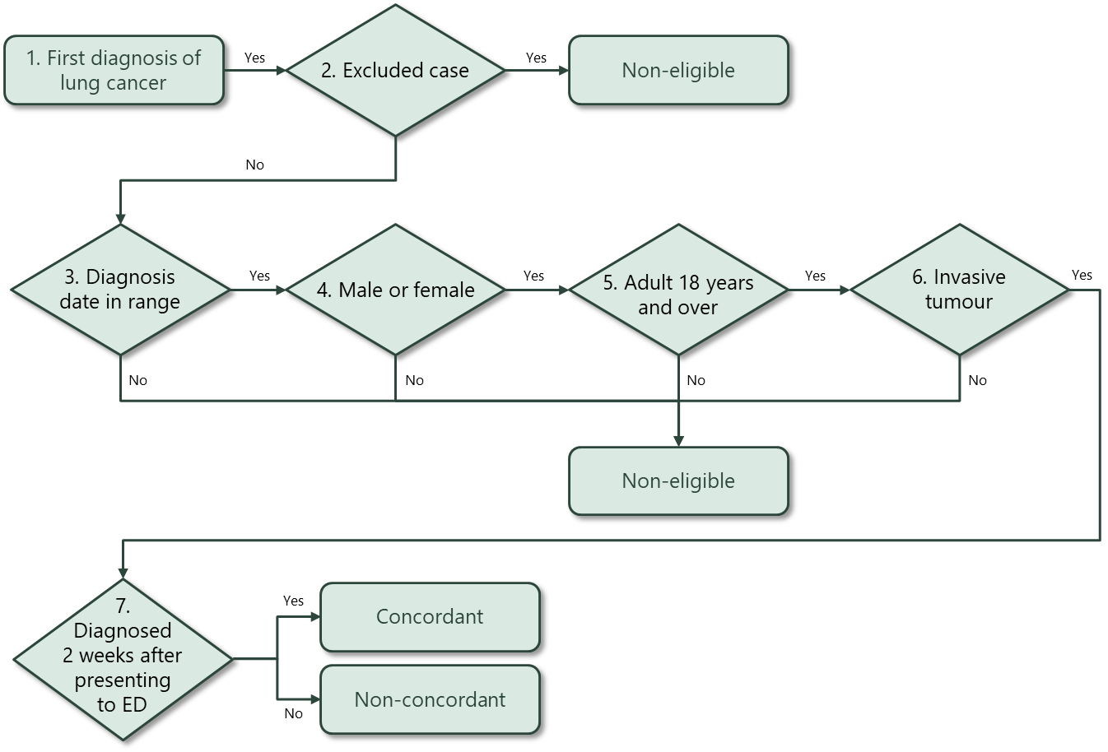

Hospital events in NMDS are coded using the International Statistical Classification of Diseases and Related Health Problems, Tenth Revision, Australian Modification (ICD-10-AM) for diagnoses and the Australian Classification of Health Interventions (ACHI) for procedures. Both ICD-10-AM and ACHI are from the Independent Hospital Pricing Authority, Australia.

