Lung Cancer Quality Performance Indicator Specifications
LCQI07 Systemic Anti-cancer Therapy
2021

Citation: Te Aho o Te Kahu. 2021. Lung Cancer Quality Performance Indicator Specifications: LCQI07 Systemic Anti-cancer Therapy. Wellington: Te Aho o Te Kahu.
Published in March 2021 by the Te Aho o Te Kahu
PO Box 5013, Wellington 6140, New Zealand
ISBN 978-1-99-002988-2 (online)
HP 7603
This document is available at teaho.govt.nz
This work is licensed under the Creative Commons Attribution 4.0 International licence. In essence, you are free to: share ie, copy and redistribute the material in any medium or format; adapt ie, remix, transform and build upon the material. You must give appropriate credit, provide a link to the licence and indicate if changes were made.

Contents
Introduction 1
Sources of data for indicator 1
LCQI07 Systemic anti-cancer therapy 2
Measure items 2
Case eligibility criteria (denominator) 3
Numerator criteria 5
Chemotherapy drug codes and names 6

Introduction
This information is provided to make it easier for analysts to replicate our calculations. For each measure we have provided supporting information, a table and a flow diagram.

This document provides specifications for the following measure.

Measure | Measure abbreviation | Measure type
a) Proportion of people with non-small cell lung cancer receiving systemic anti-cancer therapy | NSCLC_SACT | Quality improvement
b) Proportion of people with small cell lung cancer receiving systemic anti-cancer therapy | SCLC_SACT | Quality improvement

Sources of data for indicator
- New Zealand Cancer Registry (NZCR) – a population-based register of all primary malignant diseases diagnosed in New Zealand, excluding squamous and basal cell skin cancers
- Pharmaceutical Collection (PHARMS) – a data warehouse that supports the management of pharmaceutical subsidies, and contains claim and payment information from pharmacists for subsidised dispensings

More information on these data sources can be found on the Ministry of Health’s website: www.health.govt.nz.

LCQI07
Systemic anti-cancer therapy
a) Proportion of people with non-small cell lung cancer receiving systemic anti-cancer therapy.
b) Proportion of people with small cell lung cancer receiving systemic anti-cancer therapy.

Measure type: quality improvement

Measure items
Dataset | Data item | Description
NZCR | NHI | Patient identifier
NZCR | Cancer event ID | Cancer registration identifier
NZCR | Date of initial diagnosis | Date person first diagnosed with lung cancer
NZCR | Diagnosis year | Calendar year of first diagnosis
NZCR | Site | Primary organ of origin of the cancer (ICD-10-AM 8th Edition code)
NZCR | Morphology code | 4-digit code (ICD-O-3) for microscopic or cellular anatomy of the cancer
NZCR | Basis | Basis of diagnosis
NZCR | DHB of domicile | DHB code for domicile of patient at diagnosis
NZCR | DHB | DHB name based on domicile of patient at diagnosis
NZCR | Age at diagnosis | Age of patient at diagnosis in years
NZCR | Prioritised ethnicity | Ethnic group derived from patient’s ethnicity
NZCR | Sex | Sex of patient
NZCR | Deprivation quintile | NZDep2013 index of social deprivation quintile based on patient’s domicile
NZCR | Date of death | Date patient died
NZCR | TNM_T | Stage at diagnosis – tumour
NZCR | TNM_N | Stage at diagnosis – node
NZCR | TNM_M | Stage at diagnosis – metastases
NZCR | Behaviour code | Neoplastic behaviour of the cancer
NZCR | Multiple tumour flags | Person diagnosed with more than one tumour
NZCR | Registration status code | Status of registration processing
PHARMS | Date of dispensing | Date of dispensing of chemotherapy drugs
PHARMS | Funding DHB code | Code of DHB of service
PHARMS | Funding DHB | DHB of service for patient
PHARMS | Chemical ID | Identifier for drug
PHARMS | Chemical name | Name of chemotherapy drug

Case eligibility criteria (denominator)

a) NSCLC
Diagram reference | Assessment | Item | Codes
1 | First or only diagnosis of malignant neoplasm | Primary site | First diagnosis of lung cancer (trachea C33 or bronchus C34)
2 | Exclude manually censored case | Exclusion | Registration codes not R_C (registered complete) or R_R (registered)  No incident cancer (exclude people with multiple tumour flags = yes)  People diagnosed following death certificate only (basis = 0)  People domiciled outside of New Zealand (DHB_code = 999)  Cancer morphologies of melanoma, sarcoma and other unusual morphologies (codes 8333, 8720, 8772, 8800, 8801, 8803, 8805, 8815, 8890, 9040, 9041, 9133)
3 | Diagnosis date | Date of initial diagnosis | 2015–18
4 | Male or female | Sex | M or F
5 | Adult patient 18 years and older at diagnosis | Age at diagnosis | 18 years and older
6 | Invasive tumours | Behaviour code | 3
7 | Non-small cell lung cancer | Morphology code | Include all morphology codes except codes for SCLC (8041, 8042, 8043, 8044 and 8054) and other/unspecified lung cancers (8000, 8010, 8020, 8240, 8244, 8249)

b) SCLC
Diagram reference | Assessment | Item | Codes
1 | First or only diagnosis of malignant neoplasm | Primary site | First diagnosis of lung cancer (trachea C33 or bronchus C34)
2 | Exclude manually censored case | Exclusion | Registration codes not R_C (registered complete) or R_R (registered)  No incident cancer (exclude people with multiple tumour flags = yes)  People diagnosed following death certificate only (basis = 0)  People domiciled outside of New Zealand (DHB_code = 999)  Cancer morphologies of melanoma, sarcoma and other unusual morphologies (codes 8333, 8720, 8772, 8800, 8801, 8803, 8805, 8815, 8890, 9040, 9041, 9133)
3 | Diagnosis date | Date of initial diagnosis | 2015–18
4 | Male or female | Sex | M or F
5 | Adult patient 18 years and older at diagnosis | Age at diagnosis | 18 years and older
6 | Invasive tumours | Behaviour code | 3
7 | Small cell lung cancer | Morphology code | Include SCLC morphology codes (80413, 80423, 80433, 80443 and 80543)

Numerator criteria

a) NSCLC
Diagram reference | Assessment | Item | Codes
8 | Number of people with non-small cell lung cancer who receive systemic anti-cancer therapy | NSCLC_SACT | Drugs with chemical ID 3826, 3825, 2433, 3847, 3811, 3815, 3834, 3842, 3816, 4088, 3966, 3916, 1369, 3813, 2319, 2320

b) SCLC
Diagram reference | Assessment | Item | Codes
8 | Number of people with small cell lung cancer who receive platinum-etoposide based systemic anti-cancer therapy | SCLC_SACT | Drugs with chemical ID 3826, 3825, 2433, 3847, 3811, 3815, 3834, 3842, 3816, 4088, 3966, 3916, 1369, 3813, 2319, 2320  and  dispensed date between -30 and 275 days from diagnosis date

Chemotherapy drug codes and names
Chemical ID | Chemical name
3826 | Cisplatin
3825 | Carboplatin
2433 | Etoposide
3847 | Etoposide phosphate
3811 | Irinotecan hydrochloride
3815 | Paclitaxel
3834 | Docetaxel
3842 | Gemcitabine hydrochloride
3816 | Vinorelbine
4088 | Pemetrexed
3966 | Gefitinib
3916 | Erlotinib hydrochloride
1369 | Cyclophosphamide
3813 | Doxorubicin
2319 | Vinblastine sulphate
2320 | Vincristine sulphate

a) NSCLC
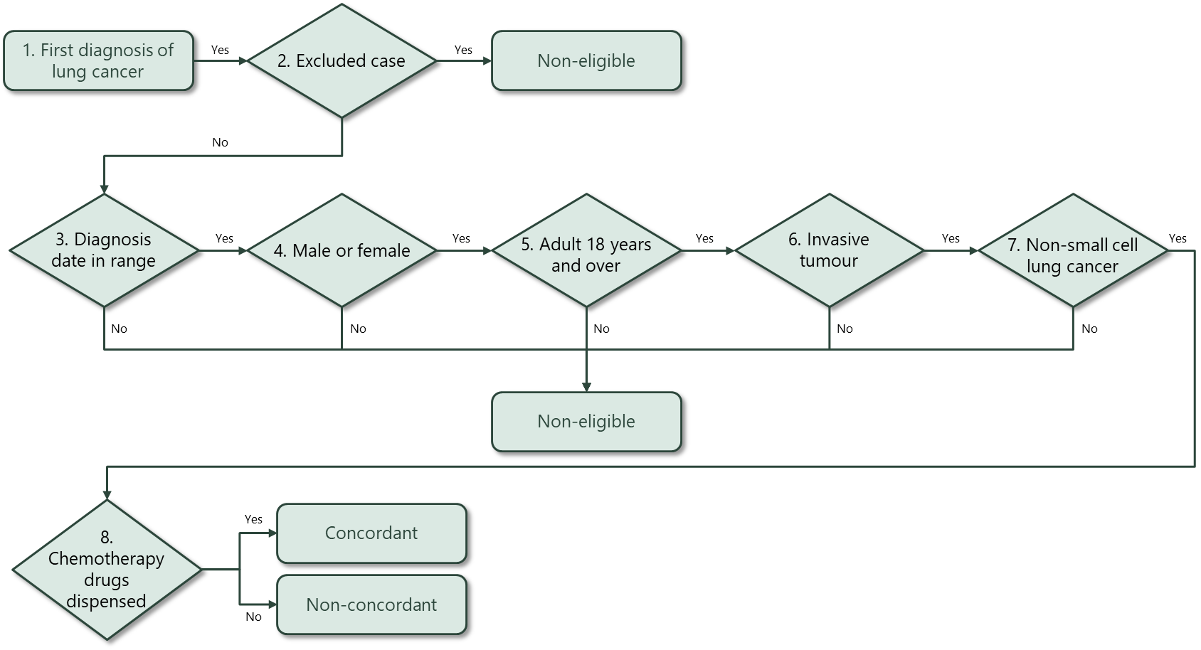

b) SCLC
