Lung Cancer Quality Performance Indicator Specifications
LCQI11 Cancer Treatment at the End-of-Life
2021

Citation: Te Aho o Te Kahu. 2021. Lung Cancer Quality Performance Indicator Specifications: LCQI11 Cancer Treatment at the End-of-Life. Wellington: Te Aho o Te Kahu.
Published in March 2021 by the Te Aho o Te Kahu
PO Box 5013, Wellington 6140, New Zealand
ISBN 978-1-99-002992-9 (online)
HP 7607
This document is available at teaho.govt.nz
This work is licensed under the Creative Commons Attribution 4.0 International licence. In essence, you are free to: share ie, copy and redistribute the material in any medium or format; adapt ie, remix, transform and build upon the material. You must give appropriate credit, provide a link to the licence and indicate if changes were made.

Contents
Introduction 1
Sources of data for indicator 1
LCQI11 Cancer treatment at the end-of-life 2
Measure items 2
Case eligibility criteria (denominator) 3
Numerator criteria 4
Chemotherapy drug codes and names 4

Introduction
This information is provided to make it easier for analysts to replicate our calculations. For each measure we have provided supporting information, a table and a flow diagram.

This document provides specifications for the following measure.

Measure | Measure abbreviation | Measure type
Proportion of people with lung cancer who receive systemic anti-cancer therapy within 30 days of death | SACT_EOL | Quality improvement

Sources of data for indicator
- New Zealand Cancer Registry (NZCR) – a population-based register of all primary malignant diseases diagnosed in New Zealand, excluding squamous and basal cell skin cancers
- Pharmaceutical Collection (PHARMS) – a data warehouse that supports the management of pharmaceutical subsidies, and contains claim and payment information from pharmacists for subsidised dispensings
- Mortality Collection– classifies the underlying cause of death for all deaths registered in New Zealand

More information on these data sources can be found on the Ministry of Health’s website: www.health.govt.nz.

LCQI11
Cancer treatment at the end-of-life
Proportion of people with lung cancer who receive systemic anti-cancer therapy within 30 days of death.

Measure type: quality improvement

Measure items
Dataset | Data item | Description
NZCR | NHI | Patient identifier
NZCR | Cancer event ID | Cancer registration identifier
NZCR | Date of initial diagnosis | Date person first diagnosed with lung cancer
NZCR | Diagnosis year | Calendar year of first diagnosis
NZCR | Site | Primary organ of origin of the cancer (ICD-10-AM 8th Edition code)
NZCR | Morphology code | 4-digit code (ICD-O-3) for microscopic or cellular anatomy of the cancer
NZCR | Basis | Basis of diagnosis
NZCR | DHB of domicile | DHB code for domicile of patient at diagnosis
NZCR | DHB | DHB name based on domicile of patient at diagnosis
NZCR | Age at diagnosis | Age of patient at diagnosis in years
NZCR | Prioritised ethnicity | Ethnic group derived from patient’s ethnicity
NZCR | Sex | Sex of patient
NZCR | Deprivation quintile | NZDep2013 index of social deprivation quintile based on patient’s domicile
NZCR | TNM_T | Stage at diagnosis – tumour
NZCR | TNM_N | Stage at diagnosis – node
NZCR | TNM_M | Stage at diagnosis – metastases
NZCR | Behaviour code | Neoplastic behaviour of the cancer
NZCR | Multiple tumour flags | Person diagnosed with more than one tumour
NZCR | Registration status code | Status of registration processing
MORT | Date of death | Date patient died
PHARMS | Date of dispensing | Date of dispensing of chemotherapy drugs
PHARMS | Chemical ID | Identifier for drug
PHARMS | Chemical name | Name of chemotherapy drug
PHARMS | Chemical ID | Identifier for drug

Case eligibility criteria (denominator)
Diagram reference | Assessment | Item | Codes
1 | First or only diagnosis of malignant neoplasm | Primary site | First diagnosis of lung cancer (trachea C33 or bronchus C34)
2 | Exclude manually censored case | Exclusion | Registration codes not R_C (registered complete) or R_R (registered)  No incident cancer (exclude people with multiple tumour flags = yes)  People diagnosed following death certificate only (basis = 0)  People domiciled outside of New Zealand (DHB_code = 999)  Cancer morphologies of melanoma, sarcoma and other unusual morphologies (codes 8333, 8720, 8772, 8800, 8801, 8803, 8805, 8815, 8890, 9040, 9041, 9133)
3 | Diagnosis date | Date of initial diagnosis | 2015–18
4 | Male or female | Sex | M or F
5 | Adult patient 18 years and older at diagnosis | Age at diagnosis | 18 years and older
6 | Invasive tumours | Behaviour code | 3
7 | Deceased | Date of death | Date of death is not null

Numerator criteria
Diagram reference | Assessment | Item | Codes
8 | Number of people with lung cancer who receive systemic anti-cancer therapy within 30 days of death | SACT_EOL | From PHARMS dataset, include patients with:  - Drugs with chemical ID 3826, 3825, 2433, 3847, 3811, 3815, 3834, 3842, 3816, 4088, 3966, 3916, 1369, 3813, 2319, 2320  AND  - Dispensed date is within 30 days prior to date of death

Chemotherapy drug codes and names
Chemical ID | Chemical name
3826 | Cisplatin
3825 | Carboplatin
2433 | Etoposide
3847 | Etoposide phosphate
3811 | Irinotecan hydrochloride
3815 | Paclitaxel
3834 | Docetaxel
3842 | Gemcitabine hydrochloride
3816 | Vinorelbine
4088 | Pemetrexed
3966 | Gefitinib
3916 | Erlotinib hydrochloride
1369 | Cyclophosphamide
3813 | Doxorubicin
2319 | Vinblastine sulphate
2320 | Vincristine sulphate

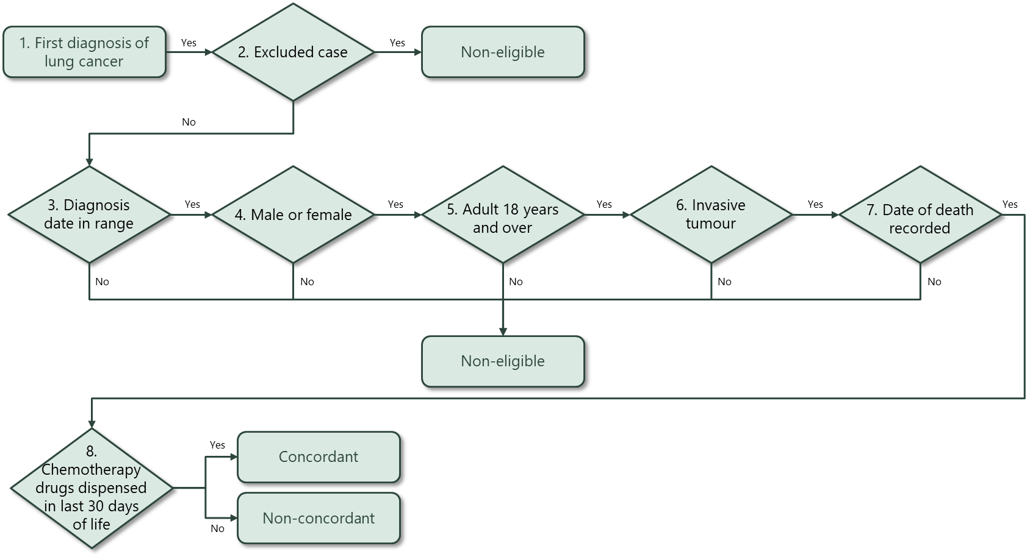

ICD-10-AM: causes of death were coded to the International Statistical Classification of Diseases and Related Health Problems, Tenth Revision, Australian Modification, Eighth Edition (Source: Independent Hospital Pricing Authority).

