LUNG CANCER QUALITY IMPROVEMENT Monitoring REPORT
2021

Acknowledgements
“For all health care professionals, ensure that they know that the first rule of medicine is ‘listen to the patient’ and that human hope should never be destroyed.”
Cancer Control New Zealand 2009
This Lung Cancer Quality Improvement Monitoring Report (the Report) publishes quality performance indicator (QPI) data from the New Zealand Cancer Registry (NZCR) and the Ministry of Health’s national collections of patients diagnosed with lung cancer in Aotearoa New Zealand between 1 January 2015 and 31 December 2018.
Each point of the data is an individual or cluster of patients. Each lung cancer will have significantly impacted the patient and their whānau/family, with most patients dying from this disease. The development group wish to acknowledge all of those impacted.
The report is being released by Te Aho o Te Kahu, Cancer Control Agency to identify and report on lung cancer QPIs. The Agency, Midland Cancer Network (MCN) and the National Lung Cancer Working Group (NLCWG) have worked collaboratively to identify and develop indicators that will drive quality improvement.

Authors
An initial report was prepared by staff at Midland Cancer Network (MCN) in partnership with the NLCWG, chaired by Dr Paul Dawkins. The report has been finalised by Te Aho o Te Kahu and published as part of our quality improvement programme.
In writing this report, we are reminded of the following whakataukī (Māori proverb):
E koekoe te tūī, e ketekete te kākā, e kuku te kereru.
The tūī sings, the kākā chatter, and the kererū coos.
(Each person has their own voice and perspective.)
Citation: Te Aho o Te Kahu. 2021. Lung Cancer Quality Improvement Monitoring Report 2021. Wellington: Cancer Control Agency.
Published in March 2021 by the Te Aho o Te Kahu
PO Box 5013, Wellington 6140, New Zealand
ISBN 978-1-99-002994-3 (online)
HP 7609
This document is available at teaho.govt.nz
This work is licensed under the Creative Commons Attribution 4.0 International licence. In essence, you are free to: share ie, copy and redistribute the material in any medium or format; adapt ie, remix, transform and build upon the material. You must give appropriate credit, provide a link to the licence and indicate if changes were made.

Contents
Executive summary vii
1 Key findings and recommendations 1
1.1 Equity 1
1.2 Diagnostic pathway 1
1.3 Treatment 2
1.4 Overall survival 4
2 Introduction 5
2.1 Background 5
2.2 Equity 5
2.3 Report process 6
2.4 Data improvement 7
2.5 Lung cancer cohort 7
3 Quality performance 10
3.1 Routes to diagnosis 10
3.2 Pathological diagnosis 13
3.3 Surgical resection 16
3.4 Systemic anti-cancer therapy 19
3.5 Radiation therapy 24
3.6 Cancer treatment at end of life 30
3.7 Treatment mortality 33
3.8 Overall survival 36
Appendix A: Methods 41
Appendix B: DHB results tables 47
Appendix C: References 51
Appendix D: Working group members 54

List of Figures
Figure 1: Proportion of people diagnosed with lung cancer following presentation to an ED, by DHB of domicile, 2015–18 11
Figure 2: Proportion of people with a pathological diagnosis of lung cancer, by DHB of domicile, 2015–18 14
Figure 3: Curative resection rate for patients diagnosed with non-small cell lung cancer, by DHB of domicile, 2015–18 17
Figure 4: Proportion of people with non-small cell lung cancer receiving systemic anti-cancer therapy, by DHB of domicile, 2015–18 20
Figure 5: Proportion of people with small cell lung cancer receiving systemic anti-cancer therapy, by DHB of domicile, 2015–18 22
Figure 6: Proportion of people with non-small cell lung cancer receiving concurrent chemoradiation, by DHB of domicile, 2015–18 26
Figure 7: Proportion of people with small cell lung cancer receiving concurrent chemoradiation, by DHB of domicile, 2015–18 28
Figure 8: Proportion of people with lung cancer who receive systemic anti-cancer therapy (SACT) within 30 days of death, by DHB of domicile, 2015–18 31
Figure 9: 90-day radical treatment-related mortality rate for people with NSCLC, by DHB of domicile, 2015–18 34
Figure 10: Proportion of people with lung cancer alive one year after diagnosis, by DHB of domicile, 2015–17 37
Figure 11: Proportion of people with lung cancer alive two years after diagnosis, by DHB of domicile, 2015–16 37
Figure 12: Proportion of people with lung cancer alive three years after diagnosis, by DHB of domicile, 2015 38

List of Tables
Table 1: Number and proportion of people diagnosed with lung cancer, by cancer morphology type and subtype, 2015–18 8
Table 2: People diagnosed with lung cancer by ethnic group and cancer type, 2015–18 8
Table 3: People diagnosed with lung cancer by ethnic group, age, sex, NZDep2013 quintile and year of diagnosis, 2015–18 9
Table 4: People diagnosed with lung cancer following presentation to an ED or referral to a clinic, by age group, sex, ethnic group and social deprivation, 2015–18 12
Table 5: Proportion of people with a pathological diagnosis of lung cancer, by age group, sex, ethnic group and social deprivation, 2015–18 15
Table 6: Curative resection rate for patients diagnosed with non-small cell lung cancer, by age group, sex, ethnic group and social deprivation, 2015–18 18
Table 7: Systemic anti-cancer therapy rate for people with non-small cell lung cancer, by age group, sex, ethnic group and social deprivation, 2015–18 21
Table 8: Systemic anti-cancer therapy rate for people with small cell lung cancer, by age group, sex, ethnic group and social deprivation, 2015–18 23
Table 9: Proportion of people with lung cancer receiving concurrent chemoradiation by cancer type, 2015–18 26
Table 10: Concurrent chemoradiation rate for people with non-small cell lung cancer, by age group, sex, ethnic group and social deprivation, 2015–18 27
Table 11: Concurrent chemoradiation rate for people with small cell lung cancer, by age group, sex, ethnic group, and social deprivation, 2015–18 29
Table 12: Proportion of people with lung cancer who receive systemic anti-cancer therapy within 30 days of death, by year and cancer type, 2015–18 30
Table 13: Proportion of people with lung cancer who receive systemic anti-cancer therapy within 30 days of death, by age group, sex, ethnic group and social deprivation, 2015–18 32
Table 14: 30-day and 90-day treatment-related mortality rate for people with NSCLC, 2015–18 34
Table 15: 90-day treatment-related mortality rate for people with NSCLC, by age group, sex, ethnic group and social deprivation, 2015–18 34
Table 16: Overall survival for people with lung cancer one, two and three years after diagnosis, by year of diagnosis and cancer type 36
Table 17: Proportion of people alive one, two and three years after diagnosis of lung cancer 39
Table 18: Number of people on the NZCR with lung cancer carcinoid tumours or unspecified morphology by morphology code and description, 2015–18 43
Table 19: People who had lung cancer surgery with pathological tumour, node, metastasis stage available on the NZCR, 2015–18 44
Table 20: People diagnosed with lung cancer by hub and district health board of domicile, 2015-18 47
Table 21: People alive one, two and three years after diagnosis with lung cancer by hub and district health board of domicile 48
Table 22: People diagnosed with non-small cell lung cancer by hub and district health board of domicile, 2015-18 49
Table 23: People diagnosed with small cell lung cancer by hub and district health board of domicile, 2015-18 50

Executive summary
Naū te rourou, nāku te rourou, ka ora ai te iwi.
With your food basket and my food basket, the people will thrive.
(By sharing our ideas and working together, we can achieve equity.)

In this report, we present the first results from our investigation into the use of the Ministry of Health’s national collections to calculate district health board (DHB) performance against quality performance indicators (QPIs) for people diagnosed with lung cancer.

We expect these results to drive improvements in care and outcomes and reduce inequities for people diagnosed with lung cancer.

The primary audience for this report includes those who deliver care to people with lung cancer and manage the delivery of health services. This report will support Te Aho o Te Kahu Cancer Control Agency (Te Aho o Te Kahu) in developing and prioritising its work programme.

Eight QPIs are presented in this report.

All QPIs showed geographic variation in cancer services and outcomes. There is also variation in access and outcomes for different ethnic and age groups. Several of the QPI results are poorer than those experienced in many of our Organisation for Economic Co-operation and Development (OECD) counterparts.

Further investigation of the QPIs is needed at a DHB level to understand the variation between DHBs, particularly with regard to those DHBs presenting as outliers from this initial investigation. The results of further investigations will present opportunities to reduce inequalities, improve health services and care pathways, validate and improve local data collections and encourage collaborative learning between DHBs.

Tumour stage and patient performance status are not currently available in national data collections, and we urge readers to take this factor into account when interpreting the results described in this report.

Lung cancer priorities highlighted in this report align with the four outcomes outlined in the New Zealand Cancer Action Plan 2019–2029, Te Mahere mō te Mate Pukupuku o Aotearoa 2019–2020 (Ministry of Health 2019b) and its strategies for implementation.

Key findings and recommendations

Equity
Lung cancer contributes to ethnic inequities in health outcomes in Aotearoa New Zealand, with rates of lung care nearly four times higher for Māori compared with non-Māori (83 per 100,000 for Māori, 22.6 per 100,000 for non-Māori).

Three indicators were worse for Māori. Māori were more likely to be diagnosed via emergency departments (EDs) and less likely to receive curative surgery. There were also differences in several other indicators that may be related to stage of diagnosis. Māori had the lowest overall survival of all ethnic groups, with 37.7 percent alive one year after diagnosis, 21.6 percent two years after diagnosis and 17.5 percent three years after diagnosis. However, this was only slightly less than the survival proportion for New Zealand Europeans.

Recommendations
All quality improvement initiatives for lung cancer should focus on improving care pathways for Māori and those living in areas of high socioeconomic deprivation. These should be developed in partnership with Māori.

Smoking cessation support and tobacco control, although not reported on directly in this report, are critical to improving equity and should be key focus areas for DHBs.

Diagnostic pathway

Route to diagnosis
A high proportion of people (45 percent) were diagnosed with lung cancer following a presentation to an emergency department (ED). This indicator showed large variation by DHB and by ethnicity, social deprivation and age. The rate of ED presentation in Aotearoa New Zealand was high compared with international ED presentation rates.

Pathological diagnosis
Attempts to get a pathological diagnosis needs to be balanced against the risk of undertaking the diagnostic procedure. Overall, the proportion of people with a pathological diagnosis of lung cancer was high (81.4 percent), with some variation by DHB (71.4–89.1 percent). Pathological diagnosis rates decreased with increasing age and increasing social deprivation.

Recommendations
Further investigation at a DHB level of patients who present via ED is needed to identify systematic factors that could be the focus of quality improvement initiatives. For example, one large DHB had a low percentage of people diagnosed via the ED. Further investigation of the referral and diagnostic pathways within this DHB may provide insights into processes that could be followed in other regions to reduce ED presentations. Some DHBs may follow different clinical coding approaches, and such variation needs to be considered carefully before making assumptions on diagnostic pathways.

The DHBs that are outliers for pathological diagnosis also warrant further review to compare outliers at either end of the spectrum. The investigation should consider DHBs’ multidisciplinary team management and whether a pathological diagnosis is appropriate.

Pathological diagnosis is the main route to New Zealand Cancer Registry (NZCR) registration. People without a pathological diagnosis (e.g. diagnosed with imaging only) may not be reported to the NZCR.

Treatment
Stage and performance status will impact an individual’s suitability for treatment; however, there is unlikely to be large variation in these factors between DHBs at a population level, so this alone is unlikely to be the cause of variation seen between DHBs.

Surgical resection
The overall surgical resection rate (16.7 percent) is lower than rates found in other Organisation for Economic Co-operation and Development (OECD) countries. There was a marked variation across DHB of domicile, ranging from 9.5 to 24.3 percent. Māori and Pacific peoples had the lowest curative resection rate compared with other ethnic groups.

Systemic anti-cancer therapy
The overall receipt of systemic anti-cancer therapy for non-small-cell lung cancer (NSCLC) was 29.7 percent, with large variation by DHB (12.7–38.4 percent). Systemic anti-cancer therapy rates were higher for small-cell lung cancer (SCLC) (71.3 percent) with less variation by DHB. The systemic anti-cancer therapy data does not include private treatment, which may mask inequities in access.

Radiation therapy
Stereotactic ablative radiation therapy (SABR) rates could not be calculated with confidence from existing national data collections for this report.

The overall rate of combined chemoradiation was 5.4 percent (5.8 percent for NSCLC and 10.7 percent for SCLC), with a small amount of variation by DHB.

Cancer treatment at the end of life
Overall, 5.9 percent of people received chemotherapy within 30 days of death. This was higher for people with SCLC (14.3 percent) than NSCLC (5.9 percent). There was a small variation by DHB.

Treatment mortality
Mortality after curative intent treatment at 30 and 90 days was low and showed no variability by DHB.

Recommendations
Further investigation at the DHB level will help us understand the drivers of variation across the different methods of treatment. As part of reviewing their own data, DHBs may stratify their results by stage and performance status from local data sources.

Te Aho o Te Kahu has initiated a project to improve collection of systemic anti-cancer therapy data for reporting purposes. Once the ACT-NOW New Zealand project has been completed, more detail will be available on access to chemotherapy.

The primary sources for NZCR registrations are reports from pathology laboratories, hospital admissions and death certificates. People treated with stereotactic ablative radiotherapy (SABR) for lung cancer are often diagnosed with imaging and treated as outpatients. This has likely resulted in the under-reporting of the number of people diagnosed with lung cancer. People with lung cancer who are treated with SABR are reported in the Radiation Oncology Collection. We recommend the NZCR consider registering people diagnosed with lung cancer from alternative national data sources (for example, including the Radiation Oncology Collection).

We recommend that cancer centres regularly review 30-day mortality after chemotherapy to better understand factors that may contribute to over (or under) treatment, with a view to maximising opportunities to improve care and palliation at end of life.

Currently, there is no high-quality, nationally available data on palliative care. This would be an area for further investigation and data-quality improvement work.

Overall survival
Overall, one-year survival in Aotearoa New Zealand has improved over time. At 41.6 percent, our one-year survival rate is higher than that of the United Kingdom (36.7 percent) but lower than Australia’s survival rate (54.3 percent).

There is marked variation across DHB, by ethnicity (with Māori having particularly poor survival) and by socioeconomic status (people living in areas of high social deprivation have a worse survival rate).

Recommendations
All quality improvement initiatives for lung cancer should focus on improving care pathways for Māori and those living in areas of high socioeconomic deprivation, with the idea being that the cumulative impact will improve the overall survival rate.

Earlier diagnosis and stage shift are critical to improving survival and mortality outcomes. Improvements could be achieved through:
- the Ministry of Health and DHBs continuing to support efforts to reduce the prevalence of smoking in Aotearoa New Zealand, as this is the single most effective measure to reduce the incidence of lung cancer
- broader cross-government work to address the drivers of inequity, including policies that aim to improve access to the social determinants of health, which will have a large impact on the overall survival rate.

Introduction

Background
Lung cancer is the leading cause of cancer death in Aotearoa New Zealand (Ministry of Health 19). Lung cancer also contributes to inequities in health outcomes, with mortality rates three to four times higher for Māori compared with non-Māori (Robson et al 2010). A recent International Cancer Benchmarking Partnership (ICBP) report showed Aotearoa New Zealand sixth out of seven high-income countries for five-year survival from lung cancer (Arnold et al 2019).

The single most effective measure for long-term improvement in lung cancer in Aotearoa New Zealand would be to reduce the prevalence of smoking.

The Ministry of Health worked with the National Lung Cancer Working Group (NLCWG) to develop a set of quality performance indicators (QPIs) to drive quality improvement in lung cancer diagnosis and management in Aotearoa New Zealand.

This report presents the results of the QPIs for which data is available in the National Data Collections. This provides a baseline for quality improvement. The report presents QPIs that are agreed measures of good care and primarily describes the variation in these measures between district health boards (DHBs).

In December 2019, Te Aho o Te Kahu Cancer Control Agency (Te Aho o Te Kahu) was set up to provide national leadership for, and oversight of, cancer control in Aotearoa New Zealand. The Ministry of Health had started QPI work for lung cancer, but that work has since been taken over by Te Aho o Te Kahu.

Equity
In Aotearoa New Zealand, people have differences in health that are not only avoidable but unfair and unjust. Equity recognises different people with different levels of advantage require different approaches and resources to get equitable health outcomes. (Ministry of Health 2019a)

Māori currently experience a disproportionate and inequitable burden from lung cancer in Aotearoa New Zealand. Addressing variation in the quality of cancer services is pivotal to delivering equitable, high-quality care.

QPIs are a recognised tool for identifying opportunities for quality improvement and addressing equity. By stratifying QPIs by ethnicity, Te Aho o Te Kahu and DHBs will identify specific areas of inequity, develop quality improvement initiatives to address these and monitor progress over time.

Te Tiriti o Waitangi
Te Tiriti o Waitangi (the Treaty of Waitangi) provides an imperative for the Crown to protect and promote the health and wellbeing of Māori, including responding to and meeting Māori health needs.

The Waitangi Tribunal Health Services and Outcomes Inquiry (Wai 2575), initiated in November 2016, commenced hearing all claims concerning grievances relating to health services and outcomes of national significance for Māori.

The Wai 2575 Māori Health Trends Report (Ministry of Health 2019c) identifies lung cancer as the leading cause of death for Māori females aged 25 years and over, and the second leading cause of death for Māori males.

Given that Māori have the poorest overall health status in Aotearoa New Zealand and are significantly disadvantaged in terms of health inequities, it is essential that we ensure the rights and meet the needs of Māori people (Ministry of Health 2019b).

From the initial hearings related to primary health care, the Waitangi Tribunal made several recommendations in accordance with the principles of tino rangatiratanga, equity, active protection, options and partnership. The QPIs were developed for this investigation with these factors in mind, and a partnership approach should be taken with respect to all quality improvement initiatives.

Report process
This report is part of the national cancer quality improvement programme. Prior to the formation of Te Ahu o Te Kahu, the Ministry of Health worked with the NLCWG to identify measures to drive improvement in the quality of care for people with lung cancer. In total, 11 QPIs for lung cancer were agreed following consultation and feedback from the wider cancer care sector. Of the 11, eight QPIs are currently measurable using national collections data. The full list of QPIs and the indicator selection and development process are outlined in Lung Cancer Quality Performance Indicators: Descriptions, 2020 (Te Aho o Te Kahu 2020).

This report provides DHB data for the eight QPIs. It includes data extracted from the New Zealand Cancer Registry (NZCR) for people diagnosed with a new primary diagnosis of lung cancer from 1 January 2015 to 31 December 2018.

The report presents the variation in diagnosis and treatment indicators between DHBs, with funnel plots used to compare results. Results have also been compared with previous research in Aotearoa New Zealand and, where available, with international results.

Te Aho o Te Kahu expects that DHBs will review their performance and, where this performance is outside appropriate levels, as indicated by the funnel plots, take action to improve performance, and therefore patient outcomes. The variations noted in our investigations and discussed in this report will also help guide national quality improvement programmes.

Data improvement
Data is not currently available for all the lung cancer QPIs, and Te Aho o Te Kahu is prioritising the development of technical solutions to address these data issues.

There is currently one major national data improvement project under way. The ACT-NOW New Zealand project will improve the collection of data relating to chemotherapy and immunotherapy nationally. There is also scoping work to look at the development of structured pathology reporting. This will allow more reliable data on pathological stage. These projects will support ongoing quality improvement initiatives.

Lung cancer cohort
The cohort used for the analysis includes people from the NZCR who received a new primary diagnosis of lung cancer from 1 January 2015 to 31 December 2018. Methods outlines the sources of data for the indicators and the methods used in analysing the data.

Lung cancer types
Cancer type and subtype were categorised using the morphology recorded on the NZCR. Cancers that could be identified clearly as non-small cell lung cancers (NSCLCs) or small cell lung cancers (SCLCs) based on the morphology were grouped into these cancer types. Carcinoid tumours and unspecified or non-specific morphologies were classified as other cancers (see Table 18).

Table 1 shows the distribution of people diagnosed with lung cancer by cancer type and subtype. NSCLC (70 percent) was the most common lung cancer type for people in the cohort, with 61 percent of these people diagnosed with an adenocarcinoma.

Table 1: Number and proportion of people diagnosed with lung cancer, by cancer morphology type and subtype, 2015–18
 | N |  | %
Total | 8,577
Non-small cell lung cancer (NSCLC) | 6,023 |  | 70.2
Adenocarcinoma |  | 3,663 |  | 60.8
Squamous cell carcinoma |  | 1,675 |  | 27.8
Other NSCLC |  | 685 |  | 11.4
Small cell lung cancer (SCLC) | 943 |  | 11.0
Small cell carcinoma |  | 943 |  | 100.0
Other lung cancer | 1,611 |  | 18.8
Carcinoid tumours |  | 129 |  | 8.0
Unknown |  | 1482 |  | 92.0

The proportion of people with different cancer types and subtypes varies by ethnicity. Asian people had the highest proportion of NSCLC, and Māori had the highest proportion of SCLC (Table 2).

Table 2: People diagnosed with lung cancer by ethnic group and cancer type, 2015–18
Ethnic group | Total | Non-small cell lung cancer (NSCLC) |  | Small cell lung cancer (SCLC) |  | Other
 |  | N | % | N | % | N | %
Total | 8,577 | 6,023 | 70.2 | 943 | 11.0 | 1,611 | 18.8
Māori | 1,855 | 1,236 | 66.6 | 300 | 16.2 | 319 | 17.2
Pacific peoples | 434 | 329 | 75.8 | 43 | 9.9 | 62 | 14.3
Asian | 439 | 384 | 87.5 | 19 | 4.3 | 36 | 8.2
NZ European | 5,828 | 4,056 | 69.6 | 580 | 10.0 | 1,192 | 20.5
Unknown | 21 | 18 | 85.7 | 1 | 4.8 | 2 | 9.5

Lung cancer demographic characteristics
Demographic characteristics of the lung cancer cohort analysed for this report are presented in Table 3.

The median age at diagnosis for people with lung cancer was 70 years. Māori represent 16.5 percent of the general population but accounted for 22 percent of people diagnosed with lung cancer.

People who lived in areas of greater social deprivation were over represented in the cohort.

Table 3: People diagnosed with lung cancer by ethnic group, age, sex, NZDep2013 quintile and year of diagnosis, 2015–18
 | N | %
Total | 8,577 | 100
Ethnic group
Māori | 1,855 | 21.6
Pacific peoples | 434 | 5.1
Asian | 439 | 5.1
NZ European/Other | 5,828 | 67.9
Unknown | 21 | 0.2
Age group (years)
18–49 | 314 | 3.7
50–59 | 1,179 | 13.7
60–69 | 2,477 | 28.9
70–79 | 2,919 | 34.0
80+ | 1,688 | 19.7
Sex
Female | 4,280 | 49.9
Male | 4,295 | 50.1
Unknown | 2 | 0.0
NZDep2013 quintile
1 (least deprived) | 1,090 | 12.7
2 | 1,261 | 14.7
3 | 1,630 | 19.0
4 | 2,038 | 23.8
5 (most deprived) | 2,553 | 29.8
Unknown | 5 | 0.1
Year of diagnosis
2015 | 2,094 | 24.4
2016 | 2,155 | 25.1
2017 | 2,101 | 24.5
2018 | 2,227 | 26.0

Quality performance

Routes to diagnosis

Statement of intent
The majority of people with lung cancer should be diagnosed through an established elective referral pathway.

Context
People presenting with lung cancer via the ED are more likely to have advanced, incurable disease than those diagnosed through a clinic (Beatty et al 2009). Initial presentation to an ED is a strong negative predictor of survival. ED is often a suboptimal environment for routine cancer work-up for patients, whānau/families and staff as out-of-hours access to specialist imaging, knowledge and support are reduced and the patient journey is likely to be less smooth than rapid ambulatory work-up pathways.

Results
A high proportion of people (45.0 percent) were diagnosed with lung cancer following a presentation to an ED.

There was wide variation between DHBs for diagnosis following presentation at an ED, ranging from 30.8 percent to 62.7 percent (Figure 1). Three DHBs were outside the outer limits of the funnel plot.

Figure 1: Proportion of people diagnosed with lung cancer following presentation to an ED, by DHB of domicile, 2015–18
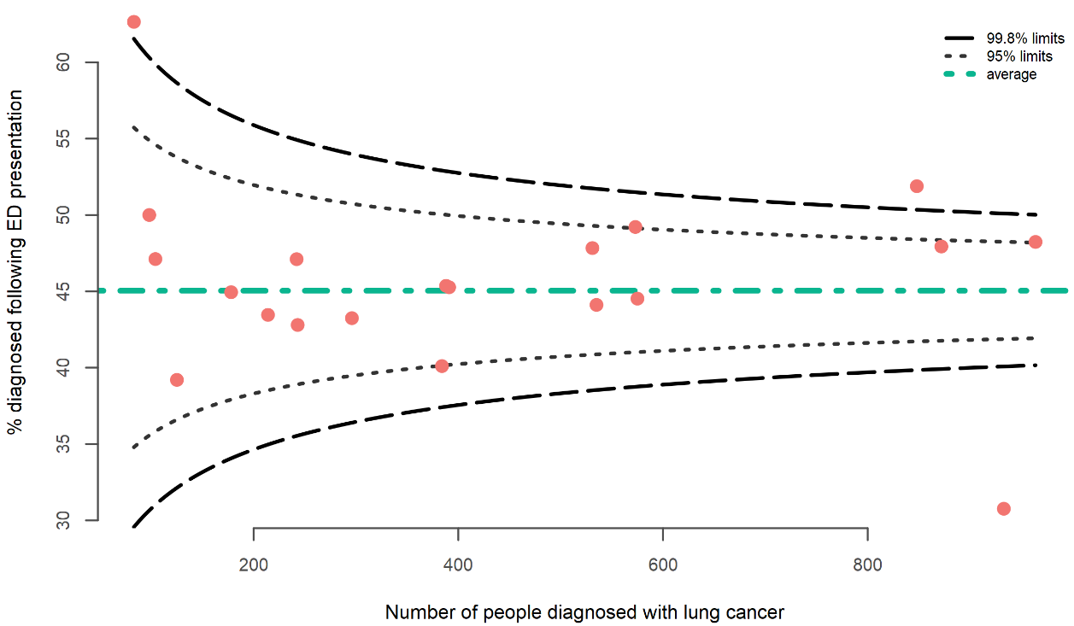

Pacific peoples (57.4 percent) and Māori (48.9 percent) were more likely to be diagnosed through an ED compared with Asian (41.5 percent) and New Zealand European/Other ethnicities (43.2 percent). The proportion of people presenting to an ED increased as social deprivation increased.

Table 4: People diagnosed with lung cancer following presentation to an ED or referral to a clinic, by age group, sex, ethnic group and social deprivation, 2015–18
 | People diagnosed  (N) | ED presentation
 |  | N | %
Total | 8,577 | 3,863 | 45.0
Ethnic group
Māori | 1,855 | 907 | 48.9
Pacific peoples | 434 | 249 | 57.4
Asian | 439 | 182 | 41.5
NZ European/Other | 5,828 | 2,520 | 43.2
Age group (years)
18–49 | 314 | 150 | 47.8
50–59 | 1,179 | 515 | 43.7
60–69 | 2,477 | 1,003 | 40.5
70–79 | 2,919 | 1,268 | 43.4
80+ | 1,688 | 927 | 54.9
Sex
Female | 4,280 | 1,906 | 44.5
Male | 4,295 | 1,957 | 45.6
NZDep2013 quintile
1 | 1,090 | 425 | 39.0
2 | 1,261 | 529 | 42.0
3 | 1,630 | 731 | 44.8
4 | 2,038 | 945 | 46.4
5 | 2,553 | 1,229 | 48.1

Comparison
Previous Aotearoa New Zealand research found an ED presentation rate of 36 percent in a 2004 cohort (Beatty et al 2009). The current data suggests that the proportion of people presenting via an ED has increased over time. This does not appear to reflect a change in case definition.

ED presentation appears high in Aotearoa New Zealand compared with rates seen internationally. Research estimated an ED presentation of 34.5 percent for NSCLC in Australia (Yap et al 2018), 35.5 percent in Canada (Suhail et al 2019) and 34.4 percent in England (Maringe et al 2018).

Recommendations
One large DHB had a low percentage of people diagnosed via the ED. Further investigation of the referral and diagnostic pathways within this DHB may provide insights into processes that could be followed in other regions to reduce ED presentations.

Overall, our ED presentation rates appear high compared to rates seen internationally and these rates seem to have increased over time. Further investigation at the DHB level of patients who present via the ED will help identify systematic issues that can be addressed, such as access to primary health care and rapid elective pathways for work-up. This may include education around early detection.

DHBs will need to focus on understanding and addressing the systemic reasons why more Māori and Pacific peoples are diagnosed through the ED is necessary to improve equity outcomes.

Pathological diagnosis

Statement of intent
The majority of people diagnosed with lung cancer should have a pathological diagnosis.

Context
Pathological diagnosis is important for guiding treatment decisions. A pathological diagnosis identifies tumour type and enables molecular analysis to ascertain the suitability of targeted therapies.

However, biopsies also carry a risk of complication, and it is not expected that every patient will benefit from a pathological diagnosis. Reasons for not having a pathological diagnosis include cases where:
- the anatomical position of the cancer makes it is not possible to conduct a biopsy safely
- a biopsy was attempted, but diagnostic tissue was not obtained
- the patient was in palliative care and a biopsy was not attempted
- patient factors (such as frailty or co-morbidities) meant a biopsy posed too much risk to the patient.

For lung cancer, broadly speaking, there are two ways to achieve a pathological diagnosis:
- lung biopsy or resection (leading to a histological diagnosis)
- bronchial washing, fine needle aspiration or pleural fluid (leading to a cytological diagnosis).

Results
The proportion of people with a pathological diagnosis of lung cancer was 81.4 percent.

There was variation between DHBs in the proportion of people with a pathological diagnosis, ranging from 71.4 percent to 89.1 percent. Two DHBs were above and two DHBs were below the outer limits of the funnel plot (Figure 2).

Figure 2: Proportion of people with a pathological diagnosis of lung cancer, by DHB of domicile, 2015–18
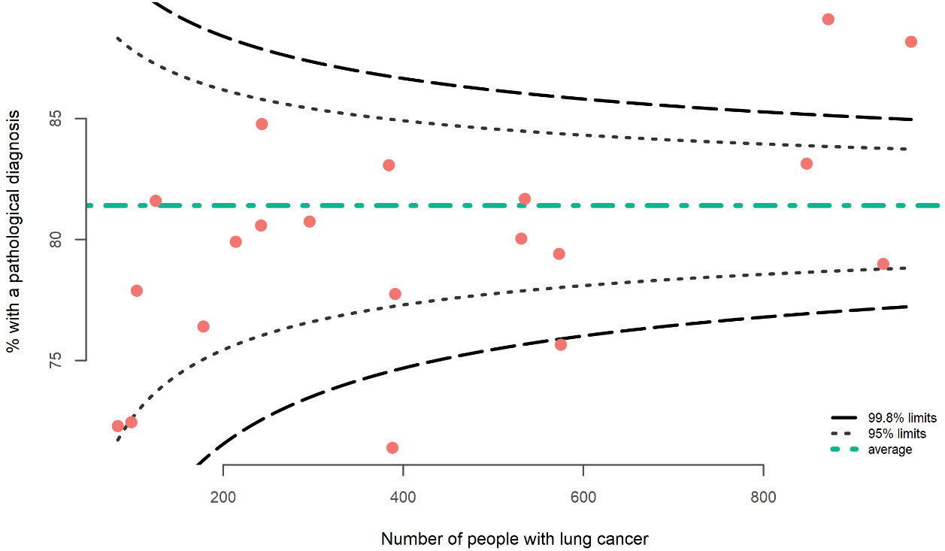

Overall, the proportion of people with a pathological diagnosis of lung cancer was highest for Asian (90.0 percent) and Pacific peoples (86.6 percent) ethnicities. Pathological diagnosis rates decreased with increasing age (Table 5).

Table 5: Proportion of people with a pathological diagnosis of lung cancer, by age group, sex, ethnic group and social deprivation, 2015–18
 | Total people  (N) | Pathological diagnosis
 |  | N | %
Total | 8,577 | 6,982 | 81.4
Ethnic group
Māori | 1,855 | 1,523 | 82.1
Pacific peoples | 434 | 376 | 86.6
Asian | 439 | 395 | 90.0
NZ European/Other | 5,828 | 4,669 | 80.1
Sex
Female | 4,280 | 3,510 | 82.0
Male | 4,295 | 3,472 | 80.8
Age group (years)
18–49 | 314 | 296 | 94.3
50–59 | 1,179 | 1,094 | 92.8
60–69 | 2,477 | 2,214 | 89.4
70–79 | 2,919 | 2,415 | 82.7
80 + | 1,688 | 963 | 57.0
NZDep2013 quintile
1 (least deprived) | 1,090 | 908 | 83.3
2 | 1,261 | 1,035 | 82.1
3 | 1,630 | 1,323 | 81.2
4 | 2,038 | 1,634 | 80.2
5 (most deprived) | 2,553 | 2,080 | 81.5

Comparison
The proportion of people with a pathological diagnosis has increased slightly since the 2008–12 Health Quality and Safety Commission report (HQSC 2016), from 79 percent to 81.6 percent.

In the United Kingdom the proportion of people with a pathological diagnosis of lung cancer was 72 percent as reported in the National Lung Cancer Audit Annual report 2018 (Royal College of Physicians 2019).

Recommendations
Pathological diagnosis rates are generally high. Outlier DHBs that have a lower proportion of pathological diagnosis warrant further investigation to better understand the variance. Variation may reflect multidisciplinary team management systems and the aggressiveness of investigation rates. It is also important to recognise that the main route to cancer registration within the NZCR is a pathological diagnosis. Other routes to registration, for example via discharge summaries, may vary by DHB. This means variation by DHB may also reflect differences in approach to clinical coding.

The DHBs with significantly higher proportions of pathological diagnosis should also be investigated further to ensure no inappropriate biopsies are occurring, resulting in greater harm from the procedures.

Surgical resection

Statement of intent
All people with early stage NSCLC cancers and good performance status should be considered for surgery.

Context
Complete surgical resection is the gold standard of treatment for early stage lung cancer and offers the best chance of cure.

Surgical resection is recommended for patients with clinical stage I and II NSCLC (Howington et al 2013). Surgery should also be considered in selected regionally advanced lung cancers (stage IIIA). This is most appropriately done in a multidisciplinary setting, with the goal of maximising a patient’s survival chances, as well as their quality of life.

Results
The proportion of people with NSCLC who underwent curative surgical resection was 16.7 percent, increasing to 17.2 percent for those with NSCLC and a pathological diagnosis.

Wide variation was observed in the rate of curative resection across DHBs, varying from 9.5 percent to 24.3 percent (Figure 3). Two DHBs were above and three DHBs were below the 95 percent confidence limits.

Figure 3: Curative resection rate for patients diagnosed with non-small cell lung cancer, by DHB of domicile, 2015–18
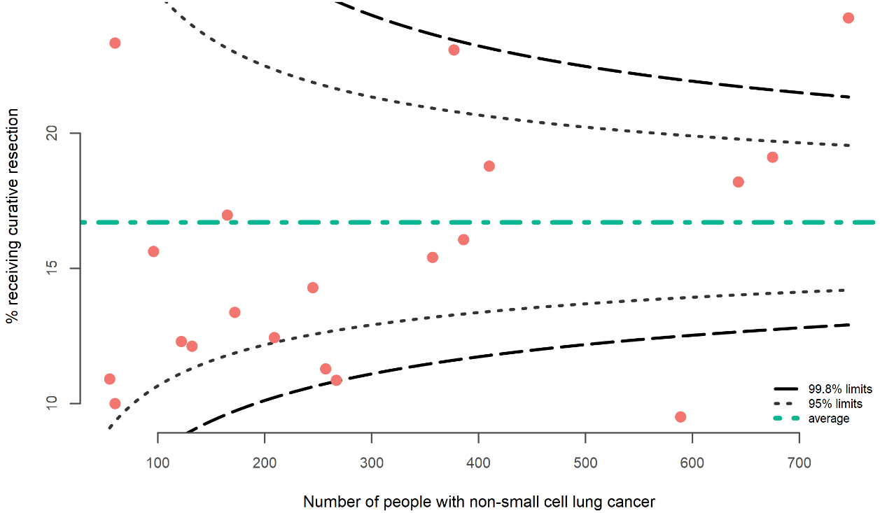

Māori and Pacific peoples had the lowest curative resection rate compared with other ethnic groups. There was a lower curative resection rate for people 80 years and over, with no major differences observed for the other age groups. Curative resection rates appeared to decrease as social deprivation increased (see Table 6).

Table 6: Curative resection rate for patients diagnosed with non-small cell lung cancer, by age group, sex, ethnic group and social deprivation, 2015–18
 | People with NSCLC  (N) | Surgical resection
 |  | N | %
Total NSCLC | 6,023 | 1,006 | 16.7
Pathological diagnosis of NSCLC | 5,847 | 1,006 | 17.2
Ethnic group
Māori | 1,236 | 166 | 13.4
Pacific peoples | 329 | 40 | 12.2
Asian | 384 | 96 | 25.0
NZ European/Other | 4,056 | 696 | 17.2
Sex
Female | 2,974 | 543 | 18.3
Male | 3,049 | 463 | 15.2
Age group (years)
18–49 | 241 | 44 | 18.3
50–59 | 905 | 160 | 17.7
60–69 | 1,881 | 349 | 18.6
70–79 | 2,103 | 387 | 18.4
80+ | 893 | 66 | 7.4
NZDep2013 quintile
1 (least deprived) | 804 | 151 | 18.8
2 | 908 | 172 | 18.9
3 | 1,152 | 189 | 16.4
4 | 1,417 | 227 | 16.0
5 (most deprived) | 1,740 | 267 | 15.3

Comparison
There has been an increase in overall curative resection rates since the 2008–12 Health Quality and Safety Commission report (HQSC 2016), from 14.7 percent to 16.7 percent.

The Aotearoa New Zealand curative resection rates for NSCLC appear to be lower than in the United Kingdom (18.4 percent) (Ginsberg and Rubinstein 1995), Scotland (23.3 percent) (NHS National Services Scotland 2017), Australia (22 percent) (Thai et al 2019) and Denmark (19.8 percent) (Jakobsen et al 2013).

Recommendations
Further investigation at the DHB level will help clarify the drivers of variation. Stage and performance status will impact an individual’s suitability for surgery, and DHBs may look to classify their patients by these groupings as they review their own data. However, there is unlikely to be large variation in these factors between DHBs at a population level, so this alone is unlikely to be the cause of variation.

There are two large DHBs that are notable outliers, one with a high proportion and one with a low proportion of patients undergoing surgical resection. Investigation at a DHB level may highlight issues with the diagnostic and referral pathways (meaning that people are presenting at a late stage and are ineligible for surgery) or differences in multidisciplinary team approaches and intervention rates.

Previous research has found similar rates of curative treatment for Māori and non-Māori, once they reach diagnosis (Lawrenson et al 2020). This means variation by ethnicity, and probably by socioeconomic status as well, reflects systematic barriers along the cancer diagnosis and treatment pathway. Further investigation of the diagnosis and treatment pathway will identify areas for quality improvement.

Overall, our rate of surgical resection appears lower than that of other Organisation for Economic Co-operation and Development (OECD) countries. Te Aho o Te Kahu will work to develop a quality improvement programme to increase surgical resection rates.

Systemic anti-cancer therapy

Statement of intent
People with lung cancer should be considered for and offered systemic anti-cancer therapy if appropriate.

Context
Systemic anti-cancer therapy can provide benefit to people with NSCLC in different contexts, adding to cure rates for people whose cancers are amenable to surgical resection or to radical chemoradiation and improving quality of life and longevity in fit people with advanced disease. However, many people will not be appropriate for treatment due to comorbidity or poor performance status. There will also be some people who have early stage disease and do not require systemic treatment.

The majority of people with small cell lung cancer will require systemic anti-cancer therapy, unless they are not fit for treatment on the basis of pre-existing comorbidities.

Results
This analysis only deals with publicly funded treatment and does not consider those treated privately or as part of clinical trials. This is an important consideration as the data may hide inequities by making it look like those who access care privately (New Zealand European and those with higher incomes) have lower rates of systemic anti-cancer therapy.

Non-small cell lung cancer
Overall, 29.7 percent of people with NSCLC received systemic anti-cancer therapy. This varied across DHBs, from 12.7 percent to 38.4 percent (Figure 4). Three DHBs were below and two DHBs were above the 95 percent confidence limits of the funnel plot.

Figure 4: Proportion of people with non-small cell lung cancer receiving systemic anti-cancer therapy, by DHB of domicile, 2015–18
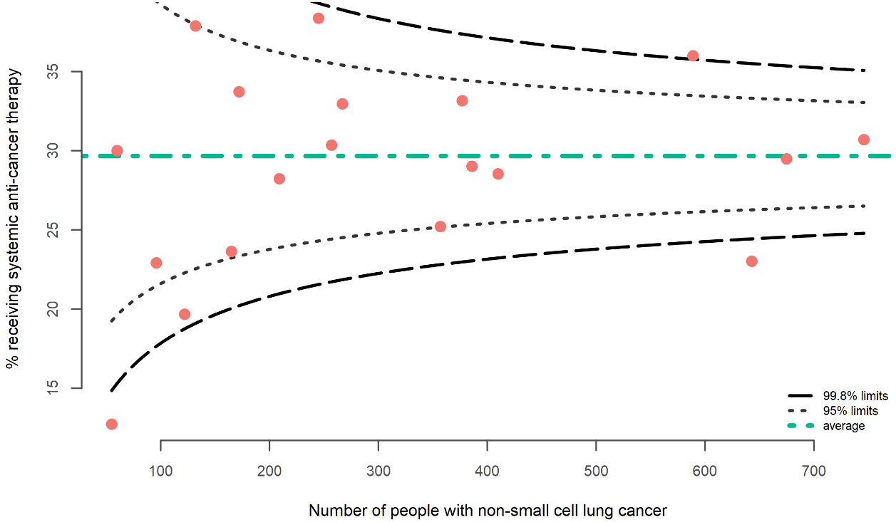

Among people with NSCLC, the systemic anti-cancer therapy rate was highest for those of Asian ethnicity (42.4 percent) and for people below 50 years of age (49.4 percent) (Table 7). Females had a slightly higher rate (31.7 percent) compared with males (27.6 percent).

Table 7: Systemic anti-cancer therapy rate for people with non-small cell lung cancer, by age group, sex, ethnic group and social deprivation, 2015–18
 | People with NSCLC  (N) | Systemic anti-cancer therapy
 |  | N | %
Total NSCLC | 6,023 | 1,787 | 29.7
Ethnic group
Māori | 1,236 | 395 | 32.0
Pacific peoples | 329 | 124 | 37.7
Asian | 384 | 163 | 42.4
NZ European/Other | 4,056 | 1,097 | 27.0
Sex
Female | 2,974 | 944 | 31.7
Male | 3,049 | 843 | 27.6
Age group (years)
18–49 | 241 | 119 | 49.4
50–59 | 905 | 405 | 44.8
60–69 | 1,881 | 697 | 37.1
70–79 | 2,103 | 496 | 23.6
80+ | 893 | 70 | 7.8
NZDep2013 quintile
1 | 804 | 246 | 30.6
2 | 908 | 293 | 32.3
3 | 1,152 | 331 | 28.7
4 | 1,417 | 368 | 26.0
5 | 1,740 | 548 | 31.5

Small cell lung cancer
The systemic anti-cancer therapy rate for SCLC was 71.3 percent. There was variation in the proportion of people with SCLC receiving systemic anti-cancer therapy across DHBs; however, these generally fell within the expected range (Figure 5).

Figure 5: Proportion of people with small cell lung cancer receiving systemic anti-cancer therapy, by DHB of domicile, 2015–18
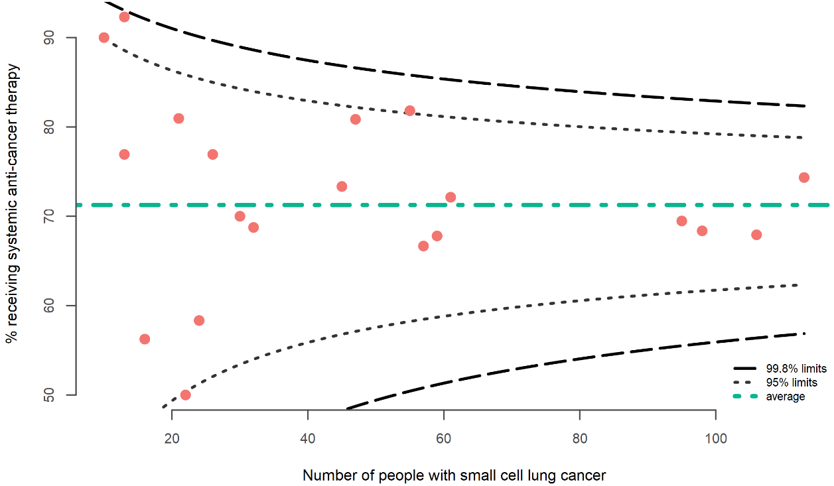

The systemic anti-cancer therapy rate among people with SCLC was highest for Māori (75.3 percent) and for those under 60 years old, noting that this does not include private data, which may bias results (Table 8). No differences were observed between females and males.

Table 8: Systemic anti-cancer therapy rate for people with small cell lung cancer, by age group, sex, ethnic group and social deprivation, 2015–18
 | People with SCLC  (N) | Systemic anti-cancer therapy
 |  | N | %
Total SCLC | 943 | 672 | 71.3
Ethnic group
Māori | 300 | 226 | 75.3
Pacific peoples | 43 | 25 | 58.1
Asian | 19 | 13 | 68.4
NZ European/Other | 580 | 407 | 70.2
Sex
Female | 502 | 357 | 71.1
Male | 441 | 315 | 71.4
Age group (years)
18–49 | 30 | 26 | 86.7
50–59 | 172 | 148 | 86.0
60–69 | 339 | 264 | 77.9
70–79 | 315 | 209 | 66.3
80+ | 87 | 25 | 28.7
NZDep2013 quintile
1 | 106 | 76 | 71.7
2 | 121 | 84 | 69.4
3 | 167 | 111 | 66.5
4 | 221 | 174 | 78.7
5 | 328 | 227 | 69.2

Comparison

Non-small cell lung cancer
The proportion of people with NSCLC who received systemic anti-cancer therapy has increased since the 2008–12 Health Quality and Safety Commission report (HQSC 2016), from 20.1 percent to 29.3 percent. This rate is comparable with that for the United Kingdom, at 27 percent (Royal College of Physicians 2019).

Small cell lung cancer
The proportion of people with SCLC who received systemic anti-cancer therapy has increased since the 2008–12 Health Quality and Safety Commission report (HQSC 2016), from 66.2 percent to 71.2 percent, and again, is comparable with that for the United Kingdom, at 71 percent (Royal College of Physicians 2019).

Recommendations
This analysis only includes publicly funded treatment, which may mask inequities. We recommend that DHBs continue to provide support for the development and implementation of the ACT-NOW New Zealand project, which will allow for further assessment of systemic anti-cancer therapy.

Once it has been completed, the ACT-NOW New Zealand project will be able to provide further detail on this indicator.

We recommend DHBs that are outside the funnel plot review the care pathways followed in their DHB. The drivers of variation could include access to treatment, differences in treatment pathways and diagnostic pathways (resulting in differences in stage at diagnosis). DHBs may also need to consider differences in the proportion of treatment that is provided privately.

There may also be merit in reporting data by cancer centre, as well as by DHB, as most cancer centres have a catchment that encompasses more than one DHB population.

Radiation therapy
- Stereotactic ablative radiation therapy

Statement of intent
People with early stage NSCLC who are not suitable for surgery should be offered SABR.

Context
SABR is a focused treatment, used to deliver a high dose of radiation to a small area of lung containing tumour, with minimal radiation to the reminder of the lungs and surrounding structures. SABR has survival benefits for people with early stage NSCLC who are not suitable for surgery and has superior local control than conventionally fractionated radiotherapy in stage I NSCLC (Ball et al 2019).

Results
The proportion of people with lung cancer receiving SABR could not be calculated with confidence from existing national data collections.

Recommendations
As part of reviewing this indicator, we noted that the SABR volumes identified from our analyses were lower than the actual number of people treated with SABR over this period. An audit of patients treated with SABR at one regional cancer centre found that over 40 percent of patients treated with SABR did not have their lung cancer diagnosis recorded on the NZCR and were therefore not included in the cohort of people identified for the QPI analysis.

Patients without a pathological diagnosis or cancer coding from a hospital admission event are not registered on the NZCR. We recommend that all patients with a lung cancer diagnosis are reported to the NZCR.

Cross-correlation of the Radiation Oncology Collection (ROC) with NZCR will improve the accuracy of figures around patients who have not received a pathological diagnosis. This includes a standard for how SABR patients are recorded in the ROC.

Timeliness of radiation therapy treatment is critical to improving survival and to reducing anxiety associated with lengthy wait times. Future QPI work could include looking at improving this factor.

- Concurrent chemoradiation

Statement of intent
People with locally advanced lung cancer should be considered for concurrent chemoradiation.

Context
Concurrent chemoradiation is the definitive treatment for patients with limited stage SCLC who are fit enough to undergo treatment. Concurrent chemoradiation is also the main radical treatment option for people with stage III NSCLC, most of whom are not suitable for surgery. However, any potential benefit needs to be balanced against the risk of toxicity from the treatment.

Results
The proportion of people with lung cancer receiving concurrent chemoradiation was 5.4 percent (5.8 percent for NSCLC, 10.7 percent for SCLC) (

Table 9).

Table 9: Proportion of people with lung cancer receiving concurrent chemoradiation by cancer type, 2015–18
 | Total people  (N) | Concurrent chemoradiation
 |  | N | %
All lung cancers | 8,577 | 460 | 5.4
Non-small cell lung cancer | 6,023 | 352 | 5.8
Small cell lung cancer | 943 | 101 | 10.7
Other lung cancers | 1,611 | 7 | 0.4

There was variation between DHBs for the concurrent chemoradiation rate for NSCLC, ranging from 1.7 percent to 10.0 percent (Figure 6). Two DHBs were below the 95 percent confidence limit.

Figure 6: Proportion of people with non-small cell lung cancer receiving concurrent chemoradiation, by DHB of domicile, 2015–18
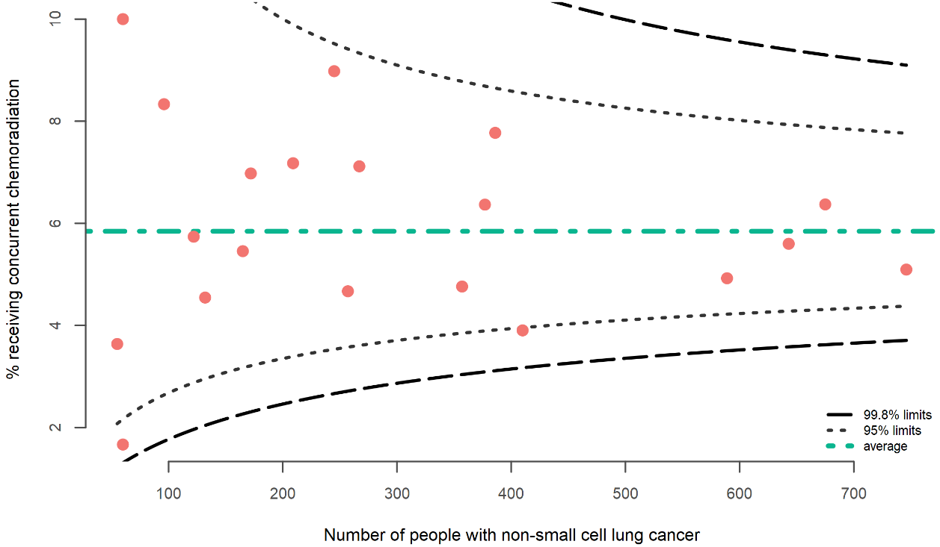

The concurrent chemoradiation rate for NSCLC was highest for Pacific peoples (7.3 percent) and Māori (7.0 percent). Older age groups, 70 years and over, had lower concurrent chemoradiation rates compared with the under-70s (Table 10).

Table 10: Concurrent chemoradiation rate for people with non-small cell lung cancer, by age group, sex, ethnic group and social deprivation, 2015–18
 | People with NSCLC  (N) | Concurrent chemoradiation
 |  | N | %
Total NSCLC | 6,023 | 352 | 5.8
Ethnic group
Māori | 1,236 | 87 | 7.0
Pacific peoples | 329 | 24 | 7.3
Asian | 384 | 20 | 5.2
NZ European/Other | 4,056 | 221 | 5.4
Sex
Female | 2,974 | 167 | 5.6
Male | 3,049 | 185 | 6.1
Age group (years)
18–49 | 241 | 21 | 8.7
50–59 | 905 | 83 | 9.2
60–69 | 1,881 | 158 | 8.4
70–79 | 2,103 | 81 | 3.9
80+ | 893 | 9 | 1.0
NZDep2013 quintile
1 (least deprived) | 804 | 33 | 4.1
2 | 908 | 65 | 7.2
3 | 1,152 | 64 | 5.6
4 | 1,417 | 80 | 5.6
5 (most deprived) | 1,740 | 109 | 6.3

The proportion of people with SCLC receiving concurrent chemoradiation was 10.7 percent. There was variation between DHBs for the concurrent chemoradiation rate for SCLC, ranging from 3.5 percent to 50.0 percent (Figure 7). Three DHBs were below and one DHB was above the 95 percent confidence limits of the funnel plot. Some DHBs had only small numbers of SCLC (for example, four DHBs had less than 20 people with SCLC over the four-year period of this investigation).

Figure 7: Proportion of people with small cell lung cancer receiving concurrent chemoradiation, by DHB of domicile, 2015–18
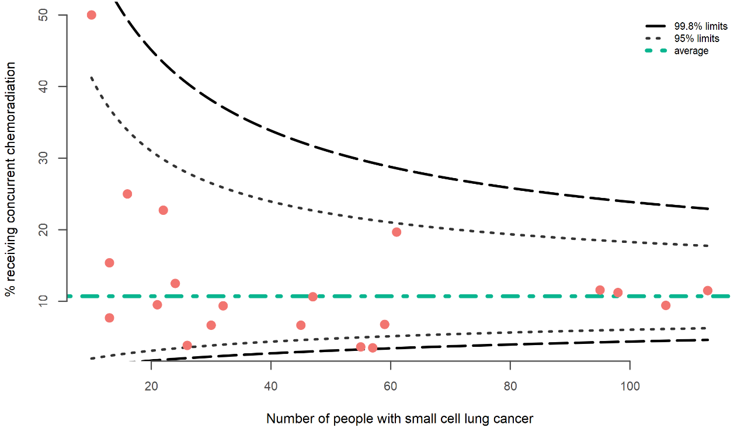

Younger age groups had higher concurrent chemoradiation rates compared with those aged 70 years and over. Females (13.1 percent) had higher rates compared to males (7.9 percent). Rates of concurrent chemoradiation appear to decrease as deprivation increases (Table 11).

Table 11: Concurrent chemoradiation rate for people with small cell lung cancer, by age group, sex, ethnic group, and social deprivation, 2015–18
 | People with SCLC  (N) | Concurrent chemoradiation
 |  | N | %
Total SCLC | 943 | 101 | 10.7
Ethnic group
Māori | 300 | 30 | 10.0
Pacific peoples | 43 | 3 | 7.0
Asian | 19 |  | 0.0
NZ European/Other | 580 | 68 | 11.7
Sex
Female | 502 | 66 | 13.1
Male | 441 | 35 | 7.9
Age group (years)
18–49 | 30 | 4 | 13.3
50–59 | 172 | 28 | 16.3
60–69 | 339 | 46 | 13.6
70–79 | 315 | 23 | 7.3
80+ | 87 |  | 0.0
NZDep2013 quintile
1 (least deprived) | 106 | 15 | 14.2
2 | 121 | 17 | 14.0
3 | 167 | 19 | 11.4
4 | 221 | 23 | 10.4
5 (most deprived) | 328 | 27 | 8.2

Comparison
Rates for Aotearoa New Zealand were similar to results from the Danish Lung Cancer Registry, which found a combined chemoradiation rate of 5 percent for all lung cancer patients, noting that this data is now relatively old (Jakobsen et al 2013). Other international benchmarking is difficult without stage.

Recommendations
Completion of the ACT-NOW project will provide more information on patients receiving chemotherapy. Future work to allow cross-referencing of ROC and ACT -NOW databases will improve data quality and allow for international comparison and benchmarking.

Cancer treatment at end of life

Statement of intent
People should not receive chemotherapy for lung cancer in the 30 days before death if they are unlikely to benefit from it.

Context
During cancer treatment, quality of life should be prioritised and systemic anti-cancer therapy should only be offered when there is a reasonable chance that it will provide a meaningful benefit. In a hospital setting, where the culture is often focused on cure, continuing invasive procedures, investigations and treatments may compromise the patient’s quality of life and comfort.

End-of-life chemotherapy and aggressive end-of-life care can have negative effects, including higher rates of ED visits, hospitalisations, admissions to intensive care and lower levels of engagement with hospice services.

This indicator aims to assess treatment at the end of life and how we make decisions about chemotherapy in people with lung cancer at life’s end and considers what benefit there might be to such treatments.

Results
The proportion of people receiving systemic anti-cancer therapy within 30 days before death was 5.9 percent. This proportion was lower for people with NSCLC (5.9 percent) compared with people diagnosed with SCLC (14.3 percent) (Table 12).

Table 12: Proportion of people with lung cancer who receive systemic anti-cancer therapy within 30 days of death, by year and cancer type, 2015–18
 | People deceased  (N) | SACT 30 days before death
 |  | N | %
Total | 6,520 | 387 | 5.9
Non-small cell lung cancer | 4,278 | 253 | 5.9
Small cell lung cancer | 838 | 120 | 14.3
Other lung cancers | 1,404 | 14 | 1.0

There was variation between DHBs, ranging from 1.6 percent to 11. percent (Figure 8). Two DHBs were above and two DHBs were below the 95 percent confidence limits of the funnel plot.

Figure 8: Proportion of people with lung cancer who receive systemic anti-cancer therapy (SACT) within 30 days of death, by DHB of domicile, 2015–18
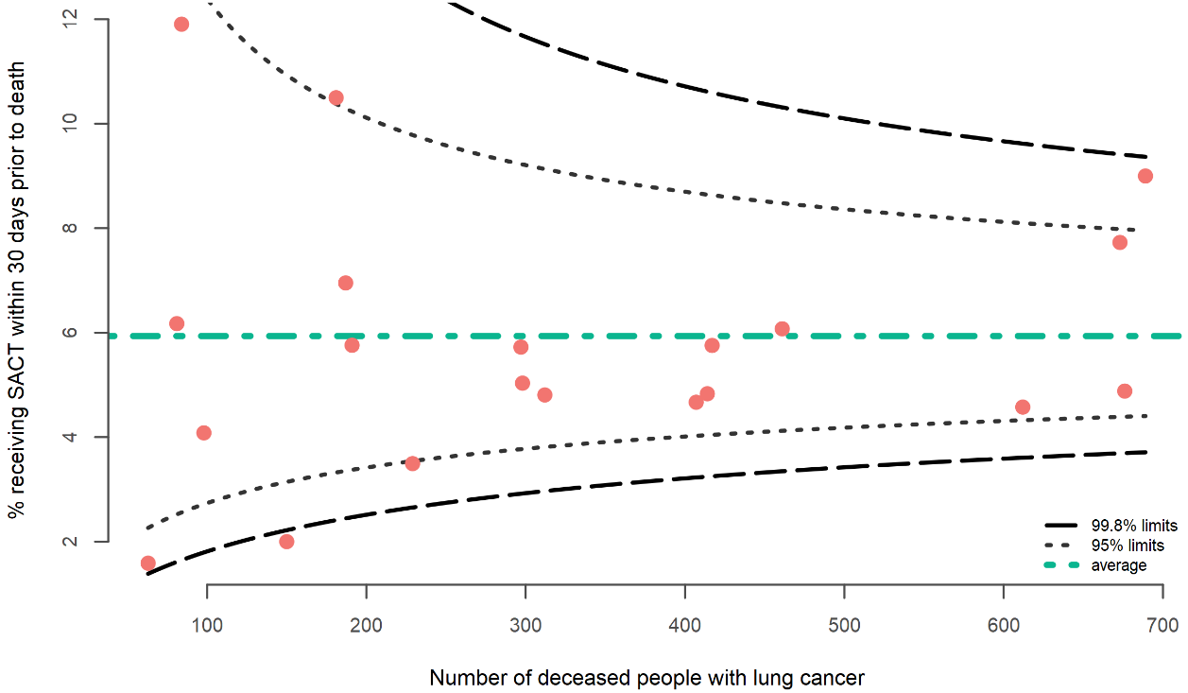

Overall, the proportion of people with lung cancer who received systemic anti-cancer therapy within 30 days of death was highest for people aged 18–49 years (18.2 percent) and for Pacific (10.3 percent) and Asian (9.3 percent) ethnicities (Table 13). Note: This analysis only considers publicly funded treatment and does not include those treated privately or as part of clinical trials.

Table 13: Proportion of people with lung cancer who receive systemic anti-cancer therapy within 30 days of death, by age group, sex, ethnic group and social deprivation, 2015–18
 | People deceased  (N) | SACT 30 days before death
 |  | N | %
Total SACT | 6,520 | 387 | 5.9
Ethnic group
Māori | 1,518 | 118 | 7.8
Pacific peoples | 329 | 34 | 10.3
Asian | 247 | 23 | 9.3
NZ European/Other | 4,425 | 212 | 4.8
Sex
Female | 3,117 | 207 | 6.6
Male | 3,401 | 180 | 5.3
Age group (years)
18–49 | 198 | 36 | 18.2
50–59 | 830 | 86 | 10.4
60–69 | 1,787 | 155 | 8.7
70–79 | 2,234 | 98 | 4.4
80+ | 1,471 | 12 | 0.8
NZDep2013 quintile
1 (least deprived) | 773 | 49 | 6.3
2 | 908 | 53 | 5.8
3 | 1,225 | 57 | 4.7
4 | 1,598 | 80 | 5.0
5 (most deprived) | 2,013 | 148 | 7.4

Comparison
Overall, Aotearoa New Zealand appears to have comparable but slightly lower rates of systemic anti-cancer therapy within 30 days of death compared with other countries. Research internationally found rates of: 8 percent in the United Kingdom (Wallington et al) and 6.2 percent in the Netherlands (Burgers et al 2018). Some countries appear to have considerably higher rates of systemic anti-cancer therapy within 30 days of death, with Canadian rates as high as 19 percent for NSCLC (Gibson et al 2019).

Recommendations
We recommend that DHBs currently outside the upper limit of the funnel review their models of care to see if over treatment is occurring within their cancer centre.

We also recommend that DHBs and cancer centres regularly review 30-day mortality after chemotherapy for people with lung cancer to better understand factors that may contribute to over (or under) treatment, with a view to maximising opportunities to improve care and palliation at end of life.

It would also be useful to undertake an audit and cross-reference this data with hospice data to see if chemotherapy at the end of life comes at the expense of access to specialist palliative care.

This indicator was selected to provide a measure of end-of-life care. Currently, there is not high-quality, nationally available data on palliative care. This would be an area for further investigation and data quality improvement work to measure access to specialist palliative care.

Treatment mortality

Statement of intent
Mortality after curative intent treatment at 30 and 90 days should be equivalent to other OECD countries and should not have significant variation across geographic, socioeconomic or ethnic groupings.

Context
Cancer treatment should only be offered when the benefits are likely to balance the risks. Treatment-related mortality is a marker of the quality and safety of cancer care and treatment provided by the multidisciplinary team.

Death within 30 or 90 days of curative treatment may mean the treatment was inappropriate, the extent or intensity of the treatment was too high, the patient’s fitness to receive treatment was not adequately assessed or the post-treatment monitoring was suboptimal. It may also be due to non-response to the treatment and disease progression.

Results
The number of people with SCLC who died within 30 days and 90 days of radical treatment was too low to enable detailed analysis in this investigation.

Death within three months of radical treatment was low for people with NSCLC, 1.0 percent at 30 days and 2.8 percent at 90 days. Although the numbers are small, surgical treatment and SABR both appear to have a lower 30- and 90-day treatment mortality than concurrent chemoradiation (Table 14).

Table 14: 30-day and 90-day treatment-related mortality rate for people with NSCLC, 2015–18
 | People with NSCLC  (N) | People with radical treatment | 30-day mortality |  | 90-day mortality
 |  |  | N | % | N | %
Total NSCLC | 6,023 | 1,464 | 15 | 1.0 | 41 | 2.8
Treatment modality
Surgery/SABR/concurrent chemoradiation combination |  | 28 | 1 | 3.6 | 2 | 7.1
Surgery only |  | 981 | 7 | 0.7 | 19 | 1.9
SABR only |  | 125 | 0 | 0.0 | 2 | 1.6
Concurrent chemoradiation |  | 330 | 7 | 2.1 | 18 | 5.5
Note: The SABR treatment numbers presented here underestimate the number of people treated but are included here for completeness of the treatment options offered to people with lung cancer. See section 3.5.1 for more information about SABR treatment reporting.

No DHBs were above the 95 percent confidence limit of the funnel plot. The total number of people who died within 30 days of treatment was too low to analyse by DHB.

Figure 9: 90-day radical treatment-related mortality rate for people with NSCLC, by DHB of domicile, 2015–18
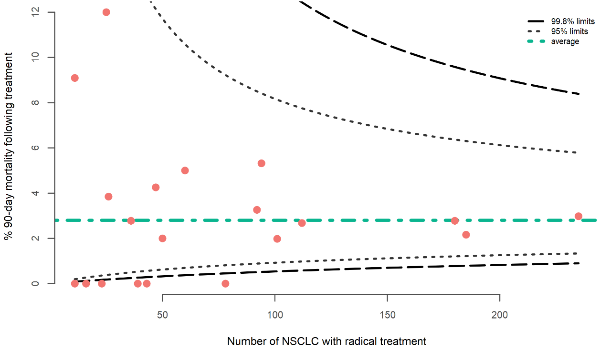
Pacific peoples experienced the highest 90-day treatment-related mortality compared with other ethnic groups but this was based on a small number of cases. Males had a higher 90-day treatment related mortality rate compared to females and people between 70 to 79 years of age had the highest mortality rate from all age groups (Table 15).

Table 15: 90-day treatment-related mortality rate for people with NSCLC, by age group, sex, ethnic group and social deprivation, 2015–18
 | People with NSCLC  (N) | People with radical treatment (N) | 90-day mortality
 |  |  | N | %
Total NSCLC | 6,023 | 1,464 | 41 | 2.8
Ethnic group
Māori | 1,236 | 280 | 7 | 2.5
Pacific peoples | 329 | 68 | 3 | 4.4
Asian | 384 | 117 | 4 | 3.4
NZ European/Other | 4,056 | 991 | 27 | 2.7
Sex
Female | 2,974 | 771 | 19 | 2.5
Male | 3,049 | 693 | 22 | 3.2
Age group (years)
18–49 | 241 | 67 | 1 | 1.5
50–59 | 905 | 242 | 8 | 3.3
60–69 | 1,881 | 519 | 10 | 1.9
70–79 | 2,103 | 523 | 21 | 4.0
80+ | 893 | 113 | 1 | 0.9
NZDep2013 quintile
1 (least deprived) | 804 | 199 | 8 | 4.0
2 | 908 | 253 | 5 | 2.0
3 | 1,152 | 281 | 4 | 1.4
4 | 1,417 | 324 | 11 | 3.4
5 (most deprived) | 1,740 | 406 | 13 | 3.2

Comparison
Internationally, the post-treatment mortality rate changes with treatment type. Aotearoa New Zealand appears to be comparable with Scotland, where the 30-day mortality was 1.5 percent following surgery, 1.9 percent following chemoradiotherapy and 1.3 percent following radical radiotherapy (NHS National Services Scotland 2017). In the United Kingdom lung cancer audit, the post-surgical mortality for NSCLC is higher than seen in Aotearoa New Zealand; 3 percent at 30 days and 5.9 percent at 90 days (Powell et al 2013). This is comparable with the United States, which had a 30-day mortality rate of 2.8 percent and a 90-day mortality rate of 5.4 percent (Pezzi et al 2014).

Recommendations
Overall, the post treatment mortality in Aotearoa New Zealand appears acceptable. Treatment survival could be improved by assessing patient’s’ comorbidities and fitness for radical interventions before treatment, including considering ‘prehabilitation’ programmes, which aim to enhance a patient’s general health and wellbeing before surgery to improve their post-operative outcomes.

Overall survival

Statement of intent
New Zealanders’ lung cancer survival rates should be equivalent to those in OECD countries, and we should not have significant variation across geographic, socioeconomic and ethnic groupings.

Context
Good survival is the overall aim of our processes and outcome measures in lung cancer management. Survival figures are the product of all interventions from screening and early detection through to treatment. Survival rates also incorporate factors such as the general health and wellbeing of the population, access to health care and genetic and environmental variables.

For most cancers, survival five years after diagnosis is generally accepted as an indicator of cure. As lung cancer has an overall poor prognosis, one-year survival time can be used as an indicator of effectiveness of care (Cancer Control New Zealand 2009) and is likely to be more sensitive to recent interventions than five-year survival.

Results
Between 2015 and 2017, 41.6 percent of people diagnosed with lung cancer survived one year after diagnosis. One-year survival was higher for people with NSCLC (48.2 percent) than for SCLC (29.8 percent). Survival decreased at two years, with an overall proportion of 26.8 percent for all lung cancers, 32.3 percent for NSCLC and 13.3 percent for SCLC. At three years from diagnosis, the proportion surviving rate was 20.5 percent for all lung cancers, 24.7 percent for NSCLC and 11.4 percent for SCLC (Table 16).

Table 16: Overall survival for people with lung cancer one, two and three years after diagnosis, by year of diagnosis and cancer type
 | One-year survival  (diagnosed 2015–17) |  | Two-year survival  (diagnosed 2015–16) |  | Three-year survival  (diagnosed 2015)
 | N | % | N | % | N | %
All lung cancers | 2,641 | 41.6 | 1,138 | 26.8 | 430 | 20.5
Non-small cell lung cancer | 2,144 | 48.2 | 955 | 32.3 | 361 | 24.7
Small cell lung cancer | 216 | 29.8 | 64 | 13.3 | 25 | 11.4
Other lung cancers | 281 | 23.9 | 119 | 14.7 | 44 | 10.7

There was variation between DHBs for overall survival at one, two and three year after diagnosis (Figure 10, Figure 11, Figure 12 respectively). Two DHBs were below the 95 percent confidence limit of the funnel plot for one-year survival, and four DHBs were below the 95 percent confidence limits of the funnel plots for two-year and three-year survival.

Figure 10: Proportion of people with lung cancer alive one year after diagnosis, by DHB of domicile, 2015–17
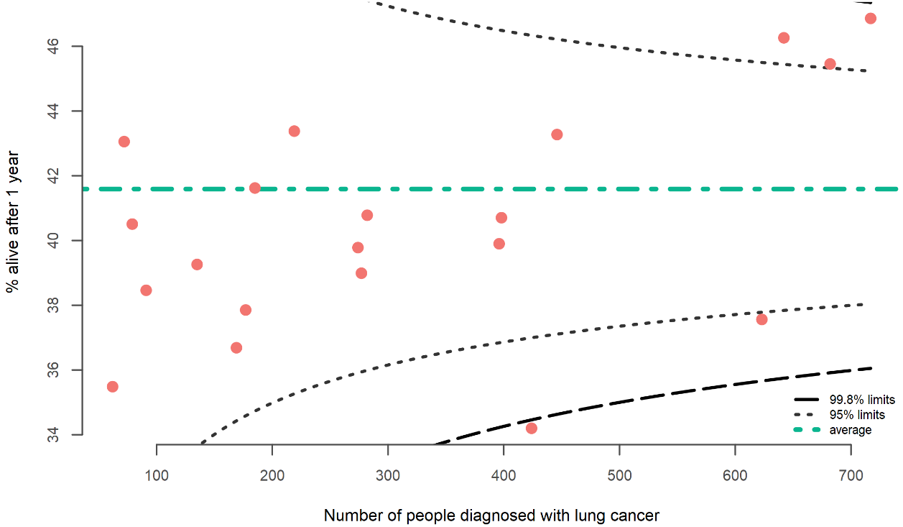

Figure 11: Proportion of people with lung cancer alive two years after diagnosis, by DHB of domicile, 2015–16
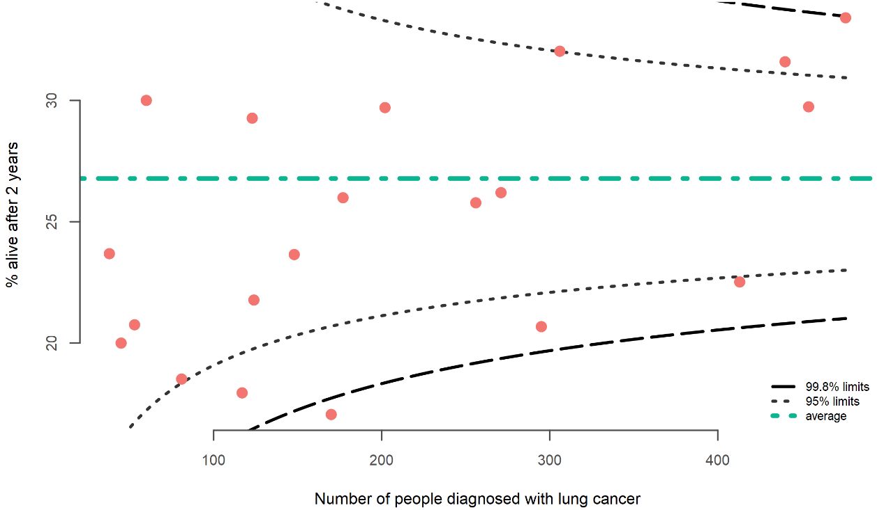

Figure 12: Proportion of people with lung cancer alive three years after diagnosis, by DHB of domicile, 2015
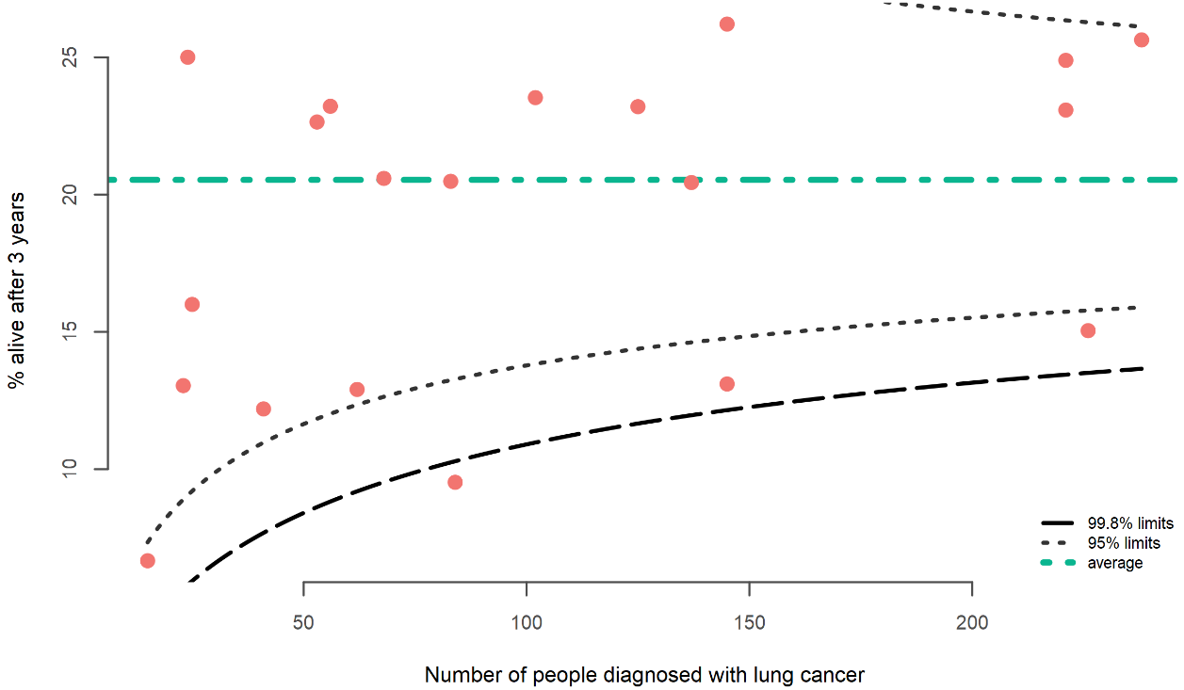

Māori had the lowest overall survival of all ethnic groups, with 37.7 percent alive one year after diagnosis, 21.6 percent two years after diagnosis and 17.5 percent three years after diagnosis. However, this was only slightly less than the survival proportion for New Zealand Europeans. Asians had the highest overall survival across all years. People aged 80 years and older, males and those living in areas of high social deprivation had poorer overall survival.

Table 17: Proportion of people alive one, two and three years after diagnosis of lung cancer
 | 1-year survival  (diagnosed 2015–17) |  | 2-year survival  (diagnosed 2015–16) |  | 3-year survival  (diagnosed 2015)
 | N | % | N | % | N | %
Total all lung cancers | 2,641 | 41.6 | 1,138 | 26.8 | 430 | 20.5
Ethnic group
Māori | 521 | 37.7 | 194 | 21.6 | 79 | 17.5
Pacific peoples | 149 | 46.9 | 62 | 29.4 | 22 | 24.2
Asian | 194 | 61.2 | 103 | 49.5 | 39 | 43.3
NZ European/Other | 1,768 | 40.9 | 774 | 26.4 | 286 | 19.6
Sex
Female | 1,432 | 45.0 | 649 | 30.8 | 247 | 23.6
Male | 1,209 | 38.2 | 489 | 22.8 | 183 | 17.5
Age group (years)
18–49 | 117 | 51.5 | 64 | 41.0 | 30 | 34.9
50–59 | 442 | 49.2 | 190 | 32.0 | 86 | 27.7
60–69 | 838 | 45.7 | 385 | 31.3 | 150 | 24.5
70–79 | 907 | 41.9 | 374 | 26.2 | 131 | 19.3
80+ | 337 | 27.4 | 125 | 14.8 | 33 | 8.1
NZDep2013 quintile
1 (least deprived) | 376 | 47.2 | 176 | 32.8 | 67 | 26.3
2 | 437 | 46.4 | 188 | 30.0 | 64 | 21.1
3 | 510 | 42.1 | 225 | 28.1 | 87 | 21.8
4 | 584 | 38.3 | 244 | 23.3 | 87 | 17.0
5 (most deprived) | 732 | 39.1 | 305 | 24.7 | 125 | 20.0

Comparison
The proportion of people alive one year after diagnosis in Aotearoa New Zealand (41.6 percent) has improved over time, with data from those diagnosed in 2010–2011 showing a one-year survival of 34.3 percent (Ministry of Health 2015a).

Aotearoa New Zealand’s one-year survival is higher than that of the United Kingdom (36.7 percent) (Royal College of Physicians 2019) but lower than Australia’s (54.3 percent) (Stirling et al 2017).

Recommendations
The funnel plots for one-, two- and three-year survival illustrate marked variation in survival for people with lung cancer according to DHB of residence. Furthermore, there is variation by ethnicity (with Māori having poor survival) and socioeconomic status (people living in areas with high social deprivation have worse survival). All quality improvement initiatives for lung cancer should focus on improving care pathways for Māori and those living in areas of high socioeconomic deprivation, with the aim of improving overall survival.

One large-population and one medium-population DHB are below the 95 percent confidence limits of the funnel plot for one-, two- and three-year survival, indicating poor survival rates in these DHBs. We recommend Te Aho o Te Kahu work with these DHBs to develop a quality improvement plan to improve survival. There are also two large population DHBs with survival rates higher than the 95 percent confidence limit, indicating good survival. These DHBs may have systems or processes in place that could be useful in other regions.

Improved access to new drugs that are shown to have an impact on survival in clinical trials, such as immunotherapies and mutational targeted treatments, may also improve survival rates over time.

Survival data are reported in order to give an overarching picture of the cumulative effect of all interventions on lung cancer outcomes. Benchmarking with survival data from other comparable OECD countries will serve to indicate how Aotearoa New Zealand is faring in terms of reducing lung cancer mortality globally.

- Methods
- Methods summary
We extracted data from the NZCR for people diagnosed with lung cancer from 1 January 2015 to 31 December 2018. For the purpose of this report, our dataset only includes people with a new primary diagnosis of lung cancer.

We linked data from the Ministry of Health’s National Collections to the cancer registrations at the patient level using National Health Index (NHI) numbers to obtain information on patient care and follow-up.

We used funnel plots to make comparisons between district health boards (DHBs). There were no adjustments of outcomes for patient-case mix.

We contacted all DHBs before publishing this report to inform them of their results and provide them with the opportunity to review those results and consider areas where they could improve services and outcomes for patients.

- Data sources
All patient data for this report came from administrative datasets held within the Ministry of Health’s National Collections. These include only publicly funded treatments following diagnosis for people diagnosed with lung cancer in Aotearoa New Zealand between 1 January 2015 and 31 December 2018.

- Data links

New Zealand Cancer Registry
The New Zealand Cancer Registry (NZCR) is a population-based registry. It is the most comprehensive source of information on people who have been diagnosed with malignant cancer in Aotearoa New Zealand. It is primarily based on pathology reporting but includes information from other sources, including death certificates and reviews of the diagnosis coding for people admitted to public hospitals.

National Minimum Dataset
The National Minimum Dataset (NMDS) is a national collection of public and private hospital discharge information, including coded clinical data for inpatients and day patients.

Linking NZCR data to NMDS data gave us a view of the procedures each patient underwent as treatments in public hospitals leading up to and following their lung cancer diagnosis.

Radiation Oncology Collection
The Radiation Oncology Collection is a national collection of private and public courses of radiation therapy delivered.

Treatment centres have submitted data electronically in an agreed format since 2018, although most providers have supplied historic data back to 2012.

Data collected for each course of radiation therapy delivered includes treatment centre, diagnosis code (according to the International Statistical Classification of Diseases and Related Health Problems, Tenth Revision, Australian Modification (ICD-10-AM), 8th edition), treatment site, intent of the treatment, dose, fractions and number of treatment sessions.

Only publicly funded radiation therapy treatments were extracted from this collection for linking with the NZCR data.

Pharmaceutical Collection (PHARMS)
The Pharmaceutical Collection (PHARMS) is a national data warehouse that supports the management of pharmaceutical subsidies and contains claim and payment information from pharmacists for subsidised dispensing. The PHARMS collection includes names of drugs dispensed and date of dispensing.

National Non-Admitted Patients Collection
The National Non-Admitted Patients Collection (NNPAC) information includes event-based purchase units that relate to medical and surgical outpatient events and emergency department (ED) events. This includes information on the type of service provided and the health specialty involved.

The NNPAC allows the Ministry of Health and DHBs to monitor outpatient activity and ensure that DHBs are appropriately remunerated for the services they provide.

The NNPAC provides national consistent data on non-admitted patient (outpatient and ED) activity.
- Data processing
We used existing data within the Ministry of Health’s National Collections to analyse the quality performance indicators (QPIs). No data was provided by DHBs specifically for these indicators.

We used existing routinely available national administrative data sources to work through individual patients’ cancer journeys for all people diagnosed with lung cancer between 1 January 2015 and 31 December 2018 and examine the sequence of events that took them to that diagnosis, treatment and outcome. These routes to diagnosis included ED presentation or referral to a clinic (as inpatients (NMDS) or outpatients (NNPAC)).

We linked lung cancer patients from the NZCR to data sources within the National Collections using encrypted NHIs.

A patient is considered diagnosed with primary lung cancer when that patient is registered on the NZCR for the first time with a diagnosis of lung cancer. We defined lung cancer as C33 or C34 according to the ICD-10-AM, 8th edition. We assumed a patient’s diagnosis to be the first diagnosis if we could identify no previous diagnosis for that patient in the NZCR since 1 January 1995.

We excluded from all analyses people who were registered on the NZCR from death certificates only and those with a lung cancer diagnosis but with morphology codes for sarcomas and lymphomas.

We defined cancer types and subtypes using the morphology recorded on the NZCR. We grouped cancers that could clearly be identified as NSCLC or SCLC based on the morphology into the two cancer types. We classified carcinoid tumours and morphologies that were unspecified as other cancers (Table 18).

Table 18: Number of people on the NZCR with lung cancer carcinoid tumours or unspecified morphology by morphology code and description, 2015–18
Cancer subtype | Morphology code | Morphology description | Total people  (N)
Carcinoid tumours | 8240 | Carcinoid tumour, not otherwise specified | 103
 | 8244 | Mixed adenoneuroendocrine carcinoma | 2
 | 8249 | Atypical carcinoid tumour | 24
Total carcinoid tumours |  |  | 129
Unspecified lung | 8000 | Neoplasm, malignant | 1,377
 | 8010 | Carcinoma, not otherwise specified | 104
 | 8020 | Carcinoma, undifferentiated, not otherwise specified | 1
Total unspecified lung |  |  | 1,482
Total other lung cancers |  |  | 1,611

- Data completeness
We defined data completeness as the proportion of people with complete data on all four of the variables: age; sex; pathological tumour, node, metastasis (TNM) stage; and site of cancer, as we will use these variables for risk adjustment in future. In the future, the risk adjustment model will also need data on mode of admission and number of co--morbidities. We only assessed data completeness in patients who underwent major surgery for lung cancer because only in these patients could we expect all six data items to be complete.

Table 19: People who had lung cancer surgery with pathological tumour, node, metastasis stage available on the NZCR, 2015–18
Year | Total people  (N) | Tumour  (T) |  | Node  (N) |  | Metastases  (M) |  | Any  (T, N or M) |  | All  (T, N and M)
 |  | N | % | N | % | N | % | N | % | N | %
2015 | 254 | 233 | 91.7 | 223 | 87.8 | 114 | 44.9 | 233 | 91.7 | 114 | 44.9
2016 | 263 | 249 | 94.7 | 233 | 88.6 | 110 | 41.8 | 250 | 95.1 | 110 | 41.8
2017 | 293 | 264 | 90.1 | 246 | 84.0 | 116 | 39.6 | 264 | 90.1 | 116 | 39.6
2018 | 289 | 266 | 92.0 | 256 | 88.6 | 118 | 40.8 | 266 | 92.0 | 117 | 40.5
Total | 1,099 | 1,012 | 92.1 | 958 | 87.2 | 458 | 41.7 | 1,013 | 92.2 | 457 | 41.6

National Collections have high rates of completion of data fields. For patients undergoing major surgery, data on all patients included sex, age and site of cancer.

While most cases of lung cancer reported to the NZCR are derived from positive histology or cytology, a proportion are reported from radiology reports, admissions coding, or death certificates as required by the Cancer Registry Act 1993.

This introduces a potential source of bias in identifying people with cancer and is relevant to all international cancer registries that use multi-source case identification methods.

Large variances in the proportion of patients diagnosed by histology or cytology may be due to either real differences in case ascertainment or case identification (ascertainment). This may impact indicator interpretation related to case denominator, and a focused audit of hospitals with outlier status of cases with histological confirmation may identify possible issues with case ascertainment.

- Privately funded service provider data
The National Collections include all publicly funded hospital events. Private hospitals in Aotearoa New Zealand have recently begun voluntary submission of treatment data, but reporting was incomplete from 2015 to 2018. Therefore, this report does not include private care events. We hope that future quality reports will include this data.

- Definitions derived from National Collections
People diagnosed following an ED presentation were defined as people who have an ED presentation (from NNPAC) or admission (from NMDS) in the two weeks before their date of diagnosis.

People with surgical resection for lung cancer were derived from the procedures coded on inpatient admitted events (from NMDS) where the procedure was one of eight procedures identified as curative surgery for lung cancer.

Systemic anti-cancer therapy (SACT) was identified from the PHARMS collection for people who were dispensed publicly funded drugs for lung cancer treatment.

People receiving stereotactic ablative radiation therapy (SABR) were derived from the ROC (Radiation Oncology Collection) data using indication of curative intent of the course of treatment and a combination of dose and fraction as agreed by the radiation oncologists.

Concurrent chemoradiation was identified linking both the ROC data and PHARMS data, where the chemotherapy dispensing date was between the treatment start and end dates for a course of radiation therapy.

Date of death recorded on the NZCR was used for analysing treatment survival and overall survival. For people with more than one type of treatment (surgery, SACT, radiation therapy), treatment survival was calculated from date of first treatment received.

- Statistical analysis
Most results discussed in this report are descriptive. We report the results of categorical data as percentages (%). We typically group results by DHB of domicile (ie, where the patient resided at the time of diagnosis).

We also present results by year of diagnosis, ethnic group (prioritised), sex, age group (years) and NZDep2013 (Atkinson et al 2014) quintile (based on domicile at the time of diagnosis) in the data tables in Appendix B.

We have not presented results in the tables when there are fewer than 10 people in the denominator.

Funnel plots
This report uses funnel plots to make comparisons between DHBs. We plot the rate for each DHB against the total number of patients used to estimate the rate. The average across all DHBs appears as an orange line.

The funnel limits depend on the average rate and the number of patients included in the estimate; rate estimates have greater uncertainty when estimated from fewer patients. Results fall outside the inner limits if they are statistically different from the average at a 95 percent confidence limit and outside the outer limits if they are statistically significantly different from the average at a 99.8 percent confidence limit.

We contacted all DHBs before we published this report to inform them of their results and provide them with an opportunity to review their results and consider areas where they could improve services and outcomes for patients.

Adjusted outcomes
No risk adjustment was made to the data due to missing stage data and other risks, such as comorbidity.

We encourage service providers to interpret their results in context of the case mix of their unit. Data is stratified and presented in data tables in Appendix B. Stratifying variables include age group, sex, ethnic group (prioritised) and NZDep2013 quintile with data from the NZCR. Other variables (such as TNM group stage and comorbidity) are not available in National Collections but should be available in local DHB records.

- DHB results tables
Table 20: People diagnosed with lung cancer by hub and district health board of domicile, 2015-18
Hub and DHB | People diagnosed following presentation to an emergency department  (%) |  | People with  a pathological diagnosis (%) |  | People receiving systemic anti-cancer therapy within 30 days of death (%)
 | N | % | N | % | N | %
Ngā Hau Ki Te Raki – Northern | 1,401 | 47.6 | 2,519 | 85.6 | 123 | 5.8
Northland | 236 | 44.1 | 437 | 81.7 | 24 | 5.8
Waitemata | 418 | 47.9 | 777 | 89.1 | 28 | 4.6
Auckland | 282 | 49.2 | 455 | 79.4 | 19 | 4.7
Counties Manukau | 465 | 48.2 | 850 | 88.2 | 52 | 7.7
Te Manawa Taki – Midland | 836 | 49.3 | 1,382 | 81.4 | 111 | 8.1
Waikato | 440 | 51.9 | 705 | 83.1 | 62 | 9.0
Lakes | 93 | 43.5 | 171 | 79.9 | 19 | 10.5
Bay of Plenty | 254 | 47.8 | 425 | 80.0 | 20 | 4.8
Tairāwhiti | 49 | 47.1 | 81 | 77.9 | 10 | 11.9
Te Hōkai O Te Ika – Central | 854 | 44.4 | 1,508 | 78.4 | 79 | 5.2
Taranaki | 114 | 47.1 | 195 | 80.6 | 11 | 5.8
Hawke’s Bay | 177 | 45.3 | 304 | 77.7 | 15 | 4.8
Whanganui | 80 | 44.9 | 136 | 76.4 | 3 | 2.0
MidCentral | 154 | 40.1 | 319 | 83.1 | 15 | 5.0
Capital & Coast | 176 | 45.4 | 277 | 71.4 | 17 | 5.7
Hutt Valley | 104 | 42.8 | 206 | 84.8 | 13 | 7.0
Wairarapa | 49 | 50.0 | 71 | 72.4 | 5 | 6.2
Te Waipounamu – Southern | 772 | 38.4 | 1,573 | 78.2 | 74 | 4.8
Nelson Marlborough | 128 | 43.2 | 239 | 80.7 | 8 | 3.5
West Coast | 52 | 62.7 | 60 | 72.3 | 1 | 1.6
Canterbury | 287 | 30.8 | 737 | 79.0 | 33 | 4.9
South Canterbury | 49 | 39.2 | 102 | 81.6 | 4 | 4.1
Southern | 256 | 44.5 | 435 | 75.7 | 28 | 6.1
Total | 3,863 | 45.0 | 6,982 | 81.4 | 387 | 5.9

Table 21: People alive one, two and three years after diagnosis with lung cancer by hub and district health board of domicile
Hub and DHB | People alive at 1 year (diagnosed 2015–17)  (%) |  | People alive at 2 years (diagnosed 2015–16)  (%) |  | People alive at 3 years (diagnosed 2015)  (%)
 | N | % | N | % | N | %
Ngā Hau Ki Te Raki – Northern | 988 | 44.8 | 467 | 31.3 | 179 | 24.6
Northland | 162 | 40.7 | 71 | 26.2 | 29 | 23.2
Waitemata | 297 | 46.3 | 139 | 31.6 | 51 | 23.1
Auckland | 193 | 43.3 | 98 | 32.0 | 38 | 26.2
Counties Manukau | 336 | 46.9 | 159 | 33.4 | 61 | 25.6
Te Manawa Taki – Midland | 486 | 38.4 | 191 | 22.8 | 74 | 16.4
Waikato | 234 | 37.6 | 93 | 22.5 | 34 | 15.0
Lakes | 62 | 36.7 | 21 | 17.9 | 8 | 12.9
Bay of Plenty | 158 | 39.9 | 66 | 25.8 | 28 | 20.4
Tairāwhiti | 32 | 40.5 | 11 | 20.8 | 4 | 16.0
Te Hōkai O Te Ika – Central | 560 | 39.9 | 222 | 24.1 | 82 | 18.6
Taranaki | 67 | 37.9 | 27 | 21.8 | 13 | 23.2
Hawke’s Bay | 108 | 39.0 | 29 | 17.1 | 8 | 9.5
Whanganui | 53 | 39.3 | 15 | 18.5 | 5 | 12.2
MidCentral | 109 | 39.8 | 46 | 26.0 | 17 | 20.5
Capital & Coast | 115 | 40.8 | 60 | 29.7 | 24 | 23.5
Hutt Valley | 77 | 41.6 | 36 | 29.3 | 12 | 22.6
Wairarapa | 31 | 43.1 | 9 | 20.0 | 3 | 13.0
Te Waipounamu – Southern | 607 | 41.1 | 258 | 25.9 | 95 | 20.1
Nelson Marlborough | 95 | 43.4 | 35 | 23.6 | 14 | 20.6
West Coast | 22 | 35.5 | 9 | 23.7 | 1 | 6.7
Canterbury | 310 | 45.5 | 135 | 29.7 | 55 | 24.9
South Canterbury | 35 | 38.5 | 18 | 30.0 | 6 | 25.0
Southern | 145 | 34.2 | 61 | 20.7 | 19 | 13.1
Total | 2,641 | 41.6 | 1,138 | 26.8 | 430 | 20.5

Table 22: People diagnosed with non-small cell lung cancer by hub and district health board of domicile, 2015-18
Hub and DHB | People receiving surgical resection  (%) |  | People who died within 90 days of radical treatment (%) |  | People receiving systemic anti-cancer therapy  (%) |  | People receiving concurrent chemoradiation  (%) |  | People receiving curative radiation therapy  (%)
 | N | % | N | % | N | % | N | % | N | %
Ngā Hau Ki Te Raki – Northern | 474 | 21.5 | 16 | 2.5 | 670 | 30.3 | 121 | 5.5 | 265 | 12.0
Northland | 87 | 23.1 | 3 | 2.7 | 125 | 33.2 | 24 | 6.4 | 44 | 11.7
Waitemata | 129 | 19.1 | 4 | 2.2 | 199 | 29.5 | 43 | 6.4 | 92 | 13.6
Auckland | 77 | 18.8 | 2 | 2.0 | 117 | 28.5 | 16 | 3.9 | 40 | 9.8
Counties Manukau | 181 | 24.3 | 7 | 3.0 | 229 | 30.7 | 38 | 5.1 | 89 | 11.9
Te Manawa Taki – Midland | 141 | 12.4 | 6 | 2.8 | 370 | 32.5 | 53 | 4.7 | 138 | 12.1
Waikato | 56 | 9.5 | 3 | 3.3 | 212 | 36.0 | 29 | 4.9 | 62 | 10.5
Lakes | 16 | 12.1 | 3 | 12.0 | 50 | 37.9 | 6 | 4.5 | 17 | 12.9
Bay of Plenty | 55 | 15.4 | 0 | 0 | 90 | 25.2 | 17 | 4.8 | 49 | 13.7
Tairāwhiti | 14 | 23.3 | 0 | 0 | 18 | 30.0 | 1 | 1.7 | 10 | 16.7
Te Hōkai O Te Ika – Central | 165 | 12.8 | 5 | 1.9 | 399 | 31.0 | 87 | 6.8 | 209 | 16.2
Taranaki | 28 | 17.0 | 1 | 2.8 | 39 | 23.6 | 9 | 5.5 | 32 | 19.4
Hawke’s Bay | 29 | 11.3 | 0 | 0 | 78 | 30.4 | 12 | 4.7 | 42 | 16.3
Whanganui | 15 | 12.3 | 0 | 0 | 24 | 19.7 | 7 | 5.7 | 22 | 18.0
MidCentral | 29 | 10.9 | 1 | 2.0 | 88 | 33.0 | 19 | 7.1 | 53 | 19.9
Capital & Coast | 35 | 14.3 | 3 | 5.0 | 94 | 38.4 | 22 | 9.0 | 31 | 12.7
Hutt Valley | 23 | 13.4 | 0 | 0 | 58 | 33.7 | 12 | 7.0 | 20 | 11.6
Wairarapa | 6 | 10.0 | 0 | 0 | 18 | 30.0 | 6 | 10.0 | 9 | 15.0
Te Waipounamu – Southern | 226 | 16.3 | 14 | 3.9 | 348 | 25.1 | 91 | 6.6 | 198 | 14.3
Nelson Marlborough | 26 | 12.4 | 2 | 4.3 | 59 | 28.2 | 15 | 7.2 | 28 | 13.4
West Coast | 6 | 10.9 | 1 | 9.1 | 7 | 12.7 | 2 | 3.6 | 11 | 20.0
Canterbury | 117 | 18.2 | 5 | 2.8 | 148 | 23.0 | 36 | 5.6 | 107 | 16.6
South Canterbury | 15 | 15.6 | 1 | 3.8 | 22 | 22.9 | 8 | 8.3 | 16 | 16.7
Southern | 62 | 16.1 | 5 | 5.3 | 112 | 29.0 | 30 | 7.8 | 36 | 9.3
Total | 1,006 | 16.7 | 41 | 2.8 | 1,787 | 29.7 | 352 | 5.8 | 810 | 13.4

Table 23: People diagnosed with small cell lung cancer by hub and district health board of domicile, 2015-18
Hub and DHB | People receiving curative radiation therapy  (%) |  | People receiving systemic anti-cancer therapy  (%) |  | People receiving concurrent chemoradiation  (%)
 | N | % | N | % | N | %
Ngā Hau Ki Te Raki – Northern | 79 | 25.7 | 218 | 71.0 | 28 | 9.1
Northland | 8 | 14.5 | 45 | 81.8 | 2 | 3.6
Waitemata | 28 | 29.5 | 66 | 69.5 | 11 | 11.6
Auckland | 15 | 25.4 | 40 | 67.8 | 4 | 6.8
Counties Manukau | 28 | 28.6 | 67 | 68.4 | 11 | 11.2
Te Manawa Taki – Midland | 23 | 10.6 | 149 | 69.0 | 17 | 7.9
Waikato | 13 | 12.3 | 72 | 67.9 | 10 | 9.4
Lakes | 3 | 9.4 | 22 | 68.8 | 3 | 9.4
Bay of Plenty | 4 | 7.0 | 38 | 66.7 | 2 | 3.5
Tairāwhiti | 3 | 14.3 | 17 | 81.0 | 2 | 9.5
Te Hōkai O Te Ika – Central | 40 | 20.3 | 136 | 69.0 | 24 | 12.2
Taranaki | 9 | 30.0 | 21 | 70.0 | 2 | 6.7
Hawke’s Bay | 5 | 10.6 | 38 | 80.9 | 5 | 10.6
Whanganui | 8 | 50.0 | 9 | 56.2 | 4 | 25.0
MidCentral | 8 | 17.8 | 33 | 73.3 | 3 | 6.7
Capital & Coast | 6 | 27.3 | 11 | 50.0 | 5 | 22.7
Hutt Valley | 3 | 12.5 | 14 | 58.3 | 3 | 12.5
Wairarapa | 1 | 7.7 | 10 | 76.9 | 2 | 15.4
Te Waipounamu – Southern | 46 | 20.6 | 169 | 75.8 | 32 | 14.3
Nelson Marlborough | 4 | 15.4 | 20 | 76.9 | 1 | 3.8
West Coast | 5 | 50.0 | 9 | 90.0 | 5 | 50.0
Canterbury | 22 | 19.5 | 84 | 74.3 | 13 | 11.5
South Canterbury | 1 | 7.7 | 12 | 92.3 | 1 | 7.7
Southern | 14 | 23.0 | 44 | 72.1 | 12 | 19.7
Total | 188 | 19.9 | 672 | 71.3 | 101 | 10.7

- References
Arnold M, Rutherford MJ, Bardot A, et al. 2019. Progress in cancer survival, mortality, and incidence in seven high-income countries 1995–2014 (ICBP SURVMARK-2): a population-based study. Lancet Oncol 20(11): 1493–505. DOI: https://doi.org/10.1016/S1470-2045(19)30456-5.
Atkinson J, Salmond C, Crampton P. 2014. NZDep2013 Index of Deprivation. Dunedin: University of Otago.
Ball D, Mai GT, Vinod S, et al. 2019. Stereotactic ablative radiotherapy versus standard radiotherapy in stage 1 non-small-cell lung cancer (TROG 09.02 CHISEL): a phase 3, open-label, randomised controlled trial. Lancet Oncol 20(4): 489–503. DOI: https://doi.org/10.1016/S1470-2045(18)30896-9.
Beatty S, Stevens W, Stevens G, et al. 2009. Lung cancer patients in New Zealand initially present to secondary care through the emergency department rather than by referral to a respiratory specialist. The New Zealand Medical Journal (Online) 122(1294).
Burgers JA, Damhuis RA. 2018. 30-day mortality after the start of systemic anticancer therapy for lung cancer: is it really a useful performance indicator? ERJ Open Research 4(4): 00030–2018.
Cancer Control New Zealand. 2009. The Voice of Experience, Part 1, National report: Preliminary results from the 2009 Cancer Care Survey. Wellington: Cancer Control New Zealand.
Cassim S, Chepulis L, Keenan R, et al. 2019. Patient and carer perceived barriers to early presentation and diagnosis of lung cancer: a systematic review. BMC Cancer 19(25). DOI: https://doi.org/10.1186/s12885-018-5169-9.
Chang JY, Tian J, Wang C. 2015. Surgery versus SABR for resectable non-small-cell lung cancer. Lancet Oncol 16(6): 630–7. DOI: https://doi.org/10.1016/S1470-2045(15)00063-7.
Gibson AJ, Li H, D’Silva A, et al. 2019. Factors associated with early mortality in non-small cell lung cancer patients following systemic anti-cancer therapy: a 10-year population-based study. Lung Cancer 134: 141–6.
Ginsberg RJ, Rubinstein LV. 1995. Randomized trial of lobectomy versus limited resection for T1 N0 non-small cell lung cancer. Lung Cancer Study Group. Ann Thorac Surg (Sep), 60(3): 615–22; discussion 622–3.
Howington JA, Blum MG, Chang AC, et al. 2013. Treatment of stage I and II non-small cell lung cancer: diagnosis and management of lung cancer, 3rd ed: American College of Chest Physicians evidence-based clinical practice guidelines. Chest Journal 143(5), sup E278S–E313S. DOI: https://doi.org/10.1378/chest.12-2359.
HQSC. 2016. Atlas of Healthcare Variation, Lung Cancer. Wellington: Health Quality and Safety Commission. URL: www.hqsc.govt.nz/our-programmes/health-quality-evaluation/projects/atlas-of-healthcare-variation/lung-cancer/ (accessed 17 August 2020).
Htun HW, Elwood JM, Ioannides SJ, et al. 2017. Investigations and referral for suspected cancer in primary care in New Zealand: s survey linked to the International Cancer Benchmarking Partnership. Eur J Cancer Care (Engl) (May) 26(3).
Jakobsen E, Green A, Oesterlind K, et al. 2013. Nationwide quality improvement in lung cancer care: the role of the Danish Lung Cancer Group and Registry. Journal of Thoracic Oncology 8(10): 1238–47. DOI: https://doi.org/10.1097/JTO.0b013e3182a4070f.
Lawrenson R, Lao C, Brown L, et al. 2018. Characteristics of lung cancers and accuracy and completeness of registration in the New Zealand Cancer Registry. Why is alcohol in the government’s ‘too hard basket’? 131(1479).
Lawrenson R, Lao C, Brown L, et al. 2020. Management of patients with early stage lung cancer – why do some patients not receive treatment with curative intent? BMC Cancer 20(109). DOI: https://doi.org/10.1186/s12885-020-6580-6.
Maringe C, Pashayan N, Rubio FJ, et al. 2018. Trends in lung cancer emergency presentation in England, 2006–2013: Is there a pattern by general practice? BMC Cancer 18(615). DOI: https://doi.org/10.1186/s12885-018-4476-5.
Ministry of Health. 2014. Equity of Health Care for Māori: A framework. Wellington: Ministry of Health.
Ministry of Health. 2015a. Cancer Patient Survival 1994–2011. Wellington: Ministry of Health.
Ministry of Health. 2015b. New Zealand Cancer Health Information Strategy. Wellington: Ministry of Health.
Ministry of Health. 2019a. Achieving Equity in Health Outcomes: Summary of a discovery process. Wellington: Ministry of Health.
Ministry of Health. 2019. Cancer Care Data Explorer 2019. URL: https://minhealthnz.shinyapps.io/cancer-care-explorer/_w_6d273ec1/#!/home (accessed 19 August 2020).
Ministry of Health. 2019b. New Zealand Cancer Action Plan 2019–2029: Te Mahere mō te Mate Pukupuku o Aotearoa 2019–2029. Revised January 2020. Wellington: Ministry of Health.
Ministry of Health. 2019c. Wai 2575 Māori Health Trends Report. Wellington: Ministry of Health.
National Collaborating Centre for Cancer. 2011. The Diagnosis and Treatment of Lung Cancer (update). Cardiff: National Collaborating Centre for Cancer. URL: www.nice.org.uk/guidance/ng122/evidence/full-guideline-pdf-6722113502 (accessed 17 August 2020).
National Lung Cancer Working Group. 2016. Standards of Service Provision for Lung Cancer Patients in New Zealand (2nd ed). Wellington: Ministry of Health.
NHS National Services Scotland. 2017. Lung Cancer Quality Performance Indicators: Patients diagnosed during April 2013 to December 2015. Edinburgh: NHS National Services Scotland. URL: www.isdscotland.org/Health-Topics/Quality-Indicators/Publications/2017-02-28/2017-02-28-Lung-QPI-Report.pdf (accessed 17 August 2020).
Pezzi CM, Mallin K, Mendez AS, et al. 2014. Ninety-day mortality after resection for lung cancer is nearly double 30-day mortality. Thorac Cardiovasc Surg 148(5): 2269–78. DOI: https://doi.org/10.1016/j.jtcvs.2014.07.077.
Postmus PE, Kerr KM, Oudkerk M, et al, on behalf of the ESMO Guidelines Committee. 2017. Early-stage and locally advanced (non-metastatic) non-small-cell lung cancer: ESMO clinical practice guidelines for diagnosis, treatment and follow-up. Annals of Onc 28(4). DOI: https://doi.org/10.1093/annonc/mdx222.
Powell HA, Tata LJ, Baldwin DR, et al. 2013. Early mortality after surgical resection for lung cancer: an analysis of the English National Lung cancer audit. Thorax 68(9): 826–34. DOI: https://doi.org/10.1136/thoraxjnl-2012-203123.
Robson B, Purdie G, Cormack, D. 2010. Unequal Impact II: Māori and Non-Māori Cancer Statistics by Deprivation and Rural–Urban Status, 2002–2006. Wellington: Ministry of Health.
Royal College of Physicians. 2019. National Lung Cancer Audit Annual Report 2018 (for the audit period 2017). London: Royal College of Physicians. URL: file:///C:/Users/User/AppData/Local/Temp/NLCA%202018%20annual%20report_0_0-1.pdf (accessed 17 August 2020).
Stirling R, Martin C, Brand M, et al, on behalf of the Victorian Lung Cancer Registry. 2017. The Victorian Lung Cancer Registry Annual Report, 2017. Report no 4. Melbourne: Department of Epidemiology and Preventive Medicine, Monash University. URL: www.monash.edu/__data/assets/pdf_file/0020/2220842/vlcr-annual-report-2017.pdf (accessed 17 August 2020).
Suhail A, Crocker CE, Das B, et al. 2019. Initial presentation of lung cancer in the emergency department: a descriptive analysis. CMAJ 7(1): E117.
Te Aho o Te Kahu. 2020. Lung Cancer Quality Performance Indicators: Descriptions 2020. Wellington: Te Aho o Te Kahu.
Thai AA, Stuart E, te Marvelde L, et al. 2019. Hospital lung surgery volume and patient outcomes. Lung Cancer 129: 2227. DOI: https://doi.org/10.1016/j.lungcan.2019.01.002.
Waitangi Tribunal. 2019. Hauora: Report on Stage One of the Health Services and Outcomes Kaupapa Inquiry. Wai 2575. Wellington: Waitangi Tribunal. URL: https://waitangitribunal.govt.nz/inquiries/kaupapa-inquiries/health-services-and-outcomes-inquiry/ (accessed 17 August 2020).
Wallington M, Saxon EB, Bomb M, et al. 2016. 30-day mortality after systemic anticancer treatment for breast and lung cancer in England: a population-based, observational study. The Lancet Oncology 17(9): 1203–16.
Yap S, Goldsbury D, Yap ML, et al. 2018. Patterns of care and emergency presentations for people with non-small cell lung cancer in New South Wales, Australia: a population-based study. Lung Cancer (Aug) 122: 171–9. DOI: https://doi.org/10.1016/j.lungcan.2018.06.006.

- Working group members
The National Lung Cancer Working Group comprises:

Chair
Dr Paul Dawkins, respiratory physician, Counties Manukau DHB

Members
Dr Jonathan Adler, consultant palliative care, Capital & Coast DHB
Dr Denise Aitken, physician and clinical director medicine, Lakes DHB
Dr Scott Babington, radiation oncologist, Christchurch Hospital
Dr Ben Brockway, consultant and senior lecturer in respiratory medicine, Dunedin Hospital and Dunedin School of Medicine, University of Otago Medical School, Dunedin
Dr Paul Conaglen, cardiothoracic specialist, Waikato DHB
Dr James Entwisle, clinical leader, Radiology Department, Wellington Hospital
Dr Greg Frazer, respiratory and general physician, Christchurch Hospital; Clinical Senior Lecturer, University of Otago, Christchurch
Dr David Hamilton, radiation oncologist, Capital & Coast DHB
Dr Jeremy Hyde, consultant anatomical pathologist, Canterbury Health Laboratories, Christchurch.
Dianne Keip, clinical care coordinator, Hawke’s Bay DHB
Dr George Laking, medical oncologist, Auckland DHB, Hei Āhuru Mōwai
Professor Ross Lawrenson, Professor of Population Health, University of Waikato; clinical director, Waikato Hospital
Dr Brendan Luey, consultant medical oncologist, Capital & Coast DHB
Dr Felicity Meikle, cardiothoracic specialist, Waikato DHB
Dr Aisha Paulose, general practitioner, South Island
Jo Stafford, consumer and Māori representative, Auckland

The ACT-NOW New Zealand project was launched in late 2018 by the Ministry of Health. It aims to develop a detailed database of information on patients receiving systemic anti-cancer therapy across Aotearoa New Zealand. This will help identify and reduce variation, enhance equity of access and support resource planning.
An international multidisciplinary collaboration of clinicians, policy makers, researchers and data experts from around the world. Its aim is to help improve outcomes for cancer patients by measuring international variation in cancer survival, incidence and mortality while identifying factors that might account for these differences.
The ACT-NOW New Zealand project was launched in late 2018 by Ministry of Health. It aims to develop a detailed database of information on patients receiving systemic anti-cancer therapy in Aotearoa New Zealand. This will help identify and reduce variation, enhance equity of access and support resource planning.
No pathology was available, cell morphology was not reported or indeterminate.
“Prehabilitation” prepares people for cancer treatment by optimising their physical and mental health through needs based prescribing of exercise, nutrition, and psychological interventions

