He Pūrongo mate pukupuku o Aotearoa 2020

the state of cancer in new zealand 2020

Citation: Te Aho o Te Kahu. 2021. He Pūrongo Mate Pukupuku o Aotearoa 2020, The State of Cancer in New Zealand 2020. Wellington: Te Aho o Te Kahu, Cancer Control Agency.
Published in February 2021 (Revised March 2021) by Te Aho o Te Kahu, Cancer Control Agency
PO Box 5013, Wellington 6140, New Zealand
ISBN 978-1-99-002979-0 (print)
ISBN 978-1-99-002980-6 (online)
HP 7540
This document is available at teaho.govt.nz
This work is licensed under the Creative Commons Attribution 4.0 International licence. In essence, you are free to: share ie, copy and redistribute the material in any medium or format; adapt ie, remix, transform and build upon the material. You must give appropriate credit, provide a link to the licence and indicate if changes were made.

Foreword
On 1 December 2019, it was my greatest honour and pleasure to take part in the opening of Te Aho o Te Kahu, Cancer Control Agency. ‘Te Aho o Te Kahu’ refers to the binding weave of the cloak, metaphorically reflecting the kaupapa of our fledgling agency to lead and unite efforts to improve cancer outcomes for New Zealanders.

Te Aho o Te Kahu aims to both assist and challenge the cancer care sector to achieve fewer cancers, better survival and equity for all – encouraging and supporting changes that will lower the risk of people developing cancer and improving care for those with cancer. He Pūrongo Mate Pukupuku o Aotearoa 2020, The State of Cancer in New Zealand 2020 marks one of the first steps in that process.

We have developed He Pūrongo Mate Pukupuku o Aotearoa 2020 to provide a snapshot of our country’s progress in relation to cancer. While it is difficult to do full justice to the multi-faceted system of cancer prevention and care in Aotearoa, we have aimed to provide a clear and concise narrative of the current situation. We recognise there are layers of detail underpinning every aspect of this report that would be impossible to cover in a single document. Yet this first ‘state of’ report is significant for a range of reasons. It is the first time that data on cancer in Aotearoa has been gathered and reviewed in one place, and it represents the first stage in what will become an ongoing critical analysis of our country’s cancer care system. We intend to use it as a stepping stone to develop a comprehensive monitoring system that will help improve cancer care for all New Zealanders.

I would like to acknowledge all those across Aotearoa who have been and are affected by cancer – either living with the disease or supporting others with cancer. We will strive to develop responses that better meet your needs, and we look forward to continuing to work with you to ensure our cancer care services become and remain the best they can be.

I would also like to take this opportunity to thank all the skilled and dedicated people who work in the cancer services sector and who are making a real difference every day. I thank the many people – consumers, family and whānau members, Māori, Pacific peoples, primary health care leaders, clinicians and advisors – who contributed experiences and expertise to the development of this, the inaugural, He Pūrongo Mate Pukupuku o Aotearoa 2020, The State of Cancer in New Zealand 2020.

Noho ora mai.

Professor Diana Sarfati
Chief Executive and National Director of Cancer Control
Te Aho o Te Kahu, Cancer Control Agency

Acknowledgements
We take this opportunity to first and foremost acknowledge Hei Āhuru Mōwai, Māori Cancer Leadership Network. Hei Āhuru Mōwai is a partner to Te Aho o Te Kahu and gifted its name. The name translates as ‘the central thread (Te Aho) of the cloak (Te Kahu)’ and refers to the weaving together of all the people, organisations and services involved along the cancer continuum. Hei Āhuru Mōwai have worked alongside Te Aho o Te Kahu since its establishment and have provided considerable thought and input to this report.

We would also like to acknowledge all those who contributed to the collection and review of data and provided text and information that has been critical in developing the report, as well as peer review of various drafts.

Marj Allan (consumer advocate); Kirsten Ballantine (National Child Cancer Network); Jeanine Corke (Technical Advisor Services); Liz Dennett (Department of Surgery and Anaesthesia, University of Otago); Richard Doocey (Auckland DHB); Anthony Doyle (Ministry of Health); James Entwisle (Capital & Coast DHB); Moahuia Goza (Hei Āhuru Mōwai); Justin Gulliver (Capital & Coast DHB); Jason Gurney (Department of Public Health, University of Otago); Lauren Hancock (Taranaki DHB); Claire Hardie (MidCentral DHB, Chair Radiation Oncology Work Group); Chris Hemmings (Canterbury Health Laboratories, Canterbury DHB); Alex Henderson (Capital & Coast DHB); Sarah Hunter (Auckland DHB); Chris Jackson (Department of Medicine (Dunedin), University of Otago); Scott Macfarlane (Auckland DHB); Heather McLeod (researcher, palliative care); John McMenamin (general practitioner and clinical director Health Solutions Trust); Tom Middlemiss (Te Omanga Hospice); Rochelle Moss (AYA Cancer Network Aotearoa); Koki Mugabe (Waikato DHB); Richard North (Bay of Plenty DHB, Chair Medical Oncology Work Group); Clare O’Leary (Health Quality & Safety Commission New Zealand); Humphrey Pullon (Waikato DHB); Denise Robbins (consumer advocate); Myra Ruka (Waikato DHB); Elizabeth Ryan (Auckland DHB); Mary Schumacher (Hospice New Zealand); Nina Scott (Hei Āhuru Mōwai); Heidi Watson (AYA Cancer Network Aotearoa); Andrew Wood (Auckland DHB)

Te Hiringa Hauora / Health Promotion Agency

Child and Community Health; Communications; Data and Digital; Health Workforce; Māori Health; Population Health and Prevention of the Ministry of Health

Contents
Foreword iii
Acknowledgements iv
Introduction 1
The role of Te Aho o Te Kahu in reporting on the state of cancer in Aotearoa 2
The current setting for Māori 3
Key reviews and strategies 3
The COVID-19 pandemic 6
1 Cancer in Aotearoa 7
Key points 7
Cancer incidence 8
Incidence trends over time 9
Child cancer incidence 15
Adolescent and young adult cancer incidence 16
Cancer survival 17
Cancer mortality 19
2 Inequities in cancer 20
Key points 20
Māori and cancer 21
Pacific peoples and cancer 26
Asian peoples and cancer 28
Those living in deprived areas and cancer 30
Those living in rural areas and cancer 32
People with mental health and addiction issues and cancer 33
People with disabilities and cancer 34
SOGIESC-diverse peoples and cancer 35
3 The people providing cancer care 36
Key points 36
Primary health care practitioners 37
Specialised cancer doctors 38
Cancer and haematology nurses 39
Allied health care 40
Issues facing the workforce around cancer care 41
Kaupapa Māori and cancer 46
Non-governmental organisations 48
4 Prevention 49
Key points 49
Exposure to cancer risk factors 50
Prevention approaches 51
Tobacco 52
Nutrition, physical activity and body weight 55
Alcohol 58
Ultraviolet radiation / sun exposure 61
Workplace carcinogens 64
Chronic infections 67
5 Screening 74
Key points 74
BreastScreen Aotearoa 76
National Cervical Screening Programme 77
National Bowel Screening Programme 78
Achieving equity in existing programmes 79
New screening programmes: considering pros and cons 80
6 Diagnosis 81
Key points 81
The path to diagnosis 83
Providing high-quality diagnostic services 89
Overdiagnosis 91
7 Treatment 93
Key points 93
Cancer surgery 94
Radiation therapy 96
Systemic anti-cancer therapy 101
Immunotherapy 103
Te Pātaka Whaioranga | PHARMAC 104
Personalised treatment and genomic testing 105
Treating blood cancers 105
Treating child, adolescent and young adult cancers 107
Rongoā 108
Supportive care 109
Accessing treatment 110
Improving cancer diagnosis and treatment in Aotearoa 111
8 Survivorship, surveillance, palliative care and end-of-life care 117
Key points 117
Survivorship 118
Surveillance 119
Advance care planning 120
Palliative care 120
End-of-life care 122
9 Research 125
Key points 125
Cancer research funding 125
Addressing inequities in cancer research and Te Tiriti o Waitangi obligations 127
Cancer clinical trials 128
Translating research into practice 128
10 References 130

List of figures
Figure 1.1: Incidence rates for the 10 most commonly diagnosed cancers in Aotearoa, Māori and non-Māori, age- and sex-standardised,
2008–2017 8
Figure 1.2: Lung cancer incidence in Aotearoa, 1996–2017 9
Figure 1.3: Colorectal cancer incidence in Aotearoa, 1996–2017 9
Figure 1.4: Stomach cancer incidence in Aotearoa, 1996–2017 10
Figure 1.5: Liver cancer incidence in Aotearoa, 1996–2017 10
Figure 1.6: Pancreatic cancer incidence in Aotearoa, 1996–2017 11
Figure 1.7: Female breast cancer incidence in Aotearoa, 1996–2017 12
Figure 1.8: Prostate cancer incidence in Aotearoa, 1996–2017 12
Figure 1.9: Uterine cancer incidence in Aotearoa, 1996–2017 13
Figure 1.10: Cervical cancer incidence in Aotearoa, 1996–2017 14
Figure 1.11: Ovarian cancer incidence in Aotearoa, 1996–2017 14
Figure 1.12: Ethnicity of children diagnosed with cancer in Aotearoa, 2019 15
Figure 1.13: Common cancers by age group in children diagnosed with cancer in Aotearoa, 2019 15
Figure 1.14: Ethnicity of AYA diagnosed with cancer in Aotearoa, 2018 16
Figure 1.15: Common cancers by age group in AYA diagnosed with cancer in Aotearoa, 2018 16
Figure 1.16: Trends in select cancers with >50% five-year survival rates,
1998/99–2016/17 17
Figure 1.17: Trends in select cancers with <50% five-year survival rates,
1998/99–2016/17 18
Figure 1.18: Age- and sex-standardised cancer-related mortality 2007–2017 19
Figure 2.1: Drivers of equitable cancer outcomes among indigenous peoples 21
Figure 2.2: Survival disparity between Māori and non-Māori for the most common cancers among Māori, 2007–2016 23
Figure 2.3: The main factors driving disparities in cancer survival between Māori and non-Māori 24
Figure 2.4: Age- and sex-standardised incidence and mortality data for Māori, 2007–2017 25
Figure 2.5: Age- and sex-standardised incidence and mortality data for Pacific peoples, 2007–2017 27
Figure 2.6: Age- and sex-standardised incidence and mortality data for Asian peoples, 2007–2017 29
Figure 2.7: Impact of deprivation on cancer survival, 2007–2016 31
Figure 3.1: Age breakdown of a range of professions involved in providing cancer care in Aotearoa, 2019/20 41
Figure 3.2: Ethnic breakdown of a range of professions involved in providing cancer care in Aotearoa, 2019/20 43
Figure 3.3: Breakdown by sex of a range of professions involved in providing cancer care in Aotearoa 43
Figure 3.4: Number of charities per 100,000 people, by country, 2018 48
Figure 4.1: Influences on a person’s health 51
Figure 4.2: HPV coverage of girls and boys by 2003–2006 birth cohorts, as at July 2020 70
Figure 4.3: Hepatitis B vaccination coverage at 2 years of age, by ethnicity, September 2016–June 2020 72
Figure 4.4: Notifications of hepatitis B, 1997–2019 72
Figure 6.1: Five-year survival by stage at diagnosis 82
Figure 6.2: Diagnosis via emergency department, lung and bowel cancers 83
Figure 6.3: Components of an effective diagnostic pathway 84
Figure 6.4: Cumulative number of gastroscopies and colonoscopies by year, 2018–2020 88
Figure 6.5: Overdiagnosis outcomes 91
Figure 6.6: Thyroid cancer incidence and mortality, by sex, Aotearoa, 1996–2017 92
Figure 7.1: National radiation therapy intervention rates by DHB, 2018 97
Figure 7.2: Proportion of curative breast courses prescribed hypofractionation (15 fractions excluding boost), 2017/18 and 2019/20 98
Figure 7.3: Proportion of courses prescribing one and five fractions for palliative bone metastases, 2012–2020 99
Figure 7.4: SABR treatments in Aotearoa, 2012–2019 99
Figure 7.5: Cumulative number of attendances for IV chemotherapy by year, 2018–2020 103
Figure 8.1: Place of death for people who died of cancer 1998–2017 123
Figure 9.1: Health Research Council cancer research funding, by type of cancer, 2006–2019 126

List of tables
Table 4.1: Examples of workplace 65
Table 6.1: Colonoscopy diagnostic waiting time indicator, 2019/20 87
Table 7.1: Cancer Quality Performance Indicator Programme: progress at 30 November 2020 112
Table 8.1: Number of transitions between home, public hospital, aged residential care and hospice inpatient unit, in the last year of life, 2015 121

E kore e taea te whenu kotahi ki te raranga i te whāriki kia mōhio tātou ki ā tātou.
Mā te mahi tahi ō ngā whenu, mā te mahi tahi ō ngā kairaranga, ka oti tenei whāriki.
I te otinga me titiro tātou ki ngā mea pai ka puta mai. Ā tana wā, me titiro hoki ki ngā raranga i makere nā te mea, he kōrero anō kei reira.
The tapestry of understanding cannot be woven by one strand alone.
Only by the working together of strands and the working together of weavers
will such a tapestry be completed. With its completion, let us look at the good that comes from it and, in time, we should also look at those stitches that have been dropped, because they also have a message.

Introduction
At some stage in our lives, we will all be touched to varying degrees and in different ways by cancer. We will all know of someone who has been diagnosed with cancer – maybe an acquaintance, a friend, a loved one; maybe one person, maybe more ... maybe ourselves.

I’ve had four close friends die of cancer in the past two years … and I’ve had the privilege of being involved at various stages of their cancer journeys. And then, there’s my mum and another friend who are both amazing breast cancer survivors. It seems to me that cancer is an omnipresent fact of life for many of us.
Whānau

Cancer in its many forms is a global issue, and this report is not unique in the topics it covers. What is unique is that this is the first comprehensive report on the state of cancer for the people of Aotearoa. Many of the findings discussed over the following pages relate to Māori as tangata whenua in Aotearoa. The report highlights inequalities faced by Māori, Pacific peoples and other communities that experience institutional racism, socioeconomic disadvantage and disparities in cancer outcomes.

He Pūrongo Mate Pukupuku o Aotearoa 2020, The State of Cancer in New Zealand 2020 does not attempt to address those inequalities; that is not its role. Rather, it aims to provide a snapshot of cancer data for 2020 (or as up to date as research will allow). It also highlights gaps in our knowledge; areas where more research and attention could be focused. The intention is to review the state of cancer in Aotearoa biennially over the years to come. These reports into the state of cancer in Aotearoa will be used as a benchmark for monitoring actions and will encourage and challenge our health sector to provide equitable, effective care for all who are affected by cancer.

The report is set out in sections:
1: Cancer in Aotearoa outlines the most common cancers in the country, looking at trends in incidence, survival and mortality for these cancers in particular.
2: Inequities in cancer addresses the cancer inequities for different groups in our country. This includes Māori, Pacific peoples, Asian peoples, those living in socioeconomically deprived and rural areas, disabled people and SOGIESC-diverse peoples.
3: The people providing cancer care focuses on the people and workforces that provide care across the cancer care spectrum.
4: Prevention considers people’s exposure to some of the most common cancer risk factors, such as tobacco; poor nutrition, insufficient physical activity and excess body weight; alcohol; excess ultraviolet radiation; workplace carcinogens; and chronic infections such as Helicobacter pylori (H. pylori), human papillomavirus (HPV) and hepatitis B and C.
5: Screening examines the nation’s three current cancer screening programmes for breast, cervical and bowel cancers.
6: Diagnosis looks at the cancer detection pathway; from first becoming aware of symptoms to accessing appropriate, high-quality diagnostic services in a timely manner.
7: Treatment discusses availability and access to the broad range of care options available in Aotearoa.
8: Survivorship, surveillance, palliative care and end-of-life care discusses the phases of cancer care that lie beyond the diagnosis and treatment stages.
9: Research considers the current state of cancer research in Aotearoa, including cancer research funding, priorities in cancer research and the translation of research into practice.

Reporting on and monitoring progress around the state of cancer in Aotearoa will be conducted by Te Aho o Te Kahu, Cancer Control Agency (Te Aho o Te Kahu). This scrutiny will enable interested parties to assess how effectively our country is meeting the goals of the New Zealand Cancer Action Plan 2019–2029 (Ministry of Health 2019) and improving cancer outcomes for all New Zealanders.

The role of Te Aho o Te Kahu in reporting on the state of cancer in Aotearoa
Te Aho o Te Kahu was established on 1 December 2019 to provide national leadership for, and oversight of, cancer control across Aotearoa. Its name was gifted by Dame Naida Glavish and Matua Gary Thompson from Hei Āhuru Mōwai, Māori Cancer Leadership Aotearoa. Meaning ‘the central thread of the cloak,’ it symbolises commitment to the principles of Te Tiriti o Waitangi, equity and uniting stakeholders along the cancer continuum.

Te Aho o Te Kahu makes decisions on nationally agreed aspects of cancer control and oversees system-wide prioritisation and coordination of cancer care in Aotearoa. This work involves researching and analysing current practices and innovations, encouraging an equity focus throughout cancer care service provision and convening interested parties to support the Minister of Health in making decisions around cancer control in Aotearoa.
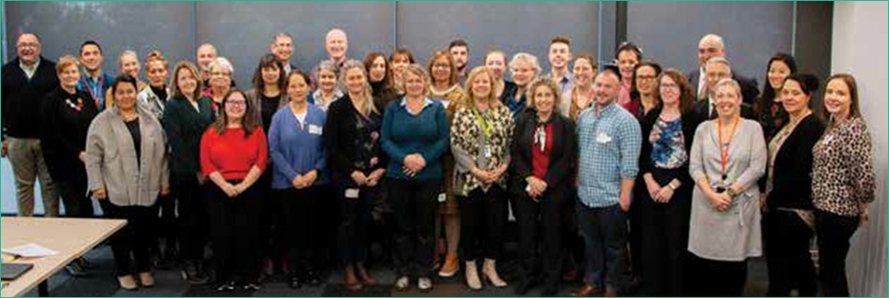
Te Aho o Te Kahu team members

The current setting for Māori
He Pūrongo Mate Pukupuku o Aotearoa 2020, The State of Cancer in New Zealand 2020 was produced during a time of significant review and change within our country’s health system. There has been a prominent and heightened focus on equity and Māori health in recent years that has culminated in a series of important inquiries, reviews and reports, creating both a focus and expectation towards improving systems and services performance for Māori health outcomes. This will have an impact on cancer services and outcomes for Māori in particular.

Key reviews and strategies

The Health and Disability System Review
The Health and Disability System Review was undertaken between 2018 and 2020. It aimed to identify opportunities to improve the performance, structure and sustainability of the health system to achieve equity of outcomes and contribute to wellness for all, particularly Māori and Pacific peoples. There were a number of recommendations included in the review that align well with the work of Te Aho o Te Kahu. These include recommendations relating to a focus on long- term strategic planning, increasing emphasis on prevention and population health, strong Treaty- based partnerships and clear leadership. Other key recommendations relate to the establishment of an independent Māori health authority and a reduction in the number of district health boards (DHBs). As at November 2020, a transition unit had been established within the Department of the Prime Minister and Cabinet to carry out the detailed policy and design work for the recommended changes.

Waitangi Tribunal, Kaupapa inquiries, Health Services and Outcomes Inquiry
The Waitangi Tribunal’s Kaupapa inquiries, Health Services and Outcomes Inquiry (Wai 2575) considered contemporary grievances relating to health service and outcomes for Māori. Stage one of the inquiry addressed the legislative and policy frameworks of the primary health care system and, in particular, the Crown’s failures to address and implement equity for Māori health through a lack of commitment to Te Tiriti o Waitangi and the United Nations Declaration on the Rights of Indigenous Peoples (Waitangi Tribunal 2019). Wai 2575 identified four thematic issues from the claimant submissions that needed to be addressed:
1. Te Tiriti compliance of the New Zealand Public Health and Disability Act 2000 and policy framework
2. Funding arrangements for primary health care
3. Accountability arrangements for primary health care
4. The nature of Te Tiriti partnership arrangements in the primary health sector.

The Ministry of Health is responsible for working with stage one claimants to respond to these issues. The Waitangi Tribunal has yet to hear from claimants for stages two and three of the Wai 2575 inquiry.

Inquiry into health inequities for Māori: Report of the Māori Affairs Committee
The Māori Affairs Committee released their report Pakirehua e Pā Ana ki ngā Taumahatanga Hauora mō Ngāi Māori: Pūrongo a te Komiti Whiriwhiri Take Māori: Inquiry into Health Inequities for Māori: Report of the Māori Affairs Committee in August 2020. This report was initiated in response to letters from Māori users of the health system expressing concern and identifying shortcomings for Māori seeking cancer care. The report details a number of recommendations to government, including establishing an independent Māori health entity and a Te Ao Māori health promotion agency, expanding cancer screening activities for Māori, increasing the prevention focus on Māori and strengthening the Māori health workforce.

Key strategy documents
There are a number of key strategy documents that provide important context for the work of Te Aho o Te Kahu, Cancer Control Agency including:
- New Zealand Cancer Action Plan 2019–2029 | Te Mahere mō te Mate Pukupuku o Aotearoa 2019–2029 provides a pathway to improve cancer outcomes for all New Zealanders. The plan sets out the four main goals required over the next 10 years to ensure better cancer outcomes:
- New Zealanders have a system that delivers consistent and modern cancer care.
- New Zealanders experience equitable cancer outcomes.
- New Zealanders have fewer cancers.
- New Zealanders have better cancer survival, supportive care and end-of-life care (Ministry of Health 2019).
- New Zealand Cancer Plan: Better, faster cancer care 2015–2018 sets out the cancer-related programmes, activities and services implemented across the country to maintain high quality of care and improve the quality of life for people with cancer; effectively, equitably and sustainably meet the future demand for cancer services and ensure fiscal responsibility (Ministry of Health 2014b).
- The New Zealand Cancer Control Strategy (the Strategy) was developed in 2003. The Strategy was the first phase in developing and implementing a comprehensive and coordinated programme to control cancer in Aotearoa. The Strategy includes the purposes, principles and goals to guide existing and future actions to control cancer (Ministry of Health 2003).
- Whakamaua: Māori Health Action Plan 2020–2025 provides the implementation plan for He Korowai Oranga, New Zealand’s Māori Health Strategy, and sets out the government’s direction for advancing Māori health outcomes over the next five years (Ministry of Health 2020).
- The ‘Ala Mo’ui: Pathways to Pacific Health and Wellbeing 2014–2018 has been developed to facilitate the delivery of high-quality health services to meet the needs of Pacific peoples (Ministry of Health 2014a).
- The New Zealand Disability Strategy 2016–2026 sets out the vision for New Zealand to be a non-disabling society and guides the work of government agencies on disability issues (Office for Disability Issues 2016).

The COVID-19 pandemic
The first case of COVID-19 infection in Aotearoa was reported in February 2020 (COVID19.govt.nz), and the World Health Organization (WHO) declared COVID-19 a global pandemic one month later. In Aotearoa, early border closures and a rigorous COVID-19 elimination strategy has, so far, prevented our health system from being overrun with cases of the virus. This has protected people with cancer (who are often immunocompromised) and enabled hospital cancer services to continue with treatments and care options.

However, during the preparation and early response phases of the pandemic, many services that were deemed ‘non-acute’ were postponed, including some cancer screening and diagnostic services. There was also a substantial shift to providing remote care and a drop in the number of people accessing primary health care services.

Overall, these unplanned disruptions to normal care led to a drop in new registrations of cancer during the nationwide alert level 4 period, with 1,031 fewer cancers registered in April 2020 compared with April 2019 (a 47 percent decrease) (Te Aho o Te Kahu 2020). The decrease was seen across all tumour groups and appeared to impact all ethnic groups equally. In the months following alert level 4, the health sector worked hard to catch up on delayed diagnostic procedures. As a result, the number of cancer registrations was back in line with expected levels by the end of September 2020.

Cancer in Aotearoa

Key points
→ Each year, approximately 25,000 people are diagnosed with cancer in Aotearoa, with nearly 3,000 of those people being Māori.
→ The most commonly diagnosed cancers are breast, lung, prostate and colorectal cancers.
→ Cancer incidence patterns have changed over time, with some decreasing (for example, stomach and lung cancers) and others increasing (for example, liver and pancreatic cancers).
→ 150 children (aged 0–14 years) were diagnosed with cancer in 2019, most commonly leukaemias and central nervous system cancers.
→ 176 adolescents and young adults (aged 12–24 years) were diagnosed with cancer in 2018, most commonly gonadal germ cell tumours and Hodgkin’s lymphoma.
→ Over the past 20 years, cancer survival rates in Aotearoa have increased substantially, with more people surviving their cancer than ever before. However, our survival rates are not improving as quickly as survival rates in other high-income countries.
→ Lung cancer and colorectal cancer account for the highest number of cancer deaths each year (around 1,700 and 1,200 respectively).
→ Māori are twice as likely to die from cancer as non-Māori.

My story? I’m sure it’s the same as the stories of many others who have been affected by cancer. I was diagnosed … and my whole world was flipped upside down. I felt scared, angry and confused – why me?
Cancer patient

In Aotearoa, approximately 25,000 people are diagnosed with cancer each year. Our population is growing and ageing and, because cancer is more common among older people, we can expect the number of New Zealanders with cancer to grow over time.

Monitoring cancer at the population level requires us to look at cancer incidence, survival and mortality.

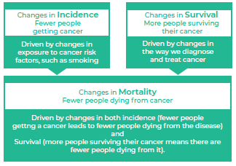

Cancer incidence
The most commonly diagnosed cancers in Aotearoa (excluding non-melanoma skin cancers) are breast, lung, prostate and colorectal cancers.

Māori are more likely than non-Māori to be diagnosed with a range of cancers, including breast, liver, lung, pancreatic, stomach and uterine. However, non-Māori (primarily New Zealand Europeans) are more likely than Māori to be diagnosed with melanoma and prostate cancers (see Figure 1.1).

Figure 1.1: Incidence rates for the 10 most commonly diagnosed cancers in Aotearoa, Māori and non-Māori, age- and sex-standardised, 2008–2017
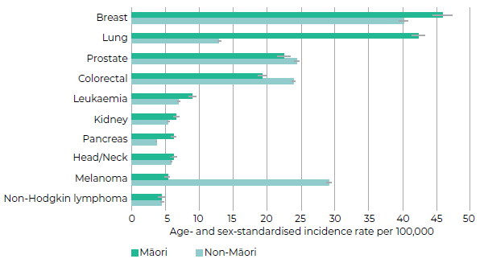

Incidence trends over time
Cancer incidence in Aotearoa has changed considerably over the past 20 years.

Both Māori and non-Māori have experienced a gradual reduction in the incidence of lung cancer since 1996 (driven largely by reduced exposure to tobacco), but Māori rates remain substantially higher than non-Māori rates.

Figure 1.2: Lung cancer incidence in Aotearoa, 1996–2017
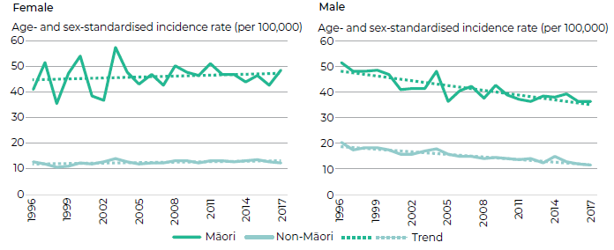

While the incidence of colorectal cancer has reduced over time for non-Māori, the opposite has occurred for Māori, and Māori and non-Māori now experience similar rates of this cancer. The reasons for these trends are not well understood (Shah et al 2012).

Figure 1.3: Colorectal cancer incidence in Aotearoa, 1996–2017
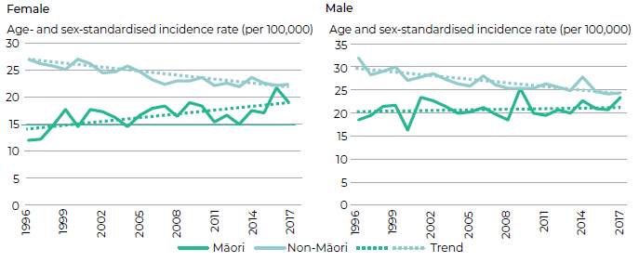

In terms of other digestive system cancers, the rate of stomach cancer for both Māori and non- Māori has nearly halved over the past two decades (see Figure 1.4). Stomach cancer is caused by infection with a bacteria called Helicobacter pylori (H. pylori), and rates of H. pylori have been decreasing over time (see 4 Prevention) (Signal et al 2019). However, rates of both H. pylori and stomach cancer remain higher for Māori. There has also been a relatively steady increase in rates of liver and pancreatic cancers for both Māori and non-Māori (see Figure 1.5 and Figure 1.6 respectively). This may be related to increases in type-2 diabetes (for pancreatic cancer) and exposure to the hepatitis virus (for liver cancer) (Mizrahi et al 2020; Teng et al 2016).

Figure 1.4: Stomach cancer incidence in Aotearoa, 1996–2017
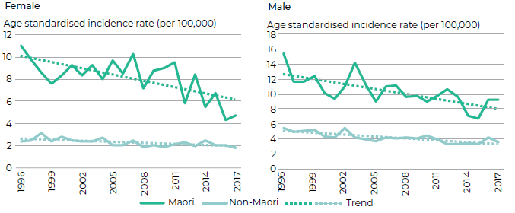

Figure 1.5: Liver cancer incidence in Aotearoa, 1996–2017
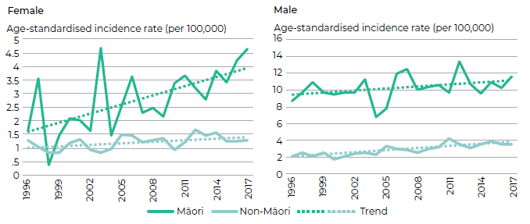

Figure 1.6: Pancreatic cancer incidence in Aotearoa, 1996–2017
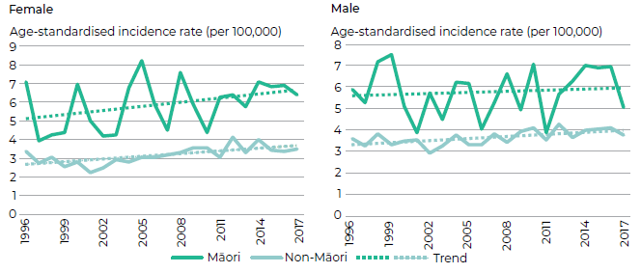

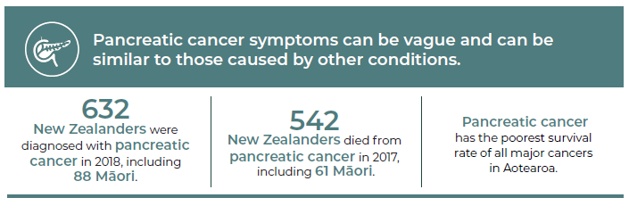
Source: Ministry of Health cancer data (incidence and mortality) and Gurney et al 2020

The most common cancer to affect women in Aotearoa is breast cancer (with around 3,500 new cases a year). Rates of breast cancer have increased slightly over the past 20 years for both wāhine Māori and non-Māori women. There are probably multiple causes for this trend, including increased exposure to factors associated with breast cancer (for example, rising rates of obesity). However, the increase may also reflect the expansion of the inclusion age for the national breast screening programme in 2004 (originally offered to women aged 50–64 years and expanded to 45–69 years), which has led to an increase in the detection of breast cancer among those newly included age groups.

Figure 1.7: Female breast cancer incidence in Aotearoa, 1996–2017
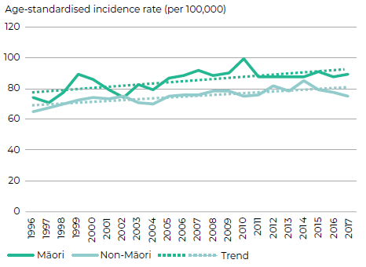

At around 4,000 new cases a year, prostate cancer remains the most common cancer to affect men in Aotearoa. We have seen relatively little change in prostate cancer rates for both tāne Māori and non-Māori men over the same 20-year time period. This may reflect a stabilisation of prostate-specific antigen (PSA) testing, which was first introduced in the early 1990s and rapidly led to an increase in the diagnosis of early prostate cancer.

Figure 1.8: Prostate cancer incidence in Aotearoa, 1996–2017
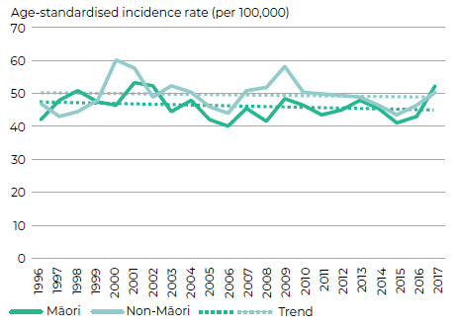

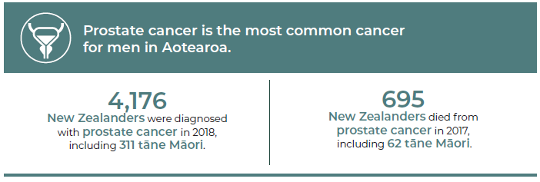
Source: Ministry of Health cancer data (incidence and mortality)

In terms of gynaecological cancers, over the past two decades, both wāhine Māori and non-Māori women have experienced a gradual increase in the rate of uterine cancer, likely due to increasing body weight (Scott et al 2019). However, over the same period, both groups have also experienced substantial reductions in rates of cervical and ovarian cancers (see Figure 1.9, Figure 1.10 and Figure 1.11 below). The major driver in the reduction in cervical cancer rates is likely to be the success of the cervical screening programme (NSU 2020).

Figure 1.9: Uterine cancer incidence in Aotearoa, 1996–2017
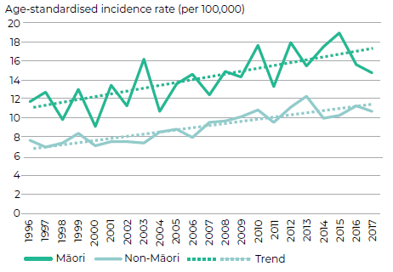

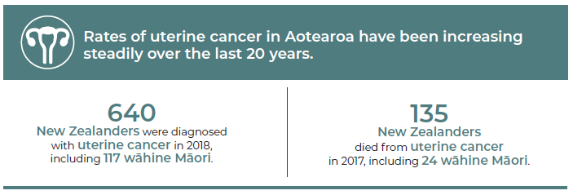
Source: Ministry of Health cancer data (incidence and mortality) and Gurney et al 2020

Figure 1.10: Cervical cancer incidence in Aotearoa, 1996–2017
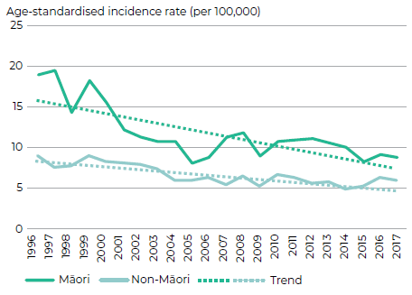

Figure 1.11: Ovarian cancer incidence in Aotearoa, 1996–2017
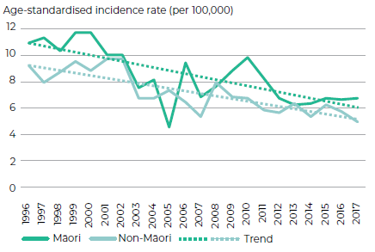

Child cancer incidence
Children (aged from birth to 14 years) in Aotearoa make up 19% (964,650) of the total population: 27% are Māori, 10% are Pacific peoples and 16% are Asian peoples.
Source: Projections produced by Stats NZ according to assumptions agreed to by the Ministry of Health. The population projections for 2020 are based on the 2013 Census.

Figure 1.12: Ethnicity of children diagnosed with cancer in Aotearoa, 2019
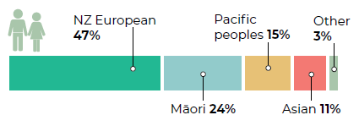

Child cancer is very rare – of all cancer diagnoses in Aotearoa, less than 1 percent relate to children. Each year worldwide, 300,000 children (aged between 0 and 19 years) are diagnosed with cancer (WHO 2018). In 2019, 150 children aged between 0 and 14 years were diagnosed with cancer in Aotearoa. There are many different types of cancer that can affect children. Leukaemia was the most common diagnosis (28 percent of all diagnoses), followed by central nervous system (CNS) tumours (27 percent). Around one in four children diagnosed with cancer in 2018 were Māori (24 percent).

Figure 1.13: Common cancers by age group in children diagnosed with cancer in Aotearoa, 2019
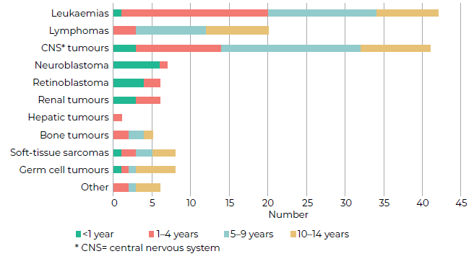

Adolescent and young adult cancer incidence
AYA (aged 12–24 years) in Aotearoa make up 17% (849,640) of the total population: 23% of AYA are Māori, 9% are Pacific peoples and 16% are Asian peoples.
Source: Projections produced by Stats NZ according to assumptions agreed to by the Ministry of Health. The population projections for 2020 are based on the 2013 Census.

Figure 1.14: Ethnicity of AYA diagnosed with cancer in Aotearoa, 2018
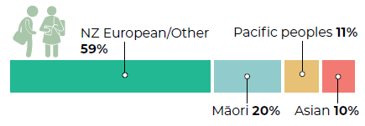

In 2018, a total of 176 adolescents and young adults (AYA) aged 12–24 years were diagnosed with cancer. Figure 1.15 below outlines the most common cancers in the AYA age group. The most common cancer type varies considerably by age: leukaemias for the younger members of this age group, lymphomas for 15- to 19-year-olds and carcinomas for young adults aged 20–24 years. In addition, those in the older AYA group have a high incidence of melanoma and germ cell tumours (predominantly testicular cancer) (Ballantine et al 2020). Around one in five AYA with cancer in 2018 were Māori (20 percent).

Figure 1.15: Common cancers by age group in AYA diagnosed with cancer in Aotearoa, 2018
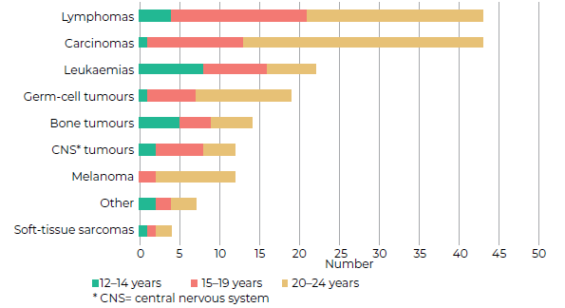
* CNS= central nervous system
Sources: 12–14 years New Zealand Children’s Cancer Registry (NZCCR); age 15–24 years New Zealand Cancer Registry (NZCR)
Compared with non-Māori/non-Pacific AYA, Māori AYA have a higher incidence of Ewing tumours and carcinoma of the gastro-intestinal tract, while Pacific AYA are at higher risk of acute myeloid leukaemia. The incidence of melanoma among our young people is 37 percent lower than it was a decade ago and is likely due to successful public health campaigns around SunSmart practices and early warning signs (Ballantine et al 2020; NZCCR 2020).

Cancer survival
Survival rates for most cancers are improving in Aotearoa. Most people will now survive their cancer, with 66 percent of all cancer patients surviving at least five years after diagnosis (further information on survival rates specific to Māori is included under 2. Inequities in cancer: Cancer survival for Māori). However, cancer survival varies a lot depending on the type of cancer. Some common cancers have overall high survival rates, such as prostate (92 percent survival at five years), melanoma (91 percent survival at five years) and breast (89 percent survival at five years).

Other cancers have overall low survival rates, such as stomach (29 percent survival at five years), liver (21 percent survival at five years), lung (19 percent survival at five years) and pancreatic (12 percent survival at five years).

Figure 1.16 below shows trends in five-year survival from 1998/99 (left end of each type of cancer line) to 2016/17 (right end of each type of cancer line) for selected cancers that had a greater than 50 percent survival at the end of this time period.

Figure 1.16: Trends in select cancers with >50% five-year survival rates, 1998/99–2016/17
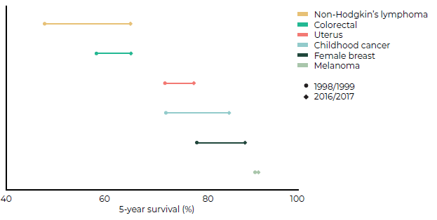

As shown in Figure 1.16, substantial gains have been seen in non-Hodgkin’s lymphoma (up from 48 percent five-year survival in 1998/99 to 65 percent survival in 2016/17), childhood cancers (up from 73 percent to 86 percent) and female breast cancer (from 79 percent to 89 percent). More moderate increases have been observed for colorectal cancer (from 59 percent to 66 percent) and uterine cancer (from 73 percent to 79 percent). There has been no change in the already-high survival rates experienced by patients with melanoma (91 percent in both 1998/99 and 2016/17).

Over the same period, there have been only small gains in survival for some cancers with a poor prognosis (those with less than 50 percent five-year survival rate). This includes lung (up from 12 percent to 19 percent), pancreatic (up from 8 percent to 12 percent) and stomach cancers (up from 20 percent to 29 percent). At the same time, there was little or no gain in other cancers, including brain (up from 21 percent to 22 percent), liver (up from 18 percent to 21 percent) and ovarian cancers (up from 43 percent to 45 percent) (see Figure 1.17).

Figure 1.17: Trends in select cancers with <50% five-year survival rates, 1998/99–2016/17
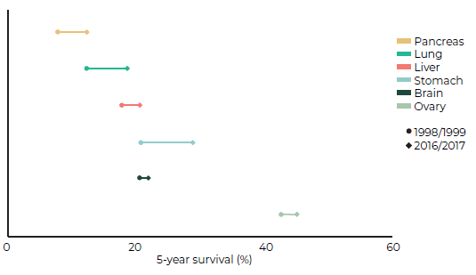

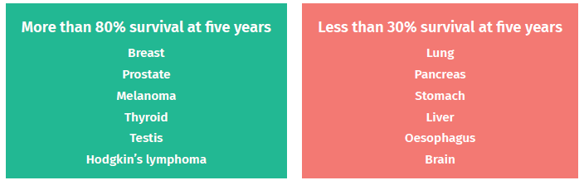

Survival in Aotearoa compared with other countries
Between 1995 and 2014, Aotearoa experienced similar changes in cancer incidence and mortality as other high-income countries (Arnold et al 2019). However, improvements in cancer survival rates have been slower in Aotearoa compared with other countries, and we now rank lower than in the past relative to other high-income countries group in terms of survival rates – we still have plenty of work to do to become world leaders in cancer survival outcomes.

Cancer mortality
Approximately 9,000 New Zealanders die from cancer each year. As shown in Figure 1.18, the cancers causing the most deaths are lung (around 1,780 deaths/year), colorectal (1,200 deaths/year), breast (670 deaths/year) and prostate (700 deaths/year) cancers.

Figure 1.18 also highlights substantial ethnic differences in mortality across most cancers, and research has shown that Māori are twice as likely to die from cancer as non-Māori (Robson et al 2010). These inequities in cancer-related mortality have increased over time (Teng et al 2016). For more details, see 2 Inequities in cancer.

Figure 1.18: Age- and sex-standardised cancer-related mortality 2007–2017
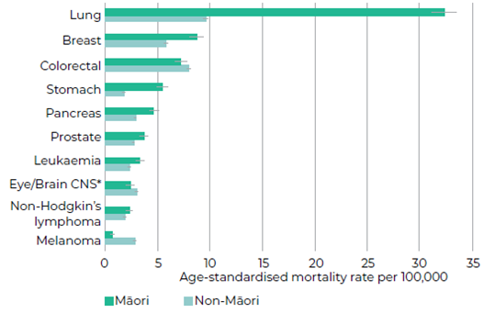
* CNS = central nervous system

Inequities in cancer

Key points
→ Inequities occur along every step of the cancer continuum and affect a number of specific population groups.
→ Māori are approximately 20 percent more likely to develop cancer than non-Māori and twice as likely to die from cancer.
→ The biggest improvements in cancer mortality and reduction in mortality disparities will come from prevention activities that reduce the incidence of poorer-prognosis cancers.
→ Pacific peoples experience higher incidence and mortality for a range of cancers compared with non-Pacific, with notably high rates of uterine cancer.
→ Asian peoples experience lower incidence of cancer overall, although they have higher incidence of thyroid cancer.
→ People living in deprived areas are more likely to be exposed to a range of cancer-causing risk factors, are more likely to develop cancer overall and are more likely to have poorer survival rates.
→ People living with mental illness experience poorer cancer survival rates for some cancers, likely due to late diagnoses, comorbidities and differences in cancer care delivery.
→ We have limited information on cancer outcomes for disabled people, SOGIESC-diverse peoples and those living in rural areas, but it is likely that the barriers these communities experience contribute to cancer inequities.

Cancer does not impact all groups within our population evenly. There are inequities at every step along the cancer continuum – from an individual’s exposure to risk factors and their likelihood of developing cancer in the first place to the speed with which they are diagnosed, their ability to access appropriate cancer treatment, their timely referral to specialist palliative care and bereavement support for whānau after death. Such inequities have been observed in every country in which they have been investigated. They can be seen across a range of factors, including ethnicity, levels of deprivation, geography, sexual orientation, etc. Inequities also combine to create cumulative layers of disadvantage for some and privilege for others.

This section outlines the population groups most affected by inequities in the cancer care system of Aotearoa.

Māori and cancer
In the 2018 census, 775,836 people identified as Māori*, representing 16.5% of the population, an increase of 14.9% from 2013.
Source: Stats NZ 2019
* Where a person reported more than one ethnic group, they were counted in each applicable group.

Māori have been adversely affected by colonisation, including alienation from their land, language and cultural practices, racism, increasing marginalisation and lower socioeconomic status (UN 2009; Robson and Harris 2007). This has contributed to negative cancer-related outcomes for Māori through a range of mechanisms, including higher exposure to risk factors for developing cancer (such as tobacco, alcohol, poor nutrition and household overcrowding) and poorer access to and through the health system. Figure 2.1 illustrates the relationship between the determinants of health, cancer-specific protective factors, health care and improved cancer outcomes for indigenous peoples (Sarfati et al 2020).

Figure 2.1: Drivers of equitable cancer outcomes among indigenous peoples
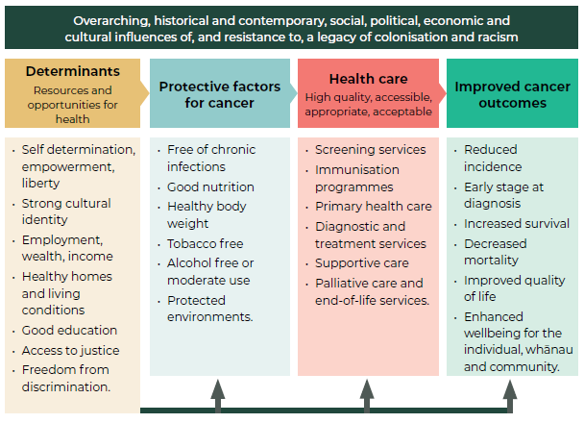

There is compelling, and growing, evidence of the role of racism as a determinant of health (HDSR 2020). Racism is prevalent in Aotearoa and within the nation’s health care system (HQSC 2019). It can manifest in three ways: institutional (systemic), interpersonal (personally mediated) and internalised (Jones 2000). The effects of institutional and interpersonal racism are particularly important. Self-reported racial discrimination is consistently associated with a range of poorer health outcomes, reduced access to health care and poor-quality care (Harris et al 2018; HQSC 2019). There is significant evidence that self-reported experience of racism, including by health professionals, is higher for Māori, Pacific peoples and Asian peoples than for New Zealand European/Other people (Harris et al 2019; Crengle et al 2012; Harris et al 2012a, 2012b and 2006).

Cancer incidence for Māori
As discussed in 1 Cancer in Aotearoa, the most commonly diagnosed cancers among Māori are breast, lung, prostate and colorectal cancers. Cancers of the breast, liver, lung, pancreas and stomach had the highest levels of disparity in incidence for Māori in the period 2007–2017 (Gurney et al. 2020a). In general, this reflects the leading cancer risk factors for Māori: disproportionately high rates of tobacco exposure; chronic infections such as Helicobacter pylori (H. pylori) and hepatitis; factors associated with obesity; alcohol use and occupational exposures (Wilson et al 2010; Walsh and Grey 2019). Of note, the cancers that disproportionately affect Māori tend both to be highly preventable and to have poor prognoses (see 4 Prevention).

Cancer survival for Māori
While cancer survival rates are improving for both Māori and non-Māori, there is still a substantial gap in the survival rates between the two groups (Gurney et al 2020b; Robson et al 2010). Overall, once diagnosed with cancer, Māori continue to experience poorer survival rates than non-Māori for nearly all the most common cancers (see Figure 2.2 below) and experience between 12 and 156 percent higher mortality compared with non-Māori across these cancers (Gurney et al 2020a).

Figure 2.2: Survival disparity between Māori and non-Māori for the most common cancers among Māori, 2007–2016
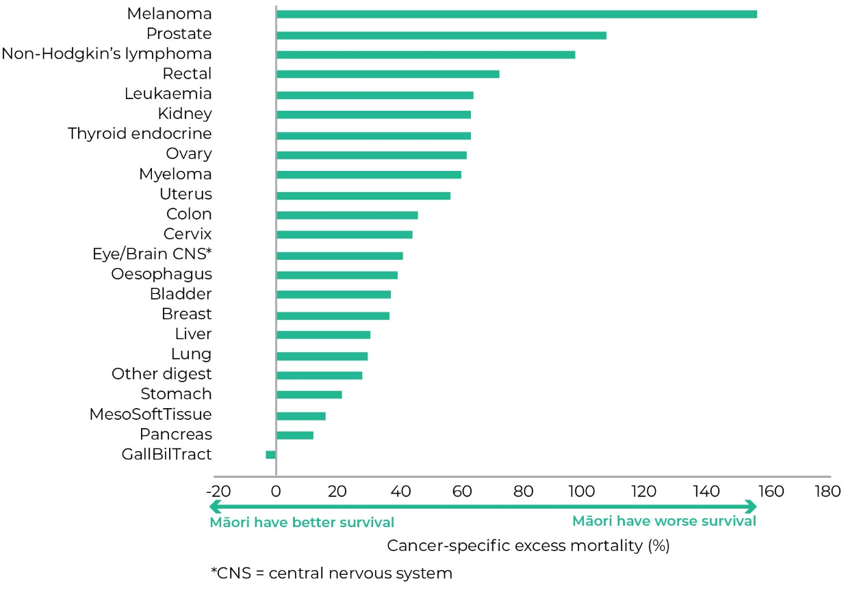
Source: Gurney et al 2020a

Poorer access to early diagnosis and screening, the presence of comorbidities and poorer access to best-practice treatments have all been associated with disparities in survival between Māori and non-Māori cancer patients (Hill et al 2010; Robson et al 2010; Gurney et al 2020a; McLeod et al 2010; Seneviratne et al 2015; Tin Tin et al 2018). Figure 2.3 outlines some of the drivers of inequitable survival rates for Māori.

Figure 2.3: The main factors driving disparities in cancer survival between Māori and non-Māori
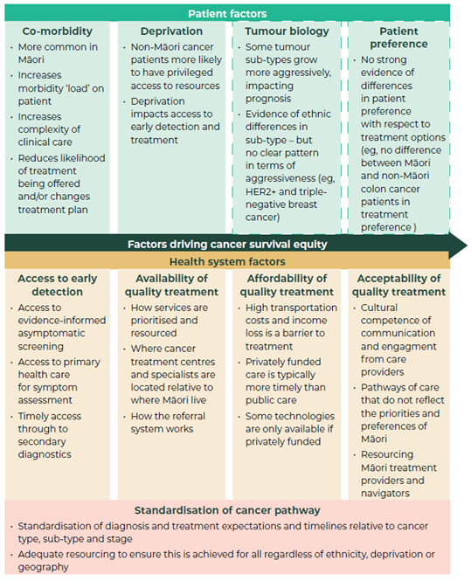
Note: Boxes with dashed lines indicate factors with limited or conflicting evidence.
Source: Gurney et al 2019

The Ministry of Health’s New Zealand Cancer Action Plan 2019–2029 includes an explicit goal to achieve equity in cancer survival by 2030 for all New Zealanders, with the first objective being to ‘achieve equity in cancer survival for Māori compared with non-Māori New Zealanders’ (Ministry of Health 2019, page 29). While this goal is aspirational, it is also intended to act as a catalyst for changing how cancer services are delivered for Māori. The goal aligns with Te Tiriti o Waitangi principles and will require ‘a cultural shift in focus, a systems-change approach and fundamental changes across the whole cancer continuum’ (Robson et al 2019). The collection and monitoring of high-quality ethnicity data are critical to the success of such changes.

Cancer mortality for Māori
Mortality rates are higher for Māori for all the most common cancers, except for colorectal cancer and melanoma. The highest cancer mortality disparities between Māori and non-Māori are seen in breast, liver, lung, pancreatic and stomach cancers (Gurney et al. 2020a), with lung cancer continuing to be by far the most significant cancer for Māori in terms of mortality (Figure 2.4).

These disparities in cancer mortality are driven by a combination of disparities in incidence and survival among those diagnosed. For example, the marked disparity in lung cancer mortality is primarily driven by the disparity in lung cancer incidence (more Māori develop lung cancer compared with non-Māori). Conversely, the disparity in prostate cancer mortality is primarily driven by poorer survival outcomes among Māori patients (Māori are less likely than non-Māori to develop prostate cancer but more likely to have poorer survival once they have it) (Gurney et al 2020a).

Inequities in cancer-related mortality have increased over time, most markedly for wāhine Māori when compared with New Zealand European/Other populations (Teng et al 2016). In general, while it is important to address disparities in survival, the main improvements in mortality will come from prevention activities that reduce the incidence of poorer-prognosis cancers.

Figure 2.4: Age- and sex-standardised incidence and mortality data for Māori, 2007–2017
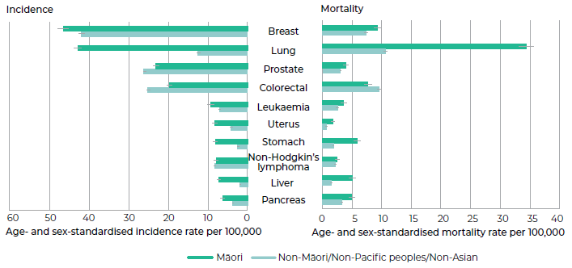

Pacific peoples and cancer
In the 2018 census, 381,642 people identified with at least one Pacific ethnic group, making up 8.1% of the population. The largest groups were Samoan, Tongan and Cook Islands Māori.
Source: Stats NZ 2019

Breast, prostate, lung and uterine cancers are the most commonly diagnosed cancers among Pacific peoples (Figure 2.5). Compared with other ethnic groups, Pacific peoples in Aotearoa experience higher rates of several cancers, including breast, lung and uterine (Teng et al 2016). Pacific peoples also carry a disproportionate burden of cancers associated with infectious agents, such as cervical, liver and stomach cancers. Like Māori, Pacific peoples have lower rates of melanoma and colorectal cancer (Meredith et al 2012).

There is also strong evidence of poorer cancer survival for Pacific peoples in Aotearoa. For example, Pacific women have poorer breast cancer survival rates than others as a result of late diagnosis, deprivation and differences in access to and quality of care after diagnosis (Tin Tin et al 2018). Pacific peoples also have significantly poorer survival rates from colorectal cancer than non-Pacific peoples (Sharples et al 2018). The most common causes of cancer deaths among Pacific peoples are breast, colorectal and lung cancers (Figure 2.5).

Factors influencing Pacific peoples’ access to quality cancer care in Aotearoa, include cost, geographic location of services, transport, culture, communication and health literacy (Foliaki and Matheson 2015; McKinlay et al 2015; Southwick et al 2012; Wai et al 2010). Pacific peoples also have substantially lower participation rates in cancer screening programmes. Like Māori, Pacific peoples have poorer access to the resources that support good health and are more likely to be exposed to the environmental factors that influence cancer risk, such as tobacco, high alcohol use, poor nutrition and insufficient physical activity (Ministry of Health 2020c).

Ola Manuia: Pacific Health and Wellbeing Action Plan 2020–2025 aims to provide a new direction for Pacific health and improve Pacific people’s overall health and wellbeing (Ministry of Health 2020c).

Figure 2.5: Age- and sex-standardised incidence and mortality data for Pacific peoples, 2007–2017
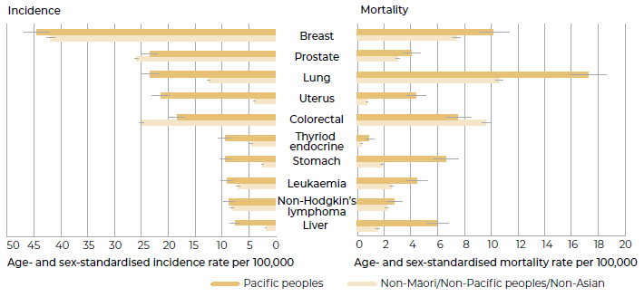

Asian peoples and cancer
In the 2018 census, 707,598 people identified with at least one Asian ethnicity, making up 15.1% of the population in 2018. The largest Asian ethnic groups were Chinese, Indian and Filipino.
Source: Stats NZ 2019

The most common cancers diagnosed among Asian peoples in Aotearoa are breast, colorectal, lung and prostate cancers – although rates of these cancers are lower among Asian peoples compared with non-Māori/non-Pacific/non-Asian (that is, mostly New Zealand European) people (see Figure 2.6). Like other ethnic groups in Aotearoa, lung cancer is the most common cause of cancer death for Asian peoples, followed by breast and colorectal cancers.

Thyroid cancer is the fifth most commonly diagnosed cancer among Asian peoples in Aotearoa, with rates higher than among other ethnic groups. This pattern has also been seen in other countries around the world and is thought to be related to differences between Asian (particularly Southeast Asian) and non-Asian peoples’ exposure to the environmental and nutritional factors that might cause thyroid cancer (Shah et al 2017). Mortality from thyroid cancer is low compared with other cancers, with similar rates for Asian peoples compared with other ethnic groups.

Both liver and stomach cancers are significant cancers for Asian peoples, with these cancers among the most commonly diagnosed and representing the fourth (liver) and fifth (stomach) most common causes of cancer death for this group.

While cancer is an important cause of morbidity (suffering) and mortality for Asian peoples in Aotearoa, the overall incidence of cancer remains lower among this group compared with other ethnic groups. For example, over the last decade, the age- and sex-standardised incidence of any cancer was 128 per 100,000 Asian peoples, compared with 242 per 100,000 Māori, 244 per 100,000 Pacific peoples and 223 per 100,000 non-Māori/non-Pacific/non-Asian.

However, it should be noted that like Māori and Pacific peoples, Asian peoples have lower participation in screening programmes. They also face known barriers in accessing health services generally, and these are likely to apply to cancer services as well. These barriers include language issues, lack of knowledge of the health system in Aotearoa, lack of culturally appropriate health care, stigma associated with health issues, cost and lack of transport among others (Mehta 2012).

Figure 2.6: Age- and sex-standardised incidence and mortality data for Asian peoples, 2007–2017
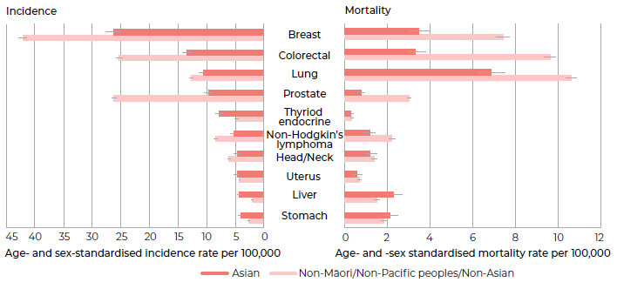

Those living in deprived areas and cancer
NZDep is a composite measure of deprivation based on where people live. Quintile 1 represents areas with the lowest deprivation scores, and quintile 5 represents areas with the highest deprivation scores. 20% of the total population sit in each quintile. However, there are large inequities by ethnicity, with 40% of Māori in quintile 5 and only 9% in quintile 1.
Source: Ministry of Health, Neighbourhood deprivation. URL: www.health.govt.nz/our-work/populations/maori-health/tatau-kahukura-maori-health-statistics/nga-awe-o-te-hauora-socioeconomic-determinants-health/neighbourhood-deprivation#1

Poverty has been described as a carcinogen: something that causes cancer (Vaccarella et al 2019). Those living in poverty may have less access to the kinds of things we know prevent some cancers from developing, such as nutritious food and clean, green spaces for physical activity. Those living in poverty are also more likely to be exposed to the things that cause some cancers, such as tobacco, unhealthy food and drink, and some infectious diseases are more common in overcrowded and poor-quality living conditions, for example, H. pylori (Signal et al 2020).

Overall, cancer incidence is higher among those living in the more deprived areas – although this varies depending on the type of cancer. For example, gastric and lung cancer rates are much higher in the most deprived areas of Aotearoa compared with our least deprived areas, while the opposite is true for prostate cancer and melanoma (Ministry of Health 2016). These trends are strongly intertwined with the ethnic trends described elsewhere in this report, for example, Māori are more likely to live in highly deprived areas and have high rates of lung cancer and low rates of melanoma.

Poverty is a barrier to accessing early diagnosis and best-practice treatment for cancers, leading to inequities in cancer survival between the poor and the affluent. This is particularly important for highly treatable cancers, where finding a cancer early and treating it quickly can significantly improve survival outcomes (Vaccarella et al 2019).

Figure 2.7 shows the impact of deprivation on cancer survival. Cancer survival is poorer as deprivation increases. This pattern is more pronounced for cancers with high survival rates (for example, breast and prostate) than for cancers with low survival rates (for example, lung and pancreas).

Figure 2.7: Impact of deprivation on cancer survival, 2007–2016
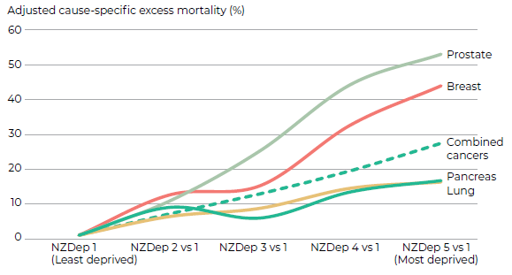

Those living in rural areas and cancer
In 2018, around 766,000 New Zealanders lived rurally, representing 16% of the total population. 18% of Māori live in rural areas.
Source: EHINZ

There is evidence that the incidence of cancer is lower among those living in rural areas, with data from 2002 to 2006 indicating that overall cancer rates are around 25 percent lower in those living rurally compared with those living in the main urban areas (25 percent lower for Māori, 22 percent lower for non-Māori) (Robson et al 2010).

There is currently little evidence to suggest that there are differences in cancer care and outcomes between rural and urban New Zealanders. Part of the reason for this lack of evidence might relate to how we measure rural status. Rurality is usually measured based on how many people live in an area, how densely populated an area is and how well connected it is to urban areas (Bayley and Goodyear 2004). However, the tools we use to measure rurality are not necessarily useful when it comes to examining access to health services and health outcomes for rural people. For example, one study found that around 20 percent of patients who were classified as living in rural areas could still readily access urban health services (Fearnley et al 2016).

However, it is reasonable to think that those living in more remote rural areas are likely to experience barriers to early detection and treatment for their cancers simply because they live further away from urban centres, where most of our cancer services are based. For example, a large national study found that rural colorectal cancer patients were 30 percent more likely than those in urban areas to have an obstructed (blocked) bowel when they first presented to a health care service (Sharples et al 2018). By contrast, some large national studies of breast and colorectal cancer found no overall difference in cancer survival between rural and urban patients (Lawrenson et al 2016; Bennett et al 2007; Sharples et al 2018).

People with mental health and addiction issues and cancer
In 2019/2020, 1 in 5 New Zealand adults reported being diagnosed with a mood and/or anxiety disorder, and an estimated 1% of the population has been diagnosed with bipolar disorder. In 2016/17, 32% of adults had a moderate or high risk of problematic substance use, largely due to the risk of problematic tobacco use (20%) and alcohol use (15%).
Source: Ministry of Health 2020a; Ministry of Health 2020b

People living with mental health and addiction issues have significantly reduced life expectancy compared with the general population, mainly due to dying early from physical illnesses, such as heart disease and cancers (Cunningham et al 2014). Access to and quality of health care are major contributors, including access to cancer screening, timely diagnosis and treatment (Davis et al 2020). Research in Aotearoa has found that, among people diagnosed with breast or colorectal cancers, survival is much poorer for those with a history of recent contact with specialist mental health services (Cunningham et al 2015).

Late diagnosis is an important contributor to poor cancer survival among those with a diagnosis of schizophrenia or bipolar disorder and may relate to poor access to cancer screening and/or mental health problems overshadowing physical health ones (known as diagnostic overshadowing). Being more likely to have other physical health conditions at the time of cancer diagnosis (comorbidity) is also an important factor in poor survival for those using mental health services. Differences in cancer care delivery may also be an important and modifiable reason for the observed survival inequity (Davis et al 2020).

People with disabilities and cancer
In the 2013 New Zealand Disability Survey, 24% of New Zealanders and 26% of the Māori population (176,000 people) were identified as disabled (a total of 1.1 million people).
For both Māori and non-Māori, more than half of disabled children and young adults (aged under 44 years) had a single impairment, but more than 60% of disabled adults aged 45 years and over had multiple impairments.
Source: Stats NZ 2014

Disabled people face a range of barriers to accessing health care, experience higher health risks, are over represented in low-income groups and live in areas of higher deprivation (Stats NZ 2014).

International research has found that disabled people have lower participation rates in cancer screening programmes, with disparity varying by type of disability and number of disabilities (Floud et al 2017; Steele et al 2017). Barriers to accessing cancer screening include lack of transport, physical inaccessibility of screening centres, communication issues and staff attitude (Floud et al 2017; Merten et al 2015).

There is limited research around the incidence of cancer and cancer outcomes for disabled New Zealanders. An important challenge is to improve data and other insights to better understand how we can improve cancer services for disabled people and to monitor outcomes.

SOGIESC-diverse peoples and cancer
In the 2019/20 Health Survey, 1.3% of adults identified as gay or lesbian, 1.6% as bisexual and 0.5% as other sexual identity not otherwise stated.
Although we do not yet collect census data on gender identity, the best estimates suggest that between 0.3% and 0.5% of New Zealanders identify as transgender.
Source: Ministry of Health 2020a and Pega et al 2017

All New Zealanders should receive high-quality cancer care, regardless of their sexual orientation, gender identity and expression, and sex characteristics (SOGIESC).

International research has shown that lesbian, gay and bisexual adults have higher rates of some cancer risk factors than heterosexual adults, including heavy drinking and smoking (Gonzales et al 2016). Gay, bisexual and other men who have sex with men (MSM) account for approximately 79 percent of all new HIV infections in Aotearoa (New Zealand AIDS Foundation 2020). People with HIV have an increased risk for some cancers compared with the general population, including anal cancer (19 times higher), Hodgkin’s lymphoma (8 times higher), liver cancer (3 times higher), lung cancer (2 times higher) and oral cavity / pharynx cancer (2 times higher) (National Cancer Institute 2017).

There is limited research in Aotearoa on cancer outcomes or the experience of cancer diagnosis and treatment for SOGIESC-diverse peoples. There is a long history of SOGIESC-diverse peoples being criminalised and pathologised by medical institutions in this country. Consequently, some members of the SOGIESC-diverse community may be hesitant to engage with health professionals or to disclose information on their sexuality or gender identity, which perpetuates health inequities. A study of Aotearoa found over one-third (36 percent) of transgender (trans) and non-binary participants avoided seeing a doctor because they were worried about being mistreated or disrespected as a trans or non-binary person (Veale et al 2019).

The people providing cancer care

Key points
→ A wide range of health professionals work to prevent, screen for, diagnose and care for people with cancer in Aotearoa.
→ Primary health care plays a critical role in all aspects of cancer care.
→ Primary health care practitioners can only remain actively involved in managing their patients along the cancer pathway when there is strong integration and communication between primary and secondary health care services.
→ There are issues with the sustainability of our cancer workforce, with a large proportion of most specialist workforces set to reach retirement age within the next 20 years.
→ Our cancer workforce does not reflect the population of Aotearoa and lacks diversity. Of the core specialties involved in providing cancer care, between 1 and 4 percent identify as Māori.
→ There is variable access to allied health support across Aotearoa. The lack of robust data on our allied health workforce creates challenges for monitoring and workforce planning.
→ Multidisciplinary meetings (MDMs) ensure input from a range of experts to support the provision of high-quality and consistent care for people with cancer. However, there are issues around consistency of information collection, technology infrastructure and increased demands on clinicians’ time in relation to MDMs.
→ Kaupapa Māori and mātauranga Māori approaches are important for addressing inequities in cancer outcomes. There are substantial barriers to their development, implementation and enhancement.
→ Non-governmental organisations (NGOs) play an important role across the cancer continuum. Aotearoa has one of the densest populations of charities in the world.

A huge range of professionals work to prevent, screen for, diagnose and care for people with cancer. These professionals work both in community and hospital-based settings. Alongside these are non- governmental organisations (NGOs), which provide support to, and advocate for, people with cancer and their whānau.

Primary health care practitioners
In 2019, there were 3,746 vocationally registered GPs. There were also 7,064 registered nurses and 147 nurse practitioners whose main or secondary work was in primary health care.
Source: Health Workforce directorate, Ministry of Health

High-quality primary health care is a cornerstone of coordinated, continuous and comprehensive health care (WHO 2018). It has a critical role across the cancer care continuum, from health promotion, screening and diagnosis through to palliative care (Rubin et al 2015).

Primary health care clinicians, including general practitioners (GPs), nurse practitioners, nurses and pharmacists are well positioned to ensure that the care of people with cancer remains holistic, including ensuring proactive management of co-existing medical conditions. This is important because many cancer patients have other health conditions, and there is evidence that providing good care of additional conditions can improve both cancer treatment access and outcomes for patients (Sarfati et al 2016). It is particularly important for patient groups that have higher rates of medical conditions in general, including older people, Māori and Pacific peoples and those with disabilities.

How lucky was I to have a switched-on GP who considered my diagnosis to be in the high-risk category and got on the case straight away?
Cancer patient

Specialised cancer doctors
As at June 2019, there were 67 radiation oncologists registered in Aotearoa. Medical oncologists and haematologists are registered with the MCNZ under the umbrella speciality ‘internal medicine’. This makes it difficult to monitor the number of clinicians in these specialities. The 2019 MCNZ workforce survey reported 69 medical oncologists and 56 haematologists, which is likely to be an underestimate.
Source: Health Workforce directorate, Ministry of Health

Oncologists are doctors who specialise in cancer and are usually either medical oncologists (specialising in systemic therapies, for example, chemotherapy) or radiation oncologists (specialising in treating cancer with radiation therapies). Haematologists are doctors who specialise in the diagnosis and management of blood cancers.

A large proportion of people with cancer will receive surgery as part of their treatment. Surgeons are a critical part of the cancer workforce, with 298 general surgeons registered in Aotearoa in 2019.

People with cancer may encounter several other hospital specialists along their cancer pathway. They will see some of these specialists in person (such as the anaesthetists involved in surgery), but other specialists will be working behind the scenes (such as pathologists working in laboratories). Some specialists are involved with diagnosing and treating cancer (such as radiologists), and others may be involved before a person gets cancer (such as geneticists involved in the care of people and whānau with familial cancer syndromes).

Cancer and haematology nurses
In 2019, there were 752 registered nurses in Aotearoa whose main or secondary clinical practice setting was cancer care.
There are currently 7 endorsed oncology nurse practitioners and 1 haematology nurse practitioner in the country.
Source: Health Workforce directorate, Ministry of Health

The cancer and haematology nursing workforce is the largest group of health care professionals specialising in cancer care in Aotearoa. Cancer nursing encompasses a wide range of specialities, including medical and radiation oncology, haematology, paediatrics and adolescence, surgery, palliative care, community and rural health, research, education, management and health promotion.

I have had the most amazing team looking after me … After nine years of no recurrence, I can now say it is these health professionals who saved my life.
Cancer patient

Specialist cancer care nursing roles also include clinical nurse specialists (CNSs) and nurse practitioners. Their roles include working collaboratively or independently with a medical team to diagnose and treat patients, including prescribing, examining and educating patients about diagnosis and treatment.

Cancer Nurses College
The Cancer Nurses College was formed under the New Zealand Nurses Organisation. It is a professional body committed to developing excellence in cancer nursing care in Aotearoa through professional development and the promotion of evidence-based practices.

Allied health care
There is limited data available on the allied health workforce, particularly for professions that are not regulated by the Health Practitioners Competence Assurance Act 2003. Those who are part of the regulated workforce must hold an annual practising certificate (APC). In 2019, this included: pharmacists (3,832 practising), occupational therapists (2,969 with APCs), medical laboratory scientists (1823 with APCs) and dieticians (737 with APCs).
Source: Pharmacy Council 2019; OTBNZ 2019; Medical Sciences Council of New Zealand 2020; New Zealand Dietitians Board 2019

There are over 40 different roles that are classified as allied health professions in Aotearoa, including physiotherapists, social workers, speech and language therapists, radiation therapists, psychologists, medical physicists and many others. These professionals play a critical role in the care of cancer patients throughout the cancer pathway, including diagnosis, treatment and supportive care. For example, medical imaging technologists (MITs) perform more than 250,000 mammograms each year as part of the national breast cancer screening programme.

Psychological and social support services
Psychological and social support services for adults with cancer help reduce barriers to receiving care and treatment and can improve people’s cancer journey. The services focus on high- priority populations; people with complex psychological and social needs, Māori and Pacific communities, people with socioeconomic disadvantage, remote and rural populations and people with co-existing physical, social and mental health challenges.
Service users report that the strengths of the services include the flexible and collaborative use of practical and therapeutic interventions, skilled staff who understand the cancer experience as well as the health and social support systems and the service being available in every district health board (DHB). Work continues around developing diversity within the workforce and enabling the services to efficiently identify those most in need of support.

Issues facing the workforce around cancer care
There are a range of issues facing the cancer workforce; issues that often are shared by the health workforce more generally.

Sustainability of the workforce
Aotearoa has an ageing cancer workforce. A significant proportion of most specialist workforces will be reaching retirement age within the next two decades. Attracting enough trainees into key areas and retaining them beyond graduate/junior levels is critical. Figure 3.1 shows a breakdown by age of a range of professions in the cancer workforce as at 2020.

Figure 3.1: Age breakdown of a range of professions involved in providing cancer care in Aotearoa, 2019/20
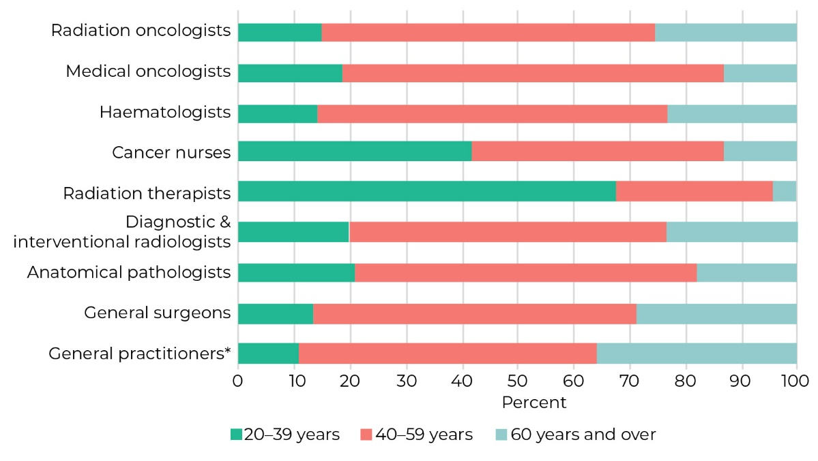
* General practitioners with vocational registration in general practice
Source: Health Workforce directorate, Ministry of Health and Royal College of Pathologists of Australasia

The changing nature of cancer care also presents challenges to the sustainability of the cancer workforce. People are living longer and have greater expectations around the level of care they should receive, and by default the demands on the professionals working in the area are increasing. There are substantial technological changes, and the complexity of treatment is increasing. Each district health board (DHB) has responded to this increased pressure to different degrees and in different ways, which has led to different models of care being developed around the country.

Psychosocial support needs to be available to all people affected by cancer and extended beyond treatment – especially for patients. Again and again, I see people returning, looking for some counselling as they experience adjustment difficulties post treatment. … People tend to struggle with adjusting to life post treatment and on treatment … The current psychosocial funding in DHBs needs to be built on … to include the entire pathway, extended to include people who do not have high and complex needs but who are struggling to adjust to their situation.
Health practitioner

One example of sustainability concerns is in the radiation therapy workforce. The workforce is small, working across 10 public and private cancer centres. There are a low number of graduates each year and high vacancy and turnover rates, which place the workforce in a vulnerable position. In a recent study (Taylor and Oetzel 2020), only 20 percent of workforce survey participants planned to stay in their current career until they retired, with 35 percent expecting to change careers at some stage. The reasons for change included seeking a new challenge, better work conditions, more flexibility and career progression. The remaining 45 percent of survey participants were unsure of their plans for the future.

There are multiple initiatives currently underway to address sustainability concerns; one example is the Voluntary Bonding Scheme run by the Ministry of Health. The scheme aims to incentivise newly qualified health professionals to work in eligible specialty areas that are hard to staff and to increase the number of Māori and Pacific peoples working in health services. Those accepted to the scheme can become eligible for payments in the first three to five years of their career to help them repay student loans or to top up their salary. Eligible professions include GP trainees, practice nurses, radiation therapists and medical physicists.

Lack of diversity
Currently, there is a concerning lack of diversity within the health workforce. Figure 3.2 and Figure 3.3 show the ethnicity and sex breakdown for a range of professions in the cancer workforce as at 2020.

Figure 3.2: Ethnic breakdown of a range of professions involved in providing cancer care in Aotearoa, 2019/20
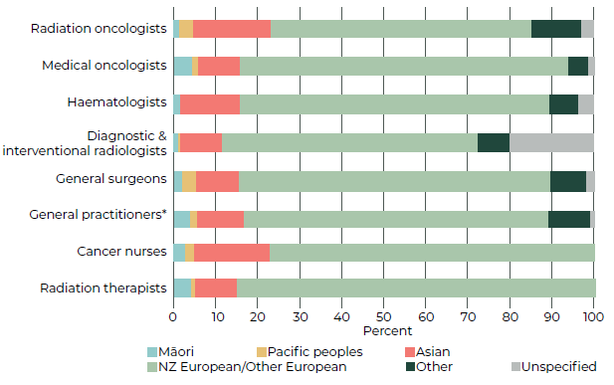

* General practitioners with vocational registration in general practice
Source: Health Workforce directorate, Ministry of Health. Prioritised ethnicity, with ethnicity categories as per the Medical Council of New Zealand

Figure 3.3: Breakdown by sex of a range of professions involved in providing cancer care in Aotearoa
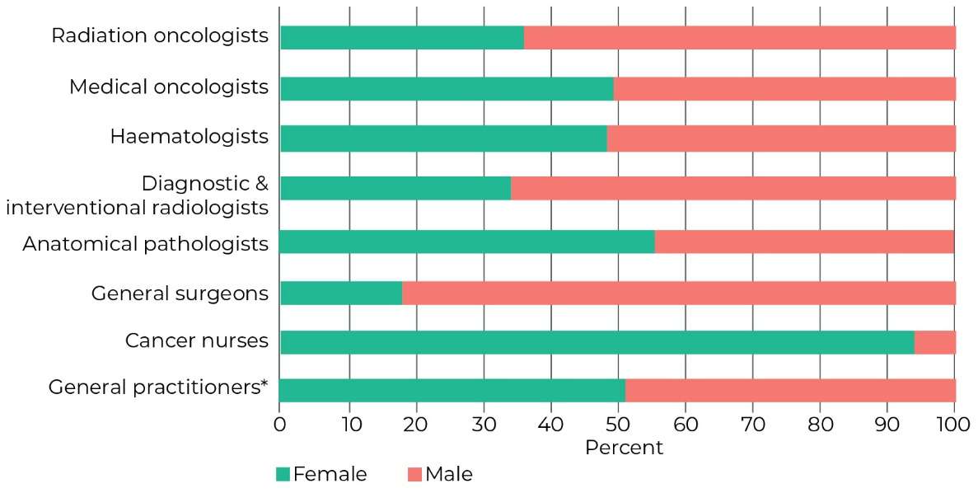
* General practitioners with vocational registration in general practice
Source: Health Workforce directorate, Ministry of Health and Royal College of Pathologists of Australasia

Although Māori make up 16.5 percent of the total population of Aotearoa, they are considerably under represented in many key health professions (HQSC 2019) – including the cancer workforce. Between 1 and 4 percent of the specialists in a range of specialties involved in providing cancer care identify as Māori.
There are ongoing initiatives, such as the University of Otago’s Mirror on Society Policy, aimed at increasing the number of Māori and Pacific peoples studying health subjects (Crampton et al 2018). In the years 2015–2019, 15.3 percent of medical students were Māori and 7.2 percent were Pacific peoples, closely mirroring the ethnic breakdown of the population of Aotearoa (16.5 percent Māori and 8.1 percent Pacific peoples) (New Zealand MSOD Steering Group 2019; Stats NZ 2019).

The Health Workforce directorate (HWNZ), based within the Ministry of Health, is responsible for national coordination and leadership on workforce issues. In 2017, HWNZ set expectations that all organisations receiving HWNZ funding should have a Māori workforce action plan in their regional service plans.

Integration between primary and secondary health care
Primary health care practitioners have expressed a strong interest in being more centrally involved with cancer policy development and the development of tools and approaches that ensure they can remain actively involved in the clinical management of their patients along the cancer pathway (McMenamin 2020). Currently people with cancer often take on the role and responsibility of being the default communicator between hospital specialists and their primary health care team.

Variable access to allied health support
Currently, patient and whānau access to allied health support throughout the cancer care continuum is varied and can be limited due to factors such as: location (more specialised workforces are more readily available at larger hospitals), workforce size (smaller workforces struggle to have capacity to provide specialised care to all patients who would benefit from input), poor awareness and acknowledgement of the critical role that allied health professionals can play in cancer care and a lack of integration of allied health services into cancer patient care pathways (Ministry of Health 2016a). The lack of robust data on the allied health workforce makes monitoring and workforce planning a challenge.

Physical infrastructure challenges
Several cancer centres around Aotearoa are facing physical infrastructure challenges, including a lack of space to provide cancer care. This was further exacerbated in early 2020 by COVID-19, which required greater physical distancing between patients receiving cancer treatment. A lack of space creates significant challenges for staff working in these areas.

Multidisciplinary teams and multidisciplinary meeting challenges
Multidisciplinary teams are teams of doctors, nurses and allied health professionals who collaborate to diagnose and develop a personalised treatment plan for people with cancer. Using a multidisciplinary approach allows a range of experts to provide input to support the provision of high-quality and consistent care.

There are currently some issues with multidisciplinary meetings (MDMs) in Aotearoa, including: a lack of standardised information to help determine which cancers should be prioritised and discussed in MDMs, the inability to collect data and information nationally to allow evaluation and monitoring of cancer care services and ongoing concerns about the increasing demands on clinician time in preparing for and attending MDMs (Ministry of Health 2016b).

A number of technological MDM management solutions either have been or are in the process of being implemented around the country to help improve the quality and capacity of MDMs (Ministry of Health 2012; National Lung Cancer Working Group 2014; National Bowel Cancer Working Group 2012). Work is underway to develop data standards to ensure information is collected in a consistent manner. This standardisation aims to provide a set process that will speed up MDMs and enable teams to feel more confident they are covering all details appropriately.

There is no specific data available on the frequency or extent to which Māori and Pacific health professionals participate in the MDM process. The presence of Māori or Pacific health professionals as part of MDM discussions is one mechanism to maximise the potential for Māori or Pacific health gain and equity from cancer treatment and care.

While nurses and allied health professionals attend MDMs and can provide valuable information regarding the interests of their patients, their opportunity to contribute at these meetings varies widely by cancer stream and DHB location, and in some cases, there is limited ability for the supportive and palliative care needs of patients to be discussed (Lamprell et al 2019).

Kaupapa Māori and cancer
Kaupapa Māori approaches to cancer care align with the aspirations of He Korowai Oranga, ensuring that whānau have control over their cancer journey and receive care that restores mauri, enhances mana and is centred around whānau. Kaupapa Māori is a ‘by Māori for Māori’ approach to health services and project development and implementation (Smith 1998). It is not a single approach but is always based on Māori being empowered to determine their own health from within their own value system (the concept of tino rangatiratanga) (Rolleston et al 2020, Pipi et al 2003).

There are ‘by Māori for Māori’ cancer care initiatives running across Aotearoa. Examples include:
Mana Wāhine
Mana Wāhine is a kaupapa Māori service in the Wellington region. It provides breast and cervical screening support and health promotion for wāhine Māori, their whānau, hapū and iwi. Mana Wāhine works at the preventative and early detection stage of the cancer continuum. It is governed and delivered by a collective of Māori organisations and supports the reclamation of mātauranga Māori and the empowerment of whānau Māori.
Arohamai Services
Arohamai Services are a kaupapa Māori service, supporting approximately 200 cancer patients and their whānau across the Lakes DHB catchment area. Arohamai Services provide guidance, advocacy and whakawhiti kōrero (counselling); can assist with petrol vouchers when available; help transport whānau to doctors’ appointments and Work and Income visits and can pick up prescriptions. They work alongside Te Arawa and other local iwi to make sure whānau in the area have support during a cancer diagnosis.
Kia ora E te iwi
Kia ora E te iwi is a kaupapa Māori approach taken to provide support to whānau with cancer and is an alternative to the Cancer Society’s Living Well programme. It is an education and support programme for Māori and their whānau and aims to increase knowledge of cancer and cancer services, work through common concerns and coping mechanisms and provide an option for whānau to support each other (Cancer Society NZ 2020). Kia ora E te Iwi is delivered in collaboration with numerous mainstream and Māori organisations.

Kaupapa Māori approaches may improve all facets of hauora for Māori who are living with cancer and their whānau. This includes prevention initiatives directed at Māori, wairua and mauri support, education, psychosocial support, treatment, rehabilitation and palliative care. Kaupapa Māori services are often well received by Māori and fill gaps in the provision of culturally appropriate cancer services (Cram et al 2003).
There are varying degrees to which Māori world views, models and mātauranga are expressed and applied across the cancer continuum. This includes Māori initiatives led and delivered by Māori organisations; initiatives led by Māori staff within non-Māori organisations and initiatives led by Māori staff from a range of organisations.

There is consensus that kaupapa Māori and mātauranga Māori approaches are important for addressing inequities (Beazley 2020). A study that synthesised findings from 13 kaupapa Māori health initiatives (Rolleston et al 2020) found that the privileging of Western notions of ‘evidence’ contributed to failures to accept the validity of kaupapa Māori programmes and this acted as a barrier to the development, implementation and enhancement of these approaches. Other identified barriers to implementing kaupapa Māori approaches include a lack of understanding of kaupapa Māori among commissioning providers, limited accountability for health workforce competence in Māori health and health equity, and a lack of equitably designed funding streams (Chin et al 2018).

As stated in the New Zealand Cancer Action Plan 2019–2029, the entire cancer care sector needs to focus on and support kaupapa Māori and mātauranga Māori initiatives (Ministry of Health 2019).

Non-governmental organisations
Non-governmental organisations (NGOs) play a critical role in raising awareness and understanding of cancer. They provide advice and support to people with cancer and their whānau across the cancer continuum, from prevention to palliation. They also have strong community engagement, involving volunteers, donors and supporters.

I am a kaumātua of my whānau and hapū. I have been a whānau member at the side of many whānau sufferers of cancer. I have led karakia and hīmene in cultural support of my aunties, uncles, nieces, nephews, kaumātua and kuia who were diagnosed with cancer. And I have bid farewell through whaikōrero to many, many more at their tangi.
Kaumātua

A number of NGOs provide support and assistance for people to access cancer treatment. This is usually in the form of volunteer drivers, shuttles or petrol or taxi vouchers to help people who cannot access travel options themselves. A number also provide accommodation and, in some cases, psychosocial support. While most of these organisations receive some indirect funding through national travel and accommodation reimbursements for eligible people (see 7 Treatment: Accessing treatment during COVID-19), this does not fully cover the cost of the support services provided.

There are currently 27,736 charities registered in Aotearoa (Charities Services 2020), with 2,118 (7.6 percent) working in the health sector and 218 registered as cancer charities (either with cancer in their name or listed as their main activity). Compared with other countries, Aotearoa has one of the densest populations of charities in the world (see Figure 3.4). This creates some duplication of services and can lead to challenges as different charities compete for the same donations and funding.

Figure 3.4: Number of charities per 100,000 people, by country, 2018
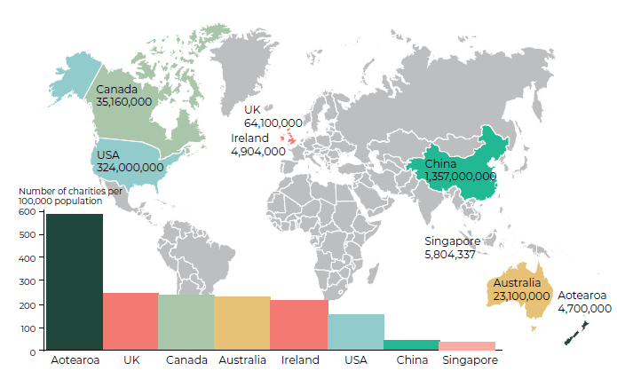

Prevention

Key points
→ About 30–50 percent of all cancers are preventable.
→ Preventing cancers from developing is the ideal in cancer control.
→ The main modifiable cancer risk factors are: tobacco, poor nutrition, inadequate physical activity, excess body weight, alcohol, exposure to UV radiation, workplace carcinogens and chronic infections.
→ Exposure to cancer risk factors is heavily influenced by the environments in which people live. There are significant inequities in exposure for Māori, Pacific peoples and people living in more socioeconomically deprived areas.
→ Prevention strategies that are focused on populations or population groups are generally more effective, cost-effective and equitable than those focused on changing individual behaviour.
→ The tobacco control programme in Aotearoa has seen some success in reducing smoking and lung cancer rates. This has been attributed to Māori leadership, government commitment and comprehensive actions to address tobacco affordability, availability, acceptability and advertising.
→ In contrast, strong action on alcohol affordability, availability, acceptability and advertising is lacking.
→ There has also been limited progress around reducing exposure to other risk factors, such as poor nutrition, physical inactivity and UV radiation.
→ Immunisation programmes for chronic infections, such as human papillomavirus (HPV) and hepatitis B have effectively reduced prevalence of these infections, although it is too soon to see an impact on cancer rates.

Aotearoa has a high burden of preventable cancers, with significant inequities for Māori, Pacific peoples and people living in more socioeconomically deprived areas (Teng et al 2016). It is estimated that 30–50 percent of cancers (including lung, skin, stomach and liver cancer) are caused by modifiable lifestyle and environmental risk factors (WHO 2020). Many of these risk factors are shared by other diseases, such as diabetes and heart disease.

Preventing new cancers from developing is the ideal in cancer control. Wherever possible, it is best to act early and avoid the distress and disruption that a diagnosis of cancer brings. Cancer prevention is essential in reducing the burden of cancer in an effective and sustainable way.

Exposure to cancer risk factors
Although exposure to cancer risk factors often involves a level of choice, these choices are heavily influenced by a range of environmental factors. The environments in which people live, work and play determine many things, such as whether healthy food options are available and affordable or whether there are safe spaces for children to play outside. In turn, these conditions are determined by wider social, economic, cultural and political factors (see Figure 4.1).

Modifiable cancer risk factors:
Tobacco
Poor nutrition
Insufficient physical activity
Excess body weight
Alcohol
Ultraviolet radiation
Workplace carcinogens
Chronic infections

Making healthy choices is much harder, and unfairly so, for some groups and communities in Aotearoa. For example, low-income communities have more shops selling alcohol and unhealthy foods (Sushil et al 2017). Māori and Pacific peoples are also more likely to have low incomes and live in overcrowded, unhealthy homes, all of which contribute to making it more likely they will develop cancer-causing infections (Stats NZ 2020a). They are also likely to experience racism and discrimination in health care interactions (Harris et al 2019) and may also experience stigma and other forms of discrimination related to obesity or smoking (Rahiri et al 2018). These experiences can cause significant distress, which makes it harder to make healthy choices and access preventative health services, such as immunisation or screening (Marmot and Bell 2019). In short, a person’s environment has a strong influence on their exposure to cancer risk factors – and yet their ability to influence those environmental factors is extremely limited.

Figure 4.1: Influences on a person’s health
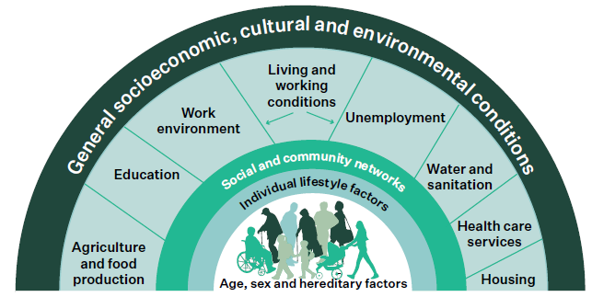
Source: Reproduced with permission from Dahlgren and Whitehead 1991.

Prevention approaches
Just as there are multiple influences on a person’s health and exposure to cancer risk, there is a range of prevention approaches in cancer control. Prevention strategies can focus on high-risk individuals, or they can focus on populations and communities. Prevention strategies can address the more immediate drivers of behaviours (such as education to improve individual knowledge), or they can focus on changing the wider, upstream drivers of these behaviours (such as changing the physical or social environment).

Prevention strategies that are focused on populations or population groups and typically address the more upstream influences on behaviour have been found to be generally more effective, cost- effective and equitable than those focused on high-risk individuals (WHO 2007; Capewell and Graham 2010). A combined approach can maximise effectiveness.

No country can afford to treat their way out of the cancer crisis.
Chris Wild, Director,
International Agency for Research on Cancer, 2009–2018

This section provides an overview of each cancer risk factor identified above: which cancers they cause, levels of exposure to the risk factor and examples of prevention activities aimed at reducing that exposure.

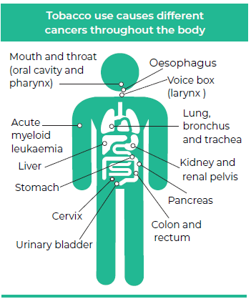
Tobacco

Risk of cancer
Tobacco is one of the most important preventable causes of cancer, causing at least 80 percent of all lung cancers and more than 60 percent of all cancers of the larynx (voicebox), oral cavity (mouth) and oesophagus (gullet) (Whiteman et al 2015). It is also linked to at least nine other cancers. Māori, Pacific peoples and those experiencing high levels of socioeconomic deprivation carry the highest burden of tobacco-related cancers.

Prevalence of tobacco use
There has been a steady reduction in tobacco use in Aotearoa since the early 1980s, with the proportion of daily smokers falling from 33 percent in 1983 (Te Hiringa Hauora 2020c) to 12 percent in 2019/20 (Ministry of Health 2019c). Currently, there are 464,000 daily smokers in Aotearoa, including 145,000 Māori and 49,000 Pacific peoples.

Smoking rates have fallen overall in the past 20 years or so, but there are still marked differences in smoking rates by sex, ethnicity, socioeconomic deprivation and age. For example, in 2019/20, 29 percent of Māori and 18 percent of Pacific peoples were daily smokers, compared with 10 percent of New Zealand European/Other ethnicities. Twenty-four percent of adults living in the most deprived neighbourhoods were daily smokers compared with only 5 percent of adults living in the least deprived neighbourhoods. The inequity seen in smoking rates for wāhine Māori is especially concerning. In 2019/20, 32 percent of wāhine Māori were daily smokers. This is significantly higher than any other population group and makes wāhine Māori almost four times as likely as non-Māori women to be daily smokers (Ministry of Health 2020f).

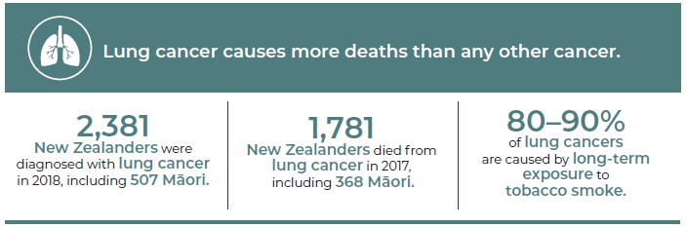
Source: Ministry of Health cancer data (incidence and mortality)

Current prevention activities
Aotearoa is a party to the World Health Organization’s (WHO’s) Framework Convention on Tobacco Control (the WHO Framework). In 2011, the Government also committed to achieving a Smokefree 2025 goal (commonly understood to mean daily smoking rates of less than 5 percent for all population groups). In line with the WHO Framework, Aotearoa has used comprehensive, multicomponent interventions aimed at preventing people from starting smoking and supporting smokers to quit. Māori leadership at the national and community level has been prominent and is thought to be a key component of the success of tobacco control in Aotearoa (Signal et al 2020a).

As at December 2020, the Ministry of Health were intending to start consulting on proposals for inclusion in a national action plan for achieving the Smokefree 2025 goal. Recent modelling based on current tobacco control activities shows that this goal will not be achieved for the overall population, and Māori will miss the goal by a significant margin (Wilson et al 2018).

Examples of current prevention activities include:
- Legislation and policy: The Smokefree Environments and Regulated Products (Vaping) Amendment Act 2020 (previously the Smoke-free Environments Act 1990) bans smoking and vaping on public transport and in indoor areas of bars, restaurants, workplaces and all school and early childhood centre buildings and grounds, and sales to people aged less than 18 years. In 2020, amendments were passed to ban smoking in vehicles that have children in them, and a new regulatory framework for vaping was introduced. The vaping amendment is intended to balance the desire of smokers who want to switch to a less harmful option against the need to ensure these products are not sold or marketed to young people (Ministry of Health 2020g).
All tobacco products sold in Aotearoa incur excise tax. Since 2010, there have been yearly increases in excise tax (over and above inflation), which have successfully reduced the affordability of tobacco. From 2010 to 2020, the price of a standard pack of 20 cigarettes increased by about 200 percent (from about $10/pack to over $30/pack) (Ministry of Health 2020h).
However, as excise tax is paid by the importer or manufacturer, there is choice as to how much of the tax is passed onto consumers. This has resulted in price increases varying for different products, with smaller increases applied to cheaper types of tobacco (Ernst and Young 2018).
- Supportive environments: More than 50 councils have introduced policies to make playgrounds, parks and/or council events smokefree (Te Hiringa Hauora 2020d). Many other organisations have also implemented smokefree outdoor policies, including iwi, district health boards (DHBs), universities and some businesses (Thomson and Wilson 2017).
- Advertising and marketing restrictions: The Smokefree Environments and Regulated Products (Vaping) Amendment Act 2020 bans the advertising and marketing of tobacco and vaping products as well as tobacco product displays. It also requires warning labels and standardised plain packaging for all tobacco products.
- Education: In the past, mass-media campaigns have effectively targeted different sectors of the population to raise awareness of the health risks of tobacco, the efforts by tobacco companies to make their products more addictive and the importance of quitting (Edwards et al 2014). More recent campaigns have focused on high-risk groups, including Māori, Pacific peoples and young adults (Te Hiringa Hauora 2018b).
- Health sector actions: Smokers have several options for accessing support to stop smoking. Quitline is a free national service that provides support by phone, text, email and online and can provide prescriptions for nicotine patches, gum and lozenges. Evaluations have consistently found Quitline to be effective at stimulating quit attempts, particularly for Māori and those living in the most deprived communities (Nghiem et al 2018; Wilson et al 2010).

For face-to-face support, community-based stop smoking services are also available throughout Aotearoa. Health professionals in Aotearoa provide regular brief advice on quitting to smokers. They can also provide prescriptions for fully subsidised stop smoking medicines (including nicotine replacement therapy and other agents) and referrals to local stop-smoking services (Ministry of Health 2014).

Innovative approaches to improving quit rates
The Ministry of Health has recently completed a project ‘Addressing the challenge of young Māori women who smoke’. This project engaged with 50 young wāhine Māori and identified key barriers to stopping smoking for these wāhine. The insights gained informed the co-design of four community-based smoking cessation interventions. These interventions were evaluated by a team of experts. The results informed a co-design of best practice guidelines for smoking cessation services (Wehipeihana et al 2018).

Nutrition, physical activity and body weight

Risk of cancer
Dietary factors (such as high consumption of red and processed meats) and insufficient physical activity increase the risk of many cancers, including colorectal, endometrial and breast cancer (WCRF / American Institute for Cancer Research 2018; Kerr et al 2017).

Poor nutrition and insufficient physical activity increase the risk of gaining weight. Excess body weight (having a body mass index, BMI, in the overweight or obese range) is associated with an increased risk of developing many common cancers.

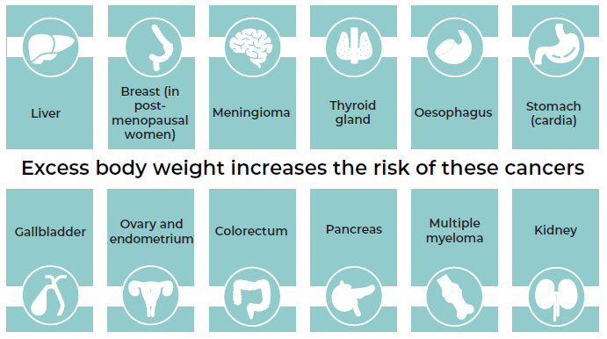

Prevalence of poor nutrition
In 2019/20, only 33 percent of adults and 44 percent of all children consumed the recommended servings of fruit and vegetables each day (Ministry of Health 2020c). Men, people living in the most deprived areas, Māori adults, Pacific peoples and Asian peoples were less likely to consume enough fruit and vegetables.

New Zealand children regularly consume fast foods and fizzy drinks, with over half of children eating fast foods and one-third drinking fizzy drinks at least weekly. This is not surprising as children are regularly exposed to advertising and marketing of unhealthy foods in public spaces and at school (Signal et al 2017). Māori and Pacific children and children living in the most deprived areas are more likely to be exposed to unhealthy foods as there is a higher density of unhealthy food outlets and a higher ratio of unhealthy foods in supermarkets in more socioeconomically deprived areas (Vandevijvere et al 2019).

Prevalence of insufficient physical activity
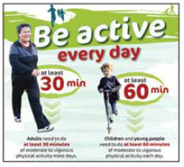
In 2019/20, half of New Zealand adults were physically active for the recommended minimum of 30 minutes a day on at least five days a week (Ministry of Health 2020a). Concerningly, one in eight adults were physically inactive (that is, they did less than 30 minutes physical activity a week). Women, adults living in the most deprived communities and Māori, Pacific and Asian adults were more likely to be physically inactive.

Many New Zealand children are not meeting recommended levels of physical activity. A recent study found that only 40 percent of school children met the recommended 60 minutes of moderate to vigorous activity each day (Oliver et al 2016).

Prevalence of excess body weight
The prevalence of overweight and obesity have increased rapidly in Aotearoa and globally. In 2019/2020, only one-third of New Zealand adults and two-thirds of children had a BMI in the normal range (Ministry of Health 2020c). Māori and Pacific peoples and those living in the most deprived areas are more likely to have a BMI in the overweight or obese range than those of European or Asian ethnicity and those living in the least socioeconomically deprived areas of the country.

Many adults and children with excess body weight experience significant stigma and discrimination in health care settings (Puhl and Heuer 2010). This can lead to delays in accessing cancer screening and poorer quality care, including missing cancer diagnoses.

Current prevention activities
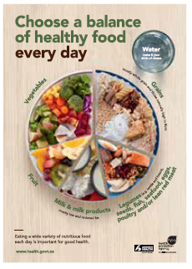
A variety of strategies have been used to improve nutrition and physical activity levels in Aotearoa. Many interventions have focused on providing education and clinical support for individuals to change their behaviour. However, there is now a greater focus on population-level action to create supportive environments for healthy eating and physical activity (Ministry of Health 2020e). Examples of current prevention activities include:
- Legislation and policy: The National Healthy Food and Drink Policy (National District Health Board Food and Drink Environments Network 2019) was developed by the DHB Healthy Food and Drink Environments Network in collaboration with the Ministry of Health in 2016 to provide nationally consistent guidance on how to ensure that all food and drink available for purchase or supplied by an organisation is consistent with the Eating and Activity Guidelines for New Zealand Adults (Ministry of Health 2020b).
- Supportive environments: A voluntary Healthy Active Learning initiative has recently been established by the Ministries of Health and Education and Sport New Zealand. This initiative provides curriculum resources and support for developing and implementing healthy food and water-only policies and delivering physical activity experiences (Ministry of Education 2019). The initiative was rolled out to 300 schools in 2020 and will expand to 800 schools by 2022. The Ministry of Health has also funded the Fruit in Schools programme since 2005 (Watts 2018). This programme provides children in deciles 1 and 2 primary schools with a piece of fruit (or vegetable) each day. An evaluation in 2018 found it was well received, contributed to improved knowledge of health and nutrition and had positive impacts on student health, wellbeing and behaviour (Watts 2018).
Healthy Families New Zealand is an initiative funded by the Ministry of Health that operates in 10 communities in Aotearoa. It supports community leaders to work together to create healthier environments (food, physical activity, alcohol and tobacco) in a range of community settings, including in schools, early childhood education centres, marae, workplaces and sports clubs. An initial evaluation found the programme had successfully prioritised equity, Māori ownership and participation and had strengthened prevention efforts in all communities (Massey University Evaluation Team 2018). The evaluation also identified national-level barriers that need to be addressed and recommended identifying communities that could benefit from a similar approach.
- Advertising and marketing restrictions: While there are currently no legislative restrictions on the marketing or promotion of unhealthy foods in Aotearoa, the Advertising Standards Authority (ASA) oversees a voluntary code that restricts advertising of specific foods and drinks to children and young people (Mackay et al 2020). The code has been criticised for not adequately protecting children and very few complaints have been upheld by the ASA (Mackay et al 2020). The government recently indicated its intention to progress restricting the advertising, marketing and sponsorship of energy-dense, nutrient-poor food and beverages (Clark and O’Connor 2018).
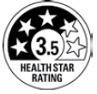
- Education: There are national eating and activity guidelines and resources for the general public (Ministry of Health 2018b), schools (Ministry of Health 2020c) and health professionals (Ministry of Health 2016a; Te Hiringa Hauora 2020b).
A health star rating food labelling system was introduced in Aotearoa in 2014. The system is voluntary and was designed to help consumers more easily choose between similar packaged foods. Stars are allocated according to the nutritional content of the food, with a higher rating indicating a healthier food. In 2019, an estimated 25 percent of eligible packaged foods and drinks had a health star rating (Mackay et al 2020).
- Health sector actions: Health professionals can refer adults, children and whānau (who meet certain criteria) to community-based programmes for nutrition and physical activity support, either Green Prescriptions (Ministry of Health 2016b) or Active Families (Ministry of Health 2020a). Such programmes usually include either face-to-face or telephone support for information and goal setting and/or group sessions, such as virtual supermarket tours, cooking skills, games and fitness circuits. The programmes are well received by participants. In 2018, more than 85 percent of families participating in the Active Families programme reported improvements in their diet and physical activity (Ministry of Health 2018a). However, access to these programmes is limited to those who meet eligibility criteria.

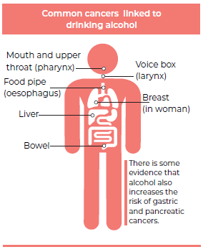
Alcohol

Risk of cancer
Alcohol is strongly linked to the development of many common cancers, including bowel, breast and liver cancers (Connor et al 2017; WCRF / American Institute for Cancer Research 2016). The risk of head and neck cancers is substantially increased when alcohol and tobacco are consumed together (Dal Maso et al 2016).

Māori have a higher burden of alcohol-related cancers. In 2012, Māori with alcohol-related cancers died on average two years earlier than non-Māori with alcohol-related cancers (Connor et al 2017).

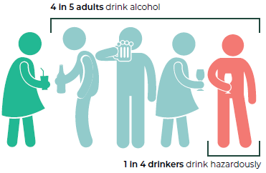
Prevalence of alcohol use
Most adults in Aotearoa drink alcohol (four in five adults), and there has not been any significant change in total consumption of alcohol since 2004 (Ministry of Health 2019c).

For some cancers, any amount of alcohol consumed increases cancer risk. For other cancers, risk is apparent once a higher level of alcohol consumption has been reached (WCRF / American Institute for Cancer Research, 2016).

Of those who drink alcohol, 26 percent are hazardous drinkers, which means their drinking patterns could put themselves and others at risk of harm (Ministry of Health 2019c). The highest rates of hazardous drinking are in men (34 percent), young adults aged 18–24 years (38 percent), Māori adults (43 percent), Pacific adults (38 percent) and those living in the most deprived areas (32 percent).

Current prevention activities
Although there is no current overarching action plan or framework to guide the minimisation of alcohol-related harm in Aotearoa, a range of activities to reduce harm has been implemented. Most interventions have focused on reducing hazardous drinking; however, as cancer risk is related to total consumption over a lifetime (WCRF / American Institute for Cancer Research, 2016), these strategies may not be effective at reducing the risk of developing cancer. Examples of current prevention activities include:
- Legislation and policy: Alcohol is regulated through the Sale and Supply of Alcohol Act 2012, which sets out maximum default trading hours for licensed premises, where alcohol can be sold, who can buy alcohol and how licenses to sell alcohol are issued (including a provision for community input into alcohol licensing decisions); requires parental permission for supply of alcohol to those aged under 18 years and prohibits sale of alcohol to intoxicated people.
All alcohol products sold in Aotearoa incur excise tax. Excise taxes can be used to make a product more expensive to encourage less consumption. However, despite excise on alcohol increasing by the level of inflation each year, alcohol has become more affordable in Aotearoa over the last 10 years (Te Hiringa Hauora 2018a). This is due to a combination of factors, including rising incomes, high levels of competition between retailers (which have led to discounted alcohol prices) and variation in how the excise tax is applied to different alcohol products (for example, wine, beer and spirits).
Alcohol produced in or imported into Aotearoa is also levied. The money from this levy is allocated to a number of organisations for activities and interventions around reducing alcohol- related harms. For example, the portion of money provided to Te Hiringa Hauora / Health Promotion Agency enables the agency to address alcohol-related harm, provide advice and undertake research into matters related to alcohol use. Activities undertaken include national low-risk drinking advice, an annual survey on alcohol use and partnering with Māori on issues of alcohol-related harm.
It is illegal for people under the age of 18 years to purchase alcohol, but there is no age restriction on who can drink alcohol. In 2012, it became illegal to supply alcohol to a minor without parental permission. However, as most minors obtain alcohol from their parents, it is unclear whether this will reduce the number of minors drinking alcohol (Huckle and Romeo 2018).
- Supportive environments: Local councils are responsible for granting licenses to enable businesses to sell alcohol. Since 2012, councils have been able to develop local alcohol policies that can specify how many new licenses will be granted, how far they can be from schools, hospitals and playgrounds, and their opening hours. However, due to appeals by the alcohol industry, many local alcohol policies have been weakened or abandoned because the cost of litigation is too much for local ratepayers (Jackson and Robertson 2017). Between 1990 and 2010, the number of premises with licenses to sell alcohol doubled (Randerson et al 2018; Cameron et al 2013). There was no change in the number or density of alcohol outlets in the two years after the Sale and Supply of Alcohol Act 2012 was introduced (Randerson et al 2018).
- Advertising and marketing: Aotearoa has a voluntary alcohol advertising code aimed at preventing alcohol advertising and marketing that encourages irresponsible drinking behaviours or is directed at or appeals to those aged under 18 years (ASA nd). This includes bans on alcohol sponsorship for children’s sport or any events where children are expected to make up more than 25 percent of participants or spectators. However, research shows that despite this, children are regularly exposed to alcohol marketing, with Māori and Pacific children, and children living in more socioeconomically deprived areas more likely to be exposed (Chambers et al 2018).
- Education: Mass-media campaigns have aimed to raise public awareness about many alcohol- related harms, including drink driving, drinking alcohol during pregnancy and hazardous drinking. Recent campaigns have focused on high-risk drinking by the 18- to 24-year-old group (Te Hiringa Hauora nd). However, awareness-raising campaigns have not highlighted the link between alcohol and cancer, and there is a low level of awareness of the link with cancer in Aotearoa (Richards et al 2017). There is currently no requirement for alcohol containers to include health warnings about the risk of cancer.
Te Hiringa Hauora / Health Promotion Agency has developed several tools to support people to understand their alcohol consumption and its impact. These include: Low-risk alcohol drinking advice (Alcohol.org.nz); Is your drinking OK? (Alcohol.org.nz) and Alcohol Journeys.
- Health sector actions: It is recommended that all patients seeing their general practitioner (GP) or attending an emergency department (ED) be asked about their use of alcohol (BPAC 2018a; Love et al 2011), although it is uncertain if this is done routinely. If potentially harmful drinking patterns are identified, the patient should be offered brief advice to reduce the amount of alcohol they drink. Referral to community support or alcohol treatment services is considered for those with very high-risk drinking patterns (BPAC 2018a).

Ultraviolet radiation / sun exposure

Risk of cancer
Ultraviolet (UV) radiation from the sun or sun beds causes 90 percent of all skin cancers (WHO 2016b). The risk of cancer increases with the number and severity of sunburn episodes (at any age) and higher cumulative exposures, such as occur with outdoor occupations or hobbies.

Skin cancers are the most common cancers diagnosed in Aotearoa. There are two main categories of skin cancer: melanoma and non-melanoma. Melanoma is less common but is more likely to cause death than non-melanoma skin cancer.

All types of skin cancers are more common in men and those of European ethnicity, and the risk increases with age (EHINZ 2020a). Men are more likely to die from skin cancer than women (EHINZ 2020b and c), particularly after the age of 55 years. Māori and Pacific peoples have a lower incidence of melanoma but poorer survival once diagnosed.

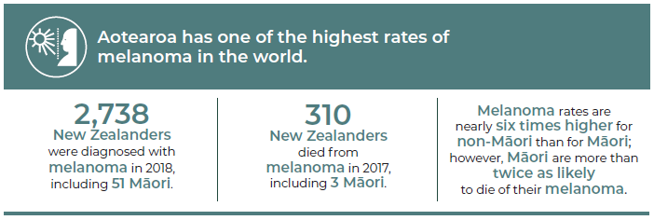
Source: Ministry of Health cancer data (incidence and mortality) and Gurney et al. 2020.

Prevalence of exposure to excessive UV radiation
Aotearoa has relatively high UV levels compared with other countries, particularly in summer months. Sun protection is required when the UV index is 3 or higher (EHINZ nd).

A recent survey found that half of adults in Aotearoa had experienced at least one episode of moderate to severe sunburn (sunburn that resulted in blisters or pain that lasted for two or more days) in the past (Trowland et al 2016). Although the proportion of people sunburnt each summer is reducing, the level remains high. In a 2016 sun exposure survey, it was found that one in seven adults and one in six teenagers had been sunburnt in the previous weekend (Te Hiringa Hauora 2016).

Observational research from 2015/2016 found that many children in Aotearoa were not adequately protected from the sun while at school (Gage et al 2018b) or in outdoor recreation spaces (Gage 2018, Gage et al 2018a and c). Only 40 percent of playgrounds in Aotearoa provided adequate shade protection, and this proportion was even lower in more socioeconomically deprived areas (Gage 2018c).

Current prevention activities
Strategies to reduce exposure to UV radiation in Aotearoa have largely focused on education and support for individuals to adopt appropriate sun protection behaviours. More comprehensive approaches have been used in some settings, including schools, early childhood education centres and workplaces. Examples of current prevention activities include:
- Legislation and policy: In 2017, changes to the Health Act 1956 banned the use of sunbeds by people under 18 years old. The Health and Safety at Work Act 2015 introduced requirements for employers to protect their employees from risks associated with UV exposure.
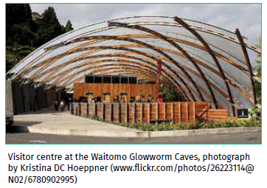
- Supportive environments: There is no legislative requirement for councils to develop sun protection or shade provision policies. However, some councils have developed these as part of their role in providing their communities with safe and healthy environments (Palmerston North City Council 2010; Napier City Council 2016). A recent study found that Waikato, Whangarei and Wairarapa districts had higher levels of shade in outdoor recreation spaces than other parts of Aotearoa (Gage et al 2018c). The Cancer Society of New Zealand delivers education initiatives with a focus on schools and preschools. The SunSmart schools programme provides support for primary schools and preschools to develop policies encompassing hats, sun protective clothing, provision of shade and student education around care in the sun (Cancer Society 2019).
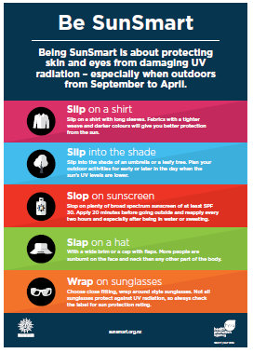
- Education: National mass-media campaigns aimed at promoting SunSmart behaviours in the population have been common in Aotearoa, especially between 1980 and 2007 (Signal et al 2020a; SBRU 2018). More recent campaigns run by Te Hiringa Hauora / Health Promotion Agency have focused on changing behaviours of high-risk groups, such as young people and those who work or socialise outside (Te Hiringa Hauora 2020a). Evaluations have shown that although knowledge of SunSmart messaging is high, adopting the behaviours is less consistent, particularly when it is cloudy and the air temperature is low (Kingstone and Nicolson 2020).
- Health sector action: Workplaces are required to supply sunscreen to workers exposed to UV radiation as part of their job, but this is not required in other settings such as schools (although use of sunscreen is encouraged). As sunscreens are not currently regulated in Aotearoa, quality cannot be assured for all products. Additionally, the cost of sunscreen is likely to be a barrier to its use, with recent evidence showing that sunscreen is more expensive in Aotearoa than in Australia (Light 2020). The national drug-buying agency Te Pātaka Whaioranga / PHARMAC funds sunscreen only for those with medical conditions that make them very sensitive to UV radiation.
- Surveillance and monitoring: New cases of melanoma are recorded in the New Zealand Cancer Registry (NZCR), a population-based register coordinated by the Ministry of Health. The registry records all new cases of cancer diagnosed in Aotearoa except for non-melanoma skin cancer (for example, squamous and basal cell skin cancer). This means that we do not have accurate information on the number of new non-melanoma skin cancer cases and cannot fully evaluate the impact of prevention strategies.

Workplace carcinogens

Risk of cancer
In 2015, of an estimated 750 work-related deaths, cancer was responsible for half. Cancer was also responsible for one-third of all work-related hospitalisations and one-sixth of the total burden of work-related disability and premature death in Aotearoa (WorkSafe 2019c; Butchard 2019). Lung cancer and mesothelioma were responsible for the most work-related cancer deaths (250 and 90 deaths respectively), but non-melanoma skin cancer was the main cause of hospitalisations. Most workplace cancer deaths and hospitalisations are in men (Butchard 2019).

Exposure to workplace carcinogens
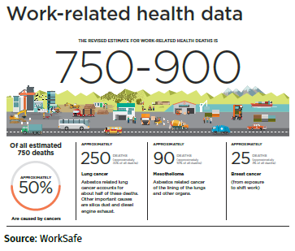
Over 100 cancer-causing agents (carcinogens) have been identified that could be present in workplaces (see Table 4.1) (Cancer Council 2020). Asbestos causes most work-related cancer deaths in Aotearoa despite local production ending in the 1980s, which significantly reduced occupational asbestos exposure (Bardsley 2015). Asbestos-related (and many other work-related) cancers can take many decades to develop (Takala 2015), which is why we are currently still seeing asbestos-related cancer deaths.

Table 4.1: Examples of workplace
Categories | Carcinogen | Key cancers | Example occupations that may be affected
Metals | Welding fumes | Lung cancer | Welders
Combustion products | Diesel engine exhaust | Lung cancer, bladder cancer | Transport workers, eg, heavy truck drivers, road transport
Dust | Asbestos | Lung cancer, mesothelioma | Textiles, insulation
 | Wood dust | Nasal cavity cancers | Wood industry, eg, forestry, logging, sawmill workers
 | Silica | Lung cancer | Miners, stone cutters
Radiation | UV radiation | Non-melanoma skin cancer  Melanoma | Outdoor workers, eg, construction, road workers
 |  | Melanoma of the eye | Welders
Chemicals | Pesticidesª | Leukaemia | Agricultural workers, eg, field crop and vegetable growers
Workplace organisation | Shift work^{b} | Breast cancer | Health workers, cleaners
a limited but suggestive evidence
b limited evidence for association; included in WorkSafe assessment of workplace cancers
Sources: Cancer Council 2020; McLean 2016; Cogliano et al 2011

Population-based surveys from 2004/2006 and 2009/2010 show that 50 percent of all workers in Aotearoa are regularly exposed to workplace carcinogens (Eng et al 2018). The risk of exposure differs by occupation type, sex and ethnicity. People working in manual occupations, such as agriculture, construction and manufacturing, have the highest risk of exposure to dust, smoke, fumes, solvents or gases.

A more recent survey of workers in seven high-risk occupations (Eng et al 2019) confirmed that manual workers such as collision repair workers, construction workers, sawmill workers and agricultural workers have high levels of exposure to various carcinogens. Over 80 percent of agricultural and construction workers and 40 percent of sawmill workers in the survey reported high levels of exposure to UV radiation at work.

Men are twice as likely as women to report exposures to potential carcinogens at work (Eng et al 2018) and account for over 90 percent of workplace-related cancer deaths and hospitalisations in Aotearoa (Butchard 2019). Māori are 1.4 times as likely as non-Māori to report exposures to potential carcinogens at work (Eng et al 2018).

Current prevention activities
All workplace cancer prevention activities are coordinated by WorkSafe, the government organisation responsible for workplace health and safety in Aotearoa. Examples of current prevention activities include:
- Legislation and policy: The Health and Safety at Work Act 2015 is the key legislation for managing work-related health risks (including exposure to carcinogens) in Aotearoa (WorkSafe 2017). It includes requirements for businesses to identify and manage potential health risks, monitor and minimise levels of exposure to potential carcinogens, and monitor the health of workers to enable early diagnosis of any work-related diseases.
WorkSafe is currently developing a national action plan to reduce exposure to work-related carcinogens as part of its overall work-related health action plan (WorkSafe 2019a).
- Education: WorkSafe has produced guidelines and educational material for businesses and employees (available from the WorkSafe website) on how to reduce exposures and manage risks related to workplace carcinogens. This includes guidance on maximum safe levels of exposure to carcinogens (WorkSafe 2019b).

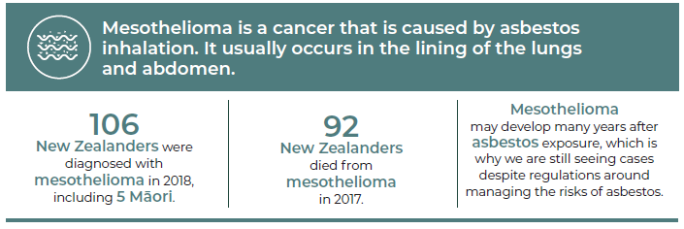
Source: Ministry of Health cancer data (incidence and mortality) and Ministry of Health 2017

Chronic infections
Globally, infections are responsible for at least 12 percent of all cancers (Rositch 2020). Eleven infectious causes of cancer have been identified, but four in particular: Helicobacter pylori (H. pylori), human papillomavirus (HPV), hepatitis B and hepatitis C, account for 90 percent of all infection-related cancers (de Martel et al 2020). These four infections are described in more detail below.

Helicobacter pylori (H. pylori) infection

Risk of cancer
H. pylori is a bacterial infection that causes over 90 percent of cancers of the lower part of the stomach (de Martel et al 2020). However, most people with H. pylori do not develop cancer (Signal et al 2020b).

In Aotearoa, Māori, Pacific peoples and those living in more socioeconomically deprived areas are more likely to develop stomach cancer (Signal et al 2020b; McDonald et al 2015).

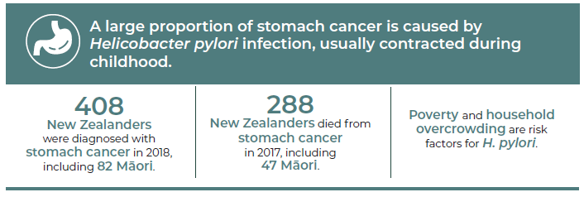

Source: Ministry of Health cancer data (incidence and mortality) and Signal et al 2020b

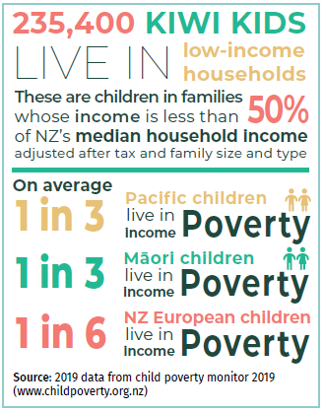
Prevalence of H. pylori infection
Most of the people who get infected with H. pylori contract it in childhood and usually do not clear the infection without antibiotic treatment (BPAC 2014).

H. pylori infection rates are not regularly monitored in Aotearoa. Estimates of prevalence based on blood testing from 1983 to 1999 showed more than double the infection rates in Māori (ranging from 18–57 percent) and Pacific peoples (39–83 percent) than in New Zealand Europeans (7–35 percent) (McDonald et al 2015). This is consistent with higher rates of poverty and household overcrowding for Māori and Pacific families (Stats NZ 2020a), which is known to increase the likelihood of being infected with H. pylori (Baker et al 2013).

Current prevention activities
Current prevention strategies for H. pylori-related stomach cancers focus primarily on testing and treating Māori and Pacific adults who have dyspeptic (indigestion) symptoms. However, interventions to address poverty and household overcrowding are likely to reduce H. pylori infection, even though they were not designed specifically for this purpose, and will have multiple benefits beyond cancer prevention. Examples of current prevention activities include:
- Supportive environments: The Healthy Homes Initiatives were established between 2013 and 2015 to improve access to warm, dry, uncrowded homes for children at risk of developing acute rheumatic fever. The programme was expanded in 2016 to include low-income children hospitalised or at risk for any housing-related illnesses. The initiative involves partnerships between many different agencies, including the Ministry of Health, DHBs, Kāinga Ora: Homes and Communities and the Ministry of Social Development. A recent evaluation of the programme showed that it has effectively reduced hospital admissions and GP visits for infectious illnesses, although its impact on H. pylori infection rates was not assessed (Pierse et al 2019).
The Child Poverty Reduction Act was introduced in 2018 to set bold targets for reducing child poverty. In 2018, at least 23 percent of children (250,000) were living in poverty (Stats NZ 2020b). It is unclear whether there has been any change to child poverty rates since the introduction of this Act.
- Health sector actions: Treatment of H. pylori is very effective. Guidelines for Aotearoa recommend H. pylori testing and treatment for people with symptoms of dyspepsia (such as indigestion, heart burn or reflux) who are at higher risk of infection (such and Māori and Pacific patients) (BPAC 2014).
As most people with H. pylori do not have symptoms, the current approach to testing is likely to miss many cases of infection. The WHO recommends countries explore the feasibility of screening for H. pylori in people without symptoms. Recent modelling suggests that screening for H. pylori (for example, by taking stool samples or conducting breath tests) in Māori and Pacific peoples who do not have symptoms is likely to be cost effective in Aotearoa (Teng et al 2017) and could reduce the risk of stomach cancer by one-third (Signal et al 2020b; Teng et al 2017). However, more information, including up-to-date estimates of H. pylori prevalence rates is needed before such a programme could be implemented (Signal et al 2020b).

Human papillomavirus (HPV) infection

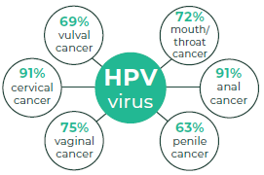
Risk of cancer
Human papillomaviruses (HPV) are a group of very common viruses that infect the reproductive tract. HPV is the main cause of cervical cancer (de Martel et al 2017), the third most common cancer in women in Aotearoa. Wāhine Māori have higher rates of cervical cancer and higher mortality from cervical cancer than non-Māori women (Ministry of Health 2020d).

HPV can also cause anal, mouth and throat, penile, vaginal and vulval cancers (Ministry of Health 2020d). Most people infected with HPV do not develop cancer. This is because not all types of HPV cause cancer and most people (98 percent) clear the virus completely and do not develop chronic infections that can lead to cancer (Immunisation Advisory Centre 2020).

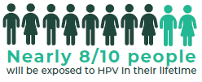
Prevalence of HPV
HPV is spread through skin-to-skin contact and through sexual activity. Around two-thirds of people will be infected with HPV within three years of becoming sexually active (Ministry of Health 2020d).

Testing for HPV in abnormal cervical samples between 2009 and 2011 found that 85 percent of samples with evidence of precancerous or invasive lesions were positive for HPV infection (Ministry of Health 2020d).

Current prevention activities
Multiple strategies are used to prevent HPV-related cancers (and other conditions) in Aotearoa, including immunisation, screening for precancerous abnormalities and general education about preventing sexually transmitted infections (STIs). Examples of current prevention activities include:
- Education: Education around HPV-related cancers and genital warts is provided to parents as part of the informed consent process for the HPV vaccination programme.
The Ministry of Health, The New Zealand Sexual Health Society Inc (NZSHS), New Zealand Family Planning and other organisations have produced resources for the public and health professionals on sexually transmitted infections (STIs) and preventing STIs through safe sex and condom use (Ministry of Health 2019b). Sexuality education, including teaching about STIs and safe sex, is compulsory in schools in Aotearoa up until the end of year 10.
- Health sector actions: Immunisation is the most effective prevention strategy for HPV-related cancers. The current vaccine protects against most cancer-causing strains of HPV (seven types) as well as strains that cause genital warts. As it takes
10–15 years for such cancers to develop and HPV immunisation began in Aotearoa in 2008, it is too early to see whether the immunisation programme has reduced cancer rates. However, there is clear evidence that genital wart infection rates have fallen substantially since the HPV vaccine was introduced, which means it is likely that there has been an overall reduction in HPV prevalence in Aotearoa (ESR 2019).

As shown in Figure 4.2 below, approximately 69 percent of New Zealand females and 70 percent of New Zealand males born in 2006 have completed their course of HPV vaccines. Immunisation rates are significantly lower for rangatahi Māori compared with other ethnic groups.

Figure 4.2: HPV coverage of girls and boys by 2003–2006 birth cohorts, as at July 2020
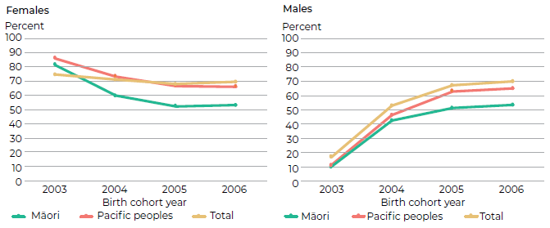
Source: National Immunisation Register, Ministry of Health – data supplied by the Immunisation team

Hepatitis B and C virus infections

Risk of cancer
Hepatitis B and C are viruses that infect the liver. These viruses cause 80 percent of liver cancers in Aotearoa and globally (Schauer et al 2020). Māori and Pacific peoples have substantially higher rates of liver cancer than non-Māori non-Pacific peoples (BPAC 2018b).

Not all people infected with hepatitis B or C will develop liver cancer. Liver cancer only develops in people whose immune system does not clear the virus (known as chronic hepatitis). Among those with chronic hepatitis, approximately 40 percent will develop permanent liver damage (cirrhosis). Of those with cirrhosis, 1 percent (for hepatitis B) and 2–4 percent (for hepatitis C) develop liver cancer each year (BPAC 2018b, 2019). There is a synergistic effect of hepatitis and heavy alcohol consumption, with the two risk factors combining to accelerate the risk of developing liver cancer (Matsushita and Takaki 2019).

Prevalence of chronic hepatitis B and C infections
Hepatitis B and C are both very infectious and can be easily spread through exposure to infected blood and body fluids. Hepatitis B can also be transmitted through sexual activity and from mother to baby during delivery (Ministry of Health 2020d). Intravenous drug use is a major risk factor for developing hepatitis C in Aotearoa (WHO 2019).

It is estimated that 100,000 New Zealanders are living with chronic hepatitis B and 45,000 are currently living with chronic hepatitis C (Hassan et al 2018). Many people do not experience any symptoms, and it is likely that at least 40 percent of people with chronic hepatitis B or C do not know they are infected (Schauer et al 2020).

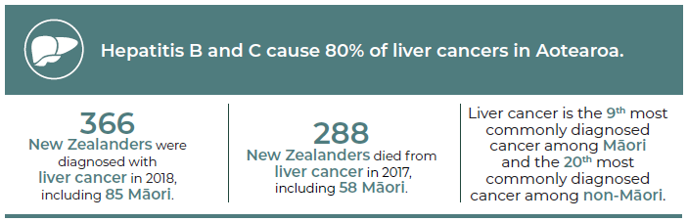

Source: Ministry of Health cancer data (incidence and mortality) and Gurney et al 2020

As mentioned earlier, not all people infected with hepatitis B or C develop chronic infections. For hepatitis B, the risk is higher if you are infected at a younger age. For example, 90 percent of babies infected with hepatitis B perinatally and 30 percent of children infected with hepatitis B between the ages of 1 and 4 years will go on to develop chronic hepatis B, but only 5 percent of adults do (Ministry of Health 2020d). An estimated 75 percent of people infected with hepatitis C will develop chronic infections (BPAC 2019). Māori and Pacific and Asian peoples experience higher rates of hepatitis B infection than European New Zealanders (Robinson et al 2005). The distribution of hepatitis C by ethnicity is not known.

Current prevention activities
Aotearoa has adopted the WHO’s Global Health Sector Strategy on Viral Hepatitis to eliminate viral hepatitis as a public health threat by 2030 (WHO 2016a). Prevention strategies encompass preventing infection in the first place and identifying infections early so that treatment can be given to cure and/or prevent progression to liver cancer. Examples of current prevention activities include:
- Legislation and policy: The Ministry of Health (in collaboration with an external working group) is developing a National Hepatitis C Action Plan 2020–2030 (Ministry of Health 2019a). There is an opportunity for Aotearoa to eliminate hepatitis C now that a highly effective antiviral treatment is available. The action plan has five main areas of focus that include increasing awareness, prevention and harm reduction, testing and screening, surveillance and monitoring, and accessible services. Activities are currently being planned across these areas.
- Health sector actions: Immunisation is the most effective strategy for preventing hepatitis B related liver cancer. However, there is no vaccine against hepatitis C, and those who recover do not develop immunity (BPAC 2018b). The hepatitis B vaccine is highly effective and provides lifelong immunity in 95 percent of people. Currently, immunisation rates are high, with more than 90 percent of 2-year olds fully immunised between 2016 and 2018 (see Figure 4.3). Immunisation rates are highest for Pacific children. However, immunisation rates for Māori infants have fallen.

Figure 4.3: Hepatitis B vaccination coverage at 2 years of age, by ethnicity, September 2016–June 2020
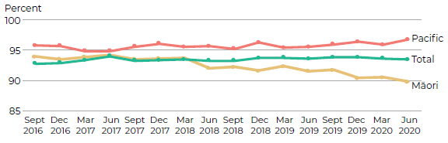
Source: National Immunisation Register, Ministry of Health

Since the vaccine was introduced in 1988, there has been a dramatic reduction in new hepatitis B infections in Aotearoa (see Figure 4.4) (Ministry of Health 2020d). However, as it takes many decades for cancer to develop, there is unlikely to be a significant reduction in the number of liver cancers in Aotearoa until approximately 2030 (Ministry of Health 2020d).

Figure 4.4: Notifications of hepatitis B, 1997–2019
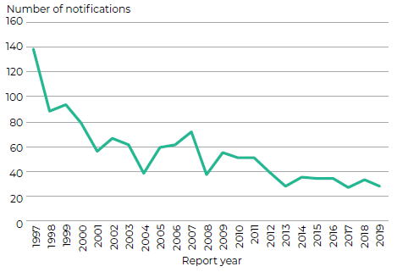
Source: Ministry of Health and ESR

Blood products for Aotearoa (such as blood transfusions) have been screened for hepatitis B and C since 1992. Since this time, there have been no cases of infection transmitted through blood products in Aotearoa (BPAC 2018b).

Needle exchange programmes were introduced in Aotearoa more than 20 years ago. The programmes provide clean needles and injecting equipment to IV drug users to reduce the risk of blood-borne infections (BPAC 2019). A review four to six years after the programmes started showed a reduction in needle sharing behaviours and a lower proportion of HCV infections in those who started using IV drugs since the programmes were introduced (Robinson et al 1995).

From February 2019, an effective antiviral treatment for hepatitis C was funded without restriction in Aotearoa that is ideally suited for community prescribing (Brown 2018).

Early diagnosis of chronic hepatitis B and C is needed so that effective treatment can be given to cure the infection in the case of hepatitis C (BPAC 2018b, 2019) or reduce the risk of progression to cancer in the case of hepatitis B (Papatheodoridis et al 2010). Because of this, it is recommended that health professionals offer opportunistic screening for people at higher risk for hepatitis B or C (BPAC 2018b, 2019). All pregnant women in Aotearoa are offered antenatal screening for hepatitis B to prevent transmission of infection from mother to baby.

Screening

Key points
→ Screening is one way of preventing cancers from developing and/or treating them early.
→ Aotearoa has three cancer screening programmes: breast, cervical and bowel cancers.
→ While the three screening programmes are well organised, they do not function equally well for all groups, especially Māori and Pacific peoples.
→ Screening has both benefits and harms, so decisions about any new cancer screening programmes are made very carefully.
→ Possible screening programmes for future consideration include screening for lung cancer, which has significant potential to reduce inequities.

The purpose of cancer screening programmes is to prevent some cancers from developing and to detect some cancers earlier. Picking up cancer early means it may be less advanced when diagnosed, treatment can be less aggressive and individuals have better outcomes from treatment.

Working in the health sector means I hear the voices of cancer patients’ successes and tragedies. I strongly believe in early detection to improve health outcomes for New Zealanders.
Health practitioner

Cancer screening is different from detecting cancer in people who have symptoms. Screening programmes look for pre-cancer and cancer in people who otherwise seem healthy and free of symptoms. A cancer screening test is not a diagnostic test. Rather, the screening test indicates whether a person has an increased chance of having the condition (positive screening test result) or not (negative screening test result). Those with a positive screening test result will be offered a more definitive diagnostic test. Those with a negative screening test result will simply be invited back for screening in the next screening cycle.

Cancer screening programmes are organised and systematic. They are centrally coordinated and monitored through the National Screening Unit (NSU) of the Ministry of Health and delivered through health service providers in each region around the country.

Not all cancers are good candidates for screening programmes. Aotearoa currently has three national cancer screening programmes, for breast cancer (BreastScreen Aotearoa), cervical cancer (National Cervical Screening Programme) and bowel cancer (National Bowel Screening Programme).

Individuals with especially high risk for specific cancers are managed through specialised services rather than screening programmes. Genetic Health Service New Zealand offers genetic testing and advice to whānau with inherited conditions that predispose them to particular cancers and will offer advice about both screening and risk reduction to individuals with a high risk based on family history. For example, women who are known to have an abnormality on a gene associated with high risk of breast and ovarian cancer may be offered extra screening but may also consider surgery to remove breast and/or ovarian tissue in order to prevent them developing cancer. Another example is for individuals with inherited genetic conditions such as Lynch syndrome or familial adenomatous polyposis (FAP) who are at increased risk of developing bowel cancer. The New Zealand Familial Gastrointestinal Cancer Service offers risk assessment, facilitates diagnosis and provides surveillance recommendations for individuals at potentially high risk of developing bowel or other gastrointestinal cancers.

This section outlines the three screening programmes and discusses how to achieve equity in these existing programmes and the key considerations for any new screening programmes.

BreastScreen Aotearoa
BreastScreen Aotearoa became a national cancer screening programme in 1998. It aims to reduce the morbidity (suffering) and mortality from breast cancer by identifying breast cancers at an early stage.

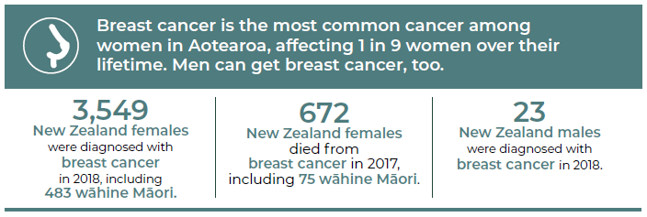
Source: Ministry of Health cancer data (incidence and mortality)

Free screening mammograms are currently offered every two years to eligible women aged 45 to 69 years, a total of approximately 270,000 women each year (Ministry of Health 2019). Women self-enrol or are encouraged to enrol through their primary health care service. Mammograms (X-rays of the breast) are delivered by lead providers across the country in dedicated clinics and mobile units, with further diagnostic tests and treatments provided at hospitals and at outpatient facilities. Eleven screening support service providers also provide individual-level support to help wāhine Māori, Pacific and other priority-group women access breast (and cervical) screening.

The coverage target is to screen 70 percent of all women aged 45 to 69 years every two years. As at October 2020, coverage was 67 percent of this total group, with a lower rate for wāhine Māori (60 percent) and a slightly higher rate for Pacific women (69 percent) (NSU 2020a).

An evaluation of BreastScreen Aotearoa from 1999 to 2011 found that the screening programme reduced mortality from breast cancer in women overall by 34 percent. The mortality benefit in wāhine Māori was a little lower at 28 percent but would have been similar if target coverage had been achieved for this group (Morell et al 2015). BreastScreen Aotearoa plans to introduce a new funding model for lead providers in 2021, aimed at improving participation for wāhine Māori and Pacific women. The NSU is also evaluating screening support services, and the evaluation findings will inform future efforts to improve participation for wāhine Māori and Pacific women.

National Cervical Screening Programme
The National Cervical Screening Programme (NCSP) began in 1990. It aims to detect and treat cervical pre-cancerous changes before they develop into cervical cancer. Cervical screening tests are currently offered every three years to eligible women aged between 25 and 69 years, which equates to over 300,000 women each year (Smith et al 2018). Women are identified for screening through their primary health care services.

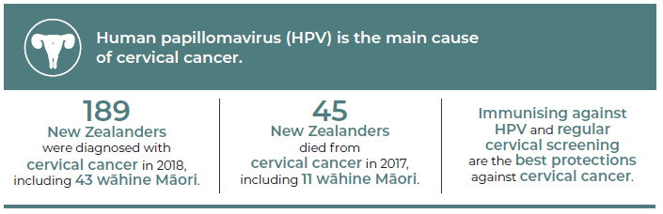
Source: Ministry of Health cancer data (incidence and mortality); WHO 2020, HPV 2020

Cervical screening tests involve a health care worker sampling cells from the woman’s cervix and the lower end of the uterus (or the ‘vault’ area of the vagina in women who have had a hysterectomy). Cytologists in one of five laboratories around the country assess the cells in the cervical samples under a microscope for early abnormalities or pre-cancer. Depending on the level of abnormality seen in the cervical sample, women may be referred to hospital for further assessment, using colposcopy, where a biopsy may be taken and the abnormal cells removed if necessary. The screening results are recorded on the NCSP Register unless women choose to opt off the programme. As with breast screening, support services are available in many regions to provide individual-level support to help Māori, Pacific and other priority-group women to access cervical screening and colposcopy services.

The coverage target is to have 80 percent of women screened within the previous three years. As at September 2020, coverage was 62 percent of wāhine Māori, 64 percent of Pacific women, 61 percent of Asian women and 70 percent of women overall (NSU 2020e). Initiatives to improve screening participation include targeted messaging for priority-group women, free or low-cost cervical screening and support services for priority-group women.

Since the NCSP began, the incidence of cervical cancer has decreased by about 50 percent and mortality from cervical cancer by about 60 percent (NSU 2020d). The reductions are larger for wāhine Māori, although inequities in incidence and mortality persist (Ministry of Health 2020). These reductions are also a reflection of other trends over this time, such as reduced smoking and improved cervical cancer treatment.
Cervical screening self-testing
In line with international best practice, the National Cervical Screening Programme is continuing to work towards introducing a programme change from the current cytology or cell-based screening to primary human papilloma virus (HPV) screening. This initiative is subject to government funding. Almost all cervical cancer is caused by HPV infection, though it is important to note that most people with HPV infection will not get cervical cancer. Not only is HPV testing a more sensitive test and in line with international best practice, it also allows the option of self-testing. Here, women can take their own sample using a vaginal swab if they prefer it over a clinician-taken cervical sample. Research has shown self-testing to be as accurate for detecting HPV as a clinician-taken sample (Polman et al 2019). This initiative could improve cervical screening participation especially in priority-group women (Adcock et al 2019).

National Bowel Screening Programme
The National Bowel Screening Programme started in 2017 and is being gradually introduced across the country after a six-year pilot programme in Waitemata District Health Board (DHB). The gradual roll-out aims to allow each DHB to prepare for all requirements needed to deliver the bowel screening programme and to avoid displacing the usual diagnostic and treatment services for individuals who have symptoms of bowel cancer. As at November 2020, the bowel screening programme is available in the following DHB regions: Canterbury, Counties Manukau, Hawke’s Bay, Hutt Valley, Lakes, MidCentral, Nelson Marlborough, South Canterbury, Southern, Tairāwhiti, Wairarapa, Waitemata and Whanganui (Time to Screen 2020a). It is expected that the programme will be implemented in the remaining DHBs by November 2021.

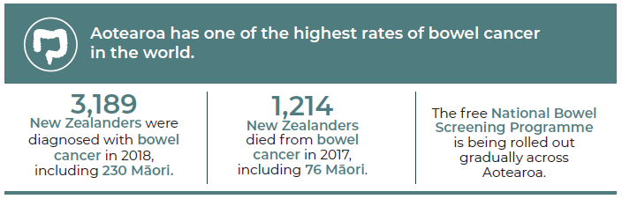
Source: Ministry of Health cancer data (incidence and mortality), National Screening Unit – National Bowel Screening Programme data

The programme posts free bowel screening test kits every two years to eligible people aged 60 to 74 years, identified through a national register. People complete their bowel screening test at home and mail them back to the laboratory, which processes the sample to see if there are small amounts of blood that meet a set threshold. If the test is positive by this measure, those individuals are offered a diagnostic colonoscopy at their local hospital. This procedure examines the large bowel visually using a small camera, and a biopsy is taken if necessary. Further treatment is offered depending on the outcome of the colonoscopy. Primary health care services help explain and manage positive bowel screening test results with individuals, as well as encouraging participation and raising awareness of bowel cancer symptoms.

The programme aims to find bowel pre-cancer and cancer and treat both early. As at November 2020, the programme has sent out about 512,100 bowel screening test kits and detected cancers in 753 individuals (NSU 2020c). Since the programme is still being implemented, its impact on bowel cancer incidence and mortality rates will not be apparent for some years. International evidence indicates that such programmes can reduce the mortality from bowel cancer by about 16–22 percent and potentially up to 30 percent, after 8–10 years (Ministry of Health 2018). Maintaining equitably high participation rates is critical to achieving this anticipated benefit.

The participation target is to have 60 percent of eligible people invited returning a completed bowel screening test kit. As at August 2020, participation in bowel screening was 63 percent overall, 56 percent for Māori, 44 percent for Pacific peoples, 53 percent for Asian peoples, and 53 percent for people living in the most socioeconomically deprived areas (NSU 2020b). Equity initiatives in bowel screening include active follow-up by phone if a bowel screening kit return is delayed (for Māori, Pacific peoples and people living in most deprived areas) and a trial of people dropping their bowel screening kits at community labs (instead of posting them back) in Counties Manukau and Waitemata DHBs. There is ongoing consideration about the possibility of extending the age range for bowel cancer screening for Māori and Pacific peoples.

Achieving equity in existing programmes
In general, cancer screening programmes in Aotearoa are well organised. However, they do not function equally well for all population groups, especially Māori and Pacific peoples. In particular, Māori and Pacific peoples have significantly lower participation rates in existing screening programmes (Gurney et al 2019). Each screening programme is focused on improving existing equity initiatives, as well as testing new approaches.

The challenges existing screening programmes face in delivering screening equitably underscore the importance of embedding equity into the design of any new screening programmes from the outset.

New screening programmes: considering pros and cons
Screening programmes have both benefits and harms. Harms include falsely positive screening results (resulting in unnecessary stress and further investigation), falsely negative screening results (resulting in false reassurance and potentially missed cancers) and overdiagnosis (unnecessary diagnosis and treatment of cancers that might never have caused any problems in a person’s lifetime). Decisions about new screening programmes must consider the balance of benefits and harms very carefully.

Two advisory groups, the National Screening Advisory Committee (NSAC) and the Māori Monitoring and Equity Group (MMEG), provide advice to the NSU about changes to existing screening programmes and any potential new programmes for consideration (such as, CT screening for lung cancer and Helicobacter pylori screening for gastric cancer).

Diagnosis

Key points
→ Confirming a cancer diagnosis can be complex and may require multiple tests in different settings.
→ Aotearoa has high rates of emergency presentation for certain cancers, indicating that there are areas of the cancer diagnostic pathway that could be improved. Currently, we cannot measure and report on all aspects of the diagnostic pathway.
→ Māori and Pacific peoples encounter multiple barriers and delays along the diagnostic pathway, contributing to poorer outcomes.
→ Primary health care is often the first point of contact for people with symptoms of cancer, but access can be a challenge. An estimated 1.2 million adults in Aotearoa had an unmet need for primary health care in 2019/20.
→ Access to specialised diagnostic tests currently varies across Aotearoa, including for some genomic testing and positron emission tomography (PET) scans.
→ People with symptoms highly suggestive of cancer are generally seen quickly. However, many people experience delays for critical diagnostic tests.
→ Generally diagnostic services are of high quality, but there is some variation across DHBs.

Diagnosing cancer can be a complex process. Often people will require multiple different tests, performed by different specialists and in different settings. Some tests can be completed in the primary health care setting, some in the local community and some in a hospital or specialist setting.

Hearing those three words ‘you have cancer’ is probably the most shocking thing anyone can ever experience. Nothing can prepare you for it. Your whole world changes – and not just your own world but also the world for your family, friends and work colleagues. Life is no longer normal.
Cancer patient

The different types of diagnostic tests for cancer include:
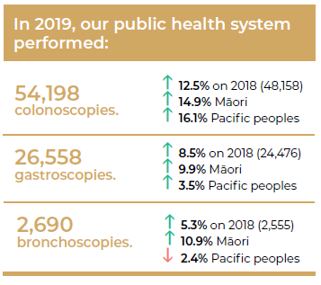
- Radiological imaging: including ultrasound, X-ray, computerised tomography (CT) scans, bone scans, magnetic resonance imaging (MRI) and positron emission tomography (PET) scans. Radiology can be used to diagnose cancer, to guide biopsies to get further information on a suspected cancer, to look for spread of disease and to monitor progress during or after treatment.
- Endoscopy: is used to look inside the body and includes colonoscopy (looking at the bowel), gastroscopy (stomach and oesophagus), bronchoscopy (lungs), colposcopy (cervix), hysteroscopy (uterus) and cystoscopy (bladder). Biopsies are often taken during endoscopies.
- Pathology and laboratory tests: cancer diagnosis often involves looking at tissue – frequently from biopsies – under a microscope. Pathology includes cytology (focused on individual cells) and histology (looking at the intact pieces of tissue). Diagnosis and monitoring of cancer often also involves blood tests and other laboratory tests.
- Genomic testing: is used to detect genetic changes either within cancer cells or in a person’s DNA. This may help confirm a diagnosis, predict the aggressiveness of the cancer, predict the likelihood that the cancer will respond to certain drug therapies or identify a syndrome that predisposes the person, or their whānau, to additional cancers.

Reducing delays to cancer diagnosis is important for improving survival and quality of life (Neal et al 2015). Diagnosing cancer at an early stage increases the chance that curative treatment options will be available for patients (see Figure 6.1).

Figure 6.1: Five-year survival by stage at diagnosis
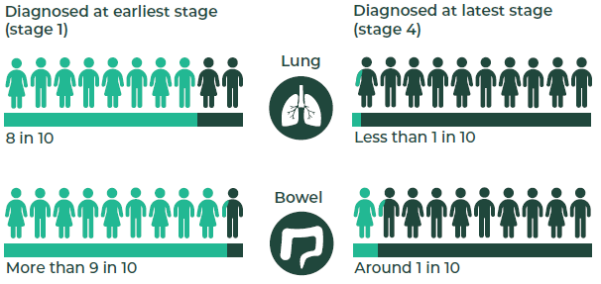

Reducing delays in diagnosis is particularly critical if we are to achieve equity in cancer outcomes for Māori and Pacific peoples. Structural issues and processes within the health system, including institutionalised racism, mean that Māori and Pacific peoples experience numerous delays along the diagnostic pathway. These cumulative delays contribute to poorer survival outcomes for Māori and Pacific peoples (Hill et al 2013; Blackmore et al 2020; Ellison-Loschmann et al 2015).

The path to diagnosis
The path to diagnosis varies depending on each person’s situation. One marker of the effectiveness of the overall diagnostic path is the place of diagnosis. Ideally people are diagnosed through an established elective referral pathway, for example, a referal from their local doctor to a specialist service at a hospital or through a national screening programme, but this does not always occur. People who present with cancer via the emergency department (ED) are more likely to have advanced, incurable disease and often have worse cancer care experiences (Beatty et al 2009; Sharples et al 2018).

Although some people diagnosed through the ED may have been asymptomatic until they develop severe and sudden symptoms, diagnosis through the ED can be a sign that some aspect of the diagnostic pathway is not working. From 2015 to 2018, almost half (45 percent) of people with lung cancer were diagnosed following a presentation to an ED (Te Aho o Te Kahu nd). There was wide variation between DHBs (ranging from 31 percent to 65 percent) and higher rates for Māori (49 percent) and Pacific peoples (57 percent) compared with New Zealand European/Other ethnicities (43 percent). This is a high ED presentation rate compared with other countries (36 percent in Canada, 34 percent in England and 35 percent for non-small cell lung cancer in Australia) (Te Aho o Te Kahu nd).

The proportion of people being diagnosed with bowel cancer following a presentation to ED is lower, at 26 percent between 2013 and 2016 (Ministry of Health 2019a) (see Figure 6.2). The majority (71 percent) of people with bowel cancer were diagnosed following a referral to a secondary health care clinic. Only 3 percent were diagnosed via screening during this period, but that figure is expected to increase as the National Bowel Screening Programme is rolled out across the country (see 5 Screening). Pacific peoples and Māori had higher rates of ED presentation for bowel cancer than New Zealand European/Other ethnicities (Ministry of Health 2019a).

Figure 6.2: Diagnosis via emergency department, lung and bowel cancers
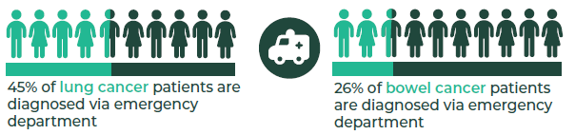

In order to support the early diagnosis of cancer, the whole cancer diagnostic pathway needs to be operating well (see Figure 6.3). This includes:
- improving public awareness of symptoms so that people seek medical advice if they develop symptoms
- increasing uptake of national screening programmes (see 5 Screening)
- ensuring access to diagnostic services, including:
- access to primary health care services
- availability and accessibility of diagnostic procedures
- ensuring diagnostic procedures occur in a timely manner
- ensuring all care delivered is high quality, including being culturally appropriate.

Figure 6.3: Components of an effective diagnostic pathway
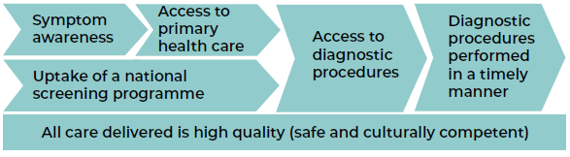

Awareness of symptoms
People do not always recognise the symptoms of cancer (Koia et al 2020), which can lead to delays in seeking medical care for investigation and diagnosis.
I was diagnosed with quite advanced prostate cancer. I’d been ignoring the warning signs, such as frequent urination and inability to hold urine … one of the problems was that I didn’t have a good relationship with my GP, so I didn’t really talk with them, and I didn’t grasp the seriousness of the implications myself.
Cancer patient

Also, while some cancers may present with high-risk symptoms, cancer symptoms can often be vague and shared with several other conditions. This makes the recognition and investigation of symptoms by primary health care teams a challenge (McMenamin 2020). An investigation of reports to the Health and Disability Commissioner due to perceived delays in diagnosis found that just over half of patients had non-specific or atypical symptoms (Health and Disability Commissioner 2015).

Access to primary health care services
Primary health care is a critical component of the diagnostic pathway. However, in 2019/2020, 31 percent of New Zealanders reported some form of unmet need for primary health care services. This unmet need was driven by a variety of barriers, including cost or lack of transport or appointment availability. Māori were 1.4 times more likely to report an unmet need for primary health care than non-Māori. Those living in the most deprived areas were 1.4 times more likely to report unmet need than those living in the least deprived areas (Ministry of Health 2020).
An estimated 1.2 million adults in Aotearoa had an unmet need for primary health care in 2019/20.
In 2019/20, more than 1 in 5 Māori adults (20.5%) had not visited a GP due to cost in the past year; 16% of Pacific adults had not visited a GP due to cost in the past year.
Nearly 1 in 5 adults living in the most socioeconomically deprived areas were unable to visit a GP due to cost.
Source: NZHS 2019/20

Access to diagnostic services
Once patients have presented to a primary health care service with cancer symptoms, they need to access appropriate diagnostic procedures and services. This requires clear criteria and pathways for primary health care services to refer patients for diagnostic tests. There is limited data collected nationally on barriers to accessing diagnostic procedures, and improvements in national data collection will help clarify access issues and current inequities.
HealthPathways: Improving patient management
HealthPathways Community is an online manual used to guide primary health care clinicians’ decision-making when managing patients with particular conditions. It includes information and processes for initiating diagnostic requests, including referrals to specialist services. HealthPathways is available across Aotearoa and is localised to reflect how conditions are managed in each region.
There are several webpages within HealthPathways that support primary health care investigation of cancer symptoms. For example, in 2019, there were nearly 7,000 visits to the bowel cancer screening webpage and 1,400 visits to the ovarian cancer symptoms webpage.

If primary health care clinicians believe a specialist opinion is needed, patients will be referred through to a secondary health care service for further diagnostic tests and/or management. One measure of the effectiveness of the referral pathway between primary and secondary health care is declined referrals. Referrals may be declined because they are deemed inappropriate (that is, the referral criteria or pathway was not clear or not understood or the criteria did not meet the needs of the primary health care clinicians) or because of capacity issues within the hospital. Both options indicate a need for improvement.

Of the 773,323 referrals received by secondary health care services and captured in National Patient Flow reporting in 2018, 667,114 were accepted (86 percent).

Currently there is some variability in access to diagnostic testing across Aotearoa. One example is genomic testing. Many specialised tests require sophisticated equipment and skilled interpretation, and in some cases, there is only a small number of cancers requiring some of the less common tests per year. This means that it is not feasible for all laboratories in Aotearoa to provide these services. Some laboratories act as agents for commercially marketed tests, which are performed – often overseas – at a direct cost to the patients. Other laboratories perform testing themselves and absorb the cost of providing this service, as there is currently no specific funding for it.

Similarly, PET scanning is all done by contracted private practices, with five of these in the country. Currently, there are inconsistencies between DHBs in terms of routine funding for PET scanning. Even if not routinely funded, clinicians can apply for a PET scan to be funded where they feel that a scan is clinically appropriate.

Performing diagnostic procedures in a timely manner
All care that people receive along their diagnostic journey should be performed in a timely manner. There is an expectation that people referred to secondary health care services and triaged as having a high suspicion of cancer (with a need to be seen in two weeks) will receive further diagnostic tests and start their first treatment (or other management) within 62 days of the referral being received by the hospital. In 2019/2020, 87 percent of the 5,354 people referred via the ‘high suspicion of cancer’ pathway met the target (the target is 90 percent). This was 85 percent for both Māori and for Pacific peoples.

The hardest time to deal with a cancer diagnosis is the two weeks after the initial diagnosis to the first consultation with the medical professionals to discuss what will happen next. You are left in a state of limbo and uncertainty. Once I was seen, I had a better idea and understanding of what was going to happen, what treatments I could expect and how long I’d be taking those treatments.
Cancer patient

Colonoscopy
Colonoscopy is the primary method used to diagnose bowel cancer. There are longstanding challenges for DHBs to keep up with colonoscopy demand. In 2020, this was exacerbated by the COVID-19 pandemic, where there was a large drop off in colonoscopies performed during national alert level 4, followed by lower capacity during alert levels 2 and 3 due to physical distancing and protective equipment requirements. Colonoscopy demand is anticipated to increase as the National Bowel Screening Programme is rolled out across Aotearoa.

Table 6.1 shows the percentage of patients across Aotearoa who received their colonoscopy within the target timeframe between July 2019 and June 2020.

Table 6.1: Colonoscopy diagnostic waiting time indicator, 2019/20
 | Number completed | Target timeframe | Percentage of patients meeting target*
Urgent colonoscopy | 5,830 | 90% within 2 weeks | 89%
Non-urgent colonoscopy | 28,645 | 70% within 6 weeks | 48%
Surveillance colonoscopy | 13,280 | 70% within 12 weeks | 53%
* Calculated as an average percentage of the those who met the target each month in 2019/20.
Source: Ministry of Health 2019b

COVID-19 and cancer diagnostics
Responding to COVID-19 presented diagnostic health services with two competing challenges. On one hand, at national alert level 4, the aim was to minimise spread, limit person-to-person contact and protect health services from people potentially infected with COVID. On the other hand, there was a need to maintain services that were likely to have a serious impact on patient health outcomes.
FIT for symptoms
In 2020, a pilot programme began to investigate the use of faecal immunochemical testing (FIT) to identify those at highest risk of colorectal cancer and prioritise urgent colonoscopy for these patients.
During alert level 4 (March 2020), there was a large decrease in colonoscopy delivery. Figure 6.4 shows the cumulative number of colonoscopies performed each year. There was a noticeable impact as we moved to alert level 4 of the COVID-19 pandemic response, with increased service provision to catch up following the departure from alert level 4.
Figure 6.4: Cumulative number of gastroscopies and colonoscopies by year, 2018–2020
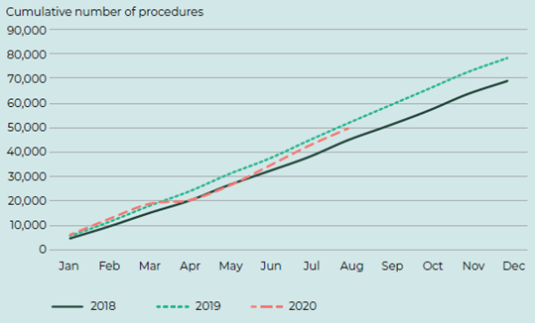

Radiology
We do not yet have national data systems to track the timeliness of radiology procedures for people being investigated specifically for a suspicion of cancer. This creates challenges for understanding demand, timeliness and reasons for delay. It is a high priority area for data improvement in Aotearoa.

In 2019, approximately 78 percent of patients referred for radiological imaging, for any indication (not just cancer) received their CT scan within 42 days (target of 95 percent), and 62 percent received their magnetic resonance imaging (MRI) scan within 42 days (target of 90 percent).

Providing high-quality diagnostic services
All care that people receive along their diagnostic journey should be high quality; from the interactions with primary health care clinicians through to the reporting of radiology scans. The overall quality of the diagnostic pathway will be evident in patients’ experiences and outcomes. It is also possible to analyse the quality of specific sections of the diagnostic pathway.

Patient experience of primary health care
Whilst people being aware of symptoms is a critical first step in diagnosing cancer, there are additional barriers to seeking care, even if people recognise their symptoms. These barriers include distrust of the health care system and an environment where people feel embarrassed discussing some symptoms (Ellison-Loschmann et al 2015).

In 2019/20, around four out of five New Zealanders (83 percent) reported definitely having confidence and trust in their general practitioner (GP) (Ministry of Health 2020). Trust generally increased with increasing patient age, and there was no difference by patient ethnicity. People generally reported being treated with respect (95 percent) and with kindness and understanding (93 percent) by their GP or nurse (HQSC 2020).

Pathological diagnosis
A pathological diagnosis identifies the specific type of tumour and is important for guiding decisions around treatment. A pathological diagnosis can also enable molecular testing to see if a patient is suitability for targeted therapies.

Having a pathological diagnosis is one of the quality performance indicators for lung cancer in Aotearoa. Not every patient will have a pathological diagnosis, because it may be impossible or too risky to attempt a biopsy. From 2015 to 2018, the proportion of people in Aotearoa with a pathological diagnosis of lung cancer was 81.4 percent. This is higher than rates seen overseas (for example, 72 percent in the United Kingdom). There was variation between DHBs in the proportion of people with a pathological diagnosis, ranging from 71.4 percent to 89.1 percent (Te Aho o Te Kahu nd).

Lymph node yield
When cancer is diagnosed, additional investigations are often conducted to establish how much the cancer has grown and if, and how far, it has spread. This is referred to as ‘staging’. Accurately staging cancer helps guide treatment decisions and is a significant contributor to providing a cancer prognosis. However, appropriate tumour staging at diagnosis is not completed for Māori for a large number of cancers, and the lack of adequate staging data may contribute to underestimation of cancer-specific inequities for Māori (Gurney et al 2020).

One example of a quality indicator for the staging of bowel cancer is lymph node yield (the number of lymph nodes that are resected and examined). Maximising lymph node yield enables reliable staging. Current guidelines recommend that a minimum of 12 nodes be harvested as the standard of care. From 2013 to 2016, overall, 82 percent of people had 12 or more lymph nodes examined; however, there was large variation between DHBs, from 55 percent to 95 percent (Ministry of Health 2019a).

High-quality pathology reporting
The Royal College of Pathologists of Australasia (RCPA) has developed guidelines or protocols for reporting various types of cancer through the Structured Pathology Reporting of Cancer (SPRC) project. More than 45 SPRC protocols have been published to date, and more are in development.
More recently, the RCPA joined with other pathology organisations in North America, the United Kingdom and Europe to form the International Collaboration on Cancer Reporting (ICCR), which also publishes protocols and guidelines for pathology reporting of cancer internationally. The ICCR has now expanded to include several other countries in Asia, Africa and South America.
Currently in Aotearoa, most pathologists use some form of structured reporting protocols for most cancers, but adoption of the RCPA and ICCR protocols has been variable across the regions and there is still room for improvement in terms of standardising the approach to structured reporting and use of common terminology. The consistency and completeness of information provided could be improved with the use of more up-to-date IT systems and links between laboratories and through use of standardised terminology.

Overdiagnosis
Early diagnosis is critical to improving cancer outcomes. However, the diagnosis of a cancer before a person develops symptoms can also have unintended consequences, notably overdiagnosis. Overdiagnosis is the diagnosis of cancer in people who would have lived their entire life without ever experiencing harm or developing symptoms from their cancer. It can occur when non-progressive or very slow growing tumours are found incidentally during the investigation of other abnormalities or symptoms (Glasziou et al 2020).

Figure 6.5: Overdiagnosis outcomes
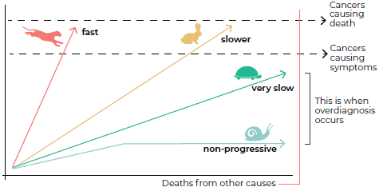
Amended from The National Cancer Institute

Because it can be difficult to identify which cancers will progress to cause harm and which will not, overdiagnosis leads to overtreatment. It is associated with significant harm to patients, as it means people experience side effects and complications from unnecessary treatment, as well as the psychological harm of receiving the news of a cancer diagnosis. Overdiagnosis also affects the population as a whole, as the money and resources consumed could otherwise have been directed to other parts of the health system (Esserman et al 2014).

Thyroid cancer is one example of a cancer that is well recognised for overdiagnosis (Vaccarella et al 2016, Mengmeng et al 2020). Worldwide, there has been a large increase in the diagnosis of thyroid cancer over the last two decades; however, there has been no change in mortality from this cancer (see Figure 6.6). This suggests that people are now being diagnosed and treated for thyroid cancer who previously would have lived without knowing they had the cancer.

Figure 6.6: Thyroid cancer incidence and mortality, by sex, Aotearoa, 1996–2017
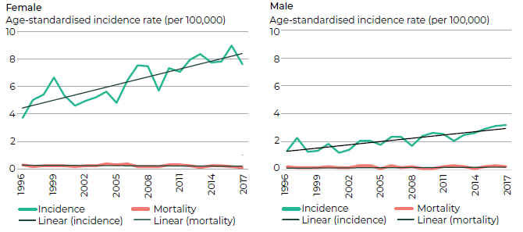

Treatment

Key points
→ The three key cancer treatments are: surgery, radiation therapy and systemic anti-cancer therapy (cancer medicines).
→ Surgery is the most common type of cancer treatment used in Aotearoa. For example, in 2019, over 2,500 New Zealanders received surgery aimed at curing their colorectal cancer, more than 700 New Zealanders had curative lung cancer surgery, and 700 had curative prostate cancer surgery.
→ There are six public cancer centres and four private cancer centres that provide radiation therapy in Aotearoa. In 2018, 33 percent of New Zealanders with cancer received radiation therapy.
→ There were nearly 75,000 systemic anti-cancer therapies (cancer medicines) delivered in 2019. This is a 6.4 percent increase from 2018.
→ The main treatment for blood cancers is chemotherapy. Other treatments include radiation and stem-cell transplants. In 2018, 310 patients had a stem-cell transplantation in Aotearoa.
→ Work is under way to improve the availability of treatment data. This will allow us to better understand who is, and is not, accessing treatment and the impact access to treatment has on outcomes.
→ Quality performance indicators are currently being developed for each cancer type to identify variation in treatment quality and drive improvement in care.
→ Over the last decade, improved treatment models and access to adolescent and young adult (AYA) key workers have led to improvements in AYA cancer survival rates and equity in outcomes.
→ There is limited overall understanding of how and when cancer patients use rongoā. The Ministry of Health currently contracts 20 providers to deliver rongoā services in Aotearoa.

Cancer treatment goals vary, depending on a person’s individual situation, and can include treatment to cure cancer or prolong life and treatment to reduce the symptoms of cancer and improve quality of life. Aotearoa has publicly funded cancer services that provide these treatments, with some services also provided by private hospitals.

The three main forms of cancer treatment are surgery, radiation therapy and systemic anti-cancer therapy (cancer medicines, including chemotherapy, hormonal therapy, immune therapy and targeted therapy). These treatments may be used alone or in combination, depending on factors such as the type of cancer, how far the cancer has spread, the age of the person, their underlying health and their treatment preferences.

The extent of cancer spread is usually summarised as ‘cancer stage’. Early and intermediate-stage cancers are confined to the primary or source organ and adjacent areas, such as lymph nodes. Advanced-stage cancers are those that have usually spread elsewhere in the body.

Surgery is the most common (and usually first) treatment for early- and intermediate-stage solid tumours, such as breast and colorectal cancer. Depending on the extent of the local cancer, sometimes other treatments (such as radiation) are given before the main treatment to shrink the tumour to make it easier to remove. Following the main treatment, other treatments (such as chemotherapy) might be given to prevent new tumours from growing.

Occasionally, systemic therapy can cure some cancers that are at an advanced stage. More often however, systemic treatment is given to extend life or reduce symptoms. This is often referred to as palliative treatment.

Blood cancers such as leukaemia are different to solid tumours. Blood cancers are not usually defined by ‘cancer stage’. Systemic therapies are the most commonly used treatments for blood cancers.

Cancer surgery
Cancer surgeries in Aotearoa are performed through the public and private health system by surgeons (for major procedures) or by dermatologists or general practitioners (GPs) (for minor skin surgeries).

Surgery is commonly used to diagnose (confirm a cancer diagnosis), treat (remove the tumour from the body) and/or debulk (remove as much of the tumour as possible to reduce symptoms or prevent future complications).

Faster Cancer Treatment (FCT) Health Target
(Definition: 90% of patients receive their first cancer treatment within 62 days of being referred with a high suspicion of cancer and a need to be seen in two weeks.)
In 2019/2020:
55% of all patients on the FCT pathway had surgery as a first treatment
88% of patients received their surgery within the 62-day timeframe
82% of Māori received their surgery within the 62-day timeframe.
Source: Ministry of Health, Faster Cancer Treatment. URL: www.health.govt.nz/new-zealand-health-system/health-targets/about-health-targets/health-targets-faster-cancer-treatment

Each of our 20 district health boards (DHBs) provide some surgical treatment for cancer, but some treatments are only available in larger centres. Simple surgical procedures, such as surgery for breast cancer that hasn’t spread around the body, may take place in a regional hospital. More complex procedures, such as surgery for pancreatic cancer, will be performed in hospitals where there is access to technical expertise and specialised equipment.

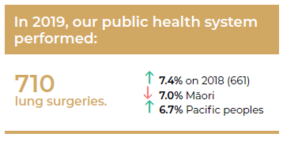
As part of their quality performance indicator work, Te Aho o Te Kahu (and, before their establishment, the Ministry of Health) have been reporting on indicators of quality of cancer surgery. For example, between 2013 and 2016, a total of 7,170 people underwent surgical resection for colorectal cancer. The median length of stay in hospital following major resection was seven days, increasing for those aged 75 years and over and for those undergoing emergency surgeries who required a longer recovery time (Ministry of Health 2019a).

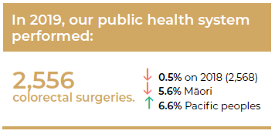
Between 2013 and 2016, the overall 90-day mortality rate following colorectal cancer resection was 4.0 percent, and the overall 30-day mortality rate was 2.7 percent. There was higher risk of death for those requiring emergency surgery (compared with elective surgery). Although overall post-operative mortality in patients undergoing surgery for colorectal cancer in Aotearoa is comparable with other countries, there is variation between DHBs. There is also evidence that Māori have higher post-operative mortality than non-Māori (Gurney et al 2020b).

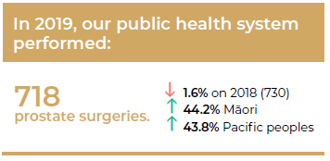
There is also variation between DHBs in the likelihood that patients receive more complex surgery. For example, between 2015 and 2018, a total of 1,006 people with non-small cell lung cancer (a rate of 16.7 percent) underwent surgical resection. However, there was marked variation based on where people lived, with rates across different DHBs ranging from 10–24 percent (Te Aho o Te Kahu nd).

Radiation therapy
Radiation therapy uses ionising radiation to destroy or damage cancer cells to stop them multiplying and growing. It can be used to cure cancer; to reduce the size of the cancer before surgery; to reduce the risk of the cancer returning after surgery; and in the palliative setting, to relieve pain and other symptoms.

Radiation therapy may be given alone or in conjunction with other treatments. For example, there were 2,998 people diagnosed with rectal cancer between 2013 and 2016. Of those who underwent major surgery, 54 percent received preoperative radiation therapy treatment (Ministry of Health 2019a).
Faster Cancer Treatment (FCT)
In 2019/2020:
11% of all patients on the FCT pathway had radiation as a first treatment (including concurrent radiation therapy and chemotherapy treatment)
71% received radiation therapy within the 62-day timeframe
80% of Māori received radiation therapy within the 62-day timeframe.

In Aotearoa, radiation therapy is given at six public cancer centres and four private cancer centres. It is provided by a team of health care professionals, including radiation oncologists (the specialists who oversee radiation treatment), medical physicists, radiation therapists and specialist nurses.

Currently, 24 linear accelerator (LINAC) machines deliver radiation therapy in our public cancer centres, with a further eight in private cancer centres. The LINAC machine generates a radiation beam, which can be targeted at specific sites to treat tumours or areas at risk of containing tumour cells. The machines have a usual lifespan of 10 years, and following a government announcement in August 2019, 12 are in the process of being replaced in our public cancer centres over the next three years, including placing three in regional sites.

Radiation therapy is given externally or internally. The types of therapy include:
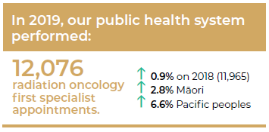
- External-beam radiation therapy: This is the most common type of radiation therapy and can treat large areas of the body, if needed. The specialised computer software adjusts the radiation beam’s size and shape to help target the cancer while avoiding healthy tissue.
- Superficial radiation therapy: The beam of radiation is directed to penetrate only the surface of the skin to avoid deep tissue damage and minimise scarring.
- Brachytherapy: Implants containing radioactive material are placed in the cancer or surrounding tissue. These implants may be permanent or temporary.
- Radioisotopes: People swallow or receive an injection of radioactive material that targets cancer cells. This material leaves the body over a few hours to days through saliva, sweat and urine and, during this time, these fluids are radioactive.

A key measure of access to radiation oncology services is the population intervention rate. This assesses the number of cases of cancer that are treated with radiation therapy. Several countries (including the United Kingdom, Australia, Canada, the Netherlands and Sweden) have set ‘optimal’ intervention rates as a national standard for access to radiation therapy, but Aotearoa currently has not set this rate (Ministry of Health 2017). In 2018, the intervention rate in Aotearoa was 32.9 percent.

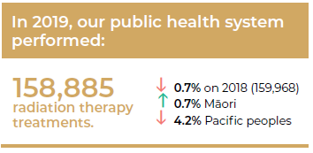
Figure 7.1 shows the range of intervention rates across DHBs. The wide range highlights the considerable variation in access across the DHBs. However, living far from a treatment centre may reduce access to treatment. A recent measure to address this will be the placement of the three regional LINACs, which were announced in 2019.

Figure 7.1: National radiation therapy intervention rates by DHB, 2018
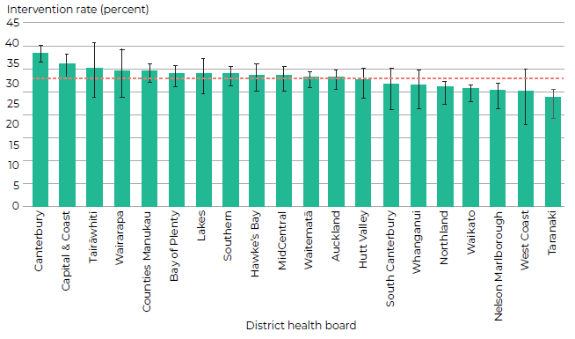

Hypofractionation
Hypofractionation is an advanced radiation therapy technique that has been developed to treat certain cancers. In this technique, larger doses of radiation are delivered at each treatment session. This means that patients are able to complete their radiation therapy courses much quicker with fewer sessions. For example, breast cancer trials in the adjuvant setting indicates there is no worsening of side effects or local cancer control with 40Gy in 15 fractions (doses of radiation) compared to 50Gy in 25 fractions. Figure 7.2 shows the increase in uptake of hypofractionation for breast cancer in Aotearoa.

Figure 7.2: Proportion of curative breast courses prescribed hypofractionation (15 fractions excluding boost), 2017/18 and 2019/20
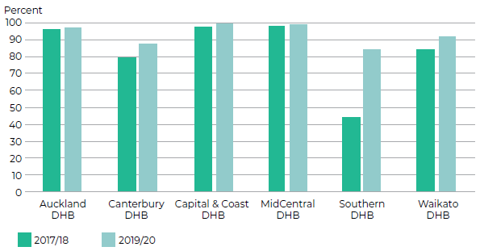

An 8Gy single fraction of radiation is considered standard of care and clinically equivalent to 20Gy in five fractions for the treatment of palliative bone metastases. Since 2012, there has been a trend in favour of using single fractions, which has accelerated in recent years. The percentage of eligible patients receiving a single fraction has increased from 45 percent in 2012 to 70 percent in 2020 – see Figure 7.3. This greatly benefits patients receiving this treatment, with patients generally attending fewer treatment appointments for the same outcome. It also represents resource savings of approximately 29 percent, or 1,850 treatment sessions.

Figure 7.3: Proportion of courses prescribing one and five fractions for palliative bone metastases, 2012–2020
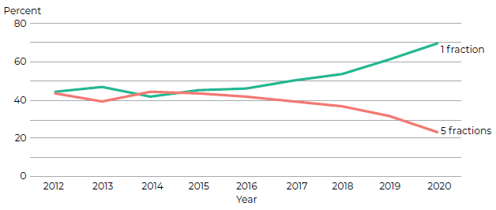

A specific type of hypofractionation is extreme hypofractionation or stereotactic ablative radiation therapy (SABR). This is a highly specialised and complex radiation technique that delivers very high doses of radiation to a tumour either in a single or small number of treatments. This is now commonly used to manage early lung cancers in patients for whom surgery is not suitable and in managing some secondary cancers that have spread to the brain, bone or other parts of the body. Increasingly, this technique is being trialled overseas in managing other cancers such as cancer in the prostate. Figure 7.4 shows very clearly the increase in uptake of SABR over the eight years from 2012 to 2019.

Figure 7.4: SABR treatments in Aotearoa, 2012–2019
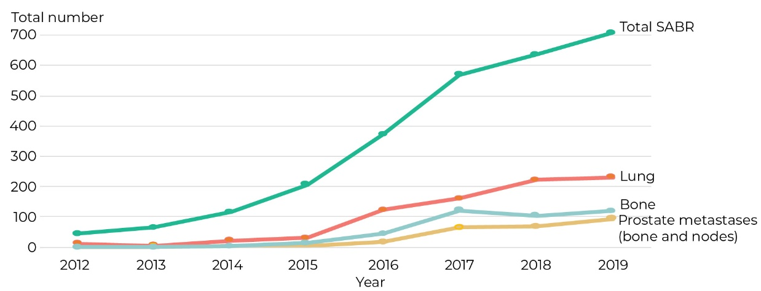

Radiation for early, high-risk prostate cancer
When prostate cancer has not spread beyond the prostate itself, treatment can take many forms. An active surveillance approach may be taken for low-risk, early stage cancers that appear to be slow growing. Active treatment options for high-risk prostate cancers (that is, those that may not be slow growing) include surgery (prostatectomy) or radical radiation therapy (using high doses of radiation to destroy the cancer cells growing within the prostate). Radical radiation therapy is often used in combination with hormone therapy and has been shown to be as effective as surgery in treating early prostate cancer (Donovan et al 2016, Hamdy et al 2016, Kishan et al 2018).
The decision around whether to go with surgery or radiation for treating early, high-risk prostate cancer should be made by the patient and their whānau. The patient and their whānau should discuss all options with both a urologist and a radiation oncologist before deciding which is the right treatment for them.
One of the new quality performance indicators that is currently being set for prostate cancer includes a requirement to monitor how well we are informing patients of their treatment options (see Improving cancer diagnosis and treatment in Aotearoa on page 104).

Systemic anti-cancer therapy
Systemic anti-cancer therapy involves drugs being spread throughout the body to treat cancer cells wherever they lie. It includes chemotherapy, hormonal therapy, immunotherapy and targeted therapies.

Depending on the type of cancer and whether or how far it has spread, systemic therapies may be used in a variety of ways: to eliminate all cancer cells in the body, even when cancer is widespread; to reduce the size of a tumour before surgery; to prolong life by controlling cancer growth and spread; and to relieve symptoms and improve quality of life.

Faster Cancer Treatment (FCT)
In 2019/2020:
25% of all patients on the FCT pathway had chemotherapy as a first treatment (including concurrent radiation and chemotherapy treatment, targeted therapy)
88% received chemotherapy within the 62-day timeframe
86% of Māori received chemotherapy within the 62-day timeframe.

Medical oncologists and haematologists are the specialists who oversee systemic anti-cancer therapies for patients with cancer. In Aotearoa, the majority of systemic therapies are delivered in our public health system.

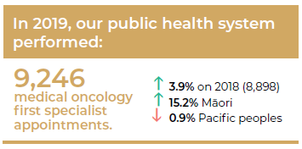
Most systemic anti-cancer therapy drugs are given intravenously (IV) through an injection, although an increasing number are given orally as a tablet or capsule. Chemotherapy is given in cycles, either daily, weekly or monthly. This is because some treatments only kill cancer cells at certain phases in the cancer’s cell cycle, so cycles are repeated to kill any cancer cells that were unharmed in the previous cycle. The schedule and duration of treatment can vary depending on the type of cancer, the extent of spread, other health conditions (or comorbidities) the patient may have and the patient’s choice.

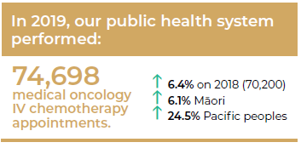
Access to systemic anti-cancer therapy for some cancers has increased over time. For example, 20 percent of those diagnosed with non-small cell lung cancer between 2008 and 2012 received systemic anti-cancer therapy. This increased to 29 percent for those diagnosed between 2015 and 2018. The rate of systemic anti-cancer therapy for non-small cell lung cancer in Aotearoa is now comparable to that for the United Kingdom, although once again there is large variation between DHBs, with a range from 13 to 38 percent (Te Aho o Te Kahu nd). For small cell lung cancer, systemic anti-cancer therapy rates are higher (71 percent) with less variation by DHB and similar rates to the United Kingdom (Te Aho o Te Kahu nd). Importantly, current systemic anti-cancer therapy data does not include information from private treatment providers, which will likely mask inequities in access to treatment. However, Māori have been shown to have less access to specialist cancer care centres, and this reduced access has been associated with a lower level of supplementary treatments for Māori with colon cancer when compared with non-Māori (Hill et al 2010).

Dramatic improvements in testicular cancer survival: a chemotherapy success story
Testicular cancer is the most common cancer to be diagnosed among men aged 15–39 years. In 2018 in Aotearoa, 173 males were diagnosed with testicular cancer, including 36 Māori. In 2017, eight men died from testicular cancer (including three Māori). While the highest rates are usually found among European men in other countries, Māori have the highest rates of testicular cancer in Aotearoa. The reasons for this inequity are currently unknown (Gurney 2019).
Over the last 50 years, testicular cancer survival rates have increased dramatically. Where previously more than 90 percent of patients would be expected to die within one year of diagnosis, now more than 90 percent are expected to survive (Hanna and Einhorn 2014). While surgical removal of the testicle (an orchiectomy) remains the primary treatment for cancers that are caught early, developments in chemotherapy have also been credited with the dramatic increase in survival rates.
Among those with ‘early’ cancers that have not spread beyond the testicle, one or two doses of chemotherapy after surgery dramatically reduces the chance of the cancer recurring (Rajpert et al 2016).
Also, cancers that have spread from the testicle are very sensitive to treatment with a platinum-based chemotherapy drug called cisplatin. Since its accidental discovery in the early 1970s, the use of cisplatin in combination with other drugs has led to a major improvement in survival rates for men with advanced testicular cancer (Rajpert et al 2016).

Immunotherapy
Immunotherapy is a type of cancer treatment that harnesses a person’s own immune system to recognise cancer cells as being foreign (in much the same way as they do a virus or bacteria) and destroy them.

Examples of immunotherapy commonly used and funded in Aotearoa are as follows:
- Rituximab is a type of immunotherapy that has been funded in Aotearoa for certain types of non-Hodgkin’s lymphoma for many years. Rituximab binds to the surface of the cancer cells, signalling to the body’s immune system to destroy them. The addition of rituximab to standard chemotherapy has significantly increased overall survival for patients with certain types of non- Hodgkin’s lymphoma (Bertrand Coiffier 2002).
- Nivolumab is another type of immunotherapy that has been funded in Aotearoa for the last few years for metastatic melanoma. It has been shown to significantly increase overall survival when given instead of the previous treatments. At one year, approximately 73 percent of patients receiving nivolumab are still alive, compared with 42 percent of those receiving previous treatment regimens (Robert 2015).
Cancer treatment and COVID-19
Cancer treatment services, including surgery, radiation therapy and systemic anti-cancer therapy, were largely maintained during the COVID-19 alert levels 3 and 4. This required innovation and dedication from cancer treatment providers around the country, as services were delivered with increased infection control practices and physical distancing. Figure 7.5 shows the cumulative number of attendances for IV chemotherapy by year and the ongoing provision of services across alert levels 3 and 4 in March and April 2020.
Figure 7.5: Cumulative number of attendances for IV chemotherapy by year,
2018–2020
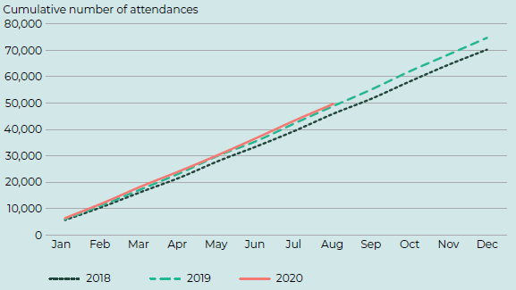

Te Pātaka Whaioranga | PHARMAC
Te Pātaka Whaioranga / Pharmaceutical Management Agency (also known as PHARMAC) is a governmental agency that decides which medicines to fund, including all medicines used in cancer treatment. Te Pātaka Whaioranga negotiates prices for publicly funded medicines on behalf of all New Zealanders, within the fixed budget that the Government sets. Te Pātaka Whaioranga also manages the funding and supply of all Government-funded vaccines (including some that prevent cancer) and promotes the responsible use of medicines in Aotearoa (PHARMAC 2020).

Te Pātaka Whaioranga approved six new cancer medicines for funding during the 2019/20 financial year. This included palbociclib (under the brand name Ibrance) and fulvestrant. These two medicines are used in combination for certain types of locally advanced or metastatic breast cancer. These treatments improve survival and maintain quality of life for people with these cancers and will benefit more than 2,000 New Zealanders in the first year of funding and up to 950 more New Zealanders over each subsequent year.

Some of the challenges facing Te Pātaka Whaioranga and the rest of the cancer sector include the pace at which new treatments are becoming available. Many of these new treatments work in different ways to traditional chemotherapy agents and may present new challenges in terms of administration and management (for example, side effects may be very different to the side effects from traditional chemotherapy). These treatments can also be very expensive, often with limited information available about their effectiveness.

Māori and Pacific peoples, and those living in socioeconomic disadvantage and in rural locations have significant barriers to accessing and utilising the medicines that are currently funded. This is despite their health needs being higher, which contributes to greater inequities in health (Bhawan 2019). Te Pātaka Whaioranga has a bold goal of eliminating inequities in access to medicines by 2025 by ensuring their funding decisions do not create barriers to access for those already experiencing health inequities and by supporting optimal prescribing and uptake. However, the drivers for improved access are not all in the hands of Te Pātaka Whaioranga, and this goal requires a whole- of-sector approach to be achieved.

Other newly funded cancer treatments include alectinib for ALK positive advanced non-small cell lung cancer, venetoclax (used in combination with rituximab) for chronic lymphocytic leukaemia, olaparib for BRCA-mutated ovarian cancer and trastuzumab emtansine for HER-2 positive metastatic breast cancer.

Personalised treatment and genomic testing
Decisions about what treatment will be available may be influenced by genomic tests from tumour or blood samples. These tests are done to look for genetic mutations that are unique to that particular cancer and can be the key to developing personalised treatments and can also help determine if the patient could be a candidate for a clinical trial.

For example, some people with lung cancers have a mutation in the epidermal growth factor receptor (EGFR) gene. A tablet, erlotinib, works well for many patients with this mutation. People who do not have this mutation do not benefit from erlotinib. Genomic testing for this mutation can identify who might benefit from treatment and who the treatment would not work for (Aye et al 2020).

Molecular testing of some cancers, to identify the gene or genes responsible for driving the abnormal cell growth, can be helpful in selecting effective targeted treatments.

People who develop Chronic Myeloid Leukaemia (CML) are routinely tested for the presence of the abnormal BCR/ABL transcript, associated with this type of leukaemia.

Treatment with a class of drugs known as tyrosine kinase inhibitors (TKIs), such as Imatinib or Dasatinib, is very effective in suppressing the growth of cells with the BCR/ABL molecular abnormality, thereby bringing the leukaemia under very good control. Such targeted therapies often allow the person to avoid side effects of traditional chemotherapy treatment.

Inconsistencies in access to genomic testing is a significant challenge. Patients in some DHBs may have routine access to a particular test, whereas patients in other DHBs may have limited access and/or be required to fund the test themselves.

Treating blood cancers
The incidence of blood cancers in Aotearoa, like many countries in the world, is increasing due to an expanding and aging population. Haematologists are the specialists who oversee diagnosis and treatment for patients with blood cancer.

When combined, blood cancers are the fourth most commonly diagnosed cancer for Māori (Gurney et al 2020c), the sixth most commonly diagnosed for non-Māori and the third most common cause of cancer death for all New Zealanders – around 800 New Zealanders die from a blood cancer each year.
Faster Cancer Treatment (FCT)
In 2019/2020:
92% of all patients on the FCT pathway received treatment within the 62-day timeframe
93% of Māori received treatment within the 62-day timeframe.

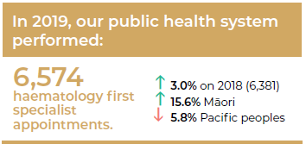
The main treatment for blood cancers is chemotherapy, which may be the only treatment required to cure some blood cancers.

Other treatments that are commonly used are radiation therapy and stem-cell transplant therapy. Increasing numbers of patients with blood cancers are now able to undergo stem-cell transplant procedures. For example, in 2018:
- 203 patients had an autologous (from your own body) stem-cell transplantation, at five different centres across the country (Most of these patients had either myeloma or relapsed lymphoma.)
- 107 patients had a allogeneic stem-cell transplantation, using blood or bone marrow stem cells from another healthy individual (ABMTRR 2019).

Access to healthy donors is improving, aided by the New Zealand Bone Marrow Donor Registry (NZBMDR), which provides access to potential volunteer donors worldwide. There is also an expanding use of haplo-identical donors (half-matched with the recipient), with improving success rates.

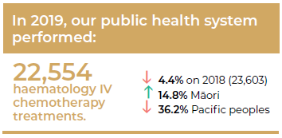
Many patients with blood cancers require blood and blood products to support them through intensive anti-cancer treatments. Most patients with blood cancers could not have effective treatment without the support and generosity of blood donors and the expertise of the New Zealand Blood Service (NZBS) in making blood and related blood products available. In 2018/19, New Zealanders donated a total of 112,341 whole blood units through the NZBS, with 25 percent of these units going to cancer patients (NZBS 2019).

Treating child, adolescent and young adult cancers
Cancers occurring in children and adolescents differ markedly from cancers in adults in their incidence and cancer characteristics (see 1 Cancer in Aotearoa). Children and adolescents and young adults (AYA) with cancer require specialised care. They have physical and emotional needs that differ from those of adults with cancer.

I was numb. I mean what did cancer mean for my plans for university? What about life and marriage and even kids? I hadn’t thought about kids before, but now I had to.
AYA cancer patient

There are two treatment centres for childhood cancers in Aotearoa: the Starship Blood and Cancer Centre in Auckland (which saw and treated 64 percent of the 150 children diagnosed with cancer in Aotearoa in 2019) and the Children’s Haematology Oncology Centre in Christchurch (which saw and treated 36 percent of the children). There are 14 shared care centres in Aotearoa that are for children with cancer who live outside Auckland and Christchurch. They work closely with the two treatment centres so that as much of the treatment, as safely as possible, can be given closer to home.

Child and adult cancer services within DHBs provide treatment and support for AYA with cancer in Aotearoa. Health and other professionals working within these services have considerable experience in treating and caring for young people, including the regional AYA cancer key workers. However, often AYA with cancer feel lost between the services, on the periphery of cancer care.

Ten years ago, survival rates for AYA in Aotearoa lagged behind international comparisons by 7 percent with inequities in outcomes for certain ethnic, disease-specific and age-related populations. Reassuringly, over the last decade, overall AYA cancer survival has improved, and some of the specific inequities have reduced through a number of complex, innovative and responsive actions. These actions include having key AYA workers in each region, the establishment of the AYA Cancer Network in 2014, increasing access to clinical trials and the publication of AYA Cancer Standards of Care in 2016 (AYA Cancer Network Aotearoa 2016).

National Child Cancer Network
Child cancer services encompass the full spectrum of services available to treat and support children diagnosed with cancer and their whānau. The National Child Cancer Network (NCCN) brings together health professionals and stakeholder organisations to work collaboratively and provide leadership for service development across childhood cancer services in Aotearoa.
Adolescent and Young Adult Cancer Network Aotearoa
The Adolescent and Young Adult Cancer Network Aotearoa provides clinical leadership and national oversight of adolescent and young adult (AYA) cancer care in Aotearoa. It is a membership organisation that connects hands-on health professionals and support providers from many disciplines and organisations. The network’s aim is to find new and innovative ways of delivering care to AYAs with cancer to improve the service they receive.

Rongoā
Rongoā is the traditional healing system for Māori. It is a body of knowledge that incorporates and maintains hauora (wellbeing), including the dimensions of: a-tinana (physical), a-wairua (spiritual), a-hinengaro (mental and emotional), a-whānau (family, communal) and a-whenua (land and environmental).
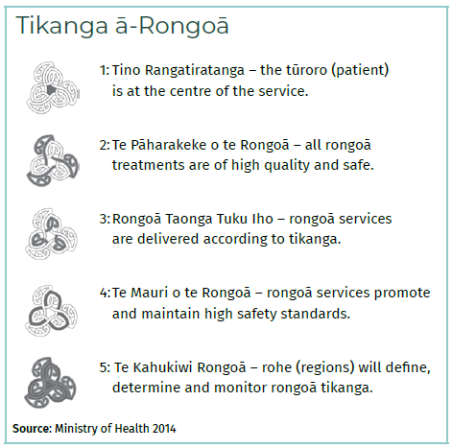
Across Aotearoa, rongoā practitioners support those with cancer and their whānau. There are two main ways of receiving rongoā, either through traditional networks and processes, which aren’t recorded; or through providers who are contracted by the Ministry of Health to provide rongoā services. Because data is only captured by providers who are contracted to provide rongoā, there is limited overall understanding of how and when cancer patients use rongoā in Aotearoa.

The Ministry of Health currently contracts 20 providers to deliver rongoā services across Aotearoa. Each year, they provide many rongoā services, which can include: mirimiri, karakia and whitiwhiti kōrero (Ministry of Health 2014; Stewart et al 2014; Mark and Koea 2018). These rongoā services align with Tikanga ā-Rongoā standards, a voluntary set of standards that provide clear requirements for rongoā providers. The standards support the consistent, high-quality delivery of rongoā as well as the ongoing development of the rongoā workforce (Ministry of Health 2014).

Although demand for collaboration between rongoā and medical methods of health care has been increasing in Aotearoa (Stewart et al 2014), a recent thematic review found that rongoā Māori remains largely unrecognised, and authentic collaboration between rongoā Māori healing and medical health treatment systems is still lacking (Mark and Koea 2018).

Supportive care
Cancer care is broader than treating the physical consequences of cancer and includes meeting the needs of the person as a whole. Supportive care is a critical part of treatment and aims to improve the quality of life for those with cancer and their whānau. This includes care focused on addressing a person’s physical, social, cultural, emotional, informational, psychological, spiritual and practical needs throughout their experience with cancer. Many people are involved with providing supportive care across the diagnosis, treatment and post-cancer-treatment continuum (see 3 The people providing cancer care).

For Māori, providing options for kaupapa Māori supportive care approaches includes discussing specific needs and preferences with whānau during their treatment. This can encompass options such as kaumātua and kuia support, Māori mental health services, whānau ora navigators or Māori cancer nurse coordinators.

Another example of supportive care is spiritual care. Spiritual health, or taha wairua, is a key component of health and wellbeing (Durie 1985; Capstick et al 2009; Ministry of Health 2001). There are many definitions of spirituality, with common spiritual classifications including: meaning, purpose, beliefs, values, connectedness and transcendence (Egan et al 2011). Spirituality means different things to different people and may be experienced in relation to self, whānau, community, nature or the sacred (Puchalski et al 2014). People affected by cancer may experience spiritual distress through having one or more of these elements challenged during cancer diagnosis and treatment.

Most people affected by cancer have spiritual care needs, particularly as part of end-of-life care (Egan et al 2016) but also across the broader cancer continuum (Pulchalski et al 2019). Both international and Aotearoa guidance recognises the importance of providing spiritual care and having staff who are working in cancer treatment services understand the spiritual needs of people with cancer (NHS Education Scotland 2009; Ministry of Health 2010). Further, there is evidence many Māori and Pacific peoples in particular hold spirituality central to their wellbeing (Valentine et al 2017; Nelson-Becker and Moeke-Maxwell 2020; Tamasese et al 2014). Therefore, spiritual care can be understood in the context of cultural safety and a Te Tiriti o Waitangi issue (Berghan et al 2017).

Accessing treatment
While access to cancer treatment has increased over the past 10 years, unfortunately not all people across Aotearoa have benefitted equally. Māori and Pacific peoples have been shown to be less likely to have access to some systemic anti-cancer therapies than non-Māori, non-Pacific New Zealanders (Hill et al 2010; Lao et al 2020). New Zealanders from high deprivation and rural backgrounds are also likely to experience significant barriers to accessing funded medicines (Bhawan 2019).

The cancer sector is working to reduce these inequities. For example, Te Pātaka Whaioranga is working to address barriers to accessing medicines, including access issues (for example, cost, transport, family structure and beliefs), structural issues (for example, health system design) and the ability of providers to meet a person’s individual needs (for example, cultural safety and competence, health literacy, adherence) (Bhawan 2019).

The National Travel Assistance (NTA) scheme contributes to the costs of long-distance (and/or frequent or regular) travel for people who need to travel to receive specialist services, including cancer treatments. The scheme may also make a financial contribution towards travel assistance for one or two support people (Ministry of Health 2019b).

Eligibility for travel assistance is determined by a national policy, which sets out the criteria for DHBs to administer the funding. Reimbursements differ according to a person’s age, the distance they have to travel for treatment, the frequency of their treatment and their income level (Ministry of Health 2019b).

Accessibility and distance to travel to services have been associated with delays in access to treatment services and poorer cancer outcomes (Seneviratne et al 2015). Key concerns with the NTA scheme include a lack of clarity about eligibility for funding and miscommunication. Additional barriers to accessing travel and accommodation support include a lack of upfront financial support, a low rate of reimbursement, high costs associated with parking and urban centre and peak season accommodation rates (Masters-Awatere et al 2020).

The NTA scheme was reviewed in 2019, with recommendations provided for improvements across two phases. The first phase focused on a programme of work to improve governance of and education around the current scheme, along with improving the existing administration features of the scheme. The phase two recommendations include:
- improving eligibility and scope of funding in order to address travel and accommodation inequities and coverage of first specialist appointment costs
- improving administration, including developing a wider range of payment options
- providing further investment to meet increased eligibility and to bring the financial assistance available in line with increased costs (including those associated with parking) (Ministry of Health 2019b).

Accessing treatment during COVID-19
COVID-19 resulted in an unparalleled change in the way cancer services were being delivered in Aotearoa. Health professionals had to quickly shift consultations with patients and their whānau from the hospital setting to primarily via telephone and, to a lesser extent, video (known as telehealth).

Telehealth use increased significantly during national alert levels 3 and 4. An average of 0.5 percent of first specialist assessments (FSAs) and 1.3 percent for follow-ups had been conducted via telehealth throughout 2018 and 2019, but this increased to 50 percent and 80 percent respectively in April 2020. These high levels of telehealth use occurred across all cancer specialties. The same pattern of increase applied to Māori cancer patients, while Pacific peoples had even higher increases in telehealth use.

Enabling patients, whānau and health professionals to stay closer to home offered multiple benefits including less travel requirements, ensuring people could remain safe and allowing patients and whānau to receive advice and care in a more familiar setting.

Although, by June 2020, consultations had shifted back to predominantly providing in-person care services, the prompt shift in practice processes as a result of an unexpected event shows how the cancer care sector can respond quickly to changing demands.

The use of telehealth throughout alert levels 3 and 4 marks an opportunity to embrace further virtual care opportunities. These include tele-chemotherapy; tele-clinical trials and greater promotion, education and training opportunities for patients, whānau and health professionals. However, any future use of telehealth needs to be approached carefully to ensure it is appropriate for the patient, their whānau and the health professionals involved and is used in the right clinical situations.

Improving cancer diagnosis and treatment in Aotearoa
There is evidence in Aotearoa that cancer care is not consistent across the country or across ethnic groups, with Māori and Pacific people in particular receiving poorer quality care (Hill et al 2013; Lawrenson et al 2019; Sarfati et al 2014; Gurney et al 2020a). Efforts to improve cancer treatment are common at all service levels, including individual clinicians, services, DHBs and nationally. Te Aho o Te Kahu is strongly committed to supporting excellent care for all New Zealanders, no matter who they are or where they live. Achieving equity in outcomes is one of the foundational goals for the agency.

There are three broad approaches that Te Aho o Te Kahu is taking to improve the quality of cancer care:
- Identifying clinical variance across the country, and between population groups, and addressing it where appropriate
- Identifying gaps in cancer-related data, so that the agency can pinpoint and monitor the important elements of cancer diagnosis, treatment and outcomes, including patients’ perspectives of those steps
- Monitoring and guiding systems of cancer care to ensure appropriate care is provided across the country in a consistent, evidence-based and patient-centred manner.

Identifying clinical variance: The Cancer Quality Performance Indicator Programme
Some variation is appropriate in clinical practice as this reflects differences in individual health needs; however, it is important to identify unwarranted clinical variation, because such variation inevitably means that some patients may not be getting optimal care. Importantly, there is evidence that, where variation in care is minimised, disparities in survival between Māori and non-Māori are no longer evident (Lawrenson et al 2019).

The Cancer Quality Performance Indicator Programme involves identifying key steps in the cancer pathway to measure and report against. Quality performance indicators (QPIs) are being developed specific to each cancer type. The process of identifying these indicators involves substantial clinical engagement, broad consultation and consensus that the indicators selected, developed and published are appropriate.

Once the indicators have been identified, a report is produced that provides information about how each DHB is doing in relation to each indicator and whether there is inequity between different population groups. Where variation is seen, DHBs and Te Aho o Te Kahu undertake work to understand the causes of the variation and develop and implement programmes of work to improve quality of care and reduce inequities.

Te Aho o Te Kahu aims to have the QPI process underway for several cancers by the end of 2021. Table 7.1 provides a summary of the progress to date.

Table 7.1: Cancer Quality Performance Indicator Programme: progress at 30 November 2020
 | Indicators agreed | Indicators calculated | Report published | Improvement plan published
Bowel | Completed | Completed | Completed | Completed
Lung | Completed | Completed | In progress
Prostate | Completed | In progress
Neuro-endocrine tumours (NETs) | Completed
Head and neck | Completed
Pancreas | In progress
Breast | Initial meeting held
Gynaecological | Initial meeting held

Identifying gaps in cancer-related data to inform quality care
Currently it is difficult to monitor some important elements of cancer diagnosis and treatment because we do not have adequate data systems in place. Having timely, high-quality data allows us to identify where diagnosis and treatment can be improved and ensure that the care is meeting the needs of patients and their whānau. For this reason, Te Aho o Te Kahu is working on a number of projects to improve the data that is collected nationally.

Radiation Oncology Collection (ROC)
In 2016, the Ministry of Health set out to form a collection of data about courses of radiation therapy delivered nationally, in both public and private settings. Collecting data at a national level can give us a clearer understanding of the strategies and technologies radiation oncologists are using to treat cancer.

The resulting Radiation Oncology Collection (ROC) provides reports and analyses about trends in who is accessing radiation therapy and how that therapy is being delivered (that is, the techniques and treatment protocols being used).

A radiation oncology online data tool has been developed alongside the collection to make it easier for those involved with providing radiation oncology care to see who is accessing radiation therapy and compare how treatment protocols differ by DHB and treatment centre and against national guidelines. This tool, which initially identified substantial clinical variation around the country, has already detected substantially greater consistency of care across DHBs.

The Anti-Cancer Therapy – Nationally Organised Workgroups (ACT-NOW) programme
People receiving systemic anti-cancer therapy are treated by medical oncologists and haematologists in public and private hospitals around Aotearoa. An audit of these services has shown that there are subtle differences in the treatments prescribed around the country, with small differences in the drugs used, dosages or treatment frequency. Sometimes these differences are due to factors such as patient health or geographic locations (for example, some centres prefer oral treatments for those who live further away from the treatment centre).

At present, it is difficult to understand how big these differences are, what impact they have on outcomes or whether there are some people who are missing out on appropriate treatment because of poorer access to health services.

The Anti-Cancer Therapy – Nationally Organised Workgroups (ACT-NOW) programme aims to create a system that provides detailed information about systemic anti-cancer therapy use in Aotearoa. It is being rolled out in several stages. In the first stage, specialists have worked together to standardise chemotherapy regimens and definitions, coming up with core regimens of use and standardising naming of treatments across all hospitals. This first stage has already resulted in some improvements and efficiencies in drug use. The second phase involves developing a national data collection to understand and interpret regional variations in care.

This national ACT-NOW programme is truly unique. While many countries have standard definitions for regimens, it is extremely rare for any country to have a comprehensive overview of drug use for cancer across all cancer centres and across public and private systems. The programme will improve quality, efficiency and future planning and will streamline processes when Te Pātaka Whaioranga introduce new treatments.

Te Aho o Te Kahu expect to have standardised all chemotherapy regimens by mid-2021. In 2022, Te Aho o Te Kahu will be building and testing the systems to extract and analyse key data from providers, and by late 2022, this data will be being used to drive improvements in cancer care.

The Anti-Cancer Treatment – Nationally Organised Workgroups (ACT-NOW) programme
Workshops were held with clinicians to discuss and align all regimens in breast, colorectal, lung and prostate cancer; as well as the supportive medications that are given in conjunction (for example, medicines to prevent nausea and vomiting).
All public and most private cancer centres have participated in this work, which has seen a total of 744 regimens submitted and, from these, 207 discrete regimens defined. Work is currently underway to publish these 207 regimens on a newly developed website and to organise workshops to review the remaining 14 work streams across medical oncology and haematology.

Patient reported measures
Patient reported measures (PRMs) are surveys and questionnaires that are used to capture the patient’s perspective about their care and experiences. The questionnaires can focus on quality of life, symptoms and side effects and experiences of care and treatment. These measures provide a platform for people to voice their perspectives, which can assist with clinical decision-making and communication as well as improving health outcomes.

Overall, PRMs can help us better understand variations in care and experiences across Aotearoa and provides a direct route for patients to drive improvement in cancer services based on their experiences and outcomes.

The Prostate Cancer Outcomes Registry – Australia and New Zealand and Breast Cancer Foundation NZ
The Prostate Cancer Outcomes Registry – Australia and New Zealand (PCOR-ANZ) is a large-scale prostate cancer registry that collects information on the care provided and the outcomes for people diagnosed with prostate cancer. Collecting this information allows clinicians and researchers to identify population-wide trends in diagnosis and treatment practices, track survival rates and understand what effect different treatments are having on quality of life.
The Breast Cancer Foundation NZ are also currently trialling the PROMs programme to enable nurse-led management for symptoms of advanced breast cancer (ABC). In partnership with Waikato DHB, the foundation has developed ABCPro: customised, electronic, nurse-initiated patient symptom management surveys integrated with clinical decision support, for reporting and managing symptoms of ABC.

PRMs currently do not occur at a national level; however, several regional tumour-specific PRMs have been established in different cancer centres. PRMs is a key implementation activity in the New Zealand Cancer Action Plan 2019–2029 to capture patient voices and ensure the voices of Māori, Pacific peoples and other priority populations are heard (Ministry of Health 2019b). Work is currently under way to scope a national PRMs project to understand and test how PRMs can be implemented and used effectively across Aotearoa.

Improving staging data
Currently cancer stage data is not collected at a sufficient level of quality, accessibility and timeliness to inform quality improvement efforts at the national level.

Work is being undertaken on initiatives to address this, including:
- developing Health Information Standards Organisation (HISO) data, process and messaging standards to better capture, validate and make available high-quality and complete cancer data and information
- improving the quality of existing datasets, and developing new national stage datasets for surgical, medical and radiation oncology
- improving the quality and completeness of pathology data with the delivery of a HISO-endorsed structured pathology standard (see Pathological diagnosis on page 84)
- enhancing the ROC with the collection of TNM (tumour, node, metastases) and related staging information
- collecting for the ACT-NOW dataset, including TNM and related staging data.

Monitoring and guiding systems of cancer care
Te Aho o Te Kahu is working in partnership with the cancer care sector to ensure Aotearoa has sustainable and equitable cancer service models. This includes considering:
- the distribution of specialist services around the country
- resource planning at DHB, regional and national levels
- the way in which complex specialist services are delivered, including those services that are considered vulnerable
- the way in which services with low-volume patients are delivered.

Survivorship, surveillance, palliative care and end-of-life care

Key points
→ The number of New Zealanders living with and beyond their cancer is growing.
→ Post-treatment surveillance monitors for cancer recurrence, immediate and late side effects and overall health. There is long-standing variation in approaches to post-treatment surveillance.
→ As our population ages, palliative care is being increasingly provided in aged residential care and in the community.
→ There is limited quality data available in Aotearoa for palliative and end-of-life care services.
→ Palliative care is delivered by a mix of primary health care, community and specialist services, mostly funded through DHBs with charitable fundraising contributing to hospice services.
→ Currently, not all New Zealanders have equal or early access to palliative care.
→ The End of Life Choice Act will come into force in November 2021. This new Act provides eligible people who have a terminal illness with the option to request an assisted death.
→ High-quality end-of-life care relies on strong collaboration between primary and secondary health care providers, specialist palliative care services, aged residential care and hospice.
→ Aotearoa ranked third in the 2015 Quality of Death Index – an index that ranks the availability, affordability and quality of end-of-life care in 80 countries.

Survivorship
Te noho ora me te matepukupuku, eke panuku noa Living with, through and beyond cancer
(gifted by Hohepa MacDougall; Kaumatua Te Kāhui Matepukupuku o Aotearoa, CCN et al 2018)

The number of people living with and beyond cancer is expected to rise rapidly over the coming years. This is primarily the result of two factors: an aging and growing population and increasing survival rates due to improved diagnosis and treatment. Improved survival has led to a variety of new challenges for cancer services, primary and community cancer care providers, patients and their whānau.

Some of those affected by cancer require very little rehabilitative support after treatment. Others may require continued psychosocial and rehabilitative support to help them re-establish a more regular life. The nature and intensity of support is often related to the type of cancer someone is diagnosed with. For example, someone who has been treated for a head and neck cancer is likely to require input from speech-language therapists and dieticians. Currently access to rehabilitation services like these can be variable across the country and within regions.
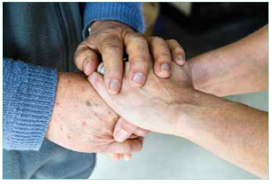
Living with and beyond cancer can be a difficult time for people as they deal with challenges such as returning to work, long-term rehabilitation and distress. It is not uncommon for people to feel vulnerable and alone after finishing treatment. Some patients will experience a sense of loss for the frequent contact and structure, and possibly for a feeling of safety, that treatment routines can provide.

In 2018, the Central Cancer Network (CCN), the Cancer Society and the Cancer Nurses College worked with a wide range of stakeholders, including consumers and health professionals, to develop a consensus statement about cancer survivorship in Aotearoa. While there are several survivorship-focused services and programmes being delivered around the country, at this stage there has been limited policy and research work undertaken in this area. The consensus statement provides a foundation to inform policy development and evaluate existing services and provides a guide for establishing new initiatives and services (CCN et al 2018).

I know I will have cancer for the rest of my life, but I just have to live each day as it comes.
Cancer patient

Essential components of cancer survivorship
1. Prevention of recurrent cancers, new cancers and late effects of treatment
2. Surveillance for recurrence, secondary cancers and late effects of treatment
3. Intervention and management of any late effects or consequences of treatment – both physical and psychosocial
4. Coordination between the many specialists and primary and community cancer care providers to ensure all needs are met.
(Institute of Medicine and National Research Council 2006)

Surveillance
Surveillance after cancer treatment monitors for cancer recurrence and monitors and manages immediate and late side effects. It also reviews the patient’s overall health. Surveillance can be undertaken by the cancer treatment team or by primary health care providers, depending on the extent of the treatment, the type and stage of cancer and the treatment side effects that the patient experiences.

Late Effects Assessment Programme (LEAP)
The Late Effects Assessment Programme (LEAP) was established in 2006 to provide long-term surveillance of the medical, psychological and educational needs of young people who have completed cancer treatment. This national programme is delivered from three centres (Auckland, Wellington and Christchurch) by specialist teams, which include oncologists, clinical nurse specialists (CNSs) and clinical psychologists.
LEAP focuses on children and young people, usually about two to five years after cancer treatment has finished and most of their disease surveillance programme has ended. The programme deals with the consequences of the treatment that was necessary to cure the cancer. This includes evaluating treatment-related organ system dysfunction, reintegration into the community and surveillance for further cancers.

Follow-up and surveillance activities should always involve primary health care providers to ensure there are no double-ups or gaps and that the transition from hospital care to primary health care meets the needs of the person and their whānau.

I have multiple myeloma and was treated in the public health system. The cancer is now in a stable state but not reduced to the levels we hoped for after chemo. We take it day by day, with a positive outlook.
Cancer patient

Currently in Aotearoa, there is limited cancer-specific national-standard guidance on post-curative surveillance. At the same time, there is long-standing variation in approaches to post-treatment surveillance across cancer types, district health boards (DHBs) and primary health care services. The New Zealand Cancer Action Plan 2019–2029 (Ministry of Health 2019) acknowledges the need for such guidance, and work has begun on developing suitable guidelines.

Advance care planning
Advance care planning is a way of helping people think and talk about what matters to them in terms of their current and future health care. It also includes their goals, values and preferences, which may be incorporated into plans for their future health care. It is person and whānau centred and involves the health care professionals who are and will be responsible for that person’s care (Ministry of Health 2011).

The process for sharing advance care plans varies across Aotearoa. In some parts of the country, the person/whānau holds the plan and shares it with their health care team. In other areas, the plan can be stored on the electronic medical record. In the South Island, more than 5,000 people have an electronic advance care plan included in their medical record (Health of Older People Service Level Alliance – South Island Alliance, South Island quality review process, SIRV, October 2020).

Palliative care
Palliative care is the care given to people of any age who have a chronic and life-limiting or life- threatening condition. It aims to optimise a person’s quality of life until death by addressing their physical, psychosocial, spiritual and cultural needs. Palliative care also provides support for the person’s whānau and other caregivers where needed, both throughout the illness and after death. This support can help preserve a person’s independence and maintain their quality of life, but there are few services currently able to provide this support.

To minimise the burden of the disease on people with an incurable cancer, New Zealanders should all have timely access to high-quality palliative care regardless of where they live, their age, their ethnicity or their socioeconomic situation. Palliative care is part of the skillset of many health care professionals, across all care settings, including primary and secondary health care.

People receive palliative care according to their individual needs. It may be suitable whether death is days, weeks, months or even years away. It may also be suitable when people are receiving treatments aimed at increasing their quality of life.

Many people have their palliative care needs met by their primary health care team, with specialist palliative care services providing direct care and support as required. The specialist services are made up of multidisciplinary professionals, including doctors and nurses, who may have trained to be experts in providing palliative care, and others with skills in allied health areas, such as occupational therapy, pharmacy or social work.

Specialist palliative care services are based within either hospital teams or a hospice service. It is estimated that 90 percent of people who die from cancer in Aotearoa receive specialist palliative care input (McLeod and Atkinson 2019b). Timely involvement of specialist palliative care services leads to better management of symptoms, but this is not always possible. There may be both organisational and individual barriers to the involvement of specialist palliative care services, and this can negatively impact the overall quality of treatment and care of patients.

A palliative focus to care can be undertaken in any setting – in hospital, at home, in a hospice or in aged residential care. Research looking into the place of care has found that people often transition between settings, particularly in their last year of life. Transitions can be stressful for both the patient and their whānau and can lead to fragmented care despite often occurring for good reason (Casotto et al 2017). Cancer patients have a high number of transitions in their last year of life compared with people who die from other causes (see Table 8.1). However, we are unable to determine the impact of those transitions on a person’s care at this stage.

Table 8.1: Number of transitions between home, public hospital, aged residential care and hospice inpatient unit, in the last year of life, 2015
 | Cancer deaths | All deaths
No transitions | 4% | 20.2%
One transition | 5.6% | 11.6%
Two transitions | 10.4% | 13.4%
Three or four transitions | 19.5% | 18%
Five to nine transitions | 33.9% | 23.6%
Ten or more transitions | 26.7% | 13.1%
Average number of transitions | 7.5 | 4.6

Despite the large number of transitions, researchers have found that people with cancer are spending a large amount of time in the community (either at home or at home with hospice care). A 2015 study revealed that people with cancer spent 93.6 percent of their time in their last three years of life in the community (compared with 77.8 percent of all people in the last three years of life). In their last year of life, the amount of time people with cancer spent in the community decreased to 87 percent (compared with 69 percent for all people in their last year of life) (McLeod and Atkinson 2019a).

Modelling shows that, by 2038, the number of people needing palliative care will increase by more than 50 percent compared with 2015 levels, with an increase of 90 percent by 2068 (McLeod and Atkinson 2019a).

Many people fear death and dying. They fear the unknown and worry about what might happen to them and their loved ones. And with that fear comes a reluctance to talk openly about something that will happen to us all. We want to support New Zealanders everywhere to have more conversations about dying in the hope they might worry about it less.
Mary Schumacher, Chief Executive, Hospice New Zealand

The 2017 Review of Adult Palliative Care Services in New Zealand (Ministry of Health 2017a) found that there were pockets of excellent care around the country, but access to services varied around the country by location, diagnosis and ethnicity. Financial and cultural barriers may also exist. The report summarised key aspects of adult palliative care in Aotearoa. It also outlined the implications of proposed improvements and changes and suggested opportunities to help manage such changes with a continued focus on providing high-quality care.

In 2015, The Economist Intelligence Unit (EIU), commissioned by the Lien Foundation, produced a Quality of Death Index – an index that evaluates 80 countries, using 20 quantitative and qualitative indicators across five categories: the palliative and health care environment, human resources, the affordability of care, the quality of care and the level of community engagement. The authors found that “New Zealand has excellent facilities and a qualified workforce, and access to palliative care is free and universal. Inconsistent standards for research and quality monitoring make nationwide assessments difficult” (EIU 2015, page 50).

Following the United Kingdom and Australia, Aotearoa ranked third (in both the 2010 and 2015 editions) in the overall Quality of Death Index.

End-of-life care
As the title suggests, end-of-life care is given near the end of a person’s life, when treatment to control or cure their cancer has been stopped, with the goal of making the person as comfortable as possible. It involves controlling physical symptoms and providing emotional, social and spiritual support for patients and their whānau.

Death occurs in all settings and, as such, end-of-life care occurs in all settings. Compared with deaths from other causes, a large proportion of people with cancer die in a private residence, although increasing numbers are dying in residential care (see Figure 8.1).

Figure 8.1: Place of death for people who died of cancer 1998–2017
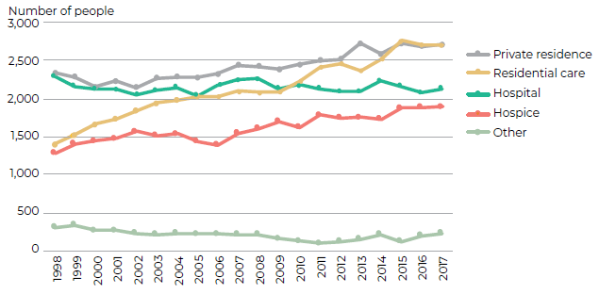
Source: Ministry of Health MORT data 1998–2017

There is some reluctance amongst health care professionals to discuss dying, end-of-life care and death. Often health workers are ill equipped and ill prepared to undertake these difficult conversations. Training to improve the skill and preparedness of health care workers to undertake conversations about end-of-life approaches needs to continue to occur (Palliative Care Managed Clinical Network et al 2017).

Alongside the general election in October 2020, New Zealanders were asked to vote in a referendum on the End of Life Choice Bill. The End of Life Choice Bill gives people with a terminal illness the option of requesting assisted dying. The referendum received majority support from the vote, and the End of Life Choice Act will come into force as of November 2021.

Assisted dying is not a replacement for palliative care or health care services more generally. The Ministry of Health is engaging with key stakeholders during the 12 months before the Act comes into force to determine how the Act will be implemented.

Te Ara Whakapiri: Principles and guidance for the last days of life is a Ministry of Health document, released in 2017, that outlines the essential considerations required to promote quality care at the end of life for all adults in Aotearoa (Ministry of Health 2017b). Currently, it is unknown who is accessing this document and what changes to services have been made since its publication.

Mauri Mate – A Māori palliative care framework for hospices is a Māori philosophical approach to palliative care for hospices in Aotearoa. This framework was designed to address a lack of palliative care services led by Māori across the country (Te Ohu Rata o Aotearoa Māori Medical Practitioners 2020). Mauri Mate uses Māori world views to strengthen hospice responses to patients and their whānau, ensuring Māori patients receive good-quality and compassionate palliative care and whānau receive spiritual and grief support during and after the illness and end of life (Te Ohu Rata o Aotearoa Māori Medical Practitioners 2020; Moeke-Maxwell et al 2014).

Hospice services in Aotearoa
There are currently 33 hospice services across Aotearoa. Each hospice is an independently operated, charitable organisation, providing palliative care based on local community need. Some hospices provide inpatient care, including specialist services. Most provide care and support to people and their whānau in their own homes and may provide care to people in residential settings.
All hospice services provided to a patient and their whānau are completely free. As an essential health service, hospices receive most of their funding from contracts with DHBs, with the remainder donated by the community through fundraising and hospice-specific shops.
It is estimated that 78 percent of people who die of cancer use hospice at some stage of their illness (McLeod and Atkinson 2019b). People with cancer are often referred to hospice early; however, one-quarter are referred in the last four weeks of life (McLeod and Atkinson 2019b).
Hospice New Zealand (www.hospice.org.nz) provides many resources to support New Zealanders, including information on hospices around Aotearoa. Information is also available through Te Hokinga ā Wairua, End of Life Service (https://endoflife.services.govt.nz).

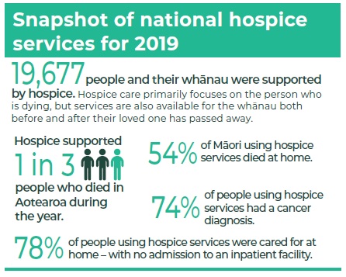
Source: The information for this snapshot was provided by Hospice New Zealand from their 2019 annual report. The data was supplied by member and associate member hospices of Hospice New Zealand.

Research

Key points
→ Cancer research informs cancer control efforts across the disease’s continuum.
→ Cancer accounts for more health loss than any other area of health in Aotearoa and is the most funded and most studied area of health in the country.
→ Cancer research funding may not always be distributed in a way that meets equity priorities or Te Tiriti obligations or to areas where the biggest gains can be made.
→ The relatively small size of research and policy communities within Aotearoa means that there are good opportunities to translate research findings into improvements in cancer policy and practice.

Research is central to cancer control. It underpins every part of the cancer continuum: from comparing cancer survival rates in Aotearoa with those in similar countries; assessing the burden of different cancers and current inequities; and studying interventions that prevent cancer or detect it earlier through to trialling new tests and treatments that can improve cancer outcomes and quality of life. Cancer research is usually perceived as the domain of scientists and researchers, but it is more than that. Individuals, whānau, communities, providers of health services, government organisations, not-for-profit organisations and private industry also participate in and enhance cancer research in various ways.

Cancer research funding
Cancer research in Aotearoa is mainly funded by the government, primarily through the Health Research Council of New Zealand (HRC) and other funding rounds organised by the Ministry of Business, Innovation and Employment (MBIE). There is no fixed amount set aside by the government specifically for cancer research, so cancer researchers compete alongside other health researchers for funding every year. There are, however, other sources of cancer research funding, including through non-governmental organisations, universities and private industry (Gurney et al 2020).

My husband was diagnosed with myeloma five years ago. We have two young children and rely on access to new treatments to keep our family together.
Whānau

Cancer research received 13 percent of the total available funding from the HRC over the last 10 years (approximately NZ$103 million in total) (Gurney et al 2020). For context, HRC’s investment in all health research (cancer and non-cancer) currently sits at NZ$126 million a year (HRCNZ 2020), after receiving a significant boost for the four years from 2016 to 2019 (HRCNZ 2016). This allocation of funding for cancer research (13 percent) sits a little under cancer’s share of total ‘health loss’ (17 percent). Health loss is a way of comparing the mortality and morbidity (suffering) of very different conditions (for example, cancer, cardiovascular disease, diabetes and dementia). Cancer accounts for the greatest health loss (Ministry of Health 2020) and remains the most funded and most studied area of health research in Aotearoa (HRCNZ 2015, Hunter et al 2018).

Within finite cancer research funding, it is vital that the funding be directed to our most pressing priorities and where the biggest gains in cancer outcomes can be made, as articulated more generally in the New Zealand Health Research Strategy 2017–2027 (MBIE and Ministry of Health 2017) and The New Zealand Health Research Prioritisation Framework (HRCNZ et al 2019). Other countries have identified that particular cancers (such as liver and lung cancers) receive a smaller share of non-profit cancer research funding than would be expected, given their incidence and survival rates compared with other cancers (Kamath et al 2019, Maruthappu et al 2017, Parliament of Australia 2017). A similar assessment for Aotearoa, looking at HRC cancer research funding by type of cancer, shows that we also have cancers that are under-funded relative to their mortality burden, in particular lung cancer (see Figure 9.1).

Figure 9.1: Health Research Council cancer research funding, by type of cancer,
2006–2019
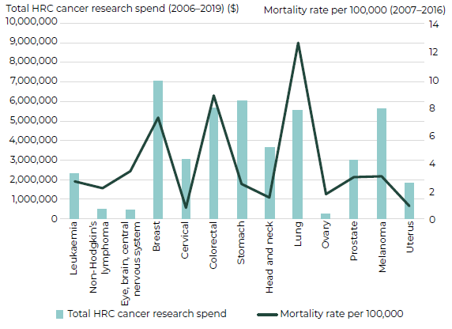
Note: This graph only includes cancer research funding where the funding was directly for a specific cancer. It does not include funding that covered multiple cancers (approximately $3.5 million) or general cancer biological pathways research (approximately $76 million). Funding for non-melanoma skin cancers is not included due to lack of corresponding mortality data.
It is also important to consider whether the mix of cancer research funding across different parts of the cancer continuum aligns with where the greatest cancer gains can be made. For example, cancer prevention research typically receives less funding than treatment research (Parliament of Australia 2017). Part of the reluctance in funding prevention research is that potential health gains are often not seen for years or decades, despite prevention activities generally delivering more gain for health dollars spent (Vos et al 2010).

Addressing inequities in cancer research and Te Tiriti o Waitangi obligations
Addressing the ethnic inequities in cancer care is a priority for cancer control efforts generally and for cancer research specifically. In terms of cancer research, this includes:
- concentrating more on cancers that are major contributors to disparities (Teng et al 2016)
- prioritising research that helps us understand what drives these disparities and what can bridge them, and effectively feeding the research into decision-making at all levels
- ensuring that high-quality ethnicity data is collected while undertaking research and that Māori retain access rights to and sovereignty over Māori data (Te Mana Raraunga 2016).

In health research and cancer research, levels of engagement with Māori health and equity responsibilities span a spectrum, with kaupapa Māori research at one end, research that covers different degrees of equity responsiveness in the middle and research that does not meet our obligations at the other end (Scott et al 2020). Currently, when submitting a research proposal to a government funder, researchers must consider the impact of their research on Māori and how Māori are involved in the development, processes, leadership and dissemination of the research (Gurney et al 2020). This is a strong starting point, but this process can often be hampered by power imbalances, excessive expectations on Māori partners and a lack of resourcing to build quality power-sharing partnerships (Scott et al 2020).

Another critical area is mātauranga Māori cancer research. Mātauranga Māori can be defined as Māori knowledge and understandings of the world, including the foundational elements of whakapapa (geneology of all things), pūrākau (creation stories), atua (ancestors with continuous influence) and tohu (signs). Although Māori experience disproportionately higher rates of cancer, there is little understanding of what cancer is from a mātauranga Māori view. A recent mātauranga Māori thesis explored this question and subsequently developed a mātauranga Māori concept of cancer (Goza 2019).

Cancer clinical trials
The purpose of cancer research is ultimately to improve cancer outcomes and reduce inequities. Cancer clinical trials are one area of cancer research where the benefits are wide ranging. These trials (involving human participants, most often researching drugs but also surgery, radiation and devices) are mostly run at sites within district health boards (DHBs). Being involved in a clinical trial can allow patients access to cancer drugs that are not otherwise available in Aotearoa. Additionally, clinical trials can provide health professionals with better access to international networks and improved training opportunities.

I was diagnosed with lung cancer, but I had never smoked and was always very healthy. Luckily, I applied for a clinical trial, which I stayed on for nearly four years. If this drug had not been funded, I would not have been able to afford it. I don’t know anyone who could afford it. If I hadn’t gone to that clinical trial, I wouldn’t be here today.
Cancer patient

There are, however, ongoing challenges with cancer clinical trials. These include inequities in trial participation, especially for patients who live far away from tertiary treatment centres but also for those with further health conditions who are often excluded. In addition, there is a lack of infrastructure and resources in DHBs to support such trials and a lack of awareness of patients and clinicians about existing trials (Gurney et al 2020; personal communication, Dr Michelle Wilson, 20 April 2020).

Translating research into practice
It is important to ensure that research findings are well utilised to improve policy and practice. Because our policy and research communities are relatively small, senior researchers are frequently included in policy discussions at many levels (Gurney et al 2020). This, together with innovative ways of making research findings more accessible (Blakely et al 2017) and large national symposiums that bring the cancer care sector and policymakers together (Sarfati et al 2019) help make research more accessible and used as much as possible in policy making and practice. Symposiums on indigenous cancer issues are particularly important for catalysing collective action on cancer inequities. Aotearoa has been nominated to host the next World Indigenous Cancer Symposium.

There is always room to improve how we translate research into practice. Research focused on quality improvement (including system-level factors) of cancer services and implementation and evaluation of new cancer initiatives can be especially useful in this context (MBIE and Ministry of Health 2017). As a country with a small population, Aotearoa produces a small fraction of global cancer research, therefore it will always be necessary to take research from offshore and adapt it to our own setting.

Kaupapa Māori research
The three most common blood cancers in Aotearoa are non-Hodgkin’s lymphoma, leukaemia and multiple myeloma. Māori have much higher (age standardised) rates for all of these three cancers compared with non-Māori non-Pacific peoples. Once diagnosed, Māori go on to have poorer survival rates as well. The causes for such inequities in blood cancer survival remains a puzzle.
A Māori-led programme of research commenced in the Waikato, Lakes, Bay of Plenty and Tairāwhiti DHBs in late 2019 to study this issue. The research is looking at the multiple drivers of inequity for Māori patients with multiple myeloma. These drivers include socioeconomic, cultural and health-system factors. The strength of this research lies in the fact that it is led by Māori and reflects kaupapa Māori throughout its processes. The results of this study will be published in stages over three years.

References
We have listed the references alphabetically by chapter.

Introduction
COVID-19.govt.nz. History of the COVID-19 Alert System. URL: https://covid19.govt.nz/alert-system/history-of-the-covid-19-alert-system/ (accessed 19 November 2020).
Health and Disability System Review. 2020. Health and Disability System Review: Final report. Wellington: Health and Disability System Review.
Māori Affairs Committee. 2020. Pakirehua e Pā Ana ki ngā Taumahatanga Hauora mō Ngāi Māori: Pūrongo a te Komiti Whiriwhiri Take Māori: Inquiry into Health Inequities for Māori: Report of the Māori Affairs Committee. Wellington: New Zealand Parliament. URL: www.parliament.nz/resource/en-NZ/SCR_100072/fbcffc6f0b843cb0adcbe1cbbe29fcb45b1f1d48 (accessed 19 November 2020).
Minister of Health. 2003. The New Zealand Cancer Control Strategy. Wellington: Ministry of Health and the New Zealand Cancer Control Trust. URL: www.health.govt.nz/system/files/documents/ publications/cancercontrolstrategy.pdf (accessed 29 November 2020).
Ministry of Health. 2014a. ’Ala Mo’ui: Pathways to Pacific Health and Wellbeing 2014–2018. Wellington: Ministry of Health.
Ministry of Health. 2014b. New Zealand Cancer Plan: Better, faster cancer care 2015–2018. Wellington: Ministry of Health. URL: www.health.govt.nz/publication/new-zealand-cancer-plan-better-faster-cancer-care-2015-2018 (accessed 11 January 2021).
Ministry of Health. 2019. New Zealand Cancer Action Plan 2019–2029: Te Mahere mō te Mate Pukupuku o Aotearoa 2019–2029. Revised January 2020. Wellington: Ministry of Health.
Ministry of Health. 2020. Whakamaua: Māori Health Action Plan 2020–2025. Wellington: Ministry of Health.
Office for Disability Issues. 2016. New Zealand Disability Strategy 2016–2026. Wellington: Ministry of Social Development. URL: www.odi.govt.nz/assets/New-Zealand-Disability-Strategy-files/pdf-nz-disability-strategy-2016.pdf (accessed 29 November 2020).
Te Aho o Te Kahu. 2020. COVID-19 and Cancer Services: A Cancer Control Agency working report on the impact of COVID-19 and the lockdown on cancer services in New Zealand. Welllington: Te Aho o Te Kahu. URL: https://teaho.govt.nz/static/reports/2020-impact-of-covid-19-on-cancer-services-report.pdf (accessed 23 November 2020).
Waitangi Tribunal. 2019. Hauora: Report on Stage One of the Health Services and Outcomes Kaupapa Inquiry (WAI 2575). Wellington: Waitangi Tribunal.

1 Cancer in Aotearoa New Zealand
Arnold M, Rutherford MJ, Bardot A, et al. 2019. Progress in cancer survival, mortality, and incidence in seven high-income countries 1995–2014 (ICBP SURVMARK-2): a population-based study. The Lancet Oncology 20 (11) 1493–505. DOI: https://doi.org/10.1016/S1470-2045(19)30456-5 (accessed 22 September 2020).
Ballantine K, Moss R, Watson H. 2020. Adolescent and Young Adult Cancer Incidence and Survival in Aotearoa 2008–2017. Auckland: AYA Cancer Network Aotearoa.
Gurney J, Stanley J, McLeod M, et al. 2020. Disparities in cancer-specific survival between Māori and non-Māori New Zealanders, 2007–2016. JCO Global Oncology 6: 766–74.
HDSR. 2020. Health and Disability System Review: Final Report: Pūrongo Whakamutunga. Wellington: New Zealand Health and Disability System Review (HDSR). URL: https://systemreview.health.govt.nz/final-report (accessed 19 November 2020).
Mizrahi JD, Surana R, Valle JW, et al. 2020. Pancreatic cancer. Lancet (27 Jun) 395(10242): 2008–20. PMID: 32593337. DOI: https://doi.org/10.1016/S0140-6736(20)30974-0 (accessed 30 November 2020).
NSU. 2020. National Cervical Screening Programme. URL: www.nsu.govt.nz/health-professionals/national-cervical-screening-programme (accessed 20 November 2020).
NZCCR. 2020. NZCCR Annual Report 2019. Auckland: New Zealand Children’s Cancer Registry (NZCCR) Working Group.
Robson B, Purdie G, Cormack D. 2010. Unequal Impact II: Māori and Non-Māori cancer statistics by deprivation and rural-urban status, 2002–2006. Wellington: Ministry of Health, 2010. URL: www.health.govt.nz/publication/unequal-impact-ii-maori-and-non-maori-cancer-statistics-deprivation-and-rural-urban-status-2002-2006 (accessed 28 September 2020).
Shah A, Sarfati D, Blakely T, et al. 2012. Trends in colorectal cancer incidence rates in New Zealand, 1981–2004. Australian and New Zealand Journal of Surgery 82(4): 258–64.
Scott OW, Tin Tin S, Bigby SM, et al. 2019. Rapid increase in endometrial cancer incidence and ethnic differences in New Zealand. Cancer Causes Control (Feb) 30(2): 121–7. PMID: 30671687. DOI: https://doi.org/10.1007/s10552-019-1129-1 (accessed 29 November 2020).
Signal V, Gurney J, Inns S, et al. 2019. Helicobacter pylori, stomach cancer and its prevention in New Zealand. Journal of the Royal Society of New Zealand 50(3): 397–417. DOI: https://doi.org/10.1080/03036758.2019.1650081 (accessed 28 September 2020).
Teng AM, Atkinson J, Disney G, et al. 2016. Ethnic Inequalities in cancer incidence and mortality: census-linked cohort studies with 87 million years of person-time follow-up. BMC Cancer 16: 755. DOI: https://doi.org/10.1186/s12885-016-2781-4 (accessed 28 September 2020).
WHO. 2018. Cancer in Children. World Health Organization. URL: www.who.int/news-room/fact-sheets/detail/cancer-in-children (accessed 11 January 2021).

2 Inequities in cancer
Bayley A, Goodyear R. 2004. New Zealand: An urban/rural profile. Wellington, New Zealand: Stats NZ.
Bennett H, Marshall R, Campbell I, et al. 2007. Women with breast cancer in Aotearoa New Zealand: the effect of urban versus rural residence on stage at diagnosis and survival. The New Zealand Medical Journal 120(1266): U2831.
Crengle S, Robinson E, Ameratunga S, et al. 2012. Ethnic discrimination prevalence and associations with health outcomes: data from a nationally representative cross-sectional survey of secondary school students in New Zealand. BMC Public Health 12: 45.
Cunningham R, Sarfati D, Peterson D, et al. 2014. Premature mortality in adults using New Zealand psychiatric services. The New Zealand Medical Journal (online) 127: 1394.
Cunningham R, Sarfati D, Stanley J, et al. 2015. Cancer survival in the context of mental illness: a national cohort study. General Hospital Psychiatry 37(6): 501–6.
Davis LE, Bogner E, Coburn NG, et al. 2020. Stage at diagnosis and survival in patients with cancer and a pre-existing mental illness: a meta-analysis. J Epidemiol Community Health 74(1): 84–94.
EHINZ (Environmental Health Indicators New Zealand). Urban–Rural Profile. URL: www.ehinz.ac.nz/indicators/population-vulnerability/urbanrural-profile/ (accessed 23 November 2020).
Fearnley D, Lawrenson R, Nixon G. 2016. ‘Poorly defined’: unknown unknowns in New Zealand Rural Health. The New Zealand Medical Journal 129(1439): 77–81.
Floud S, Barnes I, Verfürden M, et al. 2017. Disability and participation in breast and bowel cancer screening in England: a large prospective study. Br J Cancer 117: 1711–14. DOI: https://doi.org/10.1038/bjc.2017.331.
Foliaki S, Matheson A. 2015. Barriers to cervical screening among Pacific women in a New Zealand urban population. Asian Pac J Cancer Prev 16(4): 1565–70.
Gonzales G, Przedworski J, Henning-Smith C. 2016. Comparison of health and health risk factors between lesbian, gay, and bisexual adults and heterosexual adults in the United States: results from the National Health Interview Survey. JAMA Intern Med (1 Sep) 176(9): 1344–51. DOI: https://doi.org/10.1001/jamainternmed.2016.3432 (accessed 19 October 2020). PMID: 27367843.
Gurney J, Campbell S, Jackson C, et al. 2019. Equity by 2030: achieving equity in survival for Māori cancer patients The New Zealand Medical Journal 132(1506): 66–76. PMID: 31778374. URL: www.nzma.org.nz/journal-articles/equity-by-2030-achieving-equity-in-survival-for-maori-cancer-patients (accessed 23 September 2020).
Gurney J, Stanley J, McLeod M, et al. 2020a. Disparities in cancer-specific survival between Māori and Non-Māori New Zealanders, 2007–2016. JCO Global Oncology
6: 766–74. DOI: https://doi.org/10.1200/GO.20.00028 (accessed 22 September 2020).
Gurney J, Robson B, Koea J, et al. 2020b. The most commonly diagnosed and most common causes of cancer death for Maori New Zealanders. The New Zealand Medical Journal 133: 1521. URL: www.nzma.org.nz/journal-articles/the-most-commonly-diagnosed-and-most-common-causes-of-cancer- death-for-maori-new-zealanders#:~:text=Lung%20cancer%20was%20the%20most%20common%20c-ause%20of%20cancer%20death,year%2C%207%2F100%2C000) (accessed 28 September 2020).
Harris R, Tobias M, Jeffreys M, et al. 2006. Racism and health: the relationship between experience of racial discrimination and health in New Zealand. Soc Sci Med
63(6): 1428–41.
Harris R, Cormack D, Tobias M, et al. 2012a. Self-reported experience of racial discrimination and health care use in New Zealand: results from the 2006/07 New Zealand Health Survey. Am J Public Health 102(5): 1012–101.
Harris R, Cormack D, Tobias M, et al. 2012b. The pervasive effects of racism: experiences of racial discrimination in New Zealand over time and associations with multiple health domains. Soc Sci Med 74(3): 408–15.
Harris RB, Stanley J, Cormack DM. 2018. Racism and health in New Zealand: Prevalence over time and associations between recent experience of racism and health and wellbeing measures using national survey data. PLoS ONE 13(5): e0196476. DOI: https://doi.org/10.1371/journal.pone.0196476.
Harris R, Cormack D, Stanley J. 2019. Experience of racism and associations with unmet health need and health care satisfaction: The 2011/12 adult New Zealand Health Survey. Australia New Zealand Journal of Public Health 43(1): 75–80.
HDSR. 2020. Health and Disability System Review: Final Report: Pūrongo Whakamutunga. Wellington: New Zealand Health and Disability System Review (HDSR). URL: https://systemreview.health.govt.nz/final-report (accessed 19 November 2020).
Hill S, Sarfati D, Blakely T, et al. 2010. Survival disparities in indigenous and non-indigenous New Zealanders with colon cancer: the role of patient comorbidity, treatment and health service factors. Journal of Epidemiology & Community Health 64(2): 117–23. DOI: https://doi.org/10.1136/jech.2008.083816 (accessed 28 September 2020).
HQSC. 2019. A Window on the Quality of Aotearoa New Zealand’s Health Care. Wellington: Health Quality and Safety Commission (HQSC).
Jones C. 2000. Levels of racism: A theoretic framework and a gardener’s tale. American Journal of Public Health 90(8): 1212–15.
Lawrenson R, Lao C, Elwood M, et al. 2016. Urban rural differences in breast cancer in New Zealand. Int J Environ Res Public Health 13(10): 1,000.
McKinlay E, Graham S, Horrill P. 2015. Culturally and linguistically diverse patients’ views of multimorbidity and general practice care. Journal of Primary Health Care 7(3): 228–35.
McLeod M, Harris R, Purdie G, et al. 2010. Improving survival disparities in cervical cancer between Māori and non-Māori women in New Zealand: a national retrospective cohort study. Australian and New Zealand Journal of Public Health 34(2): 193–9. DOI: https://doi.org/10.1111/j.1753-6405.2010.00506.x (accessed 28 September 2020).
Mehta S. 2012. Health Needs Assessment of Asian People Living in the Auckland Region. Auckland: Northern DHB Support Agency (NDSA). URL: www.ecald.com/assets/Resources/Assets/Health-Needs-Assessment-Asian-Auckland.pdf (accessed 28 October 2020).
Meredith I, Sarfati D, Ikeda T, et al. 2012. Cancer in Pacific people in New Zealand. Cancer Causes Control 23: 1173–84. DOI: https://doi.org/10.1007/s10552-012-9986-x (accessed 28 September 2020).
Merten JW, Pomeranz JL, King JL, et al. 2015. Barriers to cancer screening for people with disabilities: a literature review. Disability and Health Journal 8(1): 9–16. DOI: https://doi.org/10.1016/j.dhjo.2014.06.004 (accessed 23 November 2020).
Ministry of Health. 2016. Cancer: New registrations and deaths 2013. Wellington: Ministry of Health.
Ministry of Health. 2019. New Zealand Cancer Action Plan 2019–2029: Te Mahere mō te Mate Pukupuku o Aotearoa 2019–2029. Revised January 2020. Wellington: Ministry of Health. URL: www.health.govt.nz/publication/new-zealand-cancer-action-plan-2019-2029 (accessed 28 September 2020).
Ministry of Health. 2020a. Annual Data Explorer 2019/20: New Zealand Health Survey [Data File]. URL: https://minhealthnz.shinyapps.io/nz-health-survey-2019-20-annual-data-explorer/.
Ministry of Health. 2020b. Mental Health Data Explorer 2016/17: New Zealand Health Survey [Data File]. URL: https://minhealthnz.shinyapps.io/nz-health-survey-2016-17-annual-data-explorer/.
Ministry of Health. 2020c. Ola Manuia: Pacific Health and Wellbeing Action Plan
2020–2025. Wellington: Ministry of Health. URL: www.health.govt.nz/publication/ola-manuia-pacific-health-and-wellbeing-action-plan-2020-2025 (accessed 28 September 2020).
National Cancer Institute. 2017. HIV Infection and Cancer Risk. URL: www.cancer.gov/about-cancer/causes-prevention/risk/infectious-agents/hiv-fact-sheet (accessed 12 October 2020).
New Zealand AIDS Foundation. 2020. HIV in New Zealand. URL: www.nzaf.org.nz/awareness-and-prevention/hiv/hiv-in-nz/ (accessed 9 October 2020).
Pega F, Reisner SL, Sell RL, et al. 2017. Transgender health: New Zealand’s innovative statistical standard for gender identity. American Journal of Public Health 107(2): 217–21. DOI: https://doi.org/10.2105/AJPH.2016.303465 (accessed 19 October 2020).
Robson BH, Ellison-Loschmann EE, Jeffreys M, et al. 2019. Cancer survival equity by 2030: a Treaty compliant systems approach required. The New Zealand Medical Journal 132: 1506. URL: www.nzma.org.nz/journal-articles/cancer-survival-equity-by-2030-a-treaty-compliant-systems-approach-required (accessed 28 September 2020).
Robson B, Harris R (eds). 2007. Hauora: Māori Standards of Health IV. A study of the years 2000–2005. Wellington: Te Rōpū Rangahau Hauora a Eru Pōmare. URL: https://www.otago.ac.nz/wellington/departments/publichealth/research/erupomare/research/otago019494.html#download (accessed 30 November 2020).
Robson B, Purdie G, Cormack D. 2010. Unequal Impact II: Māori and Non-Māori cancer statistics by deprivation and rural-urban status, 2002–2006. Wellington: Ministry of Health. URL: www.health.govt.nz/publication/unequal-impact-ii-maori-and-non-maori-cancer-statistics-deprivation-and-rural-urban-status-2002-2006 (accessed 28 September 2020).
Sarfati D, Robson BH, Garvey G. 2020. Cancer in indigenous populations: Focusing on inequalities that are sometimes invisible. In CP Wild, E Weiderpass, BW Stewart (eds). World Cancer Report: Cancer Research for Cancer Prevention. Lyon, France: International Agency for Research on Cancer. URL: www.iccp-portal.org/sites/default/files/resources/IARC%20World%20Cancer%20Report%20 2020.pdf (accessed 20 November 2020).
Seneviratne S, Campbell I, Scott N, et al. 2015. Treatment delay for Māori women with breast cancer in New Zealand. Ethnicity & Health 20(2): 178–93. DOI: https://doi.org/10.1080/13557858.2014.895976 (accessed 23 September 2020).
Shah BR, Griffiths R, Hall SF. 2017. Thyroid cancer incidence among Asian immigrants to Ontario, Canada: A population-based cohort study. Cancer 123(17): 3320–5.
Sharples KJ, Firth MJ, Hinder VA, et al. 2018. The New Zealand PIPER Project: colorectal cancer survival according to rurality, ethnicity and socioeconomic deprivation-results from a retrospective cohort study. The New Zealand Medical Journal 131(1476): 24–39.
Signal LN, Edwards R, Gage R, et al. 2020. The state of cancer prevention in Aotearoa New Zealand: slow progress requires political leadership and investment for health and equity. Journal of Cancer Policy 23. DOI: https://doi.org/10.1016/j.jcpo.2019.100212.
Southwick M, Kenealy T, Ryan D. 2012. Primary Care for Pacific People: A Pacific and health systems approach. Wellington: Pacific Perspectives.
Stats NZ. 2014. Disability Survey: 2013. Wellington: Stats NZ. URL: http://archive.stats.govt.nz/browse_for_stats/health/disabilities/disabilitysurvey_hotp2013.aspx#gsc.tab=0 (accessed 29 September 2020).
Stats NZ. 2019. New Zealand’s Population Reflects Growing Diversity. News story, 23 September. Wellington: Statistics New Zealand. URL: www.stats.govt.nz/news/new-zealands-population-reflects-growing-diversity#:~:text=Ethnicity%20as%20a%20proportion%20of%20the%20population&text=The%20next%20largest%20ethnic%20group,from%2014.9%20percent%20in%20 2013 (accessed 28 October 2020).
Steele CB, Townsend JS, Courtney-Long EA, et al. 2017. Prevalence of cancer screening among adults with disabilities, United States. Prev Chronic Dis 14: E09. DOI: http://dx.doi.org/10.5888/pcd14.160312.
Teng AM, Atkinson J, Disney G, et al. 2016. Ethnic Inequalities in cancer incidence and mortality: census-linked cohort studies with 87 million years of person-time follow-up. BMC Cancer 16: 755. DOI: https://doi.org/10.1186/s12885-016-2781-4 (accessed 28 September 2020).
Tin Tin S, Elwood JM, Brown C, et al. 2018. Ethnic disparities in breast cancer survival in New Zealand: which factors contribute? BMC Cancer 18(1): 58. DOI: https://doi.org/10.1186/s12885-017-3797-0 (accessed 28 September 2020).
UN. 2009. State of the World’s Indigenous Peoples. New York: Department of Economic and Social Affairs, United Nations (UN). URL: www.un.org/esa/socdev/unpfii/documents/SOWIP/en/SOWIP_web.pdf (accessed 30 November 2020).
Vaccarella S, Lortet-Tieulent J, Saracci R, et al (eds). 2019. Reducing Social Inequalities in Cancer: Evidence and Priorities for Research. Lyon: International Agency for Research on Cancer, WHO. URL: https://publications.iarc.fr/Book-And-Report-Series/Iarc-Scientific-Publications/Reducing-Social-Inequalities-In-Cancer-Evidence-And-Priorities-For-Research-2019 (accessed 23 September 2020).
Veale J, Byrne J, Tan K, et al. 2019. Counting Ourselves: The health and wellbeing of trans and non-binary people in Aotearoa New Zealand. Hamilton: Transgender Health Research Lab, University of Waikato.
Wai KC, Elley CR, Nosa V, et al. 2010. Perspectives on adherence to blood pressure–lowering medications among Samoan patients: qualitative interviews. Journal of Primary Health Care 2(3): 217–24. PMID: 21069117.
Walsh M, Grey C. 2019. The contribution of avoidable mortality to the life expectancy gap in Māori and Pacific populations in New Zealand – a decomposition analysis. The New Zealand Medical Journal 132(1492): 46–60.
Wilson N, Blakely T, Foster R, et al. 2010. What are the priority health risk factors for researching preventive interventions as part of NZACE-Prevention. Burden of Disease Epidemiology Equity and Cost Effectiveness Programme, Technical Report: Number 1. Wellington: Department of Public Health, University of Otago. URL: www.otago.ac.nz/wellington/otago019488.pdf (accessed 28 September 2020).

3 The people providing cancer care
Beazley F. 2020. Deep Dive Kaupapa Māori Evaluation. Palmerston North: Central Cancer Network. URL: https://centralcancernetwork.org.nz/wp-content/uploads/2020/06/Job-J402106-Proof-3.pdf (accessed 29 September 2020).
Cancer Society NZ. 2020. Kia ora E te Iwi. URL: https://wellington.cancernz.org.nz/how-we-can-help/want-local-support/support-and-information-for-people-affected-by-cancer/kia-ora-i-te-iwi/ (accessed 16 August 2020).
Charities Services. 2020. Home page. URL: www.charities.govt.nz/ (accessed 29 September 2020).
Chin MH, King PT, Jones RG, et al. 2018. Lessons for achieving health equity comparing Aotearoa/New Zealand and the United States. Health Policy 122(8): 837–53.
Cram F, Smith L, Johnstone W. 2003. Mapping the themes of Māori talk about health. The New Zealand Medical Journal 116: 1170. URL: www.nzma.org.nz/journal/116-1170/357/ (accessed 29 September 2020).
Crampton P, Weaver N, Howard A. 2018. Holding a mirror to society? Progression towards achieving better sociodemographic representation among the University of Otago’s health professional students. The New Zealand Medical Journal 131: 1476. URL: www.nzma.org.nz/journal-articles/holding-a-mirror-to-society-progression-towards-achieving-better-sociodemographic-representation-among-the-university-of-otagoaeu-tm-s-health-professional-students (accessed 28 October 2020).
HQSC. 2019. A Window on the Quality of Aotearoa New Zealand’s Health Care. Wellington: Health Quality and Safety Commission (HQSC).
Lamprell K, Arnolda G, Delaney GP, et al. 2019. The challenge of putting principles into practice: resource tensions and real-world constraints in multidisciplinary oncology team meetings. Asia–Pacific Journal of Clinical Oncology 15(4): 199–207.
McMenamin J. 2020. Cancer care at a crossroads: realising the potential in primary care in New Zealand. Journal of Cancer Policy 23: 100213. DOI: https://doi.org/10.1016/j.jcpo.2019.100213 (accessed 29 September 2020).
Medical Sciences Council of New Zealand. 2020. Annual Report 1 April 2019–31 March 2020. Wellington: Medical Sciences Council of New Zealand. URL: www.mscouncil.org.nz/assets_mlsb/Uploads/MSC-annual-report-2020.pdf (accessed 24 November 2020).
Ministry of Health. 2012. Guidance for Implementing High-Quality Multidisciplinary Meetings: Achieving best practice cancer care. Wellington: Ministry of Health. URL: www.health.govt.nz/publication/guidance-implementing-high-quality-multidisciplinary-meetings (accessed 29 September 2020).
Ministry of Health. 2016a. Health of the Health Workforce 2015. Wellington: Ministry of Health.
Ministry of Health. 2016b. MDM National Future State Data Standards and MDM Future State Business Requirements and Processes. Wellington: Ministry of Health.
Ministry of Health. 2019. New Zealand Cancer Action Plan 2019–2029: Te Mahere mō te Mate Pukupuku o Aotearoa 2019–2029. Revised January 2020. Wellington: Ministry of Health. URL: www.health.govt.nz/publication/new-zealand-cancer-action-plan-2019-2029 (accessed 28 September 2020).
National Bowel Cancer Working Group. 2012. The National Bowel Cancer Working Group Colorectal MDT Attitudes Survey. Wellington: Ministry of Health.
National Lung Cancer Working Group. 2014. Lung Cancer Multidisciplinary Meeting Toolkit. Wellington: Ministry of Health. URL: www.health.govt.nz/publication/lung-cancer-multidisciplinary-meeting-toolkit (accessed 29 September 2020).
New Zealand Dietitians Board. 2019. Annual Report New Zealand Dietitians Board: Te Mana Mātanga Mātai Kai 2018/19. Wellington: New Zealand Dietitians Board. URL: www.dietitiansboard.org.nz/wp-content/uploads/2020/02/NZDB-AR-2019-Online.pdf (accessed 24 November 2020).
New Zealand MSOD Steering Group, The. 2019. National Report on Students Commencing Medical School in New Zealand in 2015–2019. Dunedin: Otago Medical School. URL: www.otago.ac.nz/medical-school/otago718595.pdf (accessed 29 September 2020).
OTBNZ. 2019. Annual Report 2019. Wellington: Occupational Therapy Board of New Zealand (OTBNZ). URL: www.otboard.org.nz/wp-content/uploads/2019/11/Annual-Report-2019.pdf (accessed 24 November 2020).
Pharmacy Council, The. 2019. Annual Report 2019. Welllington: The Pharmacy Council. URL: www.pharmacycouncil.org.nz/wp-content/uploads/Final-Pharmacy-Council-Annual-Report-2019_web.pdf (accessed 24 November 2020).
Pipi K, Cram F, Hawke R, et al. 2003. Māori and Iwi Provider Success: A research report of interviews with successful iwi and Māori providers and government agencies. Wellington: Te Puni Kōkiri.
Rolleston A, Cassim S, Kidd J, et al. 2020. Seeing the unseen: evidence of kaupapa Māori health interventions. Alternative 16: 2.
Rubin G, Berendsen A, Crawford SM, et al. 2015. The expanding role of primary care in cancer control. The Lancet Oncology 16(12): 1231–72.
Sarfati D, Koczwara B, Jackson C. 2016. The impact of comorbidity on cancer and its treatment. CA: A cancer journal for clinicians 66(4): 337–50. DOI: https://doi.org/10.3322/caac.21342 (accessed 29 September 2020).
Smith LT. 1998. Decolonizing Methodologies: Research and indigenous peoples. Dunedin: University of Otago Press. URL: https://nycstandswithstandingrock.files.wordpress.com/2016/10/linda-tuhiwai-smith-decolonizing-methodologies-research-and-indigenous-peoples.pdf (accessed 29 September 2020).
Stats NZ. 2019. New Zealand’s population reflects growing diversity. News story. URL: www.stats.govt.nz/news/new-zealands-population-reflects-growing-diversity (accessed 29 September 2020).
Taylor MR. Oetzel JG. 2020. The sustainability of the New Zealand radiation therapy workforce: factors that influence intent to leave the workplace and profession. Technical Innovations and Patient Support in Radiation Oncology: 16, 77-82.
WHO. 2018. Vision for Primary Health Care in the 21st Century: Towards universal health coverage and the sustainable development goals. No. WHO/HIS/SDS/2018.15. Geneva: World Health Organization (WHO) and the United Nations Children’s Fund (UNICEF) (WHO/HIS/SDS/2018.X). Licence: CC BY-NC-SA 3.0 IGO. URL: www.who.int/docs/default-source/primary-health/vision.pdf (accessed 30 November 2020).

4 Prevention
ASA. nd. Code for Advertising and Promotion of Alcohol. Wellington: Advertising Standards Authority (ASA). URL: www.asa.co.nz/codes/codes/code-for-advertising-and-promotion-of-alcohol/ (accessed 2 October 2020).
Baker M, McDonald A, Zhang J, et al. 2013. Infectious Diseases Attributable to Household Crowding in New Zealand: A systematic review and burden of disease estimate. Wellington: He Kainga Oranga/ Housing and Health Research.
Bardsley A. 2015. Asbestos Exposure in New Zealand: Review of the scientific evidence of non-occupational risks. A report on behalf of the Royal Society of New Zealand and the Office of the Prime Minister’s Chief Science Advisor. Wellington: Royal Society of New Zealand. URL: https://royalsociety.org.nz/assets/documents/Asbestos-exposure-in-New-Zealand-April-2015.pdf (accessed 2 October 2020).
Brown K. 2018. Pharmac to fund new Hep C treatment. RNZ: New Zealand, Health. URL: www.rnz.co.nz/news/national/378443/pharmac-to-fund-new-hep-c-treatment (accessed 24 November 2020).
BPAC. 2014. The changing face of Helicobacter pylori testing. Best Tests 23. URL: https://bpac.org.nz/BT/2014/May/docs/BT23-h-pylori.pdf (accessed 2 October 2020).
BPAC. 2018a. Assessment and Management of Alcohol Misuse by Primary Care. Dunedin: Best Practice Advisory Centre (BPAC). URL: https://bpac.org.nz/2018/alcohol.aspx (accessed 2 October 2020).
BPAC. 2018b. Hepatitis B: treatments now available for primary care. URL: https://bpac.org.nz/2018/hepb.aspx (accessed 2 October 2020).
BPAC. 2019. Testing for Hepatitis C Virus (HCV) in Patients at High Risk of Infection. URL: https://bpac.org.nz/2019/hepc/testing.aspx (accessed 2 October 2020).
Butchard M. 2019. Work-related Health Estimates. Work-related health deaths and hospitalisation estimates, an update of the ACC work-related health claims figure. Wellington: WorkSafe.
Cameron MP, Cochrane W, Gordon C, et al. 2013. The Locally Specific Impacts of Alcohol Outlet Density in the North Island of New Zealand 2006–2011. Research report commissioned by TTH. Wellington: Te Hiringa Hauora / Health Promotion Agency (TTH).
Cancer Council. 2020. Workplace Cancer. Reduce the cancer risks for you and your workers. Sydney: Cancer Council Australia. URL: www.cancer.org.au/cancer-information/causes-and-prevention/workplace-cancer.
Cancer Society. 2019. Sunsmart Schools: Be SunSmart. URL: http://sunsmartschools.co.nz/.
Capewell S, Graham H. 2010. Will cardiovascular disease prevention widen health inequalities? PLoS Med 7(8): e1000320.
Chambers T, Stanley J, Signal L, et al. 2018. Quantifying the nature and extent of children’s real-time exposure to alcohol marketing in their everyday lives using wearable cameras: Children’s exposure via a range of media in a range of key places. Alcohol Alcohol 53(5): 626–33.
Clark D, O’Connor D. 2018. Government Response to the Food Industry Taskforce’s Report. Wellington: New Zealand Government. URL: www.fgc.org.nz/wp-content/uploads/2019/11/Food-Industry-Taskforce-Report-Govt-response.pdf (accessed 2 October 2020).
Cogliano VJ, Baan R, Straif K, et al. 2011. Preventable exposures associated with human cancers. JNCI Oxford Journals 103(24): 1827–39. DOI: https://doi.org/10.1093/jnci/djr483 (accessed 21 October 2020).
Connor J, Kydd R, Maclennan B, et al. 2017. Alcohol-attributable cancer deaths under 80 years of age in New Zealand. Drug and Alcohol Review 36(3): 415–23.
Dahlgren G, Whitehead M. 1991. Policies and Strategies to Promote Social Equity in Health. Stockholm, Sweden: Institute for Future Studies. URL: www.iffs.se/media/1326/20080109110739filmZ8UVQv2wQFShMRF6cuT.pdf (accessed 11 January 2021).
Dal Maso L, Torelli N, Biancotto E, et al. 2016. Combined effect of tobacco smoking and alcohol drinking in the risk of head and neck cancers: a re-analysis of case–control studies using bi-dimensional spline models. European Journal of Epidemiology 31(4): 385–93.
de Martel C, Plummer M, Vignat J, et al. 2017. Worldwide burden of cancer attributable to HPV by site, country and HPV type. Int J Cancer 141(4): 664–70.
de Martel C, Georges D, Bray F, et al. 2020. Global burden of cancer attributable to infections in 2018: a worldwide incidence analysis. The Lancet Global Health
8(2): e180–e90.
Edwards R, Hoek J, van der Deen F. 2014. Smokefree 2025 – use of mass media in New Zealand lacks alignment with evidence and needs. Australian and New Zealand Journal of Public Health 38(4): 395–6.
EHINZ. nd. UV Exposure – UV levels. Wellington: Environmental Health Indicators New Zealand, Massey University. URL: www.ehinz.ac.nz/indicators/uv-exposure/ (accessed 2 October 2020).
EHINZ. 2020a. Melanoma Cancer Registrations. (Factsheet). Wellington: Environmental Health Indicators New Zealand, Massey University. URL: www.ehinz.ac.nz/assets/Factsheets/Released_2020/Melanoma-Registrations-2020.pdf (accessed 2 October 2020).
EHINZ. 2020b. Melanoma Deaths. (Factsheet). Wellington: Environmental Health Indicators New Zealand, Massey University. URL: www.ehinz.ac.nz/indicators/uv-exposure/melanoma/ (accessed 2 October 2020).
EHINZ. 2020c. Non-melanoma Skin Cancer Deaths. (Factsheet). Wellington: Environmental Health Indicators New Zealand, Massey University.
Eng A, Barnes L, t’Mannetje A, et al. 2018. Worker Exposure Survey Report. Part 1: Results from two large New Zealand workforce surveys conducted in 2004–2006 and 2009–2010. Wellington: WorkSafe.
Eng A, Denison H, t’Mannetje A, et al. 2019. Worker Exposure Survey Report. Part 2: Results from a worker exposure survey in seven targeted occupational groups. Wellington: WorkSafe.
Ernst and Young. 2018. Evaluation of the Tobacco Excise Increases as a Contributor to Smokefree 2025. Final report. Wellington: Ernst and Young.
ESR. 2019. Sexually Transmitted Infections in New Zealand: Annual surveillance report 2016. Porirua: Institute of Environmental Science and Research Ltd (ESR).
Gage R. 2018. Wellington Playgrounds uncovered: an examination of solar ultraviolet radiation and shade protection in New Zealand. Photochemistry and Photobiology 94: 357–61. DOI: https://doi.org/10.1007/s10389-018-0990-9 (accessed 29 September 2020).
Gage R, Barr M, Stanley J, et al 2018a. Sun protection and shade availability in New Zealand’s outdoor recreation spaces. The New Zealand Medical Journal 131: 1484.
Gage R, Leung W, Stanley J, et al. 2018b. Sun protection among New Zealand primary school children. Health Educ Behav 45(5): 800–7. DOI: https://doi.org/10.1177/1090198117741943 (accessed 29 September 2020).
Gage R, Wilson N, Signal L, et al. 2018c. Shade in playgrounds: findings from a nationwide survey and implications for urban health policy. Journal of Public Health 27: 669–74.
Gurney J, Stanley J, McLeod M, et al. 2020. Disparities in cancer-specific survival between Māori and non-Māori New Zealanders, 2007–2016. JCO Global Oncology 6: 766–74.
Harris RB, Cormack DM, Stanley J. 2019. Experience of racism and associations with unmet need and healthcare satisfaction: the 2011/12 adult New Zealand health survey. Australian and New Zealand Journal of Public Health 43: 175–80.
Hassan I, Gane E, Prasad D, et al. 2018. Improving survival in patients with hepatocellular carcinoma related to chronic hepatitis C and B but not in those related to non-alcoholic steatohepatitis or alcoholic liver disease: a 20-year experience from a national programme. J Hepatol 68: S424.
Healthy Auckland Together. 2017. The Healthy Auckland Together Plan 2015–2020. Auckland: Healthy Auckland Together. URL: www.healthyaucklandtogether.org.nz/assets/Uploads/HAT-actionplan.pdf (accessed 2 October 2020).
Huckle T, Romeo P. 2018. Patterns of Social Supply of Alcohol over Time in New Zealand. Wellington: Health Promotion Agency (HPA).
Immunisation Advisory Centre, The. 2020. Human Papillomavirus (HPV). URL: www.immune.org.nz/diseases/human-papillomavirus-hpv (accessed 2 October 2020).
Jackson N, Robertson H. 2017. A Review of Territorial Authority Progress towards Local Alcohol Policy Development (2nd edition). Auckland: Alcohol Healthwatch. URL: www.ahw.org.nz/Portals/5/Resources/Documents-other/2017/LAPReport_2017_WEB_amended%2020_3_18.pdf (accessed 24 November 2020).
Kerr J, Anderson C, Lippman SM. 2017. Physical activity, sedentary behaviour, diet, and cancer: an update and emerging new evidence. The Lancet Oncology 18(8): e457–e71.
Kingstone S, Nicolson M. 2020. Sunsmart Behaviours – Outdoor socialisers. Wellington: Health Promotion Agency. URL: www.hpa.org.nz/sites/default/files/Outdoor%20Socialisers%20SunSmart%20Behaviours.pdf (accessed 2 October 2020).
Light J. 2020. We all scream for sun cream: So why is sunscreen so expensive in New Zealand? The Spinoff 20 January.
Love T, Hefford M, Ehrenberg N. 2011. Cost Savings of Brief Alcohol Interventions in Primary Health Care. Wellington: Alcohol Advisory Council of New Zealand.
Mackay S, Sing F, Gerritsen S, et al. 2020. Benchmarking Food Environments 2020: Progress by the New Zealand Government on implementing recommended food environment policies and priority recommendations. Auckland: The University of Auckland.
Marmot M, Bell R. 2019. Social determinants and non-communicable diseases: time for integrated action. BMJ 364. DOI: https://doi.org/10.1136/bmj.l251 (accessed 2 October 2020).
Massey University Evaluation Team. 2018. Summative Evaluation Report: Healthy Families NZ. Wellington: Ministry of Health.
Matsushita H, Takaki A. 2019. Alcohol and hepatocellular carcinoma. BMJ Open Gastroenterology 6: e000260. DOI: http://dx.doi.org/10.1136/bmjgast-2018-000260 (accessed 24 November 2020).
McDonald AM, Sarfati D, Baker MG, et al. 2015. Trends in Helicobacter pylori infection among Māori, Pacific, and European birth cohorts in New Zealand. Helicobacter 20(2): 139–45.
McLean D. 2016. Presentation: The Epidemiology of Occupational Cancer in New Zealand. Health and Safety Association New Zealand (HASANZ).
Ministry of Education. 2019. Healthy Active Learning. Wellington: Ministry of Education. URL: www.education.govt.nz/our-work/changes-in-education/healthy-active-learning/ (accessed 1 August 2020).
Ministry of Health. 2014. The New Zealand Guidelines for Helping People to Stop Smoking. Wellington: Ministry of Health.
Ministry of Health. 2016a. Clinical Guidelines for Weight Management in New Zealand Children and Young People. Wellington: Ministry of Health.
Ministry of Health. 2016b. Green Prescriptions. Wellington: Ministry of Health.
Ministry of Health. 2017. All about Asbestos: Protecting your health at home. Wellington: Ministry of Health. URL: www.health.govt.nz/publication/all-about-asbestos-protecting-your-health-home.
Ministry of Health. 2018a. Green Prescription Patient Survey (updated 2 April 2019). Wellington: Ministry of Health. URL: www.health.govt.nz/our-work/preventative-health-wellness/physical-activity/green-prescriptions/green-prescription-research/green-prescription-patient-survey (accessed 2 October 2020).
Ministry of Health. 2018b. Healthy eating. Wellington: Ministry of Health. URL: www.health.govt.nz/your-health/healthy-living/food-activity-and-sleep/healthy-eating?icn=yh-healthy-eating&ici=readmore (accessed 2 October 2020).
Ministry of Health. 2019a. Development of a National Hepatitis C Action Plan. Wellington: Ministry of Health. URL: www.health.govt.nz/our-work/diseases-and-conditions/hepatitis-c/development-national-hepatitis-c-action-plan (accessed 24 November 2020).
Ministry of Health. 2019b. Sexual and reproductive health. Information and resources on sexual and reproductive health. Wellington: Ministry of Health. URL: www.health.govt.nz/our-work/preventative-health-wellness/sexual-and-reproductive-health (accessed 2 October 2020).
Ministry of Health. 2019c. Tier 1 Statistics 2018/19: New Zealand Health Survey. Wellington: Ministry of Health. URL: www.health.govt.nz/publication/tier-1-statistics-2018-19-new-zealand-health-survey (accessed 2 October 2020).
Ministry of Health. 2020a. Active Families. Wellington: Ministry of Health. URL: www.health.govt.nz/your-health/healthy-living/food-activity-and-sleep/green-prescriptions/active-families (accessed 2 October 2020).
Ministry of Health. 2020b. Eating and Activity Guidelines for New Zealand Adults: Updated 2020. Wellington: Ministry of Health. URL: www.health.govt.nz/publication/eating-and-activity-guidelines-new-zealand-adults (accessed 11 January 2021).
Ministry of Health. 2020c. Healthy Food and Drink Guidance: Schools. Wellington:. Wellington: Ministry of Health.
Ministry of Health. 2020d. Immunisation Handbook. Wellington: Ministry of Health.
Ministry of Health. 2020e. Obesity. Wellington: Ministry of Health. URL: www.health.govt.nz/our-work/diseases-and-conditions/obesity (accessed 2 October 2020).
Ministry of Health. 2020f. New Zealand Health Survey Annual Data Explorer. URL: https://minhealthnz.shinyapps.io/nz-health-survey-2019-20-annual-data-explorer/_w_4ddefae6/#!/explore-indicators (accessed 24 November 2020).
Ministry of Health. 2020g. Regulation of Vaping and Smokeless Tobacco Products. URL: www.health.govt.nz/our-work/regulation-health-and-disability-system/regulation-vaping-and-smokeless-tobacco-products (accessed 24 November 2020).
Ministry of Health. 2020h. Tobacco Returns. URL: www.health.govt.nz/our-work/preventative-health-wellness/tobacco-control/tobacco-returns (accessed 24 November 2020).
Napier City Council. 2016. Shade Policy. Napier: Napier City Council.
National District Health Board Food and Drink Environments Network. 2019. National Healthy Food and Drink Policy (2nd ed). Wellington: Ministry of Health. URL: www.health.govt.nz/publication/national-healthy-food-and-drink-policy (accessed 2 October 2020).
Nghiem N, Cleghorn CL, Leung W, et al. 2018. A national quitline service and its promotion in the mass media: modelling the health gain, health equity and cost–utility. Tob Control 27(4): 434–41.
Oliver M, McPhee J, Carroll P, et al. 2016. Neighbourhoods for active kids: study protocol for a cross-sectional examination of neighbourhood features and children’s physical activity, active travel, independent mobility, and body size. BMJ Open, Public Health 6: e013377. DOI: https://doi.org/10.1136/bmjopen-2016-013377 (accessed 28 November 2020).
Palmerston North City Council. 2010. Sun Protection Policy. Palmerston North: Palmerston North City Council.
Papatheodoridis GV, Lampertico P, Manolakopoulos S, et al. 2010. Incidence of hepatocellular carcinoma in chronic hepatitis B patients receiving nucleos (t) ide therapy: a systematic review. J Hepatol 53(2): 348–56.
Pierse N, White M, Riggs L. 2019. Healthy Homes Initiative Outcomes Evaluation Service: Initial analysis of health outcomes (Interim Report). Wellington: Ministry of Health.
Puhl RM, Heuer CA. 2010. Obesity stigma: important considerations for public health. American Journal of Public Health 100(6): 1019–28.
Rahiri J-L, Gillon A, Furukawa S, et al. 2018. Media portrayal of Māori and bariatric surgery in Aotearoa/New Zealand. The New Zealand Medical Journal 131(1479): 72–80.
Randerson S, Casswell S, Huckle T. 2018. Changes in New Zealand’s alcohol environment following implementation of the Sale and Supply of Alcohol Act (2012). The New Zealand Medical Journal 131(1476): 14–23. URL: https://pubmed.ncbi.nlm.nih.gov/29879723/ (accessed 2 October 2020).
Richards R, McNoe B, Iosua E, et al. 2017. Knowledge of evidence-based cancer risk factors remains low among New Zealand adults: findings from two cross-sectional studies, 2001 and 2015. Asian Pacific Journal of Cancer Prevention 18(11): 2931.
Robinson GM, Reynolds J, Robinson B. 1995. Hepatitis C prevalence and needle/syringe sharing behaviours in recent onset injecting drug users. The New Zealand Medical Journal 108(996): 103.
Robinson T, Bullen C, Humphries W, et al. 2005. The New Zealand Hepatitis B Screening Programme: screening coverage and prevalence of chronic hepatitis B infection. NZ Med J 118: 1–11.
Rositch AF. 2020. Global burden of cancer attributable to infections: the critical role of implementation science. The Lancet Global Health 8(2): e153–e4.
SBRU. 2018. Skin Cancer in New Zealand. (Factsheet). Dunedin: Social and Behavioural Research Unit (SBRU), University of Otago. URL: www.otago.ac.nz/sbru/otago687389.pdf (accessed 2 October 2020).
Schauer C, Mules T, van Rijnsoever M, et al. 2020. Increasing burden of advanced hepatocellular carcinoma in New Zealand-the need for better surveillance. The New Zealand Medical Journal (online) 133(1515): 25–35.
Signal LN, Stanley J, Smith M, et al. 2017. Children’s everyday exposure to food marketing: an objective analysis using wearable cameras. International Journal of Behavioral Nutrition and Physical Activity 14(1): 137.
Signal LN, Edwards R, Gage R, et al. 2020a. The state of cancer prevention in Aotearoa New Zealand: slow progress requires political leadership and investment for health and equity. Journal of Cancer Policy 23. DOI: https://doi.org/10.1016/j.jcpo.2019.100212.
Signal V, Gurney J, Inns S, et al. 2020b. Helicobacter pylori, stomach cancer and its prevention in New Zealand. Journal of the Royal Society of New Zealand 50(3): 397–417.
Smith M, Ikeda E, Hinckson E, et al. 2018. 2018 New Zealand Physical Activity Report Card for Children & Youth. Auckland: The University of Auckland. URL: www.activehealthykids.org/wp-content/uploads/2018/11/new-zealand-report-card-long-form-2018.pdf (accessed 2 October 2020).
Sneyd MJ, Gray A. 2018. Expected Non-melanoma skin (Keratinocytic) Cancer Incidence in New Zealand for 2018. Wellington: Health Promotion Agency (HPA).
Stats NZ. 2020a. Almost 1 in 9 people live in a crowded house. News story. Wellington Statistics New Zealand. URL: www.stats.govt.nz/news/almost-1-in-9-people-live-in-a-crowded-house (accessed 1 August 2020).
Stats NZ. 2020b. Child Poverty Statistics: Year ended June 2019. Wellington Statistics New Zealand. URL: www.stats.govt.nz/information-releases/child-poverty-statistics-year-ended-june-2019 (accessed 24 November 2020).
Sushil Z, Vandevijvere S, Exeter DJ, et al. 2017. Food swamps by area socioeconomic deprivation in New Zealand: a national study. International Journal of Public Health 62(8): 869–77.
Takala J. 2015. Eliminating occupational cancer. Ind Health 53(4): 307–9.
Te Hiringa Hauora. nd. Campaign. Say yeah, nah – Department of Lost Nights. Wellington: Te Hiringa Hauora / Health Promotion Agency. URL: www.hpa.org.nz/campaign/say-yeah-nah-department-of-lost-nights (accessed 2 October 2020).
Te Hiringa Hauora. 2016. Sun Exposure Survey 2016: Demographic report. Wellington: Te Hiringa Hauora / Health Promotion Agency. URL: www.hpa.org.nz/research-library/research-publications/sun-exposure-survey-2016-demographic-report (accessed 2 October 2020).
Te Hiringa Hauora. 2018a. Trends in Affordability of Alcohol in New Zealand. Wellington: Te Hiringa Hauora / Health Promotion Agency. URL: www.hpa.org.nz/sites/default/files/Final%20Report%20-%20Trends%20in%20affordibility%20of%20alcohol%20in%20New%20Zealand%20April%202018_0.pdf (accessed 2 October 2020).
Te Hiringa Hauora. 2018b. Whakahaere Tupeka. Tobacco Control. Wellington: Te Hiringa Hauora / Health Promotion Agency. URL: https://hpa.org.nz/programme/tobacco-control (accessed 2 October 2020).
Te Hiringa Hauora. 2020a. Beaching with the Bros? Avoid #DUMBBURN (Sun safety campaign). Wellington: Te Hiringa Hauora / Health Promotion Agency. URL: www.hpa.org.nz/campaign/dumbburn (accessed 2 October 2020).
Te Hiringa Hauora. 2020b. Kai tōtika me te kori tinana. Nutrition and Physical Activity. Wellington: Te Hiringa Hauora / Health Promotion Agency. URL: www.hpa.org.nz/programme/nutrition-and-physical-activity (accessed 2 October 2020).
Te Hiringa Hauora. 2020c. Overview of Key Tobacco Control Trends Tobacco Control Data Repository. Wellington: Te Hiringa Hauora / Health Promotion Agency. URL: https://tcdata.org.nz/TobaccoSectorOverview.html (accessed 2 October 2020).
Te Hiringa Hauora. 2020d. Smokefree in your community. Protecting our families and breathing easy in our communities. Wellington: Te Hiringa Hauora / Health Promotion Agency. URL: www.smokefree.org.nz/smokefree-environments/smokefree-in-your-community (accessed 2 October 2020).
Teng AM, Atkinson J, Disney G, et al. 2016. Ethnic inequalities in cancer incidence and mortality: census-linked cohort studies with 87 million years of person-time follow-up. BMC Cancer 16(1): 755. DOI: https://doi.org/10.1186/s12885-016-2781-4 (accessed 29 November 2020).
Teng AM, Kvizhinadze G, Nair N, et al. 2017. A screening program to test and treat for Helicobacter pylori infection: Cost-utility analysis by age, sex and ethnicity. BMC Infect Dis 17(1): 156.
Thomson G, Wilson N. 2017. Local and regional smokefree and tobacco-free action in New Zealand: highlights and directions. The New Zealand Medical Journal (online) 130(1462): 89.
Trowland H, Thimasarn-Anwar T, Dallas S, et al. 2016. Sun Exposure Survey 2016: Adult Topline Time Series Report. Wellington: Research and Evaluation Unit, Health Promotion Agency (HPA). URL: www.hpa.org.nz/sites/default/files/2016_ses_topline_time_series_report_final.pdf (accessed 2 October 2020).
Vandevijvere S, Mackay S, D’Souza E, et al. 2019. The first INFORMAS national food environments and policies survey in New Zealand: A blueprint country profile for measuring progress on creating healthy food environments. Obesity Reviews 20: 141–60.
Watts C. 2018. External Evaluation of Fruit in Schools Final Report. Prepared for 5+ A Day Charitable Trust. URL: www.5aday.co.nz/media/213674/final-fruit-vegetables-in-schools-research-report-august-2018.pdf (accessed 2 October 2020).
WCRF / American Institute for Cancer Research. 2016. Cancer Prevention and Survival. Continuous Update Project Summary Report: July 2016. London: World Cancer Research Fund International (WCRF).
WCRF / American Institute for Cancer Research. 2018. Continuous Update Project Expert Report. Diet, nutrition, physical cctivity and cancer: a gobal perspective. London: World Cancer Research Fund International (WCRF).
Wehipeihana N, Were L, Goodwin D, et al. 2018. Addressing the Challenges of Young Māori Women Who Smoke: A developmental evaluation of the phase two demonstration project. Evaluation Report. Wellington: Ministry of Health.
Whiteman DC, Webb PM, Green AC, et al. 2015. Cancers in Australia in 2010 attributable to modifiable factors: summary and conclusions. Australian and New Zealand Journal of Public Health 39(5): 477–84.
WHO. 2007. Cancer Control. Knowledge into Action. Geneva: World Health Organization (WHO) Guide for Effective Programmes, Prevention. URL: www.who.int/cancer/modules/en/ (accessed 2 October 2020).
WHO. 2016a. Global Health Sector Strataegy on Viral Hepatitis 2016–2021. Towards ending viral hepatitis. Geneva: World Health Organization.
WHO. 2016b. Solar Ultraviolet Radiation: Global burden of disease from solar ultraviolet radiation. Geneva: World Health Organization (WHO).
WHO. 2019. What is hepatitis? Western Pacific: World Health Organization. URL: www.who.int/westernpacific/news/q-a-detail/what-is-hepatitis (accessed 2 October 2020).
WHO. 2020‎. WHO Report on Cancer: Setting priorities, investing wisely and providing care for all. Geneva: World Health Organization (WHO). URL: https://apps.who.int/iris/handle/10665/330745 (accessed 29 November 2020).
Wilson N, Weerasekera D, Borland R, et al. 2010. Use of a national quitline and variation in use by smoker characteristics: ITC Project New Zealand. Nicotine & Tobacco Research 12(suppl1): S78–S84.
Wilson N, Petrović-van der Deen FS, Edwards R, et al. 2018. Modelling the number of quitters needed to achieve New Zealand’s Smokefree 2025 goal for Māori and non-Māori. The New Zealand Medical Journal (online) 131(1487): 30.
WorkSafe. 2017. Health and Safety at Work Act 2015. URL: https://worksafe.govt.nz/laws-and-regulations/acts/hswa/ (accessed 1 August 2020).
WorkSafe. 2019a. What New Zealanders don’t know about Cancer. URL: https://worksafe.govt.nz/about-us/news-and-media/what-new-zealanders-dont-know-about-cancer/ (accessed 1 August 2020).
Worksafe. 2019b. Workplace Exposure Standards and Biological Exposure Indices. 11th edition. Wellington: Worksafe.
Worksafe. 2019c. Work-related Health Estimates and Burden of Harm. Wellington: Worksafe. URL: https://worksafe.govt.nz/topic-and-industry/work-related-health/work-related-health-estimates-and-burden-of-harm/.

5 Screening
Adcock A, Cram F, Lawton B, et al. 2019. Acceptability of self-taken vaginal HPV sample for cervical screening among an under-screened Indigenous population. Australian and New Zealand Journal of Obstetrics and Gynaecology 59(2): 301–7. DOI: https://doi.org/10.1111/ajo.12933 (accessed 30 September 2020).
Gurney J, Campbell S, Jackson C, et al. 2019. Equity by 2030: achieving equity in survival for Māori cancer patients. The New Zealand Medical Journal 132(1506): 66–76. PMID: 31778374. URL: www.nzma.org.nz/journal-articles/equity-by-2030-achieving-equity-in-survival-for-maori-cancer-patients (accessed 23 September 2020).
HPV. 2020. The New Zealand HPV Project, About HPV. URL: www.hpv.org.nz/about-hpv/about-hpv.
Ministry of Health. 2010a. Cancer: New Registrations and Deaths 2006. Wellington: Ministry of Health.
Ministry of Health. 2010b. Cancer: New Registrations and Deaths 2007. Wellington: Ministry of Health.
Ministry of Health. 2018. National Bowel Screening Programme 2018/19 Business Case. Wellington: Ministry of Health. URL: www.health.govt.nz/system/files/documents/pages/nbsp_business_case_2018_19_v1.0_redacted.pdf (accessed 30 September 2020).
Ministry of Health. 2019. Impact Analysis: Extending BreastScreen Aotearoa to include women aged 70–74 years. Wellington: Ministry of Health.
Ministry of Health. 2020. National Cervical Screening Programme Annual Report 2017. Wellington: Ministry of Health. URL: www.nsu.govt.nz/system/files/page/national-cervical-screening-programme-annual-report-2017-oct20.pdf (accessed 20 November).
Morell S, Taylor R, Roder D, et al. 2015. Cohort and Case Control Analyses of Breast Cancer Mortality: BreastScreen Aotearoa 1999–2011. Commissioned by Ministry of Health, Wellington, New Zealand. 119p. URL: www.nsu.govt.nz/health-professionals/breastscreen-aotearoa/publications-and-reports (accessed 30 September 2020).
NSU. 2020a. BreastScreen Aotearoa DHB Coverage Report. URL: https://minhealthnz.shinyapps.io/nsu-bsa-coverage-dhb/ (accessed 20 November 2020).
NSU. 2020b. National Bowel Screening Programme: Dashboard. URL: https://minhealthnz.shinyapps.io/nsu-bsp-index/ (accessed 20 November 2020).
NSU. 2020c. National Bowel Screening Programme (NBSP) Volumes Report 2020. URL: https://minhealthnz.shinyapps.io/nsu-bsp-volume/ (accessed 20 November 2020).
NSU. 2020d. National Cervical Screening Programme. URL: www.nsu.govt.nz/health-professionals/national-cervical-screening-programme (accessed 20 November 2020).
NSU. 2020e. National Cervical Screening Programme Coverage Report. URL: https://minhealthnz.shinyapps.io/nsu-ncsp-coverage/ (accessed 20 November 2020).
Polman NJ, Ebisch RMF, Heideman DAM, et al. 2019. Performance of human papillomavirus testing on self-collected versus clinician-collected samples for the detection of cervical intraepithelial neoplasia of grade 2 or worse: a randomised, paired screen-positive, non-inferiority trial. Lancet Oncol (Feb) 20(2): 229–38. DOI: 10.1016/S1470-2045(18)30763-0. Epub 2019 Jan 15. PMID: 30658933.
Smith M, Walkder R, Canfell K. 2012. National Cervical Screening Programme Annual Report 2008– 009. Wellington: National Screening Unit.
Smith ML, Rumlee L, Canfell K. 2018. National Cervical Screening Programme Monitoring Report 48 (1 July–31 December 2017). Wellington: National Screening Unit.
Time to Screen. 2020a. About the National Bowel Screening Programme, Staged roll-out underway. URL: www.timetoscreen.nz/bowel-screening/about-the-national-bowel-screening-programme (accessed 20 November 2020).
Time to Screen. 2020b. Doing the Bowel Screening Test. URL: http://www.timetoscreen.nz/bowel-screening/doing-the-bowel-screening-test/ (accessed 24 November 2020).
Time to Screen. 2020c. Give Your Cervix Some Screen Time. URL: www.timetoscreen.nz/cervical-screening/start-to-screen/ (accessed 24 November 2020).
Time to Screen. 2020d. Having a Mammogram. URL: www.timetoscreen.nz/breast-screening/having-a-mammogram (accessed 24 November 2020).
WHO. 2020. World Health Organization, Human Papillomavirus (HPV) and Cervical Cancer. URL: www.who.int/en/news-room/fact-sheets/detail/human-papillomavirus-(hpv)-and-cervical-cancer.

6 Diagnosis
Beatty S, Stevens W, Stevens G, et al. 2009. Lung cancer patients in New Zealand initially present to secondary care through the emergency department rather than by referral to a respiratory specialist. The New Zealand Medical Journal (Online) 122 (1294).
Blackmore T, Norman K, Kidd J, et al. 2020. Barriers and facilitators to colorectal cancer diagnosis in New Zealand: a qualitative study. BMC Fam Pract 21: 206. DOI: https://doi.org/10.1186/s12875-020-01276-w (accessed 21 October 2020).
Ellison-Loschmann L, Firestone R, Aquilina L, et al. 2015. Barriers to and delays in accessing breast cancer care among New Zealand women: disparities by ethnicity. BMC Health Serv Res 15: 394. DOI: https://doi.org/10.1186/s12913-015-1050-6 (accessed 21 October 2020).
Esserman LJ, Thompson IM, Reid B, et al. 2014. Addressing overdiagnosis and overtreatment in cancer: a prescription for change. The Lancet Oncology 15(6):
e234–e242. DOI: https://dx.doi.org/10.1016%2FS1470-2045(13)70598-9 (accessed 30 September 2020).
Glasziou PP, Jones MA, Pathirana T, et al. 2020. Estimating the magnitude of cancer overdiagnosis in Australia. The Medical Journal of Australia 212(4): 163–8. DOI: https://doi.org/10.5694/mja2.50455 (accessed 30 September 2020).
Gurney J, Stanley J, Jackson C, et al. 2020. Stage at diagnosis for Māori cancer patients: disparities, similarities and data limitations. The New Zealand Medical Journal 133(1508): 43–64.
Health and Disability Commissioner. 2015. Delayed Diagnosis of Cancer in Primary Care: Complaints to the Health and Disability Commissioner 2004–2013. Auckland: Health and Disability Commissioner.
Hill S, Sarfati D, Robson B, et al. 2013. Indigenous inequalities in cancer: what role for health care? ANZ Journal of Surgery 83(1–2): 36–41. DOI: https://doi.org/10.1111/ans.12041 (accessed 21 October 2020).
HQSC. 2020. Primary Care Patient Experience Survey 2019: A review of responses in the general practice module and suggestions for the future. Wellington: Health Quality and Safety Commission (HQSC). URL: https://www.hqsc.govt.nz/assets/Health-Quality-Evaluation/PR/PES/Primary-care-patient-experience-survey-report-Jun-2020.pdf (accessed 24 November 2020).
Koia M, Te Wiata I, Webster J. 2020. Deep Dive Feedback Report: June 2020. Palmerston North: Central Cancer Network. URL: https://centralcancernetwork.org.nz/wp-content/uploads/2020/06/New-J402106-Deep-Dive-Feedback-Report-June-2020.pdf (accessed 30 September 2020).
McMenamin J. 2020. Cancer care at a crossroads: realising the potential in primary care in New Zealand. Journal of Cancer Policy 23: 100213. DOI: https://doi.org/10.1016/j.jcpo.2019.100213 (accessed 29 September 2020).
Mengmeng L, Dal Maso L, Vaccarella S. 2020. Global trends in thyroid cancer incidence and the impact of overdiagnosis. The Lancet Diabetes & Endocrinology 8(6): 468–70. DOI: https://doi.org/10.1016/s2213-8587(20)30115-7 (accessed 30 September 2020).
Ministry of Health. 2019a. Bowel Cancer Quality Improvement Report. Wellington: Ministry of Health. URL: www.health.govt.nz/system/files/documents/publications/bowel-cancer-quality-improvement-report-mar19v1.pdf (accessed 30 September 2020).
Ministry of Health. 2019b. Referral Criteria for Direct Access Outpatient Colonoscopy or Computed Tomography Colonography. Wellington: Ministry of Health. URL: www.health.govt.nz/publication/referral-criteria-direct-access-outpatient-colonoscopy-or-computed-tomography-colonography (accessed 30 September 2020).
Ministry of Health. 2020. Annual Data Explorer 2019/20: New Zealand Health Survey [Data File]. URL: https://minhealthnz.shinyapps.io/nz-health-survey-2019-20-annual-data-explorer/ (accessed 24 November 2020).
Neal RD, Tharmanathan P, France B, et al. 2015. Is increased time to diagnosis and treatment in symptomatic cancer associated with poorer outcomes? Systematic review. British Journal of Cancer 112(1): S92–S107.
Sharples K, Firth M, Hinder V, et al. 2018. The New Zealand PIPER Project: colorectal cancer survival according to rurality, ethnicity and socioeconomic deprivation-results from a retrospective cohort study. The New Zealand Medical Journal 131: 24–39.
Smith M, Rumlee L, Canfell K. 2019. National Cervical Screening Programme Monitoring Report Number 48 (1 July–31 December 2017). Wellington: National Screening Unit.
Smith M, Rumlee L, Sherrah M, et al. 2020. National Cervical Screening Programme Monitoring Report Number 49 (1 January–30 June 2018). Wellington: National Screening Unit.
Te Aho o Te Kahu. nd. Lung Cancer Quality Improvement Report. Wellington: Ministry of Health.
Vaccarella S, Franceschi S, Bray F, et al. 2016. Worldwide thyroid-cancer epidemic? The increasing impact of overdiagnosis. N Engl J Med 375(7): 614–61. DOI: https://doi.org/10.1056/nejmp1604412 (accessed 30 September 2020).

7 Treatment
ABMTRR. 2019. Australasian Bone Marrow Transplant Recipient Registry: Annual Data Summary 2018. Darlinghurst, NSW, Australia: Australasian Bone Marrow Transplant Recipient Registry (ABMTRR).
AYA Cancer Network Aotearoa. 2016. Service Provision for Adolescent and Young Adult Cancer Patients in New Zealand including Standards of Care 2016. Auckland: AYA Cancer Network Aotearoa. URL: https://ayacancernetwork.org.nz/assets/documents/AYA_Standards_low_res.pdf (accessed 30 November 2020).
Aye PS, Tin Tin S, McKeage MJ, et al. 2020. Development and validation of a predictive model for estimating EGFR mutation probabilities in patients with non-squamous non-small cell lung cancer in New Zealand. BMC Cancer 20: 658.
Berghan G, Came H, Coupe N, et al. 2017. Te Tiriti o Waitangi-based Practice in Health Promotion. Auckland: Aotearoa New Zealand: STIR: Stop Institutional.
Bertrand Coiffier ME. 2002. CHOP chemotherapy plus Rituximab compared with CHOP alone in elderly patients with diffuse large-B-cell lymphoma. N Engl J Med 346: 235–42.
Bhawan S. 2019. Achieving Medicine Access Equity in Aotearoa New Zealand. Towards a theory of change. Wellington: Pharmaceutical Management Agency (PHARMAC).
Capstick S, Norris P, Sopoaga F, et al. 2009. Relationships between health and culture in Polynesia – A review. Soc Sci Med 68(7): 1341–48.
Donovan JL, Hamdy FC, Lane JA, et al. 2016. Patient-reported outcomes after monitoring, surgery, or radiotherapy for prostate cancer. New England Journal of Medicine 375(15): 1425–37.
Durie M. 1985. A Maori perspective of health. Soc Sci Med 20(5): 483–6.
Egan R, MacLeod R, Jaye C, et al. 2011. What is spirituality? Evidence from a New Zealand hospice study. Mortality 16(4): 307–24. DOI: https://doi.org/10.1080/13576275.2011.613267 (accessed 25 November 2020).
Egan R, MacLeod R, Jaye C, et al. 2016. Spiritual beliefs, practices, and needs at the end of life: Results from a New Zealand national hospice study. Palliat Support Care; FirstView: 1–8. DOI: https://doi.org/10.1017/S147895151600064X (accessed 25 November 2020).
Gurney JK. 2019. The puzzling incidence of testicular cancer in New Zealand: what can we learn? Andrology 7(4): 394–401.
Gurney J, Stanley J, McLeod M, et al. 2020a. Disparities in cancer-specific survival between Māori and non-Māori New Zealanders, 2007–2016. J Global Oncology 6: 766–74.
Gurney JK, McLeod M, Stanley J, et al. 2020b. Postoperative mortality in New Zealand following general anaesthetic: demographic patterns and temporal trends. BMJ Open 10(9): e036451. DOI: https://doi.org/10.1136/bmjopen-2019-036451 (accessed 29 November 2020).
Gurney J, Robson B, Koea J, et al. 2020c. The most commonly diagnosed and most common causes of cancer death for Maori New Zealanders. The New Zealand Medical Journal 133: 77–96.
Hamdy FC, Donovan JL, Lane JA, et al. 2016. 10-year outcomes after monitoring, surgery, or radiotherapy for localized prostate cancer. New England Journal of Medicine 375(15): 1415–24.
Hanna NH, Einhorn LH. 2014. Testicular cancer – discoveries and updates. N Engl J Med 371(21): 2005–16.
Hill S, Sarfati D, Blakely T, et al. 2010. Ethnicity and management of colon cancer in New Zealand. Cancer 3205–14.
Hill S, Sarfati D, Robson B, et al. 2013. Indigenous inequalities in cancer – what role for health care? Australian and NZ Journal of Surgery 83: 36–41.
Kishan AU, Cook RR, Ciezki JP, et al. 2018. Radical rrostatectomy, external beam radiotherapy, or external beam radiotherapy with brachytherapy boost and disease progression and mortality in patients with Gleason Score 9–10 prostate cancer. JAMA 319(9): 896–905.
Lao C, Kuper-Hommel M, Laking G, et al. 2020. Evidence of inequitable use of chemotherapy in New Zealand colorectal cancer patients. NZMJ 133(1520): 15–26.
Lawrenson R, Lao C, Jacobson G, et al. 2019. Outcomes in different ethnic groups of New Zealand patients with screen detected vs non-screen-detected breast cancer. J Med Screening. DOI: https://doi.org/10.1177/0969141319844801 (accessed 28 October 2020).
Mark G, Koea J. 2018. Identifying Rongoā Māori Healing and Medical Health Collaboration Issues: A thematic synthesis review. Auckland: Health Research Council.
Masters-Awatere B, Murphy S, Helmhout TB, et al. 2020. National travel assistance entitlements are inaccessible to whānau Māori. International Perspectives in Psychology: Research, Practice, Consultation 9(3): 180–4. DOI: https://doi.org/10.1037/ipp0000140 (accessed 29 September 2020).
Ministry of Health. 2001. The New Zealand Palliative Care Strategy. Wellington: Ministry of Health.
Ministry of Health. 2010. Guidance for Improving Supportive Care for Adults with Cancer in New Zealand. Wellington: Ministry of Health.
Ministry of Health. 2014. Tikanga ā Rongoa. Wellington: Ministry of Health. Wellington, New Zealand. URL: www.health.govt.nz/publication/tikanga-rongoa (accessed 6 October 2020).
Ministry of Health. 2017. The National Radiation Oncology Plan 2017 to 2021. Wellington: Ministry of Health.
Ministry of Health. 2019a. Bowel Cancer Quality Improvement Report. Wellington: Ministry of Health. URL: www.health.govt.nz/publication/bowel-cancer-quality-improvement-report-2019 (accessed 6 October 2020).
Ministry of Health. 2019b. New Zealand Cancer Action Plan 2019–2029: Te Mahere mō te Mate Pukupuku o Aotearoa 2019–2029. Revised January 2020. Wellington: Ministry of Health. URL: www.health.govt.nz/publication/new-zealand-cancer-action-plan-2019-2029 (accessed 28 September 2020).
NHS Education Scotland. 2009. Spiritual Care Matters: An introductory resource for all NHS Scotland staff. Edinburgh: NHS Education for Scotland.
Nelson-Becker H, Moeke-Maxwell T. 2020. Spiritual diversity, spiritual assessment, and Māori end-of-life perspectives: Attaining ka ea. Religions 11(10): 536.
NZBS. 2019. Celebrate 20: New Zealand Blood Service Annual Report 2018/19. Auckland: New Zealand Blood Service (NZBS). URL: www.nzblood.co.nz/assets/About-NZBS/PDFs/New-Zealand-Blood-Service-2018-19-Annual-Report.pdf (accessed 29 November 2020).
Puchalski CM, Vitillo R, Hull SK, et al. 2014. Improving the spiritual dimension of whole person care: reaching national and international consensus. J Palliat Med 17(6): 642–56. DOI: https://doi.org/10.1089/jpm.2014.9427 (accessed 25 November 2020).
Puchalski CM, Sbrana A, Ferrell B, et al. 2019. Interprofessional spiritual care in oncology: a literature review. ESMO Open 4(1): e000465. DOI: https://doi.org/10.1136/esmoopen-2018-000465 (accessed 25 November 2020).
PHARMAC. 2020. An Introduction to PHARMAC. Pharmaceutical Management Agency (PHARMAC). URL: https://pharmac.govt.nz/about/what-we-do/welcome-to-pharmac/.
Rajpert-De Meyts E, McGlynn KA, Okamoto K, et al. 2016. Testicular germ cell tumours. Lancet (London, England) 387(10029): 1762–74.
Robert CG. 2015. Nivolumab in previously untreated melanoma without BRAF mutation. N Engl J Med 372(4): 320–30.
Sarfati D, Gurney J, Stanley J, et al. 2014. A retrospective cohort study of patients with stomach and liver cancers: the impact of comorbidity and ethnicity on cancer care and outcomes. BMC Cancer 14: 821. DOI: https://doi.org/10.1186/1471-2407-14-821 (accessed 28 October 2020).
Seneviratne S, Campbell I, Scott N, et al. 2015. Treatment delay for Māori women with breast cancer in New Zealand. Ethnicity & Health 20(2): 178–93. DOI: https://doi.org/10.1080/13557858.2014.895976 (accessed 23 September 2020).
Stewart A, Hudson M, Brow B, et al. 2014. Developing a Collaborative Approach to Health Service Delivery Involving Rongoā Practitioners and Medical Clinicians in te Tairāwhiti. Final research report. Auckland: Health Research Council.
Tamasese TK, Parsons TL, Waldegrave C. 2014. Pacific Perspectives on Ageing in New Zealand. Wellington: The Family Centre.
Te Aho o Te Kahu. nd. Lung Cancer Quality Improvement Report. Wellington: Ministry of Health.
Valentine H, Tassell-Mataamua N, Flett R. 2017. Whakairia ki runga: The many dimensions of wairua. New Zealand Journal of Psychology (Online) 46(3): 64–71.

8 Survivorship, surveillance, palliative care and end-of-life care
Casotto V, Rolfini M, Ferroni E, et al. 2017. End-of-life place of care, health care settings, and health care transitions among cancer patients: Impact of an integrated cancer palliative care plan. Journal of Pain and Symptom Management 54(2): 167–75. DOI: https://doi.org/10.1016/j.jpainsymman.2017.04.004 (accessed 30 September 2020).
CCN, Cancer Society, Cancer Nurses College. 2018. Cancer Survivorship in New Zealand – Consensus Statement. Wellington: Central Cancer Network (CCN), Cancer Society, Cancer Nurses College. URL: https://wellington.cancernz.org.nz/assets/Uploads/Survivorship-Consensus-Statement.pdf (accessed 7 October).
EIU. 2015. The 2015 Quality of Death Index – Country profiles: Ranking palliative care across the world. London: The Economist Intelligence Unit (EIU). URL: https://eiuperspectives.economist.com/sites/default/files/images/2015%20Quality%20of%20Death%20Index%20Country%20Profiles_Oct%206%20FINAL.pdf (accessed 12 November 2020).
Institute of Medicine and National Research Council. 2006. From Cancer Patient to Cancer Survivor: Lost in Transition. Washington, DC: The National Academies Press. URL: www.nap.edu/catalog/11468/from-cancer-patient-to-cancer-survivor-lost-in-transition (accessed 7 October 2020).
McLeod H, Atkinson J. 2019a. Policy Brief on Place of Care and Time in the Community at the End of Life in New Zealand. URL: www.researchgate.net/deref/http%3A%2F%2Fdx.doi.org%2F10.13140%2FRG.2.2.36166.22082 (accessed 30 September 2020).
McLeod H, Atkinson J. 2019b. Policy Brief on Trajectories of Care at the End of Life in New Zealand. URL: https://cdn.ymaws.com/www.healtheconomics.org/resource/resmgr/webinars/policy_brief_on_trajectories.pdf (accessed 30 September 2020).
Ministry of Health. 2011. Advance Care Planning: A guide for the New Zealand health care workforce. Wellington: Ministry of Health. URL: www.health.govt.nz/system/files/documents/publications/ advance-care-planning-aug11.pdf (accessed 7 October 2020).
Ministry of Health. 2017a. Review of Adult Palliative Care Services in New Zealand. Wellington: Ministry of Health. URL: www.health.govt.nz/system/files/documents/publications/review-adult-palliative-care-services-nz-mar17.pdf (accessed 18 November 2020).
Ministry of Health. 2017b. Te Ara Whakapiri: Principles and guidance for the last days of life. (2nd edn). Wellington: Ministry of Health. URL: www.health.govt.nz/publication/te-ara-whakapiri-principles-and-guidance-last-days-life (accessed 30 September 2020).
Ministry of Health. 2019. New Zealand Cancer Action Plan 2019–2029: Te Mahere mō te Mate Pukupuku o Aotearoa 2019–2029. Revised January 2020. Wellington: Ministry of Health. URL: www.health.govt.nz/publication/new-zealand-cancer-action-plan-2019-2029 (accessed 28 September 2020).
Moeke-Maxwell T, Nikora LW, Te Awekotuku N. 2014. End-of-life care and Māori whānau resilience. Mai Journal 3(2): 140–52.
Palliative Care Managed Clinical Network, Wairarapa DHB, Hutt Valley DHB, et al. 2017. Living Well, Dying Well: A strategy for a palliative care approach 2017–2020. Masterton: Wairarapa District Health Board (DHB). URL: www.wairarapa.dhb.org.nz/your-health/palliative-care/strategy-full-document-final.PDF (accessed 18 November 2020).
Te Ohu Rata o Aotearoa Māori Medical Practitioners. 2020. Mauri Mate: A Māori palliative care framework for hospices. Wellington: Te Kāhui Pairuri o Aotearoa Hospice New Zealand.

9 Research
Blakely T, Wilson N, Kvizhinadze G, et al. 2017. Comparing Health Interventions in a Meaningful Way – Introducing the BODE3 Interactive League Table. Blog: Public Health Expert, University of Otago. URL: https://blogs.otago.ac.nz/pubhealthexpert/2017/08/14/comparing-health-interventions-in-a-meaningful-way-introducing-the-bode3-interactive-league-table/ (accessed 29 September 2020).
Goza M. 2019. Ko te Tinana he Pā, ko te Puku he Hapū, ka Ora, ka Mate. Unpublished thesis. Tāhūhū Mātauranga Māori, Te Wānanga o Raukawa.
Gurney JK, Sarfati D, Lawrence B, et al. 2020. Cancer research in the New Zealand context: challenges and advantages. Journal of Cancer Policy 23: 100204. DOI: https://doi.org/10.1016/j.jcpo.2019.100204 (accessed 29 September 2020).
HRCNZ. 2015. Research to Action: Improving the lives of New Zealanders through health research. Auckland: Health Research Council New Zealand (HRCNZ).
HRCNZ. 2016. New $97m boost to health research funding. (Media release) URL: www.hrc.govt.nz/news-and-events/new-97m-boost-health-research-funding (accessed 29 September 2020).
HRCNZ. 2020. Grants and Funding. URL: www.hrc.govt.nz/grants-funding (accessed 29 September 2020).
HRCNZ, MBIE and Ministry of Health. 2019. The New Zealand Health Research Prioritisation Framework. Wellington: New Zealand Government.
Hunter KE, Barba SA, Wynn M, et al. 2018. The Clinical Trials Landscape in New Zealand 2006–2015. Sydney: Australian New Zealand Clinical Trials Registry.
Kamath SD, Kircher SM, Benson AB. 2019. Comparison of cancer burden and non-profit organization funding reveals disparities in funding across cancer types. J Natl Compr Canc Netw 17(7): 849–54.
Maruthappu M, Head MG, Zhou CD, et al. 2017. Investments in cancer research awarded to UK institutions and the global burden of cancer 2000-2013: a systematic analysis. BMJ Open Access 7(4): e013936. URL: https://bmjopen.bmj.com/content/bmjopen/7/4/e013936.full.pdf (accessed 29 September 2020).
MBIE and Ministry of Health. 2017. New Zealand Health Research Strategy 2017–2027. Wellington: Ministry of Business, Innovation and Employment (MBIE) and Ministry of Health.
Ministry of Health. 2020. Longer, Healthier Lives: New Zealand’s Health 1990–2017. Wellington: Ministry of Health.
Parliament of Australia. 2017. Select Committee into Funding for Research into Cancers with Low Survival Rates: Report. Canberra: Parliament of Australia. URL: https://gicancer.org.au/wp-content/uploads/2017/12/Low-Survival-Cancers-Funding-Parliamentary-Senate-Inquiry-Report.pdf (accessed 28 September 2020).
Sarfati D, Jackson C, Macfarlane S, et al. 2019. Cancer care at a crossroads: time to make a choice. The New Zealand Medical Journal 132(1493): 6–11. URL: www.nzma.org.nz/journal-articles/cancer-care-at-a-crossroads-time-to-make-a-choice (accessed 29 September 2020).
Scott N, Bennett H, Masters-Awatere B, et al. 2020. Indigenous cancer research: reflections on roles and responsibilities. JCO Global Oncology 6: 143–7. DOI: https://doi.org/10.1200/JGO.19.00124 (accessed 29 September 2020).
Te Mana Raraunga. 2016. Te Mana Raraunga—Māori Data Sovereignty Network Charter. URL: https://static1.squarespace.com/static/58e9b10f9de4bb8d1fb5ebbc/t/5913020d15cf7dde1df34482/1494417935052/Te+Mana+Raraunga+Charter+%28Final+%26+Approved%29.pdf (accessed 30 November 2020).
Teng AM, Atkinson J, Disney G, et al. 2016. Ethnic Inequalities in cancer incidence and mortality: census-linked cohort studies with 87 million years of person-time follow-up. BMC Cancer 16: 755. DOI: https://doi.org/10.1186/s12885-016-2781-4 (accessed 28 September 2020).
Vos T, Carter R, Barendregt J, et al. 2010. Assessing Cost-Effectiveness in Prevention (ACE–Prevention): Final report. Brisbane: University of Queensland and Deakin University, Melbourne. URL: https://public-health.uq.edu.au/files/571/ACE-Prevention_final_report.pdf (accessed 29 September 2020).

In this document, we use the umbrella term ‘SOGIESC’ to reflect the broadly diverse members of the LGBTIQ+ communities (also known as rainbow or MVPFAFF communities). In Aotearoa, SOGIESC stands for sexual orientation, gender identity and expression, and sex characteristics. SOGIESC-diverse encompasses, but is not limited to, people who do not identify as heterosexual, have a gender identity that does not match the sex they were assigned at birth, do not fit the typical or majority binary gender norms and/or were born with bodies that do not match common biological definitions of male or female. It includes people who are takatāpui, lesbian, gay, bisexual, queer, intersex, transgender, transsexual, whakawahine, tangata ira tāne, māhū (Tahiti and Hawaii), vakasalewalewa (Fiji), palopa (Papua New Guinea), fa’afafine (Samoa, America Samoa and Tokelau), akava’ine (Cook Islands), fakaleiti or leiti (the Kingdom of Tonga), or fakafifine (Niue).
For more details on He Korowai Oranga see the He Korowai Oranga webpage on Ministry of Health’s website: www.health.govt.nz/our-work/populations/maori-health/he-korowai-oranga
This number is derived from new registrations to the New Zealand Cancer Registry (NZCR), which does not include some skin cancers.
In this document, we use the umbrella term ‘SOGIESC’ to reflect the broadly diverse members of the LGBTIQ+ communities (also known as rainbow or MVPFAFF communities). In Aotearoa, SOGIESC stands for sexual orientation, gender identity and expression, and sex characteristics. SOGIESC-diverse encompasses, but is not limited to, people who do not identify as heterosexual, have a gender identity that does not match the sex they were assigned at birth, do not fit the typical or majority binary gender norms and/or were born with bodies that do not match common biological definitions of male or female. It includes people who are takatāpui, lesbian, gay, bisexual, queer, intersex, transgender, transsexual, whakawahine, tangata ira tāne, māhū (Tahiti and Hawaii), vakasalewalewa (Fiji), palopa (Papua New Guinea), fa’afafine (Samoa, America Samoa and Tokelau), akava’ine (Cook Islands), fakaleiti or leiti (the Kingdom of Tonga), or fakafifine (Niue).
Data provided by the Health Workforce team of the Ministry of Health.
For more details on the Voluntary Bonding Scheme, see the Ministry of Health webpage: www.health.govt.nz/our-work/health-workforce/voluntary-bonding-scheme
He Korowai Oranga, the Māori Health Strategy, sets the framework to guide the government and the health and disability sector to achieve the best health outcomes for Māori. For more details, see He Korowai Oranga on the Ministry of Health website: www.health.govt.nz/our-work/populations/maori-health/he-korowai-oranga
For more information on the Act, see Te Hiringa Hauora / Health Promotion Agency’s alcohol.org.nz, Sale and Supply of Alcohol Act 2012 at: www.alcohol.org.nz/management-laws/nz-alcohol-laws/sale-and-supply-of-alcohol-act-2012
See Healthy Homes Initiative on the Ministry of Health website at: www.health.govt.nz/our-work/preventative-health-wellness/healthy-homes-initiative
‘Poverty’ has been defined by Stats NZ as ‘living in households with disposable equivalised income less than 50 percent of the median, after housing costs’.
For more details, see: the National Screening Unit website, URL: www.nsu.govt.nz
For more details, see the New Zealand Familial Gastrointestinal Cancer Service website, URL: www.nzfgcs.co.nz
Women aged 45 to 69 years who have no symptoms of breast cancer, have not had a mammogram from another provider in the last 12 months, are not currently pregnant or breastfeeding and are eligible for public health services in New Zealand are eligible for breast screening (Time to Screen 2020d).
Individuals aged 25 to 69 years old who have a cervix (including trans or non-binary people) who have ever been sexually active are eligible for cervical screening (Time to Screen 2020c).
For example, see HPA, Start to Screen – Give your cervix some screen time, URL: www.hpa.org.nz/campaign/start-to-screen (accessed 30 September 2020).
Most people aged 60 to 74 years are eligible for bowel screening, with some exceptions (for example, if they have symptoms of bowel cancer, have had a colonoscopy within the last five years, are on a bowel polyp/cancer surveillance programme, etc) (Time to Screen 2020b).
The National Patient Flow programme is a Ministry of Health programme that began in mid-2014. Its aim is to collect information around patients who are referred for specialist services and measure the patient journey through secondary health care services. The collection is being phased in gradually and is still in development; DHBs are working towards improving the quality of data they provide to the collection.
See the Ministry of Health webpage on Faster Cancer Treatment for more information about the targets for cancer treatment, at: www.health.govt.nz/our-work/diseases-and-conditions/cancer/cancer-initiatives/faster-cancer-treatment
See COVID-19 reports on the Te Aho o Te Kahu, Cancer Control Agency’s website: Cancer Care and COVID-19 at: https://teaho.govt.nz/reports/cancer-care
Māori massage informed by wairua and tikanga.
Māori incantations, affirmations and spoken word healing.
Māori counselling informed by wairua and tikanga.

