
The State
of Cancer in
New Zealand 2025

He Pūrongo
Mate Pukupuku o Aotearoa 2025

Citation: Te Aho o Te Kahu | Cancer Control Agency. 2025. The State of Cancer in New Zealand 2025 | He Pūrongo Mate Pukupuku o Aotearoa 2025. Wellington: Te Aho o Te Kahu | Cancer Control Agency.
Published in December 2025 by Te Aho o Te Kahu | Cancer Control Agency,
PO Box 5013, Wellington 6140, New Zealand
ISBN 978-1-7385872-8-5 (online)
TP0022

This document and the accompanying Insights and Summary Report are available at teaho.govt.nz
 | This work is licensed under the Creative Commons Attribution 4.0 International licence. In essence, you are free to: share, ie, copy and redistribute the material in any medium or format; adapt, ie, remix, transform and build upon the material. You must give appropriate credit, provide a link to the licence and indicate if changes were made.

Foreword | He kupu takamua
Kia ora koutou
Five years ago, Te Aho o Te Kahu | Cancer Control Agency released He Pūrongo Mate Pukupuku o Aotearoa 2020 | The State of Cancer in New Zealand 2020. That report provided the first comprehensive snapshot of our country’s progress in improving cancer control.
Te Aho o Te Kahu | Cancer Control Agency is now proud to present The State of Cancer in New Zealand 2025 | He Pūrongo Mate Pukupuku o Aotearoa 2025 (State of Cancer 2025). This builds on the foundation of the first report, offering updated information and a refreshed view of how New Zealand is tracking when it comes to cancer control. We hope it will inform the sector and highlight where improvements and positive changes have been made as well as where further work and continued investment would be beneficial.
Taking the positive first, the chance of dying from cancer has been declining for decades in New Zealand, mostly due to improvements in screening and cancer treatment. The chance of surviving cancer 5 years after diagnosis has also improved, translating to nearly 3,000 more people with cancer being alive each year. Hundreds of millions of dollars have been invested to make more cancer medicines publicly available to thousands of cancer patients. Other large investments have been made in expanding radiation treatment capacity through new treatment centres opening this year and others to follow. These are all ‘wins’ for people in New Zealand.
However, as New Zealand’s population grows and ages in the coming decades, and the number of cancer cases continues to rise, the demand the sector is currently facing will continue to grow. As the State of Cancer 2025 report shows, there is much work left to do to meet growing demands.
Examples of aspects of cancer control that require future focus and improvement include the following:
- The improvement in cancer survival here is not happening as quickly as in peer countries.
- There has been minimal change to cancer incidence rates, as improvements due to the steady reduction in smoking rates have been offset by increases in other cancer risk factors like poor nutrition, physical inactivity and excess body weight.
- Too many people in New Zealand are getting their cancer diagnosis following an emergency department admission, when their symptoms are more advanced, rather than early through primary care, when their cancer is more likely to be at an earlier stage and more treatment options are possible.
- Recruiting and retaining cancer clinical professionals remains a challenge. There are workforce shortages in several areas, contributing to reduced access and increased wait times for many patients and their whānau.
- While investments in expanded navigation services for Māori are making a positive difference, gaps persist.
- The National Travel Assistance scheme is still falling short of meeting all patient needs, although reforms are underway.
- There continue to be gaps in the quality of data systems in New Zealand and the ability to conduct clinical research at the levels needed.
- The state of physical infrastructure is mixed, with a number of hospitals and cancer centres in serious need of investment.
- The need to fund increasingly expensive diagnostics and therapeutics that are coming onstream will continue to put major pressure on financial resources.
The State of Cancer 2025 explores these and other aspects of cancer control in more detail.
It is also important to recognise some exciting opportunities on the horizon. For example, a lung cancer screening programme in New Zealand is being considered. A coordinated strategy for the elimination of cervical cancer could make this cancer a rare disease in New Zealand. There are moves to transform the way care is delivered, shifting from large tertiary centres to community-based care closer to home. The roles of specially trained nurses, radiation technologists and others are being expanded to take on tasks previously done by cancer doctors. These and other improvements could help the health system respond better to rapidly rising demand and make access to care easier.
Reading the full State of Cancer 2025 report will provide a complete picture of how cancer control is working; for an abbreviated version, readers can view the accompanying Insights and Summary Report (also available to download from teaho.govt.nz). This contains infographics, an insights commentary and report chapter summaries. The commentary uses the report’s findings to describe how cancer control is working and spotlight some key trends and themes. It provides examples of where different indicator results, when viewed together, might reveal something of interest. The chapter summaries include key points of note from the main report and focus areas where long-term thinking, planning and investment are needed.
We hope the State of Cancer 2025 helps those within cancer control celebrate the successes while staying focused on the critically important work still to be done to deliver timely, high-quality, equitable cancer care to the people of New Zealand.

Rami Rahal
Chief Executive, Te Aho o Te Kahu | Cancer Control Agency

Acknowledgements | Ngā mihi
Te Aho o Te Kahu | Cancer Control Agency would like to acknowledge Hei Āhuru Mōwai, the Māori Cancer Leadership Network. Hei Āhuru Mōwai is a partner of Te Aho o Te Kahu | Cancer Control Agency and gifted its name. The name translates as ‘the central thread (Te Aho) of the Cloak (Te Kahu)’ and refers to the weaving together of all the people, organisations and services involved across the cancer continuum. Hei Āhuru Mōwai has worked alongside Te Aho o Te Kahu | Cancer Control Agency since its establishment and provides meaningful input to its work.
Te Aho o Te Kahu | Cancer Control Agency would also like to acknowledge everyone who contributed to the collection and review of data and provided critical text and information used to develop the report, as well as those who provided peer reviews of various drafts. These include representatives from Adolescent and Young Adult Cancer Network Aotearoa, Cancer National Clinical Network, Cancer Society New Zealand, Health New Zealand, Hei Āhuru Mōwai, Leukaemia and Blood Cancer New Zealand; and the Ministry of Health – Manatū Hauora; and Dr Diana Sarfati and Professor Jason Gurney.
Ngā mihi nui ki a koutou.



E kore e taea te whenu kotahi ki te raranga i te whāriki kia mōhio tātou ki ā tātou. Mā te mahi tahi ō ngā whenu, mā te mahi tahi ō ngā kairaranga, ka oti tenei whāriki. I te otinga me titiro tātou ki ngā mea pai ka puta mai. Ā tana wā, me titiro hoki ki ngā raranga i makere nā te mea, he kōrero anō kei reira.

The tapestry of understanding cannot be woven by one strand alone. Only by the working together of strands and the working together of weavers will such a tapestry be completed. With its completion, let us look at the good that comes from it and, in time, we should also look at those stitches that have been dropped, because they also have a message.

Contents | Ngā ihirangi
Foreword | He kupu takamua iii
Acknowledgements | Ngā mihi v
Executive summary | He whakarāpopotonga 1
The data used in this report | Ngā raraunga e meatia ai i tēnei pūrongo 9
Introduction | He kupu whakataki 13
1 The burden of cancer in New Zealand | Te taumaha o te mate pukupuku i Aotearoa 19
2 Preventing cancer | Te ārai mate pukupuku 56
3 Screening for cancer | Te mātai mō te mate pukupuku 76
4 Getting a cancer diagnosis | Te tautohu mate pukupuku 85
5 Undergoing cancer treatment | Te maimoatanga 99
6 Supporting people during their entire cancer experience | Hei tautoko tūroro 115
7 Enablers of cancer care | Te hunga tautoko tauwhiro 126
The people providing cancer care | Te hunga tauwhiro 126
Physical infrastructure supporting cancer care | Te hanganga tautoko 130
Data and technology needed to improve cancer care | Ngā raraunga me te hangarau 133
Cancer research and innovation | Te rangahau me te auaha 137
Explanation of terms used in this report | Kuputaka 140
References | Ngā tohutoro 148

Figures
Figure 1: Three indicators for monitoring cancer at a population level 20
Figure 2: Absolute count and incidence rate of all cancers, New Zealand, 2001–2022 21
Figure 3: Incidence of the 10 most-diagnosed cancers in females and males,
New Zealand, 2013–2022 22
Figure 4: New cancers diagnosed in New Zealand, 2018–2022 23
Figure 5: Most-diagnosed cancers, by sex, New Zealand, 2018–2022 23
Figure 6: Prostate cancer registrations per year, by ethnicity, New Zealand, 2001–2022 24
Figure 7: Prostate cancer registrations per year, by deprivation quintile, New Zealand,
2001–2022 25
Figure 8: Breast cancer registrations per year, by ethnicity, New Zealand, 2001–2022 26
Figure 9: Bowel cancer registrations per year, by ethnicity, New Zealand, 2001–2022 27
Figure 10: Bowel cancer incidence rate for people aged under 50 years, by ethnicity,
New Zealand, 2001–2022 28
Figure 11: Lung cancer registrations per year, by ethnicity, New Zealand, 2001–2022 29
Figure 12: Lung cancer registrations per year, by ethnicity and gender, New Zealand,
2001–2022 30
Figure 13: Lung cancer registrations per year, by deprivation quintile, New Zealand,
2001–2022 31
Figure 14: Melanoma cancer registrations per year, by ethnicity, New Zealand,
2001–2022 32
Figure 15: Children diagnosed with cancer, by age group and cancer type,
New Zealand, 2022 33
Figure 16: Ethnicity of children diagnosed with cancer, New Zealand, 2022 33
Figure 17: Adolescents and young adults diagnosed with cancer, by age group
and cancer type, New Zealand, 2022 34
Figure 18: Ethnicity of adolescents and young adults diagnosed with cancer,
New Zealand, 2022 34
Figure 19: Net survival at 5 years, by cancer type, New Zealand, 1998–1999 and
2020–2021 35
Figure 20: Number of deaths and mortality rate from all cancers, New Zealand,
2001–2021 36
Figure 21: Mortality rate from all cancer types, by ethnicity, New Zealand, 2001–2021 37
Figure 22: Deaths from cancer in New Zealand, 2017–2021 37
Figure 23: Lung cancer mortality rate, by ethnicity, New Zealand, 2001–2021 38
Figure 24: Bowel cancer mortality rate, by ethnicity, New Zealand, 2001–2021 39
Figure 25: Prostate cancer mortality rate, by ethnicity, New Zealand, 2001–2021 40

Figure 26: Breast cancer mortality rate, by ethnicity, New Zealand, 2001–2021 41
Figure 27: Breast cancer mortality rate per year, by deprivation quintile, New Zealand,
2001–2022 42
Figure 28: Pancreatic cancer mortality rate, by ethnicity, New Zealand, 2001–2021 43
Figure 29: Factors driving inequitable cancer outcomes 44
Figure 30: The most-diagnosed cancers in Māori and Pacific females and males,
New Zealand, 2018–2022 46
Figure 31: Five-year incidence rate ratios for stomach cancer, by ethnicity,
New Zealand, 2003–2022 47
Figure 32: Five-year incidence rate ratios for uterine cancer, by ethnicity,
New Zealand, 2003–2022 48
Figure 33: Five-year incidence rate ratios for kidney cancer, by ethnicity,
New Zealand, 2003–2022 49
Figure 34: Five-year incidence rate ratios for lung cancer, most deprived vs
least deprived, New Zealand, 2003–2022 50
Figure 35: Incidence of all cancers in disabled people and the total population,
New Zealand, 2018–2022 51
Figure 36: Incidence of selected cancers in disabled people and the total population,
New Zealand, 2018–2022 52
Figure 37: The most-diagnosed cancers in females and males in rural areas,
New Zealand, 2016–2020 54
Figure 38: The highest-mortality cancers in females and males in rural areas,
New Zealand, 2016–2020 55
Figure 39: Cancers related to tobacco 58
Figure 40: Percentage of adults aged 15 years and over who smoked daily in the
past year, by ethnicity, New Zealand, 2011–2024 59
Figure 41: Smoking policies and the percentage of adults who smoke currently
over time, New Zealand, 1983–2024 61
Figure 42: Prevalence of daily smoking and daily vaping, New Zealand, 2011–2024 62
Figure 43: Cancers related to alcohol 63
Figure 44: Percentage of adults who drank alcohol in the past year, New Zealand,
2011–2024 65
Figure 45: Association between nutrition and risk of cancer 66
Figure 46: Cancers related to excess body weight 68
Figure 47: Association between physical activity and risk of cancer 70
Figure 48: Cancers related to physical inactivity or sedentary behaviour 70
Figure 49: Cancers related to Helicobacter pylori, human papillomaviruses and
hepatitis B and C viruses 72

Figure 50: Difference in percentage of eligible people who have had cervical
screening compared with before COVID-19, by ethnicity, New Zealand,
March 2020–December 2024 79
Figure 51: Difference in percentage of eligible people who have received breast
screening compared with before COVID-19, by ethnicity, New Zealand,
March 2020–December 2024 80
Figure 52: Percentage of eligible people who have had breast screening,
by ethnicity, New Zealand, December 2018–December 2024 81
Figure 53: Percentage of eligible people who had cervical screening,
by ethnicity, New Zealand, December 2018–December 2024 82
Figure 54: Number of eligible people who had bowel screening (invited vs completed), New Zealand, August 2020–August 2024 83
Figure 55: Percentage of invited people who participated in bowel screening,
by ethnicity, New Zealand, August 2020–August 2024 84
Figure 56: Average number of years of life lost to selected cancers, by stage
and ethnicity, New Zealand, 2017–2019 86
Figure 57: Potentially avoidable deaths within 5 years of diagnosis if cancer was
diagnosed one stage earlier, by cancer type, New Zealand, 2017–2019 87
Figure 58: Potentially avoidable deaths within 5 years, if cancer diagnosed one
stage earlier, by sex and type, New Zealand, 2017–2019 88
Figure 59: Percentage of patients receiving treatment within 62 days of receipt of
referral with high suspicion of cancer, by ethnicity, New Zealand,
2020–2024 89
Figure 60: Percentage of cases diagnosed within 30 days of emergency department admission, New Zealand compared with other International Cancer
Benchmarking Partnership jurisdictions, 2012–2017 90
Figure 61: Proportion of people diagnosed with cancer following an emergency
admission to hospital, New Zealand, 2017–2021 91
Figure 62: Proportion of cancer diagnoses associated with emergency department
admission, by cancer type, New Zealand, 2017–2021 92
Figure 63: Percentage of deaths within 12 months of diagnosis, by emergency
admission compared with non-emergency admission, New Zealand,
2012–2017 93
Figure 64: Percentage of population with unmet need for a GP due to cost,
by population group, New Zealand, 2019–2024 95
Figure 65: Faster Cancer Treatment 31-day target, by ethnicity, New Zealand,
2020–2024 100
Figure 66: Radiation treatment intervention rate, by health region, New Zealand, 2023 103
Figure 67: Proportion of people waiting beyond guidelines for radiation treatment,
by public radiation cancer centre, New Zealand, January 2024–April 2025 104
Figure 68: Proportion of people with invasive breast cancer starting adjuvant
radiation treatment within 8 weeks of surgery, New Zealand, 2020–2021 105
Figure 69: Number of radiation treatments, by complexity, New Zealand, 2018–2023 106
Figure 70: Percentage of people receiving curative breast cancer treatment
involving 5, 15–21 or 25 or more fractions, New Zealand, 2018–2023 107
Figure 71: Percentage of people receiving curative prostate cancer treatment
involving 5 or 7, 20 or 32 or more fractions, New Zealand, 2018–2023 108
Figure 72: Proportion of people with stage II or III breast cancer who were either
triple-negative or HER2-positive and received neoadjuvant chemotherapy, including neoadjuvant trastuzumab, New Zealand, 2020–2021 111
Figure 73: Forecast transplant and cellular therapy volumes, New Zealand, 2015–2023 112
Figure 74: Number of people referred to the Cancer Psychological and Social Support
Service, New Zealand, 2020–2024 116

Executive summary | He whakarāpopotonga
It is important that people in New Zealand have a health care system that delivers world-class cancer care; a system that provides timely access to high-quality services designed around their specific needs and those of their whānau. The most reliable way to assess if this is being delivered is to measure and report on the performance of that system. Bringing together data, evidence and patient perspectives helps to paint a meaningful and complete picture of progress and opportunities for improvement.
Te Aho o Te Kahu | Cancer Control Agency is the Government’s principal advisor on cancer control. It provides strong central leadership and oversight of cancer control and unites efforts to deliver better cancer outcomes for people in New Zealand.
Te Aho o Te Kahu | Cancer Control Agency report He Pūrongo Mate Pukupuku o Aotearoa 2020 | The State of Cancer in New Zealand 2020 provided a point-in-time snapshot of how cancer was affecting communities and how national cancer control was supporting and serving them. It provided a benchmark for monitoring progress and encouraged and challenged the health sector to provide more equitable, effective care for people and whānau affected by cancer.
This report, The State of Cancer in New Zealand 2025 | He Pūrongo Mate Pukupuku o Aotearoa 2025 (State of Cancer 2025), along with its companion Insights and Summary Report and the associated online data dashboard, continue this work and provide an overview of and update on the state of cancer in New Zealand over the last 5 years. During these years, cancer services have felt the ongoing impacts of several major and unprecedented events including the reform of the New Zealand health system, the disestablishment of Te Aka Whai Ora | Māori Health Authority and a global pandemic.
The State of Cancer 2025 presents data and information on the changes that have taken place over the last 5 years and how they affect long-term trends. It also highlights initiatives that are underway and provides commentary on ongoing inequities.
This report cannot address all aspects of cancer control in New Zealand; the focus is on notable areas where important changes have occurred or where improvements are needed. As a result, some of the work that happens in research, university, non-governmental organisation and private health settings has not been included. Data sources are also limited to national data sets and published evidence.
The topics covered in the report include:
- the burden of cancer in New Zealand – trends in cancer over time and how these are different for different population groups
- preventing cancer
- screening for cancer
- getting a cancer diagnosis
- undergoing cancer treatment
- supporting people during their entire cancer experience – psychosocial support, cancer navigation, travel assistance, survivorship and care after treatment, and palliative care
overarching enablers of cancer care – workforce, physical infrastructure, data and technology, and research and innovation.

The burden of cancer in New Zealand
This part of the report is divided into two sections: the first looks at the number of people who develop cancer (incidence), how long people survive once they are diagnosed with cancer (survival) and the number of people who die from cancer (mortality). The second section looks at how cancer inequities exist for some population groups.
The number of people living with cancer in New Zealand is increasing and is expected to continue to do so. This is due to a growing and ageing population and increased life expectancy (as people live longer, they are more likely to get cancer). The number of people in New Zealand diagnosed with cancer every year is expected to increase from over 30,000 in 2025 to over 45,000 by 2044.
Taking population changes into account, the proportion of people in New Zealand being diagnosed with cancer (or the risk of being diagnosed with cancer) has seen minimal overall change in recent years, although there are significant changes in particular cancer types within different population groups. For example, males have experienced steady decreases in cancer incidence until 2015, with a levelling off after this point. Among females, trends in incidence have been lower overall with minimal change over the past 2 decades.
In 2022, 160 children (aged 0–14 years) were diagnosed with cancer. The most common cancer in children in 2022 was leukaemia (29% of all diagnoses). Cancer incidence in adolescents and young adults (aged 15–24 years) slightly exceeds cancer incidence in children. In 2022, 170 people aged
15–24 years were diagnosed with cancer. The most common cancers in adolescents and young adults in 2022 were carcinomas, such as gastrointestinal carcinomas and thyroid carcinomas.
The likelihood of people in New Zealand surviving their cancer is increasing steadily, although New Zealand continues to lag behind other high-income countries. Net survival varies markedly depending on factors such as the type of cancer.
Cancer remains the leading cause of death for people in New Zealand. In general, the rate of death from cancer is continuing to drop. Half of all cancer-related deaths are from five cancers – lung, bowel, prostate, breast and pancreatic. Lung cancer remains the leading cause of cancer death, with Māori continuing to experience particularly high rates.
In New Zealand, cancer does not affect all population groups equally due to a range of factors including the environments in which people live, their exposure to cancer risk factors and broader societal (socioeconomic) factors. People who are Māori, Pacific and/or living in high deprivation areas face significantly higher risks of cancer diagnosis and mortality compared with people of European/other ethnicity and those living in more affluent areas. For example, Māori are over three times more likely to die from lung cancer than people of European/other ethnicity.
Over time, some of these differences have improved while others have worsened. This report looks at some of the differences, including by ethnicity and by deprivation; and presents emerging evidence of the impact of cancer on disabled people and on rural populations.

Cancer prevention
Up to half of all cancers may be prevented by eradicating tobacco use, limiting alcohol intake and ensuring broad access to healthy nutrition, physical activity, sun protection and infection-prevention measures. Exposure to risk factors is influenced not only by individual choices but by wider social, political, commercial, economic and environmental factors in which people live and work.
Cancer prevention saves lives; saves the distress, disruption and suffering people and their whānau experience with a cancer diagnosis; and saves the health system time, resources and cost. As New Zealand’s population grows and ages, and cancer cases continue to rise, prevention will become even more critical, as cancer services as they currently function cannot cope with the forecast cancer numbers over the next 15–20 years.
Some prevention initiatives such as screening and immunisation programmes have been effective.
Tobacco smoking is the single greatest preventable cause of cancer in New Zealand. While the number of people smoking is declining, some population groups are at higher risk of exposure to this key cancer risk factor, particularly Māori, Pacific peoples and people living in high-deprivation areas.
The number of people taking up vaping over the last 5 years has risen markedly, particularly in younger people. There are now more people vaping daily than smoking. Emerging evidence suggests the use of vaping products may increase the risk of cancer due to harmful chemicals, however, long-term impacts on cancer are still unclear given the relative newness of vaping compared with smoking.
Drinking alcohol is linked to at least seven types of cancers. Three-quarters of New Zealand adults drink alcohol yet only one in five adults is aware of the link between alcohol and cancer. Some harm-reduction activities are underway in this area, yet public awareness of the link between alcohol and cancer remains low.
The foods people eat can impact the risk of them developing several cancers. For example, diets that are high in red meat increase the risk of bowel cancer, while diets containing dietary fibre and those high in calcium help reduce the risk. The number of people in New Zealand eating a nutritious diet is decreasing and household food insecurity is rising, which can limit regular access to cancer-protective foods like fresh fruit and vegetables.
Reducing excess body weight can lower a person’s risk of developing several cancers. This is particularly important for New Zealand because obesity rates here are high. Compared with comparable overseas countries, adults in New Zealand have the third-highest rates of obesity and second-highest childhood prevalence of obesity.
Other preventive actions that reduce people’s risk of developing cancer include:
- increasing physical activity
- reducing exposure to ultraviolet radiation (UV) from the sun, the main cause of skin cancer – the most-diagnosed site of cancer in New Zealand
- reducing exposure to carcinogens in the workplace
- reducing the impact of chronic infections that can cause cancer.

Screening for cancer
Screening can detect some conditions and reduce the chance of developing or dying from some cancers. When people have their cancer detected and diagnosed at an early stage, it is often easier to treat or cure and they have better outcomes, a better chance of survival and a lower risk of complications associated with treatment.
New Zealand has three national cancer screening programmes: breast, cervical and bowel.
There have been substantial investments in and improvements to these screening programmes over the last 5 years, including changes to eligibility age-range for bowel and breast screening, and a switch to primary human papillomavirus (HPV) screening for cervical cancer. However, ongoing and focused work is needed to meet participation targets and help more patients access screening, particularly those with greatest health needs.
Supporting all population groups to access screening remains a challenge, with many people having unmet needs. The COVID-19 pandemic caused a substantial drop in the number of people participating in all screening programmes, which has remained for breast screening.
The three national cancer screening programmes are close to reaching government targets. In August 2024, bowel screening reached 57.1% coverage (target 60%) and in December 2024, breast screening reached 69.7% coverage (target 70%) and cervical screening 72.7% coverage (target 80%). Ongoing focus is needed to ensure the targets are met and ideally exceeded. There are significant inequities for Māori and Asian populations across all screening programmes, and for Pacific peoples in some programmes. International evidence also shows that disabled people are under-screened.
New Zealand is constantly evaluating the potential for new screening programmes. Any decision about introducing new programmes weighs benefits, harms, equity impacts and resource allocation. At the time of publication, work to introduce a national lung screening programme was underway.

Getting a cancer diagnosis
Confirming a cancer diagnosis can be complex and may require multiple tests in different settings. The earlier a person’s diagnosis, the better their survival and quality of life.
Timely diagnosis means patients can live longer lives. However, New Zealand continues to lag behind comparable countries when it comes to timely diagnosis. New Zealand has the highest rates of cancer patients diagnosed following an emergency department admission for seven out of eight cancers. This particularly affects Māori and Pacific peoples, and people living in areas of high deprivation. Having cancer diagnosed following an emergency department admission is associated with late-stage diagnosis, poorer outcomes and increased distress for patients and their whānau. These rates highlight an opportunity to improve cancer detection in primary and community care.
Primary health care providers are often the first point of contact for people with possible symptoms of cancer. New Zealand has almost universal enrolment in primary care, although some population groups have lower rates of enrolment. Initiatives are underway to strengthen the capacity and capability of primary care. However, being able to see a GP remains problematic for many people, with long wait times to access a GP being the most reported barrier, in addition to cost and inconsistent access to diagnostic services. Diagnosis is becoming more efficient through several national ‘pathways’ – methods involving mutual decision-making and organisation of care relating to a patient – updated clinical criteria, investment in radiology and improved multidisciplinary meetings (for complex cases).
Progress has been made in bringing diagnostics closer to home for people and improving national access to certain tests. However, access to diagnostic services continues to vary depending on where people live, and delays in confirming a diagnosis can impact the time to treatment.

Undergoing cancer treatment
In the past 5 years, more cancer treatments have become available to patients. New models of care mean more treatments will be available closer to home. But many patients still face challenges getting treatment, particularly Māori, Pacific peoples, people living in rural areas and people living in areas of high deprivation.
The main types of cancer treatment are surgery, radiation oncology, systemic anti-cancer therapy (SACT, which includes chemotherapy, hormonal therapy, immune therapy and targeted therapy) and stem cell transplant. These treatments may be used alone or combined, depending on factors such as the type of cancer, how far the cancer has spread, the age of the person, their underlying health and their treatment preferences.
Difficulties accessing radiation oncology are long recognised. Patients have different levels of access to radiation oncology across the country depending on where they live. Factors affecting the delivery of radiation treatment include workforce challenges and the national availability of linear accelerator (LINAC) machines. Actions are being taken to address these.
Over the last 5 years there has been a reduction in the proportion of patients in New Zealand receiving initial cancer treatment within the target timeframe of 31 days from the decision to treat their cancer. For example, the proportion of people who had surgery within the 31-day target timeframe dropped from 80.9% in 2020 to 72.7% in 2024. However, preliminary data from the first half of 2025 shows an improvement in those wait times.
While surgery remains the most-common first treatment for solid cancers, there has been a shift toward high-complexity radiation treatments. These can reduce side effects and replace invasive surgery for some patients.
Over the last 5 years there has been substantial work and investment to improve access to SACT, including expanded treatment locations, improved data systems and increased availability of new cancer medicines and biomarker testing. However, patients still have varied access to SACT depending on the region where they are treated.
Demand for transplant and cellular therapy, primarily used to treat blood cancers, continues to rise but access remains a challenge due to capacity. Ensuring patients receive the appropriate standard of care will require adequate investment, infrastructure and resourcing.
There are dedicated care pathways for children, adolescents and young adults with cancer. The aim of these pathways is for children to receive much of their treatment closer to home, as safely as possible; and for adolescents and young adults to benefit from greater national consistency and targeted improvements in service delivery.

Supporting people during their entire cancer experience
Cancer patients require services and support beyond the treatment of their disease. This includes psychosocial support, navigation and care coordination, transportation assistance, symptom management and quality-of-life supports, and in many cases access to early and effective palliative care services.
The Cancer Psychological and Social Support Service continues to grow in reach and has brought psychological and social issues to the forefront of cancer care, highlighting how patients can have more positive outcomes with these comprehensive wraparound services. It is leading the world in data collection for psychosocial oncology.
Funding has strengthened cancer navigation services to help more people access the care they need. These services support people and whānau to navigate the many diagnosis and treatment options across all aspects of the cancer continuum. A national model of care for cancer navigation is also being developed.
People with cancer often need to travel to receive specialist care and therefore are high users of the National Travel Assistance (NTA) scheme, which provides financial support for people who need to travel to receive treatment. However, some people who want NTA support find it hard to get, and there is potential to improve the scheme further.
More people are surviving longer after their cancer. This is a positive outcome but means an increasing number of people are requiring care and support years after the end of treatment. There has been work to improve the care of people after they complete treatment, but cancer survivors have identified gaps in the care they receive. There has been limited progress in nationally coordinated publicly funded care for people after completion of their treatment since the State of Cancer 2020 report. Improved services are needed, particularly with the growing number of cancer survivors increasing the pressure on specialised services.
The critical roles of allied health and supportive care services have been increasingly recognised during and after a cancer diagnosis. Many non-governmental organisations are also working to support people who have completed cancer treatment through physical exercise and rehabilitation initiatives, counselling and support groups and resources.
A rongoā Māori action plan will drive action to support rongoā and has the potential to give Māori whānau more choice in their cancer treatment and care.
Progress is being made towards achieving a nationally consistent approach to palliative care with the establishment of a National Palliative Care Work Programme in July 2023. The palliative care system remains under pressure in New Zealand, which is impacting people with cancer, some of whom cannot access the palliative care services they need. Demand for palliative care services is expected to increase as the population ages and grows, and the number of cancer cases increases. Workforce shortages and financial pressures may constrain the sector’s ability to meet this rising need.

Enablers of cancer care

The people providing cancer care
Several strategic initiatives have progressed to address the pressures facing the cancer workforce. Shifting towards more sustainable ways to grow and support the workforce to deliver care effectively will be necessary to meet future demand. New initiatives like nurse practitioners and providing care closer to people’s homes will also have implications for the workforce.
The current cancer workforce in New Zealand is experiencing shortages of skilled workers across a range of professions, and these shortages are growing. Health workforce shortages are not unique to New Zealand or cancer services, but the demand for skilled cancer care workers across the world is making it hard for providers to recruit and retain staff.
There has been progress in better understanding the workforce requirements for delivering effective cancer services both now and in the future. However, data limitations mean that cancer workforce models in New Zealand do not take into account past and present workforce shortages and only forecast how many workers will be needed in certain cancer professions if nothing changes. To secure the workforce New Zealand needs, the sector needs accurate forecasting of current capacity issues (deficits), supply challenges and future demand and growth modelling.

Physical infrastructure supporting cancer care
Over the last 5 years, groundwork has begun to improve facilities for patients, including substantial investment in the regional rollout of LINAC facilities to improve access to radiation treatment. Many infrastructure projects provide improvements beyond cancer care, but all take time to complete and deliver full benefit.
Physical infrastructure is a government priority and a long-term activity, which requires a focus on future demand and capacity models for the decades ahead. However, existing infrastructure is often not currently fit for purpose, which impacts the quality and quantity of cancer services and the patient experience.
A shift to more community-based models of care is an effective way to improve access and patient experience and relieve capacity pressure in secondary and tertiary hospitals. The location of cancer services impacts how easily patients can access care and several recent improvements have been made to the settings where patients receive treatment.

Data and technology needed to improve cancer care
Enhancing the use of data and technology in cancer control can help drive informed decision-making, improve the quality of care, support personalised health outcomes and improve equitable access to cancer services. A substantial amount of information is currently collected within the New Zealand health system but much of it is hard to access.
Investment over the last 5 years includes developing a national Health Data Platform and a national cancer informatics platform (CanShare), both of which will support the timely sharing of complete and accurate cancer data. The benefits of data standardisation will increase if national standards for describing and exchanging data are adopted across the country.
Emerging technologies such as artificial intelligence and genomics hold great promise for providing more personalised and effective care across many cancer services. However, they are not currently implemented consistently or widely enough in New Zealand to make substantive system impacts.

Cancer research and innovation
High-quality cancer research and innovation can reduce the burden of cancer on people in New Zealand, by generating evidence and knowledge that drive evidence-informed practice changes and improvements in cancer outcomes.
There is substantial activity across both cancer research and policy in New Zealand, and cancer remains among the most-funded and most-studied areas of health research in the country. However, there is currently a lack of connection between research and policy, which limits the ability of cancer research to influence improvement and innovation. It is highly likely that there is overlapping or duplicate research underway.
In 2024, a cross-sector workshop brought together members from the cancer research and policy communities to identify potential solutions. This included discussion on developing a clear strategic direction for cancer research, ‘fast-track’ processes for funding research with a high potential for policy impact and focusing on ‘windows of opportunity’ to translate research findings into policy and practice.
In addition to system- or policy-level cancer research, New Zealand-based clinical trials can also provide evidence to inform decision-making in health care and improvements in service delivery. Over the last 5 years there has been an increased focus on improving access to clinical trials and various new initiatives are underway.

The data used in this report | Ngā raraunga e meatia ai i tēnei pūrongo

Data sources

Quantitative data
Most of the quantitative data in this report, unless otherwise stated, is taken from national data collections and sources. These include:
- New Zealand Cancer Registry
- Radiation Oncology Collection
- Anti-Cancer Treatment – Nationally Organised Workstreams Collection
- Mortality Collection
- National Health Index
- Health Service User data set
- New Zealand Health Survey 2023/2024
- Population data from Stats NZ
Health New Zealand | Te Whatu Ora (Health NZ) data sets.
These data sources have been used to analyse and compare results using a range of key variables (for example, cancer type, age, sex, ethnicity, rural/urban status and deprivation level). Unfortunately, multivariable analysis was not always possible. This means the results reported may mask the impacts of intersectionality (which is where overlapping factors combine for specific population groups).
These data sources have also been used for the accompanying interactive State of Cancer dashboard [1]. The dashboard focuses primarily on key areas of change and trends in high-volume cancers, and includes incidence, survival and mortality rates. It allows users to explore data and trends for all cancers, including those not presented in this report. It also allows for a range of comparisons, including changes over time and some comparisons between various demographic groups (sex, ethnicity and deprivation).

Date of quantitative data
This report includes the most up-to-date data available at the time of analysis.
Unless otherwise stated, this extends the data provided in the State of Cancer 2020 report to cover 2018–2022 for cancer incidence and 2017–2021 for mortality.
The lag between the end of these primary data series and the publication of this report in 2025 is due to it taking several years for records to be finalised in the New Zealand Cancer Registry, which is the primary source for incidence information here.
Similarly, it takes several years for death records and Coronial outcomes to be completed by the Registrar of Births, Deaths and Marriages, and passed to the national Mortality Collection within Health NZ for cause-of-death coding to be finalised.
Other data sources in the health system are collected and disseminated in near real-time. For example, Health NZ monitors and publicly disseminates measures of National Cervical Screening Programme coverage with a lag time of approximately 1 month.
As a result of these data limitations and characteristics, within this report there is inevitable variation in the time periods covered by the statistics used and reported on. Readers are asked to please note the specific time periods for data, provided in the labels for each figure.

Qualitative data
The report also uses qualitative data, where possible, to express the voices of people affected by cancer.

District health board versus districts
New Zealand currently has four health regions, within which are 20 districts that provide local health services. These districts were formerly known as district health boards (DHBs) before the recent health reforms.
Depending on the dates covered by the data presented, some results in this report are shown by health region or refer to districts; others refer to the DHBs. Figure labels make the distinction clear.

Rates and counts
Simple counts of the number of new cases of cancer and of cancer-associated deaths each year are the most direct measure of the impact of cancer upon society and the health system. In this report, such counts are shown only very selectively.
This is due to the number of cases and associated deaths being primarily driven by population change.
This means that, even if both prevention and treatment become more effective, they can be outweighed simply by both the growth and the ageing of the national population.
Rather than reporting just the count of new cancer cases per year, the incidence rate (the number of cases per 100,000 people per year) is reported. This allows readers to see, for example, whether the underlying risk of a particular cancer is rising, falling or remaining stable, even though the number of cases may be increasing due to population growth.
Similarly, instead of the simple count of deaths due to cancer, the mortality rate (the number of deaths per 100,000 people per year due to cancer) is reported.

Age standardisation
Using rates rather than counts is not enough to allow comparisons over time, between ethnicities or across countries.
Cancer is an age-associated disease, so even if the risk of people developing cancer did not change, the number of new cases in New Zealand would rise each year, simply because of the progressively ageing population.
Therefore, rates must be calculated as if the population age structure was stable. In this report, the incidence and mortality rates are generally calculated by standardising to the age and sex structure of the fixed World Health Organization (WHO) 2001 World Standard Population.
This allows the report to meaningfully show changes over time. It also allows comparison between different ethnicities. For example, the Māori and Pacific populations have a younger age structure than the European/other population in New Zealand. By standardising each ethnicity to have the same age structure, it allows the detection of differences that might be missed because one group is younger than another. Lastly, it also allows New Zealand values to be meaningfully compared with those in other countries, as this is a common standard used internationally. In some cases, data is separated into male and female categories. This allows the report to use sex-specific rates, which avoids under-reporting the incidence or mortality of cancers like prostate, breast or uterine cancer, by presenting those rates relative to their respective primary population at risk.
While the 2001 Māori population was used in the State of Cancer 2020 report as the standard population, the WHO 2001 World Standard Population was chosen for this 2025 report to facilitate international comparison and to align with data published by Health NZ via its cancer web tool [2]. The age structures of the 2001 Māori and WHO populations are quite similar. Having relatively high proportions of people at younger ages, they give similar results, but are increasingly not representative of the current New Zealand population, with a growing older cohort that produces most cancer cases. Accordingly, Te Aho o Te Kahu | Cancer Control Agency has begun to adopt custom age-standardisation processes that better reflect the national population. For example, in the 2025 Breast Cancer Quality Improvement Monitoring Report [3], age standardisation was based on a cohort of all Māori diagnosed with breast cancer in 2020–2021. A generalised version of such an approach is likely to become the standard for future reports, unless their focus is on international or historical comparisons.
Note that the interactive State of Cancer dashboard [1] that accompanies this report allows incidence, survival and mortality data to be standardised using either the 2001 Māori or WHO populations, or to show crude (ie, unstandardised) values.

Rurality definition
There are multiple standards for defining areas into urban or rural classifications. The State of Cancer 2020 report used the Stats NZ urban rural indicator, which is based primarily on population size and physical infrastructure [4].
The Geographical Classification for Health (GCH) [5] was subsequently developed by the Rural Health Research Network specifically for health-related analyses. It classifies areas based on population size but also on proximity/drive time to larger urban areas and in particular to health service facilities. The GCH has been found to be more sensitive in detecting urban vs rural health inequities [5] and has been mandated to be used by government health entities in the Ministry of Health’s Rural Health Strategy [6]. Consequently, this classification has been used for analyses conducted specifically for this report; Te Aho o Te Kahu | Cancer Control Agency will shift to this standard in ongoing work.
The GCH classifies small areas into five categories: two urban and three rural. In this report, these have been aggregated to form a binary rural/urban classification. The GCH identifies a rural population that is different to (and larger than) the population captured by the Stats NZ urban/rural classification. Previous or contemporary findings on rural/urban differences are therefore not necessarily comparable if different classification standards were used.
The GCH determines urban/rural classifications for each SA1 (Stats NZ Statistical Area 1), as at the time of the relevant census (for this report, the 2018 Census). As urban/rural status can change over time, for example, through new housing developments or population shift, a time period of 2 years either side of the 2018 Census was included to minimise this impact and ensure results are accurate. As a result, rural/urban analyses in this report cover the time period 2016–2020.

Non-melanoma skin cancer data
New Zealand does not have accurate information on the number of new non-melanoma skin cancer cases (for example, squamous and basal cell skin cancer). Cancer registration data in this report is taken from the New Zealand Cancer Registry, which has not registered non-melanoma skin cancers since 1958.
The New Zealand Cancer Registry records all other new cases of diagnosed cancer [7].

Introduction | He kupu whakataki
It is important that people in New Zealand have a health care system that delivers world-class cancer care; a system that provides timely access to high-quality services designed around their specific needs and those of their whānau. The most reliable way to assess if this is being delivered is to measure and report on the performance of that system. Bringing together data, evidence and patient perspectives helps to paint a meaningful and complete picture of progress and opportunities for improvement.
Te Aho o Te Kahu | Cancer Control Agency provides strong central leadership and oversight of cancer control and unites efforts to deliver better cancer outcomes for people in New Zealand. A key part of its mandate is to undertake national initiatives to improve cancer outcomes for people in New Zealand and to assemble and disseminate cancer data and information to inform decision-making and service delivery. Achieving this requires transparent and consistent reporting, particularly in areas like wait times, treatment delays and patient outcomes.
In 2021, Te Aho o Te Kahu | Cancer Control Agency released He Pūrongo Mate Pukupuku o Aotearoa 2020 | The State of Cancer in New Zealand 2020 (State of Cancer 2020) [8]. This was the first report of its kind. It provided a point-in-time snapshot of the ways in which cancer was affecting communities and how cancer control was supporting and serving them.
The State of Cancer 2020 report provided a benchmark for monitoring progress and encouraged and challenged the health sector to provide more equitable, effective care for people and whānau affected by cancer.
This report, The State of Cancer in New Zealand 2025 | He Pūrongo Mate Pukupuku o Aotearoa 2025 (State of Cancer 2025), provides an overview of and update on the state of cancer in New Zealand since the last report was published. It presents evidence-based changes since 2020, notes if and how long-term trends have been affected and highlights initiatives that are underway. As many cancer data indicators are not available in real time, the most recent available data has been used (see The data used in this report for more detail).
The findings from this 2025 report have helped to inform the development of the New Zealand Cancer Action Plan 2026–2029, which will outline where change and actions are needed to improve cancer control in New Zealand over the coming years. This will be published in the next few months.
The State of Cancer 2025 covers the following topics:
- the burden of cancer in New Zealand – trends in cancer over time and how these are different for different population groups
- preventing cancer
- screening for cancer
- getting a cancer diagnosis
- undergoing cancer treatment
- supporting people during their entire cancer experience – psychosocial support, cancer navigation, travel assistance, survivorship and care after treatment, and palliative care
enablers of cancer care – workforce, physical infrastructure, data and technology, and research and innovation.
This report also highlights inequities, where evidence shows particular population groups experience disproportionate cancer outcomes.
The data presented is predominantly taken from the State of Cancer dashboard [1], and includes breakdowns by age group, ethnicity, sex, urban/rural and socioeconomic deprivation where available. Some results are shown by health region or refer to districts (formerly district health boards (DHBs)).
Limitations: Te Aho o Te Kahu | Cancer Control Agency acknowledges that the nature and scope of the cancer experience is varied and diverse, and every patient and whānau story is valid and important. The State of Cancer 2025 is the best attempt by Te Aho o Te Kahu | Cancer Control Agency to tell a meaningful story of the performance of cancer control, given the data and information available at the time of writing. This report is not intended to cover every aspect, include all data or represent all perspectives and experiences.
Technical language: Te Aho o Te Kahu | Cancer Control Agency has presented as much information as possible in this report in plain language. However, due to the nature of the content, some language is technical. An explanation of terms is included at the end of the report to help.

Major events of the last 5 years
In the 5 years since the State of Cancer 2020 report, there has been an unprecedented number of system-wide events and changes – from the biggest-ever reform of the New Zealand health system to a global pandemic. The impacts of these have been felt by many, and these changes have impacted cancer services, patients with cancer and their whānau, and others across the health sector.

The health and disability system reforms
In July 2022, the largest and most complex reforms of New Zealand’s health and disability system began with the introduction of the Pae Ora (Healthy Futures) Act 2022 (Pae Ora Act) [9].
DHBs were disestablished. The running of hospital and specialist services, and primary and community care was centralised to a new entity, Health New Zealand | Te Whatu Ora (Health NZ).
Te Aka Whai Ora | Māori Health Authority was established to improve Māori health outcomes. It was then disestablished on 30 June 2024 by the newly elected Government, with its functions and staff transferred to the Ministry of Health and Health NZ.
The Hauora Māori Advisory Committee and Iwi-Māori Partnership Boards were also created under the Pae Ora Act to focus on improving Māori health outcomes. While the Hauora Māori Advisory Committee advises the Minister of Health on Māori health, the Iwi-Māori Partnership Boards are rooted in communities, supporting local health services to meet the needs and aspirations of Māori.
In the reformed system, Health NZ is responsible for managing and improving services and outcomes across the health system in New Zealand, including hospital and specialist services, and primary and community care. The Ministry of Health is the lead adviser to the Government on health and makes sure the health system is delivering to meet the current and future needs of people in New Zealand. This includes monitoring the performance of the system – including the performance of the health Crown entities and organisations such as Health NZ.
The sector is working to progress the reforms, and the first few years have been demanding. There have been ongoing challenges in service delivery across hospital and specialist services, and primary and community care. In addition, the health system, particularly Health NZ, has been undergoing substantial restructuring and operating in a fiscally constrained environment [10]. Given the scale of the reforms, the transition and development required to fully grow and refine the functions of all health entities is expected to take several years.

Cancer control and care under the reforms
The role and responsibilities of Te Aho o Te Kahu | Cancer Control Agency have not changed under the reforms. It continues to be the national leader for cancer control, and the central thread (the ‘aho’) that connects and unites the wider cancer sector. It provides leadership and oversight of cancer control and unites efforts to deliver better cancer outcomes for patients with cancer and their whānau.
Te Aho o Te Kahu | Cancer Control Agency works closely with multiple teams within Health NZ and the Ministry of Health. This collaboration helps Te Aho o Te Kahu | Cancer Control Agency to identify areas for improvement and support Health NZ to deliver nationally consistent cancer care.
The challenges presented by the reforms have impacted cancer services, and Te Aho o Te Kahu | Cancer Control Agency has had to adapt how it engages with partners to align with the ongoing changes.

Direction of the reformed health system

Pae Ora strategies
The long-term direction for the health system is outlined in six strategies required under the Pae Ora Act [11]:
- New Zealand Health Strategy
- Pae Tū: Hauora Māori Strategy
- Te Mana Ola: The Pacific Health Strategy
- Health of Disabled People Strategy
- Rural Health Strategy
Women’s Health Strategy.
These strategies outline the key areas where change is needed to improve the health and wellbeing of people in New Zealand. They also lay the foundations for the Government Policy Statement on Health 2024–2027 (GPS).

The Government Policy Statement on Health 2024–2027
In line with the Pae Ora Act, the GPS sets the Government’s priorities and objectives for the health sector for the 3 years from 1 July 2024 to 30 June 2027 [12].
The key priority areas for action outlined in the GPS include:
- ensuring timely access to quality health care, with an emphasis on workforce development and infrastructure enhancement
- shifting towards prevention and early intervention, and bringing care closer to home to address five non-communicable diseases, including cancer
addressing the social determinants of health and environmental factors, such as education, employment, housing, transport and climate, by partnering and influencing across sectors nationally and with communities at local and regional levels.
The GPS outlines a commitment to improving the health of populations with the highest need, which includes Māori, Pacific peoples, disabled people, females and people living in rural communities. It sets clear expectations for health entities to address the unfair differences in health needs and outcomes across New Zealand’s population groups. This is especially important for cancer control given the inequitable outcomes many of these groups experience (see 1 The burden of cancer in New Zealand).
The GPS also calls for the health system to be more financially sustainable. In the short term, this means health entities need a strong focus on fiscal responsibility. In the longer term, health entities need to increase the use of evidence in decisions on how to get best value for money from existing and new investments.

Health targets
The Government launched five health targets in February 2024, to be achieved by 2030, which reflect its commitment to and focus on improving people’s access to and timeliness of quality health care [13]. The targets are:
- faster cancer treatment, where 90% of patients are to receive cancer management within 31 days of the decision to treat
- improved immunisation, where 95% of children are to be fully immunised at 24 months of age
- shorter stays in emergency departments, where 95% of patients are to be admitted, discharged or transferred from an emergency department within 6 hours of arrival
- shorter wait times for first specialist assessment, where 95% of patients are to wait less than 4 months for a first specialist assessment
shorter wait times for elective treatment, where 95% of patients are to wait less than 4 months for elective treatment.
While only one of the targets focuses specifically on better-quality care for cancer patients, other targets, such as improved immunisation and shorter wait time for first specialist assessment, support cancer prevention and treatment within the broader health system objectives.

Disruptions to cancer services
Cancer services in New Zealand have faced several major and unexpected disruptions during the last 5 years. This includes the COVID-19 pandemic, the Waikato cyberattack (2021) and several environmental events such as Cyclone Gabrielle (2023), the Auckland Anniversary weekend floods (2023) and the Nelson floods (2025). These events have not only affected the operations of hospitals and treatment services but also people’s physical and mental health and wellbeing, prevention behaviour and ability to travel for diagnosis and treatment.
Similarly, the workforce providing cancer services has been impacted, with burnout and psychological distress reported during such events [14]. While extremely challenging, these events also provide opportunities to learn and better prepare for the next unexpected event before it happens.

Impact of COVID-19
New Zealand cancer services faced major disruptions in the early stages of COVID-19 pandemic [15]. However, they performed well when compared internationally, due to rapid mobilisation, coordination and innovation [16]. Some of the initiatives undertaken included:
- rapidly developing and rolling out cancer-specific prioritisation guidelines in response to operational shortages. These guidelines are also being applied to support prioritisation in ‘regular’ times
- Te Aho o Te Kahu | Cancer Control Agency producing monthly reports (from April 2020 to April 2022) on diagnostic testing, new cancer registrations and treatment service provision. This reporting provided near-real-time monitoring of cancer care and meant providers could adapt service delivery, public messaging could be targeted and officials and ministers could receive up-to-date information to help them make policy decisions
- increasing the use of telehealth for people receiving cancer care during COVID-19 lockdowns, with telehealth covering 50% of first specialist appointments and 80% of follow-up appointments in April 2020 [16] [17]. Some health providers still use telehealth regularly and patients and whānau are benefiting from it [18]. However, overall use of telehealth in cancer services has reduced, and there remain some limitations and risks associated with telehealth within cancer care [18]. In 2022, Massey University and Te Aho o Te Kahu | Cancer Control Agency also conducted a survey on telehealth with people working in publicly funded cancer services. Results showed that, while there was support and interest for telehealth within cancer services, the necessary supports and enablers were not yet considered to be in place
- expanding community-led support networks. Non-governmental organisations (NGOs) such as the Cancer Society, Child Cancer Foundation and local Māori health providers scaled up remote patient navigation, virtual peer-support groups and home-delivered care packs [19] [20]
increasing investment in providing care for patients closer to home in response to lockdowns and other challenges in accessing care. This investment has had ongoing benefits for cancer patients and whānau. For example, patients can now receive peptide receptor radionuclide therapy (PRRT), a crucial treatment for neuroendocrine tumours, in Auckland instead of having to go to Australia [21].
The Royal Commission on Lessons Learned from COVID-19 spotlighted the response of cancer services to the pandemic. The report cited cancer care as an example of how it is possible to protect delivery of non-pandemic health care effectively, particularly when there is real-time monitoring of service delivery and innovation to deliver care through alternative models [16].
Several research studies have been conducted on the patient experience during the COVID-19 pandemic. One study explored the experiences of 30 lung cancer patients with telehealth during COVID-19 restrictions in New Zealand [22]. It found that telehealth was supported during the management of COVID-19 in the setting of lung cancer, and that connectedness with health care providers and convenience were key to this.
Another study evaluated the voices of Māori patients and their whānau living with cancer in New Zealand during the COVID-19 pandemic from 2020 to 2022 [23]. It found that COVID-19 restrictions disrupted access to cancer care, kaupapa Māori practices and whānau involvement. In response, whānau developed their own support strategies, including rongoā, hui and clinical monitoring, to maintain care and connection.

Impact of the Waikato cyberattack
On 18 May 2021, the then-Waikato DHB experienced a large-scale criminal cyberattack that caused a complete outage of most of its IT systems and networks. This resulted in a shutdown of critical services, with surgeries postponed and seriously ill patients transferred to other hospitals.
The attack forced the DHB to revert to manual processes, which was a massive logistical exercise that affected the delivery of local and regional services. For example, all incoming referrals had to be manually printed and transferred daily by car to the hospital. It took several months for some compromised systems, and a number of years for others, to be restored and for the backlog of surgeries, treatments and appointments to be addressed [24].
The cyberattack heavily impacted the Waikato radiation oncology service, the second largest in the country. Radiation oncology relies heavily on technology for its planning and delivery. During the cyberattack, the service was unable to access the linear accelerator (LINAC) machines needed for treatment. This meant that all patients requiring radiation oncology had to be transferred to three other sites in New Zealand, causing substantial disruption.
Te Aho o Te Kahu | Cancer Control Agency worked with the Waikato Regional Cancer Centre to coordinate a national response for radiation oncology. This included rapid modelling of national capacity to deliver radiation oncology under different scenarios. The centre worked efficiently to manually identify all patients who were currently receiving or waiting for treatment and minimise disruptions to their care. The response included ensuring that patients who needed to travel for treatment had access to travel and psychosocial support. This included support from NGOs such as the Cancer Society to relocate patients to other treatment centres across the country. Radiation oncology staff from Waikato were also temporarily transferred to other regions to help other centres manage the increase in treatment volumes.
The cyberattack incident was officially closed out in November 2021 when the majority of systems had been recovered and were operating securely [24].

Impact of Cyclone Gabrielle
On 13–14 February 2023, severe tropical Cyclone Gabrielle hit the North Island of New Zealand. It was one of the worst storms to affect the country in decades, causing widespread damage and flooding, particularly in the Hawke’s Bay and Tairāwhiti regions. Eleven people lost their lives, thousands of people and whānau were displaced and several communities were isolated due to damage to infrastructure and disruptions to communications.
The cyclone impacted how cancer patients could access cancer services, including screening and treatment [25]. Some cancer services changed their approach after the cyclone, providing more specialist services in regional centres. This meant some patients could receive care much closer to home. For example, cancer patients living in Wairoa who previously had to travel to Hastings for treatment were able to access a new systemic anti-cancer therapy (SACT) service established in the town as a result of the cyclone [26].
A review of the impact of the cyclone on health services has helped the sector plan for future disaster risk responses in the community. The recommendations in the review included: bolstering localised community capacity, capability and connections to enable communities to support themselves and control emergency responses; strengthening the connection and presence of health services within local communities; and reflecting health in disaster procurement policy [27].

1 The burden of cancer in New Zealand |
Te taumaha o te mate pukupuku i Aotearoa

Key messages
- Looking at the number of people who develop cancer (incidence), how long people survive once they are diagnosed with cancer (survival) and the number of people who die from cancer (mortality) helps to quantify the impact of cancer in New Zealand.
- The number of people affected by cancer in New Zealand is increasing due to the growing population, improvements in the diagnosis and treatment of cancer, and increased life expectancy.
- The number of people diagnosed with cancer each year is expected to increase from over 30,000 in 2025 to over 45,000 by 2044, which will put substantial stress on the health system.
- The risk of being diagnosed with cancer varies considerably across different cancer types and for different population groups.
- Children (aged 0–14 years) and young people (aged 15–24 years) experience different types of cancer than adults. In 2022, 160 children and 170 young people aged 15–24 were diagnosed with cancer.
- People who are diagnosed with cancer are now surviving longer than ever before. However, improvements in survival have been slower in New Zealand compared with other high-income countries.
- In general, the rate of death from cancer continues to decline over time. However, this can differ substantially by cancer type and population group.
- Lung cancer remains the leading cause of cancer death for people in New Zealand, with Māori particularly affected.
- Some population groups are disproportionately affected by cancer, with ethnicity and deprivation seen as factors linked to inequitable outcomes. Some of these differences in outcomes have improved over time, while others have worsened.
- Māori, Pacific peoples and people living in areas of high deprivation are more likely to be diagnosed with cancer. Similarly, once cancer has been diagnosed, persistent inequities in survival are evident across population groups. Improvement is needed across the entire cancer care system so patients experience equitable outcomes.
- There is emerging evidence of inequitable outcomes for disabled people with cancer. There are also indications of differences in cancer outcomes between rural and urban communities. However, more work is needed to explore this further.

How this part of the report is structured
This part of the report has been divided into two sections. The first looks at three key ‘indicators’ that are used to monitor cancer at a population level. These are: cancer incidence, survival and mortality (Figure 1). Together, these show how well the cancer care system is reducing both the number of people in New Zealand developing cancer and the impact of cancer when it does occur.
Figure 1: Three indicators for monitoring cancer at a population level
Incidence
The number of people
diagnosed with cancer
Driven by changes in exposure to cancer risk factors, such as smoking
Survival
The number of people
surviving their cancer
Driven by changes in the way
we diagnose and treat cancer
Mortality
The number of people dying from cancer
Driven by changes in both incidence (fewer people getting cancer leads to
fewer people dying from the disease) and survival (more people surviving
their cancer means there are fewer people dying from it)
The second section looks at how cancer inequities exist for some population groups. There are many factors that influence cancer service delivery and cancer outcomes in New Zealand. Some of these factors are specific to cancer care, while others are broader social factors that affect people in a range of ways. When combined, these factors can significantly affect a range of cancer outcomes. For some population groups, these factors create notable impacts and inequities.

Three key indicators show how people in New Zealand are affected by cancer

Incidence: the total number of patients diagnosed with cancer is increasing and the trend for incidence rates is changing
The total number of people being diagnosed with cancer each year is increasing (Figure 2, left). The main drivers of this are:
- the growing population (from 4.9 million in 2018 to 5.2 million in 2023)
- the ageing population (as of 2023, approximately 828,600 people were aged 65 and over, which is 16.6% of the population. This group is projected to reach around 1 million by 2028 and 1.9 million by 2073)
increased life expectancy (as people live longer, they are more likely to be diagnosed with cancer).

The most recent data available covers 2018–2022. Over this time period, a total of 137,000 people were diagnosed with cancer. Projections show that over 30,000 people in New Zealand will be diagnosed with cancer in 2025. That number is expected to increase to 45,100 new cases per year by 2044 [28].
When incidence rates of cancer over time (which allow for increase in population size and change in the population structure) are considered, there has been minimal overall change in recent years (Figure 2, right). However, males have experienced steady decreases in incidence until 2015, with a levelling off after this point. Among females, trends in incidence have fluctuated, with lower rates overall but minimal change over the past 2 decades.
Trends in incidence rates also look quite different when focusing on particular cancer types and within different population groups. For example, decreases in lung cancer incidence (largely due to dramatic reductions in smoking rates) over the last 25 years have been offset by increases in prostate cancer incidence in males (likely due to higher use of prostate-specific antigen (PSA) testing) and uterine cancer incidence in females (linked to higher rates of excess body weight).
Figure 2: Absolute count and incidence rate of all cancers, New Zealand, 2001–2022
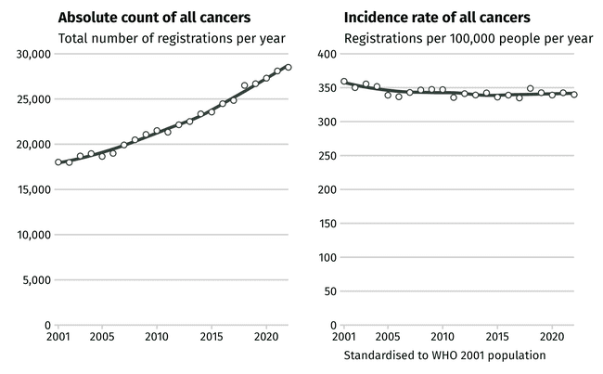
Notes: The number of cancers registered each year in New Zealand is increasing continuously, as the population grows both larger and older (left panel). When correction for population change is made, including adjusting to the WHO 2001 World Population Standard, the risk of getting any cancer, however, has remained relatively stable. Note that this flat overall trajectory across all cancers masks changes, both increases and decreases, within specific cancer types and within different population sub-groups.
Source: New Zealand Cancer Registry.

The variation in incidence patterns over time can be seen in Figure 3. It shows the 10 most-diagnosed cancers across the total population in New Zealand between 2018 and 2022, and how incidence rates have changed since the State of Cancer 2020 report.
Figure 3: Incidence of the 10 most-diagnosed cancers in females and males, New Zealand,
2013–2022
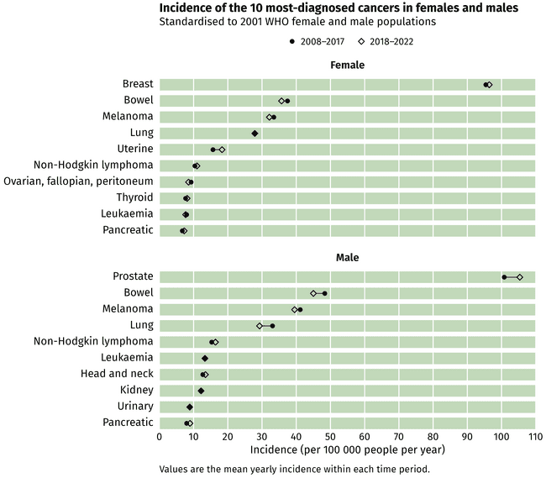
,
Notes: This figure shows the incidence of the 10 most-diagnosed cancers across all females and males in New Zealand, comparing the rate averaged across 2013–2017 (circles) to the most recent data period (2018–2022, diamonds). There is a mixed pattern of relative stability or modest increases or decreases.
Source: New Zealand Cancer Registry.

Five cancers make up 60% of all diagnoses
The cancers most diagnosed in people in New Zealand (excluding non-melanoma skin cancers) are breast, prostate, bowel, melanoma and lung cancer [29]. Together these five cancers accounted for 60% of all new cancers diagnosed in 2018–2022 (Figure 4). The key trends in these cancers, including a selection of trends seen in different demographic groups, are discussed below.
Figure 4: New cancers diagnosed in New Zealand, 2018–2022
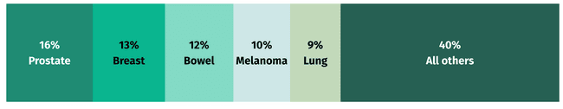
Note: Five cancers responsible for the highest number of diagnoses over the period 2018–2022.
Source: New Zealand Cancer Registry.
As a group, blood cancers also affect many people in New Zealand. When leukaemia, myeloma, Hodgkin lymphoma and non-Hodgkin lymphoma are considered together, these blood cancers were the sixth most-diagnosed cancer (9%) in adults in 2018–2022 (Figure 5). Blood cancers have not been included in an aggregated form elsewhere in this report. However, this is a consideration for future work to ensure greater visibility of this important group of cancers.
Figure 5: Most-diagnosed cancers, by sex, New Zealand, 2018–2022
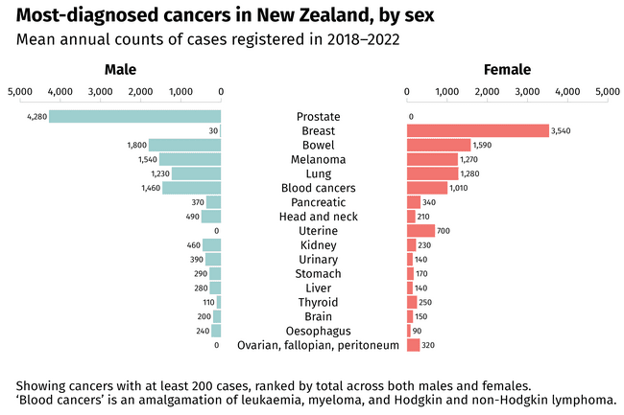
Notes: Cancers with at least 200 cases per year, ranked by total across both males and females. ‘Blood cancers’ is an amalgamation of leukaemia, myeloma and Hodgkin and non-Hodgkin lymphoma.
Source: New Zealand Cancer Registry.

Prostate cancer rates are steadily increasing and there is a change in the demographics of males being diagnosed
Prostate cancer remains the most-diagnosed cancer for males in New Zealand (see Figure 5 above). Over the last decade, rates have remained largely stable for Māori and Pacific peoples, while steadily increasing for European/other and Asian populations. This increase is likely in part due to increased use of PSA testing [30]. Incidence is higher among European/other males compared with Māori and Pacific males, with notably lower incidence among Asian males (Figure 6).
Figure 6: Prostate cancer registrations per year, by ethnicity, New Zealand, 2001–2022
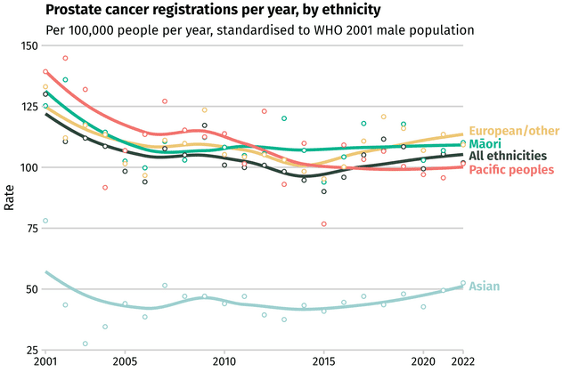
Notes: Prostate cancer is detected at a substantially lower rate in Asian males compared with males of other ethnicities in New Zealand. ‘European/other’ refers to non-Māori, non-Pacific, non-Asian.
Source: New Zealand Cancer Registry.

Over the last 10 years, there has been a shift in the distribution of prostate cancer in relation to deprivation. This shift has become more pronounced over the last 5 years. In 2001 prostate cancer registrations were highest among males living in areas of high deprivation (NZDep quintile 5), whereas most recent data shows incidence is now highest among those living in areas of lowest deprivation (NZDep quintile 1) (Figure 7).
This change is likely driven by differences in opportunistic (ie, not organised) PSA testing in New Zealand. Research has found that males living in areas of higher deprivation have lower rates of PSA testing than those living in more affluent areas. Lower PSA testing levels are likely to also explain the lower rates of prostate cancer seen among Māori and disabled males; these are population groups that experience higher rates of many cancer types.
Figure 7: Prostate cancer registrations per year, by deprivation quintile, New Zealand, 2001–2022
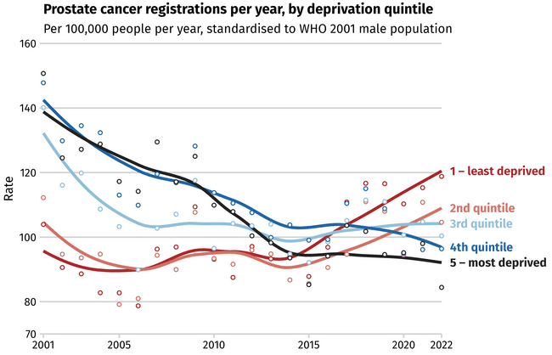
Notes: The pattern of prostate cancer incidence by deprivation has reversed over the last 2 decades. Cases are now more likely to be detected among the least-deprived quintiles, where previously the opposite was true. Socioeconomic deprivation is measured using quintiles from the area-based New Zealand Deprivation Index.
Source: New Zealand Cancer Registry.
This difference in opportunistic PSA testing could lead to differing rates of over- or under-diagnosis across socioeconomic groups. Over-diagnosis is the diagnosis of cancer in people who would have lived their entire life without ever experiencing harm or developing symptoms from their cancer. Due to the slow-growing nature of many prostate cancers, there is a risk of over-diagnosis, especially when opportunistic PSA screening occurs. While over-diagnosis is difficult to quantify, it is estimated that it could occur in 21%–50% of prostate cancers diagnosed via opportunistic screening [31].
There are both benefits and risks associated with opportunistic PSA testing. While testing could lead to early detection of prostate cancer and subsequent decreased morbidity and mortality, risks include infection as a result of biopsy, over-diagnosis and substantial psychological and physiological side-effects due to over-treatment. It is recommended that primary care providers discuss the benefits and harms of the test with the person and their whānau using a shared decision-making model.
New Zealand does not have a national prostate screening programme, as evidence does not currently support its implementation. However, several countries are involved in pilot projects exploring the feasibility of prostate screening programmes. The National Screening Advisory Committee within Health NZ will continue to monitor the evidence around population screening for prostate cancer and make recommendations about any new screening programme in New Zealand, should the evidence support this in future.

Breast cancer rates are increasing for Pacific females
The number of females diagnosed with breast cancer in New Zealand had been increasing prior to the State of Cancer 2020 report but this trend has since flattened, with overall population rates appearing relatively stable. However, there are some notable differences among ethnic groups, with breast cancer rates among Pacific females continuing to increase (Figure 8). Pacific females tend to be younger when diagnosed and are more likely to have advanced disease [32].
Breast screening in New Zealand started with two pilot programmes in 1991, initially for females aged 50–64 years. The national BreastScreen Aotearoa programme officially began in 1998 before being extended in 2004 to include females aged 45–69 years. The programme was further expanded recently to include females aged 70–74 years (this is currently being phased in nationwide).
Figure 8: Breast cancer registrations per year, by ethnicity, New Zealand, 2001–2022
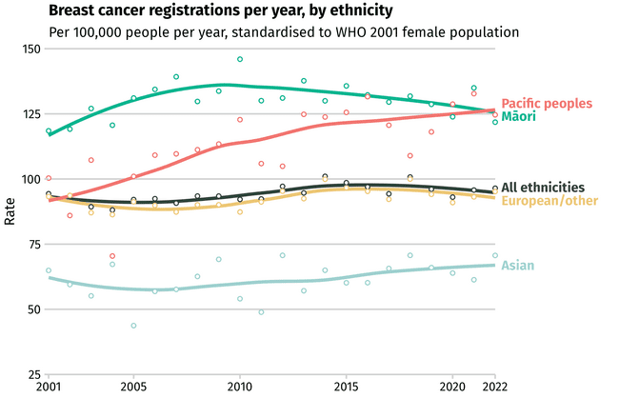
Notes: The incidence rate of breast cancer registrations per year shows substantial ethnic inequities. The incidence in Pacific females in particular has risen markedly between 2001 and 2022. ‘European/other’ refers to non-Māori, non-Pacific, non-Asian.
Source: New Zealand Cancer Registry.

Bowel cancer rates are decreasing for the European/other population, while remaining flat for Māori and increasing for Pacific peoples and people aged under 50 years
People of European/other ethnicity continue to have the highest rates of bowel cancer, although rates have decreased at an average of 0.9% per year since 2001. In contrast to this, since 2001, bowel cancer rates have continued to increase for Pacific peoples at an average rate of 1.6% per year, while remaining relatively stable for Māori over this same time period (Figure 9). Māori are more likely to be younger at diagnosis because there is a higher proportion of young people in the Māori population. They are also more likely to have advanced disease [33].
The National Bowel Screening Programme was rolled out nationwide between 2017 and 2022, initially for people aged 60–74 years. It is now being extended to include people aged 58–59 years. The relatively recent introduction of the programme may result in a brief increase in the number of bowel cancer diagnoses in the coming years as those cancers that would otherwise be undetected at an early stage are identified.
Figure 9: Bowel cancer registrations per year, by ethnicity, New Zealand, 2001–2022
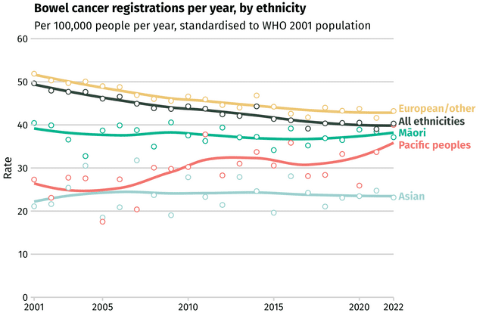
Note: ‘European/other’ refers to non-Māori, non-Pacific, non-Asian.
Source: New Zealand Cancer Registry.

Rates of early-onset bowel cancer (diagnosed in people aged under 50 years) are increasing at an average rate of 3.5% per year (Figure 10). While early-onset bowel cancer remains less common, the increasing trend is being seen both in New Zealand and internationally. The drivers of this change are not yet fully understood [34].
Figure 10: Bowel cancer incidence rate for people aged under 50 years, by ethnicity, New Zealand,
2001–2022
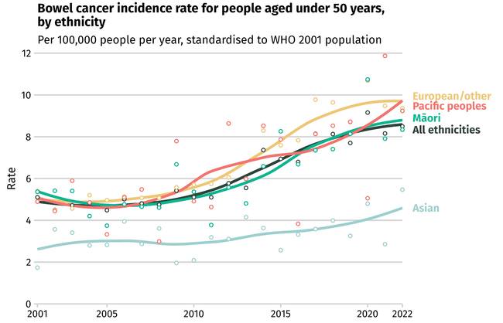
Notes: In the total population, there is a mixed pattern by ethnicity of bowel cancer incidence falling, rising or remaining stable. The incidence of early-onset bowel cancer (ie, in those aged under 50 years) is much lower than in older people. It is, however, rising across ethnicities. ‘European/other’ refers to non-Māori, non-Pacific, non-Asian.
Source: New Zealand Cancer Registry.

Lung cancer rates remain high for Māori – particularly wāhine Māori – and people living in areas of high deprivation
Overall, the number of people developing lung cancer has continued to decrease over the last 5 years. Despite experiencing an ongoing decrease, Māori still have the highest rates of lung cancer (Figure 11). In 2018–2022, Māori were more than three times as likely as people of European/other ethnicity to develop lung cancer (rate ratio (RR) 3.23, 95% confidence interval (CI) 3.09–3.37).
Emerging evidence based on analysis completed by Te Aho o Te Kahu | Cancer Control Agency shows that disabled people also experience a high burden of lung cancer, having a 71% higher incidence compared with the total population (RR 1.71, 95% CI 1.62–1.80). This effect may be even more pronounced among tāngata whaikaha (disabled Māori) [35] [36].
Figure 11: Lung cancer registrations per year, by ethnicity, New Zealand, 2001–2022
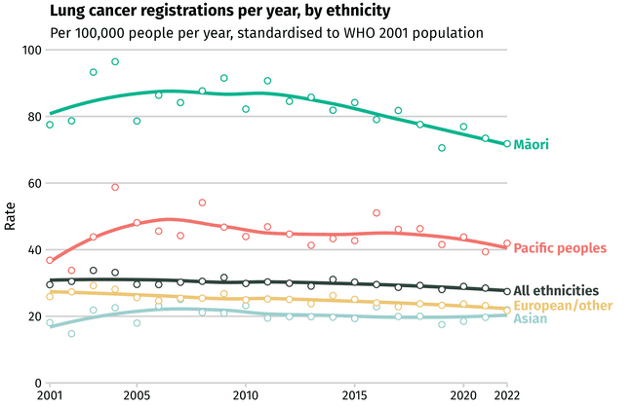
Note: ‘European/other’ refers to non-Māori, non-Pacific, non-Asian.
Source: New Zealand Cancer Registry.

Trends in lung cancer incidence vary by gender. At a population level, incidence rates have been slowly increasing for females since 2000, while simultaneously decreasing for males. In 2022, females had a higher incidence rate of lung cancer than males for the first time. However, there are significant variations when ethnicity and gender are both considered. Wāhine Māori (Māori females) continue to have the highest incidence of lung cancer overall and there are different trends between genders within multiple ethnic groups (Figure 12).
Figure 12: Lung cancer registrations per year, by ethnicity and gender, New Zealand, 2001–2022
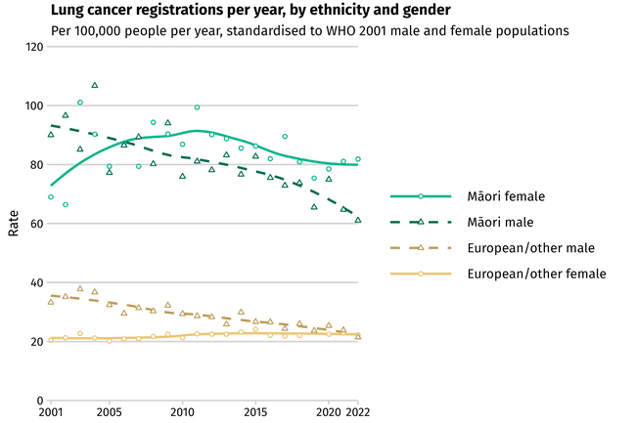
Notes: Lung cancer rates have been declining for both Māori and European/other males but have been stable for European/other females. Meanwhile, rates in wāhine Māori (Māori females) have surpassed those of their male counterparts. ‘European/other’ refers to non-Māori, non-Pacific, non-Asian.
Source: New Zealand Cancer Registry.
Lung cancer incidence is strongly linked to patterns of smoking across different groups, with reductions in lung cancer following some years behind reductions in smoking rates. There have been reductions in smoking rates across all ethnic groups (discussed in more detail in 2 Preventing cancer), with particularly steep reductions over the last 15 years among Māori, and wāhine Māori in particular. The significant decrease in smoking rates for Māori and Pacific peoples over the last 15 years is expected to result in a continuing decrease in lung cancer incidence and mortality over coming years.
While daily smoking rates have been reducing for Māori, this group continues to be at substantially higher risk of exposure to this key cancer risk factor. For example, wāhine Māori are over three-and-a-half times more likely to smoke daily than non-Māori females [37]. This is reflected in the observed higher risk of developing lung cancer.

People living in areas of highest deprivation (NZDep quintile 5) are significantly more likely to develop lung cancer than those living in areas of lowest deprivation (NZDep quintile 1) (Figure 13). This is strongly linked with patterns by ethnicity, with Māori and Pacific peoples over-represented in areas of highest deprivation. As outlined above, the different demographic trends in lung cancer reflect the trends seen in smoking, with changes in lung cancer lagging behind changes in smoking.
Figure 13: Lung cancer registrations per year, by deprivation quintile, New Zealand, 2001–2022
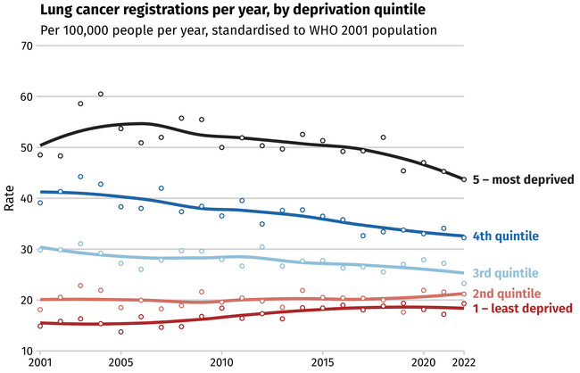
Notes: Socioeconomic deprivation is measured using quintiles from the area-based New Zealand Deprivation Index.
Source: New Zealand Cancer Registry.

Melanoma rates are rising for some population groups
Alongside Australians, people in New Zealand continue to have one of the highest rates of melanoma in the world.
Melanoma rates have risen here for some population groups between 2001 and 2022 (Figure 14). Melanoma continues to be most common among people of European/other ethnicity, with males and older adults particularly affected. While the risk of being diagnosed with melanoma is lower among Māori, research has found that Māori have worse outcomes once diagnosed [38]. Melanoma is a relatively preventable cancer, with more than 95% of melanomas related to ultraviolet (UV) radiation resulting from sun exposure (discussed more in 2 Preventing cancer).
Figure 14: Melanoma cancer registrations per year, by ethnicity, New Zealand, 2001–2022
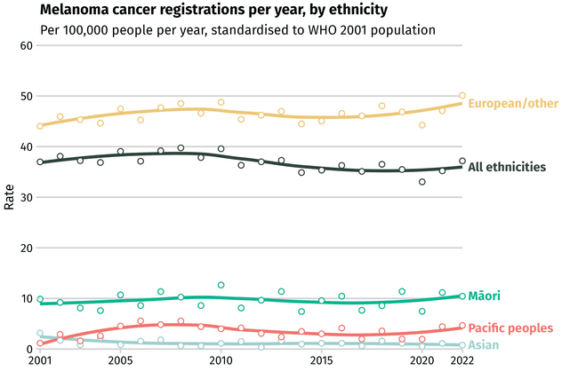
Notes: The incidence of melanoma is substantially higher for the European/other population in New Zealand compared with other ethnicities. ‘European/other’ refers to non-Māori, non-Pacific, non-Asian.
Source: New Zealand Cancer Registry.

Children and young people experience different types of cancer than adults

Child cancer incidence
Cancer in children (aged 0–14 years) represents less than 1% of all cancer diagnoses in New Zealand. In 2022, 160 children were diagnosed with cancer. The incidence of childhood cancer has remained stable over time and is comparable with other high-income countries [39].
The types of cancers most common in children are different to those most common in adults. Children diagnosed with cancer in 2022 were most likely to have leukaemia (29% of all diagnoses), followed by central nervous system tumours (26%) (Figure 15). Approximately one-quarter of the children diagnosed with cancer in 2022 were Māori (25.6%, Figure 16).
Data is primarily captured through the New Zealand Children’s Cancer Registry. The National Child Cancer Network [40] publishes yearly snapshots of key statistics relating to cancer for children under 15 years of age.
Figure 15: Children diagnosed with cancer, by age group and cancer type, New Zealand, 2022
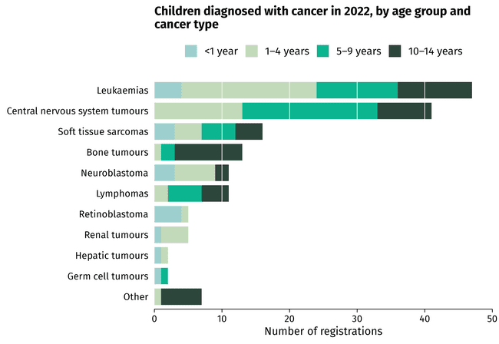
Source: New Zealand Children’s Cancer Registry.
Figure 16: Ethnicity of children diagnosed with cancer, New Zealand, 2022
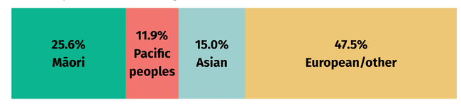
Note: ‘European/other’ refers to non-Māori, non-Pacific, non-Asian.
Source: New Zealand Children’s Cancer Registry.

Adolescent and young adult cancer incidence
In New Zealand, the age range for adolescent and young adult (AYA) cancer services is defined as 12–24 years [41]. For the purposes of this report, however, the age range is 15–24 years, with the younger years incorporated into the preceding child cancer incidence section [42].
The AYA grouping is important because these young people experience different types of cancer to those experienced by children and adults, although there is overlap with both. AYA also have specific psychosocial and developmental needs.
In 2022, 170 people aged 15–24 years were diagnosed with cancer (Figure 17). Around one-fifth of those were Māori (21.8%, Figure 18).
Figure 17: Adolescents and young adults diagnosed with cancer, by age group and cancer type, New Zealand, 2022
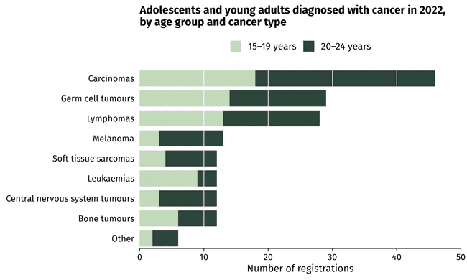
Source: New Zealand Cancer Registry.
Figure 18: Ethnicity of adolescents and young adults diagnosed with cancer, New Zealand, 2022
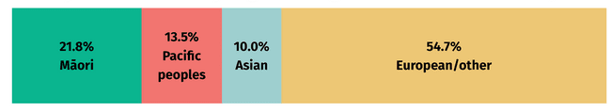
Note: ‘European/other’ refers to non-Māori, non-Pacific, non-Asian.
Source: New Zealand Cancer Registry.

Survival: more people are living longer after their cancer diagnosis
More people diagnosed with cancer are living longer. Across all cancers, 67.6% of people with cancer in 2020–2021 were surviving at least 5 years after diagnosis, an increase from 65.5% at the time of the State of Cancer 2020 report. This is a substantial shift since the first robust data on survival from 1998–1999, when 5-year survival was 58.0%. However, net survival varies markedly across different cancer types, as shown in Figure 19.
Figure 19: Net survival at 5 years, by cancer type, New Zealand, 1998–1999 and 2020–2021
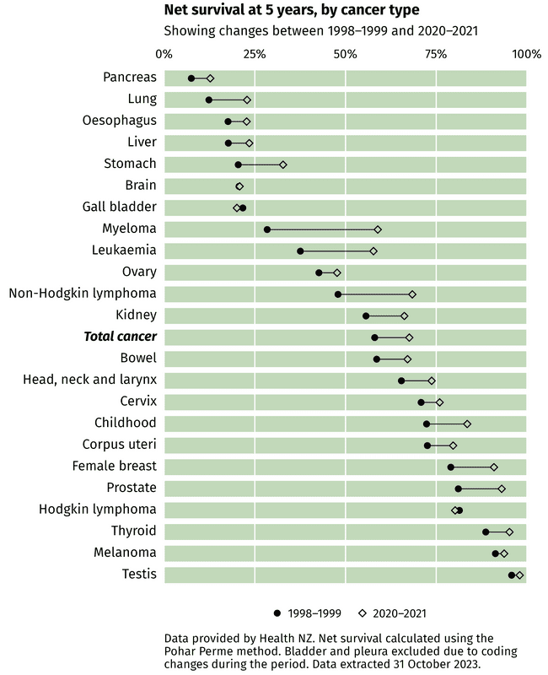
Notes: Different cancers vary markedly in the net proportion of people surviving at 5 years after diagnosis. The net survival in 2020–2021 (diamond symbols) has, however, generally improved for most cancer types since 1998–1999 (circles).
Source: Health New Zealand.

As noted in the State of Cancer 2020 report, while net survival is improving in New Zealand, improvements have been slower compared with other high-income countries [43]. At the time of the analysis shown in Figure 19, updated ethnic-specific life-tables were not available, meaning analysis of net survival for each ethnicity was not possible. These survival values were only able to be calculated for the total population. Further analysis will be needed to examine whether there has been any shift in inequities in survival across ethnic groups, such as those previously shown for Māori [44] and Pacific peoples [45], and other population groups, such as disabled people or people living in areas of higher deprivation.

Mortality: rates of death from cancer are continuing to decline over time
Cancer remains the leading cause of death for people in New Zealand, with 10,565 dying from cancer in 2021 [46]. Cancer mortality can be reduced through prevention – reducing the number of people who develop cancer – and/or through early detection and effective treatment of cancer – improving people’s chance of survival.
The number of people dying from cancer in New Zealand has continued to increase steadily over time (Figure 20, left), driven by the increasing number of people diagnosed every year, coupled with the growing and ageing population. When data is corrected for changes in the underlying population, however, the mortality rate (the risk of dying of cancer in a given year) has been steadily falling (Figure 20, right).
Figure 20: Number of deaths and mortality rate from all cancers, New Zealand, 2001–2021
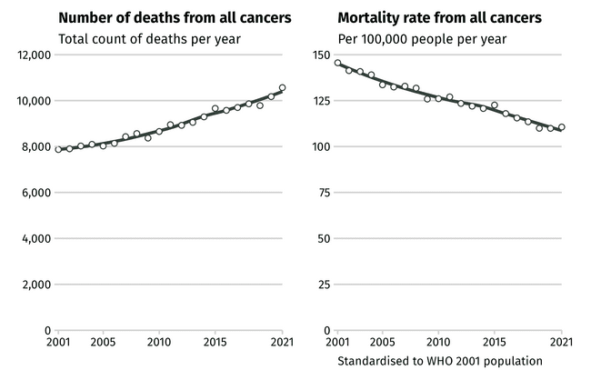
Notes: The total number of deaths from all cancers (left panel) is continuously increasing. The underlying mortality rate (right panel), which adjusts for the growing and ageing population, is, however, decreasing.
Source: New Zealand Cancer Registry and Mortality Collection.

Ethnicity and level of deprivation are two factors that highlight inequities within cancer mortality rates. Cancer mortality has been decreasing for Māori at a faster average rate than for people of European/other ethnicity: 1.6% per year since 2001 for Māori versus 1.3% for European/other (Figure 21). Despite the gap between these groups getting smaller, Māori remain nearly 1.6 times as likely to die from cancer than people of European/other ethnicity (95% CI 1.55–1.63). Between 2017 and 2021, Pacific peoples were nearly 1.4 times (95% CI 1.32–1.44) and Asian peoples nearly half as likely (RR 0.54, 95% CI 0.52–0.56) to die from cancer as people of European/other ethnicity.
Figure 21: Mortality rate from all cancer types, by ethnicity, New Zealand, 2001–2021
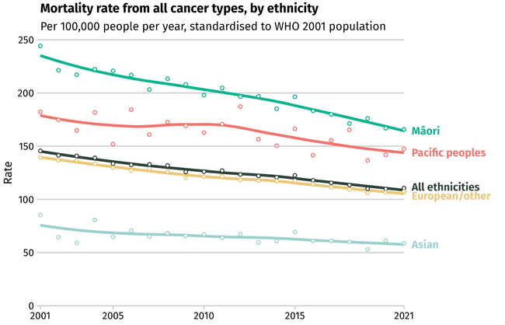
Notes: The total mortality rate due to all cancers continues to decline for all ethnicities, although substantial inequities in mortality between ethnic groups persist. ‘European/other’ refers to non-Māori, non-Pacific, non-Asian.
Source: New Zealand Cancer Registry and Mortality Collection.
Similarly, cancer mortality rates are consistently higher among people living in the most deprived areas of New Zealand than people living in the least deprived areas. While the gap between the two groups is closing, between 2017 and 2021, people living in the most deprived areas were still 1.55 times more likely to die from cancer than those living in the least deprived areas (95% CI 1.51–1.6).

Half of all cancer deaths are from five cancers
Five cancer types are associated with half of all cancer deaths in New Zealand. Lung cancer is the leading cause of cancer death, followed by bowel, prostate, breast and pancreatic cancers (Figure 22). Key trends in these cancers, including differing impacts among population groups, are discussed below.
Figure 22: Deaths from cancer in New Zealand, 2017–2021
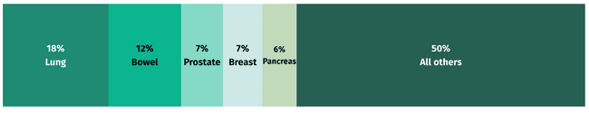
Note: The five cancers responsible for the highest number of deaths over the period 2017–2021.
Sources: New Zealand Cancer Registry and Mortality Collection.

Lung cancer remains the leading cause of cancer death in people in New Zealand
Lung cancer is the biggest cause of cancer death in New Zealand and one of the largest contributors to the life expectancy gap between Māori and non-Māori (6.6 years between 2020 and 2022). For all ethnicities, the lung cancer mortality rate has continued to decrease (Figure 23). However, mortality remains considerably higher for Māori. It was the biggest contributor to the difference in life expectancy for wāhine Māori and the second biggest contributor for tāne Māori (Māori males) between 2020 and 2022 [47]. Over the last 5 years, Māori were more than three times as likely to die from lung cancer than people of European/other ethnicity. Wāhine Māori have the highest rates of lung cancer mortality.
Figure 23: Lung cancer mortality rate, by ethnicity, New Zealand, 2001–2021
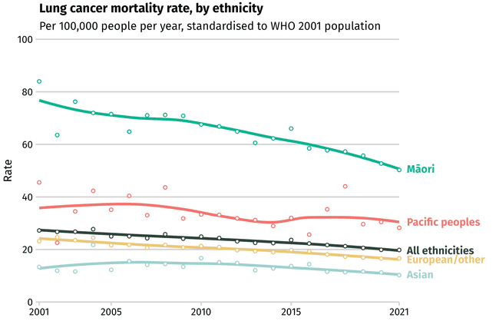
Note: ‘European/other’ refers to non-Māori, non-Pacific, non-Asian.
Source: New Zealand Cancer Registry and Mortality Collection.
Deprivation is another factor that appears to influence lung cancer mortality rates. Across 2017–2021, people living in the most deprived areas of New Zealand were 2.8 times more likely to die from lung cancer than people living in the least deprived areas of the country. While the gap between the two population groups reduced between 2002 and 2011, there has been little change in this disparity over the last decade.

Bowel cancer mortality rates are decreasing for European/other and Māori populations but there is little change for other ethnic groups
Over the last 5 years, the number of people of European/other ethnicity dying from bowel cancer has continued to decline, aligning with a gradual decrease in incidence in this group. Since 2010 there has also been a notable decline in bowel cancer mortality for Māori. The same decrease has not been observed as consistently in other ethnic groups during that time period (Figure 24).
Figure 24: Bowel cancer mortality rate, by ethnicity, New Zealand, 2001–2021
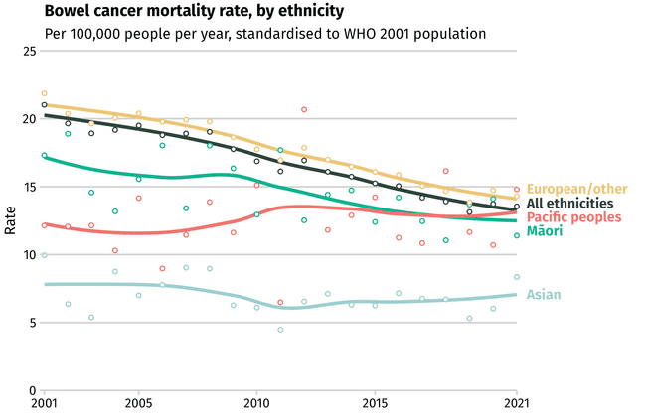
Note: ‘European/other’ refers to non-Māori, non-Pacific, non-Asian.
Source: New Zealand Cancer Registry and Mortality Collection.

The number of males dying from prostate cancer is decreasing over time
Overall, the number of males dying from prostate cancer has been slowly decreasing over time. However, despite tāne Māori having a lower incidence of prostate cancer than males of European/other ethnicity (see Figure 6), tāne Māori have higher mortality from prostate cancer (Figure 25).
Figure 25: Prostate cancer mortality rate, by ethnicity, New Zealand, 2001–2021
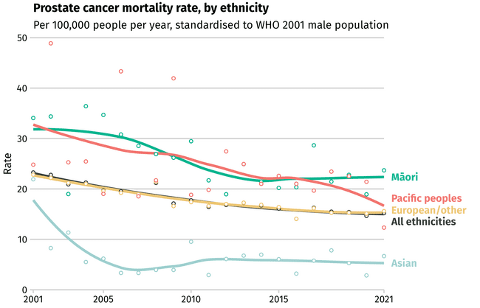
Notes: The prostate cancer mortality rate in males has declined over the last 2 decades but inequities persist between ethnicities. ‘European/other’ refers to non-Māori, non-Pacific, non-Asian.
Source: New Zealand Cancer Registry and Mortality Collection.

Breast cancer mortality rates continue to decrease over time but inequities remain
The number of females dying from breast cancer has continued to decline across all population groups. Mortality remains higher for wāhine Māori and Pacific females. In 2021, wāhine Māori and Pacific females were almost twice as likely as European/other females to die from breast cancer. The difference between these groups was decreasing but may have plateaued or possibly increased slightly in recent years. More time is needed to see how these trends progress (Figure 26). The reduction in mortality rates is likely due to both the impact of breast screening, which reduces late-stage incidence, and improvements in the diagnosis and treatment of breast cancer.
Figure 26: Breast cancer mortality rate, by ethnicity, New Zealand, 2001–2021
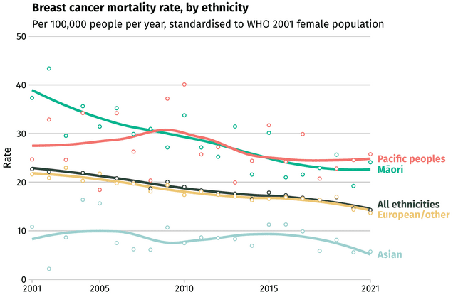
Notes: The breast cancer mortality rate is declining overall but continues to show persistent inequities between ethnicities. ‘European/other’ refers to non-Māori, non-Pacific, non-Asian.
Source: New Zealand Cancer Registry and Mortality Collection.

There remains a persistent gap between the number of females living in areas of high deprivation (NZDep quintile 5) who die from breast cancer compared with those living in areas of lowest deprivation (NZDep quintile 1, see Figure 27).
Figure 27: Breast cancer mortality rate per year, by deprivation quintile, New Zealand, 2001–2022
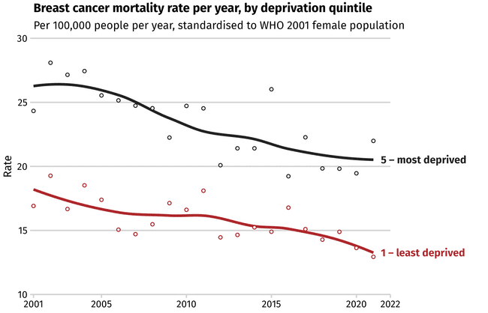
Notes: Although breast cancer mortality continues to decline overall, a substantial inequity remains between females living in areas with the highest levels of socioeconomic deprivation versus those in the lowest. Socioeconomic deprivation is measured using quintiles from the area-based New Zealand Deprivation Index.
Source: New Zealand Cancer Registry and Mortality Collection.

Pancreatic cancer mortality rates are increasing
Pancreatic cancer is only the 11th most-diagnosed cancer in New Zealand, but people’s chances of survival are poor. This makes pancreatic cancer the fifth-most-common cause of cancer-related death. Pancreatic cancer causes a similar number of deaths as the most-common cancers like prostate and breast cancer, which have over five times as many people diagnosed each year as pancreatic cancer.
The rate of people dying from pancreatic cancer has been gradually increasing, including over the last 5 years (Figure 28). This is probably due to increases in the number of people in the general population with excess body weight or diabetes, or both, which are risk factors for pancreatic cancer. Note, the trends seen among Pacific peoples should be interpreted with caution because of the very small number of cases, meaning results are unstable.
Figure 28: Pancreatic cancer mortality rate, by ethnicity, New Zealand, 2001–2021
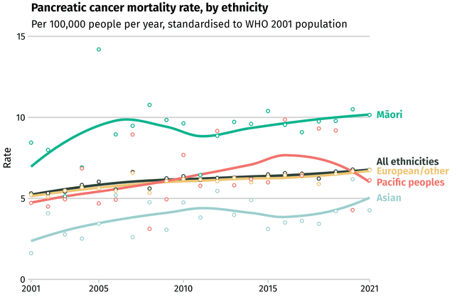
Notes: Mortality from pancreatic cancer has been rising in general and remains markedly higher in Māori. ‘European/other’ refers to non-Māori, non-Pacific, non-Asian.
Source: New Zealand Cancer Registry and Mortality Collection.

Cancer inequities exist for some population groups
There are many factors that influence cancer outcomes in New Zealand. Figure 29 illustrates how overarching social influences impact people’s exposure to different risk or protective factors for cancer and the delivery of cancer services. This, in turn, influences people’s cancer outcomes.
Key modifiable risk and protective factors for cancer are discussed in more detail in 2 Preventing cancer; however, examples of important factors are given below. These include smoking, alcohol consumption, excess body weight, physical inactivity and the presence of some chronic infections. Addressing these risk factors can have a protective effect for cancer, with up to half of cancers preventable by reducing key modifiable risk factors.
These same overarching social influences impact the delivery of cancer services, for example, whether services are available, accessible and high quality for all patients or if there is appropriate infrastructure, workforce, technology and capability available to service all health needs.
These factors combine to impact cancer outcomes for individuals and communities. While some people may be well served by cancer services and exposed to protective factors for cancer, others may experience cancer services that are not tailored to their needs and be exposed to risk factors for cancer.
At the broader population level, local and international evidence shows that these factors disproportionately affect some population groups. This is often referred to as unwarranted variation, disparity or inequity. In New Zealand, ethnicity and deprivation are two factors commonly linked to inequitable cancer outcomes.
Figure 29: Factors driving inequitable cancer outcomes
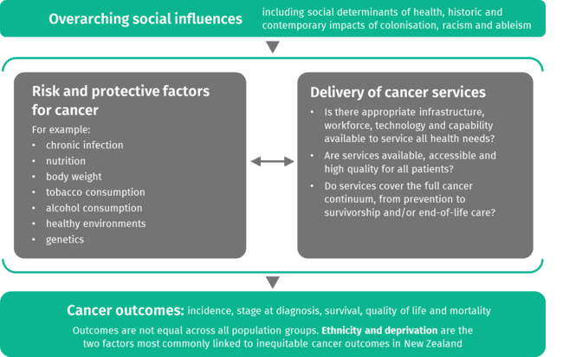

When looking at incidence, survival and mortality rates across different types of cancer, variation and inequities for particular population groups are clear. Those experiencing inequitable cancer outcomes include the groups summarised below, however, this is not an exhaustive list of groups that experience unmet needs. The most recent 5 years of data (2018–2022) show that:
- Māori were 1.13 times more likely to be diagnosed with cancer and 1.59 times more likely to die from cancer than people of European/other ethnicity. Lung cancer is a key driver of this mortality gap
- Pacific peoples were 1.05 times more likely to be diagnosed with cancer and 1.38 times more likely to die from cancer than people of European/other ethnicity. Pacific peoples are experiencing increasingly high rates of cancers such as breast and uterine cancer
people living in areas of high deprivation were 1.10 times more likely to be diagnosed with cancer and 1.55 times more likely to die from cancer than people living in areas of lowest deprivation. This is particularly notable for lung cancer – people living in areas of high deprivation were 2.5 times more likely to be diagnosed with lung cancer than people living in areas of lowest deprivation.
See Differences by ethnicity and Differences by deprivation for more details.
There is also emerging evidence that suggests disabled people are 1.22 times more likely to be diagnosed with cancer than the total population (survival and mortality data are not yet available) [35] [36] [48]. There are also indications that there may be differences in some cancer outcomes between rural and urban communities, but more work is needed to investigate this. (More detail is available in Disabled people likely have a higher risk of being diagnosed with cancer).
While there is limited cancer-specific data currently available to support this, it is known that other population groups – including migrants and refugees, people with severe mental illness and SOGIESC (sexual orientation, gender identity and expression, and sex characteristics) diverse [49] people – experience barriers to accessing health care and controlling the determinants of health; it is therefore likely that these groups are experiencing poorer cancer outcomes.
It is important to recognise that people may have multiple and interconnected dimensions of identity (including ethnicity, age, gender and socioeconomic status) – often referred to as ‘intersectionality’. Different parts of a person’s identity or lived experience can expose them to overlapping forms of discrimination and marginalisation, which can further influence their health outcomes [50]. This overlap of disadvantage contributes to inequities in cancer outcomes for people in New Zealand.

Some inequities are improving and some are getting worse
When analysing population-level inequities, it is important to consider trends over time as well as the latest data. Some population groups have seen disparities reduce over time, while others have increased. This can vary by cancer type and within population groups (for example, lung cancer incidence rates vary significantly between tāne Māori and wāhine Māori). A selection of examples that illustrate different trends are included below.

Differences by ethnicity
Figure 30 shows the incidence of the most-diagnosed cancers in Māori and Pacific females and males in New Zealand between 2018 and 2022, and the comparative incidence in the European/other population.
Figure 30: The most-diagnosed cancers in Māori and Pacific females and males, New Zealand,
2018–2022
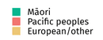
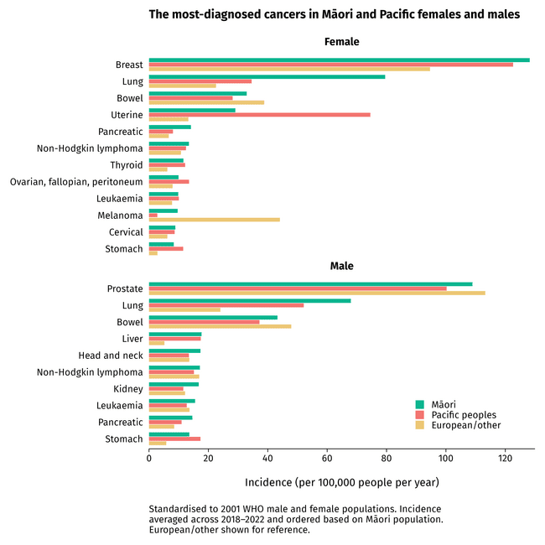
Notes: The most-diagnosed cancers in wāhine Māori (Māori females) and tāne Māori (Māori males) (green bars) and Pacific females and males (red bars) differ from the commonest cancers in the total population, as indicated by varying incidence in the European/other group. Values represent the mean yearly incidence from 2018 to 2022. ‘European/other’ refers to non-Māori, non-Pacific, non-Asian.
Source: New Zealand Cancer Registry.

When looking at the most-diagnosed cancers among Māori, the majority occur at a higher rate among Māori compared with people of European/other ethnicity. Exceptions to this are bowel and prostate cancers, and melanoma in females. It is likely that recognised differences in levels of opportunistic PSA screening are contributing to the observed difference in prostate cancer diagnosis between tāne Māori and European/other males. Within the Māori population, there is also some variation in cancer incidence by sex, for example, wāhine Māori have notably higher incidence of lung cancer than tāne Māori.
When looking at the most-diagnosed cancers among Pacific peoples, the picture is similar. In the majority of these cancers, Pacific peoples are diagnosed at higher rates than people of European/other ethnicity. Again, melanoma, bowel and prostate cancers are exceptions to this, in addition to some of the less commonly diagnosed cancers such as kidney, head and neck cancers and some blood cancers. Pacific females have particularly high rates of uterine cancer (more detail on changes in rates of uterine cancer over time is included in Figure 32 below).
Some of the disparities in cancer incidence experienced by different ethnicities have decreased. These are best illustrated using incidence rate ratios. For example, in 2008–2012, Māori were 3.8 times as likely to be diagnosed with stomach cancer than people of European/other ethnicity. This has decreased to 2.5 times as likely in 2018–2022 (Figure 31). Similar patterns are present for Pacific peoples and Asian populations.
Figure 31: Five-year incidence rate ratios for stomach cancer, by ethnicity, New Zealand, 2003–2022
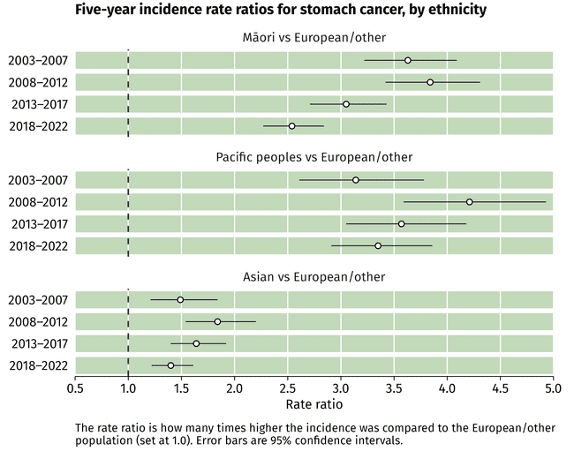
Notes: The incidence of stomach cancer in Māori relative to the European/other population is very high but appears to be decreasing. Similar patterns are seen among Pacific peoples and Asian populations. ‘European/other’ refers to non-Māori, non-Pacific, non-Asian.
Source: New Zealand Cancer Registry.
Incidence gaps have increased for other cancers, such as uterine. In 2018–2022, Pacific females had the highest incidence of uterine cancer and were 5.6 times as likely to develop uterine cancer than females of European/other ethnicity. This inequity has increased over time (Figure 32).
Figure 32: Five-year incidence rate ratios for uterine cancer, by ethnicity, New Zealand, 2003–2022
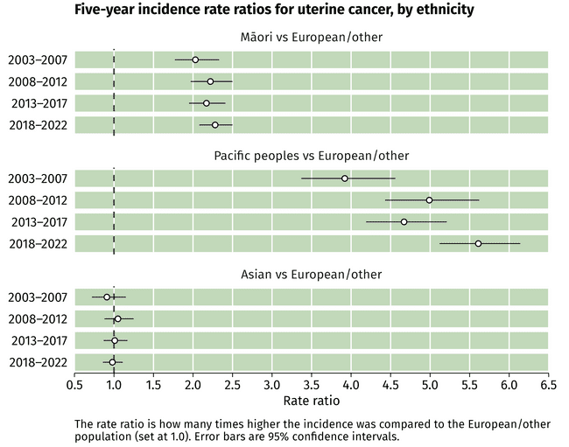
Notes: Incidence of uterine cancer in wāhine Māori (Māori females) has been consistently just over twice as high as in the European/other population. Incidence in Pacific females is markedly higher and this inequity appears to be worsening. Incidence in the Asian population, however, is quite similar to that in the European/other population. ‘European/other’ refers to non-Māori, non-Pacific, non-Asian.
Source: New Zealand Cancer Registry.

There are some emerging patterns for particular cancer types. This includes changes in the incidence of kidney cancer, where in 2003–2007, Māori were 1.2 times as likely to be diagnosed with kidney cancer than people of European/other ethnicity. However, increasing incidence in Māori means that Māori are now 1.5 times as likely to be diagnosed with kidney cancer than people of European/other ethnicity (Figure 33).
Figure 33: Five-year incidence rate ratios for kidney cancer, by ethnicity, New Zealand, 2003–2022
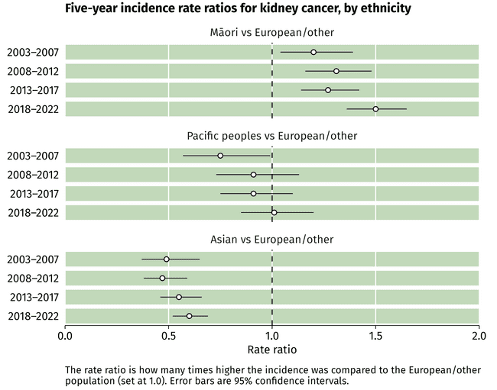
Notes: The incidence of kidney cancer in Māori in 2003–2007 was approximately 1.2 times that in the European/other population but has progressively worsened since. The incidence in Pacific peoples was initially lower than in the European/other population but has subsequently reached a similar value. Incidence in the Asian population remains significantly lower than in the European/other population but is progressively increasing relative to it. ‘European/other’ refers to non-Māori, non-Pacific, non-Asian.
Source: New Zealand Cancer Registry.

Differences by deprivation
As discussed earlier, deprivation is associated with differences in some cancer outcomes. While the equity gaps are decreasing for many cancer types, there are still significant differences in many cancer incidence and mortality rates when comparing people living in areas of highest deprivation with those living in areas of lowest deprivation.
Progress has been made in some instances. For example, while people living in areas of high deprivation remain more likely to be diagnosed with lung cancer than those living in areas of low deprivation, this gap has decreased over time. Figure 34 shows that, in 2003–2007, those living in the most deprived areas were 3.6 times as likely to be diagnosed with lung cancer than those living in the least deprived areas, whereas in 2018–2022 this decreased to 2.5 times as likely.
Figure 34: Five-year incidence rate ratios for lung cancer, most deprived vs least deprived, New Zealand, 2003–2022
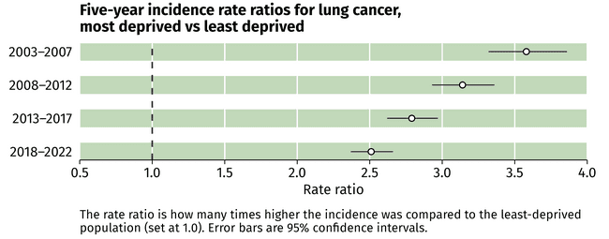
Source: New Zealand Cancer Registry.

There is emerging evidence of inequities for other population groups
Recent work by Te Aho o Te Kahu | Cancer Control Agency has highlighted some emerging evidence of cancer inequities for two specific population groups: disabled people and rural communities. However, more work is needed to confirm the nature and extent of these. The emerging evidence is summarised below. Te Aho o Te Kahu | Cancer Control Agency will undertake further work to examine outcomes for these groups in future.

Disabled people likely have a higher risk of being diagnosed with cancer
In the State of Cancer 2020 report, it was noted that there was limited data on the incidence of cancer and cancer outcomes for disabled people in New Zealand. To address this gap, Te Aho o Te Kahu | Cancer Control Agency established a programme of work to improve what is known about disabled people who have been affected by cancer. This work included a literature review and analysing data on cancer incidence for disabled people [35] [36].
In 2025, Te Aho o Te Kahu | Cancer Control Agency began developing a report looking at cancer registration data for disabled people between 2018 and 2022 and comparing results with the total population. It is important to note that there are inconsistencies in the collection of disability status across health and social data sets. As a result, it has not been possible to reliably identify a ‘non-disabled’ comparison group. The analysis compared cancer registrations for disabled people with those of the total population.

Rates are expressed as number of cases per 100,000 person years. This looks at how many new cases occur over time, taking into account both the number of people and how long they were observed. It is important to use this measure to account for the dynamic nature of disability status over time. This is a different approach to the data methodology used elsewhere in this report, therefore results are not directly comparable with those of other population groups.
The early findings indicate some significant disparities, including that disabled people were 22% more likely to be diagnosed with cancer than the total population during that timeframe (Figure 35 and Figure 36). Other key findings included:
- disabled people were 1.71 times more likely to be diagnosed with lung cancer than the total population
- tāngata whaikaha (disabled Māori) were 1.26 times more likely to be diagnosed with cancer than the total Māori population
- disabled people living rurally were 1.23 times more likely to be diagnosed with cancer than the total rural population
disabled people living in areas of high deprivation (NZDep quintile 5) were 1.23 times more likely to be diagnosed with cancer than the total population living in NZDep quintile 5.
Figure 35: Incidence of all cancers in disabled people and the total population, New Zealand,
2018–2022
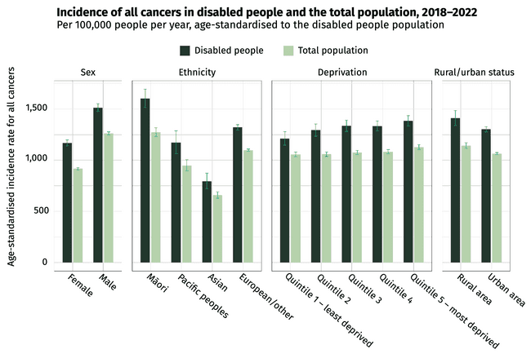
Notes: Rural/urban status in this analysis was based on the Stats NZ urban-rural indicator, rather than the Geographical Classification for Health. ‘European/other’ refers to non-Māori, non-Pacific, non-Asian.
Source: Stats NZ Integrated Data Infrastructure 2025.

Figure 36: Incidence of selected cancers in disabled people and the total population, New Zealand, 2018–2022
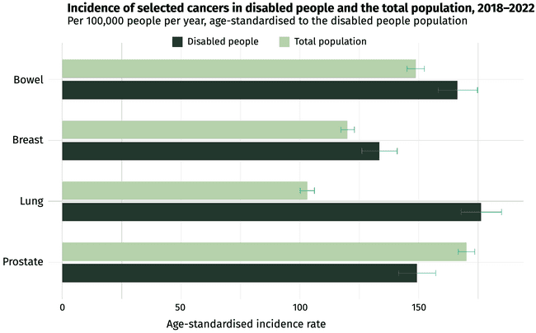
Note: Age standardisation was relative to a disabled population reference, rather than using sex-specific values for breast and prostate, as generally used in the rest of this report.
Source: Stats NZ Integrated Data Infrastructure 2025.
Disabled people experience higher rates of poverty than the non-disabled population together with barriers and discrimination to accessing education, employment, health care and other services [51]. These differences lead to disabled people having higher exposure to cancer-causing risk factors, including higher rates of smoking, increased body weight and physical inactivity, compared with non-disabled people and subsequently higher rates of cancer diagnosis [51] [52] [53] [54].

Work is needed to understand the impact of cancer on rural populations
Rural communities often experience poorer overall health outcomes compared with urban populations [6] and research over the last 5 years suggests that similar patterns exist for cancer outcomes [55]. Te Aho o Te Kahu | Cancer Control Agency is undertaking work to better understand the impact of cancer on rural communities. The initial stages of this work are included in this report.
Rural communities have unique characteristics. Compared with urban populations, rural communities have a higher proportion of older adults and a higher proportion of Māori. Around one in five people who live rurally are Māori (22%), with Asian and Pacific peoples making up just 4% and 3% of the population, respectively [56]. Rural communities also face unique challenges, such as differing access to health care services and higher rates of socioeconomic deprivation [57].
When interpreting rurality data, it is important to be aware of how the different demographic characteristics and health care experiences of people living in urban and rural areas may influence their health outcomes. For example, a variety of factors associated with rurality (such as higher Māori prevalence, higher deprivation, geographic remoteness and variable access to primary care) may compound and contribute to a higher burden of cancer for people living in rural communities. Also, rural communities are far from uniform in the prevalence of these characteristics. Some have lower levels of deprivation than many urban areas while others have substantially higher deprivation. Further analysis and data-gathering are needed to understand the underlying causes of any differences observed in cancer outcomes between rural and urban populations.
Since the State of Cancer 2020 report, a new classification system to define rurality for health-specific analyses has been developed. The Geographic Classification for Health (GCH) classifies rurality based not only on population density but also on proximity/drive time to larger urban areas and their health service facilities [5]. Further detail is available in The data used in this report. Previous findings on rural/urban differences are not necessarily comparable due to the different classification systems used.
Incidence and mortality rates were reviewed across a range of specific cancer types. The most-diagnosed cancers in rural areas are included in Figure 37, in addition to the cancers with highest mortality in rural areas (Figure 38). The pattern of cancers with the highest incidence and mortality rates were largely similar to that seen in the general population.
When considering cancer incidence, differences were seen between rural and urban populations across some cancer types (Figure 37). For example, rural populations experienced a higher incidence of some cancers, such as bowel and lung cancer, while a lower incidence for others, such as uterine cancer.
The causes of the differences observed between rural and urban populations are not yet understood and require further exploration. Research in this area will need to consider the influence of the demographic factors that vary within rural and urban populations, as discussed above.

Figure 37: The most-diagnosed cancers in females and males in rural areas, New Zealand,
2016–2020
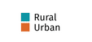
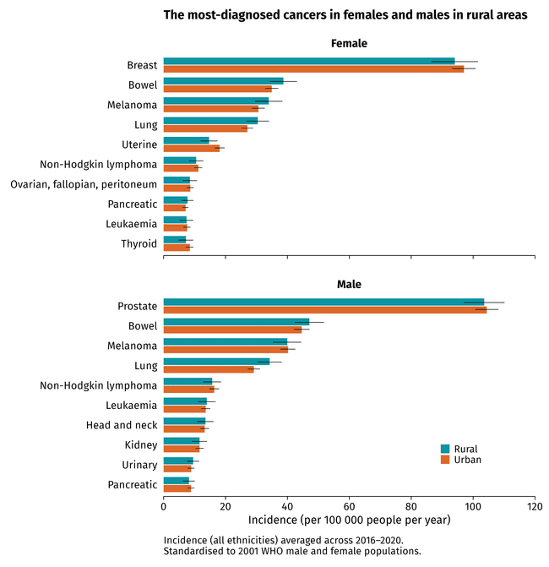
,
Notes: The cancers with the highest incidence for females and males in rural areas, as defined by the 2018 Geographical Classification for Health. Corresponding urban values are shown for comparison. Error bars are 95% confidence intervals.
Source: New Zealand Cancer Registry.

The cancers that had the highest mortality rate differed to those that were most diagnosed (Figure 38). This is consistent with the pattern seen for the general population. In some cases this rural/urban difference appeared more marked than the corresponding rural/urban difference for incidence. Again, this is likely influenced by a range of factors including demographic differences between the two groups, but also potentially challenges faced by rural communities in accessing health and treatment services.
More research is needed to understand the causes of these differences, particularly in the context of the change to the new GCH tool for classifying rurality (see The data used in this report). Understanding how different factors influence any observed differences is an important component of understanding how cancer affects rural communities.
Figure 38: The highest-mortality cancers in females and males in rural areas, New Zealand,
2016–2020
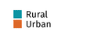
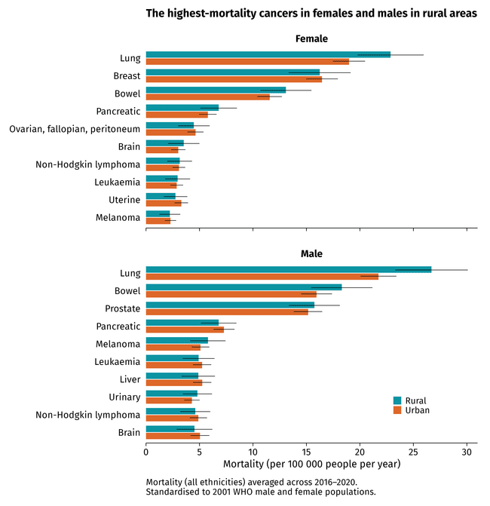
,
Notes: The cancers with the highest mortality for females and males in rural areas, as defined by the 2018 Geographical Classification for Health. Corresponding urban values shown for comparison. Error bars are 95% confidence intervals.
Source: New Zealand Cancer Registry and Mortality Collection.

2 Preventing cancer | Te ārai mate pukupuku

Key messages
- Up to half of all cancers globally may be prevented by eradicating tobacco use, limiting alcohol intake and ensuring broad access to healthy nutrition, physical activity, sun protection and infection-prevention measures.
- Exposure to cancer risk factors can be heavily influenced by the environments in which people live, work and play. People’s environments are often determined by wider social, political, commercial, economic and environmental factors. As such, preventing cancer requires consideration of these broad factors to enable healthy environments and is not simply a function of improving individual decision-making.
- Cancer prevention is a long-term strategy but offers the most cost-effective approach to controlling many cancers. As the New Zealand population ages and increases in size, cancer cases will increase and ‘treating our way out’ of this will not be possible.
- The number of people smoking daily in New Zealand has decreased over the last 5 years; however, this decrease may now be plateauing. The burden of tobacco-related cancers in New Zealand is highest for Māori, Pacific peoples and people living in deprived areas.
- Around three-quarters of adults in New Zealand drink alcohol. The risk of a person developing cancer increases as they consume more alcohol, with heavy drinking carrying the greatest risk. Several initiatives are underway to reduce harm from alcohol, but public awareness of the link between alcohol and cancer is still poor.
- Over the last 5 years, the number of people having a nutritious diet and exercising has decreased, while the number of people with excess body weight has increased.
- UV radiation from the sun is the main cause of skin cancer – the most-diagnosed site of cancer in New Zealand. A new skin cancer strategy was released in 2025, including several actions to reduce the impact and incidence of skin cancer.
- Some infections such as Helicobacter pylori, human papillomaviruses and hepatitis B and C can cause cancer. Screening and immunisation programmes have been effective in reducing the occurrence of these infections in the New Zealand population and subsequently will decrease the incidence of cancers they cause.
Preventing people’s exposure to carcinogens in the workplace can reduce their risk of developing cancer and respiratory diseases. Māori, Pacific peoples and males were the most likely to be exposed to at least one carcinogen at any level in the workplace.

Up to half of all cancers are preventable
Cancer prevention is the ideal in cancer control: it saves lives; it saves the distress, disruption and suffering people and their whānau experience with a cancer diagnosis; and it saves the health system time, resources and cost.
The causes of cancer are complex. Some of the factors that put people at risk of developing cancer cannot be changed, such as age and family history. Other factors can be changed, with the changes collectively increasing or decreasing each person’s risk of developing cancer.
It is estimated that 30%–50% of cancers globally are preventable [57]. A total of 137,000 people were diagnosed with cancer in New Zealand in the 5-year period from 2018 to 2022. It is projected that over 30,000 people will be diagnosed in 2025, increasing to over 45,000 per year by 2044 [28]. Better awareness, prevention and elimination of exposure to all known risk factors could mean fewer people developing cancer. This demonstrates the important role of prevention in reducing the burden of disease on people, whānau and the health system.

The environments people live in impact their risk of developing cancer
There are many modifiable risk factors that can increase a person’s risk of getting cancer. These include tobacco smoking, alcohol consumption, physical inactivity, poor nutrition, excess body weight, sun exposure, infections, exposure to certain chemicals and commercial factors. These modifiable risk factors are addressed on the following pages.
There is also increasing concern and evidence relating to exposure to proven and potential carcinogens through the foods people eat, and the pollution or contamination of air, water and soil. These topics are not directly addressed in this report.
The environments in which people live, work and play can influence their exposure to cancer risk factors. People’s environments are heavily determined by wider social, political, cultural and economic factors. In this way, some groups and communities have higher exposure to cancer risk factors due to factors beyond their control. For example, a person’s nutrition will be influenced by whether healthy food options are available and affordable. Research shows there are more fast food and alcohol outlets in deprived areas, where more whānau Māori and Pacific families live [58] [59]. Supermarkets in low-income areas also have a higher ratio of unhealthy to healthy foods compared with supermarkets in high-income areas [59] [60].

Policy changes supporting cancer prevention
In the 5 years since the State of Cancer 2020 report was published, a number of changes and initiatives have supported a greater emphasis on cancer prevention. Some of the key changes are highlighted here.
New public health entities: As part of the 2022 health reforms, a Public Health Agency [61] and National Public Health Service [62] were established in the Ministry of Health and Health NZ, respectively. Both agencies work to strengthen population and public health in New Zealand together with Te Aho o Te Kahu | Cancer Control Agency. They are also focused on reducing modifiable risk factors associated with cancer to support people, their whānau and their environments to be healthy and improve wellbeing.
Non-communicable disease prevention: The Government Policy Statement on Health 2024–2027 (GPS) [12] calls for accelerated action to prevent non-communicable diseases including cancer. The Government is progressing work to address five key risk factors for non-communicable diseases: alcohol, tobacco, poor nutrition, physical inactivity and adverse social and environmental factors, working in partnership with communities and cross-government partners. All of these factors increase a person’s risk of developing cancer.
Cancer Prevention Report: In 2022, Te Aho o Te Kahu | Cancer Control Agency released Pūrongo Ārai Mate Pukupuku, Cancer Prevention Report [63]. The report gives a comprehensive overview of cancer prevention and highlights where cancer prevention efforts can be strengthened to help shape relevant policies.
Cancer prevention research: In 2025, the Public Health Agency, in partnership with Te Aho o Te Kahu | Cancer Control Agency, commissioned research to determine the Population Attributable Fractions for modifiable risk factors for cancer in New Zealand. This work will identify how many people could, in theory, have their cancer prevented by addressing different risk factors, with results included by ethnicity. It also aims to help guide investment in targeted, evidence-based prevention initiatives that meet the needs of New Zealand’s diverse populations.

Smoking is the single greatest preventable cause of cancer
Tobacco smoking remains the leading cause of preventable death and disease in New Zealand, accounting for more than one in five of all cancer deaths [64]. In addition to the devastating impact it has on people and whānau, smoking places a substantial economic burden on society. Globally, the annual economic loss due to smoking has been estimated at US$1,436 billion, equivalent to 1.8% of the world’s annual gross domestic product (GDP) [65].
Smoking is linked to several types of cancer (Figure 39). It accounts for approximately 85% of all lung cancers globally [66]. The burden of tobacco-related cancers in New Zealand is highest for Māori, Pacific peoples [45] and people living in deprived areas [67]. Smoking has been particularly damaging for Māori, who have higher smoking rates and higher rates of death and tobacco-related illness than non-Māori.
Figure 39: Cancers related to tobacco
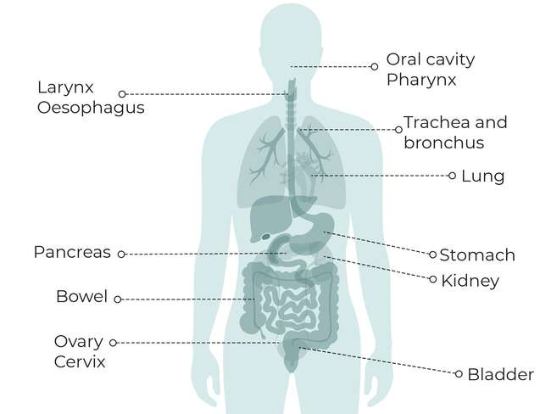
Breast
Source: Wild C, Weiderpass E, Stewart B (eds). 2020. World Cancer Report: Cancer research for cancer prevention. Lyon: International Agency for Research on Cancer. URL: http://publications.iarc.fr/586.

The number of people smoking has declined for many years, but may now be plateauing
The number of adults who smoke daily in New Zealand declined steadily from 573,000 (16.4%) in 2011/2012 to 300,000 in 2023/2024 (6.9%) [37]. However, this drop may have plateaued as the 2023/2024 smoking rate for the adult population is similar to the 2022/2023 rate (6.8%).
Ethnicity, deprivation and disability are strongly linked to smoking rates. Daily smoking rates for all ethnic groups except for Asian declined from 2022/2023 to 2023/2024, with particularly steep reductions among Māori and Pacific peoples (Figure 40). In terms of long-term trends, Māori daily smoking rates fell from 37.7% in 2011/2012 to 14.7% in 2023/2024, and rates for Pacific peoples dropped from 22.6% to 12.3% over the same period [37].
Despite this progress, significant differences remain for some ethnic groups. In 2023/2024, Māori were 2.75 times as likely to smoke daily than non-Māori, with wāhine Māori having particularly high smoking rates and being 3.72 times as likely to smoke daily than non-Māori females. There are also marked differences in the number of adults who smoke by deprivation, with those living in the most deprived areas being six times as likely to smoke daily as those living in the least deprived areas. Additionally, disabled adults were nearly twice as likely to smoke daily than non-disabled adults [37].
Figure 40: Percentage of adults aged 15 years and over who smoked daily in the past year, by ethnicity, New Zealand, 2011–2024
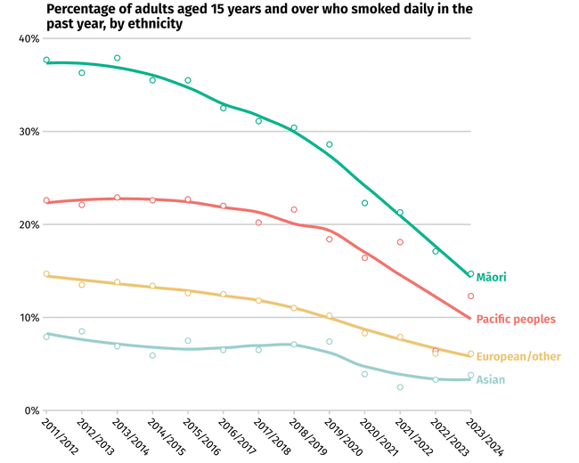
Notes: Smoking rates are declining across ethnicities in New Zealand, but inequities remain. ‘European/other’ refers to non-Māori, non-Pacific, non-Asian.
Source: New Zealand Health Survey 2023/2024.

The number of people who smoke has dropped substantially over the past few decades due to fewer people starting to smoke and more people quitting smoking (some of whom have switched to vaping). These changes are likely a result of a comprehensive tobacco control strategy and legislative framework. Key elements of the strategy and framework include:
- high pricing (due to taxation)
- bans on the advertising, promotion and sponsorship of tobacco products
- public health warnings
- education and social marketing campaigns
- restrictions on smoking in public places and workplaces
free access to quit-smoking services.
Figure 41 shows the key tobacco control initiatives implemented since the 1980s and the impact these have had over time on the number of people who currently smoke.
A key change in the last 5 years is the updates to smoking legislation. In 2022, the Government introduced the Smokefree Environment and Regulated Products (Smoke Tobacco) Amendment Act 2022 [68], which included measures such as reducing the number of retail outlets selling tobacco, removing nicotine from products and implementing a generational ban on tobacco sales for those born after 2008. In 2024, this Act was repealed. There was substantial opposition to this change, with critics arguing that the repeal would result in avoidable deaths and widen life expectancy gaps between Māori and non-Māori [69] [70] [71]. The Act was replaced by a new non-legislative action plan to help achieve the Smokefree 2025 goal [72]. The plan includes the following areas of focus:
- reduce smoking uptake
- increase quit attempts
- improve access to quit support
- support people to stay smokefree.

Figure 41: Smoking policies and the percentage of adults who smoke currently over time, New Zealand, 1983–2024
1974
Health warnings on
New Zealand cigarette packs
1999
Launch of Quitline
2004
Workplaces and licensed premises become smokefree indoors
2010
Annual excise tax increases of 10% begin (additional to inflation increases)
2011
Goal of Smokefree NZ by 2025 established
2018
Tobacco plain packaging introduced
2020
Final additional 10% excise tax increase
2021
Ban on smoking in vehicles carrying children
2022 Introduction
of smokefree generation policy
2024
Repeal of smokefree generation policy
1948
First Department of Health posters linking smoking to cancer released
Pre-1984
Māori reported as having the highest rate of lung cancer in the world of all registries that reported data
1769
Tobacco introduced to New Zealand
Early 1900s
Mass-produced tobacco cigarettes become widely available in
New Zealand
1984
First government tobacco control programme including tax, support to quit and health warnings
1990
Smokefree Environments Act passed
1994
Auahi Kore launched by
Te Hotu Manawa Māori to address tobacco harm and control for Māori
1995–1997
Legislative changes removed the majority of tobacco advertising and sponsorships, and raised the legal purchase age to
18 from 16
2008
Graphic health warnings added to cigarette packets
2012
All tobacco references removed from retailers’ displays
2004
New Zealand became a party to the WHO Framework Convention on Tobacco Control

Data source: www.smokefree.org.nz/facts/law-policy-and-research/smoking-rates-and-figures.
Information source: www.smokefree.org.nz/our-community/smokefree-providers/history-of-tobacco-control-in-aotearoa.

More people are taking up vaping
The Ministry of Health regulates vaping (e-cigarette) products under the Smokefree Environments and Regulated Products Act 1990. The Government has made recent changes to this Act to better protect children and young people by reducing their access to vaping products. These changes include restrictions on advertising and retail display, increased penalties for selling to minors and a ban on disposable vaping devices [73]. Some of these changes came into force on 18 December 2024, with others being implemented on 17 June 2025 and 1 September 2025, respectively.
Despite tighter regulation, the number of people using vaping products in New Zealand has risen markedly over the last 5 years and there are now more people vaping daily than smoking (Figure 42). The number of adults who vape daily increased from 3.5% in 2019/2020 to 11.1% in 2023/2024 [37]. In 2023/2024, Māori (28.8%) and Pacific peoples (21.5%) had the highest rates of daily vaping.
Daily vaping has increased more quickly in younger age groups, especially those aged 15–17 and 18–24 years. Increases in daily vaping in these age groups exceeded decreases in daily smoking, suggesting that some people in this age group who have never smoked are taking up vaping. Among adults aged 25–64 years, increases in daily vaping are similar in size to decreases in daily smoking, suggesting that those who smoke in this age group may have switched from smoking to vaping.
Figure 42: Prevalence of daily smoking and daily vaping, New Zealand, 2011–2024
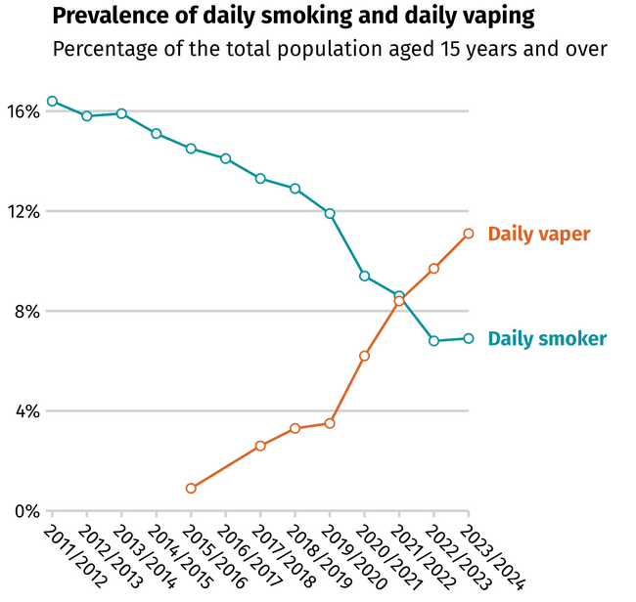
Note: Until recently, the prevalence of daily smoking has steadily declined. The prevalence of daily vaping, meanwhile, continues to rise.
Source: New Zealand Health Survey 2023/2024.
While vaping products can help people who smoke quit [74] and reduce the number of cigarettes they smoke, some have been found to contain cancer-causing chemicals and tiny particles that can be inhaled deep into the lungs. There is emerging evidence to suggest that the use of vaping products may increase the risk of cancer due to these harmful chemicals [75] [76]. However, more research is needed and the long-term effect of using vaping products in developing cancer are not yet understood, given the relative newness of vaping compared with smoking.

Alcohol is a risk factor for many cancers
If people limit or avoid alcohol intake, this can reduce both alcohol-related harm and the risk of people developing alcohol-related cancers (Figure 43).
Drinking alcohol is linked to at least seven types of cancers including two of the most common cancer types in New Zealand: bowel cancer and breast cancer. The risk of a person developing cancer increases as they consume more alcohol, with heavy drinking carrying the greatest risk. However, light and moderate alcohol consumption has also been found to cause cancers [77]. The World Health Organization states there is currently no safe amount of alcohol consumption that does not affect health. For example, females who consume even one standard drink of alcohol each day increase their risk of developing breast cancer by up to 11% [78]. A New Zealand study also estimated that half the deaths from alcohol-caused cancer were of people who drank fewer than four standard drinks a day [79].
International research has also shown that, when people drink and smoke at the same time, the cancer risks from each do not just add together; they multiply [80].
Figure 43: Cancers related to alcohol
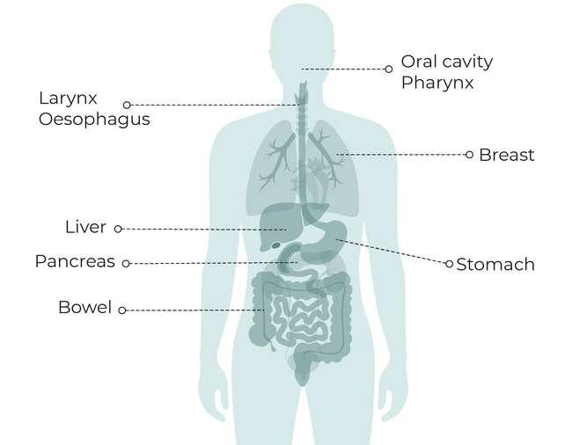
Source: Wild C, Weiderpass E, Stewart B (eds). 2020. World Cancer Report: Cancer research for cancer prevention. Lyon: International Agency for Research on Cancer. URL: http://publications.iarc.fr/586.

Initiatives are underway to reduce harm from alcohol, but there is a long way to go
The last 5 years has seen some action to reduce harm from alcohol in New Zealand and, in turn, alcohol-related cancers.
Alcohol harm reduction: The Alcohol Harm Reduction team in the Public Health Agency is working with Health NZ to continue to develop initiatives such as brief interventions and screening of alcohol in hospitals and general health settings.
Local mechanisms to address harm: In a Supreme Court ruling in 2023, Foodstuffs North Island and Woolworths lost their appeal that sought to prevent Auckland Council from restricting liquor sales trading hours and where new off-licences could open in the region. The ruling now allows Auckland Council to put mechanisms in place to address locally identified alcohol-related harm, with implications for how other councils and their communities regulate the sale of alcohol in New Zealand [81].
Updated legislation: The Sale and Supply of Alcohol (Community Participation) Amendment Bill [82], which seeks to increase the influence of local communities on alcohol licensing decisions in their area, was also passed in 2023. The Act allows councils to develop local alcohol policies (LAPs) in consultation with the local community, to influence factors like the number, location and opening hours of businesses licensed to sell alcohol in the area.
Community Action Fund: In February 2025, a new Community Action Fund was established to fund more local, community-led services and innovative local projects and initiatives to reduce alcohol-related harm. The first funding round of $1 million included grants, pilot projects and contracts. A second round of funding applications opened in late 2025 [83].
Alcohol levy increase: In 2023, the Ministry of Health, with the support of Health NZ, commissioned a review of the use of the alcohol levy. The levy comes from alcohol produced or imported for sale in New Zealand and allows the Ministry of Health to recover some of the cost of addressing the harm caused by alcohol. As a result of the review, the alcohol levy was increased from around $11.5 million a year to about $16.6 million a year, effective from 1 July 2024. The review recommendations are informing the Ministry of Health’s approach to administering and allocating the levy in future, including setting criteria for investment [84].

Most adults in New Zealand drink alcohol
Around three-quarters of adults (76%) in New Zealand drink alcohol [37]. While this has decreased slightly over the last 5 years (down from 82%), the proportion of adults drinking alcohol has not changed significantly since 2011 (Figure 44). New Zealand ranks at 32 out of 189 countries for alcohol consumption per capita [85].
The likelihood of a person drinking alcohol varies by gender, ethnicity, age and deprivation. In 2023/2024, males and those living in the least deprived areas of New Zealand were, in general, most likely to have drunk alcohol in the past year (80.8% and 80.7%, respectively). Within these broad groups, males between the ages of 35 and 44 years and males living in the least deprived areas were most likely to have drunk alcohol in the past year (85.7% and 85.3%, respectively). Females and Pacific and Asian adults were least likely to have drunk alcohol in the past year, with particularly low rates among women aged 15–17 years (47.6%), and Asian and Pacific females (43.9% and 47.9%, respectively).
In 2023/2024, the overall rate of hazardous drinking was 16.6% or 718,000 adults, a decrease from 20.4% in 2018/2019. The highest prevalence of hazardous drinking was among those aged 18–24 years (22.6%) and males (22.2%). Specific groups with high prevalence within these were 45–54-year-old men (30.3%) and tāne Māori (38.4%). Asian adults (5.7%) had the lowest rate of hazardous drinking compared with other ethnic groups: Māori (29.6%), Pacific peoples (16.2%) and European/other (17.9%).
Figure 44: Percentage of adults who drank alcohol in the past year, New Zealand, 2011–2024
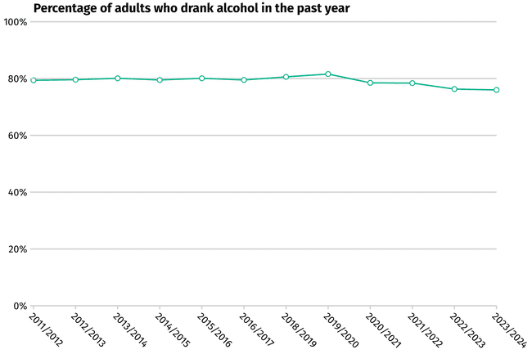
Note: The proportion of people in New Zealand who drink alcohol has remained relatively stable.
Source: New Zealand Health Survey 2023/2024.

A significant number of deaths from cancer in New Zealand were attributed to alcohol
A New Zealand study found that alcohol accounted for an estimated 1,250 new cancer cases in 2018, or 4.8% of all cancer registrations in New Zealand [86]. A significant number of deaths from cancer in New Zealand were attributed to alcohol, including 12% of all breast cancer deaths, 12% of bowel cancers deaths, 43% of lip and oral cavity (mouth) cancer deaths, 45% of nasopharyngeal (upper throat) cancer deaths and 52% of pharyngeal (throat) cancer deaths [86].
Māori experience a higher burden of alcohol-related cancers. In 2018, Māori had 21% higher alcohol-related cancer rates than non-Māori [86]. Māori are also dying from alcohol-related cancer deaths 2 years earlier than non-Māori and are more likely to experience disproportionate alcohol-related harm [87].

Most adults do not know that alcohol causes cancer
Alcohol remains readily available and accessible in New Zealand and public awareness of the link between alcohol and cancer is still poor. Only one in five adults in New Zealand surveyed in 2023 were aware that alcohol causes cancer [88]. Currently, New Zealand does not have any large-scale public awareness campaigns addressing alcohol as a cause of cancer. The only mandatory health warnings for alcohol in New Zealand warn against drinking during pregnancy and these were not required until 2023.

Nutrition can increase or decrease cancer risk
The foods people eat can increase or decrease the risk of them developing several cancers (Figure 45). For example, diets that are high in red meat increases the risk of bowel cancer, while diets containing dietary fibre and those high in calcium help protect against bowel cancer.
Figure 45: Association between nutrition and risk of cancer
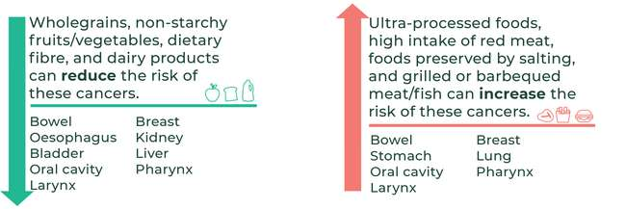
Sources: Wild C, Weiderpass E, Stewart B (eds). 2020. World Cancer Report: Cancer research for cancer prevention. Lyon: International Agency for Research on Cancer. URL: http://publications.iarc.fr/586; World Cancer Research Fund and American Institute for Cancer Research. 2018. Diet, Nutrition, Physical Activity and Cancer: A global perspective. Continuous Update Project Expert Report 2018. World Cancer Research Fund International. URL: www.wcrf.org/wp-content/uploads/2024/11/Summary-of-Third-Expert-Report-2018.pdf.

The number of people in New Zealand eating a nutritious diet is decreasing
In 2023/2024, only 1 in 10 adults (9.1%) in New Zealand ate the recommended amount of vegetables and just under half of adults (47.1%) ate the recommended amount of fruit [37]. Only 5.8% of adults ate both the recommended amount of vegetables and fruit, down from 6.6% in 2021/2022. Similarly, only 8.2% of children aged 2–14 years ate the recommended amount of vegetables, but 70.5% ate the recommended amount of fruit. In the 5 years from 2018/2019 to 2023/2024, the number of children eating breakfast everyday declined from 84.5% to 78.2%.
Over the last 5 years there has also been a rise in household food insecurity [37], which can limit regular access to cancer-protective foods like fresh fruit and vegetables. In 2023/2024 one in four children (27.0%) lived in households where food ran out often or sometimes, up from 14.9% of children in 2020/2021. Childhood exposure to household food insecurity is substantially higher in certain population groups. One in two Pacific (54.8%) and one in three Māori (34.3%) children were living in households where food ran out often or sometimes in the 12 months prior to New Zealand Health Survey 2023/2024. This compares with one in five European/other (21.9%) and one in six Asian (17.1%) children.

There have been efforts to improve nutrition over the last 5 years
The Government has progressed several actions relating to nutrition in New Zealand over the last 5 years, including improving access to nutritious foods through the Heart Foundation’s reformulation programme and the Health Star Rating, and Ka Ora, Ka Ako (Healthy School Lunches Programme), a large-scale Government initiative that provides lunches daily to the 25% of children in need of the greatest support, to help their learning and development [89].
Despite this progress, more work is needed. For example, a report released by the Public Health Advisory Committee, Rebalancing our food system, examined the deficiencies in the way food is produced, consumed and distributed in New Zealand [90]. The report found the New Zealand food system is out of balance and urgent action is needed to protect the health and wellbeing of people in New Zealand [90]. Further, New Zealand does not regularly collect detailed information on nutrition at a population level. The last nutritional surveys were conducted nearly 15 years ago among adults and over 20 years ago for children [91].

Reducing excess body weight can lower a person’s risk of developing cancer
Reducing excess body weight can lower a person’s risk of developing cancer [92]. Supportive options include structured exercise in combination with dietary changes and behaviour therapy. In some cases, medication or bariatric (weight-reduction) surgery might be considered [93]. However, maintaining weight loss over time can be extremely difficult and long-term population-level focused prevention initiatives and measures should also be considered – prevention that prioritises creating health environments and addresses the structural and systemic barriers that make healthy living difficult for many communities.
Excess body weight can increase the risk of developing several types of cancers (Figure 46). This happens through a series of biological changes, such as higher levels of insulin, that help cancer cells grow [94].
Figure 46: Cancers related to excess body weight
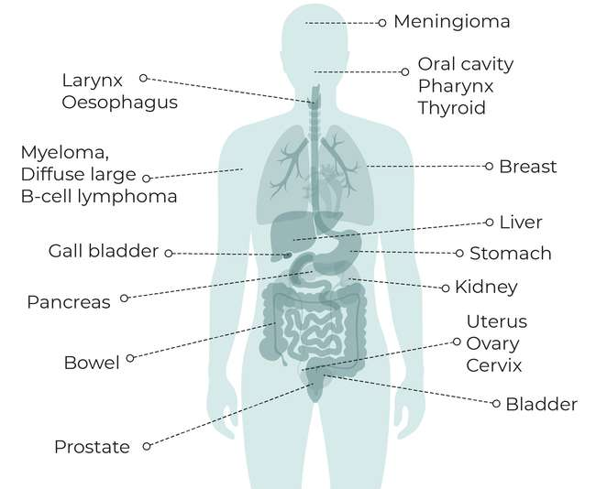
Source: Wild C, Weiderpass E, Stewart B (eds). 2020. World Cancer Report: Cancer research for cancer prevention. Lyon: International Agency for Research on Cancer. URL: http://publications.iarc.fr/586.
Between 2019 and 2023, 5.1% of all cancer cases among adults aged 30 years and above were potentially attributable to excess body weight [95]. Māori and Pacific peoples have a higher burden of cancers related to excess body weight, such as uterine and breast cancers. Pacific peoples have the highest rate (11.8%) of cancers related to excess body weight, and this is highest among Pacific females (16.1%) [95].

Nearly 1.5 million adults in New Zealand are classified as obese
In 2023/2024, one in three adults were classified as obese (33.8% or nearly 1.5 million), up from 31.3% (1.2 million) in 2018/2019. During the same year, an additional 33.1% or 1.4 million people were classified as overweight, down from 34.2% in 2018/2019. One in eight children aged 2–14 years were classified as obese (12.5%) and nearly one in five as overweight (19.0%) in 2023/2024, compared with 11.4% and 19.9%, respectively, 5 years prior [37]. In 2023/2024, nearly half of adults (47.8%) living in the most deprived areas were classified as obese, compared with one-quarter of adults (25.7%) living in the least deprived.
In terms of differences by ethnicity in the prevalence of obesity among adults, the New Zealand Health Survey 2023/2024 identified just under two-thirds of Pacific peoples, one-half of Māori and one-third of European/other adult respondents as obese [37]. A smaller proportion of Asian adults were identified as obese, approximately one in six. These rates have remained relatively stable since 2011/2012, with slight increases for Pacific peoples, Māori and European/other, and a decrease among Asian populations.
There are also differences in prevalence of excess body weight in disabled adults, with disabled adults being 1.3 times as likely to be obese than non-disabled adults [37].
Within Organisation for Economic Co-operation and Development (OECD) countries, New Zealand adults have the third-highest rates of obesity and second-highest childhood prevalence of obesity [96].
Please note: ‘Obesity’ is defined in the New Zealand Health Survey using body mass index (BMI), which is recognised as an imperfect measure of excess body fat across different ethnicities. When compared with people of European/other ethnicity, Māori and Pacific peoples have a higher proportion of lean body mass, while this is generally lower among Asian populations. As a result, the same BMI across different ethnicities can reflect differing levels of excess body weight and health risk associated with this.

Physical activity can protect people against cancer, and sedentary behaviour can increase risk
Physical activity can help protect people against several cancers (Figure 47).
Figure 47: Association between physical activity and risk of cancer
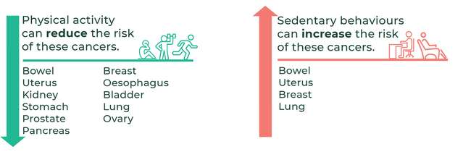

The number of people in New Zealand being physically active is decreasing
The number of people exercising weekly in New Zealand is decreasing. In 2023/2024, less than half (46.6%) of adults met physical activity guidelines, down from over half (50.9%) in 2018/2019. One in seven adults (13.6%) did little or no physical activity and this was more likely for adults living in the most deprived areas compared with adults in the least deprived (19.9% and 11.1%, respectively).
There is evidence that sedentary behaviour can increase the risk of developing some cancers [97] (Figure 48).
Figure 48: Cancers related to physical inactivity or sedentary behaviour
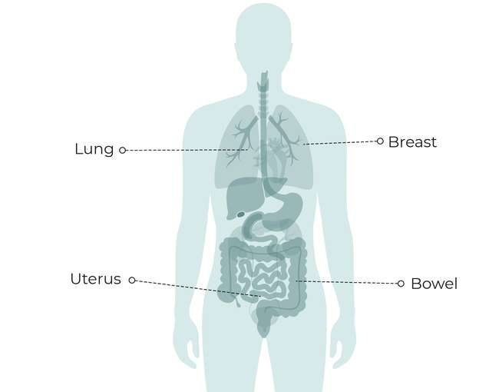
Source: Wild C, Weiderpass E, Stewart B (eds). 2020. World Cancer Report: Cancer research for cancer prevention. Lyon: International Agency for Research on Cancer. URL: http://publications.iarc.fr/586.

There have been efforts to improve physical activity over the last 5 years
The Government has progressed several actions to improve physical activity in New Zealand over the last 5 years, including:
- cross-government support to deliver the National Physical Activity and Play Plan, led by SportNZ [98]
- supporting children to be active and healthy through the Healthy Active Learning workforce
supporting community-led action to build healthy environments through the Healthy Families programme.
Despite this progress, more work is needed.

UV radiation from the sun is the main cause of skin cancer in New Zealand
UV radiation is a type of energy released naturally by the sun and artificially from sunbeds. Exposure to too much UV radiation is the main cause of skin cancer [99]. Most types of skin cancer are preventable, yet New Zealand has one of the highest incidence rates in the world [100] [101]. A major contributing factor to this is New Zealand’s high UV levels, which are higher than comparable Northern hemisphere latitudes [102]. For example, between 2004 and 2023, locations like Leigh (Auckland region) had an average of 137 days per year with peak UV intensity at very high or extreme levels [103].
The main categories of skin cancer are cutaneous melanoma (commonly known as melanoma) and non-melanoma skin cancer (also known as keratinocytic cancer). The New Zealand Cancer Registry includes details of all cutaneous melanoma diagnosed, but stopped collecting information on non-melanoma skin cancers in 1958. In 2022, there were over 3,000 melanoma registrations in New Zealand [2], while research suggests more than 90,000 people are diagnosed with at least one non-melanoma skin cancer every year [104]. Although melanoma is far less common than non-melanoma skin cancer, it is more likely to result in death.
Skin cancer is more common in people of European/other ethnicity and males, and the risk increases with age [8]. Māori and Pacific peoples have lower risk of melanoma but poorer survival [63].
Skin cancer presents a substantial burden on patients, with approximately 500 people losing their lives to skin cancer in New Zealand in 2018 [105].
Skin cancer also costs the country financially. The financial impact of skin cancer in New Zealand in 2025 is estimated at $494.9 million from direct health care costs and loss of productivity [105]. At the same time, government investment in skin cancer prevention and early detection decreased from $1.2 million in 2005 to $275,000 in 2023/2024 [105].
New Zealand currently spends over 1,600 times more treating skin cancer than preventing it.
Skin cancer cases are projected to increase due to the New Zealand population ageing and having ongoing exposure to high levels of UV radiation. However, the number of people aged under 40 years diagnosed with melanoma over the last decade has declined significantly [106]; this is likely due to successful public health campaigns around SunSmart practices and early warning signs.
In 2025, the Melanoma Network (MelNet) published the Skin Cancer Prevention and Early Detection Strategy (2024–2028) [105], which makes recommendations aimed at reducing the impact and incidence of skin cancer through prevention and early detection [105]. It supports the outcomes identified in the Government health care frameworks and sits alongside the Quality Statements to Guide Melanoma Diagnosis and Treatment in New Zealand [107], which also cover best practice melanoma diagnosis, treatment and care.
Health NZ funded the development of the strategy and also funded several related activities in 2024/2025.

Initiatives to reduce the impact of chronic infections can prevent cancers
It is estimated that, globally, around 13% of all cancers are caused by infections [108]. Four main types of infections account for approximately 90% of the infection-related cancers: Helicobacter pylori (H. pylori), human papillomaviruses (HPVs) and hepatitis B and C viruses [109] (Figure 49). Other cancer-causing infections include Epstein-Barr virus (EBV), human immunodeficiency virus (HIV) and human T-cell leukaemia/lymphoma virus type 1 (HTLV-1).
Most people who get these infections do not develop cancer. However, they are more likely to develop cancer if the infection remains in the body for a long period of time (chronic infection) or if other contributing high-risk factors such as alcohol or smoking are present [110].
Figure 49: Cancers related to Helicobacter pylori, human papillomaviruses and hepatitis B and C viruses
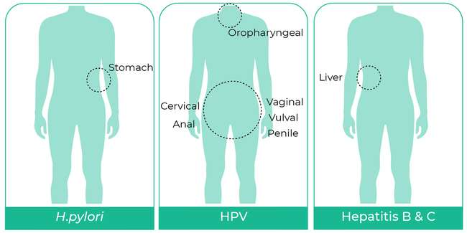
Hepatitis B and C viruses
Human papillomaviruses
H. pylori

H. pylori
H. pylori is a bacterium that infects the lining of the stomach. If left untreated it can lead to people developing ulcers, tissue damage and cancers of the lower stomach.
New Zealand has a lower overall incidence of stomach cancer (6.1 per 100,000 in 2022) [2] compared with other international populations (11.1 per 100,000) [111]. Despite this, significant inequities exist, with Māori and Pacific peoples being around three times more likely to develop stomach cancer than the European/other population, and experience worse survival and mortality outcomes [44]. Between 2018 and 2022, mortality rates were significantly higher for Māori (7.1 per 100,000) and Pacific peoples (8.4 per 100,000) compared with people of Asian (2.7 per 100,000) and European/other (2.6 per 100,000) ethnicities [2].
Infection with H. pylori has been shown to be a major contributor to these ethnic inequities, accounting for 50% and 82% of the excess stomach cancer incidence among Māori and Pacific peoples [112].
The Cancer and Chronic Conditions (C3) research group at the University of Otago is conducting a research study to identify the drivers for both the inequities in incidence and survival from stomach cancer, including the prevalence and role of H. pylori, and investigate possible ways to address these [113].
Challenges to managing H. pylori infection include inconsistent testing guidelines for health practitioners, an increase in antibiotic resistance to H. pylori and inconsistent access to treatment for patients. In 2024, the Malaghan Institute of Medical Research launched a new clinical research programme to develop and validate new methods to test for antibiotic resistance in H. pylori to guide antibiotic prescribing. This could help to individualise treatment regimens so the right antibiotic can be prescribed for the right person, while also reducing inappropriate antibiotic prescribing.

Human papillomaviruses
Human papillomaviruses (HPVs) are a common group of viruses that spread through direct skin-to-skin contact, especially during sexual activity. HPVs are the main cause of several cancers including anal (90%), vaginal (75%), vulval (69%), penile (63%) and oropharyngeal (middle of throat) (70%). Virtually all cervical cancers are caused by HPVs [114].
Most people infected with HPVs do not develop cancer. This is because not all types of HPV cause cancer and most people (98%) clear the virus completely and do not develop chronic infections that can lead to cancer.
In 2022, there were 164 cervical cancer registrations in New Zealand and 37 females died from cervical cancer [2]. This is a decrease from 173 cervical cancer registrations and 62 deaths the year before. Wāhine Māori and Pacific females have higher rates of cervical cancer and higher mortality from cervical cancer than females of European/other ethnicity [2].
In August 2020 the World Health Assembly adopted the Global Strategy for cervical cancer elimination [115], part of the Cervical Cancer Elimination Initiative [116]. The strategy includes three targets that countries must meet by 2030 to be on the path to eliminate cervical cancer:
- 90% of girls are fully HPV vaccinated by 15 years of age
- 70% of women are screened by 35 years of age and again by 45 years of age
90% of women identified with cervical disease receive treatment (90% of women with precancer treated and 90% of women with invasive cancer managed).
New Zealand has committed to this strategy [117]. HPV vaccination began in New Zealand in 2008, initially offered to specific female birth cohorts. Eligibility expanded over time and from 2017 became free for everyone aged 9–26 years old. The vaccine is offered through most schools and is also available via community immunisation providers.
In 2022, the World Health Organization updated its recommendations for the HPV vaccine, supporting the use of a single-dose schedule as an alternative to the two-dose schedule [118]. This reflects emerging clinical evidence that a single dose provides sufficient protection [119]. Some countries, including Australia, have shifted to one-dose HPV vaccination. Currently, the approved regime in New Zealand remains as two or three doses, depending on age at first dose.
Health NZ is currently working towards a target of 75% for both HPV dose one and two. HPV immunisation coverage has been consistently low – under 70% – in New Zealand. Given that the HPV vaccine was only made available to both boys and girls from 2017, uptake is particularly low among young adults, those aged 18–25 years. Once the 75% target is achieved, the target will then be lifted to 90% to align with recommended global best practice.
Cervical screening is discussed more in 3 Screening for cancer.

Hepatitis B and C viruses
Hepatitis B and C viruses infect the liver and cause 80% of liver cancers in New Zealand [63]. Some people who get these viruses go on to develop chronic infections. A small percentage of those with chronic hepatitis B or C infections develop liver cancer. In 2022, there were 421 liver cancer registrations in New Zealand, with 341 deaths [2].
Since New Zealand introduced hepatitis B immunisation for infants in 1988, the prevalence of chronic hepatitis B infection has fallen dramatically. Currently, immunisation rates are high, with nearly 90% of 2-year olds fully immunised in 2024 [120]. However, the rate has dropped from 93% for the years 2016–2020. This drop in vaccination coverage is likely due to the impact of the COVID-19 pandemic [121]. In March 2024, the Government introduced the health target of 95% of children fully immunised at 24 months of age. This focus should improve the rates of several childhood immunisations, including hepatitis B, in the coming years in New Zealand.
Over the last 5 years, several initiatives aimed at reducing the prevalence and impact of hepatitis C have been progressed. These align with global efforts to eliminate viral hepatitis as a public health threat by 2030 [122]. In 2021, the Ministry of Health published a National Hepatitis C Action Plan for Aotearoa New Zealand 2020–2030 [123]. The plan focuses on improving the equity of health outcomes for all people in New Zealand living with hepatitis C. The five areas of focus are: awareness and understanding; prevention and harm reduction; testing and screening; surveillance and monitoring; and integration and access to care.

Where people work can increase their risk of getting cancer
Preventing people’s exposure to carcinogens in the workplace can reduce their risk of developing cancer and respiratory diseases.
In New Zealand, around 31% of work-related harm and around 650 deaths per year are caused by cancers and respiratory diseases [124].
The New Zealand Carcinogens Survey, commissioned by WorkSafe New Zealand in 2021, was the first survey of its kind that examined the prevalence of occupational-related carcinogens in the working population [125]. Findings from the 4,051 workers surveyed showed that 58% of workers were exposed to at least one cancer-causing agent at work, with around one in three exposed to a work-related carcinogen at a high level [125]. The five most-common carcinogenic agents (at any exposure level) in a New Zealand workplace were benzene, solar UV, ocular UV, diesel engine exhaust and environmental tobacco smoke [125].
The distribution of workplace carcinogen exposure differed by gender and ethnicity. Māori, Pacific peoples and males were most likely to be exposed to at least one carcinogen at any level in the workplace [125].
The New Zealand Carcinogens Survey recommendations include establishing an occupational health service to focus on improving access to screening and health care for workers at high risk of carcinogen exposure [125]. The survey findings are being used to support the Government’s Health and Safety at Work Strategy 2018–2028 [126].
Over the last 5 years, accelerated silicosis has emerged as a serious occupational health condition mainly affecting people working with artificial stone benchtops, often in industries like mining, construction and stone-cutting [127]. The condition can cause serious health problems including lung cancer. In 2020, in response to increasing rates of accelerated silicosis in artificial stone workers overseas, the Ministry of Health, WorkSafe and the Accident Compensation Corporation established the Accelerated Silicosis Assessment Pathway [128]. The pathway outlines a process for assessing people at risk of accelerated silicosis in the workplace through several steps including an Accident Compensation Corporation assessment to inform claim decisions.

3 Screening for cancer | Te mātai mō te mate pukupuku

Key messages
- Screening aims to detect cancer early or identify precancerous changes, enabling cancers to be diagnosed and treated at an earlier stage.
- Improvements are being made to existing screening programmes to remove barriers and ensure more people are screened.
- Changes over the last 5 years to these programmes include eligibility age-range changes for bowel and breast cancer screening, and a switch to primary HPV screening with the option of self-testing for cervical cancer.
- The COVID-19 pandemic resulted in a substantial drop in the number of people participating in all screening programmes and participation has not yet returned to
pre-COVID levels for breast screening.
- While the screening programmes are close to reaching their target coverage, none have yet done so. In August 2024, bowel screening reached 57.1% coverage (target 60%) and in December 2024, breast screening reached 69.7% coverage (target 70%) and cervical screening 72.7% coverage (target 80%). These improved rates are very positive, but ongoing focus is needed to ensure the targets are met, and ideally exceeded. There are significant inequities for Māori and Asian populations across all screening programmes and for Pacific peoples across some screening programmes.
Work is underway to potentially introduce a national lung cancer screening programme in New Zealand over the next few years.

New Zealand has three national cancer screening programmes: breast, cervical and bowel.
Screening aims to detect cancer early or identify precancerous changes, enabling cancers to be diagnosed at an earlier stage. When people have their cancer detected and diagnosed at an early stage, it is often easier to treat or cure and they have better treatment outcomes, a better chance of survival and a lower risk of complications associated with treatment. Cervical and bowel screening can also reduce the incidence of these cancers by detecting and removing precancerous polyps.
Improvements in screening can be made by lifting participation rates, strengthening current screening programmes and introducing new screening programmes.

There has been substantial investment in and changes to national cancer screening programmes over the last 5 years
A number of changes have been made within the three national cancer screening programmes across New Zealand. Some of the key details are highlighted below.

Breast screening is available to more people and improvements are being made to the programme
Age extension: In February 2024 the Government confirmed plans to progressively extend the age range for free breast screening to include 70–74-year-olds. Implementation of the extension began in the Nelson Marlborough district in October 2024. It is being progressively rolled out across New Zealand.
Review of BreastScreen Aotearoa: A quality improvement review of the national breast screening programme, Breastscreen Aotearoa, was published in May 2023 [129]. The review identified areas for improvement, particularly participation and experience for wāhine Māori and Pacific females. Health NZ funded 27 initiatives to address the review’s recommendations and, in June 2024, published an action plan detailing progress on implementing those recommendations [130].
Te Puna rollout: In 2025, a new, single, online, nationwide breast screening system, Te Puna, replaced the existing eight systems [131]. Te Puna introduces a population-based register to the Breastscreen Aotearoa programme for the first time and enables a systematic approach to the identification and invitation of the eligible population. Before Te Puna, females were required to self-identify to enrol in the Breastscreen Aotearoa programme before they were offered an appointment (‘opt-in’ enrolment). Now females are automatically identified as they become eligible.

Cervical screening has a better screening test and is reaching more people
Change to primary HPV testing: In September 2023, primary HPV screening replaced the previous cytology-based ‘smear’ programme. Primary HPV testing is more sensitive than cytology testing and this new test means people can be tested every 5 years instead of every 3 years. It also gives females the option of self-testing. Self-testing has been shown to help more people access testing and improve equity in coverage [132].
Free cervical screening: The Government reconfirmed funding through to June 2026 to provide free cervical screening for high-priority groups, including Māori and Pacific peoples, people with a Community Services Card and people who are very overdue to be screened.
Cervical cancer elimination: In August 2020 the World Health Assembly adopted the Global Strategy for cervical cancer elimination [115], part of the Cervical Cancer Elimination Initiative [116]. New Zealand has committed to the strategy [117], which includes a target to have 70% of women screened using a high-performance test by the age of 35 years, and again by the age of 45 [133]. The initiative is discussed further in 2 Preventing cancer.

More people are now eligible for bowel screening
Completion of initial rollout: The phased rollout of the National Bowel Screening Programme was completed in June 2022 with bowel screening available throughout New Zealand for all people aged 60–74 years.
Lowering of bowel screening age: As part of Budget 2022, the Government allocated $36 million over 4 years to lower the eligible starting age for bowel screening from 60 years to 50 years for Māori and Pacific peoples. This was trialled in three districts (MidCentral, Tairāwhiti and Waikato). However, in March 2025, the Government announced it would redirect the Budget 2022 allocation and lower the age of eligibility to 58 years for all people in New Zealand. The change was deemed controversial by many health experts and sector groups [134] [135] [136] [137].
Lowering the screening age from 60 years to 58 years will increase the number of cancers identified and deaths prevented when examining the whole population (across all ethnicities). Compared with the previous age range of 60–74 years, at least 122,000 more people will be eligible for bowel screening over the first year. Rollout of the expanded eligibility began in two regions in October 2025, with the other two regions to begin in March 2026. The Government has also committed to lowering the age of eligibility for bowel screening progressively to align with Australia (where people are eligible for bowel screening at age 45) when the health system has the capacity to do so effectively and safely [138].
Awareness campaign: A national bowel screening awareness multimedia campaign ran from 2022 to 2024 to encourage people to take part in screening. The campaign was developed through co-design, with a particular focus on Māori and Pacific peoples. The campaign has successfully increased awareness and knowledge of bowel cancer screening [139].

Emerging considerations for screening programmes
Improving participation remains a focus for all screening programmes. In addition, there are other issues to consider within existing programmes. These include age-range changes – both upper and lower limits (eg, many comparable countries start bowel screening at a younger age, with Australia starting at 45 years) – and questions about increasingly targeted/risk-stratified screening pathways (eg, implications of breast density for the breast cancer screening programme).
New Zealand is also constantly evaluating the potential for new screening programmes. Any decision about introducing new programmes weighs benefits, harms, equity impacts and resource allocation. Two advisory groups, the National Screening Advisory Committee and the Māori Monitoring and Equity Group, advise Health NZ on changes to existing screening programmes and any potential new programmes for consideration (for example, for prostate cancer screening) when the evidence and system resources clearly support them.
The National Screening Advisory Committee also monitors technological advancements that may change the way screening is undertaken in the future, including the use of biomarker testing, multi-cancer early detection tests and the use of artificial intelligence (AI) in screening.

Making screening accessible for all population groups is still a challenge
Supporting all population groups to access screening remains a challenge, with many people having unmet needs. While the three national cancer screening programmes are close to reaching government targets, the COVID-19 pandemic caused a substantial drop in the number of people participating in all screening programmes, which has remained for breast screening. Emerging evidence also suggests that disabled people are being under-screened. These and other topics are discussed below.

COVID-19 disrupted screening
Similar to international experiences, in New Zealand the COVID-19 pandemic resulted in extensive disruption to people participating in screening services. Substantial work has been done to address the gaps created by the pandemic; while this has been effective for cervical screening (Figure 50), breast screening has not yet returned to ‘pre-COVID’ coverage (Figure 51). Data is not reported for bowel screening because the programme was being rolled out during this time period.
Figure 50: Difference in percentage of eligible people who have had cervical screening compared with before COVID-19, by ethnicity, New Zealand, March 2020–December 2024
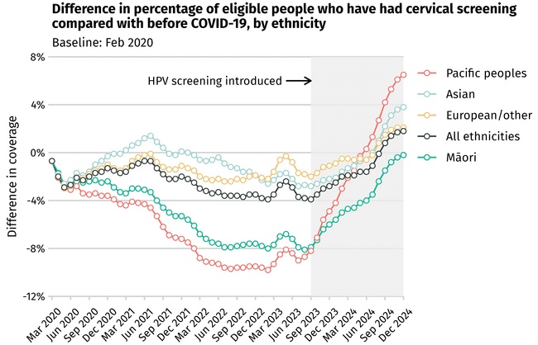
Notes: Compared with the pre-COVID period, participation in cervical screening dropped for all ethnicities. Since self-administered HPV screening became an option in September 2023, participation has increased for all groups. ‘European/other’ refers to non-Māori, non-Pacific, non-Asian.
Source: National Cervical Screening Programme data tool.

Figure 51: Difference in percentage of eligible people who have received breast screening compared with before COVID-19, by ethnicity, New Zealand, March 2020–December 2024
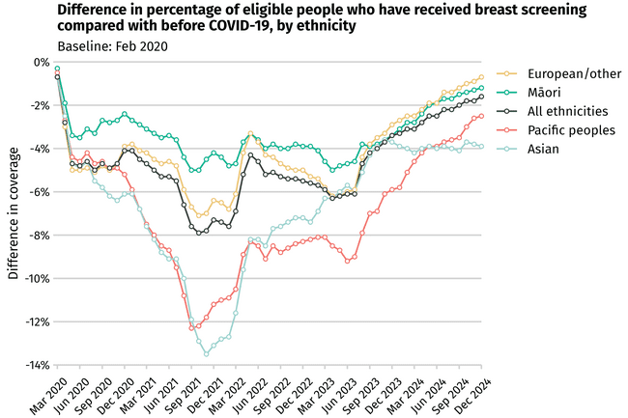
Notes: Compared with the pre-COVID period, participation in breast screening dropped for all ethnicities, and, although improving, by December 2024, had not yet recovered to those levels. ‘European/other’ refers to non-Māori, non-Pacific, non-Asian.
Source: BreastScreen Aotearoa.

Evidence shows disabled people are under-screened
Evidence from a recent literature review shows that disabled people are screened at a lower rate than non-disabled people, placing them at greater risk for delayed diagnosis and cancer mortality [36]. Screening rates appear to be even lower for disabled Indigenous populations [140]. People with learning disabilities are screened at a lower rate than those without learning disabilities.
These findings are based on international research; however, the situation is likely to be similar in New Zealand. Data limitations currently restrict analysis of disabled people’s access to screening programmes in New Zealand.

More people should be getting screened for breast cancer – particularly wāhine Māori and Asian females
Following disruption caused by the COVID-19 pandemic, the rates for females participating in breast screening reached a low in 2021. However, rates have been steadily increasing for most population groups since then, with a 2-year coverage of 69.7% in December 2024 – close to the 70% target. Despite this, marked inequities remain, with wāhine Māori (63%) and Asian females (62%) having lower rates (Figure 52).
Figure 52: Percentage of eligible people who have had breast screening, by ethnicity, New Zealand, December 2018–December 2024
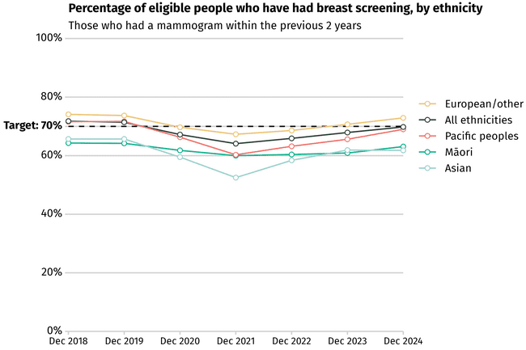
Note: ‘European/other’ refers to non-Māori, non-Pacific, non-Asian.
Source: BreastScreen Aotearoa.

More people are being screened for cervical cancer since primary HPV testing was introduced
In 2022, there were 164 new cervical cancer registrations and 37 people died from cervical cancer [2]. Ethnic inequities persist, with Māori and Pacific peoples being more likely to get cervical cancer and die from it. Of the people who develop cervical cancer in New Zealand, 85% have either never been screened or have been screened infrequently [141].
In the last 5 years, there had been a drop in the number of females participating in cervical screening. Coverage fell to a low of 57% for Māori, 55% for Pacific peoples and 67% overall in December 2022. However, since the introduction of primary HPV testing and the option of self-testing in 2023, there has been a steady increase in coverage (Figure 53). Between September 2023 and the end of 2024, more than 310,000 females were screened, with 81% choosing the new primary HPV screening and 19% of those choosing to self-test had been unscreened or under-screened prior to 12 September 2023 [142].
Figure 53: Percentage of eligible people who had cervical screening, by ethnicity, New Zealand, December 2018–December 2024
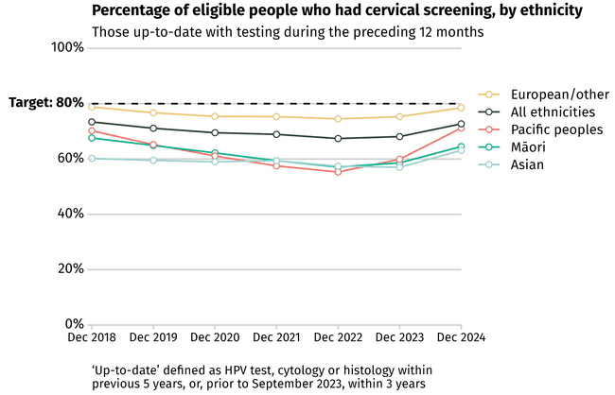
Notes: HPV = human papillomavirus. ‘European/other’ refers to non-Māori, non-Pacific, non-Asian.
Source: National Cervical Screening Programme.

More people are getting bowel cancer screening, but participation is still below target and varies by ethnic group
The overall number of people having bowel screening has increased over the last 5 years as national rollout of the screening programme has been completed. As of August 2024, of the 819,434 people invited for bowel screening, 470,691 participated (Figure 54). Despite this increase, overall, as at August 2024, bowel screening participation remained below the 60% target, particularly for Pacific (38%), Asian (43.5%) and Māori (49.8%) populations (Figure 55).
Figure 54: Number of eligible people who had bowel screening (invited vs completed), New Zealand, August 2020–August 2024
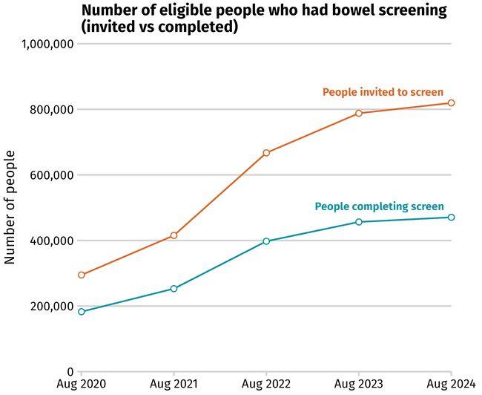
Note: Data lags by 6 months to account for the time it takes for samples to be returned.
Source: National Bowel Screening Programme.

Figure 55: Percentage of invited people who participated in bowel screening, by ethnicity, New Zealand, August 2020–August 2024
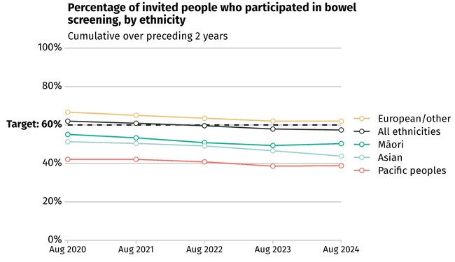
Notes: Data lags by 6 months to account for the time it takes for samples to be returned. ‘European/other’ refers to non-Māori, non-Pacific, non-Asian.
Source: National Bowel Screening Programme.

Work is underway to potentially introduce lung cancer screening to New Zealand in the next few years
Lung cancer is the leading cause of cancer death for people in New Zealand and a key contributor to health outcome inequities. Māori were nearly three times more likely (95% CI 2.76–3.01) to be diagnosed with lung cancer than people of European/other ethnicity in 2018–2022. Emerging evidence also suggests disabled people were 1.71 times more likely to be diagnosed with lung cancer than the general population in 2018–2022 (see 1 The burden of cancer in New Zealand). Lung cancer survival in New Zealand is poor compared with comparable countries; it ranked sixth out of seven high-income countries for 5-year survival [43].
International evidence from randomised controlled trials has found that low-dose computed tomography (CT) screening of people with substantial history of smoking can reduce their risk of dying from lung cancer by 20%–26%, with higher benefit (36%) for females [143] [144] [145] [146] [147]. Research in the New Zealand context has found a lung cancer screening programme is likely to be both cost effective and feasible [148] [149].
Since 2018, researchers from the University of Otago have been gathering evidence to inform the design of an equitable, culturally safe and effective lung cancer screening programme in New Zealand. The project, called Te Oranga Pūkahukahu, received Health Research Council funding to investigate the use of biomarkers and AI in lung cancer screening (see Emerging technologies have the potential to impact cancer control for more information on genomics and AI). The research found that there is potential for lung cancer screening to make a significant impact on lung cancer outcomes and associated inequities in New Zealand. However, there are many challenges to implementing a national programme in New Zealand. This research is directly informing work on a potential national lung cancer screening programme.

4 Getting a cancer diagnosis | Te tautohu mate pukupuku
pathway

Key messages
- For patients and whānau, hearing that they have been diagnosed with cancer is often a very difficult, overwhelming and confusing point in their lives. The diagnosis process should be supportive, whānau-centred and culturally safe.
- Confirming a cancer diagnosis can be complex and may require multiple tests in different settings.
- The timeliness of a cancer diagnosis is critical, however, New Zealand continues to lag behind comparable countries when it comes to early detection and timely diagnosis.
- Wait times from urgent referral to treatment are increasing. An important contributing factor to those wait times is the extended time often needed to complete required diagnostic tests.
- A high proportion of people in New Zealand with cancer are being diagnosed following an emergency department admission, which is associated with late-stage diagnosis, poorer outcomes and greater levels of distress for patients and their whānau.
- The high proportion of people having cancer diagnosed following an emergency department admission indicates an opportunity to improve detection rates of early signs of cancer in primary and community care.
- Māori and Pacific peoples and people living in areas of high deprivation continue to be more likely to be diagnosed following an emergency department admission in almost all districts for almost all cancers.
- The Government recently announced investments and innovations in primary care that have the potential to make it easier for people to see a GP. Primary health care providers are often the first point of contact for people with symptoms of cancer. Although New Zealand has almost universal enrolment in primary care, being able to see a GP remains problematic for many people, with long wait times to access a GP being the most reported barrier.
- Progress has been made in bringing some diagnostics closer to home for people and improving national access to specific tests. Despite this, regional variation persists in access to diagnostics.

Cancer is more treatable when it is diagnosed quickly and accurately at the earliest stage possible. The tests and procedures needed to investigate symptoms that may indicate cancer must be easily available and quickly accessible. These tests should also produce straightforward results that clearly indicate whether patients have cancer.
Diagnosing cancer can be a complex process because people’s symptoms can often be non-specific and some cancers can have few, if any, early symptoms. People may need to have multiple different tests, performed by different clinicians and in different settings, such as primary care, the local community and/or a hospital or specialist setting. At the same time, over-testing can lead to avoidable investigations which carry risk of harm; this is why a balance is needed to ensure the right tests are ordered for the right symptoms.

Timely diagnosis improves survival
Timely cancer diagnosis is important to improve a person’s chance of surviving and having good quality of life after diagnosis [150]. Diagnosing cancer at an early stage increases the chance of patients having curative treatment options available.
Figure 56 shows that, for four common cancers, the more advanced the cancer is at diagnosis the more years of life for the person are lost. The figure also shows that, at every stage of diagnosis, Māori experience more years of life lost than non-Māori diagnosed at the same stage.
Figure 56: Average number of years of life lost to selected cancers, by stage and ethnicity, New Zealand, 2017–2019
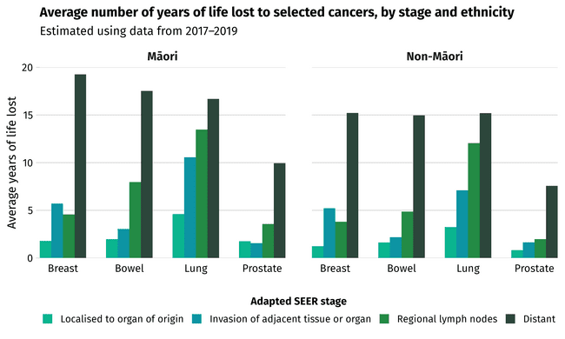
Notes: The years of life lost due to cancer can be estimated by comparing the patient’s age at death to their life expectancy. The years of life lost increases substantially when the cancer stage is more advanced at the time of diagnosis. In general, the number of years of life lost is higher for Māori compared with non-Māori. The deaths of a significant number of people can be avoided if their cancer is diagnosed at an earlier stage.
SEER = Surveillance, Epidemiology and End Results programme. Definitions of SEER stages in this figure are: localised to organ of origin = cancer is only in the organ where it started and has not spread to other parts of the body; invasion of adjacent tissue or organ = cancer has directly extended and penetrated neighbouring tissues or organs; regional lymph nodes = cancer cells have spread to nearby lymph nodes; distant = cancer has spread to distant organs or distant lymph nodes.
Sources: New Zealand Cancer Registry and Mortality Collection data was used to get patients’ diagnosis and death information, and Stats NZ life tables (including the life expectancy for given age) were used to calculate years of life lost.

Figure 57 shows the estimated number of deaths that could have been avoided if people diagnosed with cancer between 2017 and 2019 had received that diagnosis one stage earlier, assuming survival outcomes similar to those diagnosed one stage earlier. This shows, for example, that over 1,000 lives would have been saved in New Zealand if people who had been diagnosed with the most advanced stage of bowel cancer over this time had been diagnosed just one stage earlier.
Figure 57: Potentially avoidable deaths within 5 years of diagnosis if cancer was diagnosed one stage earlier, by cancer type, New Zealand, 2017–2019
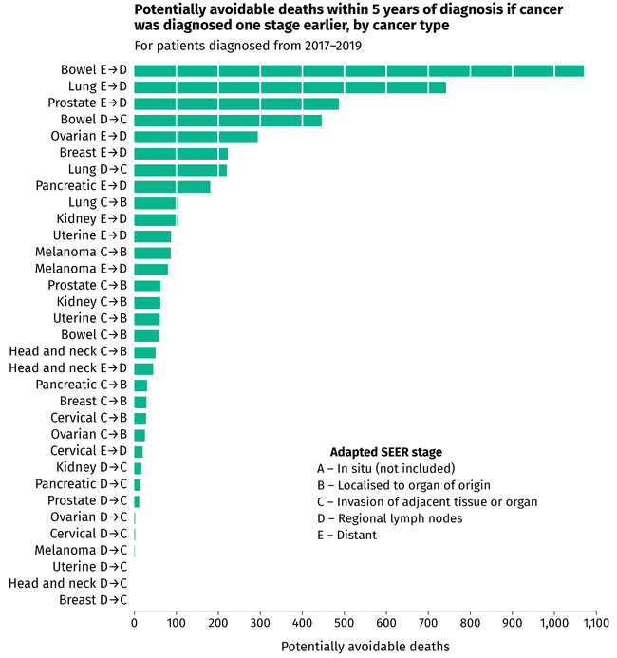
Note: SEER = Surveillance, Epidemiology and End Results programme.
Definitions of SEER stages in this figure: in situ = cancer is non-invasive and has not spread to surrounding tissues or organs; localised to organ of origin = cancer is only in the organ where it started and has not spread to other parts of the body; invasion of adjacent tissue or organ = cancer has directly extended and penetrated neighbouring tissues or organs; regional lymph nodes = cancer cells have spread to nearby lymph nodes; distant = cancer has spread to distant organs or distant lymph nodes.
Source: New Zealand Cancer Registry.

For females, earlier detection of bowel, lung, ovarian and breast cancers would have the biggest impact on reducing avoidable deaths. For males, earlier detection of bowel, prostate and lung cancers would have the biggest impact on avoidable deaths and, therefore, years of life saved (Figure 58).
Figure 58: Potentially avoidable deaths within 5 years, if cancer diagnosed one stage earlier, by sex and type, New Zealand, 2017–2019
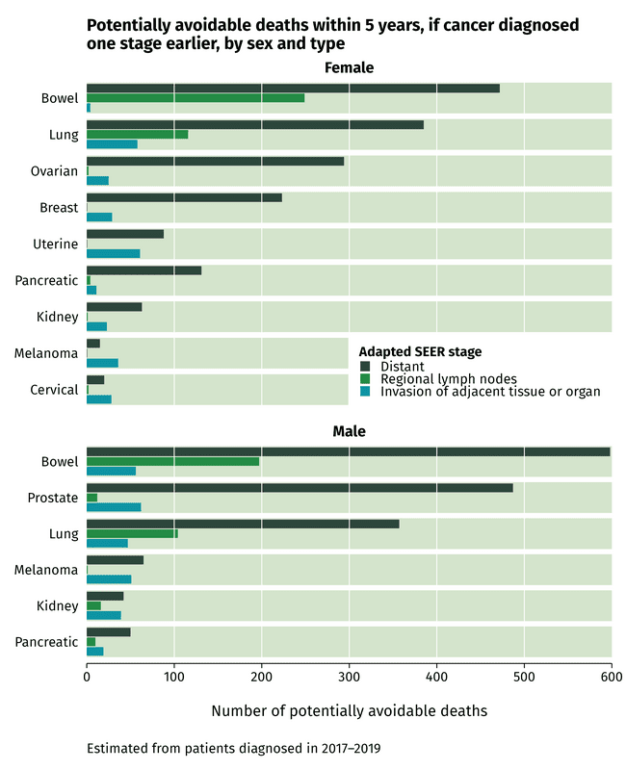
Notes: SEER = Surveillance, Epidemiology and End Results programme. Definitions of SEER stages in this figure are: distant = cancer has spread to distant organs or distant lymph nodes; regional lymph nodes = cancer cells have spread to nearby lymph nodes; invasion of adjacent tissue or organ = cancer has directly extended and penetrated neighbouring tissues or organs.
Source: New Zealand Cancer Registry.

Delays in diagnosis impact time to treatment
One way to measure whether the diagnostic pathway is operating effectively is the nationally reported wait time from urgent referral to start of treatment (62-day target). When people are referred to hospital and specialist services with a high suspicion of cancer, they should be diagnosed and begin their first cancer treatment within 62 days of the hospital receiving the referral. However, as Figure 59 shows, the proportion of people starting treatment within 62 days has been declining over the last 5 years. Delays in diagnosis will be contributing to this decline.
Figure 59: Percentage of patients receiving treatment within 62 days of receipt of referral with high suspicion of cancer, by ethnicity, New Zealand, 2020–2024
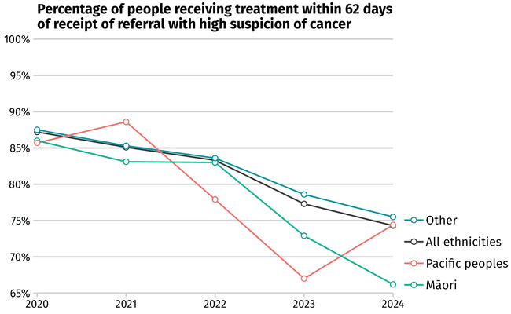
Note: ‘Other’ refers to non-Māori, non-Pacific.
Source: Health New Zealand Faster Cancer Treatment National Collection.

Too many cancers are being detected after an emergency or unplanned hospital admission, meaning cancer is often more advanced
New Zealand continues to lag behind comparable countries when it comes to timely diagnosis of cancer [151].
In 2022, an International Cancer Benchmarking Partnership (ICBP) study analysed cancer registrations and linked hospital admissions data from 14 jurisdictions in six countries: Australia, Canada, Denmark, New Zealand, Norway and the United Kingdom. The study focused on eight cancers: oesophageal, stomach, colon, rectal, liver, pancreatic, lung and ovarian. The findings were published in The Lancet Oncology in 2022 [152].
The ICBP report identified that New Zealand had the highest rates of emergency or acute (unplanned) admission prior to diagnosis for all of these cancers except liver cancer, for which it had the third-highest rate (Figure 60).
Figure 60: Percentage of cases diagnosed within 30 days of emergency department admission, New Zealand compared with other International Cancer Benchmarking Partnership jurisdictions, 2012–2017
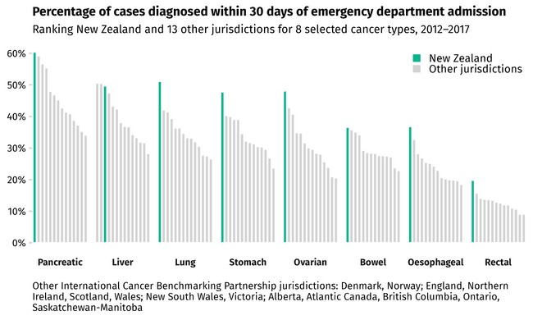
Notes: When cancer is diagnosed following an emergency department (ED) admission, the cancer tends to be more advanced than if detected through other pathways (such as screening). Compared with other jurisdictions in the International Cancer Benchmarking Partnership, New Zealand (green bars) had the highest proportion of ED-associated diagnosis in seven of the eight cancer types examined.
Source: Te Aho o Te Kahu | Cancer Control Agency. 2024. Quality Improvement Monitoring Report – Route to diagnosis: People diagnosed with cancer within 30 days of an emergency or acute (unplanned) hospital admission. Wellington: Te Aho o Te Kahu | Cancer Control Agency.

The health setting where diagnosis takes place can be a good indication of the effectiveness of the overall diagnostic pathway. There will always be people who have minimal symptoms until their cancer is advanced, sometimes causing them to present at hospital as an emergency. Ideally, however, most people with cancer should be being diagnosed through screening programmes or a pathway for symptomatic people.
Being diagnosed with cancer following an emergency admission is often associated with having more advanced cancer. This leads to those people having poorer survival or health outcomes compared with those who are diagnosed through other pathways, such as primary care and community-based diagnostic services [151] [152].
In 2024, Te Aho o Te Kahu | Cancer Control Agency produced a detailed report on patients being diagnosed with cancer, for 22 cancer types, following an admission to an emergency department, which showed that almost one in four people in New Zealand are being diagnosed with cancer following an emergency or unplanned admission to hospital. Figure 61 shows that this rate is higher for males, Māori and Pacific peoples, people living in the most deprived areas and people over 80 years of age [151].
Figure 61: Proportion of people diagnosed with cancer following an emergency admission to hospital, New Zealand, 2017–2021
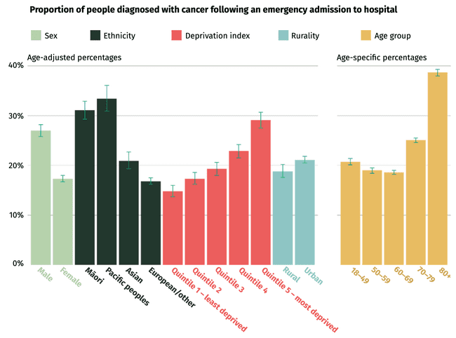
Notes: ‘European/other’ refers to non-Māori, non-Pacific, non-Asian. Socioeconomic deprivation is measured using quintiles from the area-based New Zealand Deprivation Index. Age groups are in years.
Source: New Zealand Cancer Registry, National Non-admitted Patient Collection, National Minimum Dataset.

Figure 62 shows that there is notable variation in emergency admission by cancer type. High proportions of diagnosis via emergency admission are expected for cancers that typically have sudden onset of severe symptoms requiring urgent treatment (such as some brain and central nervous system cancers) and cancers that are initially ‘quiet’ or have non-specific symptoms (such as pancreatic and ovarian cancers). However, many people with other cancer types (such as lung, stomach and bladder) usually have symptoms that indicate the potential for a diagnosis of cancer and it is concerning to see high diagnosis following emergency admissions for these cancers.
Figure 62: Proportion of cancer diagnoses associated with emergency department admission, by cancer type, New Zealand, 2017–2021
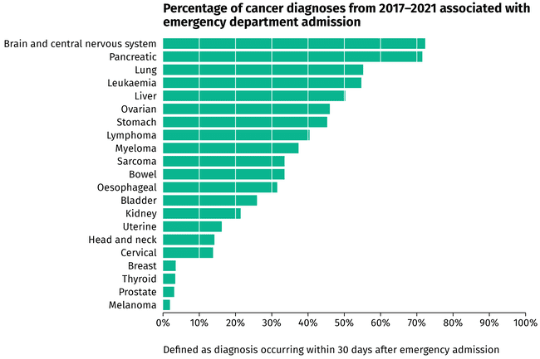
Source: Te Aho o Te Kahu | Cancer Control Agency. 2024. Quality Improvement Monitoring Report – Route to diagnosis: People diagnosed with cancer within 30 days of an emergency or acute (unplanned) hospital admission. Wellington: Te Aho o Te Kahu | Cancer Control Agency.

The high proportion of people in New Zealand receiving a cancer diagnosis following an emergency admission is particularly concerning given that diagnosis via emergency admission is associated with poorer survival outcomes and poor patient experience [153] [152] [154] [155]. Figure 63 shows that people are significantly more likely to die within 12 months of cancer diagnosis following an emergency admission compared with people diagnosed with cancer via more appropriate diagnostic pathways.
Figure 63: Percentage of deaths within 12 months of diagnosis, by emergency admission compared with non-emergency admission, New Zealand, 2012–2017
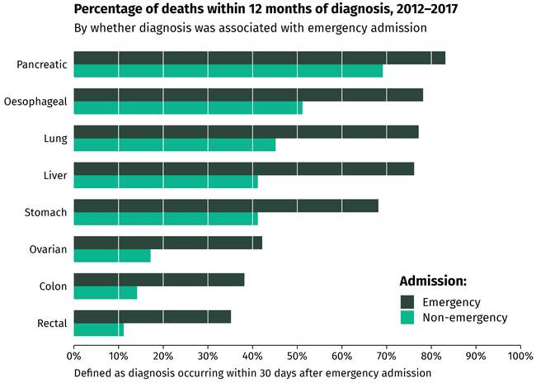
Source: Graph created using data from: McPhail S, Swann R, Johnson SA, et al. 2022. Risk factors and prognostic implications of diagnosis of cancer within 30 days after an emergency hospital admission (emergency presentation): An International Cancer Benchmarking Partnership (ICBP) population-based study. The Lancet Oncology 23(5): 587–600. URL: doi.org/10.1016/s1470-2045(22)00127-9.

Investments in primary care aim to improve patient access
Primary care is a critical part of the diagnostic pathway. In March 2025, the Government announced initiatives and funding to strengthen the capacity and capability of primary care [156] [157] [158] [159]. This included a $285 million uplift for general practice over 3 years, increasing training places for primary care nurse practitioners and registered nurses, introduction of a funded primary care pathway to registration for up to 50 New Zealand-trained graduate doctors and a new 24/7 digital service for all people in New Zealand to be able to access online medical appointments.

Example of improvement in primary care
In 2019/2020 the MidCentral Regional Cancer Treatment Service | Te Uru Mātai Matengau piloted an oncology advisory service for primary care in the MidCentral district. The pilot provided specialist oncology support and advice to non-oncological teams in primary care to manage patients where there was a suspected cancer diagnosis and non-specific symptoms, but no clear pathway for managing the patient.
The pilot included enabling GPs or nurse practitioners to directly request cross-sectional imaging (ie, CT) for their patient if clear criteria were met.
Following the successful pilot, the oncology advisory service has now become a standard part of service delivery in the region. This initiative has potential to be scalable and established in other regions across the country.

Cost and wait time are barriers to accessing a GP
Despite investments to strengthen primary care, many people in New Zealand continue to experience barriers to accessing a GP, including wait time and cost.
In 2023/2024 one in four adults (25.7%) and nearly one in five children (18.5%) reported the ‘time taken to get an appointment was too long’ as a barrier to visiting the GP in the previous 12 months. This proportion has been increasing each year since the question was first included in the New Zealand Health Survey in 2021/2022 (when it was 11.6% for adults and 8.0% for children) [37].

In 2023/2024, one in six adults (15.5%) reported not visiting a GP in the 12 months prior to the New Zealand Health Survey 2022/2023 due to cost. As shown in Figure 64, the cost barrier impacted some populations more than others. Disabled people (22.3%), Pacific peoples (22.3%) and Māori (19.6%) were the population groups most affected [37].
Figure 64: Percentage of population with unmet need for a GP due to cost, by population group, New Zealand, 2019–2024
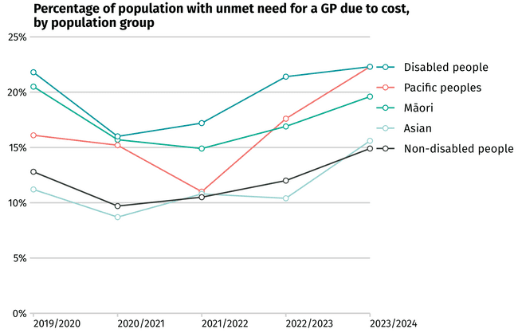
Source: New Zealand Health Survey 2023/2024.

Work is underway to improve diagnostic pathways
While diagnosing cancer can be a complex process, a number of initiatives have been working to improve diagnostic pathways. These include the development of guidance and pathways bringing care close to home, investment in medical imaging sites and updated access criteria, a project to help fast-track lung cancer patients and improvements in bowel cancer detection, radiology and the use of IT in multidisciplinary meetings. These initiatives are discussed further below.

Development of guidance and pathways
Patients can have better outcomes when their cancer care aligns with existing clinical pathways that describe the optimal principles of care; and unwarranted variation in care is also reduced [160]. Clear pathways can also improve equity in cancer control [161]. Over the last 5 years, there has been investment in development of HealthPathways, localised online manuals that guide and support diagnosis, access to relevant diagnostic tests and imaging, and referral to specialist services.
Additionally, Te Aho o Te Kahu | Cancer Control Agency has developed Optimal Cancer Care Pathways (OCCPs) for 16 cancer types [30]. The OCCPs outline consistent, safe, high-quality and evidence-based pathways for people with cancer across the whole cancer continuum – from prevention, screening, diagnosis and treatment to survivorship and palliative and end-of-life care. A number of cancer-specific OCCPs were published in 2025 and are now being progressively implemented.
In April 2023 Health NZ designed a pathway of care for people with abnormal uterine bleeding. Abnormal uterine bleeding pathways are now operational in Hawke’s Bay and Counties Manukau districts. Rollout of the National Abnormal Uterine Bleeding Pathway of Care and an aligned HealthPathway is a priority for Health NZ. This will strengthen and standardise the management of menorrhagia, inter-menstrual bleeding, endometrial cells on a smear in an over 40-year-old and post-menopausal bleeding; and will improve the timeliness of diagnosis of endometrial cancer. It will also allow people to receive care closer to home and provide females needing hospital and specialist services with timelier triage [162].

PET-CT investment and access criteria
A PET-CT scan is a medical imaging technique that combines a positron emission tomography (PET) scan with a CT scan. It is often used in the cancer staging process. All PET-CT services in New Zealand are provided by private radiology providers; public hospitals refer patients to these private providers and cover the costs of PET-CT in most cases. PET-CT scanners are located in Auckland, Hamilton, Wellington and Christchurch. Since 2020 there has been investment in two additional private fixed sites (Tauranga and Hawke’s Bay) and a mobile PET-CT unit, which provides access closer to home for people in Rotorua, Palmerston North, Lower Hutt and Dunedin [163].
In March 2024, Health NZ released updated national clinical criteria confirming who could access publicly funded PET-CT. In the preceding years, regional differences in access criteria had resulted in unwarranted variation in access to publicly funded PET-CT. In addition to national standardisation of access criteria, funding was made available to offer males with prostate cancer national access to prostate-specific membrane antigen (PSMA) PET-CT scans. This is an important diagnostic test that can be done in advance of a full prostatectomy, which is invasive and can have serious side effects.

Lung cancer CT after x-ray project
People with lung cancer often receive a late diagnosis, due to early symptoms being similar to cold or flu symptoms. The proportion of people being diagnosed with lung cancer within 30 days of emergency department admission has shown no improvement between 2015–2018 and 2019–2022 [164] [165]. Data indicates that late diagnoses disproportionally impact Māori. Reducing the inequitable burden of lung cancer requires action across the health sector, including a focus on prevention and early detection (see 2 Preventing cancer), lung cancer screening (see 3 Screening for cancer) and targeted actions to improve diagnosis, including removing barriers to accessing primary care, and adequate resourcing of Māori and Pacific-led primary care services [153] [28].
In 2023 Health NZ began developing a new National Lung Cancer HealthPathway to allow patients to be fast-tracked to the most appropriate diagnostic test and referred to the appropriate specialist. This allows primary care specialists to refer patients for CT after they have had an x-ray, rather than requiring the referral come from specialist respiratory services. This initiative has a focus on Māori patients living rurally who present to primary care with symptoms that could indicate lung cancer. This HealthPathway is aligned with the national lung cancer OCCP [30]. Extra resourcing will be required for the national implementation of the HealthPathway (particularly in community radiology) but, once operational, the pathway should improve timeliness of diagnosis.

Bowel cancer – FIT for Symptomatic Pathway
Colonoscopy is an important part of the diagnostic pathway for bowel cancer; however, access can be a challenge due to limitations in workforce capacity and equipment, which impacts timely diagnosis of cancer. In 2024, 80% of people needing an urgent colonoscopy received this on time (within 14 days), whereas only 40% of people with a non-urgent referral received a colonoscopy on time (within 42 days) and less than half of all people on surveillance received it on time (within 82 days) [166].
The Faecal Immunochemical Test (FIT) for Symptomatic Pathway is a new bowel cancer detection project currently in development by Health NZ. This pathway will enable more accurate prioritisation of patients suspected to be at risk of bowel cancer and reduce colonoscopy demand.
The FIT for Symptomatic Pathway is for patients referred to hospital and specialist services with bowel symptoms who do not meet criteria for urgent colonoscopy. A negative FIT will see patients staying under the care of their GP with advice regarding safety netting or further imaging. The initial implementation in 2025 in five districts (Waitematā, Counties Manukau, Waikato, Hawke’s Bay and Canterbury) will allow Health NZ to evaluate the pathway, make refinements and test the cost–benefit of further rollout in hospitals or moving directly into primary care.

Radiology improvements
Radiology is a critical tool for diagnosing cancer. However, patients sometimes experience variable access to radiology services based on their location and where they require treatment.
The radiology sector is experiencing substantial challenges, including the increased complexity of patients’ needs, and demand associated with population growth that is exceeding resourcing for CT, MRI and ultrasound. New clinical initiatives and health care pathways being introduced across cancer control are putting additional loads on already-stretched radiology services.
The National Radiology Clinical Network was one of the first national clinical networks to be established by Health NZ in early 2024. The activities of these national clinical networks include:
- developing national standards and models of care
- identifying ways to address variation in equity, service quality and outcomes
- developing innovative, efficient and evidence-based solutions that will inform investments and workforce planning
collaborating with relevant national, regional and local stakeholders to identify what care and services are required at different levels, who should provide these services and how the services or care should be delivered.
In 2024 the Radiology Transformation Programme was established in partnership with the National Radiology Clinical Network and national planning teams within Health NZ. The vision for this programme is that, ‘Patients, whānau and their referrers will be able to access radiology services close to home; and service improvements will improve health and system outcomes for all New Zealanders’ [167].

Initiatives in the programme include:
- increasing training numbers in the medical and technologist workforces
- developing national prioritisation, waitlist management and service continuance guidelines to improve equity of access including during a service disruption event
- updating clinical access criteria and establishing regional triage hubs to support equitable access and facilitate the new investment/removal of co-payments for community referred radiology
- using integrated data sets to report on activity, waitlists and worklists
developing clinical guidelines to standardise practice and reduce unwarranted variation.

Use of IT to improve multidisciplinary meetings
The cancer multidisciplinary meeting (MDM) [168] allows a range of health professionals with expertise in the diagnosis and management of cancer to collaborate and make recommendations for the optimal treatment and care of patients according to tumour stream.
Full implementation of the South Island electronic MDM approach was completed in 2021. It is being used to support 15 cancer tumour streams as well as providing clinicians with real-time data that enables them to monitor MDM quality indicators, undertake audits and service improvement work. The solution is integrated with the regions clinical portal providing full access to patient electronic medical records including diagnostics.
Midland | Te Manawa Taki region has been implementing an electronic Clinical Pathway – MDM solution, which has integration functions including electronic referral integration, laboratory and radiology reports, and a built-in reporting function allowing users to run data reports and audits. The region has implemented 12 MDMs and one supra-regional MDM with Auckland. The remaining nine MDMs for implementation were stopped due to limited IT resource.

5 Undergoing cancer treatment |
Te maimoatanga

Key messages
- In the past 5 years, more cancer treatments have become available to patients. New models of care also mean more treatments will be available closer to home. But many patients still face challenges getting treatment, particularly Māori, Pacific peoples, people living in rural areas and people living in areas of high deprivation.
- While most patients in New Zealand get the surgery they need in a timely fashion, access to surgery differs by population group.
- Difficulties in accessing radiation oncology are long recognised and several actions are being taken to address these.
- While surgery remains the most common first treatment for solid tumour cancers, there has been a positive shift toward high-complexity radiation treatments, which have fewer side effects and can replace invasive surgery for some patients.
- There has been substantial work and investment to improve access to systemic anti-cancer therapy (SACT), including increased availability of new cancer medicines and biomarker testing. However, some patients have poorer access to SACT.
- Over the last 5 years there has been a decrease in patients receiving initial cancer treatment within the 31-day ‘decision to treat’ timeframe although there has been improvement in first half of 2025.
- Demand for stem cell transplant and cellular therapy continues to rise while access continues to be a challenge due to insufficient treatment capacity.
Dedicated care pathways are being used for children, adolescents and young adults.

The main forms of cancer treatment are surgery, radiation oncology, systemic anti-cancer therapy (SACT; cancer medicines, including chemotherapy, hormonal therapy, immune therapy and targeted therapy) and stem cell transplant. These treatments may be used alone or in combination, depending on factors such as the type of cancer a person has, how far the cancer has spread, the age of the person, their underlying health and their treatment preferences.
Cancer treatment varies depending on the patient’s individual needs and can include treatment to cure cancer, treatment to prolong life, treatment to reduce the symptoms of cancer and improve quality of life including palliative care and end-of-life care. This section focuses on surgery, radiation oncology, SACT and transplant and cellular therapy. Allied health, palliative care and supportive care services for cancer patients are covered in the next section, 6 Supporting people during their entire cancer experience.

Work is underway to improve cancer treatment and the monitoring of care
A number of significant changes in cancer treatment have occurred in the last 5 years.
In 2022, Te Aho o Te Kahu | Cancer Control Agency released the report He Mahere Ratonga Mate Pukupuku, Cancer Services Planning [169]. The report’s findings were particularly important given the differences in care patients experience based on where they live or who they are.
Since then, Te Aho o Te Kahu | Cancer Control Agency has built on the recommendations in report and been working to instigate transformative change and ongoing quality improvement in the manner in which patients receive cancer treatment services. This work programme has included the development of models of service delivery for different cancer treatment types (radiation oncology, SACT, stem cell transplant and complex cancer surgery), which are discussed under the different treatment modalities below. All models of care have been integrated into the OCCPs [30]. The work is now transitioning into phased implementation by Health NZ.

Faster Cancer Treatment data insights
In 2024 the Government re-introduced the FCT health target: that, by 2030, 90% of patients receive cancer management within 31 days of the decision to treat. It is used alongside the 62-day indicator described earlier (see Delays in diagnosis impact time to treatment). The Faster Cancer Treatment (FCT) indicators, business rules and data definitions were also updated in 2023 to ensure all centres providing cancer care report in a standardised way and now provides a more accurate picture of how quickly patients are receiving the treatment they need. The 31-day FCT achievement rate has declined for all ethnicities since the State of Cancer 2020 report was published (Figure 65).
Commentary on FCT trends for surgery, radiation oncology and SACT is included in the following sections.
Figure 65: Faster Cancer Treatment 31-day target, by ethnicity, New Zealand,
2020–2024
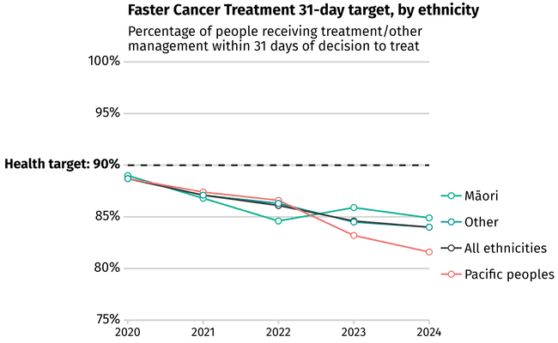
Notes: The 90% target is to be achieved by 2030. ‘Other’ refers to non-Māori, non-Pacific.
Source: Health New Zealand Faster Cancer Treatment National Collection.

Surgery
Surgery is a critical part of cancer care. It is the most-common first treatment for people with cancer, with nearly half (49.4%) of people newly diagnosed with cancer between 2020 and 2024 receiving surgery as their first form of treatment.
Cancer surgery in New Zealand is of high quality and considered a priority within surgical services. While most patients in New Zealand get the surgery they need in a timely fashion, not all population groups are receiving the same benefit from surgical services.

Work to improve access to high-quality surgical care is underway
Historically, there has been no consistent or proactive national process to consider the distribution of surgical services across New Zealand. This was in part due to the previous structure of the health system, where district health boards operated as independent entities. A new set of capability frameworks for complex cancer surgeries are in development by Te Aho o Te Kahu | Cancer Control Agency and will be referenced by the relevant OCCPs [30]. The frameworks describe a set of capabilities a hospital must have to ensure safe, high-quality and equitable care for people requiring different kinds of complex cancer surgery. They aim to support service delivery decision-making across pre-, peri- and post-surgical care. Resources are being developed for hepato-pancreato-biliary (liver, pancreas, gallbladder and bile ducts), esophagogastric (oesophagus and stomach), sarcoma and head and neck cancer surgeries.

It remains hard for some patients to get cancer surgery
Faster Cancer Treatment rates: Surgery as first cancer treatment within 31 days from a decision to treat for FCT-eligible patients in New Zealand declined from 80.9% in 2020 to 72.7% in 2024.
Patients continue to have different access to cancer surgery. For example, between 2019 and 2022, 18.9% of people with non-small cell lung cancer (NSCLC) had curative surgical resection. When adjusted for age, Māori with NSCLC were least likely to receive a curative surgical resection (16.8%) compared with people of Asian (24.4%) and European/other (20.0%) ethnicities, likely due to cancer being at a later stage at diagnosis. Those who lived in rural areas were also less likely to receive a curative surgical resection (17.6%) compared with those living in urban areas (20.2%) [165].
Reporting by Te Aho o Te Kahu | Cancer Control Agency shows that people from different demographic groups and geographic locations have varied access to surgical cancer treatment and this is a consistent issue for multiple cancer types [170]. For example, between 2020 and 2021, the percentage of females with breast cancer receiving surgery within 6 weeks of the decision to treat ranged from 95.2% in one district to 70.2% in another [3]. There are many factors that can contribute to variability in cancer surgery rates, including system-level factors (such as location and availability of services) and patient-level factors (such as presence of comorbidity and stage of cancer at diagnosis).
Rates of emergency (unplanned) surgery also varied across regions in 2017–2019, ranging from 13.1% to 26.2%. Variations like these are likely contributing to people experiencing inequitable outcomes and may be reflecting inequities in other aspects of the patient pathway [171]. This is particularly important to further understand considering the higher mortality rate seen with emergency surgery [172].

Radiation oncology
It is estimated that approximately half of all people diagnosed with cancer would benefit from radiation treatment [173].
Currently patients receive radiation treatment across seven public cancer centres, which have a combined total of 25 linear accelerator (LINAC) machines. One of these centres, in Taranaki, opened in November 2025 and means that 70%–80% of Taranaki cancer patients that require radiation treatment will be able to have most of their treatment provided locally [174]. A further eight LINACs are in private cancer centres, with many public centres outsourcing treatment to private providers (see Physical infrastructure supporting cancer care).
From 2020 to 2024, approximately 8.0% of FCT-eligible patients in New Zealand received radiation treatment as their first treatment, with a further 2.7% receiving concurrent radiation and chemotherapy as first treatment. In 2024, 83.0% of those who underwent radiation treatment under the FCT pathway received it within the 31-day decision to treat timeframe, a decrease from 89.1% in 2020.

Improvements are being made to increase patient access to radiation oncology
Difficulties in accessing radiation oncology are long recognised and several actions are being taken to address these.
Radiation Oncology Model of Care: Te Aho o Te Kahu | Cancer Control Agency developed a national Radiation Oncology Model of Care in 2024, which identifies the attributes required to make access to radiation treatment more equitable for people in New Zealand. The model includes a coordinated national radiation oncology service, which, when implemented, would be delivered across multiple regional sites. Patients would receive comprehensive, coordinated radiation oncology services and face fewer geographic barriers to access. Small-volume, high-complexity services and treatment techniques will require a degree of centralisation and standardised pathways to maintain safety and quality for patients accessing these services.
New radiation oncology facilities:
- Work is underway to build new LINAC facilities in two additional locations: Northland and Hawke’s Bay. The Northland site is expected to be operational during 2026, and the Hawke’s Bay site is estimated to open in 2028. Additional new LINACs are planned for Counties Manukau, Nelson Marlborough and Canterbury in the next 5–7 years.
- The opening of a peptide receptor radionuclide therapy (PRRT) [175] service in Auckland in 2021 means that patients with neuroendocrine tumours no longer have to travel to Australia to access this treatment.
For more information on LINACs and radiation oncology infrastructure, see Physical infrastructure supporting cancer care.
Expanded workforce: In 2023, five additional radiation oncologist training positions were created to grow the radiation oncologist workforce. A national guidance document for advancing practice in radiation therapy was also published in 2024 to support staff development and retention. For more information, see The people providing cancer care.
New guidance: In May 2024, guidance to support the use of telehealth and remote working in radiation oncology was finalised. In September 2024, national radiation oncology business rules were also completed so that referrals to radiation oncology are managed consistently across services [176].

Some patients still experience challenges in accessing radiation oncology
Factors currently impacting the delivery of radiation treatment include workforce challenges (see The people providing cancer care), the national availability of LINAC machines (see Physical infrastructure supporting cancer care) and the need for some patients to travel to receive treatment.
It is important to note that highly specialised care will often require travel, depending on where a patient lives. While this is unavoidable, it can affect access. Patients cannot access some types of specialised radiation treatment in every main centre; for example, high-dose brachytherapy (a type of internal radiation treatment) is only available in Auckland, Waikato, Tauranga, Wellington and Christchurch; and paediatric radiation treatment is only available in Auckland and Christchurch.
Patients and whānau must often travel long distances to receive treatment and may need to live away from home for periods of up to 6 weeks or more. This means patients are required to spend time away from home and work, and may need more support from whānau or friends. Māori and Pacific peoples experience higher levels of deprivation and, proportionately, more Māori live rurally; therefore, Māori are likely to be disproportionately impacted by the requirement to travel, including the cost and logistics associated with travel and accommodation, arranging care for any dependents at home and coordinating appointments at a stressful time in their lives [177]. The distance to radiation oncology facilities may influence whether people decide to receive radiation treatment or not.
The variation in patient access to radiation oncology across health regions is shown in Figure 66 as the range of intervention rates. The intervention rate represents the proportion of patients receiving radiation as part of their treatment. Several factors impact the intervention rate, such as distance to a radiation oncology facility, workforce availability, infrastructure investment and resourcing for centres, patient demographics and cancer registrations.
Figure 66: Radiation treatment intervention rate, by health region, New Zealand, 2023
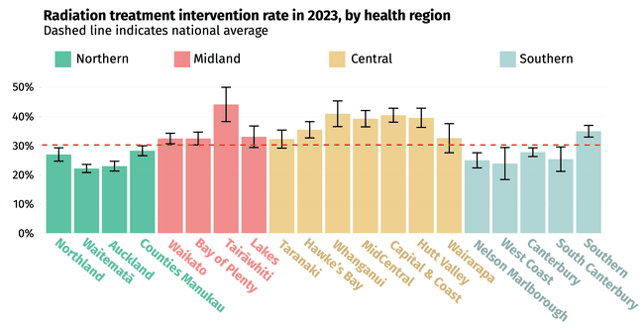
Notes: Due to some private provider data being unavailable, the reported national average intervention rate is likely understated. This limitation affects the accuracy of intervention rate assessments in certain regions (and centres), particularly those where private providers hold a reasonable market share, such as Auckland. Dashed line indicates national average. Names reflects the former district health boards.
Source: Radiation Oncology Collection.

Initiatives are underway to mitigate some of the challenges associated with patient travel, such as improving the National Travel Assistance scheme (see 6 Supporting people during their entire cancer experience) and, where possible, bringing care closer to home by opening new LINACs in regional centres (see Physical infrastructure supporting cancer care).
Where people live can impact their access to radiation oncology in a range of ways. Figure 67 shows that people in Canterbury have consistently had to wait longer than recommended – and much longer than people in other districts – for radiation treatment. Health NZ has indicated there will be investment in new LINACs to increase capacity (see Physical infrastructure supporting cancer care).
Recommended treatment guidelines are based on cancer type, treatment intent and clinical considerations (Figure 67 does not capture wait times for first specialist assessment). Radiation oncology wait times can be attributed to multifactorial causes, in particular resourcing constraints such LINAC capacity and workforce shortages. The waitlist data collection does not account for operational service arrangements, such as outsourcing to private providers, which may be in place to help manage waitlists.
Figure 67: Proportion of people waiting beyond guidelines for radiation treatment, by public radiation cancer centre, New Zealand, January 2024–April 2025
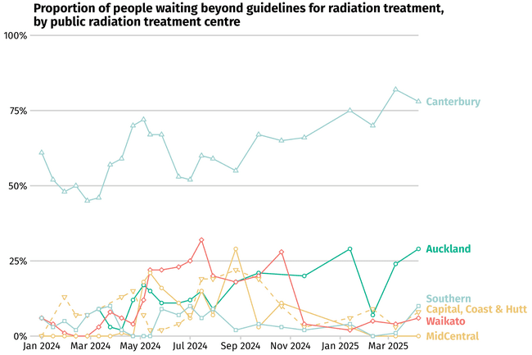
Notes: Data relates to public providers. The business rules for the radiation oncology waitlist guidelines are published by Health New Zealand here: www.tewhatuora.govt.nz/for-health-professionals/hospital-and-specialist-services/radiation-oncology.
Source: Public radiation oncology providers via waitlist data collection.

Variation can also be seen in the differences in timely access to adjuvant radiation treatment for breast cancer (treatment given after the primary treatment to increase the chances of a cure). Between 2020 and 2021, 25.5% of people with invasive breast cancer started adjuvant radiation treatment within 8 weeks of surgery. When adjusted for age, there was variation by ethnicity, with 27.7% of European/other starting adjuvant radiation treatment within 8 weeks of surgery compared with 25.1% of Pacific peoples, 23.1% of Māori and 21.5% of Asian [3]. Only 20.5% of people living in rural areas started adjuvant radiation treatment within 8 weeks of surgery compared with 27.6% of people living in urban areas [3]. Those living in quintile 1 (least deprived) were more likely (34.7%) to receive adjuvant radiation therapy within 8 weeks of surgery than females living in any other quintile (Figure 68).
Figure 68: Proportion of people with invasive breast cancer starting adjuvant radiation treatment within 8 weeks of surgery, New Zealand, 2020–2021
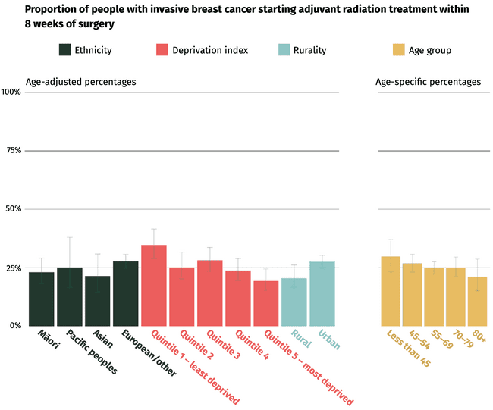
Notes: ‘European/other’ refers to non-Māori, non-Pacific, non-Asian. Socioeconomic deprivation is measured using quintiles from the area-based New Zealand Deprivation Index. Age groups are in years.
Source: Te Aho o Te Kahu | Cancer Control Agency. 2025. Breast Cancer Quality Performance Indicator Monitoring Report. Wellington: Te Aho o Te Kahu | Cancer Control Agency.

More patients are receiving complex radiation treatments
Since the State of Cancer 2020 report, more patients are receiving ‘complex’ radiation treatments. These are treatments that target the tumour more precisely and typically have less impact on healthy surrounding tissue. This is positive for patients, because use of these more advanced radiation treatment techniques can improve chance of survival, reduce side effects and offer treatment options to people who may not be able to undergo surgery for their cancer. However, complex treatments generally require more specialised equipment, technology, training and time to plan and deliver these treatments safely.
Figure 69 shows that, between 2018 and 2023, fewer patients were accessing low- and medium-complexity treatment, with a significant increase in high-complexity treatment. There has been minimal change in how much very-high-complexity treatment (brachytherapy) is being delivered. As treatment technology continues to advance, cancer services must be able to plan ahead so they are ready to provide optimal, modern care to patients.
Figure 69: Number of radiation treatments, by complexity, New Zealand, 2018–2023
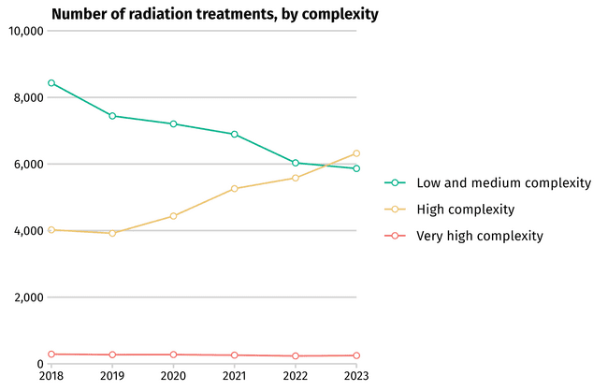
Notes: Low- and medium-complexity treatments include standard external beam (SEB) therapies. High complexity treatments encompass techniques such as intensity modulated arc therapy (IMRT), volumetric modulated arc therapy (VMAT) and stereotactic ablative body radiotherapy (SABR). Very high complexity treatment is assigned to brachytherapy, which is not delivered on a LINAC and only offered at some radiation centres.
Source: Radiation Oncology Collection.

Increased use of hypofractionation means more patients can be treated in a shorter timeframe
Patients who have radiation treatment have historically received treatment in multiple small doses, with each dose called a ‘fraction’. Over the last 5 years, there has been an increase in the use of ‘hypofractionation’ (the use of higher doses but in fewer fractions) when clinically appropriate. This is positive for patients because it means they generally attend fewer treatment appointments with no worsening of side effects. They have the same treatment outcomes and can complete their radiation treatment course more quickly. In some cases, where there is no increase in treatment complexity, this also improves capacity, meaning more patients can be treated by the same treatment facility in the same timeframe. The impact of hypofractionation is discussed below for two types of cancer.
Breast cancer: Evidence has shown that 5 fractions (‘ultra-hypofractionation’) is considered standard and clinically equivalent to the previous 15 fractions (hypofractionation) and 25 fractions (standard) for some curative breast cancers [178]. As shown in Figure 70, this evidence is leading to a change of care for patients, many of whom will now benefit from having much shorter courses of treatment.
Figure 70: Percentage of people receiving curative breast cancer treatment involving 5, 15–21 or 25 or more fractions, New Zealand, 2018–2023
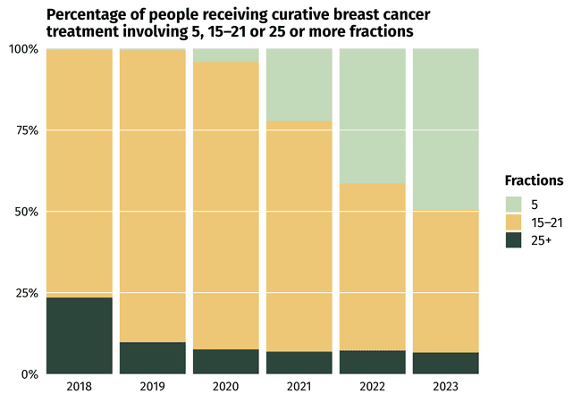
Note: The proportion of people receiving just 5 fractions (ie, treatment sessions) of radiation treatment for breast cancer is growing year upon year compared with earlier standard regimens requiring a larger number of fractions.
Source: Radiation Oncology Collection.

Prostate cancer: Since 2020, ultra-hypofractionation (5 or 7 fractions) has been increasingly adopted for patients with curative prostate cancer (see Figure 71). Unlike in breast cancer treatment, ultra-hypofractionation has reduced the number of treatments prostate cancer patients have to receive but increased the complexity of their treatment. This is because ultra-hypofractionation is delivered using stereotactic ablative radiation therapy (SABR), which is a highly specialised and complex radiation technique that requires more resources.
Figure 71: Percentage of people receiving curative prostate cancer treatment involving 5 or 7, 20 or 32 or more fractions, New Zealand, 2018–2023
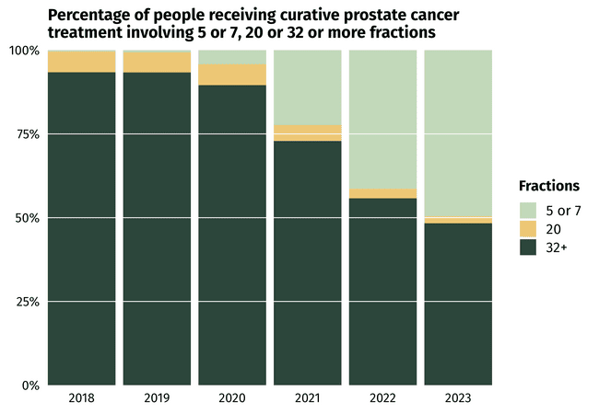
Note: The proportion of people receiving just 5 or 7 fractions (ie, treatment sessions) of radiation treatment for prostate cancer is growing year upon year compared with earlier standard regimens requiring a larger number of fractions.
Source: Radiation Oncology Collection.

Systemic anti-cancer therapy
Systemic anti-cancer therapy (SACT) refers to drug treatments used to control or treat someone’s cancer. SACT includes chemotherapy, hormonal therapy, immunotherapy and targeted therapies. These therapies can be curative or life-prolonging and are a critical part of cancer care. When people in New Zealand access effective SACT when they need it, their cancer outcomes are better.
Faster Cancer Treatment rates: SACT was the first treatment for approximately one-fifth (19.9%) of FCT-eligible patients in New Zealand from 2020 to 2024. Over those 5 years, the proportion of people under the FCT pathway receiving SACT treatment within 31 days of a decision to treat remained consistent (97.4% in 2020 and 97.5% in 2024).

Over the last 5 years there has been substantial work and investment to improve access to SACT
The following sections outline some of the substantial work and investment that have taken place in the last 5 years to improve access to SACT.

Two key reports helped to quantify the availability of cancer medicines for people in New Zealand
In 2022, Te Aho o Te Kahu | Cancer Control Agency published Mārama ana ki te Āputa: he tātari i te wāteatanga o ngā rongoā mate pukupuku i Aotearoa | Understanding the Gap: An analysis of the availability of cancer medicines in Aotearoa [179]. The report compared the availability of publicly funded cancer medicines in New Zealand with those publicly funded in Australia. The work identified 20 medicines that would provide substantial clinical benefit to patients with solid tumours if made available in New Zealand. Three of these ‘gaps’ were for medicines used with the intention of cure, with the others being non-curative (ie, used to prolong patients’ quality or length of life).
Assessing the size of the clinical benefit for blood cancer medicines was not possible at the time of the 2022 report. However, as soon as the relevant tool became available, Te Aho o Te Kahu | Cancer Control Agency completed the analysis for blood cancers and, in 2024, published a follow-up report, Te rere o te toto – Understanding blood cancer medicines availability in Aotearoa New Zealand [180]. This report found that Australians with blood cancers had access to 12 medicines that people in New Zealand with blood cancers did not, and access would provide substantial clinical benefit if those medicines were available here.
These reports were not intended to provide a list of medicines that should be funded, but to highlight to the health sector the difference in medicine access between Australians and people in New Zealand living with cancer. Funding decisions are the role of Pharmac; its decisions take into consideration a range of factors [181]. However, the reports highlighted what the medicines gaps were, how many there were and what these gaps might mean for patients in New Zealand.

More than 2,350 people in New Zealand are expected to benefit from increased funding for cancer medicines within the first year of funding
In June 2024, the Government announced an unprecedented $604 million funding boost to Pharmac’s Combined Pharmaceutical Budget over 4 years [182]. Health NZ received additional funding to support implementation of the new medicines and help people living with cancer and other health conditions access them.
As of May 2025, Pharmac had funded 33 new cancer medicines for a range of solid tumours and blood cancers as a result of the budget uplift [183]. These medicines are projected to have a positive impact for approximately 2,350 people in New Zealand within the first year of funding.

Biomarker testing will support the implementation of the new cancer medicines
Many of the newly funded cancer medicines, or those that are proposed to be funded, have biomarker testing requirements. Biomarker tests are used to understand the genetics of a cancer and have implications for prognosis and treatment options. Biomarker testing can ensure new medicines are safe and effective for individual patients before medicines are started.
New Zealand currently lags behind comparable countries, where biomarker testing and tools are widely available and the standard for care of cancer patients. There have been long-standing issues around inconsistent and inequitable access to biomarker testing across New Zealand. As part of the implementation of the new cancer medicines, funding has been allocated to make access to biomarker testing nationally consistent for patients on the new medicines.

A new national model of care is helping to improve SACT services for patients in New Zealand
In 2024 Te Aho o Te Kahu | Cancer Control Agency completed work on the SACT Model of Care for adults in New Zealand [184]. This set out a future state for SACT services and described how to improve and strengthen patient outcomes, patient and whānau experiences, sustainability of service delivery and equity.
Work is now underway to implement the newly funded cancer medicines and the SACT Model of Care in New Zealand. This includes moving some SACT treatments into the community and closer to where people live. To support this, National Minimum Standards have been developed to enable new sites delivering SACT to be set up in a consistent way. When patients receive treatment closer to home it can help reduce stress, the time needed to travel to appointments and the associated financial burden, and also improve patient and whānau experience of treatment. This means people in need of SACT are more likely to start and complete treatment.
Several new SACT sites have opened since the State of Cancer 2020 report was published, including a Taupō chemotherapy service and infusion services in Wairoa, the Bay of Islands and Whanganui. These services successfully balance providing patients with care and treatment closer to home with having the required workforce and physical facilities to safely deliver care [185]. This is discussed further in The people providing cancer care and Physical infrastructure supporting cancer care.

Progress has been made to improve SACT data to drive service improvements for patients
Anti-Cancer Therapy – Nationally Organised Workstreams (ACT-NOW) is a programme of work designed to better understand how patients are receiving SACT across New Zealand. ACT-NOW involves improving the collection of treatment and treatment-related data from public chemotherapy providers and working with doctors and other stakeholders to identify opportunities to drive other improvements for people needing SACT. ACT-NOW is building the technology to securely share relevant data from hospital information systems to a new national chemotherapy database, where data can be analysed and fed back to key stakeholders in a format that can inform action and drive improvements for patients [186].

Some people experience barriers to accessing SACT
Despite the improvements described above, not everyone in New Zealand has equitable access to SACT currently and there is notable variation in different regions. For example, the proportion of patients with non-small cell lung cancer who received SACT between 2019 and 2022 varied from 26.7% in one region to 45.9% in others [165].
Some patients have poorer access to treatment because of where they live and the location of services where they require treatment. For example, nearly two-fifths of the Pacific population of New Zealand lives in the Counties Manukau district; however, most cancer patients in Counties Manukau must travel to Auckland City Hospital to receive SACT, which can be a travel burden [169]. The direct and indirect costs associated with treatment, prescription and travel present substantial barriers to some people in accessing and completing SACT [169].
There is ongoing variation in SACT delivery for many patients including people with stage II or III breast cancer who need neoadjuvant chemotherapy. Between 2020 and 2021, people of Asian (40.5%), Pacific (46.0%) and Māori (47.1%) ethnicities were less likely to receive neoadjuvant chemotherapy compared with people of European/other ethnicity (53.6%) (Figure 72) [3].
Figure 72: Proportion of people with stage II or III breast cancer who were either triple-negative or HER2-positive and received neoadjuvant chemotherapy, including neoadjuvant trastuzumab, New Zealand, 2020–2021
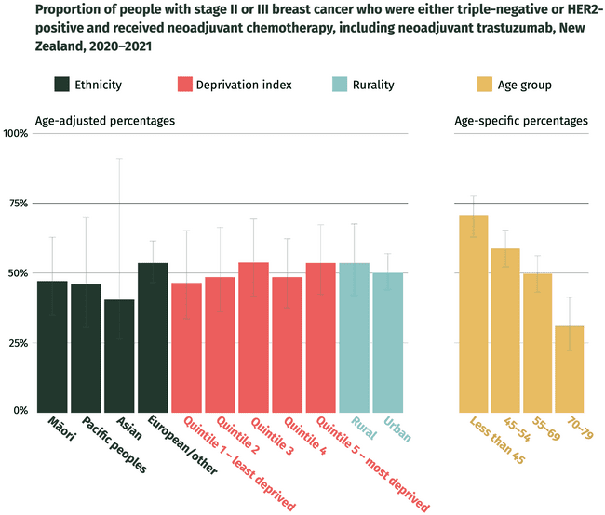
Notes: ‘European/other’ refers to non-Māori, non-Pacific, non-Asian. Socioeconomic deprivation is measured using quintiles from the area-based New Zealand Deprivation Index. Age groups are in years.
Source: Te Aho o Te Kahu | Cancer Control Agency. 2025. Breast Cancer Quality Performance Indicator Monitoring Report. Wellington: Te Aho o Te Kahu | Cancer Control Agency.

Investment in stem cell transplant services will enable more people to have access

Demand for transplant and cellular therapies continues to increase
Transplant and cellular therapy (TCT) is provided as curative and life-extending treatment for some acute and chronic leukaemia, lymphoma and multiple myeloma and some non-malignant disorders, including bone marrow failure and inherited immunodeficiency disorders. The treatment generally requires a preparatory phase of chemotherapy, and sometimes radiation therapy, before transplantation with the patient’s own cells (autologous) or donor cells (allogeneic). TCT services are currently available from five locations: Auckland, Hamilton, Palmerston North, Wellington and Christchurch.
The demand for TCT has continued to increase in New Zealand. Modelling completed in 2011 and 2018 projected the expected increase in TCT demand per year against the national population [187]. This shows that, by 2030, demands for allogeneic and autologous stem cell transplantation are forecast to increase by 40% and 51%, respectively (based on the middle growth rate displayed in Figure 73 below) (see also Cancer research and innovation). This will require adequate resourcing to ensure patients receive the appropriate standard of care.
Figure 73: Forecast transplant and cellular therapy volumes, New Zealand, 2015–2023

82
114
105
114
115
121
125
134
135
142
146
155
156
162
166
175
199
208
181
198
193
223
229
246
242
273
279
297
292
323
329
346
0
50
100
150
200
250
300
350
400
2015
2016
2017
2018
2019
2020
2021
2022
2023
2024
2025
2026
2027
2028
2029
2030
Allogeneic
Projected allogeneic
Autologous
Projected autologous
Notes: This linear regression modelling used data sourced from the Australia and New Zealand Transplant and Cellular Therapy Registry Data Summary 2021. Forecasts are shown for annual volumes of transplant and cellular therapy assuming middle growth rates (displayed in the dashed line). The projected growth range, including high- and low-growth scenarios, is displayed in the blue lines.
Source: Te Aho o Te Kahu | Cancer Control Agency.

A model of care has been developed to guide service planning
To avoid relapse or disease progression, transplant needs to occur in a timely manner once the patient is clinically ready to receive it. Delays in accessing transplant can result in patient harm, including avoidable death and provision of additional cycles of chemotherapy.
To support timely access to quality care, the National Model of Care for Haematopoietic Transplant and Cellular Therapies was developed in 2023 [187]. The model has been distributed to the haematology sector and provides a framework for commissioners, funders, managers and clinicians to deliver high-quality, efficient, effective, sustainable and equitable care for people in New Zealand.
A self-assessment tool has been developed that TCT services can use to assess how well they align with the model of care attributes and prioritise what they may need to do to improve and develop their services. The tool was finalised and distributed to TCT service managers in 2024.

Increased investment in allogeneic stem cell transplant centres will support service delivery
Health NZ is phasing in new investment in the stem cell transplant workforce in Auckland and Christchurch. This included $4.5 million in 2024/2025 and $6.1 million in 2025/2026 with plans for ongoing funding to support increased capacity, expand the workforce and infrastructure, increase the number of transplants delivered and meet the growing demand for TCT services.
Health NZ leaders, including clinical leads from the allogeneic stem cell transplant centres, have developed a plan for further increased investment to begin in 2026 that will expand capacity over the following 3 years to meet forecast demand.
As a part of this, a waitlist management tool is being developed that will support operational management at all five centres and provide nationwide visibility of how long people are waiting once they are clinically ready to receive their transplant. Development will be completed in 2025 with implementation planned in 2026.

How children get cancer treatment
The model of care for child cancer treatment is deliberately different to the adult model of care. Most children (aged 0–14 years) diagnosed with cancer in New Zealand are treated at one of two specialist child cancer centres in Auckland and Christchurch. In 2022, 69% of children diagnosed with cancer lived in locations covered by Starship Blood and Cancer Centre in Auckland, and 31% lived in locations covered by the Children’s Haematology and Oncology Centre in Christchurch.
However, half of the children diagnosed with cancer in 2022 lived outside of the Auckland or Christchurch and needed to travel more than 100 km to a specialist treatment centre for at least some of their treatment.
Children with cancer who live outside Auckland and Christchurch can also receive care at one of 14 shared-care centres around the country. These centres work closely with the two specialist centres so children can receive as much of their treatment, as safely as possible, closer to home.

How adolescents and young adults get cancer treatment
Adolescents and young adults (AYA) with cancer – typically defined as those aged 12–24 years – may get treatment within either adult or paediatric cancer services, depending on their age, diagnosis, location and clinical considerations. Both sectors have considerable capability in supporting young people with cancer, however, AYA have historically struggled to find a clear ‘fit’ within a system designed primarily for younger children or older adults.
The establishment of a dedicated AYA cancer service in six tertiary centres across the country in 2007 was a major step forward. Dedicated AYA cancer keyworkers act as navigators and advocates, providing age-appropriate psychosocial support during diagnosis, treatment and beyond.
The AYA Standards of Care 2016 [188] and AYA Action Plan 2020–2025 [189], developed by the Adolescent and Young Adult Cancer Network Aotearoa [190], have supported efforts to better meet the distinct needs of this age group, by driving greater national consistency and targeted improvements in service delivery.

Teenager Jake shares his positive experience about the team and services providing his care
Teh services can
Jake:
‘I was diagnosed with leukaemia 2 months ago and since then most of my time has been spent in hospital either getting or recovering from treatment. It has been a really tough time for me and my family, but the staff at Waikato have been awesome and are always keen to support me in my journey. At 16, I am the youngest one on the haematology/oncology ward and that has come with some benefits. I’m pretty much the only person who uses the YouthPad, which is a dedicated youth space setup with a big TV and PlayStation. My younger brother and my family can hang out with me in there and it’s the closest I can get to being in my lounge room at home. Because of my age, I feel like I almost get “special treatment” on the ward, which is cool.
‘My mum or dad can always stay over so I’m not on my own, and I’ve been able to negotiate my treatment and sleep schedules with my medical team. As much as possible, I get to be my own boss, and am always involved in decision-making. The team have even let me sneak out when I had the opportunity to meet some of my sporting heroes, the Black Caps, and I was also able to safely delay my second round of chemo by a couple of days so I could attend my school formal before returning to hospital. Being in hospital isn’t awesome, and having cancer sucks, but I’m glad that I have ways to get through it that are specific to me and what I want and need as a teenager.’
Jake’s mother:
‘We initially wondered what it would be like for Jake being on an adult ward. He’s still a young guy and being treated like an adult just wouldn’t have worked. I’ve been so happy with the approaches taken by staff in how they communicate and adapt to Jake’s needs, and that there is always flexibility for him when it’s safe. In what can be an overwhelming and scary time, it is so reassuring to know that all of Jake’s needs are being considered – not just the physical, but all elements of his wellbeing as a young person.’

6 Supporting people during their entire cancer experience | Hei tautoko tūroro

Key messages
- Cancer patients require services and support beyond the treatment of their disease. This includes psychosocial support, navigation and care coordination, transportation assistance, symptom management and quality of life supports, and in many cases access to early and effective palliative care services.
- More people are surviving longer after their cancer. While this is positive, it means an increasing number of people are requiring care and support for longer.
- The Cancer Psychological and Social Support Service, a national programme dedicated to supporting people who are referred to hospital with a high suspicion of cancer, continues to grow in reach. It supports people throughout their active treatment.
- Cancer navigation services support people and whānau to navigate the many services, pathways of diagnosis and treatment options across all aspects of the cancer continuum. Funding has enabled cancer navigation services to help more people access the cancer care they need, but the services do not have capacity to support all patients needing help.
- People with cancer frequently have to travel to receive specialist care and therefore are high users of the National Travel Assistance scheme. The scheme is making cancer treatment more accessible, but there is recognised potential to strengthen and improve it further.
- There has been work to improve care of people after they complete treatment, but cancer survivors continue to identify gaps in the care available to them in the community.
- There is scope for primary care to play a stronger role in survivorship, but this requires appropriate investment, resourcing and support.
- The critical roles of allied health and supportive care services have been increasingly recognised. Across New Zealand many NGOs are also working to support people who have completed cancer treatment.
- A rongoā Māori action plan will drive action to support rongoā.
- Progress is being made towards achieving a nationally consistent approach to palliative care with the establishment of the National Palliative Care Work Programme within Health NZ.
The palliative care system is under pressure in New Zealand, which is impacting people with cancer. Demand for palliative care services is expected to increase as the population ages and grows, and the number of cancer cases increase. Workforce shortages and financial pressures may constrain the sector’s ability to meet this rising need.

Cancer patients require services and support beyond the treatment of their disease. This can include psychosocial support, navigation and care coordination, transportation assistance, symptom management and quality of life supports, and in many cases access to early and effective palliative care services. In addition, allied health specialists often support patients to prepare for, undergo and recover from cancer treatment.
These services are critically important, particularly for population groups experiencing inequities. These services support patients to complete cancer treatment and transition to the post-treatment or survivorship phase. A number of key changes have occurred since the State of Cancer 2020 report was published, with several of the changes highlighted in this section.

Psychosocial support
The Cancer Psychological and Social Support Service (CPSSS) is a national programme dedicated to supporting people who are referred to a hospital with a high suspicion of cancer. This support is available throughout their active treatment [191]. Launched in 2015, the initiative employs over 43 psychologists and social workers in New Zealand to help reduce the psychological and social barriers that patients can face when accessing treatment and that negatively impact their health outcomes.
The CPSSS targets people who are most likely to experience barriers in accessing care, including people living rurally, people with additional mental health or physical health needs, and Māori and Pacific peoples.
Psychological and social support is not always about distress (anxiety and depression); it may be about enabling the patient to understand their responses and beliefs about treatment and hospital encounters, explore their spirituality, organise their life and assist in decision-making. It can also be used to help prepare patients for treatments and promote behaviour change for favourable outcomes. The CPSSS also offers support to the medical teams that work with patients.
Over the past decade, the CPSSS has expanded its reach and is serving more people across New Zealand, with data showing it is successfully reaching target populations. Referrals to the CPSSS increased nationally every year from 2015 to 2024 (Figure 74).
Figure 74: Number of people referred to the Cancer Psychological and Social Support Service, New Zealand, 2020–2024
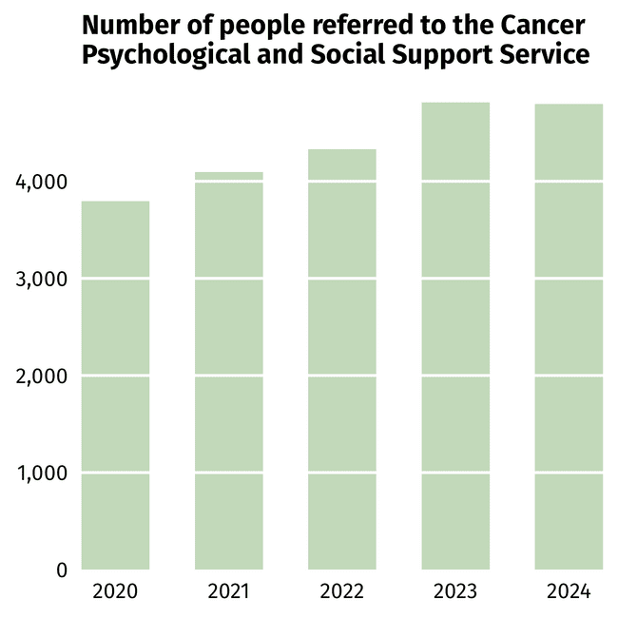
5,000
Source: Health New Zealand.
A ground-breaking achievement of the CPSSS, in collaboration with Te Aho o Te Kahu | Cancer Control Agency, is the implementation of a standardised data collection system, the first of its kind globally. This system tracks service flow and effectiveness, providing invaluable insights into the programme's impact (such as ethnic or regional access to the service) and areas for improvement.

Cancer navigation
Cancer navigators support people and whānau to navigate the many services, pathways of diagnosis and treatment options across all aspects of the cancer continuum (see also The people providing cancer care). Many people experience barriers when trying to access cancer care when they need it, including financial constraints, travel requirements and culturally unsafe services, and cancer navigators play a key supporting role. As the scope and complexity of cancer services continue to grow, requiring patients and whānau to be fully involved in decisions about their care and navigate increasingly complex pathways throughout, the importance of cancer navigation services will continue to grow.
The key components of cancer navigation include holistic needs assessment, liaison with clinical and non-clinical services to reduce barriers to care and supporting patients and whānau with their spiritual, cultural, practical, information and social support needs. Cancer navigators can improve continuity of care and coverage of chemotherapy, reduce time to surgery and radiation treatment and improve the experience of care for patients and whānau [184].
Cancer navigation can be delivered by both clinical and non-clinical specialists based in a range of settings including primary care, hospital and specialist care and kaupapa Māori organisations. People who offer navigation support can have a range of job titles including cancer navigators, health navigators (including some who work specifically with Māori, Pacific and disabled patients), cancer nurse specialists, social workers and nurses.

Patients and whānau appreciate cancer navigation services
In 2021, Te Aho o Te Kahu | Cancer Control Agency undertook a nationwide hui series, attended by more than 2,500 whānau Māori, to understand the lived experiences of whānau Māori affected by cancer. Whānau Māori repeatedly raised navigation as being a potential solution to several issues within the cancer treatment system [192].
High praise was given for treatment services, hospitals and health districts that have cancer navigators to support whānau through the complex cancer continuum. Where navigators were in place, they were described as ‘the link, the constant’ for whānau. [192]
Since the State of Cancer 2020 report was published, there has been significant investment in kaupapa Māori cancer navigation services and more Māori are now accessing the cancer care they need. While most hospitals have offered in-house navigation services for many years, historically there has been limited Government investment in community-based cancer navigation services. This changed in 2023 when Te Aka Whai Ora | Māori Health Authority invested $6.2 million in community-based cancer navigation services [193]. This allowed 20 hauora Māori organisations to establish or scale up these services, which now support whānau through their cancer treatment every year. A further $1.9 million was invested in 2025, supporting another seven hauora Māori organisations to undertake this work. While Health NZ now funds community-based cancer navigation services in almost all districts throughout the country, more investment will be needed to meet rising future demand. A national model of care for navigation services is also being developed, informed by the learnings from these investments.

Travel assistance
Health NZ’s National Travel Assistance (NTA) scheme supports people who need to travel long distances or travel frequently to access specialist health services. The scheme was created in recognition of the fact that people should not be disadvantaged in accessing health services because of where they live [194].
Across New Zealand, different districts offer various levels of cancer services, meaning people with cancer frequently have to travel to receive specialist care and therefore are high users of the NTA scheme. Nearly one in five (19%) people diagnosed with cancer between 2018 and 2021 accessed NTA support, at a cost of $43.8 million dollars over the 4 years. This represents over a quarter (28%) of the total NTA spend over that time period. This data is based on analysis completed by Te Aho o Te Kahu | Cancer Control Agency (but not publicly available at the time of writing).
A 2019 review of the NTA scheme highlighted many opportunities to improve the scheme [194]. NTA was also a common theme in the stories told by people attending the 2021 nationwide hui series described in the previous section. Common issues raised included the systemic barriers that made it difficult for people to access NTA support, including how patients and their whānau have to pay costs up front before they can be reimbursed [194].
In April 2024, the Government announced an $18 million dollar uplift in NTA funding to support a reform programme led by Health NZ [195]. This included:
- increasing the mileage reimbursement rate from 28c per kilometre to 34c per kilometre
- increasing the maximum nightly rate for accommodation from $100 to $140, or from $25 to $35 per night if staying with family or friends
piloting more flexible payment options, including pre-payment and options for people claiming assistance via email.
Further long-term changes have also been announced, including changes to eligibility criteria to better target those in need, as well as improved promotion and awareness of the NTA.

Survivorship and care after treatment
As described earlier in 1 The burden of cancer in New Zealand, people diagnosed with cancer are surviving longer. Across all cancers, 67.6% of people with cancer are surviving at least 5 years after diagnosis; this is a substantial increase of almost 10 percentage points from 1998–1999, when
5-year net survival was 58.0%. While this change is extremely positive, it means extra resourcing is needed to meet the demand so people can receive the care and support they need after treatment.
Survivorship and care after treatment are critical parts of cancer care and include:
- management of late effects of treatment
- surveillance for recurrence and secondary cancers
- intervention and management of any consequences of treatment or ongoing symptoms and concerns – physical, practical and psychosocial
coordination and navigation services between the many specialists and primary and community cancer care providers so all the needs of the patient are met [196].
The 2018 Survivorship Consensus Statement provides some direction about the needs of patients and the services required to meet those needs once patients complete their active treatment [197]. This includes suggestions for services that help peoples’ emotional and mental wellbeing, social wellbeing (such as return-to-work support), physical wellbeing (such as cancer rehabilitation or rapid specialist reassessment pathways) and spiritual wellbeing.

Improvements are being made to the care people receive after they complete treatment
Changes are underway to improve how people are cared for after they complete their cancer treatment. Some of these initiatives are described below. Further resourcing and effort will be needed for the growing number of people who are surviving cancer to realise the full benefits of these improvements.
Optimal Cancer Care Pathways (OCCPs): Care for patients after treatment is a component of the OCCPs (see 4 Getting a cancer diagnosis) [30]. The OCCPs provide (where available) the guidance needed to review and improve ongoing surveillance and rehabilitation requirements. This includes frequency and duration of follow-up including testing guidelines (where available), the use of patient care plans, multidisciplinary team involvement in rehabilitation and direct entry into services when there are concerns a patient may relapse or their cancer recur. For the OCCPs to be effective in helping people with a range of cancers, they will need to be adequately funded and resourced. Given that existing services experience workforce pressures (see The people providing cancer care), maturation of care after treatment is likely to face barriers.
Lung cancer follow-up and surveillance; the role of primary care: In 2021, a report was published on the role of primary care in lung cancer follow-up and surveillance. This was in recognition of the fact that transitioning from active treatment to post-treatment care is an important milestone in the long-term health of people who have undergone curative treatment of lung cancer. Primary care is an appropriate setting to offer follow-up and supportive care to patients and their whānau, including monitoring for cancer recurrence and reducing the physical and psychosocial impacts of cancer and its treatments. The report includes a checklist for GPs to help them support survivors of lung cancer [197]. The capacity of primary care professionals to deliver the care that patients need is likely to vary around the country and will depend on resourcing.
Support for adolescents and young adults: The Adolescent and Young Adult Cancer Network Aotearoa published educational support for patients, including fertility information in 2021 [198] and the ‘Life after cancer’ resource in 2023 [199].

Improvements to access to lymphoedema treatment
Lymphoedema is a chronic disease marked by the increased collection of lymphatic fluid in the body, causing swelling, which can lead to skin and tissue changes [200]. People with lymphoedema can experience a range of negative psychological, physical and social challenges [201].
The development of secondary lymphoedema [202] by a patient is a common outcome of cancer or cancer treatment such as surgical excision of lymph nodes, local radiation treatment or medical therapy. Breast cancer is the most common cancer associated with secondary lymphoedema in high-income countries [201].
It is difficult to know exactly how many people with cancer develop lymphoedema. It is estimated that one in five females who survive breast cancer will develop lymphoedema. One study reported that 37% of females treated for gynaecological cancer had measurable evidence of lymphoedema within 12 months of their treatment [203]. Patients who have been treated for head and neck cancer can develop lymphatic and soft tissue complications throughout the first 18 months post-treatment, with more than 90% of patients experiencing some form of internal, external or combined lymphoedema [204].

Since the State of Cancer 2020 report, all regions in New Zealand now have a publicly funded lymphoedema service [205]. Wellington was the last to achieve this in 2023.
While there is no nationally available information on referrals or wait times for lymphoedema services, feedback from the Oncology, Palliative Care and Lymphoedema (OPAL) Special Interest Group of Physiotherapy New Zealand [206] suggests that demand is increasing but the workforce is not. As with many cancer services, the need for adequate lymphoedema services is growing as more people are surviving cancer.

Cancer survivors have identified gaps in the care they receive after treatment
Considerable variation remains in the care people receive after cancer treatment. The care available can be influenced by the type of cancer a person has had, what support services are available and whether the person can access care privately. Many aspects of care after treatment are district-dependant and the service models vary. Care after treatment has not been coordinated and progressed well enough at a national level, despite this aspect of care being a recognised priority within the New Zealand Cancer Action Plan 2019–2029 [207].
In a 2023 qualitative study that focused on the provision of supportive care services and programmes for cancer survivors post-treatment in New Zealand, cancer survivors reported facing many issues, including:
- a sense of abandonment after having care ‘wrapped around’ them by health professionals during their active treatment, leading to anxiety and depression
- fear that their cancer will return and be missed, leading to the need for survivors to be monitored and reassured
- physical issues of varying nature, which need rehabilitation
- financial and social issues, such as pressure and anxiety associated with returning to work
the fragmented nature of existing support, limited implementation of existing survivorship models of care and a lack of clear referral pathways [208].
The increase in the number of cancer survivors puts increased pressure on specialised services and survivors are increasingly referred back to their GP for follow-up support. While it is positive that people can often be cared for by primary care specialists, the sector requires better resourcing, integration and support to care for people experiencing the range of long-term physical and psychosocial health consequences of a cancer diagnosis.
Post-treatment surveillance programmes monitor people for cancer recurrence, immediate and late side effects, and overall health. There is long-standing variation in approaches to post-treatment surveillance across New Zealand. The National Radiology Clinical Network has identified that standardising follow-up imaging guidance would reduce unwarranted variation between districts and individual referrers but work to address this is yet to be done.
Addressing the complex issue of the growing number of people requiring support after cancer treatment is not unique to New Zealand. International literature shows that, despite advances in cancer care, survivors of cancer consistently report not getting appropriate follow-up care once they have completed active treatment [196] [209]. Similarly, many models of care for cancer survivorship have been researched and developed in the past decade, but there is little evidence of their efficacy [209] [210] [211] [212].

Allied health workers and services play crucial roles in providing cancer care
In New Zealand, there are at least 43 professions classified as allied health professions. The New Zealand Cancer Action Plan 2019–2029 acknowledged the critical role these professions play in cancer prevention, diagnosis and treatment, and rehabilitation and supportive care for patients [207].
However, as outlined in the Ministry of Health’s 2024 Hauora Haumi Allied Health report, each of the allied health professions face challenges that are impacting the development and sustainability of the workforce (see The people providing cancer care) and the optimal delivery of care to patients across New Zealand [213].
In 2024, Physiotherapy New Zealand published the Physiotherapy in Cancer Care | Oncology Rehabilitation document [214]. This presents a call to action for the public funding of oncology rehabilitation for people affected by cancer. Given recent evidence that, in addition to improving quality of life and prognosis, a 12-week intervention of physiotherapy can reduce pressures on other health services such as emergency departments (21.5% reduction), hospital outpatients (21.5% reduction) and oncology clinics and GPs (41.8% reduction) [215], this is an area that would benefit from further focus and investment

NGOs also support people after treatment
Across New Zealand many NGOs are also working to support people who have completed cancer treatment. Physical exercise and rehabilitation initiatives continue around the country. Counselling and support groups and resources are offered to people affected by cancer by the Cancer Society and several other cancer NGOs.
One example is the Southern Cancer Online Support Centre, an online platform that has been piloted by the Cancer Society. The platform helps people with cancer across the South Island access a range of support options, including information and ways to connect with groups and Cancer Society navigators. Users can choose how they receive support, with the Cancer Society team working with them to create tailored support plans. The Cancer Society is now looking at how to extend the platform’s reach and support more people digitally.

A rongoā Māori action plan will drive action to support and enable rongoā
Rongoā Māori is a cultural healing practice and incorporates deep, personal connections with the natural environment. It is a complete and uniquely Māori system of healing derived from mātauranga Māori [216]. Many Māori regard rongoā as central to their identity [217]. As was recognised by the Waitangi Tribunal WAI 262 claim, support and recognition of rongoā is a key pathway to good health outcomes for Māori [218].
In the 2021 report, Rongohia Te Reo, Whatua He Oranga: The voices of whānau Māori affected by cancer, Māori whānau said they wanted to have more choice in their cancer treatment and care [192]. During the hui series, there was a strong call for mātauranga Māori and rongoā to be recognised and available alongside Western treatments.
‘Whānau need to have a choice of services including rongoā, mirimiri etc… and know how to access tohunga, particularly for whānau who may be disconnected from te ao Māori.’
‘We don’t have karakia… we want to see more integration of wairua with rongoā, karakia…’
In 2023 the Rongoā Māori Action Plan was developed by Te Aka Whai Ora | Māori Health Authority following in-depth engagement with tohunga, mātanga rongoā, rongoā collectives and hauora Māori partners. The action plan was designed as a guiding cross-agency tool to drive action to support rongoā in five aronga or focus areas: increase investment in rongoā Māori; implement a partnership approach to rongoā commissioning; support and grow the rongoā workforce; strengthen system coordination for rongoā Māori; and increased awareness and understanding of rongoā Māori [217].
Since the disestablishment of Te Aka Whai Ora | Māori Health Authority, the Accident Compensation Corporation and Health NZ are leading this work, with support from other government agencies.

Palliative care
Palliative care is an essential health service for people of all ages with a life-limiting illness. It aims to:
- optimise people’s quality of life until death
support whānau, and other formal and informal carers, during caring and bereavement [219].
Palliative care services may be suitable whether death is days, weeks, months or even years away. At times palliative care may be provided alongside treatments aimed at extending life and should be available wherever a person and whānau may be. High-quality palliative care can also reduce hospital admissions, relieving pressure on hospitals and reducing the financial costs on the health system [220].
In New Zealand, palliative care is provided through two main pathways: primary palliative care (through a person’s usual health team, such as general practice teams and aged residential care) or, if required, specialist palliative care (by health professionals specialising in palliative care, often delivered in hospices or hospital-based teams). It is estimated that 90% of people who die from cancer in New Zealand receive specialist palliative care [221].
NGOs and allied health professionals play a vital role in delivering supportive and generalist palliative care. Informal carers, such as families and whānau, can also support people and are often the main providers of care. The physical, psychological and financial burden on these informal carers can be high and prolonged.

Improvements to palliative care services have been made over the last 5 years
The following new pathways, resources and networks have emerged in the last 5 years, bringing more consistency, guidance and support to palliative care services in New Zealand.
New pathways:
- Health NZ has begun planning the development of a national suite of Community HealthPathways for palliative care. The current pathways are inconsistent; there are 10 separate sites and 35 different pathways.
- Palliative care is part of the Optimal Cancer Care Pathways (OCCPs) that have been developed (see 4 Getting a cancer diagnosis) [30]. Te Aho o Te Kahu | Cancer Control Agency worked with the National Palliative Care Steering Group and palliative care sector to review the Australian OCPs and adapt them for New Zealand.

Resources published:
- Hospice New Zealand developed He Puka Ārahi Kaimanaaki Pairuri – A Hospice Guide for Carers in August 2024 [222]. The guide contains up-to-date information and support for those caring for someone with a life-limiting illness.
- In 2025, Hospice New Zealand published the first edition of Te Puka Manaaki Pairuri o Aotearoa – the Palliative Care Handbook New Zealand [223]. It provides guidance on what is both safe and expected palliative care practice within a non-specialist (generalist) palliative care setting.
Compassionate communities: Following international trends [224], New Zealand has started to see pockets of compassionate communities start to develop. These groups are not publicly funded. They are described as, ‘naturally occurring networks of support in neighbourhoods and communities, surrounding those experiencing death, dying, caregiving, loss and bereavement’ [225]. They support community education and discussions on death and dying, and affordable natural burials, including access to natural burial sites and funeral resources.

Developing a nationally consistent approach to palliative care
The New Zealand Health Plan Te Pae Waenga for 2024–2027 includes the following action:
Develop a consistent model of palliative care across Aotearoa [226].
This replaces a similar action in the Interim New Zealand Health Plan, which was published in 2022 [227]. In response, Health NZ established the National Palliative Care Work Programme in July 2023 [228]. The programme supports a nationally consistent approach to palliative and end-of-life care planning, funding, service delivery and outcomes.
The programme is overseen by a National Palliative Care Steering Group, which works in partnership with whānau and communities to:
- recommend how to achieve equitable access to, and outcomes from, palliative care services for all New Zealanders
- identify and recommend core palliative care services that will be publicly funded
- develop a national model for paediatric and adult palliative care
- propose national adult specialist palliative care service specifications and costings
- recommend how to sustain a clinically and culturally competent, diverse workforce that represents the community it is serving and meets service demands
develop a national outcomes and reporting framework.
As of mid-2025, sector feedback was being sought on the proposed paediatric, adolescent and young adult palliative model of care proposal, and the model of care and equity framework for adult palliative care was in development.
Some of the outputs from the National Palliative Care Work Programme have been released. These include the findings from a national survey, conducted in 2024, to understand how adult palliative care services and systems work together in New Zealand [229]. The survey had over 1,000 responses from staff and patients of palliative care services. Of these, nearly one-third were working in cancer care or experiencing cancer.

The survey identified areas of strength such as the quality of care and holistic care patients receive. Challenges identified included inadequate funding, service inequities, regional and geographical inequities, poor access to and resourcing of services and limited support afterhours. It also identified priority areas for improvement and change. These include:
- addressing resource and funding constraints in community services, such as general practice, hospices and aged residential care – including pay equity for nurses
- educating health professionals on holistic palliative care, emphasising culturally safe and whānau-centred care
- developing a national standardised, auditable, palliative care model with standardised service components and specification, at both generalist and specialist levels, including afterhours support
- implementing a coordinator/navigator/kaiāwhina role to help patients navigate the health care system and get the care they need
- adopting a shared patient record system to make care seamless
- streamlining the provision of end-of-life equipment in community settings
increasing the availability and accessibility of respite beds.

Palliative care remains under pressure, making progress a challenge
Despite the publication of the Palliative Care Action Plan in 2017 [230] and palliative care being a recognised priority within the New Zealand Cancer Action Plan 2019–2029 [207], there has been little progress to address the ongoing challenges the palliative care system is facing.
Access to palliative care in New Zealand varies. Factors including location and diagnosis affect access, with Māori and Pacific peoples in particular facing inequities in access [231] [232]. These inequities result in poorer health outcomes and experiences for these communities, such as dying younger, greater suffering and lack of culturally safe care [191] [232]. These issues are made worse by workforce shortages and challenges (see The people providing cancer care); they will also be exacerbated by the predicted growth in cancer cases over the coming decades.
Primary palliative care services are experiencing financial pressures, with both service demand and patient complexity increasing. Workforce shortages are another issue, with staff often having limited time to undertake adequate training [219]. These sectors provide the majority of care for people with life-limiting illnesses.
Hospices are the largest providers of specialist palliative care in the community and are under similar pressures. These includes financial pressures, an unsustainable burden on communities to raise funds, increasing demand and complexity of care, inconsistent access to hospice care across New Zealand and workforce challenges including pay equity [219] [233].
Demand on palliative care services is expected to increase as the New Zealand population ages and more people live longer. Modelling shows that, by 2038, the number of people needing palliative care will increase by more than 50% compared with 2015 levels, with an increase of 90% by 2068 [221]. People living with cancer are likely to continue to be a significant proportion of those needing palliative care in future.

People and whānau describe many challenges with receiving palliative care
Two reports published in the last 5 years have highlighted the many challenges people and whānau experience when receiving palliative care.
In 2023, the Te Aho o Te Kahu | Cancer Control Agency report Rongohia Te Reo, Whatua He Oranga: The voices of whānau Māori affected by cancer included feedback on some of the key issues faced in palliative and end-of-life care [192]. Issues ranged from inconsistent palliative care and practical issues in home care to concerns about assisted dying and dealing with systemic racism. They also emphasised the importance of holistic health models, mātauranga Māori and the integration of rongoā.
In 2024, Te Ārai Palliative Care and End of Life Research Group released a report that provided a snapshot of key issues for nine communities traditionally underserved by palliative care [232] and collated all available published evidence regarding Māori and Pacific experiences of palliative and end-of-life care. Issues identified by members of these communities included limited access to consistent and culturally appropriate palliative care services, particularly for those experiencing homelessness, rural deprivation or incarceration. Stigma, discrimination and a lack of cultural competency within the health care system disproportionally affected gang-affiliated/related whānau, rainbow communities and people with mental illness or learning disabilities, often leading to mistrust and underuse of services. Refugees faced language and system navigation barriers, while children and young people lacked adequate age-specific services, especially outside urban areas.

Assisted Dying Service
The End of Life Choice Act 2019 came into force on 7 November 2021 [234]. This established the Assisted Dying Service | Ngā Ratonga Mate Whakaahuru in New Zealand. The service gives a person experiencing unbearable suffering from a terminal illness the ability to take, or be given, medication to end their life. There are strict criteria, processes and safeguards in place for people using the service.
While individual health professionals may conscientiously object to providing assisted dying services, service providers must uphold the legal rights of a person to access assisted dying.
Health NZ oversees and monitors all operational aspects of the Assisted Dying Service, including collecting data and generating summary reports [235]. The Ministry of Health is responsible for regulating the Assisted Dying Service, ensuring services are safe, high quality and delivered in line with the End of Life Choice Act 2019 [236].
Since the End of Life Choice Act 2019 came into force, nearly 2,500 people in New Zealand have applied for a physician-assisted death. Between 1 January 2025 and 31 March 2025, the service received 237 applications for assisted dying; 62% of applicants had a cancer diagnosis. Most applicants (85.2%) were receiving palliative care at the time of application [237].

7 Enablers of cancer care | Te hunga tautoko tauwhiro
There are several aspects of cancer service delivery that are relevant within all aspects of the cancer continuum. Examples include workforce, physical infrastructure, data and technology, and research and innovation. These enablers are highlighted and discussed in this section.

The people providing cancer care | Te hunga tauwhiro

Key messages
- The current cancer workforce in New Zealand is experiencing shortages of skilled workers across a range of professions. Demand on the workforce is expected to rise substantially as the number of people being diagnosed with cancer increases due to the population growing and ageing.
- Over the last 5 years, there have been new and innovative approaches to how the cancer workforce is trained and utilised, and how care is provided. Several strategic initiatives have progressed to address the pressures facing the cancer workforce. Shifting towards more sustainable ways to grow and support the workforce to deliver care effectively will be necessary to meet future demand.
- There has been progress in understanding the workforce requirements for delivering effective cancer services both now and in the future. However, cancer workforce models in New Zealand do not take current workforce shortages into account and can only forecast how many workers will be needed in certain cancer professions in the future if nothing changes.
- Improvements to the delivery of cancer care, such as providing care closer to people’s homes, will have implications for the workforces required to provide this care.

The cancer workforce in New Zealand includes a diverse group of health professionals who work together to help prevent, diagnose, treat and support people with cancer. Some of these professionals work exclusively in cancer care, such as medical oncologists, while others have a broader role across health care, such as GPs. People who form the cancer workforce work in various settings across New Zealand, including hospitals, community health centres, primary care, academic institutions, palliative care facilities and NGOs.

Strengthening the cancer workforce
Over the last 5 years, there have been new and innovative approaches to how the cancer workforce is trained and utilised, and how care is provided. Initiatives underway are described below.
Specific uplifts in the cancer workforce: Five additional radiation oncology registrars have been added per year across the six cancer centres. Nurse practitioner roles in oncology and investment have also been added through the new cancer medicines programme [238].

Changes to recruitment and retention approaches: Changes to recruitment and retention approaches have been made through the Health NZ workforce taskforce, including better management of international recruitment and standardisation of terms, conditions and benefits [239].
Cancer Nursing Workforce Pipeline: A Cancer Nursing Workforce Pipeline programme was developed in 2023. This provides detailed supply and demand modelling for the cancer and haematology nursing workforce, building on the modelling work already done for registered nurses across different settings.
Oncology capability in primary care: Oncology capability in primary care has been established through various innovations including General Practitioner with Special Interest models. These have the potential for patients and whānau to access care closer to home and have greater continuity of care.
Cancer National Clinical Network: The Cancer National Clinical Network was established in 2025 [240]. Along with education providers and professional colleges, the network will explore new and innovative ways of increasing workforce capacity to meet demand.
Advance Practice for Radiation Therapists programme: A nationalised Advance Practice for Radiation Therapists programme has been developed to support radiation therapists in career progression and make radiation treatment across New Zealand more sustainable [241].
Primary care improvements: The substantial investment made by Government in 2025 to improve primary care in New Zealand included increasing training places for primary care nurse practitioners and initiatives to expand the GP workforce [242].
New medical school: In July 2025 the Government approved investment to develop a new medical school at the University of Waikato as part of its plan to build a stronger health workforce. The new school will have a strong focus on primary care and rural health, and will add 120 doctor training places each year starting in 2028 [243].

There is a current and growing shortage of cancer care workers
Over the last 5 years, New Zealand has experienced shortages of skilled workers across a range of professions within the cancer workforce. There are also not enough Māori and Pacific peoples represented in the palliative care workforce [219].
As a result of these shortages, people with cancer may face longer waiting times for treatments and services, and the existing workforce is put under additional pressure. Such pressure has been linked to moral distress [244] – a deep unease that arises when health care professionals are unable to act in line with their ethical beliefs due to constraints, such as limited staffing, time, training or resources [245]. Over time, this can evolve into moral injury, where repeated exposure to such situations causes lasting psychological harm, erodes trust in the health system and diminishes the sense of purpose that drew health care professionals into their chosen field [245]. Moral distress has been linked to burnout (physical and emotional exhaustion [246]), compassion fatigue (stress resulting from exposure to traumatised individuals), depression, post-traumatic stress disorder (PTSD) and even suicide [245] [247] [248].
Demand on the workforce is expected to rise as the number of people with cancer increases, due to the population growing and ageing [28]. Health workforce shortages are not unique to New Zealand, but the demand for skilled cancer care workers across the world is also making it hard for providers to attract, recruit and retain staff.
While these issues are being felt across the cancer workforce, and the wider health system in general, some of the specific challenges are described below.
Radiation oncologists: In 2024, as part of the development of a radiation oncology model of care, Te Aho o Te Kahu | Cancer Control Agency engaged with public radiation oncology departments across New Zealand to identify the challenges the workforce currently faced and opportunities to improve the delivery of radiation treatment to patients. A common theme in the feedback was that the workload of staff in some regions was above recommended levels and posed both a personal wellbeing and a clinical risk. To keep up with waiting lists in some regions, staff were working longer hours, additional shifts, not taking annual leave and not taking part in continuing professional development. Workforce shortages also have implications on the number of training positions that services could provide and clinicians’ capacity to develop and grow the future of radiation oncology.
Radiation oncology medical physicists: These have a critical role in safe and accurate delivery of radiation treatment. They are responsible for accurately calculating the radiation dose delivered to patients using treatment planning systems as well as calibrating, monitoring and maintaining radiation therapy machines and other systems. Increasingly, complex planning and treatment techniques require much more physicist input. A shortage in this workforce can impact treatment planning, LINAC capacity and radiation treatment wait times. There have been recent instances where LINACs have not been utilised or operating hours have been reduced due to a shortage of radiation oncology medical physicists. With the forecasted increase in cancer registrations and projected increase in LINAC hours [249] to meet demand for treatment, as well as the corresponding need for additional LINACs, the number of radiation oncology medical physicists required will continue to increase over the coming years.
Medical oncologists: This workforce is under strain, especially with the new cancer medicines announcement and the associated increased demand on their capacity. With increases in the numbers of registered indications for treatment and the complexity of clinical decision-making, senior medical officers are spending more of their time with more complex patients. This may have unintended negative consequences for service workflows and volumes.
Haematologists: The haematology workforce is under pressure, largely driven by limitations in the current training model. There is a shortage of training posts, particularly the availability of the laboratory component of training. Many laboratories embedded in public hospitals are run by private providers, which means more complex contractual and collaborative arrangements are needed to facilitate training compared with other specialist training programmes that operate solely within public health services.
Oncology nurses: There is no universal pathway for nurses to specialise as clinical nurse specialists in cancer care, and to then become cancer-specialist nurse practitioners [250].
Allied health services: Allied health covers a broad range of at least 43 professionals such as pharmacy, physiotherapists, dietitians and social workers. Allied health specialists play a critical role in supporting patients affected by cancer. Barriers facing this workforce include insufficient clinical placements and support for clinical supervisors, insufficient support for students in training programmes and challenges in retaining experienced health professionals, with competition between public and private practices [213].
The medical laboratory science sector: The demand for diagnostic services continues to increase as cancer cases and the availability of modern technologies and treatments rise. Attracting and retaining skilled professionals is also difficult because career progression opportunities within the sector are limited [251].
Primary care: There are worsening GP shortages and nursing retention issues in primary care, with a number of general practices not enrolling new patients [252]. This is affecting many patients’ ability to access care and may lead to later presentations of cancers in emergency departments.
Cancer surgical services: There are staff shortages in several surgical specialities such as gynaecological oncology. At the same time, demand for more advanced surgical interventions is increasing [169].
Palliative care workforce: There is limited palliative care undergraduate, postgraduate and vocational training for health professionals and few opportunities for people to specialise in palliative care.
NGOs: Many NGOs such as the Cancer Society rely on donations, fundraising and government grants that can fluctuate, limiting an organisation’s capacity to invest in staff development, expand services and respond to increasing demand. Some NGOs rely heavily on volunteers to deliver services, but recruiting and retaining volunteers can be challenging due to time constraints, lack of skills and experience, low pay or no pay and a lack of recognition [253]. The NGO workforce, including nurses, counsellors and volunteers, also experience burnout and compassion fatigue from the emotional toll that supporting cancer care demands.

Setting the direction for a more sustainable workforce
Workforce changes require years of advance planning. Understanding workforce supply and demand can help identify potential workforce gaps and determine strategies to address these gaps, so patients receive high-quality care in a timely way.
One of the difficulties in identifying workforce gaps is that ideal workforce requirements in New Zealand have not been quantified across different cancer treatment areas, except for radiation oncologists [254]. In 2022, a comprehensive demand model for radiation oncologists – integrating treatment volumes with detailed work-activity data – produced reliable workforce estimates for future planning. Comparable analyses are still needed for other oncology specialties.
With the current and growing demand on the cancer workforce, there is a need to shift towards more sustainable ways of growing and supporting the workforce to deliver cancer care effectively.
In 2023, the Health Workforce Strategic Framework was published by the Ministry of Health to guide health system settings in New Zealand [255].
Following this, Health NZ released its workforce plan for 2024–2027 [256], which signalled a particular focus on strengthening the cancer workforce [250]. This includes priority actions to:
- improve national workforce planning and align it with national and regional service planning
- align training volumes with the number of health workers needed in future
- create private training capacity
- change how care is being delivered by shifting to new models of care and service delivery approaches
- expand medical training in vulnerable specialities
establish advance practice roles and clearer cancer specialisation pathways, particularly for nursing and kaiāwhina workforces.

Physical infrastructure supporting cancer care | Te hanganga tautoko

Key messages
- A shift to more community-based models of care is an effective way to improve access and patient experience and relieve capacity pressure in secondary and tertiary hospitals.
- There has been historic underinvestment in health sector infrastructure, resulting in poor building, site-wide infrastructure and clinical facility condition. This affects many aspects of the health sector including cancer care.
- Over the last 5 years, groundwork has begun to improve facilities for patients. These infrastructure projects take time to complete and to deliver full benefit.
- Existing physical infrastructure is increasingly not fit for purpose, which impacts the quality and quantity of cancer services and the patient experience.

Delivering cancer care close to where people live
The location of cancer services impacts how easily patients can access care. Historically, cancer treatment models have often relied on patients travelling to main centres to access surgery, radiation oncology and/or SACT. Now there is a push for patients to be able to receive care closer to where they live, making their treatment as accessible as possible.
Community-based models of care can help relieve capacity pressure in secondary and tertiary hospital day-stay units, which can in turn improve patient wait times.
Examples of recent improvements made to the settings where patients receive treatment include:
- the opening of the Kimiora Infusion Unit at Whanganui Hospital in December 2023. By December 2024, the unit was delivering up to 40 cancer treatments a month, saving patients the need to travel from Whanganui to Palmerston North to receive medical oncology treatment
- the opening of a chemotherapy infusion unit at Bay of Islands Hospital in Kawakawa in October 2024. The unit allows people in the mid-north to get treatment locally instead of making the long trip to Whangārei
- the establishment of cancer infusion services in Wairoa, so local patients no longer have to travel to Hastings (discussed in Major events of the last 5 years)
- the opening of a new purpose-built 50-room Cancer Society facility in Christchurch where patients and whānau can access on-site, integrated support, accommodation and transport services
- investment in PET-CT infrastructure and changes to access criteria to improve access for patients (outlined further in 4 Getting a cancer diagnosis)
the opening of a peptide receptor radionuclide therapy (PRRT) [175] site in Auckland in 2021. Now patients with neuroendocrine tumours no longer have to travel to Australia for this treatment.

Work to improve facilities for patients is underway but still has far to go
In 2021 the New Zealand Infrastructure Commission published Sector State of Play: Health and Disability Infrastructure [257]. The report highlighted:
- there has been historic underinvestment in the health sector’s infrastructure, resulting in poor building, site-wide infrastructure and clinical facility condition
- health and disability facilities are increasingly not fit for purpose due to growing diversity, rising rates of chronic disease and increasing complexity in the way people receive care when they are unwell. New facility design standards are needed to improve long-term planning and facilitate modern care practices to meet future demand
- technological advancement is disrupting the health sector, for example, AI and ‘big data’. While this advancement means patients have more treatment options and diagnostics, it comes at an increasing cost of technology and infrastructure investments
New Zealand’s ageing population will continue to place strain on the health and disability system’s capacity.
The 2022 report He Mahere Ratonga Mate Pukupuku, Cancer Services Planning published by Te Aho o Te Kahu | Cancer Control Agency noted these same issues within cancer treatment facilities. Facilities were often reported to be insufficient to support the delivery of cancer services to patients, with insufficient substantive growth in the size or scale of facilities over the past 2 decades to keep up with patient demand [169].
Infrastructure (both physical and digital) is one of five priority areas in the Government Policy Statement on Health 2024–2027 (GPS). The GPS sets an expectation that there will be a greater focus on national planning for asset management and infrastructure investment. This should result in improvements in the quality and timely delivery of infrastructure projects [12]. New infrastructure must be developed with robust future volume and population modelling at the core.
Health NZ has established a new Infrastructure and Investment Group to lead health investment through national planning, prioritisation and monitoring of capital infrastructure projects [258]. To support this, Health NZ published the National Asset Management Strategy – Infrastructure in March 2025, setting out a forward-looking approach to improving the management of building, plant and infrastructure assets across the public health system [259]. This strategy sits alongside the Health Infrastructure Plan 2025, which outlines the pipeline of investments in physical infrastructure over the next 10 years [260].
Over the last 5 years, groundwork has begun for physical infrastructure projects to improve facilities for patients; however, many of these projects are not yet completed.
The ongoing and substantial investment in the regional LINAC rollout remains a key project to improve patients’ access to radiation oncology. The LINAC investment programme includes:
- the construction of the Taranaki Cancer Centre was completed in 2025. The centre houses a new LINAC for the region, meaning most patients will no longer need to travel to Palmerston North to receive radiation treatment. There is also an improved space to deliver chemotherapy and other forms of SACT
- a new LINAC in Whangārei, expected to be operational in mid-2026. This will mean many patients will no longer need to travel to Auckland to receive radiation treatment
- a new LINAC approved for Hawke’s Bay but still in the planning phase. This will include the building of the bunker to house the LINAC, alongside consideration of changes to medical oncology infrastructure as current facilities require replacement
- additional bunkers included in the designs of LINAC builds for the Taranaki Cancer Centre (one bunker plus space to add another), Hawke's Bay and Whangārei (two bunkers) to plan for future growth. This will allow other LINACs to be placed when required to expand service capacity
planned investment outlined in the Health Infrastructure Plan 2025 for new LINACs in the next 5 years in Counties Manakau, Nelson Marlborough and Canterbury [260].
Alongside planning for new LINACs, 10 ageing LINACs in public hospitals have been replaced over the last 5 years, and new treatment planning and delivery technologies purchased or upgraded. Private centres have also invested in additional infrastructure, including an additional LINAC in Bay of Plenty, a CyberKnife and additional LINAC in Auckland and an MR-LINAC in Christchurch.
Many infrastructure projects are broad and provide positive benefits beyond cancer care. For example, over the last 5 years there has been investment in radiology infrastructure, both to replace or upgrade existing machines and create additional capacity. This work is critical for the care of cancer patients as well as for the diagnosis and management of other health issues. Examples include additional MRI machines being installed in Auckland, Whanganui and Dunedin, as well as new CT scanners in a number of centres.
Several hospitals across New Zealand have received upgrades and refurbishments in the last 5 years, and the new build of Dunedin Hospital is underway [261]. The Health Infrastructure Plan 2025 also outlines a staged and sequenced approach to substantial investments in public hospital redevelopments across New Zealand over the next 10 years [260].

Data and technology needed to improve cancer care |
Ngā raraunga me te hangarau

Key messages
- Enhancing the use of data and technology in cancer control can help drive informed decision-making, give people greater access to their health information, improve their quality of care, support personalised health outcomes and improve equitable access to cancer services.
- Large volumes of information are currently collected within the wider New Zealand health system but much of it is hard to access. Information is recorded in different ways and kept in hundreds of separate systems that have not been designed to connect, communicate or work together.
- Investment over the last 5 years is enabling the development of a national cancer informatics platform that aims to support the timely sharing of complete and accurate cancer data. The benefits of this standardisation will increase if national standards for describing and exchanging data are adopted.
Emerging technologies, such as AI and genomics, are expected to support the delivery of more personalised cancer care but have yet to be implemented consistently and widely enough to make substantive system impacts.

Improving cancer data
Effective use of data and technology in cancer care has the power to change lives. When health professionals have the right information at the right time, they can make faster, more accurate decisions. With accessible data, patients can better understand their health information, quality of care improves and services can be more accessible and tailored to each person’s needs.
Large volumes of information are currently collected within the New Zealand health system but much of it is hard to access. Information is recorded in different ways and kept in hundreds of separate systems that have not been designed to connect, communicate or work together. This fragmented situation is common when data systems have been built and delivered in isolation.
Cancer data is an integral component of the health system’s data landscape, embedded within its infrastructure and systems. To improve the collation and use of cancer data, Te Aho o Te Kahu | Cancer Control Agency is leading the development of a national programme called CanShare.
CanShare will focus on turning cancer data into insights that can be used by health services to make informed decisions and track progress. This includes the development and implementation of national data standards – agreed ways of recording and sharing information so all health systems across the country can ‘speak the same language’. The standards will allow different systems to work together more easily and for data to be more reliable, complete and timely.

The CanShare programme includes a range of initiatives, described below. These aim to improve specific aspects of cancer data and care, working collectively to build more equitable, integrated and effective cancer control for New Zealand.
- The Radiation Oncology Collection (ROC) [262] collects detailed information about cancer patients who receive radiation oncology. Data from the ROC is used to help health providers and decision-makers understand which treatments are being used, where new facilities might be needed and whether patients are being treated with a similar standard of care. While the ROC has been used for many improvement projects already, it is not currently operating to CanShare standards. Future plans include making all ROC data adopt CanShare standards, which means information will be available almost in real time.
ROC data in practice: Since the State of Cancer 2020 report, the benefits of the ROC have been seen in practice. Clinical improvements include supporting shifts to delivery of fewer fractionations (individual treatments) for several cancer types, saving hundreds of hours of clinician and patient time. Systemic improvements include providing the demand modelling that identified the best placements for new LINAC machines and workforce in 2025 and beyond [254].
- The Anti-Cancer Therapies – Nationally Organised Workstreams (ACT-NOW) [186] project focuses on collecting information about SACT medicines such as chemotherapy and other anti-cancer drugs. ACT-NOW aims for all treatment information to be collected in the same way so it can be shared and compared. This will help identify variation in treatment patterns across the country and enable health providers to make changes to reduce variation. Like ROC data, ACT-NOW data has yet to become fully compliant with CanShare standards at a national level.
Structured pathology reporting aims to provide a solid foundation for the national implementation of electronic structured pathology reporting. Pathology reports – the results from lab tests that help to diagnose cancer – are a vital part of cancer care. In the past, these reports have often been written in different ways, making them difficult to use and share effectively. CanShare is working with pathologists to create structured, standardised reports for all types of cancer. Pathology reports will be comprehensive, consistent and complete, facilitating the sharing of standardised pathology information over the coming years.
Other initiatives that aim to improve access to cancer data in New Zealand include:
- the Health NZ cancer web tool [2], an online interactive tool that is updated annually and provides public access to cancer registration, diagnosis and mortality data. The data can be viewed through interactive visualisations and explored by demographics such as age, ethnic groups, gender and location
- the Cancer Quality Performance Indicator (QPI) programme [170]. Led by Te Aho o Te Kahu | Cancer Control Agency, this programme develops, calculates and reports on cancer-specific QPIs for bowel, lung, prostate, pancreatic and breast cancers using national data collections. The information is used by clinicians and health professionals to improve the quality of cancer services and deliver better outcomes for people diagnosed with cancer across New Zealand. The programme includes:
  - the Cancer Care Data Explorer [263] – an interactive dashboard for clinicians and service providers to explore QPI results by region and district, gender, age group, ethnic group and socioeconomic deprivation
  - the route to diagnosis dashboard [264] – an interactive tool that provides data on cancers diagnosed within 30 days of emergency or acute (unplanned) hospital admission. As discussed earlier (see 4 Getting a cancer diagnosis), patients who are diagnosed following an emergency or unplanned hospital admission often present with severe symptoms, indicating an advanced stage of cancer resulting in poorer outcomes. This tool presents the latest indicator results for 22 cancer types by geographic areas and by age, sex, ethnic group, rural–urban status and socioeconomic deprivation
electronic prescribing (often referred to as e-prescribing) systems. These provide cloud-based access to prescription details. While these systems have been operating within primary care in New Zealand for some time, they have not been used in cancer care until recently. Work is underway to give all regions access to e-prescribing platforms, which are a key requirement for community-based SACT treatments. The Northern region’s new oncology e-prescribing system, called Raurau Ngaehe, is the country’s first CanShare-compliant oncology prescribing system. It will start sharing treatment data in 2025, providing a clearer picture of how cancer medicines are being used.
In terms of broader changes across the whole health system, the Health Data Platform (HDP) is a unified and standardised system currently being developed by Health NZ [265]. Previously known as the National Data Platform (NDP), the HDP is designed to be a comprehensive data resource, driving improvements in health care and targeting services to meet the specific needs of communities. The HDP is expected to provide valuable insights into medication demand, service gaps and public health trends, which will inform evidence-based policy decisions.

Emerging technologies and innovations have potential to impact cancer control
Several emerging technologies and innovations hold great promise and potential for providing more personalised and effective care across the continuum of cancer prevention, early detection and treatment.
In New Zealand, the Ministry of Health has signalled a shift towards developing and adopting more precise ways of keeping people healthy, known as ‘precision health’, in a Long-term Insights Briefing published in August 2023 [266]. The briefing explored opportunities and challenges, using AI and genomics as two examples of precision health technologies. Both are already being used in cancer care in New Zealand and around the world.

Artificial intelligence
The speed of AI development has increased rapidly since the State of Cancer 2020 report, presenting major opportunities and challenges for cancer control in New Zealand. Existing AI technologies can, when used appropriately, improve the quality of care people can access while making the health system more efficient.
AI is currently being applied in cancer diagnostic imaging and radiology, supporting technicians to read scans such as breast screening mammograms [267]. It is also helping pathologists examine tissue samples more efficiently. AI can scan thousands of images and identify cancer cells with high accuracy, speeding up diagnosis and reducing human error [268]. In addition, it is being explored as a way of integrating multiple data types, such as genetic and clinical information, to assist clinical decision-making [269].
A 2023 report by the Department of the Prime Minister and Cabinet, in collaboration with the Ministry of Health, outlines some of the challenges and opportunities for AI in health care [270]. In early 2025, guidance was released to support the New Zealand public service to adopt generative AI (GenAI) [271]. The Government recently released the first national AI strategy for New Zealand to help drive adoption of AI to boost productivity and grow the economy [272].

Genomics
Cancer is a disease of the genome, caused by abnormal changes to the DNA in human cells. Genomics is playing an increasingly vital role in cancer care, enabling more precise interventions at every stage of the cancer continuum [273] [274]. Genomic or biomarker testing can identify treatments that are more targeted, more effective and less likely to cause adverse side effects for patients, improving their quality of life.
Genomics can also be used to help detect cancer earlier, guide cancer prevention and improve chances of successful cancer treatment. For example, liquid biopsy tests that analyse circulating tumour DNA (ctDNA) in blood are increasingly used to detect cancer early. They also enable clinicians to monitor disease progression and detect minimal residual disease after treatment, offering insights into the likelihood of relapse.
Additionally, genomics has supported the development of immunotherapies such as immune checkpoint inhibitor drugs [275], cancer vaccines [276] and chimeric antigen receptor (CAR) T-cell approaches [277], which have extended remissions and improved overall survival across a growing number of cancer types [278]. In New Zealand, genetic screening is already being used to assess the risk of some types of breast (eg, BRCA1/2) or stomach (eg, CDH1) cancers within individuals or families [273] [274].
The wider use of genomics in New Zealand cancer care is limited compared with other comparable countries, and unevenly distributed [266]. This is reducing the impact genomics can have on delivering high-quality cancer care for all patients. Current laboratory and clinical services in New Zealand do not have funding, capability or capacity to deliver genomic testing at scale for cancer patients, and a sizeable proportion of genomic testing is being sent overseas. This carries potential risks and challenges for the sovereignty of data and tissue/DNA, particularly for Māori.
There are also concerns that the information from genetic testing could be misused or lead to genetic discrimination. For example, insurance companies could increase premiums or deny cover to applicants based on their genetic information [279].
Progress is being made to make access to genomics safer and more equitable, as the following initiatives demonstrate.
Precision health programme: The Ministry of Health has established a precision health programme to guide the use of AI and genomics in New Zealand’s health system [266]. The programme is bringing together international partners to share best-practice examples and regulatory models before considering how they might inform New Zealand’s unique health care context. The programme aims to identify and manage potential challenges associated with precision health. These include risk of discrimination, financial costs that could widen gaps in health outcomes, and potential privacy issues. The guiding principles for precision health technologies are that they should be accessible, safe, effective, accountable, equitable and provide value for money.
Rakeiora pathfinder programme: The Rakeiora pathfinder programme was commissioned by the Ministry of Business, Innovation and Employment in 2019 to generate infrastructure that enables high-impact research in New Zealand using linked genomic and health care information [280]. Early findings of the programme detail a robust pilot research infrastructure consistent with international standards and a tikanga framework to uphold Māori data sovereignty principles.
Genomics Aotearoa: This collaborative research platform, led by the University of Otago, received nearly $40 million from 2017 to 2024, with a further $25 million announced in February 2025 to extend the project until 2030 [281]. Genomics Aotearoa’s mission is to deliver infrastructure that builds capability and enhances the use of genomics and bioinformatics for the New Zealand research community. The renewed platform will focus on enabling genomic research with the potential to deliver economic benefits to New Zealand, and research and capability development.

Cancer research and innovation | Te rangahau me te auaha

Key messages
- High-quality cancer research and innovation drives evidence-informed practice improvements across the cancer continuum and the wider health system.
- There is a substantial volume of activity across both cancer research and policy in New Zealand. However, the connection between the two needs to be strengthened to enable cancer research to better influence improvement and innovation.
- A 2024 workshop brought together members of the cancer research and policy communities to identify potential opportunities for connection, collaboration and improved alignment of activity. These included developing a clear strategic direction for cancer research, ‘fast-track’ processes for funding research with a high potential for policy impact and focusing on ‘windows of opportunity’ to translate research findings into policy and practice.
In addition to system- or policy-level cancer research, New Zealand-based clinical trials can provide evidence to inform decision-making in health care and improvements in service delivery.

Research is fundamental to reducing the burden of cancer and underpins every part of the cancer continuum. Cancer research generates evidence and knowledge that drive improvements in cancer outcomes for all people in New Zealand and make services more sustainable.
Over the last 5 years, cancer has remained among the most-funded and most-studied areas of health research in New Zealand. Different types of cancer research are funded by a wide range of funders – primarily government but also NGOs, universities and private industry [282].

Connecting cancer researchers, policy makers and the cancer sector
Cancer care and patient outcomes improve when the evidence and knowledge generated from research are translated into practice and policy. Bridging this gap between research and practice and policy is often cited as taking 17 years internationally [283]. There is an additional issue in New Zealand, as there are currently no regular processes for cancer researchers to engage with cancer control policy and delivery, and vice versa.
As a step towards bridging the gap, Te Aho o Te Kahu | Cancer Control Agency collaborated with partners across the health and research sector to host a 1-day workshop in 2024, bringing together cancer researchers, policy makers and members of the cancer sector. The workshop involved stakeholders representing 14 organisations, including 27 research leaders from 4 universities, 6 from non-governmental stakeholder organisations and 22 from government departments. A common reflection from workshop attendees was that a lot of research is occurring, but it does not have a natural ‘landing place’ within the current policy agenda. Other challenges identified included there being no nationally aligned cancer research strategy and no process for building relationships and collaborations within the research sector, and between researchers and policy makers.

The workshop participants provided a range of potential solutions to these challenges, including developing clear strategic direction for cancer research, ‘fast-track’ processes for funding research with a high potential for policy impact and focusing on ‘windows of opportunity’ to translate research findings into policy and practice. There was also strong support for activities that enable researchers, government and stakeholders to work more closely together.
In March 2025, the Cancer Society hosted an inaugural research and innovation conference, called In Pursuit, to unite researchers, health care professionals, innovators and investors. The conference explored cutting-edge cancer research, innovative treatments and collaborative efforts to combat cancer [284]. Topics covered during the conference included the role of biobanking to support cancer research, the global surge in diagnoses in people aged under 50 years, cancer prevention through equitable environments and policy change, and innovations in cancer screening.
Another event that brings together researchers, health workers and community members is the Matariki Rangahau Series, convened by Hei Āhuru Mōwai. The event fosters collaboration, knowledge sharing and community engagement to improve Māori health outcomes and celebrate Māori and Pacific health research. The 2025 event was presented by four leading agencies: Te Aka Mātauranga Matepukupuku – Centre for Cancer Research University of Auckland, Hei Āhuru Mōwai, Health NZ and Te Aho o Te Kahu | Cancer Control Agency [285].

Work is underway to improve availability of and access to clinical trials
Clinical trials are an important part of cancer research. A clinical trial is a research study where new treatments, medicines or procedures are tested to assess their safety and efficacy. They are essential for advancing modern cancer care and can also give cancer patients access to treatments that would not otherwise be publicly available.
New Zealand has pockets of excellence in clinical trial activity and a reputation among the international research community as a respected place to conduct clinical trials. However, a lack of national leadership, infrastructure and coordination and the stretched nature of the workforce prevent New Zealand from realising and maximising the benefits that clinical trials could bring to cancer patients and the wider system [286].
Over the last 5 years there has been an increased focus on improving access to clinical trials in New Zealand. The Ministry of Health and the Health Research Council of New Zealand commissioned the 2022 report, Enhancing Aotearoa New Zealand Clinical Trials [287]. The report include recommendations for the development of an infrastructure roadmap and operating model to improve equitable access to clinical trials for all people in New Zealand. The Ministry of Health and Health NZ have been working to identify options that can be progressed within the current fiscally constrained environment.
Some of the other new initiatives underway to improve access to clinical trials include the following.
- Health NZ has adapted a suite of workforce training modules to the New Zealand setting to provide essential clinical trials education to staff.
In 2022, Clinical Trials NZ and the University of Auckland were funded by Te Aho o Te Kahu | Cancer Control Agency to develop a framework for the evaluation of the implementation of decentralised cancer clinical trial methodology [288]. In 2024, funding to continue progressing work to embed a decentralised trial model in New Zealand was provided by the Health Research Council of New Zealand [289]. Decentralised cancer clinical trials allow people to take part in clinical trials from their own homes or local communities instead of having to travel to a hospital or research centre. This makes clinical trials more inclusive, accessible and
whānau-centred.
Work to connect the research system into policy and decision-making is underway, but it needs to continue to scale up.

Example of a clinical trial: CAR T-cell therapy
The Malaghan Institute, in partnership with Wellington Zhaotai Therapies [290], is developing and trialling a new chimeric antigen receptor (CAR) T-cell therapy in New Zealand for patients with a
B-cell non-Hodgkin lymphoma. The treatment works by redirecting a patient’s own immune cells (T-cells) in the laboratory to directly identify and attack cancer cells. These modified T-cells are then returned to the patient where they can attack and destroy cancer cells. Phase one of the clinical trial, conducted at Wellington Hospital, has ended, with positive preliminary results presented in 2023. Phase two started in July 2024 and has expanded to include sites in Christchurch and Auckland, alongside the original site in Wellington.
CAR T-cell therapy is already a standard part of cancer care in several countries like Australia, the United Kingdom and the United States of America, but is currently only available in New Zealand via this clinical trial. Independent of the trial itself, coordinated efforts across government agencies will be essential to ensure the appropriate operational, funding and regulatory frameworks are in place to support the safe adoption of CAR T-cell therapy as an available treatment modality in New Zealand.

A targeted research fund was developed to improve equitable cancer outcomes
In 2021, Te Aho o Te Kahu | Cancer Control Agency, the Health Research Council of New Zealand and the Ministry of Health released joint research funding of $6.2 million, aimed at improving equitable cancer outcomes [291]. Six research projects were funded in the areas of lung cancer screening and clinical lung cancer research. The research topics included the following:
- Lung cancer screening: Testing ethnicity weighting for risk prediction in Māori
- Improving management and outcomes for patients with lung cancer
Whānau Ora navigation in local delivery of oncology care.
The final reports for these projects are due at the beginning of 2027.

Explanation of terms used in this report | Kuputaka
TERM | EXPLANATION
Access barriers | Factors that prevent people from obtaining and using health care services when needed, such as affordability, availability and acceptability of services.
Adjuvant therapy | Treatment given after the primary treatment to increase the chances of a cure. In cancer, adjuvant treatment often refers to chemotherapy, hormonal therapy or radiation treatment after surgery, which is aimed at killing any remaining cancer cells.
Age-specific rate | Instead of looking at cancer incidence or mortality across the entire population, risks can be examined within several age bands separately, revealing different patterns in different age groups.
Age-standardised rate | Populations continually change in their balance of old and young people. To allow valid comparisons of entire populations across time or between countries, rates are adjusted as if the data came from a single, stable age structure. This means the risk of cancer or risk of mortality does not appear to rise just because the population is ageing. In this report, New Zealand data has been adjusted to fit the World Health Organization’s 2001 population standard.
Allied health | Health professionals who are qualified practitioners with specialised expertise in preventing, diagnosing and treating a range of conditions and illnesses. Examples include pharmacists, physiotherapists, dietitians and social workers.
Allogeneic transplant | Stem cells in allogeneic transplants come from another person rather than the patient.
Artificial intelligence (AI) | The capability of computers and machines to perform tasks typically associated with human intelligence, such as learning, reasoning, problem-solving, perception and decision-making.
Autologous transplant | Stem cells in autologous transplants come from the patient receiving the transplant.
Biomarkers | A biological molecule found in blood, other body fluids or tissues that is a sign of a normal or abnormal process, or of a condition or disease. A biomarker may be used to see how well the body responds to a treatment for a disease or condition.
Brachytherapy | Where a radioactive source is placed inside or near a tumour, delivering radiation directly to the cancer. Also known as internal radiation therapy.
Burden of cancer | The number of cancer cases and the effects of cancer in a country, community, family or individual.

Cancer continuum | The full spectrum of cancer control services from prevention, screening and early detection efforts, through diagnosis and treatment, to rehabilitation and support services for people living with cancer and/or palliative care.
Cancer registration | Data about cancer patients that is received and captured in a cancer registry.
Capability framework | A common foundation and common language to describe the knowledge, skills and abilities needed to perform work across all levels of an organisation.
Carcinogens | Substances that can cause cancer.
Chemotherapy | The use of drugs, which kill or slow cell growth, to treat cancer. These are called cytotoxic drugs.  See also: Systemic anti-cancer therapy (SACT)
Chronic infection | An infection that, although not necessarily causing symptoms, may still be active and may spread to others.
CNS tumours | Central nervous system tumours.
Co-design | The involvement of people in the design of processes, services, information, models of care, strategies, environments and policies that impact them.
Colonoscopy | A procedure carried out by a doctor or nurse using a very small camera to look directly at the lining of a person’s large bowel.
Comorbidity | The simultaneous presence of two or more diseases or medical conditions in a patient.
Complex radiation treatment | Treatments that target a tumour more precisely and typically impact healthy surrounding tissue less.
Computed tomography (CT) | The technique for constructing pictures from cross-sections of the body, by x-raying the part of the body to be examined from many different angles.
Confidence interval (CI) | An indication of the precision of a statistical estimate of a value. A narrower interval indicates higher precision.
Continuum | See Cancer continuum
Corpus uteri | The epithelial lining of the uterine cavity. In this report, cancer of the corpus uteri refers to endometrial cancer.
Curative surgical resection | Surgery with the purpose of removing all of the cancer completely.
Curative treatment | Treatments provided to a patient with the goal of curing an illness or condition.
Cytology | Examination of cells from bodily tissue or fluids to determine a diagnosis.
Demographic | Characteristics of a population, for example, ethnicity, age and gender.
Deprivation | Not having things or conditions that are usually considered to be necessities in life.
Diagnostic pathway | The route that that patients take from first presenting their symptoms to a clinician to receiving their diagnosis.
Diagnostics | Examinations or tests to identify a disease, condition or injury from its signs and symptoms.
Emergency admission | When a person is admitted to hospital unexpectedly or at very short notice needing urgent care.
Emergency presentation | When a person receives a diagnosis of cancer within 30 days of an emergency hospital admission.
Equity | In New Zealand, people have differences in health that are not only avoidable but unfair and unjust. Equity recognises different people with different levels of advantage require different approaches and resources to get equitable health outcomes.
Esophagogastric | Relating to or involving both the oesophagus and stomach.
Fractions | Radiation treatment provided in multiple small doses.
Genomics | The branch of molecular biology concerned with the structure, function, evolution and mapping of genomes (the DNA of organisms).
Germ cell tumours | Growths of cells that form from reproductive cells called germ cells. They mainly develop in the ovary or testicle.
Haematopoietic transplant and cellular therapies | Usually refers to a bone marrow transplant; involves administering healthy hematopoietic stem cells to patients with dysfunctional or depleted bone marrow.
Health outcome | A change in a person's health status that results from a health intervention or event.
HealthPathway | A localised online manual that guides and support sdiagnosis, access to relevant diagnostic tests and imaging, and referral to specialist services.
Helicobacter pylori  (H. pylori) | A common stomach infection caused by the presence of a bacteria called Helicobacter pylori.
Hepatic tumour | A tumour on or in the liver.
Hepato-pancreato-biliary | Surgery relating to the liver, pancreas, gallbladder and bile ducts.
Hormonal therapy | A treatment that blocks the body's natural hormones, which help cancer grow (also known as endocrine therapy).
Human papillomaviruses (HPV) | A group of common viruses spread through skin-to-skin contact, usually affecting the skin, genital area and throat.
Hypofractionation | A method for delivering larger doses of radiation treatment per treatment over a shorter period of time than standard radiation treatment.

Immune therapy | A type of cancer treatment designed to boost the body's natural defences to fight the cancer. It uses materials made either by the body or in a laboratory to improve, target or restore immune system function. It may also be called biologic therapy.
Incidence | The number of new cases of a condition that develop during a specific time period.
Inequity | In a health context, inequity refers to systematic differences in the health status of different population groups. These inequities have social and economic costs both to individuals and societies.
Intersectionality | People's multiple and interconnected dimensions of identity (including ethnicity, age, gender and socioeconomic status). Different parts of a person’s identity or lived experience can expose them to overlapping forms of discrimination and marginalisation, which can contribute to inequities in cancer outcomes.
Intervention | In a health context, an intervention is any activity (such as screening or treatment) intended to improve the health of a person.
Kaiāwhina | Care and support workers.
Keratinocytic cancer | Non-melanoma skin cancer, a type of skin cancer that forms from keratinocytes, the cells that produce keratin in the epidermis (outer layer) of the skin.
Late-stage diagnosis | A term used to describe cancer that is far along in its growth and has spread to the lymph nodes or other places in the body.
Linear accelerator (LINAC) | A linear accelerator is the device most commonly used for radiation treatments for people with cancer. It can be used to treat all parts or organs of the body. It delivers high-energy x-rays or electrons to the person's tumour.
Lymphoedema | A chronic disease marked by the increased collection of lymphatic fluid in the body, causing swelling.
Lymphoma | Cancer of the lymphatic system, which is part of the body’s immune system and defends the body against infections.
Melanoma | A kind of skin cancer that starts in the melanocytes, which are skin cells that give skin its colour.
Modalities | The ways in which things are done. In health, this usually refers to treatment methods, equipment or intervention strategies.
Model of care | A framework for how health care is provided.
Mortality | The death rate, which reflects the number of deaths per unit of population in any specific region, age group, disease or other classification, usually expressed as deaths per 1,000, 10,000 or 100,000.
Myeloma | A cancer of the plasma cells, which are a type of white blood cell.
Neoadjuvant chemotherapy | Chemotherapy treatment given before the main treatment, which is most often surgery, to increase the chances of a cure.
Neuroblastoma | A cancer that starts in immature nerve cells called neuroblasts.
Neuroendocrine tumours | Cancers that start in the neuroendocrine system, which makes and releases hormones that control many body functions.
Non-communicable disease | A disease that is not transmissible directly from one person to another, for example, cancer or cardiovascular disease.
NZDep | The New Zealand Index of Deprivation, which is a small-area measure of socioeconomic deprivation.
Oncology | A branch of medicine specialising in cancer research, risk and prevention, diagnosis, treatment and survivorship.
Palliative care | An essential health service for people of all ages with a life-limiting illness which aims to: optimise people’s quality of life until death by addressing their taha tinana (physical), taha hinengaro (psychological), taha wairua (spiritual), taha whānau (family), and cultural needs. In some cases, this care may extend the person’s life; and support whānau and family, and other formal and informal carers, during caring and bereavement.
Pathway of care | A methodology for the mutual decision-making and organisation of care relating to a patient – what happens, when it happens and who is responsible at a stage.
Peptide receptor radionuclide therapy (PRRT) | Highly specialised treatment for people with neuroendocrine tumours.
PET-CT | A type of scan that scan combines two imaging technologies: positron emission tomography (PET) and computed tomography (CT). PET scans show how organs and tissues are functioning by detecting radioactive tracers, while CT scans provide detailed anatomical images. The combined PET-CT scan offers a more comprehensive view, aiding in the diagnosis, staging and monitoring of various diseases, particularly cancers.
Pohar Perme method | The Pohar Perme estimator is a tool for unbiased estimation of net survival.
Population group | A group of individuals united by a common factor, such as geographic location, ethnicity or age.
Prevention behaviour | Individual behaviour someone engages in to reduce their potential exposure to risk and hazards.
Prostate-specific membrane antigen (PSMA) | A protein found on the surface of most prostate cancer cells.
Psychosocial | Involving both psychological and social aspects and their combined influence on individual thought and behaviour.
Quality Performance Indicator | Measures used to improve the quality of cancer services and deliver better outcomes for people diagnosed with cancer.
Radiation oncology vs radiation treatment | Radiation oncology is the broad term that captures the whole service (for example, specialist appointments, treatment and follow-up). Radiation treatment is the specific provision of treatment; it is also called radiation therapy and radiotherapy.
Randomised control trial | A study that reduces bias by randomly assigning participants into an experimental group or a control group. In health care, randomised control trials are often used to measure the effectiveness of a new intervention or treatment.
Rate ratio | To compare rates (like incidence or mortality) in two groups, one rate is divided by the other to make a ratio. A rate ratio close to 1.0 indicates the two groups are similar.
Renal tumour | Abnormal growth in the kidneys.
Resection | Surgical removal of a portion of any part of the body.
Retinoblastoma | A type of eye cancer that starts as a growth of cells in the retina.
Risk stratified | Risk stratification involves the grading of patients into levels of risk and using this information to make medical decisions.
Rongoā | Māori cultural healing practice.
Rurality | This report uses the Rural Health Research Network’s Geographical Classification for Health (GCH) to assess urban vs rural differences. The GCH is based both on population size and drive time to access urban health facilities.  (See also: The data used in this report)
Sarcoma | A malignant tumour (a cancer) that starts in connective tissue.
Screening coverage | The proportion of people eligible for screening (as defined by the individual screening programme) who have been screened in a specific time period.
Screening participation | The proportion of people eligible for screening (as defined by the individual screening programme) who completed screening.
SEER stage | A system developed by the National Cancer Institute in the United States of America that describes the stage of development reached by the tumour at diagnosis using the Surveillance, Epidemiology and End Results (SEER) Summary Staging. The system classifies a cancer case into a broad category (in situ, localised, regional extension and distant metastases), representing the extent of involvement of the tumour as determined using all diagnostic and therapeutic evidence available at the end of the first course of therapy or within 4 months of the date of diagnosis, whichever is earlier. (See also: Staging, staging process)
Silicosis | A long-term lung disease caused by inhaling tiny crystalline particles of silicone dioxide (silica) dust.
Social determinants | The conditions in which people are born, grow, live, work and age, and people’s access to power, money and resources.
Socioeconomic | The interaction of social and economic factors and how these affect people.
SOGIESC | Sexual orientation, gender identity and expression, and sex characteristics.
Staging, staging process | Tests to find out, and also a means of describing, how far a cancer has spread. Conventionally refers to the allocation of categories (0, I, II, III, IV) to groupings of tumours defined by internationally agreed criteria.  Stage 0 means abnormal cells are present but have not spread to nearby tissue; stages I to III mean that cancer is present (the higher the number, the larger the cancer tumour and the more it has spread into nearby tissues); and stage IV means the cancer has spread to distant parts of the body.  Frequently the staging is based on the tumour, the nodes and the metastases. Staging may be based on clinical or pathological features. Clinical staging determines how much cancer there is based on the physical examination, imaging tests, and biopsies of affected areas. Pathologic staging can only be determined from individual patients who have had surgery to remove a tumour or explore the extent of the cancer.  There are several internationally accepted standards for describing the staging of cancer. The New Zealand Cancer Registry uses adapted SEER staging (see SEER stage above) and this is shown in several analyses in this report.
Stem cell transplant | A regenerative treatment option for some people who have had cancer, where stem cells are collected and then re-inserted to repair or replace tissue or organ function.
Stereotactic ablative radiation therapy (SABR) | A type of external radiation treatment that uses special equipment to position a patient and precisely deliver radiation to tumours in the body (except the brain). The total dose of radiation is divided into smaller doses given over several days. This type of radiation therapy helps to spare normal tissue.
Surveillance | In health, this refers to the continuous and systematic collection, consolidation, evaluation and sharing of health-related information in order to detect and understand health threats.
Survivorship | The process of living with, through and beyond cancer. The health and wellbeing of a person with cancer from the time of their diagnosis until the end of their life is considered.
Symptomatic pathway | A methodology for the mutual decision-making and organisation of care relating to a patient who has symptoms of cancer.
Systemic ableism | Prejudice embedded in structures and systems (such as laws and policy) that create barriers for disabled people and often prioritises the needs and perspectives of non-disabled people.
Systemic anti-cancer therapy (SACT) | Drug treatments used to control or treat someone’s cancer, including chemotherapy, hormone therapy, targeted therapy and immune therapy.
Systemic barriers | Policies, practices or procedures that prevent some people from having equal access or being included.
Targeted therapy | A type of cancer treatment that targets the changes in cancer cells that help them grow, divide and spread.
Telehealth | Health or medical care delivered from a distance via phone and digital channels.
Timely diagnosis | A diagnosis received at a time when a person can gain access to care, support and resources, and maximise quality of life.
Transplant and cellular therapies (TCT) | Treatment for blood cancers involving the use of stem cells and immune cells.
Triage, triaged | A way of assessing patients according to the urgency of their need for treatment.
Variation | In health care, variation refers to differences in the care and services people receive. Variation can be an indicator of equity, quality and consistency of care. Unwarranted variation often cannot be explained by demographic factors or other determinants of health need.

References | Ngā tohutoro
- Te Aho o Te Kahu | Cancer Control Agency. 2025. State of Cancer dashboard. Wellington: Te Aho o Te Kahu | Cancer Control Agency. URL: https://minhealthnz.shinyapps.io/state_of_cancer/.
- Health New Zealand | Te Whatu Ora. 2022. Cancer web tool. Wellington: Health New Zealand | Te Whatu Ora. URL: www.tewhatuora.govt.nz/for-health-professionals/data-and-statistics/cancer/data-web-tool.
- Te Aho o Te Kahu | Cancer Control Agency. 2025. Breast Cancer Quality Improvement Monitoring Report 2025. Wellington: Te Aho o Te Kahu | Cancer Control Agency. URL: https://teaho.govt.nz/application/files/4317/5132/8358/Breast_cancer_quality_monitoring_report_FINAL_2.pdf.
- Stats NZ. 2017. Statistical standard for geographic areas 2018. Wellington: Stats NZ. URL: www.stats.govt.nz/methods/statistical-standard-for-geographic-areas-2018/.
- Whitehead J, Davie G, de Graaf B, et al. 2022. Defining rural in Aotearoa New Zealand: a novel geographic classification for health purposes. N Z Med J 135(1559): 24–40. DOI: https://doi.org/10.26635/6965.5495.
- Ministry of Health. 2023. Rural Health Strategy. Wellington: Ministry of Health. URL: www.health.govt.nz/strategies-initiatives/health-strategies/rural-health-strategy.
- Health New Zealand | Te Whatu Ora. nd. New Zealand Cancer Registry. Wellington: Health New Zealand | Te Whatu Ora. URL: www.tewhatuora.govt.nz/for-health-professionals/clinical-guidance/diseases-and-conditions/cancer/new-zealand-cancer-registry-nzcr.
- Te Aho o Te Kahu | Cancer Control Agency. 2021. He Pūrongo Mate Pukupuku o Aotearoa 2020 | The State of Cancer in New Zealand 2020. Wellington: Te Aho o Te Kahu | Cancer Control Agency. URL: https://teaho.govt.nz/index.php/reports-and-numbers/reports/state-cancer-new-zealand-2020.
- New Zealand Legislation. 2024. Pae Ora (Healthy Futures) Act 2022. Wellington: Parliamentary Counsel Office. URL: www.legislation.govt.nz/act/public/2022/0030/latest/LMS575405.html.
- Health New Zealand | Te Whatu Ora. 2025. Health NZ Financial Management Review. Wellington: Health New Zealand | Te Whatu Ora. URL: www.tewhatuora.govt.nz/publications/health-nz-financial-management-review.
- Ministry of Health. 2023. Pae Ora Strategies Ngā Rautaki o Pae Ora. Wellington: Ministry of Health. URL: www.health.govt.nz/strategies-initiatives/health-strategies/pae-ora-strategies.
- Ministry of Health. 2024. Government Policy Statement on Health 2024 – 2027. Wellington: Ministry of Health. URL: www.health.govt.nz/publications/government-policy-statement-on-health-2024-2027.
- Ministry of Health. 2025. Health targets. Wellington: Ministry of Health. URL: www.health.govt.nz/statistics-research/system-monitoring/health-targets.
- Bell C, Williman J, Beaglehole B, et al. 2021. Challenges facing essential workers: a cross-sectional survey of the subjective mental health and well-being of New Zealand healthcare and ‘other’ essential workers during the COVID-19 lockdown. BMJ Open 11(7): e048107. DOI: https://doi.org/10.1136/bmjopen-2020-048107.

- Gurney JK, Millar E, Dunn A, et al. 2021. The impact of the COVID-19 pandemic on cancer diagnosis and service access in New Zealand–a country pursuing COVID-19 elimination. The Lancet Regional Health – Western Pacific 10: 100127. DOI: https://doi.org/10.1016/j.lanwpc.2021.100127.
- NZ Royal Commision COVID-19 Lessons Learned. 2025. Main Report Pūrongo mātua. URL: www.covid19lessons.royalcommission.nz/reports-lessons-learned/main-report/.
- Millar E, Gurney J, Beuker S, et al. 2021. Maintaining cancer services during the COVID-19 pandemic: the Aotearoa New Zealand experience. The Lancet Regional Health – Western Pacific 11: 100172. DOI: https://doi.org/10.1016/j.lanwpc.2021.100172.
- Health Quality & Safety Commission | Te Tāhū Hauora. 2023. A window on quality 2024: Turbulence, quality and the future | He tirohanga kounga 2024: He hūkeri, he kounga ki anamata hoki. Wellington: Health Quality & Safety Commission | Te Tāhū Hauora. URL: www.hqsc.govt.nz/resources/resource-library/a-window-on-quality-2024-turbulence-quality-and-the-future-he-tirohanga-kounga-2024-he-hukeri-he-kounga-ki-anamata-hoki/.
- Milne M. 2020. Iwi response to COVID-19 shows power of Māori-led health care. Kaitiaki Nursing New Zealand. https://kaitiaki.org.nz/article/iwi-response-to-covid-19-shows-power-of-maori-lead-health-care/.
- New Zealand Government. 2020. Government funding boost for the Cancer Society. Wellington: New Zealand Government.
- New Zealand Government. 2021. New national cancer treatment service opens. Wellington: New Zealand Government. URL: www.beehive.govt.nz/release/new-national-cancer-treatment-service-opens.
- Fraser A, McNeill R, Robinson J. 2022. Cancer care in a time of COVID: lung cancer patient’s experience of telehealth and connectedness. Supportive Care in Cancer 30(2): 1823–30. DOI: https://doi.org/10.1007/s00520-021-06528-8.
- Hei Āhuru Mōwai. nd. Āhuru Ākonga, Looking after emerging Māori cancer researchers. URL: www.heiahurumowai.org.nz/rangahau.
- InPhySec Security. 2022. Waikato District Health Board (WDHB) Incident Response Analysis: Final Report 2 September 2022. Wellington: Fujitsu New Zealand.
- Te Weu Tairāwhiti. 2023. Extreme Weather Events Impact on Health & Wellbeing in Tairāwhiti & Hawkes Bay. URL: https://teweu.nz/extreme-weather-events-impact-on-health-wellbeing-in-tairawhiti/.
- Hawke's Bay Today. 2024. Chemotherapy in Wairoa: Isolated Hawke’s Bay town will continue to get vital treatment sessions thanks to nurse advocacy. URL: www.nzherald.co.nz/hawkes-bay-today/news/nurse-advocacy-and-cyclone-gabrielle-bring-permanent-chemotherapy-to-wairoa/YORTSTC6DJAPVG7SIV4RR7IPS4/.
- Ministry of Health. 2024. Research into health and wellbeing impacts of adverse weather conditions. Wellington: Ministry of Health. URL: www.health.govt.nz/news/research-into-health-and-wellbeing-impacts-of-adverse-weather-conditions.
- Teng A, Stanley J, Jackson C, et al. 2024. The growing cancer burden: Age-period-cohort projections in Aotearoa New Zealand 2020–2044. Cancer Epidemiology 89: 102535. DOI: https://doi.org/10.1016/j.canep.2024.102535.
- Non-melanoma skin cancers are not included because they are no longer in the New Zealand Cancer Registry.
- Te Aho o Te Kahu | Cancer Control Agency. 2025. Optimal Cancer Care Pathways. Wellington: Te Aho o Te Kahu | Cancer Control Agency. URL: https://teaho.govt.nz/index.php/our-work/optimal-cancer-care-pathways.
- Fenton JJ, Weyrich MS, Durbin S, et al. 2018. Prostate-Specific Antigen-Based Screening for Prostate Cancer: Evidence Report and Systematic Review for the US Preventive Services Task Force. JAMA 319(18): 1914–31. DOI: https://doi.org/10.1001/jama.2018.3712.
- Breast Cancer Foundation NZ. 2022. 30,000 voices: Informing a better future for breast cancer in Aotearoa New Zealand. Auckland: Breast Cancer Foundation NZ.
- Waddell O, Pearson J, McCombie A, et al. 2024. The incidence of early onset colorectal cancer in Aotearoa New Zealand: 2000-2020. BMC Cancer 24: 456. DOI: https://doi.org/10.1186/s12885-024-12122-y.
- Sinicrope FA. 2022. Increasing Incidence of Early-Onset Colorectal Cancer. N Engl J Med 386(16): 1547–58. DOI: https://doi.org/10.1056/NEJMra2200869.
- Te Aho o Te Kahu | Cancer Control Agency. 2025. The burden of cancer among disabled people: Diagnosis insights. He taumaha te mate pukupuku ki ngā tāngata whaikaha: Ngā kitenge. Wellington: Te Aho o Te Kahu | Cancer Control Agency.
- Te Aho o Te Kahu | Cancer Control Agency. 2025. Ngā tāngata whaikaha me te mate pukupuku: He arotakenga mātātuhi – Disabled people and cancer: Literature review. Wellington: Te Aho o Te Kahu | Cancer Control Agency.
- Ministry of Health. 2024. Annual Data Explorer 2023/24: New Zealand Health Survey. Wellington: Ministry of Health. URL: https://minhealthnz.shinyapps.io/nz-health-survey-2024-25-annual-data-explorer/.
- Hore T, Robinson E, Martin RCW. 2010. Malignant Melanoma Amongst Maori and New Zealand Europeans, 2000–2004. World J Surg 34(8): 1788–92. DOI: https://doi.org/10.1007/s00268-010-0558-5.
- National Child Cancer Network. 2022. Childhood cancer incidence in Aotearoa, New Zealand 2015–2019. Auckland: National Child Cancer Network. URL: www.childcancernetwork.org.nz/wp-content/uploads/2022/08/Final-July-2022-Childhood-Cancer-Incidence-2015-2019.pdf.
- The National Child Cancer Network provides national oversight and clinical leadership for child cancer services in New Zealand. The Network champions best practices in treatment and care with a focus on equitable patient outcomes and experience for all children with cancer. It brings together health professionals and stakeholder organisations to foster collaboration and unite efforts to drive service development and continual quality improvement.
- Health New Zealand | Te Whatu Ora. 2024. Coordination of adolescent/young adult (AYA) cancer service; Tier 3 Service Specification. Specialist Medical and Surgical Services. Wellington: Health New Zealand | Te Whatu Ora. URL: www.tewhatuora.govt.nz/assets/Our-health-system/National-Service-Framework/Service-specifications/Specialist-medical-services/T3_SM_Coordination_of_AYA_Cancer_Services_202411.pdf.
- The age range for children and adolescent and young adults overlaps for those aged 12–14 years. The analysis in this section was performed using data from the New Zealand Cancer Registry, whereas the child cancer data analysis in the previous section was performed using data from the New Zealand Child Cancer Registry. To avoid discrepancies that may arise due to these different data sources, the age range for the purposes of this report was adjusted to 15–24 years.
- Arnold M, Rutherford M, Bardot A, et al. 2019. Progress in cancer survival, mortality, and incidence in seven high-income countries 1995–2014 (ICBP SURVMARK-2): a population-based study. Lancet Oncol 20(11): 1493–505. DOI: https://doi.org/10.1016/S1470-2045(19)30456-5.
- Gurney J, Stanley J, McLeod M, et al. 2020. Disparities in Cancer-Specific Survival Between Māori and Non-Māori New Zealanders, 2007-2016. JCO Glob Oncol 6: 766–74. DOI: https://doi.org/10.1200/go.20.00028.
- Cleverley T, Meredith I, Sika-Paotonu D, et al. 2023. Cancer incidence, mortality and survival for Pacific Peoples in Aotearoa New Zealand. N Z Med J 136(1586): 12–31. DOI: https://doi.org/10.26635/6965.6299.
- Cancer mortality data captures people who die from cancer. People who have cancer when they die, but their cause of death is something else, are not included.
- Health New Zealand | Te Whatu Ora. 2024. Life Expectancy in Aotearoa New Zealand: An Analysis of Socioeconomic, Geographic, Sex and Ethnic Variation from 2001 to 2022. Wellington: Health New Zealand | Te Whatu Ora. URL: www.tewhatuora.govt.nz/assets/Uploads/Technical-Report-Life-Expectancy-Nov-2024-printable.pdf.
- Incidence data is from 2018–2022 and mortality data is from 2017–2021. Analysis of mortality data for disabled people was not complete at the time of publication.
- ‘SOGIESC’ is an umbrella term used to reflect the broadly diverse members of the LGBTIQ+ communities (also known as rainbow or MVPFAFF communities). In New Zealand, SOGIESC stands for sexual orientation, gender identity and expression, and sex characteristics.
- Hankivsky O, Grace D, Hunting G, et al. 2014. An intersectionality-based policy analysis framework: critical reflections on a methodology for advancing equity. Int J Equity Health 13: 119. DOI: https://doi.org/10.1186/s12939-014-0119-x.
- Ministry of Health. 2023. Provisional Health of Disabled People Strategy. Wellington: Ministry of Health. URL: www.health.govt.nz/publications/health-of-disabled-people-strategy.
- Iezzoni LI. 2022. Cancer detection, diagnosis, and treatment for adults with disabilities. Lancet Oncol 23(4): e164–e73. DOI: https://doi.org/10.1016/s1470-2045(22)00018-3.
- World Health Organization. 2011. World Report on Disability. Geneva: World Health Organization.
- Beltran-Castillon L, Mcleod K. 2023. From Data to Dignity: Health and Wellbeing Indicators for New Zealanders with Intellectual Disability | Mai i te Raraunga ki te Rangatiratanga o te Noho: Ngā Tūtohu Hauora, Toiora Hoki mō te Hunga Whai Kaha o Aotearoa Final Report. Wellington: IHC.
- Whitehead J. 2022. Policy brief. The Geographic Classification for Health: A fit-for-purpose rurality classification. URL: https://asset.turboweb.co.nz/219/file/rrskrp8gwocgfgtdlr4d/Policy-Brief-The-Geographic-Classification-for-Health-A-fit-for-purpose-rurality-classification.pdf.
- Stats NZ. 2020. 2018 Census. Wellington: Stats NZ. URL: www.stats.govt.nz/2018-census/.
- World Health Organization. nd. Preventing cancer. Geneva: World Health Organization. URL: www.who.int/activities/preventing-cancer.
- Vandevijvere S, Sushil Z, Exeter DJ, et al. 2016. Obesogenic Retail Food Environments Around New Zealand Schools: A National Study. Am J Prev Med 51(3): e57–e66. DOI: https://doi.org/10.1016/j.amepre.2016.03.013.
- Morrison C, Ponicki WR, Smith K. 2015. Social disadvantage and exposure to lower priced alcohol in off-premise outlets. Drug Alcohol Rev 34(4): 375–8. DOI: https://doi.org/10.1111/dar.12256.
- Vandevijvere S, Mackay S, D'Souza E, et al. 2019. The first INFORMAS national food environments and policies survey in New Zealand: A blueprint country profile for measuring progress on creating healthy food environments. Obes Rev 20(Suppl 2): 141–60. DOI: https://doi.org/10.1111/obr.12850.
- See: www.health.govt.nz/about-us/organisation-and-leadership/public-health-agency.
- See: www.tewhatuora.govt.nz/health-services-and-programmes/national-public-health-service.
- Te Aho o Te Kahu | Cancer Control Agency. 2022. Pūrongo Ārai Mate Pukupuku, Cancer Prevention Report. Wellington: Te Aho o Te Kahu | Cancer Control Agency. URL: https://teaho.govt.nz/index.php/reports-and-numbers/reports/cancer-prevention-report.
- Institute for Health Metrics and Evaluation. 2019. GBD Results. Seattle, WA: Institute for Health Metrics and Evaluation. URL: www.healthdata.org/data-tools-practices/interactive-visuals/gbd-results.
- Goodchild M, Nargis N, d'Espaignet ET. 2018. Global economic cost of smoking-attributable diseases. Tobacco control 27(1): 58–64. DOI: https://doi.org/10.1136/tobaccocontrol-2016-053305.
- World Health Organization. 2023a. Lung Cancer. Geneva: World Health Organization. URL: www.who.int/news-room/fact-sheets/detail/lung-cancer.
- Wilson N, Blakely T, Tobias M. 2006. What potential has tobacco control for reducing health inequalities? The New Zealand situation. Int J Equity Health 5: 14. DOI: https://doi.org/10.1186/1475-9276-5-14.
- Ministry of Health. 2024. Smokefree Environments and Regulated Products (Smoked Tobacco) Amendment Act. Wellington: Ministry of Health. URL: www.health.govt.nz/regulation-legislation/smoked-tobacco/smokefree-legislation/smokefree-environments-and-regulated-products-smoked-tobacco-act.
- Andrew A. 2024. New Zealand's world-first smokefree legislation 'goes up in smoke': A setback in ending the tobacco epidemic. Health Policy 147: 105123. DOI: https://doi.org/10.1016/j.healthpol.2024.105123.
- University of Otago. 2024. Repeal of smokefree laws means thousands will die, researchers warn. Dunedin: University of Otago. URL: www.otago.ac.nz/news/newsroom/repeal-of-smokefree-laws-means-thousands-will-die,-researchers-warn.
- Health Coalition Aotearoa. 2004. Shameful repeal of Smokefree law will result in more tobacco harm, deaths. URL: www.healthcoalition.org.nz/shameful-repeal-of-smokefree-law-will-result-in-more-tobacco-harm-deaths.
- Health New Zealand | Te Whatu Ora. 2024. Getting to Smokefree 2025: The final push to achieving the Smokefree 2025 goal. Wellington: Health New Zealand | Te Whatu Ora. URL: www.tewhatuora.govt.nz/publications/getting-to-smokefree-2025-the-final-push-to-achieving-the-smokefree-2025-goal.
- Ministry of Health. 2025. Recent changes to Smokefree laws. Wellington: Ministry of Health. URL: www.health.govt.nz/regulation-legislation/vaping-herbal-smoking-and-smokeless-tobacco/requirements/recent-changes-to-smokefree-laws.
- Ashour AM. 2023. Use of Vaping as a Smoking Cessation Aid: A Review of Clinical Trials. Journal of Multidisciplinary Healthcare 16: 2137–44. DOI: https://doi.org/10.2147/JMDH.S419945.
- Kundu A, Sachdeva K, Feore A, et al. Evidence update on the cancer risk of vaping e-cigarettes: A systematic review. Tobacco induced diseases 23. DOI: https://doi.org/10.18332/tid/192934.
- Sahu R, Shah K, Malviya R, et al. E-Cigarettes and Associated Health Risks: An Update on Cancer Potential. Advances in respiratory medicine 91(6): 516–31. DOI: https://doi.org/10.3390/arm91060038.
- World Health Organization. 2023. No level of alcohol consumption is safe for our health. Geneva: World Health Organization. URL: www.who.int/europe/news/item/04-01-2023-no-level-of-alcohol-consumption-is-safe-for-our-health.
- Sun Q, Xie W, Wang Y, et al. 2020. Alcohol Consumption by Beverage Type and Risk of Breast Cancer: A Dose-Response Meta-Analysis of Prospective Cohort Studies. Alcohol and Alcoholism 55(3): 246–53. DOI: https://doi.org/10.1093/alcalc/agaa012.
- Connor J, Kydd R, Maclennan B, et al. 2017. Alcohol-attributable cancer deaths under 80 years of age in New Zealand. Drug and Alcohol Review 36(3): 415–23. DOI: https://doi.org/10.1111/dar.12443.
- Hashibe M, Brennan P, Chuang S-C, et al. 2009. Interaction between tobacco and alcohol use and the risk of head and neck cancer: Pooled analysis in the International Head and Neck Cancer Epidemiology Consortium. Cancer Epidemiology, Biomarkers & Prevention 18(2): 541–50. DOI: https://doi.org/10.1158/1055-9965.EPI-08-0347.
- University of Auckland. 2023. Wide impact of court’s liquor licensing decision. Auckland: University of Auckland. URL: www.auckland.ac.nz/en/news/2023/05/25/Wide-impact-of-courts-liquor-licensing-decision.html.
- New Zealand Legislation. 2023. Sale and Supply of Alcohol (Community Participation) Amendment Bill. Wellington: Parliamentary Counsel Office. URL: https://legislation.govt.nz/bill/government/2022/0205/latest/LMS791367.html?src=qs.
- New Zealand Government. 2025. Community-based approaches to reduce alcohol harm. Wellington: New Zealand Government. URL: www.beehive.govt.nz/release/community-based-approaches-reduce-alcohol-harm-0.
- Clarke A. 2024. Independent Review of the Alcohol Levy: Stage Two. A report for the Ministry of Health. Wellington: Ministry of Health.
- Central Intelligence Agency. 2019. Country comparisons - alcohol consumption per capita. The World Factbook. Washington, DC: US Government.
- Chambers T, Mizdrak A, Jones AC, et al. 2024. Estimated alcohol-attributable health burden in Aotearoa New Zealand. Wellington: Health New Zealand | Te Whatu Ora.
- Royal Society of New Zealand. 2024. Alcohol causes cancer: more awareness and action needed in Aotearoa – Report. Wellington: Royal Society of New Zealand. URL: www.royalsociety.org.nz/news/alcohol-causes-cancer-more-awareness-and-action-needed-in-aotearoa-report.
- Peniamina R, McNoe B, Signal L. 2023. Public awareness of cancer risk factors & support for prevention policies in Aotearoa New Zealand: A focus on alcohol and diet. Dunedin: Te Rōpū Rangahau ō Te Kāhui Matepukupuku (Cancer Society Research Collaboration). URL: www.cancer.org.nz/assets/Awareness-fullreport-Oct2023-ISBN.pdf.
- Ministry of Education. 2023. Healthy School Lunches Programme. Wellington: Ministry of Education. URL: www.education.govt.nz/our-work/overall-strategies-and-policies/wellbeing-in-education/free-and-healthy-school-lunches.
- Ministry of Health. 2024. Urgent government action needed to rebalance New Zealand’s food system. Wellington: Ministry of Health. URL: www.health.govt.nz/news/urgent-government-action-needed-to-rebalance-new-zealands-food-system.
- Ministry of Health. 2023. Nutrition Survey. Wellington: Ministry of Health. URL: www.health.govt.nz/statistics-research/surveys/past-surveys/nutrition.
- Luo J, Hendryx M, Manson JE, et al. 2019. Intentional Weight Loss and Obesity-Related Cancer Risk. JNCI cancer spectrum 3(4): pkz054. DOI: https://doi.org/10.1093/jncics/pkz054.
- Pati S, Irfan W, Jameel A, et al. 2023. Obesity and Cancer: A Current Overview of Epidemiology, Pathogenesis, Outcomes, and Management. Cancers 15(2): 485. DOI: https://doi.org/10.3390/cancers15020485.
- Hopkins BD, Goncalves MD, Cantley LC. 2016. Obesity and Cancer Mechanisms: Cancer Metabolism. Journal of clinical oncology: official journal of the American Society of Clinical Oncology 34(35): 4277–83. DOI: https://doi.org/10.1200/JCO.2016.67.9712.
- Walsh M, Brenton-Peters J, Perelini O, et al. 2023. Cancers potentially attributable to excess body weight in Aotearoa New Zealand from 2019 to 2023. N Z Med J 138(1614): 91–109. DOI: https://doi.org/10.26635/6965.6871.
- Mackay S, Gerritsen S, Sing F, et al. 2022. Implementing healthy food environment policies in New Zealand: nine years of inaction. Health Research Policy and Systems 20(1): 8. DOI: https://doi.org/10.1186/s12961-021-00809-8.
- Sanchis-Gomar F, Lucia A, Yvert T, et al. 2015. Physical Inactivity and Low Fitness Deserve More Attention to Alter Cancer Risk and Prognosis. Cancer Prevention Research 8(2): 105–10. DOI: https://doi.org/10.1158/1940-6207.Capr-14-0320.
- See: https://sportnz.org.nz/resources/national-physical-activity-and-play-plan.
- Armstrong BK, Kricker A. 2001. The epidemiology of UV induced skin cancer. J Photochem Photobiol B 63(1–3): 1011–1344. DOI: https://doi.org/10.1016/s1011-1344(01)00198-1.
- Wen D, Pullman JS, Sharma A, et al. 2024. Exploring melanoma shifts: a two-decade analysis in New Zealand. N Z Med J 137(1596): 35–42. DOI: https://doi.org/10.26635/6965.6430.
- Gordon LG, Leung W, Johns R, et al. 2022. Estimated healthcare costs of melanoma and keratinocyte skin cancers in Australia and Aotearoa New Zealand in 2021. International Journal of Environmental Research and Public Health 19(6): 3178. DOI: https://doi.org/10.3390/ijerph19063178.
- McKenzie R. 2017. UV radiation in the melanoma capital of the world: What makes New Zealand so different? AIP Conference Proceedings 1810(1): 020003. DOI: https://doi.org/10.1063/1.4975499.
- Stats NZ. 2025. UV intensity: Data to 2023. Wellington: Stats NZ. URL: www.stats.govt.nz/indicators/uv-intensity-data-to-2023/.
- Sneyd MJ, Gray A. 2018. Expected non melanoma skin (Keratinocytic) cancer incidence in New Zealand for 2018. Wellington: Health Promotion Agency.
- MelNet. 2024. Skin Cancer Prevention and Early Detection Strategy. Christchurch: Melanoma Network of New Zealand. URL: https://strategy.melnet.org.nz.
- MelNet. 2025. Supplementary Information to the Skin Cancer Prevention and Early Detection Strategy 2024 – 2028. Christchurch: Melanoma Network of New Zealand. URL: https://strategy.melnet.org.nz/wp-content/uploads/2025/02/Supplementary-Information-to-the-Skin-Cancer-Prevention-and-Early-Detection-Strategy-FINAL-February-2025.pdf.
- MelNet. 2023. Quality Statements to Guide Melanoma Diagnosis and Treatment in New Zealand. Christchurch: Melanoma Network of New Zealand. URL: https://melnet.org.nz/assets/Melanoma-Quality-Statements-3rd-edition-FINAL-updated-July-2024-UNDER-REVIEW.pdf.
- de Martel C, Georges D, Bray F, et al. 2020. Global burden of cancer attributable to infections in 2018: a worldwide incidence analysis. The Lancet Global Health 8(2): e180–e190. DOI: https://doi.org/10.1016/S2214-109X(19)30488-7.
- Rositch AF. 2020. Global burden of cancer attributable to infections: the critical role of implementation science. The Lancet Global Health 8(2): e153–e4. DOI: https://doi.org/10.1016/S2214-109X(20)30001-2.
- American Cancer Society. 2016. Can Infections Cause Cancer? Atlanta, GA: American Cancer Society. URL: www.cancer.org/cancer/risk-prevention/infections/infections-that-can-lead-to-cancer/intro.html.
- Yang WJ, Zhao HP, Yu Y, et al. 2023. Updates on global epidemiology, risk and prognostic factors of gastric cancer. World journal of gastroenterology 29(16): 2452–68. DOI: https://doi.org/10.3748/wjg.v29.i16.2452.
- Teng AM, Blakely T, Baker MG, et al. 2017. The contribution of Helicobacter pylori to excess gastric cancer in Indigenous and Pacific men: a birth cohort estimate. Gastric cancer 20(4): 752–5. DOI: https://doi.org/10.1007/s10120-016-0671-8.

- University of Otago. nd. Stomach cancer: prevention and care. Dunedin: University of Otago. URL: www.otago.ac.nz/wellington/research/groups/research-groups-in-the-department-of-public-health/cancer-and-chronic-conditions-c3-research-group/stomach-cancer-prevention-and-care.
- National Cancer Institute. 2025. HPV and Cancer. Betesda, MD: National Cancer Institute. URL: www.cancer.gov/about-cancer/causes-prevention/risk/infectious-agents/hpv-and-cancer.
- See: www.who.int/publications/i/item/9789240014107.
- See: www.who.int/initiatives/cervical-cancer-elimination-initiative.
- This requires reaching and maintaining an incidence rate of below 4 per 100,000 females.
- World Health Organization. 2022. WHO updates recommendations on HPV vaccination schedule. Geneva: World Health Organization. URL: www.who.int/news/item/20-12-2022-WHO-updates-recommendations-on-HPV-vaccination-schedule.
- Watson-Jones D, Changalucha J, Whitworth H, et al. 2022. Immunogenicity and safety of one-dose human papillomavirus vaccine compared with two or three doses in Tanzanian girls (DoRIS): an open-label, randomised, non-inferiority trial. The Lancet. Global health 10(10): e1473–e84. DOI: https://doi.org/10.1016/S2214-109X(22)00309-6.
- World Health Organization. nd. Hepatitis B vaccination coverage. Geneva: World Health Organization. URL: https://immunizationdata.who.int/global/wiise-detail-page/hepatitis-b-vaccination-coverage?CODE=NZL&ANTIGEN=&YEAR=.
- Iusitini L, Pacheco G, Schober T. 2024. Assessing the impact of the COVID-19 pandemic on childhood vaccine uptake with administrative data. SSM – Population Health 26: 101657. DOI: https://doi.org/10.1016/j.ssmph.2024.101657.
- World Health Organization. nd. Hepatitis. Geneva: World Health Organization. URL: www.who.int/health-topics/hepatitis/elimination-of-hepatitis-by-2030#tab=tab_1.
- Ministry of Health. 2021. National Hepatitis C Action Plan for Aotearoa New Zealand 2020–2030. Wellington: Ministry of Health. URL: www.health.govt.nz/publications/national-hepatitis-c-action-plan-for-aotearoa-new-zealand.
- WorkSafe New Zealand. 2023. What are carcinogens and airborne risks? Wellington: WorkSafe New Zealand. URL: www.worksafe.govt.nz/topic-and-industry/work-related-health/carcinogens-and-airborne-risks/what-are-carcinogens-and-airborne-risks/.
- Eng A, McLeod J, Potter J. 2023. Carcinogen exposure in Aotearoa workplaces is unacceptably high. Wellington: Public Health Communication Centre.
- See: www.mbie.govt.nz/assets/69361d5a98/health-safety-at-work-strategy-2018-2028.pdf.
- BPAC NZ. 2023. Accelerated silicosis: diagnosis of an occupational disease. Dunedin: BPAC NZ. URL: https://bpac.org.nz/2023/silicosis.aspx.
- Health New Zealand | Te Whatu Ora. 2025. Accelerated silicosis assessment pathway. Wellington: Health New Zealand | Te Whatu Ora. URL: www.tewhatuora.govt.nz/for-health-professionals/clinical-guidance/diseases-and-conditions/accelerated-silicosis/accelerated-silicosis-assessment-pathway.
- Health New Zealand | Te Whatu Ora. 2023. BreastScreen Aotearoa Quality and Safety Review Report. Wellington: Health New Zealand | Te Whatu Ora. URL: www.tewhatuora.govt.nz/publications/bsa-quality-and-safety-review-report.
- Health New Zealand | Te Whatu Ora. 2024. BreastScreen Aotearoa Quality Improvement Action Plan. Wellington: Health New Zealand | Te Whatu Ora. URL: www.tewhatuora.govt.nz/publications/breastscreen-aotearoa-quality-improvement-action-plan.
- Health New Zealand | Te Whatu Ora. 2025. New online breastscreening system. Wellington: Health New Zealand | Te Whatu Ora. URL: www.tewhatuora.govt.nz/health-services-and-programmes/breastscreen-aotearoa/national-breast-screening-system-te-puna.
- Health New Zealand | Te Whatu Ora. 2025. About HPV screening. Wellington: Health New Zealand | Te Whatu Ora. URL: www.tewhatuora.govt.nz/health-services-and-programmes/ncsp-hpv-screening/about-hpv-screening.
- World Health Organization. Cervical Cancer Elimination Initiative. Geneva: World Health Organization. URL: www.who.int/initiatives/cervical-cancer-elimination-initiative.
- New Zealand Nurses Organisation. 2025. Nurses call for bowel screening changes to be reversed. Wellington: New Zealand Nurses Organisation. URL: www.nzno.org.nz/about_us/media_releases/artmid/4731/articleid/6853/nurses-call-for-bowel-screening-changes-to-be-reversed.
- Royal Australasian College of Physicians. 2025. Govt move to raise age of free bowel cancer screenings for Māori and Pacific People will cost lives, doctors warn. Wellington: Royal Australasian College of Physicians. URL: www.racp.edu.au/news-and-events/media-releases/govt-move-to-raise-age-of-free-bowel-cancer-screenings-for-m%C4%81ori-and-pacific-people-will-cost-lives-doctors-warn.
- Bowel Cancer New Zealand. 2025. Screening Age Announcement Leaves Prime Minister’s Promise 90% Unmet. Auckland: Bowel Cancer New Zealand. URL: https://bowelcancernz.org.nz/new/prime-minister-new-screening-age-announcement/.
- Hei Āhuru Mōwai. 2025. Hei Āhuru Mōwai Slams Government for Abandoning Māori and Pacific Health in Bowel Screening Announcement. URL: www.heiahurumowai.org.nz/news/hei-huru-mwai-slams-government-for-abandoning-mori-and-pacific-health-in-bowel-screening-announcement.
- New Zealand Government. 2025. Bowel screening changes to save hundreds of lives. Wellington: New Zealand Government. URL: www.beehive.govt.nz/release/bowel-screening-changes-save-hundreds-lives.
- Health New Zealand | Te Whatu Ora. 2024. Bowel screening programme resources. Wellington: Health New Zealand | Te Whatu Ora. URL: www.tewhatuora.govt.nz/health-services-and-programmes/national-bowel-screening-programme/resources.
- Armin JS, Williamson HJ, Rothers J, et al. 2023. An Adapted Cancer Screening Education Program for Native American Women With Intellectual and Developmental Disabilities and Their Caregivers: Protocol for Feasibility and Acceptability Testing. JMIR research protocols 12: e37801. DOI: https://doi.org/10.2196/37801.
- Health New Zealand | Te Whatu Ora. 2023. Clinical Practice Guidelines for Cervical Screening in Aotearoa New Zealand. Wellington: Health New Zealand | Te Whatu Ora. URL: www.tewhatuora.govt.nz/assets/Our-health-system/Screening/HPV-Primary-Screening/clinical_practice_guidelines_final_version_1.1.pdf.
- Health New Zealand | Te Whatu Ora. 2025. National Cervical Screening Programme Coverage Report. Wellington: Health New Zealand | Te Whatu Ora. URL: https://tewhatuora.shinyapps.io/nsu-ncsp-coverage/.
- Aberle DR, Adams AM, Berg CD, et al. 2011. Reduced lung-cancer mortality with low-dose computed tomographic screening. N Engl J Med 365(5): 395–409. DOI: https://doi.org/10.1056/NEJMoa1102873.
- Oudkerk M, Devaraj A, Vliegenthart R, et al. 2017. European position statement on lung cancer screening. Lancet Oncol 18(12): e754–e66. DOI: https://doi.org/10.1016/s1470-2045(17)30861-6.

- de Koning H, Van Der Aalst C, Ten Haaf K, et al. 2018. PL02.05 Effects of Volume CT Lung Cancer Screening: Mortality Results of the NELSON Randomised-Controlled Population Based Trial. Journal of Thoracic Oncology 13(10): S185. DOI: https://doi.org/10.1016/j.jtho.2018.08.012.
- de Koning HJ, Van Der Aalst C, de Jong PA, et al. 2020. Reduced Lung-Cancer Mortality with Volume CT Screening in a Randomized Trial. N Engl J Med 382(6): 503–13. DOI: https://doi.org/10.1056/NEJMoa1911793.
- National Lung Screening Trial Research Team. 2019. Lung Cancer Incidence and Mortality with Extended Follow-up in the National Lung Screening Trial. Journal of Thoracic Oncology 14(10): 1732–42. DOI: https://doi.org/10.1016/j.jtho.2019.05.044.
- Manners D, Dawkins P, Pascoe D, et al. 2021. Lung cancer screening in Australia and New Zealand: the evidence and the challenge. Intern Med J 51(3): 436–41. DOI: https://doi.org/10.1111/imj.15230.
- McLeod M, Sandiford P, Kvizhinadze G, et al. 2020. Impact of low-dose CT screening for lung cancer on ethnic health inequities in New Zealand: a cost-effectiveness analysis. BMJ Open 10(9): e037145. DOI: https://doi.org/10.1136/bmjopen-2020-037145.
- Neal RD, Tharmanathan P, France B, et al. 2015. Is increased time to diagnosis and treatment in symptomatic cancer associated with poorer outcomes? Systematic review. Br J Cancer 112: S92–S107. DOI: https://doi.org/10.1038/bjc.2015.48.
- Te Aho o Te Kahu | Cancer Control Agency. 2024. Quality Improvement Monitoring Report – Route to diagnosis: People diagnosed with cancer within 30 days of an emergency or acute (unplanned) hospital admission. Wellington: Te Aho o Te Kahu | Cancer Control Agency. URL: https://teaho.govt.nz/index.php/reports-and-numbers/reports/route-diagnosis-people-diagnosed-cancer-within-30-days-emergency-or-acute-unplanned-hospital-admission.
- McPhail S, Swann R, Johnson SA, et al. 2022. Risk factors and prognostic implications of diagnosis of cancer within 30 days after an emergency hospital admission (emergency presentation): an International Cancer Benchmarking Partnership (ICBP) population-based study. Lancet Oncol 23(5): 587–600. DOI: https://doi.org/10.1016/s1470-2045(22)00127-9.
- Gurney J, Davies A, Stanley J, et al. 2023. Emergency presentation prior to lung cancer diagnosis: A national-level examination of disparities and survival outcomes. Lung cancer 179: 107174. DOI: https://doi.org/10.1016/j.lungcan.2023.03.010.
- Zhou Y, Abel GA, Hamilton W, et al. 2017. Diagnosis of cancer as an emergency: a critical review of current evidence. Nature Reviews Clinical Oncology 14(1): 45–56. DOI: https://doi.org/10.1038/nrclinonc.2016.155.
- Pham TM, Gomez-Cano M, Salika T, et al. 2019. Diagnostic route is associated with care satisfaction independently of tumour stage: Evidence from linked English Cancer Patient Experience Survey and cancer registration data. Cancer Epidemiology 61: 70–8. DOI: https://doi.org/10.1016/j.canep.2019.04.011.
- New Zealand Government. 2025. More locally trained doctors in primary care. Wellington: New Zealand Government. URL: www.beehive.govt.nz/release/more-locally-trained-doctors-primary-care.
- New Zealand Government. 2025. Greater role for nurses in primary care. Wellington: New Zealand Government. URL: www.beehive.govt.nz/release/greater-role-nurses-primary-care.
- New Zealand Government. 2025. Healthcare boost means seeing a GP, faster. Wellington: New Zealand Government. URL: www.beehive.govt.nz/release/healthcare-boost-means-seeing-gp-faster.
- New Zealand Government. 2025. Strengthening primary care to better meet patient needs. Wellington: New Zealand Government. URL: www.beehive.govt.nz/release/strengthening-primary-care-better-meet-patient-needs.
- Bergin RJ, Whitfield K, White V, et al. 2020. Optimal care pathways: A national policy to improve quality of cancer care and address inequalities in cancer outcomes. Journal of Cancer Policy 25: 100245. DOI: https://doi.org/10.1016/j.jcpo.2020.100245.
- te Marvelde L, McNair P, Whitfield K, et al. 2019. Alignment with indices of a care pathway is associated with improved survival: an observational population-based study in colon cancer patients. eClinicalMedicine 15: 42–50. DOI: https://doi.org/10.1016/j.eclinm.2019.08.009.
- Health New Zealand | Te Whatu Ora. 2023. Investigation and Management of Abnormal Uterine Bleeding (AUB) in Pre-Menopausal Women and Post Menopausal Bleeding (PMB). (Unpublished). Wellington: Health New Zealand | Te Whatu Ora.
- RNZ. 2024. Mobile PET-CT scanner a 'game changer' for patients in provincial NZ. Wellington: RNZ. URL: www.rnz.co.nz/news/national/516063/mobile-pet-ct-scanner-a-game-changer-for-patients-in-provincial-nz.
- Te Aho o Te Kahu | Cancer Control Agency. 2021. Lung Cancer Quality Improvement Monitoring Report 2021. Wellington: Te Aho o Te Kahu | Cancer Control Agency. URL: https://teaho.govt.nz/application/files/6817/4045/2175/Lung_Cancer_Quality_Improvement_Monitoring_Report_20210103_FINAL.pdf.
- Te Aho o Te Kahu | Cancer Control Agency. 2025. Lung Cancer Quality Improvement Monitoring Report 2025. Wellington: Te Aho o Te Kahu | Cancer Control Agency. URL: https://teaho.govt.nz/application/files/2117/5374/3063/Lung_cancer_quality_improvement_monitoring_report_update_2025_Te_Aho_o_Te_Kahu_Cancer_Control_Agency_July_2025.pdf.
- Health New Zealand | Te Whatu Ora. 2025. National Colonoscopy Wait Time Indicator. Wellington: Health New Zealand | Te Whatu Ora. URL: https://tewhatuora.shinyapps.io/nsu-bsp-colonoscopywaittime.
- New Zealand Government. 2024. $30m investment for faster access to radiology services. Wellington: New Zealand Government. URL: www.beehive.govt.nz/release/30m-investment-faster-access-radiology-services.
- Multidisciplinary meetings are managed by two standards: Standards for High-Quality Multidisciplinary Meetings (MDMs) in Aotearoa New Zealand and HISO 0038.4:2021 Cancer Multidisciplinary Meeting Data Standard (see: https://teaho.govt.nz/index.php/download_file/view/8b1c1605-5aff-49e4-9b05-79c97a355e0d/365).
- Te Aho o Te Kahu | Cancer Control Agency. 2022. He Mahere Ratonga Mate PukupukuCancer Services Planning. Wellington: Te Aho o Te Kahu | Cancer Control Agency. URL: https://teaho.govt.nz/index.php/reports-and-numbers/reports/cancer-services-planning.
- Te Aho o Te Kahu | Cancer Control Agency. nd. Cancer Quality Performance Indicator Programme (QPI). Wellington: Te Aho o Te Kahu | Cancer Control Agency. URL: https://teaho.govt.nz/index.php/our-work/cancer-quality-performance-indicator-programme-qpi.
- Gurney JK, Campbell S, Turner S, et al. 2020. Addressing cancer inequities for indigenous populations: The New Zealand story. Journal of Cancer Policy 23: 100209. DOI: https://doi.org/10.1016/j.jcpo.2019.100209.
- Esswein K, Ninkovic M, Gasser E, et al. 2023. Emergency resection is an independent risk factor for decreased long-term overall survival in colorectal cancer: a matched-pair analysis. World Journal of Surgical Oncology 21(1): 310. DOI: https://doi.org/10.1186/s12957-023-03182-8.
- Barton MB, Jacob S, Shafiq J, et al. 2014. Estimating the demand for radiotherapy from the evidence: a review of changes from 2003 to 2012. Radiother Oncol 112(1): 140–4. DOI: https://doi.org/10.1016/j.radonc.2014.03.024.
- Health New Zealand | Te Whatu Ora. 2025. Project Maunga — Taranaki Base Hospital Redevelopment. Wellington: Health New Zealand | Te Whatu Ora. URL: www.tewhatuora.govt.nz/health-services-and-programmes/infrastructure-and-investment/project-maunga.
- Peptide receptor radionuclide therapy is a highly specialised treatment for people with neuroendocrine tumours. The treatment involves injecting a radioactive material attached to a protein into a patient’s bloodstream, where it then delivers a high dose of radiation to the cancer cells.
- Health New Zealand | Te Whatu Ora. 2024. Radiation Oncology Waitlist Data Business Rules. Wellington: Health New Zealand | Te Whatu Ora. URL: www.tewhatuora.govt.nz/for-health-professionals/hospital-and-specialist-services/radiation-oncology.
- Gurney J, Whitehead J, Kerrison C, et al. 2022. Equity of travel required to access first definitive surgery for liver or stomach cancer in New Zealand. PLOS ONE 17(8). DOI: https://doi.org/10.1371/journal.pone.0269593.
- Murray Brunt A, Haviland JS, Wheatley DA, et al. 2020. Hypofractionated breast radiotherapy for 1 week versus 3 weeks (FAST-Forward): 5-year efficacy and late normal tissue effects results from a multicentre, non-inferiority, randomised, phase 3 trial. The Lancet 395(10237): 1613–26. DOI: https://doi.org/10.1016/S0140-6736(20)30932-6.
- Te Aho o Te Kahu | Cancer Control Agency. 2022. Mārama ana ki te Āputa: he tātari i te wāteatanga o ngā rongoā mate pukupuku i Aotearoa | Understanding the Gap: an analysis of the availability of cancer medicines in Aotearoa. Wellington: Te Aho o Te Kahu | Cancer Control Agency. URL: https://teaho.govt.nz/index.php/reports-and-numbers/reports/cancer-medicines-availability-analysis.
- Te Aho o Te Kahu | Cancer Control Agency. 2024. Te rere o te toto – Understanding blood cancer medicine availability in Aotearoa New Zealand: Full report. Wellington: Te Aho o Te Kahu | Cancer Control Agency. URL: https://teaho.govt.nz/application/files/9917/3308/7354/Te_rere_o_te_toto_Understanding_blood_cancer_medicine_availability_in_Aotearoa_Full_report_Released_24102024_d22fc8cb34.pdf.
- Pharmac. nd. Factors for Consideration. Wellington: Pharmac. URL: www.pharmac.govt.nz/medicine-funding-and-supply/the-funding-process/policies-manuals-and-processes/factors-for-consideration.
- Pharmac. 2024. Funding boost means more medicines for more New Zealanders. Wellington: Pharmac. URL: www.pharmac.govt.nz/news-and-resources/news/funding-boost-means-more-medicines-for-more-new-zealanders.
- Details about the treatments being funded are on the Pharmac website: www.pharmac.govt.nz/medicine-funding-and-supply/funding-cancer-medicines.
- Te Aho o Te Kahu | Cancer Control Agency. 2024. The Model of Care for Adult Systemic Anti-Cancer Therapy Services in Aotearoa, New Zealand. Unpublished. Wellington: Te Aho o Te Kahu | Cancer Control Agency.
- Health New Zealand | Te Whatu Ora. 2024. Nurse-led Bay of Islands Chemotherapy Infusion Unit saves hours of travel. Wellington: Health New Zealand | Te Whatu Ora.
- Te Aho o Te Kahu | Cancer Control Agency. nd. ACT-NOW Programme. Wellington: Te Aho o Te Kahu | Cancer Control Agency. URL: https://teaho.govt.nz/index.php/our-work/canshare/act-now-programme.
- Te Aho o Te Kahu | Cancer Control Agency. 2023. The Model of Care for Transplant & Cellular Therapy Service in Aotearoa, New Zealand. Unpublished. Wellington: Te Aho o Te Kahu | Cancer Control Agency.
- AYA Cancer Network Aotearoa. 2016. Standards of Care. Auckland: AYA Cancer Network Aotearoa. URL: https://ayacancernetwork.org.nz/wp-content/uploads/2021/07/AYA_Standards_low_res.pdf.
- AYA Cancer Network Aotearoa. 2020. Cancer Action Plan 2020 to 2025. Auckland: AYA Cancer Network Aotearoa. URL: https://ayacancernetwork.org.nz/wp-content/uploads/2025/03/AYA-Cancer-Action-Plan-2020-2025-for-website.pdf.
- The Adolescent and Young Adult Cancer Network Aotearoa provides national leadership to improve cancer care for people aged 12–24 years. The network brings together clinicians, support providers and sector partners across disciplines to strengthen service delivery and advocate for high-quality, equitable and developmentally appropriate care. It focuses on innovation, collaboration and system-level change.
- Te Aho o Te Kahu | Cancer Control Agency. nd. Cancer Psychological and Social Support Service National Group. Wellington: Te Aho o Te Kahu | Cancer Control Agency. URL: https://teaho.govt.nz/index.php/about-us/our-people/partnerships-and-advisory-groups/cancer-psychological-and-social-support-service-national-group.
- Te Aho o Te Kahu | Cancer Control Agency. 2023. Rongohia Te Reo, Whatua He Oranga: The voices of whānau Māori affected by cancer. Wellington: Te Aho o Te Kahu | Cancer Control Agency. URL: https://teaho.govt.nz/index.php/reports-and-numbers/reports/voices-whanau-maori-affected-cancer.
- Health New Zealand | Te Whatu Ora. 2023. EWS Cancer care coordination services receive $6.2m boost. Wellington: Health New Zealand | Te Whatu Ora.
- Ministry of Health. 2019. The National Travel Assistance Scheme: Policy Recommendations Report. Wellington: Ministry of Health.
- New Zealand Government. 2024. $18m boost for Kiwis travelling to health treatment. Wellington: New Zealand Government. URL: www.beehive.govt.nz/release/18m-boost-kiwis-travelling-health-treatment.
- Institute of Medicine and National Research Council. 2006. From Cancer Patient to Cancer Survivor: Lost in Transition. Washington, DC: The National Academies Press. https://doi.org/10.17226/11468.
- BPAC NZ. 2021. Lung cancer follow-up and surveillance: the role of primary care. Dunedin: BPAC NZ. URL: https://bpac.org.nz/2021/lung-cancer-surveillance.aspx.
- AYA Cancer Network Aotearoa. 2021. Fertility and Sexuality. Auckland: AYA Cancer Network Aotearoa. URL: https://ayacancernetwork.org.nz/general-fertility-and-sexuality/.
- AYA Cancer Network Aotearoa. 2023. Auckland: AYA Cancer Network Aotearoa. Life After Cancer. URL: https://ayacancernetwork.org.nz/our-resources/.
- Swelling associated with lymphoedema can occur anywhere in a patient’s body, including their arms, legs, genitals, face, neck, chest wall and oral cavity.
- Sleigh BC, Manna B. Updated 2023. Lymphedema. Treasure Island, FL: StatPearls Publishing. URL: www.ncbi.nlm.nih.gov/books/NBK537239/.
- Secondary lymphoedema can result from insult, injury or obstruction to the lymphatic system of a patient.
- Hayes SC, Janda M, Ward LC, et al. 2017. Lymphedema following gynecological cancer: Results from a prospective, longitudinal cohort study on prevalence, incidence and risk factors. Gynecol Oncol 146(3): 623–9. DOI: https://doi.org/10.1016/j.ygyno.2017.06.004.
- Ridner SH, Dietrich MS, Niermann K, et al. 2016. A Prospective Study of the Lymphedema and Fibrosis Continuum in Patients with Head and Neck Cancer. Lymphat Res Biol 14(4): 198–205. DOI: https://doi.org/10.1089/lrb.2016.0001.
- Christchurch Hospital does not have a lymphoedema service but there is a service operated out of Burwood Hospital in Christchurch.
- Physiotherapy New Zealand is the professional body for physiotherapists in New Zealand. The OPAL Group is open to all clinicians practising lymphoedema in New Zealand.
- Ministry of Health. 2019. New Zealand Cancer Action Plan 2019–2029 – Te Mahere mō te Mate Pukupuku o Aotearoa 2019–2029. Revised January 2020. Wellington: Ministry of Health. URL: www.health.govt.nz/publications/new-zealand-cancer-action-plan-2019-2029.
- Bateman J, Egan R, Maclennan K. 2023. 'Survivorship care is one big gap': a qualitative study of post-treatment supportive care in Aotearoa New Zealand. BMC Health Serv Res 23(1): 594. DOI: https://doi.org/10.1186/s12913-023-09580-8.
- Jacobs LA, Shulman LN. 2017. Follow-up care of cancer survivors: challenges and solutions. Lancet Oncol 18(1): e19–e29. DOI: https://doi.org/10.1016/s1470-2045(16)30386-2.
- Jacobs LA, Vaughn DJ. 2013. In the clinic. Care of the adult cancer survivor. Ann Intern Med 158(11): Itc6–1. DOI: https://doi.org/10.7326/0003-4819-158-11-201306040-01006.
- Halpern MT, Viswanathan M, Evans TS, et al. 2015. Models of Cancer Survivorship Care: Overview and Summary of Current Evidence. J Oncol Pract 11(1): e19–e27. DOI: https://doi.org/10.1200/jop.2014.001403.
- Shakeel S, Tung J, Rahal R, et al. 2020. Evaluation of Factors Associated With Unmet Needs in Adult Cancer Survivors in Canada. JAMA network open 3(3): e200506. DOI: https://doi.org/10.1001/jamanetworkopen.2020.0506.
- Ministry of Health. 2024. Hauora Haumi Allied Health Report 2024. Wellington: Ministry of Health. URL: www.health.govt.nz/publications/hauora-haumi-allied-health-report-2024.
- Physiotherapy New Zealand. 2024. Physiotherapy in Cancer Care. Wellington: Physiotherapy New Zealand. URL: https://pnz.org.nz/Story?Action=View&Story_id=5204.
- Wonders K, Schmitz K, Harness JK, et al. 2023. The Impact of Supervised, Individualized Exercise on Fatigue and Quality of Life during Adjuvant Radiotherapy for Breast Cancer. International Journal of Radiation Oncology*Biology*Physics 117(Suppl 2): e267. DOI: https://doi.org/10.1016/j.ijrobp.2023.06.1229.
- Rongoā includes, but is not limited to, practices such as mirimiri and romiromi, mahi wairua, wai rākau, whakairo, tā moko, moko kauae and rongoā rākau. It can also include understanding of, and connection to, whakapapa and te ao Māori, kōrero Māori and protection of te taiao.
- Te Aka Whai Ora. 2023. Rongoā Māori Action Plan, September 2023. Wellington: Te Aka Whai Ora. URL: www.tewhatuora.govt.nz/assets/Health-services-and-programmes/Maori-health/231006-Te-Aka-Whai-Ora-Rongoa-Action-Plan-Oct-2023-v2.pdf.
- The Waitangi Tribunal. 2011. Ko Aotearoa Tēnei: A Report into Claims concerning New Zealand Law and Policy Affecting Māori Culture and Identity, Taumata Tuatahi. Wellington: The Waitangi Tribunal. URL: https://forms.justice.govt.nz/search/Documents/WT/wt_DOC_68356054/KoAotearoaTeneiTT1W.pdf.
- Health New Zealand | Te Whatu Ora. 2024. Position statement on palliative care in Aotearoa New Zealand, National Palliative Care Steering Group. Wellington: Health New Zealand | Te Whatu Ora. URL: www.tewhatuora.govt.nz/assets/For-the-health-sector/Specific-life-stage/Palliative-Care/FINAL-Position-statement-National-Palliative-Care-Steering-Group-September-2024.pdf.
- Palliative Care Australia. 2020. KPMG Palliative Care Economic Report. Deakin, ACT: Palliative Care Australia. URL: https://palliativecare.org.au/publication/kpmg-palliativecare-economic-report/.
- McLeod H, Atkinson J. 2019. Policy Brief on Trajectories of Care at the End of Life in New Zealand. URL: www.otago.ac.nz/__data/assets/pdf_file/0036/259299/policy-brief-711830.pdf.
- Hospice New Zealand. 2024. New Guide for Carers Launched. Wellington: Hospice New Zealand. URL: www.hospice.org.nz/new_carers_guide.
- Hospice New Zealand. 2025. Te Puka Manaaki Pairuri o Aotearoa – Putanga Tuatahi The Palliative Care Handbook New Zealand – First Edition. Wellington: Hospice New Zealand. URL: www.hospice.org.nz/palliative_care_handbook.
- Palliative Care Australia. 2018. Compassionate communities: An implementation guide for community approaches to end of life care. Deakin, ACT: Palliative Care Australia. URL: https://palliativecare.org.au/wp-content/uploads/dlm_uploads/2018/09/An-implementation-guide-for-community.pdf.
- Abel J, Kellehear A, Karapliagou A. 2018. Palliative care—the new essentials. Annals of Palliative Medicine 7: Suppl 2. DOI: https://doi.org/10.21037/apm.2018.03.04.
- Health New Zealand | Te Whatu Ora. 2024. New Zealand Health Plan | Te Pae Waenga. Wellington: Health New Zealand | Te Whatu Ora. URL: www.tewhatuora.govt.nz/publications/new-zealand-health-plan-te-pae-waenga.
- Health New Zealand | Te Whatu Ora. 2022. Te Pae Tata Interim New Zealand Health Plan 2022. Wellington: Health New Zealand | Te Whatu Ora. URL: www.tewhatuora.govt.nz/publications/te-pae-tata-interim-new-zealand-health-plan-2022.
- Health New Zealand | Te Whatu Ora. 2023. National Palliative Care Work Programme. Wellington: Health New Zealand | Te Whatu Ora. URL: www.tewhatuora.govt.nz/for-health-professionals/clinical-guidance/specific-life-stage-health-information/palliative/national-palliative-care-work-programme.
- Health New Zealand | Te Whatu Ora. 2024. Palliative Care Survey. Wellington: Health New Zealand | Te Whatu Ora. URL: www.tewhatuora.govt.nz/assets/For-the-health-sector/Specific-life-stage/Palliative-Care/Palliative-care-survey-key-themes-report_May_2024.pdf.
- Hospice New Zealand and Health New Zealand | Te Whatu Ora. 2017. Palliative Care Action Plan. Wellington: Health New Zealand | Te Whatu Ora. URL: www.tewhatuora.govt.nz/publications/palliative-care-action-plan.
- Mason K, Moeke-Maxwell T. 2018. Māori and Palliative Care: Literature review report for Te Ohu Rata o Aotearoa. Wellington: Te Ohu Rata o Aotearoa. URL: https://assets.nationbuilder.com/hospicenz/pages/38/attachments/original/1715088365/Maori-and-Palliative-Care_Te-ORA-Literature-Review.pdf?1715088365.
- University of Auckland. nd. The Voices of Underserved Communities in Palliative Care. Auckland: University of Auckland. URL: www.tewhatuora.govt.nz/assets/For-health-professionals/Clinical-guidance/Specific-life-stage/Palliative-care/The-voices-of-underserved-communities-in-palliative-care.pdf.
- MartinJenkins. 2024. Sustainable funding for hospice services: Health and social impacts of specialist hospice palliative care and an economic case for investment. Auckland: MartinJenkins. URL: https://assets.nationbuilder.com/hospicenz/pages/554/attachments/original/1741218449/Sustainable_funding_for_hospice_services_-_Final_report_50924.pdf?1741218449.
- New Zealand Legislation. 2021. End of Life Choice Act 2019. Wellington: Parliamentary Counsel Office. URL: www.legislation.govt.nz/act/public/2019/0067/latest/whole.html.
- Health New Zealand | Te Whatu Ora. 2025. Assisted Dying Service data and reporting. Wellington: Health New Zealand | Te Whatu Ora. URL: www.tewhatuora.govt.nz/health-services-and-programmes/assisted-dying-service/assisted-dying-service-data-and-reporting.
- Ministry of Health. 2024. Assisted dying regulation and reporting. Wellington: Ministry of Health. URL: www.health.govt.nz/regulation-legislation/assisted-dying/regulation-and-reporting.
- Health New Zealand | Te Whatu Ora. 2025. Assisted Dying Service: Quarterly Report, Quarter Three 2024/25. Wellington: Health New Zealand | Te Whatu Ora. URL: www.tewhatuora.govt.nz/publications/assisted-dying-service-quarterly-report-from-1-january-2025-to-31-march-2025.
- Te Aho o Te Kahu | Cancer Control Agency. 2024. Increasing access to new cancer medicines. Wellington: Te Aho o Te Kahu | Cancer Control Agency. URL: https://teaho.govt.nz/index.php/blog/increasing-access-new-cancer-medicines.
- Health New Zealand | Te Whatu Ora. nd. Health workforce initiatives. Wellington: Health New Zealand | Te Whatu Ora. URL: www.tewhatuora.govt.nz/for-health-professionals/health-workforce-development/health-workforce-initiatives.
- Health New Zealand | Te Whatu Ora. 2025. Cancer National Clinical Network. Wellington: Health New Zealand | Te Whatu Ora. URL: www.tewhatuora.govt.nz/corporate-information/our-health-system/strategic-initiatives-in-health-research-and-innovation/national-clinical-networks/cancer-national-clinical-network.
- Taylor M, Oetzel J. 2020. The sustainability of the New Zealand radiation therapy workforce: Factors that influence intent to leave the workplace and profession. Technical Innovations & Patient Support in Radiation Oncology 16: 77–82. DOI: https://doi.org/10.1016/j.tipsro.2020.11.002.
- Ministry of Health. 2025. Primary care announcements. Wellington: Ministry of Health. URL: www.health.govt.nz/strategies-initiatives/programmes-and-initiatives/primary-and-community-health-care/primary-care-announcements.
- New Zealand Government. 2025. New Waikato medical school gets green light. Wellington: New Zealand Government. URL: www.beehive.govt.nz/release/new-waikato-medical-school-gets-green-light.
- Woods M, Rodgers V, Towers A, et al. 2015. Researching moral distress among New Zealand nurses: A national survey. Nursing Ethics 22(1): 117–30. DOI: https://doi.org/10.1177/0969733014542679.
- British Medical Association. 2021. Moral distress and moral injury: Recognising and tackling it for UK doctors. London: British Medical Association.
- Parker G, Tavella G. 2021. Burnout: modeling, measuring, and managing. Australas Psychiatry 29(6): 625–7. DOI: https://doi.org/10.1177/10398562211037332.
- Barnes HA, Hurley RA, Taber KH. 2019. Moral Injury and PTSD: Often Co-Occurring Yet Mechanistically Different. J Neuropsychiatry Clin Neurosci 31(2): A4–A103. DOI: https://doi.org/10.1176/appi.neuropsych.19020036.
- Morley G, Bradbury-Jones C, Ives J. 2020. What is 'moral distress' in nursing? A feminist empirical bioethics study. Nursing ethics 27(5): 1297–314. DOI: https://doi.org/10.1177/0969733019874492.
- Te Aho o Te Kahu | Cancer Control Agency. 2024. The Radiation Oncology Online Tool. Wellington: Te Aho o Te Kahu | Cancer Control Agency. URL: https://minhealthnz.shinyapps.io/radiation-oncology-online-tool-test-version-2/.
- Health New Zealand | Te Whatu Ora. 2024. Cancer workforce focus. Wellington: Health New Zealand | Te Whatu Ora. URL: www.tewhatuora.govt.nz/corporate-information/planning-and-performance/health-workforce/health-workforce-plan-2024/cancer-workforce-focus.

- New Zealand Doctor. 2023. Expectation continues to override investment in the medical laboratory workforce. Auckland: New Zealand Doctor Rata Aotearoa. URL: www.nzdoctor.co.nz/article/undoctored/expectation-continues-override-investment-medical-laboratory-workforce.
- Health New Zealand | Te Whatu Ora. 2025. Improving Primary Care. Wellington: Health New Zealand | Te Whatu Ora.
- Not For Profit Resource. 2023. Current Challenges. Auckland: Not For Profit Resource. URL: https://not-for-profit.org.nz/current-challenges/.
- Dunn A, Costello S, Imlach F, et al. 2022. Using national data to model the New Zealand radiation oncology workforce. J Med Imaging Radiat Oncol 66(5): 708–16. DOI: https://doi.org/10.1111/1754-9485.13448.
- Ministry of Health. 2023. Health Workforce Strategic Framework. Wellington: Ministry of Health. URL: www.health.govt.nz/publications/health-workforce-strategic-framework.
- Health New Zealand | Te Whatu Ora. 2024. Health Workforce Plan 2024. Wellington: Health New Zealand | Te Whatu Ora. URL: www.tewhatuora.govt.nz/publications/health-workforce-plan-2024.
- New Zealand Infrastructure Commision. nd. Sector state of play: Health. Wellington: New Zealand Infrastructure Commision. URL: https://tewaihanga.govt.nz/our-work/research-insights/sector-state-of-play-health.
- Health New Zealand | Te Whatu Ora. 2025. About the Infrastructure and Investment Group. Wellington: Health New Zealand | Te Whatu Ora. URL: www.tewhatuora.govt.nz/health-services-and-programmes/infrastructure-and-investment/about.
- Health New Zealand | Te Whatu Ora. 2025. National Asset Management Strategy - Infrastructure. Wellington: Health New Zealand | Te Whatu Ora. URL: www.tewhatuora.govt.nz/publications/national-asset-management-strategy-infrastructure.
- Health New Zealand | Te Whatu Ora. 2025. Health Infrastructure Plan 2025. Wellington: Health New Zealand | Te Whatu Ora. URL: www.tewhatuora.govt.nz/publications/health-infrastructure-plan.
- Health New Zealand | Te Whatu Ora. nd. Our health system. Wellington: Health New Zealand | Te Whatu Ora. URL: www.tewhatuora.govt.nz/corporate-information/our-health-system.
- Te Aho o Te Kahu | Cancer Control Agency. nd. Radiation Oncology Collection. Wellington: Te Aho o Te Kahu | Cancer Control Agency. URL: https://teaho.govt.nz/index.php/our-work/canshare/radiation-oncology-collection.
- Te Aho o Te Kahu | Cancer Control Agency. 2025. Cancer Care Data Explorer. Wellington: Te Aho o Te Kahu | Cancer Control Agency. URL: https://minhealthnz.shinyapps.io/cancer-care-data-explorer/.
- Te Aho o Te Kahu | Cancer Control Agency. nd. Route to diagnosis (data explorer). Wellington: Te Aho o Te Kahu | Cancer Control Agency. URL: https://minhealthnz.shinyapps.io/cancer-route-to-diagnosis/.
- Health New Zealand | Te Whatu Ora. 2024. Health New Zealand's National Data Platform: A Leap Forward in Health Service Planning. Wellington: Health New Zealand | Te Whatu Ora.
- Ministry of Health. 2023. Precision health: exploring opportunities and challenges to predict, prevent, diagnose, and treat health needs more precisely in Aotearoa New Zealand. Wellington: Ministry of Health. URL: www.health.govt.nz/publications/precision-health-exploring-opportunities-and-challenges-to-predict-prevent-diagnose-and-treat-health.

- Ahn JS, Shin S, Yang SA, et al. 2023. Artificial Intelligence in Breast Cancer Diagnosis and Personalized Medicine. J Breast Cancer 26(5): 405–35. DOI: https://doi.org/10.4048/jbc.2023.26.e45.
- Bera K, Schalper KA, Rimm DL, et al. 2019. Artificial intelligence in digital pathology - new tools for diagnosis and precision oncology. Nature reviews. Clinical oncology 16(11): 703–15. DOI: https://doi.org/10.1038/s41571-019-0252-y.
- Giordano C, Brennan M, Mohamed B, et al. 2021. Accessing Artificial Intelligence for Clinical Decision-Making. Frontiers in digital health 3: 645232. DOI: https://doi.org/10.3389/fdgth.2021.645232.
- Department of Prime Minister and Cabinet. 2023. Capturing the benefits of AI in healthcare for Aotearoa New Zealand - Key messages. Wellington: Department of Prime Minister and Cabinet. URL: www.dpmc.govt.nz/sites/default/files/2024-01/PMCSA-23-12-03-V3-PMCSA-AI-healthcare-LONG-REPORT-FINAL-%28pdf-version%29-v3.pdf.
- Digital.govt.nz. nd. Responsible AI Guidance for the Public Service: GenAI. Wellington: New Zealand Government. URL: www.digital.govt.nz/standards-and-guidance/technology-and-architecture/artificial-intelligence/responsible-ai-guidance-for-the-public-service-genai.
- New Zealand Government. 2025. Government AI Strategy to boost productivity. Wellington: New Zealand Government. URL: www.beehive.govt.nz/release/government-ai-strategy-boost-productivity.
- Chakravarty D, Solit DB. 2021. Clinical cancer genomic profiling. Nature Reviews Genetics 22(8): 483–501. DOI: https://doi.org/10.1038/s41576-021-00338-8.
- Pritchard D, Goodman C, Nadauld LD. 2022. Clinical utility of genomic testing in cancer care. JCO Precision Oncology 6: e2100349. DOI: https://doi.org/10.1200/PO.21.00349.
- Wojtukiewicz MZ, Rek MM, Karpowicz K, et al. 2021. Inhibitors of immune checkpoints-PD-1, PD-L1, CTLA-4-new opportunities for cancer patients and a new challenge for internists and general practitioners. Cancer metastasis reviews 40(3): 949–82. DOI: https://doi.org/10.1007/s10555-021-09976-0.
- Lin MJ, Svensson-Arvelund J, Lubitz GS, et al. 2022. Cancer vaccines: the next immunotherapy frontier. Nat Cancer 3: 911–26. DOI: https://doi.org/10.1038/s43018-022-00418-6.
- Mohanty R, Chowdhury CR, Arega S, et al. 2019. CAR T cell therapy: A new era for cancer treatment (Review). Oncology reports 42(6): 2183–95. DOI: https://doi.org/10.3892/or.2019.7335.
- Liu C, Yang M, Zhang D, et al. 2022. Clinical cancer immunotherapy: Current progress and prospects. Frontiers in immunology 13: 961805. DOI: https://doi.org/10.3389/fimmu.2022.961805.
- Shelling AN, Bicknell LS, Bohlander SS, et al. 2022. Genomic discrimination in New Zealand health and life insurance. AGenDA: Against Genomic Discrimination in Aotearoa. N Z Med J 135(1551): 7–12. URL: https://pubmed.ncbi.nlm.nih.gov/35728166/.
- Genomics Aotearoa. nd. Rakeiora: A pathfinder for genomic medicine in Aotearoa/New Zealand. URL: www.genomics-aotearoa.org.nz/our-work/health-projects/rakeiora-pathfinder-genomic-medicine.
- University of Otago. 2025. Govt invests $25m in Otago-led genomics research. Dunedin: University of Otago. URL: www.otago.ac.nz/news/newsroom/govt-invests-$25m-in-otago-led-genomics-research.
- Gurney JK, Sarfati D, Lawrence B, et al. 2020. Cancer research in the New Zealand context: Challenges and advantages. Journal of Cancer Policy 23: 100204. DOI: https://doi.org/10.1016/j.jcpo.2019.100204.
- Rubin R. 2023. It Takes an Average of 17 Years for Evidence to Change Practice—the Burgeoning Field of Implementation Science Seeks to Speed Things Up. JAMA 329(16): 1333–6. DOI: https://doi.org/10.1001/jama.2023.4387.
- In Pursuit. 2025. In Pursuit of Cancer Innovations and Breakthroughs 2025. URL: www.inpursuit.co.nz.
- New Zealand College of Public Health Medicine. 2025. Matariki Rangahau Cancer Symposium. Wellington: New Zealand College of Public Health Medicine. URL: https://nzcphm.org.nz/Matariki-Rangahau-Cancer-Symposium/10929-b7341542-3f83-49ed-a4c9-33217914a1d1/.
- New Zealand Institute of Economic Research. 2020. The value of clinical research with modern medicines in New Zealand: Economic contribution and wide-ranging benefits. Wellington: New Zealand Institute of Economic Research. URL: www.nzier.org.nz/publications/the-value-of-clinical-research-with-modern-medicines-in-new-zealand.
- University of Auckland. 2022. Enhancing Aotearoa New Zealand Clinical Trials. Auckland: University of Auckland. URL: www.auckland.ac.nz/en/liggins/our-research/reports-and-guidelines-1/enhancing-aotearoa-nz-clinical-trials.html.
- Lawrence NJ, Laing BB, Tyro J, et al. 2024. Process of development of decentralised clinical trial methodology for cancer clinical trials. N Z Med J 137(1607): 12–21. URL: https://nzmj.org.nz/media/pages/journal/vol-137-no-1607/process-of-development-of-decentralised-clinical-trial-methodology-for-cancer-clinical-trials-in-aotearoa-new-zealand/183622f68c-1733948489/6628.pdf.
- Health Research Council of New Zealand. 2024. Study to help more NZ cancer patients access clinical trials remotely. Auckland: Health Research Council of New Zealand. URL: www.hrc.govt.nz/news-and-events/study-help-more-nz-cancer-patients-access-clinical-trials-remotely.
- Malaghan Institute. nd. CAR T-cell therapy. Wellington: Malaghan Institute. URL: www.malaghan.org.nz/research-and-expertise/clinical-trials-and-studies/car-t-cell/.
- Health Research Council of New Zealand. 2022. Government agencies team up to help achieve equity in cancer outcomes. Auckland: Health Research Council of New Zealand. URL: www.hrc.govt.nz/news-and-events/government-agencies-team-help-achieve-equity-cancer-outcomes.

